Machine-learning Solution for Automatic Spacesuit Motion Recognition and Measurement from Conventional Video
Linh Vu, K. Han Kim, Alex Gordon
KBR, Inc, Houston, TX, 77058,
Sudhakar Rajulu
NASA Johnson Space Center, Houston, TX, 77058
Extravehicular Activity (EVA) spacesuits exhibit unique movement patterns due to their design characteristics. Mobility assessments using traditional motion capture systems are cost prohibitive and not feasible for some training conditions (e.g., simulated lunar outdoor terrain). This paper aims to present the ongoing development of machine learning solutions to quantify suit motions from conventional videos without special sensors or hardware. Preliminary work into this field was promising but given the fast growth in deep/machine learning technologies, external expertise was sought from open-source communities. Partnerships were formed with the NASA JSC Center of Excellence for Collaborative Innovation (CoCEI) and an execution crowdsourcing platform partner to solicit machine learning framework developments from external contenders. NASA provided contenders with images and video clips of spacesuits with simultaneously measured motion capture data during EVA simulation tasks. The contenders used this data to train and develop generalized algorithms to predict motions. At the end of the crowdsourcing event, the top five solutions were selected from 250 submissions. Each submission was tested and scored using video clips not previously disclosed to the contenders. The weighted scoring metrics measured how well the algorithm detected the suit shape, the 2D suit joint detection accuracy, and 3D joint detection accuracy. The winning solution was able to achieve roughly 85% prediction accuracy. Overall, the algorithms could efficiently detect various types of spacesuits and motions across different EVA environments such as the NASA Active Response Gravity Offload System (ARGOS). After continued improvements and validation, the fully developed system will enable EVA stakeholders to quantify suit kinematic patterns, which can help optimize suit, hardware, and task designs.

Nomenclature
ARGOS = Active Response Gravity Offload System
CAD = Computer-aided design
CoCEI = Center of Excellence for Collaborative Innovation
EMU = Extravehicular Mobility Unit
EVA = Extravehicular Activity
IMU = Inertial measurement unit
ISS = International Space Station
JSC = Johnson Space Center
NBL = Neutral Buoyancy Laboratory
NASA = National Aeronautics and Space Administration
MS COCO = Microsoft Common Objects in Context
RMSE = Root Mean Squared Error
xEMU = Exploration Extravehicular Mobility Unit

Introduction
S
PACESUITS have distinct motion and posture patterns that can be observed during spacewalks or extravehicular activities (EVAs). EVAs are functionally different on planetary or lunar surfaces, as compared to EVAs on the International Space Station (ISS). ISS EVAs are performed in the Exploration Mobility Unit (EMU) and consist of microgravity tasks such as maintenance operations or translation, where primarily upper body movement is required. Conversely, planetary or lunar surface EVAs will be much more dynamic and involve full-body tasks such as equipment deployment, geology, and habitat construction. The unique task demands from planetary or lunar EVAs have motivated newer spacesuit designs such as the Mark-III Space Suit Technology Demonstrator (MKIII spacesuit) and Exploration Extravehicular Mobility Unit (xEMU spacesuit) to provide greater lower body mobility by including mechanical hip bearings and boots capable of terrain transversal. These mobility characteristics directly influence spacesuit performance and the ability to complete EVA tasks. Understanding how a person moves in the spacesuit helps to optimize EVA tasks, training, and hardware. For example, maximum reach envelopes have commonly been used in ergonomics to assess the mobility of a person and to ensure placement of critical controls and hardware within reach of the wearer. Furthermore, the kinematic patterns of the spacesuit can inform the different types and magnitudes of biomechanical stresses that may occur during EVA tasks. With this information, countermeasures can be taken to mitigate injury risk.
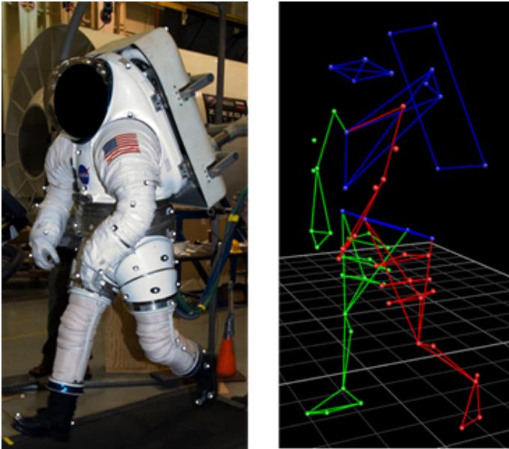

Figure 1. Left: Retroreflective markers placed on MKIII spacesuit. Right: 3D reconstruction of the marker trajectories.

Traditionally, optical motion capture performed with infrared cameras has been used to measure suited kinematics (Figure 1). Retroreflective markers are placed on the limbs and other landmarks on the spacesuit. The 3D trajectories of the markers are then triangulated and reconstructed to derive kinematic variables such as joint angles. However, some training environments, such as the NASA Neutral Buoyancy Laboratory (NBL) or simulated lunar outdoor terrain, are particularly challenging for optical motion capture due to infrared interference from the water column or outdoor ambient lighting conditions. Additionally, optical motion capture requires specialized cameras which can be cost prohibitive, and data post-processing or “motion tracking,” can be time consuming.

There are several low-cost alternatives such as inertial measurement unit (IMU) motion tracking, wearable sensors, and multi-camera triangulation, but each have their limitations to implementation. IMUs can be attached to the spacesuit¹ but are prone to magnetic interference and measurement drift over time. Wearable sensors such as a stretch sensor embedded garment can measure the suited subject’s kinematics², but the robustness of power delivery and cable management is still an unresolved issue, and the systems require lengthy instrumentation procedures prior to EVA. A motion capture system with water-resistant action cameras was developed for underwater testing, based on video images recorded from multiple cameras to triangulate marker coordinates.³ However, this system requires an extensive calibration process and is sensitive to any physical disturbances to the placed cameras. Each of the described methods also involve specialized equipment, which can be time-consuming to setup and logistically challenging to deploy at EVA training events. Furthermore, none of these systems can be used to analyze archived EVAs, including those from the Apollo and ISS missions. As a result, lessons learned from past EVAs have been supplied only through crewmembers’ anecdotes and quantitative measurements on spacesuit motions are lacking.

However, in nearly all training or EVA events, standard video and photography is performed, so a large amount of video archives collected from past EVAs exists. A solid technical framework capable of extracting motion and posture data from video recording could be an extremely useful tool for EVA analysis. The rise of machine-learning and deep-learning techniques have enabled the application of automatic recognition of objects from images and video. Machine-learning and computer vision frameworks have been widely tested and used for posture classification of the human body, once trained on large, annotated datasets of humans performing different activities such as jogging or cycling in a variety of indoor and outdoor environments. These frameworks learn to identify different objects (e.g., human, car, etc.) through object instance segmentation algorithms such as Mask-RCNN⁴. Additionally, keypoint locations in the image that correlate to anatomical features such as the hand or head can be automatically identified through neural networks. For example, OpenPose is a multi-person human pose detection library that estimates the simplified human pose skeleton with a two-branch convolutional neural network.⁵ Building on the achievements from learning-based 2D human pose estimation, research has been conducted into 3D human pose estimation such as DeepPose.⁶ Thus, it is suggested that a similar machine learning and computer vison approach can specifically identify spacesuits and estimate the pose. Generally, the spacesuit has less degrees of freedom in mobility compared to the unsuited human body and has uniquely restricted patterns. By taking advantage of the unique structure and mechanics of the spacesuit for machine learning, accuracy for posture estimation can be greatly enhanced through forward work. The objective of this paper aims to present the ongoing development of machine learning solutions to quantify suit motions from conventional videos without special sensors or hardware. Details on any machine-learning framework and statistical analysis were intentionally omitted as the intent of this paper was solely to document the on-going advances in machine-learning applications for spacesuit motion measurement.

In-house Machine-learning Pilot Studies
To initially prove if machine learning approaches can feasibly identify spacesuits in photos, a pretrained Mask R-CNN object segmentation framework was applied to various images of a spacesuit using deep learning libraries in Python, following similar methods in study by Abdudlla.⁷ Mask R-CNN is a framework that uses object detection and semantic segmentation to recognize different objects such as a human or backpack. Initial observations show promise as the spacesuit shape is identified and outlined properly (Figure 2). However, it was also noted that the algorithm was not able to distinguish between a spacesuit, unsuited human, and nearby objects.
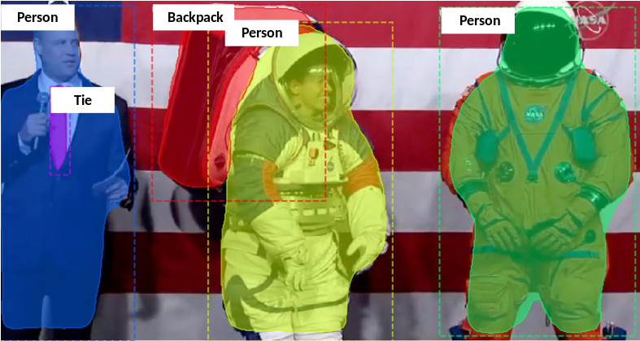
Figure 2. Example image processed using Mask R-CNN

A prototype framework, based on computer vision techniques, was developed to identify the 3D spacesuit posture given the silhouette of the spacesuit separately extracted from images (Figure 3). This framework is based on a previous method that was preliminarily tested to estimate the crewmembers' unsuited postures from the videos taken from the inside of the International Space Station (ISS).⁸ To obtain the unsuited postures, 3D body shape manikins were projected onto the virtual cameras and overlaid on the subjects’ silhouettes in an image For this suit-detection framework, an artificial spacesuit model was constructed from the computer aided-design (CAD) models of EMU and xEMU components. The hybrid spacesuit model was iteratively reposed into 500 different postures using a Monte Carlo technique to generate the training dataset. Screenshots were taken of the CAD model at different angles for each posture and the outline of the suit was extracted using background subtraction algorithms. A probabilistic classifier was modeled using the training dataset. Each pose in the training dataset was individually weighted for the likelihood of observation in EVA tasks. For example, overhead arm poses that are extended away from the body are not common due to joint restrictions and additional physical demands thus were assigned a lower weighting factor. Conversely, neutral postures where the arms are down and besides the body in a neutral posture as seen in Figure 2 were assigned a greater weighting factor. Given a new test photograph, the suit image outline was first extracted from the background and iteratively compared against the CAD-generated outlines. The best-fitting CAD outline that minimizes the outline pixel difference and maximizes the likelihood of observation was selected. Once the best match was identified, the 3D posture of the CAD model that generated the corresponding outline image was extracted. There were several limitations with this approach as an accurate silhouette of the spacesuit is required and more data was needed to train the classifier.
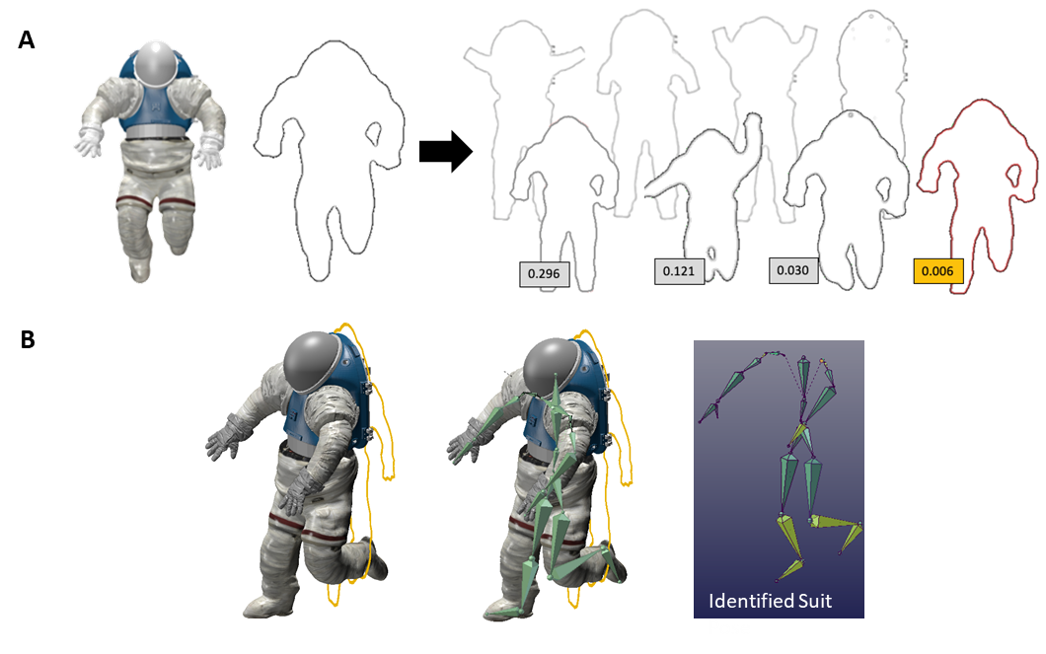
Figure 3. Summary of spacesuit posture extraction using probabilistic classifer.
A: The classifier system iteratively matches the test photograph with the CAD-generated outlines and identifies the pose that minimizes the image difference metric and maximizes the likelihood of observation. B: Afterwards, the 3D pose can be derived from the suit pose that created the silhouette.

Crowdsourcing Machine-learning Solutions
Given the complexity of this problem and need for specialized expertise, crowdsourcing was identified to have a variety of benefits and a potential to accelerate the progress of this type of work. The accumulated knowledge in machine-learning communities can be applied towards spacesuit pose extraction through a NASA-specific crowdsourcing solicitation. Because of the diversity of technologies employed by open-source communities, there can be cost and time savings by leaning on their expertise. Through collaborations with the NASA JSC Center of Excellence for Collaborative Innovation (CoCEI) and an execution crowdsourcing platform partner TopCoder, a crowdsourcing challenge was released to the public. The specific assignment of the contest was to develop novel algorithms to label and identify spacesuit motions from conventional and readily available video and photographs. The solutions were expected to detect spacesuits in a variety of environments and lighting conditions, correctly discriminate between an “unsuited” person (e.g., test personnel and NBL divers in the camera view) and spacesuit, and to be capable of functioning with single or multiple spacesuits. These environments could include the lunar surface, NBL, ISS, or simulated planetary surface terrains. (Figure 4).
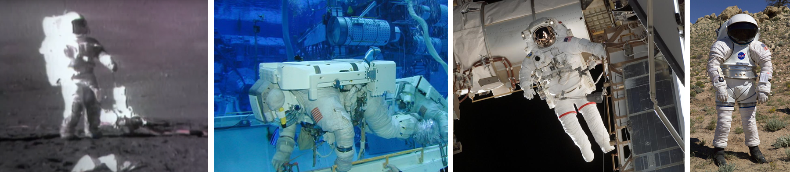
Figure 4. Representative EVA photos from a variety of environments for spacesuit pose estimation challenge.
(Photo credit: NASA)

Since this was a machine-learning and computer vision challenge, a sample dataset of spacesuit postures was provided to the contenders, consisting of approximately 200 suit images in various environments. The dataset consisted of both publicly available EVA images and NASA export control approved laboratory testing images. A summary of the dataset, categorized by environment and including example tasks, is provided in Table 1.

Table 1. Dataset composition
Environment | Dataset distribution (%) | Example tasks
Apollo Lunar EVA | 9% | Flag placement, lander egress
ISS EVA | 9% | Translation, hardware maintenance tasks
NBL ISS EVA training | 9% | Translation, hardware maintenance tasks
NBL preliminary Lunar EVA testing | 11% | Walking, geology
Laboratory spacesuit evaluations | 53% | Walking, object transfer, reach tasks
Public affairs events | 7% | Neutral posture, object pickup
Simulated spacesuit animations | 2% | Kneeling poses, stairclimbing

Images were prepared in compliance with the Microsoft Common Objects in Context (MS COCO) dataset annotations, which contains the annotated 2-D keypoint joint locations and pixel coordinates for the spacesuit silhouette outlines. Additionally 7,200 image frames (240 seconds) of video and synced 3D suit joint centers derived from simultaneously recorded optical motion capture data were provided. Examples of the provided dataset are shown in Figure 5.
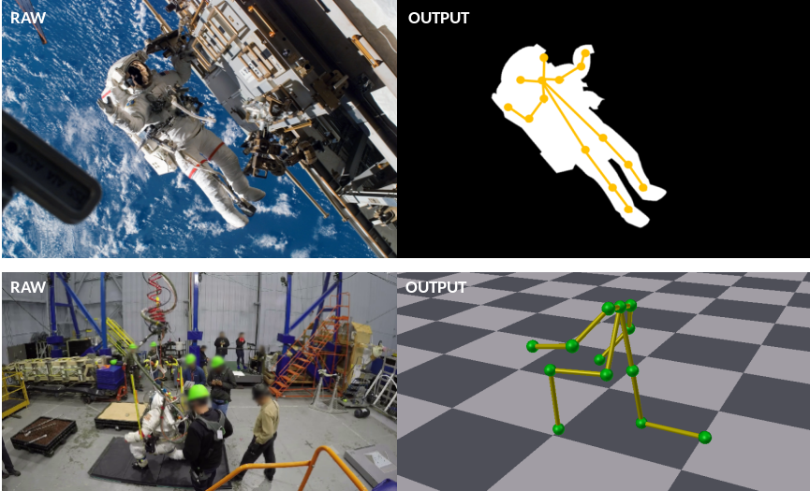
Figure 5. Top: 2D Spacesuit outline and 2D keypoint joint annotation. Bottom: Synced 3D suit joint center data.

The data was partitioned into a training set that contenders could use to train their models, a validation set with which the contenders could tune their models to achieve greater prediction accuracy, and a test set against which the contenders were scored on spacesuit pose prediction accuracy. The scoring rubric had 3 components: S2, J2, and J3, where S2 describes how well a solver detected suit outlines on the 2D images, J2 describes the joint detection accuracy in 2D images, and J3 is the same as J2 but scored in 3D coordinates (videos). S2 calculates the image similarity metric (F-score) between the predicted and test set spacesuit outlines. J2 and J3 calculates the Root Mean Square Error (RMSE) of the 2D and 3D keypoint coordinates, respectively. All scoring metrics were normalized from 0 to 1, where 1 represents perfect suit outline and joint location prediction. Given the limited 3D suit joint coordinate data, suit shape and 2D joint extraction (S2 and J2) was assigned with a higher weight (0.4 and 0.4) compared to J3 (0.2). Thus, a weighted final score was developed as shown:

 | $$Weighted score = (0.4 * S2) + (0.4* J2) + (0.2 * J3)$$ | (1)

Results from Crowdsourcing Challenge
The crowdsourcing challenge was opened in March 2020 and ended after a month and a half (the last half month of the challenge was dedicated to scoring the submissions). In that timeframe, there were a total of 285 registered participants and 285 solution submissions. The prediction accuracy of the contenders throughout the length of the challenge is provided in Figure 6. By the end of the challenge, most solutions had a weighted final score between 0.8 to 0.7 with the validation set. All submissions were then evaluated against the test set to determine the top solutions.
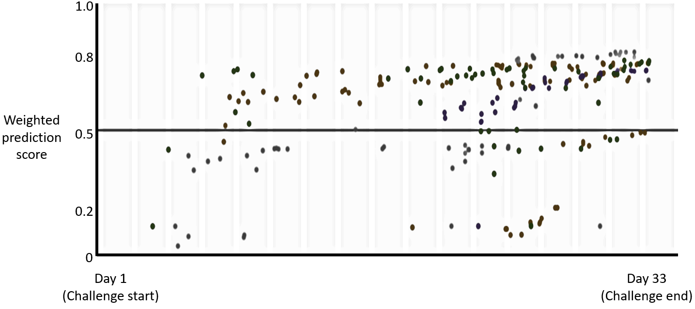
Figure 6. Distribution of weighted prediction scores during the duration of the challenge.

The top five solutions scored over 78% accuracy, and the best solution had an accuracy score of 85%. The top solution used a Mask R-CNN with X101-RPN⁹ backbone for suit image segmentation and a Keypoint R-CNN with R101-RPN⁸ backbone for suit keypoint detection. 3D joint estimation was performed by calculating the projection matrix from 3D keypoints to 2D keypoints under a preliminary assumption for camera perspectives, which was then used to convert the 2D keypoint predictions to 3D. The top winner had a S2, J2, and J3 accuracy score of 0.92, 0.84, and 0.72, respectively, with a total weighted score of 0.85. The score breakdown of the top 5 solutions is listed in Table 2. Based on the scoring breakdown across the top five solutions, algorithms performed best with suit image segmentation, followed by suit keypoint detection, and finally 3D joint detection. Representative images of good and poor prediction performances are provided in Figure 7. A poorly predicted image does not closely follow the curvature of the limbs and will often infer joints incorrectly. An accurately predicted image will have an outline prediction that matches closely with the silhouette of the suit and joint location predictions are similar to the ground truth data.
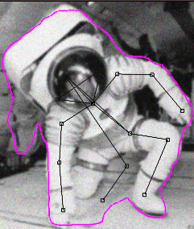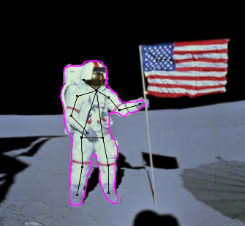
Figure 7. Representative images with poor prediction accuracy (Left, S2=0.76, J2 = 0.71) and good prediction accuracy (Right, S2=0.97, J2 = 0.94).

Table 2. Summary of Accuracy Scores from Top 5 Solutions
 | S2 score | J2 score | J3 score | Weighted score
Solution 1 | 0.92 | 0.84 | 0.72 | 0.85
Solution 2 | 0.88 | 0.81 | 0.67 | 0.81
Solution 3 | 0.91 | 0.78 | 0.65 | 0.80
Solution 4 | 0.87 | 0.77 | 0.68 | 0.79
Solution 5 | 0.90 | 0.77 | 0.59 | 0.79

In-depth data analysis is on-going, but a few highlights and observations on predictions made from the behaviors of the top solution algorithms are provided. In general, the top solution worked in a robust manner on images taken in the laboratory environments such as the Active Response Gravity Offload System (ARGOS) test area. The solution seemed to perform well on predicting joint coordinates in active, planetary EVA postures such as squatting or crawling (Figure 8). When a large proportion of the suit is fully visible on the image, the occluded suit components (e.g., left knee in Figure 8) appear to be predicted well using algorithm inference. Furthermore, the solution could effectively distinguish between the spacesuit and hardware or unsuited people as seen in Figure 8. A summary of the image accuracy by environment was provided in Table 3. Laboratory spacesuit evaluation images had the highest S2 scores (0.93), while Apollo Lunar EVA had the highest J2 scores (0.87).
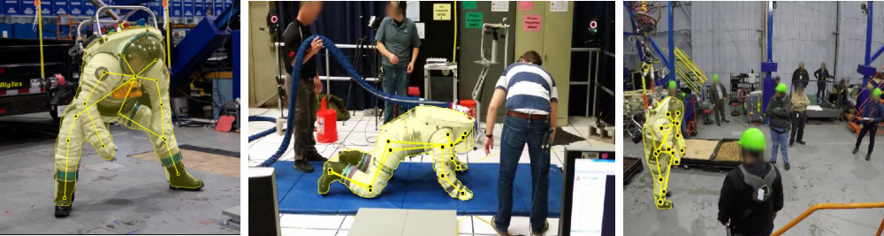
Figure 8. Spacesuit pose estimation on images of the MK-III spacesuit in a variety of postures.

Table 3. Summary of Image Accuracy across Various Environments
Environment | S2 scores | J2 scores
Apollo Lunar EVA | 0.92 | 0.87
ISS EVA | 0.92 | 0.85
NBL ISS EVA training | 0.84 | 0.76
NBL preliminary Lunar EVA testing | 0.92 | 0.76
Laboratory spacesuit evaluations | 0.93 | 0.85
Public affairs events | 0.92 | 0.85
Simulated spacesuit animations | N/A | N/A

Additionally, the solution could accurately identify the spacesuit in a deep space environment, where there were mainly black and white hues (Figure 9). The solution performed well against ISS, where the color and luminance are similar between the suit and nearby hardware. A similar performance was observed from the reflective lunar surface with dark shadows and backgrounds. Additionally, the solution was robust to image resolution and quality, as performance did not decrease in low resolution images. In a separate test in which Gaussian blurring was artificially added to the images to simulate the degraded quality, the solution still showed good accuracy in identifying the suit outlines and joint coordinates.
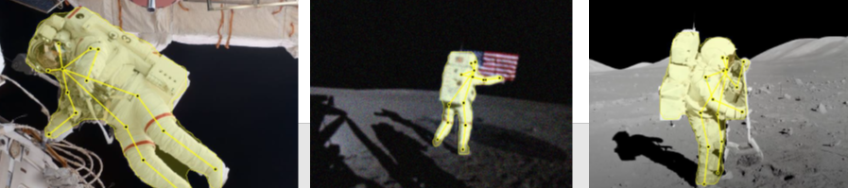
Figure 9. Spacesuit pose estimation on images during ISS EVA (left) and Apollo EVA (middle & right panel).

However, the solution appeared to struggle with images taken at the NBL, possibly due to color desaturation and optical distortion resulting from underwater photography (Figure 10). For images taken from NBL ISS EVA training events, the overall S2 score is the smallest at 0.84. J2 accuracy scores were among the lowest at 0.76 for both NBL ISS EVA and NBL preliminary lunar EVA testing. The S2 scores for left and middle panels of Figure 10 were 0.88 and 0.82, respectively. The J2 scores for the left and middle panels of Figure 10 were 0.33 and 0.65, respectively. As shown Figure 10, there were instances of mislabeled 2D keypoints (left panel) and misidentified spacesuits objects (middle panel). If some components of the suit were outside of the image boundaries, inferences of joint locations were often incorrect, but this is a common problem even in pose estimation algorithms for unsuited persons. However, multiple spacesuits were simultaneously identified and could be distinguished from the divers in the background as separate objects with this solution (right panel).
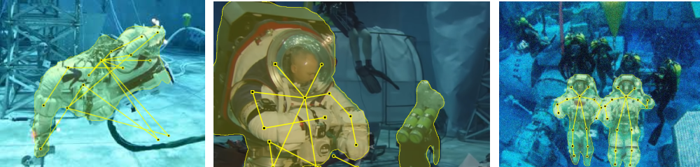
Figure 10. Spacesuit pose estimation on images of the spacesuit in the NBL.

As expected, 3D suit joint prediction accuracy was very inconsistent across images (Figure 11). It was observed that 3D suit joint prediction accuracy performed better when a camera projection matrix can be easily estimated such as the computer-generated MK-III suit animation images (left panel of Figure 11, J3 = 0.80) in comparison to the laboratory testing images (right panel of Figure 11, J3 = 0.71). The issue may be related to the fairly sparse dataset of 3D joint coordinates, which is insufficient to train these types of machine learning applications. Increasing the size and variety in the image and video training dataset is expected to improve the camera projection predictions and overall accuracy.
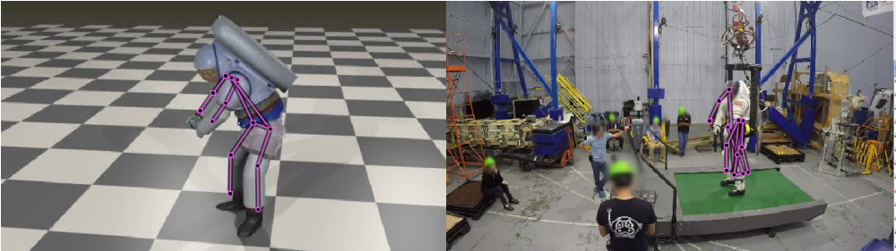
Figure 11. 3D joint predictions (purple) overlaid with images from video.

Future Work
The crowdsourcing competition provided solutions that use different approaches with varying degrees of accuracy for suited posture extraction. By leveraging the accumulated knowledge in the machine learning/deep learning community, the provided solutions will accelerate development of the suited posture extraction from video methodology. While the top solution showed a useful level of accuracy, future work is needed to increase prediction strength and improve 3D joint center estimates. Since there was a diverse number of solutions, the multiple learning algorithms can be ensembled or combined to obtain better predictive performance. NASA will then use their detailed expertise of spacesuit geometry, mechanics, and movement characteristics to further improve on the suit detection algorithms. For example, a probabilistic suit posture model can be developed from the testing data for joint limits or range of motion. Such models can substantially reduce estimations that contain infeasible or unlikely postures. Any suit outlines that do not adhere to the expected spacesuit shape can be dismissed, reducing chances for errors. After suited posture extraction frameworks have been refined, the framework will be tested and validated on video recordings collected during xEMU spacesuit testing. Suit joint center estimates will be compared to a “gold standard” motion capture system that is simultaneously measuring the spacesuit posture. Currently, there is minimal suited motion capture data to perform the validation, so additional data collection during future xEMU testing is planned.

It is still anticipated that this machine learning approach will have limitations in accuracy due to camera distortion and inconsistent image quality, but it may provide approximate postural information that is sufficient for specific scenarios such as full-body posture evaluations. Once validated for the reliability of the posture extractions, the developed tool can be used for a variety of applications to inform spacesuit hardware and training design. The system can be deployed to estimate the EVA postures in the current, past, and future missions and analog training events. The tool, once deployed for NBL and ARGOS testing, can provide key measurements for ergonomic assessments and optimization of training procedures. During EVAs, the tool can be used to estimate individual spacesuit joint movements and perform hardware “wear and tear” monitoring. Suit joint cycle tracking, which is critical for spacesuit integrity but has traditionally relied on manually counting when the suit bearings articulate, is an area that the machine learning algorithm may be immediately applied. The tool can be further applied against a large wealth of video archives of past EVAs for task and timeline analysis. EVA motions can be characterized, and joint mobility defined for each EVA task. This joint mobility data can be used in design requirements to improve current suit hardware as well as evaluate future suit designs. Furthermore, active monitoring of suit kinematics can allow EVA trainers to detect anomalies in suited subject task performance and provide corrective feedback. Realtime feedback based on their kinematics could be provided to the crew, which can potentially improve mobility performance and training efficacy. Future work is needed to ensure that the information is presented with human factors considerations. Since the core framework has been established, the tool will be easily adapted for future spacesuits through additional model training. This new framework, potentially in a more generalized and expanded form, can be applied to estimate the kinematics of different human-machine systems, such as exoskeletons and robots.

Conclusion
Characterization of EVA motions and spacesuit mobility is critical to understanding the spacesuit performance and injury risk. Existing motion capture tools require additional hardware and time for setup, but videography is often already included in the planned operations. Automatic posture extraction by machine-learning solutions, as those obtained from the crowdsourcing community, expands on preliminary proof-of-concepts to greatly advance the technology readiness. Future work is planned to incorporate spacesuit geometry and movement patterns insight to improve prediction strength. The fully developed video-based posture extraction method will extend the capabilities to assess suited kinematics in a variety of environments and enable more effective spacesuit, hardware, and EVA task planning.

References
₁Anderson, A., Hilbert, A., Bertrand, P., McFarland, S., & Newman, D. J. (2014, July). In-suit sensor systems for characterizing human-space suit interaction. In 44th International Conference on Environmental Systems.
₂Vu, L. Q., Kim, H., Schulze, L. J., & Rajulu, S. L. (2020). Evaluating Lumbar Shape Deformation With Fabric Strain Sensors. Human Factors, 0018720820965302. Vu, L. Q., Kim, H., Schulze, L. J., & Rajulu, S. L. (2020). Evaluating Lumbar Shape Deformation With Fabric Strain Sensors. Human Factors, 0018720820965302.
₃Hernandez, Y., Kim, K. H., Benson, E., Jarvis, S., Meginnis, I., & Rajulu, S. (2019). Underwater space suit performance assessments part 1: Motion capture system development and validation. International Journal of Industrial Ergonomics, 72, 119-127.
₄He, K., Gkioxari, G., Dollár, P., & Girshick, R. (2017). Mask r-cnn. In Proceedings of the IEEE international conference on computer vision (pp. 2961-2969).
₅Cao, Z., Simon, T., Wei, S. E., & Sheikh, Y. (2017). Realtime multi-person 2d pose estimation using part affinity fields. In Proceedings of the IEEE conference on computer vision and pattern recognition (pp. 7291-7299).
₆Toshev, A., & Szegedy, C. (2014). Deeppose: Human pose estimation via deep neural networks. In Proceedings of the IEEE conference on computer vision and pattern recognition (pp. 1653-1660).
₇Abdulla, Waleed. (2017). Mask R-CNN for object detection and instance segmentation on Keras and TensorFlow. Github repository. https://github.com/matterport/Mask_RCNN.
₈Rajulu, S., Young, K., Kim, H., & Dirlich, T. (2017, January). Quantification of Inflight Physical Changes: Anthropometry and Neutral Body Posture (Body Measures). In Human Research Program Investigators Workshop 2017 (No. JSC-CN-38417).
₉Yuxin Wu, Alexander Kirillov, Francisco Massa, Wan-Yen Lo, and Ross Girshick. (2019). Detectron2. https://github.com/facebookresearch/detectron2.

Human Factors Engineer, Aegis Aerospace, Inc. 2101 NASA Parkway, Houston, TX 77058.
Human Factors Engineer, Leidos Innovations Corp. 2101 NASA Parkway, Houston, TX 77058.
Human Factors Engineer, KBR, Inc. 2101 NASA Parkway, Houston, TX 77058.
NASA Technical Monitor, NASA, 2101 NASA Parkway, Houston, TX 77058.

