Arizona Water Resources

Utilizing Aerial Imagery and NASA Earth Observations to Assess Pinyon-Juniper Tree Mortality in Flagstaff, AZ

 **Technical Report**

Final – March 31st, 2022

Margaret Jaenicke (Project Lead)

Anne Britton

Abbi Brown

Liam Megraw

***Advisors:***

Sean McCartney, Science Systems and Applications, Inc., NASA Goddard Space Flight Center (Science Advisor)

Joseph Spruce, Science Systems and Applications, Inc. (Science Advisor)

# 1. Abstract

Pinyon-juniper woodlands (PJW) are a vital habitat and food source for several wildlife species and a source of both utility and cultural importance for Indigenous groups. In 2021, amidst a decades-long drought, an extensive juniper mortality event occurred at Wupatki National Monument (WNM) in Arizona. In response, the National Park Service (NPS) is evaluating which land management practices will be beneficial. In partnership with the NPS, the NASA DEVELOP team used remote sensing data to map PJW mortality and analyze the relation of tree mortality to stand density, climate, and topography in north-central Arizona from 2015 to 2021. To identify the extent of PJW, the team performed an unsupervised classification using National Agricultural Imagery Program (NAIP) data with validation sources including NPS-created land cover maps, Landscape Fire and Resource Management Planning Tools (LANDFIRE), NPS and United States Forest Service (USFS) vegetation maps, and Landsat 8 Operational Land Imager (OLI) and Thermal Infrared Sensor (TIRS) data. Terra Moderate Resolution Imaging Spectroradiometer (MODIS), Global Precipitation Measurement (GPM) Integrated Multi-satellite Retrievals for GPM (IMERG), Soil Moisture Active Passive (SMAP), Shuttle Radar Topography Mission (SRTM), and Landsat 8-derived Normalized Difference Vegetation Index (NDVI) and Normalized Difference Moisture Index (NDMI) were used to analyze factors contributing to pinyon-juniper mortality. Although no relationships were found in the broader study region, PJW mortality was weakly correlated to elevation, soil moisture, and land surface temperature within WNM. Results from this study can inform NPS vegetation management that best protects natural and cultural resources.

**Key Terms**

remote sensing, pinyon-juniper woodlands, tree mortality, drought, National Park Service, cultural resources, Indigenous groups, vegetation management

# 2. Introduction

***2.1 Background Information***

As climate change-related drought continues to negatively impact the greater American Southwest, land management decisions increasingly rely on understanding the impacts of limited water resources on ecosystems. In the Flagstaff, Arizona area, National Park Service (NPS) lands, surrounding United States Forest Service (USFS) lands, and unprotected lands have been impacted by a decades-long hydrological and ecological drought (Arizona State Climate Office, 2022; Crausbay et al., 2017). These areas each serve as interconnected patches of land that contain cultural resource sites and habitat for numerous plant and animal species, including those living in pinyon-juniper woodlands (*Pinus* spp.-*Juniperus* spp.).

Pinyon-juniper woodlands are a forest type defined by the presence of at least one species each of juniper and pinyon pine, which are associated with a range of other vegetation types (National Park Service, 2015). Specifically, there are 3 major types that have been identified and are broadly referred to here as pinyon-juniper woodland (PJW) habitat: (1) pinyon-juniper savanna, (2) pinyon-juniper wooded shrubland, and (3) pinyon-juniper persistent woodland (Romme et al., 2009). Within these classifications, PJW may exhibit a variety of compositions and structures each influenced by regional factors and disturbances. Generally, most PJW are found in regions defined by seasonally extreme temperatures and relatively xeric conditions (Gottfried et al., 1995). The PJW forest type covers roughly 19 million hectares of land in nine western states, with the majority in Arizona, Colorado, Nevada, New Mexico, Utah, Oregon, and California (Evans, 1988). PJW provide vegetative cover for watershed protection, key food sources for local birds, and habitat for rare plants and wildlife like obligates (National Park Service, 2015). Despite this, PJW are amongst the least studied woodland types in North America (National Park Service, 2015).

Since the beginning of Arizona’s decades-long drought, most watersheds in the state have only seen 9 to 10 years of significant precipitation (Arizona State Climate Office, 2022). Although PJW are well-adapted to semiarid conditions, increases in the length, severity, and frequency of climate change-related drought puts this ecosystem at risk (Clifford et al., 2011). As drought conditions become more common and temperatures rise across Arizona and the greater American Southwest, over 1.2 million hectares of PJW have experienced at least some overstory tree mortality leading to a reduction in ecosystem services and increased wildfire risk (USFS, 2015). In 2021, the National Park Service observed unprecedented PJW mortality across protected NPS and USFS lands and unprotected areas (*Figure 1*)*.* This current PJW mortality event was also observed across central and northern Arizona by the USFS as early as April 2021, with assessments from the USFS Forest Health Protection office suggesting that the majority of mortality was due to drought (USFS, 2021).

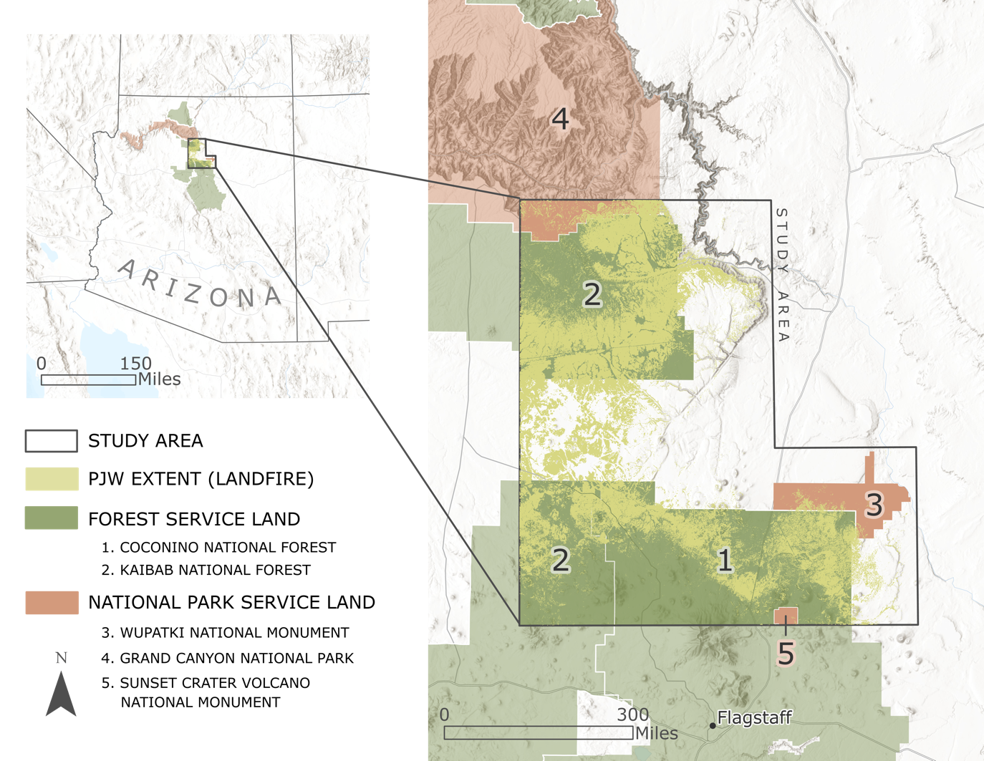

*Figure 1.* The project study area includes the Coconino and Kaibab National Forests, the Wupatki and Sunset Crater National Monuments, and the Southern Rim of Grand Canyon National Park. PJW extent sourced from LANDFIRE is also shown.

Mapping tree die-off using remote sensing techniques provides a unique opportunity to generate spatially explicit geospatial data that can be a foundation for analyzing potential drivers of mortality (Anderegg et al., 2016). Approaches for mapping tree mortality using remote sensing typically include two methodologies that can be applied depending on the regional and physiological structure of the species in question: 1) individual tree mapping using high spatial resolution data, and/or 2) stand or forest-level mapping using moderate resolution data. When used singularly as a data source, each of these techniques has spatiotemporal benefits and drawbacks (Campbell et al., 2020). Joined together, high and moderate spatial resolution multispectral imagery have been used to quantify and assess tree mortality (Spruce et al., 2019). However, before moderate resolution imagery (e.g., Landsat) can be used to derive percent tree mortality maps, one needs reference data to train and assess the model, such as tree mortality maps from high spatial resolution data (Meddens et al., 2013; Spruce et al., 2019). Due to this factor as well as the sparse occurrence of PJW in the study area and the relatively small size of the type’s tree canopies, the team used high resolution aerial data to map PJW mortality occurrence between 2015 and 2021.

***2.2 Project Partners & Objectives***

The team partnered with Flagstaff Area National Monuments NPS staff, represented by Mark Szydlo of Wupatki National Monument (WNM). In response to a significant PJW mortality event in 2021, WNM staff were considering the implementation of new forest management practices to protect the species and cultural resource sites in and around PJW. Prior to this project, the partners used limited remote sensing methods for landscape-scale analyses. This work was conducted to potentially inform management decisions by assessing pinyon-juniper mortality in relation to tree density, climatic variables, and topographic parameters. The primary objectives of this study were to 1) assess the extent of PJW mortality by mapping changes in tree canopy cover across the study area between 2015 and 2021, 2) identify changes in PJW stand density, soil moisture, precipitation, land surface temperature, evapotranspiration, NDVI, and NDMI during the study period, and 3) provide the partners with a method for continued monitoring and detection of pinyon-juniper tree mortality events.

# 3. Methodology

***3.1 Data Acquisition***

The team acquired a variety of freely available NASA Earth observations, aerial imagery, and ancillary data. NASA Earth observations were used to explore climatic and topographic factors such as soil moisture, precipitation, evapotranspiration, and elevation. Aerial imagery and ancillary datasets were used to generate the mortality map end products.

**3.1.1 NASA Earth Observations**

Utilizing Google Earth Engine (GEE), our team acquired the following NASA Earth observations: Soil Moisture Active Passive (SMAP) from 2015–2021, Shuttle Radar Topography Mission (SRTM) for the year 2000, Terra Moderate Resolution Imaging Spectroradiometer (MODIS) for 2015–2021, Landsat 8 Operational Land Imager (OLI) and Thermal Infrared Sensor (TIRS) for 2015–2021, Landsat derived Normalized Difference Vegetation Index (NDVI) and Normalized Difference Moisture Index (NDMI) for 2015–2021. These Earth observations were paired with Integrated Multi-satellite Retrievals for Global Precipitation Measurement (GPM IMERG) data acquired from NASA Earthdata for monthly datasets and GEE for yearly datasets from 2015–2021. The team acquired images from these products for each month and year available between January 2015 and December 2021. For additional information about specific products and their temporal and spatial extents, see Table 1.

Table 1

*NASA Earth observations utilized to assess influential climatic and topographic factors on pinyon-juniper mortality*

|  |  |  |  |
| --- | --- | --- | --- |
| **Earth Observation Product** | **Spatial Resolution** | **Temporal Resolution** | **Years Active** |
| Landsat 8 OLI Collection 1 Tier 1 Land Surface Reflectance | 30 meters | 16 days | 2013-03-18 – Present |
| Landsat 8 TIRS Collection 1 Tier 1 Land Surface Temperature | 30 meters | 16 days | 2013-04-01 – Present |
| SMAP Enhanced L3 Radiometer Global Daily 10 km EASE-Grid Soil Moisture, Version 2 | 10,000 meters | 49 minutes | 2015-04-02 – Present |
| GPM IMERG Final Precipitation L3 1 Month 0.1 Degree x 0.1 Degree V06 | 10,000 meters | 3.5 months | 2000-06 – Present |
| Shuttle Radar Topography Mission (SRTM) Version 3.0 (SRTM Plus) | 30 meters | N/A** | 2000-02-11 – 2000-02-22 |
| MODIS/Terra Net Evapotranspiration 8-Day L4 Global 500 m SIN Grid v006 | 500 meters | 8 days | 2001-01-01 – Present |
| MODIS/Terra+Aqua Burned Area Monthly L3 Global 500 m SIN Grid v006 | 500 meters | Monthly | 2000-11-01 – Present |

*Nominally daily but dependent upon orbital cycle.

**Single-pass collection of SRTM elevation data.

**3.1.2 National Agriculture Imagery Program (NAIP) Aerial Multispectral Imagery**

In conjunction with NASA Earth observations, the team acquired NAIP data from the United States Department of Agriculture (USDA) NAIP imagery Dropbox and the United States Geological Survey’s (USGS) EarthExplorer (Table 2). These high-resolution images cover the extent of the study area. The team used tiles acquired and aggregated by the USDA into county mosaics for Coconino County for color infrared imagery for 2021. Because the USDA did not have color infrared county mosaics for 2015, the team acquired four-band tiles for 2015 from Earth Explorer.

Table 2

*Aerial imagery products utilized to assess the extent of pinyon-juniper mortality*

|  |  |  |  |
| --- | --- | --- | --- |
| **Aerial Imagery Product** | **Spatial Resolution** | **Temporal Resolution** | **Years Active** |
| NAIP Aerial Multispectral Imagery | 1 meter (2003 – 2015)  0.6 meters (2017 – 2021) | 2 years (current revisit) | 2003 – Present |

Table 3

*Collection dates for NAIP Aerial Multispectral Imagery*

|  |  |  |
| --- | --- | --- |
| **Aerial Imagery Product** | **Imagery Year** | **Collection Dates** |
| NAIP Aerial Multispectral Imagery | 2015 | 2015-05-28 – 2015-07-27 |
| NAIP Aerial Multispectral Imagery | 2021 | 2021-10-23 – 2021-11-12 |

**3.1.3 Ancillary Geospatial Datasets**

The team also acquired several ancillary geospatial datasets to examine in relation to observed pinyon-juniper tree mortality in 2021 (Table 4). These datasets include: LANDFIRE for 2016 existing vegetation types and height from the LANDFIRE Data Distribution Site, public land boundaries from the Protected Areas Database of the United States (PAD-US) version 2.1, and Monitoring Trends in Burn Severity (MTBS) Burned Area Maps. The USFS provided 60 PJW dieback survey points from 2021. In addition, the team received the following data from partners at WNM: National Park Service (NPS) Vegetation Inventory Maps with existing vegetation for WNM as of 2004 and National Park Service (NPS) Juniper Survey Points with 13 survey points from WNM in 2021.

Table 4

*Ancillary datasets utilized for additional analysis*

|  |  |  |
| --- | --- | --- |
| **Product Name** | **Use** | **Dataset Year** |
| LANDFIRE Existing Vegetation Type [v1.4.0] | Mask out ponderosa pine areas | 2016 |
| LANDFIRE Existing Vegetation Height [v2.0.0] | Mask out vegetation unlikely to be pinyon-juniper woodlands | 2016 |
| Public Land Boundaries from Protected Areas Database of the United States (PAD-US) [v2.1] | Display boundaries of public lands within the study area | 2020 |
| United States Forest Service (USFS) Ground Truth PJW Sites within the Coconino National Forest and Southern Kaibab National Forest from 2021 | Compare with mortality classification results | 2021 |
| National Park Service (NPS) Vegetation Inventory Maps | Identify types of pinyon-juniper woodland and locations in Wupatki National Monument | 2004 |
| National Park Service (NPS) Juniper Survey Points | Starting point for classification analysis in Wupatki National Monument | 2021 |
| Monitoring Trends in Burn Severity (MTBS) Burned Area Maps | Mask out burn areas | 2015 – 2020 |

***3.2 Data Processing***

**3.2.1 Pinyon-Juniper Mortality Mapping**

After acquiring 2015 and 2021 NAIP imagery, the team mosaicked the 2015 tiles from Earth Explorer in ArcGIS Pro to cover the full extent of the study area. NAIP color infrared imagery from the USDA Dropbox from 2021 was already mosaicked to the extent of Coconino County prior to acquisition and therefore did not need to be mosaicked by the team. Using ArcGIS Pro, the team projected both the 2015 and 2021 NAIP images and clipped them to the extent of the study region to minimize processing times. Because the 2015 imagery consisted of four bands while the 2021 imagery only contained three bands, the team isolated the near infrared, red, and green bands from the 2015 image and used the Raster Functions Composite tool in ArcGIS Pro to create a three-band color infrared raster to match the 2021 data.

To identify forested areas, the team used ArcGIS Pro to first train the Geoprocessing Iso Cluster Classifier. Next, for both the 2015 and 2021 three-band NAIP images, the team input the resulting file into the Geoprocessing Classify Raster tool to return a classified raster with 20 cluster classes. The team then visually reviewed the resulting 20 clusters for each year. Four classes (pinyon-juniper, shadow, grass or shrub, and bare earth) were assigned and merged into clusters using the Image Classification Assign Classes tool in ArcGIS Pro.

The team then estimated tree mortality by calculating the difference between the 2021 and 2015 classifications. The classified 2021 NAIP imagery was at a 0.6 m resolution while the 2015 imagery was at a 1 m resolution. The team resampled both images to a 3 m resolution with a nearest neighbor of four to facilitate a more direct comparison of the mortality and environmental variable datasets during analysis. To assign a meaningful difference, the team merged the four classes defined above into the following: PJW (2), Shadow (1) and not PJW (0). When subtracted, the difference raster contained the following values: PJW mortality (-2), PJW growth (2), and no change (0, -1 or 1) (Table A1).

After generating the difference raster, the team then reclassified it such that mortality (–2) became 200, and all other values became NODATA. The 2015 classification was also reclassified such that the pinyon-juniper class (2) became zero, and all other values became NODATA. The team then performed cell statistics in ArcGIS Pro to compute the mean of these two layers, resulting in values of 100 (mortality) and 0 (2015 pinyon-juniper), and then resampled the dataset to 30 m. This process masked out areas without pinyon-juniper in 2015, resulting in a percentage pinyon-juniper mortality map between 2015 and 2021.

The goal of the PJW classification was to produce accurate tree mortality maps of PJW areas. However, ponderosa pine and wildfires posed a challenge to classification accuracy. Approximately 35 percent of the pinyon-juniper class was incorrectly classified as ponderosa pine according to the LANDFIRE reference land cover map, while areas burned between 2015 and 2021 would incorrectly be considered an “unknown” mortality event. Therefore, a mask was needed to increase classification accuracy and non-wildfire related tree mortality estimates.

The team used existing vegetation type and height, elevation, and burn boundaries to create masks for improving classification of PJW areas. Together, three LANDFIRE 2016 ponderosa pine classes served as the ponderosa pine mask. Of those, the Southern Rocky Mountain Ponderosa Woodland class represented 98 percent of the masked area and had 93 percent classification accuracy (NatureServe, 2011). Depending on the region, the maximum elevation for oneseed juniper (*Juniperus monosperma*) ranges from 1500 m to 2130 m. The maximum elevation for two-needle pinyon (*Pinus edulis*) is approximately 2290 m, with individual trees of either oneseed juniper or two-needle pinyon growing as high as 2590 m (Cronquist et al., 1972 as cited in Miller et al., 2019, p. 29; Emerson, 1932; Kearney et al., 1960, p. 60; USFS, 1965, p. 398). Given that all pinyon-juniper accuracy points were below 2250 m, the team used SRTM elevation data to mask out areas above the 2290 m two-needle pinyon threshold. Additionally, the team used ocular sampling within the study area to determine the 7 m existing vegetation height cutoff between PJW and ponderosa pine forests. Lastly, the team compiled burn boundaries from MTBS data for 2015-05-28 (the earliest NAIP collection date) through 2020 and MODIS data from the start of 2021 until 2021-11-12 (the latest NAIP collection date).

Simplification was necessary to reduce the complexity of the masks for clipping and visualization purposes. This resulted in two products: a generalized mask with several hundred polygons and a convex hull mask composed of two polygons. To produce the generalized mask, the team removed areas less than 3600 m2 andfilled gaps smaller than 14,400 m2 with a series of square buffers. The team then calculated minimum bounding geometry (i.e., a convex hull) for that layer, while removing areas smaller than 150,000 m2 and those in the western portion of the study area that were further to the north and south of the two largest masked areas.

**3.2.2 Environmental Variables**

Utilizing GEE, the team obtained slope and aspect datasets from SRTM elevation data prior to export. NDVI (Equation 1, Landsat Missions 2016) and NDMI (Equation 2, Landsat Missions 2016) were calculated in GEE from Landsat 8 surface reflectance data:

|  |  |  |
| --- | --- | --- |
|  | $$NDVI = \frac{\left(NIR-R\right)}{\left(NIR+R\right)}$$ | (1) |

|  |  |  |
| --- | --- | --- |
|  |  | (2) |

NIR is Near Infrared, R is Red, and SWIR is Shortwave Infrared bands. The team also acquired composite datasets for each of the environmental variables, calculating the mean of each cell for each dataset between 2020–2021 and 2019–2021. Each of the raster datasets, including the mortality percentage data, were then imported to ArcGIS Pro for processing. Evapotranspiration, soil moisture, precipitation, Landsat NDVI, Landsat NDMI, Landsat land surface temperature, slope, elevation, aspect, and mortality percentage raster datasets were all projected and clipped to the study area and resampled to a 300-meter resolution. The team also used the Subtract Raster tool in ArcGIS Pro to generate an output raster representing the difference of each cell by subtracting the 2015 raster from the 2021 raster. Using this output raster consisting of the difference of means for these datasets allowed for a more direct comparison between the mortality data and the environmental variables.

In ArcGIS Pro, the team used the burn area and ponderosa masks to eliminate areas that were less likely to contain PJW habitat. In doing so, they clipped each of the raster datasets to the convex hull mask. These masked regions consisted of areas with known wildfire occurrences as well as mixed ponderosa and pinyon-juniper cover to account for any external factors such as tree mortality from wildfire and uncertainty associated with mixed ponderosa pine areas. These masked regions therefore represent excluded low probability areas where the team did not evaluate tree mortality. Finally, the mortality percentages were converted to point data and the environmental variable data were converted to multi-point data. This ultimately allowed for a more direct comparison between each of the environmental and topographic variables and tree mortality when performing the statistical analyses.

The team also acquired available monthly data for each of the environmental variables between 2015 and 2021 to generate monthly time series plots. Utilizing ArcGIS Pro, the team projected and clipped these raster datasets to the study region. Next, the team calculated the mean of all raster cells within each monthly dataset using zonal statistics and merged the individual monthly means into a single table for each variable. Exporting these tables as Microsoft Excel files allowed the team to produce monthly time series plots for each variable.

***3.3 Data Analysis***

**3.3.1 Pinyon-Juniper Mortality Mapping**

After converting the 2015 pinyon-juniper classification into a percentage cover product, the team estimated stand density. It is important to note that because the classification performed was pixel-based, there were no counts of individual trees, necessitating percentage cover as a proxy. The team reclassed pinyon-juniper as 100 and all other classes as zero. When resampled to 30 m using the mean, the resulting raster consisted of percentage canopy cover per 30 m pixel.

To evaluate classification accuracy, the team visually assessed 240 equalized stratified random points within the 2021 NAIP classification. During assessment, the team noted any points where an individual tree appeared to be dead or living. The team used shadow lines and crown shape as the differentiating factor between ponderosa pine and PJ, marking ponderosa pine as a fifth ground truth class. For the 2015 accuracy assessment, the team revisited the 2021 points and updated classifications based on visual identification of cover in the 2015 imagery.

The team assessed the accuracy of the mortality classification via visual assessment of 2021 NAIP Imagery along with the juniper survey points provided by the USFS. A subset of 240 cell centers outside of the convex hull mask, determined by equalized stratified random sampling, defined the points for review. These points were evenly split between the mortality and “not mortality” classes.

**3.3.2 Environmental Variables**

To evaluate the relationship between pinyon-juniper tree mortality and the environmental and topographic variables, the team performed a Principal Component Analysis (PCA) in ArcGIS Pro. This analysis allowed for a comparison of component weights to evaluate which variables showed the highest variability across the study region. Due to a variety of spatial resolutions within our datasets, the team performed the PCA at a moderate resolution of 300 meters within the entire study region as well as within WNM alone. Performing two PCAs on all of the environmental and topographic variables as well as the environmental variables alone allowed for a better understanding of the potential influences of both groups of variables within WNM and the entire study area.

Considering the environmental variables independently, the team produced monthly time series plots in Tableau to visualize trends of each variable between 2015 and 2021. To evaluate the statistical significance of these trends, the team performed a generalized linear regression in Tableau. Visualizing these monthly time series plots provided a more comprehensive understanding of trends in environmental and climatic conditions across the study period and helped inform the most appropriate time periods for Spearman’s Correlation analyses.

Utilizing RStudio, the team performed a non-parametric Spearman’s Correlation analysis to evaluate whether the data showed any statistically significant correlations between tree mortality and the environmental variables within WNM and the entire study area. Performing a Spearman’s Correlation on averaged values for each environmental variable between 2020 – 2021, 2019 – 2021, and 2015 – 2021 provided a greater depiction of the relationships between tree mortality and the climatic and topographic variables at differing temporal scales leading up to the 2021 mortality event. The Spearman’s Correlation generated rho and p-values for each of these analyses, allowing for a statistical evaluation of correlations between mortality and climatic variables.

# 4. Results & Discussion

***4.1 Analysis of Results***

**4.1.1 Pinyon-Juniper Mortality Mapping**

The overall accuracy for the land cover classification was higher for the 2015 classification (82 percent) than the 2021 classification (73 percent; Table 5). The most notable issue with accuracy in the 2021 classification came from the pinyon-juniper class, which had a user’s accuracy of 58 percent. This low accuracy was almost entirely due to the misclassification of ponderosa pine, which accounted for 84 percent of this error. The bare earth and non-PJ vegetation classes also included some confusion with each other, though these issues did not affect the mortality or stand density estimates. Masking out areas likely to be ponderosa pine also improved results. After masking, 100 percent of ponderosa pine related classification errors were removed, with the caveat that pinyon-juniper stands mixed with ponderosa pine were omitted as well and therefore not analyzed.

Table 5

*Accuracy assessment results for the 2015 and 2021 study area land cover classifications*

|  |  |  |  |  |  |  |
| --- | --- | --- | --- | --- | --- | --- |
| **Assessment** | **# of Random Points** | **Method** | **Percent (%) Accuracy** | **Kappa** | **Error** | **95% Confidence Interval** |
| 2015 Vegetation Classification | 240 | Equalized Stratified Random | 82% | 0.69 | 0.18 | 82% +/- 4.9% |
| 2021 Vegetation Classification | 240 | Equalized Stratified Random | 73% | 0.65 | 0.27 | 73% +/- 5.6% |

An estimated 43 percent of pinyon-juniper trees experienced mortality between 2015 and 2021 in the high-probability portions of our study area. In WNM, mortality was significantly higher at 47 percent based on a chi-squared test (chi-square statistic = 226.9084, p-value =< 0.00001). Mortality was spatially widespread yet heterogeneous in the study region. Some PJW patches experienced complete mortality, while other PJW areas experienced no mortality (Figure 2). The overall accuracy of the mortality classification was 89 percent ± 4 percent (95% Confidence Interval) with a kappa of 0.78 (Table 6). The largest source of error came from inaccuracies in the original unsupervised classifications from 2015 and 2021.

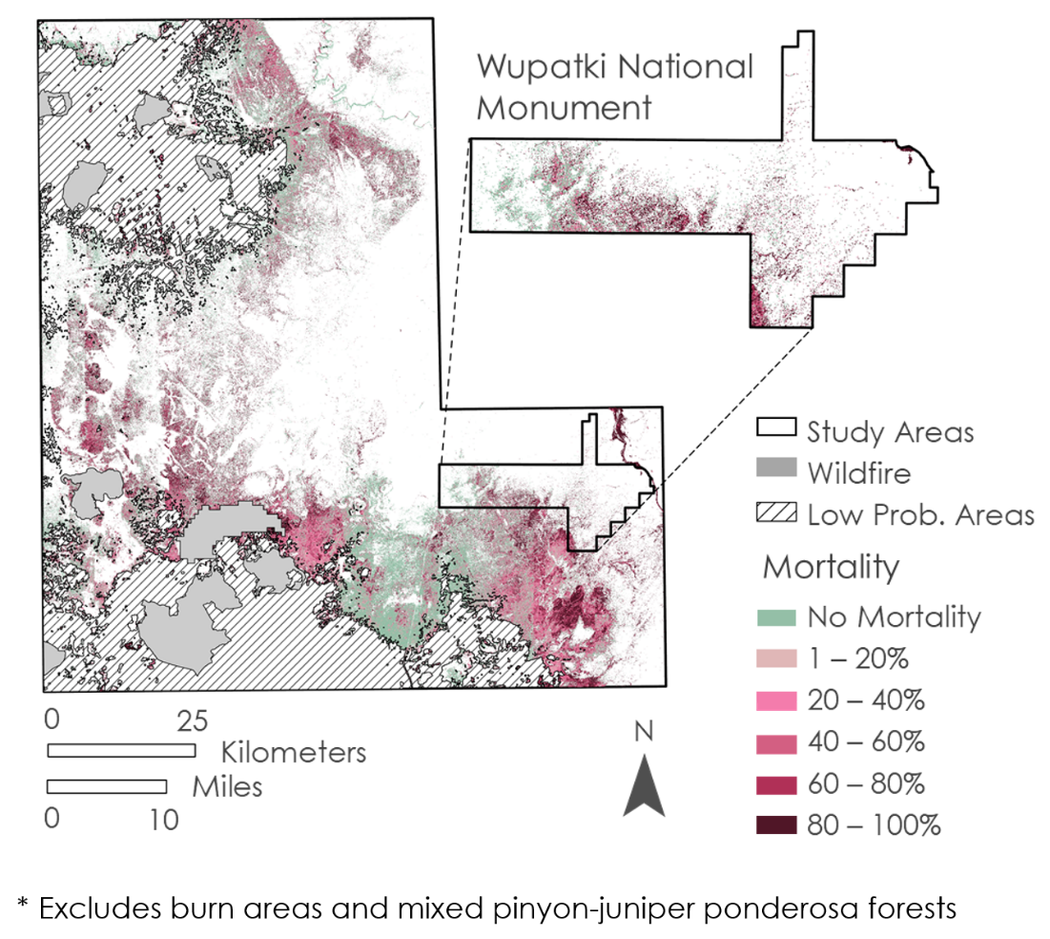

*Figure 2.* Map showing the percentage of pinyon-juniper trees within each pixel experiencing mortality in WNM and the study area. The percentage of tree mortality is shown in shades of purple, while pixels with no pinyon-juniper mortality are shown in green. White areas are those that did not contain any living or dead stands of pinyon-juniper trees in either 2015 or 2021. Grey shaded regions depict areas of low pinyon-juniper probability, including burn areas and mixed pinyon-juniper ponderosa pine forests, which were masked out of the final analysis.

Table 6

*Accuracy assessment results for the mortality map*

|  |  |  |  |  |  |  |
| --- | --- | --- | --- | --- | --- | --- |
| **Assessment** | **# of Random Points** | **Method** | **Percent (%) Accuracy** | **Kappa** | **Error** | **95% Confidence Interval** |
| Mortality in High Probability Pinyon-Juniper Areas | 240 | Equalized Stratified Random | 89% | 0.78 | 0.11 | 89% +/- 4.0 |

**4.1.2 Environmental Variables**

Within the entire study area, the greatest variability in the PCA was accounted for in Principal Component 1 (PC1) and Principal Component 2 (PC2) with a percent variance of 79.32 percent and 20.50 percent, respectively (*Figure* B1 and Table B1). Considering WNM alone, the greatest variability was also accounted for in PC1 and PC2 with percent variances of 61.02 percent and 38.90 percent, respectively (*Figure* B2 and Table B2). These principal components suggest that the topographic variables of elevation and aspect have the greatest variability across the study region and therefore may have a greater influence on tree mortality.

The results of the Spearman’s Correlation analysis for the entire study region did show significant relationships between tree mortality and many of the environmental variables. However, these were weak relationships with low rho values ranging from 0.00 to 0.16 across all time periods (Table C1). When WNM was considered separately, a Spearman’s Correlation then revealed higher rho values ranging from 0.03 to 0.39 across each of the time periods the team evaluated (Table C1). Within WNM, the highest correlations determined by the test were an inverse correlation between tree mortality and elevation (rho = -0. 37) and positive correlations between tree mortality, soil moisture (rho = 0.39), and land surface temperature (rho = 0.38; *Figure* 3, Table C1).

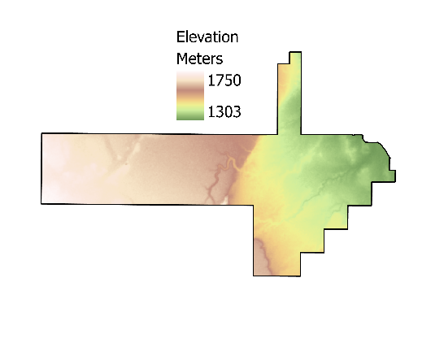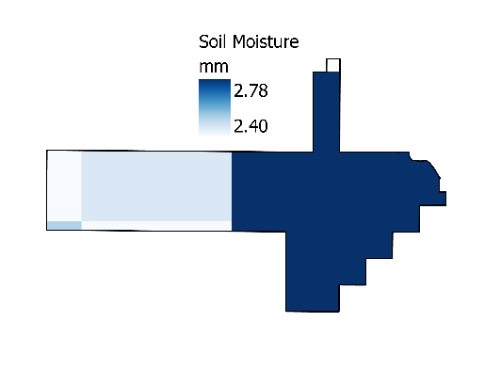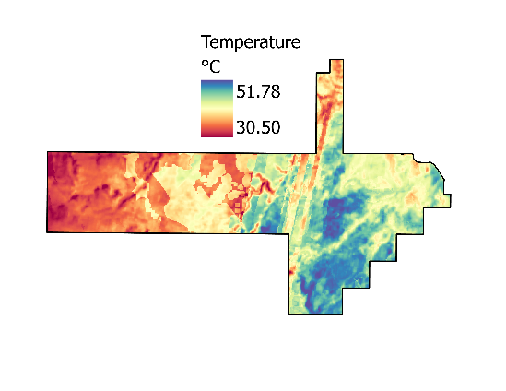

*Figure 3.* Landsat 8 TIRS-derived land surface temperature, SMAP soil moisture, and SRTM elevation data averaged from April 2020 to May 2021 period for Wupatki National Monument.

Comparing monthly time series data for all environmental variables, a generalized linear regression revealed significant differences in precipitation and soil moisture between 2015 and 2021 across the study area (*Figure* 4, Table D1). There was a statistically significant downward trend for monthly precipitation (p-value = .026) and soil moisture (p-value = .016) across the study period. Generalized linear regressions on NDMI, NDVI, land surface temperature, and evapotranspiration did not reveal statistically significant results for the monthly time series analysis.

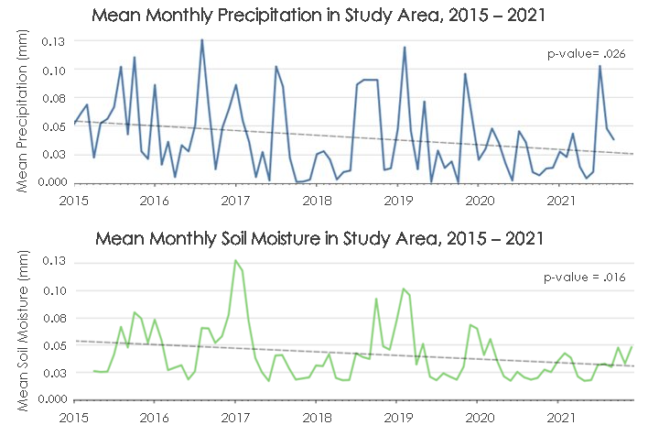

*Figure 4.* Time series plots of mean monthly precipitation and soil moisture between 2015 and 2021 for the study area. Data are derived from IMERG and SMAP.

***4.2 Future Work***

There are many areas in which future research could expand upon this work. Firstly, the team had to exclude a large portion of the study area due to mixed PJW and ponderosa pine forests, which were difficult to distinguish in the NAIP classification alone. While it was possible to identify these areas generally with LANDFIRE data, future researchers could explore other data sources, expanding the area that can be distinguished by the classification. Further, aerial LIDAR data could provide higher resolution information about canopy height, which would help to differentiate between ponderosa pine (a taller species) and pinyon-juniper stands. While the team investigated using LIDAR data, GEDI canopy data products were not used due to the coarse resolution relative to NAIP data.

Considering on-the-ground partner observations, April 2021 was pinpointed as the period when mass mortality was first observed, ultimately informing the scope of this project. To better understand tree mortality, it would be beneficial to examine intermediate years of NAIP imagery between 2015 and 2021. It may also be worthwhile to extend the study period of NAIP imagery back in time by multiple decades to better understand whether recent PJW mortality is in fact an isolated and unprecedented event. When considering environmental variables, it could be beneficial to extend the study period beyond 30 years to view more holistic climatic trends that may be contributing to PJW mortality. The regional drought has been ongoing for multiple decades, so this study’s seven-year time series only provides a small window into greater climatic trends. Additionally, a deeper look into the optimal resolution for the analysis of environmental variables as well as using a multivariate approach for environmental variable-mortality analyses would be recommended in further study as it is possible that certain analyses are biased towards data produced at coarser resolutions, such as SMAP (Newman et al., 2019).

To further aid partner organizations, it could be beneficial to utilize the mapping methodology from this research as a springboard to develop an approach for using NAIP data to inform Landsat vegetation classifications. This would aid in increasing the temporal scale of the data and possibly enable an annual tree mortality monitoring capability. NAIP data can be challenging and time-consuming to process due to its high resolution, so bridging this methodological gap to accurately utilize Landsat data to map PJW mortality would prove beneficial for improving processing speeds and minimizing required resources.

# 5. Conclusions

Accurately mapping pinyon-juniper mortality across the landscape of north-central Arizona and WNM presented technical challenges, but ultimately was achieved through a process of unsupervised classification of multiyear NAIP data and mortality map validation. The team demonstrated that NAIP imagery can feasibly be used to accurately map mortality across large areas and quantify mortality with spatially explicit and implicit results. The team's spatially implicit calculated mortality percentages of 43 percent and 47 percent in the study area and WNM, respectively, align with ground level mortality observations from the NPS and USFS. These results demonstrate that the study area has experienced an extensive mortality event even in nearby areas not under the jurisdiction of Federal agencies. Given the short duration of the project, the team explored a few, but not all options for assessing the role of environmental factors on tree mortality. Using environmental and topographic data derived from NASA Earth observations, the team was able to assess correlations between mortality and these variables across three separate periods of environmental variable analysis. The team’s analyses produced weak correlations between environmental variables and tree mortality for both WNM and the study area as a whole. Primarily, these results exemplify the challenges involved in relating environmental and climatic variables with mortality over non-climatic timescales of less than 30 years, especially in areas that have been experiencing drought for several decades. Moving forward, the team hopes that further research can be done to extend the study period for both mortality data and environmental variables. The results and end products produced by this research will enable a better understanding of the changing environment for partners with the NPS. At WNM, this research will help resource managers prepare for increased fire risks, monitor effects of habitat and food resource loss, and monitor native grass and invasive plant establishment in highly affected juniper mortality sites.

# 6. Acknowledgments

The team would like to thank our project partner from the National Park Service at Wupatki National Monument, Mark Szydlo, for providing extensive resources and knowledge to ground our project. This work was also made possible by our advisors from Goddard Space Flight Center, Sean McCartney and Joseph Spruce, Fellow Nicole Ramberg-Pihl from NASA DEVELOP, and additional support from Dr. John Bolten (Goddard Space Flight Center).

Any opinions, findings, and conclusions or recommendations expressed in this material are those of the author(s) and do not necessarily reflect the views of the National Aeronautics and Space Administration.

This material is based upon work supported by NASA through contract NNL16AA05C.

# 

# 7. Glossary

**Earth observations** – Satellites and sensors that collect information about the Earth’s physical, chemical, and biological systems over space and time

**Evapotranspiration** – A process through which water is transferred to the atmosphere from the land by both evaporation from the soil surface and transpiration from plants

**GEE** – Google Earth engine

**GPM IMERG** – Integrated Multi-satellitE Retrievals for Global Precipitation Measurement

**ISS GEDI** – International Space Station Global Ecosystem Dynamics Investigation

**LANDFIRE EVH** –LANDFIRE Existing Vegetation Height

**LANDFIRE EVT** –LANDFIRE Existing Vegetation Type

**MODIS** – Moderate Resolution Imaging Spectroradiometer

**NAIP** – National Agriculture Imagery Program

**NDMI** – Normalized Difference Moisture Index

**NDVI** – Normalized Difference Vegetation Index

**NPS** – National Park Service

**OLI** – Operational Land Imager

**PAD-US** – Protected Areas Database of the United States

**PCA** – Principal Component Analysis

**PC1** –Principal Component 1

**PC2** –Principal Component 2

**PJW** – Pinyon-juniper woodlands, or areas that have the presence of at least one species each of juniper and pinyon pine (*Pinus* spp.-*Juniperus* spp.)

**SMAP** – Soil Moisture Active Passive

**SRTM** – Shuttle Radar Topography Mission

**TIRS** – Thermal Infrared Sensor

**USDA** – United States Department of Agriculture

**USFS** – United States Forest Service

**USGS** – United States Geological Survey

**WNM** – Wupatki National Monument

# 8. References

Anderegg, W. R. L., Hicke, J. A., Fisher, R. A., Allen, C. D., Aukema, J., Bentz, Hood, S., Lichstein, J. W., Macalady, A. K., McDowell, N., Pan, Y., Raffa, K., Sala, A., Shaw, J. D., Stephenson, N. L., Tague, C., & Zeppel, M. (2016). Tree mortality from drought, insects, and their interactions in a changing climate. *New Phytologist*, *208*(3), 674–683. https://doi.org/10.1111/nph.13477

Arizona State Climate Office.(2022, January 12). *Drought*. Arizona State Climate Office. https://azclimate.asu.edu/drought

Campbell, M. J., Dennison, P. E., Tune, J. W., Kannenberg, S. A., Kerr, K. L., Codding, B. F., & Anderegg, W. R. (2020). A multi-sensor, multi-scale approach to mapping tree mortality in Woodland ecosystems. *Remote Sensing of Environment*, *245*, Article 111853. https://doi.org/10.1016/j.rse.2020.111853

Clifford, M. J., Cobb, N. S., & Buenemann, M. (2011). Long-term tree cover dynamics in a pinyon-juniper woodland: Climate-change-type drought resets successional clock. *Ecosystems*, *14,* 949–962. https://doi.org/10.1007/s10021-011-9458-2

Crausbay, S. D., Ramirez, A. R., Carter, S. L., Cross, M. S., Hall, K. R., Bathke, D. J., Betancourt, J. L., Colt, S., Cravens, A. E., Dalton, M. S., Dunham, J. B., Hay, L. E., Hayes, M. J., McEvoy, J., McNutt, C. A., Moritz, M. A., Nislow, K. H., Raheem, N., & Sanford, T. (2017). Defining ecological drought for the twenty-first century. *Bulletin of the American Meteorological Society*, *98*(12), 2543–2550. https://doi.org/10.1175/BAMS-D-16-0292.1

Emerson, F. W. (1932). The tension zone between the grama grass and pinon-juniper associations in northeastern New Mexico. *Ecology, 13*(4), 347–358. https://doi.org/10.2307/1932311

Evans, R. A. (1988). *Management of pinyon-juniper woodlands.* USDA Forest Service. https://hdl.handle.net/2027/umn.31951d03009596z

Farr, T. G., Rosen, P. A., Caro, E., Crippen, R., Duren, R., Hensley, S., Kobrick, M., Paller, M., Rodriguez, E., Roth, L., Seal, D., Shaffer, S., Shimada, J., Umland, J., Werner, M., Oskin, M., Burbank, D., & Alsdorf, D. (2007). The Shuttle Radar Topography Mission, Rev. *Reviews of Geophysics*, *45*, RG2004, https://doi.org/10.1029/2005RG000183

Giglio, L., Justice, C., Boschetti, L., Roy, D. (2021). *MODIS/Terra+Aqua Burned Area Monthly L3 Global 500m SIN Grid V061* [Data set]. NASA EOSDIS Land Processes DAAC. https://doi.org/10.5067/MODIS/MCD64A1.061

Gottfried, G. J., Swetnam, T. W., Allen, C. D., Betancourt, J. L., & Chung-MacCoubrey, A. L. (1995). Pinyon-Juniper Woodlands. In *Ecology, diversity, and sustainability of the middle Rio Grande basin.* USDA Forest Service. https://www.fs.fed.us/rm/pubs_rm/rm_gtr268/rm_gtr268_095_132.pdf

Hansen M. (2004). *Vegetation Classification and Distribution* [Data set]. USGS-NPS National Vegetation Mapping Program: WNM, Arizona.

Huffman, G. J., Stocker, E. F., Bolvin, D. T., Nelkin, E. J., & Tan, J. (2019). *GPM IMERG Final Precipitation L3 1 month 0.1 degree x 0.1 degree V06* [Data set]. Greenbelt, MD, Goddard Earth Sciences Data and Information Services Center (GES DISC). https://doi.org/10.5067/GPM/IMERG/3B-MONTH/06

Kearney, T. H., Peebles, R. H., Howell, H. T., and McClintock, E. (1960). *Arizona flora.* University of California Press.

Landsat Missions. (2016). *Landsat Normalized Difference Moisture Index*. United States Geological Survey. https://www.usgs.gov/landsat-missions/normalized-difference-moisture-index

Landsat Missions. (2016). *Landsat Normalized Difference Vegetation Index*. United States Geological Survey. https://www.usgs.gov/landsat-missions/landsat-normalized-difference-vegetation-index?msclkid=923f77ddb12911ecb58012d3434040d2

Meddens, A. J., Hicke, J. A., Vierling, L. A., & Hudak, A. T. (2013). Evaluating methods to detect bark beetle-caused tree mortality using single-date and multi-date Landsat imagery. *Remote Sensing of Environment, 132*, 49-58. https://doi.org/10.1016/j.rse.2013.01.002

Miller, R. F., Chambers, J. C., Evers, L., Williams, C. J., Snyder, K. A., Roundy, B. A., & Pierson, F. B. (2019). *The ecology, history, ecohydrology, and management of pinyon and juniper woodlands in the Great Basin and northern Colorado plateau of the western United States.* U.S. Forest Service. https://doi.org/10.2737/rmrs-gtr-403

NASA Shuttle Radar Topography Mission. (2013). *Shuttle Radar Topography Mission (SRTM) Global* [Data set]. Distributed by OpenTopography. https://doi.org/10.5069/G9445JDF

National Park Service. (2015, February 3). *Pinyon-Juniper Woodlands – Species Composition and Classification. National Park Service*. https://www.nps.gov/articles/pinyon-juniper-woodlands-species-composition-classification.htm

NatureServe. (2011, December). *Expert attribution for auto-key improvements (LANDFIRE) and advancing methods for integration with the revised US-national vegetation classification standard: GeoArea 4 results table.* [Data set]. LANDFIRE Program. https://landfire.gov/lf_improvements.php

Newman, E. A., Kennedy, M. C., Falk, D. A., & McKenzie, D. (2019). Scaling and complexity in landscape ecology. *Frontiers in Ecology and Evolution, 7*(293), https://doi.org/10.3389/fevo.2019.00293

O'Neill, P. E., Chan, S., Njoku, E. G., Jackson, T., & Bindlish, R. (2018). *SMAP Enhanced L3 Radiometer Global Daily 9 km EASE-Grid Soil Moisture, Version 2* [Data set]. Boulder, Colorado USA. NASA National Snow and Ice Data Center Distributed Active Archive Center. https://doi.org/10.5067/RFKIZ5QY5ABN

Romme, W. H., Allen, C. D., Bailey, J. D., Baker, W. L., Bestelmeyer, B. T., Brown, P. M., Eisenhart, K. S., Floyd, M. L., Huffman, D. W., Jacobs, B. F., Miller, R. F., Muldavin, E. H., Swetnam, T. W., Tausch, R. J., & Weisberg, P. J. (2009). Historical and modern disturbance regimes, stand structures, and landscape dynamics in Pinon–juniper vegetation of the western United States. *Rangeland Ecology & Management*, *62*(3), 203–222. https://doi.org/10.2111/08-188r1.1

Rosen, P. A., Hensley, S., Joughin, I. R., Li, F. K., Madsen, S. N., Rodriguez, E., & Goldstein, R. M. (2000). Synthetic aperture radar interferometry. *Proceedings of the IEEE*, *88*, 333-382. https://doi.org/10.1109/5.838084

Running, S., Mu, Q., & Zhao, M. (2017). *MOD16A2 MODIS/Terra Net Evapotranspiration 8-Day L4 Global 500m SIN Grid V006* [Data set]. NASA EOSDIS Land Processes DAAC. https://doi.org/10.5067/MODIS/MOD16A2.006

Spruce, J. P., Hicke, J. A., Hargrove, W. W., Grulke, N. E., & Meddens, A. J. H. (2019). Use of MODIS NDVI products to map tree mortality levels in forests affected by mountain pine beetle outbreaks. *Forests*, *10*(9), Article 811. https://doi.org/10.3390/f10090811

U.S. Department of Agriculture, Forest Service and U.S. Geological Survey. (2020). *MTBS Data Access: Burned Area Perimeter Data* [Data set]. http://mtbs.gov/direct-download

U.S. Department of Agriculture. (2021). *National Agriculture Imagery Program (NAIP)* [Data set]. U.S. Department of Agriculture. https://doi.org/10.5066/F7QN651G

U.S. Department of the Interior, Geological Survey, and U.S. Department of Agriculture. (2016). *Existing Vegetation Height Layer*, LANDFIRE 2.0.0 [Data set]. http://landfire.cr.usgs.gov/viewer/

U.S. Department of the Interior, Geological Survey, and U.S. Department of Agriculture. (2016). *Existing Vegetation Type Layer, LANDFIRE* 2.0.0 [Data set]. http://landfire.cr.usgs.gov/viewer/

USFS. (1965). *Silvics of forest trees of the United States.* U.S. Forest Service. Agriculture Handbook 271. https://hdl.handle.net/2027/umn.31951d02469242e

USFS. (2015, August). *Drought and piñon-juniper woodlands: Changing fuel loads from tree mortality*. U.S. Forest Service. https://www.fs.usda.gov/rmrs/projects/drought-and-pi%C3%B1on-juniper-woodlands-changing-fuel-loads-tree-mortality

USFS.(2021, April 21). *Drought causing juniper die-off in central and northern Arizona*. U.S. Forest Service. https://www.fs.usda.gov/detail/kaibab/news-events/?cid=FSEPRD906836

U.S. Geological Survey Earth Resources Observation and Science Center. (2015-2021). *Landsat 8 OLI and TIRS Collection 1 Tier 1 Data Products* [Data set]. Courtesy of the U.S. Geological Survey. https://doi.org/10.5066/F71835S6

U.S. Geological Survey Gap Analysis Project (GAP). (2020). *Protected Areas Database of the United States (PAD-US) 2.1* [Data set]. U.S. Geological Survey data release. https://doi.org/10.5066/P92QM3NT

# 9. Appendices

**Appendix A: Mortality Subtraction Classifications**

Table A1

*Values for the raster subtraction process*

|  |  |  |  |
| --- | --- | --- | --- |
| **2021 Classified Value** | **2015 Classified Value** | **2021 – 2015 Subtracted Value** | **Subtraction Outline** |
| 0 (Not PJW) | 2 (PJW) | -2 | Not PJW - PJW = Mortality |
| 0 (Not PJW) | 1 (Shadow) | -1 | Not PJW - Shadow = No Change |
| 0 (Not PJW) | 0 (Not PJW) | 0 | Not PJW - Not PJW = No Change |
| 1 (Shadow) | 2 (PJW) | -1 | Shadow - PJW = No Change |
| 1 (Shadow) | 1 (Shadow) | 0 | Shadow - Shadow = No Change |
| 1 (Shadow) | 0 (Not PJW) | 1 | Shadow - Not PJW = No Change |
| 2 (PJW) | 0 (Not PJW) | 2 | PJW - Not PJW = Growth |
| 2 (PJW) | 2 (PJW) | 0 | PJW - PJW = No Change |
| 2 (PJW) | 1 (Shadow) | 1 | PJW - Shadow = No Change |

**Appendix B: PCA Results**

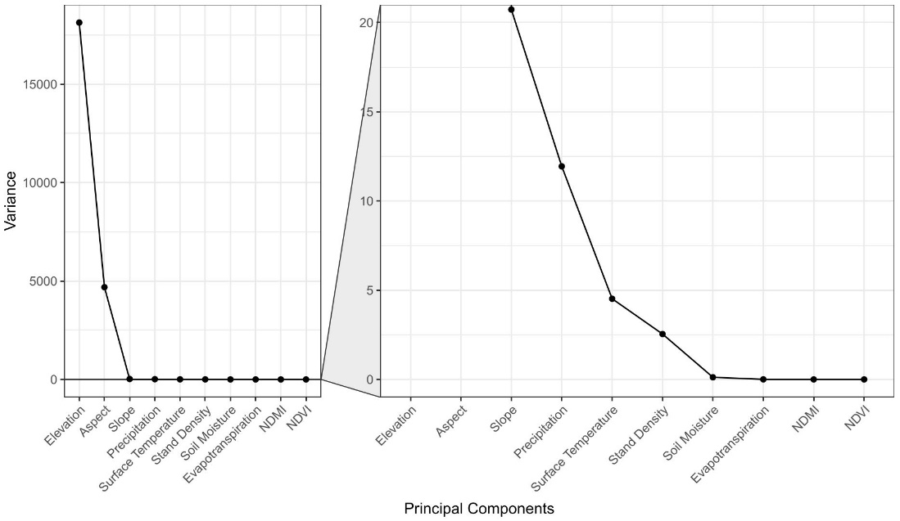

*Figure B1*. A PCA plot depicting the variance of each principal component within the entire study region. The plot on the right is enlarged to display smaller variance values.

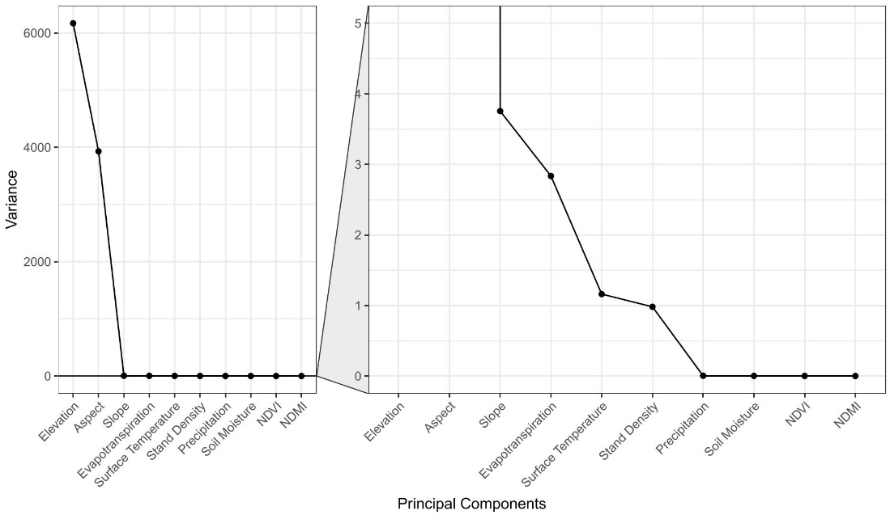

*Figure B2*. A PCA plot depicting the variance of each principal component within WNM. The plot on the right is enlarged to display smaller variance values.

Table B1

*PCA output values within high confidence areas in the entire study region.*

|  |  |  |  |
| --- | --- | --- | --- |
| **Variable** | **Eigenvalue** | **Percent Variance** | **Cumulative Variance** |
| Elevation | 1.81296E04 | 79.3264 | 79.3264 |
| Aspect | 4.68499E03 | 20.4992 | 99.8256 |
| Slope | 2.07308E01 | 0.0907 | 99.9163 |
| Precipitation | 1.19423E01 | 0.0523 | 99.9685 |
| Surface Temperature | 4.52070 | 0.0198 | 99.9883 |
| Stand Density | 2.54349 | 0.0111 | 99.9995 |
| Soil Moisture | 1.18593E-01 | 0.0005 | 100.0000 |
| Evapotranspiration | 4.73702E-03 | 0.0000 | 100.0000 |
| NDMI | 8.96630E-04 | 0.0000 | 100.0000 |
| NDVI | 3.97762E-04 | 0.0000 | 100.0000 |

Table B2

*PCA output values within Wupatki National Monument.*

|  |  |  |  |
| --- | --- | --- | --- |
| **Variable** | **Eigenvalue** | **Percent Variance** | **Cumulative Variance** |
| Elevation | 6.17056E03 | 61.0158 | 61.0158 |
| Aspect | 3.93376E03 | 38.8978 | 99.9136 |
| Slope | 3.75467 | 0.0371 | 99.9507 |
| Evapotranspiration | 2.83452 | 0.0280 | 99.9788 |
| Surface Temperature | 1.16097 | 0.0115 | 99.9902 |
| Stand Density | 9.81063E-01 | 0.0097 | 100.0000 |
| Precipitation | 2.96122E-03 | 0.0000 | 100.0000 |
| Soil Moisture | 1.40755E-03 | 0.0000 | 100.0000 |
| NDMI | 5.34528E-04 | 0.0000 | 100.0000 |
| NDVI | 1.17156E-04 | 0.0000 | 100.0000 |

**Appendix C: Spearman’s Correlation Results**

Table C1

*Spearman’s Correlation values for the high confidence areas across the entire study region and Wupatki National Monument over three time periods.*

|  |  |  |  |  |  |
| --- | --- | --- | --- | --- | --- |
| **Parameters** | | **High Confidence Areas** | | **Wupatki National Monument** | |
| **Time Period\*** | **Variable** | **Rho** | **P-Value** | **Rho** | **P-Value** |
| N/A | Aspect | -0.01 | 0.4364 | 0.03 | 0.617 |
| N/A | Elevation | -0.11 | 2.20E-16 | -0.37 | 3.75E-10 |
| N/A | Slope | -0.04 | 0.004554 | -0.10 | 0.1215 |
| N/A | Stand Density | 0.02 | 0.1107 | -0.03 | 0.6201 |
| 2020-2021 | Soil Moisture | 0.05 | 4.32E-05 | 0.39 | 1.01E-10 |
| 2020-2021 | Evapotranspiration | -0.06 | 6.14E-05 | -0.21 | 1.13E-03 |
| 2020-2021 | Precipitation | -0.06 | 5.78E-06 | -0.20 | 0.001153 |
| 2020-2021 | Surface Temperature | 0.12 | 2.20E-16 | 0.38 | 3.21E-10 |
| 2020-2021 | NDMI | 0.00 | 0.7104 | 0.19 | 0.002817 |
| 2020-2021 | NDVI | -0.16 | 2.20E-16 | -0.14 | 0.02352 |
| 2019-2021 | Soil Moisture | 0.04 | 1.95E-03 | 0.35 | 4.66E-09 |
| 2019-2021 | Evapotranspiration | -0.04 | 3.06E-03 | -0.30 | 5.40E-06 |
| 2019-2021 | Precipitation | -0.03 | 0.01367 | -0.14 | 0.02766 |
| 2019-2021 | Surface Temperature | 0.12 | 2.20E-16 | 0.35 | 4.94E-09 |
| 2019-2021 | NDMI | -0.03 | 0.04881 | 0.19 | 0.001925 |
| 2019-2021 | NDVI | -0.12 | 2.20E-16 | -0.07 | 0.2665 |
| 2015-2021 | Soil Moisture | 0.12 | 2.20E-16 | 0.39 | 6.79E-11 |
| 2015-2021 | Evapotranspiration | -0.02 | 9.25E-02 | -0.10 | 2.18E-01 |
| 2015-2021 | Precipitation | -0.01 | 0.3516 | -0.20 | 0.00121 |
| 2015-2021 | Surface Temperature | 0.16 | 2.20E-16 | 0.33 | 3.15E-08 |
| 2015-2021 | NDMI | -0.10 | 7.65E-16 | -0.23 | 0.000128 |
| 2015-2021 | NDVI | -0.05 | 3.10E-05 | -0.06 | 0.304400 |

*Time periods for aspect, elevation, and slope are listed as N/A as these are static variables sampled in 2000. Stand density was also computed at a single point in time. Time periods depict mean values between 2020-2021 and 2019-2021 and differences between 2015 and 2021.

**Appendix D: Time Series Results**

Table D1

*Generalized linear regression values for monthly time series of environmental variables between 2015 and 2021.*

|  |  |  |
| --- | --- | --- |
| **Environmental Variable** | **P-Value** | **R2** |
| Precipitation | 0.026 | 0.061 |
| Soil Moisture | 0.016 | 0.071 |
| Evapotranspiration | 0.478 | 0.006 |
| Surface Temperature | 0.501 | 0.006 |
| NDMI | 0.454 | 0.007 |
| NDVI | 0.687 | 0.002 |