Extended abstract submitted to:
AIAA SciTech Forum
23 Jan 2023 - 27 Jan 2023
National Harbor, MD

A Microphone Phased Array for Launch Acoustics Application

J. Panda, NASA Ames Research Center, Moffett Field, CA
M. P. Nguyen, Metis Technology Solutions, Moffett Field, CA
D. R. Keil, Jacobs, Moffett Field, CA
K. R. Hamm, Jr. NASA Ames Research Center, Moffett Field, CA

A new, portable, phased array of microphones is built at NASA Ames Research Center specifically for the harsh environment encountered in launch pads of rocket vehicles. It uses 70 rugged, piezo-electric, dynamic pressure sensors optimally distributed on a 10.5ft diameter open frame dome structure. The open frame is light yet robust to sustain the high wind load of typical seaside launch pads, and the blast and acoustic loads from the launch. A 200-ft long cable bundle carries the microphone signals to a weather-protected electronic cabinet containing the data acquisition system, computers, and other equipment. The array is equipped with an infra-red camera and a visible wavelength camera for imaging the launch site. The beamformed noise maps will be superimposed on the video footages collected by the cameras for correct identification of the noise sources. The array is tested with very loud noise sources to determine the beamforming ability. Multiple mathematical models, such as the conventional beamforming, orthogonal-functional beamforming, spectral element method etc. are used to determine the minimum spatial resolution of the sound sources that can be measured at different frequencies. Additionally, the array hardware is being tested for different environmental conditions and electro-magnetic compliance. The goal is to use the array for NASA’s Artemis/SLS vehicle that will be launched from a newly built Mobile Launch platform and a modified launch pad. Data from a couple of validation tests will be presented in this paper. The first test involves an outdoor setup where the array was placed on a crane at several different heights and distances from a pair of very loud noise sources. The second test from the static firing of the RS25 engines in an outdoor test stand.
- Introduction
Every part of a launch vehicle, launch pad, and ground operation equipment is subjected to the high acoustic load generated during lift-off [1]. The acoustic load is a major contributor to the vibro-acoustics environment to which every payload, vehicle structure, propellant storage and handling devices, and electronics and navigational component must be designed, tested and certified. Even a couple of decibel reduction of the acoustic level translates into a sizable reduction of certification cost, operation cost and vehicle weight. The same is true for every payload that the vehicle carries. Therefore, lowering of the acoustic level via various mitigation schemes is an important aspect of a launch pad design. The first step is the identification of the sources responsible for noise generation. Typically, single microphones are placed at different locations on a launch pad to measure acoustic fluctuations. Such microphones, however, are unable to determine the noise sources. Single microphones provide a measure of the absolute level, leaving the cause of noise generation to speculation. In contrast, a phased array of microphones directly identifies the locations and relative strengths of the noise sources and is therefore capable of providing significant insights into the underlying cause. Fundamentally a phased array detects the curvature of the acoustic waves to determine the angular location of the noise sources. It effectively acts as a “tuned ear,” a “sound camera.” Another advantage of a phased array is its ability to “see” through the smoke, water vapor and dust cloud generated during a rocket launch. While the view of the pad becomes obscure by this cloud the sound waves pass through. This allows for the identification of the noise sources at all phases of the launch from hold-down to elevation above the launch tower. A third advantage of a phased array is its ability to identify regions of the pad affected by the splashing of the rocket plumes as the vehicle ascends from the hold-down state. The zones affected by the plume impingement are typically locations of louder noise sources and are easily identifiable by a phased array [2, 3]. The plume impingement zones can create thermal damage to the launch platform. To mitigate such thermal damage and to reduce the acoustic environment many launch pads for heavy-lift rocket vehicles employ extensive water suppression systems. A knowledge of the distribution of the acoustic sources at every stage of the launch provides actionable information to optimize the water suppression system.
The benefits of a phased array were demonstrated earlier in the static-burn tests [2], and in the static engine test and the first launch of the Northrop Grumman’s Antares vehicle [3]. In the recent past phased array proved to be a valuable tool to redesign the launch pads of Ariane [4] and Vega [5] vehicles.

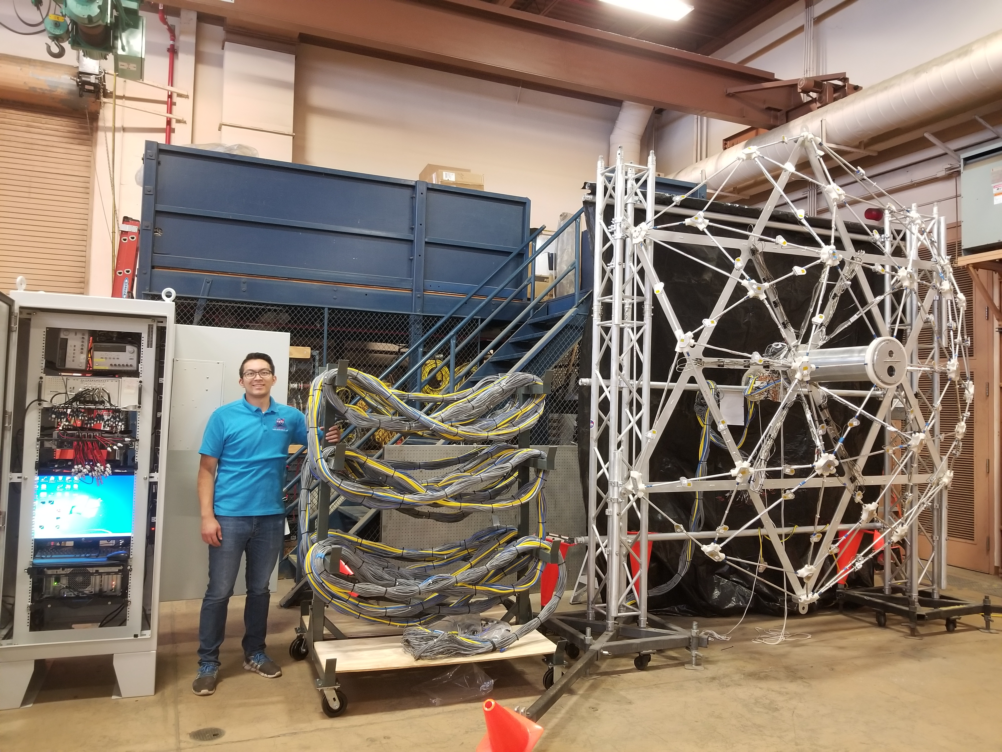
Fig 1. Photograph of the phased array frame, cable bundle and the electronic cabinet.

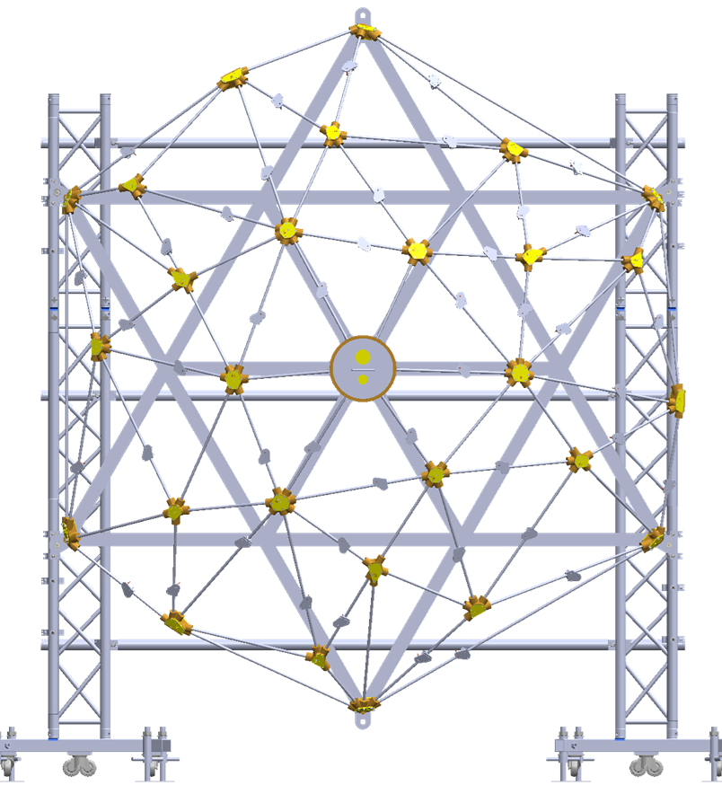  Fig 2. Front view of the array mounted on two vertical trusses. | 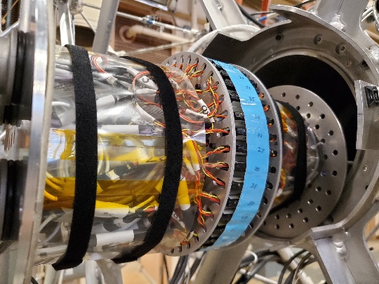  Fig 3. Photograph of the Amplifier rack inside the central canister of the array dome.
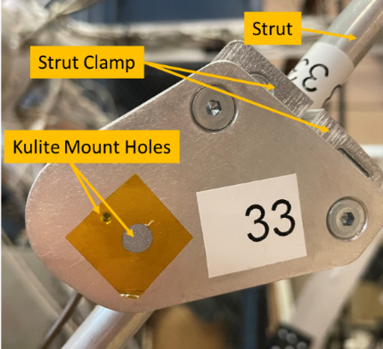
Fig 4. Photograph of the sensor mounting plate with provisions for two different sized sensors.

- Array Hardware
Figure 1 shows a photograph of the newly-built phased array with its three primary components: (a) the hemispherical dome shaped lattice structure that holds 70 dynamic pressure sensors, (b) a 200-ft long cable bundle, and (c) an air-conditioned cabinet to hold all electronic components and personal computers. The canister at the center of the dome structure holds one visible wavelength video camera, and a long infra-red wavelength (2micron- 10micron meter) video camera. A glass and a Germanium window, placed on the front cap, provide clear view of the launch pad and the vehicle in the visible and infra-red wavelengths, respectively. Additionally, amplifiers for all 70 microphones are also housed inside the canister (fig 3). To monitor the temperature of the amplifier rack a resistance temperature detector is attached to the amplifier housing. Additionally, a three-axis accelerometer is placed on the mounting rod for the amplifier rack to monitor the vibration levels encountered during the launch. Finally, a 1/4inch diameter tube is placed close to the amplifier housing to bring in cool, dry air to cool, and to maintain a low humidity environment at the interior of the canister. The array is expected to be mounted close to a launch pad weeks before the actual launch with little access. The cooling air allows limiting the temperature and humidity rise inside the canister.
Figure 2 shows a front view of the array-frame mounted on two vertical trusses. The triangular lattice structure was made of 1/2inch Aluminum tubes and Nylon 3D printed connectors. The individual tubes were match-drilled into the connectors. The lattice structure was inspired by a similar dome shaped array built by Burnside and Horne [6]. The present construction is made much stiffer as needed for the application at hand. The Kulite sensors are placed either on the node points or on a plate mounted on the individual Aluminum Struts (Fig 4). There are provisions to use either a smaller XCL-072 variety of sensor or a larger diameter XTEH-10 variety. The goal of the microphone layout was to maximize the array resolution at the mid 500Hz ≤ f ≤ 2 kHz frequency range, while also reducing the side lobes. To design the layout, at first the locations were determined on a two-dimensional base circle of 62.7” radius; subsequently they were raised on a hemispherical surface of 88.67 inch in radius. Inside the base circle nearly half of the microphones were positioned on logarithmic spirals and the rest were randomly scattered. The pattern turned out to produce a fairly narrow point-spread function (psf).
The cable bundle passes all DC power and signals to and from the Kulite amplifiers, RTD temperature sensor, accelerometer, and the two cameras. Additionally, a long tube to send cooling air to the canister is also bundled in. The cable bundle is wrapped with conductive Aluminum tape to minimize radio-frequency interference to the low voltage signals transmitted through the cables. Finally, a semi-rigid braided sleeving provided protection and structural strength to the bundle. The 200-ft long cable bundle is suitable for raising and mounting the array on nearby tall structures (such as lightening towers, water tanks or any other suitable structure) so that a clear view of the top surface of the launch platform becomes visible to the array cameras.
The electronic cabinet held a primary and a backup data acquisition system to digitize the microphone and the accelerometer signals. Both systems have 80 channels of differential inputs. The 24-bit primary ADC system can sample at a higher 1024k Samples/s and the 16-bit backup system at a lower 10240 /s. The DC power supplies for all amplifiers and cameras, two personal computers, a monitor and keyboard, RTD and accelerometer processing units, network switches, distribution boxes and other peripheral equipment were packed in this cabinet. The cabinet is made of steel for protection from the launch environment. It also has an air-conditioning unit to cool all electronics during the expected multiple weeks of continuous operation in the hot sun.

- results
The first series of tests conducted on the array simulated the expected setup around a Launchpad – the array elevated on a platform, the data system kept at the base of the platform and the data acquisition was performed remotely over a local area network. Figs. 5 and 6 show photographs of the setup. The array dome structure was elevated at different heights, 10’, 15’, 20’ and 40’ above ground using a Tele-handler crane (fig 6). A special pallet was built to mount the array frame. The Tele-handler boom was able to swing and pitch the array for pointing it to the noise sources. The electronic cabinet was placed 120ft away from the Array, and the data and image acquisition operations were conducted over a network line. In addition to the network line, compressed air and power were supplied to the cabinet, which in turn powered-up the amplifiers inside the canister and sent air cooling the amplifiers. A three-horn train horn and a Long Range Acoustic Device (LRAD) were used to create sufficiently loud noise for the piezo-resistive microphones to sense. The train horn was of a relatively weaker source, producing omnidirectional tonal noise of amplitude 125dB at 1m. The LRAD was much louder, 145dB at 1m, and produced a focused beam along the line of sight. The separation between the two noise sources were varied to determine the spatial resolvability of sound sources by the array. Figure 7 shows a sample result using a combination of the orthogonal and functional beamforming technique [7], which was found to reduce the spot size of the beamformed map by nearly half compared to that achievable by the conventional beamforming method. An examination of the four plots at four different frequencies show that the LRAD and the train horn remains inseparable (for a 10dB range of plot) at the lowest 875Hz, and becomes separable at the higher frequencies. More such figures and a detailed discussion will be provided in the final paper.
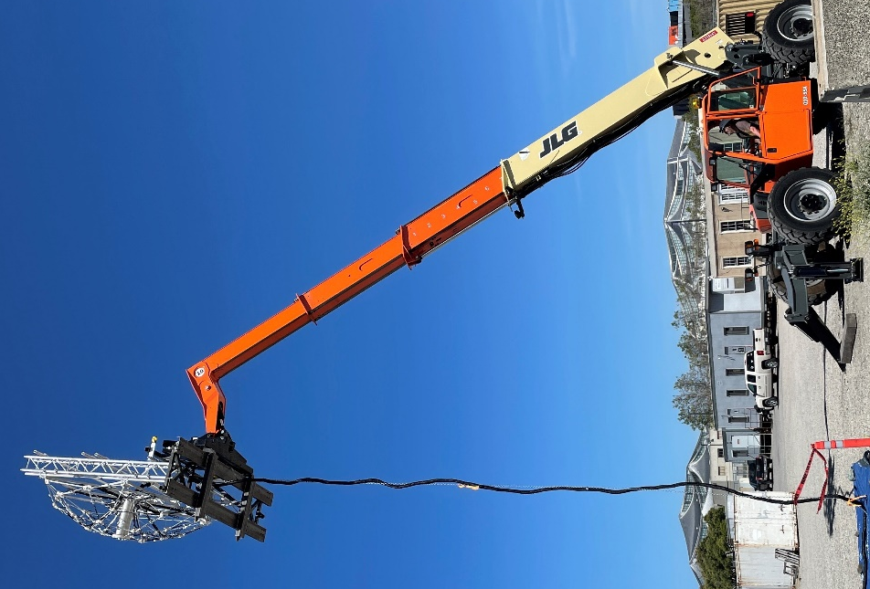
Fig 6. The array frame mounted on a pallet and lifted to 40ft height for outdoor speaker test.

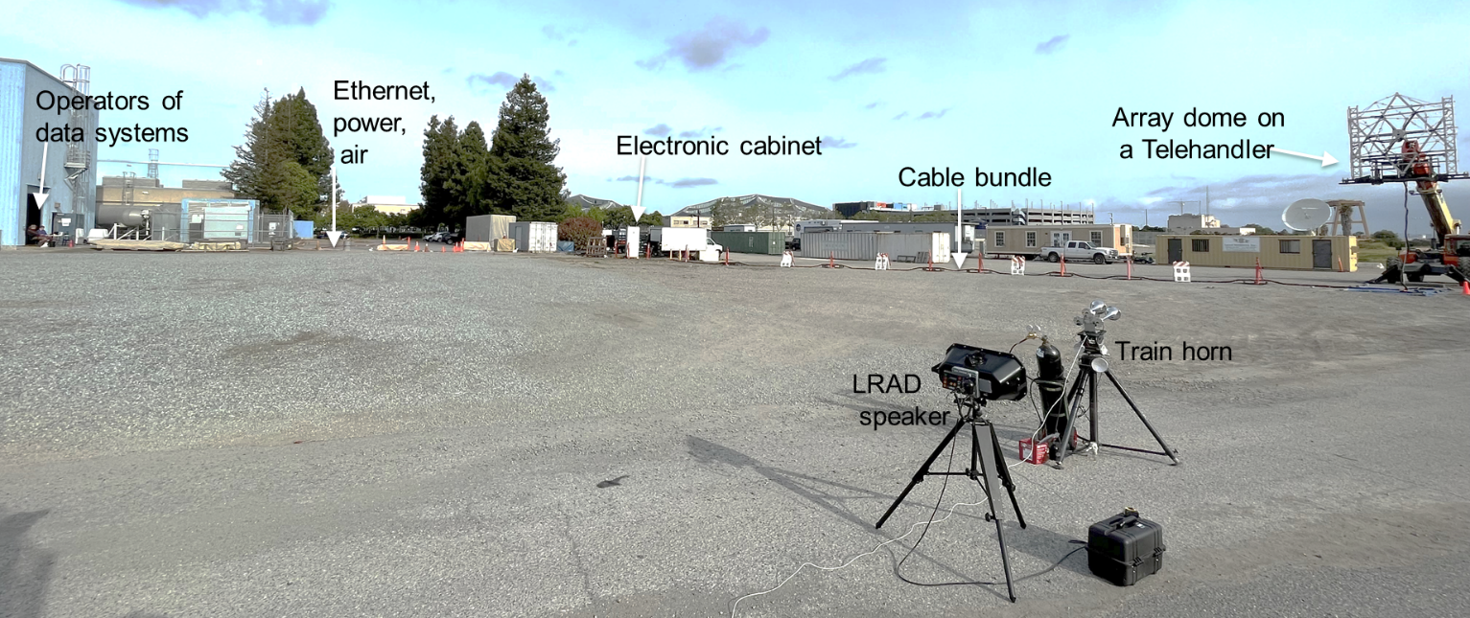
Fig 5. Setup for an outdoor test using a train horn and an LRAD speaker

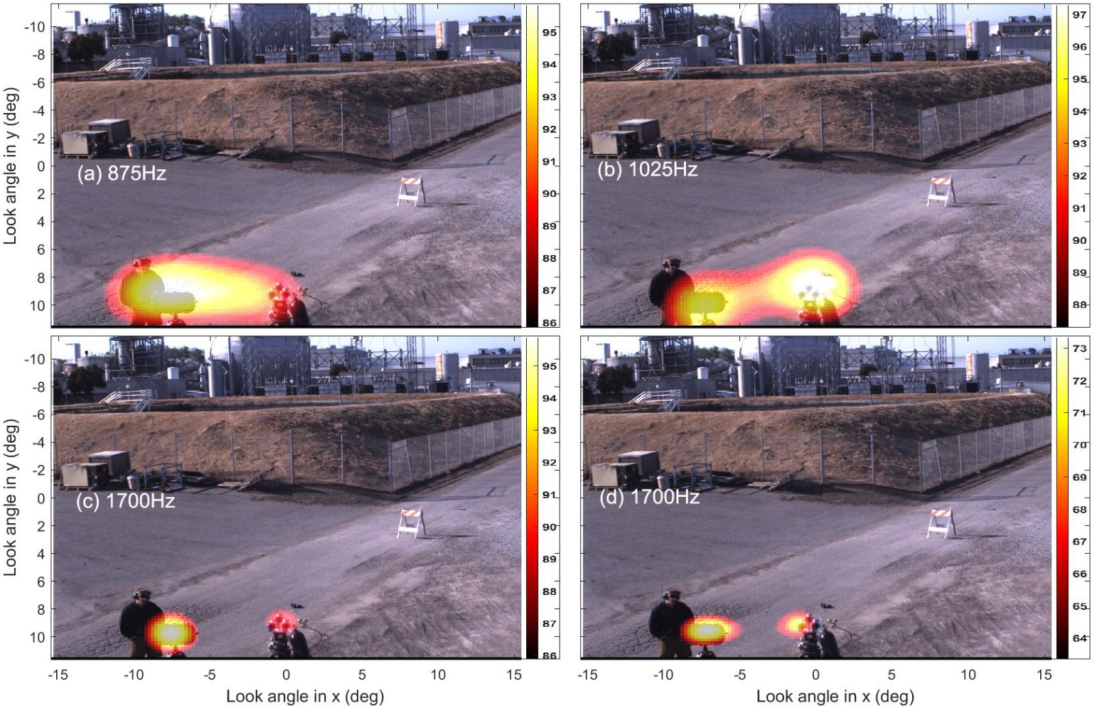
Fig 7. Bamformed noise map superimposed on a photograph from the visible camera at four different, indicated frequencies. The two speakers are separated by 5ft; distance from array 50ft; array was elevated by 15ft.
- Concluding comments

Acknowledgements:
The authors are thankful to NESC and NASA Ames MPCV project office for providing procurement funds. Help from Mr. Don Morr of Millennium Engineering to design the array frame, and various procurement and IT supports from Mr. David Stathatos (also of Millennium Engineering) and Mr. Nick Garbe (Metis Technology Solutions) for IT support, Mr. Earl Daley of NASA Ames for the design of the pallet and test support, and Mr. Winston Czakon of NASA Ames for test support are also acknowledged.

References:

[1] Eldred, K. M. & Jones, G. W., Jr., “Acoustic load generated by the propulsion system,” NASA SP-8072, 1971.
[2] Panda, J. & Mosher, R., “Microphone Phased Array to Identify Liftoff Noise Sources in Model-Scale Tests,” Journal of Spacecraft and Rockets, Vol. 50, No. 5, Sept-Oct 2013. DOI: 10.2514/1.A32433
[3] Panda, J., Mosher, R. N. & Porter, B. J., “Noise Source Identification During Rocket Engine Test Firings and a Rocket Launch,” Journal of Spacecraft and Rockets, Vol. 51, No. 4, July-Aug 2014. DOI: 10.2514/1.A32863.
[4] Gély, D., Elias, G., Bresson, C., Foulon, H., Radulovic, S, 2000 “Reduction of supersonic jet noise. Application to the Ariane 5 launch vehicle,” 6th AIAA/CEAS Aeracoustics Conference, AIAA paper 2000-2026, 2000.
[5] Mortain, F. & Clero, F., “Full-scale acoustic source identification on Vega Launch pad at lift-off”, 26th Intl. Congress on Sound & Vib., July 2019.
[6] Burnside, N. J. & Horne, W. C., “Development of Instrumentation and Methods for Time-Domain Measurement of Rotor-Type noise Sources in a Hard Wall Wind Tunnel,” presented at the VFS Aeromechanics for Advanced Vertical Flight Testing Meeting, San Jose, CA, Jan. 21-23, 2020.
[7] R. Merino-Martinez, P. Sijtsma, M. Snellen, T. Ahlefeldt, J. Antoni, C.J. Bahr, D. Blacondon, D. Ernst, A. Finez, S. Funke, T.F. Geyer, S. Haxter, G. Herold, X. Huang, W. M. Humphreys, Q. Leclere, A. Malgoezar, U. Michel, T. Padois, A. Pereia, C. Picard, e. Sarradj, H. Siller, D.G. Simons, C. Spehr, “A review of acoustic imaging methods using phased microphone arrays,” CEAS Aeronautical Journal, 10:197-230, 16 March 2019.

