Development of Slat-gap and Slat-cove Filler Treatments for Noise Reduction Assessment on the High Lift Common Research Model in the NASA LaRC 14x22
Travis L. Turner, John W. Mulvaney, David P. Lockard, Albert R. Allen, Scott E. Brynildsen
*,†,‡,§NASA Langley Research Center, Hampton, VA, 23681, USA
**Analytical Mechanics Associates, Hampton, VA, 23666, USA
Airframe noise is an important issue during the approach and landing phases of flight because engines are throttled back, and airframe sources become an equal or greater contributor to environmental noise. The leading-edge slat component of the high-lift system for transport aircraft has been identified as a prominent source of airframe noise. Noise production mechanisms and potential treatments to mitigate airframe noise have been areas of active research for nearly three decades. Two promising technologies for slat noise reduction are the slat-gap filler (SGF) and slat-cove filler (SCF). Previous work was done using a 2D section of a transport class aircraft wing to demonstrate their feasibility via benchtop and computational models. A wind tunnel test campaign was recently undertaken to test the SGF and SCF technologies in a flight-like environment by installing dynamically scaled treatments on the 10%-scale High-Lift Common Research Model (CRM-HL), which is representative of a commercial twin-aisle transport aircraft. Advancement of the SGF and SCF technologies to overcome challenges of integration with 3D airframe structures, computational simulations of the CRM-HL predicting the aerodynamic and aeroacoustic performance and structural loads, and design of wind tunnel model hardware with features accommodating noise treatments were conducted in parallel. Details of innovations in the SGF and SCF technologies for 3D airframe feasibility will be described. The loads the treatments must sustain in flight and the influence of those loads on the design is also discussed. Finally, the design of wing leading-edge assemblies to treat the 10% CRM-HL with dynamically scaled SGF and SCF components is presented. The treatments were successfully tested in 2020/2021 providing a demonstration of leading-edge noise reduction using components that would allow slat articulation.
- Introduction
Aircraft noise reduction continues to be an important topic for NASA. Airframe noise (nonpropulsive noise) is very important at approach and landing conditions because the engines are at lower power settings and their contribution to environmental noise is on par with the airframe. Airframe noise is typically attributed to the landing gear and the high lift system, which is deployed to increase lift at low speeds. The relative contribution of those sources of airframe noise is dependent on a number of factors, but model scale tests [1]-[7] and aircraft flyover experiments [8] have both shown that the leading-edge slat is a prominent source of noise for transport class aircraft during the approach and landing phases of flight.
The separated, multielement high-lift system produces greater lift than a single, contiguous system but the gaps, edges, and cavities associated with the multielement system produce considerable flow unsteadiness that results in many noise production mechanisms. NASA previously developed and evaluated noise reduction treatments for flap side edges and landing gear [9] culminating in a flight test [10]. Although many treatments have been proposed to reduce slat noise, NASA has only evaluated those computationally and in small-scale experiments. Two treatments that show significant promise are the focus of this study: the slat-gap filler (SGF) [11] and the slat-cove filler (SCF) [12]. Previous structures work demonstrated the 2D feasibility of the SGF and SCF [13], [14] concepts and motivated the work presented here. Extension of the technologies to 3D and demonstration in a flight-relevant environment is desirable for TRL advancement. The current work endeavored to address practical implementation details while simultaneously achieving meaningful noise reduction. Prior to the present developments, no aerodynamic or aeroacoustic assessment had been performed for realistic, 3D airframe geometry with flexible SGF or SCF treatments representative of flight hardware. The overarching goal of the work reported here was to enable such a demonstration through a large-scale wind tunnel test.
Boeing and NASA previously collaborated on the development of an airframe configuration known as the Common Research Model (CRM), which is representative of a widebody transport aircraft but is an open geometry that has been widely used in the AIAA Drag Prediction Workshops [15]. A high-lift version of the CRM [16], [17], the CRM-HL, was developed for further investigation of airframe noise reduction and other technologies. The CRM-HL is also an open geometry that was used in the AIAA Geometry and Mesh Generation Workshop [18] as well as the 3rd AIAA High-Lift Prediction Workshop [19]. NASA fabricated a 10% scale version of the CRM-HL for testing of airframe noise and high-lift technologies.
Challenges were expected and realized in the extension of the SGF and SCF technologies to the 3D geometry of the CRM-HL. The specific challenges forced innovations in both the SGF and SCF technologies for feasibility as flight hardware. Furthermore, model fabrication at 10% scale and the requirement for fail-safety during wind tunnel testing presented additional constraints and forced some compromises in fidelity.
Substantial risk-reduction research was conducted on similar SGF and SCF treatments in 2D to assess the aeroacoustic performance [20]-[22], and to investigate fluid structure interaction behaviors and stability [23], [24]. Extensive CFD and CAA analyses of the semispan model with geometry representing SGF and SCF treatments [25] were performed in parallel with development of the structural treatments and of the corresponding wind tunnel model components. CFD and acoustic results guided final treatment and model designs, as well as the wind tunnel test matrix.
The objective of this paper is to describe adaptation of the SGF and SCF technologies to the CRM-HL configuration, extension of the SGF and SCF concepts to 3D on the CRM-HL, innovations in the 3D SGF and SCF technologies to represent flight hardware, and design and fabrication of the SGF- and SCF-treated CRM-HL at 10% scale. This paper is one in a series documenting aerodynamic and aeroacoustic testing of the 10% CRM-HL in the NASA Langley Research Center (LaRC) 14- by 22-Foot Subsonic Tunnel (14x22). Companion publications present aeroacoustic simulations of the 10% CRM-HL and validation with experiment [25], coherence correction of the phased array used in the wind tunnel testing [26], background noise alleviation in the 14x22 for aeroacoustic testing of the 10% CRM-HL [27], and phased array characterization of slat noise radiation from the 10% CRM-HL [28]. An overview of the aeroacoustic results from the test was previously published [29].
- Background
Several treatments have been proposed to reduce slat noise without detrimental effects to the aerodynamics. The two of interest in this study are the SGF and the SCF, which are shown schematically in Fig. 1. The SGF represents a gap-on-demand system that blocks the gap flow under all normal operating conditions and opens in atypical or emergency conditions to revert to the baseline high-lift configuration when noise is not the primary concern. It has been shown experimentally that closing the slat gap practically eliminates the noise from the slat component [30]. Previous work done on the SGF studied possible 2D implementation including mechanized and deformable concepts [13]. The approach that was carried forward for further development on the CRM-HL is the overleaf concept that represents a minimum gauge skin component of superelastic shape memory alloy (SMA) composition that only sustains its local aerodynamic load when deployed and that conformally overlays the skin on the main wing that sustains flight loads when the SGF is stowed.
In contrast with the SGF, the SCF is a structural addition to the slat and the SCF guides the flow through the slat-wing gap, thereby maintaining the baseline high-lift performance in a manner that reduces the flow unsteadiness and noise. Previous work on the SCF studied 2D implementation approaches and downselected a superelastic SMA component shape set to the deployed configuration [31], optimized the 2D SCF to known constraints and steady loads [32], [14], and assessed the fluid-structure interaction behavior of the 2D SCF system [33].

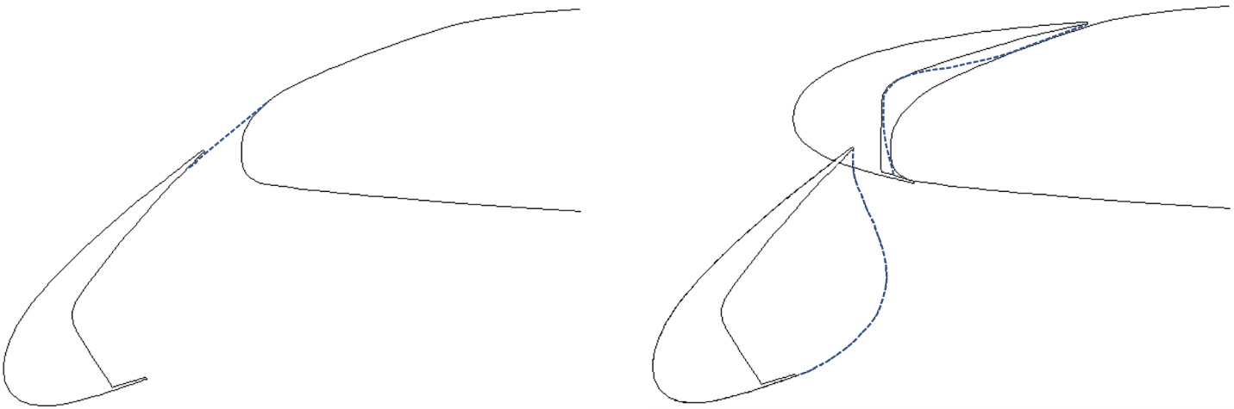
Gap
Thickness
Chord
Thickness
Abrupt SGF
Main wing
Main wing
SCF retracted
(b)
(a)
SCF deployed
Stagnation
SGF
Slat
Slat
Fig. 1 Schematics of the (a) SGF and (b) SCF concepts for treatment of the leading-edge slat for noise reduction.
- CRM-HL Geometry & SGF/SCF Refinement
The CRM consists of a contemporary supercritical transonic wing with flow-through nacelles and a fuselage that is representative of a wide-body commercial transport aircraft. The CRM-HL is a three-element, high-lift adaptation of the cruise geometry, as shown in Fig. 2. The 10% CRM-HL is a nonarticulating model that is intended for wind tunnel testing while fixed in the fully deployed high-lift configuration at flow speeds matching flight conditions. Challenges to SGF and SCF design associated with the sweep, taper, and other details of a 3D airframe were anticipated. The most-significant challenges for SGF and SCF treatment designs arose from the significant change in thickness/gap and thickness/chord ratios with spanwise position.

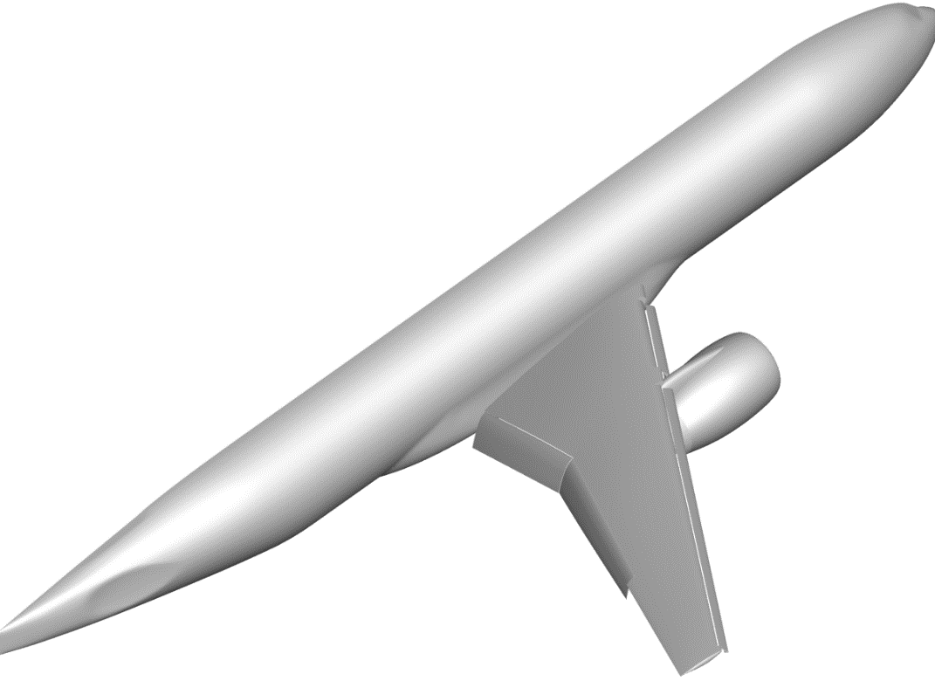
Nacelle & Pylon
Flaps
Inboard slat
Main wing
Outboard slat
Fig. 2 Semispan geometry of the CRM-HL.

- SGF Refinement
Best practices for the overleaf configuration shown schematically in Fig. 1(a) are described here. It is desirable that the joint between the SGF and the main wing be in a region that is hidden behind the retracted slat such that an additional joint will not be unnecessarily presented to the flow on the top (suction side) of the wing during cruise. Additionally, it is intuitive that the unsupported length of the deployed SGF, i.e., the distance between the support at the slat trailing edge (TE) and attachment to the main wing, should be minimized to reduce the aerodynamic load on the SGF, maximize the structural stiffness of the SGF to that load, and minimize the structural/weight addition. However, these observations on unsupported length should be balanced with aerodynamic and aeroacoustic performance, and actuation authority requirement to articulate the SGF.
The relative position of the deployed slat to the main wing in Fig. 1(a) allows for the rather “conformal” shape for the deployed SGF shown in the figure while also adhering to the observations mentioned in the previous paragraph. An SGF of even shorter unsupported length when deployed could be envisioned for that geometry, i.e., by moving the attachment location on the main wing forward, but that would be at the expense of presenting an adverse slope to the flow, as indicated by the “abrupt” SGF geometry shown in the same figure.
Indeed, the relative position of the deployed slat to the main wing for other airframes presents geometry that necessitates an abrupt shape for the deployed SGF. For example, applying best practices from the observations on unsupported length to a leading-edge normal section of the CRM-HL resulted in a rule of SGF attachment at 1.85% of the main wing chord, as indicated by the deployed baseline overleaf SGF in Fig. 3. The 1.85% rule did not result from optimization but represented a balance of the unsupported length factors mentioned previously. The adverse slope of the unsupported length resulted from fairing slope continuous junctures at the slat TE and the main wing outer mold line (OML). Overlap of the SGF with the slat provided means for sealing the SGF to the slat cove, which could be achieved by a compliant contact/rub strip in the relevant region of the slat-cove wall. That same contact/rub strip on the slat-cove wall could serve as a seal to the main wing OML when the slat is retracted, in addition to or in place of the bulb seal typically employed further forward on the slat in current practice. Avoiding the adverse slope presented to the flow by the baseline overleaf SGF would require a deployed shape like that represented in Fig. 3 by the dashed line and clearly demonstrates that a noninflected deployed shape for the SGF is impractical in such cases.

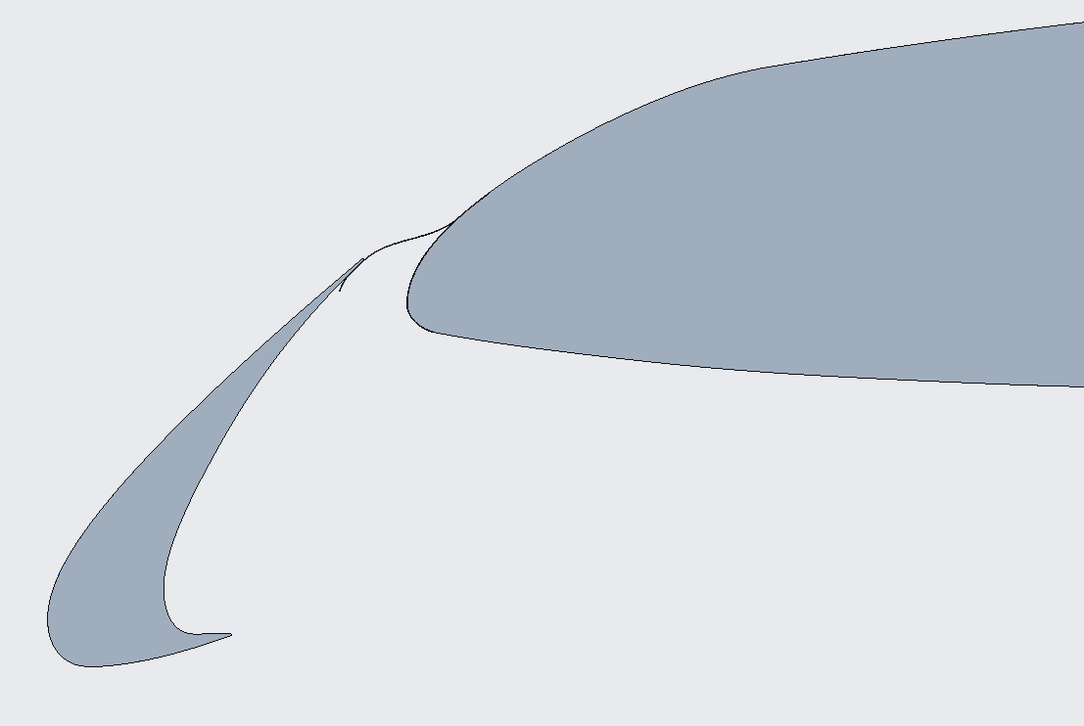
Baseline overleaf SGF
(deployed)
SGF
(retracted)
Slat
Non-inflected SGF
(deployed)
Main wing
Fig. 3 Baseline overleaf SGF for a leading-edge normal section taken at the midspan of the outboard slat on the CRM-HL; baseline SGF shown deployed and retracted in comparison to a noninflected deployed shape.
The sweep and taper of the CRM-HL wing results in many features that must be accommodated in SGF design and integration into the airframe. One important characteristic of the 3D geometry is the increasing ratio of slat gap to wing thickness with increasing spanwise distance from the fuselage. The 1.85% rule for SGF attachment to the main wing was applied at several spanwise stations of the CRM-HL wing, on both the inboard (IB) and outboard (OB) slats, and a surface was lofted over the discrete stations to represent the top surface of a continuous SGF for each slat to form a treatment for the entire wing. The relative positions of the SGF, the deployed slat, and the wing under slat surface (WUSS) for the OB slat of the CRM-HL are shown in both the retracted and deployed configurations in Fig. 4.
Additional insight is afforded by the 2D cross sections in Fig. 5 that correspond to the IB end of the IB slat, the midspan of the OB slat, and the OB end of the OB slat, respectively. At IB spanwise stations, the wing is typically quite thick and the curvature of the main wing OML around the leading edge is mild. Additionally, the SGF chordwise length required to close the gap between the slat and main wing at IB spanwise stations, and to result in a reasonable overlap at the slat TE, positions the forward edge of the retracted SGF on the main wing OML at a location above the leading edge. The location of the forward edge of the retracted SGF progressively moves around the leading edge and onto the bottom of the main wing, and the curvature of the main wing OML around the leading edge increases as the spanwise position moves OB because of the progressive reduction in wing thickness while the slat gap remains relatively unchanged.
An important aspect of the slat gap/wing thickness ratio is the corresponding strain requirement for the SGF to reconfigure with deployment and retraction. Although the strain due to curvature change over part of the wingspan is within reason for application of conventional materials to the SGF treatment, the strain in those regions is still high and is excessive for conventional materials over a significant portion of the wingspan. Superelastic SMA materials are considered ideal for the application due to their high-strain capability, corrosion resistance, hardness, and passive reconfiguration due to stress induced transformation under load. The variation in retracted shape of the SGF with spanwise location also has implications for actuation of the overleaf SGF concept that require consideration, as will be described subsequently.

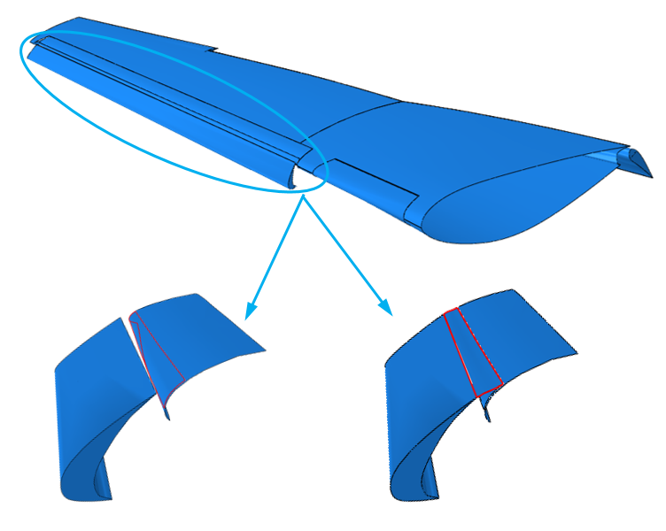
Deployed SGF (outline)
Retracted SGF (outline)
OB Slat
Main wing
Outboard slat
WUSS
WUSS
OB Slat
Fig. 4 Schematic of SGF surfaces for the CRM-HL OB slat in the retracted and deployed configurations; IB slat omitted for clarity.

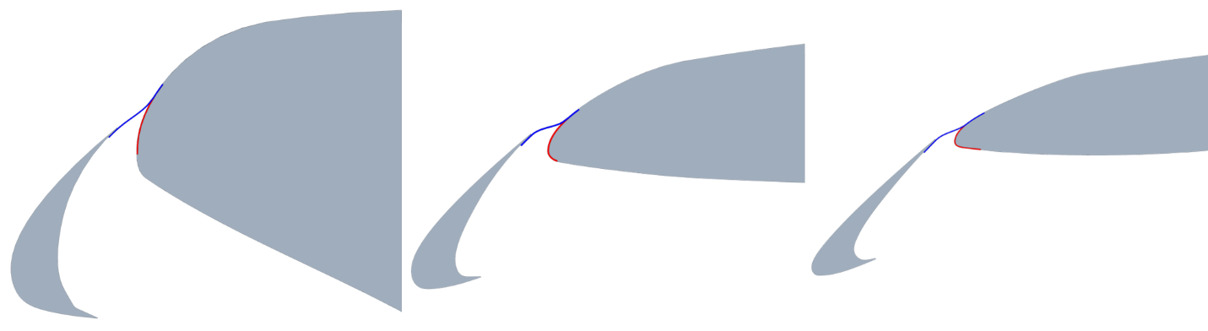
(b)
(c)
(a)
Fig. 5 2D cross sections of the CRM-HL leading edge showing stowed (red) and deployed (blue) SGF geometries at the (a) IB end of the IB slat, (b) midspan of the OB slat, and (c) OB end of the OB slat.
As stated previously, the SGF implementation should be such that the gap between the slat TE and main wing never opens under normal operating conditions and autonomously opens in emergency conditions. In emergency, the slat must remain deployed while the system reverts to the baseline high-lift configuration. The original vision for actuation (baseline actuation) of the overleaf SGF was through a mechanism deriving authority from the slat actuator and applying a follower force aligned with the local skin normal near the forward end of the SGF [13]. A region of fixed curvature in the SGF, matching the corresponding main wing OML curvature when retracted, was envisioned to be a consequence of augmented stiffness/strength at actuator attachments as might be provided by a stringer to bridge between actuators. The mechanized approach was adopted to schedule the SGF movement with the slat and to avoid auxiliary actuation systems. Two options for the stress-free shape were originally envisioned: one that is stress free in the retracted (SFR) configuration and one that is stress free when deployed (SFD). The SFR SGF must be actuated to deploy and means to achieve a suitable deployed shape is a priority. The restoring force due to deformation opposes the aerodynamic load and acts to return the SFR SGF to the retracted configuration either under control of the retreating actuation mechanism or freely (due to mechanism disengagement) in the case of emergency. Conversely, the SFD SGF is shape set to geometry suitable for the aerodynamics when deployed and it must be actuated to retract. The restoring force due to deformation combines with the aerodynamic load to resist retraction for the SFD SGF case, which typically increases actuation loads and requires bias for emergency. Frames and load bearing skin of the main wing provide a stiff boundary upon which to properly shape the retracted SFD SGF.
A variety of mechanisms have been devised to achieve the baseline actuation functionality. Authority by geared or other coupling to a slat track or directly to a slat actuator have been considered, including both servohydraulic and electromechanical slat actuation. Application of the baseline actuation method, i.e., with a single follower force attachment at the forward end, to the SFR SGF concept at the three spanwise stations represented in Fig. 5 results in the corresponding deployed (deformed) shapes shown in Fig. 6. The baseline actuation approach produces a deployed shape for the SFR SGF that is a close match to the idealized (produced by the 1.85% rule) over a large portion of the wingspan, starting at the IB end. However, additional design considerations are clearly required to achieve a deployed shape that is suitable for the aerodynamics starting at a spanwise location OB of the OB slat midspan and continuing to the OB end.

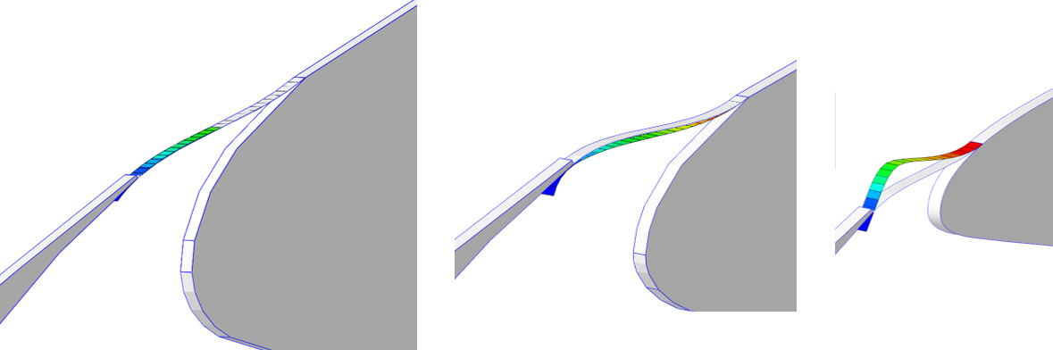
Deflected SGF
Deflected SGF
Deflected SGF
Idealized Shape
Idealized Shape
Idealized Shape
Slat
Slat
(c)
(a)
(b)
Fig. 6 Zoom of the SFR SGF deflected shapes due to a normal, follower force at the forward end in comparison with corresponding idealized shapes for (a) IB and (b) midspan, and (c) OB locations.
Several approaches are available to control the deflected shape and avoid undesirable shapes such as that shown in Fig. 6(c). First, modifications to the baseline actuation method are possible that incorporate a secondary attachment to the SGF in the unsupported chordwise length to restrain the undesirable crest during deployment. Additionally, functional gradients in thickness, material properties, and installation prestress can be used to tailor the stiffness distribution of the structure to result in a suitable deployed shape for the SFR SGF while satisfying other constraints of the application like sustaining the aerodynamic load and minimization of actuation loads. For example, a functional gradient in thickness was applied to the case shown in Fig. 6(c) and the resulting deflected shape due to a normal, follower force applied at the forward end of the SGF is shown in Fig. 7. The result shown in Fig. 7(b) was achieved by maintaining the baseline thickness for the outboard spanwise station near the root and tip of the SGF while adjusting the thickness at locations progressively further from the ends. As a point of reference, the thickness in the chordwise portion with greatest curvature is half that at the root and tip, but an acceptable deflection to a conservative aerodynamic load of 1 psi is still obtained. Additionally, the actuation authority required to deploy the thickness-graded SGF is roughly 40% of the force applied to produce the result in Fig. 6(c). Of course, the thickness gradient and other approaches would have to be balanced with other constraints such as aeroelastic stability. A balance of modified actuation and/or functional gradient approaches to satisfy the requirements and constraints of the application can be achieved through multiobjective design optimization.

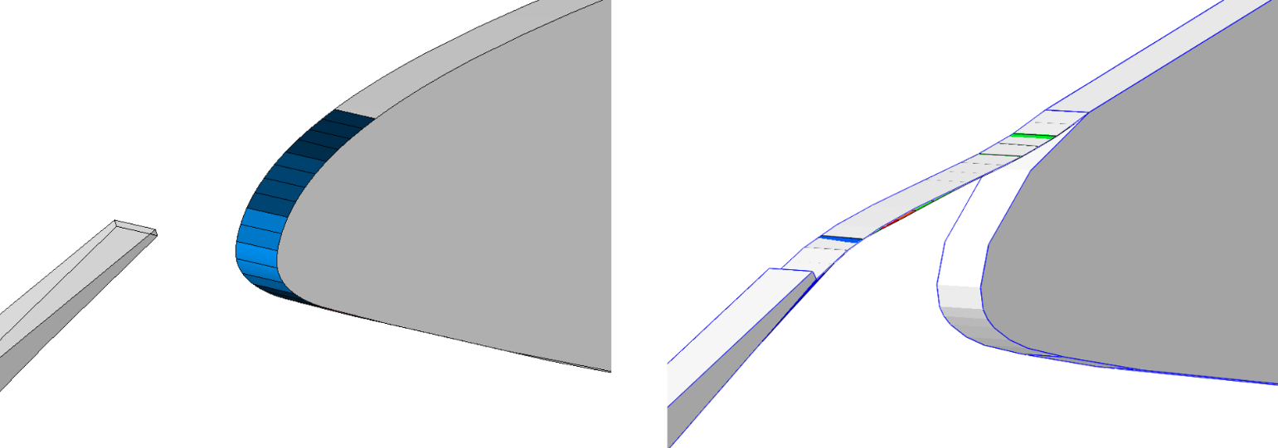
Deflected SGF
(a)
Idealized Shape
Graded Thickness
(b)
Fig. 7 Zoom of outboard SGF with (a) functionally graded thickness in retracted configuration and (b) deflected shape due to a normal, follower force at the forward end in comparison with idealized shape.
An analogous mechanized actuation approach is applicable for the SFD SGF, albeit the functionality is reversed. The SFD SGF is less encumbered by the requirement of achieving suitable geometry because it strives for its stress-free shape in the deployed configuration. Additionally, actuation to retract the SGF can make use of the frames and load bearing skin of the main wing as a stiff boundary upon which to draw the SGF to a shape that is conformal to the main wing OML. The only caveat is that tension imparted by the actuation mechanism to the SGF during retraction is desirable to ensure a conformal fit and final shape. The SFD SGF has the additional advantage that actuation to retract can be achieved with tension-only elements such as a cable system, which also offers a natural way to tension the SGF during retraction. Modifications to the baseline actuation system and the functional gradients in thickness, materials, and installation stress are also applicable to retraction of the SFD SGF to facilitate achievement of a conformal shape and to minimize actuation loads.
Simulations were conducted on large 3D sections of the SGF treatment in both the SFR and SFD configurations to assess flight hardware feasibility and to determine best practices for airframe implementation. As expected, it was found that the deformed SGF structures exhibit a spanwise scallop-type deformation between actuator attachment locations. Addition of a stringer component was introduced to bridge between SGF actuators and reduce the undesirable deflections. Minimizing the deflections would be necessary for the deployed SFR SGF to achieve a positive seal to a compliant contact/rub strip on the slat-cove wall over the entire span of the SGF treatment. Similarly, minimization of scalloping between actuators is required for the retracted SFD SGF to faithfully conform to the main wing OML over the entire span. Note that the location of the compliant contact/rub strip would coincide with the region of shear layer reattachment when the gap is open, which could weaken fluid structure interaction mechanisms of slat noise when in the emergency open configuration. Provisions to receive one or more stringers in the region(s) of fixed curvature at the actuator attachment location(s) for each SGF component would be necessary in the OML of the main wing.
The leading-edge slat components of typical transport aircraft are spanwise segmented. The SGF treatment was envisioned to be spanwise segmented at least to the extent that the slats are themselves. Gaps between adjacent spanwise segments of the SGF would be sealed in flight hardware by lap, brush, or other seals. Additional segmentation could be necessary or desirable due to component fabrication constraints, geometry irregularities in the airframe, etc. For example, the SGF actuation system was envisioned to consist of main actuators that derive authority from the slat actuation, as discussed above, and distribute that authority to additional SGF actuators spaced in a refined fashion relative to the slat actuators. The scallop-type deformation and corresponding stringer requirement can be reduced in this manner because of the reduced unsupported length in the spanwise direction between actuators. Functional gradients also affect deformation, as shown in Fig. 7 for 2D, and can be leveraged to further reduce scalloping, the stringer requirement, and required actuation authority.
All developments and observations about the overleaf SGFs described above formed a foundation upon which to assess feasibility of SFR and SFD overleaf SGFs for implementation in flight hardware and upon which treatment of the 10% CRM-HL with the spanwise segmented overleaf SGF of superelastic SMA composition was substantiated. Work in 3D implementation is still ongoing to further discern between the SFR and SFD overleaf approaches and to further raise the TRL of the technologies, particularly in terms of actuation and airframe integration.
The SGF treatments for the 10% CRM-HL were planned to be designed for the fully deployed high-lift configuration and to be dynamically scaled, i.e., exhibit the correct static and dynamic response at model scale, but lack the features required to retract and deploy because the 10% CRM-HL cannot articulate. The SFR and SFD SGFs would be essentially equivalent in terms of the geometry presented to the flow under these conditions. However, the SFR would be much more difficult to implement, especially at 10% scale, and the SFD would be the least conservative, i.e., not misrepresenting the technology by the most favorable conditions, because it lacks additional stiffness due to internal stress that the SFR possesses in the deployed configuration. Therefore, the SFD overleaf SGF fabricated from superelastic SMA materials was selected as the baseline treatment for the 10% CRM-HL. SGF treatment details for the 10% CRM-HL and model design features that represent the SGF functionality described above will be described in sections IV and V.
Computational fluid dynamic and computational aeroacoustic analyses were performed on the 3D CRM-HL with a baseline SFD overleaf SGF treatment applied to all slats and based upon the 1.85% rule mentioned above. The adverse slope presented to the flow by the SFD overleaf SGF geometry produced a small region of recirculation immediately above and aft of the SGF. However, that recirculation did not result in degradation to the predicted aerodynamic or aeroacoustic performance of the wing, which brought about two important observations. First, the overleaf SGF approach was validated for reduction of slat noise even for airframe configurations that require nonideal SGF geometry. Secondly, the aerodynamic and aeroacoustic performance of the wing in the high-lift configuration and with the slat gap closed is insensitive to closure geometry, at least to the extent of the 1.85% design rule for the overleaf concept. The insensitivity of the aerodynamics/aeroacoustics to the imperfect geometry led to development of additional SGF concepts that further deviate from conformal transition between the slat and main wing. These new SGF concepts represent treatments that could be deployed from within the main wing or the slat. Two such geometries, shown in Fig. 8 and termed the alternative baseline and min-distance, were devised to integrate with the 10% CRM-HL hardware in a way that is consistent with the SFD overleaf SGF to facilitate interchangeability for testing. The alternative baseline and min-distance concepts were selected as additional SGF treatments for testing on the 10% CRM-HL for two purposes: (1) assess the measured sensitivity of aerodynamics and aeroacoustics to SGF geometry and (2) provide an efficient means for assessing porosity/flow resistivity in the SGF. Additional work is also ongoing to assess feasibility and raise the TRL of SGF implementation approaches motivated by the closure geometry insensitivity.

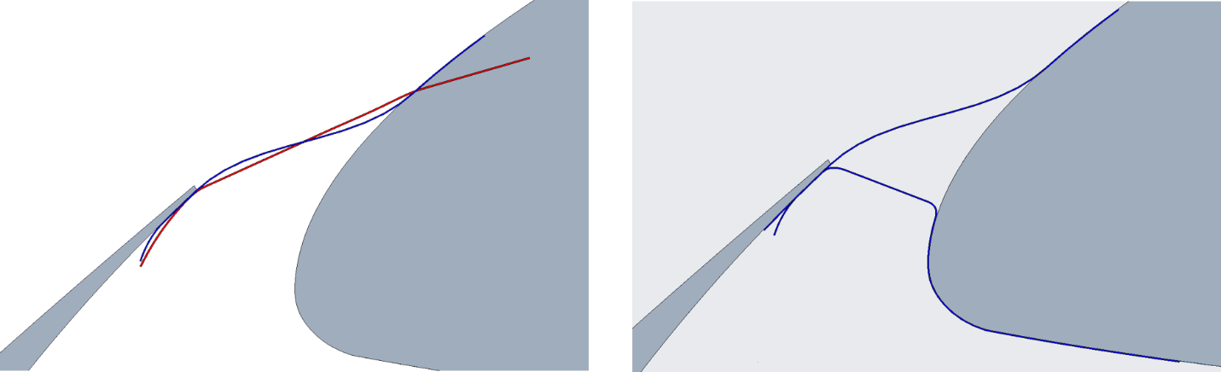
Baseline SFD overleaf
Min-distance
Baseline SFD overleaf
Alternative baseline
Fig. 8 Schematics of the (a) alternative baseline and (b) min-distance SGF concepts.
It was hypothesized that a porous or flow resistive SGF concept could strike a balance of permitting enough flow through the treatment to create a more favorable pressure gradient on the top of the main wing and still slow the flow in the slat cove enough to mitigate many of the noise production mechanisms. This would achieve noise reduction similar to that expected for the SGF with complete blockage but preserve the aerodynamic performance to higher angles of attack. Three levels of porosity were planned for testing to interrogate the parametric space empirically on the 10% CRM-HL: 15%, 30%, and 50% open area (POA).
Schematics of the three porosity designs are shown in Fig. 9. The porosity was introduced as slots with the long dimension aligned spanwise. 30% and 50% porosity cases were developed from the baseline 15% case by increasing the slot width and height while maintaining spacing in the chordwise and spanwise directions. Porous designs were generated for both the alternative baseline and min-distance SGFs, where the porosity was distributed over the unsupported area in each case. Initial CFD results suggested that porosity in the min-distance configuration could be more successful than for the alterative baseline because of the proximity and orientation of the flow through the porosity relative to the shear layer detaching from the slat trailing edge. However, porous treatments of both types were carried forward for testing.

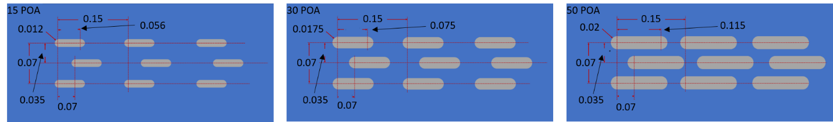
Fig. 9 Schematics of the (a) 15%, (b) 30%, and (c) 50% open area patterns used in the unsupported area of alternative baseline and min-distance SGF components to produce flow resistive treatments.
- SCF Refinement
Like the SGF case, the great change in aspect ratio for the slat cross section presented challenges for the SCF. The shape shown for the SCF in Fig. 1(b) is optimized for noise reduction [5], [12]. The original SCF concept consisted of a superelastic SMA sheet component shape set to the deployed configuration, attached to the slat TE in a lap joint and attached near the cusp of the slat by a hinge [31], [14]. Note the steep angle between the deployed SCF and the slat TE in Fig. 1(b). Early SCF work elucidated desirable design trends like minimizing hinge length and deviations from the optimized SCF profile to achieve a lap joint at the slat TE. Additionally, the curvilinear length of the SCF and hinge assembly should not significantly exceed (>5-10%) the curvilinear length of the slat-cove wall measured from the TE to the SCF hinge. SCF treatments with greater curvilinear length would produce excessive forces during retraction or not stow at all.
A noise-optimized SCF shape analogous to that shown in Fig. 1(b) was developed for the CRM-HL, but only for the OB slat because the flowfield about the IB slat made a SCF impractical. Sections through the CRM-HL wing are shown at six spanwise stations along the OB slat in Fig. 10. As indicated by the SCF/cove ratios in the figure, it was found that the curvilinear length of the optimized SCF profile was too great to stow in the cavity between the retracted slat and WUSS for much of the OB slat span, starting around midspan of the OB slat and worsening as the location is moved inboard. A sliding flexure hinge concept, shown as a 2D inset in Fig. 10, was developed to overcome the geometric incompatibility for SCF stowage.
The sliding flexure hinge consists of the forward end of the SCF, a gap and curved bulb feature at the base of the slat-cove wall, and a biased stop (passive) and/or latch (active) that helps control movement. Contact between the SCF and the main wing during slat retraction initially causes the SCF to bend at the trailing edge and force the forward end into the slat body beneath the bulb and through the gap at the base of the cove wall. A balance of sliding at the forward end and around the main wing and flexure at the tailing edge autonomously adjusts the chordwise extent of the SCF in the cove during early retraction. Bending at the forward end of the SCF around the bulb eventually becomes significant as the SCF gets forced further up into the slat cove. Bending around the bulb becomes the greatest contributor to added strain energy toward the end of SCF stowage. The SCF stowage process can be optimized and the required authority minimized through bulb placement, bulb shape, and through functional gradients in thickness and material properties. Deployment of the SCF is autonomous due to release of strain energy from the deformed structure. Stop, bias, and/or latch features will be described subsequently in the context of 3D aircraft structural integration.

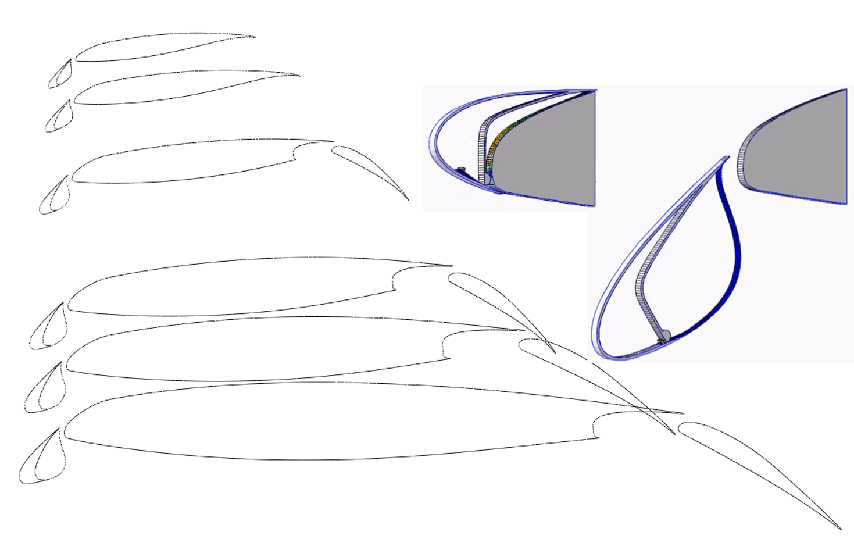
Sliding hinge
SCF fwd end w/ stop
Slat
Main wing
Main wing
SCF
Deployed
Retracted
Slat
OB Section: SCF/cove ≈ 1
IB Section: SCF/cove >> 1
Slat cove profile
SCF profile
Fig. 10 CRM-HL wing sections from IB to OB end of OB slat with optimized SCF profile.
Additionally, it was found that the thickness/chord ratio of the slat for the CRM-HL is greater than for similar airframe geometries studied previously. Whereas previous geometries allowed an adjustment to be made to the SCF profile at the aft end to fair it into the slat TE without significant impact on flow quality, the CRM-HL geometry was incompatible with that approach, as shown in Fig. 11(a). New concepts termed the traditional auxiliary and reverse auxiliary components, shown in Fig. 11(b) and (c), were developed to enable adherence to the optimized geometry over the entire SCF profile while allowing the curvilinear length to shorten via the sliding flexure hinge during stowage. The traditional/reverse auxiliary component joins the main SCF component to the slat. The traditional auxiliary component has the advantage of attaching to the main SCF component further down/forward such that the unsupported length of the main SCF component is significantly reduced, which could enable a reduced thickness requirement. The reverse auxiliary component has the greater advantage of attaching to the slat further forward where the slat has much greater structural stiffness and strength. The reverse auxiliary component is the only practical option at 10% scale, so the combination of the reverse auxiliary and the sliding flexure hinge were selected for the SCF treatment to the CRM-HL.

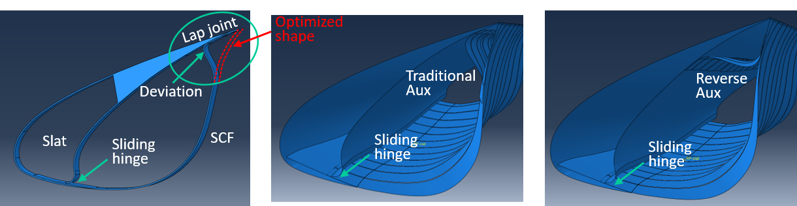
(c)
(b)
(a)
Fig. 11 Schematic of (a) an unacceptable SCF deviation to create a lap joint, and (b) the traditional auxiliary concept and (c) the reverse auxiliary concept to avoid deviation in the SCF profile.
Portions of the chordwise length of the SCF over the entire span experience strain that is well beyond the capability of conventional materials due to the large configuration change as shown in the inset of Fig. 10. Large strains are also implied by the need for the auxiliary components in Fig. 11 to stow in the small space between the slat cove and main wing when the slat is retracted. Again, superelastic SMA materials are ideal for the SCF application due to their high-strain capability, corrosion resistance, hardness, and passive reconfiguration due to stress induced transformation under load.
3D simulations of the SCF treatment focused on a large spanwise section at the IB end of the OB slat because it represented the worst case for assessing flight hardware feasibility and for developing best practices for implementation. It was found that the balance of deformation and sliding provided by the sliding flexure hinge enables spanwise mobility at the forward edge, i.e., as might be beneficial to relieve shear, in addition to the chordwise mobility that stows excessive length and relieves the compression associated with a fixed hinge. The traditional auxiliary component tends to allow the TE of the main SCF component to come to rest forward of the slat TE when stowed, whereas the reverse auxiliary component tends to push the TE of the main SCF component aft. Both trends can be controlled and even tailored for effective use by functional gradients and intentional mobility in the SCF/slat and/or auxiliary/main joint design. Functional gradients in thickness and material properties are also important for optimization of the SCF stowage process and for minimization of the required actuator authority. For example, thinning a chordwise portion of the main SCF that is in the unsupported length when deployed can have a small effect on the deployed shape of the SCF under aerodynamic load, but have a large effect on the authority required to stow the SCF when the thinned region is pushed forward and flexed around the bulb.
The SCF components in flight hardware would need to be segmented similarly to the leading-edge slats. Additionally, the geometry of the slat tracks and main SCF components interfere in the slat cove. At least two options exist for removing the interference: chordwise slots in the main SCF around the slat tracks or breaks between SCF spanwise sections at the slat tracks. Slots in SCF components or breaks between them would be treated with lap, bridge, brush, and/or other seals to reduce flow interaction with geometric discontinuities.
Traditional construction of a leading-edge slat incorporates frames that prescribe the cross-sectional shape of the slat upon which skin is attached to form the aerodynamic surface. Integration of the sliding flexure hinge with typical slat construction entails cutouts in the SCF forward edge for relief around the slat frames, which create tongues in the SCF forward edge that protrude under the bulb and through the gap at the base of the cove wall for ingress to the slat body. Contact between the SCF and the main wing during slat retraction forces the SCF to bend at the TE which pushes the SCF tongues into the slat body while the cutouts remain hidden above the slat cusp from the flow. Again, a balance of flexure at the forward and aft ends of the SCF and sliding around the main wing and at the base of the slat-cove wall autonomously maintains SCF chordwise extent commensurate with available space in the cove. Stop and bias features prevent the SCF from being fully withdrawn from the slat body and provide additional deployment authority as needed. Alternatively, latch features integrated with the aircraft control system permit sliding motion during slat deployment and retraction but secure the SCF otherwise. As with the SGF concepts, functional gradients in thickness and material properties can be leveraged to optimize the SCF retraction behavior and minimize the required actuation authority.
The SCF developments and observations above summarize feasibility assessment of the technology for flight hardware and substantiate treating the 10% CRM-HL with a spanwise segmented SCF having reverse auxiliary components for attachment to the slat TE and features at the base of the cove wall that represent the sliding flexure hinge. 3D implementation development is ongoing to increase the TRL with regard to actuation and airframe integration. Details of the dynamically scaled SCF treatments for the nonarticulating 10% CRM-HL and model design features that represent the functionality of the SCF described above will be presented in the next two sections.
- Aerodynamic Loads, Treatment Sizing, and Fabrication
Much of the development work for the SGF and SCF treatments to the CRM-HL was done on 2.5D sections (thin spanwise uniform extrusions) at various spanwise stations and on large 3D sections of the airframe using preliminary or approximate pressure loads for initial sizing. This section discusses additional detail on the aerodynamic loads the SGF and SCF treatments must sustain, deflections of the flexible structures to those loads, treatment sizing for wind tunnel testing, and fabrication of the treatments.
- SGF Treatment
The CRM-HL geometry corresponds to a large twin-aisle transport aircraft with IB and OB slat consisting of one and six segments, respectively. However, the OB slat for the 10% CRM-HL was combined into one segment to simplify assembly. The spanwise length of the IB slat was greater than the maximum length an SMA component could be produced at the time of model fabrication, so the SGF treatment for the IB slat was broken into two segments. The SGF treatment for the OB slat was broken into six segments to represent flight hardware and because the lengths after segmentation were within SMA component production limits.
CFD computations [25] were performed on the CRM-HL geometry including the SFD overleaf SGF treatment to assess the aerodynamic and aeroacoustic performance, as mentioned in section III.A., and to produce accurate aerodynamic loads for final structural design. The resulting aerodynamic load on the SGF components corresponding to the maximum loading case of Mach 0.24 and an angle of attack (AoA) of 8 degrees, shown in Fig. 12, exhibits a gradual reduction in differential pressure from IB to OB, a steeper gradient from fore to aft, and an average differential pressure of about 1 psi on both SGFs. A finite element model was developed in Abaqus to represent the 10% CRM-HL integration features for the SGF treatment described in section V. The model incorporated the elasticity of the slats, fasteners joining the SGF components to the slats, and SMA material properties for the SGF components. The Souza-Auricchio constitutive model [34] was incorporated with properties representative of NiTi to model the material response, although that level of fidelity was only necessary for the retract/deploy simulations. The SGF components were assumed perfectly joined to the main wing. The 3D time-averaged aerodynamic load from the CFD solution was applied to the SGF components and the thickness of each segment was adjusted over a range to assess maximum deflection and deflected shape. The results of that study are shown in Fig. 13.
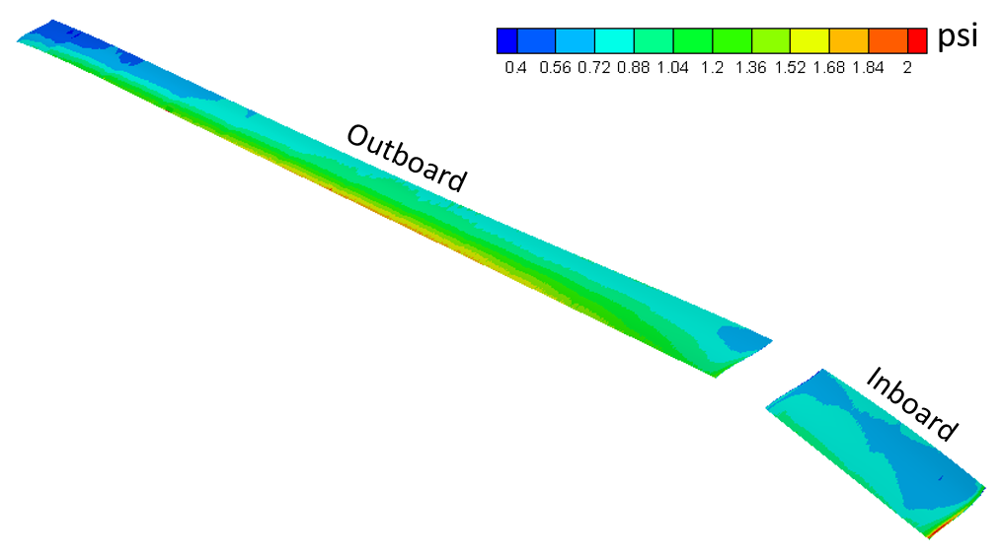
Fig. 12 Differential pressure distribution acting on the SFD overleaf SGF treatment for the CRM-HL from CFD of Mach 0.24 flow at 8 degrees AoA.
Knowledge that the flow on both sides of the SGF components is separated and recirculating reduces the risk of destabilizing coupling between the structure and the flow. Also, previous computational and experimental study of the static and dynamic stability of similar SGF treatments using simplified models (2.5D) in flow offered some reassurance that a SGF component thickness of 0.005” for the midspan of the OB slat would be quite conservative. However, due to the lack of better guidance from 3D fluid structure interaction computations or experimental measurements at the time of SGF component design, a more aggressive but still conservative estimate for an allowable deflection of twice the treatment thickness was selected for final design, represented by the horizontal green line in Fig. 13. Applying the 2x thickness criterion for the maximum deflection, the final thickness assignment for each SFD overleaf SGF component is shown in Table 1. Values were rounded to the nearest 0.0005” as that is the typical thickness accuracy for rolled superelastic SMA sheet at these thickness values. The deflection of each SGF component to the maximum aerodynamic load case and with the corresponding thickness assignment from Table 1 is shown in Fig. 14.
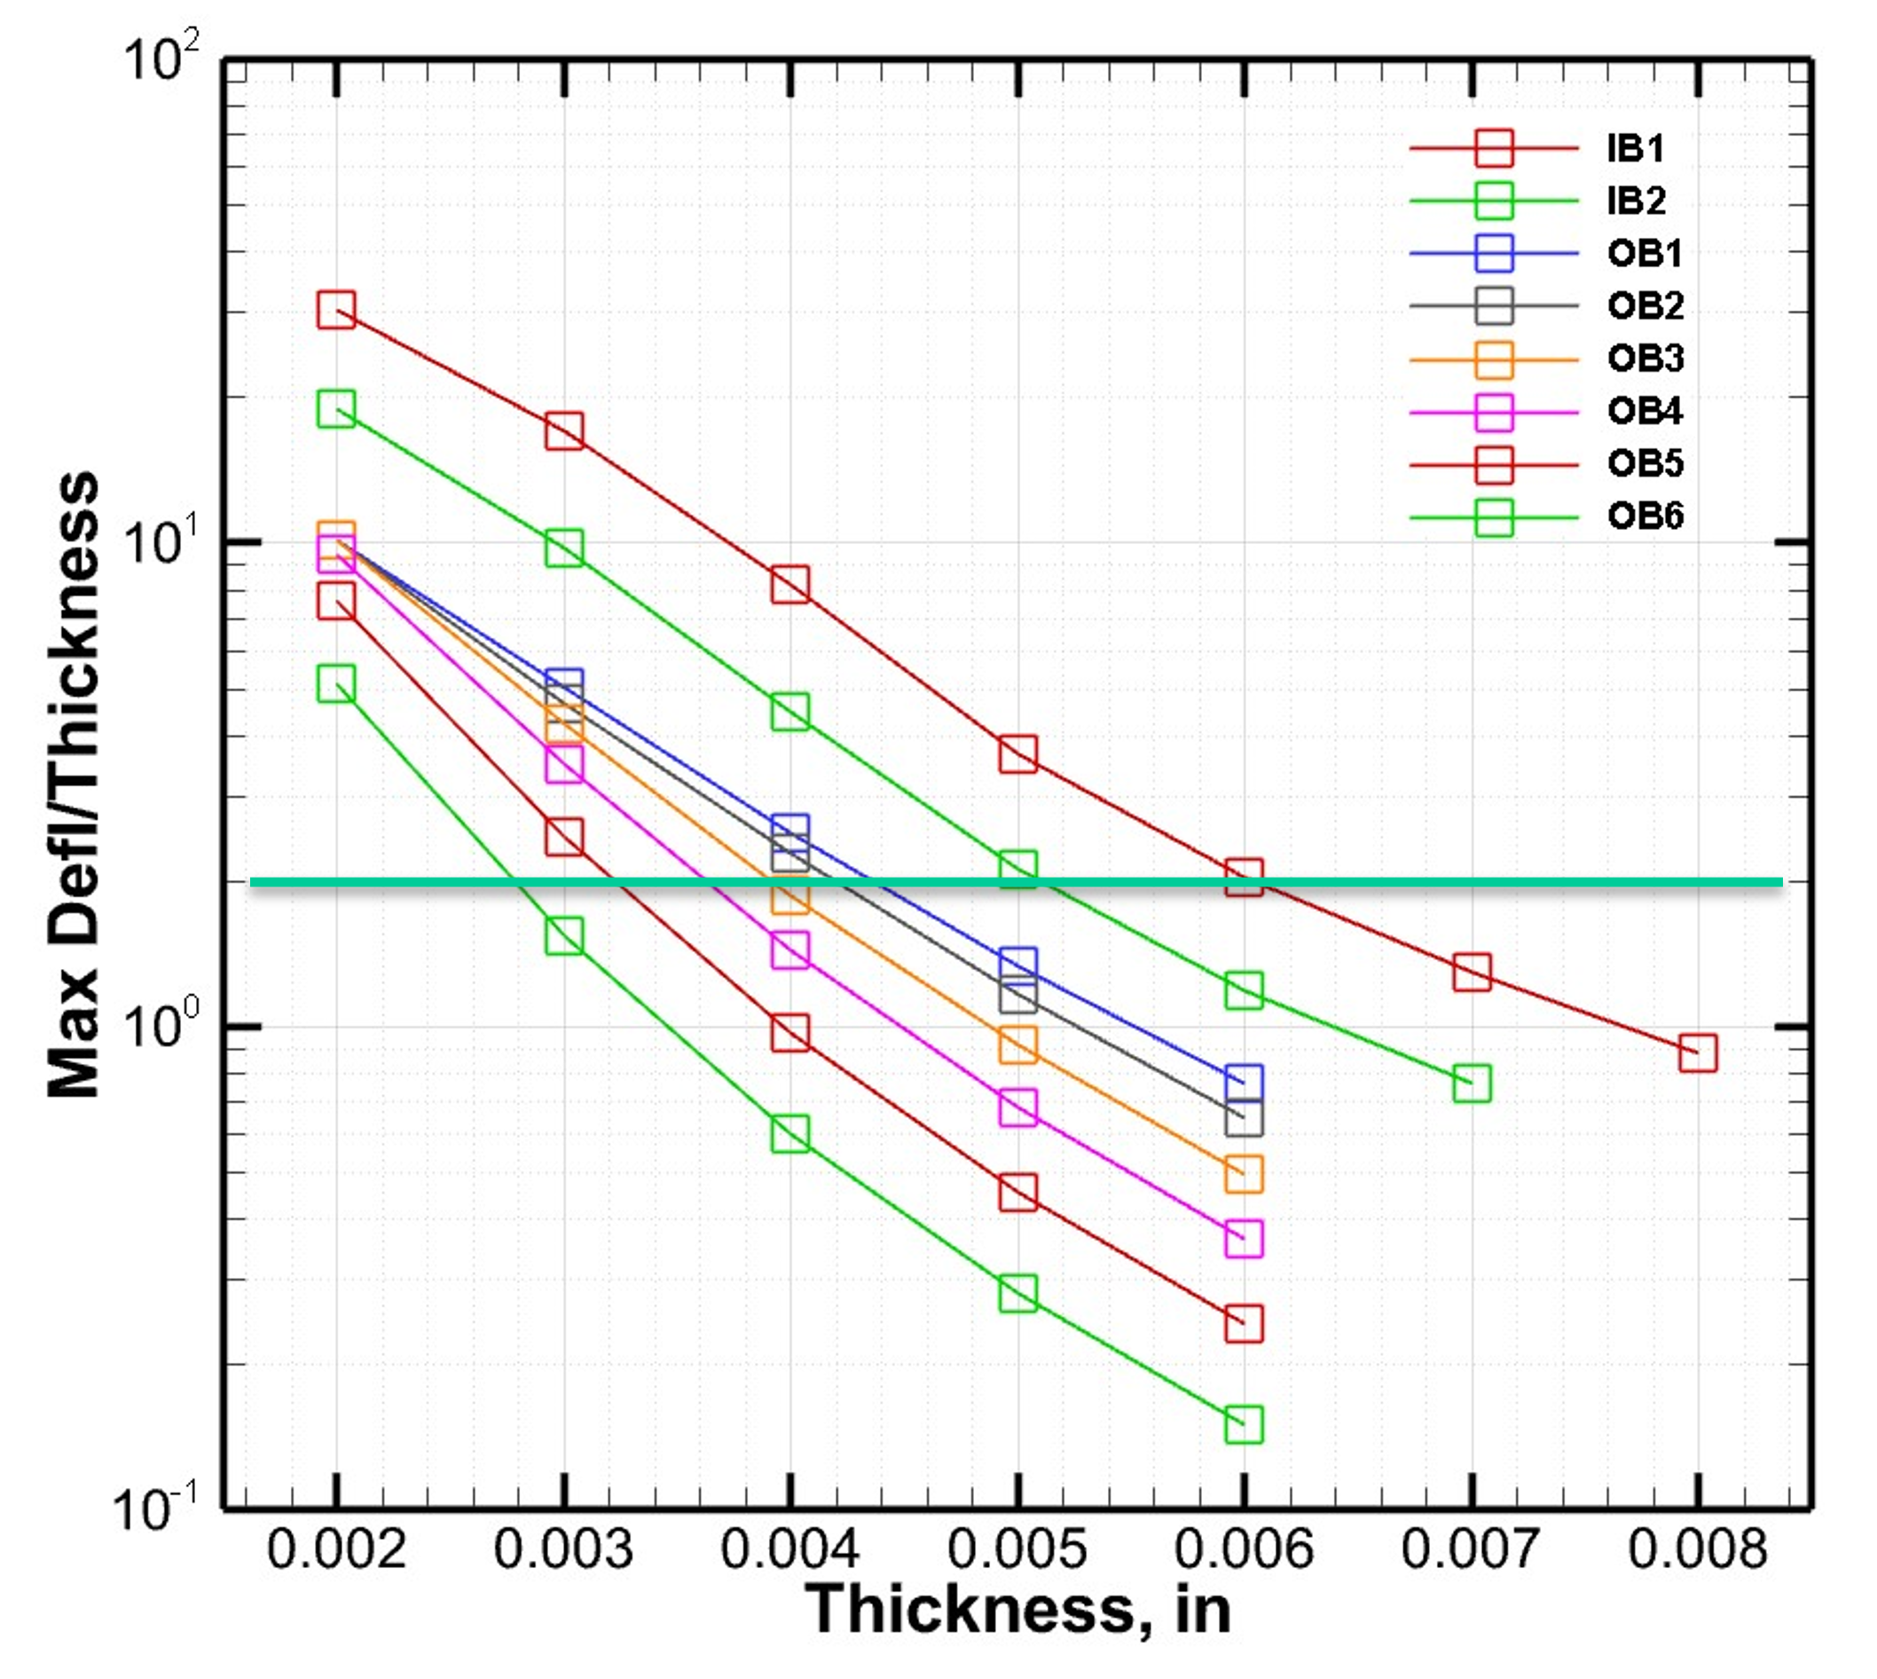
Fig. 13 Maximum deflection vs thickness due to time averaged aerodynamic load from semispan CFD (M=0.24, AoA=8°) for each SGF treatment section.

Table 1 Assigned thickness for each SGF section from time averaged aerodynamic load (M=0.24, AoA=8°) analysis.

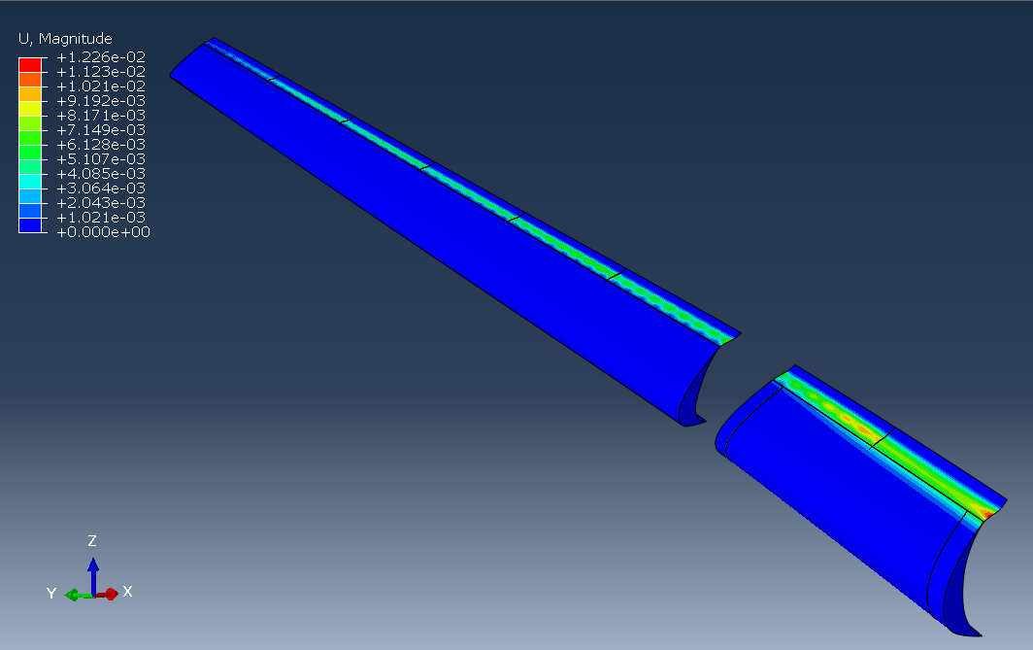
2 SGF segments
6 SGF segments
WUSS attachment edge
OB slat
IB slat
Fig. 14 IB and OB slat with deployed SGF treatment deflected by aerodynamic loading at Mach 0.24 and an AoA of 8 degrees.
Superelastic SMA materials are the main interest for SGF technology for the passive reconfiguration behavior due to the stress-induced martensitic transformation. Although flight application of a superelastic SMA would necessitate a material that is austenitic down to about -40°F, a Nickel-Titanium (NiTi) material was selected for wind-tunnel demonstration of the SGF technology due to its availability, familiarity, and suitable properties. Geometry and material specifications were developed to form nine SFD overleaf SGF components from superelastic NiTi sheet such that they would be fully austenitic above 32 °F, which is readily achievable with a NiTi material system and is below the average daytime temperature at NASA LaRC in winter. The ninth component was designed to treat a transition slat component that replaced the slatless WUSS when testing the 10% CRM-HL in a single full span slat configuration without the nacelle and pylon. FWD Technologies, Inc. produced the components shown in Fig. 15 from NiTi sheet with the chemical composition shown in Table 2. The components are numbered 1-9 from IB to OB; 1-2 for the IB slat, 3 for the transition slat (when used), and 4-9 for the OB slat. The unnumbered small components in the image are interchangeable end treatments, to be discussed in the next section.

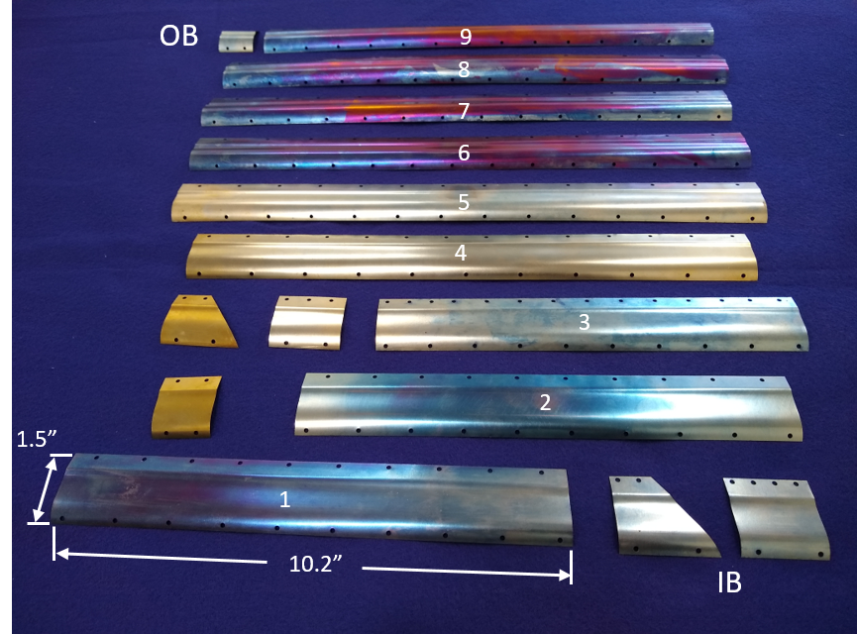
Fig. 15 SFD overleaf SGF components fabricated by FWD Technologies, Inc. from superelastic NiTi.

Table 2 Chemical composition of NiTi sheet used for fabrication of SGF and SCF components.

The alternative baseline and min-distance SGF treatments were meant for empirical assessment of the aerodynamic and aeroacoustic sensitivity to SGF shape as well as to evaluate three levels of porosity: 15, 30, and 50 POA. Ease and cost of component fabrication and ease of interchange on the 10% CRM-HL in the wind tunnel were major concerns with a total number of components at 45, not including the interchangeable end components. Consequently, aluminum sheet was selected for fabrication of the solid and porous alternative baseline and min-distance components, and a manual process of forming the components in male-female tools was selected for producing the shaped components. Having sized the SFD overleaf SGFs of superelastic SMA to a maximum thickness of 0.006” at the IB end of the IB slat, a thickness of 0.010” was selected for the aluminum sheet because fidelity of flight hardware representation wasn’t important for the solid and porous alterative baseline and min-distance components. Additionally, 0.010” was the greatest thickness that could be incorporated in the attachment features for the SFD overleaf SGFs without redesign. The 3D SGF shapes corresponding to the midspan example profiles in Fig. 8 were flattened to produce planform shapes. Fotofab, LLC produced the planform shapes from the aluminum sheet (3003 H14) and produced the porosity patterns via a chemical etching process. Male-female plastic tools were designed and fabricated by additive manufacturing and used to form the SGF components to the corresponding shape for the 10% CRM-HL via manual clamping. A three-part tool for forming a min-distance SGF component is shown in Fig. 16(a). Clamping the part in place in the tool, as shown in Fig. 16(b), resulted in the finished min-distance component with porosity shown in Fig. 17. Each part was left in the corresponding toolset for 2 weeks to allow the material to relax after forming and reduce springback.
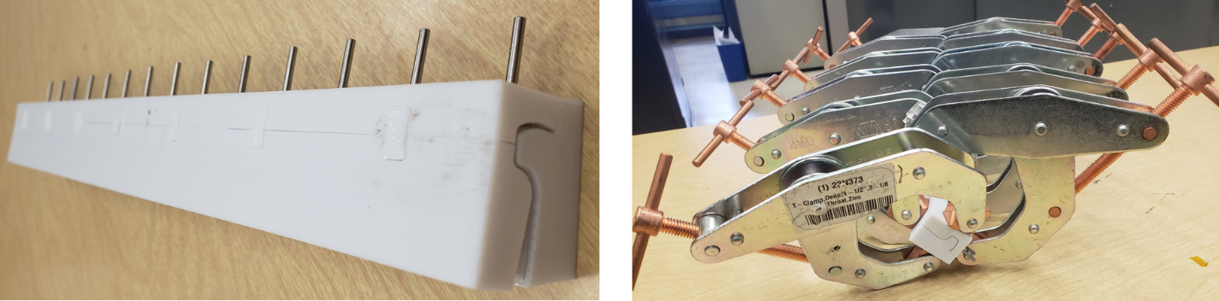
Fig. 16 Images of (a) three-part forming tool for a min-distance component and (b) clamps installed on the tool.
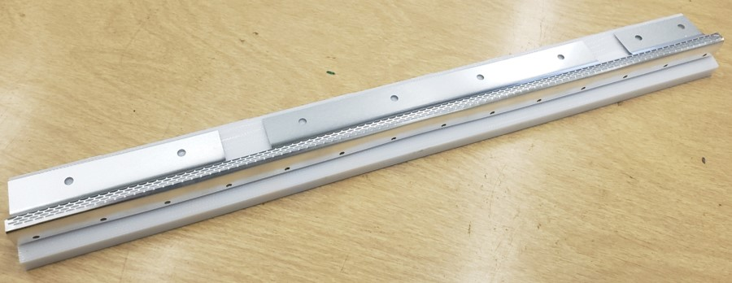
Fig. 17 Sample porous mid-distance component produced from clamping male-female tool.
- SCF Treatment
The SCF treatment was only designed for the OB slat because the commensurate shape for an optimized SCF on the IB slat was impractical. The CRM-HL geometry incorporated three (3) slat brackets (tracks for articulating hardware) for the IB slat and twelve (12) for the OB slat. The SCF treatment on the OB slat was segmented around the slat brackets, which resulted in 13 spanwise sections of SCF on the OB slat.
CFD analysis was performed on the CRM-HL with geometry representing the OML of the SCF treatment. The aerodynamic load corresponding to the maximum loading case of Mach 0.24 and 8 degrees AoA is shown in Fig. 18. The differential pressure distribution showed significant nonuniformity with a highly localized maximum pressure region at the outboard end of each SCF section, i.e., adjacent to the bracket just outboard of each SCF section. It was surmised that the strong nonuniformity and localized maximum pressure in the load resulted from spanwise flow effects not seen in previous computations because slat brackets were ignored. The presence of localized high pressure that is weak at the IB end of the OB slat, strengthens through midspan, and then diminishes again to the OB end suggests that stagnation of the spanwise flow on the slat brackets is the dominant effect, but vortex impingement from flow separation on each preceding bracket is also a possible contributor. The strong pressure nonuniformity and maximum pressure that exceeded cases previously studied were factors that had to be considered in SCF treatment sizing for the 10% CRM-HL.
A finite element model was developed in Abaqus to study the deflection response of the SCF treatment on the 10% CRM-HL to the steady aerodynamic load. The model included geometry, constraints, and interactions that represent integration of the SCF assembly with the model as described in section V. The slat was treated as a rigid body with tie constraints joining the reverse auxiliary and main components in regions where the slat was very stiff. The Souza-Auricchio constitutive model [34] was incorporated with properties representative of NiTi to model the material response, where again that level of detail was mainly important for retract/deploy simulations. Contact was defined between the main SCF components and the TE, and between the SCF components and the bulb at the base of the cove wall. Fastened and bonded joints between the main and reverse auxiliary components were both under consideration at the time, so a representative fastener joint was developed as the most conservative case in terms of deflection under load. Independent adjustment of thickness for the main and reverse auxiliary SCF components was possible and considered, but the final design incorporated pairs of SCF components matched in thickness.
A combined computational and experimental study of the static and dynamic stability of similar SCF treatments was previously conducted in 2.5D and a design rule that resulted from that work called for a SCF with a maximum deflection of one structural thickness. It was found that SCF designs that allowed greater deflection were more susceptible to destabilizing coupling with the flow. A more cautious and conservative approach was taken in the SCF case because of the presence of high-speed attached flow on one side of the SCF treatment. Lacking knowledge of the importance on stability of the spanwise flow component and corresponding flow features creating the highly nonuniform pressure distribution on the SCF, a highly conservative approach was taken of assigning structural thickness to limit the localized maximum deflection of each SCF section to one thickness. The resulting thickness assignments and deflection field to the maximum aerodynamic load are shown in Table 3 and Fig. 19, respectively.

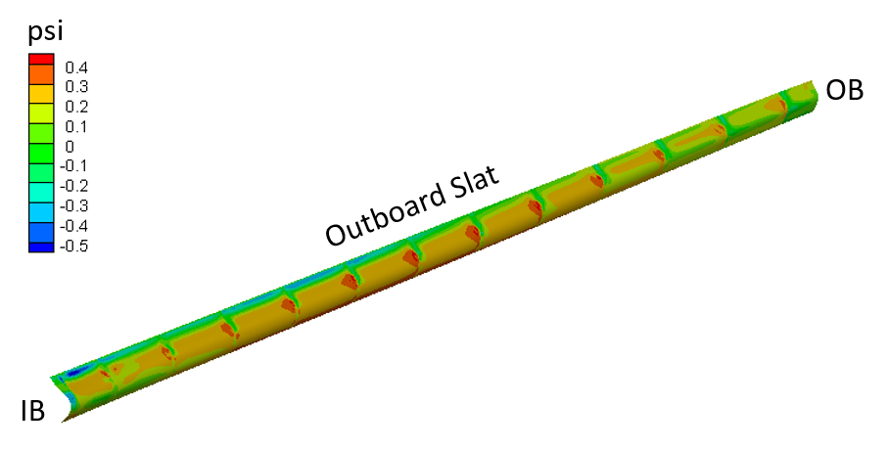
Fig. 18 Time-averaged differential pressure distribution acting on the main SCF components for the CRM-HL from CFD analysis of Mach 0.24 flow at 8 degrees AoA.

Table 3 Assigned thickness for each SCF section from steady aerodynamic load (M=0.2, AoA=8°) analysis.

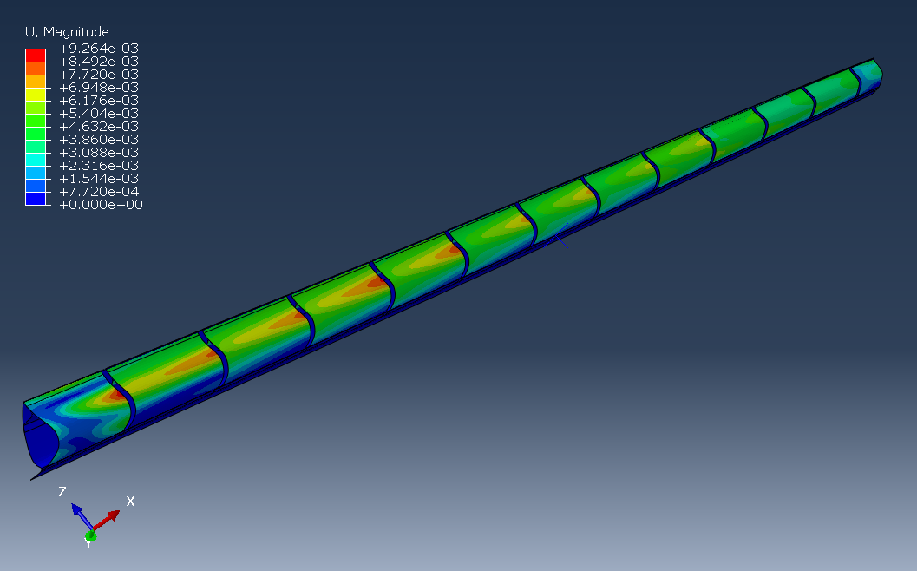
Fig. 19 OB slat with deployed SCF treatment deflected by aerodynamic loading at Mach 0.24 and an AoA of 8 degrees.
Superelastic SMAs are again of main interest for the SCF technology, but SMA materials of shape memory composition (i.e., intended for actuation) are also under study due to advantages they offer in some cases. NiTi was selected because of its suitable properties and ready availability in a composition to place the austenite transformation temperatures below the lowest average temperature likely to be encountered in wind-tunnel testing. FWD Technologies, Inc. again produced the main and reverse auxiliary SCF components from geometry specifications for integration with the 10% CRM-HL and material specifications such that the components would be fully austenitic above 32 °F. The components shown in Fig. 20 were fabricated from NiTi sheet with the composition shown in Table 2. The main and reverse auxiliary component pairs are numbered 1-13 from IB to OB.

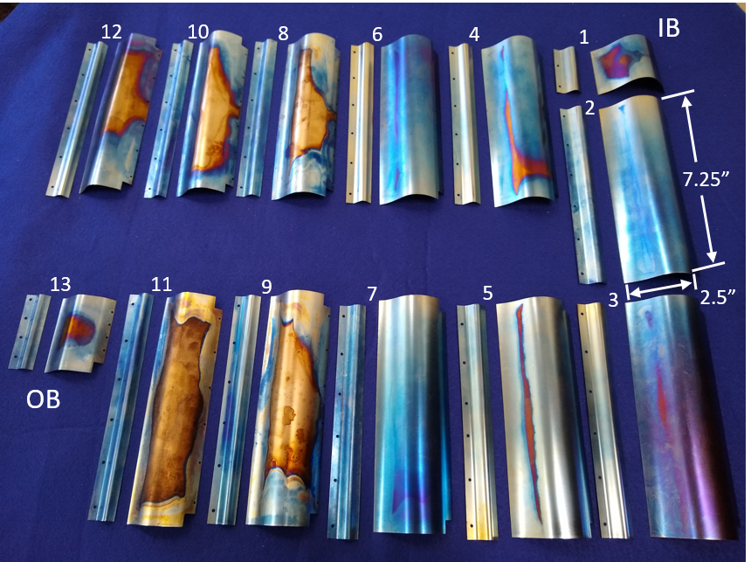
Fig. 20 Main and reverse auxiliary SCF components fabricated by FWD Technologies, Inc. from superelastic NiTi.
- CRM-HL Model Design
Design of new wind tunnel models was undertaken in parallel with the SGF/SCF treatment design work and CFD/CAA computations. The wind tunnel models are at 10% scale of the CRM-HL with a half-span of ~12 feet. The existing main element of the CRM-HL has provisions for many permutations of the test configuration, including leading-edge and trailing-edge provisions for slat and flap interchange. Three acoustic slat/WUSS assemblies were designed and built for testing: the acoustic baseline, the SGF-treated, and the SCF-treated. A photo of the 10% CRM-HL in the NASA Langley 14’x22’ wind tunnel is shown in Fig. 21.

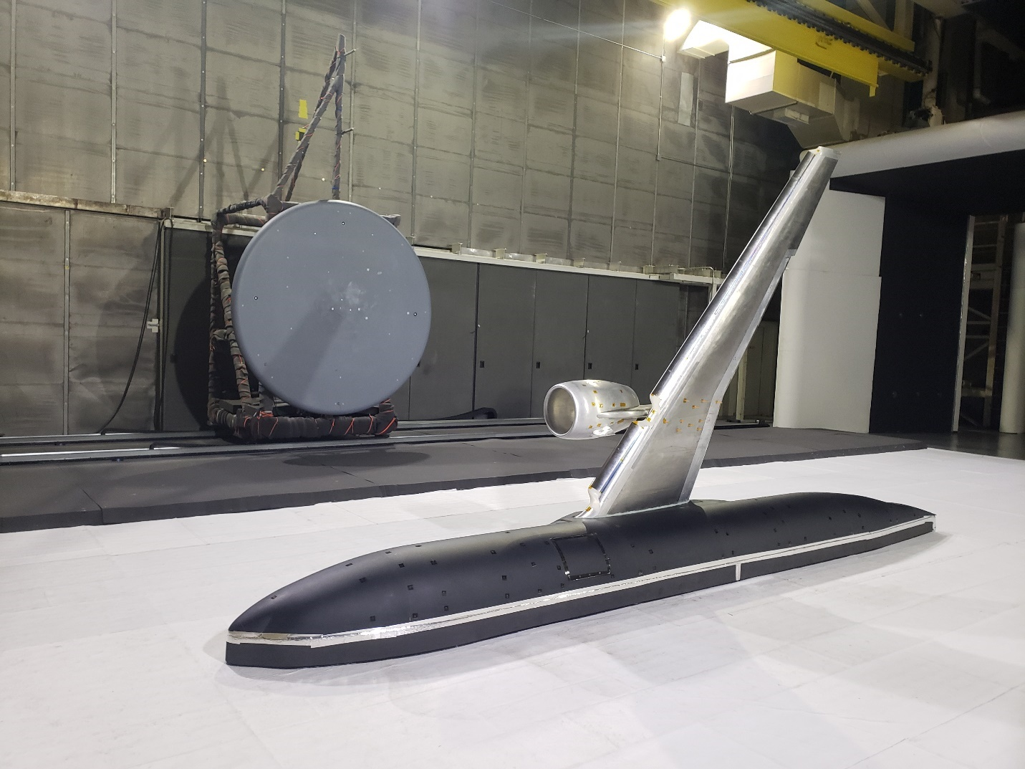
Fig. 21 A photo of the 10% CRM-HL model in the NASA Langley 14’x22’ wind tunnel.

A. Existing CRM Hardware
Prior to developing acoustically treated hardware for the CRM-HL, several 10% CRM-HL models were designed and produced for other areas of research, including active flow control [35]. The existing CRM main element provides the main structure for any configuration of the 10% CRM-HL and was designed concurrently with initial leading edge and flap variants for AFC research. The baseline 37° flap designed alongside the main element was also used during acoustic testing of the 10% CRM-HL. A CAD model of the 10% CRM-HL main element is shown in Fig. 22.

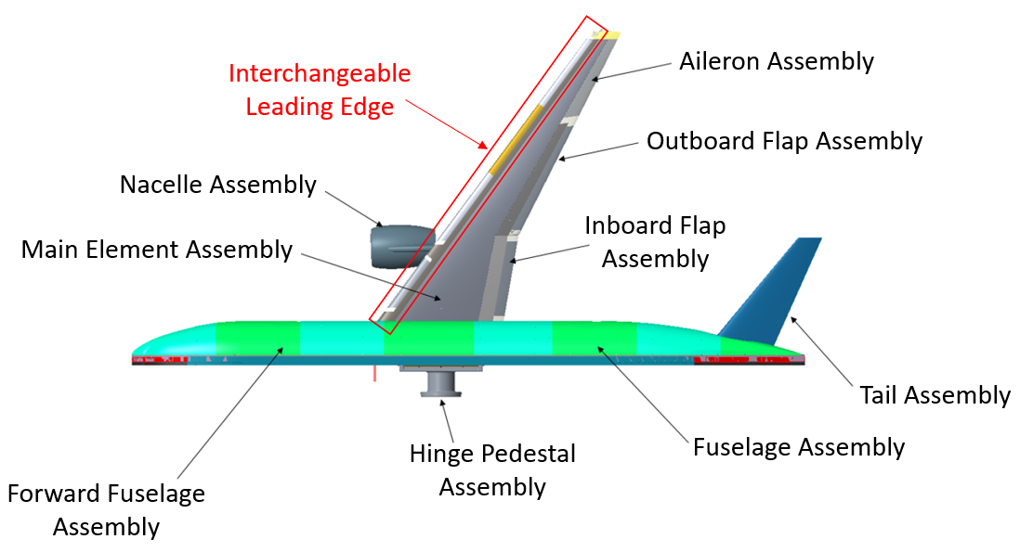
Fig. 22 CAD image of CRM-HL assembly.
The CRM main element was designed to accept a variety of leading-edge slat assemblies and trailing-edge flap assemblies. This leading-edge interchangeability allowed for one assembly to be undergoing testing while another assembly was being modified or prepared for testing. To ensure reliable attachment of leading-edge assemblies, each leading-edge variant is pinned and fastened to the main element. The internals of the main element include plumbing to allow for active flow control testing and routing of static and dynamic pressure instrumentation and accelerometers.

B. Acoustic Baseline Design
Prior to the development of the SGF and SCF leading-edge models, the acoustic baseline slat and WUSS assembly was designed and manufactured by Advanced Technologies, Inc. with input from NASA LaRC. This model significantly differed from previous leading-edge assemblies in the design of the brackets connecting the slat to the WUSS. The brackets were altered to more closely align with the shape of slat brackets used on aircraft. In addition, the new acoustic slat brackets no longer provided variability in slat gaps and overlap, and were set at 30°, as is consistent with final approach and landing. A comparison of acoustic-baseline and aerodynamic-baseline slat brackets is shown in Fig. 23.

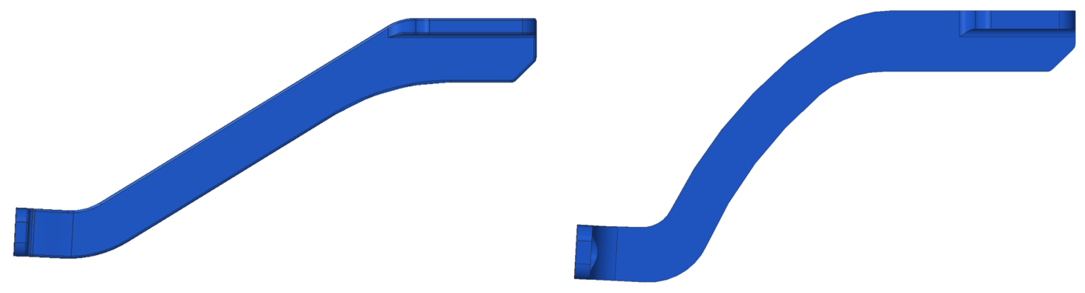
(a)
(b)
Fig. 23 CRM-HL (a) aerodynamic baseline and (b) acoustic baseline slat brackets.
The new acoustic baseline leading-edge model also added the full-span slat configuration option, which included the installation of a slatless WUSS component, a transition slat component connecting the outboard end of the inboard slat to the inboard end of the outboard slat, and the removal of the nacelle and pylon. This configuration is not flight realistic, but it allows for exclusion of a noise source originating from the separated flow around the slat break and pylon. The SGF and SCF models also included this configuration option to allow for comparison. An image of the full-span slat configuration of the acoustic baseline model is shown in Fig. 24. Note the lack of the nacelle and pylon and the presence of the transition slat component, highlighted in green in the figure and spanning from the inboard to the outboard slat.

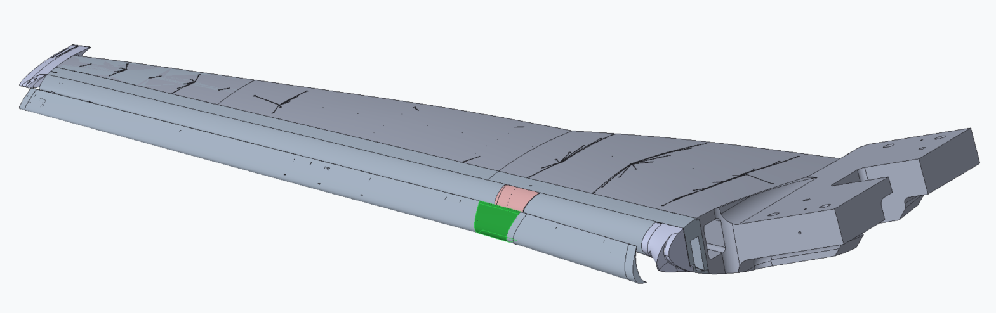
Fig. 24 Acoustic baseline full span slat configuration with slat transition highlighted in green.

C. SGF Model Design
The SGF leading-edge model has much in common with the acoustic baseline model including slat position relative to the WUSS, bracket design, slat OML, and WUSS OML. The key differences between the SGF leading-edge model and the acoustic baseline leading-edge model are the features included to allow for installation of SGF surfaces and interchangeability. As previously discussed, three variants of SGF treatment were designed for implementation in the SGF model: SFD overleaf, alternative baseline, and min-distance. The design of these SGF treatments, especially the forward and aftmost sections that allow for attachment to the model, was conducted in parallel with the SGF model design.
The original slat and WUSS geometry for the SGF and SCF models was provided by Boeing and included an unrealistically thickened slat trailing edge and cusp. The thickened trailing edge and cusp were achieved through alteration of the slat-cove wall and allowed for machining at 10% scale, where 0.010” edges were determined to be the thinnest possible trailing edge. Slat geometry for structural simulations was further modified to reduce the slat cusp and trailing edge thickness by modification of the slat-cove wall so that the slat could stow without interference.
Through design iteration and consultation with wind tunnel model safety personnel, the best path forward for installation of the SGF treatments was determined to be fastening. Representation of SGF mechanization in the support structure was determined to be unfeasible due to the small scale of the model, the challenges such intricate details add to SGF treatment interchangeability, and the safety concerns with small-scale components retaining the SGF treatments during testing.
The possibility of bonding the SGF treatments in place was also dismissed due to safety and interchangeability challenges. Regarding safety, the strength of an adhesive joint is difficult to quantify due to variation in bond quality and to differences in surface preparation. Regarding interchangeability, using adhesive joints would remove the ability to quickly interchange SGF components and would require greater expense in producing components that would bond to the SGF treatments and be interchangeable in the model.
On the aft end of the SGF treatments, the attachment to the WUSS required more extensive departure from the acoustic baseline design as the upper surface of the wing is more sensitive to surface deviation. To avoid large disruptions in the wing surface, the fasteners would be required to be slightly recessed below the WUSS upper surface. Flat head fasteners and a corresponding stringer with countersunk fastener through holes were used to clamp the aft end of the SGF into place on the WUSS. The outer surface of each stringer matches the WUSS OML. Due to volume constraints and the prescribed attachment point of the SGF to the WUSS, the stringer is installed on the upper surface of the WUSS for the entire inboard slat and the first four outboard slat sections of SGF. The stringer is installed on the lower surface of the WUSS for the remaining two outboard slat sections of SGF. The fasteners passed through the stringer, holes in the SGF treatment, a shim, and finally threaded into tapped holes on the WUSS structure. As the thickness of installed SGF components varied, shims were included to ensure the top of the stringer properly met the WUSS structure with no discontinuity. The thickness of the shim was altered for different SGF thicknesses, with the overall thickness of the SGF component and shim being equal to 0.010”. If no shim is included, a maximum SGF thickness of 0.010” can be used along the full span of the model. After the fasteners are installed, Kapton tape was used over the fastener holes to prevent any local effects on the flow. From CFD results, the stringers were also determined to lie forward of reattachment along the upper surface of the WUSS. Fig. 25 shows a cross sectional diagram of this installation method at inboard and outboard locations.

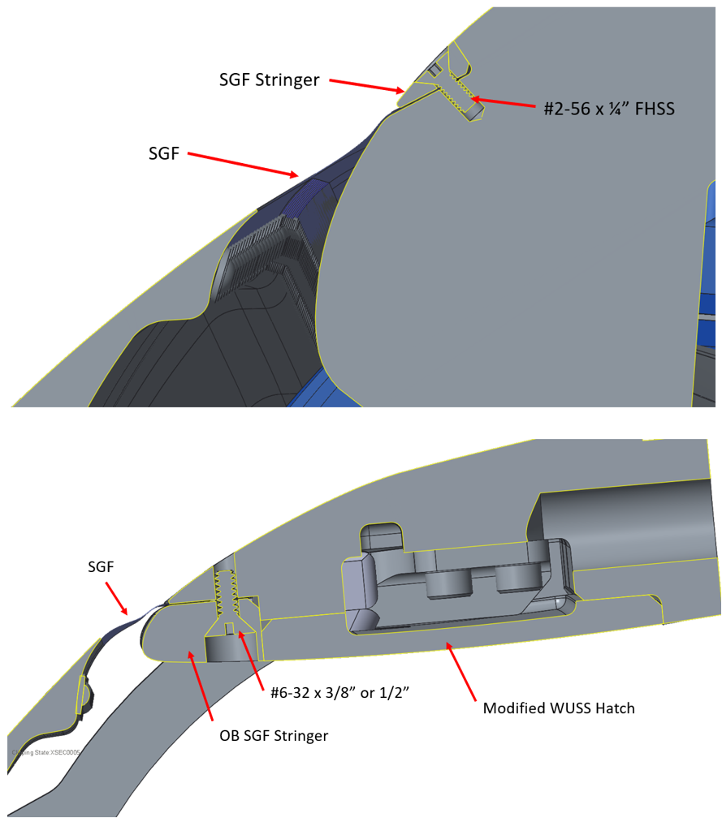
(a)
(b)
Fig. 25 WUSS installation of SFD overleaf and alternative baseline SGFs at (a) inboard and (b) outboard locations.
In order to install the SFD overleaf SGF and Alternate Baseline SGF components under the WUSS stringer as described, the SGF geometry was altered to “dive-in” to the WUSS under the stringers. This model integration feature required a slight alteration of the geometry in the unsupported length of the SGF, as a sharp departure from the unsupported length to below the stringer would be unfeasible to manufacture. A side-by-side comparison of the baseline overleaf geometry and the altered geometry for model installation is shown in Fig. 26.

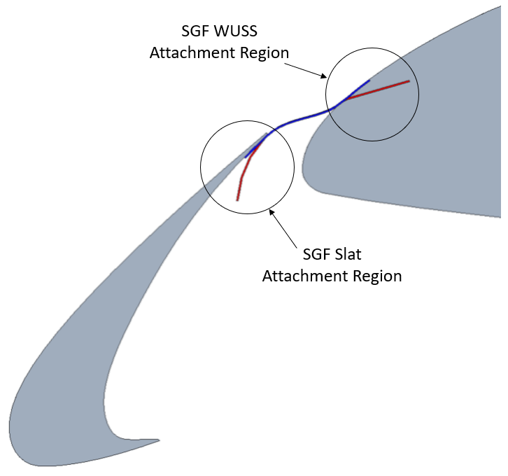
Fig. 26 SGF WUSS attachment overleaf (blue) and dive-in (red) geometry.
The forward end of the SGF was also altered to allow for fastening. The forward attachment of the SGF is to the underside of the slat, which is a location insensitive to protrusions due to recirculation in the slat cove. Hence, fasteners in this location were not required to lie below the surface of the slat OML. The trailing edge of the slat was altered, however, to allow enough depth for fastener threads while maintaining attachment of the SGF at the slat trailing edge. As a result, the geometry of the forward section of the SFD overleaf and Alternate Baseline SGF designs were altered to match the “ramp” added at the trailing edge of the slat. In addition, a small portion of the forward unsupported length of these geometries was altered to provide a smooth transition from the original geometry to the model fixturing geometry. Fasteners with malleable washers were used to install the SGF directly to the slat trailing edge. This installation technique was used for the full span of the model. Fig. 27 shows a cross sectional diagram of this installation method. Note the departure from the overleaf geometry as shown in Fig. 26 above.

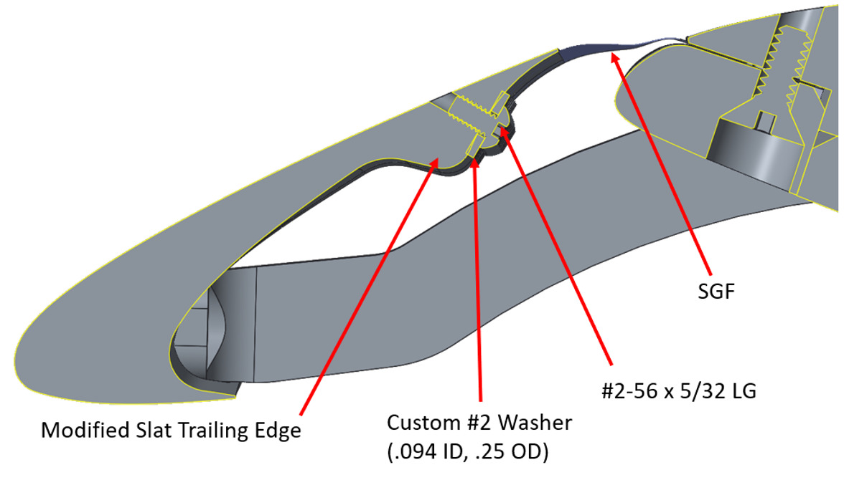
Fig. 27 SGF attachment to slat trailing edge.
The min-distance SGF treatment was mounted using the same method along the slat span as the SFD overleaf and alternative baseline SGF components. On the aft end of the min-distance SGF components, the aluminum SGF structures met the WUSS and wrapped toward the bottom surface of the wing. This alternative direction was required to avoid a negative draft angle in the aluminum structures and allow for manufacturing. The min-distance SGF components were fixtured along the lower surface of the WUSS using button head fasteners and deformable nylon washers. The fastening along the lower surface of the WUSS was considered acceptable due to geometric insensitivity on the pressure side of the wing, and because the attachment region is in the region of recirculating flow forward of stagnation on the main wing. The attachment method of the SGF min-distance design is shown in Fig. 28.
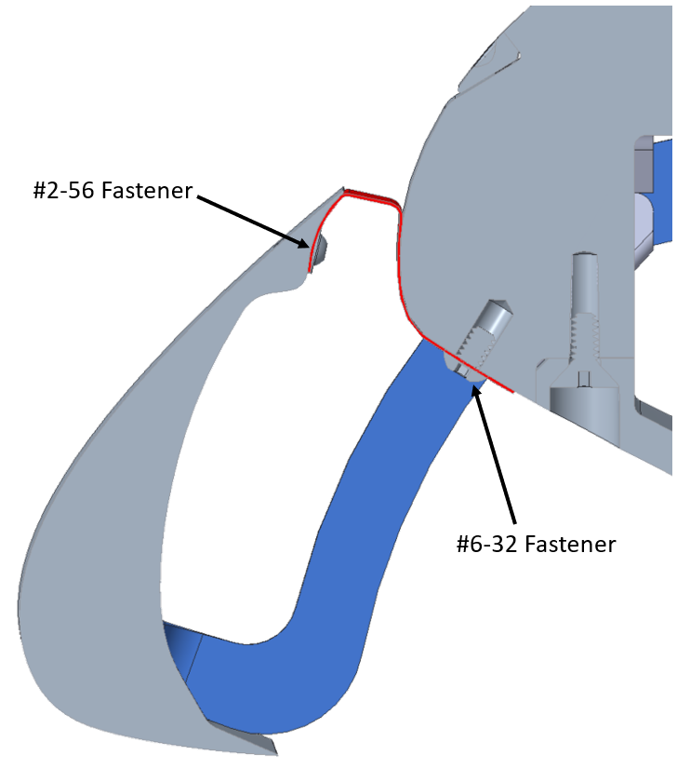
Fig. 28 Min-distance SGF attachment to SGF model.
For a full-sized aircraft, brush or other seals would ideally be used between spanwise segments of SGF treatment to fill the gap maintained to avoid interference during installation or operation in service. On the 10% scale models, brushes would be too large to fill the 0.025” gap between SGF components, so Kapton tape was used.

D. SCF Model Design
Similar to the SGF leading-edge model, the SCF leading-edge model shares many features with the acoustic baseline model, including slat position relative to the WUSS, bracket design, slat OML, and WUSS OML. The inboard slat of the SCF model is treated with SGF components and therefore the design of the SCF model matches the SGF model for the entire inboard slat section. The main alterations for the SCF model are to the outboard slat, as the outboard section of the SCF WUSS is nearly identical to the outboard section of the acoustic baseline WUSS.
Fastening was again determined to be the best method of attachment of surfaces to the SCF model, as actuation at this scale was not feasible and bonding could pose a safety risk. As previously discussed, the SCF model would be treated with a two-component system: the main and reverse auxiliary SCF components. Although fastening each of these components to the slat was required for safety, the matched pairs of components were bonded together to create a lap joint near the trailing edge of the slat.
The SCF model slat was designed to be treated with 13 main and reverse auxiliary SCF component pairs. The SCF slat incorporated leading-edge components that captured the forward edge of the main SCF components at the base of the slat-cove wall and provided mechanical boundary conditions that represented the sliding flexure hinge when fixed in the fully deployed configuration. The forward edge of each main SCF component was shimmed to achieve an overall thickness of double that shown in Table 3, aligned and attached to the slat via dowel pins that were pressed into the slat body, and captured by installation of the slat leading-edge component. The leading-edge component was then fastened to the slat structure using a series of counterbored fasteners and thereby provided clamping force on the main SCF component and shim. The fastener and pin holes on the leading edge of the slat were filled with wind tunnel model clax (clay/wax combination) prior to testing. The forward attachment of the main SCF component and the bulb near the cusp, as labeled in Fig. 29, accurately represents the boundary condition instituted in the SCF computational development, as previously discussed. Figure 29 shows the attachment of the main SCF component at the cusp of the slat.

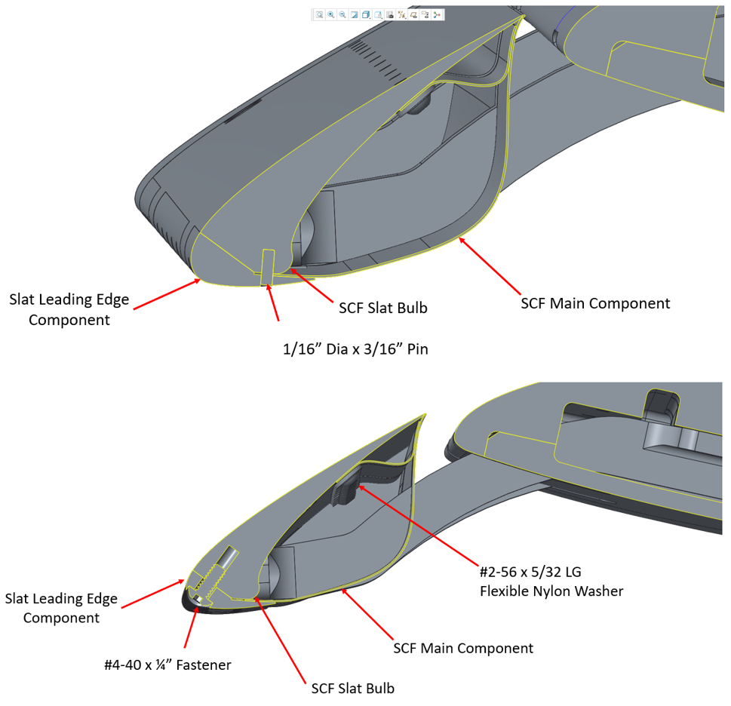
(b)
(a)
Fig. 29 Attachment of main and reverse auxiliary SCF components to the slat at different spanwise stations.
The reverse auxiliary SCF component was also fastened directly to the SCF slat. A series of button head fasteners with deformable washers were used to directly attach the reverse auxiliary SCF components to the slat at the location specified by the computational model to ensure an accurate boundary condition. Fig. 29 also shows the mounting of the reverse auxiliary SCF component to the SCF slat.
The main and reverse auxiliary SCF components were attached to each other using a bonding material, Loctite 2216. The strength of this bond was determined to be sufficient to sustain the aerodynamic load, however the fastened leading edges of both SCF components guarantee arrestment in case of bond failure. The use of bonding material between the main and reverse auxiliary SCF components, as shown in Fig. 30, allows for a desired flexibility in the joint and does not interact with the high-speed flow between the slat and the WUSS, as would protrusions from fastener heads or rivets. Due to concern that the trailing edge of the main and reverse auxiliary SCF structure may flutter in the flow and generate noise when interacting with the slat trailing edge, the model was first tested in the wind tunnel with the trailing edge of the SCF assembly bonded to the trailing edge of the slat. Later in the test sequence, this joint was released to re-perform testing with the trailing edge in freely sliding contact. Releasing the joint had no noticeable impact on the noise measurements.

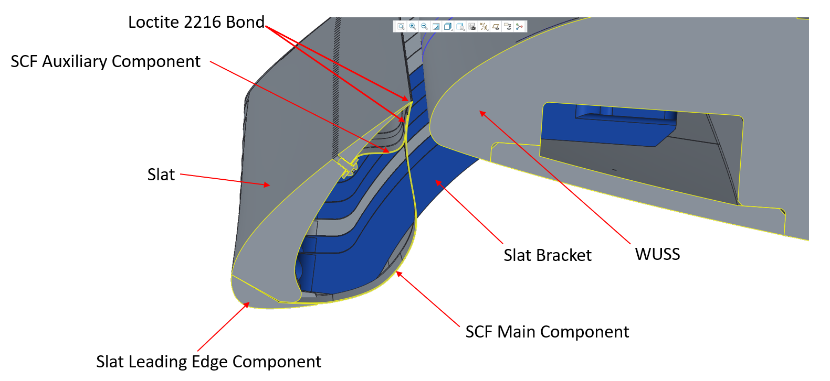
Fig. 30 SCF model cross section showing SCF component bonding locations.
As previously mentioned, the original slat and WUSS geometry was provided by Boeing and modified for structural simulations. The original geometry of the slat was modified for SCF treatment simulations by removing interference between the slat and WUSS in the stowed configuration. Interference removal resulted in an edge thickness of 0.005” (at 10% scale) at both the slat trailing edge and the cusp. Structural simulations were conducted with the thinned trailing edges, but they were impractical for the wind tunnel model. For the wind tunnel model, the original cove wall was retained in the aft part of the slat to maintain the original location for the trailing edge and to achieve an acceptable thickness of 0.010” there. The slat trailing edge was truncated by an amount (roughly the main SCF thickness) to remove interference with the main SCF component, which has a finite thickness where CFD had prescribed an infinitely thin surface for the SCF.
Kapton tape was used to bridge the gaps between main SCF components in place of brush or other seals, in a similar method to the SGF model. The tape was applied between SCF components aft of the location the bracket exits the slat cove and between SCF components and the bracket at locations forward of the location the bracket exits the slat cove.

E. Slat Tips
Unsteady flow about the slat tips is also known to produce significant aeroacoustic noise. Slat tip transitions that were motivated by previous work [36], [37] were developed for the SGF and SCF models to connect the slat tips to the WUSS. Several variants of these slat tips were developed, including a smooth transition and a stepped transition, which is representative of a structure which could realistically be installed and articulate on a full-scale aircraft. The slat tips for the 10% CRM-HL leading-edge models were 3D printed through stereolithography to ensure high resolution and allow for thin trailing edges of the tips. Images of the two main variants of transition tips and the traditional slat tip are shown in Fig. 31.

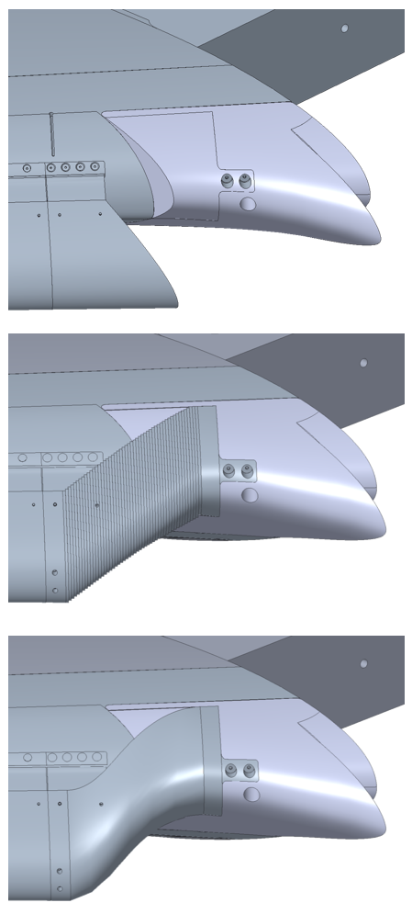
(b)
(c)
(a)

Fig. 31 (a) Traditional slat tip, (b) stepped transition slat tip, and (c) continuous transition slat tip mounted on the inboard SGF slat.
For installation of these slat transition tips onto SGF treated slats, the design ensured that no gap was formed between the slat and the WUSS, as a small gap would allow for high-speed flow that could possibly generate noise. This gap was closed either through integral structure of the slat tip transition or through inclusion of a new aluminum SGF component. The need for interchangeability between the stat tip transitions and slat tips representing conventional practice gave rise to the need for segmentation of small SGF components, exemplified for the SFD overleaf case shown in Fig. 15, at the slat ends.
Similar considerations were made for the SCF slat tips. Each SCF slat tip included a “cap” to enclose the internal cove of the slat. As the slat cove and SCF main component created a cavity, full enclosure of the cavity was necessary to avoid noise production. These SCF caps were produced in metal due to the thin dimension of the cap and the need to carry forces generated on the slat transition tips. An image of a SCF slat transition is shown in Fig. 32.
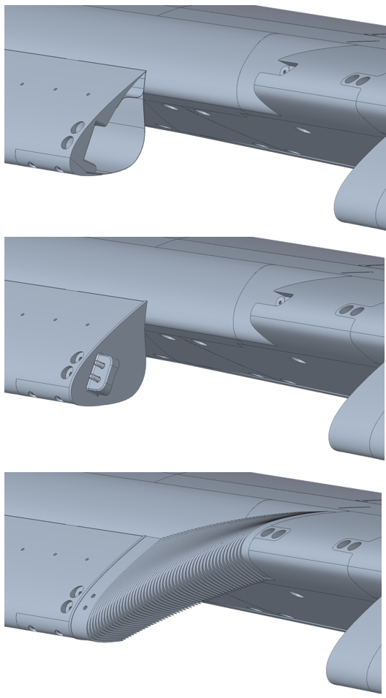
(b)
(c)
(a)
Fig. 32 (a) Inboard end of SCF slat with no tip installed, (b) a slat tip transition cove cap installed, and (c) with slat tip transition cove cap and stepped transition component installed.

F. Model Systems Reports
In order to test the described wind tunnel models in the NASA Langley 14- by 22-Foot Subsonic tunnel, a Model Systems Report was generated to ensure safety requirements were met per the Langley Procedural Requirement for Wind-Tunnel Model Systems Criteria (LPR 1710-15 Rev. K). The analysis for certification of the acoustic baseline leading-edge assembly was completed by ATI and reviewed by NASA Langley personnel. The existing hardware was previously certified through analysis completed at NASA Langley. These existing analyses were considered sufficient as the acoustic test matrix ensured the airframe was at lower angles of attack and tunnel pressures than those considered in the analyses.
The SGF and SCF leading-edge assemblies were analyzed using FEA and hand calculations. Pressure distributions from CFD analysis were used to characterize the loads acting on the semispan wing. For certification of the slat, WUSS, slat brackets, and corresponding fasteners, the full span slat configuration was considered the highest load case due to additional sections of slat and SGF. FEA was used to determine the maximum stresses on these components, with the resulting maximum realistic stress found to be on the fourth bracket, near the transition slat component and therefore the largest spanwise extent of slat between brackets. The maximum stress of 71 ksi is shown in Fig. 33 and Fig. 34. The resulting factor of safety, which produced the lowest factor of safety for the Model Systems Report, was determined to be 2.18 on the ultimate allowable stress, which is considered acceptable per LPR 1710-15 Rev. K. The FEA model for this analysis was also compared to hand calculations for analysis validation.

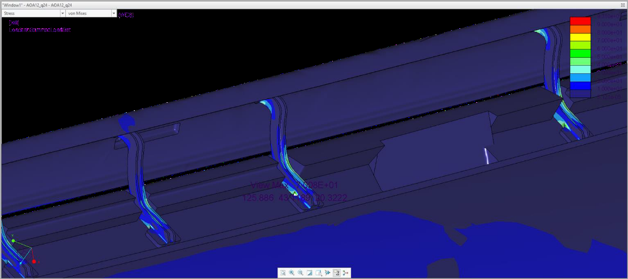
Fig. 33 Location of maximum stress in CRM-HL FEA model with acoustic slat brackets.

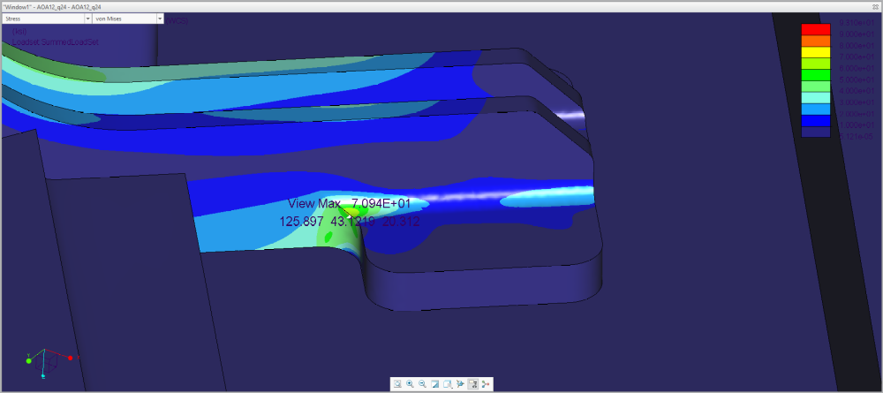
Fig. 34 Closer view of maximum stress in CRM-HL FEA model with acoustic slat brackets.
The remaining components of the SGF and SCF model assemblies were analyzed and certified through use of CFD pressure results, an estimate of maximum model loads on the airframe, and hand calculations. This includes hand calculations for attachment of slat tips, attachment of slat tip transitions, fastener tear out of SGF and SCF surfaces, and attachment of the leading-edge assemblies to the 10% CRM-HL Main Element. A dimensional analysis and stability assessment was conducted on the SGF and SCF treatments, but that study was limited to 2D cases at the time of wind tunnel testing. Nonetheless, the results of the stability assessment aided in substantiating the safety of testing the dynamically scaled SGF and SCF treatments at flight Mach numbers. The concluded MSR was reviewed by Aeronautics Systems Engineering Branch (ASEB) Models Safety Engineers and approved for wind tunnel testing.
- Conclusion
Airframe noise is an important source of environmental noise around airports because engines operate at low power settings during approach and landing such that airframe noise is often an equal contributor or even dominant in those conditions. The leading-edge slat has been identified as a key element of airframe noise. Several approaches for mitigation of slat noise have been proposed. Two that show significant promise are the slat-gap filler (SGF) and slat-cove filler (SCF). The SGF blocks the gap flow under all normal operating conditions but is autonomously opened in the event of emergency to revert to the baseline high lift configuration and the accompanying stall characteristics. The SCF fills the slat cove with a deformable structure but leaves the gap open and guides the flow between the slat and main wing in a manner that reduces flow unsteadiness and noise but maintains the baseline high-lift performance. Previous work on SGF and SCF technologies focused on 2D feasibility assessment via development of benchtop and computational models.
A high-lift version of the Common Research Model (CRM), which is an open geometry representing a twin aisle transport aircraft and was developed via Boeing-NASA collaboration, was recently developed for advancement of airframe noise reduction and other technologies. Several aspects of the 3D geometry for the CRM-HL were challenging for application of SGF and SCF technologies. Perhaps most influential was the wing thickness/gap ratio for the SGF and the slat thickness to chord ratio for the SCF.
The baseline overleaf SGF concept, a minimum-gauge deployable skin that conformally overleaves the stressed skin on the main wing when retracted, required significant advancement to accommodate the great variation in retracted shape caused by the gradient in wing thickness/gap ratio with spanwise position. Actuation configuration modifications alone or in combination with functional gradients in thickness, material properties, and/or prestress were found to be capable of compensating for the variation.
Additionally, the high-lift configuration for the CRM-HL was found to be different from previous geometries studied in that the transition geometry for the deployed overleaf SGF from the slat trailing edge to the main wing presented an adverse slope to the flow. However, CFD and CAA showed no detrimental effects on the aerodynamic or noise reduction performance. The overleaf concept was thus validated for application and potential new opportunities were opened for SGF implementations that further deviate from a conformal geometry. Two alternate configurations, the alternate baseline and min-distance, were devised that represent airframe integration different from the overleaf. Porosity is a final parameter of investigation for the SGF that was planned for testing on the CRM-HL. Modifications to the alternative baseline and min-distance design to introduce three levels of porosity with a goal of seeking a balance between resisting flow enough to create recirculation below the SGF while permitting enough flow to generate a more favorable pressure gradient on the top of the main wing for lift production at higher angles of attack.
The high-lift configuration for the CRM-HL is different from previous geometries studied in that transition geometry for the overleaf SGF from the slat trailing edge to the main wing presented an adverse slope to the flow. However, CFD and CAA showed no detrimental effects on the aerodynamic or noise reduction performance, thus validating the overleaf approach for these cases and potentially opening new opportunities for SGF implementation that further deviate from a conformal geometry. Two alternate configurations, the alternate baseline and min-distance, were devised that represent airframe integration different from the overleaf.
The baseline SCF configuration also required significant advancement for application to the 3D airframe on the CRM-HL. The slat thickness to chord ratio proved most challenging further inboard for the SCF. A sliding flexure hinge was devised at the forward attachment of the SCF to the slat and an auxiliary component was added for aft attachment to the slat. The combination of the two innovations enabled retention of the noise optimized profile for the SCF over the entire chord, autonomous stowage of excess SCF chordwise length throughout slat movement, and reduction of the actuation authority required to stow the SCF.
The maximum aerodynamic loads that the SGF and SCF treatments must sustain during wind tunnel testing, corresponding to flight conditions of Mach 0.24 and 8 degrees angle of attack, were described and applied to finite element models of the treated subsystems to size the thickness of the treatments for final design. Overleaf SGF and matched pairs of SCF components manufactured from NiTi were presented. Additionally, aluminum components representing the solid and porous alternative baseline and min-distance SGF components, and the method of their manufacture, were provided.
CRM-HL components such as the main wing element, flap system, fuselage, and engine nacelle and pylon existed prior to the start of the treated model development. The main wing element had provisions for attachment of interchangeable leading-edge assemblies consisting of slats, slat brackets (representing slat tracks in flight hardware), and the wing under slat surface (WUSS). Design of three interchangeable slat/WUSS assemblies was discussed including the acoustic baseline, SGF, and SCF assembly. The dynamically scaled SGF and SCF treatments were fastened to their respective WUSS and/or slat components for wind tunnel safety. However, design features enabling the fastened integration provided boundary conditions to the flexible treatments that were representative of flight hardware configured in the fully deployed position. Finally, stress analyses and other criteria for substantiation of wind tunnel entry for the SGF and SCF treated 10% CRM-HL was described.
The model components described herein were successfully tested in a 2020/2021 entry in the NASA LaRC 14x22 wind tunnel. All components performed as expected structurally, and the efforts to allow efficient model changes were generally effective. Although the wind tunnel components were rigidly attached to the model for tunnel safety reasons, model integration features for the SGF and SCF treatments represented flight conditions in the fully-deployed configuration. The SGF and SCF SMA components were exposed to realistic forces, yet showed no signs of flutter or failure modes, consistent with the results of a fluid-structure interaction simulation performed on an SGF component [38] and previous small-scale testing that included articulation [23]. Additional studies of articulating models under load are planned to further demonstrate the viability of the designs developed under this project. Furthermore, all of the designs were first developed at full-scale before scaling and adapting them to the 10% CRM-HL, so they are already appropriate for flight vehicles. Some specific implementation details at full-scale still require attention, but most would require knowledge of actuation mechanisms and peculiar geometric features of a particular aircraft that are not readily available. Nonetheless, simulations of full-scale implementations using reasonable assumptions about aircraft features is ongoing.

Acknowledgments
The authors gratefully acknowledge Steve Geissinger and John Lowe for fabrication of the SGF- and SCF-treated 10% CRM-HL, Carol Harrison and Clint Reese for quality assurance measurements on the SGF & SCF components, and Kenny Elliott and Justin Templeton for modal analysis of the SGF slat/WUSS assembly. The support of NASA’s Advanced Air Transport Technology Project in conducting this research is also gratefully acknowledged by the authors.

References
- Hayes, J. A., Horne, W. C., Soderman, P. T., and Bent, P. H., “Airframe Noise Characteristics of a 4.7% Scale DC-10 Model,” AIAA 1997-1594, 1997.
- Storms, B.L., Ross, J.C., Horne, W.C., Hayes, J.A., Dougherty, R.P., Underbrink, J.R., Scharpf, D.F., and Moriarty, P.J., “An Aeroacoustic Study of an Unswept Wing with a Three-Dimensional High Lift System,” NASA TM 112222, February 1998.
- Dobrzynski, W., Nagakura, K., Gehlhar, B., and Buschbaum, A., “Airframe Noise Studies on Wings with Deployed High-Lift Devices,” AIAA 1998-2337, 1998.
- Storms, B.L., Hayes, J.A., Moriarty, P.J., and Ross, J.C., “Aeroacoustic Measurements of Slat Noise on a Three-Dimensional High-Lift System,” AIAA 1999-1957, 1999.
- Choudhari, M.M., Lockard, D.P., Macaraeg, M.G., Singer, B.A., Streett, C.L., Neubert, G.R., Stoker, R.W., Underbrink, J.R., Berkman, M.E., Khorrami, M.R., and Sadowski, S.S., “Aeroacoustic Experiments in the Langley Low-Turbulence Pressure Tunnel,” NASA TM 211432, February 2002.
- Mendoza, F., and Brooks, T., “Aeroacoustic Measurements of a Wing/Slat Model,” AIAA 2002-2604, 2002.
- Terracol, M., Manoha, E., and Lemoin, B., “Noise Sources Generation in a Slat Cove: Hybrid Zonal RANS/LES Simulation and Dedicated Experiment,” AIAA 2011-3203, 2011.
- Chow, L.C., Mau, K., and Remy, H., “Landing Gears and High Lift Devices Airframe Noise Research,” AIAA 2002-2408, 2002.
- Khorrami, M. R., Humphreys, W. M., Lockard, D. P., and Ravetta, P. A., “An Assessment of Flap and Main Landing Gear Noise Abatement Concepts,” AIAA 2015-2978, 2015 AIAA/CEAS Aeroacoustics Conference, 22-26 June 2015, https://doi.org/10.2514/6.2015-2987.
- Khorrami, M. R., Lockard, D. P., Humphreys, W. M., and Ravetta, P. A., “Flight-Test Evaluation of Airframe Noise Mitigation Technologies,” AIAA 2018-2972, 2018 AIAA/CEAS Aeroacoustics Conference, 25-29 June 2018, https://doi.org/10.2514/6.2018-2972.
- Zhang, Y., Cattafesta, L., Pascioni, K., Choudhari, M., Lockard, D., Khorrami, M., and Turner, T., “Slat Noise Control Using a Slat-gap Filler,” AIAA-2020-2553, AIAA Aviation 2020 Forum, Virtual Event, June 15–19, 2020.
- Streett, C.L., Casper, J., Lockard, D.P., Khorrami, M.R., Stoker, R., Elkoby, R., Wenneman, W., and Underbrink, J., “Aerodynamic Noise Reduction for High-Lift Devices on a Swept Wing Model,” AIAA-2006-0212, 2006.
- Turner, T.L., and Long, D.L., “Development of a SMA-Based, Slat-Gap Filler for Airframe Noise Reduction,” AIAA-2015-0730, 2015.
- Scholten, W.D., Hartl, D.J., Turner, T.L., and Kidd, R.T., “Development and Analysis-Driven Optimization of Superelastic Slat-Cove Fillers for Airframe Noise Reduction,” AIAA Journal, Vol. 54, No. 3, 2016, pp. 1078–1094, doi: 10.2514/1.J054011.
- AIAA Drag Prediction Workshop Web Site: https://aiaa-dpw.larc.nasa.gov/, retrieved 20 May 2021.
- Lacy, D.S., and Sclafani, A.J., “Development of the High Lift Common Research Model (HL-CRM): A Representative High Lift Configuration for Transonic Transports,” AIAA-2016-0308, 2016.
- NASA Common Research Model Web Site: https://commonresearchmodel.larc.nasa.gov/, retrieved 17 May 2021.
- AIAA Geometry and Mesh Generation Web Site: http://www.gmgworkshop.com/, retrieved 17 May 2021.
- AIAA High Lift Prediction Workshop: https://hiliftpw.larc.nasa.gov/, retrieved 20 May 2021.\
- Zhang, Y., O’Neill, A., Cattafesta, L., Pascioni, K., Choudhari, M., Khorrami, M., Lockard, D., and Turner, T., “Assessment of Noise Reduction Concepts for Leading-Edge Slat Noise,” AIAA-2018-3461, 2018 AIAA Aviation Forum, Atlanta, GA, 25-29 June 2018.
- Zhang, Y., Cattafesta, L., Choudhari, M., Khorrami, M., Pascioni, K., Lockard, D., and Turner, T., “Investigation of the 30P30N Slat Flow Field with Passive Control Devices Using Particle Image Velocimetry,” AIAA-2021-2116, 2021 AIAA Aviation Forum, Virtual Event, 2-6 August 2021, DOI: 10.2514/6.2021-2116.
- Zhang, Y., Cattafesta, L., Pascioni, K., Choudhari, M., Lockard, D., Khorrami, M., and Turner, T., “Slat Noise Control Using a Slat Gap Filler,” AIAA-2020-2553, AIAA Aviation 2020 Forum, Virtual Event, 15-19 June 2020.
- Scholten, W., Patterson, R., Eustice, M., Cook, S., Hartl, D., Strganac, T., Turner, T., “Aerodynamic and Structural Evaluation of an SMA Slat-Cove Filler Using Computational and Experimental Tools at Model Scale,” Proc. ASME 2018 Conf. on Smart Matl., Adaptive Struct. and Intell. Sys., SMASIS2018-8129, San Antonio, TX, 10-12 September 2018.
- Mu, M. S., Schrass, J. A., Lieb, K. F., Hartl, D. J., “Aerodynamic and Aeroacoustic Experimentation of a Slat-Gap Filler for Airframe Noise Reduction,” AIAA 2021-1997, AIAA 2021 SciTech Forum, 10.2514/6.2021-1997.
- Lockard, D. P., Choudhari, M. M., and Vatsa, V. N., “Aeroacoustic Simulations of the High-Lift Common Research Model and Validation with Experiment,” to be presented at the 28th AIAA/CEAS Aeroacoustics Conference, 14-17 June 2022, Southampton, UK.
- Bahr, C. J., “Accounting for the Influence of Decorrelation in Microphone Phased Array Deconvolution Methods,” to be presented at the 28th AIAA/CEAS Aeroacoustics Conference, 14-17 June 2022, Southampton, UK.
- Hutcheson, F. V., Lockard, D. P., and Stead, D. J., “On the Alleviation of Background Noise for the High-Lift Common Research Model Aeroacoustic Test,” to be presented at the 28th AIAA/CEAS Aeroacoustics Conference, 14-17 June 2022, Southampton, UK.
- Humphreys, W. M. Jr., Lockard, D. P., Bahr, C. J., “Phased Array Characterization of Slat Noise Radiation from the High-Lift Common Research Model,” to be presented at the 28th AIAA/CEAS Aeroacoustics Conference, 14-17 June 2022, Southampton, UK.
- Lockard, D. P., Turner, T. L., Bahr, C. J., and Hutcheson, F. V., “Overview of Aeroacoustic Testing of the High-Lift Common Research Model,” AIAA AVIATION 2021 FORUM, AIAA 2021-2113, August 2021.
- Bahr, C. J., Hutcheson, F. V., Thomas, R. T., and Housman, J. A., “A Comparison of the Noise Characteristics of a Conventional Slat and Krueger Flap,” AIAA-2016-2961.
- Turner, T. L., Kidd, R. T.; Hartl, D. J., and Scholten, W. D., “Development of a SMA-Based, Slat-Cove Filler for Reduction of Aeroacoustic Noise Associated with Transport-Class Aircraft Wings,” Proc. ASME 2013 Conf. on Smart Matl., Adaptive Struct. and Intell. Sys., SMASIS2013-3100, Snowbird, UT, September 16-18, 2013.
- Scholten, W. D., Hartl, D. J., and Turner, T. L., “Analysis-Driven Design Optimization of a SMA-Based Slat-Cove Filler for Aeroacoustic Noise Reduction,” Proc. ASME 2013 Conf. on Smart Matl., Adaptive Struct. and Intell. Sys., SMASIS2013-3104, Snowbird, UT, September 16-18, 2013.
- Scholten, W., Patterson, R., Hartl, D., Strganac, T., Volpi, J., Chapelon, Q., and Turner, T., “Noise Reduction in a High-Lift Wing using SMAs: Computational Fluid-Structural Analysis,” Proc. ASME 2016 Conf. on Smart Matl., Adaptive Struct. and Intell. Sys., SMASIS2016-9196, Stowe, VT, 28-30 September 2016.
- Auricchio, F., and Sacco, E., “A One-Dimensional Model for Superleastic Shape-Memory Alloys with Different Elastic Properties Between Austenite and Martensite,” International Journal of Non-Linear Mechanics, Vol. 32, No. 6, 1997, pp. 1101–1114. https://doi.org/10.1016/S0020-7462(96)00130-8
- Melton, L. G., Lin, J. C., Hannon, J., Koklu, M., Andino, M., and Paschal, K., “Sweeping Jet Flow Control on the Simplified High-Lift Version of the Common Research Model,” AIAA 2019-3726, AIAA Aviation 2019 Forum, 17-21 June 2019, Dallas, TX, https://doi.org/10.2514/6.2019-3726.
- Khorrami, M. R., Lockard, D. P., Moore, J. B., Su, J., Turner, T. L., Lin, J. C., Taminger, K. M. B., Kahng, S. K., Verden, S. A., “Elastically Deformable Side-Edge Link for Trailing-Edge Flap Aeroacoustic Noise Reduction,” US Patent No. 8,695,925, LaRC Case No. LAR-17984-1, 15 April 2014.
- Turner, T. L., Moore, J. B., Long, D. L., Haskin, H. H., Allen, A. R., Lockard, D. P., Streett, C. L., and Khorrami, M. R., “Wing Structure for an Aircraft,” US Patent No. 11,001,368, LaRC Case No. LAR-19145-1, NASA Langley Research Center, 11 May 2021.
- Nucci, M. R., Blades, E. L., Reveles, N. D., Shah, P. N., Turner, T. L., and Lockard, D. P., “Fully Coupled Aeroelastic Stability Analysis of Adaptive Shape Memory Alloy Structural Technologies for Airframe Noise Reduction,” AIAA-2022-0317, AIAA SciTech 2022 Forum, 3-7 January 2022, San Diego, CA, DOI: 10.2514/6.2022-0317.

Aerospace Technologist, Structural Acoustics Branch, AIAA Associate Fellow
Aerospace Technologist, Space Mission Analysis Branch (formerly Analytical Mechanics Associates, Aeronautics Systems Engineering Branch)
Aerospace Technologist, Computational Aerosciences Branch, AIAA Associate Fellow
Aerospace Technologist, Structural Acoustics Branch
Scientist 4, Computational Aerosciences Branch (formerly Craig Technologies, Computational Aerosciences Branch)
Specific vendor and manufacturer names are explicitly mentioned only to accurately describe the test hardware. The use of vendor and manufacturer names does not imply an endorsement by the U.S. Government, nor does it imply that the specified equipment is the best available.
Fail-safety in this context refers to model design practices that achieve minimum factors and/or margins of safety such that any model failure causes no damage to the wind tunnel.

