Maine Ecological Forecasting II
Identifying Forest Cover and Assessing Federally Endangered Atlantic Salmon Habitat in Maine Using Earth Observations


Technical Report
Final – March 31st, 2022

Tony Bowman (Project Lead)
Jonathan Falciani
Christopher Matechik
Kelsey Preslar

Advisors:
Sean McCartney, NASA Goddard Space Flight Center, Science Systems and Applications, Inc. (Science Advisor)
Dr. Bridget Seegers, NASA Goddard Space Flight Center, Morgan State University (Science Advisor)
Joseph Spruce, Science Systems and Applications, Inc. (Science Advisor)

Previous Contributors:
Michael Corley
Philip Casey
Olivia Landry
Lily Oliver
Brian Varley

1. Abstract
Major declines in Atlantic salmon (Salmo salar) populations have occurred alongside dam construction, shifting temperatures, and changing land use and land cover (LULC), restricting the last remaining wild population in the United States to Maine. In collaboration with the Maine Department of Marine Resources and the Downeast Salmon Federation, the NASA DEVELOP team utilized Earth observations to assess changes within critical salmon habitat. The team used the Landsat 5 Thematic Mapper (TM), Landsat 8 Operation Land Imager (OLI), Sentinel-2 MultiSpectral Instrument (MSI), and National Land Cover Database (NLCD) to refine historical LULC maps from 1985 to 2021. The team also used elevation data from the Shuttle Radar Topography Mission (SRTM) and IDRISI TerrSet Land Change Modeler to forecast LULC change to 2040. From Terra Moderate Resolution Imaging Spectroradiometer (MODIS) land surface temperature (LST) data, the team derived a time series, summer averages, and anomaly maps between 2000 and 2021. The team analyzed LST in relation to LULC classes, specifically forest cover type, and in-situ stream temperature from the Spatial Hydro-Ecological Decision System (EcoSHEDS). LULC trends from 1985 to 2021 revealed a net transition of coniferous forest to other classes, such as deciduous forest and developed land. The team found an association between warmer temperatures and a greater presence of developed and mixed forest classes per 10,000 acres across Maine. These visualizations and analyses will aid partners in identifying riparian locations with ideal or unfavorable habitat conditions to inform Atlantic salmon population recovery efforts.

Key Terms
LULC, land surface reflectance, TerrSet, ecological forecasting, Landsat, MODIS, land surface temperature, critical salmon habitat

2. Introduction
2.1 Background Information
Atlantic salmon (Salmo salar) are a Federally Endangered anadromous fish species that were once abundant throughout New England (National Marine Fisheries Service, National Oceanic & Atmospheric Administration, & United States Fish & Wildlife Service, 2000). Juvenile salmon spawn in freshwater streams and develop over a 1- to 3-year period before smolting and migrating to the ocean to reach adulthood. Upon maturation, salmon return to freshwater streams to spawn (McCormick et al., 1998). These migrations can benefit aquatic ecosystems through nutrient cycling, though in recent decades, a declining Atlantic salmon population has likely reduced these effects (Hilderbrand et al., 2004; Jonsson & Jonsson, 2003).

Warming stream temperatures due to climate change are exacerbated by land use land cover (LULC) changes in riparian areas and can have a multitude of effects on aquatic populations and habitat quality (Jonsson & Jonsson, 2009; Turunen et al., 2021). Atlantic salmon are directly and indirectly affected by temperature at each life stage. Early in development, extreme temperatures can influence egg hatching and larval emergence times, while thermal extremes at the juvenile and adult stages directly influence survival by decreasing performance and limiting productivity via thermal stress (Jonsson & Jonsson, 2009). Because salmon rely on thermally optimal waters to regulate body temperature, increasing stream and air temperatures within their native range threaten population recovery potential.
Over the past two centuries, anthropogenic effects from LULC changes, dam construction, overfishing, and pollution have decreased the range of Atlantic salmon to watersheds and rivers in Maine (Figure 1; Figure D1; Saunders et al., 2006). The state of Maine is temperate, and forests cover 83 percent of its total surface area; 91 percent of that forested land is under private ownership (USDA Forest Service, 2020). Maine is known for its freshwater rivers and streams that support diverse coldwater and diadromous fish communities (Saunders et al., 2006). Forested riparian areas have shown promise to reduce the effects of climate change and pollution on aquatic species; they reduce heating of streams and rivers by providing shade and reduce siltation flow by improving stream bank stability (Krosby et al., 2018; Turunen et al., 2021).
Remote sensing data can be applied in combination with in-situ records of stream temperature, LULC changes, and population surveys to support management efforts and population recovery initiatives (Dauwalter et al., 2017; Krosby et al., 2018). The first term of this project utilized the Landsat 5 Thematic Mapper (TM) and Landsat 8 Operational Land Imager (OLI) to generate foundational LULC maps of Maine within ArcGIS Pro and quantified overall LULC change from 1985 to 2021. This team also utilized Terra Moderate Resolution Imaging Spectroradiometer (MODIS) land surface temperature (LST) datasets to create temperature anomaly maps for 2000 to 2020, and they used Global Precipitation Measurement (GPM) Integrated Multi-satellitE Retrievals (IMERG) to create precipitation anomaly maps for 2000 to 2020. The results from the first team’s study reflect shifts in approximately 1,458,374 hectares of forested land to other LULC classes from 1985 to 2021. The first team’s results also highlight regions with above or below average LST and precipitation values which can be visually and statistically compared to LULC types to understand how these climatic variables influence salmon habitat.

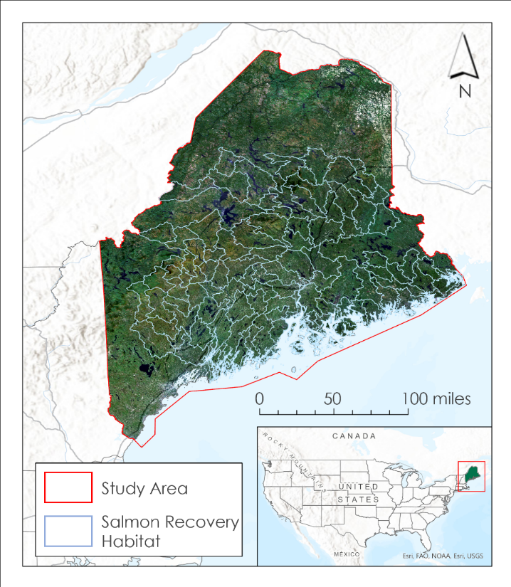
Figure 1. Study area of the state of Maine shown on a 2021 Landsat 8 OLI true color composite image with polygons representing watershed delineations for areas containing critical salmon habitat.

2.2 Project Partners & Objectives
The Maine Ecological Forecasting II team partnered with the Maine Department of Marine Resources (DMR) and the Downeast Salmon Federation (DSF) to assess changes in LULC and temperature across salmon habitat in Maine. The DMR is a state agency responsible for monitoring and restoring salmon populations in Maine through a variety of activities. The DSF is a non-profit organization that is interested in rebuilding salmon populations in Maine through cooperative conservation hatcheries and stocking, stream restoration, and land acquisition to support salmon habitat connectivity. Both partners are interested in understanding how stream temperature is driven by LST and LULC changes. The partners are also interested in forecasting LULC changes into the future so they can better plan their restoration efforts. The Maine Ecological Forecasting II team specifically focused on both partners’ interests in identifying thermally optimal waters for juvenile salmon.

To aid the partners in their salmon recovery efforts, the team refined LULC maps for 1985, 2003, and 2021 based on those generated during the first term to identify coniferous forests. LST anomalies were calculated across Maine and mapped alongside forest type to visually explore their relationship. Spatial analyses quantifying the relationship between forest type and LST were paired with the temperature anomaly maps to further assess the relationship between LST and forest type. Finally, the LULC maps of past years in the study period were used to determine LULC trends and forecast LULC changes to the year 2040.

3. Methodology
3.1 Data Acquisition
The Maine Ecological Forecasting II team collected NASA Earth observations spanning from 1985 to 2021. The team used Google Earth Engine (GEE) to acquire 30-meter spatial resolution surface reflectance datasets from Landsat 5 TM and Landsat 8 OLI (Collection 2, Tier 1, Level 2) for leaf-on (summer, May 1 – July 31) and leaf-off (winter, December 31 – March 8) dates during 1985, 2003, and 2021 (Table 1). Reflectance values were downloaded as integer types to avoid complications with image classification tools in ArcGIS Pro 2.9.0. The yearly images were composited for each leaf-on and leaf-off season using the median value for each pixel. The team masked out cloud cover in each scene, as well as snow- or ice-covered pixels during winter months. To visually validate the 2021 LULC classification conducted on Landsat imagery, the team acquired 10-meter spatial resolution Bottom of Atmosphere (BOA) Surface Reflectance data (Level 2A) from the European Space Agency Copernicus Sentinel-2 MultiSpectral Instrument (MSI) for leaf-off and leaf-on periods. LULC data from the Unites States Geological Survey (USGS) National Land Cover Database (NLCD) were used to identify woody wetlands that the team was unable to identify with spectral data alone.

The team also used GEE to acquire LST datasets from Terra MODIS for the leaf-on dates between 2000 and 2021 (Table 1). To assess the correlation between LST and in-situ stream data, the team collected stream temperature data from the Eco Spatial Hydro-Ecological Decision System (EcoSHEDS) Stream Temperature Database at the 305 sites within the Maine Coastal HUC-4 (Hydrologic Unit Code 4) subregion that collected data contemporaneously with available Terra MODIS LST from 2000 until 2021. The DMR provided Salmon Survey Data which included historical records of Young of the Year (YoY) and juvenile salmon density in various streams within Downeast Maine that informed the selection of the Maine Coastal subregion for EcoSHEDS sites. The Salmon Survey Data also included the Wright Habitat Suitability Model which delineates streams that are known to be suitable for salmon habitat.

Lastly, the team used GEE to acquire Shuttle Radar Topography Mission (SRTM) data to obtain elevation values for the state of Maine. This was used as a driver variable for change prediction with the IDRISI TerrSet Land Change Modeler (LCM). Data for driver variables also included roads and urban polygon layers from the Maine Office of GIS as well as stream and river layers from Esri, the National Atlas of the United States, and the United States Geological Survey.

Table 1
List of Sensor and Data Products utilized for this project
Platform and Sensor | Data Product | Dates | Variable(s)
Landsat 5 TM | 10.5066/P9IAXOVV | December 1984 – February 1985, May 1985 – July 1985,  December 2002 – February 2003, May 2003 – July 2003 | LULC
Landsat 8 OLI | 10.5066/P9OGBGM6 | December 2020 – February 2021, May 2021 – July 2021 | LULC
Terra MODIS | MOD11A1 | March 2000 – July 2021 | LST
Sentinel-2 MSI | 10.5066/F76W992G | December 2020 – February 2021, May 2021 – July 2021 | LULC
SRTM | 10.5067/SRTMGL1v003 | February 2000 | Elevation, Aspect, and Slope

3.2 Data Processing
3.2.1 Land Use Land Cover and Forest Cover Types
GEE exports large images as separate files, so the team mosaiced them in ArcGIS Pro using the mosaic raster geoprocessing tool. A large portion of Maine was cloud/snow masked in 2003 and filled with data from 2002 using con statements and the IsNull function in the Raster Calculator tool in ArcGIS Pro. Next, the team calculated the Normalized Difference Vegetation Index (NDVI) for leaf-on and leaf-off seasons in ArcGIS Pro using the Raster Functions pane (Da Silva et al., 2020; Equation 1).

$\text{NDVI} \text{=} \frac{\left(\text{NIR} \text{–} \text{red}\right)}{\left(\text{NIR} \text{+} \text{red}\right)}$ (1)

A modified bare index (MBI) intended to separate barren and planted/cultivated land was calculated for summer data in ArcGIS Pro by entering Equation 2 as a custom index in the raster indices tab (Nguyen et al., 2021).

$\text{MBI} \text{=} \frac{\left(\text{SWIR1} \text{–} \text{SWIR2} \text{–} \text{NIR}\right)}{\left(\text{SWIR1} \text{+} \text{SWIR2} \text{+} \text{NIR}\right)}$ (2)

The team calculated a normalized difference built-up index (NDBI) with summer data using the raster functions pane (Equation 3; Zha et al., 2003).

$\text{NDBI} \text{=}\frac{\left(\text{SWIR1} \text{–} \text{NIR}\right)}{\left(\text{SWIR1} \text{+} \text{NIR}\right)}$ (3)

MBI and NDBI values were multiplied by 1,000 and then integerized to avoid processing errors in ArcGIS Pro.

The team used the Image Classification Wizard in ArcGIS Pro to produce LULC maps for 1985, 2003, and 2021. In-situ training data were unavailable because much of Maine is privately owned; the limited data that were publicly accessible did not correspond to the forest type classes the team was trying to identify. An unsupervised, iso-clustering classification method allowed the team to delineate classes without in-situ training data. Using the NLCD dataset closest to the date of the Landsat imagery, the team removed water features (e.g., lakes, streams, rivers, ponds) to prevent class confusion. Water features were then merged back into the LULC map after classification was completed. New natural water features were unlikely to appear over the timeframe of the study period, but there was a 16-year difference between the 1985 map and the nearest NLCD Layer (2001). Winter NDVI was used to identify evergreen plants, which are mostly coniferous (cone-bearing) trees. However, some conifers, such as eastern larch (Larix laricina), are deciduous (seasonally shed leaves or needles) and were not detected. Similarly, some broadleaf trees and shrubs, such as great rhododendron (Rhododendron maximum), are not deciduous yet got classified along with conifers. Hereafter, evergreen will refer to non-deciduous conifers and broadleaf trees and shrubs, with the understanding that, in Maine, most evergreen trees are coniferous. An initial round of classification using a data stack consisting of all summer Landsat spectral bands, summer NDVI, winter NDVI, NDBI, and MBI produced an initial LULC map with 11 classes: water, barren, wetlands, evergreen forest, deciduous forest, mixed forest, shrubland, herbaceous, planted/cultivated, developed, and snow/cloud mask (Table A1). However, high rates of class confusion existed between forest types and among developed, wetlands, planted/cultivated, and barren classes. Confused classes were isolated, and the team performed a second round of classification on each to reduce class confusion. A stack consisting of all summer spectral bands, winter NIR and SWIR, winter NDVI, and summer NDVI was used for the second classification of shrublands, deciduous forest, evergreen forest, and mixed forest. A stack consisting of all summer spectral bands and MBI was used for the second classification of developed, planted/cultivated, and wetlands. Herbaceous and barren classes were not reclassified. After the second round of classification, the team compiled the classes back into one raster using the Raster Calculator tool in ArcGIS Pro.

3.2.2 Land Surface Temperature Trends on Forest Cover and Stream Temperature
The team summarized temperature trends for each year of available Terra MODIS data by computing the median LST of each pixel from March until July in GEE, corresponding to the leaf-on dates that have the relatively high annual probability of exceeding salmon’s thermal tolerance. Summer LST anomalies (A) were calculated for each pixel (i) during each year (y) between 2011 and 2021 in relation to the pixel’s summer median baseline established between 2000 and 2010 (Equation 4). This provided a metric for spatial warming trends throughout the state.

${\text{A}}_{\text{y,i}} \text{=} {\text{LST}}_{\text{y,i}} \text{–} \text{median}\left({\text{LST}}_{\text{2000-2010,}\text{i}}\right)$ (4)

For in-situ stream temperature, the team filtered each of the 305 EcoSHEDS sites in coastal Maine to include data between 11:00am and 3:00pm, the interval during which Terra MODIS flies over the region. Then, the team averaged the time series at each site into daily means to correspond with the Terra MODIS sampling period.

3.2.3 Land Use Land Cover Forecasts
The team completed a land cover change assessment and forecasted LULC to 2040 in IDRISI TerrSet’s LCM. All inputs for IDRISI TerrSet LCM were first compiled using ArcGIS Pro model builder. The spatial environment of the model was set so that all driver variables and LULC maps had the same spatial extent, which is a requirement of the LCM. The team derived aspects and slopes of the study area using the SRTM raster and ArcGIS Pro Spatial Analyst Surface toolsets. Distance from roads, urban areas, and streams was computed using the Spatial Analyst Distance Accumulation function to create individual raster layers for analysis. Due to time constraints, the team focused on inland Maine instead of including Maine’s complex coastlines and further processed LULC maps and driver variables to a coarser resolution. These steps decreased processing time. This was done using the Contract Module within TerrSet using a pixel thinning contraction rule with a contraction factor of X and Y of 2.

3.3 Data Analysis
3.3.1 Land Use Land Cover and Forest Cover Type Classifications
The team conducted a relative accuracy assessment of the unsupervised LULC classifications for each year (1985, 2003, and 2021) using roughly 400 stratified random sampling points distributed across all classes throughout the study area. Each accuracy assessment point was manually assigned a class based on a visual assessment of Google Earth Pro and Landsat true and false color imagery for all years. In addition, Sentinel-2 MSI true and false color imagery was used to assess the team’s 2021 LULC map, as the 10m pixel resolution of this dataset allowed for improved image interpretation where Google Earth Pro or Landsat imagery was suboptimal. The team compared their manual class assignments to the class assignments within the produced LULC map and compiled a confusion matrix to quantify the agreement for a given date. The confusion matrices (Tables A2-A4) display individual class accuracies and the overall accuracy for each year. Because the reference imagery used in the accuracy assessment are also derived images (as opposed to in-situ data) and may contain errors, the accuracy assessments can only measure relative, not absolute, classification accuracy.

Spectral data alone were not sufficient to identify woody wetlands, which tended to classify as one of the forest types using Landsat data. Instead, the intersection between the team’s evergreen forest class and the NLCD data was used to identify woody wetlands. All remaining evergreen forest pixels were considered evergreen uplands. These classifications are not included in the overall LULC maps but are provided separately (Figure 2).

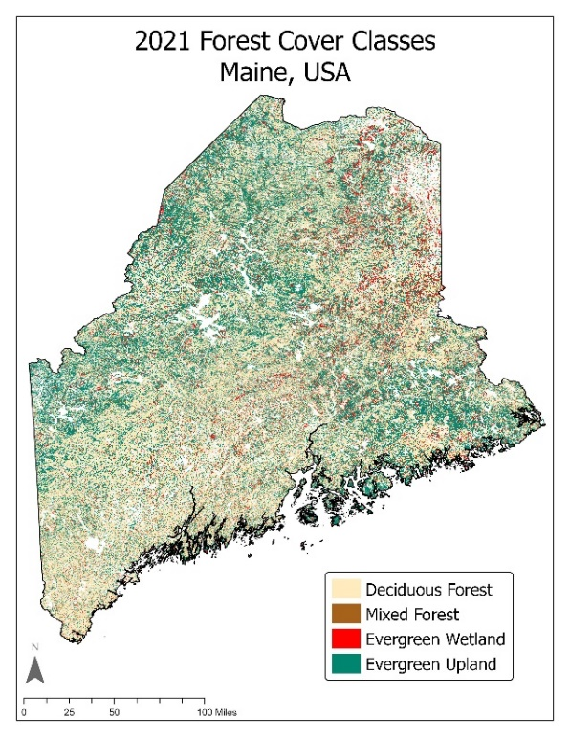
Figure 2. Forest cover map of Maine in 2021.

3.3.2 Land Surface Temperature Trends on Forest Cover and Stream Temperature
The team imported the annual summer LST and LST anomaly maps into ArcGIS Pro alongside the completed LULC maps for 2003 and 2021. Initially, the team used the Zonal Statistics tool to calculate the average LST (for 2003 and 2021) and average LST anomalies (for 2021) for each LULC class. However, this method did not provide statistical significance for the observed differences between land cover types. The team then analyzed relationships between LULC and LST by local HUC-12 sub-watershed (Table B1), merging proximate, traversable streams together for juvenile salmon. For each HUC-12 sub-watershed, the team found the average summer LST, average summer LST anomalies, average SRTM elevation, and the total area occupied by each LULC class using the Zonal Statistics Tool. Using a linear model, the team regressed LST (for 2003 and 2021) and LST anomalies (for 2021) using elevation and LULC area (Table B1). LULC area was square root transformed to meet the assumptions of normality. All explanatory variables were Z-score standardized to make coefficient estimates comparable.

To assess the collinearity between EcoSHEDS and Terra MODIS LST, the team regressed daily stream temperatures with the contemporary MODIS LST measurement at each site. Three time series for the Narraguagus River, the Orange River, and Second Lake areas were visually assessed to track the association between Terra MODIS and the in-situ stream temperature. The 8 sites that did not report temperature in Celsius were removed. To assess the variability between MODIS LST and EcoSHEDS, the team then calculated the difference between MODIS LST and EcoSHEDS for each day.

3.3.3 Land Use Land Cover Forecasts
The team completed a land cover change assessment and forecasted LULC to 2040 in IDRISI TerrSet’s LCM. Three key features were used: Land Change Analysis, Land Transition Potential Modeling, and Change Prediction. For the Land Change Analysis section, the team used land class composite images for the years 1985 to 2021 to produce an analysis of net change. Model constraints only allowed for 9 LULC class inputs. The team combined herbaceous and shrubland types for the analysis, as these LULC types were most spectrally and ecologically similar and were not a key interest of our partners. The team focused on five potential land cover transitions of changes in evergreen forests, which were of interest to our partners. Model predicting accuracy assessments also resulted in the highest accuracy when focusing only on these 5 transitions. This included evergreen to deciduous forest, mixed forest, developed, barren, and shrubland/herbaceous. Additional delineation of evergreen upland and wetlands were not yet computed at the time of the LCM analysis and therefore all evergreen forest areas were grouped as a whole for the forecasting analysis. For the Land Transition Potential Modeling, the transition-driving variables included elevation, slope, aspect, distance to roads, distance to streams, and distance to state-defined urban area polygons. All potential transitions between the selected land cover classes were then modeled from transition-driving variables using a Multi-Layer Perceptron neural network with the default parameters. Next, the transition potential maps were used to quantify the change in each transition between the five land cover classes, resulting in a land cover change map forecasted to the year 2040 based on trends between 1985 and 2021. Finally, the 2021 LULC map and the 2040 forecasted LULC map were imported into the Change Prediction feature to quantify predicted net change to evergreen forests in 2040.

4. Results & Discussion
4.1 Analysis of Results
4.1.1 Land Use Land Cover and Forest Cover Type Classifications
Refined LULC maps created this term indicate a net loss in evergreen forest stands and a net gain in developed and cultivated LULC classes (Figure 3). Figures A1-A3 in the appendix provide an enlarged view of the state for 1985, 2003, and 2021. Suboptimal imagery introduced uncertainty within cloud or snow masked areas though overall trends in LULC change are nonetheless apparent. Particularly in the Downeast region of Maine, cloud masked locations along the Machias River should be further investigated with field data to inform classifications and decipher potential temperature relationships in this region. We observed classification accuracy (i.e., agreement with reference data) of 90 percent in our 1985 map (Figure 3a) that was influenced by highly continuous forest stands correctly identified across the state. Because Maine is predominately forested, a majority of the stratified random sampling points within our accuracy assessment fell within the deciduous forest, mixed forest, and evergreen forest classes. Our LULC maps for 2003 (Figure 3b) and 2021 (Figure 3c) reflect lower classification accuracy compared to reference data (81 and 82 percent, respectively). This is potentially due to the increase in other classes such as developed and cultivated land over time, which adds further complexity to the classified map upon which the accuracy points were stratified. The observed accuracies of classifying deciduous forest (91, 80, and 92 percent for 1985, 2003, and 2021, respectively) were higher than the overall accuracies for the LULC maps. The accuracies of classifying evergreen forest (99, 90, and 92 percent for 1985, 2003, and 2021, respectively) were higher than all other classes across all years.

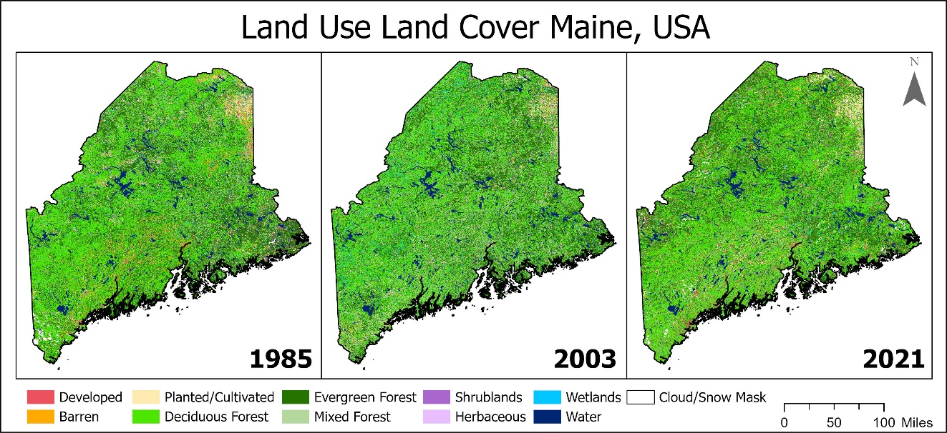
Figure 3. Land Use Land Cover of Maine for (a) 1985, (b) 2003, and (c) 2021.

The 2021 forest cover map created during this term (Figure 2) includes evergreen wetlands, which the partners were especially interested in identifying, delineated using NLCD data. Evergreen uplands were more common than evergreen wetlands. Evergreen wetlands may be under-represented due to the NLCD’s incorporation of National Wetland Inventory data, which are conservative estimators of wetlands. Due to time constraints and difficulty in visually recognizing woody wetlands from Google Earth Pro imagery, an accuracy assessment was not completed on this forest cover map, so caution must be used when applying this map in restoration initiatives. However, high accuracies within the forest types in our LULC map suggest that the data can be used for exploratory studies as long as users are aware of data limitations.

4.1.2 Land Surface Temperature Trends on Forest Cover and Stream Temperature
LST is largely associated with LULC classes across Maine’s landscape (Figure 4a-b compared to Figure 3). Some geographic features are clearly visible on the LST maps: bodies of water like Moosehead and Sebago Lakes are cool, as expected due to water’s high heat capacity, and extensive urban areas like Portland, Lewiston, and Bangor are warmer than the rural areas. These observations are reinforced by the HUC-12 statistics (Figure 5). LULC and elevation could explain nearly 50% of the variance in LST, although it could only explain 23% in LST anomalies. Planted/cultivated, barren, deciduous forest, and herbaceous areas were associated with warmer LST in 2003, and developed, deciduous forest, and mixed forest, and wetland areas were associated with warmer LST in the summer of 2021. Evergreen forest uplands and water were consistently associated with cooler sub-watersheds in 2003 and 2021 (Figure 5). Evergreen forest areas, such as those in Downeast Maine and the western mountains (Figure 4), appear to be cooler than deciduous forests (Figure 5).

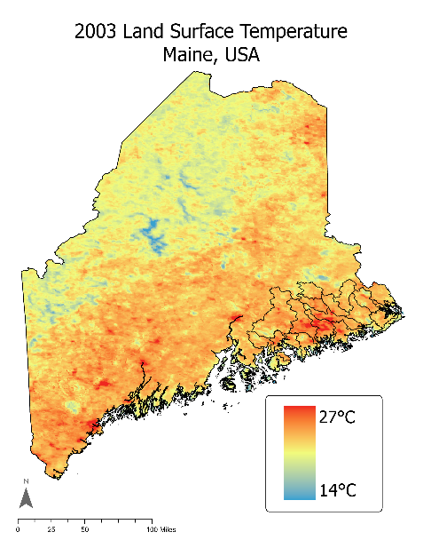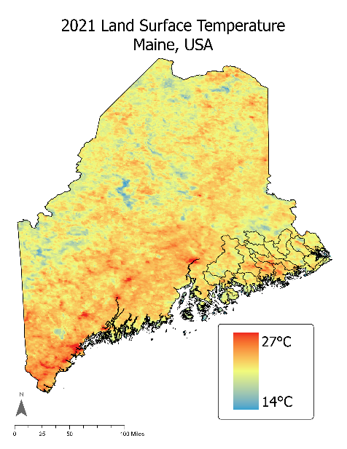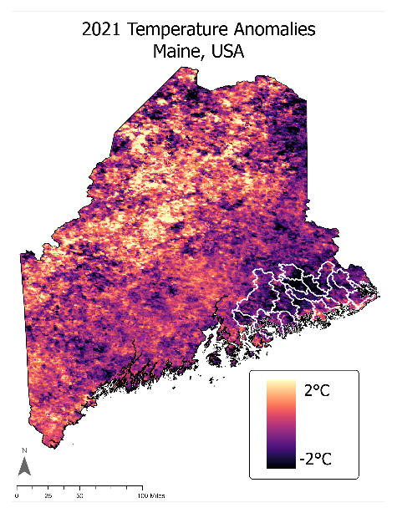
Figure 4. Map of summer (a) LST in 2003, (b) LST in 2021, and (c) LST anomalies in 2021. HUC-10 watersheds within the Downeast Salmon Habitat Recovery Unit (SHRU) are indicated.

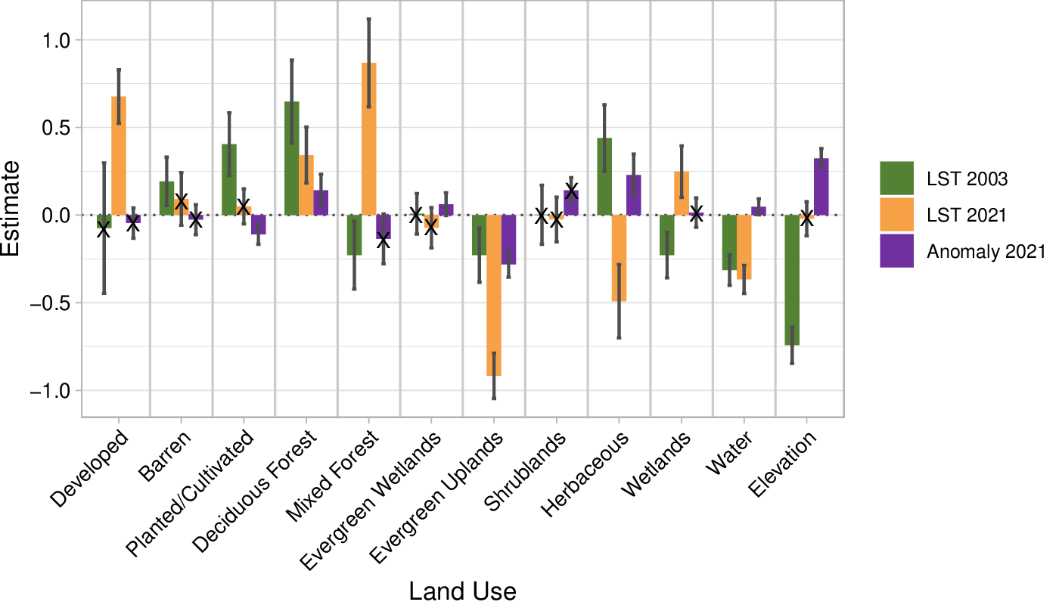
Figure 5. Estimated linear model coefficients for each LULC class and elevation for summer land surface temperature in 2003 (R² = 0.44) and 2021 (R² = 0.49), and temperature anomalies in 2021 (R² = 0.23). The bars represent one standard deviation. The crosses denote insignificant variables.

Overall, Maine is experiencing summer warming trends, despite 2003 being warmer than 2021 (Figure 4c). Throughout the state, 2011–2021 experienced summer anomalies that were 0.62°C warmer than the 2000–2010 summer baseline on average (Figure B1). These trends were not uniform; the mountains in Western Maine have warmed the most, by as much as 1.87°C in the 99.5th percentile (Figure B2), while Downeast Maine has cooled by as much as 0.88°C in the 0.5th percentile, possibly buffered by the Gulf of Maine. Evergreen forests are thus divided into a cool, and cooling, Downeast segment, and a cool, but warming, mountainous segment (Figure 4c compared to Figure 2). By including elevation in the linear model, the team was able to account for this difference, revealing that evergreen uplands have cooled more than average, while elevated areas have warmed more than average (Figure 5). The cool areas in Downeast Maine that are not associated with the warm, clear-cut regions could have a positive effect on salmon survivorship, but this warrants further study.

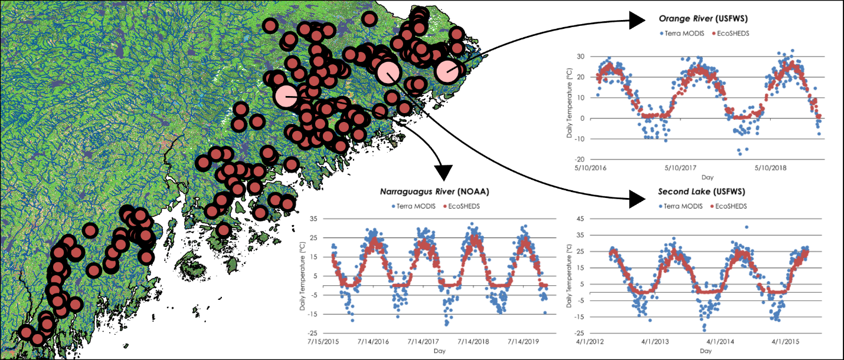
Figure 6. (Left) Map of the 305 EcoSHEDS sites that collected data between 2000 and 2021 in the Maine Coastal HUC-4 subregion, overlain on a map of Maine streams. (Right) Case studies at three selected sites, comparing Terra MODIS LST (blue) to EcoSHEDS temperature (red).

The team’s MODIS LST analysis captures the broad drivers of EcoSHEDS stream temperature as a close proxy, reinforcing the observed LST trends on LULC. However, it does not serve as a sole substitute for in-situ measurements. A visual assessment shows that LST seasonal variability consistently corresponds with the seasonal variations in stream temperature (Figure 6). This relationship is decoupled in the winter when the streams freeze. The relationship between LST and EcoSHEDS is collinear (R² = 0.80) throughout coastal Maine, where, on average, LST is only 0.16°C warmer on unfrozen days (Figure B3). However, LST does not capture the daily variability in stream temperature, with a wide standard deviation of 7.77°C. This is likely due to Terra MODIS’s coarse spatial resolution, which cannot accurately assess Maine’s smaller streams. These streams could be investigated using the finer Landsat constellation.

4.1.3 Land Use Land Cover Forecasts
The 2040 forecasting map (Figure 7) estimates losses to evergreen forest composition in the year 2040 under a business-as-usual modeling approach. Transitions of evergreen forest to developed, barren, deciduous forest, mixed forest, and shrublands were modeled for the analysis of net change from 2021 to 2040. The model does not consider the net change of evergreen forest types, but instead focuses on net loss and forecasting trends of LULC transitions from evergreen forest. Evergreen forests are projected to see the highest rate of transition to deciduous forests, followed by transitions to mixed forest, shrublands/herbaceous, developed, and lastly barren land classes (Figure 7a, Figure C1). The model produced an accuracy rate of 30.6 percent.
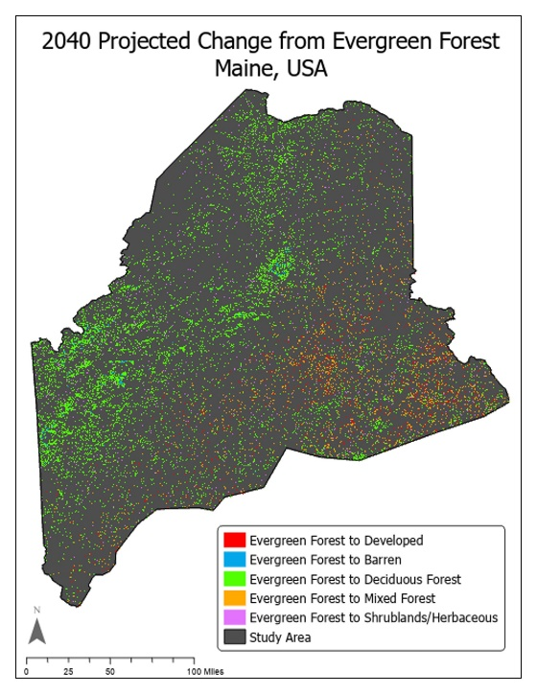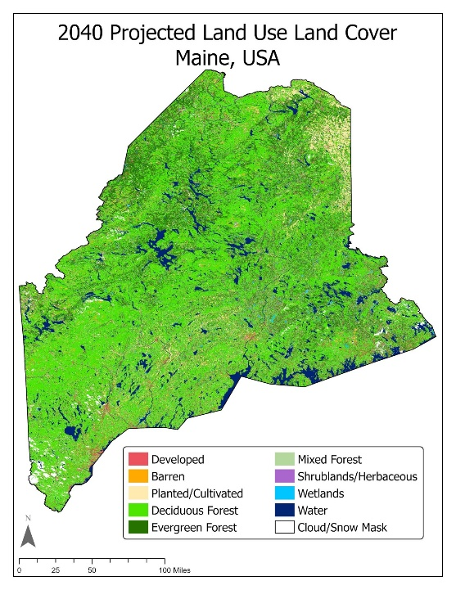
Figure 7. The figure on the left (a) shows projected transitions from evergreen forests to corresponding LULC in 2040. The map on the right (b) models these transitions as projected LULC for the year 2040.

4.2 Future Work
Future work should use end products from Term I and Term II, including refined and forecasted LULC maps, LST anomaly maps and plots, and precipitation data, for further analysis. This could include further analysis of forest cover type maps in relation to anomalous LST and precipitation change maps coupled with partner-provided fish presence datasets. More work is needed to further refine and assess LULC forecast models, which could improve the accuracy of LST analysis. An assessment of Synthetic Aperture Radar data to identify specific wetland types could aid in refining the LULC maps created by the team. Future work could also incorporate modeling for different management strategies (e.g., International Panel on Climate Change [IPCC] Representative Concentration Pathway [RCP] warming scenarios) to investigate the impact of climate change on water temperature and the forest cover types that could maintain optimal temperatures for salmon.

Forecasting model accuracy of 30.61 percent should be improved upon in future work. This could include adding additional driver variables such as soil properties, population variables, or precipitation data. Performing modeling on a smaller scale by breaking up the state into eco-regions or specific areas of the partner’s interest could also improve model accuracy. It would also be beneficial to look at more comprehensive LULC transitions that include net growth in addition to net loss to provide a clearer picture of net change in a given land class. The end products and methods from the initial two terms can be directly applied to the final DEVELOP team’s development of a workshop which will give the partners tools to integrate Earth observations and related data processing methods into their future projects.

5. Conclusions
Overall forest change between 1985 and 2021 suggests a net loss of 230,219 hectares, particularly within evergreen and mixed forest stands. Net evergreen and mixed forest loss over our study period was accompanied by an increase in other LULC classes, such as developed and cultivated land along with deciduous forests. The 30m resolution of the Landsat images, as well as suspected misclassification between deciduous forest stands and evergreen forests stands that were clear-cut over the fall each year, introduced uncertainty to our LULC maps. The team’s comparison of in-situ stream temperature data and LST indicate LST is a useful proxy for stream temperatures during the summer months. Based on the team’s results, the loss of evergreen forests associated with lower average LST could impact habitat suitability in these riparian zones during summer months. Since Atlantic salmon are known to rely on cool water refugia when stream temperatures exceed the species’ thermal optimum of roughly 18° Celsius, these refugia could be limited by deforestation associated with changes to land types with a higher LST and stream temperature. The average LST and temperature anomaly maps created this term reflect an association between evergreen forests and cooler temperatures which could maintain stream temperatures in salmon refugia later into the spring and early summer during critical lifecycle stages.

6. Acknowledgments

The Spring 2022 Maine Ecological Forecasting II Team would like to thank the project partners, science advisors, and additional supporters: Dwayne Shaw of the Downeast Salmon Federation and Ernie Atkinson of the State of Maine Department of Marine Resources; Sean McCartney, Science Systems & Applications, Inc., NASA Goddard Space Flight Center; Dr. Bridget Noreen Seegers, NASA Goddard Space Flight Center, Morgan State University; Joseph Spruce, Science Systems & Applications, Inc.; Dr. Nicole Ramberg-Pihl, Science Systems & Applications, Inc., NASA Goddard Space Flight Center; Dr. John Bolten, NASA Goddard Space Flight Center; Dr. Kenton Ross, NASA Langley Research Center; and Caroline Williams, Science Systems & Applications, Inc.

Any opinions, findings, and conclusions or recommendations expressed in this material are those of the author(s) and do not necessarily reflect the views of the National Aeronautics and Space Administration.

This material is based upon work supported by NASA through contract NNL16AA05C.

This material contains modified Copernicus Sentinel data (2020, 2021), processed by ESA.

7. Glossary
Anadromous – Fish that migrate upstream from the sea for spawning
Diadromous – Fish that migrate between fresh and saltwater environments in different life stages
DMR – The State of Maine Department of Marine Resources
DSF – The Downeast Salmon Federation
Earth observations – Satellites and sensors that collect information about the Earth’s physical, chemical, and biological systems over space and time
GEE – Google Earth Engine
GIS – Geographic Information Systems
GPM – Global Precipitation Measurement
IMERG – Integrated Multi-satellite Retrievals for GPM
Landsat – Family of satellite missions in NASA’s Earth observing fleet in collaboration with USGS
LCM – Land Change Modeler from TerrSet software toolkit
LST – Land Surface Temperature
LULC – Land Use Land Cover
MODIS – Moderate Resolution Imaging Spectroradiometer
NLCD – National Land Cover Database
NDVI – Normalized Difference Vegetation Index
OLI – Operational Land Imager
EcoSHEDS – Eco Spatial Hydro-Ecological Decision System
Smolt – Life cycle stage wherein salmon first migrate to sea
SRTM – Shuttle Radar Topography Mission
TM – Thematic Mapper

8. References
Da Silva, V. S., Salami, G., Da Silva, M. I. O., Silva, E. A., Monteiro Junior, J. J., & Alba, E. (2020). Methodological evaluation of vegetation indexes in land use and land cover (LULC) classification. Geology, Ecology, and Landscapes, 4(2), 159–169. https://doi.org/10.1080/24749508.2019.1608409
Dauwalter, D. C., Fesenmyer, K. A., Bjork, R., Leasure, D. R., & Wenger, S. J. (2017). Satellite and airborne remote sensing applications for freshwater fisheries. Fisheries, 42(10), 526–537. https://doi.org/10.1080/03632415.2017.1357911

Hilderbrand, G. V., Farley, S. D., Schwartz, C. C., & Robbins, C. T. (2004). Importance of salmon to wildlife: Implications for integrated management. Ursus, 15(1), 1–9. https://doi.org/10.2192/1537-6176(2004)015<0001:IOSTWI>2.0.CO;2
Jonsson, B. & Jonsson, N. (2003) Migratory Atlantic salmon as vectors for the transfer of energy and nutrients between freshwater and marine environments. Freshwater Biology, 48(1), 21–27. https://doi.org/10.1046/j.1365-2427.2003.00964.x
Jonsson, B., & Jonsson, N. (2009). A review of the likely effects of climate change on anadromous Atlantic salmon Salmo salar and brown trout Salmo trutta, with particular reference to water temperature and flow. Journal of Fish Biology, 75(10), 2381–2447. https://doi.org/10.1111/j.1095-8649.2009.02380.x
Krosby, M., Theobald, D. M., Norheim, R. & McRae, B. H. (2018) Identifying riparian climate corridors to inform climate adaptation planning. PLoS One, 13(11). Article e0205156. https://doi.org/10.1371/journal.pone.0205156
McCormick, S. D., Hansen, L. P., Quinn, T. P., & Saunders, R. L. (1998). Movement, migration, and smolting of Atlantic salmon (Salmo salar). Canadian Journal of Fisheries and Aquatic Sciences, 55(S1), 77–92. https://doi.org/10.1139/d98-011
NASA JPL (2013). NASA Shuttle Radar Topography Mission Global 1 arc second [Data set]. NASA EOSDIS Land Processes DAAC. Accessed 2022-03-29 from https://doi.org/10.5067/MEaSUREs/SRTM/SRTMGL1.003
National Marine Fisheries Service, National Oceanic and Atmospheric Administration, & United States Fish & Wildlife Service (2000). Endangered and Threatened Species; Final Status for a Distinct Population Segment of Atlantic Salmon (Salmo salar) in the Gulf of Maine, 65 Fed. Reg. 69459. Effective Date: 12/18/2000. https://www.federalregister.gov/documents/2000/11/17/00-29423/endangered-and-threatened-species-final-endangered-status-for-a-distinct-population-segment-of
Nguyen, C. T., Chidthaisong, A., Kieu Diem, P., Huo, L.-Z. (2021). A modified bare soil index to identify bare land features during agricultural fallow-period in southeast Asia using Landsat 8. Land, 10(3), Article 231. https://doi.org/10.3390/land10030231
Saunders, R., Hachey, M. A., & Fay, C. W. (2006). Maine’s diadromous fish community: Past, present, and implications for Atlantic salmon recovery. Fisheries, 31(11), 537–547. https://doi.org/10.1577/1548-8446
Turunen, J., Elbrecht, V., Steinke, D., & Aroviita, J. (2021) Riparian forests can mitigate warming and ecological degradation of agricultural headwater streams. Freshwater Biology, 66(4), 785–789. https://doi.org/10.1111/fwb.13678
USDA Forest Service (2020). Forests of Maine, 2019. Resource Update FS-236. Madison, WI: U.S. Department of Agriculture, Forest Service. 2p. https://doi.org/10.2737/FS-RU-236
U.S. Fish and Wildlife Service and National Marine Fisheries Service (2019). Recovery Plan for the Gulf of Maine Distinct Population Segment of Atlantic Salmon (Salmo salar). 74pp. https://www.fisheries.noaa.gov/resource/document/recovery-plan-2019-gulf-maine-distinct-population-segment-atlantic-salmon-salmo
USGS (2021) USGS EROS Archive – Landsat Archives – Landsat 5 TM Level –2 Data Products [Data set]. Retrieved from https://www.usgs.gov/core-science-systems/nli/landsat/landsat-collection-2-level-2-science-products Accessed February 1st, 2022. https://doi.org/10.5066/P9IAXOVV
USGS (2021) USGS EROS Archive – Landsat Archives – Landsat 8 OLI and TIRS Level –2 Data Products [Data set]. Retrieved from https://www.usgs.gov/core-science-systems/nli/landsat/landsat-collection-2-level-2-science-products Accessed February 1st, 2022. https://doi.org/10.5066/P9OGBGM6
USGS (2021) USGS EROS Archive – Sentinel Archives – Sentinel-2 MSI Level 2A Data Products [Data set]. Retrieved from https://www.usgs.gov/centers/eros/science/usgs-eros-archive-sentinel-2?qt-science_center_objects=0#qt-science_center_objects. Accessed February 22nd, 2022. https:/doi.org/10.5066/F76W992G
Wan, Z., Hook, S., & Hulley, G. (2015). MOD11A1 MODIS/Terra Land Surface Temperature/Emissivity Daily L3 Global 1km SIN Grid V006 [Data set]. NASA EOSDIS Land Processes DAAC. Accessed 2022-02-17 from https://doi.org/10.5067/MODIS/MOD11A1.006
Zha, Y., Gao, J., and Ni, S. (2003). Use of normalized difference built-up index in automatically mapping urban areas from TM imagery. International Journal of Remote Sensing, 24(3), 583–594. https://doi.org/10.1080/01431160304987

9. Appendices

Appendix A
Table A1
LULC classification scheme for all years.

Class ID | LULC Type | Class Description
1 | Water | Freshwater streams, lakes, and rivers that include salmon habitat
2 | Barren | Areas not covered by vegetation, or covered by sparse vegetation, that promote runoff of pollutants into water system
3 | Wetlands | Non-woody areas periodically flooded
4 | Evergreen Forest | Softwood predominates; mainly coniferous spp. including Northern White Cedar groves and managed balsam fir plantations; non-deciduous
5 | Deciduous Forest | Hardwood predominates; >50 percent of trees within selected area are deciduous
6 | Mixed Forest | Forested areas where neither evergreen nor deciduous trees dominate the stand
7 | Shrubland | Areas that are predominantly woody shrubs, such as blueberries, and lack a complex overstory
8 | Herbaceous | Vegetated areas lacking woody shrubs and trees and having no overstory
9 | Planted/Cultivated | Areas cultivated for row crops, blueberry farms, and other agriculture
10 | Developed | Built-up developed areas often with high impervious cover that promotes surface runoff of water and pollutants
11 | Cloud/Snow Mask | Areas that were not classified because Landsat pixels were removed during the cloud and snow masking process, resulting in insufficient data

Table A2
Accuracy assessment error matrix for 1985 LULC classification prior to excluding masked pixels in overall User’s accuracy calculation to avoid this accuracy bias from this class.

Class | Total # of Points per Class | Producer’s Accuracy | User’s Accuracy | Kappa Coeff.
Cloud/Snow Mask | 10 | 1 | 1 | 0
Water | 53 | 0.96 | 1 | 0
Developed | 8 | 0.63 | 0.5 | 0
Barren | 10 | 0.8 | 0.533 | 0
Deciduous | 134 | 0.96 | 0.91 | 0
Evergreen | 135 | 0.93 | 0.99 | 0
Mixed | 37 | 0.75 | 0.82 | 0
Shrubland | 9 | 1 | 0.9 | 0
Herbaceous | 7 | 1 | 0.7 | 0
Planted/Cultivated | 10 | 0.6 | 0.6 | 0
Wetlands | 15 | .53 | 0.8 | 0
Total | 428 |  | 0.9 | 0.88
Table A3
Accuracy assessment error matrix for 2003 LULC classification. This classification was not affected by snow and cloud masked pixels.

Class | Total # of Points per Class | Producer’s Accuracy | User’s Accuracy | Kappa Coeff.
Water | 53 | .94 | 1 | 0
Developed | 13 | 0.54 | 0.7 | 0
Barren | 9 | 0.44 | 0.4 | 0
Deciduous Forest | 123 | 0.86 | 0.8 | 0
Evergreen Forest | 139 | 0.82 | 0.9 | 0
Mixed Forest | 47 | 0.78 | 0.8 | 0
Shrubland | 11 | 0.55 | 0.6 | 0
Herbaceous | 11 | 0.64 | .58 | 0
Planted/Cultivated | 4 | 0.5 | .2 | 0
Wetlands | 9 | 0.4 | .33 | 0
Total | 419 |  | 0.8 | .75

Table A4
2021 accuracy assessment error matrix prior to excluding masked pixels in overall User’s accuracy calculation to avoid this accuracy bias from this class.
Class | Total # of Points per Class | Producer’s Accuracy | User’s Accuracy | Kappa Coeff.
Cloud/Snow Mask | 10 | 1 | 1 | 0
Water | 50 | .98 | .98 | 0
Developed | 8 | .625 | .33 | 0
Barren | 10 | .5 | .5 | 0
Deciduous Forest | 161 | .88 | .92 | 0
Evergreen Forest | 121 | .87 | .92 | 0
Mixed Forest | 25 | .72 | .88 | 0
Shrubland | 5 | .4 | .2 | 0
Herbaceous | 2 | .5 | .1 | 0
Planted/Cultivated | 8 | .75 | .55 | 0
Wetlands | 16 | .5 | .8 | 0
Total | 416 |  | .84 | .79

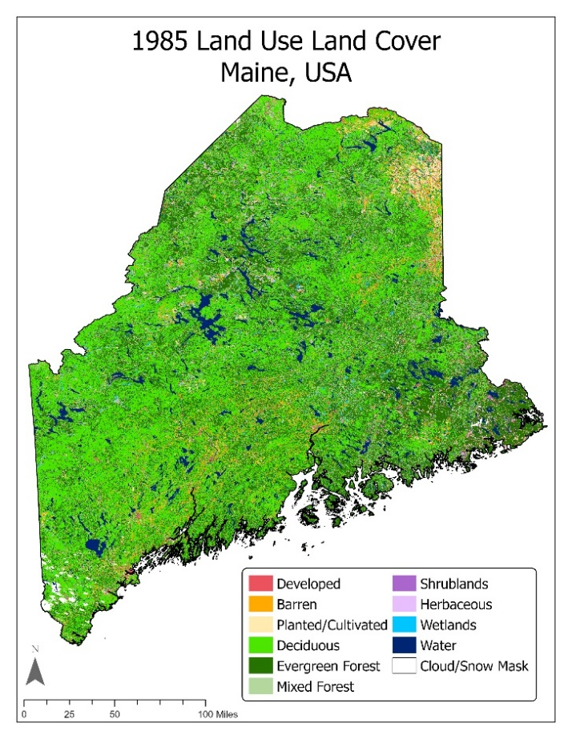
Figure A1. LULC map of Maine in 1985.

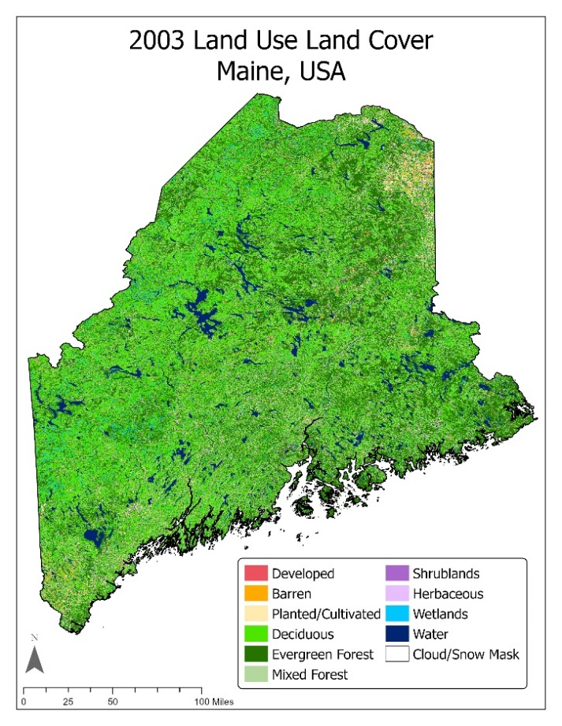
Figure A2. LULC map of Maine in 2003.

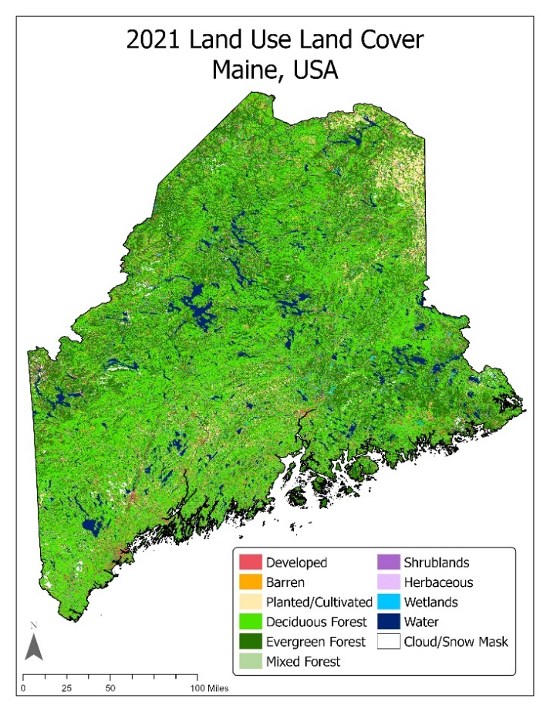
Figure A3. LULC map of Maine in 2021.

Appendix B
Table B1
The linear regression models used to analyze trends in LST (2003 and 2021), LST anomalies (2021), and EcoSHEDS stream temperature.
Analysis | Scale | Dependent Variable | Explanatory Variables
LST 2003 | HUC-12 sub-watershed | Average MODIS LST in 2003 | Area developed, area barren, area planted/cultivated, area deciduous forest, area mixed forest, area evergreen wetlands, area evergreen uplands, area shrublands, area herbaceous, area wetlands, area water, average elevation
LST 2021 | HUC-12 sub-watershed | Average MODIS LST in 2021 | Area developed, area barren, area planted/cultivated, area deciduous forest, area mixed forest, area evergreen wetlands, area evergreen uplands, area shrublands, area herbaceous, area wetlands, area water, average elevation
Anomaly 2021 | HUC-12 sub-watershed | Average MODIS LST anomaly in 2021 | Area developed, area barren, area planted/cultivated, area deciduous forest, area mixed forest, area evergreen wetlands, area evergreen uplands, area shrublands, area herbaceous, area wetlands, area water, average elevation
EcoSHEDS | EcoSHEDS site | Daily EcoSHEDS temperature | MODIS LST

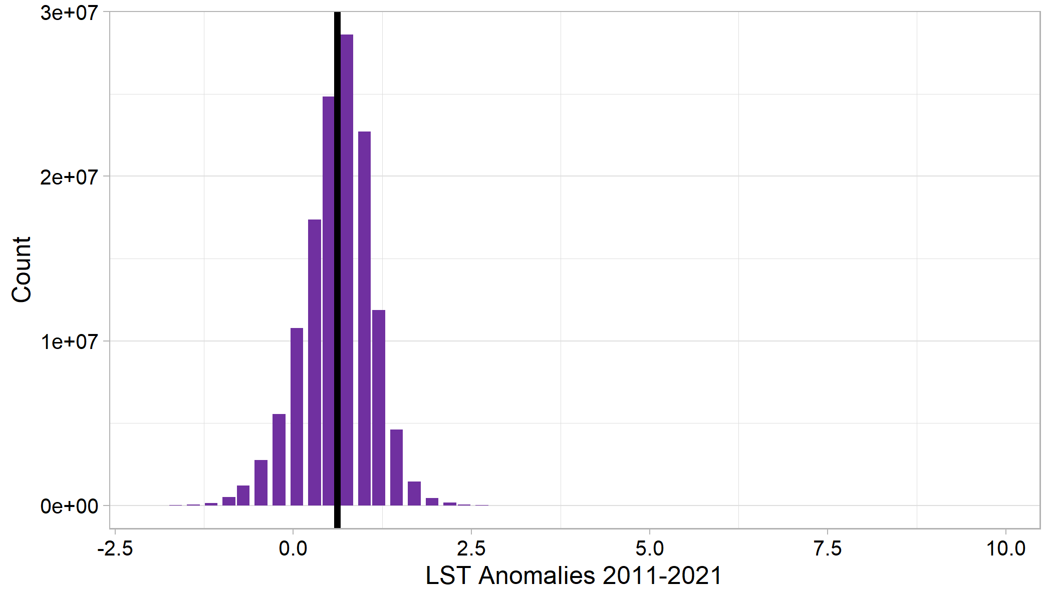
Figure B1. The distribution of decadal anomalies between 2011 and 2021. The mean (0.62°C) is indicated by the black vertical line.

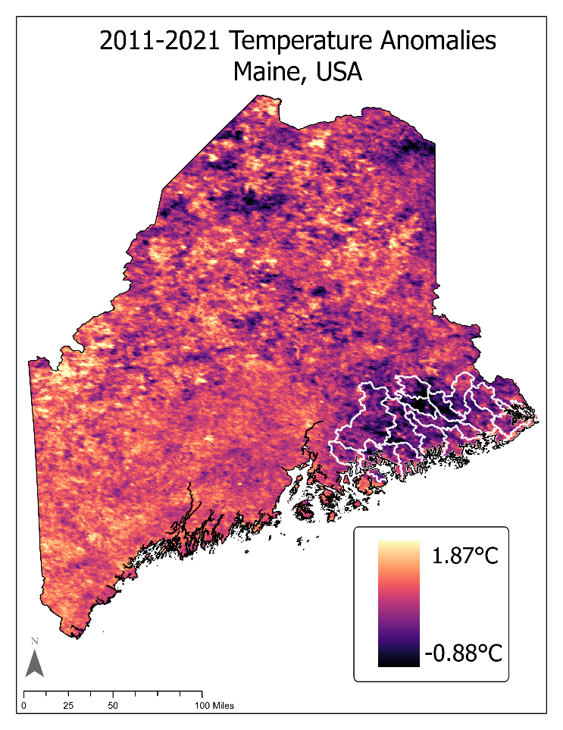
Figure B2. Decadal median temperature anomalies between 2011 and 2021 in relation to the 2000–2010 baseline. HUC-10 watersheds within the Downeast SHRU are indicated.

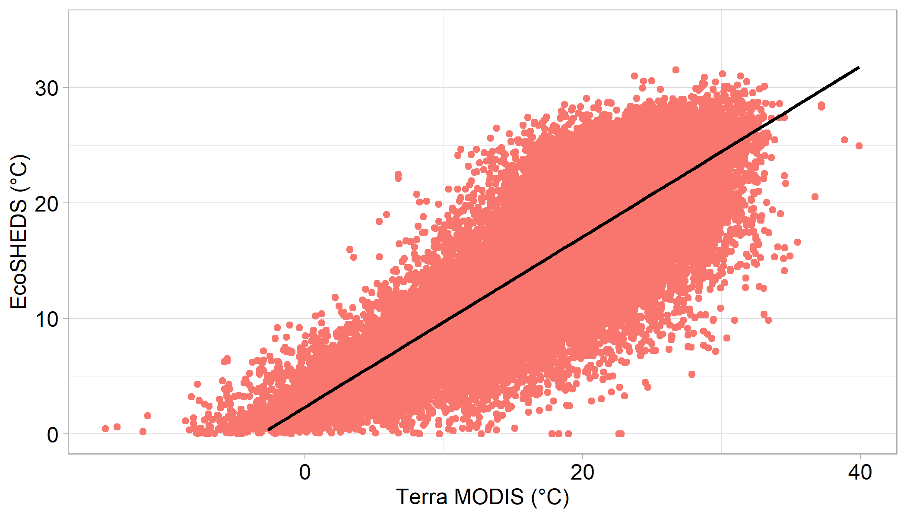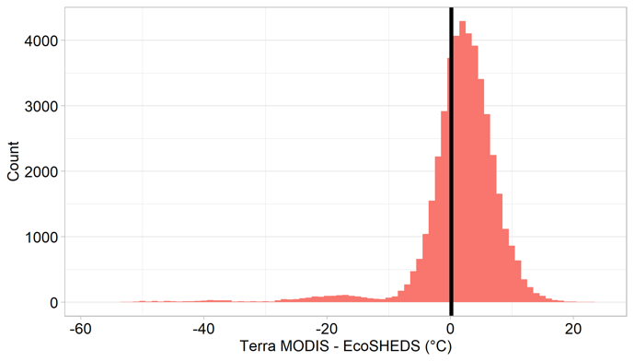
Figure B3. (Left) EcoSHEDS stream temperature versus Terra MODIS LST with a regrssion line (R² = 0.80). (Right) A histogram of the difference between MODIS LST and the contemporary EcoSHEDS temperature at each site for April through November, where mean is indicated with a vertical black line (mean = 0.16°C, median = 1.36°C, standard deviation = 7.77°C).

Appendix C

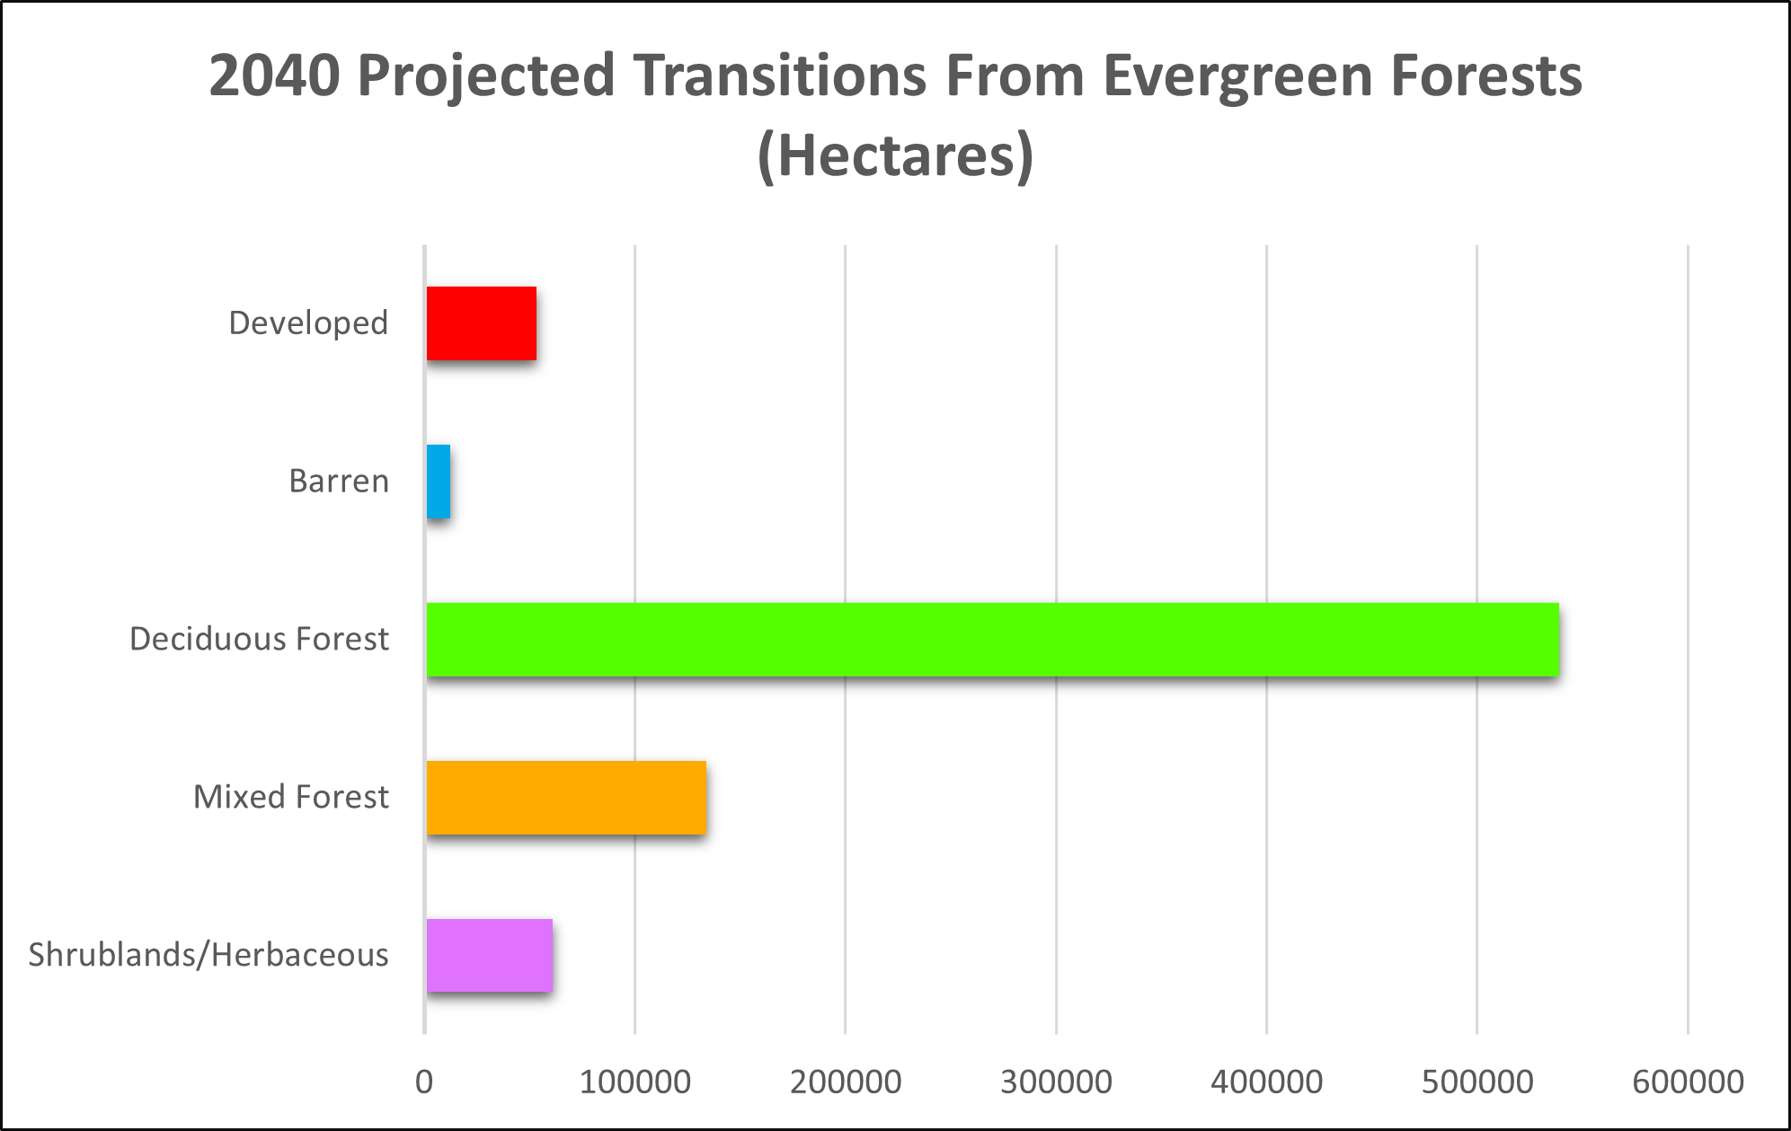

Figure C1. Projected change of evergreen forests to corresponding LULC classes in Maine for the year 2040.

Appendix D
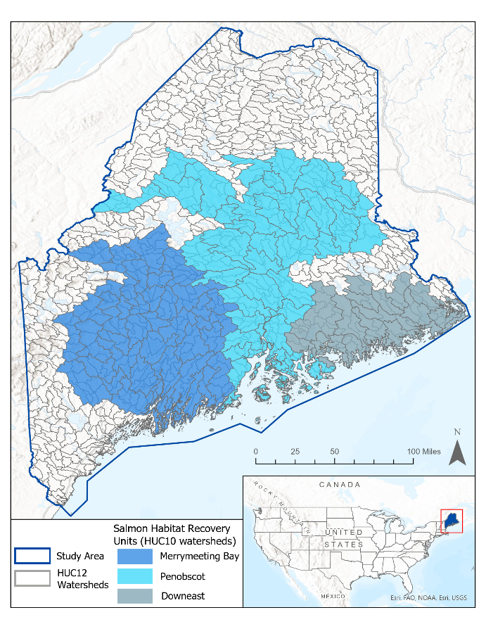
Figure D1. Study area map of Maine including HUC-12 watersheds and Salmon Habitat Recovery Units delineations.

