Grand Valley Ecological Forecasting
Assessing Trends in Pinyon-Juniper Habitat Relative to Drought, Beetle Infestation, Wildland Fires, and Treatment to Plan Future Management Strategies


Technical Report
Final Draft – March 31st, 2022

Garrett Powers (Project Lead)
Elizabeth Stone
Kolawole Arowoogun
Mitchell Tree

Advisors:
Keith Weber, Idaho State University, GIS Training and Research Center (Science Advisor)
Joe Spruce, SSAI (Science Systems and Applications, Inc.), Diamondhead, MS (Science Advisor)

1. Abstract
Drought, beetle infestation, and more frequent wildfires are changing the composition and distribution of the pinyon-juniper woodland and sagebrush ecosystems of the Grand Valley in western Colorado. Land managers must consider short- and long-term goals for restoration as well as budgetary and personnel limitations after such disturbances. Satellite remote sensing can provide long-term and continuous vegetation monitoring to assess where restoration is needed most and where treatment practices are most likely to succeed. Harnessing Earth observation data, our team set out to observe trends in disturbances and the distribution of pinyon-juniper woodlands and sagebrush communities of National Park Service (NPS) and Bureau of Land Management (BLM) lands within the Grand Valley. We used imagery from the Moderate Resolution Imaging Spectroradiometer (MODIS) aboard the Aqua and Terra satellites, and Landsat sensors to map landcover change within these ecosystems from 1984–2021. Additionally, we analyzed disturbed areas and treatment sites to understand their effect on long-term vegetation health and recovery. Results showed that pinyon-juniper woodland has expanded in extent more than other landcover types, indicating woody encroachment into sagebrush ecosystems. We also found that wildfire disturbances had lasting impacts up to 20 years post-disturbance. Pre-fire treatment practices showed mixed results regarding their effectiveness at stopping fires and promoting post-fire recovery. These results will provide context to public land managers in the Grand Valley when developing management plans, ecological monitoring locations, and implementing treatment practices for future disturbances.

Key Terms
land cover change, fire management, pinyon-juniper woodlands, Ips beetle, sagebrush, satellite imagery

2. Introduction
2.1 Background Information
Pinyon-juniper woodlands (PJW) are a major vegetation cover type in the United States (US), with approximately 35 percent of Colorado and other conterminous states classified as this land cover type (Peters and Cobb, 2008). These woodlands are vital forest ecosystems, which support wildlife habitat and provide watershed protection (Gottfried et al., 1995). However, PJW are experiencing increasing natural disturbances, the impacts of which include a reduction in forest productivity and an increased risk of damage to the forest ecosystem (National Park Service, 2008). Owing to the impact of these disturbances, natural resource managers and policymakers need information on land cover change to help minimize damage from wildfire and insect outbreaks, and to help inform future management strategies (Pontius et al., 2020).

In-situ surveys of individual trees are a proven method of quantifying forest disturbance impacts; however, such methods are limited by time, labor, and spatial scale. In contrast, remote sensing provides a potential alternative means to monitor large areas and has been successful at detecting vegetation biophysical response (Pontius et al., 2020). In addition, the historical record of satellite coverage provides vital data crucial for identifying underlying changes in forest disturbances, which improve the understanding of forest management practices.

Several studies have used remote sensing to assess land cover change caused by disturbance. For example, Vogelmann et al. (2012) used a Landsat time series to analyze four study areas in the United States with diverse forest ecosystems. This analysis revealed gradual changes in the vegetation density throughout sagebrush, woodland, forest, and rangeland ecosystems. The 30-meter spatial resolution imagery from Landsat satellites were used in the study. Such data has been used previously for wildfire mapping using multitemporal datasets to augment ground-based assessments and provide regional maps where ground survey maps are not available (Brewer et al., 2005).

Our study area lies within a subsection of the Colorado Plateau which encompasses parts of Utah and Colorado (Figure 1). We are focusing on the Grand Valley region of Colorado and Utah, specifically the McInnis Canyon National Conservation Area, Dominguez-Escalante National Conservation Area, and Colorado National Monument. The study area consists of semi-arid high desert with habitat types including PJW, sagebrush steppe, and grassland.
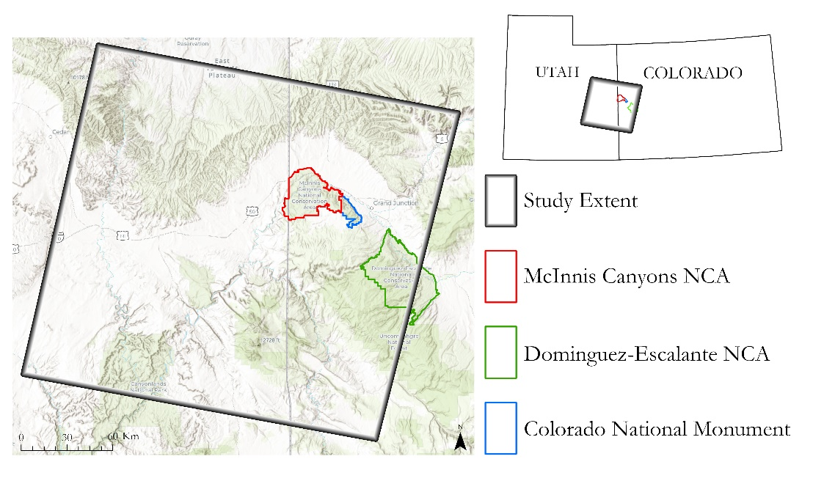
Figure 1. Map depicting the extent of the study area.

2.2 Project Partners & Objectives
Our partners in this project are the National Park Service (NPS), which manages Colorado National Monument (COLM), and the Bureau of Land Management (BLM), which is responsible for managing McInnis Canyons National Conservation Area (MCNCA). Treatment practices accomplish many different outcomes such as watershed improvement, fuels-reduction, post-fire stabilization and long-term maintenance of biodiversity (Miller et al., 2019; Grant-Hoffman & Dollerschell, 2019). COLM prefers to have as minimal impact on the land as possible, and thus has a “let nature take its course” mindset regarding the environmental issues of wildfire and beetle infestation, but COLM will consider fuel-reduction and other treatments if they have strong scientific backing. MCNCA does not share this minimalist mindset. When planning treatments, managers must consider the potential for long-term effectiveness of vegetation management on the landscape as well as the cost and time needed to do such treatments. Both agencies build their management plans around implementing high-payoff and low-cost land management practices in priority areas.

To facilitate our partners’ decision-making process, this project addressed three objectives: 1) monitor changes to the geographic extent of pinyon-juniper woodland and sagebrush ecosystems over time, 2) determine the impact of wildfire and Ips beetle infestation disturbances on the landscape, and 3) measure the response of vegetation to treatment practices over time. By identifying stable and unstable areas of the landscape, land managers can assess the potential for success of habitat restoration treatments. Analyzing the long-term outcomes of disturbances and how they relate to initial severity assessments can help partners prioritize management practices in response to anticipated future disturbance events. Finally, the analysis of treatment outcomes can help land managers assess the best practice to use depending on the desired outcome and land cover characteristics of an area.

3. Methodology
3.1 Data Acquisition
For this project we used a combination of Earth observations (EO), partner-provided Geographic Information System (GIS) layers, and ancillary GIS datasets acquired from United States government agencies and public research institutes. Our EO data acquisition (Table 1) focused on path 36, row 33 of the Worldwide Reference System-2 (Figure 1). This path/row combination covered our areas of interest and acted as a convenient study area boundary for the project. We acquired Landsat imagery through the Google Earth Engine data catalog for each year between 1986 and 2021 (Landsat 5, 7, and 8 collection 1 surface reflectance products courtesy of the U.S. Geological Survey). We only used scenes collected between June and September of each year to correspond to the growing season within the study area. Landsat imagery, provided as surface reflectance products, was atmospherically corrected using the Landsat Ecosystem Disturbance Adaptive Processing System (LEDAPS) algorithm for Landsat 5 and 7 imagery and the Land Surface Reflectance Code (LaSRC) algorithm for Landsat 8 imagery. Additionally, we acquired Normalized Difference Vegetation Index (NDVI) data (MOD13Q1) from the Aqua/Terra Moderate Resolution Imaging Spectroradiometer (MODIS). We retrieved this from the NASA Land Processes Distributed Active Archive Center (LP DAAC; Didan, 2021). Our team used these remotely sensed data in conjunction with ancillary field data to create an accurate analysis of landcover change trends, fire effects, pre-fire treatment effects, and beetle infestation effects.

Table 1
NASA Earth observations data, parameters, and temporal coverage
Platform & Sensor | Parameters | Temporal coverage
Landsat 5 TM | Visible, near-infrared, and shortwave infrared imagery | 1986 – 2011
Landsat 7 ETM+ | Visible, near-infrared, and shortwave infrared imagery | 2012
Landsat 8 OLI | Visible, near-infrared, and shortwave infrared imagery | 2013 – 2021
Terra MODIS | Spectral vegetation indices | 2001 – 2021
Aqua MODIS | Spectral vegetation indices | 2001 – 2021

Ancillary data for this project included data from our partners at the BLM and NPS along with data from the U.S. Fish and Wildlife Service (USFWS), the U.S. Forest Service (USFS), the US Census Bureau, and the United States Geological Survey (USGS) (Appendix A). Our partners provided us with fire perimeter data which delineated the geographic extent of burned areas within the study area and provided the date of fire ignition. We supplemented this data with fire perimeter data provided by the USGS through the Monitoring Trends in Burn Severity (MTBS) database. Our partners also provided us with fire pre-treatment and vegetation treatment datasets that represent the locations of treatment practices. Our partner-provided shapefile layers included polygons of wildfires, fire pre-treatment, vegetation pre-treatment, and of the boundaries of conservation areas, the national monument, and other areas which fall under their discretion.

For assessing landcover change, we acquired classified landcover raster layers from the USDA’s Land Change Monitoring System (LCMS) (Appendix A). We downloaded LCMS raster layers from 1985 to 2020 so that we could use them in our time series analysis of landcover change over time (USDA Forest Service, 2021). We also used the Rangeland Analysis Platform (RAP), created by researchers at the University of Montana to measure vegetation cover via remote sensing (Allred et al., 2020). Specifically, this platform provides yearly estimates of vegetation cover across six different categories: annual forbs and grasses, perennial forbs and grasses, bare ground, shrubs, litter, and trees using models built from ground truth data.

Additionally, we downloaded burn severity data of each fire from the USGS’s MTBS database. This dataset includes a delta Normalized Burn Ratio (dNBR) change map, which highlights the extent of a fire’s burn severity by comparing pre- and post-fire NBR. The NBR formula is based on Brewer et al. (2005) and incorporates the spectral difference between vegetation health and burned areas as vegetation health peaks in the near-infrared band (NIR) and burned areas peak in the short-wave infrared (SWIR) band (Equation 1). The change in the NBR, or delta NBR (dNBR) is calculated by finding the difference between pre- and post-fire NBR.
$$\begin{aligned}NBR = \frac{\left(NIR-SWIR\right)}{\left(NIR+SWIR\right)} \\ \#\left(1\right)\end{aligned}$$
3.2 Data Processing
We used Google Earth Engine to process Landsat imagery to create annual NDVI composites for each year in our study period. To accomplish this, we first removed pixels obscured by clouds for each scene using the pixel quality assessment band to build a mask. We then calculated NDVI for each masked scene using Equation 2 (Rouse et al., 1973). We created annual composites of NDVI images by extracting the maximum pixel value for each pixel location across all NDVI images for each year. The results of this step were cloud-free NDVI images of our study area that represented the maximum vegetation greenness for each year.

$$\begin{aligned}NDVI = \frac{NIR - RED}{NIR + RED} \\ \#\left(2\right)\end{aligned}$$
3.2.1 Geographic Extent Changes to Landcover
To quantify landcover change over time we used classified raster layers from LCMS from 1985–2020. We specifically chose the years 1985, 1995, 2005, 2015, and 2020 for analysis so that we could detect change by three 10-year intervals and also have an overall representation. We first used ArcGIS Pro 2.9.1 to preprocess the data. The preprocessing consisted of clipping our area extent from the LCMS data and projecting the LCMS data into the projected coordinate system (NAD 1983 UTM Zone 12N) of our study area. Next, we visually assessed the usability of the LCMS land cover maps and determined that a reclassification would better represent the land cover classes within our study area. This step provided a more useful assessment of pinyon-juniper extent by incorporating mixed sagebrush and pinyon-juniper woodland areas into the larger ‘woodland’ class. Afterwards, we reclassified the LCMS raster layers into 4 main classes for change analyses (Table C1). Change detection was performed by using Land Change Modeler (LCM) within IDRISI TerrSet 19.0.5. Once the LCMS imagery was imported in TerrSet we used LCM to perform change detection on the time intervals of 1985–1995, 1995–2005, 2005–2015, 2015–2020, and 1985–2020. Finally, we ended up with graphs showing gains and losses of landcover type over time (Figure B1).

3.3 Data Analysis
3.3.1 Geographic Extent Changes to Landcover
We created change maps to show geographic extent gain and loss by landcover type by mapping the transition from all landcover types to Tree, Shrub, and Grass & Forb for each time interval. We also created an additional change map to visualize conversion between PJW and sagebrush habitat as well as conversion from sagebrush to grasses. This conversion map was limited to only pixels that converted from tree to shrub, shrub to tree, or shrub to grass while ignoring transitions of less than 1000 hectares. After performing change analysis, we then exported the maps from TerrSet and imported them back into ArcGIS Pro in order to symbolize the final maps.
3.3.2 Response of Vegetation to Fire
Next, we looked at the effects fire had on landscape and the ability of the landscape to recover to its pre-fire state. To determine the post-fire recovery of vegetation, we used NDVI as a proxy for vegetation cover along with fractional cover estimates of different vegetation classes. Image differencing of NDVI for two dates was used to detect changes in these vegetation measures between pre-fire and post-fire time periods. Pre-fire NDVI and fractional cover rasters were subtracted from respective post-fire rasters to calculate the simple difference in NDVI and fractional cover. We then calculated the percentage difference in NDVI change by dividing the simple difference by the pre-fire value and multiplying the quotient by 100. This step was taken to improve the interpretability of NDVI changes and resulted in a percent NDVI change map. This image differencing procedure was carried out at 1, 5, 10, and 20 years after each fire to examine recovery over many time scales. Pre-fire conditions (i.e., land cover, NDVI, and fractional cover metrics) and immediate post-fire conditions (burn severity) were also extracted to determine the effects that these conditions have on vegetation response. The results of this step were recovery maps of NDVI and fractional cover for 1-, 5-, 10-, and 20-years post-fire. We then analyzed this data for trends in vegetation recovery over time. We also looked for differences in recovery trends between land cover types and burn severity classes using MTBS burn severity data.

Using the post-fire change map datasets, we grouped pixel values by land cover (i.e., pinyon-juniper woodland and sagebrush ecosystems) and burn severity, and then calculated the mean difference value of NDVI and each fractional cover class at each time step. Next, we plotted these values as line graphs to visualize recovery trends according to burn severity and land cover. Trends in NDVI recovery were analyzed to determine the degree of vegetation cover regrowth at each recovery interval. Fractional cover changes at each time interval were used to characterize the recovery of vegetation communities compared to pre-fire vegetation composition.

3.3.3 Pre-Fire Treatment Impacts
We looked at the effects of pre-fire treatment by examining treatment impacts on vegetation and subsequent burn severity of treatment areas after a fire. Using ArcGIS Pro, we created a multidimensional raster dataset of MODIS NDVI images of each year from 2001 to 2021, with an anniversary date of July 12, the 193rd day of the year. This mosaiced dataset allowed us to easily run statistical analyses later.

To understand the effects of treatment on vegetation health post-treatment and post-fire, we gathered mean NDVI data for each treatment area using the ‘Zonal Statistics to Table’ tool in ArcGIS Pro in conjunction with our multidimensional raster NDVI dataset. We then transferred this data into the attribute table of the pre-fire treatment polygon. To examine treatment effects on vegetation health post-fire we created a polygon dataset of intersected wildfire perimeter polygons with these pre-fire treatment areas to (1) determine the extent of these overlapped areas, and (2) to examine the NDVI information for each treatment area, using NDVI as a proxy for monitoring vegetation decline and recovery. To better understand the impacts of treatment on wildfire burn severity, we intersected the dNBR burn severity polygons from the MTBS dataset with these fire-impacted treatment polygons.
We used similar methods to create control polygons for the ten largest fire and treatment intersections. We created two different types of control groups: (1) a control area located in the same landcover type as the fire and treatment area, but not impacted by either and (2) a control area located within the fire perimeters, but not overlapping the treatment areas. We drew these control groups at greater than 10,000 meters squared and less than 20,000 meters squared to make sure each control area included multiple MODIS pixels and was also small enough to contain all the correct vegetation type. To know that we were drawing these controls in the correct spot, we used RAP Fractional Cover maps, wildfire perimeter polygons, and pre-fire treatment polygons as context. After creating the control area, we used the same ‘Zonal Statistics to Table’ tool to obtain annual, mean NDVI maximum information for each control area. After finishing these analysis methods, we created a series of six different line graphs examining the seven largest fire treatment intersected areas in comparison to the two control areas. To better understand the context of each treatment area relative to the perimeters of each wildfire, we created a map highlighting these areas (Figure C1).
3.3.4 Mapping Potential Ips Beetle Damage to Woodlands
To identify likely bark beetle infestation areas in PJW, we used maximum NDVI intra-annual composite extracted during growing season from the study area. We performed image differencing using a 1-year time step for all the images. Our team estimated a threshold value (Median – 1.96 * Standard Deviation) for probable vegetation decline for each image in the composite using a 5-year moving average. We generated probable outliers by finding all the pixels in the annual NDVI composite with values below the established threshold. The resulting vegetation decline layer was reclassified in ArcGIS Pro and aggregated for consecutive years. In addition, we applied landcover mask for the non-forest areas, known disturbance such as vegetation treatment and wildfire areas were masked using ancillary data provided by the partners to produce a vegetation greenness decline persistence map. This persistence change map showed where NDVI decline persisted for 5 consecutive years. To generate the vegetation disturbance map we subtracted the probable outlier layer of the target year from the baseline year.

4. Results and Discussion
4.1 Analysis of Results
4.1.1 Geographic Extent Changes to Landcover
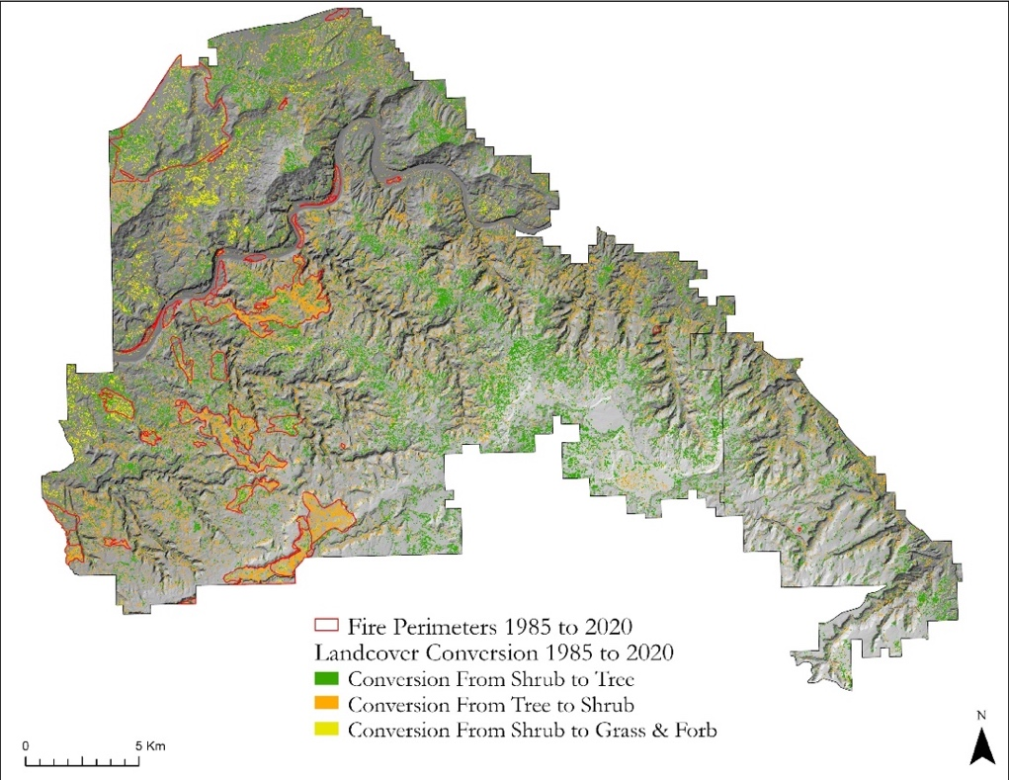
While quantifying the geographic extent of changes to tree, shrub, and grass/forb landcover within the boundaries of MCNCA and CNM we observed that the largest landcover type overall from 1985–2020 was tree (7773 hectares), followed by shrub (6521 hectares), and grass & forb (1464 hectares; Figure B1). We observed that gains and losses fluctuated between tree and shrub landcover types based upon ten-year intervals (Figure B2). We observed large areas of woody encroachment within MCNCA and less-so within COLM boundaries (Figure 2). Large and contiguous areas of conversion between tree to shrub appeared to be mainly the result of wildfire as evident in Figure 2 with fire perimeters denoted in red. We also noted patches of conversion between shrub to grass in the western portion of MCNCA which may indicate the conversion of sagebrush habitat to an annual grass dominated landcover. These results suggest there is major disturbance happening within the study area, and that major wildfires account for much of the variation in landcover change between the intervals.

Figure 2. Conversions of Tree, Shrub, and Grass & Forb landcover types within the boundaries of MCNCA between 1985–2020. Fire perimeters from the 1985–2020 are overlaying on the map.
4.1.2 Fire recovery
We found that more severe burns resulted in greater post-fire effects as evident by the mean NDVI difference, which was progressively lower for each increasing burn severity class (Figure 3). For PJW, unburned areas resulted in the lowest NDVI difference at each time step while the high burn severity class had the greatest loss in NDVI at each time step. On average, NDVI values show a sharp decline at one-year post-fire with a considerable increase by year five post-fire. After 20 years of recovery, there were still noticeable declines in vegetation compared to pre-fire conditions with clear separation between severity classes. Fractional cover changes showed a more complex recovery (Figure 4). Tree cover losses in PJW were proportional to burn severity and showed no strong signs of recovery even at 20 years post fire. Bare ground estimates increased sharply at one-year post-fire and dropped toward pre-fire levels after 5 years of recovery, while shrubs, forbs and grass estimates increased at five years post-fire.
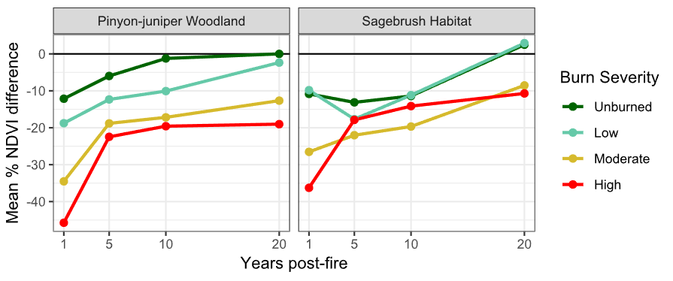
Figure 3. Mean percent change in NDVI values for pinyon-juniper woodland and sagebrush habitat at 1-, 5-, 10-, and 20-years post-fire as compared to pre-fire conditions, grouped by burn severity classification.

Sagebrush habitat exhibited more complex trends in NDVI values over time. The amount of NDVI reduction was greatest in high severity burns at one-year post-fire; however, the high severity class reached near-unburned levels of mean NDVI loss at 10 years post-fire (Figure 3). Low severity areas showed recovery trends that were similar to unburned areas. This signature could be explained by a much larger increase in forbs and grasses at 10 years exhibited by high severity burned areas (Figure 4). Shrub loss after fire in sagebrush habitats was much greater for high severity burns when compared to the lower severity burn classes. While the lower severity burn areas recovered to near-unburned levels of shrub cover after 5 years, high severity burn areas remain much lower even at 20 years post-fire. Tree cover changes in sagebrush habitats appeared to be relatively low, yet the lack of recovery mirrors the trends seen in pinyon-juniper woodlands.
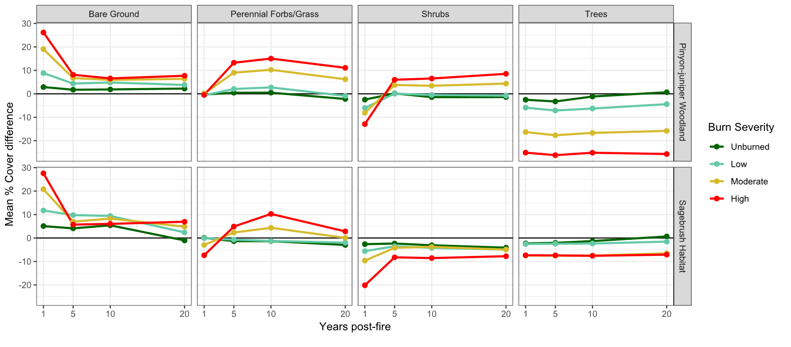
Figure 4. Mean change in fractional land cover for pinyon-juniper woodland and sagebrush habitat at 1-, 5-, 10-, and 20-years post-fire, grouped by burn severity classification.
4.1.3. Mapping Potential Ips Beetle Damage to PJW
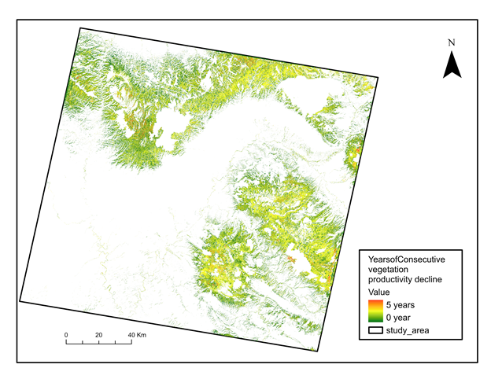
The results of the consecutive vegetation productivity decline map generally reflect the vegetation loss in successive years during the analysis period. Since beetle infestation often results in loss of vegetation cover, the trend of vegetation decline in the area suggests that a large portion of the study area has been affected by beetle disturbance in at least three years (Figure 5). This time span is designed to show persistent disturbances that occurred for 5 consecutive years that are not explained by known wildfires and silvicultural treatments. It can be inferred that these areas may possibly be zones of bark beetle infestation within the PJW in the study area. The northeast portions classified in red are areas that have consistently been disturbed for five consecutive years. These areas experienced perennial vegetation decline and are likely hotspot zones for beetle infestation. By masking out areas of known disturbance such as fire perimeters and vegetation treatments, we can see that these areas experienced unexplained perennial vegetation decline and may indicate hotspot zones for beetle infestation. While areas with vegetation decline of one year may be due to other factors like drought-induced plant stress or ephemeral insect damage, and not necessarily beetle infestation that is more permanent in that it causes tree mortality. In addition, disturbances such as floods and avalanches are usually instantaneous, and their effects can occur in one year or more.
Years of Consecutive Vegetation Productivity Decline

Figure 5. Map depicting consecutive vegetation decline of vegetation productivity within the Pinyon-juniper of the Grand Valley region.
The results also show the recent vegetation disturbance map of the area in 2021 (Appendix D). Areas classified and represented in green show undisturbed/or healthy vegetation while the disturbed areas shown in red represent patches of vegetation that are not photosynthetically active. These red colored areas are possibly due to beetle infestation, and the map can provide information on the recent disturbance to the PJW cover. One of the uncertainties associated with this result is the effect of drought on vegetation productivity, therefore, in drought years, vegetation decline may not be because of beetle infestation. In addition, weather-related disturbances such as ice and winds may cause a decline in vegetation greenness which may also be a form of disturbance. Therefore, not all areas with anomalous vegetation greenness decline are due to bark beetle damage.
4.1.4 Pre-Fire Treatment Impacts
The results of this pre-fire treatment analysis contain six different line graphs (Figure C2) measuring mean NDVI of treatment areas and controls, and one map highlighting treatment locations relative to wildfire perimeters in these seven fires (Figure C1). We chose these fires because they contained pre-fire treatment areas and were large enough to contain an untreated, wildfire control area. These fires include the 2001 Bull Hill Fire, the 2002 Miracle Complex, the 2003 Maverick Fire, the 2006 Spring Fire, the 2011 Cosgrove Fire, the 2012 Pine Ridge Fire, and the 2020 Pine Gulch Fire. The Bull Hill and Maverick Fires overlap one another, and so both fires are represented with one line graph and one map.
Looking at these line graphs, a few commonalities emerge. In all graphs, there are noticeable decreases in average NDVI in 2002, 2012, and 2018 across all areas. In all graphs there is a noticeable increase in NDVI in 2005, 2016, and 2018. The declines in vegetation productivity correspond with known drought and wet years in Mesa County, Colorado and could be attributed to water availability instead of treatment impacts (NIDIS & NOAA, 2022). In all graphs except for the Spring Fire, there is a noticeable decrease in average NDVI in the year right after a treatment occurs as well as a noticeable decrease in average NDVI post fire.
A difference between these graphs relates to pre-fire treatment effects on post-fire vegetation recovery, especially when comparing Burned Areas with No Treatment Control areas. In the cases of three fires: the 2002 Miracle Complex, the 2011 Cosgrove Fire, and the 2012 Pine Ridge Fire, fire-impacted treatment areas recovered back to the average, one-year pre-fire NDVI faster than the Burned Area, and No Treatment Control area. Looking at the four other fires: the Spring Fire, the Bull Hill Fire, the Maverick Fire, and the Pine Gulch Fire, this trend either does not occur or it is impossible to know from this graph the degree of vegetation recovery from these fires. Since the Bull Hill Fire occurred in 2001, and that is the first year of NDVI imagery for this project, we do not know what the foliar greenness of these areas were pre-fire. Conversely, the Pine Gulch fire occurred in 2020, and it is too early to determine vegetation recovery in those areas. Thus, these graphs display preliminary, but promising results as to the impacts of pre-fire treatment on vegetation recovery.
Regarding a treatment’s ability to slow down or stop fires, we created a map indicating locations of wildfire perimeters and treatment areas (Figure C1). In this map, the two largest fires, the Pine Gulch Fire at 561.76 square kilometers, and the Pine Ridge Fire at 56.10 square kilometers, held all their treatment areas within their wildfire perimeters. In the other five fires, all of which were smaller than 11 square kilometers, the treatment areas overlap the borders of the wildfire. This indicates that these treatment areas may have stopped the fires or slowed the spread enough so that suppression resources could arrive; however, we cannot make any conclusions on these pre-fire treatment areas’ placements without doing further research on each fire in depth, to fully understand the role the pre-fire treatment area held, if any.
4.2 Errors and Uncertainties
There were limitations to quantifying landcover change within our study area. One possible limitation was our imagery resolution of 30m. With this moderate resolution landcover detail is reduced. Another factor that limits our study is the fact that landcover is not discrete but is continuous and it is difficult to delineate boundaries for analyses. To reduce the amount of error caused by misclassification we reclassified the landcover maps to a coarser thematic resolution (Table B1).
While we were able to remove the influence of known fire and treatment related disturbances when detecting beetle disturbance, we did not have data that accounted for other known disturbances such as unrelated drought impacted areas. An additional major limitation to the beetle disturbance mapping is the lack of in-situ data to validate the method used in mapping vegetation disturbance and vegetation productivity decline. This lack of in-situ data also prevents the validation of fractional cover estimates. The fractional cover estimates used to assess fire impacts are produced through a model which has its own inherent errors. Interpretation of the fire impacts analysis should take this into account. Additionally, while NDVI is closely related to leaf area index, we do not know for sure how well NDVI represents vegetation cover at this study area. Further work should focus on ground truth validation of these vegetation measurements to assess the accuracy of our results.
There are several limitations to this work on vegetation treatment areas and this project marks only a small portion of research studying pre-fire treatment in Grand Valley, Colorado. First, types of pre-fire treatments interact with vegetation and the landscape differently, and this project did not have time to analyze if different treatment types affected vegetation and the landscape differently. Second, we downloaded NBR and dNBR burn severity information from the MTBS dataset for use in this project. Since the information is only available on a per-fire-polygon basis, we cannot know if pre-fire treatment areas saw lower burn severity than the rest of the fire from this polygon dataset alone. Third, the MODIS sensor imagery we used for this project uses a 250m spatial resolution, which is best for large vegetation areas. Some pre-fire treatment areas were smaller than a pixel and we could not obtain an average NDVI for these areas. We also only used one sensor for this part of the project, and it is possible for our imagery to contain errors. Fourth, the number of samples and their areas of the pre-fire treatments and fires is very small, and so no definitive results can be determined from this project. Fifth, there were instances where the partner-provided treatment layers displayed contradictory information or omitted treatment dates. Finally, there is much room left for greater data exploration. Using different vegetation indexes for measuring vegetation recovery, incorporating other datasets, having more field data of vegetation monitoring post-fire, and researching each fire in greater depth would all add nuance and clarity to this project analyses performed to date.

4.3 Future Work
The second term of this project will focus on forecast modeling of the historic trends obtained from the first term’s results. Forecast modeling is helpful to our partners for decision making and visualizing long term climate change effects. Additional analyses of habitat suitability layers and modeling would improve our current results. Additionally, creating a geodatabase that contains these layers would help our partners perform in-situ GIS analysis of our time-series models’ results in comparison to land cover and soil moisture data. Our partners would also be able to perform ongoing trend analyses with these habitat suitability layers. Concerning pre-fire treatment analyses, future researchers could run their own NBR and dNBR classification to obtain pixel-by-pixel data, use different vegetation and burn indices, examine each fire in greater depth to understand treatment’s role in fire behavior, and perform post-fire ecological monitoring with greater consistency. Concerning our beetle-induced disturbance analysis, improvement to our analysis is possible by using different metrics of disturbance, adjusting the baseline measurement, or by incorporating higher resolution data. A major limitation of this study was a lack of ground truth data. In the future, ground truth data collection of vegetation condition measurements could be used to assess product accuracy. In short, there are many potential applications to expand upon our research in ways that would help our partners.

5. Conclusions
We developed several maps to identify preliminary trends in landcover change, beetle infestation locations, post-fire vegetation recovery, and pre-fire treatment effects during this project. First, historical landcover analysis during this study suggests that PJW landcover (tree landcover) has been steadily increasing in size to around 8000 hectares within the boundaries of McInnis Canyons National Conservation area and Colorado National Monument. Our results show that grass/forb and shrub landcover types are being reduced in size as the pinyon-juniper woodlands expand. Mapping of the spatial change in extent of these landcover classes in this study can help land managers visualize areas where pinyon-juniper woodland is encroaching on sage brush and help plan future management actions.

Beetle infestation and wildfire in PJW areas are two major types of disturbance that can cause land cover conversion. There is a potential for beetle infestation due to vegetation decline to be mapped in consecutive years within mapped pinyon juniper areas. Therefore, those areas can be identified for further ground surveys, given bark beetle outbreaks can cause mass death of trees adding to the fuel loads for subsequent wildfires.

We monitored impacts of wildfire on vegetation health and structure up to 20 years post-fire and found that fire-induced changes to pinyon-juniper woodlands is still evident at 20 years post-fire. In addition, these damage impacts appear to increase in magnitude as burn severity increases. Burn severity also affects the recovery of sagebrush habitats; however, the impacts are more complex than those seen in PJW areas. High severity burns have a much greater impact on shrub cover in sagebrush habitat than lower severity burns. This indicates that burn severity could be used by managers to prioritize areas of sagebrush habitat for restoration-focused treatments.

Finally, results of the pre-fire treatment analysis show that pre-fire treatments effectively slowed down and stopped expansion of smaller fires, that pre-fire treatments encouraged faster vegetation recovery, and that areas with both pre-fire treatments and wildfires showed a noticeable decrease in NDVI. These results, though promising, could be improved by doing more analyses and fieldwork. Such additional effort is needed to fully understand the extent of pre-fire treatments on the Grand Valley landscape. Through this project we created GIS layers, and datasets to share with our partners to help them make future land management decisions.

6. Acknowledgments
The team would like to acknowledge and thank the NASA DEVELOP program for giving us the opportunity to do this work, our Fellow Brandy Nisbet-Wilcox, and our science advisors Joe Spruce and Keith Weber for their insight and advice. We would also like to thank our partners at the National Park Service: Arlene Jackson, Jessica Resnik, Molly Murphy, and Eric Shaver, at and the Bureau of Land Management: Nikki Grant-Hoffman, Marlin Deras, Emily Latta, and Doug Paul. We are appreciative of their input and expertise, as well as this opportunity.

Any opinions, findings, and conclusions or recommendations expressed in this material are those of the author(s) and do not necessarily reflect the views of the National Aeronautics and Space Administration.

This material is based upon work supported by NASA through contract NNL16AA05C.

7. Glossary
ArcGIS Pro – Geographic Information Systems (GIS) software used to store, view, and analyze geographic data
BLM – Bureau of Land Management, a government agency which is under the jurisdiction of the Department of the Interior (DOI)
dNBR – delta Normalized Burn Ratio, or the change in the Normalized Burn Ratio
DOI – Department of the Interior, a US government agency
Earth observations – Satellites and sensors that collect information about the Earth’s physical, chemical, and biological systems over space and time
GIS – Geographic Information Systems, computer applications used to store, view, and analyze geographic information
IDRISI TerrSet – Modeling software used for visualizing and analyzing landcover change
LCMS – Landscape Change Monitoring System
MODIS – Moderate Resolution Imaging Spectroradiometer, a multispectral sensor which is housed on two satellites: Aqua and Terra
MTBS – Monitoring Trends in Burn Severity, dataset
NBR – Normalized Burn Ratio
NCA – National Conservation Area
NDVI – Normalized Difference Vegetation Index
NPS – National Park Service, a government agency which is under the jurisdiction of the Department of the Interior (DOI)
PJW – Pinyon-juniper Woodland
RAP – Rangeland Analysis Platform, an application which measures percentage land cover via remote sensing analysis
Remote Sensing – obtaining information about an object or area from a distant sensor, such as on a drone, aircraft, or satellite
Shapefile – data format for Geographic Information Systems (GIS) software, data is in the format of points, lines, and/or polygons
USDA – United States Department of Agriculture, a US government agency
USFS – United States Forest Service, a government agency under the jurisdiction of the Department of Agriculture (USDA)
USGS – United States Geological Survey, a government agency under the jurisdiction of the Department of the Interior (DOI)

8. References
Allred, B.W., & Jones, M.O. (2020). Rangeland Analysis Platform (RAP) V3.0. https://rangelands.app/
Brewer, K. C., Winne, J. C., Redmond, R. L., Opitz, D. W., & Mangrich, M. V. (2005). Classifying and Mapping Wildfire Severity. Photogrammetric Engineering & Remote Sensing, 11, 1311–1320. https://doi.org/10.14358/PERS.71.11.1311

Didan, K. (2021). MODIS/Terra Vegetation Indices 16-Day L3 Global 250m SIN Grid (V061) [Data set]. NASA EOSDIS Land Processes DAAC. Retrieved February 1, 2022, from https://doi.org/10.5067/MODIS/MOD13Q1.061

Earth Resources Observation and Science (EROS) Center (2018). Landsat 4-5 TM Level-2 Data Products - Surface Reflectance [Data set]. USGS EROS Archive - Landsat Archives.
https://doi.org /10.5066/F7KD1VZ9

Earth Resources Observation and Science (EROS) Center (2018). Landsat 7 ETM+ Level-2 Data Products - Surface Reflectance [Data set]. USGS EROS Archive - Landsat Archives.
https://doi.org /10.5066/F7Q52MNK

Earth Resources Observation and Science (EROS) Center (2018). Landsat 8 OLI/TIRS Level-2 Data Products - Surface Reflectance [Data set]. USGS EROS Archive - Landsat Archives.
https://doi.org /10.5066/F78S4MZJ

Gottfried, G.J., Swetnam, T.W., Allen, C.D., Betancourt J.L., and Chung -MacCoubrey A.L., (1995). Pinyon - juniper woodlands. Pages 95-132 in D.M. Finch and J.A. Tainer, technical editors. Ecology, diversity, and sustainability of the middle Rio Grande Basin. USDA Forest Service General Technical Report RM -268. https://books.google.com/books?hl=en&lr=&id=FladWgJywokC&oi=fnd&pg=PR1&dq=Ecology,+diversity,+and+sustainability+of+the+middle+Rio+Grande+Basin.+USDA+Forest+Service+General+Technical+Report+RM+-268.&ots=n-6QYXSr2P&sig=J7NIzOR3g5eRxLc6r0ku0kMQ4uw

Grant-Hoffman, M. N., & Dollerschell, J. (2019). Post-fire vegetation communities in western Colorado. Native Plants Journal, 20(3), 226–238. https://doi.org/10.3368/npj.20.3.226

Miller, R. F., Chambers, J. C., Evers, L., Williams, C. J., Snyder, K. A., Roundy, B. A., & Pierson, F. B. (2019). The ecology, history, ecohydrology, and management of pinyon and juniper woodlands in the Great Basin and Northern Colorado Plateau of the western United States. General Technical Report RMRS-GTR-403. Fort Collins, CO: U.S. Department of Agriculture, Forest Service, Rocky Mountain Research Station. 284 p., 403. https://doi.org/10.2737/RMRS-GTR-403

National Park Service. (2008). Climate Change in Rocky Mountain National Park: Preservation in the Face of Uncertainty. National Park Service, U.S. Department of the Interior. http://npshistory.com/publications/romo/climate-change.pdf

NIDIS & NOAA (2022). Historical Conditions for Mesa County. www.drought.gov/states/colorado/county/mesa

Peters M, & Cobb N.S., (2008) Removal of pinyon-juniper woodlands on the Colorado Plateau. In: Gottfried GJ, Shaw JD, Ford PL (compilers) Ecology, management, and restoration of piñon-­juniper and ponderosa pine ecosystems: combined proceedings of the 2005 St. George, Utah and 2006 Albuquerque, New Mexico workshops. U.S. Department of Agriculture, Forest Service Proceedings RMRS-P-51, Rocky Mountain Research Station, Fort Collins, CO. https://www.fs.fed.us/rm/pubs/rmrs_p051.pdf

Pontius J., Schaberg P., Hanavan R. (2020). Remote Sensing for Early, Detailed, and Accurate Detection of Forest Disturbance and Decline for Protection of Biodiversity. Remote Sensing of Plant Biodiversity. Springer, Cham, 121–154. https://doi.org/10.1007/978-3-030-33157-3_6

Rouse, J. W., Haas, R. H., Schell, J. A., & Deering, D. W. (1973). Monitoring the Vernal Advancement and Retrogradation (Green Wave Effect) of Natural Vegetation. Texas A&M University Remote Sensing Center, College Station, TX, United States 1, 309–317. https://ntrs.nasa.gov/archive/nasa/casi.ntrs.nasa.gov/19730017588.pdf

USDA Forest Service (2021). USFS Landscape Change Monitoring System Conterminous United States (2020-5) Salt Lake City, Utah https://apps.fs.usda.gov/lcms-viewer/

Vogelmann, J.E., Xian, G., Homer, C., and Tolk, B. 2012. “Monitoring gradual ecosystem change using Landsat time series analyses: case studies in selected forest and rangeland ecosystems.” Remote Sensing of Environment, 122, 92–105. https://doi.org/10.1016/j.rse.2011.06.0279

9. Appendices

Appendix A: Ancillary Data Table

Appendix A:
Ancillary data table
Dataset Name | Type | Use
Bureau of Land Management (BLM) Wildfire Layer | Polygon shapefile | The shapefile of wildfire areas was used for fire occurrence and fire treatment impact time-series models in conjunction with EO observation data.
BLM Fuels Reduction Project Layer | Polygon shapefile | The shapefile of pre-fire treatment areas with specifics on what treatment and when was used for fire treatment impact time-series models in conjunction with EO observation data.
BLM Vegetation Treatment Layer | Polygon shapefile | The shapefile of vegetation treatment with specifics on what treatment and when was used for fire occurrence, fire treatment, and vegetation cover models, in conjunction with EO observation data.
Bureau of Land Management, National Conservation Areas Boundary Files | Polygon shapefile | The polygon shapefile of MCNCA, DNCA, and COLM boundaries was used as areas of interest for analyzing results within partner-managed properties.
USGS Monitoring Trends in Burn Severity (MTBS) Burned Area Boundaries | Polygon shapefile | The Polygon dataset represents the extent of the burned areas of all fires monitored by the MTBS program and was used to complement the partner-provided wildfire dataset.
USGS The National Map (TNM) Download (v2.0) | Digital Elevation Models | The Digital Elevation Models of the study area were used to create hill-shades for symbolizing the study area and for future generation of slope and aspect.
United States Department of Agriculture (USGS) Landscape Change Monitoring System (LCMS) | Land cover maps | The maps were used to measure land cover changes, for masking for beetle detection analysis, and to assess differences in fire recovery between land cover classes.
Rangeland Analysis Platform (RAP) | Percentage land cover maps | The spectral vegetation cover maps which include biomass percentage and herbaceous cover were used for our vegetation cover time-series model, fire occurrence time-series model, and our pre-fire treatment time-series model.

Appendix B

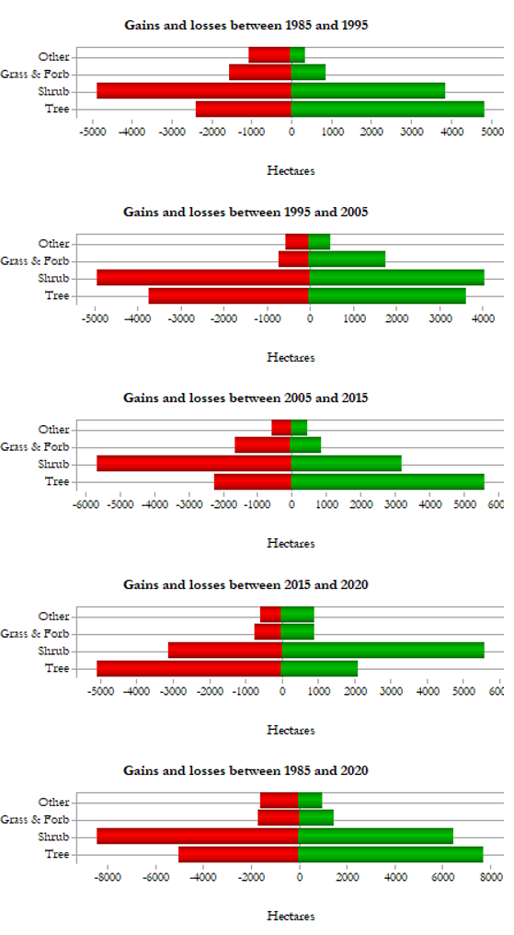
Figure B1. Graphs representing gains and losses in landcover type in hectares within the boundaries of McInnis Canyons National Conservation Area and Colorado National Monument. Each graph represents a 10-year interval from the period of 1985 to 1995. The bottom graph represents overall gains and losses between 1985 and 2020.

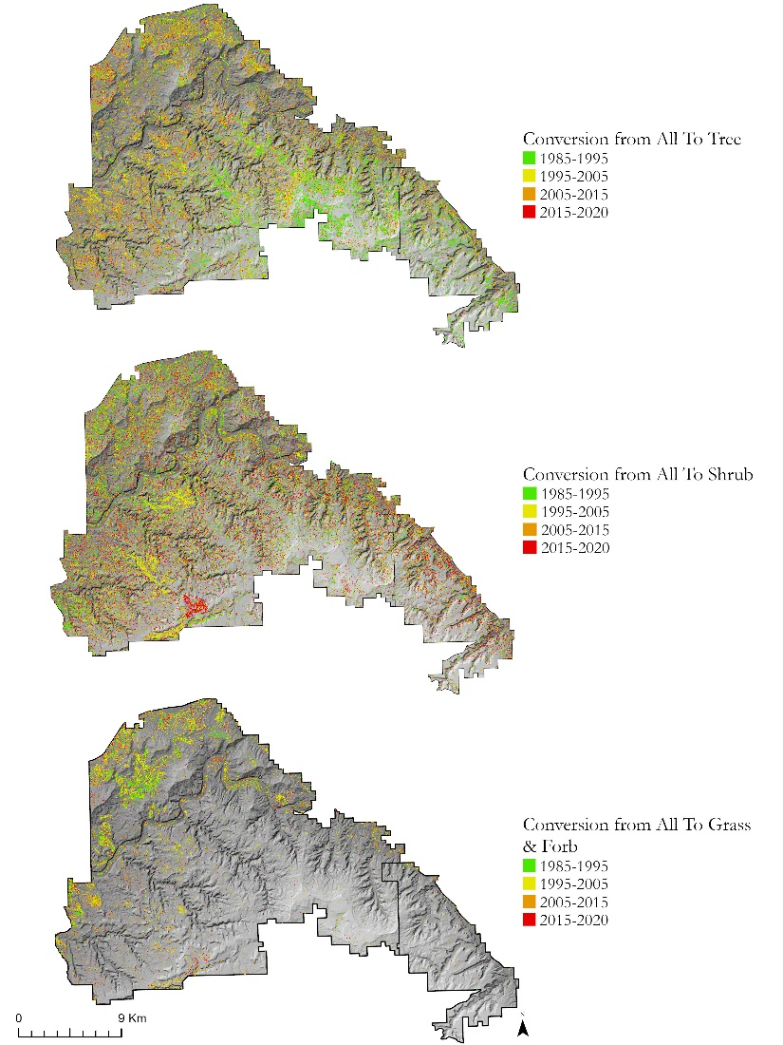
Figure B2. Maps showing the conversion of landcover from all landcover types to Tree, Shrub, and Grass & Forb by time interval.

Table B1
Table showing the reclassification of original (Landscape Change Monitoring System) landcover classes into the four classes used for generating change detection maps in our study (i.e., Tree, Shrub, Grass & Forb, and Other).
Original Landcover Class | Reclassified Landcover Class
1-Trees | Tree
3-Shrubs & Trees Mix | Tree
4-Grass/Forb/Herb & Tree Mix | Tree
5-Barren & Tree Mix | Tree
7-Shrubs | Tree
8-Grass/Forb/Herb & Shrubs Mix | Shrub
9-Barren & Shrubs Mix | Shrub
10-Grass/Forb/Herb | Grass & Forb
11-Barren & Grass/Forb/Herb | Grass & Forb
12-Barren or Impervious | Other
13-Snow or Ice | Other
14-Water | Other
15-Non-Processing Area Mask | Other

Appendix C

a. b. c.
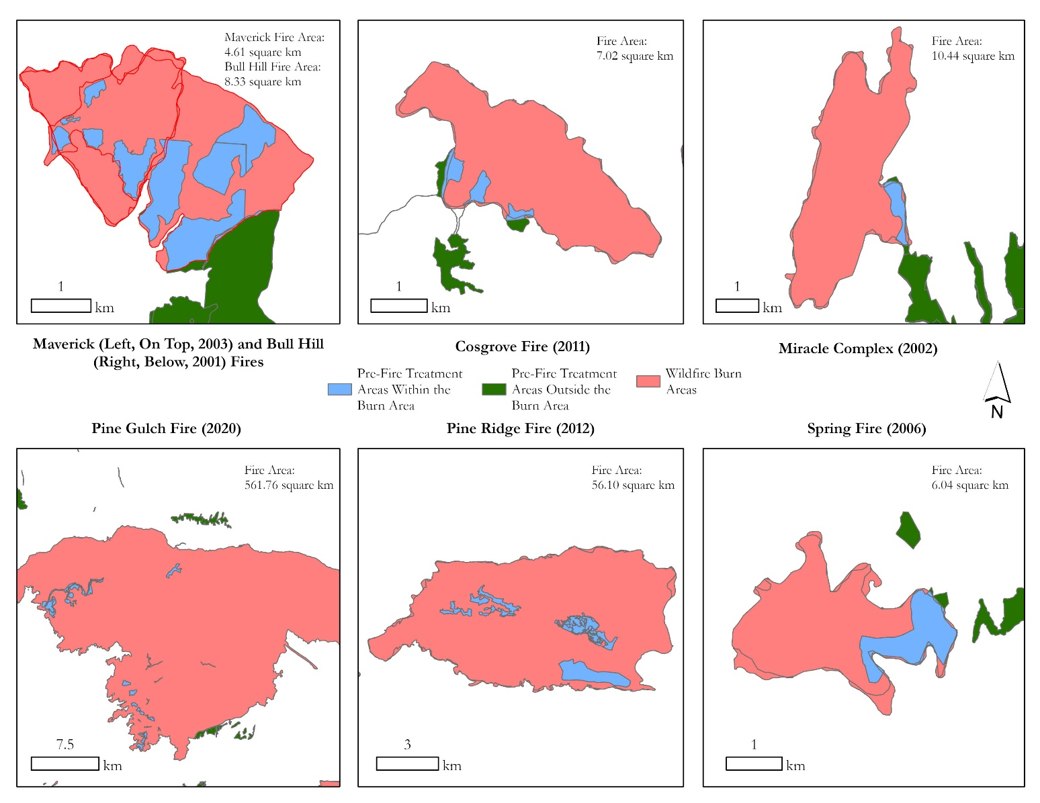

Figure C1: Map displaying the locations of 7 wildfire perimeters and pre-fire treatment areas: (a) Maverik & Bull Hill Fires (b) Cosgrove Fire (c) Miracle Complex Fire (d) Pine Gulch Fire (e) pine Ridge Fire (f) Spring Fire. The five smaller fires had treatment areas on the perimeters of the fire. The two largest fires had treatment areas entirely within the fire.

Figure C1. Pre-Fire Treatment for: (a) Maverik & Bull Hill Fires (b Cosgrove Fire (c) Miracle Complex Fire (d) Pine Gulch Fire (e) pine Ridge Fire (f) Spring Fire
c. d. e.

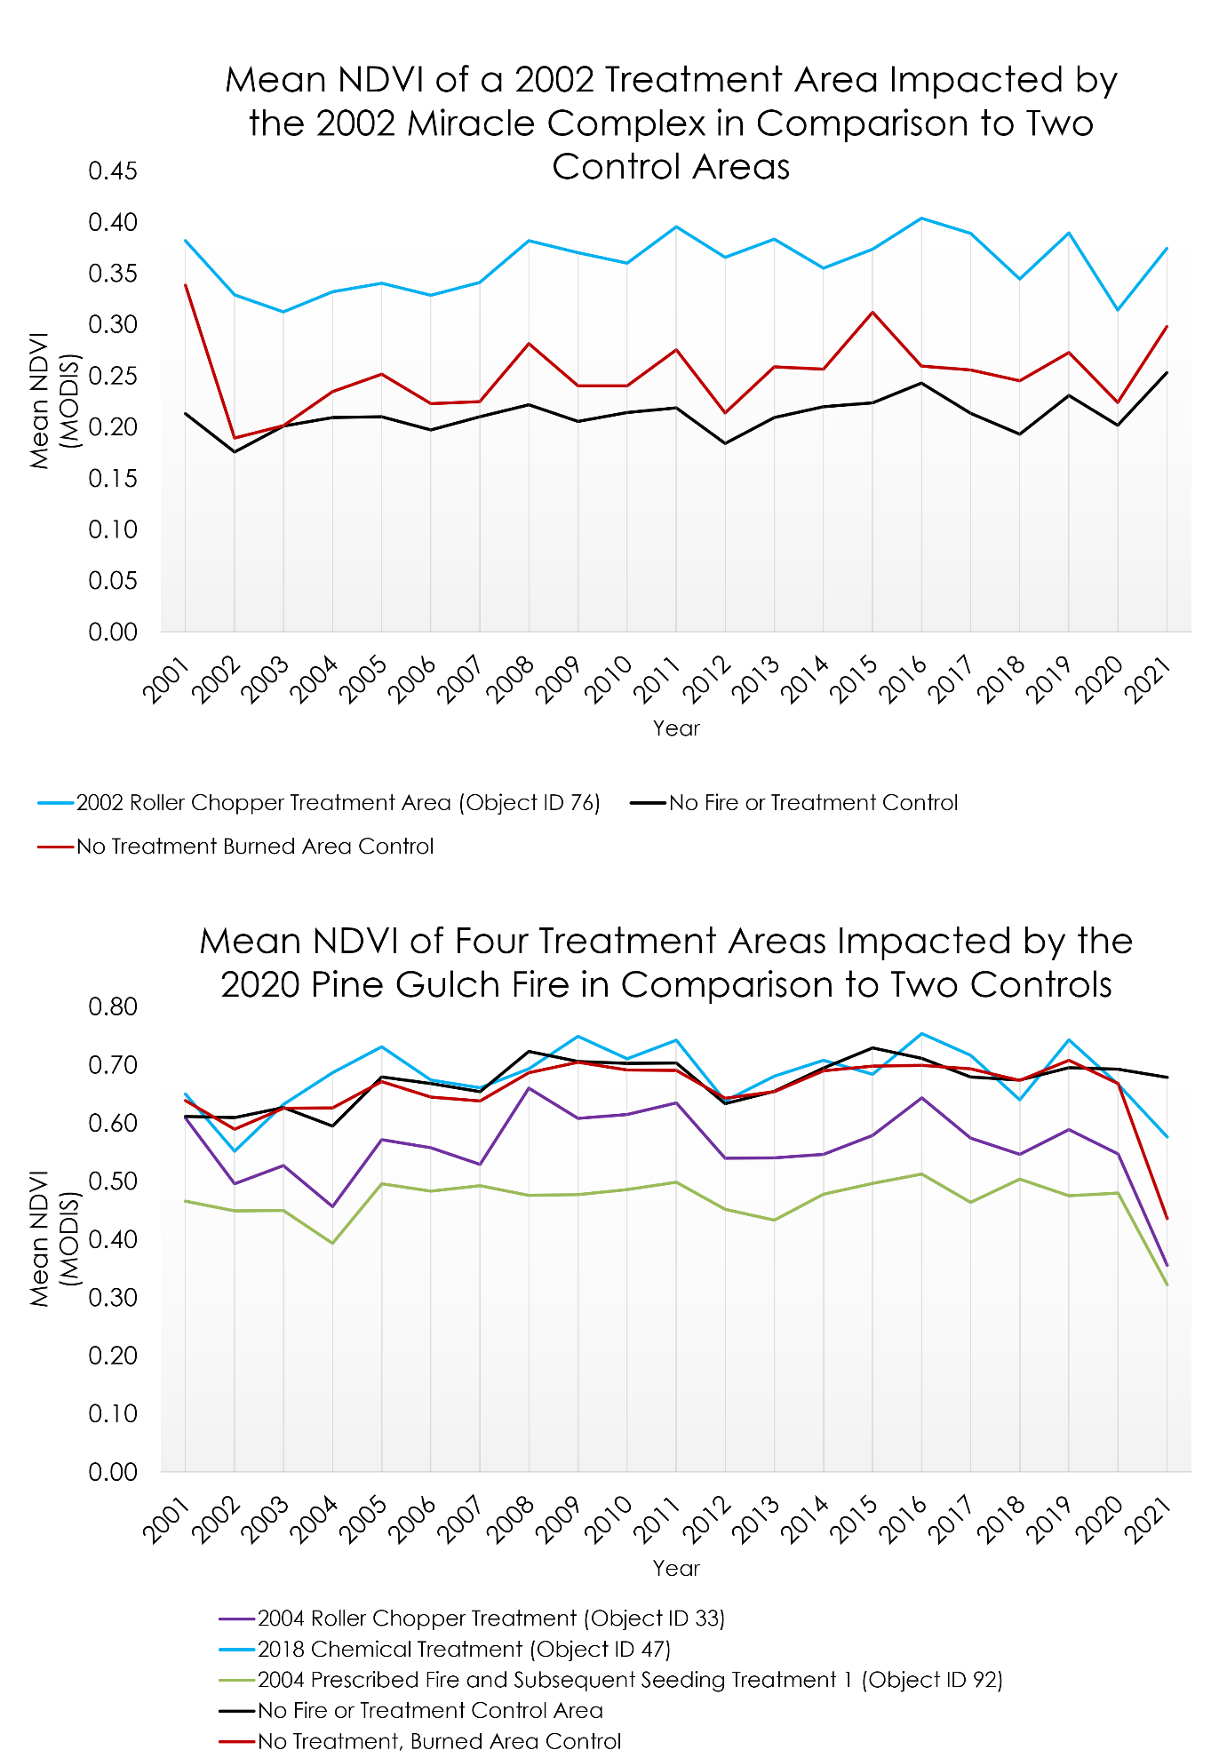
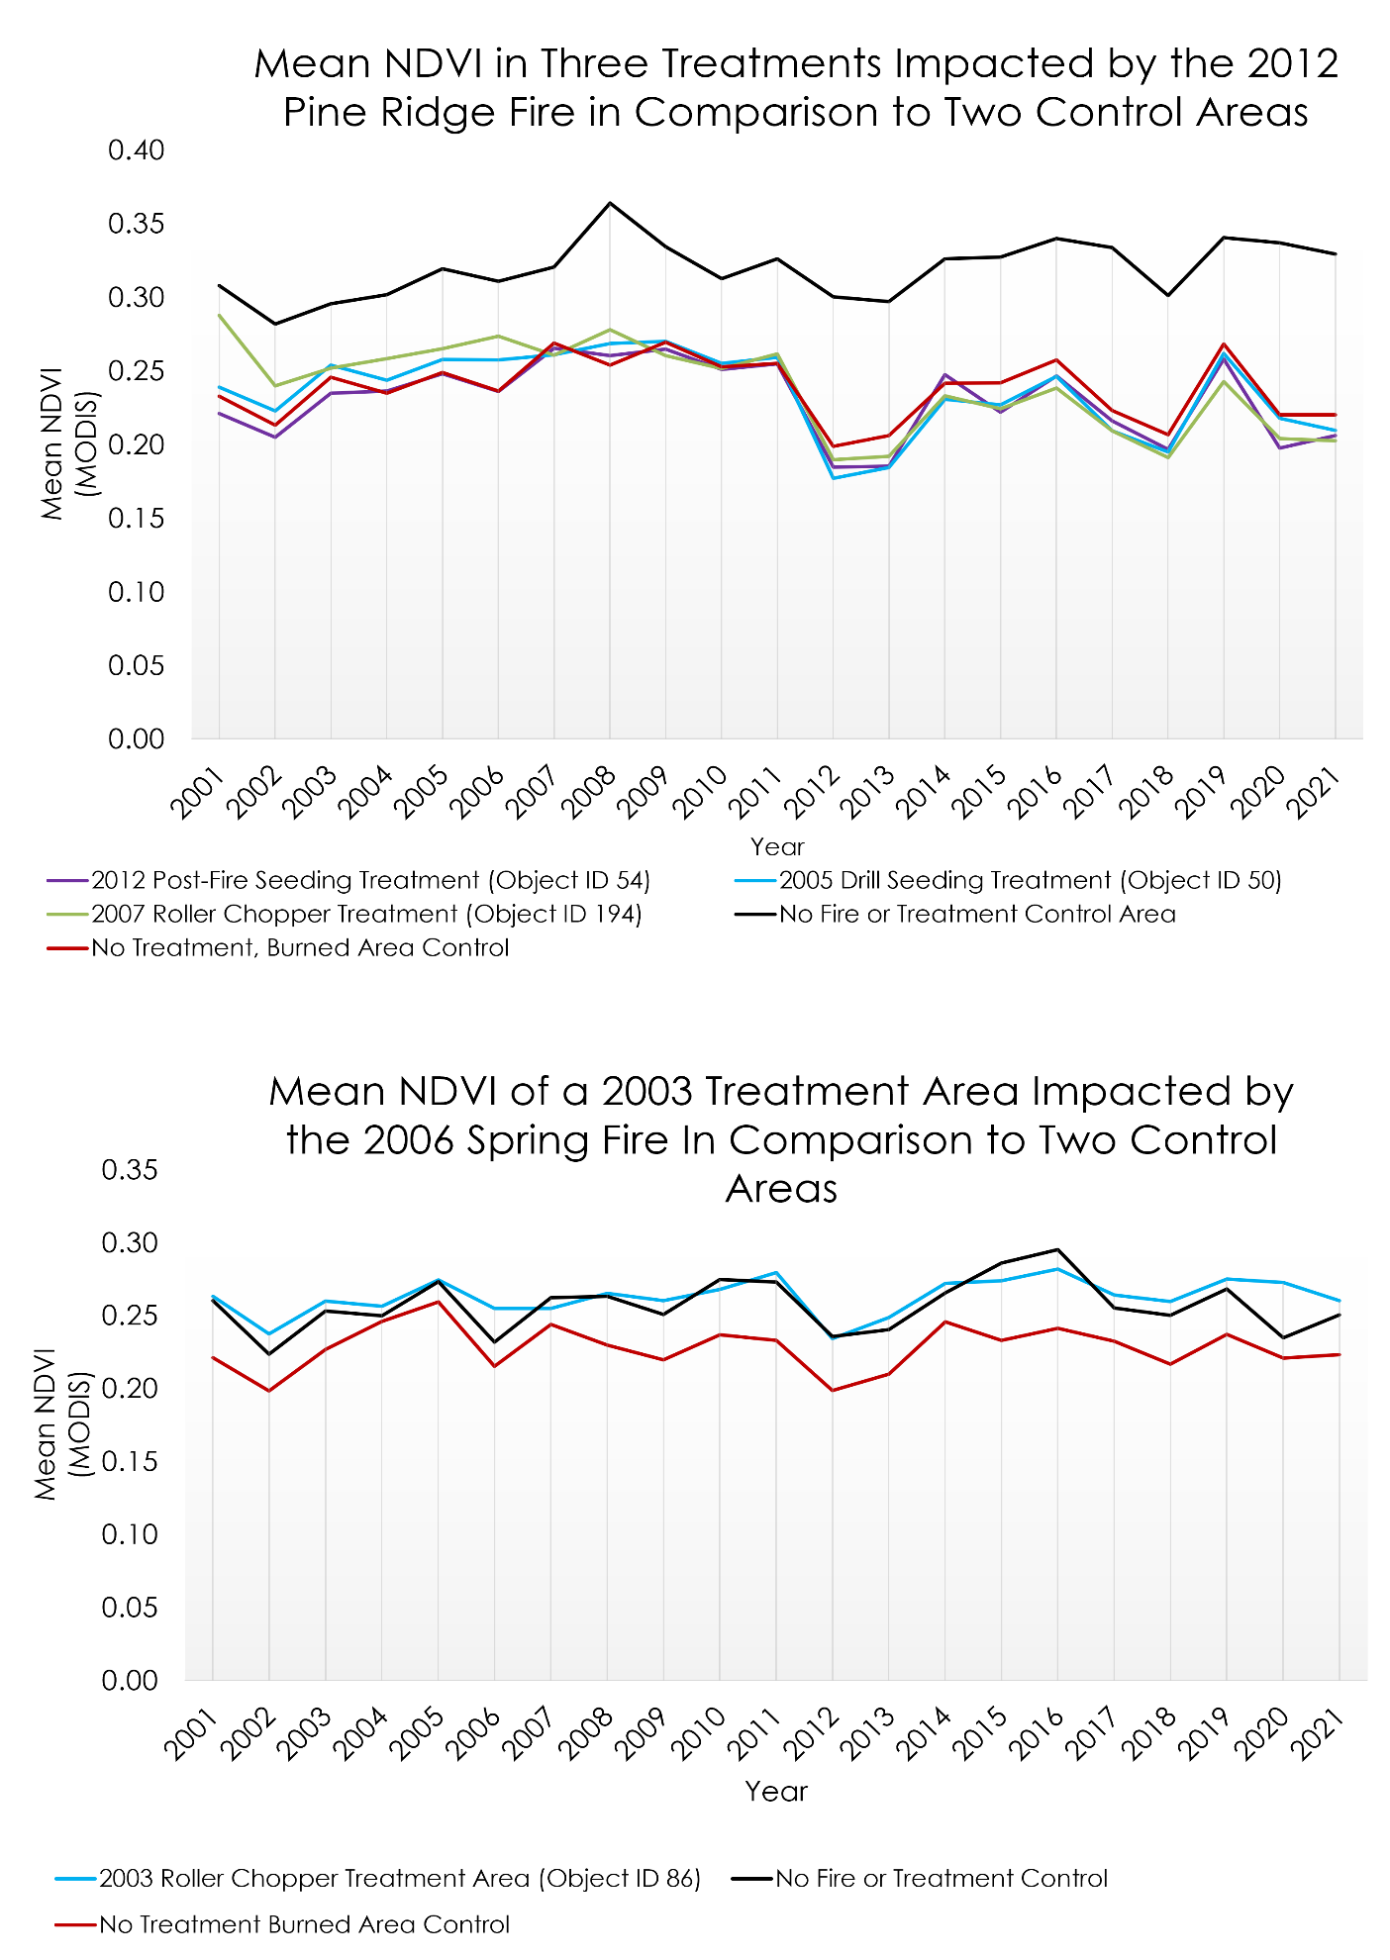
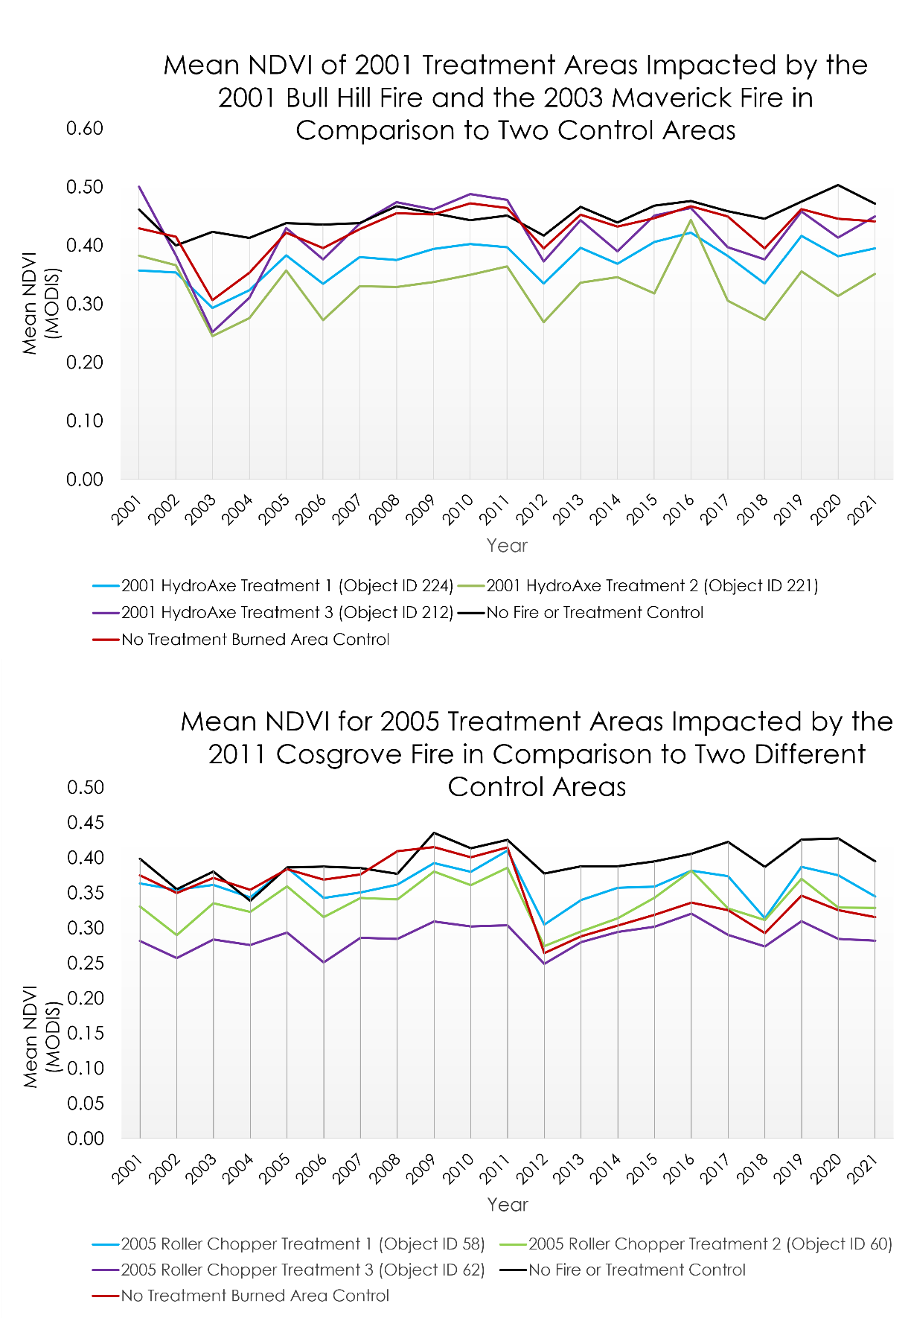
Figure C2. Line graphs displaying mean NDVI in treatment areas and control from 2001–2021. The Object ID, an index located within the attribute table of the fire-impacted treatment polygon layer, is labeled next to each treatment.
Appendix D: Vegetation Disturbance

Appendix D. Map showing vegetation disturbance within the Pinyon-juniper of the Grand Valley region in 2021.
