Environmental Justice Needs-Assessment
For Health & Air Quality
Assessing the Needs and Capacity of Organizations Working Towards Health and Environmental Justice
Related to Health and Air Quality

Synthesis Report
March 31st, 2022

Elizabeth Duran (Project Lead)
Paige Aldenberg
Sadie Murray
Thomas Schindelman

Advisors:
Lauren Childs-Gleason, NASA Langley Research Center (Science Advisor)

1. Abstract
Health and air quality are concerns in environmental justice (EJ) work, as air contaminants and their adverse health effects inequitably impact communities that are often underrepresented in research and litigation. Previously, the NASA DEVELOP National Program partnered with organizations that focus on a variety of health and air quality concerns and is now committed to partnering directly with EJ organizations to address inequities in health and air quality through the application of Earth observations. To support the establishment of future partnerships, DEVELOP is working to identify potential partners for further EJ research in the U.S. regarding health and air quality. This project conducted a needs assessment with EJ organizations to quantify their EJ involvement, geospatial capacity, and interest in collaborating with DEVELOP. A broad literature review identified multiple factors influencing health and air quality for potential DEVELOP projects: agriculture, heat, wildfires, industry and transportation infrastructure, and miscellaneous factors (e.g., burning, urban heat island effect, smoke plumes, truck exhaust, and noise). The needs assessment showed that 22% of the organizations interviewed were primarily concerned with transportation infrastructure, 21% with industry, 19% with heat, 10% with miscellaneous factors (e.g., resource mining, COVID-19), 8% with wildfires, 7% with agriculture, and 6% with resource mining. This will help inform the DEVELOP Program's pursuit of EJ projects relating to health and air quality. The team also created a directory for communities impacted by air pollutants to connect with geospatial resources and NASA Applied Sciences personnel for future EJ health and air quality work.

Key terms
Environmental Justice, Needs-Assessment, Health and Air Quality, Community Organizations, Interviews

2. Introduction
2.1 Background Information
Air quality is a leading environmental risk factor and plays an important role in the health of individuals (Castillo et al., 2021). According to the World Health Organization (WHO), 99% of the global population breathes air that exceeds WHO’s global air quality guideline limits (World Health Organization, 2019). Epidemiological literature states that air pollution can have negative impacts on human health, including: cardiovascular disease, respiratory disease, asthma, cancer, and mortality (Mullen et al., 2020; Rubio et al., 2021). Communities throughout the United States are exposed to varying levels of air pollution that impact their health and quality of life, but these impacts are not distributed equally, contributing to persistent health disparities and inequities. Neighborhoods most impacted by poor air quality conditions often are those of marginalized communities, such as low socioeconomic status (SES), racial/ethnic minorities, linguistic isolation, and more (Castillo et al., 2021; Collins et al., 2017). These communities often live near air pollution sources, as a result of historical racial policies related to transportation, zoning, and housing (Castillo et al., 2021; Kerr et al., 2021). Moreover, these communities often lack access to the necessary resources (healthcare, legal resources, and/or scientific expertise) needed to combat these health and air quality concerns (Martinez-Alier et al., 2014).
The work being done to address environmental inequities is called environmental justice (EJ). EJ is defined by the U.S Environmental Protection Agency (EPA) as “the fair treatment and meaningful involvement of all people regardless of race, color, national origin, or income, with respect to the development, implementation, and enforcement of environmental laws, regulations, and policies” (Environmental Protection Agency, n.d.). This movement began with activists, not with academics or researchers, and explores humans’ relationship with their surrounding environment (Martinez-Alier et al., 2014). There are three main types of justice that contribute to EJ: distributive justice, procedural justice, and intergenerational justice (Lersch et al., 2020). Distributive justice describes the equal distribution of benefits and burdens in an environment; procedural justice occurs with equitable institutional decision-making with respect to the values and interests of stakeholders; intergenerational justice focuses on preventing contemporary injustices from replicating themselves in the future (Lersch et al., 2020). All three components play a role in achieving environmental justice. Environmental justice in the context of air quality investigates the disproportionate distribution of air pollution and its health inequities and disparities.
The DEVELOP National Program set a goal to diversify their project reach and accessibility, centered around EJ. Not without its faults, including those in scope and accuracy (Maantay, 2002), remote sensing can be a powerful tool when applied to EJ work, especially in a mixed methods approach (Haklay & Francis, 2018; Sadd et al., 2014). The Health and Air Quality Needs Assessment team was created in January 2022 to address the regional gaps in projects related to air quality and environmental justice and expand on the scope of previous DEVELOP projects such as the work done by Wasserman et al. (2018) and Enz et al. (2021). We identified EJ organizations in each state capturing a snapshot of US-based organizations working towards health and air quality environmental justice. Health and air quality (HAQ) encompasses a wide range of topics; as a result, our team narrowed our scope to five HAQ core sources, chosen based on conversations with experts in the field and their prominence in literature (Appendix B). These core sources as seen in Figure 1 are: agriculture (Ogneva-Himmelberger et al., 2015), wildfires (Wasserman et al., 2018), urban heat islands (Weigand et al., 2019), industry and transportation infrastructure (Buzzelli et al., 2003), and miscellaneous, which includes anthropogenic sources such as noise (Haklay & Francis, 2018) and COVID (Ahmed et al., 2021; Kerr et al., 2021). Another goal of this work was to help the NASA DEVELOP National program identify EJ organizations to partner with for future projects, inform NASA DEVELOP of the level of expertise in GIS by potential partner organizations, and describe their needs and challenges.
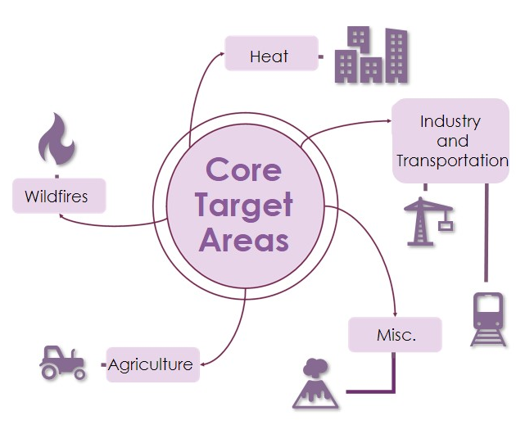
Figure 1. The core sources of air pollution selected for this study.

2.2 Environmental Justice Objectives for NASA DEVELOP
To achieve DEVELOP’s goal of increasing EJ-centered projects on the topic of HAQ, our team conducted a needs assessment of community organizations working in the EJ field. This assessment helped us to determine core air quality pollution sources, challenges faced by EJ communities, identify organizations’ interest and capacity with geospatial analyses, and explore the possibility for collaboration on a future DEVELOP project. Additionally, the team created a living directory titled Assessing Justice and Environmental Needs Directory for Air quality (AJENDA) to provide geospatial resources to organizations looking to apply Earth observations to their EJ work, and ideally leading to NASA integrating activist knowledge into research, as Temper et al. (2015) suggest. Included in this directory is a list of EJ organizations working towards improved HAQ which demonstrated interest in partnering for future DEVELOP projects. Our results provided DEVELOP with opportunities to build capacity in both DEVELOP participants and partner organizations to address environmental challenges.

3. Methodology
3.1 Organization Outreach
We reached out to 90 organizations across the United States which focus on HAQ in some aspect of their work. We found organizations through a combination of academic literature, conversations with experts in the field, internet searches, and our own personal knowledge. We created an index of organizations, noting down their location, their mission statement, a point of contact, and which of our five core sources of pollution they addressed. Each organization that we interviewed was included on one of the map tours in AJENDA. As specified by literature, we intentionally reached out to organizations with populations underrepresented in EJ research (Collins et al., 2017; Vickery & Hunter, 2016) as well as ensured that we had at least one HAQ EJ organization from each state represented. National organizations with many different branches were only included in states where no other environmental justice organization addressing HAQ could be found, provided that they had a unique contact address and office. Some organizations only had a contact form or phone number and were eliminated from our outreach campaign due to the project’s time constraints. We scheduled interviews through Calendly, which we chose to make it easier and more accessible for the organizations to select the best interview time for them.
For organization outreach, we used Mail Merge, an Office 365 feature that let us draft a template email that could be easily customized and sent out to all the organizations in our directory. The goal of our initial email was to explain who we were, what our project goals were, and establish organizations’ interest in interviewing with our team. We then sent organizations one of two needs assessment questionnaires (Appendix C). Organizations who expressed interest in scheduling an interview were sent a confirmation interview email and the long questionnaire. The responses were reviewed by a team member to tailor future interview questions. Organizations who showed interest in interviewing with our team but were unable to at the time were also sent the long questionnaire. Finally, organizations uninterested in interviewing or who did not respond were sent a follow up email with our short questionnaire in the hopes of gaining some insight even from organizations without the time for a longer survey or full interview.
3.2 Information Collection Process
The needs-based assessment data of these organizations were gathered through a combination of interviews and questionnaires. We designed two versions of the questionnaire to facilitate a greater response and capture a wider data pool by offering a shorter alternative to organizations that had little to no time to respond. Both versions held the same core goals: to understand the organizations’ capacity for GIS, their needs, populations they served, and what, if any, DEVELOP project could come out of a partnership with them. Both questionnaires were mixed method questionnaires, meaning they contained both quantitative and qualitative questions. The short questionnaire was designed to take less than five minutes, while the long questionnaire was designed to take ten to fifteen minutes. For the long questionnaire, we tailored the questions based on the organizations’ self-ascribed GIS experience. Depending on their answer, the form brought them to certain follow up questions, and their answers were used to inform our interview questions. Language accessibility and inclusivity was one of our main guiding principles in the process of developing these questionnaires. To ensure that our language and questionnaire usage achieved these goals, we consulted with Dr. Jennifer Pipitone, an environmental psychologist at the College of Mount Saint Vincent, for guidance.
Each interview block was scheduled to be 30 minutes long. We ensured extra time could be available if the organizations wanted to talk past the 30-minute timeframe. At least two team members attended each interview. One team member conducted a semi-structured interview based on a premade set of questions (Appendix D), while other team members took additional notes. Before delving into the questions, we asked each organization for their consent to record and transcribe the interview. At the end of each interview, the transcript was examined, cleaned up, and emailed back to the organization interviewed for their final approval and any redactions they might like to make. Afterwards, we performed a quantitative and qualitative analysis of the interview and questionnaire data.

3.3 Transcription/Data Analysis/Synthesis
The data from the short and long questionnaires were analyzed in Excel while the interviews were analyzed using NVivo (1.6.1) software. Using NVivo, the interview data was coded to different nodes or themes found throughout all the interviews (Figure 2). The NVivo interview data were used to perform a qualitative analysis of organizational needs and GIS proficiency, which were visualized with word clouds, while additional insights were displayed on our StoryMap. Following the methodology recommended in (Moore et al., 2019), we used an “undisciplined” approach to mapping the environmental justice data. In other words, we applied our mixed backgrounds and skill sets to the data we had gathered in a manner that was more exploratory and investigative of the data than it was seeking an answer to one pre-defined research question. We chose to use this approach as we are the first project at NASA DEVELOP to conduct this kind of work, and we did not want to make any assumptions or expectations of the data. Additionally, given that we received 22 questionnaire responses, of which only 15 translated into interviews, we sought to capture the data as holistically as possible, considering the small sample size we were drawing from.
We analyzed results of our Google Forms survey in Excel and created graphs to visualize the data, focusing our analysis on the most pertinent questions to our needs-based assessments. Based on this analysis, we created graphs of organizations' HAQ concerns, sector of work, experience with GIS and desired support. For the qualitative analysis, we used NVivo to code themes from the interviews. In order to prepare for coding the interviews in NVivo, we first generated a coding table, or list of themes to code the transcripts to, based on topics addressed in the interviews (Figure 2). By analyzing the number of interviews coded to each theme, the weight of the coding spread between interviews, and reading through the combination of responses to each theme across each organization, we hoped to gain insights on those themes.
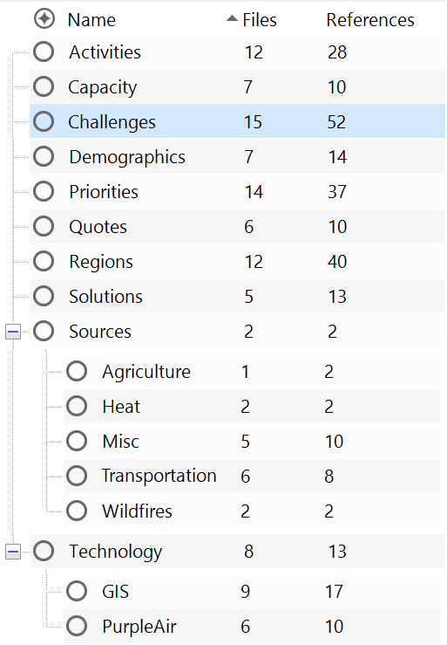
Once the interviews were coded in NVivo, we analyzed them by visualizing the qualitative data. To visualize the qualitative data from the interviews, we created word clouds to look at frequency of certain terms across different themes. To gain further insight, we restructured the data via NVivo’s node system, looking at how the themes related to each other, and which themes seemed more prominent across the interviews. Finally, we examined what collective insights could be gained from each theme.

Figure 2. A screenshot of our NVivo coding themes.
4. Results & Discussion
4.1 Analysis of Questionnaire Data
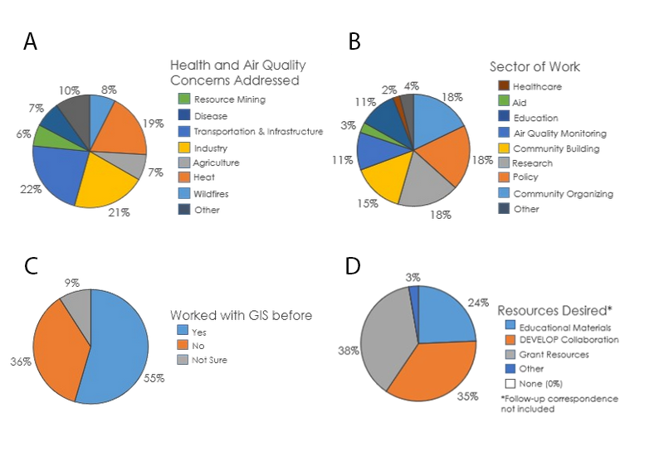
Figure 3. Quantitative Data of organizations’: A) HAQ Concerns Addressed, B) Sector of Work, C) GIS experience, and D) Resources Desired.

From our questionnaires and outreach to organizations, 22% of organizations address air quality concerns stemming from transportation & infrastructure, making this the most common HAQ concern from the pool of organizations (Figure 3A). Other concerns that were widely addressed throughout the organizations were industry (21%) and heat (19%). The most common sectors of work that the organizations worked in to address these concerns were research, policy, and community organizing (18%; Figure 3B). Most of the organizations (55%) had already worked with GIS in some capacity, but 36% had not worked with GIS before (Figure 3C). Nevertheless, all organizations expressed interest in using GIS in their future work, though some were limited in their capacity due to organization size, funding, and resources available. The most common resource desired by organizations was grant resources at 38%, followed by a DEVELOP project collaboration at 35% (Figure 3D).

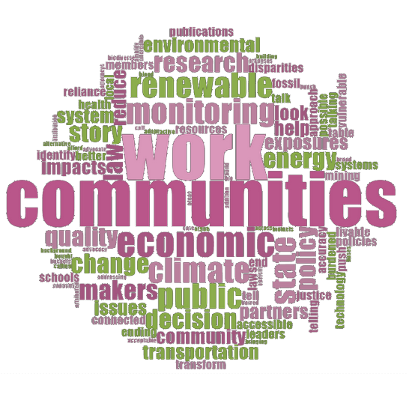
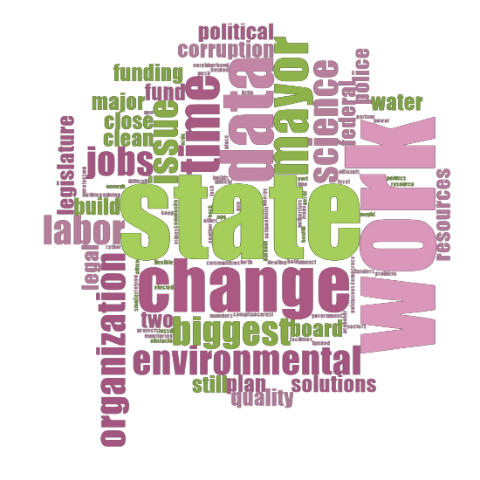
4.2 Analysis of NVivo Data
A. B.

Figure 4. Word clouds from NVivo data: A) Priorities B) Challenges.

Table 1
Most common words in each theme
Interview Theme | Five most common words
Priorities | Monitoring, public, renewable, State, change
Challenges | State, change, data, mayor, time
Capacity | Limited, partnerships, resources, information, many
Activities | Campaign, working, law, policy, communities
Demographics | Community, work, whole, majority, neighborhood

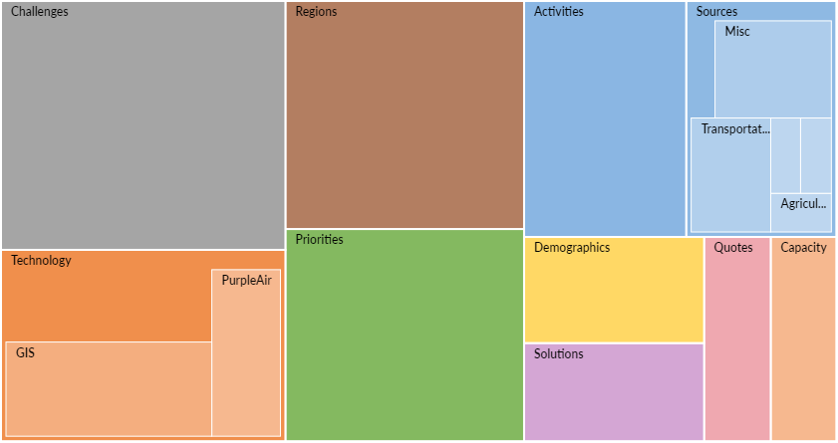
Figure 5. Tree map showing how many of our codes from the interviews went to each theme in NVivo.

Many organizations mentioned capacity as a major issue, both in terms of personnel and projects. When looking at challenges, organizations mostly spoke about the difficulties in creating political change, the dangers of untrustworthy actors in the environmental justice movement, and the importance of telling the stories of their communities. On the other hand, when talking about priorities, organizations emphasized data and technology as well as collaboration and coalition building. Figure 4 shows two word clouds generated in NVivo based on these nodes. Figure 4A was created from the Priorities node. “Communities” was the most repeated word. Scientific terms such as “monitoring,” “research,” and terms concerning the government such as “policy,” “public,” and “system” were also relatively common throughout the interviews. This supports the idea that organizational priorities center around community-driven research used to affect policy or governmental change and falls in line with contemporary definitions of environmental justice. The breakdown of the Priorities node shows that the number of priorities coded per interview is not always evenly spread, as some organizations focused much more heavily on challenges, activities, GIS capabilities or other aspects of environmental justice. The uneven representation of interviews is something to keep in mind when examining the word clouds.

In comparison to the Priorities node, the Challenges node (Figure 4B) saw much more even distribution across interviews. This tells us that the common words mentioned across the challenges node were common across all organizations, instead of just strongly represented by one organization. For the Challenges node, the top five words were state, change, data, mayor, and time (Table 1). In general, the words that filled the Challenges word cloud tended to be associated with laws, governmental bodies, struggles with capacity in terms of jobs, time and access to data and research, as well as the scale of organizations’ work. As reported in the interviews, governmental corruption, agendas, lack of concern, and political infighting posed the biggest obstacle for most groups looking to make change in environmental justice. As a governmental body, we might have to invest considerable time and work into building trust with some of these organizations that could take longer than a traditional DEVELOP project. Organizations also talked specifically about the importance of finding data that focused on their specific community, instead of regional or county wide data, as well as ways of joining demographic data with satellite imagery. Additionally, when talking about environmental justice communities, organizations tended to focus on racial justice more explicitly than economic justice.

We also compared the frequency of themes and subcategories within themes occurring across all interviews (Figure 5). Challenges, Technology, Region, Priorities, and Activities were our five most heavily coded themes. Over 40% of the interviews referred to pollution caused by transportation and infrastructure. In contrast, the other pollution sources, heat, agriculture, and wildfires were equally referred to in almost 15% of interviews. Diesel was the most common miscellaneous pollution source referenced, appearing in almost 17% of interviews.

Just over 40% of the organizations we interviewed mentioned PurpleAir monitors. While most organizations talked about how cheap they were and how they were able to provide air quality data, only one of the organizations mentioned that the PurpleAir monitors are not considered a high enough quality sensor to be accepted by the EPA and that they overestimate air quality by 60% (Johnson et al., 2020). This was indicative of the larger trend across organizations that showed an uneven scientific knowledge, or knowledge of GIS and its capabilities. Further education could be useful to help some environmental justice organizations understand the basics of what GIS can and cannot do.

4.3 Errors and Uncertainties
Out of the 90 organizations we contacted, 38.5% responded to us, likely contributing error to our work. Additionally, our initial search for organizations was not exhaustive, and there are undoubtedly countless organizations we missed. One issue we ran into in our initial outreach campaign was the validity of our identity and what we stood to offer. Some organizations expressed distrust or confusion in our relationship with NASA, given our emails were sent from SSAI accounts. One organization expressed the desire to only talk with NASA personnel directly. For some organizations, our emails were marked as spam and were never received by the organizations. It remains unknown if this validity issue is a reason some organizations did not respond to our outreach campaign at all.

Not included in this data is one anonymous organization who initially participated in the questionnaire and interview. During the interview, there were unfortunate misconceptions of the scope of DEVELOP’s work, as well as what was being offered in a NASA DEVELOP project collaboration. Due to miscommunication, the organization interpreted our work as extractive, conducted with misinformed consent, their time being misused, and a collaboration leading to the harm of frontline communities. NASA officials sent follow-up correspondence to ameliorate the issue, which resulted in a mutual agreement to terminate possible future partnerships. As such, they requested their transcription, recording and inclusion in our research to be completely scrubbed from the record, which we abided by.

4.4 Future Work
Our StoryMap AJENDA is meant to serve as the home to DEVELOP public resources relating to air quality EJ work and DEVELOP’s goals in this field. It currently hosts information on common air pollution sources, satellite missions and sensors used in remote sensing, examples of past DEVELOP projects, and lists organizations currently working in the EJ field. AJENDA should continuously be updated as more knowledge, sensors, and partnerships develop. Additionally, continuing the listening tour with adjusted outreach to discover new organizations not found in our initial search would be a prominent way of building out NASA’s knowledge of environmental justice organizations.

In addition to developing a working directory of organizations, future work for this project should involve spending longer than ten weeks to build relationships with organizations. Future projects would also benefit from exploring alternative timelines or sets of deliverables for environmental justice projects. Most organizations expressed concern over the ten-week term duration. This was reflected in our struggles to build trust in the limited time frame; many organizations shared that they often spend months forging connections to build trust before partnering. In addition to an alternative timeline, it would also be beneficial to the success of this program to explore what environmental justice deliverables should look like and how those deliverables should differ from typical feasibility projects.

Lastly, our interviews revealed several promising potential projects. In many of our discussions, organizations expressed strong interests in diesel emission tracking and pollutant ground truthing (via PurpleAir monitors). With the upcoming launch of Tropospheric Emissions: Monitoring of Pollution (TEMPO), some of these projects can be more feasible, as TEMPO is planned to receive data every daylight hour on the North American continent. Furthermore, the biggest air pollution concern was transportation & infrastructure, and DEVELOP teams should continue to explore this realm in future projects using new data that will allow for finer scaled resolution analysis. The finer resolution may also provide an opportunity to go beyond the census-block scale when looking at communities, which was often cited as a concern with vulnerability indexes. One organization stated that census-block vulnerability indexes were often used against them in litigation work because indices typically do not evaluate at a fine resolution, and bundle variables together which can blur the source of these concerns or make relationships between variables vague. Therefore, EJ DEVELOP projects should avoid creating an index or do so from a careful perspective. Moving forward, it is critical that DEVELOP be mindful of how it visualizes its data and how those visualizations will help the communities they serve.

5. Conclusions
Although the majority of organizations we spoke to used GIS in some capacity, all organizations expressed interest in collaborating with DEVELOP on a project to further enhance their capacity. Most organizations also indicated that time and money were big capacity concerns for them. However, the DEVELOP Program should not focus just on improving the capacity of organizations that already use GIS. Regardless of their level of expertise with GIS, collaborating on a DEVELOP project would allow organizations to have a wider breadth of data accessibility to continue litigation and community outreach work.

In the past, the DEVELOP Program implemented environmental justice work mainly into projects that related to urban heat islands. Though the DEVELOP Program wants to expand HAQ environmental justice project scopes, our data implies urban-environment based projects should continue to be a top priority, as transportation & infrastructure, industry, and heat were the top concerns within the organizations we interviewed. We acknowledge, however, that the sample size, availability of organizations to interview, and areas of the United States our interviewees are based in impacted our results. 40% of the organizations we spoke to were large scale, meaning they had more than one office or an office in more than one state. Most of the organizations were also small-scale, meaning they only had one office, compared to others who might have multiple offices across their state or across the U.S. Some of these small-scale organizations are located near DEVELOP node locations. If the DEVELOP Program were to plan a feasible project with these partners, having opportunities to do multi-term projects with an in-person ground-truthing term, then a geospatial analysis term, could be a model to build capacity in both the project partners and participants. Getting access to ground-truthing analyses and information is important for project partners.

DEVELOP’s work should extend beyond only providing end products: DEVELOP should do their best to ensure the collaboration meets organizations’ needs beyond just the 10-week timeframe. End products that do not come from a partner/community-forward approach can be either useless to organizations or possibly harmful to the communities they serve. Going forward, it is important for the DEVELOP Program to expand its data collection methodologies, partnerships, and evaluation metrics in order to ensure DEVELOP is providing fulfilling end-products to partner organizations. Future projects at DEVELOP could analyze the success of past DEVELOP end products to better understand the type of work that serves community interests best. In the scope of EJ work, the DEVELOP Program needs to consider expanding its project terms past the fixed timeframe, or mandate that EJ-based projects are multi-term to ensure that trust is built between a federally affiliated program and EJ organizations facing injustices, so that EJ work can be done in a thoughtful, encompassing, and applied way.

6. Acknowledgments
We would like to thank our DEVELOP Fellow Marco Vallejos, our Science Advisor Lauren Childs-Gleason, along with other external advisors such as Dr. Jennifer Pipitone, Sara Grineski, Tim Collins and Dr. Tarik Benmarhnia. This work would also not be possible without our many partners that we learned so much from regarding environmental justice work.

Any opinions, findings, and conclusions or recommendations expressed in this material are those of the author(s) and do not necessarily reflect the views of the National Aeronautics and Space Administration.

This material is based upon work supported by NASA through contract NNL16AA05C.

7. Glossary
Anthropogenic – human-caused emissions and environmental damage
Earth observations – Satellites and sensors that collect information about the Earth’s physical, chemical, and biological systems over space and time
Environmental Justice – The fair treatment and meaningful involvement of all people regardless of race, color, national origin, or income, with respect to the development, implementation, and enforcement of environmental laws, regulations, and policies (EPA)
Geographic Information Systems (GIS) – A computer system used to analyze, interpret, and display aerial and satellite imagery
Health & Air Quality (HAQ) – An application area that focuses on various air pollutants and their sources, and how they affect the wellness of surrounding communities
Urban Heat Island Effect (UHI) – Areas in an urban environment that experience extreme heat compared to suburban areas
WHO – World Health Organization

8. References
Ahmed, S. M., Shah, R. U., Fernandez, V., Grineski, S., Brintz, B., Samore, M. H., Ferrari, M. J., Leung, D. T., & Keegan, L. T. (2021). Robust testing in outpatient settings to explore COVID-19 epidemiology: disparities in race/ethnicity and age, Salt Lake County, Utah, 2020. Public Health Reports (Washington, D.C. : 1974), 136(3), 345–353. https://doi.org/10.1177/0033354920988612
Buzzelli, M., Jerrett, M., Burnett, R., & Finklestein, N. (2003). Spatiotemporal perspectives on air pollution and environmental justice in Hamilton, Canada, 1985-1996. Annals of the Association of American Geographers, 93(3), 557–573. http://www.jstor.org/stable/1515497
Castillo, M. D., Kinney, P. L., Southerland, V., Arno, C. A., Crawford, K., van Donkelaar, A., et al. (2021). Estimating intra-urban inequities in PM2.5-attributable health impacts: A case study for Washington, DC. GeoHealth, 5(11). https://doi.org/10.1029/2021GH000431
Collins, T. W., Grineski, S. E., & Morales, D. X. (2017). Environmental injustice and sexual minority health disparities: A national study of inequitable health risks from air pollution among same-sex partners. Social Science & Medicine, 191, 38–47. https://doi.org/10.1016/j.socscimed.2017.08.040
Environmental Protection Agency. (n.d.). Environmental Justice. US Environmental Protection Agency. https://www.epa.gov/environmentaljustice
Enz, M., Nichols, P., Leung, M., Van Dermark, J., Zimmerman, M. (2021). Using Remote Sensing to Detect the Frequency and Drivers of Red Tide Blooms in California to Assist in the Management of Human and Marine Exposure to Algal Toxins. [Unpublished manuscript]. NASA DEVELOP National Program, California – Ames.
Haklay, M., and Francis, L., 2018. Participatory GIS and community-based citizen science for environmental justice action, in Chakraborty, J., Walker, G. and Holifield, R.(eds.), The Routledge Handbook of Environmental Justice. Abingdon: Routledge, pp. 297-308. https://discovery.ucl.ac.uk/id/eprint/1575418/1/24%20Participatory%20GIS%20Haklay%20and%20Francis.pdf
Johnson, K., Holder, A., Frederick, S., Hagler, G., & Clements, A. (2020) PurpleAir PM2.5 performance across the U.S.#2. EPA. https://cfpub.epa.gov/si/si_public_record_Report.cfm?Lab=CEMM&dirEntryId=348236
Kerr, G. H., Goldberg, D. L., & Anenberg, S. C. (2021). COVID-19 pandemic reveals persistent disparities in nitrogen dioxide pollution. Proceedings of the National Academy of Sciences, 118(30). https://doi.org/10.1073/pnas.2022409118
Lersch, K.M. & Chakraborty, J. (eds.) (2020), Geographies of Behavioural Health, Crime, and Disorder, GeoJournal Library 126, https://doi.org/10.1007/978-3-030-33467-3_9187

Maantay, J. (2002). Mapping environmental injustices: Pitfalls and potential of geographic information systems in assessing environmental health and equity. Environmental Health Perspectives, 110(suppl 2), 161–171. https://doi.org/10.1289/ehp.02110s2161
Martinez-Alier, J., Anguelovski, I., Bond, P., Del Bene, D., & Demaria, F. (2014). Between activism and science: grassroots concepts for sustainability coined by Environmental Justice Organizations. https://doi.org/10.2458/v21i1.21124
Moore, S. A., Roth, R. E., Rosenfeld, H., Nost, E., Vincent, K., Arefin, M. R., & Buckingham, T. M. (2019). Undisciplining environmental justice research with visual storytelling. Geoforum, 102, 267-277. https://doi.org/10.1080/00087041.2019.1633103
Mullen, C., Grineski, S., Collins, T., Xing, W., Whitaker, R., Sayahi, T., … Kelly, K. (2020). Patterns of distributive environmental inequity under different PM2.5 air pollution scenarios for Salt Lake County public schools. Environmental Research, 186. https://doi.org/10.1016/j.envres.2020.109543
Ogneva-Himmelberger, Y., Huang, L., & Xin, H. (2015). CALPUFF and Cafos: Air pollution modeling and environmental justice analysis in the North Carolina Hog Industry. ISPRS International Journal of Geo-Information, 4(1), 150–171. https://doi.org/10.3390/ijgi4010150
Sadd, J., Morello-Frosch, R., Pastor, M., Matsuoka, M., Prichard, M., & Carter, V. (2014). The truth, the whole truth, and nothing but the ground-truth: methods to advance environmental justice and researcher-community partnerships. Health Education & Behavior, 41(3), 281–290. http://www.jstor.org/stable/45056915
Temper, L., Del Bene, D., & Martinez-Alier, J. (2015). Mapping the frontiers and front lines of global environmental justice: the EJAtlas. Journal of Political Ecology, 22(1), 255-278. https://doi.org/10.2458/v22i1.21108
Rubio, R., Grineski, S., & Collins, T. (2021). Children’s exposure to vehicular air pollution in the United States: environmental injustices at the interesction of race/ethnicity and language. Environmental Sociology, 7(3), 187–199. https://doi.org/10.1080/23251042.2021.1878574
Vickery, J., & Hunter, L. M. (2016). Native Americans: Where in environmental justice research?. Society & Natural Resources, 29(1), 36-52. https://doi.org/10.1080/08941920.2015.1045644
Wasserman, A., Seeley, M., Nickmeyer, A. (2018). Measuring California Air Quality through the Use of NASA Earth Observations to Identify Spatial, Temporal, and Social Disparities in Particulate Matter Pollution. [Unpublished manuscript]. NASA DEVELOP National Program, California – Ames.
Weigand, M., Wurm, M., Dech, S., & Taubenböck, H. (2019). Remote Sensing in Environmental Justice Research—A Review. ISPRS International Journal of Geo-Information, 8(1), 20. MDPI AG. Retrieved from http://dx.doi.org/10.3390/ijgi8010020
World Health Organization. (2019). Air Pollution. World Health Organization. https://www.who.int/health-topics/air-pollution#tab=tab_1

9. Appendices
Appendix A: Organization List

Organization Name | Type of Organization | Main POC | Contact Information | Geographic Area
The Clayton Crescent | Newspaper | Robin Kemp | Editor@claytoncrescent.org | Clayton County, GA
Neighbors for Clean Air | Non-Profit | Mary Peveto | Mary@neighborsforcleanair.org | OR
Iowa Environmental Council | Non-Profit | Steve Guyer | Guyer@iaenvironment.org | IA
Appalachian Voices | Non-Profit | Matt Hepler | Matt.hepler@appvoices.org | Appalachia
Oregon Environmental Council | Non-Profit | Jamie Pang South | Jamiep@oeconline.org | OR
Communities for a Better Environment | Non-Profit | Stephanie | Stephanie@cbecal.org | Los Angeles, CA
Future Earth | Non-Profit | Erica Key | Erica.key@futureearth.org | Boulder, CO
Stop the Burn (Sierra Club) | Non-Profit | Patrick Ferguson | Patrick.ferguson@sierraclub.org | Bel Glade, FL
Healthy Fresno Air | Non-Profit | Keishaun White | Kieshaun@celsblock.com | Fresno, CA
Clean Water Action | Non-Profit | Amy Goldsmith | Agoldsmith1@cleanwater.org | Long Branch, NJ
Southeast Climate and Energy Network | Non-Profit | Alex Easdale | Alex@scen-us.org | Fort Lauderdale, FL
Clean Air Coalition | Non-Profit | Matt Walker | Mwalker@cleanair.org | Philadelphia, PA
FracTracker Alliance | Non-Profit | Shannon Smith | Smith@fractracker.org | Johnstown, PA
CicLAvia | Non-Profit | Meisha Rainman | Meisha@ciclavia.org | Los Angeles, CA
NYC-EJA | Non-Profit | Victoria Sanders | victoria@nyc-eja.org | New York City, NY

Appendix B: Annotated Bibliography

1) Ahmed, S. M., Shah, R. U., Fernandez, V., Grineski, S., Brintz, B., Samore, M. H., Ferrari, M. J., Leung, D. T., & Keegan, L. T. (2021). Robust testing in outpatient settings to explore COVID-19 epidemiology: disparities in race/ethnicity and age, Salt Lake County, Utah, 2020. Public Health Reports (Washington, D.C. : 1974), 136(3), 345–353. https://doi.org/10.1177/0033354920988612
The focus of this work was to determine outpatient demographics for those ill with COVID-19 in Salt Lake County, Utah (an area receiving robust testing). The authors took demographic data and clinical data for outpatients at the University of Utah health clinics. From there, they calculated odds of testing positive by demographic and found that non-Hispanic Whites were half as likely to test positive as Hispanic/Latinx people. Additionally, they found that adults 70–79 and 40–49 were most likely to be hospitalized.
While there may be more current research on this topic, this article provides an example of health disparities of COVID-19, which other work elaborates on in how COVID-19 disparities compound with air quality disparities to cause more extreme COVID-19 responses. This article serves as a solid reference for considering COVID-19 in the scope of environmental justice work.

2) Buzzelli, M., Jerrett, M., Burnett, R., & Finklestein, N. (2003). Spatiotemporal perspectives on air pollution and environmental justice in Hamilton, Canada, 1985–1996. Annals of the Association of American Geographers, 93(3), 557–573. http://www.jstor.org/stable/1515497
This article investigates the ties between total suspended particulate (TSP) exposure and socio-economic status in Hamilton, Canada, and questions if reduction of regional pollutants will help in aiding TSP exposure disparity. Compared to 1985, 1996 showed less disparity, which the researchers concluded was a result of dispersal of pollution sources, not due to any policy.
Possibly outdated, but this article had a lot of good insights into considerations in doing EJ HAQ work including outdated data and examples within the paper of other studies lacking in robust methodology. Some other points to note are that even with an extensive air monitoring system, the city of Hamilton found a lack of awareness even in the areas that were most affected, indicating the need and importance of outreach campaigns in environmental justice work. Additionally, the presence of TSP was heavily tied to economic ebbs and flows.

3) Castillo, M. D., Kinney, P. L., Southerland, V., Arno, C. A., Crawford, K., van Donkelaar, A., et al. (2021). Estimating intra-urban inequities in PM2.5-attributable health impacts: A case study for Washington, DC. GeoHealth, 5(11). https://doi.org/10.1029/2021GH000431
This recent study employs the use of North American satellite imagery to look at PM2.5 concentrations in Washington D.C. Utilizing demographic data, the authors mapped out population based on race and ethnicity. They found that neighborhoods with higher percentages of BIPOC/low income/low education level faced higher PM2.5 related health effects.
This study adds to the literature confirming known environmental justice disparities. However, this study focused on investigating these disparities at a fine scale (neighborhood level) and in the paper, the authors advocate for continued research on the scale of population sub-groups rather than extrapolating/generalizing from one population to another. This consideration of scale has appeared frequently in the literature and should be a consideration taken into account for DEVELOP projects doing hyper local air quality topics in the future.

4) Collins, T. W., Grineski, S. E., & Morales, D. X. (2017). Environmental injustice and sexual minority health disparities: A national study of inequitable health risks from air pollution among same-sex partners. Social Science & Medicine, 191, 38–47. https://doi.org/10.1016/j.socscimed.2017.08.040
This study sought to explore a gap in existing air quality environmental justice literature, seeking to determine if LGBT+ populations face air pollution inequities, as this has not previously been researched. Using census data and data from the National Air Toxics Assessment and adjusting for other social factors, the authors found that health disparities experienced by LGBT+ populations may be compounded by the environment. Census tracks identified as LGBT+ ‘enclaves’ were shown to face higher exposure to poor air quality, especially same-sex male partner enclaves.
While this study did not employ the use of Earth observations or much mapping in general, it provides a good perspective in thinking about the populations we are considering in environmental justice work. Historically, much of environmental justice work has been focused on black/brown populations of low socio-economic status but as this paper illustrates, other intersectionality has the possibility to also influence health and air quality. Essentially, this paper highlights that we should keep in mind that air quality is an intersectional health issue.

5) Enz, M., Nichols, P., Leung, M., Van Dermark, J., Zimmerman, M. (2021). Using Remote Sensing to Detect the Frequency and Drivers of Red Tide Blooms in California to Assist in the Management of Human and Marine Exposure to Algal Toxins. [Unpublished manuscript]. NASA DEVELOP National Program, California – Ames.
This project investigated the effects of a Lingulodinium polyedra algal bloom in 2020 along the Southern California coast. This algae species is known to cause adverse health effects including respiratory-related health risks and has become an increasing concern as red tide events have become more frequent and widespread. Using NASA Earth observations, the project team created resources (a GEE tool and ArcGIS Dashboard) to help the California Office or Environmental Health Hazard Assessment identify L. polyedra blooms.
This is a good example of a project we could reference in discussing environmental justice applications to DEVELOP health and air quality projects. Additionally, this project subject is atypical to much of air quality research as its focus is on red tide events and is a good example of doing this work in a more specialized manner.

6) Grineski, S. E., Collins, T. W., & Olvera, H. A. (2015). Local variability in the impacts of residential particulate matter and pest exposure on children’s wheezing severity: a geographically weighted regression analysis of environmental health justice. Population and Environment, 37(1), 22–43. http://www.jstor.org/stable/24769760
The focus of this research was testing two assumptions about environmental justice: that uneven exposures lead to unequal health impacts, and that these effects are stable across space. The researchers used a case study in El Paso, Texas, looking at children’s wheezing severity in relation to PM2.5 and pests. From their findings, they found that these assumptions may not be wholly accurate. Indoor air quality can compound with outdoor air quality in health effects, creating a multiple jeopardy situation. Contrastingly, they also found that while indoor air quality was much more controllable based on parents’ socio-economic status, outdoor air pollution exposure was a greater determining factor for children’s health (PM2.5 being an indicator of wheezing severity even in neighborhoods with lower levels, and a lower level of exposure to pests).
This research provides a good perspective for the work we are doing. As a case study, it gives insight into working with frontline communities. Additionally, Grineski et al.’s findings are something to consider when thinking about the framing of HAQ issues and environmental justice work assumptions can be helpful in defining scope, but it must be remembered that they are assumptions.

7) Haklay, M., and Francis, L., 2018. Participatory GIS and community-based citizen science for environmental justice action, in Chakraborty, J., Walker, G. and Holifield, R.(eds.), The Routledge Handbook of Environmental Justice. Abingdon: Routledge, pp. 297-308. https://discovery.ucl.ac.uk/id/eprint/1575418/1/24%20Participatory%20GIS%20Haklay%20and%20Francis.pdf
This book chapter gave an overview of PPGIS (public participation GIS) and PGIS (participatory GIS), as well as a case study focused on addressing noise pollution in Lewisham London. For this case study they applied their six-stage methodology which utilized community science, was intentionally flexible, and incorporated the community at all stages. Findings from this case study revealed that there was a noise pollution issue, but the community was expressing their concerns to the wrong institution (didn’t have jurisdiction over the polluter). Additionally, this study showed both boons of PPGIS but also some of the shortcomings (such as participants not going outside of their neighborhood).
This chapter is helpful for thinking or rethinking methodology when doing environmental justice work with heavy influence from the community. In terms of applications for our work, we think this might be a useful resource for future methodology considerations when working with partners. It might be a good idea to even recommend a project that will evaluate DEVELOP project methodologies for interacting and working with communities and DEVELOP project foci as based on findings from our research.

8) Kerr, G. H., Goldberg, D. L., & Anenberg, S. C. (2021). COVID-19 pandemic reveals persistent disparities in nitrogen dioxide pollution. Proceedings of the National Academy of Sciences, 118(30). https://doi.org/10.1073/pnas.2022409118
This study investigated the drop in nitrogen dioxide (NO₂) levels across different demographic subgroups in the United States during the initial lockdown during the COVID-19 pandemic. Using remote sensed observations, the authors found that the drop in NO₂ levels in the least White census tracts was almost three times the amount of the drop in the most White tracts. However, least White census tracts still faced almost 1.5 times the amount of NO₂ compared to most white during lockdown, and the significant reduction is likely due to proximity of highways and interstates to the least White neighborhoods.
An important finding from this research was that urban tracts with the lowest vehicle ownership were often those tracts that had the highest density of roads and freeways and subsequently the highest drops in NO₂. This finding aligns with similar findings from the literature that air quality is disproportionately produced by wealthy, non-Hispanic White communities and disproportionately affects poor, Black, and Hispanic communities. This work is a useful case study and a relevant one to consider with the ongoing COVID-19 pandemic. As COVID-19 is an air quality issue in and of itself (especially when compounded with NO₂ or PM2.5 exposure), this research is imperative to consider for future EJ work.

9) Maantay, J. (2002). Mapping environmental injustices: Pitfalls and potential of geographic information systems in assessing environmental health and equity. Environmental Health Perspectives, 110(suppl 2), 161–171. https://doi.org/10.1289/ehp.02110s2161
This paper reviewed 13 different studies all based on using GIS to map environmental inequities within the Bronx, New York. Mostly focused on their methodologies, Maantay points out areas GIS work needs to improve in concerning accuracy of the research of different environmental hazards, as well as some potentials for the future, especially due to the sensitive nature of the work.
Among the takeaways from this article, the first is that mapping environmental justice is not a straightforward enterprise; there are multivariate factors to consider in doing this work, so drawing simple conclusions will always leave something out. For example, in trying to isolate just one factor (such as just race or just class), one can perpetuate harm by trying to treat things that are inherently intertwined as separate, and draw conclusions for one but leaving out the other. One large issue Maantay points out in doing this work is scale—zooming into the individual/neighborhood level is best, but the data for such is often not available, incomplete or sometimes inaccurate. The same applies for modeling natural processes (such as plume dispersion). Another consideration is temporality and trying to account for population migration. In short, there is a lot to consider that often gets oversimplified in GIS and we should examine as many facets of this work as possible.

10) Martinez-Alier, J., Anguelovski, I., Bond, P., Del Bene, D., & Demaria, F. (2014). Between activism and science: grassroots concepts for sustainability coined by Environmental Justice Organizations, Journal of Political Ecology. https://doi.org/10.2458/v21i1.21124
This article was an overview of environmental justice movements and the concepts/slogans introduced to political ecology work by activists. This paper traces the various contexts these environmental justice concepts have arisen from, as well as defining said concepts and chronicling shifts in language and focus. Finally, this paper provides a history of how activists have coined and used these concepts and how academics and policy makers have built upon them in a way that is mutually beneficial to environmental justice work.
The authors’ work provides a good baseline for understanding some concepts that are very applicable to any kind of environmental justice work. Additionally, this article provides a good reminder that the work of environmental justice did not start with academics or researchers—and that includes terms and concepts frequently used in the literature. This should be kept in mind, especially in DEVELOP’s goal to better support environmental justice, and may require shifts in project formats to be considered in order to ensure EJ is being done properly.

11) Moore, S. A., Roth, R. E., Rosenfeld, H., Nost, E., Vincent, K., Arefin, M. R., & Buckingham, T. M. (2019). Undisciplining environmental justice research with visual storytelling. Geoforum, 102, 267-277. https://doi.org/10.1080/00087041.2019.1633103
The authors sought to address some of the critiques of mapping environmental justice—such as it not capturing complicated processes behind spatial phenomena—by using mapping as the process of environmental justice work and not just the end-product. Looking at transnational hazardous waste trade in North America, the authors organized a “Design Challenge” for geography students. Post Design Challenge, the authors identified methods for storytelling undisciplined environmental justice research and provided several key insights from the Design Challenge process.
The authors found that in the Design Challenge setting, teams applied their different backgrounds combining to create ‘undisciplined’ environmental justice research, or research that was cross disciplinary and not constricted to any one format. Teams used mapping as the process rather than the product, using geospatial technology to analyze and assess environmental justice issues. The authors found that the concern of not capturing complicated processes were accounted for in the work. Therefore, this is a potential resource for reviewing past DEVELOP project formats and identifying weaknesses in project methodologies.

12) Mullen, C., Grineski, S., Collins, T., Xing, W., Whitaker, R., Sayahi, T., … Kelly, K. (2020). Patterns of distributive environmental inequity under different PM2.5 air pollution scenarios for Salt Lake County public schools. Environmental Research, 186. https://doi.org/10.1016/j.envres.2020.109543
This paper seeks to address a hole in the literature: many studies of air pollution look at chronic and averaged measures, creating a static model of disparities in health and air quality. For this research, the authors look at PM2.5 exposure in Salt Lake City, Utah in school age children for three different scenarios: (1) relatively clean air, (2) moderate winter persistent cold air pool, and (3) a major winter persistent cold air pool. In their models, the authors accounted for race/ethnicity, economic disparities, age, and school type. They found schools with higher populations of racial/ethnic minorities were disproportionately exposed, but that in major winter persistent cold pool air, these disparities lessened.
This paper was a good case study for PM research, but also made the point of thinking about situations across different models. This effort aligns with other critiques of some environmental justice research methods not capturing the whole picture or not being as dynamic of a model.

13) Ogneva-Himmelberger, Y., Huang, L., & Xin, H. (2015). CALPUFF and Cafos: Air pollution modeling and environmental justice analysis in the North Carolina Hog Industry. ISPRS International Journal of Geo-Information, 4(1), 150–171. https://doi.org/10.3390/ijgi4010150
This paper focused on analyzing ammonia pollution dispersion from concentrated animal feeding operations (CAFOs) and their disproportionate effects in a North Carolina watershed. The study utilized the CALPUFF dispersion model, a meteorological and air quality modeling system, and looked at data between 2000 and 2010 to compare environmental justice issues. The research found similar numbers of people affected (exceeding the minimal risk level) in both 2000 and 2010.
Part of the purpose of this study was to fill gaps in the literature where larger units of analysis had been used in modelling ammonia pollution. To address this, the authors did their research on the census block level. Similarly, this study addressed some of the limits of past studies such as their representation of CAFOs as polluters where the number of CAFO facilities or the number of hogs were used as a proxy for the amount of pollution produced. Overall, this paper was a good case study, revealing environmental justice disparities and had some considerations regarding methodology that should be kept in mind when doing this kind of work.

14) Sadd, J., Morello-Frosch, R., Pastor, M., Matsuoka, M., Prichard, M., & Carter, V. (2014). The truth, the whole truth, and nothing but the ground-truth: methods to advance environmental justice and researcher-community partnerships. Health Education & Behavior, 41(3), 281–290. http://www.jstor.org/stable/45056915
This study coupled environmental justice screening with ground-truthing – inviting community members to participate, add to, edit and address air pollution issues in their neighborhood. Researchers and community members focused on identifying hazards (and updating the existing federal list), taking air pollution data and determining sensitive receptors that hazards should not be placed nearby. They found that much of the federal listing for hazards was outdated, inaccurate or didn’t account for many smaller hazards placed close together that had similar impacts as a singular larger one.
In part, this was an effort to help address the existing tension between academics and activists (ex: work not being distributed in a timely manner). As such, the format for this project was deconstructing any power hierarchies and democratizing knowledge (valuing community members’ experiential knowledge and making academic knowledge accessible). With this in mind, researchers trained and worked with community members, giving them the tools to monitor, research and ground-truth (and then double checking the communities work). This is a great model to keep in mind, should we make recommendations for DEVELOP EJ focused project formats.

15) Temper, L., Del Bene, D., & Martinez-Alier, J. (2015). Mapping the frontiers and front lines of global environmental justice: the EJAtlas. Journal of Political Ecology, 22(1), 255-278. https://doi.org/10.2458/v22i1.21108
This article describes the creation of a global environmental justice atlas. First, the authors make a case for the need for more connected environmental justice work in the face of global capitalism. Then, the authors present their mapping initiative known as EJAtlas, which is intended to be a Global Atlas for environmental justice. Finally, the authors go into detail of how the EJAtlas can help bolster EJ work, especially as a resource to encourage the use of mapping by marginalized groups. In reviewing their work, the authors concluded that the EJAtlas helped to integrate activist knowledge into EJ research, widen geographical analysis across all levels of the work and helped to serve as an interface between the natural and social sciences.
The EJAtlas serves as a good example (and resource) for us to consider when creating our StoryMap directory, or for whatever future form VEJ’s way of providing EJ resources may take. However, EJAtlas also serves as an example of where we can delve in more specifically (as it is at the global scale and the work we are seeking to do is likely at a smaller more local scale). This article gives a good overview of what creating a resource like this entails, as well as steps to consider going forward.

16) Vickery, J., & Hunter, L. M. (2016). Native Americans: Where in environmental justice research?. Society & Natural Resources, 29(1), 36-52. https://doi.org/10.1080/08941920.2015.1045644
This article gives an overview of Native American involvement in the Environmental Justice movement, including how their position as a sovereign nation has been frequently disregarded by governments and positions them in a place to opt in or out of governmental environmental justice movements. Reviewing 60 publications, the authors discuss Native American EJ and the unique form it takes, given historical environmental trauma and the complicated political nature.
An important aspect of this article is that it summarizes many case studies showing how Native American EJ issues challenge ‘traditional’ Western concepts of science and health and provide important perspective often lacking from the field. Flexibility of DEVELOP project format is a good rule of thumb should future projects participate in Native American EJ.

17) Wasserman, A., Seeley, M., Nickmeyer, A. (2018). Measuring California Air Quality through the Use of NASA Earth Observations to Identify Spatial, Temporal, and Social Disparities in Particulate Matter Pollution. [Unpublished manuscript]. NASA DEVELOP National Program, California – California – Ames.
This DEVELOP project sought to provide improved monitoring of PM2.5 in California as current air quality monitoring regulations use in situ data. To rectify this, the Ames team used remote imagery (MODIS, MISR, CALIPSO and SeaWiFS) to study PM2.5 in California from 1998 to 2016. While acknowledging that their results were not all encompassing due to coarse resolution, the team was able to represent long-term PM2.5 exposure and observed that low-income communities with higher populations of minorities were more likely to experience greater PM2.5 concentrations.
This project gives some good background on tools and data used that we could possibly apply to our StoryMap (such as Atmospheric Composition Analysis Group’s PM2.5 raster data). Additionally, this project is a good reference for DEVELOP’s history of having an ongoing interest in applying environmental justice to DEVELOP projects. Finally, this is overall a good example to reference for a case study when thinking about how EJ has looked at DEVELOP in the past.

18) Weigand, M., Wurm, M., Dech, S., & Taubenböck, H. (2019). Remote Sensing in Environmental Justice Research—A Review. ISPRS International Journal of Geo-Information, 8(1), 20. MDPI AG. http://dx.doi.org/10.3390/ijgi8010020
Weigand et al., review recent uses of Earth observations in air quality environmental justice research. They break down air quality issues into four categories: green spaces, air pollutants, noise and heat. Throughout the review, the authors discuss these four categories and their challenges in researching them, especially considering the Modifiable Arial Unit Problem (MAUP) of moving between data scales as well as data types.
Not only does this review give a good summary of the work being done within the field, it also highlights possible challenges to be considered by researchers whose work is centered in environmental justice. Furthermore, this review provides a set of good sources for us to consider in the future as we think about potential project applications for the organizations we interview. Finally, this work references multiple different methodologies employed in this work, therefore serving as a good reference for thinking about how this work is typically done.

Appendix C: Long and Short Questionnaire Example Questions
Short
SECTION 1
- Name of your organization
- Name and position/title in organization
- Please describe the community(ies) that your organization works with and/or represents
- From the following Health and Air Quality concerns please select all that your organizations addresses: Wildfires, Urban Heat Island, Agriculture, Industry, Transportation Infrastructure, Resource Mining, Diseases, Red Tide, Natural Processes, None, Other/please explain
  - If Other, please elaborate in a few sentences below.
- Is your organization CURRENTLY INVOLVED IN environmental justice work in any of the following ways? Please check off all that apply: Community Organizing/Advocacy, Policy, Research, Community Building/Placemaking, Air Quality Monitoring, Aid, Education, Healthcare, Other/please explain
  - If Other, please elaborate in a few sentences below.
- Does your organization WANT TO BE INVOLVED IN environmental justice work in any of the following ways? Please check off all that apply: Community Organizing/Advocacy, Policy, Research, Community Building/Placemaking, Air Quality Monitoring, Aid, Education, Healthcare, Other/please explain
  - If Other, please elaborate in a few sentences below.
- Has your organization used mapping software and/or satellite imagery before?
SECTION 2: APPLYING GIS AND REMOTE SENSING
- In your organization’s use of GIS and/or remote sensing, are there things your organization wishes it could do but has been previously limited by?
SECTION 3: APPLYING MAPPING AND SATELLITE IMAGERY
Health and Air Quality research can be combined with demographic data and resource distribution to identify vulnerable populations and areas, which can then be used by interest groups for policy. Below are some examples of how GIS, satellite imagery, and remote sensing have been used in Health and Air Quality work:
Urban Heat Island effect in New Orleans, Louisiana. Red shows temperature exceeding 90F, blue shows temperatures below 80F. NASA DEVELOP MSFC Fall 2018.
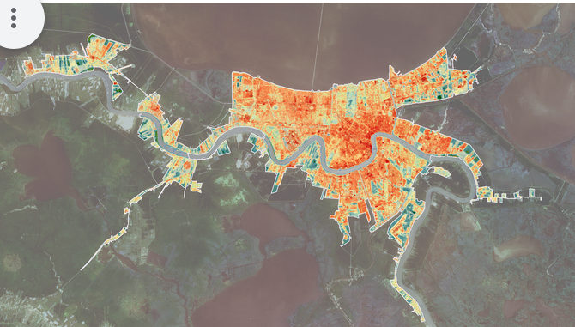
Change in Particulate Matter 2.5 in California between 1998 and 2016. NASA DEVELOP ARC Spring 2018.
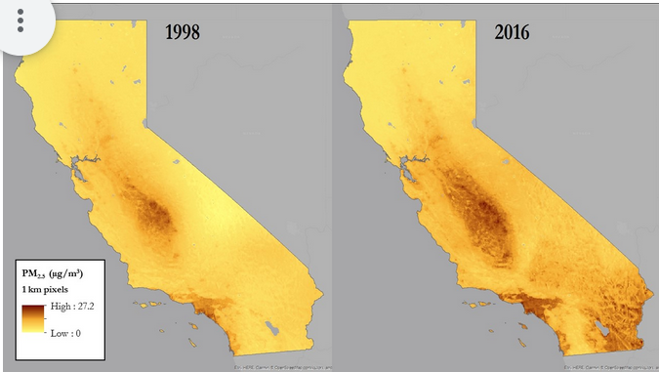
Dengue Fever Vulnerability Index in Puerto Rico as based on confirmed Dengue Fever cases 2009–2013. NASA DEVELOP ARC Fall 2015.
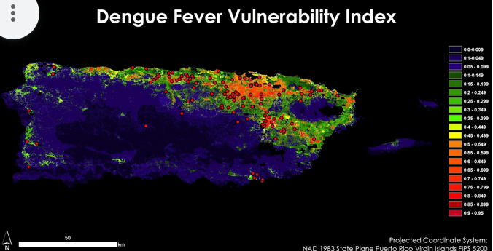
- Knowing these applications, on a scale of 1 to 5, how much interest does your organization have in using mapping software and/or satellite imagery? [1 = low interest, 3 = moderate interest, 5 = high interest]
- Are there any obstacles preventing your organization from using mapping software and/or satellite imagery to aid your work? Please select all that apply: Lack of training, No access to software resources, Too little time/not enough staff, Lack of funding, Not aware of useful mapping and/or satellite imagery applications, Not applicable to our work, Other
  - If Other, please elaborate in a few sentences below.
Long
SECTION 1
- Name of your organization
- Name and position/title in organization
- Please describe the community(ies) that your organization works with and/or represents.
- What are the top three priorities of your organization? Please list them in order from most important to least important.
- From the following Health and Air Quality concerns please select all that your organization addresses: Wildfires, Urban Heat Island, Agriculture, Industry, Transportation Infrastructure, Resource Mining, Diseases, Red Tide, Natural Processes, None, Other/please explain
  - If Other, please elaborate in a few sentences.
- What sector of work does your organization work in? Please check off all that apply: Community Organizing/Advocacy, Policy, Research, Community Building/Placemaking, Air Quality Monitoring, Aid, Education, Healthcare, Other
  - If Other, please elaborate in a few sentences.
- Does your organization address Environmental Justice? If yes, please describe how in a few sentences. If no, write N/A.
- Has your organization used mapping software and/or satellite imagery before?
  - Yes, No, Unsure
SECTION 2: APPLYING GIS AND REMOTE SENSING
- How has your organization used mapping software (such as GIS (Geographic Information Systems)) or remote sensing (such as satellite imagery) in your work? Please describe in a few sentences.
- One a scale of 1 to 5, what is your organizations level of experience with GIS and/or remote sensing (1 = beginner, 3 = intermediate, 5 = advanced)
- On average, how often does your organization use GIS and/or remote sensing?
  - One to two times ever, a few times a year, once a month, once a week, more than once a week
- On a scale of 1 to 5, how important is remote sensing and/or other GIS software to your organization’s work [1 = note important, 3 = neutral, 5 = very important]
- In your organization’s use of GIS and/or remote sensing, are there things your organization wishes it could do but has been previously limited by?
SECTION 3: APPLYING MAPPING AND SATELLITE IMAGERY
Health and Air Quality research can be combined with demographic data and resource distribution to identify vulnerable populations and areas, which can then be used by interest groups for policy. Below are some examples of how GIS, satellite imagery, and remote sensing have been used in Health and Air Quality work:
Urban Heat Island effect in New Orleans, Louisiana. Red shows temperature exceeding 90F, blue shows temperatures below 80F. NASA DEVELOP MSFC Fall 2018.
Change in Particulate Matter 2.5 in California between 1998 and 2016. NASA DEVELOP ARC Spring 2018.
Dengue Fever Vulnerability Index in Puerto Rico as based on confirmed Dengue Fever cases 2009-2013. NASA DEVELOP ARC Fall 2015.
- Knowing these applications, on a scale of 1 to 5, how much interest does your organization have in using mapping software and/or satellite imagery? [1 = low interest, 3 = moderate interest, 5 = high interest]
- Are there specific applications of mapping and/or satellite imagery that interest your organization? If yes, please explain in a few sentences. If no or not sure, indicate below.
- If you answered yes to the previous question, are there any obstacles preventing your organization from using these services? Please explain in a few sentences.
SECTION 4: FEEDBACK
- Use this space to write any comments/thoughts which weren’t captured in the above questions.
- Would your organization be interested in receiving any of these resources from DEVELOP or its affiliated programs? Check all that apply.
  - Education Materials (webinar trainings about GIS, remote sensing, etc.), Grant Resources, Collaborating on a DEVELOP project, Not interested, Other
Appendix D: Interview Questions
- From the questionnaire we sent before this call, you mentioned that your top environmental concerns were [CONCERN], [CONCERN], and [CONCERN]. Can you please elaborate on when/where these concerns began and how they shape your organization’s priorities? *(customized/case based depending on org and their responses to the questionnaire)*

- We read about some of your organization’s projects on your website and were particularly intrigued by [insert specific project]. What challenges did you face/have you faced while undertaking this work, and what lessons have you learned?

- After hearing about [insert specific project], where does your organization hope to go next with your work? What are your goals for the future?

- In your response to the questionnaire we sent out earlier, you mentioned that your organization is looking for [type of resource from survey] resources. Can you elaborate on your needs and wants related to those resources? Is there anything else you are looking for help with?

- On your questionnaire, you noted [insert interest] as your interest in using GIS and remote sensing/mapping and satellite imagery *(change language per org familiarity)* in your work. You also noted [insert org's idea] as a potential way to incorporate these in.
  - Do you have any other ideas of how these (geospatial) tools could support your work?
  - If not, could you speak more about what you listed in the survey? [then after hearing their answer, we could supplement with our ideas and ask if that’s of interest to them]

- In the past has your organization worked/undergone similar research before? If so, what were some of the successes and shortcomings you have experienced?

