Validation of Transient Spacecraft Refueling Model with Gateway Breadboard Test Data
Brian S. Lusby, Brandie L. Rhodes, and Adela D. Han
NASA Johnson Space Center, Houston, TX, 77058, USA
Pooja S. Desai and Matthew W. Green
NASA Johnson Space Center, Houston, TX, 77058, USA
Christopher D. Radke
NASA Johnson Space Center, Houston, TX, 77058, USA
The ability to refuel spacecraft on-orbit is a key enabling technology for deep space human exploration. On-orbit refueling requires priming a pressurized liquid propellant from a source tank into fluid transfer lines at vacuum conditions, which could result in excessive surge pressures beyond the system’s qualified operating limits and potentially damage hardware. Therefore, it is imperative to employ numerical models during the development of flight hardware to parametrically characterize system performance over a wide range of operating conditions. Since priming transients are difficult to model accurately, it is important to validate those models with test data. As part of the Gateway bipropellant refueling system development, a simplified fluidic breadboard system was created using water as a simulant for fuel to support early program risk reduction of refueling operations. The objectives of breadboard testing were to gather performance data to characterize and demonstrate critical refueling operations and to validate numerical models that can be extended to predicting flight system performance. A description of the breadboard test system and the results of numerical model validation is presented. The model is shown to have very good agreement with test data.
- Nomenclature
x = placeholder for list of symbols
- Introduction
The process of transferring liquid propellant from a pressurized source tank to evacuated propellant transfer lines is a highly dynamic operation. As the liquid fills the lines, it is possible to develop transient surge pressures that exceed the system’s qualified operating limits and potentially damage hardware. For this reason, additional operational controls or design features are often implemented to reduce the magnitude of surge pressures. One method involves maintaining a pad pressure of gas in the propellant transfer lines prior to priming to absorb the energy of the incoming liquid. This method can be undesirable due to the presence of gas contaminating the liquid propellant, which can lead to decreased thruster performance. Another method involves either slowly opening the control valve or adding a flow control feature, such as a cavitating venturi, to reduce the rate at which the lines are filled. This method can be undesirable due to the increased pressure drop or longer durations required for propellant transfer. Since Gateway bipropellant refueling operations will incorporate vacuum priming, a validated numerical model is needed to parametrically characterize system performance over a wide range of operating conditions.
The Lunar Gateway is a deep space orbiting outpost being developed by NASA in partnership with ESA and other domestic and international partners. It is a critical component of NASA’s Artemis program supporting long-term human exploration of the moon. The first two modules of Gateway, to be launched as part of Artemis III, will be the Power and Propulsion Element (PPE) and the Habitation and Logistics Outpost (HALO). Together these are referred to as the Co-manifested Vehicle (CMV). The PPE includes a bipropellant chemical propulsion system that will provide attitude control for Gateway. HALO will be the initial crew quarters for visiting astronauts and will have several docking ports for visiting vehicles and future modules. The European System Providing Infrastructure and Telecommunications – Refueller Module (ESPRIT-RM), which will be provided by ESA and will be launched as part of Artemis V, will provide the propellant refueling function to Gateway’s reaction control system (RCS). Monomethylhydrazine (MMH) and mixed oxides of nitrogen (MON-3) will be transferred from ESPRIT-RM through HALO to PPE, as shown in the simplified schematic in Fig. 1.
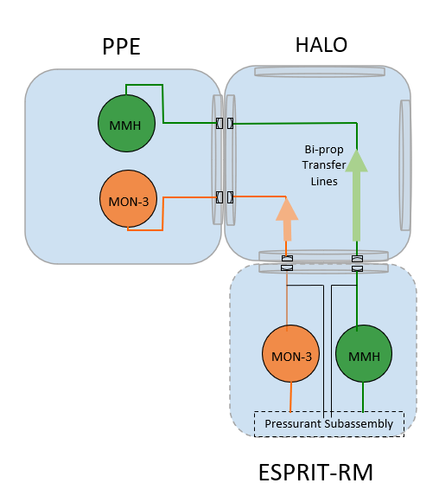
Fig. 1 Simplified illustration of bipropellant transfer path.
Placeholder for a paragraph describing risk reduction development test and modeling approach and concept of operations of refueling.
- Numerical Model Development Approach
During the priming process the pressurized liquid propellant in the source tank is accelerated into the evacuated fluid transfer lines when the control valve is opened. The liquid velocity continuously increases due to the force imbalance until the flow resistance force balances the pressure force. The terminal velocity can also be determined by flow choking in a component. When the accelerated liquid impacts a dead-end, such as a closed control valve, the velocity nearly instantaneously drops to zero, and the kinetic energy is converted to pressure energy. Initial estimates of the surge pressure can be calculated using the Joukowsky Equation. The calculated overpressure is then added to the source tank pressure to determine the maximum absolute surge pressure.
The Joukowsky Equation is good for initial estimates, but it includes several assumptions that limit its practicality when applied to real systems. Specifically, most real systems are more than a single straight tube and include a network of branched flow paths. It is also common to have sections of differing hydraulic diameters. As a result, it is necessary to develop a more detailed numerical model of real systems to capture these more complex flow characteristics. Furthermore, as this phenomenon is difficult to model and can result in high uncertainty, it is important to validate those numerical models with test data.
The CMV breadboard numerical model was developed using Thermal Desktop Version 6.1 with FloCAD. Thermal Desktop is a powerful general-purpose thermal and fluid modeling software that is widely used throughout the aerospace industry. The Thermal Desktop add-on module, FloCAD, provides the capability to graphically model fluid flow circuits typically encountered in spacecraft fluid transfer systems. Thermal Desktop was chosen for this modeling application due to its flat-front two-phase flow modeling capability, which is ideal for modeling the filling of liquid into a tubing system that initially contains a gas at low pressure or is evacuated. The flat-front method imposes an axially stratified flow regime to capture the propagation of a liquid front as if it were a piston traveling through the tubing system. Additional details of the flat-front modeling approach are discussed later.
FloCAD is pre-installed with fluid property data files for various common fluids, and those property data files come in a variety of formulations. Since water has a very low vapor pressure at ambient temperature, the nonvolatile liquid formulation was chosen to simplify computational demand by assuming fluid properties are only functions of temperature and not pressure, as well as eliminating the need to track phase changes. Therefore, the effects of flash vaporization across the valve at the initiation of the priming process is not captured, and the flat-front assumption tends to be conservative in terms of maximum surge pressure predictions. While the water is considered thermodynamically incompressible, compliance has been added to account for the slight compressibility exhibited by real fluids, which is needed for valid priming surge pressure and water hammer predictions. To account for the residual gas that is unable to be removed by the vacuum operation, the perfect gas formulation of air is included in the volume to be primed.
- CMV Breadboard Test Description
The CMV breadboard fluidic emulator was built as an early developmental test bed at NASA’s Johnson Space Center (JSC) with a simplified version of the ESPRIT-RM to validate the design and component selection and to validate numerical models. Upon completion of testing at JSC, the CMV breadboard was shipped to TAS-UK for integrated Gateway refueling testing with the ESPRIT-RM developmental test bed, referred to as ERM-1 [1]. The combination of the ERM-1 and the CMV breadboard will create a powerful early developmental tool to understand the fluid dynamics of on-orbit Gateway refueling, while saving cost and time by using representative commercial-off-the-shelf (COTS) components. The experimental data from the JSC campaign were used to calibrate the Thermal Desktop model, providing valuable validation evidence so that the models can be extended to creating flight system predictions.
An image of the CMV breadboard is shown in Fig. 2. A simplified schematic and description of the flow path will also be provided in the manuscript.

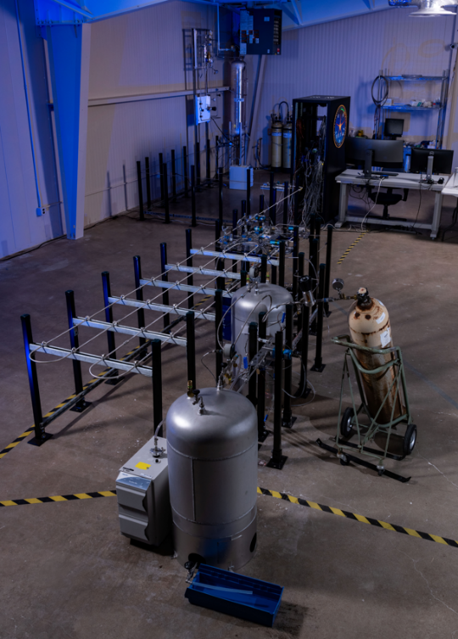
Fig. 2 CMV breadboard test set up.
Subscale tanks with sight glasses were used to represent the ERM and PPE propellant tanks. Hand valves were used to fill the ERM tank with water, pressurize the tank with helium, and control flow to the vacuum and purge systems. Fast-acting solenoid valves were used to represent flight valves and emulate their opening and closing response times. COTS filters with similar size and pressure drop characteristics as the flight components were used throughout the experimental apparatus at flight locations. The pressure drops for flight components that could not be fully represented in this developmental test were captured by using square-edge orifices. The size and length of tubing was flight representative. Pressure and temperature sensors were added in key locations to characterize both transient and steady state behavior. Data was recorded at 1 Hz and/or 10 kHz, depending on the needs of each specific test.
- Propellant Priming Tests
Placeholder for a description of priming test operations.
- Refueling Pause Tests
Placeholder for a description of refueling pause test operations.
- CMV Breadboard Numerical Model Validation Results
Placeholder for an introduction to comparisons of model results with test data.

Propellant Priming Tests
A detailed discussion of stage 1 and stage 2 priming model results compared to test data will be presented. For the purposes of this extended abstract, a sample of information to be discussed is provided.
Representative transient model results compared to test data for a stage 1 priming case with a tank pressure of 50 psia is shown in Fig. 3.
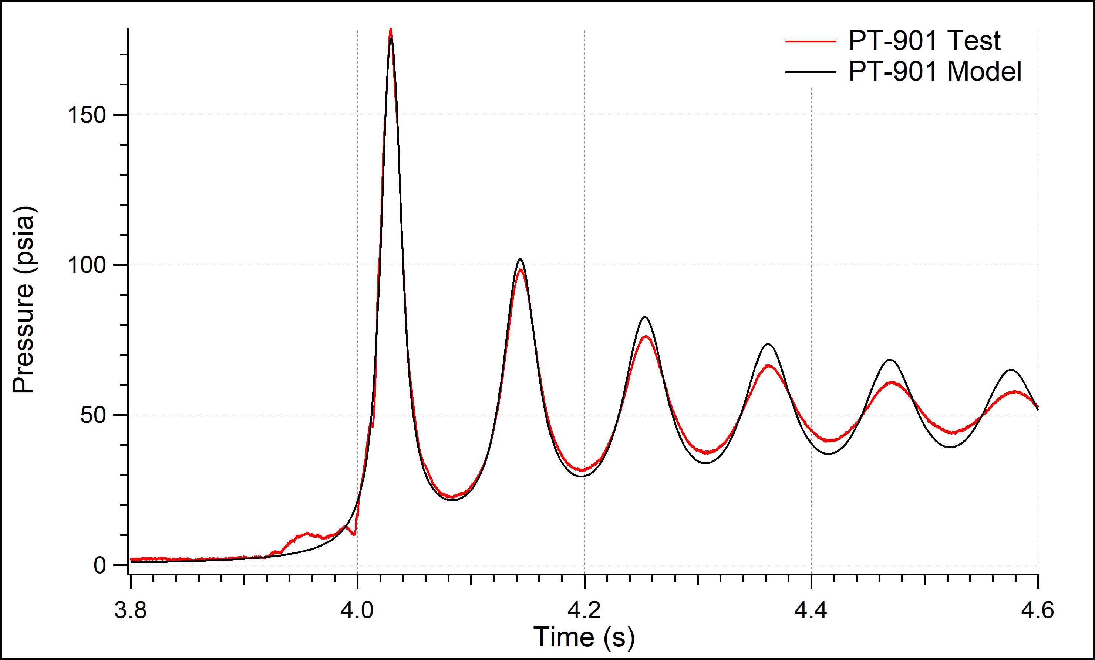
Fig. 3 Stage 1 priming transient at HALO valve.
A summary of the stage 1 priming surge pressures is shown in Fig. 4.
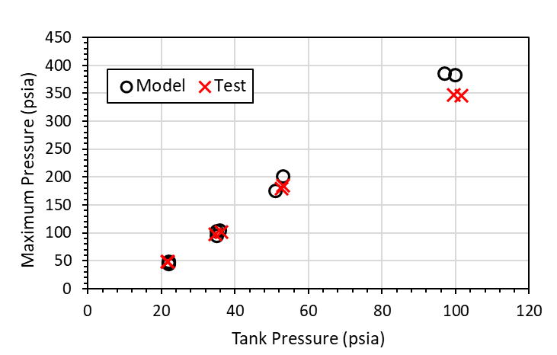
Fig. 4 Stage 1 priming surge pressures at HALO valve.
A summary of the stage 2 priming surge pressures is shown in Fig. 5.
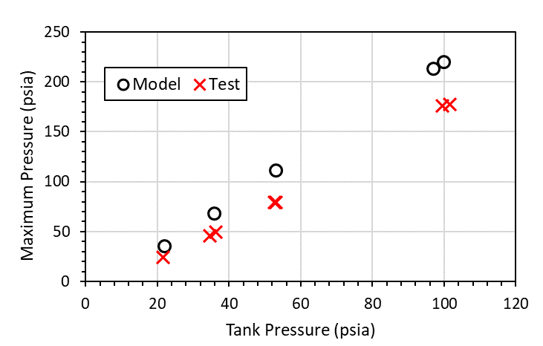
Fig. 5 Stage 2 priming surge pressures at PPE valve.
- Refueling Pause Tests
A detailed discussion of refueling pause model results compared to test data will be presented.
- Conclusion
Placeholder.

Acknowledgments
Placeholder.

References
[1] Hill, S., Hughes, A., Wellons, G., Hoyland, L., Rhodes, B., Han, A., Lusby, B., Desai, P., Radke, C., Zagoni, O., and Leonardi, M., “Joint Development Testing of the Integrated Gateway-ESPRIT Bipropellant Refuelling System,” SP2022 Paper 393, May 2022.

Fluid Dynamics Analyst, Propulsion Systems Branch.
Senior Project Lead (The Aerospace Corporation), Propulsion Systems Branch.
Test Engineer (Jacobs Technology), Propulsion Systems Branch.
Test Director, Energy Systems Test Area.
Software Engineer (Jacobs Technology), Energy Systems Test Area.
Gateway Chemical Propulsion System Manager, Propulsion Systems Branch.

