**Supporting Information**

**Along-orbit analysis of GRACE Follow-On inter-satellite laser ranging measurements for sub-monthly surface mass variations**

Khosro Ghobadi-Far (1*), Shin-Chan Han (1), Christopher M. McCullough (2), David N. Wiese (2), Richard D. Ray (3), Jeanne Sauber (3), Linus Shihora (4), Henryk Dobslaw (4)

(1) School of Engineering, University of Newcastle, Callaghan, NSW, Australia

* currently at the Department of Geosciences, Virginia Polytechnic Institute and State University, Blacksburg, VA 24061, USA

(2) Jet Propulsion Laboratory, California Institute of Technology, Pasadena, CA, USA

(3) Geodesy and Geophysics Laboratory, NASA Goddard Space Flight Center, Greenbelt, MD, USA

(4) GFZ German Research Centre for Geosciences, Department 1: Geodesy and Remote Sensing, Telegrafenberg, 14473 Potsdam, Germany

Correspondent: Khosro Ghobadi-Far ([khosro@vt.edu](mailto:khosro@vt.edu%2520))

Prepared for submission to

*Journal of Geophysical Research - Solid Earth*

Content: Text S1; Figure S1 and S2.

**Text S1**

We examined the vertical position data derived from continuous GPS sites (see Figure S1) near the GRACE-FO ground tracks to document seasonal changes in water loading. Figure S2 shows that the maximum subsidence occurs at sequentially later times for sites from higher elevations that are closer to the river catchment (TOPL) progressing (MABA) to a near coastal site (BELE). By examining GRACE-FO data from April we captured a slice in time when the maximum water loading occurred near the cGPS site MABA.

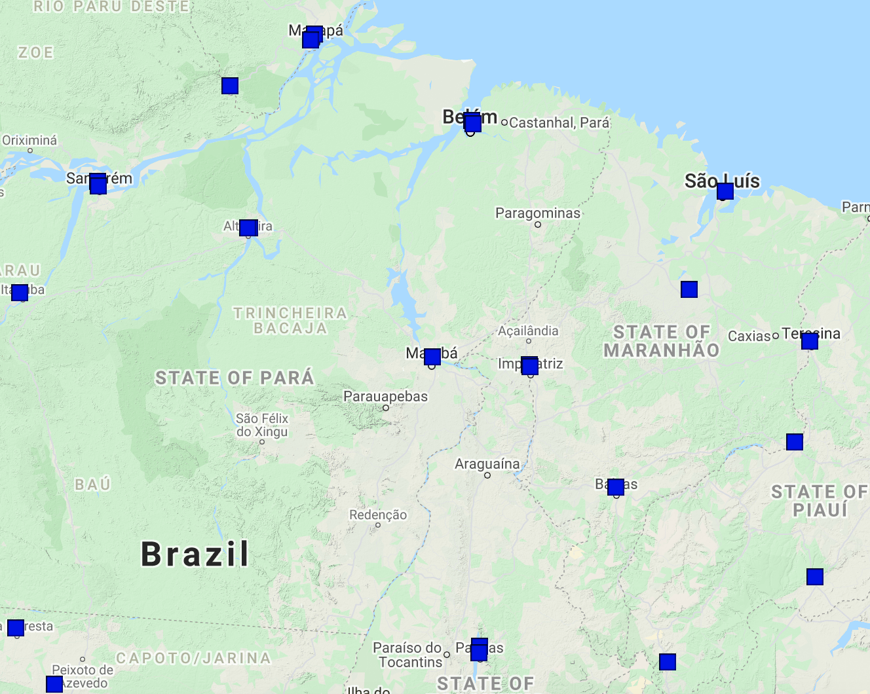

MABA

BELE

TOPL

**Figure S1**.  Brazil GPS network sites near GRACE-FO ground repeat ground track with the name of the sites used in this study.  The base map is from Google 2021.

TOPL coordinates: Latitude: -10.171, Longitude: -48.331, Elevation: 257 m

MABA coordinates: Latitude: -5.362, Longitude: -49.122, Elevation: 80 m

BELE coordinates: Latitude: -1.409, Longitude: -48.463, Elevation: 9 m

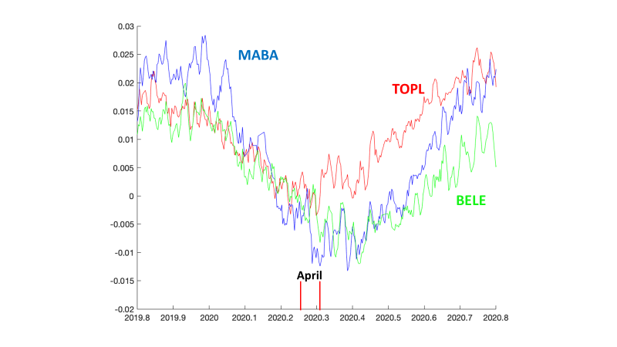

**Figure S2**.  Change in the vertical position of three Brazilian GPS sites from 2019.8 to 2020.8 with a running mean of 5 days. The vertical bars (red) indicate the bounds on the month of April 2020. The Brazilian GPS network data was processed at the University of Nevada Geodesy Laboratory (Blewitt et al. 2018).

**Reference**

Blewitt, G., W. C. Hammond, and C. Kreemer (2018), Harnessing the GPS data explosion for interdisciplinary science, *Eos, 99,* [https://doi.org/10.1029/](https://doi.org/10.1029/2018EO104623))