Mechanically Tunable Radiative Cooling for Adaptive Thermal Control
Andrew Butler and Christos Argyropoulos*
Department of Electrical and Computer Engineering, University of Nebraska-Lincoln, Lincoln, Nebraska 68588, USA
Keywords: Radiative cooling, Thermal radiation, Photonic structures
ABSTRACT
Passive radiative cooling is currently the frontier technology in renewable-energy research. In terms of extraterrestrial applications, radiative cooling is a critical component to the thermal management system of a spacecraft, where the extreme environment of space can cause large temperature variations that can break and damage equipment. For terrestrial applications, nocturnal or daytime radiative cooling is expected to lead to cost-effective passive heat management without the need of inefficient and costly artificial refrigeration technologies. However, most currently available radiative cooling systems cannot be changed dynamically and radiate a constant static amount of thermal power. Dynamically tunable adaptive radiative cooling systems will be a critical development to prolong the lifetime of spacecraft or improve the efficiency of terrestrial cooling systems. Here we propose stretchable radiative cooling designs that can be substantially tuned by using the simple physical mechanism of mechanical strain. When their structure is stretched, the radiated power is significantly reduced. We develop a modeling method that can simulate mechanical stretching combined with electromagnetic response to compute the tunable thermal emission of these new adaptive radiative cooling systems. The presented photonically engineered structures can be used as coatings to achieve efficient adaptive thermal control of various objects in a cost-effective and environmentally friendly way. The proposed designs are much simpler to be realized than others found in the literature and the best design achieves a high thermal emission power with a tunable range on the order of 132 W/m².
INTRODUCTION
Thermal management systems are a critical consideration in the design of various spacecraft components, such as satellites and space shuttles. The harsh environment of space exposes sensitive equipment to an extreme variety of thermal conditions [1]. These harsh conditions can degrade and break electronic equipment and reduce the lifetime of spacecraft. Thermal regulation systems must maintain a stable temperature to avoid damage to electronic equipment [2]. Since transferring heat out of a system through conduction and convection through the air is not possible in space, radiative cooling is the only way to efficiently expel heat from a system. Moreover, nocturnal and daytime passive radiative cooling has been used in a plethora of terrestrial applications leading to cost-effective passive heat management without the need of inefficient and costly artificial refrigeration technologies [3–9]. Interestingly, radiative cooling can be achieved through photonic engineering of the thermal emission of an object. At room temperature (300 K), black body spectral radiance peaks around the wavelength of 10 μm in the mid-infrared (mid-IR) range. Materials and structures with high emissivity in the mid-IR will naturally radiate thermal energy in outer space and passively cool themselves below the room temperature.
The terrestrial or extraterrestrial thermal environment varies greatly and requires thermal management systems to be flexible to respond to a wide range of situations. However, most radiative cooling designs have a static response and are not tunable, i.e., they always radiate the same amount of thermal energy. Typical static radiative cooling designs based on photonically engineered designs and bulk materials include multilayer configurations [4,7,8,10,11], thermally emissive paints and coatings [9,12–14], or more complex photonic structures [15–18]. Once fabricated or applied, these designs are fixed by design and cannot be changed. As an example, thermal management systems in spacecraft need to be able to alternatively heat or cool various equipment. Thus, the constant high radiative cooling will force the system to use more power for heating, which is detrimental to the power-efficiency and lifetime of spacecraft. Dynamically tunable radiative cooling will be an important development for continued smooth operation in space in order to extend the lifetime and improve the durability of equipment in this challenging environment. Similar concerns apply to terrestrial applications, where tunable passive cooling will be beneficial to achieve efficient adaptive thermal control of various objects in a cost-effective and environmentally friendly way.
Currently, the most commonly proposed approach to achieve self-adaptive radiative cooling is to use phase change materials, such as vanadium dioxide (VO₂), whose optical properties change at different temperatures [19–21]. At a critical temperature, VO₂ changes from a metallic to an insulating state that can be used to change the emissivity from high to low, essentially turning the cooling performance from on to off. While this approach requires no external input to be activated, it operates only as a discrete binary state and the thermal emission can only be at a maximum or a minimum constant value. Moreover, once fabricated, the critical temperature cannot be changed and VO₂ radiative cooling designs can only operate near this critical temperature. These factors limit the range of dynamic control that designs based on phase change materials can offer and make them useful only to a few niche applications. Alternative tunable thermal emission devices have been proposed mainly for satellite thermal management, such as electrochromic emissivity modulators that switch emissivity on and off by applying a voltage to the device [22]. However, these designs would be challenging to scale up to larger surface areas and the electrical controls will be difficult to operate in a harsh environment. Finally, another method to achieve emissivity control was recently demonstrated by using porous polymer coatings that change optical properties when wetted by different fluids [23]. While this technique may be viable for tunable radiative cooling on Earth, it is less feasible for extraterrestrial radiative cooling applications where only a limited amount of fluid could be carried on the spacecraft.
One promising alternative way to provide continuous dynamic control of the radiated emission for both terrestrial and extraterrestrial applications is to use stretchable materials that can control the emissivity of a structure through simple mechanical strain. Recently, a stretchable design was theoretically proposed that utilized nanoparticle filled polydimethylsiloxane (PDMS) along with a silver coated PDMS grating [24]. Normally, the embedded nanoparticles and the PDMS give the device high emissivity in the mid-IR range, but when stretched, the emissivity of the device drops because the period of the grating increases. While this design achieved high tunability, the cooling power was relatively low and not appropriate for practical applications. Furthermore, it relies on random nanoparticle volume filling ratios that can be very difficult to be experimentally realized. Another approach was also lately proposed using a multilayered grid structure composed of alternating layers of ethylene propylene diene monomer rubber (EPDM) and air to be used as a stretchable filter for radiative cooling [25]. When stretched, the transmission band of the filter is shifted to the 8-13 μm band in the mid-IR, allowing a thermal emitter in room temperature to radiate through this wavelength range. While this approach of using a stretchable filter is interesting, the required two-dimensional structuring and air gap between the filter and the thermal emitter makes the design difficult to realize in the real world. A similar approach was used for a design consisting of an emissive layer covered by a cracked shield [26]. The cracks in the shield grow wider when stretched and the emissive layer is able to radiate in the surrounding environment. However, this design was not explored for radiative cooling purposes due to its relatively poor emissivity performance in terms of values and tunability. Finally, another relevant design used crumpled graphene on a stretchable substrate to realize tunable mid-IR emissivity [27]. Stretching the structure decreased the pitch of the graphene which reduced the emissivity. Still, the emissivity of this structure in the mid-IR was relatively low and the stretchable graphene requirement increased the design and fabrication complexity.
Given the complexity of other stretchable radiative cooling designs, in this paper we propose much simpler novel stretchable periodic structures to achieve mechanically tunable emissivity and radiative cooling. Our designs consist of periodic mound shaped PDMS embedded with periodic rectangular and cylindrical silicon nitride (Si₃N₄) structures. Stretching the PDMS reduces its thickness and increases the periodicity of the PDMS mounds and embedded Si₃N₄ structures, which leads to reduced absorption and emissivity of the entire structure in the mid-IR range. Additionally, we show how a previously demonstrated crumpled metallic layer can be used as a substrate to further improve the tunability of the proposed radiative cooling designs [28]. By controlling the strain of the structure, the emissivity can be dynamically tuned over a wide range of values. We develop a modeling method that can simulate mechanical stretching combined with electromagnetic response to compute the tunable thermal emission of these new radiative cooling systems. The presented photonically engineered adaptive structures will achieve tunable passive radiative cooling for terrestrial and extraterrestrial applications.

THEORETICAL DESIGN
PDMS is a unique and widely used material with high elasticity and low Young’s modulus, meaning it can be extensively stretched and deformed relative to its size [29]. Our designs consist of periodic mounds of PDMS with periodicity $p_{PDMS_{0}}=45μm$ and a maximum thickness $t_{curve_{0}}=2.5μm$ with unit cells shown in Figure 1. The mounds rest on a continuous flat rectangular-shaped PDMS piece with a thickness $t_{flat_{0}}=1.5μm$. Embedded within the PDMS are simple periodic Si₃N₄ geometries. The first design uses rectangular strips of Si₃N₄ with equal width $w=6.5μm$, thickness $t_{Si3N4}=0.9μm$, and period $p_{rect_{0}}=9μm$. The top edge of the rectangular strips are offset above the top edge of the flat PDMS by $f_{rect}=300nm$ (Figure 1a). Our second design uses cylindrical Si₃N₄ rods with radius $r=350nm$ and a period $p_{cyl_{0}}=0.75μm$. The centers of the cylinders are offset below the top edge of the flat PDMS by $f_{cyl}=100nm$ (Figure 1b). The purpose of these offsets is to prevent the Si₃N₄ structures from breaking the PDMS during the stretching process and they are defined as the height of the Si₃N₄ structures above the top edge of the flat PDMS.
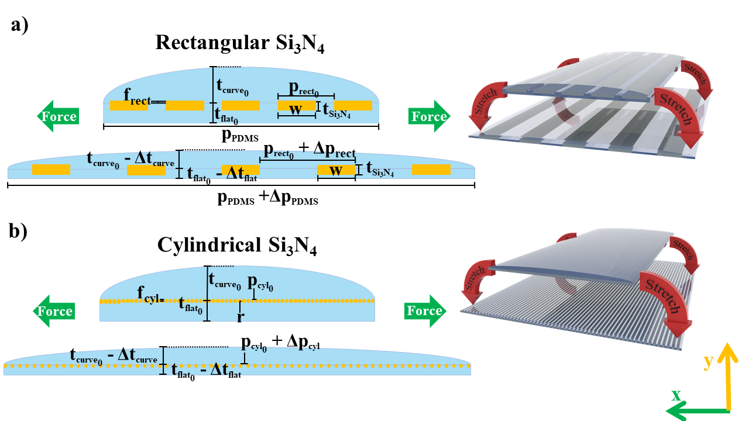
Figure 1. Schematic of the unit cell of two stretchable radiative cooling designs based on PDMS embedded with a) rectangular and b) cylindrical Si₃N₄ structures.
As shown in Figure 1, when a lateral force along the x-direction is applied to the PDMS, the periodic structure is stretched and undergoes strain and deformation. Strain is defined as the ratio between the deformation $∆x$ and the original length $x_{0}$ of the structure: $ε= \frac{∆x}{x_{0}} [30]$. Under strain, the periodicities of both the PDMS and Si₃N₄ structures are increased according to $p=p_{0}+ ∆p$, where $p_{0}$ is the initial unstretched period and $∆p= ε*p_{0}$ is the strain-induced increase in the periodicity. However, the size of the Si₃N₄ structures (w, t_{Si3N4}, and r) do not change during the stretch process because Si₃N₄ has a much higher Young’s Modulus of 280 GPa [31]. The Si₃N₄ structures remain embedded in the PDMS but move farther apart as the structure is stretched. The x-direction stretching also causes deformation and strain along the vertical y-direction. The ratio of the strain in the y- to the x-direction is defined as Poisson’s Ratio: $ν= -\frac{εy}{εx} [30]$. Here, the minus sign indicates that the structure is shrinking in the vertical y-direction. Values for the Poisson’s Ratio of PDMS range in the literature from 0.45 to 0.5 [32]. For our purposes, we choose an intermediate value of: $ν=0.48 [33]$. Thus, the thickness of the PDMS shrinks according to $t=t_{0}+ ∆t$, where $t_{0}$ is the initial unstretched thickness and $∆t= ε*ν*t_{0}$ is the decrease in thickness due to the lateral strain. This process is similar to mechanically tunable photonic crystals, where a periodic array of silicon (Si) pillars embedded within PDMS was used [34]. When stretched, the distance between the pillars increased laterally (same direction as strain) and decreased axially (perpendicular to strain). A similar design was experimentally demonstrated using vertically aligned carbon nanotubes embedded in PDMS that was used as a strain sensor [35]. Since the dimensions of the Si₃N₄ structures are not changed by the stretching, the Poisson’s Ratio of Si₃N₄ is not considered in our calculations.
The currently proposed designs are practical, since they can be fabricated by using a molding process similar to a previously demonstrated silver nanowire-embedded PDMS electrode design or a wearable strain sensor based on the PDMS-embedded conductive fabric created in [36,37]. The rectangular Si₃N₄ strips can be produced using femtosecond laser micromachining or lithography [38]. The cylindrical structures can be grown in a similar manner to previously reported silicon nitride nanofibers with rectangular cross section dimensions exceeding 1μm, grown using a carbothermal reduction process [39]. Note that the growth of ultralong Si₃N₄ nanowires with maximum diameters of 960nm has also been reported as well as the production of aligned ultralong Si₃N₄ nanowires with 200nm diameters [40,41]. Once the Si₃N₄ structures are fabricated, they could be combined with liquid PDMS in a mold to form the currently presented tunable radiative cooling designs.
In the designs presented thus far, the emissivity reduction is mainly achieved by increasing the transmittance. Recently, a triple mode device that changes between an emissive, reflective, and transparent state in the mid-IR region through stretching was demonstrated [28]. The design consisted of a crumpled metallic substrate and a polymer superstrate composed of a styrene-ethylene-butylene-styrene (SEBS) material. When stretched, the metallic layer flattens, and the device becomes predominantly reflective in the mid-IR range. Further stretching of the device causes the metal to break apart and the device becomes primarily transparent. The process is reversible but has only been explored in the general applications of radiative heat management and thermal camouflage, i.e., not on the emerging technology of passive radiative cooling.
Here, we also explore an approach where the transmission becomes zero for both stretched and unstretched cases when a crumpled metallic substrate is introduced to the designs of Figure 1 [28]. In this scenario, the emissivity of the stretched structures can be further reduced by increasing their reflectance. The metallic designs are shown in Figure 2 for both cylindrical and rectangular Si₃N₄ inclusions. We use a 300 nm thick crumpled gold layer with a periodicity $p_{Au}=1.25 μm$ and an amplitude $a_{Au}=250 nm$. However, even thinner or thicker crumpled gold layer dimensions with a range of $±5μm$ or even more will also lead to similar response. The crumpled metal is modelled as a sinusoidal geometry with the center of the shape positioned 1μm below the edge of the PDMS flat part. This geometry could realistically be fabricated using a mold created from Laser Induced Periodic Surface Structures (LIPSS). LIPSS structures are micro/nanoscale ripples that form on the surface of materials (usually metals) processed by linearly polarized laser irradiation [42]. The dimensions of the surface ripples can be controlled by changing the laser parameters such as wavelength, pulse count, pulse duration, and fluence. Using LIPSS ripples as a mold, the bottom surface of the PDMS will be textured with the sinusoidal pattern. The PDMS will then be stretched until the bottom surface is nearly flat, and the Au layer will be deposited onto this surface. When the PDMS is unstretched, the Au layer will crumple into the required sinusoidal shape. Metal films have been reportedly grown on PDMS substrates using DC magnetron sputtering [43], thus the proposed designs are feasible to fabricate.
The crumpled metal prevents transmission through the structure independent of the stretching condition. Since the metallic layer is attached to the PDMS, the change in dimensions caused by the stretching is modeled the same way as before. More specifically, the strain is used to determine the change in the periodicity and the Poisson’s Ratio of PDMS to determine the reduction in the amplitude of the metallic crumples. Similar to Si₃N₄, the thickness of the gold is unchanged by the stretching and only its lateral geometry varies due to its attachment with the elastic PDMS.
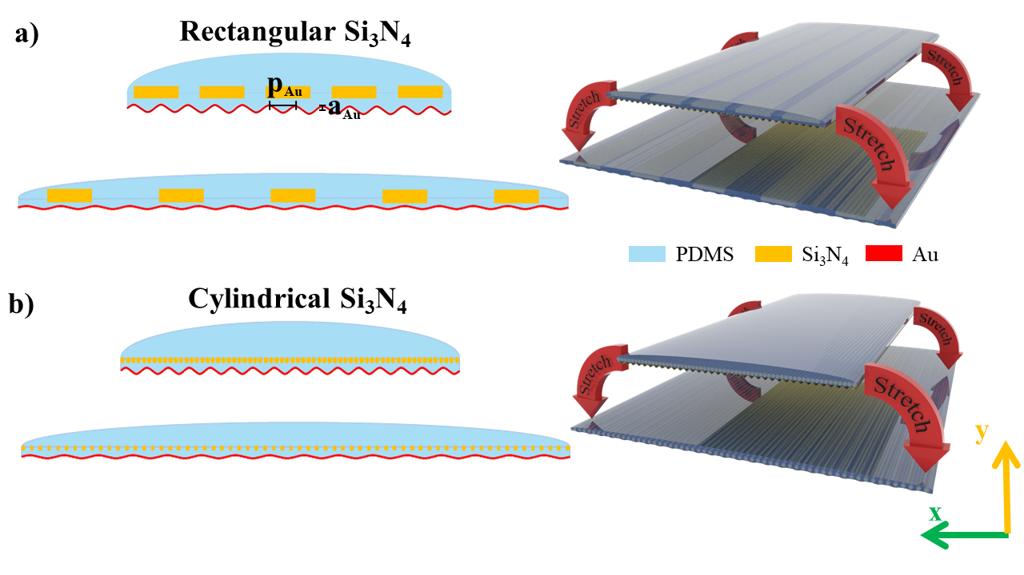
Figure 2. Schematic of the unit cell of two stretchable radiative cooling designs based on PDMS over crumpled metal embedded with a) rectangular and b) cylindrical Si₃N₄ structures.
The reflection of the metal increases the absorption of the PDMS by effectively doubling the thickness seen by the reflected light. To counteract this detrimental effect, the thicknesses of the PDMS layers and the Si₃N₄ structures are reduced compared to the previous designs. The new dimensions are $t_{curve_{0}}=1.5μm$, $t_{Si_{3}N_{4}}=600nm$, and $r_{ }=180nm$ for rectangular and cylindrical Si₃N₄ structures, respectively. The decreased thickness leads to an even more compact tunable radiative cooling design. The positions of the Si₃N₄ structures are also shifted so that the rectangular structures are centered on the top of the flat section of PDMS, and the center of the cylindrical structures are positioned 120nm below the top of the flat PDMS. The new designs are simulated using the same method as before and the gold material is modeled employing its frequency dependent refractive index [44].

RESULTS AND DISCUSSION
We assume that the structures shown in Fig. 1 are much larger in the z-direction compared to the emitted wavelength. As a result, two-dimensional simulations are required to compute their emissivity spectra by calculating their reflectance and transmittance parameters. The absorptivity A of the structures can be computed by using the formula: $A=1 - |S_{11}|^{2}- |S_{21}|^{2}$ , where $S_{11}$ is the reflection coefficient and $S_{21}$ is the transmission coefficient. The absorptivity is equal to the emissivity E = A in the far field due to the Kirchhoff’s law of thermal equilibrium. The produced thermal radiation is an incoherent source of infrared light; thus its polarization is random. To account for this important issue in all our calculations, the spectral and angular emissivity is computed as the average of the emissivity for both transverse electric (TE) and transverse magnetic (TM) polarizations. In addition, the structures were simulated by using periodic boundary conditions on the curved PDMS sides, where each unit cell is schematically depicted in Figure 1. The experimentally obtained realistic data of the frequency dependent permittivity of PDMS and Si₃N₄ were used in all simulations [45,46]. More details on the simulations are included in the Supplementary Information [47]. The developed theoretical model can be applied to any tunable thermal emitter based on mechanically stretchable materials, since it can accurately calculate mechanical stretching and its effect in the electromagnetic and thermal response. Table 1 summarizes the mechanical and electromagnetic parameters of the materials used in our modeling.

Table 1. Mechanical and electromagnetic material parameters used in our modeling.
 | PDMS | Si₃N₄
Young’s Modulus | 0.57MPa – 3.7MPa [29] | 280GPa [31]
Poisson’s Ratio | 0.45 – 0.5 [32,33] | 0.23 [48]
Peak Extinction Coefficient | ~0.72 @ 12.5um [46] | ~2.3 @ 11um [45]

PDMS is mostly transparent to light in the visible and near infrared spectrum, but the imaginary part of its refractive index becomes significant for wavelengths above 6 μm due to phonon resonances [46]. This coincides with the peak of room temperature (300K) blackbody radiation, and PDMS can radiate thermal energy in the mid-IR atmospheric transparency window. The computed emissivity of our PDMS periodic structure without any Si₃N₄ inclusions, i.e., simplest possible configuration, is shown in Fig. 3a for both the unstretched and stretched cases. While the emissivity is high in some parts of the mid-IR spectrum, there are substantial dips especially around 11 μm which turn the average emission of this structure rather low but moderately tunable, as can be seen in the angular emissivity plots also shown in Figure 3a (lower caption) where the average value of emissivity was computed along the atmospheric window (9-13 μm) for different emission angles. In the stretched case, a strain of 120% was used, which is the maximum possible value that can be obtained by PDMS without the occurrence of cracks [24]. Thus, the demonstrated results are the maximum and minimum possible emissivity spectra for our structure under stretching and define the maximum possible tunable thermal radiation emission range. The main mechanism causing the decrease in emissivity between the unstretched and stretched cases is the deformation of the structure geometry, especially in the y-direction (height). The structure becomes wider and thinner, decreasing its absorption and interaction with light.
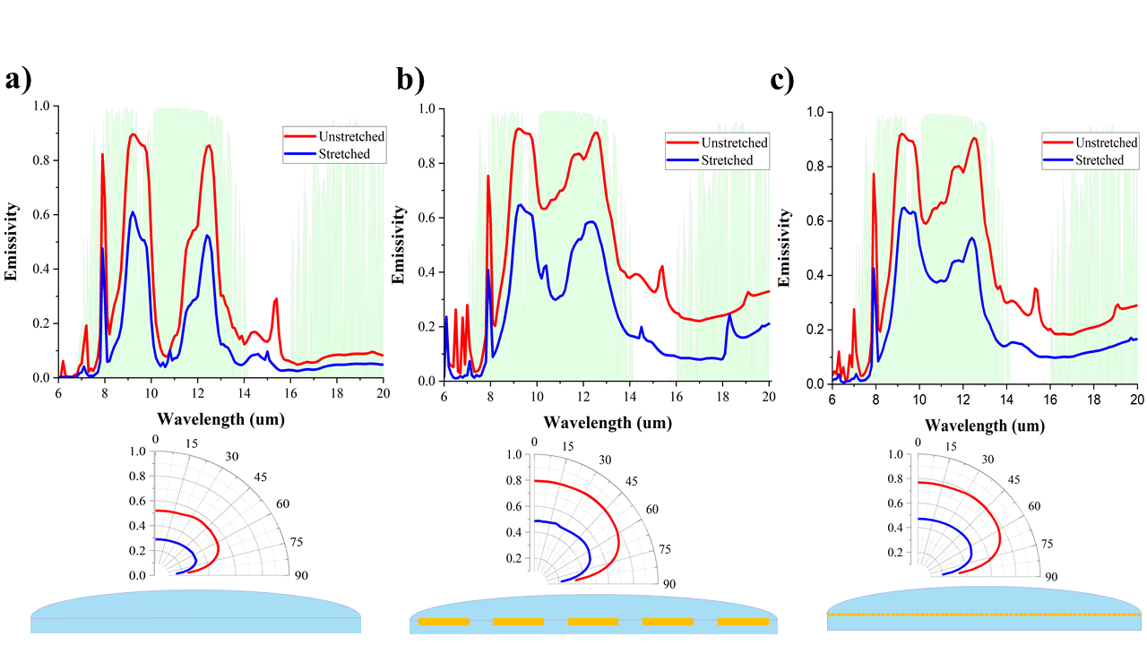
Figure 3. Emissivity spectra and angular emissivity of the PDMS structure a) without Si₃N₄ inclusions, b) with rectangular Si₃N₄, and c) with cylindrical Si₃N₄. The green shaded area represents the atmospheric transmission window. Lower captions: angular emissivity is the average emissivity value computed over 9-13 μm for different emission angles.
The tunability can be improved by the inclusion of Si₃N₄ structures inside the PDMS design. The imaginary part of the refractive index of Si₃N₄ peaks near 11.5 μm, the same wavelength where the absorption of PDMS significantly decreases [45]. Note that simply adding a layer of Si₃N₄ to the bottom of the PDMS is not possible because of Si₃N₄ high Young’s Modulus. Hence, Si₃N₄ cannot stretch as far as PDMS without cracking and fracturing. Therefore, our design uses non-continuous periodic Si₃N₄ structures that can move within the PDMS without stretching. The computed emissivities of the proposed designs with Si₃N₄ rectangular and cylindrical structures embedded in PDMS are shown in Figures 3b and 3c, respectively, and their average angular emissivity in the range λ = 9-13 μm is shown in the lower insets.
Interestingly, the shape of the Si₃N₄ structures has a pronounced effect on the total emissivity values and their tunable range. The rectangular design has slightly higher emissivity than the cylindrical design in both the stretched and unstretched cases, but the tunability in the cylindrical design is improved since the difference between the stretched and unstretched cases is greater. The thickness, width, and spacing of the structures affect the tunability and the final designs are optimized given that they provided the best results out of a wide variety of sizes and shapes. The main mechanism that causes the increase in tunability near λ = 11 μm is the change in periodicity between the stretched and unstretched configurations. When the gaps between the Si₃N₄ structures are increased, more light is able to pass unaffected through the structure and the absorption/emissivity is reduced. The physical mechanisms that enable the large differences in mid-IR emissivity between the stretched and unstretched states are further elucidated by the electric field enhancement distributions plotted in the Supplementary Information [47].
To determine the cooling performance for applications on satellites or other space applications, only the thermal power radiated by the structure P_{rad} needs to be considered. Hence, P_{rad} can be calculated by using the formula:

$$\begin{aligned}P_{rad}\left(T\right)=2πA\int_{0}^{π/2}{sin\left(θ\right)cos\left(θ\right)dθ}\int_{0}^{∞}{I_{BB}\left(T,λ\right)Ε\left(λ,θ\right)dλ,} \#(1)\#\end{aligned}$$

where A is the surface area of the structure, θ is the direction of emission, T is the temperature, and Ε(λ,θ) is the spectral and angular emissivity computed in the previous section. The blackbody spectral radiance I_{BB} is calculated through Planck’s Law:

$$\begin{aligned}I_{BB}\left(T,λ\right)=(2hc^{2}/λ^{5})(exp\left[hc/λk_{B}T\right]-1)^{-1},\#(2)\#\end{aligned}$$

where h is Planck’s constant, k_{B} is Boltzmann’s constant, c is the speed of light, and T is the temperature. Figure 4 shows the radiated cooling power versus temperature for our three designs when the goal is to keep the electronics and other satellite equipment at moderate temperatures close to room temperature (300 K) so they will not be damaged but at the same time be able to demonstrate the tuning in the temperature range. Note that larger tuning and higher radiative cooling power values can be achieved in higher temperatures.
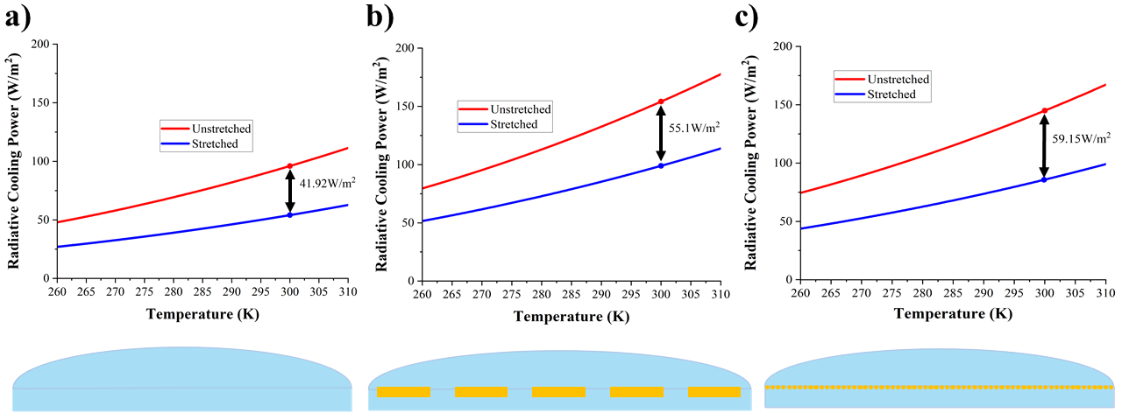
Figure 4. Radiated cooling power versus temperature for the PDMS structure a) without Si₃N₄ inclusions, b) with rectangular Si₃N₄, and c) with cylindrical Si₃N₄.
The cooling power at room temperature (300 K) achieved by the rectangular Si₃N₄ design ranges from ~98.95W/m² to ~154.1W/m². For the cylindrical design, the cooling power is slightly lower and ranges from ~85.8W/m² to ~144.95W/m². However, the cylindrical design has better tunability with a range of 59.15W/m² which is larger than the rectangular design with a tunable range of 55.1W/m². However, the rectangular design is able to cool to lower temperatures than the cylindrical design in both the stretched and unstretched cases. Without the Si₃N₄ structures, the tunability and especially the radiated power is substantially decreased.
Our design can also be used for terrestrial nocturnal tunable radiative cooling applications. To calculate the cooling power on Earth during the night, thermal emission from the atmosphere P_{atm} and conductive and convective heat sources P_{con} should be considered in the power calculations. Taking into account these additional heat sources, the cooling power P_{cool} can be calculated by using the relation:

$$\begin{aligned}P_{cool}\left(T\right)= P_{rad}\left(T\right)-P_{atm}\left(T_{amb}\right)- P_{con}\left(T\right).\#\left(4\right)\end{aligned}$$

The absorbed power from the atmospheric thermal emission can be calculated as:

$$\begin{aligned}P_{atm}\left(T_{amb}\right)=2πA\int_{0}^{π/2}{sin\left(θ\right)cos\left(θ\right)dθ}\int_{0}^{∞}{I_{BB}\left(T_{amb},λ\right)Ε_{atm}\left(λ,θ\right)Ε\left(λ,θ\right)dλ},\#\left(5\right)\end{aligned}$$

where T_{amb} is the ambient room temperature (300 K) and Ε_{atm}(λ, θ) is the atmospheric spectral and angular emissivity that can be calculated from the atmospheric transmittance t(λ) by using the relationship: $E_{atm}\left(λ,θ\right)=1-t{\left(λ\right)}^{1/cos\left(θ\right)} [49–52]$. Finally, the heating from conductive and convective sources in the environment can be computed by:

$$\begin{aligned}P_{con}\left(T,T_{amb}\right)=Ah_{con}\left(T_{amb}-T\right),\#(6)\#\end{aligned}$$

where h_{con} is the heat transfer coefficient. For the current calculations, we use a value of 10W/m²/K which is typical for ambient air convection [53]. Figure 5 demonstrates the induced cooling temperatures of the currently proposed structures over the course of nighttime. These plots were generated by calculating the equilibrium temperature of our structure given the ambient air temperature during the same time. The ambient temperature data was taken as the recorded temperatures for Omaha Nebraska on June 27-28, 2021 [54].
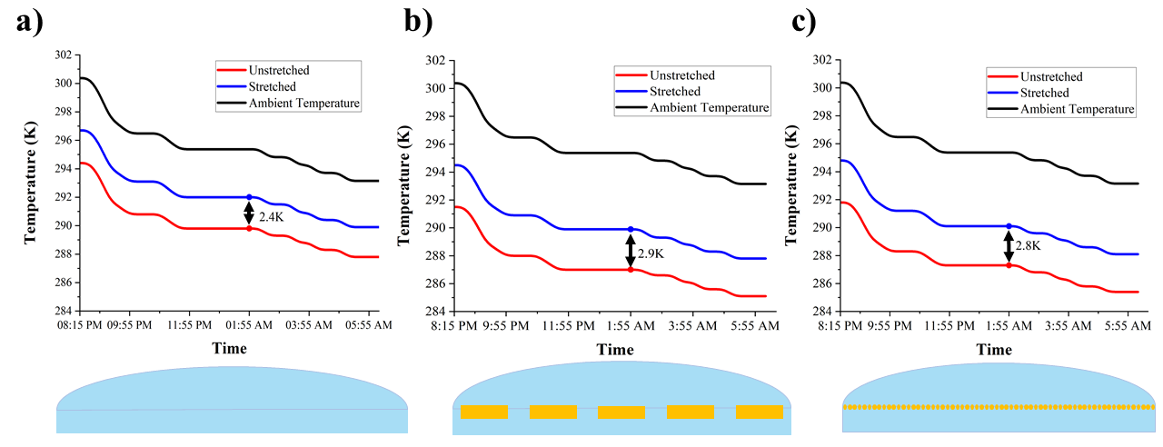
Figure 5. Computed hourly temperature plots for the PDMS structure a) without Si₃N₄ inclusions, b) with rectangular Si₃N₄, and c) with cylindrical Si₃N₄ in a terrestrial nocturnal radiative cooling scenario.
The inclusion of the atmospheric emission and conductive and convective sources reduces the cooling performance of our structures compared to the satellite application. However, our tunable structures are still able to cool several Kelvin below ambient temperatures and the difference between the stretched and unstretched cases is clearly illustrated in Figure 5. The currently presented adaptive radiative cooling designs have high and tunable emissivity values and are able to substantially cool below ambient, especially in the case of Si₃N₄ inclusions.
The tunability and cooling performance can be further improved by the inclusion of the metallic substrates (shown in Figure 2). The emissivity spectra of the stretched and unstretched metallic designs for normal incidence are shown in the upper captions of Figure 6. The addition of the crumpled metal substantially increases the difference in emissivity between the stretched and unstretched states with and without the Si₃N₄ inclusions. As the metal layer is stretched, the height of the crumples is reduced and the layer becomes flatter, leading to a substantial increase in the reflectance. At the same time, the reduction in thickness of the PDMS and increase in periodicity of the Si₃N₄ strips further reduce the total absorption of the structure. Interestingly, the average angular emissivity for the atmospheric window range λ = 9-13 μm (shown in the lower insets of Figure 6) is significantly improved compared to the designs presented in the previous section. In particular, the PDMS over crumpled metal design with rectangular Si₃N₄ inclusions (middle lower caption of Fig. 6) achieves an almost perfect broadband omnidirectional emission in the unstretched case which is considerably reduced in the stretched design leading to an unprecedented mechanically tunable performance compared to relevant designs [55]. Interestingly, the differences in the results of the rectangular versus the cylindrical structures in Figures 6(b) and 6(c), respectively, are mainly due to the large difference in size (area) of the Si₃N₄ structures and not due to their shape, as it is demonstrated in Figure S6 in the Supplementary Information [47]. We also checked the effect of the size and fill factors of the Si₃N₄ structures, and the results are shown in Figures S7-S9 in the Supplementary Information [47]. Overall, the variation in the emissivity with the Si₃N₄ dimensions is small and it can be concluded that the designs are generally robust against fabrication imperfections. In addition, it can be derived that the average emissivity will slightly change with the fill factor once the fill factor increases beyond a certain point. This can correspond to potential nonuniform strain along the x-direction in PDMS, where the main effect will be that the fill factor would change from unit cell to unit cell. Since the effect of the fill factor is small, we can surmise that the potential effect of non-uniform strain on the device performance is also expected to be insignificant. 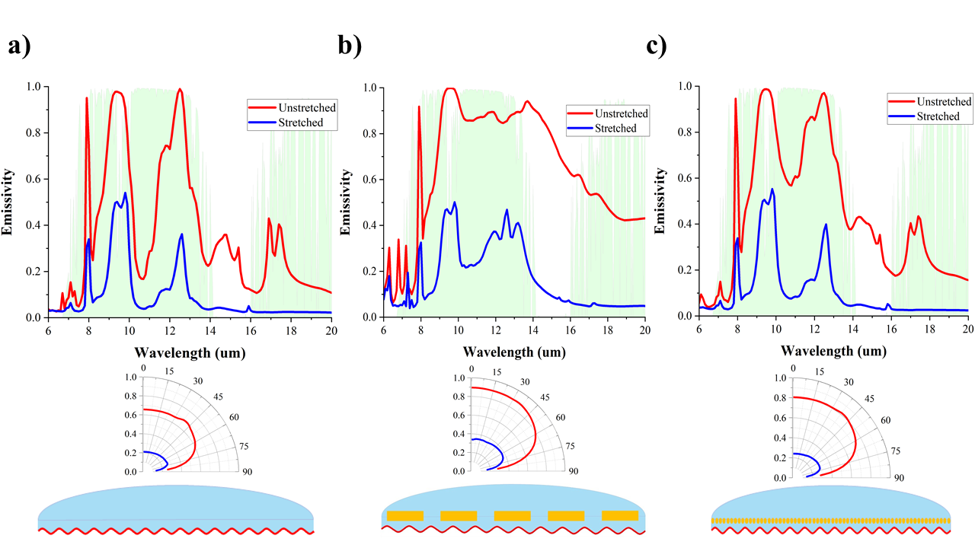
Figure 6: Emissivity spectra and angular emissivity of the PDMS over crumpled metal designs a) without Si₃N₄ inclusions, b) with rectangular Si₃N₄, and c) with cylindrical Si₃N₄. The green shaded area represents the atmospheric transmission window. Lower captions: angular emissivity is the average value computed over 9-13 μm for different emission angles.
Figure 7 shows the radiated power of these new designs versus temperature for applications on satellites or other space applications. Moreover, Figure 8 demonstrates the temperature versus time for these devices in a nocturnal radiative cooling scenario on Earth. The findings in Figures 7-8 are computed in a similar way to the results in the previous section. The unstretched structure with rectangular Si₃N₄ inclusions radiates ~199.5 W/m² at 300K, as shown in Figure 7, while the stretched structure radiates ~67.56 W/m², providing an extremely broad tunable thermal emission range of ~131.94W/m². This large tunability is further illustrated by the nocturnal radiative cooling application on Earth where there is a temperature difference of ~5.1K between the stretched and unstretched states for the same design (middle caption in Figure 8). As before, the tunability and radiated power are significantly reduced without the embedded Si₃N₄ structures. Moreover, the addition of the crumpled metal substrate further improves the tunability compared to the previous section designs and prevents transmission of IR light through the structure. This substantial improvement in tunability is due to the increase in reflectance caused by stretching the metal that eventually becomes flatter. Although the tunable temperature range of the rectangular Si₃N₄ design in Figure 8 is only 0.8K larger than the case without the Si₃N₄ inclusions, the tunable range of the radiated power in Figure 7 is much larger, hinting that the presented tunable structure should be more applicable to space applications. In the case of space radiative cooling, the radiated power is a critical component in evaluating the performance of these designs. In high temperature situations where cooling is needed, the rectangular and cylindrical designs can radiate more power than the design without Si₃N₄ inclusions. In situations where cooling is not needed, the low cooling-power stretched states of all three designs reach similarly low levels. Thus, the inclusion of the Si₃N₄ structures improves the ability of these PDMS designs to respond to a dynamic temperature environment.
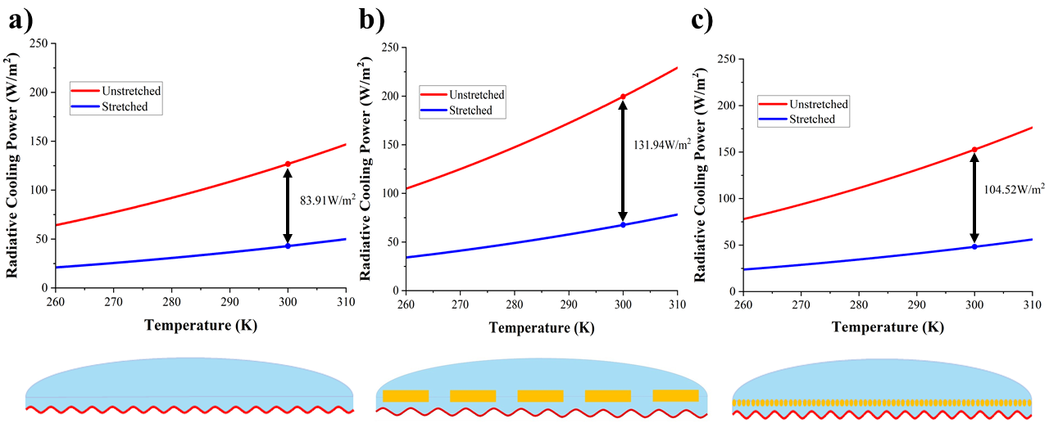
Figure 7. Radiated cooling power versus temperature for the PDMS over crumpled metal designs a) without Si₃N₄ inclusions, b) with rectangular Si₃N₄, and c) with cylindrical Si₃N₄.
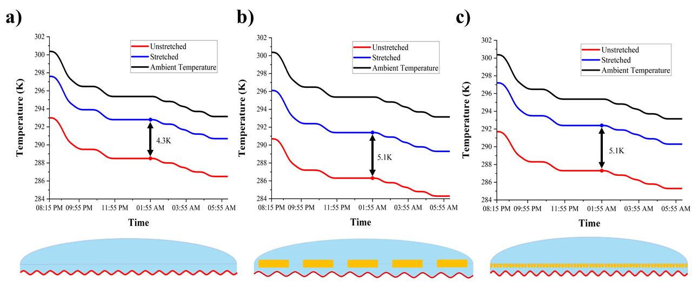
Figure 8. Computed hourly temperature plots or the PDMS over crumpled metal designs a) without Si₃N₄ inclusions, b) with rectangular Si₃N₄, and c) with cylindrical Si₃N₄ in a terrestrial nocturnal radiative cooling scenario.
CONCLUSION
In conclusion, we have demonstrated high-performance mechanically tunable radiative cooling for extraterrestrial (satellites) and terrestrial (nocturnal) applications utilizing patterned dielectric (Si₃N₄) structures embedded within an elastic material (PDMS). The decrease in the thickness and increase in the periodicity due to the stretching serve as the main mechanisms that reduce the emissivity of the structures in the mid-IR leading to a tunable cooling power response. The addition of a crumpled metal substrate further boosts the tunability and cooling performance by increasing the reflectance of the substrate when stretched. Compared to previous stretchable radiative cooling structures, our designs are simpler to fabricate and provide higher radiated power combined with larger tunable response. In addition, the currently developed theoretical model can be applied to any tunable thermal emitter based on mechanically stretchable materials, since it can accurately calculate mechanical stretching and its effect in the electromagnetic and thermal response. Extending the capabilities of radiative cooling devices to provide dynamic tunability will substantially improve the practicability of this emerging renewable-energy technology to many useful and exciting extraterrestrial applications, such as geostatic satellites operating in the Earth’s shadow, sun synchronous satellites, or terrestrial nocturnal applications for tunable radiative cooling in the night. Furthermore, the presented designs could feasibly be mounted on mechanical louvers [56] that could control and point the absorptive/emissive side of our design away from the sun, since they are either transparent or absorptive to the sun’s radiation [47].

Corresponding Author
Christos Argyropoulos - Department of Electrical and Computer Engineering, University of Nebraska-Lincoln, Lincoln, Nebraska 68588, USA. Email: christos.argyropoulos@unl.edu
Authors
Andrew Butler - Department of Electrical and Computer Engineering, University of Nebraska-Lincoln, Lincoln, Nebraska 68588, USA.
ACKNOWLEDGMENTS
This work was partially supported by the Office of Naval Research Young Investigator Program (ONR-YIP) (Grant No. N00014-19-1-2384), the National Science Foundation/EPSCoR RII Track-1: Emergent Quantum Materials and Technologies (EQUATE) (Grant No. OIA-2044049), and the NASA Nebraska Space Grant Fellowship.
REFERENCES
1. D. W. Hengeveld, M. M. Mathison, J. E. Braun, E. A. Groll, and A. D. Williams, "Review of modern spacecraft thermal control technologies," HVAC and R Research 16(2), 189–220 (2010).
2. T. D. Swanson and G. C. Birur, "NASA thermal control technologies for robotic spacecraft," Applied Thermal Engineering 23(9), 1055–1065 (2003).
3. D. Zhao, A. Aili, Y. Zhai, S. Xu, G. Tan, X. Yin, and R. Yang, "Radiative sky cooling: Fundamental principles, materials, and applications," Applied Physics Reviews 6(2), (2019).
4. A. P. Raman, M. A. Anoma, L. Zhu, E. Rephaeli, and S. Fan, "Passive radiative cooling below ambient air temperature under direct sunlight," Nature 515(7528), 540–544 (2014).
5. Y. Zhai, Y. Ma, S. N. David, D. Zhao, R. Lou, G. Tan, R. Yang, and † Xiaobo Yin, Scalable-Manufactured Randomized Glass-Polymer Hybrid Metamaterial for Daytime Radiative Cooling (2017), 355.
6. X. Li, J. Peoples, Z. Huang, Z. Zhao, J. Qiu, and X. Ruan, "Full Daytime Sub-ambient Radiative Cooling in Commercial-like Paints with High Figure of Merit," Cell Reports Physical Science 1(10), 100221 (2020).
7. Y. Fu, J. Yang, Y. S. Su, W. Du, and Y. G. Ma, "Daytime passive radiative cooler using porous alumina," Solar Energy Materials and Solar Cells 191, 50–54 (2019).
8. Z. Chen, L. Zhu, A. Raman, and S. Fan, "Radiative cooling to deep sub-freezing temperatures through a 24-h day-night cycle," Nature Communications 7(1), 1–5 (2016).
9. H. Bao, C. Yan, B. Wang, X. Fang, C. Y. Zhao, and X. Ruan, "Double-layer nanoparticle-based coatings for efficient terrestrial radiative cooling," Solar Energy Materials and Solar Cells 168, 78–84 (2017).
10. S. Y. Jeong, C. Y. Tso, J. Ha, Y. M. Wong, C. Y. H. Chao, B. Huang, and H. Qiu, "Field investigation of a photonic multi-layered TiO2 passive radiative cooler in sub-tropical climate," Renewable Energy 146, 44–55 (2020).
11. A. K. Goyal and A. Kumar, "Recent advances and progresses in photonic devices for passive radiative cooling application: a review," Journal of Nanophotonics 14(03), 030901 (2020).
12. X. Li, J. Peoples, Z. Huang, Z. Zhao, J. Qiu, and X. Ruan, "Full Daytime Sub-ambient Radiative Cooling in Commercial-like Paints with High Figure of Merit," Cell Reports Physical Science 1(10), 100221 (2020).
13. Z. Huang and X. Ruan, "Nanoparticle embedded double-layer coating for daytime radiative cooling," International Journal of Heat and Mass Transfer 104, 890–896 (2017).
14. S. Atiganyanun, J. B. Plumley, S. J. Han, K. Hsu, J. Cytrynbaum, T. L. Peng, S. M. Han, and S. E. Han, "Effective Radiative Cooling by Paint-Format Microsphere-Based Photonic Random Media," ACS Photonics 5(4), 1181–1187 (2018).
15. L. Zhu, A. Raman, and S. Fan, "Color-preserving daytime radiative cooling," Applied Physics Letters 103(22), 223902 (2013).
16. E. Rephaeli, A. Raman, and S. Fan, "Ultrabroadband Photonic Structures To Achieve High-Performance Daytime Radiative Cooling," (2013).
17. D. Wu, C. Liu, Z. Xu, Y. Liu, Z. Yu, L. Yu, L. Chen, R. Li, R. Ma, and H. Ye, "The design of ultra-broadband selective near-perfect absorber based on photonic structures to achieve near-ideal daytime radiative cooling," Materials and Design 139, 104–111 (2018).
18. B. Zhao, M. Hu, X. Ao, Q. Xuan, and G. Pei, "Comprehensive photonic approach for diurnal photovoltaic and nocturnal radiative cooling," Solar Energy Materials and Solar Cells 178, 266–272 (2018).
19. K. Chen, M. Ono, S. Fan, and W. Li, "Self-adaptive radiative cooling based on phase change materials," Optics Express, Vol. 26, Issue 18, pp. A777-A787 26(18), A777–A787 (2018).
20. S.-R. Wu, K.-L. Lai, and C.-M. Wang, "Passive temperature control based on a phase change metasurface," Scientific Reports 2018 8:1 8(1), 1–6 (2018).
21. H. Kim, K. Cheung, R. C. Y. Auyeung, D. E. Wilson, K. M. Charipar, A. Piqué, and N. A. Charipar, "VO 2 -based switchable radiator for spacecraft thermal control," Scientific Reports 2019 9:1 9(1), 1–8 (2019).
22. H. Demiryont and D. Moorehead, "Electrochromic emissivity modulator for spacecraft thermal management," Solar Energy Materials and Solar Cells 93(12), 2075–2078 (2009).
23. J. Mandal, M. Jia, A. Overvig, Y. Fu, E. Che, N. Yu, and Y. Yang, "Porous Polymers with Switchable Optical Transmittance for Optical and Thermal Regulation," Joule 3(12), 3088–3099 (2019).
24. X. Liu, Y. Tian, F. Chen, A. Ghanekar, M. Antezza, and Y. Zheng, "Continuously variable emission for mechanical deformation induced radiative cooling," Communications Materials 1(1), 95 (2020).
25. H. Shen, Q. Yang, R. Zhou, S. Pian, X. Liu, X. Liu, and Y. Ma, "Tunable radiative cooling based on a stretchable selective optical filter," JOSA B, Vol. 37, Issue 9, pp. 2534-2537 37(9), 2534–2537 (2020).
26. S. Zeng, K. Shen, Y. Liu, A. P. Chooi, A. T. Smith, S. Zhai, Z. Chen, and L. Sun, "Dynamic thermal radiation modulators via mechanically tunable surface emissivity," Materials Today 45, 44–53 (2021).
27. A. Krishna, J. M. Kim, J. Leem, M. C. Wang, S. Nam, and J. Lee, "Ultraviolet to Mid-Infrared Emissivity Control by Mechanically Reconfigurable Graphene," Nano Letters 19(8), 5086–5092 (2019).
28. H. Fang, W. Xie, X. Li, K. Fan, Y.-T. Lai, B. Sun, S. Bai, W. J. Padilla, and P.-C. Hsu, "A Triple-Mode Midinfrared Modulator for Radiative Heat Management of Objects with Various Emissivity," Nano Letters 21(9), 4106–4114 (2021).
29. Z. Wang, A. A. Volinsky, and N. D. Gallant, "Crosslinking effect on polydimethylsiloxane elastic modulus measured by custom-built compression instrument," Journal of Applied Polymer Science 131(22), 41050 (2014).
30. D. Holmes, "Mechanics of Materials: Strain," https://www.bu.edu/moss/mechanics-of-materials-strain/.
31. A. Khan, J. Philip, and P. Hess, "Young’s modulus of silicon nitride used in scanning force microscope cantilevers," Journal of Applied Physics 95(4), 1667 (2004).
32. A. Müller, M. C. Wapler, and U. Wallrabe, "A quick and accurate method to determine the Poisson’s ratio and the coefficient of thermal expansion of PDMS," Soft Matter 15(4), 779–784 (2019).
33. S. Dogru, B. Aksoy, H. Bayraktar, and B. E. Alaca, "Poisson’s ratio of PDMS thin films," Polymer Testing 69, 375–384 (2018).
34. W. Park and J.-B. Lee, "Mechanically tunable photonic crystal structure," Applied Physics Letters 85(21), 4845 (2004).
35. S. J. Paul, I. Elizabeth, and B. K. Gupta, "Ultrasensitive Wearable Strain Sensors based on a VACNT/PDMS Thin Film for a Wide Range of Human Motion Monitoring," ACS Applied Materials and Interfaces 13(7), 8871–8879 (2021).
36. A. Nag, R. B. V. B. Simorangkir, E. Valentin, T. Björninen, L. Ukkonen, R. M. Hashmi, and S. C. Mukhopadhyay, "A Transparent Strain Sensor Based on PDMS-Embedded Conductive Fabric for Wearable Sensing Applications," IEEE Access 6, 71020–71027 (2018).
37. Y. Joo, J. Byun, N. Seong, J. Ha, H. Kim, S. Kim, T. Kim, H. Im, D. Kim, and Y. Hong, "Silver nanowire-embedded PDMS with a multiscale structure for a highly sensitive and robust flexible pressure sensor," Nanoscale 7(14), 6208–6215 (2015).
38. Sanyogita, A. Ghar, U. Das, and P. K. Panigrahi, "An efficient way to fabricate micro transmission grating inside quartz and PDMS material by femtosecond laser micromachining," 10448, 104482N (2017).
39. S. Deshmukh, K.-P. Jen, and S. Santhanam, "Comparison of Silicon Nitride Nanofibers Synthesized Using Silica Nanopowders and Silica Gel," 2012(08), 523–529 (2012).
40. F. Gao, W. Yang, Y. Fan, and L. An, "Aligned ultra-long single-crystalline α-Si3N4 nanowires," Nanotechnology 19(10), 105602 (2008).
41. S. Dong, P. Hu, X. Zhang, Y. Cheng, C. Fang, J. Xu, and G. Chen, "Facile synthesis of silicon nitride nanowires with flexible mechanical properties and with diameters controlled by flow rate," Scientific Reports 2017 7:1 7(1), 1–12 (2017).
42. J. Bonse, S. Hohm, S. v. Kirner, A. Rosenfeld, and J. Kruger, "Laser-Induced Periodic Surface Structures-A Scientific Evergreen," IEEE Journal of Selected Topics in Quantum Electronics 23(3), 109–123 (2017).
43. S. Yu, Y. Sun, Y. Ni, X. Zhang, and H. Zhou, "Controlled Formation of Surface Patterns in Metal Films Deposited on Elasticity-Gradient PDMS Substrates," ACS Applied Materials and Interfaces 8(8), 5706–5714 (2016).
44. A. Ciesielski, L. Skowronski, M. Trzcinski, E. Górecka, P. Trautman, and T. Szoplik, "Evidence of germanium segregation in gold thin films," Surface Science 674, 73–78 (2018).
45. A. L. Gaeta, K. Luke, M. R. E. Lamont, M. Lipson, and Y. Okawachi, "Broadband mid-infrared frequency comb generation in a Si₃N₄ microresonator," Optics Letters, Vol. 40, Issue 21, pp. 4823-4826 40(21), 4823–4826 (2015).
46. X. Zhang, J. Qiu, J. Zhao, X. Li, and L. Liu, "Complex refractive indices measurements of polymers in infrared bands," Journal of Quantitative Spectroscopy and Radiative Transfer 252, 107063 (2020).
47. "See Supplemental Material for details on the FEM simulations, the computed electric field distributions, an analysis of the effect of the Si3N4 shape and dimensions, and for behavior in the solar wavelength spectrum," (n.d.).
48. B. A. Walmsley, Y. Liu, X. Z. Hu, M. B. Bush, J. M. Dell, and L. Faraone, "Poisson’s ratio of low-temperature PECVD silicon nitride thin films," Journal of Microelectromechanical Systems 16(3), 622–627 (2007).
49. "ATRAN," https://atran.arc.nasa.gov/cgi-bin/atran/atran.cgi.
50. Gemini Observatory, "IR Transmission Spectra," https://www.gemini.edu/observing/telescopes-and-sites/sites#Transmission.
51. S. D. Lord, A New Software Tool for Computing Earth’s Atmospheric Transmission of Near- and Far-Infrared Radiation (1992).
52. C. G. Granqvist and A. Hjortsberg, "Radiative cooling to low temperatures: General considerations and application to selectively emitting SiO films," Journal of Applied Physics 52(6), 4205–4220 (1981).
53. A. Shitzer, "Wind-chill-equivalent temperatures: regarding the impact due to the variability of the environmental convective heat transfer coefficient," International Journal of Biometeorology 2006 50:4 50(4), 224–232 (2006).
54. "Weather in June 2021 in Omaha, Nebraska, USA," https://www.timeanddate.com/weather/usa/omaha/historic?month=6&year=2021.
55. A. Reicks, A. Tsubaki, M. Anderson, J. Wieseler, L. K. Khorashad, J. E. Shield, G. Gogos, D. Alexander, C. Argyropoulos, and C. Zuhlke, "Near-unity broadband omnidirectional emissivity via femtosecond laser surface processing," Communications Materials 2021 2:1 2(1), 1–11 (2021).
56. I. Muraoka, F. L. de Sousa, F. M. Ramos, and W. R. Parisotto, "Numerical and experimental investigation of thermal louvers for space applications," Revista Brasileira de Ciencias Mecanicas/Journal of the Brazilian Society of Mechanical Sciences 23(2), 147–153 (2001).

