Supplementary Information

Mechanically Tunable Radiative Cooling for Adaptive Thermal Control

Andrew Butler and Christos Argyropoulos*
Department of Electrical and Computer Engineering, University of Nebraska-Lincoln, Lincoln, Nebraska 68588, USA
*christos.argyropoulos@unl.edu

Electromagnetic Simulation Details
The finite element method (FEM) full-wave simulation software Comsol Multiphysics® was used to calculate the mid-IR emissivity of our various PDMS tunable structures. Port boundaries at the top and bottom edges of the geometry were used to generate incident transverse electric (TE) and tranverse magnetic (TM) polarized plane waves. The incident angle of the plane wave θ is defined with respect to the y-axis. The side boundaries are simulated by using periodic boundary conditions. The simulation parameters are summarized in Figure S1 using the rectangular Si₃N₄ structures as an example. The same setup was used for the simulations of the cylindrical Si₃N₄ designs. The structures were modelled in two dimensions since they are assumed to be very large in the z-direction. PDMS [1] and Si₃N₄ [2] were simulated using frequency dependent permittivity data taken from the literature.

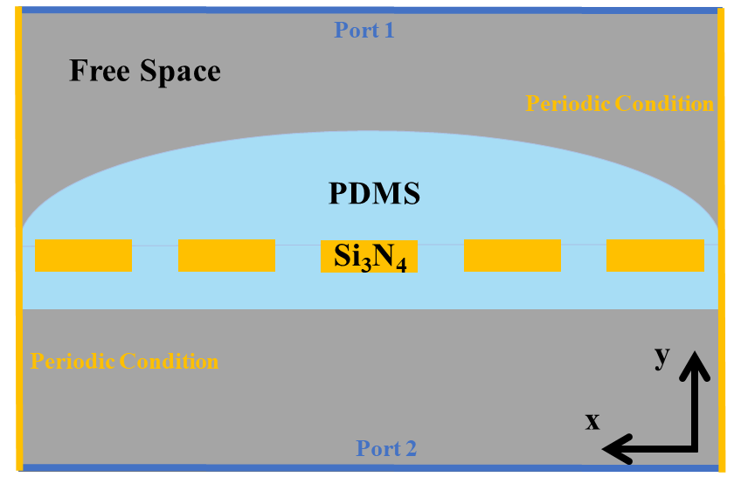
Figure S1. Schematic of the simulation domain.

The stretching of the structures was simulated by calculating the new dimensions of the structure when a 120% lateral strain is introduced in the x-direction. When stretched, dimensions in the x-direction are increased proportional to the strain. On the contrary, the dimensions in the y-direction are decreased proportional to the strain and the Poisson’s Ratio of PDMS [3]. The exceptions to this effect are the dimensions of the Si₃N₄ structures which remain the same due to the high Young’s Modulus of Si₃N₄ [4]. However, the spacing between the Si₃N₄ structures is increased with the strain. The dimension size in the x-direction after stretching can be calculated by using the formula:

$$\begin{aligned}x= x_{0}+ ϵ*x_{0}, \#\left(1\right)\end{aligned}$$

where x is the dimension in the x-direction such as the period of the PDMS or the period of the Si₃N₄ structures, x₀ is the size of the dimension before stretching, and ε is the strain. The size of dimensions in the y-direction are similarly calculated by using the relation:

$$\begin{aligned}y= y_{0}- ε*υ*y_{0},\#\left(2\right)\end{aligned}$$

where y is the dimension in the y-direction such as the thickness of the flat PDMS or the height of the PDMS mound, y₀ is the size of the dimension before stretching, and υ is the Poisson’s Ratio of PDMS. In our simulations, we use a maximum strain of 120% and a value of 0.48 for the Poisson’s Ratio of PDMS [5,6].

S-parameter reflection and transmission coefficient calculations were performed to determine the mid-IR emissivity of our structures before and after stretching. The port boundaries were used to determine the total reflected and transmitted power flow through our structures. The power flow through each port was calculated as:

$$\begin{aligned}P= \int_{C}^{ }{\vec{S}∙\vec{n}= \frac{1}{2}\int_{C}^{ }{Re\left\{\vec{E}×{\vec{H}}^{*}\right\}∙\vec{n}}},\#\left(3\right)\end{aligned}$$

where $\vec{S}$ is the time averaged Poynting Vector, C is the curve of the port boundary, $\vec{n}$ is the normal vector, $\vec{E}$ is the electric field vector, and $\vec{H}$ is the magnetic field vector. The S-parameters were then computed by:

$$\begin{aligned}S_{11}= \sqrt{\frac{power reflected back to port 1}{power emitted from port 1}},\#\left(4\right)\end{aligned}$$
$$\begin{aligned}S_{21}= \sqrt{\frac{power transmitted to port 2}{power emitted from port 1}}.\#\left(5\right)\end{aligned}$$

By using the Kirchhoff’s law of thermal equilibrium, the emissivity E is equal to the absorptance A in the far field of a structure. The power that is not transmitted or reflected from the structure must be absorbed, therefore the absorptance is computed as: A =1 - |S₁₁|² - |S₂₁|². Using this method, the full-wave simulations were performed twice for TM polarization, once for the stretched geometry and once for the unstretched geometry, to obtain the full spectral and angular emissivity of the presented structures. The same simulations were then repeated for TE polarization and the final emissivity used in the calculations of the cooling power was taken as the average of the two polarization results, since thermal emission is incoherent and contains both polarizations.

Electric Field Distributions
Figures S2 and S3 show surface plots of the electric field enhancement distributions by using TM polarized incident radiation for the rectangular and cylindrical Si₃N₄ inclusions embedded in the PDMS designs, respectively. These plots help illustrate the physical mechanisms that enable the large differences in mid-IR emissivity between the stretched and unstretched states. At a wavelength of 9.2 μm, the emissivity is mainly caused by absorption in the PDMS layer. When stretched, the PDMS layer becomes thinner and absorbs less power. Similarly, at the wavelength of 10.6 μm, the emissivity of our structures is primarily caused by absorption in the Si₃N₄ structures. When stretched, the Si₃N₄ structures move farther apart, and more power is transmitted through the total system. This is most clearly illustrated in Figure S2.
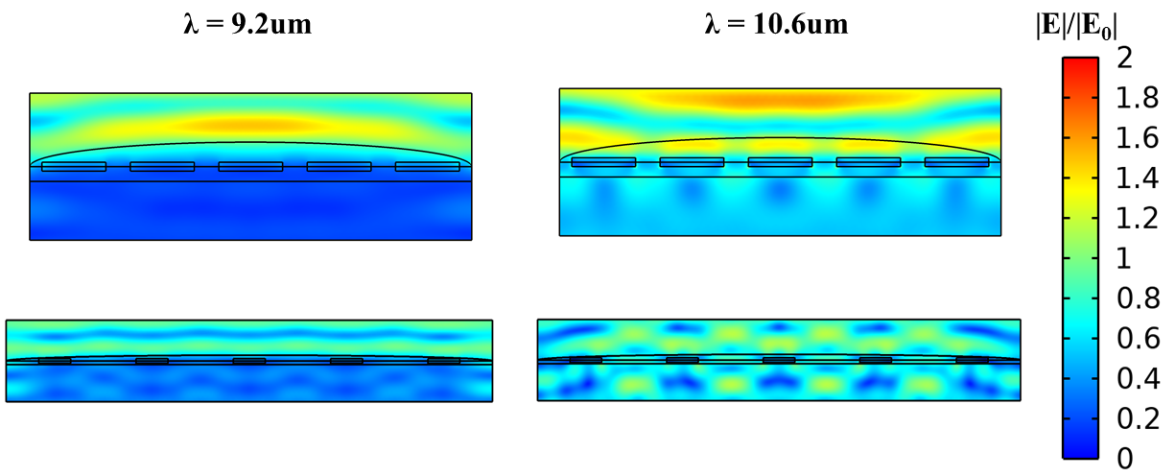
Figure S2. Surface plots of the electric field enhancement distributions for the rectangular Si₃N₄ inclusions in the PDMS structures at the peak absorption wavelengths of PDMS (9.2 μm) and Si₃N₄ (10.6 μm). The upper captions correspond to the unstretched structure while the lower captions to the stretched configuration.

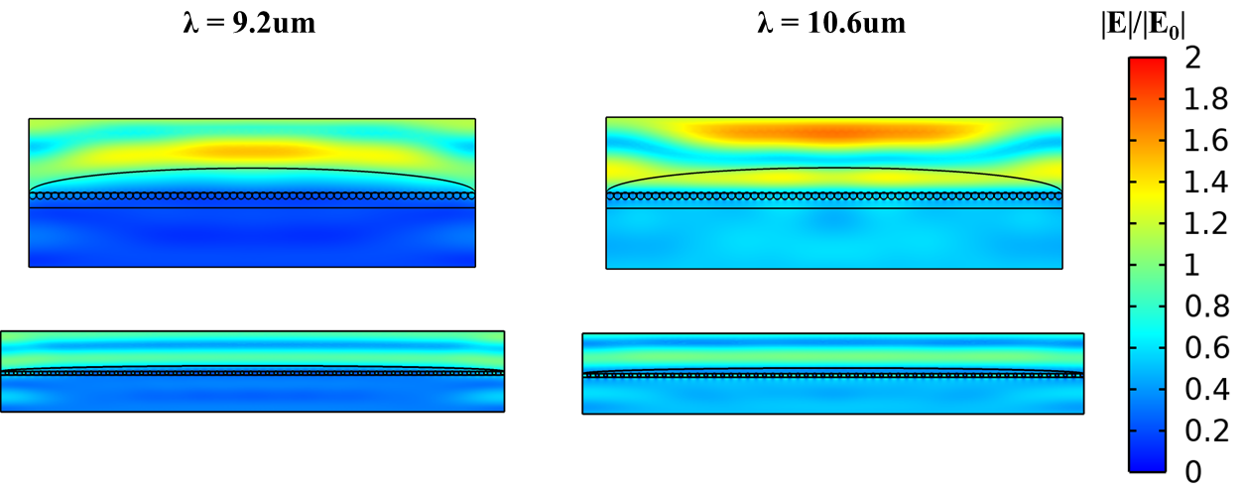
Figure S3. Surface plots of the electric field enhancement distributions for the cylindrical Si₃N₄ inclusions in the PDMS structures at the peak absorption wavelengths of PDMS (9.2 μm) and Si₃N₄ (10.6 μm). The upper captions correspond to the unstretched structure while the lower captions to the stretched configuration.

Figures S4 and S5 show the electric field enhancement distributions by using TM polarized incident radiation for the crumpled metal PDMS designs with rectangular and cylindrical Si₃N₄ inclusions, respectively. In these cases, the metallic layer prevents the transmission of light through the structure. Thus, the reduction in absorption/emissivity is due to an increase in reflection. The flattening of the metal as well as the increase in periodicity of the Si₃N₄ structures are the mechanisms by which the reflectance is increased. When the space between the Si₃N₄ structures is increased, an expanded portion of the metallic surface is exposed, leading to increased reflectance.
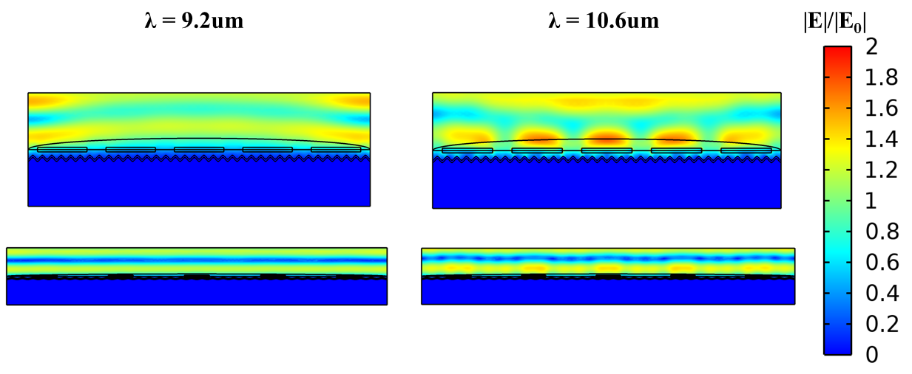
Figure S4. Surface plots of the electric field enhancement distributions for the rectangular Si₃N₄ inclusions within the crumpled metal PDMS structures at the peak absorption wavelengths of PDMS (9.2 μm) and Si₃N₄ (10.6 μm). The upper captions correspond to the unstretched structure while the lower captions to the stretched configuration.

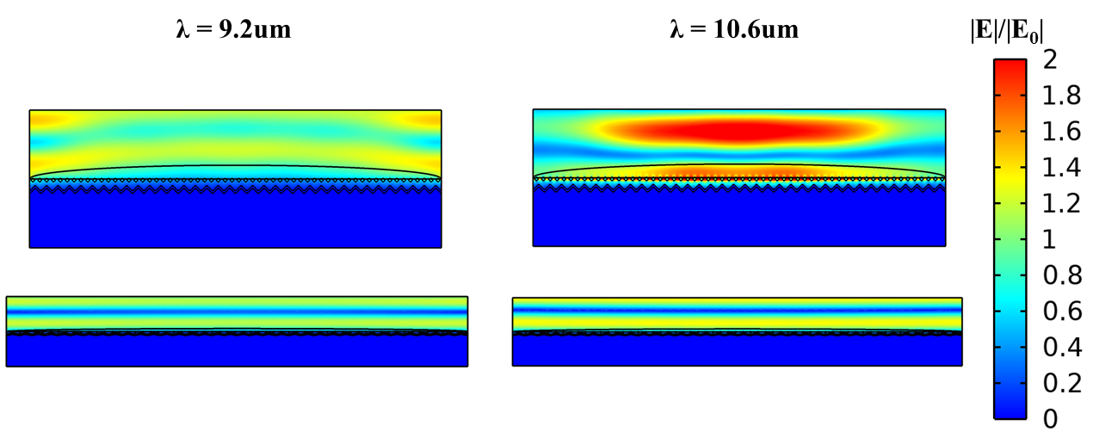
Figure S5. Surface plots of the electric field enhancement distributions for the cylindrical Si₃N₄ inclusions within the crumpled metal PDMS structures at the peak absorption wavelengths of PDMS (9.2 μm) and Si₃N₄ (10.6 μm). The upper captions correspond to the unstretched structure while the lower captions to the stretched configuration.

Si₃N₄ Shape Effect versus Size Effect
The dimensions of the cylindrical Si₃N₄ structures are much smaller than the rectangular structures. The differences in the results of the rectangular structures versus the cylindrical structures in Fig. 6 in the main paper can either be due to the shape of the structures or the large difference in size. To determine the main cause of the difference in the results, simulations were carried out for the design with the metal substrate, replacing the cylindrical structures with square shapes of the same size such that the width and thickness of the squares were equal to the diameter of the cylindrical structures used in the main paper. Figure S6a shows the emissivity spectra for these square shapes (highlighted as the blue area in the inset schematic). The emissivity near λ = 11μm is slightly higher for this case than for the cylindrical case (Figure S6b). While the dimensions of the square shaped structures are the same as the cylindrical structures, the area of the square shapes is larger. Figure S6c shows the emissivity spectra of the design with square shaped structures that are slightly smaller than the cylindrical structures (sized such that the squares are inscribed on the circles and highlighted as the blue area in the inset schematic). In this case, the emissivity near λ = 11μm is smaller than both other cases. This indicates that the emissivity due to the Si₃N₄ structures is mainly dependent on the size (area) of the structures and not their shapes.

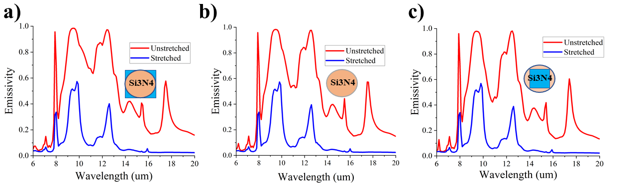
Figure S6. Emissivity spectra (TM polarized) of the PDMS device with a metallic substrate and (a) square Si₃N₄ structures of the same size as the original cylindrical design, (b) the cylindrical structures from the main paper, and (c) square shaped structures that are slightly smaller than the original cylindrical structures.

Effect of Si₃N₄ Dimensions
The dimensions of the Si₃N₄ structures have a minor effect on the performance of the designs. In this section we show the dependence of the emissivity on the geometric parameters of the Si₃N₄ structures. We begin first with the thickness of the rectangular structures and the radius of the cylindrical structures. Figure S7a shows the average emissivity over the 9-13μm wavelength range versus the thickness of the rectangular structures while Figure S7b shows average emissivity versus the radius of the cylindrical structures. The metallic substrate was included in the simulation and all other dimensions including the periodicities, rectangular width, and PDMS thicknesses were kept the same as the designs presented in Figure 2 of the main paper.

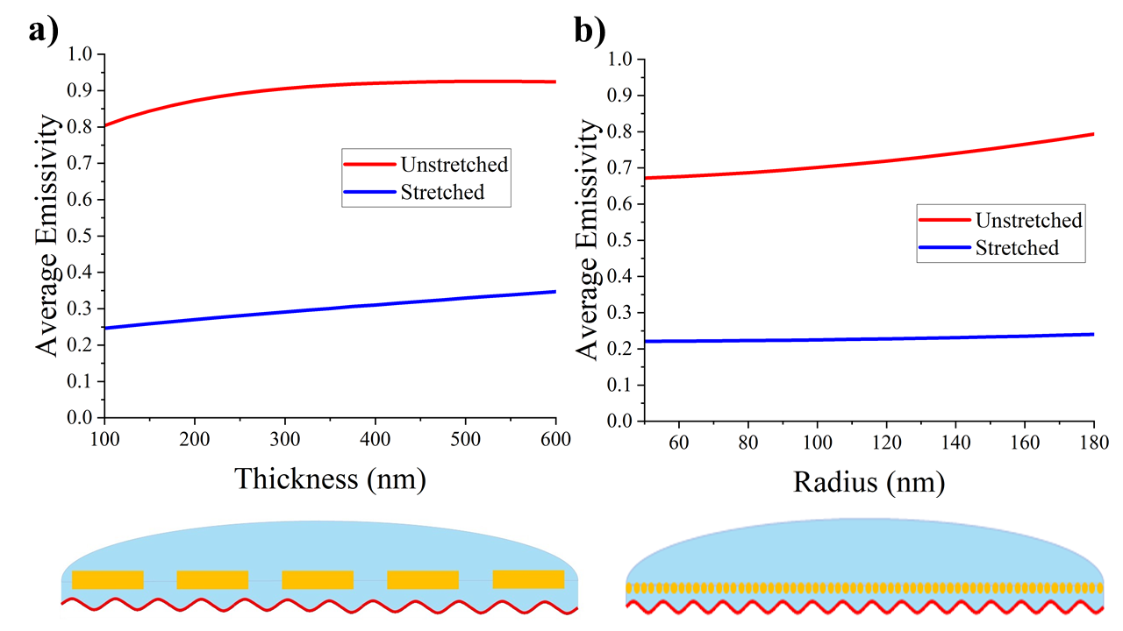
Figure S7. Average emissivity (TM polarized) between 9μm and 13μm versus (a) the thickness of the rectangular structures and (b) the radius of the cylindrical Si₃N₄.

In general, the average emissivity slightly increases with the size of the Si₃N₄ structures. The flattening of the curve for the rectangular case indicates that the results are not sensitive to the thickness. Hence, fabrication imperfections will have little effect on the results. The effect of the periodicity and width of the rectangular structures is shown in Figure S8. Here, the average emissivity is plotted for two different periodicities as a function of the fill fraction of the structures. The fill fraction is defined as the width of the structures divided by the total periodicity. For these simulations, the metal substrate was included and a value of 600nm was used for the rectangular thickness. The possible values of the periodicity are limited by the dimensions of the PDMS. The possible periodicities are first limited by the periodicity of the PDMS and should be constrained to values that divide the PDMS periodicity evenly to avoid having fractions of a unit cell embedded in the PDMS. Second, since the size and thickness of the Si₃N₄ structures remain unchanged during stretching, the periodicity, width, and thickness cannot be greater than the thickness of the PDMS when stretched, otherwise the PDMS would rupture and crack and the Si₃N₄ structures would break through the PDMS when stretched. At small periodicities, more rectangular structures are located at the edge of the device where the curved PDMS gets thinner, and it is more likely that the Si₃N₄ structures will break through the PDMS. With these restrictions we limit our investigation to two larger periodicities of 9μm and 15μm.

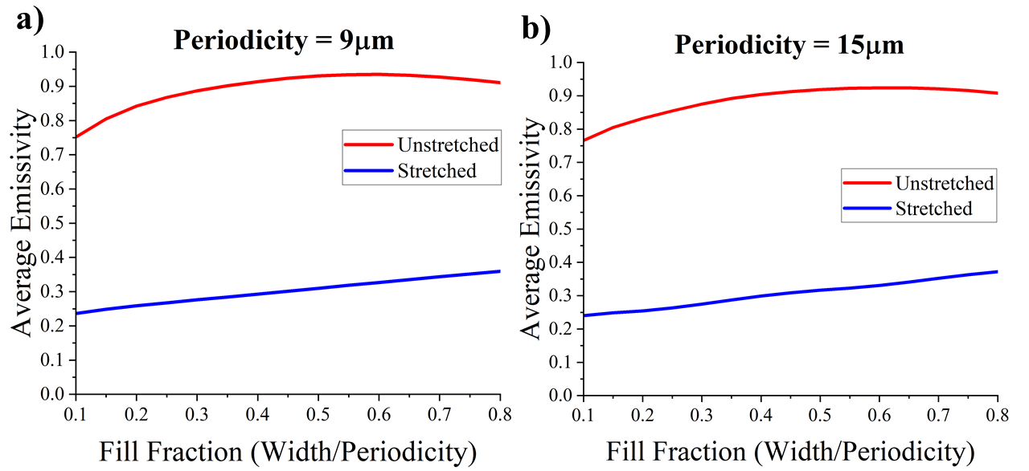
Figure S8. Average emissivity (TM polarized) between 9μm and 15μm versus the rectangular Si₃N₄ fill fraction for periodicities of (a) 9μm and (b) 15μm.

Once again, the general trend shows that larger dimensions of Si₃N₄ lead to slightly higher emissivity. The difference between the two periodicities is small and once again the curve flattens at higher fill fractions. Thus, variations in the width of the rectangular structures due to fabrication errors will have little effect on the overall performance of the device. Similar simulations were carried out for the cylindrical design to show its dependence on the periodicity. The same constraints apply for the cylindrical design and limit the possible periodicities. Since the effects of the radius have already been demonstrated before in Figure S7b, Figure S9 shows the emissivity spectra for three different periodicities of the cylindrical design. For these simulations, a radius of 180nm was used and the metal substrate was included.

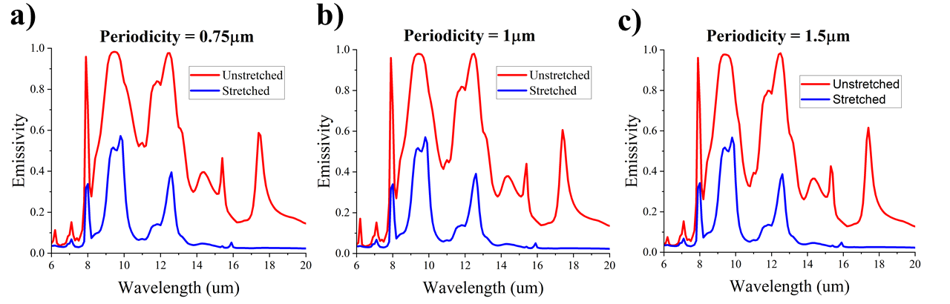
Figure S9. Emissivity spectra (TM polarized) of the cylindrical design for periodicities of (a) 0.75μm, (b) 1μm, and (c) 1.5μm.

The only notable effect of the cylindrical periodicity occurs near λ = 11μm where the emissivity slightly increases as the periodicity decreases. For the cylindrical case, a smaller periodicity means that the gap between the cylinders is smaller and thus the fill fraction is larger. Hence, this behavior is similar to that of the rectangular design presented before in Figure S8. Overall, the general trend shows that the emissivity slightly increases with the size of the Si₃N₄ structures, though at a certain point, the size effect diminishes. Since the Si₃N₄ structures are primarily responsible for the induced emissivity near λ = 11μm, small variations in dimensions that could occur during fabrication would only result in a miniscule effect on the overall performance of the device.

Device Behavior in the Solar Range
For many radiative cooling applications, sunlight plays a major factor in the device performance as a large detrimental heating source. Here we demonstrate the absorption spectra of our designs in the solar range. Figure S10 shows the absorption spectra of the rectangular designs with and without the metal substrate while Figure S11 shows the solar absorption spectra for the cylindrical designs.

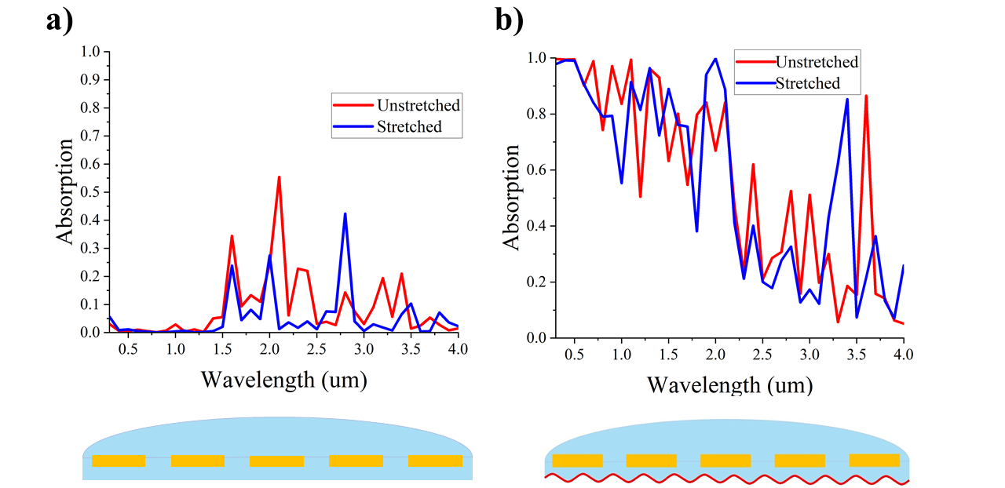
Figure S10. Solar absorption spectra (TM polarized) of the rectangular designs (a) without and (b) with metal substrate.

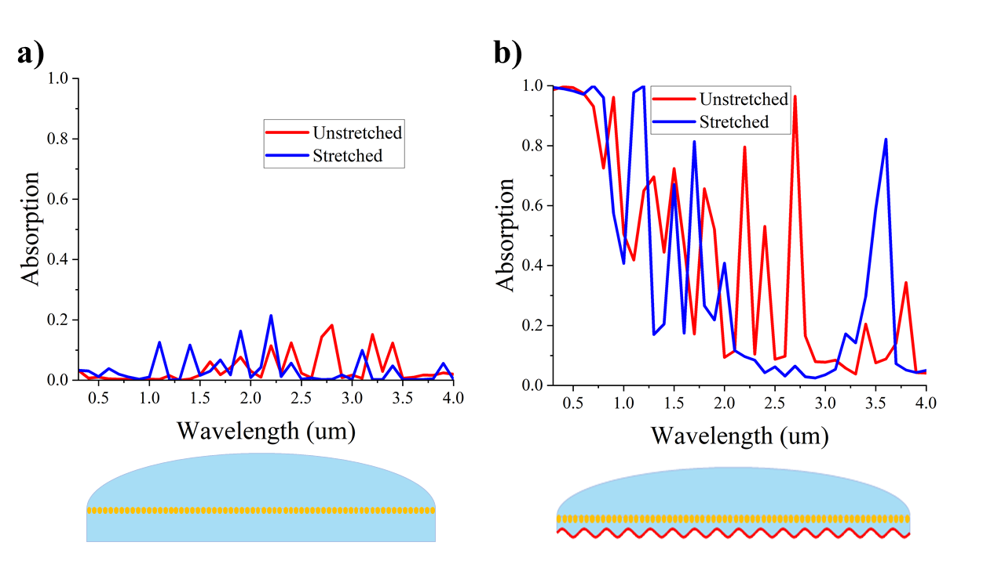
Figure S11. Solar absorption spectra (TM polarized) of the cylindrical designs (a) without and (b) with metal substrate.

It is clear that the inclusion of the crumpled metal substrate causes high absorption of solar light. Whereas for the designs without metal, the absorption is much lower due to being mostly transparent to solar light. While this behavior does somewhat limit the space applications of the presented designs, there are still useful applications for these devices on geostatic satellites operating in the Earth’s shadow or sun synchronous satellites. In the Earth’s shadow, no sunlight reaches the satellite and so conserving energy becomes an important concern since the solar panels are no longer generating electrical power. The ability to reduce the amount of power radiating from the satellite becomes an important benefit of our designs. It is also feasible that the radiative cooling devices could be mounted and controlled by using mechanical louvers [7], such that the absorptive/emissive side faces away from the sun while backed with a reflective metal surface.

References
1. X. Zhang, J. Qiu, J. Zhao, X. Li, and L. Liu, "Complex refractive indices measurements of polymers in infrared bands," Journal of Quantitative Spectroscopy and Radiative Transfer 252, 107063 (2020).
2. A. L. Gaeta, K. Luke, M. R. E. Lamont, M. Lipson, and Y. Okawachi, "Broadband mid-infrared frequency comb generation in a Si₃N₄ microresonator," Optics Letters, Vol. 40, Issue 21, pp. 4823-4826 40(21), 4823–4826 (2015).
3. D. Holmes, "Mechanics of Materials: Strain," https://www.bu.edu/moss/mechanics-of-materials-strain/.
4. A. Khan, J. Philip, and P. Hess, "Young’s modulus of silicon nitride used in scanning force microscope cantilevers," Journal of Applied Physics 95(4), 1667 (2004).
5. A. Müller, M. C. Wapler, and U. Wallrabe, "A quick and accurate method to determine the Poisson’s ratio and the coefficient of thermal expansion of PDMS," Soft Matter 15(4), 779–784 (2019).
6. S. Dogru, B. Aksoy, H. Bayraktar, and B. E. Alaca, "Poisson’s ratio of PDMS thin films," Polymer Testing 69, 375–384 (2018).
7. I. Muraoka, F. L. de Sousa, F. M. Ramos, and W. R. Parisotto, "Numerical and experimental investigation of thermal louvers for space applications," Journal of the Brazilian Society of Mechanical Sciences 23(2), 147–153 (2001).

