Journal of Geophysical Research
Supporting Information for
Evaluating Twenty-Year Trends in Earth’s Energy Flows from Observations and Reanalyses
Norman G. Loeb¹, Michael Mayer^{2,3}, Seiji Kato¹, John T. Fasullo⁴, Hao Zuo², Retish Senan², John M. Lyman^{5,6}, Gregory C. Johnson⁵ and Magdalena Balmaseda²
¹NASA Langley Research Center, Hampton, VA 23681, USA
²European Centre for Medium-Range Weather Forecasts, Reading, UK
³Department of Meteorology and Geophysics, University of Vienna, Vienna, Austria
⁴Climate and Global Dynamics Division, National Center for Atmospheric Research, Boulder, CO
⁵NOAA/Pacific Marine Environmental Laboratory, Seattle, WA, USA
⁶Cooperative Institute for Marine and Atmospheric Research, University of Hawaii at Manoa, Honolulu, HI, USANorman G. Loeb¹, Wenying Su¹, Nicolas Bellouin², Yi Ming³

Contents of this file

Figures S1 to S8

Introduction
The figures in this supporting document provide additional TOA flux comparisons between CERES, ERA5 and IFS AMIP, and also compares surface turbulent heat fluxes from SeaFlux and OAFlux.

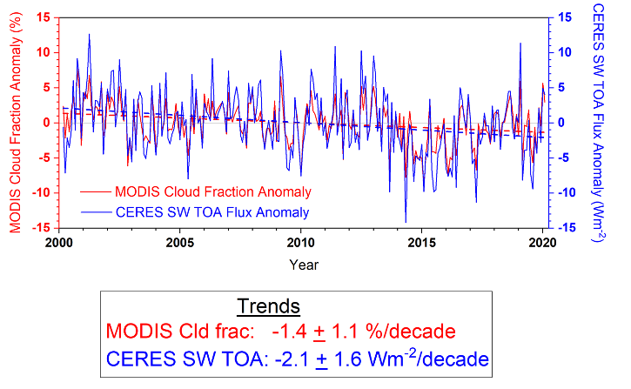
Figure S1. Anomalies in MODIS cloud fraction and CERES SW TOA flux for a region over the Eastern Pacific (10º-40ºN, 150º-110ºW) for 03/2000-02/2020.

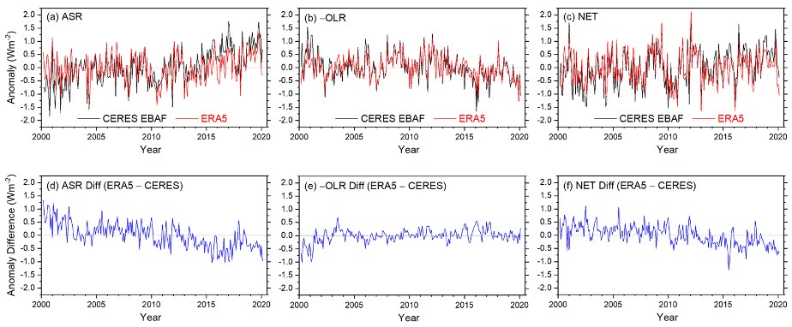

Figure S2. CERES EBAF and ERA5 global monthly anomalies at TOA for (a) ASR, (b) - OLR and (c) Net flux, and ERA5 minus CERES EBAF anomaly difference for (d) ASR, (e) -OLR and (f) Net.

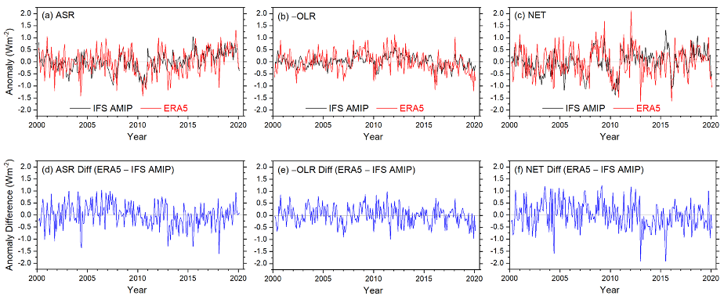
Figure S3. IFS AMIP and ERA5 global monthly anomalies at TOA for (a) ASR, (b) - OLR and (c) Net flux, and ERA5 minus IFS AMIP anomaly difference for (d) ASR, (e) -OLR and (f) Net.

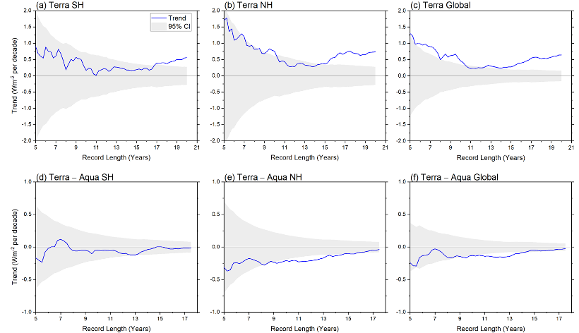
Figure S4. CERES ASR TOA flux trends against record length for CERES SSF1deg Terra (top) and Terra – Aqua (bottom) for (a, d) SH, (b, e) NH, (c, f) Global. Start date is 03/2000 for Terra and 07/2002 for Terra – Aqua. Gray shading corresponds to 95% confidence interval.

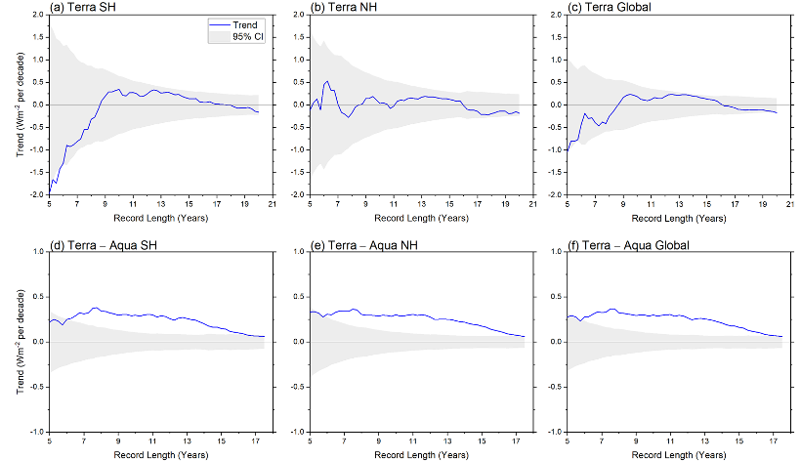
Figure S5. Same as Fig. S4 but for −OLR.

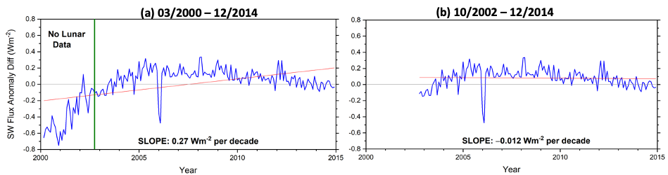
Figure S6. Reflected SW TOA flux anomaly differences between adjusted CERES Terra values in Matthews (2021) and the official CERES SSF1deg Ed4.1 product for (a) 03/2000-12/2014 and (b) 10/2002-12/2014.

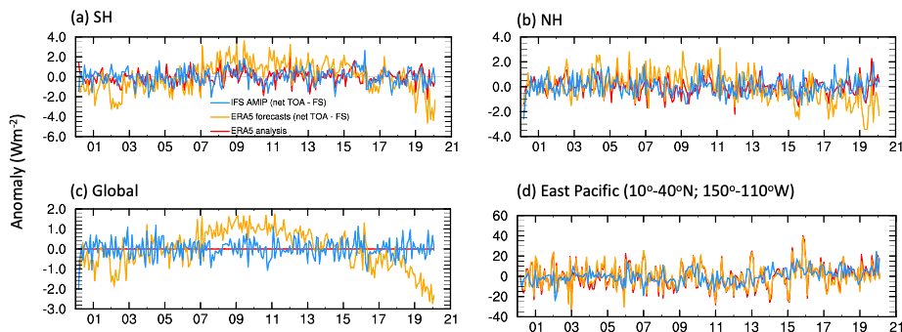
Figure S7 Monthly anomalies in TEDIV for (a) SH, (b) NH, (c) Global and (d) NE Pacific region.

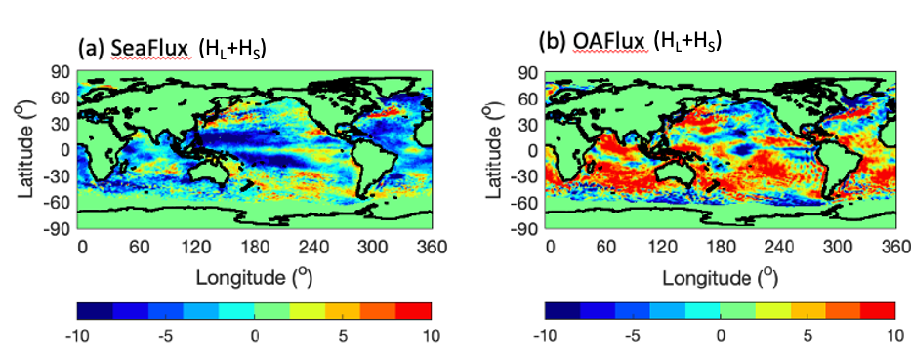
Figure S8. Trends in surface turbulent heat flux (positive downward) for 2002/08-2018/07 for (a) SeaFlux V3 and (b) OAFlux V3.

