OVERVIEW OF NASA’s RESOURCE (Resource Exploration and Science of OUR Cosmic Environment) PROJECT. Jennifer L. Heldmann¹, Alexander Sehlke^{1,2}, Matthew C. Deans¹, A. Paz³, J. Kleinhenz^{3,4}, A. Deutsch^{1,5}, Darlene S. S. Lim¹, Anthony Colaprete¹, Richard Elphic¹, Dana Hurley⁶, Andy Rivkin⁶, Dava Newman⁷, J. Shaw⁷, Kris Zacny⁸, Kathryn Bywaters⁸, Leo Stolov⁸,Josh Coyan⁹, Anna Wagner¹⁰, Zara Mirmalek^{1,2}, Alexandra Matiella Novak⁶, Deena Khalil¹¹, and the NASA RESOURCE Team. ¹NASA Ames Research Center, ²BAER Institute ³NASA Johnson Space Center, ⁴NASA Glenn Research Center, ⁵NASA Postdoctoral Program (NPP), ⁶Johns Hopkins University / Applied Physics Lab, ⁷Massachusetts Institute of Technology, ⁸Honeybee Robotics, ⁹U.S. Geological Survey, ¹⁰U.S. Army, Cold Regions Research Environment Laboratory (CRREL), ¹¹Howard University
(Contact: jennifer.heldmann@nasa.gov)
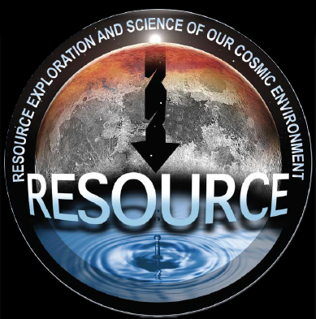

Executive Summary: The RESOURCE (Resource Exploration and Science of OUR Cosmic Environment) project is supported by NASA’s SSERVI (Solar System Exploration Research Virtual Institute) and is led by Principal Investigator (PI) Dr. Jennifer L. Heldmann and Deputy PIs Dr. Matthew Deans and Dr. Alexander Sehlke at NASA Ames Research Center. RESOURCE is focused on enabling In Situ Resource Utilization (ISRU) near the sites of robotic and/or human missions to enable sustainable and affordable exploration of the Moon and near-Earth objects (NEOs). This year RESOURCE has supported the development of a summary of the current state of knowledge regarding lunar polar volatiles as well as a comprehensive catalog and analysis of NEOs. RESOURCE is developing advanced mission capabilities to enable rapid, collaborative operations for lunar resource exploration missions. Hardware testing has been conducted to evaluate potential contaminants released during lunar polar regolith heating. Volatiles and particulates are the two sources of contamination that will affect the requirements of a water cleanup system, and RESOURCE research has identified the requirement for filtration prior to electrolysis for ISRU. RESOURCE also supports development of next-generation planetary drilling systems with integrated instrumentation within the drill. RESOURCE is also deeply committed to sustained efforts to engage educators, students, and broadening participation among underrepresented groups, and has partnered with Howard University in Washington, DC to foster minoritized students’ interest in STEAMD (science, technology, engineering, arts, math, design) careers through direct and virtual experiences with NASA Subject Matter Experts.
Resource Characterizations: Using our current understanding of the processes that contribute to the distribution of water in lunar PSRs (Permanently Shadowed Regions) and constraints from data on larger spatial scales, we devised multiple potential distributions of water ice as well as correlations with additional physical parameters such as surface roughness. Also, geostatistical analysis techniques across lunar datasets are being developed by leveraging established USGS capabilities to systematically evaluate resource potential.
Advanced Mission Operations Capabilities: The MIT team is developing a suite of virtual tools for data analysis and mission operations. The Virtual Mission Simulation System (vMSS) is a virtual reality platform currently under development and testing to determine integration and usability pathways for data display, collaborative analysis, and rapid decision making. Multiple instruments for data collection have also been field tested to provide science data as well as enable accurate 3D VR/AR/XR (virtual/augmented/mixed reality) renderings of an analog field site to capture surface features and physical forms.
ISRU Water Processing: Work supported by RESOURCE at the NASA Johnson Space Center (JSC) is working to process extracted water in an ISRU plant and demonstrate an integrated test of the critical components needed to capture, clean, deionize, and electrolyze water as well as dry the oxygen and hydrogen gas products.
Lunar Drilling Technologies: The RESOURCE team at Honeybee Robotics has been focused on developing advanced downhole technologies to integrate instruments (including neutron and near-infrared spectrometers, dielectric spectroscopy probe, temperature sensor & heater, and camera) into the drilling auger. This advancement changes the paradigm of planetary exploration: instead of bringing samples to an instrument we are bringing an instrument to the samples.
Public Engagement: The RESOURCE team is working to engage educators, students, and broadening participation among underrepresented groups. We have designed STEAMD resources to cultivate underrepresented students’ interest in space science and aerospace careers.

