DiskSat: Demonstration Mission for a Two-Dimensional Satellite Architecture

Richard Welle, Catherine Venturini, David Hinkley, Joseph Gangestad, Sara Grasso, Anastasia Muszynski
The Aerospace Corporation

Roger Hunter, Chad Frost, Chris Baker
NASA Space Technology Mission Directorate

ABSTRACT

The DiskSat is a quasi-two-dimensional satellite bus architecture designed for applications requiring high power, large apertures, and/or high maneuverability in a low-mass satellite. A representative DiskSat structure is a composite flat panel, one meter in diameter and 2.5 cm thick. The volume is almost 20 liters, equivalent to a hypothetical 20U CubeSat, while the structural mass is less than 3 kg. The surface area is large enough to host over 200 W of solar cells without deployable solar panels. For launch, multiple DiskSats are stacked in a fully enclosed container/deployer using a simple mechanical interface and are released individually in orbit.

The Aerospace Corporation, with the support of the NASA Space Technology Mission Directorate (STMD), is preparing a flight of four DiskSats for launch in 2024 to demonstrate the feasibility of both the dispenser and the DiskSat bus. In addition, the flight is expected to demonstrate several features of the DiskSat including the unprecedented high power-to-mass ratio, the maneuverability of the bus using low-thrust electric propulsion, and the ability to fly continuously in a low-drag orientation, enabling operations in very low Earth orbits (VLEO).

The DiskSats will be launched in and deployed from a dispenser that provides a containerized rideshare environment; the dispenser fully encloses the DiskSats during launch and then opens to dispense the satellites one at a time once in orbit. The dispenser is modular in design and expandable from the capacity of four DiskSats for this flight to as many as 20 DiskSats for future flights.

NASA STMD seeks disruptive and innovative technologies that could help lead to the next-generation systems for future science and exploration missions. DiskSat is a potentially disruptive technology leading to new, enabling architectures using ever-more capable small spacecraft. Data generated from this flight will inform the drafting of a DiskSat standard intended to encourage easy and frequent access to space, in the same manner as the CubeSat standard. DiskSat is expected to become a standard format for rideshare-compatible, high-power, maneuverable, low-mass satellites for Earth-orbit, cis-lunar, and deep space applications.

INTRODUCTION

CubeSats have done much over the past two decades to revolutionize the small satellite industry, and people have been ingenious in coming up with applications for CubeSats that were certainly never imagined when the CubeSat standard was first developed.¹ The key driver of the remarkable expansion of the CubeSat class of spacecraft is launch containerization; the container provides a standardized and highly simplified launch interface that reduces the integration cost and time for the launch provider and reduces the development cost and time for the CubeSat builder. These factors work together to ensure both frequent launch opportunities and a steady supply of CubeSats to use those launch opportunities. While containerization enabled the CubeSat revolution, the revolution is limited to space missions that can fit within the CubeSat box. Conventional CubeSats are made up of unit (or half unit) multiples of the 1-unit (1U) CubeSat, a cube measuring approximately 10 cm on a side. However, the first containerized satellites predated the CubeSat standard and did not come in a cubical shape.^{2,3} This suggests that it may be worth considering alternative approaches to containerization.

CubeSats typically come with rigidly constrained geometries that limit volume and surface area but with rather generous mass allowances. In contrast, what many space missions need in a bus are increased surface area and volume: surface area for power generation, RF apertures, and thermal management, and volume just to simplify the integration of the spacecraft. While surface area can be increased in CubeSats (within limits) through deployable structures, these deployables can become very complex as their area increases. And deployables do little to relieve volume constraints, so CubeSats are often built with ever-increasing density of components that can be a significant engineering and integration challenge.

In contrast with CubeSats, launch vehicle payload capacities are most often constrained by mass rather than by volume or surface area. Of course, the payload must fit within the payload fairing, but payload fairings are generally designed to enclose a range of possible payload sizes and shapes and it is a rare satellite that fully fills a payload fairing.

With these considerations in mind, we proposed a new satellite configuration that we call DiskSat: a large-aperture, quasi-two-dimensional satellite bus in the form of a thin disk that is designed to be stacked for containerization while making maximum use of payload volumes.⁴ A representative DiskSat is a disk one meter in diameter and only 2.5 cm thick. The structure of the DiskSat consists primarily of a composite sandwich panel with graphite/epoxy face sheets and an aluminum honeycomb core. Non-structural components of the bus and the payload are distributed on the surface or within the volume of the disk. A disk of these dimensions has a volume of about 20 liters, equivalent in volume to a hypothetical 20U CubeSat. However, it is not intended that the DiskSat will fly with this volume filled; the goal of the concept is to increase the surface area for power, aperture, and thermal management and to increase the volume to simplify manufacturing, all while maintaining a mass comparable to that of a typical 6U CubeSat. The structural mass of the disk itself is under 2 kg, so keeping the entire bus mass (power, ACS, and other avionics) under 5 kg should not be a challenge. At the same time, the surface area is large enough to support as much as 200 W of solar cells on a single face. With a 5-kg payload, the total satellite mass is still under 10 kg.

The size of the baseline DiskSat was chosen to fit within a 1-m payload fairing, making it compatible with multiple launch vehicles entering the market, such as Rocket Lab’s Electron or Virgin Orbit’s LauncherOne. The disks are intended to be stacked; if the mass of each satellite is kept to no more than 10 kg, then a stack of 20 DiskSats could be launched by a single Electron (depending on the mass of the dispenser and the desired orbit). The concept could be extended to larger diameters for larger payload fairings or even to other shapes such as a square or rectangle to fit, for example, an ESPA port. Scaling to larger thicknesses is also possible if more volume is needed; a disk five or ten cm thick will be much more rigid than one only 2.5 cm thick and, since the core material has very low density, the thicker disks will not be much more massive than the baseline disk (assuming the volume is not overly filled with non-structural components).

The original motivation for the DiskSat was the need for a large surface area in a containerized satellite to provide high power and to support large-aperture RF antennas. However, the DiskSat approach has benefits beyond an increase in surface area. For example, the DiskSat’s combination of high power and low mass supports the use of electric propulsion to create a maneuverable satellites for missions requiring significant delta-v. In addition, the DiskSat’s combination of large volume and large surface area can greatly simplify the satellite assembly process. In typical volume-constrained CubeSats, internal components have to be assembled in a compact three-dimensional package that can present significant integration challenges. In a DiskSat, the arrangement of internal components is more two-dimensional than three-dimensional; the components are laid out over a large area, and most components remain accessible after integration, simplifying post-integration testing as well as removal and replacement of components if necessary.

DISKSAT DEMONSTRATION MISSION

While the DiskSat has many apparent advantages over conventional satellites, the design does not come without challenges. The three most often noted are satellite deployment, attitude control, and thermal management. To demonstrate that these challenges are manageable, and to support development of a DiskSat standard analogous to the CubeSat standard,^{5,6} The Aerospace Corporation, with support from NASA Space Technology Mission Directorate, is developing a demonstration flight of four DiskSats for launch within two years. The primary objectives of the project are:

Develop a DiskSat container/dispenser capable of supporting the DiskSats during launch and of dispensing the satellites one at a time once on orbit.

Develop a DiskSat bus.

Demonstrate the operation of the DiskSat dispenser and bus in orbit.

Develop a first draft of a DiskSat standard based on lessons learned in developing and flying the dispenser and bus.

Mission Concept

The DiskSat demonstration mission will be a flight of four one-meter-class DiskSats launched in a prototype dispenser. The DiskSats may carry payloads, but the mission is primarily intended to demonstrate the performance of the bus and dispenser and to evaluate the viability and utility of the concept for future missions. Our technical approach to the DiskSat demonstration mission builds on The Aerospace Corporation’s long history of design and flight experience with CubeSats.⁷⁻¹¹ The DiskSat bus is a new mechanical design, but the avionics will build on (including extensive reuse of) the avionics developed and evolved over a long series of AeroCube CubeSat flights.

The DiskSat dispenser will be designed for use on a small expendable launch vehicle, either as the sole payload or in a rideshare configuration. The dispenser will be designed to hold the DiskSats in a closed container for launch and to deploy the DiskSats one at a time after launch. The dispenser for the demonstration mission will be configured to contain only the four demonstration DiskSats, but the design is guided by the goal of being able to expand the dispenser to the full capacity of a lunch vehicle. The dispenser will remain attached to the launch vehicle after deployment of the DiskSats, and disposal will be through atmospheric re-entry, along with the launch vehicle.

The DiskSats will operate in LEO, with initial orbital insertion between 450 and 600 km altitude. This insertion altitude is being targeted to ensure that the vehicles will not reenter too quickly before the completion of on-orbit checkout. The tumbling area-to-mass ratio of a DiskSat is approximately four times that of a typical 3U or 6U CubeSat, and an uncontrolled DiskSat could reenter from atmospheric drag in only weeks if deployed at a low altitude, such as from the International Space Station. Deployment above 450 km should provide operators greater than 3 months of lifetime to establish attitude control of the vehicle.

Each DiskSat will carry a commercially sourced electric propulsion (EP) system to enable orbital maneuvering and a demonstration of the ability of the DiskSat to operate at very low altitudes (below 300 km). Each DiskSat will also host up to 200 W of input solar power. Figure 1 shows an illustration of the planned configuration of the DiskSat, including the electric propulsion system. Note that the EP system protrudes above and below the surface of the disk, an approach that illustrates one of the design features of the DiskSat; there is a corresponding cutout from the disk offset 180 degrees from the EP system to facilitate close stacking.

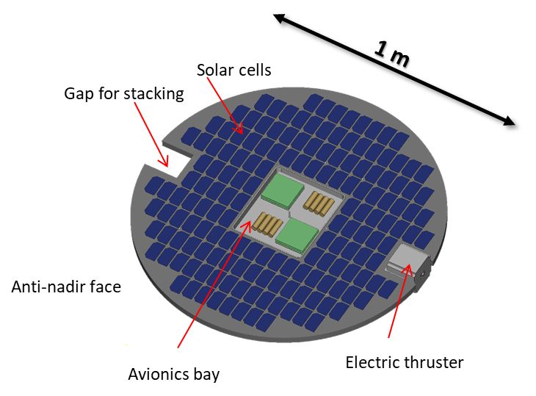

Figure 1. Planned configuration of the DiskSat demonstration satellite.

Satellite Structure

The satellite structure consists primarily of a circular rigid plate fabricated as a composite sandwich with graphite/epoxy face sheets and an aluminum honeycomb core. Composite sandwich structures can be fabricated using other materials, but graphite/epoxy is preferred in the face sheets for its high strength-to-weight ratio and low coefficient of thermal expansion, and aluminum honeycomb is preferred over foam core materials for its high thermal conductivity. The disk is one meter in diameter and 2.5 cm thick, but portions of the disk will be cut out to accommodate other satellite components. Specifically, as illustrated in figure 2, a central portion of the disk will be cut out to make space for a chassis box that will hold most of the spacecraft avionics. The avionics box is expected to occupy a square approximately 25 cm on a side. In addition, two square sections will be removed from the perimeter of the disk on opposite sides. One square will host a propulsion system and the other will provide clearance for the propulsion systems of adjacent satellites when they are stacked for launch. As the dispenser design is finalized, additional small cutouts may be required to provide an interface with the dispenser. In this configuration, assuming face sheets that are 0.5 mm thick, the mass of the disk itself will be just under 2 kg.



Figure 2. DiskSat structural plate showing cutouts for chassis box, mounting location for propulsion unit, and clearance for stacking.

The structural loads on the sandwich panel during launch are a primary design consideration. In the initial concept of the DiskSat, it was not anticipated that a sandwich panel one meter in diameter would be robust against launch loads when held only at the perimeter. Thus, the original concept called for a set of distributed contact points to ensure separation between adjacent DiskSats in a stack.⁴ Subsequent structural modeling has shown, however, that when fabricated with high-modulus graphite fibers, a disk one meter in diameter and 2.5 cm thick, supported only at the perimeter, should experience a maximum central displacement of well under 1 mm under any reasonably expected launch loads. Figure 3 shows the layout of the finite-element model for a representative case; the disk is one meter in diameter, 2.5 cm thick, and is supported at four points around the perimeter. The central chassis box is represented by a 5-kg point mass, and the propulsion unit by a 1.45-kg point mass. Figure 4 shows a map of deflection under a 43.3-g static load; the maximum deflection of the disk is only 0.074 mm. Since we anticipate using a disk-to-disk separation of at least one cm in the dispenser, the flexing of the disks is within acceptable limits, and it should be possible to support them only at their perimeter, simplifying the stacking process and opening the trade space for dispenser mechanisms.

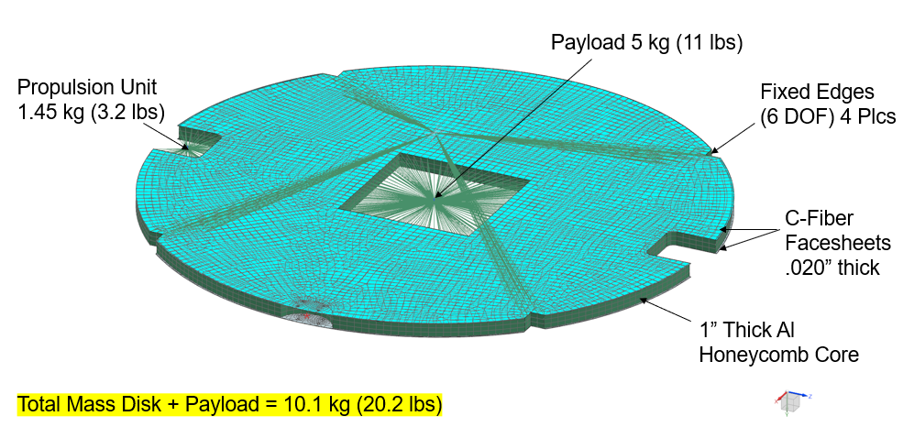

Figure 3. Finite-element model for evaluation of disk deflection under load.

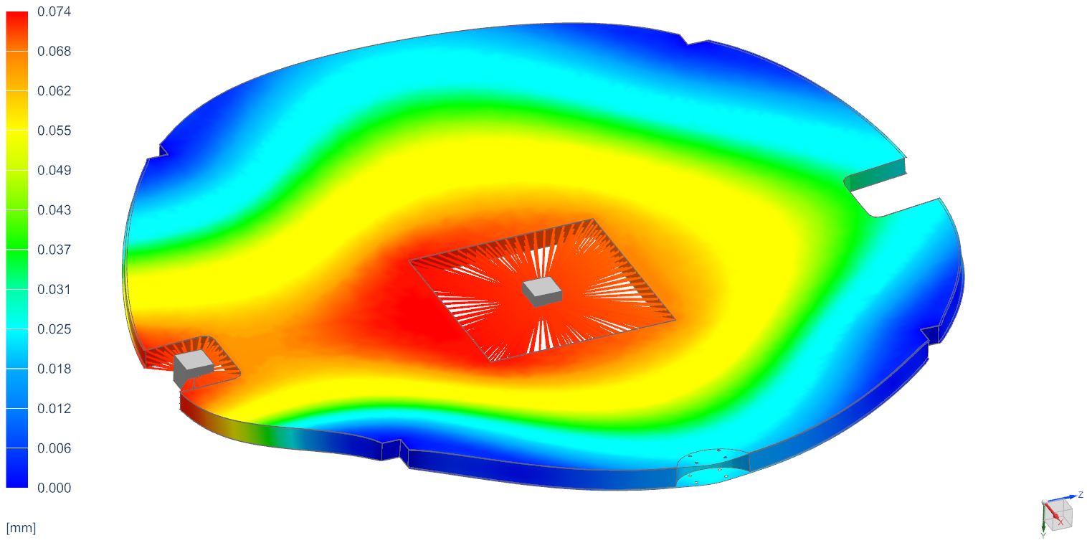

Figure 4. Map of disk deflection under a 42.3-g static load.

Common Avionics

The spacecraft avionics will be housed predominantly in a central chassis box. The location of this box is shown centered in the disk in Figure 1, but the design is flexible and further analysis of the attitude control system may indicate a need to shift its location away from the disk center to adjust the center of mass of the satellite. Construction of the chassis box is straightforward, needing only to meet the requirement to support the mass of the contents against launch loads and to provide a thermal path for disposing waste heat.

Many of the basic functions of a spacecraft are independent of spacecraft size or geometry. In the DiskSat, we intend to use the primary flight computer, navigation, imaging, and communications systems designs previously flown on many AeroCube CubeSats. These systems have previously been built on individual PCBs designed to be stacked for easy incorporation in a CubeSat. For the DiskSat, the boards will be built with the same layout, but they will be assembled into multiple short stacks rather than a single tall stack to accommodate the different geometry of the chassis box. Figure 5 shows an image of a preliminary avionics layout.

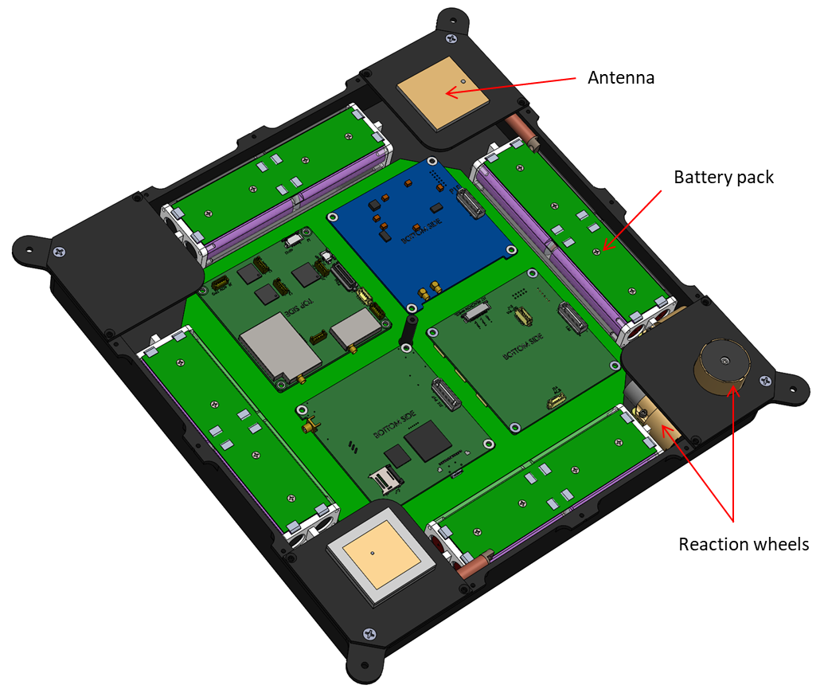

Figure 5. Preliminary avionics layout.

Attitude Control

In the AeroCubes, the attitude control system (ACS) includes various sensors (magnetometers, rate gyro, sun sensors, Earth horizon sensors, and star cameras), two types of actuators (reaction wheels, magnetic torque rods), and an attitude-control processor to analyze sensor data and control the actuators; it is anticipated that these components can fly in the DiskSat without modifications beyond mounting methods. For the ACS, the primary difference between the DiskSat and a CubeSat is the substantial increase in moments of inertia. For example, a typical 3U CubeSat with a mass of 4 kg (assuming uniform density) will have moments of inertia of about 0.0081 kg-m² about its short axes and about 0.042 kg-m² about its long axis. The DiskSats for the demonstration mission are expected to have a mass of about 6.2 kg, made up of the disk itself, the chassis box, all avionics, and the propulsion system. If we assume this mass to be uniformly distributed in the disk, the moment of inertia about the axes in the plane of the disk would be about 0.39 kg-m² and the moment of inertia about the axis perpendicular to the face of the disk would be about 0.77 kg-m2, which is almost 20 times the maximum moment of the 3U CubeSat. However, as can be seen in figure 1, the mass of the disk is not uniformly distributed. Because the mass is concentrated in the chassis box and the propulsion system, the lowest moment of inertia will be about the axis in the plane of the disk along the line through the propulsion system and the chassis box. The estimated moment of inertia about this axis is 0.24 kg-m², which is only about five times the maximum moment of the 3U CubeSat.

The significance of these higher moments of inertia depends on the intended mission of the spacecraft. For a given set of reaction wheels, increasing the spacecraft moments of inertia implies a corresponding reduction in the maximum angular acceleration and maximum slew rate of the spacecraft. For a mission that must point inertially such as, for example, having one face continuously pointed at the sun or other astronomical object, or for a mission slewing at a constant rate to have one face continuously nadir pointing, neither maximum angular acceleration nor maximum slew rate is significant; the reaction wheels are used to fine-tune the pointing, but are not typically called on to rapidly slew the spacecraft from one orientation to another. On the other hand, for a mission in LEO that needs to track a point on the ground, the reaction wheels must have sufficient torque and momentum storage capacity to accelerate the spacecraft's rotation speed to a maximum that depends on the geometry of the orbit relative to the ground station. In general, both the peak acceleration and peak slew rate will increase as the orbit altitude decreases. For a circular orbit at an altitude of 600 km, the peak slew rate will be just over 0.7 deg/s. Reducing the orbit altitude to 400 km increases the peak slew rate to about 1.1 deg/s.

The reaction wheels that Aerospace has been flying in our 3U spacecraft have a peak momentum storage capacity of about 8 mN-m-s, and the wheels recently qualified for our 6U CubeSats have close to twice that capacity. These 6U wheels should allow the DiskSat to slew at up to 3.5 deg/s about its axis with the smallest moment of inertia, and slew rates close to 1 deg/s should be possible about the other axes. By flying these new, larger wheels, DiskSat should be able to track a ground point, at least from altitudes above 400 km.

The other significant difference between the DiskSat and a CubeSat that affects the ACS is the possibility of aerodynamic torques acting on the spacecraft due to atmospheric drag. At high altitudes this is not a concern, but one of our goals for the demonstration mission is to explore flight operations in very low Earth orbit (VLEO). For a DiskSat flown with the velocity vector aligned in the plane of the disk, the drag will be low and aerodynamic torques negligible, as indicated in figure 6, which shows the cross section of the DiskSat in the low-drag orientation with and without propulsion. However, if the DiskSat attitude is offset from the low-drag orientation, then the center of drag on the spacecraft may be offset from the center of mass, creating a torque. The magnitude of this effect depends on the magnitude of the total drag and on the offset between the centers of drag and mass. Aerodynamic torques can be offset using the reaction wheels, but if the torque is continuous the reaction wheels will eventually saturate. If the magnitude of the torque is small enough, regular or continuous operation of the magnetic torque rods can offset the aerodynamic torque. Again, this gets more challenging as the altitude decreases and as the attitude offset increases. A detailed analysis is planned, but preliminary results indicate that the existing reaction wheels and torque rods should be able to compensate for aerodynamic torques in normal operations at least down to an altitude of 300 km, and probably down to 250 km or lower, depending on atmospheric conditions. As noted above, this analysis may suggest shifting the location of some components to shift the location of the center of mass of the spacecraft.

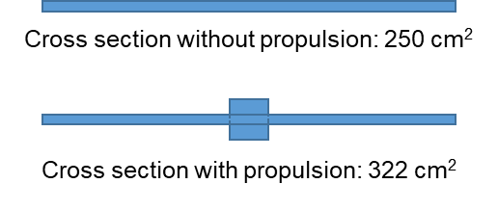

Figure 6. DiskSat cross section in low-drag orientation, with and without propulsion.

A secondary effect of the geometry of the DiskSat on the ACS is the effect on placement of some of the ACS sensors and actuators. The rate gyro will work from any location on the spacecraft, so placement is not an issue. Magnetometers may benefit from placement near the perimeter of the disk, placing them at a greater distance from residual magnetic fields of other avionics components than is possible in CubeSats. In the AeroCubes, one sun sensor is placed on each of the six faces, and Earth horizon sensors are placed on each of the four faces adjacent to the nadir face. The DiskSat is expected to fly predominantly with one face nadir pointing (to reduce drag). Sun sensors can be placed on each of the two faces; the other four sun sensors and the four Earth horizon sensors will be placed in an outward-facing orientation at 90-degree intervals around the perimeter of the disk. Placement of the star cameras will require analysis to identify the combination of locations on the satellite and fields of view that provide the best insurance against both star cameras being simultaneously blinded by sunshine or Earth glare.

One additional requirement on the attitude control system should be noted. In general, our AeroCube satellites fly with a fallback safe mode that puts the satellite into a power-conservation mode should any of various triggering anomalies be encountered. Once in safe mode the satellites record onboard diagnostics and listen for instructions from the ground but otherwise do very little; in this mode the ACS is deactivated, and the satellite is allowed to tumble. With a DiskSat, however, any significant time spent tumbling in LEO at any altitudes below about 400 km could result in significant loss of altitude. In VLEO, at 250 km or below, even a day spent tumbling would likely result in the satellite deorbiting. As such, the DiskSat will have a tiered safe mode system with at least one mode that will automatically maintain a low-drag orientation.

Overall, the preliminary analysis indicates that the heritage AeroCube ACS hardware (sensors, actuators, and processor) should be able to support the ACS requirements of the DiskSat demonstration mission. Software changes will be required to handle the changes in moments of inertia, the interface with the propulsion system, and a new ACS-maintaining satellite safe mode.

Power

The DiskSat concept arose out of a study of a potential mission that required 100 W of orbit-average power in an otherwise low-mass satellite. The one-meter DiskSats planned for the demonstration mission have sufficient area on each face to mount nearly 200 W of solar cells. Although no payloads are currently planned for the demonstration flight that would require substantial power, the mission is intended to explore the capabilities of the DiskSat, so the anti-nadir face of each satellite will be fully populated with solar cells, and the nadir face will be populated with sufficient cells to support spacecraft safe modes. The existing AeroCube power system is designed for a maximum solar power input of 50 W, so the demonstration mission requires the development of a new power system. Prior AeroCubes have had two semi-independent power systems, one operating at 5 V to power most spacecraft avionics and one operating at higher voltage to supply payloads that draw substantial power. The planned architecture of the DiskSat power system will include four semi-independent power quadrants, each processing 50 W of input power and operating at about 30 V. Each of these will also feed a voltage downconverter to provide a multiply redundant 5V supply for the spacecraft avionics.

Thermal Management

A challenge often encountered in small spacecraft or in spacecraft with high power densities is thermal management: in small spacecraft, the low thermal mass makes it challenging to maintain a constant temperature as the satellite moves in and out of Earth's shadow; in spacecraft with a high power density, it can be challenging to find enough surface area to dissipate waste heat from high-power components and systems. While the DiskSat can be considered small in terms of mass and has an unprecedentedly high power-to-mass ratio, the availability of large surface areas greatly simplifies the thermal management problem. Specifically, in many traditional small spacecraft, power requirements will dictate that most or all available surface area be covered with solar cells. In DiskSat, in contrast, the available surface area is very large, and adequate power can be collected for most missions without having to cover all available surface area with solar cells. Thus, it's possible to reserve surface area specifically for the purpose of thermal management.

Another unique aspect of DiskSat is that most of its volume is made up only of the graphite/epoxy sandwich structure, which is relatively insensitive to temperature swings, so it is not necessary to attempt close thermal management of the disk outside the avionics boxes or other potentially sensitive components.

Finally, the plentiful electric power available from the large solar collection area helps to ensure adequate power to run local heaters as needed to maintain at least minimum temperatures for critical components.

Propulsion

Several prior AeroCube flights have included experimental propulsion systems, and an objective of the DiskSat flight is to demonstrate the utility of combining high power with low mass and a low drag profile to provide an agile spacecraft capable both of large velocity changes and sustained flight in the high-drag environment of VLEO. As such, the DiskSats will each carry a flight-proven high-I_{sp} electric propulsion system. Current plans call for flying with the Enpulsion Nano FEEP.¹² Depending on selected operating conditions and the final mass of the DiskSat, this unit has sufficient total impulse to provide over 1000 m/s of ΔV. In addition, the peak thrust of 350 micronewtons is expected to be sufficient to overcome atmospheric drag down to altitudes near 250 km, depending on atmospheric activity. The peak power requirement of the Nano is well within the capability of the DiskSat.

DiskSat Dispenser

The dispenser development effort is still in its early phase, with requirements established and various conceptual approaches under consideration. In many ways, the requirements for the DiskSat dispenser are similar to the requirements for the CubeSat dispenser, but there are requirements that are specific to the DiskSat and drive the design challenge. The most significant is that the DiskSats should be released from the dispenser one at a time rather than all at once as is normal practice with CubeSats. Although not necessarily a factor for the demonstration mission, the one-at-a-time requirement is driven by the expectation that future DiskSat dispensers will contain large numbers of satellites in a single launch. With CubeSats, the original P-POD was designed to contain three 1U satellites, one 3U satellite, or some other combination of satellites totaling 3U. The CubeSat dispenser releases the CubeSats simply by opening the door, and a spring-loaded mechanism ejects all satellites in the dispenser simultaneously. With small numbers of satellites contained in the dispenser, the probability of satellite-to-satellite contact after release is small. Future DiskSat dispensers, in contrast, might contain 20 or more satellites in a single launch. If these were all released simultaneously, the probability of satellite-to-satellite contact increases substantially. Although the demonstration flight will include only four satellites, the goal is to develop a dispensing system capable of accommodating future expansion.

The requirement for individual release of the DiskSats implies a certain level of complexity in a mechanism that restrains a stack of DiskSats prior to release and then releases each DiskSat individually in turn. Aerospace is considering several candidate approaches for this system, with varying levels of complexity and constraints on DiskSat design. The DiskSat will, of course, include an interface with the dispenser release mechanism. While that mechanism has yet to be finalized, the design approach we are taking is to place as little complexity as possible on the DiskSat. It is expected that the DiskSat's interface with the dispenser will be a simple drop-in component that can be attached to the DiskSat late in the manufacturing process. We have also recognized that it may be necessary to develop two forms of dispenser; depending on how the dispenser is mounted on the launch vehicle, it may be preferable that the DiskSats be ejected either axially or radially relative to the axis of the disk.

Mission Operations

A launch for the DiskSat demonstration mission has yet to be identified, but the launch requirements are flexible. The inclination must be high enough that it passes over the ground stations in the Aerospace ground network (at least 45 degrees to pass over all of them). The other principal requirement is the initial launch altitude; it should be high enough that a tumbling satellite will not deorbit in less than three months, but not so high that a tumbling satellite would remain in orbit beyond the 25-year limit for compliant disposal. This implies an initial circular orbit between about 450 and 600 km altitude. An elliptical orbit with lower perigee and higher apogee would also be acceptable provided the combination gives an expected lifetime between 3 months and 25 years. Figure 7 shows a plot of anticipated orbital lifetime as a function of initial altitude for the DiskSat.

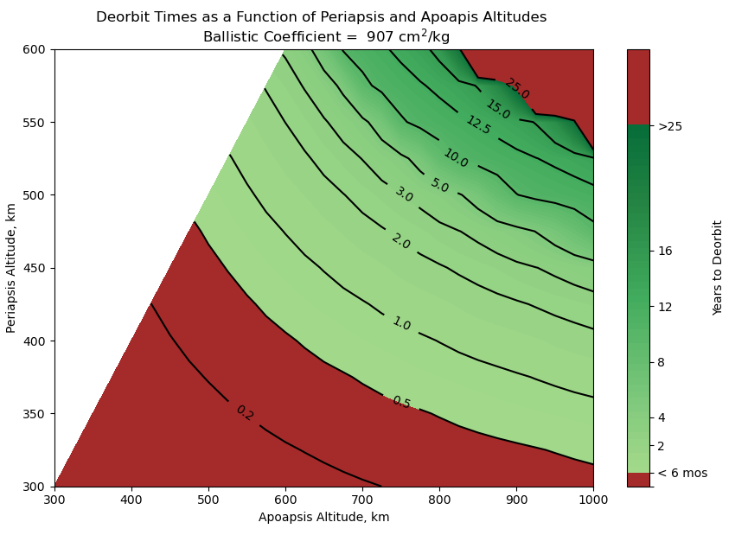

Figure 7. Deorbit times in years as a function of initial periapsis and apoapsis altitudes assuming a DiskSat ballistic coefficient of 907 cm2/kg.

Once in orbit, the DiskSat dispenser will release the four DiskSats within a few minutes of one another; the dispenser itself will remain attached to and deorbit with the launch vehicle. After satellite release, the four DiskSats will undergo initial checkout and verification of all bus systems. As with all AeroCubes, this will include on-orbit calibration of the attitude sensors. Following basic system checkout, the first portion of flight operations will exercise and evaluate the systems that distinguish the DiskSat from traditional CubeSats. Of these, available power represents the biggest change. However, the power system can be well characterized on the ground, and on-orbit checkout is expected to be uneventful. Associated with power is thermal management; we intend to equip the DiskSats with an array of temperature sensors that can validate thermal models developed before flight. Data from temperature sensors will be collected over a range of operating conditions including various attitudes with respect to the sun and Earth, and at various operating power levels. Unless the DiskSats end up in a sun-synchronous orbit, we expect to have the opportunity to evaluate temperature trends over a range of beta angles as well.

The second task is evaluation of attitude control performance. As noted above, the DiskSat has moments of inertia that are much higher than typical CubeSats, so the system will be exercised to evaluate pointing precision in inertial pointing, nadir pointing, and at high slew rates and high rates of angular acceleration. Another aspect that needs to be evaluated is ACS stability; at the initial launch altitude, ACS inaccuracies or intermittent loss of ACS control would not be problematic. However, if it happens in VLEO, particularly at the lowest altitudes, even temporary loss of attitude control could result in a very rapid deorbit.

After satellite performance is evaluated, we will exercise the propulsion system. The goals are twofold, first to experiment with low-ΔV maneuvers, and second to characterize propulsion system performance and stability. The latter is important for planning mission operations in very low orbits where unexpected propulsion-system performance changes could adversely affect mission lifetime.

After completion of operations at the launch altitude, the mission will move into the second phase: VLEO operations. The plan for this phase is to take advantage of the combination of low drag and high-delta-v electric propulsion enabled by the DiskSat's unique geometry to explore operations in rarely used orbits at very low altitudes. Figure 6 shows the cross-sectional area of the DiskSat when flown in a low-drag orientation; the disk alone would have a cross sectional area of 250 cm² in a low-drag orientation; adding the propulsion unit brings that area up to 322 cm².

In this phase of the flight, the satellites will be separated into two pairs, each with slightly different missions. Two DiskSats in one pair will use a combination of propulsion and drag to gradually reduce the satellite altitude, pausing periodically to experiment with using propulsive drag makeup to maintain operations at a constant altitude. This process will be repeated in a stepwise manner at successively lower altitudes while gaining a better understanding of satellite performance, particularly with respect to the propulsion system and the attitude control system, both of which become more critical to successful orbit maintenance as the altitude decreases. Estimates based on expected thrust and drag indicate that the spacecraft should be able to operate continuously in circular orbits down to at least 250 km altitude and possibly as low as 220 km, depending on atmospheric conditions. Figure 8 shows the expected thrust requirement for drag makeup as a function of altitude.

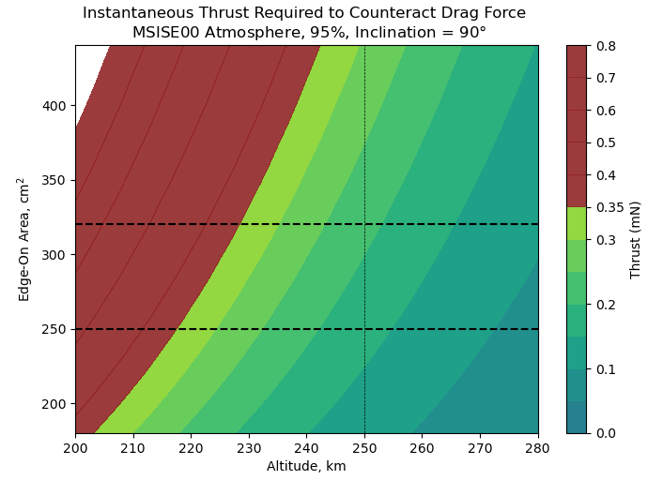

Figure 8. Instantaneous thrust required to counteract drag force for DiskSat in low drag orientation with propulsion (upper dashed line). For comparison, the instantaneous drag force on a non-propulsive DiskSat is also shown (lower dashed line). Model assumes MSISE00 atmosphere, 95%, inclination 90 degrees.

The two satellites in the other pair will use their propulsion systems to maneuver into elliptical orbits with very low perigees and moderately high apogees. The objective is to reduce the perigee below 200 km and raise the apogee above 1000 km, with the goal of exploring intermittent operations in the ultra-VLEO environment. In this orbit, the instantaneous drag during perigee will exceed the available thrust, but the satellites will spend most of the orbit well above the high-drag environment and thrusting during this time will be sufficient to make up energy lost during perigee passes and maintain perigee altitude.

Orbital Debris Considerations

At end of mission, all four DiskSats are expected to be in a high drag environment where they will rapidly deorbit simply by switching off their propulsion systems. A DiskSat in a circular orbit at 250 km will deorbit within two weeks (with typical atmospheric properties). For a DiskSat in an elliptical orbit with a perigee at 200 km and apogee of 1000 km, the orbit lifetime will be under one year; if the apogee is increased to 1500 km, the orbit lifetime is still under 18 months. These lifetime estimates apply to the case where the satellites remain in the low-drag orientation. As noted above, the DiskSat has a very small cross section, only 322 cm², when flown in a low-drag attitude, but the area can increase dramatically as the spacecraft attitude changes. In the extreme, if the disk is oriented with either face aligned with the velocity vector, the cross section is over 7,700 cm², an increase by a factor of 24 over the low-drag case. If the satellites can be held in the high-drag orientation, the satellite in the 250-km circular orbit would deorbit in less than a day, and the satellite in the 200 x 1000 km orbit would deorbit in two weeks. If the satellites are tumbling, the average cross section can be expected to be some intermediate value between the low and high-drag values, so the lifetimes would have intermediate values.

In effect, the DiskSat provides automatic debris mitigation when operated in LEO at any altitude below about 600 km. If the satellite is operational and maintaining attitude control, the drag is low and the satellite will remain in orbit, but if the satellite fails it can be expected to tumble, increasing the drag and rapidly deorbiting. For this demonstration mission, two of the satellites will always be below 600 km and the other two will always have a low perigee. Thus, all four satellites will be subject to this automatic debris-mitigation effect.

Comments on Future Plans

With the ability to launch so many satellites at one time, the ultimate vision of the DiskSat development effort is to create a new standard that, like the CubeSat, can support rideshare in a containerized environment. Also like the CubeSat, the standard will be scalable; while CubeSats are sized in terms of units, DiskSats will be sized in terms of diameter and thickness. DiskSat diameter is limited only by the diameter of the launch envelope, either the payload fairing or the allowable volume in other rideshare environments such as, for example, ESPA ports. The thickness is constrained by the total height of the payload fairing and the number of disks in the stack. Although the design of the dispensing mechanism is yet to be finalized, one of the guiding principles is that the design approach should be adaptable to various diameters and various thicknesses.

While there may be applications for DiskSat in building large constellations of identical small spacecraft, it is also expected that many potential users may want to build and fly only one or two at a time, in which case the existence of a clear standard that defines the interface between the DiskSat and the dispenser will enable the launch of a stack made up of DiskSats supplied by multiple builders. Aerospace will prepare and publish a first draft of the DiskSat standard, incorporating lessons learned in the process of developing and flying this DiskSat demonstration mission. Aerospace and NASA are looking at options for encouraging additional DiskSat flights beyond the demonstration mission.

SUMMARY AND CONCLUSION

The DiskSat is a containerized, large-area, quasi-two-dimensional satellite bus architecture, designed to bring the benefits of containerization to a low-mass, high-power satellite bus able to support a broad range of missions that would be very challenging within the CubeSat form factor. The DiskSat is intended to fill a gap in the mass-aperture space, particularly for constellations, that no rectangular prism satellite can practically fill. It is anticipated that the DiskSat will also support low-cost flight opportunities for student and other experimental flights that might require more surface area or volume than can reasonably be expected from a CubeSat, or that might simply benefit from the convenience of a more accessible and less constrained avionics and payload volume.

Aerospace is currently working on developing a demonstration mission, with initial focus on risk reduction in the dispenser, the power system, and the attitude-control system. The DiskSat demonstration is anticipated to be ready for flight in late 2023.

Experience gained in the development and flight of this demonstration mission will support the development of a universal DiskSat standard in the mold of the CubeSat standard.

REFERENCES

1. Puig-Suari, Jordi, Clark Turner, and William Ahlgren, "Development of the standard CubeSat deployer and a CubeSat class PicoSatellite," 2001 IEEE aerospace conference proceedings (Cat. No. 01TH8542), Vol. 1. IEEE, 2001.

2. Heidt, Hank, Jordi Puig-Suari, Augustus Moore, Shinichi Nakasuka, and Robert Twiggs, "CubeSat: A new generation of picosatellite for education and industry low-cost space experimentation," Proceedings of the Small Satellite Conference, 2000, SSC00-V-5 https://digitalcommons.usu.edu/smallsat/2000/All2000/32/.

3. Yao, J. Jason, Charles Chien, Robert Mihailovich, Viktor Panov, Jeffrey DeNatale, Judy Studer, Xiaobin Li, Anhua Wang, and Sangtae Park, "Microelectromechanical system radio frequency switches in a picosatellite mission," Smart Materials and Structures 10, no. 6 (2001): 1196.

4. Welle, Richard, Catherine Venturini, David Hinkley, and Joseph Gangestad, "The DiskSat: A Two-Dimensional Containerized Satellite," Proceedings of the Small Satellite Conference, 2021, SSC21-XIII-12, https://digitalcommons.usu.edu/smallsat/2021/all2021/227/.

5. Nason, Isaac, Jordi Puig-Suari, and Robert Twiggs, "Development of a family of picosatellite deployers based on the CubeSat standard," In Proceedings, IEEE Aerospace Conference, vol. 1, pp. 1-1, IEEE, 2002.

6. CubeSat Design Specification, see: https://www.cubesat.org.

7. Gangestad, Joseph, Brian Hardy, and David Hinkley, "Operations, orbit determination, and formation control of the AeroCube-4 CubeSats," Proceedings of the Small Satellite Conference, 2013, SSC13-X-4, https://digitalcommons.usu.edu/smallsat/2013/all2013/116/.

8. Gangestad, Joseph, Darren Rowen, Brian Hardy, Christopher Coffman, and Paul O'Brien, "Flight Results from AeroCube-6: A Radiation Dosimeter Mission in the 0.5 U Form Factor," In 12th Annual CubeSat Developers Workshop, San Luis Obispo, CA, 2015.

9. Welle, Richard P., Christopher M. Coffman, Dee W. Pack, and John R. Santiago, "Cubesat laser communication crosslink pointing demonstration," Proceedings of the Small Satellite Conference, 2019, SSC19-VI-06, https://digitalcommons.usu.edu/smallsat/2019/all2019/103/.

10. Gangestad, Joseph W., Catherine C. Venturini, David A. Hinkley, and Garrett Kinum, "A Sat-to-Sat Inspection Demonstration with the AeroCube-10 1.5 U CubeSats," Proceedings of the Small Satellite Conference, 2021, SSC21-I-11, https://digitalcommons.usu.edu/smallsat/2021/all2021/134/.

11. Mauerhan, Jon, Dee Pack, John Santiago, Brian Hardy, and Paul Zittel, "Radiometric Calibration of Aerocube 15 (Rogue-Alpha/Beta)," Conference on Characterization and Radiometric Calibration for Remote Sensing (CALCON), 2021, https://digitalcommons.usu.edu/calcon/CALCON2021/all2021content/8/.

12. Krejci, David, Lou Grimaud, Tony Schönherr, Valentin Hugonnaud, Alexander Reissner, and Bernhard Seifert, "ENPULSION NANO and MICRO propulsion systems: development and testing," In AIAA Propulsion and Energy 2021 Forum, p. 3420, 2021.

