Microgravity Effect on Bacterial Growth: A Literature Review
Wenyan Li, Angie M. Diaz, Tesia Irwin, Aubrie E. Orourke, and Luz M. Calle
NASA, Kennedy Space Center, Florida, 32899

Gravity is a well-known, but little understood, physical force. It interacts with other physical environmental factors to impact the formation of today’s Earth, and to contribute to biological variations between water and land species. It is also involved with cell differentiation process, and is responsible for setting the boundaries for life and keeping cells small. With their simple structures and small sizes, microbes are expected to be less gravity sensitive than larger species. Nevertheless, various effects of spaceflight on bacterial growth have been reported, but the reports have been sometime inconsistent, and the underlying mechanism remains unclear to many. This paper summarizes the systematic efforts to evaluate the spaceflight effect on microbial growth, highlighting the extracellular mass transfer mechanism. It also provides a critical literature review on the topic to resolve the discrepancy in experimental observations and to further clarify the underlying mechanisms.

Nomenclature
1 G = normal gravity NB = nutrient broth
AC = agar culture OD = optical density
BPM = the bioprocessing module PBS = phosphate buffered saline
CFU = colony-forming unit SC = suspension culture
FPA = fluid processing apparatus VBNC = viable but nonculturable cells
GE = gas exchange VBE = Vogel-Bonner medium E
LB = lysogeny broth WT = wild type
mAUM = modified artificial urine media YPD = yeast extract peptone dextrose
MET = mission elapsed time µm = micrometer

Introduction
G
RAVITY is a well-known, but little understood, physical force. The simple fact that it has been constant throughout the history of Earth masks the complexity of its impact on life. Gravity interacts with other environmental factors to impact the formation of today’s Earth; for example, it is necessary for rain to fall, for water to drain, and for heat to dissipate (convection), for air and water to separate, etc.
It likely contributes to biological changes as species evolve from water to land. To counteract gravity, land species need to develop systems for fluid flow and regulation, structural support, and locomotion to function in a 1 G terrestrial environment. It is also involved in the cell differentiation process. It is well known that plants coordinate differential growth through gravitropism; while recent studies indicate microgravity can reduce cell differentiation in mouse and in human cell cultures.,,, Underwater, gravity is partially compensated by buoyancy externally; other forces such as drag and lift becomes significant. However, some aquatic species appear to use gravity as a directional cue.
Gravity also keeps cells small. The typical size of a eukaryotic cell is about 10 μm. In larger cells, nucleoli bodies undergo gravitational sedimentation and fusion, thus additional mechanisms are needed to stabilize the cell structure.
Microbes are expected to be less gravity sensitive than larger species. Nevertheless, various effects of spaceflight on bacterial growth have been reported, and the underlying mechanism remains unclear.,,,, This paper summarizes the systematic efforts to evaluate the effect of spaceflight on microbial growth, while highlighting the extracellular mass transfer mechanism: gravity results in cell settlement and density-driven convection within the fluid media, which affect the mass transfer of nutrients and metabolic by-products, thus gravity level influences bacterial growth indirectly through the extracellular mass transfer process.

Microgravity Effect on Bacterial Growth: Current Understanding

The Direct Effect of Microgravity on Bacteria: Too Small to Notice?
With their simple structures and small sizes, microbes are expected to be less sensitive to gravity. In fact, physics predicts that altered gravity will not cause any changes in cells because gravity is extremely weak compared with other physical forces acting on or within cells. Single cells indeed can withstand 10⁵ G, while plants, rats, and humans can only briefly tolerate 30-40 G, 15 G, and 4-5 G, respectively.
Early theoretical analysis by Pollard examined the direct gravity effect on cellular structure and function, including the redistribution of cell components, such as DNA and ribosomes, the effect of density-driven convection on cell synthesis inside the cells, and the effect of stress on membranes caused by gravity. It was concluded that single cells smaller than 10 µm should show little effect of microgravity.

The Effect of Spaceflight on Bacterial Growth Observed
Nevertheless, experiments have been conducted to study the spaceflight effect on bacterial growth, and various effects have been reported. In a recent review on the effects of spaceflight and simulated microgravity on bacterial growth,9 Huang listed a large number of studies that have investigated the growth responses of bacteria, fungi, and archaea to microgravity in space and to microgravity analogs on the ground. In these studies, all possible microgravity impacts on growth (increased, unchanged, decreased) have been identified. It seems that the microbial growth effects are associated with (1) the microbial species and strains, (2) the strain’s inherent properties (cell motility), (3) the culture methods, (4) nutrient and oxygen availability, and (5) the rotation speed of the simulator. In conclusion, the author suggested that to predict the growth behavior of bacteria in space, the effect of microgravity should be intensively studied, and the specific cause-and-effect mechanisms of microbial responses to microgravity should be disclosed at the molecular level. For precision, future studies should carefully consider bacterial motility, culture methods (suspension or agar), medium nutrient concentrations and rotating speeds.
To sum up, more and better studies are needed, we are not near to a complete understanding of the microgravity effect on bacterial growth as yet. But one must ask the question: what have we learned from the past studies?

The Effect of Spaceflight on Bacterial Growth: The Systematic Approach
In 1997, in an effort to systematically evaluate the effect of spaceflight on each phase of microbial growth (lag, exponential or stationary phase), a series of experiments were carried out using in vitro suspension cultures of E. coli aboard seven US Shuttle missions. The results indicated that, as a result of spaceflight, the lag phase was shortened, the log phase was extended, while the final cell population density was increased. In the same study, David Klaus also highlighted that bacterial growth is a function of intracellular and environmental factors. The availability of nutrients and the removal of metabolic by-products are the most important factors, which are facilitated by forces acting on the cell and on the bulk fluid. Gravity results in cell settlement and induces density-driven convection within the bulk fluid. It was suggested that the effect of gravity may impact suspended cells via their fluid environment, where the immediate, direct influence of gravity might otherwise be deemed negligible.
To understand the discrepancies in the literature, Benoit and Klaus analyzed flight test results, in terms of bacterial motility and culture media (liquid suspension or solid agar), and it became clearer that changes in non-motile bacterial growth in liquid suspension during spaceflight, shorter lag and higher final cell numbers, are due to the absence of both gravity dependent cell settlement and density-driven convection; while motile bacterial cultures and solid agar cultures offset mass transfer variation caused by gravity differences.
To further demonstrate this proposed mechanism, a ground-based clinostat study was conducted to evaluate the effects of reduced cell sedimentation, using neutrally buoyant E. coli cultures (genetically modified to be gas-vesicle-producing). Since the cell settlement in these cultures was already minimal, it was hypothesized that the simulated microgravity effects on final population density would also be minimal. As a control, E. coli cultures that do not produce gas vesicles were also tested. As hypothesized, no significant difference was observed in cell populations between the clinostat and static cultures for neutrally buoyant cultures, but there is a 10.5% difference in population density for the control. These results further suggest that the lack of cell sedimentation and density-driven convection is a dominant effect of spaceflight on non-motile bacterial suspension culture.
This extracellular mass transfer mechanism was also confirmed through molecular (transcriptomic) genetic analysis, in a recent ISS flight investigation. It was hypothesized that in E. coli, grown in space, the genes associated with starvation (due to reduced nutrient transfer to the cell) and acidic response (due to reduced dispersion of acid product from the cell) would be overexpressed comparing with the Earth controls. These hypotheses were validated.
While the proposed mechanism of microgravity’s effect on bacteria (lack of cell settlement and density-driven convection) seems to explain the discrepancies in terms of bacterial motility and culture media for experiments with various strains of E. coli, there are other difficulties.

“However, it does not account for the findings of Kacena et al., who used a minimal medium to grow B. subtilis…… we would expect that bacterial motility was maintained throughout the experiment based on the growth conditions, and therefore, we would not expect the increased growth that was observed due to space flight.”16

So, it seems once more, we are at an impasse to a clear understanding of the microgravity effect on bacterial growth. Is it possible we have missed something? Can we possibly find the missing link to bridge the gap of our understanding? In the next section, we will take a deep dive into the details of the past studies.

The Effect of Spaceflight: What We Know
First, let us briefly review what we know about spaceflight and microgravity. Based on the classic Newton’s theory of gravitation, all things with mass are attracted to one another. Application of a net force results in acceleration.
In vacuum, all subjects would fall to earth at a speed that is accelerating until they hit the ground or a solid surface. In a fluid, such as water or air, the object has to displace the fluid, which results in another force, buoyancy. As a result of the net force, heavier (denser) objects sink, while lighter ones float. These relative movement, or density-driven convection, leads to mixing of the fluid, which speeds up the mass transfer processes.
In orbit, the gravity pull is still at 90% of the ground level, and it provides the centripetal acceleration to keep it in orbit. Objects of different densities travel at the same velocity, they are motionless relative to each other, thus there is no density-driven convection. Mass transfer occurs through diffusion alone, without forced mixing.
Figure 1 shows some examples that are often associated with microgravity. Everything floats together in space, there is no relative motion, or density-driven convection caused by gravity. As a result, mass transfer is slower. For a burning candle in space (in the presence of air), oxygen comes from all directions, through diffusion, so the candle burns slower, and the flames are more spherical.
The microgravity effect on the immediate environment of a non-motile bacterium can be depictured in Figure 2.
Under normal gravity, in a liquid media:
- Cells (heavier than the media) settle down, while the media around it move up.
- Cells consume nutrients and excrete waste and product in the media; typically, the media near the cells becomes lighter, and moves up, which causes other media around it to move down.
- The density-driven convection leads to the mixing of the media, which speeds up the mass transfer rates of nutrient to the cells, and waste/product away from the cells.

Under microgravity, in a liquid media:
- Objects of different densities stay motionless relative to each other.
- Cell settlement or density-driven convection does not occur.
- Mass transfer (nutrient to cell, waste/product away from cells) occurs through diffusion.

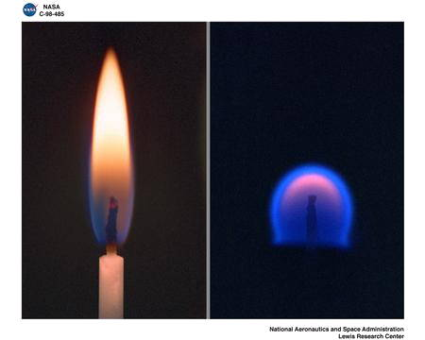
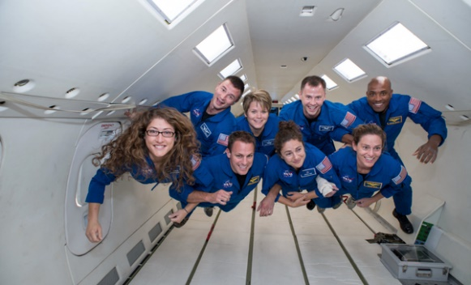
(1)
(2)

Figure 1. Some examples associated with microgravity: (1) everyone floats under microgravity, (2) a candle burning on Earth (left) and in space microgravity (right).

Cell
Nutrient
Waste/Product
Cell
Waste/Product
Nutrient

Figure 2. The effect of microgravity on the environment of a bacteria. Cell settlement occurs and mass transfer is accelerated by density-driven convection under normal gravity (left). No cell settlement and mass transfer by diffusion alone under microgravity (right).

The Effect of Spaceflight on Bacterial Growth: a Deep Dive
Let us start with the long list of microbial growth studies under simulated microgravity and spaceflight in Table S.1 of Huang 20189 and shorten the list to include only spaceflight experiments (Table 1). Simulated microgravity is an important and challenging subject on its own, we will focus on the effect of spaceflight on bacterial growth in this review.
In this section, we will go over all the references listed above, grouped into microbe species. The goal is to identify the missing elements in the systematic approach mentioned above, and to find logical explanations for the discrepancies observed in those studies.

Table 1. Responses of microbial growth to spaceflight, adopted from Huang 2018.9
Growth | Microbes | Media Type | Ref
Increased | E. coli ATCC 4157 | SC | , , ,
Increased | E. coli K12 MC4100 | SC
Increased | E. coli PhB405 | SC
Increased | B. subtilis ATCC 6051 | SC | 22,23, ,
Increased | S. typhimurium BS-5 (P-22)/P-22 | SC
Increased | P. aeruginosa PA14, motility mutant strain | SC
Unchanged | E. coli ATCC 4157 | AC | 22, 23, 28, 29
Unchanged | E. coli GC2852 | SC | , 27
Unchanged | E. coli ATCC 25922 | SC | 26
Unchanged | B. subtilis ATCC 6051 | AC | 22,23,28,29
Unchanged | P. aeruginosa PA14 wild type strain | SC | 31
Unchanged | S. cerevisiae CMBSESA1 | AC
decreased | S. plicatus WC56452 | SC
decreased | S. cerevisiae Σ1278b | AC | 33
SC = Suspension culture; AC = Agar culture or semi-solid media

Spaceflight Effect on Bacterial Growth: E. coli

Table 2 shows the summary of the studies on E. coli listed in Table 1, the final cell number changes and the test parameters are listed. The list is almost identical with the works cited by Benoit and Klaus (Table 1, reference 16).
Benoit and Klaus analyzed the flight test results, in the context of bacterial motility and culture media (liquid suspension or solid agar): the increased growth of non-motile bacteria in liquid suspension during spaceflight, is due to the lack of gravity dependent cell settlement and density-driven convection; while motile bacterial cultures and solid agar cultures offset mass transfer variation caused by gravity difference, they are not expected to show differences. While there is no apparent discrepancy here, some valuable insight was gained by a close examination of these studies.

E. coli ATCC 4157
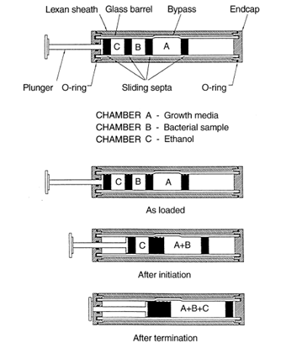
E. coli ATCC 4157 is a non-motile strain when grown with glucose as carbon source. It is the most studied bacteria in spaceflights. All works have been conducted by the scientists at BioServe Space Technologies, University of Colorado. The consistency in flight hardware, culture media, and test conditions makes the database very valuable.
The fluid processing apparatus (FPA) is the flight hardware that allows test-tube experiments to be initiated and terminated in space. Figure 3 illustrates its operation. Chamber A contains complete Vogel-Bonner medium E (VBE). Chamber B contains E. coli inoculum in minimal VBE. Chamber C contains absolute ethanol. To initiate the experiment, the plunger was depressed, mixing the contents of chamber A and B. To terminate the experiment, the plunger was depressed further to combine the content of chamber C with the content of A and B (previously mixed).22
Prior to initiation of the space-flight experiments, E. coli ATCC 4157 cells were harvested in mid-log phase to maximize viability, and then held in minimal VBE (without glucose) at 4ºC, to minimize metabolic activity. At initiation, the bacteria in the minimal VBE were mixed into complete VBE (with glucose).
Figure 3. The operation of the FPA.22
Table 2. Summary of spaceflight induced changes in E. coli and test parameters.
Final cell number | E. coli strain | Motility | Media Type | Media Nutrient | Flight Hardware | Inoculum Handle | Ref
Increased | ATCC 4157 | non-motile | liquid | Vogel-Bonner medium E | FPA | delivered at 4ºC, initiation in orbit, grown mostly at 37ºC. | Kacena 1999 22,23 Brown 2002 24 Klaus 1997 25
Increased | K12 MC4100 | non-motile | Liquid | M9 with glucose | Plastic bag with sealed glass ampoule. Bag: cells with M9 without glucose.  Ampoule: glucose. | Stored at 5ºC in the bag, till initiation with breaking the glass ampoule at 37ºC. | Gasset 1994 26
Increased | PhB405 | non-motile | Liquid | M63 with glucose | Biorack container, well-plate, sealed by septa through which syringes can be inserted. | Kept at 4ºC till initiation at 37ºC when glucose was injected into each well. | Thevenet 199627
Unchanged | ATCC 4157 | non-motile | Agar | VBE Agar | FPA (modified for Agar) | delivered at 4ºC, initiation in orbit, grown mostly at 37ºC. | Kacena 1999 22,23  Kacena 1997 28,29
Unchanged | GC2852 | motile | Liquid | M63 with glucose or glycerol | plastic bag with sealed glass ampoules, containing pressured air for rapid expulsion of the liquid in the ampoules. | Bags stored at -70ºC, transported on dry ice, kept at 37ºC till initiation (breaking the inocula ampoule). | Bouloc 1991 32
Unchanged | GC2852 | motile | liquid | M63 with glucose | Biorack container, well-plate, sealed by septa through which syringes can be inserted. | Kept at 4ºC till initiation at 37ºC when glucose was injected into each well. | Thevenet 1996 27
Unchanged | ATCC 25922 | motile | Liquid | Peptone medium | Plastic bag with sealed glass ampoule.  Bag: peptone medium  Ampoule: cells | Stored at 5ºC in the ampoule, till initiation with breaking the glass ampoule at 37ºC. | Gasset 1994 26

Figure 4B shows representative flight and ground control data for E. coli ATCC 4157 grown in VBE at 37 ºC.22 Figure 4A shows the baseline growth curves grown at 37 ºC and 23 ºC in 9-ml test-tubes, used to assist the curve fitting for the flight and ground control data. While there is a clear difference in the cell counts between the Fight and the Ground control, a closer examination also reveals the large difference between the baseline control and ground control data (at 37 ºC).
It seems that the handling process of the inocula for spaceflight, such as the low temperature and starvation before the initiation of the growth, has negatively impacted the cell viability; but the spaceflight condition can reduce that impact. Both low temperature and starvation would reduce the bacterial metabolism (as intended), and possibly result in cells in various degrees of dormancy, such as “viable but nonculturable” bacteria (VBNC). During the initiation of the experiments, bacteria experience “nutrient shock” which is not favorable for the recovery of the culturability. On the other hand, a lower nutrient level, and a microaerophilic incubation atmosphere (low oxygen, high CO₂) can be the optimal condition for the recovery of the culturability., Under this context, it appears that microgravity can result in slow introduction of glucose and oxygen and faster CO₂ accumulation in the immediate environment of the bacteria, these conditions favor the recovery of culturability, which would result in shorter lag, and higher final cell number.
If this assumption is valid, it can also account for the better growth of the motile B. subtilis during spaceflight. 22,23,28,29 Under similar testing conditions, microgravity can affect the culturability recovery of the motile bacteria as well, even it is to somewhat smaller degrees.
It should also be noted that VBE contains citric acid as a chelating agent. Normally, citrate utilization for E. coli does not occur in the presence of oxygen. However, microgravity could affect the oxygen transfer rate and its concentration around the cell. But the extent of this impact is not clear, nor is the effect on citrate utilization and growth.

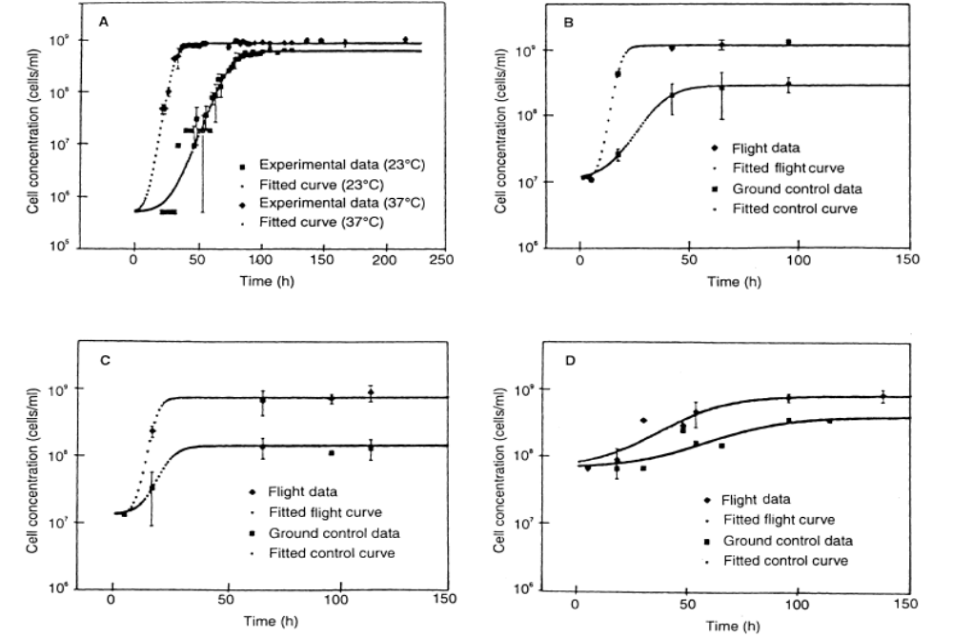

Figure 4. Experimental data for E. Coli baseline controls (A), space-flight and ground-control of E. Coli (B) and B. subtilis (C) grown at 37 °C; and B. subtilis at 23 °C (D).22

Similar trends were also observed in earlier space-flight data. David Klaus analyzed a data set of spaceflight experiments with E. coli grown on VBE in FPA (shown in Table 3). The final populations of the flight tests (column 14) are almost always higher than that of the Ground controls (column 13). However, the final population in the spaceflight tests are often less than the baseline controls shown in Figure 4. Furthermore, the largest differences between the spaceflight tests and the ground controls (highlighted in red) are not found where the spaceflight tests yielded the highest final populations.

Table 3. Summary of spaceflight experiments with E. coli , adopted from Table 4-1 of reference 38.
 | Starting Stock |  |  |  |  | Incubation |  |  |  |  | Termination
1 | 2 | 3 | 4 | 5 | 6 | 7 | 8 | 9 | 10 | 11 | 12 | 13 | 14 | 15
Mission | Inoculum Loaded |  |  |  |  | Sugar Supplement |  |  |  |  |  | Final Population (cells/ml)
STS-xx | Population (cells/ml) | volume (ml) | Sugar Adapted to Originally | Load-to-Launch time (hrs) | Launch-to-Activation Times (hrs) | Source | Final Concen (g/L) | Temp (ºC) | Total medium Vol (ml) | Air Volume (ml) | Duration of Growth (days/hrs) | Ground | Flight | % Incr
43 | 2.5x10⁴ | 2 | glucose | 65 | 21 | glucose | 5 | 22 | 4 | 6 | 0/12 | 5.6x10⁷ | 6.7x10⁷ | 20
43 | 2.5x10⁴ | 2 | glucose | 65 | 21 | glucose | 5 | 22 | 4 | 6 | 2/00 | 3.4x10⁸ | 2.8x10⁸ | -18
43 | 2.5x10⁴ | 2 | glucose | 65 | 21 | ribose | 5 | 22 | 4 | 6 | 2/00 | 6.0x10⁷ | 1.8x10⁸ | 200
50 | 2.5x10⁵ | 2 | glucose | 30 | 14 | glucose | 5 | 22 | 3 | 2 | 0/23 | 6.0x10⁷ | 9.5x10⁷ | 58
50 | 2.5x10⁵ | 2 | ribose | 30 | 14 | glucose | 5 | 22 | 3 | 2 | 0/23 | 7.5x10⁷ | 2.0x10⁸ | 167
50 | 2.5x10⁵ | 2 | ribose | 30 | 14 | glucose | 5 | 22 | 3 | 2 | 2/02 | 1.8x10⁸ | 6.2x10⁸ | 244
50 | 2.5x10⁵ | 2 | glucose | 30 | 14 | glucose | 5 | 22 | 3 | 2 | 2/18 | 1.9x10⁸ | 3.7x10⁸ | 95
50 | 2.5x10⁵ | 2 | ribose | 30 | 14 | glucose | 5 | 22 | 3 | 2 | 2/18 | 1.4x10⁸ | 5.0x10⁸ | 257
50 | 2.5x10⁵ | 0.5 | glucose | 30 | 14 | glucose | 5 | 22 | 3 | 2 | 14 | 4.3x10⁸ | 5.0x10⁸ | 16
54 | 1.0x10⁶ | 0.5 | glucose | 64 | 8 | glucose | 1 | 37 | 3 | 2 | 3/19 | 2.1x10⁸ | 4.1x10⁸ | 95
54 | 1.0x10⁶ | 0.5 | glucose | 64 | 8 | glucose | 1 | 37 | 3 | 0 | 3/19 | 2.6x10⁸ | 5.3x10⁸ | 104
54 | 1.0x10⁶ | 0.5 | glucose | 64 | 8 | glucose | 5 | 37 | 3 | 2 | 3/19 | 3.5x10⁸ | 5.4x10⁸ | 54
54 | 1.0x10⁶ | 0.5 | glucose | 64 | 8 | glucose | 5 | 37 | 3 | 0 | 3/19 | 4.7x10⁸ | 6.2x10⁸ | 32
54 | 1.0x10⁶ | 0.5 | glucose | 64 | 8 | glucose | 10 | 37 | 3 | 2 | 3/19 | 2.7x10⁸ | 5.5x10⁸ | 104
54 | 1.0x10⁶ | 0.5 | glucose | 64 | 8 | glucose | 10 | 37 | 3 | 0 | 3/19 | 3.9x10⁸ | 6.2x10⁸ | 59
57 | 1.0x10⁶ | 0.5 | glucose | 62 | 23 | glucose | 5 | 20 | 4 | 0 | 1/19 | 4.0x10⁸ | 5.5x10⁸ | 38
57 | 1.0x10⁶ | 0.5 | glucose | 62 | 23 | glucose | 5 | 20 | 4 | 0 | 1/19 | 4.0x10⁸ | 5.0x10⁸ | 25
57 | 1.0x10⁶ | 0.5 | glucose | 62 | 23 | glucose | 5 | 20 | 4 | 0 | 3/22 | 8.5x10⁸ | 1.5x10⁹ | 76
57 | 1.0x10⁶ | 0.5 | glucose | 62 | 23 | glucose | 5 | 20 | 4 | 0 | 3/22 | 1.0x10⁹ | 1.5x10⁹ | 50

A close examination on the tests highlighted (in red) shows that these are tests where the inoculum adapted to a different carbon source than the one for the growth tests. In these cases, adoption to new nutrients has to occur before (log) growth, as this is a task to be completed during the lag phase., This additional requirement makes the recovery of culturability more challenging, which results in a larger reduction of the final population in the Ground Controls (comparing with the baseline controls). Not surprisingly, this is where the largest spaceflight effect on the final populations observed.

Studies on Other E. coli Stains: Bouloc & D’Ari 199132
In the 1991 study by Bouloc and D’Ari,32 cultures of E. coli were grown in a satellite to evaluate the effect of the space environment on growth parameters and energy metabolism. Figure 5 shows the flight hardware, the biological container for the Cytos automatic incubator. The container held plastic bags containing (1 ml) culture medium and up to two sealed glass ampoules. The experiment was initiated when the pivoting bars broke the ampoules, ejecting the solution into the culture; the pressured air in the ampoules ensured rapid expulsion of the liquid on breakage. All operations were commanded automatically according to a pre-programmed schedule.
Samples (10 µl) of overnight E. coli GC2852 cultures (grown in M63 medium with 0.4% glucose or glycerol) were sealed in glass ampoules, and placed in polypropylene bags, together with M63 medium supplemented with glucose or glycerol at four concentrations from 0.01% to 0.1%. The sealed bags were stored at -70 ºC and transported on dry ice, then in portable incubators at 37 ºC, before being placed in Cytos incubators at 37 °C before launch. The cultures were inoculated in orbit and growth was stopped after 24 hours by lowering the temperature to 4 °C.
Figure 6 shows the growth yield calculated from optical density and the cell concentration measured by a Coulter counter. Based on this result, Bouloc and D’Ari concluded:
“No differences between the flight samples and control ground cultures in the growth yield per gram of carbon, in mean cell mass (from which we deduce that the growth rate was unaltered). These observations indicate that free-growing bacterial cells do not expend significant energy fighting gravity.”32
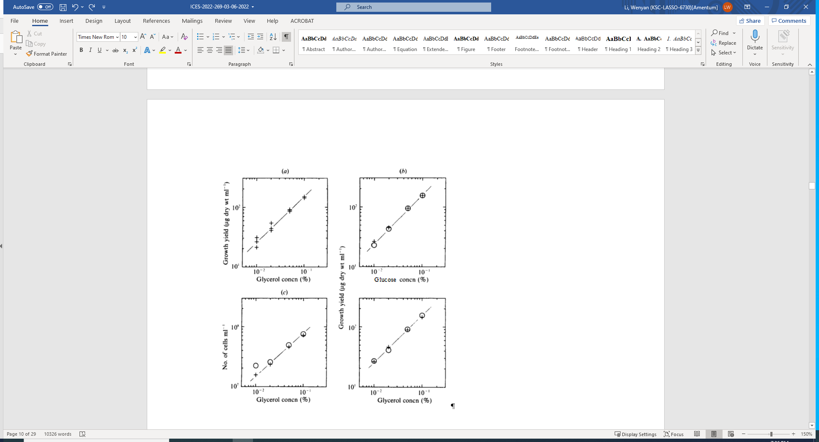
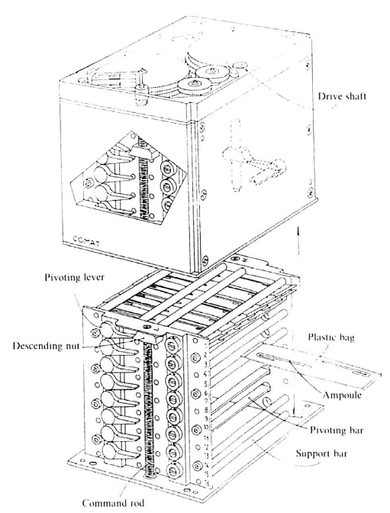
Figure 5. (a) Growth yield for the flight samples, (b) The averaged growth yield, and (c) Cell concentration.32
○, ground data; +, flight data.
Figure 6. Biological container for the Cytos automatic incubator.32

While it is reasonable to believe that bacteria do not spend significant energy fighting gravity, the apparent lack of gravity impact on the bacterial environment is worth probing. When comparing this work with the FPA studies, significant differences can be identified:
- Inoculation through rapid expulsion of the inocula into culture media (unlike the laminate mixing in FPA).
- The media container shape (a thin bag compared with the test tube shape of FPA), minimizing the impact of cell settlement and density-driven convection.
- Last, but not least, surface tension can become important for mass transfer in a thin bag geometry.
Therefore, due to the flight hardware and experiment design, less gravity impact was expected in this study.

Studies on Other E. coli Stains: Gasset 199426
In this study, two E. coli K-12 strains, MC4100 and ATCC 25922, were tested. Some experimental details are highlighted in Table 2. Note that the flight hardware used is similar with those in Bouloc & D’Ari 1991.32
Figure 6 and Figure 7 show the experiment data of K12 MC4100 and ATCC 25922, respectively. At the end of the test, K12 MC4100 grown in M9 medium with glucose was still in the log phase, while the ATCC 25922 grown in peptone medium had already reached the stationary phase.
According to Gasset26, there might be a difference in the growth rates between the Flight and the Ground growth of E. coli K12 MC4100, however, the expected size difference was not observed, so it was concluded that E. coli show no deviation in growth rate under microgravity. It is likely that the test was not long enough to be conclusive.
Due to the fast growth rate in peptone media, the ATCC 25922 reached the stationary phase at the end of test, and the final cell counts were the same for the Flight and the Ground. However, the optical density and cell count of the Flight were higher at the 5th hour, indicating a shorter lag for the Flight; but the Ground growth quickly caught up, indicating a faster growth rate in spite of the slower start. This is consistent with the possibility that slower mass transfer under microgravity results in a shorter lag phase. In rich media, the lag phase is short even for the Ground control, thus the microgravity effect is not reflected in the final cell number. However, the slower mass transfer rate under microgravity can result in a slower growth rate, as shown in Figure 7.

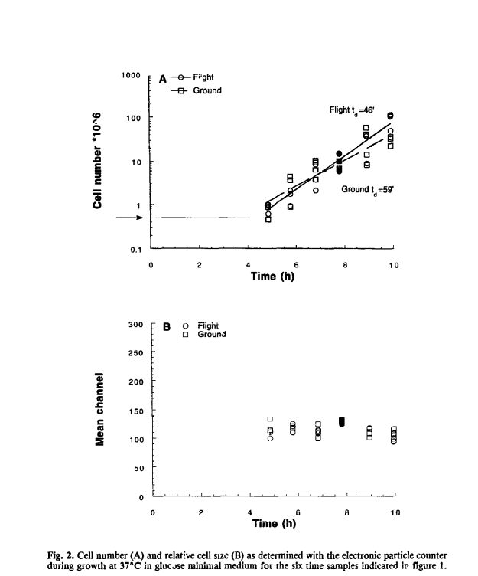
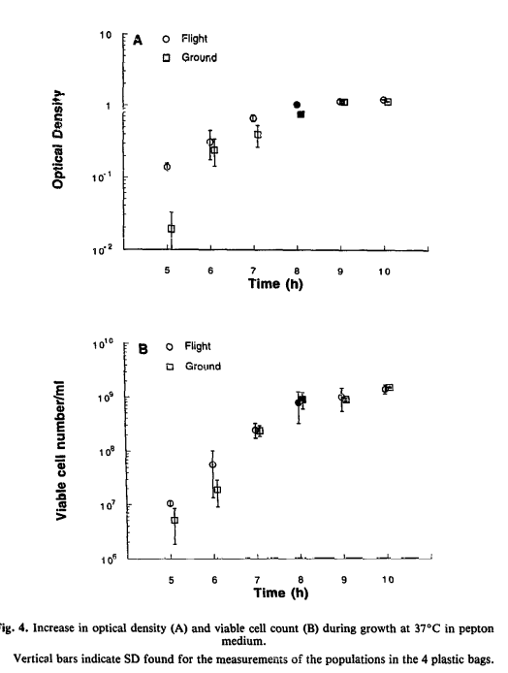
Figure 6. Cell number (A) and relative cell size (B) of K12 MC4100 in glucose M9 medium.²⁶
Figure 7. Optical density (A) and cell count (B) of ATCC 25922 in peptone medium.26

Studies on Other E. coli Stains: Thevenet 1996 27
In the study by Thevenet and colleague,27 two strains were tested: GC2852 (motile) and PhB405 (non-motile). Some of the experimental details are highlighted in Table 2. The objective was to evaluate the lag phase in a space experiment. It was observed that for low density E. coli inocula in fresh and shaken medium, the cells were unable to grow in the absence of CO₂., It was speculated that under microgravity, the lack of convection might permit the accumulation of carbon dioxide around the cell, thereby shortening the growth lag.
The flight hardware, a biological container, is essentially an 18-well plate; each well is sealed by septa through which syringes can be inserted. Cells were grown in M63 supplemented with 0.4% glucose and 1µg/ml thiamine. The inoculum was harvested at optical density (OD) 1.0, washed three time in M63 without carbon source. The inoculum filled containers were stored at 4 ºC, and transferred in an ice box to a 4 ºC incubator onboard the spacecraft. Before the experiments, the samples were transfer to a 37 ºC incubator, or a low speed (1×g) centrifuge. During the initiation of the experiment, 20% glucose was injected into each well. After 9 hours, when both cultures were actively growing, growth was stopped by an injection of 20µl chloramphenicol solution in ethanol, then the samples were transferred to a 4 ºC incubator. The cell density was assayed and the results are shown in Figure 8.
For GC2852 (motile) strain, there was no significant difference between the ground and the flight samples, except that for the sample initially contained 200 cells, the cell count is higher in the Ground than the Flight samples. This was explained by the slower growth rate in space, due to slower mass transfer rate.
For the non-motile strain, there is an obvious difference between the Ground and the Flight. There is also a large loss of culturability in the Ground samples. This is, again, consistent with our earlier discussion, that the slower mass transfer under microgravity can benefit culturability recovery during the lag phase. The effect of the microgravity is larger where the loss of culturability is greater. In this study, the larger difference is seen in the growth of PhB405.
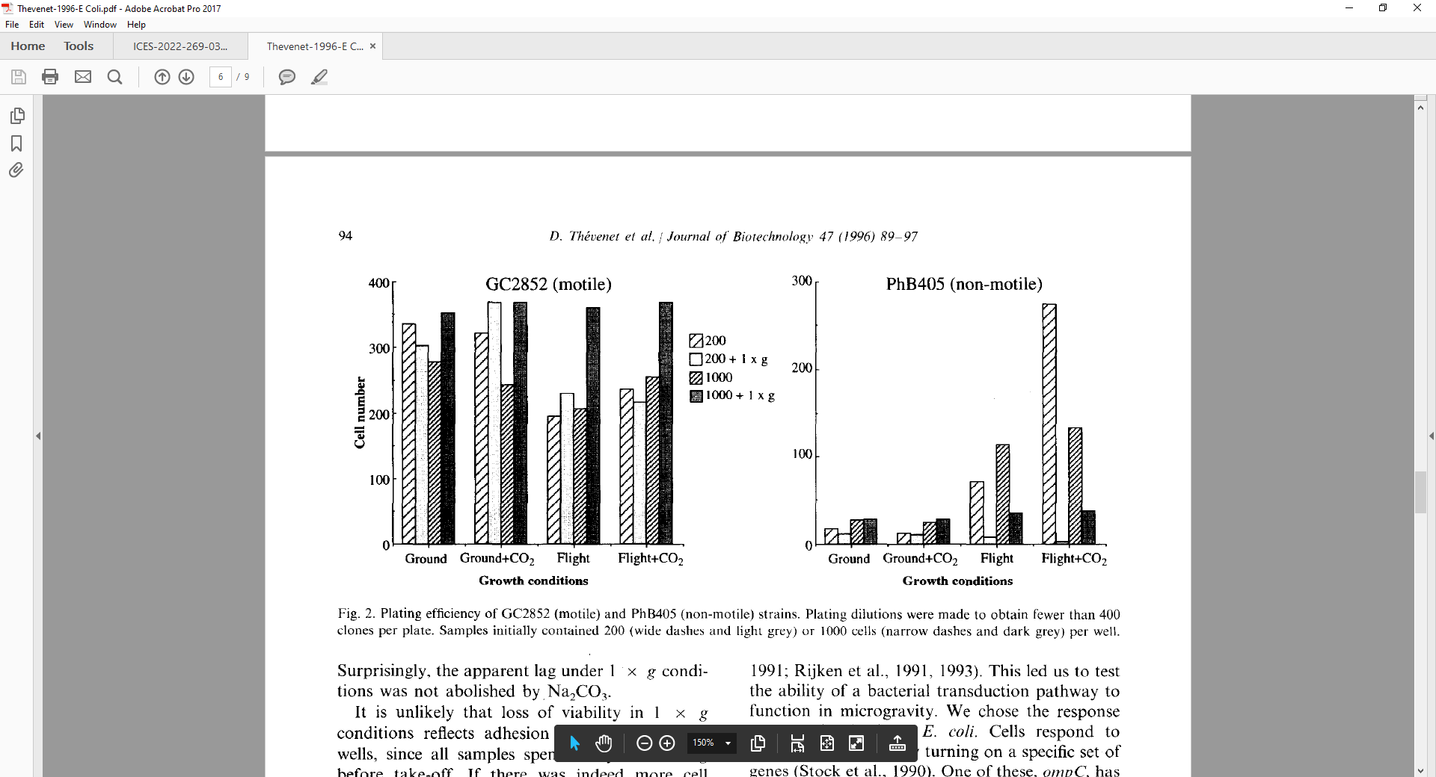
Figure 8. Cell number of (A) GC2852 and (B) PhB405 strains. Samples initially contained 200 or 1000 cells, in incubator or a 1×g centrifuge, in Ground or Flight tests. The effect of carbonate is also included.27

Spaceflight Effect on Bacterial Growth: B. subtilis22,23,28,29
Currently, all the B. subtilis growth spaceflight experiments were carried out in VBE medium using FPA, as a comparison to E. coli ATCC 4157, reported by Kacena in 1997 and 1999.22,23,28,29 Similar with E. coli ATCC 4157, the final cell count of the ground control of B. subtilis is always lower than the baseline control, indicating a loss of culturability during prolonged dormant period before the initiation of growth. In a FPA experiment, the slower mass transfer rate during spaceflight would benefit the culturability recovery of the motile bacteria as well.
It should also be pointed out that the final cell numbers of B. subtilis grown in the spaceflight is higher than that of the baseline control, so there are likely other factors beyond the culturability recovery.
David Klaus38 suggested that under microgravity, the bacterial growth has a shorter lag, longer (possibly slower) log, and higher final cell density, due to the lower mass transfer rate. The slower mass transfer rate under microgravity can result in slower growth rate, and a higher yield can be associated with slower growth rate.,
In the 1999 study,22 Kacena acknowledged the difficulty of growth rate determinations in spaceflight experiments, attempted to curve fit the Flight and the Ground Control data using baseline control parameters (shown in Figure 4), and suggested that spaceflight resulted faster growth rate. However, the baseline data is likely not a good guide for the curve fit due to the possible lag variations. It should also be noted that VBE contains two carbon sources for B. subtilis growth (citric acid and glucose), it is possible that slower mass transfer affords easier transition between the two growth phases, which results in the higher final cell counts during spaceflight.

Spaceflight Effect on Bacterial Growth: P. aeruginosa31,
In the 2013 studies by Kim and colleague on the spaceflight effect on biofilm formation and bacterial growth, Pseudomonas aeruginosa PA14, wild type (WT) and motility mutant strains (ΔmotABCD and ΔpilB) were used. Some of the experimental details are highlighted in Table 4. 31,45

Table 4. Summary of spaceflight induced changes in other microbes and test parameters.
Final cell number | Microbe Strain | Motility | Media Type | Media Nutrient | Flight Hardware | Inoculum Handle | Ref
Increased | S. typhimurium BS-5 (P-22) /P-22 |  | liquid | LB broth with added buffer and nitrate. | Vial- like culture chambers | 24 hr before launch, overnight culture grown in LB broth was diluted and kept on ice till loaded on the space vehicle. Inoculation on ground, termination by icing. | Mattoni 196830
Increased | P. aeruginosa PA14, wild and motility mutant strain | Motile and non-motile | Liquid | Modified artificial urine media (mAUM) | FPA modified for biofilm study | FPA loaded and stored at 8ºC before launch, samples activated on orbit, incubated 37ºC for 72 hrs, terminated by incubated at 8ºC. | Kim 201331
Unchanged | S. cerevisiae CMBSESA1 | non-invasive | AC | YPD agar | 12-well plates | Yeast cells in saline were inoculated onto YPD agar in 12-well plates, before sealed. The samples were transported (2 days) and tested (12 days) at 22ºC. Flight samples were transported back at 4ºC before analysis. | Mulders 1991 33
decreased | S. cerevisiae Σ1278b | invasive | AC | YPD agar | 12-well plates | See above | Mulders 1991 33
decreased | S. plicatus WC56452 |  | Liquid | Defined and complex media | The bioprocessing module (BPM): interconnected syringes. | Bacteria are maintained in 2ml of seed medium before inoculated on orbit. The sample was prepared and tested at 20ºC. After the termination of growth, the sample were placed at 6ºC for the flight duration. | Lam 200234

Overnight shaking cultures of all strains were grown at 37ºC in nutrient broth (NB). To prepare inocula, cultures were washed and resuspended in PBS to a final concentration of 6x10⁶ CFU/mL. Modified artificial urine media (mAUM) was used as the growth media. Sodium nitrate was added as a terminal electron acceptor. The effect of nutrient conditions, such as phosphate concentrations (5 and 50 mM), carbon sources (glucose and citric acid), and oxygen availability, were tested for bacterial growth and biofilm formation during spaceflight.31,45 A cellulose ester membrane disc was attached to a solid or gas exchange (GE) insert, and was added to the typical fluid processing apparatus (FPA), to collect biofilm samples and to control oxygen availability (see Appendix I).
In the biofilm study,45 Kim and colleagues observed that, under low oxygen availability (in FPA with solid insert), spaceflight increases biofilm formation, in the number of viable cells, biomass, and mean thickness of biofilms, regardless of phosphate concentration or carbon source. However, with high oxygen availability (in FPA with GE insert), no differences were observed between biofilms grown under normal and microgravity conditions, for both wild type and ΔmotABCD.
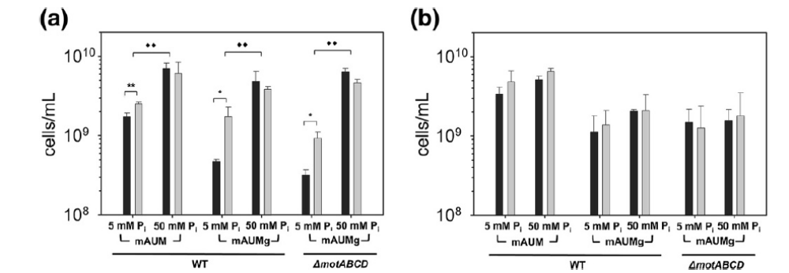
In the planktonic growth study,45 with low oxygen availability (solid insert), an increase in the final cell density was also observed during spaceflight, but only under the low phosphate conditions (5mM). No differences between spaceflight and normal gravity planktonic growth were observed at higher phosphate concentration (50mM). No significant microgravity effect on planktonic growth was observed at high oxygen availability (GE insert) either, regardless of phosphate concentration or carbon source (Figure 9).

Figure 9. Spaceflight effect on final cell density of P. aeruginosa. Wild-type (WT) P. aeruginosa and a motility mutant (ΔmotABCD) were cultured under normal gravity (black bars) and spaceflight conditions (gray bars) in FPAs with (a) solid inserts or (b) GE inserts.45

Kim and colleagues suggested that differences in P. aeruginosa final cell densities observed between spaceflight and normal gravity are due to “an interplay between changes in mixing and transport that occur under microgravity conditions and the availability of substrates essential for growth.”
To further clarify the roles of nutrient conditions, we carried out a nutrient analysis to identify the limiting nutrient of the modified artificial urine media (mAUM) (Appendix II). It was found that at low P level, depending on the metabolic process, either C or P can be the limiting nutrient. At low oxygen level (solid insert), the growth energy is likely supplied through anaerobic respiration and possibly fermentation. At higher oxygen levels, aerobic respiration plays a more important role.
At higher oxygen availability (GE insert), as shown in Figure 9(b), the effect of P concentration is relatively small (comparing the final cell densities of the 5mM P and the 50 mM P); while at lower oxygen availability (Figure 9(a)), the effect of P concentration is relatively large (larger for glucose as carbon source), so likely P is the limiting nutrient at 5mM for the low oxygen availability.
In general, the growth rate is limited by the mass transfer rate of the limiting nutrient, such as P. In a closed system, such as the FPA with a solid insert, the final biomass is also limited by the limiting nutrient. Under microgravity, the mass transfer rate of the limiting nutrient is slower, which can lead to slower growth and higher yield of the limiting nutrient.
So, it can be expected to see the spaceflight effect on biomass yield for growth controlled by a limiting nutrient, such as the growth at 5mM P, with low oxygen availability (solid insert). It is also expected to see a larger spaceflight effect where the impact of the limiting nutrient is bigger; thus, the microgravity effect is greater on growth with glucose than with citric acid (solid insert, 5mM P).

Spaceflight Effect on Bacterial Growth: Other Bacteria

S. typhimurium: Mattoni 196830
In the 1968 study, Mattoni reported the result of the BIOSATELLITE experiment, which was designed to test the effect of weightlessness and radiation on bacterial growth and lysogeny induction. Some experimental details can be found in Table 4.
E. coli C-600 (λ)/λ and Salmonella typhimurium BS-5 (P-22) /P-22 were chosen to grow cultures of lysogenic bacteria with and without γ radiation. The flight hardware, lysogenic bacteria packages, includes 1.2 to 1.8 ml vial shaped growth chambers. The cultures were grown anaerobically; the individual growth chambers were completely filled to avoid the effects of gas bubbles. Bacteria were grown on LB broth, modified to include buffer and nitrate, the latter serving as an electron acceptor for better anaerobic growth.
According to Mattoni,30 “since S. typhimurium completed growth to the stationary phase, spaceflight provided conditions for greater maximum density. E. coli, on the other hand, was still in exponential growth at recovery. Since the irradiated populations were significantly denser in flight than controls and temperatures of the irradiated sets were virtually equivalent, it must follow that the growth rate of the flight populations was also higher.”
This was an earlier study, the experimental design was not elaborate: the inoculation was performed on the ground, and the termination of the test was done by icing the culture on arrival. Nevertheless, the observations are essentially consistent with other studies, such as those done in FPAs. However, the higher populations do not always indicate higher growth rate.
In the case of S. typhimurium, the ground control reached the expected stationary populations (about 3 x 10⁸ cells/ml), while the flight growth surpassed that. As the culture was grown in LB broth, a rich media, possibly the culture entered the stationary phase as a result of the cell settlement, rather than the depletion of the nutrients (as in a minimal media). Thus, the lack of cell settlement in space would result in higher final cell density, as Mattoni rationlized.30
In the case of E. coli, the ground control did not reach the expected stationary population, so the space effect is likely not for a higher growth rate, but a higher recovery of culturability in the inoculum, as explained in other studies.

Saccharomyces cerevisiae: Van Mulders 199133
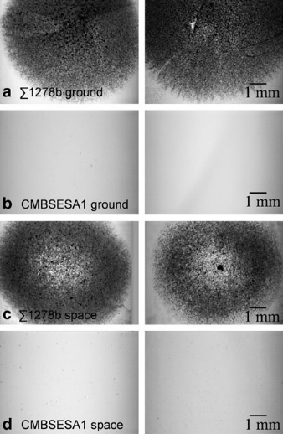
In 1991, Van Mulders and coworkers33 studied the effects of microgravity on yeast colony growth and the morphological transition from single cells to short invasive filaments in the Saccharomyces cerevisiae. Some experimental details can be found in Table 4.
Figure 10. Invasive growth assessment.33

Two-dimensional spreading of the yeast colonies grown on semi-solid yeast extract-peptone-dextrose (YPD) agar was reduced under microgravity in the Ʃ1278b invasive strain, as shown in Figure 10. The Ʃ1278b proteome map revealed upregulation of proteins linked to anaerobic conditions.
Van Mulders and coworkers atributed the observed changes as a direct microgravity effect that may be sensed by yeast cells as a stress condition, because their oxygen and carbon dioxide transport modeling showed no difference in the concentration gradients surrounding the colonies under normal and microgravity conditions.
Since the modeling work was not shown in the paper, it is difficult to validate its result. However, it is well known that the mass transfer rate of oxygen in air and in media would be slower under microgravity, so the slower growth of the invasive filaments in space would be expected, which would be consistent with the more anaerobic condition revealed by the proteome map.

Streptomyces plicatus: Lam 200234
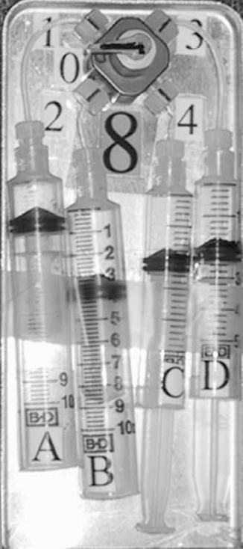
In 2002, Lam and coworkers examined the spaceflight effect on production of the antibiotic actinomycin D by Streptomyces plicatus WC56452. Some experimental details can be found in Table 4.
Figure 11. The Bioprocessing Module (BPM).34
S. plicatus WC56452 was maintained in 2 ml of seed medium before being inoculated on orbit into one of two media, F1A (complex) and DF1(defined). The seed medium contained starch, glucose, N-Z case, yeast extract, fish meat extract and CaCO₃. F1A contained starch, glucose, Pharmamedia; yeast extract, N-Z amine A, and CaCO₃. DF1 contained: fructose, L-glutamic acid·HCl, L-histidine·HCl·, K₂HPO₄, MgSO₄, ZnSO₄, CaCl₂, and FeSO₄. Ethanol (100%) was used as the fixative agent.
Figure 11 shows the flight hardware, the Bioprocessing Module (BPM), designed to contain isolated fluids for launch and subsequently mix them in the absence of gravity. The BPM consists of four syringes attached to a manually operated valve that can be configured for interconnection to allow activation and sampling. No gas exchange or agitation was provided.
Syringe A was loaded with sterile medium (F1A or DF1), B with inoculum in seed medium, C and D with 1.5 ml ethanol, and placed at 20ºC. The BPMs were manually activated after launch by mixing the content of A and B. The cultures continued to be maintained at 20ºC under anaerobic conditions. Two sample time points were fixed by transferring a part of the mixed culture into the syringe contains ethanol.
As shown in Table 5, the concentration of viable cells in the ground controls, was about threefold higher than the space samples in both media. When comparing specific productivity (the amount of antibiotic produced per viable cell), the space samples were considerably higher than the matched ground controls in both media. The residual viable space samples also had better sporulating ability than the ground samples.
Lam and coworkers contributed these effect of the spaceflight to the reduction in extracellular mass transport due to the weightless conditions, which likely results in the slower growth rate in space, and also can lead to increased secondary metabolite productivity and sporulating ability.

Table 5. Viable cell count, volumetric and specific productivity of actinomycin D on day 17.
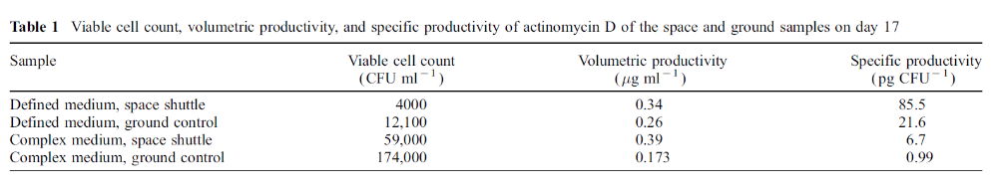

Summary
In summary, gravity results in cell settlement and induces density-driven convection within the fluid media, thus impacts the bacterial growth indirectly through the extracellular mass transfer process. As shown in Table 6, the most often observed increase in final cell density is likely to due to the reduction in lag phase and/or the higher yield due to the slower growth rate. However, these effect are not always observed, and the degree of the spaceflight effect may vary, due to the various hardware and the experiment design, the media types, and sometimes, the property of the bacterial strain.

Table 6. Summary of the spaceflight effect observed in the literature reviewed.

Stationary phase at the end of the spaceflight
 | Final cell density | Flight Hardware | Media Type | Bacteria strain | Ref | Mechanism of the spaceflight effect
 | Increased | FPA | Liquid, defined | E. coli  ATCC 4157 | 22, 23, 24, 25 | Slow mixing: lag reduction and higher yield due to slower growth
 | Increased | FPA | Liquid, defined | B. subtilis | 22, 23, 28, 29 | Same as above
 | Increased | FPA | Liquid, defined | P. aeruginosa | 31 | Higher yield due to slower growth
 | Increased | Vial-like | Liquid, complex | S. typhimurium | 30 | Lack of cell settlement
 | Unchanged | FPA | Agar, defined | E. coli ATCC 4157 | 22, 23, 28, 29 | Agar minimizes the effect of mixing
 | Unchanged | thin bag | Liquid, defined | E. coli GC2852 | 32 | Container geometry and fast mixing during inoculation minimize µg effect
 | Unchanged | thin bag | Liquid, complex | E. coli ATCC 25922 | 26 | Same as above
Log phase at the end of the spaceflight
 | Cell density | Flight Hardware | Media Type | Bacteria strain | Ref | Mechanism of the spaceflight effect
 | Decreased | well plate | Liquid, defined | E. coli GC2852 | 27 | Lower growth rate
 | Increased | well-plate | Liquid, defined | E. coli PhB405 | 27 | Lag reduction
 | Not clear | thin bag | Liquid, defined | E. coli K12 MC4100 | 26
Special cases
 | Growth | Flight Hardware | Media Type | Bacteria strain | Ref | Mechanism of the spaceflight effect
 | Unchanged | 12-well plates | Agar,YPD | S. cerevisiae CMBSESA1, non-invasive yeast | 33 | Non-invasive species
 | Decreased | 12-well plates | Agar, YPD | S. cerevisiae Σ1278b, Invasive yeast | 33 | Slower mass transfer rate (of oxygen) leads to slower growth
 | Decreased | BPM | Liquid, defined and complex | S. plicatus WC56452 | 34 | Slower mass transfer rate leads to slower growth

Appendix I
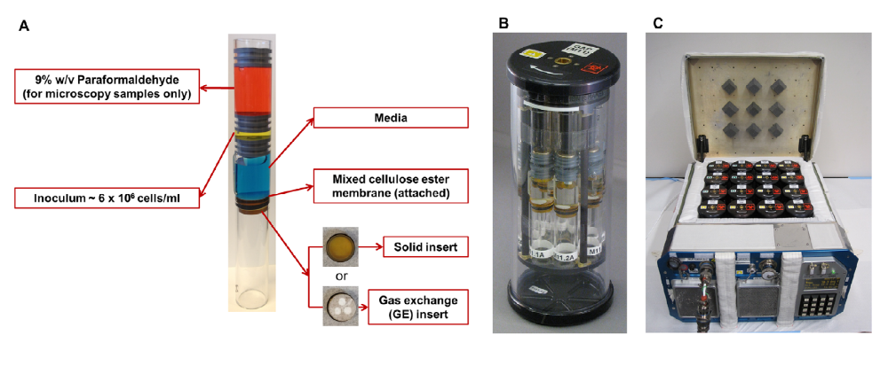
Modified FPAs used in the 2013 studies by Kim and Kim and colleague.31,45

Appendix II
In order to identify the limiting nutrient (s) in the modified artificial urine media (mAUM), the media components were listed, and the available nutrient sources were added together in the major and minor elements. The method can be found in references., Briefly, the concentration of each compound and its molecular formula are used to calculate the total amount of the elements the mAUM media contains, in the unit of concentration (mM and ppm), then the limiting nutrient can be identified by comparing the average and max biomass calculated for each element.

 |  |  |  | ave Y _{x/E} | max Y_{X/E} | Biomass | Biomass (max)
 | mM | Atomic Mass | ppm
C | 259.87 | 12 | 3118 | 1 | 1 | 3118 | 3118
N | 410.70 | 14 | 5750 | 8 | 20 | 45998
S | 12.52 | 32.07 | 402 | 100 | 333 | 40151
P | 3.6 | 30.1 | 108 | 33 | 83 | 3576 | 8994
K | 5.4 | 39.1 | 211 | 100 | 500 | 21114
Ca | 0.25 | 40.1 | 10 | 100 | 500 | 1003 | 5013
Mg | 2 | 24.3 | 49 | 200 | 1000 | 9720

Based on this rough estimation, C, P, and Ca can be limiting, but Ca is not always considered essential for growth, so it is not being considered in this case. Note that P has a larger ranges of biomass yield efficiency.
The At a higher P level (50mM), C is the limiting nutrient. At a low P level, C and P can provide similar biomass, so this is likely a P-C limiting condition. The C biomass yield also varies on the energy efficiency of the different metabolic processes: aerobic respiration, anaerobic respiration, or fermentation. The type of metabolic process is determined by the oxygen availability. In this case, the only oxygen available is dissolved air and the limited headspace (0.6ml).31 The amount of oxygen was estimated and compared with the need for aerobic respiration, it can only support 2% aerobic respiration process. So, at low oxygen availability, the growth energy is likely supplied through anabolic respiration, and possibly also fermentation.

Acknowledgments

The authors would like to acknowledge funding from NASA’s Advanced Exploration Systems (AES) Life Support Systems (LSS) Project.

References

Amentum, Research Scientist, Kennedy Space Center, FL, 32899.
Amentum, Research Scientist, Kennedy Space Center, FL, 32899.
The Bionetics Corporation, Research Scientist, Kennedy Space Center, FL, 32899.
NASA, Research Scientist, Science and Technology Programs Division, Kennedy Space Center, FL, 32899.
NASA, Senior Research Scientist, Science and Technology Programs Division, Kennedy Space Center, FL, 32899.
Emily R. Morey-Holton, The impact of gravity on life, in Evolution on Plant Earth, the Impact of the Physical Environment, edited by Lunn J. Rothschild and Adrian M. lister, Academic Press, 2003.
Mei ElGindi, Jiranuwat Sapudom, et al., May the force be with you (or not): The immune system under microgravity, Cells, 10(8), 1941 (2021); https://www.mdpi.com/2073-4409/10/8/1941
https://www.nasa.gov/pdf/570698main_AP_ST_Bio_Immune.pdf
Elizabeth A Blaber, Hayley Finkelstein, et al., Microgravity Reduces the Differentiation and Regenerative Potential of Embryonic Stem Cells, Stem Cells and Development, 24(22), 2605-2621 (2015).
Gerald Sonnenfeld, Janet Butel, William Shearer, Effect of the Space flight Environment on the Immune System, Reviews on Environmental Health, 18 (1), 1-17 (2003).
Tanbir Najrana and Juan Sanchex-Esteban, Mechanotransduction as an adaptation to gravity, Frontiers in Pediatrics 4, 140 (2016)
Feric, M., Brangwynne, C. A nuclear F-actin scaffold stabilizes ribonucleoprotein droplets against gravity in large cells. Nat Cell Biol 15, 1253–1259 (2013). https://doi.org/10.1038/ncb2830
Rosa Santomartino, Annemiek C. Waajen, et al., No effect of microgravity and simulated Mars gravity on final bacterial cell concentrations on the international space station: Applications to Space bioproduction, Frontiers in Microbiology, 14 October 2020. https://www.frontiersin.org/articles/10.3389/fmicb.2020.579156/full
Huang, B., Li, D., Huang, Y., and Liu, C., Effect of spaceflight and simulated microgravity on microbial growth and secondary metabolism, Military Midical Research 5:18 (2018) https://doi.org/10.1186/s40779-018-0162-9
Acres, J.M., Youngapelian, M.J. & Nadeau, J. The influence of spaceflight and simulated microgravity on bacterial motility and chemotaxis. npj Microgravity 7, 7 (2021). https://doi.org/10.1038/s41526-021-00135-x
Nickerson, C. A., Ott, C. M., Wilson, J. W., Ramamurthy, R., & Pierson, D. L. (2004). Microbial responses to microgravity and other low-shear environments. Microbiology and molecular biology reviews : MMBR, 68(2), 345–361. https://doi.org/10.1128/MMBR.68.2.345-361.2004
Benoit MR, Klaus DM. Microgravity, bacteria, and the influence of motility. Adv Space Res. 2007;39:1225–32.
A. H. Brown, From gravity and the organism to gravity and the cell, ASGSB Bulletin : Publication of the American Society for Gravitational and Space Biology. 1991 Jul;4(2):7-18. PMID: 11537184.
Pollard, E. C. 1965. Theoretical studies on living systems in the absence of mechanical stress. J. Theor. Biol. 8:113–123.
Klaus, D., Simski, S., Todd, P. and Stodieck, L., Investigation of space flight effects on E. coli and a proposed model of underlying physical mechanisms. Microbiology, 143: 449–455 (1997).
Michael R. Benoit and David M. Klaus, Microgravity, bacteria, and the influence of motility, Advances in Space Research, 39, 1225-1232 (2007).
Michael Benoit and David Klaus, Can genetically modified Escherichia coli with neutral buoyance induced by as gas vesicles be used as an alternative method to clinorotation for microgravity studies? Microbiology 151, 69-74 (2005).
Luis Zea, Nripesh Prasad, Shawn E. Levy, Louis Stodieck, Angela Jones, Shristi Shrestha, and David Klaus, A molecular genetic basis explaining altered bacterial behavior in space, PLOS ONE, 11(11): e0164359 (2016).
http://scienceline.ucsb.edu/getkey.php?key=4263
https://arsof-history.org/arsof_in_space/index.html
https://www.explainthatstuff.com/candles.html
Kacena MA, Merrell GA, Manfredi B, Smith EE, Klaus DM, Todd P. Bacterial growth in space flight: logistic growth curve parameters for Escherichia coli and Bacillus subtilis. Appl Microbiol Biotechnol. 1999;51:229–34.
Kacena MA, Manfredi B, Todd P. Effects of space flight and mixing on bacterial growth in low volume cultures. Microgravity Sci Tec. 1999;12:74–7.
Brown RB, Klaus D, Todd P. Effects of space flight, clinorotation, and centrifugation on the substrate utilization efficiency of Escherichia coli. Microgravity Sci Tec. 2002;13:24–9.
Klaus DM, Simske S, Todd P, Stodieck L. Investigation of space flight effects on Escherichia coli and a proposed model of underlying physical mechanisms. Microbiol. 1997;143(Pt 1):449–55.
Gasset G, Tixador R, Eche B, Lapchine L, Moatti N, Toorop P, et al. Growth and division of Escherichia coli under microgravity conditions. Res Microbiol. 1994;145:111–20.
Thevenet D, D'Ari R, Bouloc P. The SIGNAL experiment in BIORACK: Escherichia coli in microgravity. J Biotechnol. 1996;47:89–97.
Kacena MA, Todd P. Growth characteristics of Escherichia coli and Bacillus subtilis cultured on an agar substrate in microgravity. Microgravity Sci Tec. 1997;10:58–62.
Kacena MA, Leonard PE, Todd P, Luttges MW. Low gravity and inertial effects on the growth of Escherichia coli and Bacillus subtilis in semi-solid media. Aviat Space Environ Med. 1997;68:1104–8.
Mattoni RHT. Space-flight effects and gamma radiation interaction on growth and induction of lysogenic bacteria - a preliminary report. Biosci. 1968;18:602–8.
Kim W, Tengra FK, Shong J, Marchand N, Chan HK, Young Z, et al. Effect of spaceflight on Pseudomonas aeruginosa final cell density is modulated by nutrient and oxygen availability. BMC Microbiol. 2013;13:241–50.
Bouloc P, D'Ari R. Escherichia coli metabolism in space. J Gen Microbiol. 1991;137:2839–43.
Van Mulders SE, Stassen C, Daenen L, Devreese B, Siewers V, van Eijsden RG, et al. The influence of microgravity on invasive growth in Saccharomyces cerevisiae. Astrobiology. 2011;11:45–55.
Lam K, Gustavson DR, Pirnik DL, Pack E, Bulanhagui C, Mamber SW, et al. The effect of space flight on the production of actinomycin D by Streptomyces plicatus. J Ind Microbiol Biotechnol. 2002;29:299–302.
Azevedo NF, Pacheco AP, Keevil CW, Vieira MJ. Nutrient shock and incubation atmosphere influence recovery of culturable Helicobacter pylori from water. Applied and Environmental Microbiology. 2004 Jan;70(1):490-493. DOI: 10.1128/aem.70.1.490-493.2004. PMID: 14711679; PMCID: PMC321271.
Azevedo, N.F., Bragança, S.M., Simões, L.C. et al. Proposal for a method to estimate nutrient shock effects in bacteria. BMC Res Notes 5, 422 (2012). https://doi.org/10.1186/1756-0500-5-422
Blount, Z. D., J. E. Barrick, C. J. Davidson, and R. E. Lenski. 2012. Genomic analysis of a key innovation in an experimental Escherichia coli population. Nature 489:513-518.
Klaus, D. M, Effect of space flight on the growth and development of Escgerichia coli, PhD Dissertation, University of Colorado at Boulder, 1994.
Schultz, D., Kishony, R. Optimization and control in bacterial Lag phase. BMC Biol 11, 120 (2013). https://doi.org/10.1186/1741-7007-11-120
Madar, D., Dekel, E., Bren, A. et al. Promoter activity dynamics in the lag phase of Escherichia coli. BMC Syst Biol 7, 136 (2013). https://doi.org/10.1186/1752-0509-7-136
Walker, H., Carbon Dioxide as a Factor Affecting Lag in Bacterial Growth, Science , Dec. 23, 1932, New Series, Vol. 76, No. 1982 (Dec. 23, 1932), pp. 602-604
Neidhardt FC, Bloch PL, Smith DF. Culture medium for enterobacteria. J Bacteriol. 1974 Sep;119(3):736-47. doi: 10.1128/jb.119.3.736-747.1974. PMID: 4604283; PMCID: PMC245675.
Pirt, J., The energetics of microbes at slow growth rates: Maintenance energies and dormant organisms, Journal of Fermentation Technology, Volume 65, Issue 2, 1987, Pages 173-177, ISSN 0385-6380, https://doi.org/10.1016/0385-6380(87)90161-0.
Lipson, David A. “The complex relationship between microbial growth rate and yield and its implications for ecosystem processes.” Frontiers in microbiology vol. 6 615. 16 Jun. 2015, doi:10.3389/fmicb.2015.00615
Kim, W., Tengra, F. K., Young, Z., Shong, J., Marchand, N., Chan, H. K., ... & Collins, C. H. (2013). Spaceflight promotes biofilm formation by Pseudomonas aeruginosa. PLoS one, 8(4), e62437.
Diaz, A., Li, W., Irwin, T., Calle, L., Angle, G., Velez Justtniano, Y., Nur, M., and Callaham, M., “A Preliminary Modeling Study of Biofilm Accumulation in the Water Recovery System,” International Conference on Environmental Systems, ICES-2020-42.
Diaz, A., Li, W., Irwin, T., and Calle, L., “An Updated Modeling Study on Nutrient Deprivation as a Biofilm Mitigation Strategy for Long Term Space Missions,” International Conference on Environmental Systems, ICES-2021-248.

