Arizona Water Resources

Utilizing Aerial Imagery and NASA Earth Observations to Assess Pinyon-Juniper Tree Mortality in Flagstaff, AZ

**Pinyon-Juniper Mortality Detection Method**

**Using NAIP Multispectral Imagery**

Margaret Jaenicke (Project Lead)

Anne Britton

Abbi Brown

Liam Megraw

***Advisors & Mentors:***

Sean McCartney, Science Systems and Applications, Inc., NASA Goddard Space Flight Center

Joseph Spruce, Science Systems and Applications, Inc.

***Team Contact:*** Margaret Jaenicke, [maggiejaenicke@gmail.com](mailto:maggiejaenicke@gmail.com)

***Partner Contact:*** Mark Szydlo, [mark_d_szydlo@nps.gov](mailto:mark_d_szydlo@nps.gov)

**Table of Contents**

Note: Use these hyperlinks to start at any section listed below.

1. Data Acquisition
2. Data Processing
3. Performing Unsupervised Classification
4. Layer Subtraction
5. Accuracy Assessments
6. Mortality Percentage Mapping
7. Removal of Low-Probability Areas via Masking
8. Mortality Analysis
9. References

**1. Data Acquisition**

Note: Terms underlined in blue are hyperlinked to supplemental material.

***1.1 National Agriculture Imagery Program (NAIP) Aerial Multispectral Imagery***

NAIP data is the heart of the mortality mapping process that the team established. It can be accessed in multiple ways. Firstly, [USGS Earth Explorer](https://earthexplorer.usgs.gov/) can be used to download four-band NAIP tiles in bulk that can then be mosaicked and clipped in ArcGIS Pro through the Raster Functions Mosaic and Raster Functions Clip tools. When using Earth Explorer to download data, the team recommends that you upload a shapefile of your study area to limit the data shown in the search. If downloading data in bulk, you will need to install the USGS’s Bulk Download Application (BDA) to a writeable folder on your computer (e.g., Downloads or Documents). The BDA requires a computer with [JRE (Java Runtime Environment)](https://www.oracle.com/java/technologies/downloads/) installed. [A tutorial for this process](https://www.usgs.gov/centers/eros/science/earthexplorer-help-index#bulkdownload) is available on the USGS website.

Alternatively, county-level NAIP data can be downloaded from the USDA’s [NAIP Dropbox.](https://nrcs.app.box.com/v/naip/folder/17936490251) Specifically, 2021 data not available on Earth Explorer at the time of writing are available in Dropbox. The data in these folders are arranged by year, state, natural color and color infrared (if available), and county code. Information on county codes and naming conventions can be accessed through the [Reference Files folder.](https://nrcs.app.box.com/v/naip/folder/72891373659) These data can then be clipped to the study area using ArcGIS Pro’s Raster Functions Clip tool once downloaded. NAIP data from the Dropbox are highly voluminous to download per data set, but the imagery is already mosaicked according to county.

Lastly, NAIP data can also be visualized and downloaded from Google Earth Engine. However, due to the high-resolution nature of the product, limited storage space in Google Drive can quickly become a challenge if utilizing this method. As such, the team recommends utilizing the alternative resources described above.

***1.2 Validation Data***

The team recommends the use of validation data to improve the accuracy of the mortality maps. These data will be used later in the process after classification and preliminary mortality mapping. The publicly accessible data used by the team for validation purposes included [Monitoring Trends in Burn Severity (MTBS)](https://www.mtbs.gov/) data, [MODIS Burned Area Product](https://modis.gsfc.nasa.gov/data/dataprod/mod45.php) data, elevation from the [Shuttle Radar Topography Mission (STRM),](https://www2.jpl.nasa.gov/srtm/) and [LANDFIRE](https://landfire.gov/) existing vegetation type and vegetation height data. The team also received ground truth data from the National Park Service (NPS) and United States Forest Service (USFS). The unclassified NAIP true and false color composite RGB imagery can also be used as reference data given the high spatial resolution and the fact that one can distinguish between live green, dead brown, and dead gray tree crowns in addition to distinguishing between forest and non-forest vegetation. In addition, other aerial and satellite high spatial resolution true color imagery is available on Google Earth Pro that is tagged according to the collection year of a given data set.

MTBS’s Burned Areas Boundaries Dataset can be accessed via [direct download](https://www.mtbs.gov/direct-download). For fires occurring after 2020, the team recommends using the [MODIS Burned Area Product](https://modis.gsfc.nasa.gov/data/dataprod/mod45.php) which can be downloaded using Google Earth Engine. These products can be used to mask burned areas within the study area and period.

Elevation data from the Shuttle Radar Topography Mission (SRTM) can be downloaded using Google Earth Engine. LANDFIRE full extent continental United States (CONUS) existing vegetation type and height data can be found on the LANDFIRE program’s [direct download page](https://landfire.gov/version_download.php). LANDFIRE existing vegetation type and height can be beneficial for determining the extent of ponderosa pine forests, which were found to be difficult to distinguish from pinyon-juniper woodlands during the team’s classification process. These data can be used to mask areas that are considered likely to be ponderosa or mixed ponderosa and pinyon-juniper woodlands (PJW). Another potential data source is USDA Forest Service Forest Inventory and Analysis (FIA) data, though obtaining such data for specific areas would require some sort of non-disclosure agreement.

**2. Data Processing**

In order to begin the process of unsupervised classification, a few intermediate steps must be taken after data acquisition. If NAIP data have been downloaded from Earth Explorer in the form of multiple tiles, they must be mosaicked in ArcGIS Pro. Additionally, all NAIP data should be clipped to the area of study to reduce processing times. The team encountered difficulties with mosaicking and clipping such large amounts of data with the geoprocessing tools in ArcGIS Pro, and therefore highly recommends using [Raster Functions](https://pro.arcgis.com/en/pro-app/latest/help/analysis/raster-functions/raster-functions.htm) to perform mosaicking and clipping of NAIP and other high-resolution data.

If data products are downloaded from either the NAIP Dropbox or Earth Explorer, the data are already in mosaic form, but ensure that the same bands are used across the images. Bands may need to be removed and/or added so that the final pre-classification rasters match. Find each band individually in the Catalog pane by clicking the expand arrow next to the raster of choice. Drag each band that will be used into the Contents pane and use the Raster Functions Composite Bands tool to merge the desired bands into a finalized image for that year. Repeat this process for each year of data so that the finalized pre-classified layers each have the same bands.

**3. Performing Unsupervised Classification**

***3.1 Training the Classifier***

After acquiring your NAIP rasters and performing the necessary processing steps as outlined above, you can move into the classification stage. The first step is to train the classifier in ArcGIS Pro.

1. In Geoprocessing, select the [Train Iso Cluster Classifier](https://pro.arcgis.com/en/pro-app/latest/tool-reference/spatial-analyst/train-iso-cluster-classifier.htm)
2. Select your finalized raster in the **Input Raster** box
3. Input the **Max Number of Classes / Clusters**: 20
4. Select an output location and name for the **Output Classifier Definition File** (.ecd)
5. Include the following parameters, or change them as need be based on the study area/project:

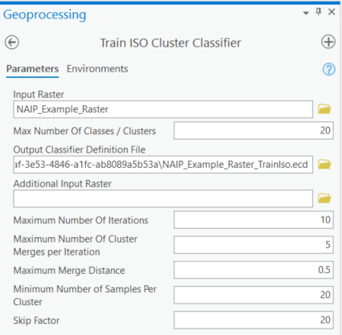

* 1. *Note that in pre-2017 NAIP imagery, a **Skip Factor** of 7 should be used to account for the lower resolution of the data (1 m versus the now standard 0.6 m)

1. Click Run

***3.2 Classifying the Raster***

Once the Train Iso Cluster Classifier finishes, navigate to the Classify Raster tool in Geoprocessing.

1. Select the same finalized raster used to train the classifier in the **Input Raster** box
2. Select the .ecd file output from the Train Iso Cluster Classifier process in the **Input Classifier** **Definition File** box
3. Select an output location and name for the **Output Classified Raster**
4. Click Run

***3.3 Assigning and Merging Classes***

The output of the Classify Raster tool should produce a new raster with a total of 20 classes. The next step of this process is to assign each of the classes to a new grouped class. The team used four overarching classes to account for features in the study area: pinyon-juniper, bare earth and senesced grass, grass or shrub, and shadow.

1. In order to reclassify the 20-class image, select the classified raster and navigate to Classification Tools under the Imagery tab
2. Select Assign Classes under Classification Tools
3. Using the **+ sign**, create four classes in the New Schema: pinyon-juniper, bare earth and senesced grass, grass or shrub, and shadow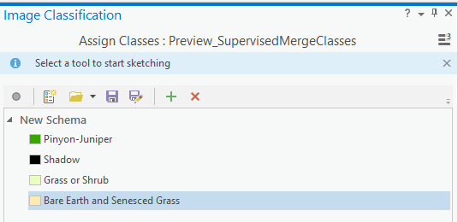
4. Start assigning Old Classes in the table below your new schema to their New Class. This can be achieved by highlighting the new class in the schema, and then using the **Select tool** (above New Schema in the image above) click on the class in your raster that should be reassigned: 
   1. If you misclassify a class in your image, select the correct class in the New Schema section and use the  tool to click and reclassify the misclassified area
5. Once all of the 20 original classes have been reassigned to the new schema, click Run

You now have your near-final classified image and can repeat Sections 3.1 through 3.3 in this guide for additional years of data.

***3.4 Filtering Classified Output***

As a final step in the classification process, the team filtered all classified images using the majority filter to remove salt and pepper noise (i.e., singular spurious pixels) from the image.

1. In Geoprocessing or in the search bar, find the Majority Filter tool
2. In the **Input Raster** box, select the near-final raster produced in Section 3.3 above
3. Select an output location and name for the **Output Raster**
4. Under **Number of Neighbors to Use**, select four (this should be the default)
5. Under **Replacement Threshold**, select Majority (this should be the default)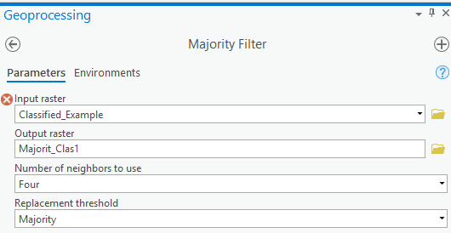
6. Click Run

**4. Layer Subtraction**

Now that you have completed your classifications for all years, you can subtract one raster from another to visualize mortality. You will need to reclassify your rasters to the correct values, resample so that resolutions match if necessary, and then use the Minus function.

***4.1 Reclassification***

1. Navigate to the Reclassify tool in Geoprocessing
2. In the **Input Raster** box, select the raster you would like to reclassify
3. **Reclass field** should remain on Value (the default)
4. Under **New** in the table, change the value of pinyon-juniper to 2, shadow to 1, bare earth and senesced grass to 0, and grass or shrub to 0

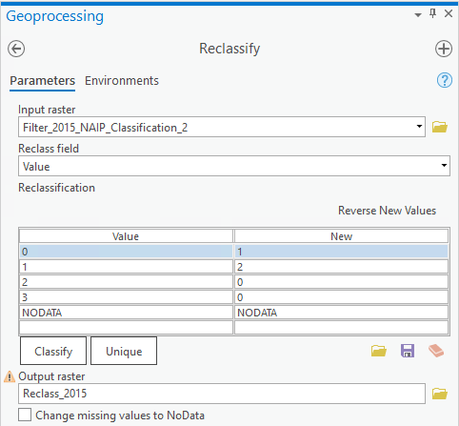

1. Assign a name and location for the reclassified raster in the **Output Raster** box
2. Click Run
3. Repeat for each raster that will be involved in the subtraction process

***4.2 Resampling***

If necessary, you may need to resample your rasters so that their resolutions match before subtraction. This is the case if you use both pre- and post-2017 NAIP imagery, which will be at 1 m and 0.6 m, respectively. To check the resolution of the raster, right click on it in the Contents pane, select properties, and navigate to Raster Information in the Source window. **If both rasters have the same resolution, skip this section.**

1. Navigate to the Resample tool in Geoprocessing
2. Select the **Input Raster** to be resampled, for instance: a 0.6 m raster
3. Assign a name and location in the **Output Raster Dataset** box
4. In boxes **X and Y**, input the desired Cell Size (often the largest pixel size of the two rasters), for instance: 1m, 1m
5. Leave the default setting at Nearest Neighbor in the **Resampling Technique** box
6. Click the **Environments** tab under Resample
7. In the **Snap Raster** section of the Environments Tab, select the second raster that you are resampling to match (i.e., a 1 m raster)
   1. This will ensure that pixels will align between the two rasters after the resampling process is complete

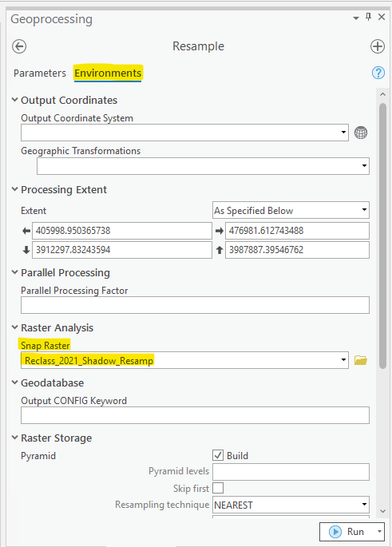

1. Click Run

***4.3 Subtraction***

Now that both layers are reclassified and resampled (if necessary) to match one another, move into the final step in the layer subtraction process. This is the process that was used by the team and will be referred to for the remainder of the document. However, for an alternative change detection method, refer to Section 4.4.

1. Navigate to Raster Functions and find the [Minus function](https://pro.arcgis.com/en/pro-app/2.8/help/analysis/raster-functions/minus.htm) under the Math section
   1. This function subtracts the pixel values of the Raster2 box from the Raster box

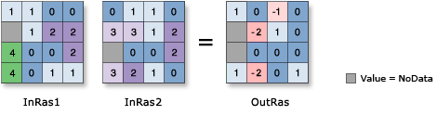

*Figure credited to Esri ArcGIS Pro help: Minus function*

1. To find mortality, subtract the older raster from the newer one (e.g., 2021 raster – 2015 raster)
2. Input the most recent raster in the **Raster** box, and the less recent raster in the **Raster2** box
3. Leave **Cellsize Type** at Max Of, and **Extent Type** at Intersection Of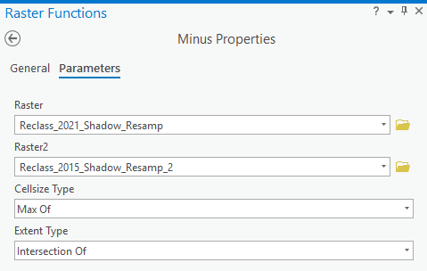
4. Click Create New Layer

The layer created will have values between –2 and 2. The –2 value is where mortality has occurred between the two years. In the Contents pane, select the new layer, right click, and select Symbology in the menu. Ensure that the Primary Symbology is set to Unique Values. You can easily set values –1 to 2 to transparent, and –2 (mortality) to a color of your choosing.

Refer to the table below for a full understanding of the values produced during the subtraction process.

|  |  |  |  |
| --- | --- | --- | --- |
| **Year 2 Classified Value** | **Year 1 Classified Value** | **Year 2 – Year 1 Subtracted Value** | **Subtraction Outline** |
| 0 (Not PJW) | 2 (PJW) | -2 | Not PJW - PJW = Mortality |
| 0 (Not PJW) | 1 (Shadow) | -1 | Not PJW - Shadow = No Change |
| 0 (Not PJW) | 0 (Not PJW) | 0 | Not PJW - Not PJW = No Change |
| 1 (Shadow) | 2 (PJW) | -1 | Shadow - PJW = No Change |
| 1 (Shadow) | 1 (Shadow) | 0 | Shadow - Shadow = No Change |
| 1 (Shadow) | 0 (Not PJW) | 1 | Shadow - Not PJW = No Change |
| 2 (PJW) | 0 (Not PJW) | 2 | PJW - Not PJW = Growth |
| 2 (PJW) | 2 (PJW) | 0 | PJW - PJW = No Change |
| 2 (PJW) | 1 (Shadow) | 1 | PJW - Shadow = No Change |

***4.4 Alternative Addition Method***

The method described above was the one used by the project team. It is possible, however, to achieve a similar result with less data loss using a different methodology. Rather than doing image subtraction to achieve a mortality change map, one can do image addition instead.

1. During the reclassification step described in Section 4.1, for the raster from the oldest date, set Not PJW to 10, Shadow to 20, and PJW to 30
2. For the raster from the more current date, set Not PJW to 1, Shadow to 2, and PJW to 3
3. Resample if necessary, referring to Section 4.2
4. Navigate to Raster Functions and find the [Plus function](https://pro.arcgis.com/en/pro-app/latest/help/analysis/raster-functions/plus-function.htm) under the Math section
   1. This function adds the pixel values of the Raster2 to the Raster box

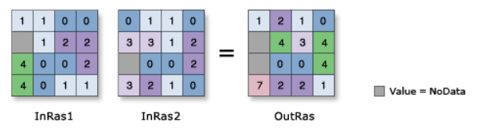

*Figure credited to Esri ArcGIS Pro help: Plus function*

1. To find mortality, add the older raster to the newer one (e.g., 2015 raster + 2021 raster)
2. Input the less recent raster in the **Raster** box, and the more recent raster in the **Raster2** box
3. Leave **Cellsize Type** at Max Of, and **Extent Type** at Intersection Of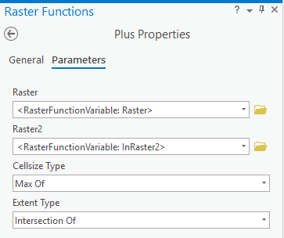
4. Click Create New Layer
5. In the Contents pane, select the new layer, right click, and select Symbology in the menu. Ensure that the Primary Symbology is set to Unique Values

The benefit of this process over subtraction is that it produces a unique value for each output, reducing unnecessary data loss. Refer to the table below for a full understanding of the values produced during the addition process.

|  |  |  |  |
| --- | --- | --- | --- |
| **Year 1 Classified Value** | **Year 2 Classified Value** | **Year 1 + Year 2**  **Added Value** | **Addition Outline** |
| 30 (PJW) | 1 (Not PJW) | 31 | PJW + Not PJW = Mortality |
| 30 (PJW) | 3 (PJW) | 33 | PJW + PJW = No PJW Change |
| 30 (PJW) | 2 (Shadow) | 32 | PJW + Shadow = Shadow Change |
| 20 (Shadow) | 3 (PJW) | 23 | Shadow + PJW = Shadow Change |
| 20 (Shadow) | 2 (Shadow) | 22 | Shadow + Shadow = Shadow |
| 20 (Shadow) | 1 (Not PJW) | 21 | Shadow + Not PJW = Shadow Change |
| 10 (Not PJW) | 3 (PJW) | 13 | Not PJW + PJW = Growth |
| 10 (Not PJW) | 2 (Shadow) | 12 | Not PJW + Shadow = No Change |
| 10 (Not PJW) | 1 (Not PJW) | 11 | Not PJW + Not PJW = No Change |

**5. Accuracy Assessments**

ArcGIS Pro can be used to assess the accuracy of your classified vegetative layers as well as the mortality layer you created in Section 4.3.

***5.1 Vegetation Layer Accuracy***

First, start by assessing the accuracy of your completed 4-class classifications finalized in Section 3.4.

1. In ArcGIS Pro, navigate to Create Accuracy Assessment Points in Geoprocessing
2. Choose the raster you would like to assess in the **Input Raster or Feature Class Data** box
3. Assign a name and location in the **Output Accuracy Assessment Points** box
4. **Target field** should be left at the default: Classified
5. In **Number of Random Points**, input the number of accuracy points you would like to create; for the original project, the team used 240
6. For **Sampling Strategy**, the team recommends Equalized Stratified Random
   1. More information on this can be found on the [ArcGIS Pro help page](https://pro.arcgis.com/en/pro-app/latest/tool-reference/spatial-analyst/create-accuracy-assessment-points.htm)

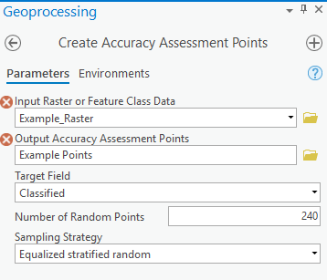

1. Click Run
2. Once the accuracy points have been created and appear in the contents pane, right click on them and select Attribute Table
3. In the Attribute Table, the **Classified column** will indicate the value provided by the classification, while the **GrndTruth column** will have some type of null value (e.g., -1)
   1. By double-clicking the number in the first column (highlighted in yellow below), the map will automatically zoom to that point.

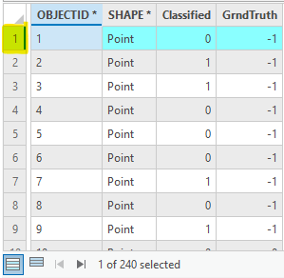

1. You can then visually assess whether the classification matches the base NAIP imagery
   1. If base imagery matches the classification value in the Classified column, input the number from this classification in the GrndTruth column
   2. If it does not match the Classification, input the value for the correct classification in the GrndTruth column
   3. For instance, row 1 below would be considered an accurate classification, while row 3 would be considered inaccurate

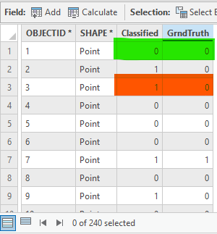

1. Once all values in the GrndTruth column are updated, save all edits by going to the Edit tab and clicking Save 
2. Navigate to Compute Confusion Matrix in Geoprocessing
3. Select the accuracy points in the **Input Accuracy Assessment Points** box and assign a name and location in the **Output Confusion Matrix** box
4. Click Run
5. In the Contents pane you will see the computed matrix; right click on it and select Open
   1. Refer to [Esri’s documentation](https://pro.arcgis.com/en/pro-app/2.8/tool-reference/spatial-analyst/compute-confusion-matrix.htm) on how to interpret your confusion matrix
6. Repeat this process for each year of classification performed

***5.2 Mortality Layer Accuracy***

The process above can be used to assess the accuracy of the mortality layer you created in Section 4.3.

1. Using the reclassification methodology outlined in Section 4.1, reclassify the mortality layer to mortality=1 (originally –2) and not mortality=0 (originally –1 through 2)
2. If desired, clip the mortality layer as necessary to remove any areas of uncertainty as described below in the Low Probability Area Masking section
3. Repeat steps 1 through 16 in Section 5.1

**6. Mortality Percentage Mapping**

In order to better visualize mortality across the study area, the team created percent mortality maps using the methods below.

1. Using the reclassification methodology outlined in Section 4.1, reclass the mortality layer you created in Section 4.3 to 200=mortality and NODATA=all other classes
2. Using the reclassification methodology outlined in Section 4.1, reclass your older vegetation layer finalized in Section 3.4 (in the case of the team’s study, the 2015 layer) to 0=pinyon-juniper and NODATA=all other classes
3. You should now have two separate rasters, each with only one value, either 200 or 0
4. Navigate to the Cell Statistics tool in Geoprocessing
5. In **Input Rasters or Constant Values**, select both of your reclassified rasters from steps 1 and 2
6. Assign a name and location in the **Output Raster** box
7. Select Mean in the **Overlay Statistic** box
8. Check Ignore NoData in **Calculations**, and leave **Process as Multiband** unchecked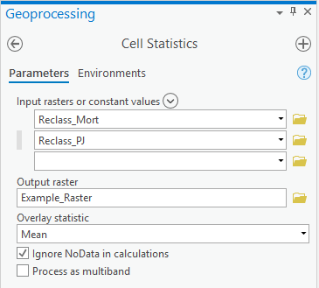
9. Click Run
10. From this process you will get a new raster of cells with values of either 0 or 100, with 0=live pinyon-juniper and 100=mortality
11. To return a final raster with varying percentages, resample this raster to 30 m using the Raster Functions Resample tool
    1. This tool will allow you to take an average of the cells
12. Input your reclassified raster from step 10 in the Raster box
13. Change **Resampling Type** to Average
14. Input the cell size of the reclassified raster in the **Input Cellsize** box
15. Input the desired **Output Cellsize**; the team chose 30 m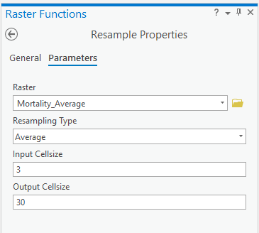
16. Click Create New Layer
17. The resulting number for each pixel represents the percentage of tree mortality in that area, or more simply, what percentage of trees alive in the earlier image are now dead in the later image

**7. Removal of Low-Probability Areas via Masking**

To account for wildfires and improve the accuracy of both the mortality classification and environmental analyses, the team created masks with the following processes. The masks were used to remove data that fell within burned areas and areas where there was a low probability of being able to identify PJW due to the presence of ponderosa pine.

***7.1 Ponderosa Pine Mask***

1. Ensure the LANDFIRE Existing Vegetation Type raster has an attribute table by right-clicking the layer in the contents pane. If Attribute Table in the popup is greyed out, you must make an attribute table with the Build Raster Attribute Table tool
   1. You can check **Convert Colormap**
   2. Do not check **Overwrite**
   3. Click Run
2. Use the Select by Attributes tool to select EVT _FUEL classes that are *not equal to* the following:
   1. 2051 (Southern Rocky Mountain Dry Mesic Montane Mixed)
   2. 2054 (Southern Rocky Mountain Ponderosa Woodland)
   3. 2117 (Southern Rocky Mountain Ponderosa Savanna)
3. In the attribute table, delete the selected data
4. Right-click the EVT layer > Data > Export Raster
   1. Assign a name and location for the raster in the **Output Raster** box
   2. Click Run
   3. The resulting raster should only have these three ponderosa classes
5. Use the Raster to Polygon tool with the resulting layer from the previous step as input
   1. Do not check **Simplify Polygons** or **Create Multipart Features**
   2. Do not define **Maximum Vertices**
   3. Assign a name and location for the raster in the **Output Polygon Features** box
   4. Click Run
6. The resulting polygon feature will be used in Sections 7.5 and 7.6

***7.2 Canopy Height Mask***

In order to determine the optimal canopy height threshold for masking, the team visually assessed LANDFIRE Existing Vegetation Height data to determine a 7 m existing vegetation height cutoff between PJW and ponderosa pine forests in the study region. While the directions below use 7 m as the minimum, **this threshold should be set according to the study area.**

1. Ensure the LANDFIRE Existing Vegetation Height raster has an attribute table in the same manner as in Section 7.1
2. In Raster Functions, use the Mask function to mask out values below 107 (LANDFIRE Existing Vegetation Height values range from 100–136, corresponding to vegetation heights of 0–36 m)
   1. Set the values in **Included Ranges** to 108–136
   2. Set **NoData Values** to zero
   3. Leave **NoData Interpretation** at its default
   4. Click Create New Layer

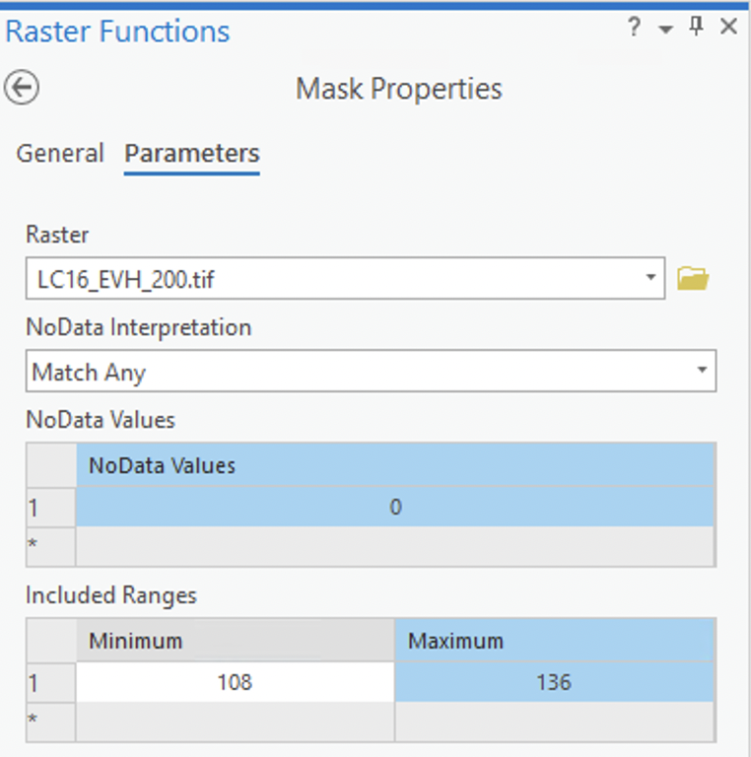

1. Use the Raster to Polygon tool with the resulting layer from the previous step as input
   1. Do not check **Simplify Polygons** or **Create Multipart Features**
   2. Do not define **Maximum Vertices**
   3. Assign a name and location for the raster in the **Output Polygon Features** box
   4. Click Run
2. The resulting polygon feature will be used in Sections 7.5 and 7.6

***7.3 Elevation Mask***

Depending on the region, the maximum elevation for oneseed juniper (*Juniperus monosperma*) ranges from 1500 m to 2130 m. The maximum elevation for two-needle pinyon (*Pinus edulis*) is approximately 2290 m, with individual trees of either oneseed juniper or two-needle pinyon growing as high as 2590 m (Cronquist et al., 1972 as cited in Miller et al., 2019, p. 29; Emerson, 1932; Kearney et al., 1960, p. 60; USFS, 1965, p. 398). Given that all pinyon-juniper accuracy points for the team’s study were below 2250 m, the team used SRTM elevation data to mask out areas above the 2290 m two-needle pinyon threshold. While the directions below use 2291 m as the minimum, **this threshold should be set according to the study area.**

1. In Raster Functions, use the Mask Function on the SRTM elevation raster to mask out values below 2290 (i.e., below 2290 m).
   1. The **NoData Interpretation** field can be left default
   2. The **NoData Values** field can be set to zero
   3. Click Create New Layer

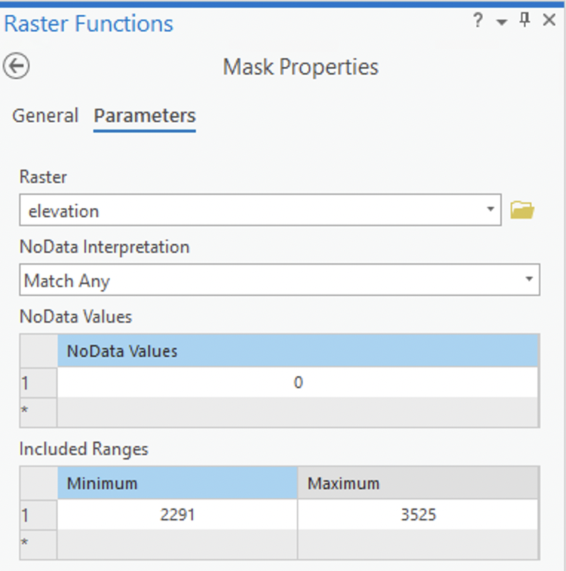

1. Use the Raster to Polygon tool with the resulting layer from the previous step as input
   1. Do not check **Simplify Polygons** or **Create Multipart Features**
   2. Do not define **Maximum Vertices**
   3. Assign a name and location for the raster in the **Output Polygon Features** box
   4. Click Run
2. The resulting polygon feature will be used in Sections 7.5 and 7.6

***7.4 Burn Boundary Mask***

MTBS polygons require no pre-processing, while MODIS burn boundaries do. If MTBS data covers your entire temporal range of interest, MODIS data is not necessary. To process MODIS data, do the following:

1. The MODIS raster may import as an entirely black image. If you would like to view features, right-click the layer and open the Symbology pane
   1. In the dropdown, select **Discrete** and select a color ramp with discrete colors
   2. The resulting symbology assigns a unique color to a cell burned for each day of the year
2. The MODIS raster is by default in a double (decimal) format, and must be converted to integer
   1. Use the Int tool to convert the raster to an integer
   2. Assign a name and location for the raster in the **Output raster** box
   3. Click Run
3. Use the Raster to Polygon tool with the resulting layer from the previous step as input
   1. Do not check **Simplify Polygons** or **Create Multipart Features**
   2. Do not define **Maximum Vertices**
   3. Assign a name and location for the raster in the **Output Polygon Features** box
   4. Click Run
4. The resulting polygon feature will be used in Sections 7.5 and 7.6

***7.5 Combining and Simplifying Masks***

After steps 7.1-7.4, you should have created four polygon features in addition to the preexisting MTBS burn boundaries which can now be combined and simplified.

1. Use the Merge tool with the following layers as input, leaving all other options to their default:
   1. LANDFIRE Ponderosa Pine
   2. LANDFIRE Canopy Height
   3. SRTM Elevation
   4. MTBS Burn Boundaries
   5. MODIS Burn Boundaries
2. Use the Dissolve Boundaries tool on the layer from the previous step to remove edges separating contiguous features
   1. Do not check **Create Multipart Features** or **Dissolve by Field Value(s)**
   2. Assign a name and location for the polygon in the **Output Feature Class** box
   3. Click Run
3. Use the Select by Attributes tool to select polygons with a Shape_Area less than 3600 m2 (i.e., smaller than four 30 m2 LANDFIRE pixels) and then delete these from the attribute table
4. Use the Graphic Buffer tool on the layer created in step 2 and edited in step 3 to create square buffers that will fill in gaps
   1. Set the **Distance** value to 120 m, which will effectively fill in gaps smaller than 6x6 LANDFIRE pixels (i.e., 14,400 m2)
   2. Leave all other options default
   3. Assign a name and location for the raster in the **Output Feature Class** box
   4. Click Run

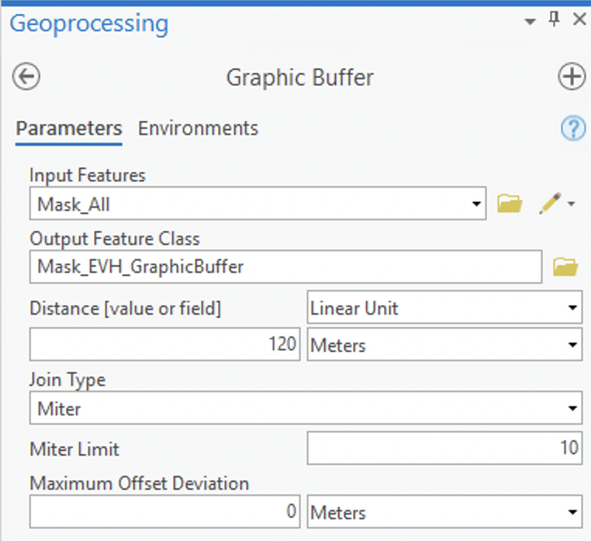

1. Use the Dissolve Boundaries tool on the layer from the previous step to remove edges separating contiguous features
   1. Do not check **Create Multipart Features** or **Dissolve by Field Value(s)**
   2. Assign a name and location for the polygon in the **Output Feature Class** box
   3. Click Run
2. Use the Graphic Buffer tool on the resulting layer, defining a distance of -120 m instead of 120 m
   1. Leave all other options default
   2. Assign a name and location for the raster in the **Output Feature Class** box
   3. Click Run
   4. This step returns polygon edges back to their original position while maintaining the filled in gaps
3. The resulting layer is the “low pinyon-juniper confidence” mask ready for visualizations on maps

***7.6 Generalizing Masks***

Even the “simplified” mask created in Section 7.5 can contain hundreds of polygons or more. To create an even more generalized mask for quick clipping of rasters used in later analyses, do the following:

1. Visually assess the mask created in Section 7.5 to decide which areas are the most important (e.g., largest) that you want to maintain in a simplified mask
2. Use the [Minimum Bounding Geometry](https://pro.arcgis.com/en/pro-app/2.8/tool-reference/data-management/minimum-bounding-geometry.htm) tool to create polygons that envelop all mask vertices for each unique feature

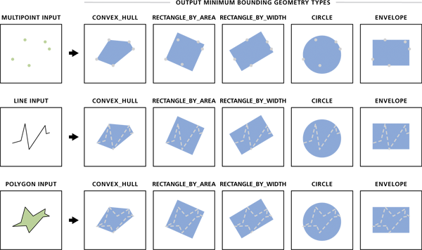

*Figure credited to Esri ArcGIS Pro help: Minimum Bounding Geometry (Data Management)*

* 1. Set **Geometry Type** to Convex hull
  2. Ensure the **Group Option** is set to None
  3. Leave all other options default
  4. Assign a name and location for the raster in the **Output Feature Class** box
  5. Click Run

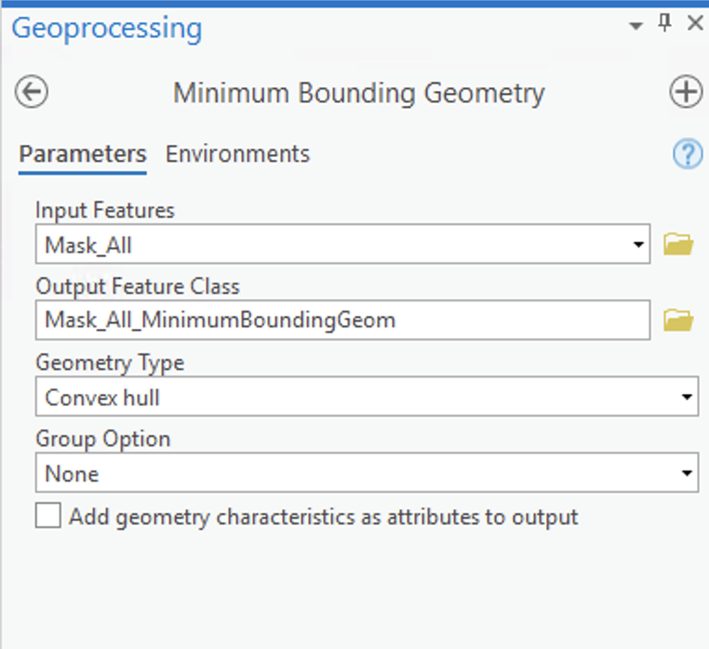

1. Use Select by Attributes on the layer created in Section 7.5 to select polygons smaller than a specific size*
2. Use the Dissolve Boundaries tool on the layer from the previous step to remove edges separating contiguous features
   1. Do not check **Create Multipart Features** or **Dissolve by Field Value(s)**
   2. Assign a name and location for the raster in the **Output Feature Class** box
   3. Click Run
3. The resulting generalized mask layer should have vastly fewer polygons compared to the simplified mask layer+

\**Note that team’s original method for this differed slightly, effectively removing polygons smaller than 150,000 m2 from influencing the creation of a generalized mask, in addition to removing polygons on the western edge of the study region. These polygons on the western edge were to the north and south of the largest polygons’ extreme vertices and ranged from 3600 m2 to 170 hectares. The team recommends simply using a size threshold to make the generalization more consistent and easier to replicate.*

+*Note that using the team’s original method, only two polygons were created.*

**8. Mortality Analysis**

In order to quantify mortality across the study area into a single percentage figure, the team used the following process.

***8.1 Creating a Point Layer***

1. Using the reclassification methodology outlined in Section 4.1, reclass your older vegetation layer finalized in Section 3.4 (in the case of the team’s study, the 2015 layer) to 1=pinyon-juniper and NODATA=all other classes
2. If using masks for low-probability areas, clip these areas from this raster by using the Raster Functions Clip tool
   1. In the **Clipping Type** box, select Inside
      1. This will remove areas within the mask from the raster
   2. In the **Clipping Geometry / Raster** box, choose the mask created in Section 7
   3. Check the **Use input features for clipping geometry** box

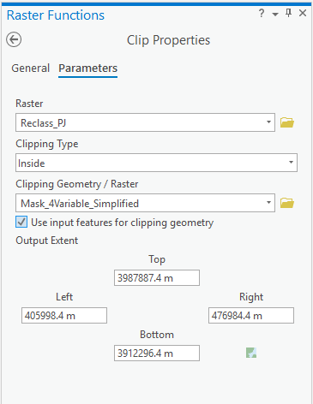

* 1. Click Create New Layer

1. Navigate to the Raster to Point tool in Geoprocessing
2. Select your new pinyon-juniper layer in the **Input Raster** box
3. Assign a name and location in the **Output Point Features** box
4. Click Run
5. This will result in a point layer wherein the grid_code column refers to the data from the pinyon-juniper input layer

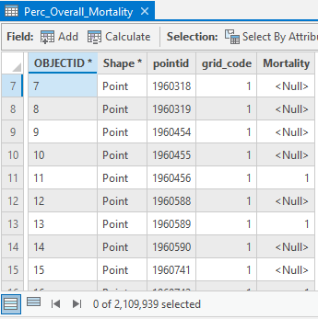

***8.2 Mortality Point Values***

Next, append mortality data to the newly created point layer.

1. Using the reclassification methodology outlined in Section 4.1, reclass the mortality layer you created in Section 4.3 to 1=mortality and NODATA=all other classes
2. Navigate to the Extract Multi Values to Points tool in Geoprocessing
3. Select the points created in Section 8.1 in the **Input Point Features** box
4. Select the reclassified raster from step 1 in the **Input Rasters** box and input a name (e.g., Mortality) in the **Output Field Name** box
5. Leave **Bilinear interpolation of values at point locations** unchecked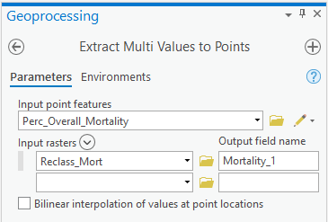
6. Click Run
7. This will result in appending the values from the mortality raster to a new column in the point layer’s attribute table
   1. Null values indicate no mortality occurred at that pixel in 2021, while 1 indicates that pixel saw mortality in 2021



***8.3 Table Export and Analysis***

In order to analyze this data, you must export the data from ArcGIS Pro.

1. This table can be exported by right clicking on the point layer in the catalog pane, navigating to Data, and selecting Export Table

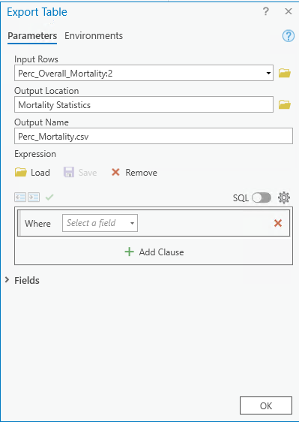

1. Select an **Output Location** and provide an **Output Name**
2. Ensure that the **Output Name** file extension is .csv and click OK

Using a program such as [RStudio](https://www.rstudio.com/) or Microsoft Excel for statistical analysis, sum the values of each relevant column (grid_code and mortality in the table from Section 8.2) and then divide the summed mortality value by the summed pinyon-juniper value to receive a value between 0 and 1 indicating percentage mortality across pinyon-juniper stands in the study area.

**9. References**

Coates, P. S., Gustafson, K. B., Roth, C. L., Chenaille, M. P., Ricca, M. A., Mauch, K., Sanchez-Chopitea, E., Kroger, T. J., Perry, W. M., & Casazza, M. L. (2017). *Using object-based image analysis to conduct high-resolution conifer extraction at regional spatial scales*. USGS Open-File Report. https://doi.org/10.3133/ofr20171093

*Compute confusion matrix (Spatial analyst)*. (2021). Esri ArcGIS Pro Help. https://pro.arcgis.com/en/pro-app/2.8/tool-reference/spatial-analyst/compute-confusion-matrix.htm

*Create accuracy assessment points (Spatial analyst)*. (2021). Esri ArcGIS Pro Help. https://pro.arcgis.com/en/pro-app/latest/tool-reference/spatial-analyst/create-accuracy-assessment-points.htm

Emerson, F. W. (1932). The tension zone between the grama grass and pinon-juniper associations in northeastern New Mexico. *Ecology, 13*(4), 347–358. https://doi.org/10.2307/1932311

Giglio, L., Justice, C., Boschetti, L., Roy, D. (2021). *MODIS/Terra+Aqua Burned Area Monthly L3 Global 500m SIN Grid V061* [Data set]. NASA EOSDIS Land Processes DAAC. https://doi.org/10.5067/MODIS/MCD64A1.061

Hansen M. (2004). *Vegetation Classification and Distribution* [Data set]. USGS-NPS National Vegetation Mapping Program: Wupatki National Monument, Arizona.

Kearney, T. H., Peebles, R. H., Howell, H. T., and McClintock, E. (1960). *Arizona flora.* University of California Press.

Miller, R. F., Chambers, J. C., Evers, L., Williams, C. J., Snyder, K. A., Roundy, B. A., & Pierson, F. B. (2019). *The ecology, history, ecohydrology, and management of pinyon and juniper woodlands in the Great Basin and northern Colorado plateau of the western United States.* U.S. Forest Service. https://doi.org/10.2737/rmrs-gtr-403

*Minimum bounding geometry (Data management).* (2021). Esri ArcGIS Pro Help. https://pro.arcgis.com/en/pro-app/2.8/tool-reference/data-management/minimum-bounding-geometry.htm

*Minus function.* (2021). Esri ArcGIS Pro Help. https://pro.arcgis.com/en/pro-app/2.8/help/analysis/raster-functions/minus.htm

NASA Shuttle Radar Topography Mission. (2013). *Shuttle Radar Topography Mission (SRTM) Global* [Data set]. Distributed by OpenTopography. https://doi.org/10.5069/G9445JDF

NatureServe. (2011, December). *Expert attribution for auto-key improvements (LANDFIRE) and advancing methods for integration with the revised US-national vegetation classification standard: GeoArea 4 results table.* LANDFIRE Program. https://landfire.gov/lf_improvements.php

Oracle. (2022). *Java Runtime Environment (JRE).* Java Downloads. https://www.oracle.com/java/technologies/downloads/

*Plus function*. (2021). Esri ArcGIS Pro Help. https://pro.arcgis.com/en/pro-app/latest/help/analysis/raster-functions/plus-function.htm

*Raster functions*. (2021). Esri ArcGIS Pro Help*.* https://pro.arcgis.com/en/pro-app/latest/help/analysis/raster-functions/raster-functions.htm

*Train ISO Cluster Classifier (Spatial Analyst)*. (2021). Esri ArcGIS Pro Help. https://pro.arcgis.com/en/pro-app/latest/tool-reference/spatial-analyst/train-iso-cluster-classifier.htm

U.S. Department of Agriculture. (2021). *National Agriculture Imagery Program (NAIP)* [Data set]. U.S. Department of Agriculture. https://doi.org/10.5066/F7QN651G

U.S. Department of the Interior, Geological Survey. (2021). *EarthExplorer Bulk Download Tutorial.* https://www.usgs.gov/centers/eros/science/earthexplorer-help-index#bulkdownload

U.S. Department of the Interior, Geological Survey, and U.S. Department of Agriculture. (2016). *Existing Vegetation Height Layer, LANDFIRE 1.4.0* [Data set]. http://landfire.cr.usgs.gov/viewer/

U.S. Department of the Interior, Geological Survey, and U.S. Department of Agriculture. (2016). *Existing Vegetation Type Layer, LANDFIRE 1.4.0* [Data set]. http://landfire.cr.usgs.gov/viewer/

U.S. Department of Agriculture, Forest Service and U.S. Geological Survey. (2020). *MTBS Data Access: Burned Area Perimeter Data* [Data set].<http://mtbs.gov/direct-download>

USFS. (1965). *Silvics of forest trees of the United States.* Agriculture Handbook 271. <https://hdl.handle.net/2027/umn.31951d02469242e>