Low Leakage Valves for Long Duration Missions.
Cody L. Gilliland
Scott Kramer
James A. Richard
William F. Sadowski
Andrew N. Smith
Robert J. Walker
NASA Marshall Space Flight Center, Alabama, USA
An Extended Abstract Submitted AIAA SciTech 2023
23-27 January 2023
National Harbor, MD
- Nomenclature
m_{typical_mission} = internal mass of propellant lost over the course of a mission with Q_{typical}
m_{mission_goal} = mass of propellant loss over the course of a mission with Q_{goal}
t_{mission} = theoretical mission duration
Q_{typical} = internal leakage rate found in commercially available valves
Q_{goal} = internal leakage rate design goal
ρ_{H2_STP} = density of hydrogen at standard temperature and pressure.

- Introduction
Current aerospace cryogenic valves present challenges to potential long duration missions that utilize cryogenic propellants. Small interplanetary and long-life communication satellites typically utilize hypergolic propellants that operate at higher temperatures, making it easier to achieve very low internal leakage rates. Larger vehicles for long duration missions will likely need to utilize cryogenic-based chemical and nuclear systems to achieve mission requirements. Some early propulsion concepts are projected to require valves with a nominal size ranging from 3” to 10”.
Currently available cryogenic aerospace valves typically have internal leakage rates which can range from 100 to 300 SCIM for 3” valves, or upwards of 2,000 SCIM for 10” valves. With just a few of these valves in a system, internal leakage could account for multiple tons of propellant loss over the course of a potential Mars mission, as shown in Figure 1.
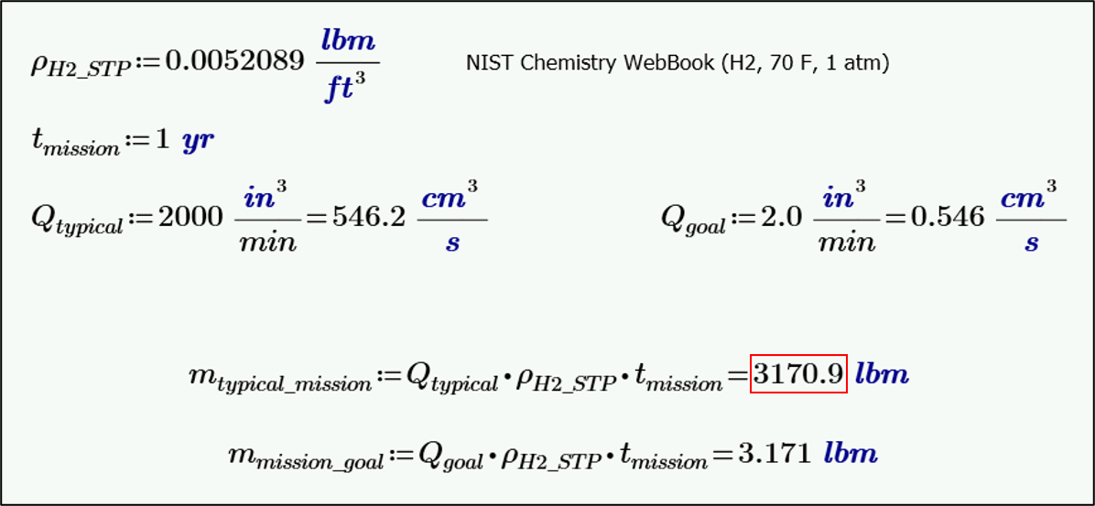
Figure 1 - Potential Propellant Loss Over the Course of a Long Duration Mission
Most internal leakage rates can be attributed to inherent imperfections and misalignments, which result in imperfect contact between sealing surfaces, as shown in Figure 2.
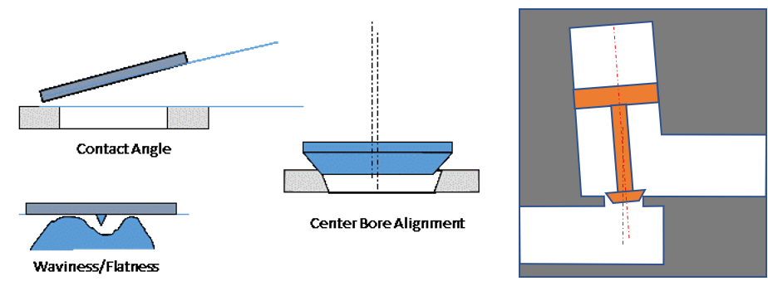
Figure 2 - Imperfections and Misalignments Between Sealing Surfaces
The ER14 Branch at Marshall Space Flight Center (MSFC) has created a self-aligning seat and poppet design (shown in Figure 3) that allows a valve to be more tolerant of imperfect contacts. This design utilizes a metallic poppet head with five degrees of freedom that allows the poppet to self-align with the seat, reducing the need for tight tolerances.
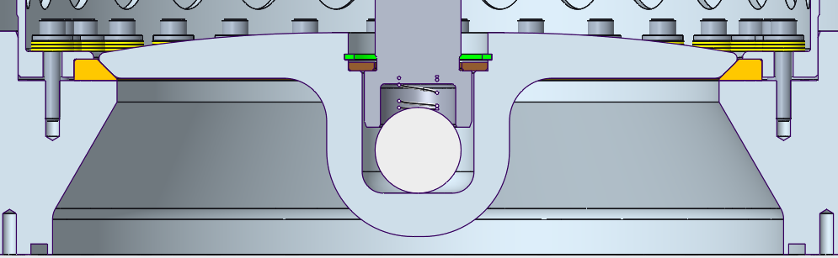
Figure 3 - Self-Aligning Seat and Poppet Design
- Test Valve Description
A series of development tasks have been conducted to study potential improvements to internal leakage rates. These tasks include 3 test valves (shown in Figure 4) to demonstrate the potential application to various configurations and sizes:
- A 3” isolation valve for liquid flows (similar to a fill and drain valve)
- A 3” relief valve for low temperature gas flows.
- An 8” pre-valve (similar to the engine isolation valve needed on a Nuclear Thermal Propulsion (NTP) engine).
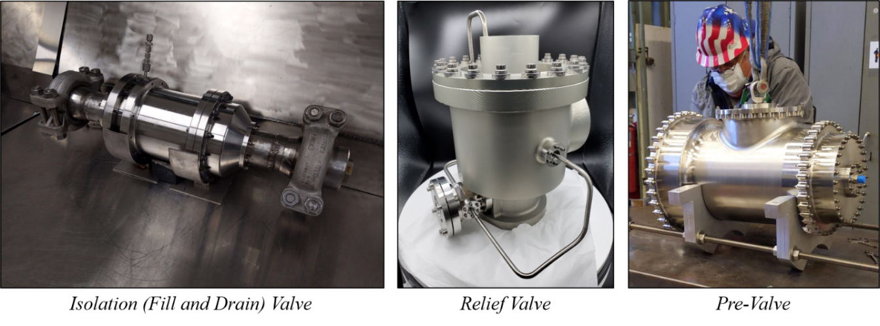
Figure 4 - Low Leakage Development Test Valves
These valves have been developed and are currently being tested at liquid nitrogen (LN2) temperatures, and are anticipated to undergo testing at liquid hydrogen (LH2) temperatures in late 2022.

NASA AST, Liquid Propulsion Valve Engineer. Valves, Actuators, and Ducts Design and Development Branch (ER14)
NASA AST, Liquid Propulsion Valve Engineer. Valves, Actuators, and Ducts Design and Development Branch (ER14)
NASA AST, Liquid Propulsion Valve Engineer (Retired). Valves, Actuators, and Ducts Design and Development Branch (ER14)
JSEG ESSCA, Engineering Specialist. Valves Actuators and Ducts Design and Development Branch (ER14)
NASA AST, Liquid Propulsion Valve Engineer. Valves, Actuators, and Ducts Design and Development Branch (ER14)
JSEG ESSCA, Valve Design and Development Engineer. Valves Actuators and Ducts Design and Development Branch (ER14)

