USING SECONDARY CRATERS TO ASSESS STRENGTH DIFFERENCES BETWEEN NEIGHBORING SURFACE UNITS. J. W. Conrad¹ and C. I. Fassett¹, ¹NASA Marshall Space Flight Center, Huntsville, AL 35805. (jack.w.conrad@nasa.gov)

Introduction: An issue with Martian remote sensing studies is the difficulty inferring surface and crustal material properties. For direct information we rely on the instruments of landed missions, like InSight, and extrapolate to other locations. To apply that extrapolation, we would like to use a methodology that can benefit from remote sensing data. We are exploring using secondary craters, which are often thought of as nuisances when determining accurate ages, to calculate crustal properties. The upside of secondary craters is that they are from ejecta blocks moving at relatively lower speeds, this lets them reside in a different crater scaling regime [1], one that is more sensitive to the crust’s effective strength (Y_{eff}) and porosity/internal friction (through the μ and K_{D} terms [A]).
Crater Scaling and Methodology: There are multiple parameters that influence the size of secondary craters, but we can measure craters in ways that isolate the dependence of crater size to just Y_{eff} (for the scope of this abstract, μ and K_{D} are assumed to a constant). We focus on secondary clusters and rays that have impacted into distinct but bordering geological units. Separate clusters/rays that are equidistant, but in bordering units are also considered. These secondaries can be used to determine Y_{eff} thanks to one important factor: all the secondaries in this cluster are from the same distant primary, and as a result, the ejecta velocity, median block sizes, and densities are expected to be the same (at least to first order). Thus, variations between secondary crater sizes in the two units are due to material property differences like Y_{eff}. Thanks to the steep size frequency distributions (SFD) of secondaries [2], observable secondary crater sizes are tightly clustered, and we can simply use differences in median secondary sizes between two geologic units to constrain the ratio of Y_{eff}. We are also able to use the SFD to check if our counted craters are secondaries and if the two crater counting areas are from the same source and thus have the same power law slope.
Our methodology needs to take care to identify secondaries near the contact region of two geologic units. Primaries will also change the crater distribution, but are typically easy to pick out based on degradation state or other morphological tells. For surveying sites of interest, we aim towards younger and/or larger primary craters, as those tend to have fresher and/or larger secondaries. Once we identify a primary of interest, we note the geologic boundaries surrounding it and if others have mapped out secondary fields in those areas. We then determine two counting areas at approximately same distance from the primary, one in each unit. Following that, we identify and count secondaries in each area, and our analysis uses those results.
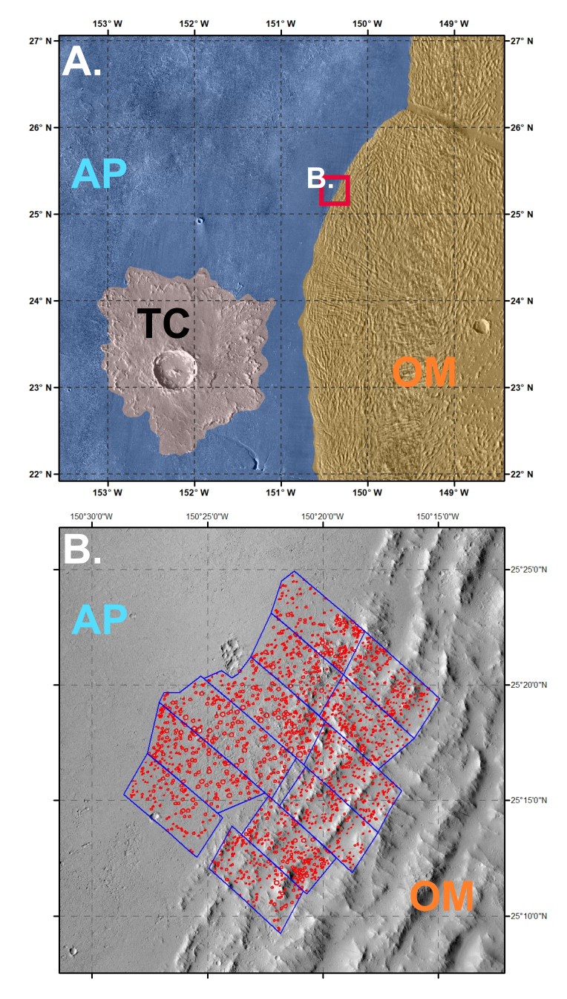
Figure 1: A. Map of TC study area, which includes the bordering units of Amazonis Planitia (AP; blue) and the Olympus Mon Aureole (OM; orange). Red square: The location of the bottom panel. B. Secondary crater counts for the two units. Divided up to test range effects, which are minimal.

Example Results: For our first attempt, we applied this technique on the secondary crater fields of Tooting Crater, Mars (TC; [3]). TC is a young complex crater that is situated in the Amazonis Planitia (AP) region and the surrounding area can be observed in Fig. 1A. TC has many fresh secondary craters that are relatively easy to count. In the northeast section of TC’s secondary field (found at -150.35˚ lon, 25.25˚ lat), there is a geologic unit boundary between AP and the Olympus Mons Aureole (OM) that contains a large number of secondaries from the same cluster across the boundary.
AP is a volcanic plain, like Elysium Planitia, which lies in the northern lowlands. OM, however, is a unit made from successive landslides off Olympus Mons that might be expected to be relatively weak compared to the AP volcanic plains. In addition, a recent observation of increased buried water ice in the unit [4], especially compared to AP, might drive the Y_{eff} value lower and the secondary sizes further from each other.
What we find when we count the secondaries in that cluster (Fig. 1), however, is that the median diameter of secondaries in AP is 96.5 m, much larger than those in OM, at 58.8 m. We can use [1] to translate from these median diameters to a Y_{eff} ratio of OM to AP if we set μ to be constant (~0.5). For secondary debris sizes around a tenth the mean crater size, we get a Y_{eff} ratio OM:AP of ~8.5. Implying that the crust of OM is considerably stronger than AP, which is the opposite of what we hypothesized based on the geology. This tells us that either our picture of the geology here is incomplete, or that another target property like porosity plays a bigger role in crater scaling.
As a second pass at this analysis technique, we looked at the region around Mojave crater (MC). MC is another young complex crater with an abundance of secondaries that can be easily sourced from it. The primary two geologic units surrounding the crater are Noachian highlands (e.g., mNH) and Hesperian transition (e.g., Ht). These respectively represent old, relatively unmodified, and younger, water modified units.
We found two study areas with equidistant clusters of MC secondaries in the two units. While not the same cluster bisected by the border as in the TC study, they do conform to the same SFC slope. The characteristic crater diameters in our counts are 275 m and 170 m for Ht, and 200 m and 110 m for mNH for the northern (Fig. 2B) and southern (Fig. 2C) aeras respectively. These values give us a Y_{eff} ratio mNH:Ht of ~4.9 and ~6.7 for the two areas. The variance is likely a product of the 30 km difference from MC and the inconsistency in using this technique on two slightly separated secondary clusters. The observed difference is hard to discredit though, and the calculated ratio implies that the Ht terrain is weaker than mNH (or less porous).
Future Work: In the future, we plan on testing differences in porosity and how that could explain the signal we observe in the secondaries of TC and MC. We also are attempting to expand to the Moon and Mercury.
Acknowledgments: J.W.C. is supported by an appointment to the NASA Postdoctoral Program at the Marshall Space Flight Center. This work was also done with support from the Solar System Workings program.
References: [1] Holsapple, K.A. and Schmidt, R.M. (1987) JGR: Solid Earth, 92(B7), 6350–6376. [A] Prieur, N. C. et al. (2017) JGR: Planets. 122, 1704-1725. [2] McEwen, A.S. and Bierhaus, E.B. (2006) Annl. Rev. EPS. 34:535-567. [3] Mouginis-Mark, P.J. and Boyce, J.M. (2012) Chemrie der Erde 72: 1-23. [4] Wilson, J.T. et al. (2018) Icarus, 299, pp.148-160.
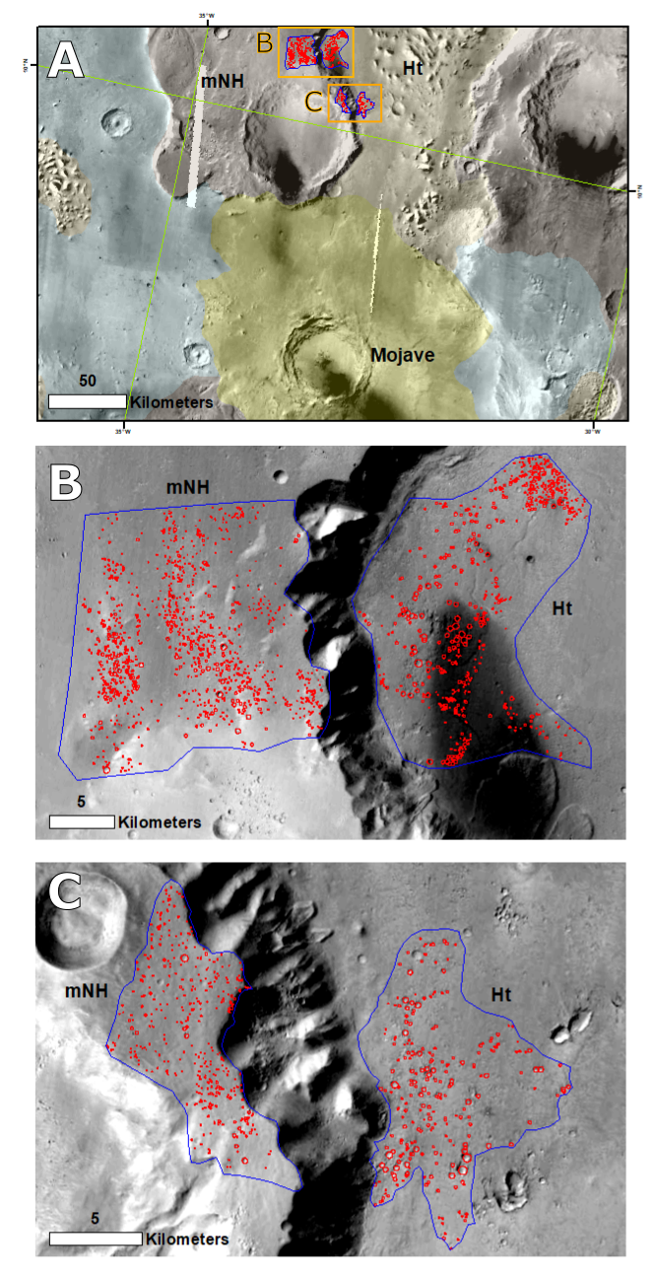
Figure 2: A. Map of the region surrounding Mojave Crater, Mars. Orange squares are the locations of the bottom panels. B. North location of interest. Multiple clusters and rays of secondaries are found equidistant from Mojave at 200 km. Left: mNH and Right: Ht. C. Same, but at 170 km. Craters are generally larger in the Ht terrain. Signal of weakness or lower porosity?

