A Generalized Dual-Frequency Ratio (DFR) Approach for Rain Retrievals

Robert Meneghini*
NASA, Goddard Space Flight Center, Greenbelt, MD

Liang Liao
Morgan State University and NASA Goddard Space Flight Center, Greenbelt, MD

Toshio Iguchi
University of Maryland and NASA Goddard Space Flight Center, Greenbelt, MD

*Corresponding Author:
Mesoscale Processes Laboratory (Code 612)
NASA Goddard Space Flight Center, Greenbelt, MD 20771
robert.meneghini-1@nasa.gov

ABSTRACT

The dual-frequency ratio of radar reflectivity factors (DFR) has been shown to be a useful quantity as it is independent of the number concentration of the particle size distribution and primarily a function of the mass-weighted particle diameter, D_{m}. A drawback of DFR-related methods for rain estimation, however, is the non-unique relationship between D_{m} and DFR. At Ku- and Ka-band frequencies, two solutions for D_{m} exist when DFR is less than zero. This ambiguity generates multiple solutions for the range profiles of the particle size parameters. We investigate characteristics of these solutions for both the initial-value (forward) and final-value (backward) forms of the equations. To choose one of among many possible range profiles of D_{m}, number concentration and rain rate, R, independently measured path attenuations are used. For the backward approach the possibility exists of dispensing with externally measured path attenuations by achieving consistency between the input and output path attenuations. The methods are tested by means of a simulation based on disdrometer-measured raindrop size distributions and the results are compared with a simplified version of the operational R-D_{m} method.

- Background and Introduction
One of the goals of rain retrievals using measurements from a dual-frequency radar is to estimate two parameters of the raindrop size distribution, RSD, at each range gate. Apart from the important microphysical information that these parameters provide, they can be used to infer bulk parameters of the rain such as rain rate and liquid water content. For satellite-based measurements, the approach offers the possibility of linking microphysical processes to different climatological regimes, changes in surface type (land versus ocean), orography and diurnal and seasonal variations over the globe. The basic idea that underlies the class of methods based on the dual-frequency ratio (DFR) is that the stronger non-Rayleigh backscattering at the higher frequency provides information on a characteristic size parameter of the distribution. In particular, the ratio of radar reflectivity factors at the two frequencies is independent of the number concentration of hydrometeors so that this ratio depends only on a characteristic size parameter of the distribution and, in the gamma parameterization of the RSD, the shape factor μ.
The basic equations for this approach were given in work related to the analysis of measurements from a dual-frequency airborne radar operating at X-band (10 GHz) and Ka-band (35 GHz) [Meneghini et al., 1992, 1997]. Iguchi and Meneghini [1995], Iguchi [2005] and Iguchi and Haddad [2020] showed that the idea could be formulated as coupled non-linear differential equations for parameters related to the number concentration and characteristic diameter of the raindrop distribution. Mardiana et al. [2004] and Rose and Chandrasekhar [2005, 2006] explored iterative solutions to the equations that do not depend on an external constraint of path-integrated attenuation (PIA). Liao and Meneghini [2005] and Adhikari et al. [2007] compared several constrained and unconstrained solutions to the problem. Seto and Iguchi [2011] provided a detailed analysis of the ambiguities that can arise in both the forward and iterative backward solutions. More recent work includes that of Gorgucci and Baldini [2016] who investigated a self-consistent numerical method and its application to data from the Micro-Wave Rain Radar and Le and Chandrasekhar [2014] in which linear models of N_{w} and D_{m} in rain are used to circumvent the dual-value problem described below and where the method was applied to data obtained from the JPL dual-frequency airborne radar. Seto et al. [2013] proposed a formulation that depends on the DFR and the Hitschfeld-Bordan [1954] method. The approach was later supplemented by estimates of path-integrated attenuation (PIA) from the Surface Reference Technique (SRT) [Seto and Iguchi, 2015]. In both studies, the goal was to develop an algorithm applicable to measurements from the Dual-frequency Precipitation Radar (DPR) onboard the GPM satellite [Hou et al., 2008; Hou et al., 2014].
One of the principal sources of error in the DFR method is the double-valued nature of the DFR-D_{m} relationship, where DFR = 10 log₁₀[Z(f₁)/Z(f₂)] = dBZ(f₁)-dBZ(f₂), f₁ and f₂ are the lower and upper frequencies of the radar, Z is the effective radar reflectivity factor, dBZ = 10 log₁₀(Z) and D_{m} is the mass-weighted diameter defined as the ratio of the fourth to third moment of the RSD. Unlike the situation in snow where the relationship between the DFR and a characteristic size parameter of the distribution is monotonic [Matrosov, 1992, 1998; Meneghini and Kumagai, 1994], in rain and for negative values of DFR, there are two solutions of the equation: DFR=g(D_{m}); that is, there are two values of D_{m} that satisfy the equation: D_{m}=g⁻¹(DFR). Moreover, it is sometimes the case that the estimated DFR is smaller than the theoretical value so that no solution for D_{m} is available. A modified DFR, DFR’, can be defined as DFR’ = dBZ(f₁)-ν*dBZ(f₂), ν∼0.6 to minimize the region of ambiguity [Liao and Meneghini, 2019b]; a drawback of the strategy, however, is that DFR’ depends on the particle number concentration, thereby sacrificing one of the main advantages of DFR.
Our approach here is to consider multiple solutions (i.e., multiple range profiles of the raindrop size distribution parameters and rainfall rate) that the double-valued DFR-D_{m} relationship generates and to select the ‘best’ solution either by using an external constraint such as the path-integrated attenuation or, in the case of the backward formulation, by imposing a self-consistency condition.
Although our focus is on the DFR approach, which is an analytical method that seeks to solve a set of equations, the operational algorithms for the DPR alone or combined with radiometer data are more accurately classified as optimal estimation methods [Seto et al., 2021; Iguchi et al., 2020; Grecu et al., 2016]. Earlier work along these lines includes Marzoug and Amayenc [1994], Haddad et al. [1997], Marzano et al. [1999] and Grecu et al. [2011]. These methods tend to be more robust with respect to the many error sources that exist. The DFR approach is subject not only to the DFR-D_{m} ambiguity but often to greater instabilities than the optimal estimation techniques. Analytical methods do have advantages, however, by dispensing with some of the assumptions used in the optimal estimation approaches thereby providing, in some cases, more accurate information on the raindrop size distribution and insight into relationships among the radar measurements and microphysical parameters.
One other relevant study is that of Iguchi and Meneghini (2022) who use a differential form of the dual-frequency equations to study their stability with respect to changes in the initial conditions. The study also proposes a new method of retrieval that employs both the DFR and the ratio of specific attenuations, dFk, k(f₁)/k(f₂). This approach mitigates the DFR-D_{m} ambiguity when the attenuation within the bin is sufficiently large. The relationship between this method and the approach taken here is the subject of ongoing investigation.

- Basic Considerations and Equations
- Dual-frequency Equations
The most common form assumed for the raindrop size distribution is the gamma which can be written [Ulbrich, 1983; Testud et al., 2001]:
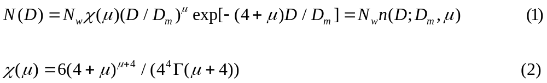
where D (mm) is the equivalent drop diameter of an oblate spheroid, D_{m} (mm) is the mass-weighted diameter (fourth over the third moment of N(D)), N_{w} (m⁻³ mm⁻¹) is the normalized intercept parameter and μ is the shape parameter. As the effective radar reflectivity factor, Z (mm⁶/m³), specific attenuation, k (dB/km), and rain rate, R (mm/h), are directly proportional to N_{w}, these quantities can be written
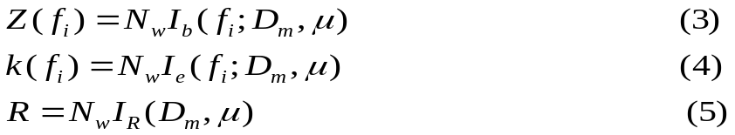
where f_{i}=f₁ or f₂, denote the lower and upper frequencies and are here taken to be the DPR frequencies of 13.6 and 35.5 GHz. Explicitly
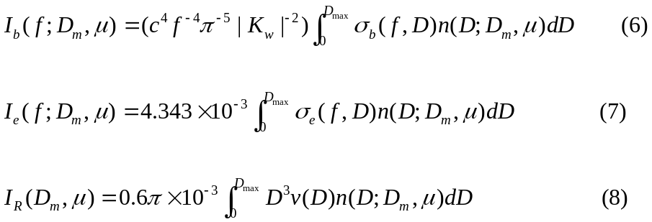
where σ_{b} (mm²) and σ_{e} (mm²) are the backscattering and extinction cross sections, c (m/s) is the speed of light and v(D) (m/s) is the drop fall speed expressed as a function of the particle diameter. The height dependence of v(D) is ignored in the simulations presented. Although σ_{b} and σ_{e} depend on temperature, the variations are small and will be neglected; the look-up tables used in the retrievals have been calculated for a temperature of 10C.
Another quantity of interest, which is directly related to the radar backscattered power, is the measured radar reflectivity factor, Z_{m}, which is related to Z and k by:
The notation dBZ=10 log₁₀(Z) and dBZ_{m}=10 log₁₀(Z_{m}) will be used in the following equations.
It is important to note that the integrals I_{b}, I_{e} and I_{R} can be computed at the outset as a function of D_{m}, for each value of μ. We assume that the drops are oblate spheroids with rotational axes along the vertical and a shape-size relationship given by Thurai et al. (2007) and that the viewing angle of the radar is near nadir. The scattering cross sections are computed by means of the T-matrix method [Mishchenko and Travis, 1998]. In large part, the retrievals amount to the repeated use of the look-up tables in concert with the set of measured radar reflectivity factors and path attenuations.
As its name indicates, the basis of the dual-frequency ratio method is the DFR itself, defined as
As this is independent of N_{w} it provides an estimate of D_{m} if μ is fixed or related to D_{m}. The DFR-D_{m} relationship for rain is shown in Fig. 1 for several values of μ where the Ku-band frequency is taken to be 13.6 GHz and the Ka-band 35.5 GHz. It can be seen from the figure that for DFR<0, and a fixed value of μ, two values of D_{m} yield the same DFR. As in previous work, we can simply take the larger of the two roots. This, however, leads to instabilities in the retrievals particularly at lighter rain rates. Use of both roots also provides more flexibility in the equations when the underlying RSD does not follow the gamma form of the distribution.
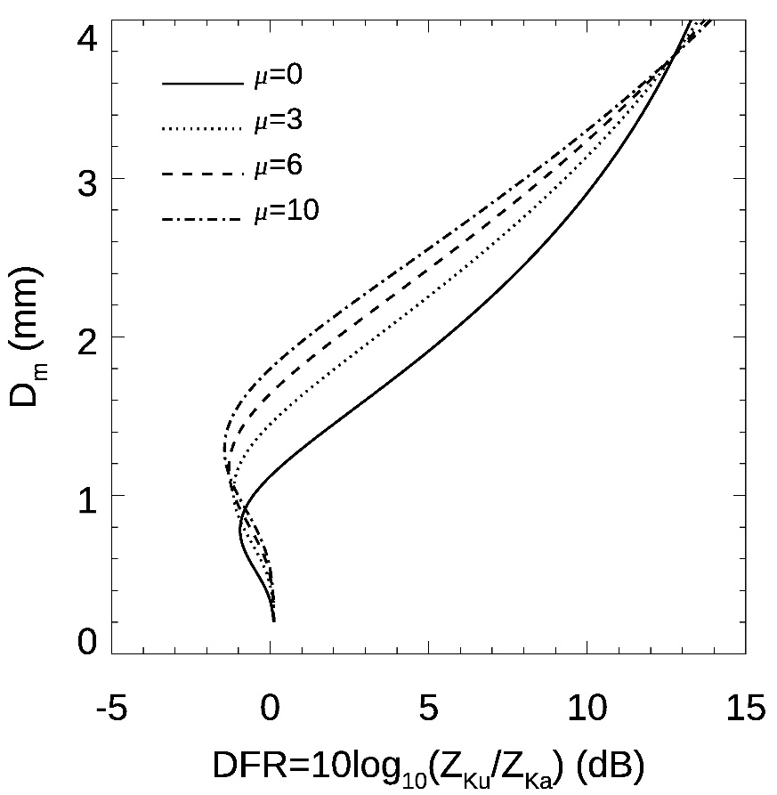
Fig. 1. D_{m} versus DFR(Ku, Ka) for a Gamma raindrop size distribution for several values of µ at a temperature of 10C.

The approach taken here is to generate all valid solutions to the equations and then choose one among them based primarily on the assumption that independent estimates of the path attenuation are available at both frequencies. As described later in the paper, for the backward recursion, a consistency condition between the input and output path attenuations can also be used to select a solution.
To get an idea of what is meant by a ‘valid’ solution, consider the extreme case where DFR_{min}<DFR<0 at each of the n gates that comprise the path from the storm top to the surface. At each range gate, two values of D_{m} will be consistent with the measured DFR so that a total of 2^{n} valid solutions can be generated. At the opposite extreme is the case where DFR>0 at all gates; in this case, a single D_{m} exists for each DFR so that only a single profile/solution is possible. Most cases will be intermediate to these extremes with the number of solutions between 1 and 2^{n}. It is also worth noting that the set of solutions depends both on the way the equations are solved (forward versus backward) and the μ value that is assumed. For example, the solution set using the forward or initial-value equations, described below, with μ=3, will generally be different than the solution set using the backward or final-value equations with μ=6, or, in fact, with μ=3.
Before discussing the generation of multiple solutions, we first describe the basic solution procedure. Because of the way the multiple solutions are generated, it is sufficient to assume that only a single root exists to the equation D_{m}=g⁻¹(DFR). For DFR<0, this can be either the upper or lower root; for DFR>0, only a single solution, considered the upper root, exists.
Consider first the forward or initial-value version of the method that proceeds from the storm top to the surface. The measured reflectivity factors over a path consisting of n range gates are written in the form: {Z_{m}(f₁,r_{j}), Z_{m}(f₂, r_{j}), j=1,…,n}. At the storm top, r=r₁, and as a first approximation, the Z_{m} are taken to be equal to the attenuation-corrected value (Z = Z_{m}) so that DFR(r₁)= dBZ_{m}(f₁,r₁)-dBZ_{m}(f₂, r₁). From this, an estimate of D_{m} is obtained. Next, D_{m} along with Z and an assumed value of μ yield an estimate of N_{w}. Note that the Z and I_{b} from either frequency give the same result. We choose f₁ so that, from (3):
From D_{m} and N_{w}, k(f₁) and k(f₂) can be obtained from (4). With the estimates of the specific attenuations, the estimated Z can be updated to dBZ(f_{i})=dBZ_{m}(f_{i})+2εhk(f_{i}) where h is the range resolution and ε is taken to be 0.5. The iteration can be continued until the Z values effectively become constant.
Having determined the values of Z(f₁), Z(f₂), k(f₁), k(f₂), D_{m} and N_{w} at the first gate, we can proceed to the second gate using the initial approximation dBZ(f_{i}, r₂)=dBZ_{m}(f_{i}, r₂)+2hk(f_{i}, r₁) to estimate DFR at this gate and the corresponding value of D_{m}. As in the first gate, D_{m} is used along with Z to estimate N_{w}; next, D_{m} and N_{w} yield k(f₁, r₂) and k(f₂, r₂). Updated estimates of dBZ can then be written: dBZ(f_{i}, r₂)=dBZ_{m}(f_{i}, r₂)+2hk(f_{i}, r₁)+2hεk(f_{i},r₂). This procedure can be iterated until stable estimates of the quantities are attained. For the calculations we have taken the number of iterations to be six. A change in this iteration number does sometimes modify the results but the changes are negligible with respect to the minimum-error and standard solutions, which are discussed below, and the differences between these solutions and the true profiles.
At the jth gate (j ≤ n) and for i=1 and 2, representing the Ku- and Ka-band frequencies, the equations become
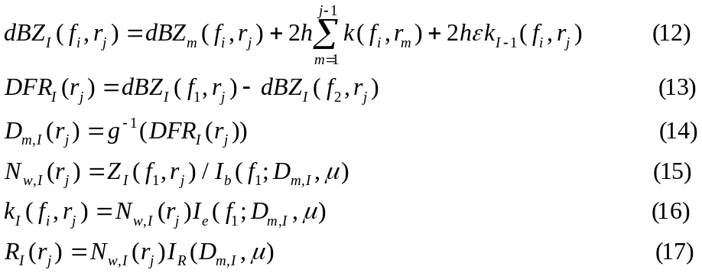
The subscript ‘I’ denotes the iteration number which begins at 1 and where k_{I=0}=0. For example, for the second iterate, I=2, the specific attenuations from the first iteration, at gate j, are used to update the Z estimates. Note that the summation term in (12) is taken to be zero for j=1.
A similar set of equations holds for the backward or final-value estimates but where the procedure begins at the last (n^{th}) gate and ascends along the path to the first gate. In this case, however, the dBZ(f_{i},r_{n}) (i=1, 2) are taken to be equal to the sum of dBZ_{m}(f_{i},r_{n}) and A_{m}(f_{i}) where A_{m}(f_{i}) are the independently-measured values of the path attenuation, obtained from methods such as the Surface Reference Technique (SRT) [e.g., Meneghini, et al., 2021]. The attenuations associated with each gate are successively subtracted from this sum so that at the jth gate, the equations for dBZ(f_{i}) become:
Equations (13)-(17) for DFR, D_{m}, etc. remain the same. Although the change in the equations from forward to backward is minor, the impact on the solutions is significant where the backward equations usually show a higher degree of stability as the path attenuations increase. The reason for this is that the path attenuations are bounded by the measured path attenuations, A_{m}(f_{i}), whereas the path attenuations obtained from (12) can increase without limit.
- Generation of Multiple Solutions
We are interested in generating all valid solutions of both the initial (12-17) and final-value (18, 13-17) equations. One way to do this is to define an integer that runs consecutively from 0 to (2^{n} – 1) where n is the number of range gates that comprise the down-looking path along which precipitation is viewed by the radar. For each of these values, the decimal number is converted to a binary which can be interpreted as an instruction to take either the lower root (when the binary digit is 1) or upper root (when the binary digit is 0) of the equation: D_{m}=g⁻¹(DFR). If the instruction calls for the lower root but only the upper root exists (i.e., DFR>0), then the instruction is considered invalid and discarded.
Consider the case where n=20 so that the counting variable, j, will range from 0 to 2²⁰-1. For example, for j=2¹⁰-1 =1023, or, in binary, 00000000000111111111, the instruction is interpreted as taking the upper root for the first 11 gates of the path, starting from the storm top, followed by taking the lower root for the last 9 gates. If the DFR over any of the last nine gates is greater than 0, however, the lower root does not exist and the instruction is considered invalid, i.e., a valid solution to the equations for this instruction does not exist. It is worth noting that valid instructions/solutions for the forward-going problem are typically not the same as valid instructions/solutions for the backward-going problem. Since the solution procedure is somewhat like a random walk, the number of solutions for the forward procedure tend to grow and diverge in magnitude as the recursion descends the column; for the backward problem, a similar proliferation of solutions can occur as the recursion ascends the column. Of course, the exact number of solutions depends on the input data. It should also be noted that, because of numerical instabilities and because of differences between the gamma model and disdrometer-measured DSD’s, which will be used to test the method, the true or input instruction often will not be chosen as the ‘best’ solution. In fact, it is sometimes the case that the input instruction yields no solution for either the forward or backward recursion.
In some cases, DFR(μ)<DFR_{min}(μ), that is, the DFR at a particular range gate is smaller than the theoretical minimum for the particular μ value that has been assumed. When this happens we can either discard the instruction or set D_{m} to D_{m}*(μ), the value of D_{m} for which DFR=DFR_{min}(μ). For the results shown below, we have used the first option since the discarded solutions rarely include a candidate for the ‘best’ solution as defined below.
To make these ideas more concrete, consider an example of a path consisting of three range gates and that, for the retrieval, we assume µ=3. For µ=3, T=10C the value of D_{m} at which DFR is minimum (-1.15 dB) is 1.03 mm and the value of D_{m} above which the DFR is positive is 1.45 mm [Fig. 1] so that if D_{m} is less than 1.03 mm, the lower root of the equation D_{m}=g⁻¹(DFR) should be chosen and if D_{m} is greater than this value, the upper root should be used. Assume further that the true values of D_{m} at these gates are: [0.4, 1.1, 1.6] mm so that the input or true instruction is [1, 0, 0], i.e., the lower root is to be chosen at the first gate and the upper root is to be chosen for the second and third gates. If the estimated values of DFR are negative for the first two gates and positive for the third then four valid instructions would exist out of a total of eight: {[0,0,0], [0,1,0],[1,0,0], [1,1,0]}. Note that all instructions ending in ‘1’ are eliminated because ‘1’ requires choosing the lower root; however, since DFR>0 at this gate, the lower root does not exist. If the DFR were negative at all gates, but greater than DFR_{min}, then the number of valid instructions would be eight whereas if the DFR were positive at all gates only a single valid instruction, [0,0,0], would exist. It is worth noting that the DFR values cannot be determined prior to the retrieval because they depend on the attenuation corrections which, in turn, depend on the choice of roots.
For the forward procedure, the path attenuation constraints are not imposed when generating the solutions. The constraints are used only in choosing the ‘best’ solution. In contrast, the backward procedure embeds the independent estimates of path attenuation into the basic equations as shown in (18). Despite this difference, both approaches yield path attenuations generated by the DSD parameters themselves. For each valid solution, indexed by q, the specific attenuations at each range gate, when summed over all gates, yield the (two-way) path integrated attenuations (PIA) at both frequencies given by
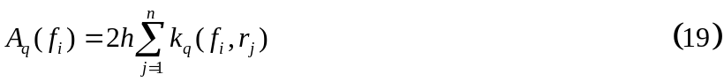
where q denotes the q^{th} valid solution/instruction and i indicates the frequency, f₁ or f₂. Note that corresponding to each pair of PIAs, {A_{q}(f₁), A_{q}(f₂)}, are profiles of {D_{mq}(r_{j}), N_{wq}(r_{j}), R_{q}(r_{j}), j=1,..,n}. Moreover, for the backward solution, the assumed or measured PIAs, A_{m}(f_{i}), used in (18) generally will not match those derived from the retrieved DSD parameters given by (19). Modifying the input PIAs to match the output PIAs is similar to the Mardiana et al. (2004) approach and will be described in section 3b.
To choose a particular solution among the, say, N_{S} valid solutions, we can define an error based on the root mean square (RMS) difference between the path attenuations at Ku- and Ka-band derived from the DSD parameters along the path, as defined in (19), and independent measurements of these quantities. We add to this a term that penalizes solutions with highly fluctuating values of D_{m} along the path. This penalty can be viewed as enforcing continuity of the D_{m} profiles. The error for each valid solution, denoted by the subscript q, is defined by the following equation:
This expression reduces to the usual RMS error for s_{Ku}=1 and s_{N}=0. Since the attenuation at Ka-band is typically about 6 times larger than that at Ku-band, the scale factor s_{Ku} can be used to give the two terms approximately equal weights by taking s_{Ku}=6². The final term in (20) consists of a product of the scale factor s_{N} and the quantity N_{trans} which is the number of 0 to 1 and 1 to 0 transitions in the instruction. In the example given earlier, with the instruction 00000000000111111111, N_{trans}=1, whereas for the instruction 10101010101010101010, N_{trans}=19 and equal to the maximum number of transitions for n=20. Nominally, s_{N} is set to 0.1; a change to 0 or 0.2 typically produces only minor changes in the profiles. Nevertheless, exceptions to this rule exist.
As already noted, the solution sets that are generated for the forward and backward equations will generally be different, although in many cases, there is a significant overlap. The solution sets will also change for different values of the parameter μ. For the examples in the paper, µ is set to 3. Changing this to 6 usually has a minor impact on the solutions. However, a significant loss of accuracy usually occurs if µ is set to 0.
Note finally that the single solution generated in previous work uses only the upper root of the D_{m}-DFR relationship; in the context of this paper, this corresponds to an instruction consisting of all zeros (bigger roots). In section 3, we will distinguish this ‘standard solution’ from the minimum-error solution given by (20). In some cases, these are identical; in other cases, they differ but both exist; in other cases, only the minimum-error solution exists.
- The R-D_{m} Method
To assess the behavior of the DFR approach, it is instructive to compare its performance to that of the R-D_{m} method which is used in the operational version of the DPR retrieval algorithm. A comprehensive description of the method has been given by Seto et al. (2021). Our intention here is to give a simplified version of the method with focus solely on the rain retrieval problem.
A straightforward way to present the method is to begin with the assumption of an R-D_{m} relationship with an adjustable parameter
Equating (5) and (21) yields an N_{w}-D_{m} relationship that can be written:

where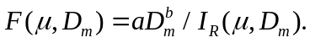 The relationship between N_{w} and D_{m} is usually expressed in the form of a power-law but the expression in (22) is sufficient for present purposes. Next, we use the equation that expresses the measured reflectivity factor, Z_{m}, in terms of the true reflectivity factor, Z, and an attenuation factor. This is given by (9). Taking 10 log₁₀ of both sides of this equation and substituting (3) and (4) gives:
Substituting (22) into (23) yields an equation that depends only on D_{m}, µ and the adjustable parameter :

For a fixed µ, , and frequency, f, (24) can be solved recursively either in the forward or backward direction. For the backward solution, the integral in (24) is written as the difference of integrals from (0, r_{n}) and (r, r_{n}) where r_{n} denotes the range to the last gate. Recognizing that the first integral represents the measured path attenuation, A_{m}(f), then (24) becomes:

In practice, only the forward-going method is used. An important feature of this equation is that it can be applied to both single and dual-frequency data [Seto et al., 2021]. For Ku-band only and dual-frequency data, (24) is applied to the Ku-band data; the difference between the Ku-band and dual-frequency estimates arises only in the constraints that are used. For single-frequency Ka-band data, (24) is applied to the Ka-band data.
Beginning at the first gate, and for a fixed value of , (24) can be solved for D_{m}; R and N_{w} then follow from (21) and (22), respectively. From N_{w} and D_{m}, the specific attenuation, k(f), can be computed from (4). Having determined these values at the first gate, the procedure can be continued to the second gate and so on until the full profiles of (D_{m}, N_{w}, R) are obtained for a given . The choice of the best has been described by Seto et al. (2021) and Liao and Meneghini (2019a) where conditions are imposed on the pdf of log() (with a maximum at the nominal value where log()=0), the closeness of the path attenuation estimate(s), derived from the DSD parameters, to match the externally measured value(s), and, in the case of dual-frequency data, the accuracy to which the dBZ_{m} profiles at Ka-band, as estimated by the DSD parameters, match the measured values. It is worth noting that for the dual-frequency case, the attenuation constraint is the differential path attenuation as derived from the dual-frequency SRT because this quantity typically can be obtained more accurately than estimates of attenuation from the single-frequency version of the method.

- Results
In this section, we present examples from the forward/backward recursion and the R-D_{m} method. For the results here, the measured or input path attenuations are taken to be equal to the true values. The shape parameter, µ, is fixed at 3. In evaluating (20) we choose s_{Ku}=1 and s_{N}=0.1.
The input profiles of the measured reflectivity factor, Z_{m}, at Ku- and Ka-band are generated from a sequence of twenty temporally consecutive raindrop size distributions (RSD) which are taken to represent the RSD along a 5 km rain column with 0.25 km range gates. A set of 500 profiles were produced from 5-minutely averaged RSDs. These data are compilations of measurements made by the PARSIVEL2 disdrometers during the Iowa Flood Studies (IFloodS) field experiment in eastern Iowa from 1 May to 15 June 2013, the Mid-latitude Continental Convective Clouds Experiment (MC3E) from 22 April–6 June 2011 near Lamont, Oklahoma [Jensen et al., 2016], and measurements at the NASA Wallops Flight Facility, located in Wallops Island, Virginia from May 2013 to February 2014 [Liao et al., 2014].
From each RSD, D_{m}, N_{w}, R, k(f_{i}), Z(f_{i}) and Z_{m}(f_{i}), A(f_{i}), i=1, 2, are computed. The two-way path attenuation, A(f_{i}), is equal to the sum of the k(f_{i}) multiplied by twice the gate spacing: 2*0.25 km. The inputs to the retrievals are the measured radar reflectivity factor profiles, Z_{m}(f_{i}; r_{j}), i=1,2; j=1,..,20 and the measured path attenuations A_{m}(f_{i}). As noted above, for the results in 3a, the true and measured path attenuations are taken to be equal.
a. General Results
Fig. 2 shows an example of a moderate rain case where the Z_{m} profiles (in dB) are given by the dashed-dotted dark blue lines for Ku-band on the left and Ka-band on the right. The true reflectivity-factor profiles, Z, derived from the input RSDs are given by the black lines. As noted in the previous section, multiple solutions are generated for the forward recursion (top plots) and backward recursion (bottom plots). For this example, the number of forward solutions, N_{F}, is 20 while the number of backward solutions, N_{B}, is 4. For each of the N_{F} and N_{B} solutions, range profiles of Z(f_{i}), k(f_{i}), D_{m}, logN_{w}, R, as well as path attenuations, are generated. (Since all logarithms are taken to the base 10, the subscript ‘10’ is suppressed.) The solution that yields the smallest error, as defined by (20), is taken as the minimum error result and represented in the panels by the heavy dotted red lines. The remaining estimated Z profiles are represented by the light blue solid lines. These profiles are visible only in the Ka-band forward Z plots (upper right) since the four backward profiles are nearly identical (bottom plots) as are the twenty profiles for the forward Ku-band results (upper left). Notice that the extent of the light blue lines in the upper-right panel increases toward the bottom of the column, indicating that the solutions tend to diverge as the forward recursion descends the path. It can be seen in this case that most of the estimated Z profiles overestimate the true Z profile.
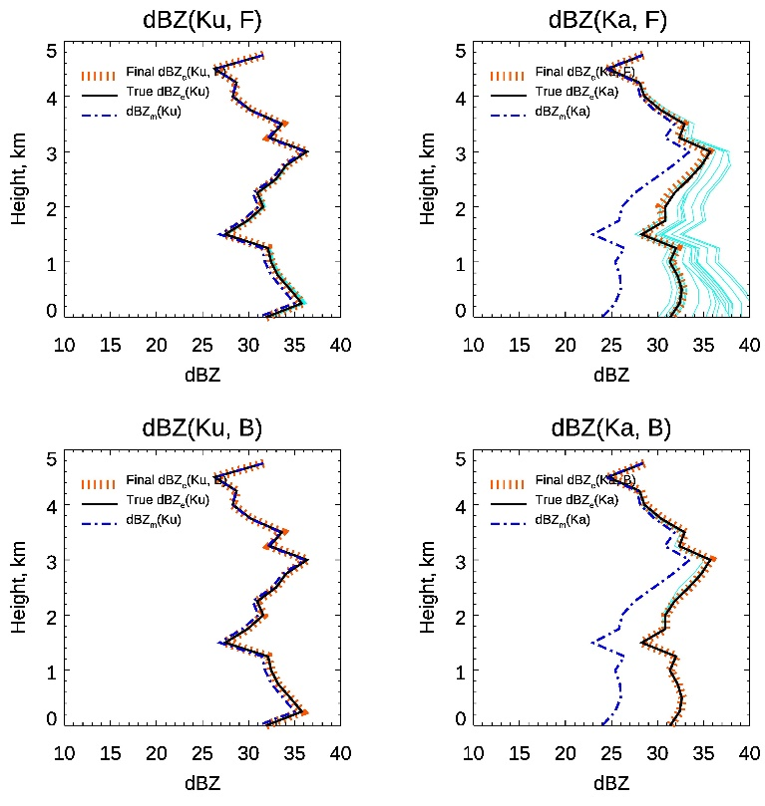
Fig. 2. dBZ_{m} and dBZ range profiles at Ku-band (left) and Ka-band (right). Forward recursion and backward recursion results are shown in the top and bottom panels, respectively. Blue dashed-dotted lines represent the dBZ_{m} input data while the black lines represent the true dBZ profiles. The heavy dotted red lines represent the estimated dBZ profile from the minimum-error solution. The light blue lines visible in the upper-right panel represent the dBZ(Ka) profiles from the solutions to the forward recursion.
The behavior of the backward profiles can be understood by noting that these solutions are constrained to be equal to dBZ_{m}(f_{i})+A_{m}(f_{i}) at the lowest gate; since A_{m}(f_{i}) is taken to be equal to the true value, the sum is equal to the true value, dBZ(f_{i}). Although the backward solutions sometimes diverge higher in the column, in this case, the four solutions give nearly the same profile. One other point worth making is that for this case, the standard solution exists for both the forward and backward recursion. As noted earlier, the standard solution is obtained by taking only the bigger root of the equation: D_{m}=g⁻¹(DFR) at all range gates. An absence of the standard solution indicates that the choice of the larger root results in DFR becoming less than DFR_{min} at some point along the path so that the solution is rejected. (For the forward solutions, the other reason for the absence of the standard solution is that the attenuations increase without bound. This is not the case for this example.)
The forward recursion results for this case are shown in Fig. 3. The path attenuations at Ku- and Ka-band are shown in the upper-left panel where the small black circles represent the PIAs for the 20 forward solutions. The true PIA(Ku, Ka) is represented by the ‘+’ sign while the PIA corresponding to the minimum-error solution is given by the blue circle, which for this case is nearly coincident with the true PIA . The PIA corresponding to the standard solution is represented by the red circle.
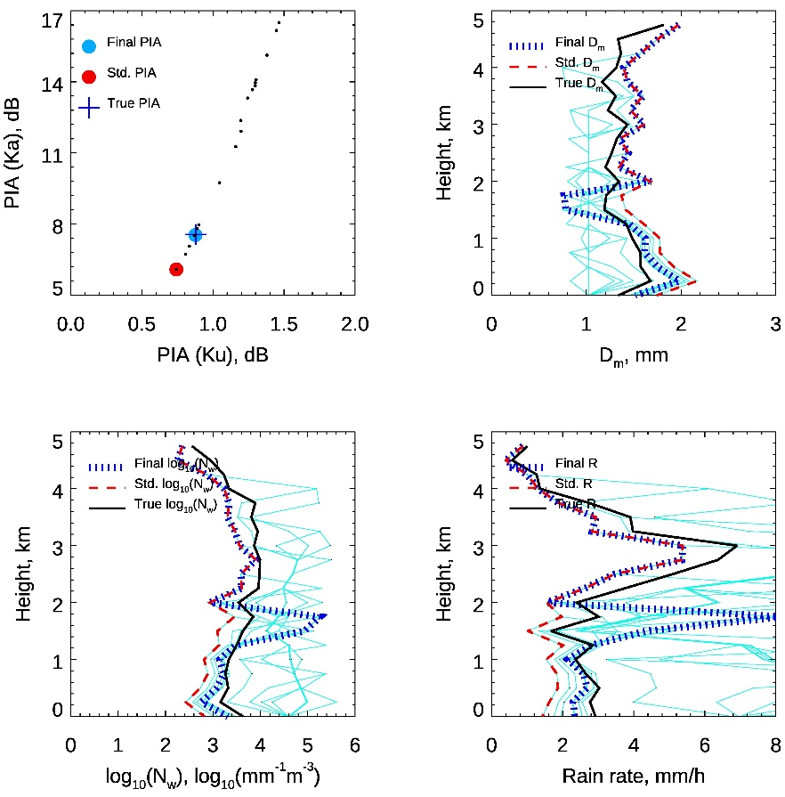
Fig. 3. Results from the forward recursion for the Z_{m} input profiles shown in Fig. 2. The 20 small black circles in the upper-left panel represent the PIA estimates from the 20 solutions. The blue circle and ‘+’ represent the estimated and true path attenuations respectively. The red circle represents the PIA from the standard solution. The heavy blue dotted lines in the remaining panels show the selected (minimum error) profiles of D_{m}, logN_{w} and R while the red curves represent the results from the standard solution. The black lines represent the true profiles while the light blue solid lines represent the profiles for the remaining 18 solutions.

The other panels in Fig. 3 show the results for D_{m} (upper right), logN_{w} (lower left) and R (lower right). In all cases, the black lines represent the true profiles as computed directly from the set of input raindrop size distributions. The heavy dotted blue lines represent the minimum-error solution from (20), while the red dashed lines represent the results from the standard solution. When it exists, as in this case, the standard solution yields the smallest PIA, the highest D_{m} and lowest logN_{w} and R profiles. In this case the standard solution provides more accurate results than the minimum-error solution. In particular, the underestimates of D_{m} and overestimates in logN_{w} and R at a height of 1.5 km that are seen in the minimum-error solution (blue) are absent in the standard solution (red), which tends to follow the input (black) profile well. What the error condition in (20) provides is the DSD-generated PIA that is ‘closest’ to the input PIA. Satisfaction of this condition often, but not always, leads to D_{m}, logN_{w} and R profiles close to the input values.
The set of light blue lines in the panels represent the profiles generated by the remaining 18 profiles and define the extent of D_{m}, logN_{w} and R profiles that are generated from the input Z_{m} profiles for the initial value problem. The largest PIA in the upper-left panel is associated with the lowest D_{m} and highest N_{w} and R profiles whereas the smallest PIA, which in this case is the standard solution, corresponds to the highest D_{m} and lowest logN_{w} and R profiles. These correspondences are a direct consequence of the retrieval where the bigger D_{m} root yields a smaller logN_{w} to satisfy the Z constraint. The higher D_{m}/lower logN_{w} combination yields smaller values of specific attenuation so that the path integrated attenuations are lower. Conversely, the lower D_{m}/higher logN_{w} combination yields larger values of the specific attenuation and higher path attenuations.
The PIA bias problem for the forward recursion can be explained by the PIA results in the upper-left panel of Fig. 3. The allowable solutions for the forward or initial-value problem depend only on the Z_{m}(f_{i}) profiles and are independent of the PIA constraint or choice of s_{N}, s_{Ku} in (20). If the measured PIA, s_{N} or s_{Ku} is changed, the choice of solution generally will change. This situation is shown schematically in Fig. 4 where for values of the measured PIA, A_{m}, above the line U, the solution associated with the highest attenuations will be selected and for values of A_{meas} below the line L, the solution associated with the lowest attenuations will be chosen. For some profiles, the PIA solution set cannot be approximated by points along a straight line; nevertheless, the idea that the procedure selects the solution ‘closest’, as defined by the minimum of (20), to the measured/input PIA remains valid.
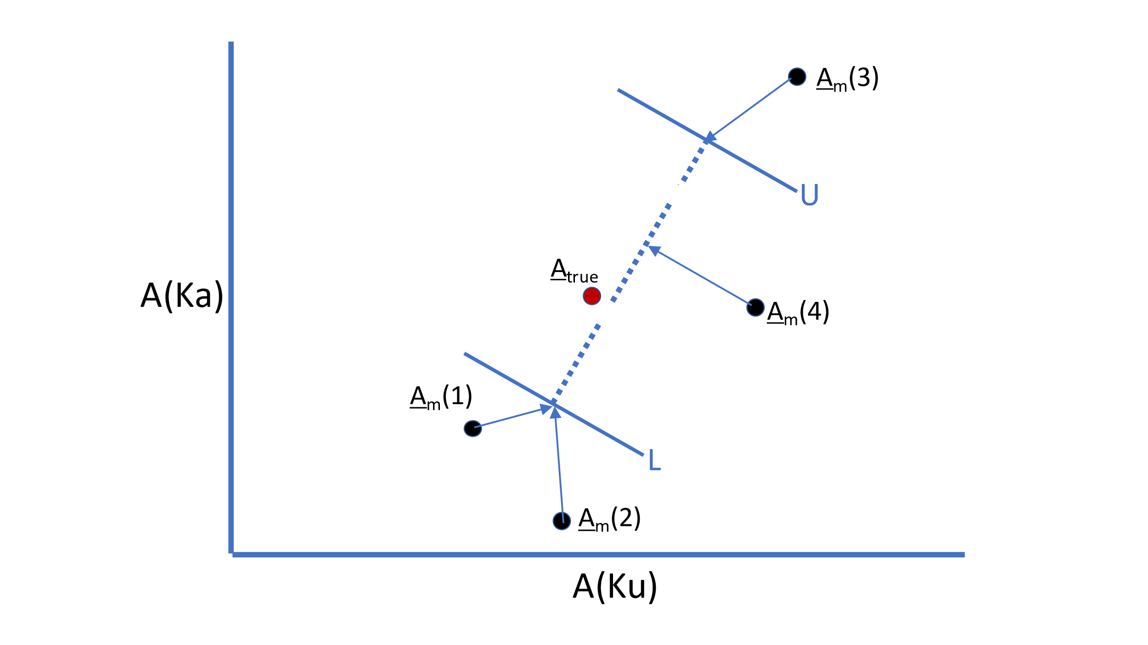
Fig. 4. Schematic of solution choice for the forward recursion. The solution set is represented by the points along a straight line in the A(Ku)-A(Ka) plane. For measured path attenuations, A_{m}, below the line L, e.g., A_{m}(1), A_{m}(2), the solution with the smallest path attenuations is chosen; for A_{m} above the line U, e.g., A_{m}(3), the solution with the highest path attenuations is chosen. For intermediate values of A_{m}, e.g., A_{m}(4), the solution ‘closest’ to A_{m}, as defined by (20), is chosen.

Results for the backward recursion for this case are shown in Fig. 5 using the same format as in Fig. 3. In this case, the 4 solutions are tightly clustered in PIA space and the minimum error and the standard solutions are the same. Despite some discrepancies between the true and retrieved data in this case, the profiles are generally accurate. It is worth noting that the minimum error solution is not the solution closest to the measured/true PIA. This is a consequence of the fact that s_{N} in (20) has been set to 0.1. By setting s_{N} to 0, the minimum error solution moves to the black circle closest to the true PIA. This results in slightly modified D_{m}, logN_{w} and R profiles and differences between the standard and minimum error solutions.
The corresponding R-D_{m} results for this profile are shown in Fig. 6 where the retrievals can be seen to be somewhat less accurate than the backward estimates of Fig 5. To quantify this, we compute the correlations and RMS errors between the true and estimated profiles for the forward, backward and R-D_{m} approaches for R, logN_{w}, and D_{m}, respectively. Specifically, we use the notation ρ_{M}=[c₁, c₂, c₃] to denote the correlation coefficients for method ‘M’ between the true and estimated rain rate profiles, c₁; the true and estimated logN_{w} profiles, c₂; and the true
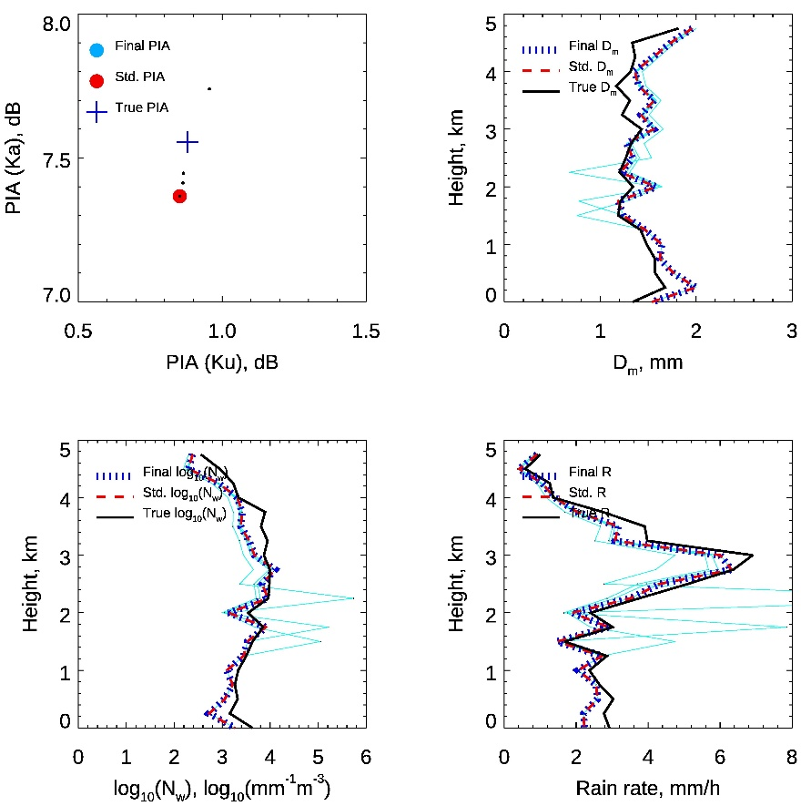
Fig. 5. Results from the backward recursion for the Z_{m} input profiles shown in Fig. 2. The 4 small black dots in the upper-left panel represent the PIA estimates from the 4 solutions where ‘+’ and the blue circle represent the PIA of true/input path attenuation and the path attenuation of the selected (minimum error) solution. The heavy blue dotted line in the remaining panels show the corresponding minimum error profiles of D_{m}, logN_{w} and R. The red lines represent the standard solution results which in this case are identical to the minimum error results. The black lines in the D_{m}, logN_{w} and R panels represent the true values; the light blue solid lines represent the set of profiles for the remaining 3 solution sets.
and estimated D_{m} profiles, c₃. The method ‘M’ can refer to the backward recursion, ‘B’, forward recursion, ‘F’, or the R-D_{m} method, ‘RD’. A similar notation is used for the RMS error. For the profiles shown in Figs. 3, 5, and 6, we obtain:
ρ_{B}=[0.98, 0.91, 0.86], RMS_{B}=[0.31, 0.2, 0.12]
ρ_{F}=[0.61, 0.65, 0.74], RMS_{F}=[1.54, 0.55, 0.21]
ρ_{RD}=[0.7, 0.21, 0.45], RMS_{RD}=[1.18, 0.39, 0.15]
The low correlation value, 0.21, of logN_{w} obtained from the R-D_{m} method will be discussed below.
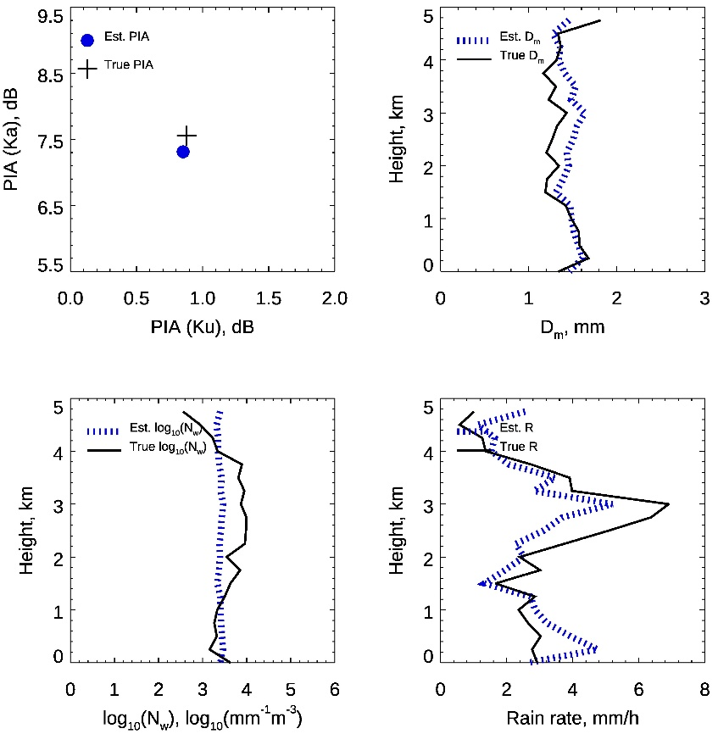
Fig. 6. Results of the R-D_{m} method for the input data shown in Fig. 2. The upper-left panel shows the true (+) and estimated (blue circle) path attenuations. The true D_{m}, logN_{w} and R profiles shown by the black lines are identical to those in Figs. 3 and 5. Results from the method are shown by the heavy dotted blue lines.
A second example of Z_{m}, Z profiles is shown in Fig. 7. In this case, the Z_{m}, Z, rain rates and path attenuations are somewhat larger and a separation between Z_{m} and Z can be seen at both Ku- and Ka-band. For the forward recursion results shown in the top panels for Ku (left) and Ka (right), there are 49 solutions (N_{F}=49) which include the standard solution. The minimum-error Z profiles are shown by the heavy red dotted lines which are close to the true profiles (black lines). The light blue lines in the upper-right panel (Ka-band, forward) represent the 48 remaining profiles of Z and show a clear divergence of some of the solutions especially near the bottom of the column. The number of backward solutions in this case is only 3 where all solutions yield corrected Z profiles nearly identical to the true Z profile.
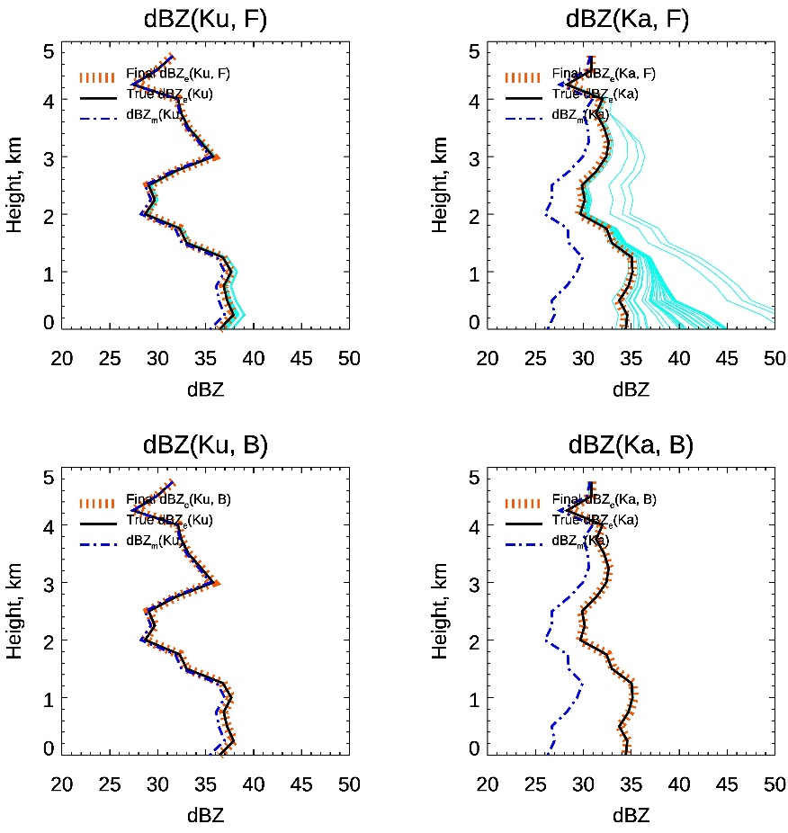
Fig. 7. dBZ_{m} and dBZ range profiles for Ku-band (left) and Ka-band (right). Forward recursion and backward recursion results are shown in the top and bottom panels, respectively. Blue dashed-dotted lines represent the dBZ_{m} input data while the black lines represent the true dBZ profiles. The heavy dotted red lines represent the estimated dBZ profiles from the minimum error solution. The light blue lines visible in the upper-right panel represent the Z(Ka) profiles from the solutions to the forward recursion.
The forward recursion results for this case are shown in Fig. 8. As in Figs. 3 and 5, the upper left panel shows the PIAs corresponding to the standard solution (red circle), the minimum error solution (blue circle) and the true value (‘+’). Of the 49 solutions, represented by the small black circles, 30 solutions yield Ka-band path attenuations greater than 14.5 dB and fall outside the plotting area. Profiles of D_{m}, logN_{w} and R, represented by the heavy blue dotted lines, correspond to the minimum-error solution and show discrepancies relative to the true profiles shown in black. For the standard solution, given by the red dashed lines, the errors are smaller than for the minimum-error solution because of the absence of the discontinuity in the D_{m}, logN_{w} and R profiles around 2 km that appear in the minimum-error profiles. The light blue solid curves that represent the profiles associated with the other solutions show that the errors in D_{m}, logN_{w} and R can become large when the estimated PIA is positively biased, leading to underestimates in D_{m} and overestimates in logN_{w} and R.
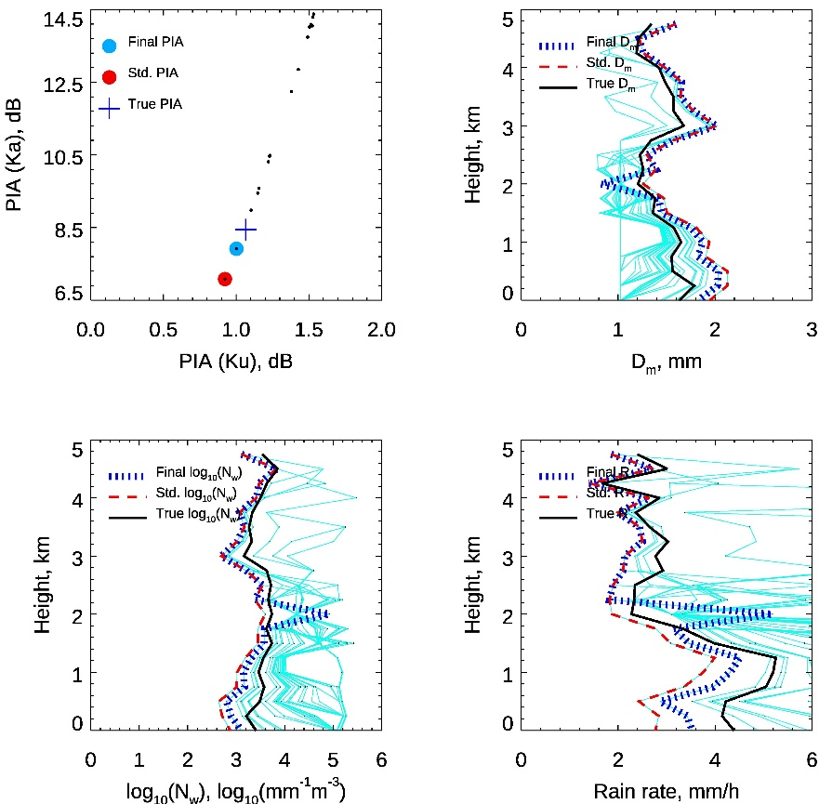
Fig. 8. Results from the forward recursion for the Z_{m} input profiles shown in Fig. 7. The small black circles in the upper-left panel represent the PIA estimates from a portion of the 49 solutions where ‘+’ represents the true/input path attenuations. The blue circle represents the path attenuations corresponding to the minimum error solution while the red circle represents the path attenuations corresponding to the standard solution. The heavy blue dotted lines in the D_{m}, logN_{w} and R panels show the corresponding minimum-error profiles of D_{m}, logN_{w} and R. Profiles corresponding to the standard solution are represented by the red dashed lines. Black lines represent the true values while the light blue solid lines represent the profiles for the remaining solutions.
The backward recursion results are given in Fig. 9. Unlike the forward solutions, the path attenuations, corresponding to the 3 backward solutions, and represented by the small black circles in the upper left panel, are tightly clustered with variations in the Ka-band PIA less than 0.5 dB. In contrast to the forward case, the standard solution does not exist for the backward so the corresponding results (red circle and red lines) are not available. As in previous plots, the blue circle represents the minimum-error solution. As in the forward case, the minimum-error solution for backward shows a discontinuity in the D_{m}, logN_{w} and R profiles at the height of 2 km. Results from the R-D_{m} method are shown in Fig. 10. Although the logN_{w} profile shows deviations from the input profile at lower heights, the D_{m} and R yields relatively accurate results throughout the profile.
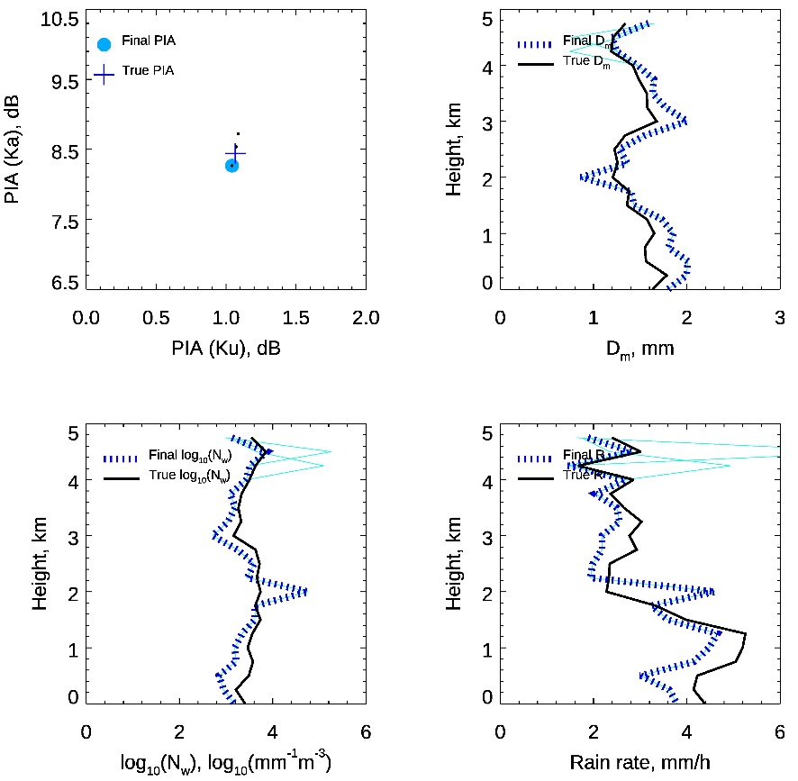
Fig. 9. Results from the backward recursion for the Z_{m} input profiles shown in Fig. 7. The black dots in the upper-left panel represent the PIA estimates from the 199 solutions where ‘+’ represents the true path attenuations. The blue circle represents PIA of the minimum-variance solution. The heavy blue dotted line in the D_{m}, logN_{w} and R panels show the corresponding profiles of D_{m}, logN_{w} and R. The black lines represent the true values while the light blue solid lines represent the profiles corresponding to the remaining 198 solutions. The standard solution (red circle and red lines) does not exist for this case.
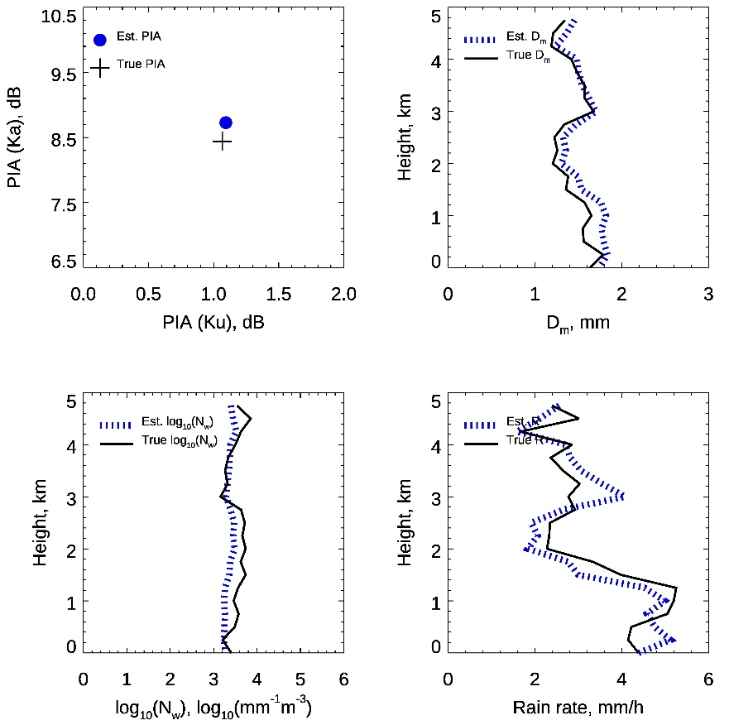
Fig. 10. Results of the R-D_{m} method for the input data shown in Fig. 7. True (+) and estimated (blue circle) path attenuations are shown in the upper-left panel. The D_{m}, logN_{w} and R profiles, shown in black, represent the true profiles and are identical to those shown in Figs. 8 and 9. Results from the method are represented by the heavy dotted blue lines.

Using the notation introduced earlier, we obtain for this case the following results:
ρ_{B}=[0.79, , 0.74, 0.91], RMS_{B}=[0.68, 0.32, 0.16]
ρ_{F}=[0.68, 0.74, 0.9], RMS_{F}=[0.84, 0.36, 0.17]
ρ_{RD}=[0.85, 0.61, 0.93], RMS_{RD}=[0.61, 0.15, 0.07]
Note that the R-D_{m} results for this case are more accurate than either the forward or backward recursion with correlations in R and D_{m} of 0.85 and 0.93, respectively, in contrast to those from the backward recursion given by 0.79 and 0.91, respectively, and lower values from the forward. The RMS errors from the R-D_{m} method for R, logN_{w} and D_{m} are also smaller than those obtained from the forward and backward recursions. It is only in the correlation of logN_{w} where the results from the R-D_{m} are poorer than those from the backward and forward recursions.
The reason for the low correlations in logN_{w} for the R-D_{m} method seems to arise from the fact that the N_{w}-D_{m} relationship is fixed to within a constant. Although this constant is adjusted by using constraints obtained from the PIA and consistency between the Ku- and Ka-band data, the exponent in this relationship is not adjustable so that the method is unable to track deviations from a fixed-slope linear logN_{w}-logD_{m} relationship. An additional example of this is shown in Fig. 11 where the result from the backward recursion (N_{B}=6) is compared with that from the R-D_{m} method. It is worth noting that, unlike the previous cases, the standard solution for this profile exists neither for the forward nor the backward recursion. On the left-hand plots of Fig. 11, the backward-derived profiles of D_{m}, logN_{w} and R are generally close to the true profiles despite some fluctuations. For the R-D_{m} result on the right, however, the retrieved logN_{w} profile fails to track the decrease in logN_{w} in the 3-4 km height range, which results in an overestimation of the rain rate over this range.
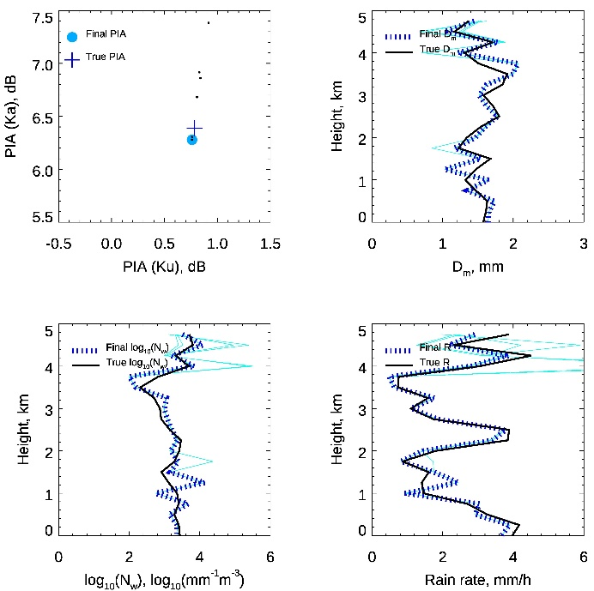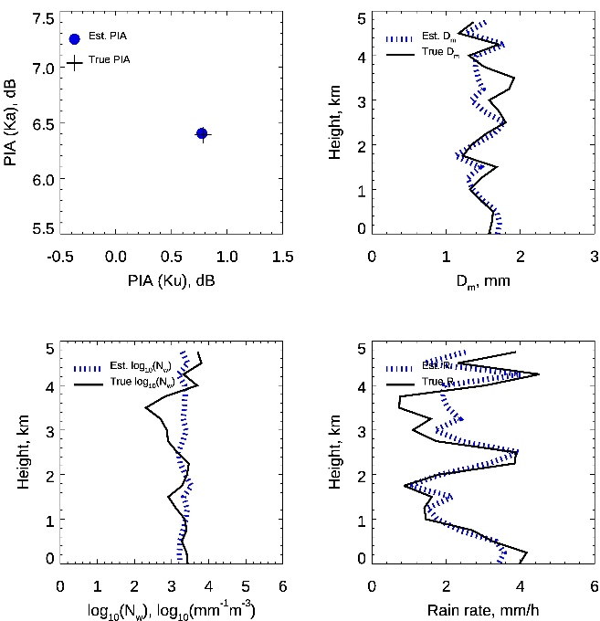
Fig. 11. a. Backward recursion (left panels) and b. R-D_{m} method (right panels) for a non-uniform logN_{w} range profile.

The statistics for this example are given below, including those from the forward recursion which are not pictured. Even though the R-D_{m} method shows no correlation (-0.06) in logN_{w}, the RMS error (0.39) is essentially the same as that of the forward (0.39) and backward (0.37) recursions and yields an accurate mean estimate of this parameter over the profile.
ρ_{B}=[0.95, , 0.70, 0.69], RMS_{B}=[0.41, 0.37, 0.20]
ρ_{F}=[0.92, 0.73, 0.71], RMS_{F}=[0.59, 0.39, 0.21]
ρ_{RD}=[0.83, -0.06, 0.58], RMS_{RD}=[0.73, 0.39, 0.18]

b. Backward Recursion with a Consistency Constraint
In the foregoing examples, the measured PIA was taken to be equal to the true PIA. When this assumption is removed, the accuracy of the retrievals usually degrades. As noted in the previous section, the effect of PIA biases on the forward recursion is relatively easy to understand as the solutions are independent of the PIA constraint; that is, the PIA has no effect on the set of solutions and is used only in selecting the ‘best’ solution. This is not the case with the backward recursion where the estimated/measured path attenuations are embedded in the basic equation (18).
A study of the PIA bias effect on the backward solutions brings to light the contradictory situation in which the PIA associated with the measured or input PIA, i.e., the A_{m} used in (18), does not match the PIA computed from the estimated drop size distribution parameters. We do, however, often find a good match between the output and input PIA when the input PIA is at or close to the true PIA. This suggests that a solution can be found with the backward recursion if we adjust the input PIA so that it matches the output or DSD-generated PIA.
This idea is reminiscent of that proposed by Mardiana et al. (2004) where an iteration is performed so that a somewhat similar kind of consistency is achieved between the input and output data. A detailed analysis of the conditions under which the backward iterative method converges to the correct solution has been given by Seto and Iguchi [2011]. The present study differs from the Mardiana et al. approach in two respects. In earlier work, only the bigger-root solution was considered so that for each input PIA only a single solution, at most, is obtained. In the present work, multiple solutions (including the no-solution case) can be generated for each input PIA. To handle this situation, we use (20) to obtain the minimum error solution for each input. For N such PIA inputs, we select the minimum of these N minima to obtain the result. This is the minimum error with respect to changes in the input PIA and the minimum error among the multiple solutions generated for each input PIA.
A second difference from the Mardiana et al. approach is that an iteration is not used but rather, a simple search in PIA space about the nominally true value. In practice, estimates of the PIA can be obtained with the SRT [Meneghini et al., 2021], the Hitschfeld-Bordan [Hitschfeld and Bordan, 1954] equations or the dual-frequency method [Durden, 2018]. For this study, we assume a region in PIA space centered about the true PIA and search over a ± 1 dB neighborhood about this point. For example, if, for a given profile, the true or SRT-estimated PIA is: A_{T}=(A_{T}(Ku), A_{T}(Ka))=(1, 6) dB, we step through values in A_{m} space from 0 to 2 dB for the Ku-band input path attenuation and from 5 to 7 dB for the Ka-band path attenuation. We choose in particular, the following set of input attenuations: A_{m}(i,j)=(A_{T}(Ku)+i*Δ_{Ku}, A_{T}(Ka)+j*Δ_{Ka}) for i = -10, -9,…, 0, 1, …10; j = -10, -9,…, 0, 1, …10 where Δ_{Ku}=Δ_{Ka}=0.1 dB. In other words, A_{m} is assumed to take on 21×21=441 equally-spaced values within ±1 dB of the true path attenuations. For each of these input PIAs, multiple solutions are generated, from which the minimum error solution, based on (20), is selected. The final step is simply to choose the smallest error among these 441 results. As in the single-input case, each PIA has associated with it profiles of D_{m}, logN_{w} and R so that the final profiles will be those corresponding to the minimum-error solution.
Four examples of the outputs from this procedure are shown in Figs. 12-15. In each example, the upper-left panel shows a plot of the minimum error along the z-axis, given by (20), for various input path attenuations as shown on the x-axis (Ku-band input PIA) and y-axis (Ka-band input PIA). In Fig. 12, which uses the same input Z_{m} profiles shown in Fig. 2, the input Ku-band PIA ranges from 0 dB to 2 dB while the input Ka-band PIA ranges from 6.5 to 8.5 dB. (Although negative path attenuations are not physically meaningful, we have chosen to keep them to simplify the presentation of the results. Moreover, solutions to the equations can exist even with negative path attenuations.) At the center of the search region is the true path attenuation indicated by the red circle. The minimum-error solution is marked by the blue circle. The D_{m}, logN_{w} and R profiles associated with the minimum-error solution are in blue, those associated with the true PIA are in red while the input/true profiles, derived from the set of input raindrop size distributions, are in black. The minimum-error PIA in Fig. 12 is displaced from the true PIA by -1 dB in Ka-band and by -0.1 dB in Ku-band. This deviation from the true PIA usually produces errors in the profiles. In this case, however, the D_{m}, logN_{w} and R profiles obtained from the true path attenuation (red) differ only slightly from the results obtained from the consistency condition (blue). It should be noted that use of the true PIA, while giving slightly more accurate profiles, shows differences with the profiles in black. Results from the remaining 439 minimum variance solutions for the remaining input PIAs are represented by the light blue lines. The interpretation of these is different than the previous curves, since in this case, the lines represent the minimum error curves from the 439 set of input PIAs. These results show explicitly the error in the solutions when the input PIAs are displaced from the true value by offsets in the Ku- and Ka-band path attenuations of up to ±1 dB.
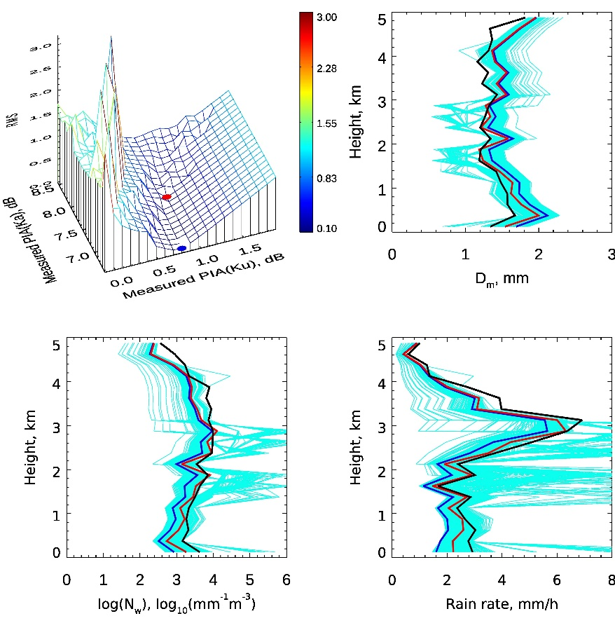
Fig. 12. Upper left: Error (z-axis) between measured/input and output path attenuations for measured PIAs within ± 1 dB of the true PIA, indicated by the red circle. The PIA corresponding to the minimum error solution is represented by the blue circle. D_{m}, log(N_{w}) and R profiles corresponding to the true PIA and minimum error PIA are given by the heavy red and blue lines, respectively. The true values derived from the input raindrop size distributions are shown by the black lines. Light blue lines represent the corresponding profiles from the remaining 439 PIA inputs.
A second example is shown in Fig. 13. In this case, the minimum error solution has a Ku-band path attenuation equal to the true value and a Ka-band path attenuation offset from the true value by 0.1 dB. Results in the other panels show only black and red lines because the red and blue lines, corresponding to the true input PIA and those from the consistency condition, are effectively identical. This case is fairly typical of other results that show that deviations from the true D_{m} and logN_{w} profiles tend to cancel for the rain rate estimates, which in this case exhibits a high degree of accuracy.
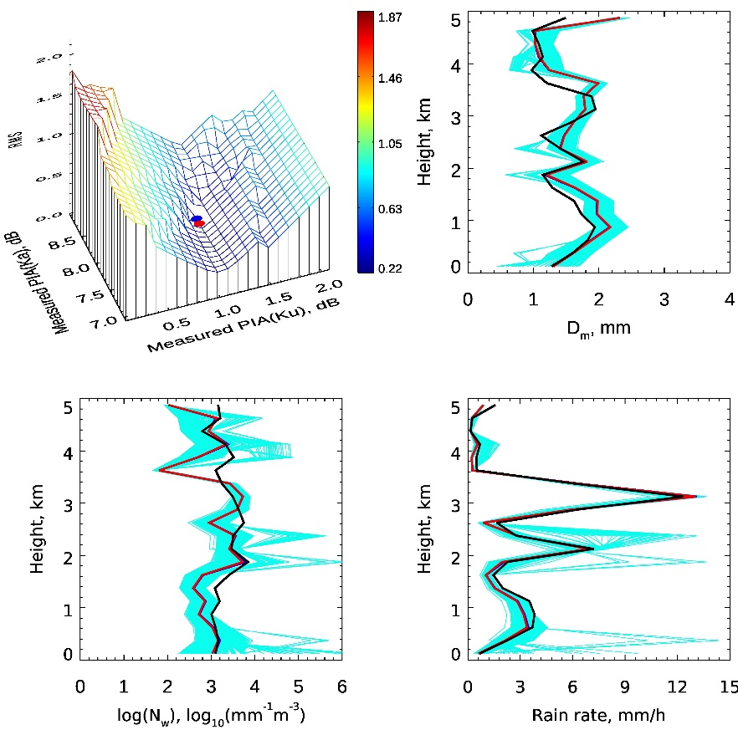
Fig. 13. Same as Fig. 12 for a case where the true PIA and minimum error PIA are nearly identical.

For the case shown in Fig. 14 the D_{m} values are in the region where only the higher root of the equation D_{m}=g⁻¹(DFR) exists. In this case, we obtain a single solution for each input PIA and the range of solutions for all 441 inputs show only a small amount of variability. This indicates that the profiles are relatively independent of the input PIA when the value is taken within ±1 dB of the true value. The forward recursion in this case yields no solution using either the true or the minimum variance PIA as input. This occurs frequently when the path attenuations are large.
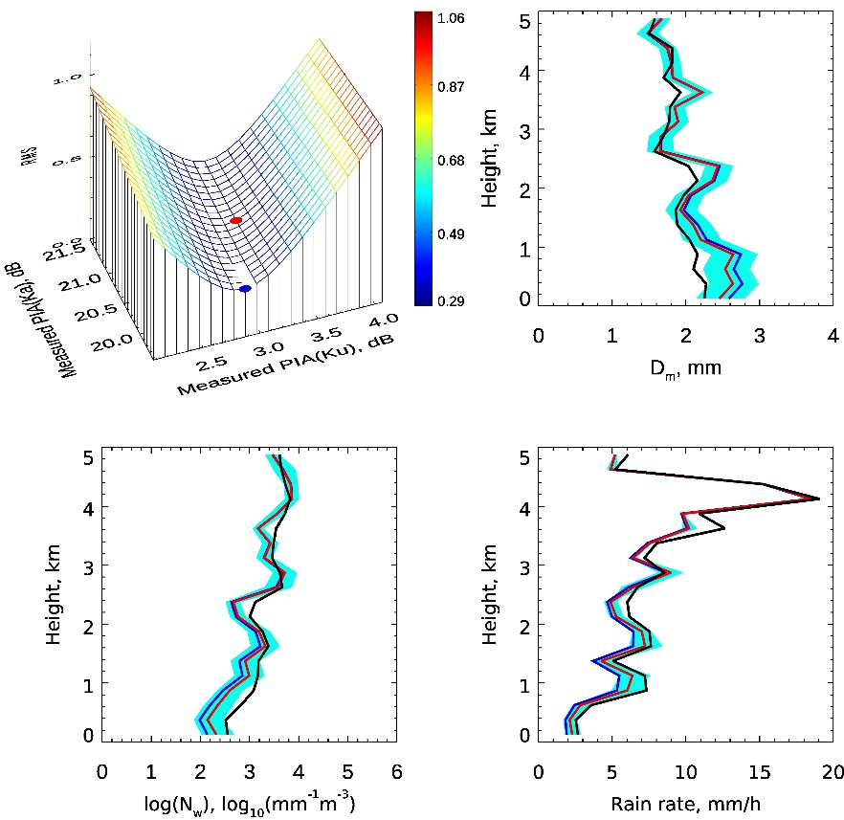
Fig. 14. Same as Fig. 12 for a case where the input D_{m} profile is in the upper-root region of the DFR-D_{m} curve.
Fig. 15 shows a profile exhibiting the opposite kind of behavior where a large portion of the D_{m} profile is in the lower root region of the D_{m}-DFR relationship. Whereas the true input PIA, represented by the red dashed lines, gives somewhat reasonable results, despite fluctuations in D_{m} and logN_{w}, the minimum variance solution shown by the heavy blue lines exhibits significant errors in the D_{m} and logN_{w} profiles. This example shows that the consistency condition can sometimes fail by the choosing the wrong root – in this case, the upper rather than the lower root. In contrast, the results from the R-D_{m} method shown in Fig. 15b, which is insensitive to the DFR-D_{m} ambiguity, yields accurate estimates of D_{m}, logN_{w} and R. For this result, we have assumed that the measured differential path attenuation is equal to the true value.
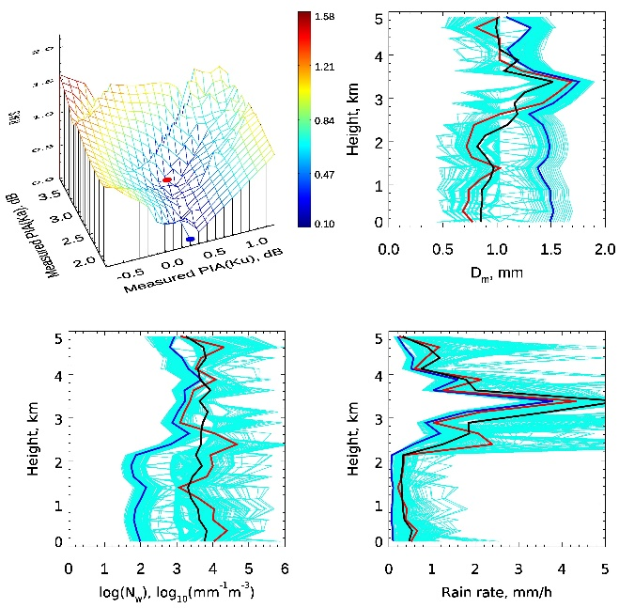
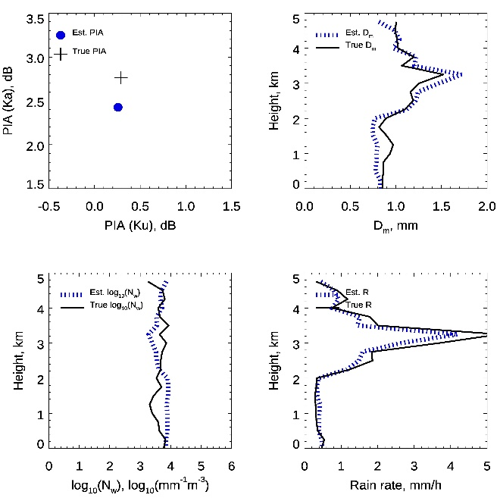
Fig. 15. a. Left panels: same presentation as in Fig. 12 for a case where the majority of the D_{m} profile is in the lower-root region of the DFR-D_{m} curve. b Right panels: R-D_{m} results assuming that the measured and true PIAs are the same.

- Discussion and Summary
By accounting for both roots of the D_{m}=g⁻¹(DFR) equation, multiple profiles of D_{m}, logN_{w} and R are obtained from the dual-frequency radar equations. For each profile, DSD-generated path attenuations are retrieved and compared with externally measured estimates, A_{m}(f₁), A_{m}(f₂) of the same quantities. If the A_{m} are accurate, then the choice of that pair of DSD-generated path attenuations ‘closest’, as defined by the minimum of (20), to the A_{m} yield profiles of D_{m}, logN_{w} and R that usually are accurate. Exceptions to this rule occur, however, particularly with the forward recursion at high path attenuations and for both forward and backward approaches when the majority of the D_{m} profile resides in the lower branch of the D_{m}-DFR curve.
Although the input set of raindrop size distributions are taken from measured disdrometer data, the assumption of a gamma distribution with µ=3 often yields accurate results and the retrieval results of the paper have been obtained with this assumption. Tests of the retrievals with µ=6 often yield comparable results but with slightly worse accuracy. On the other hand, the assumption of µ=0 leads to a significant loss of accuracy and cases where no solution exists.
For the forward recursion or initial-value problem, the solution set is independent of the externally measured path attenuations, A_{m}, or the factors s_{Ku} and s_{N} in (20). These quantities come into play only in selecting the ‘best’ solution which can be thought of as choosing that DSD-generated path attenuation pair closest to the A_{m}. Although examples can be found where the multiple solutions are tightly clustered, ensuring that all the solutions give approximately the same set of microphysical profiles, more generally, biases in the A_{m} can lead to significant errors in the results. In fact, even the A_{m} are equal to the true values, the forward recursion often fails or becomes highly inaccurate when the path attenuations become large.
For the backward recursion, the situation is different because the A_{m} are incorporated into the final-value equation. Accurate microphysical and rain rate retrievals can usually be obtained if the A_{m} are taken as the true values. For biases in A_{m}, trial and error computations show that accurate retrievals usually can be made if the input A_{m} are modified to match the DSD-generated output attenuations. In implementing this procedure, we have limited the search area to within a ±1 dB neighborhood of the true PIA. In practice, since the true PIAs are unknown, this would need to be replaced by proxy values, such as from the SRT, using a search area large enough to accommodate uncertainties in the estimates at the two frequencies.
As noted earlier, this procedure is similar to that of Mardiana et al. (2004). There are several differences, however. Mardiana et al. employed an iterative procedure beginning with zero Ku- and Ka-band path attenuations. However, because of the existence of multiple local minima for many profiles, where an iteration might fail to locate the global minimum, we have used a simple search procedure in the vicinity of the true or nominally true PIA. A second difference is that, like all earlier work, the Mardiana et al. study used only the bigger-root solution of the D_{m}=g⁻¹(DFR) equation. As we allow for multiple solutions, this requires selecting the minimum error solution for each input and then finding the minimum among these minima to obtain the final set of profiles and PIAs. While the consistency condition works well in many cases, examples such as that in Fig. 15a show that profiles in which D_{m} is predominantly in the lower branch of the D_{m}-DFR curve can give erroneous results.
A simplified form of the version 6 R-D_{m} method [Seto et al., 2021] was implemented to identify advantages and disadvantages of the generalized DFR approach. In general, the R-D_{m} method works well and often provides results comparable to or with better accuracy than the DFR approach. Exceptions occur, however, for profiles that show non-uniformities in the range profiles of N_{w}. Because of the constraint introduced by use of an N_{w}-D_{m} relationship, the method tends to produce profiles of N_{w} that do not fully capture the variations in range. This translates into errors in the rain rate profile. It is worth noting that the dual-frequency version of R-D_{m} is sensitive to errors in the differential path attenuation, δA, and a similar kind of consistency condition imposed on the input/output path attenuations might be applicable to the R-D_{m} backward-recursion equation, given by (25), to mitigate this dependence.
Although the DFR approach as described here explicitly accounts for the double-valued nature of the DFR-D_{m} relationship, it appears that the PIA alone, or the use of a consistency condition for the backward recursion, is not always sufficient to identify an accurate solution. These failed cases tend to be confined to profiles with small path attenuation, low D_{m} and relatively uniform N_{w} profiles where the R-D_{m} method works well if the differential path attenuation can be accurately specified. These cases, nevertheless, raise the question as to whether additional constraints on the DFR approach might be needed, such as a restriction on the allowable variations in the N_{w}-D_{m} relationship along the profile. Indeed, comparing the effective N_{w}-D_{m} relationships obtained from the DFR and the R-D_{m} methods may help explain differences in the retrievals, either because of an overly-constrained N_{w}-D_{m} in the R-D_{m} method or the lack of an N_{w}-D_{m} constraint in the DFR approach.
The appeal of the DFR approach is that, apart from the use of a gamma raindrop size distribution, it is independent of a priori assumptions or empirical relationships. Although the ambiguity in the DFR-D_{m} relationship can be handled analytically, finding an accurate solution among the multiplicity of solutions is not always possible even when an accurate PIA estimate is available or when a consistency condition is imposed. Nevertheless, the method provides insight into the characteristics of the solutions, their relationship to external PIA constraints, and the accuracy of existing operational methods.
Acknowledgments: We wish to thank Dr. Shinta Seto of Nagasaki University for his valuable comments. This work is funded under NASA’s Precipitation Measurement Mission (PMM) Grant NNH18ZDA001N‐PMMST.

Data Availability Statement: Information on the disdrometer data can be found at: https://gpm-gv.gsfc.nasa.gov/Disdrometer. DSD data used to generate the simulated profiles and the simulated profiles themselves will be provided by the authors upon request.

References

Adhikari, N. B., T. Iguchi, S. Seto, and N. Takahashi, 2007: Rain retrieval performance of a dual-frequency precipitation radar technique with differential-attenuation constraint. IEEE Trans. Geosci. Remote Sens., 45, 26121-2618.
Durden, S. L., 2018: Relating GPM radar reflectivity profile characteristics to path-integrated attenuation. IEEE Trans. Geosci. Remote Sens., 56, 4065–4074.
Gorgucci, E. and L. Baldini, 2016: A self-consistent Numerical Method for Microphysical Retrieval in Rain Using GPM Dual-Wavelength Radar. J. Atmos and Oceanic Technol., 33, 2205-2223, doi: 10.1175/JTECH-D-16-0020.1.

Grecu, M., L. Tian, W. S. Olson, and S. Tanelli, 2011: A robust dual-frequency radar profiling algorithm. J. Appl. Meteor. Climatol., 50, 1543–1557, doi:10.1175/2011JAMC2655.1.

Grecu, M., W.S. Olson, S.J. Munchak, et al., 2016: The GPM combined algorithm. J. Atmos and Oceanic Technol., 33, 2225-2245, DOI: 10.1175/JTECH-D-16-0019.1.
Haddad, Z. S., E. A. Smith, C. Kummerow, T. Iguchi, M. R. Farrar, S. L. Durden, M. Alves, and W. S. Olson, 1997: The TRMM ‘‘day-1’’ radar/radiometer combined rain-profiling algorithm. J. Meteor. Soc. Japan, 75, 799–808.

Hitschfeld, W., and J. Bordan, 1954: Errors inherent in the radar measurement of rainfall at attenuating wavelengths. J. Meteor., 11, 58–67.
Hou, A., G. S. Jackson, C. Kummerow, and C. M. Shepherd, 2008: Global precipitation measurement. Precipitation: Advances in Measurement, Estimation, and Prediction, S. Michaelides, Ed., Springer, 131–169.

Hou, A.Y., et al., 2014: The global precipitation measurement mission. Bull. Amer. Meteorol. Soc., 95, 701-722, doi:11.1175/BAMS-D-13-00164.1.

Iguchi, T., and R. Meneghini, 1995: Differential equations for dual-frequency radar returns,” 27th International Conf on Radar Meteor., Vail, CO, 5B.5, pp. 190-192, Oct., 1995.

Iguchi, T., 2005: Possible algorithms for the Dual-frequency Precipitation Radar (DPR) on the GPM Core Satellite. Proc. Conference on Radar Meteorology, 5R.4.
Iguchi, T. and Z. Haddad, 2020: Introduction to Radar Rain Retrieval Methods, Ch. 10. In: Satellite Precipitation Measurement, Advances in Global Change Research, V. Levizzani et al. (eds.), 67, Springer Nature Cham, doi: 10.1007/978-3-030-24568-9_13.

Iguchi, T., S. Seto, R. Meneghini, N. Yoshida, J. Awaka, M. Le, V. Chandrasekar, S. Brodzik and T. Kubota, 2020: GPM/DPR Level-2 Algorithm Theoretical Basis Document, https://gpm.nasa.gov/resources/documents/gpm-dpr-level-2-algorithm-theoretical-basis-document-atbd.
Iguchi, T. and R. Meneghini, 2022: Stability of the Dual-Frequency Radar Equations and a New Method Applied to the GPM’s Dual-frequency Precipitation Radar, vol. 60, IEEE Trans. Geosci. Remote Sens., doi: 10.1109/TGRS.2022.3159396.

Jensen, M. P., Petersen, W. A., Bansemer, A., Bharadwaj, N., Carey, L. D., Cecil, D. J., Collis, S. M., Del Genio, A. D., Dolan, B., Gerlach, J., Giangrande, S. E., Heymsfield, A., Heymsfield, G., Kollias, P., Lang, T. J., Nesbitt, S. W., Neumann, A., Poellot, M. Rutledge, S. A., Zipser, E. J., 2016: The Midlatitude Continental Convective Clouds Experiment (MC3E). Bulletin of the American Meteorological Society, 97(9), 1667–1686.
Le, M., and V. Chandrasekar, 2013: Hydrometeor profile characterization method for dual-frequency precipitation radar onboard the GPM. IEEE Trans. Geosci. Remote Sens., 51, 3648–3658.
Liao, L., and R. Meneghini, 2019a: Physical Evaluation of GPM DPR Single- and Dual-Wavelength Algorithms. J. Atmos. Oceanic Technol., 36, 883–902.
Liao, L., and R. Meneghini, 2019b: A Modified Dual-Wavelength Technique for Ku- and Ka-band Radar Rain Retrieval. J. Appl. Meteorol. Climatol. 58, 3-18.
Liao, L., R. Meneghini, and A. Tokay, 2014: Uncertainties of GPM DPR Rain Estimates caused by DSD Parameterizations. J. Appl. Meteorol. Climatol. 53, 2524-2537.
Liao, L. and R. Meneghini, 2005: A Study of Air/Space-borne Dual-Wavelength Radar for Estimates of Rain Profiles. Advances in Atmospheric Sciences, 22, 841-851.
Mardiana, R., T. Iguchi, and N. Takahashi, 2004: A dual-frequency rain profiling method without the use of a surface reference technique. IEEE Trans. Geosci. Remote Sens., 42, 2214-2225.

Marzano, F. S., A. Mugnai, G. Panegrossi, N. Pierdicca, E. A. Smith, and J. Turk, 1999: Bayesian estimation of precipitating cloud parameters from combined measurements of spaceborne microwave radiometer and radar. IEEE Trans. Geosci. Remote Sens., 37, 596–613, doi:10.1109/36.739124.

Marzoug, M., and J. P. Amayenc, 1994: A class of single and dual-frequency algorithms for rain-rate profiling from a spaceborne radar. Part I: Principle and tests from numerical simulations, J. Atmos. Oceanic TechnoL, 11, 1480-1506.

Matrosov, S. Y., 1992: Radar reflectivity in snowfall, IEEE Trans. Geosci. Remote Sens., 30, 454-461.
Matrosov, S. Y., 1998: A dual-wavelength radar method to measure snowfall rate, J. App. Meteor., 37, 1510-1521.
Meneghini, R., T. Kozu, H. Kumagai, and W. C. Boncyk, 1992: A study of rain estimation methods from space using dual-wavelength radar measurements at near-nadir incidence over ocean. J. Atmos. Oceanic Technol., 9, 364–382.

Meneghini, R. and H. Kumagai, 1994: Characteristics of the vertical profiles of dual-frequency, dual-polarization radar data in stratiform rain, J. Atmos. and Oceanic Technol., 11, 701-711.
Meneghini, R., H. Kumagai, J. R. Wang, T. Iguchi, and T. Kozu, 1997: Microphysical retrievals over stratiform rain using measurements from an airborne dual-wavelength radar-radiometer. IEEE Trans. Geosci. Remote Sens., 35, 487-506.

Meneghini, R., H. Kim, L. Liao, J. Kwiatkowski, and T. Iguchi, 2021: Path attenuation estimates for the GPM Dual-frequency Precipitation Radar (DPR). J. Meteor. Soc. Japan, 99, 181–200, doi:10.2151/jmsj.2021-010.
Mishchenko, M. I., and L. D. Travis, 1998: Capabilities and limitations of a current FORTRAN implementation of the T-matrix method for randomly oriented, rotation symmetric scatterers. J. Quant. Spectrosc. Radiat. Transfer, 60, 309–324, doi:10.1016/S0022-4073(98)00008-9.

Rose, C. R., and V. Chandrasekar, 2006a: Extension of GPM dual-frequency iterative retrieval method with DSD-profile constraint. IEEE Trans. Geosci. Remote Sens., 44, 328-335.

Rose, C. R., and V. Chandrasekar, 2006b: A GPM dual-frequency retrieval algorithm: DSD profile-optimization method. J. Atmos. Ocean. Technol., 23, 1372-1383.

Seto, S., and T. Iguchi, 2011: Applicability of the iterative backward retrieval method for the GPM dual-frequency precipitation radar. IEEE Trans. Geosci. Remote Sens., 49, 1827-1838.

Seto, S., T. Iguchi, and T. Oki, 2013: The Basic Performance of a Precipitation Retrieval Algorithm for the Global Precipitation Measurement Mission’s Single/Dual-Frequency Radar Measurements. IEEE Trans. Geosci. Remote Sens., 51, 5239-5251.

Seto, S., and T. Iguchi, 2015: Intercomparison of attenuation correction methods for the GPM Dual-frequency Precipitation Radar. J. Atmos. Ocean. Technol., 32, 915-926.
Seto, S., Iguchi, T., R. Meneghini, J. Awaka, T. Kubota, T. Masaki, and N. Takahashi, 2021: The precipitation rate retrieval algorithms for the GPM dual-frequency Precipitation Radar. J. Meteor. Soc. Japan, 99, 205–237, doi:10.2151/jmsj.2021-011.
Testud, J., S. Oury, P. Amayenc, and R. A. Black, 2001: The concept of normalized distributions to describe raindrop spectra: A tool for cloud physics and cloud remote sensing. J. Appl. Meteor., 40, 1118–1140, doi:10.1175/1520-0450(2001)040,1118: TCONDT.2.0.CO;2.

Thurai, M.; Huang, G.J.; Bringi, V.N.; Randeu, W.L.; Schönhuber, M., 2007: Drop shapes, model comparisons, and calculations of polarimetric radar parameters in rain. J. Atmos Oceanic Technol., 24, 1019–1032.

Ulbrich, C. W., 1983: Natural variations in the analytical form of raindrop size distributions. J. Climate Appl. Meteor., 22, 1764–1775, doi:10.1175/1520-0450(1983)022,1764: NVITAF.2.0.CO;2.

