Planetary protection assessment of radioisotope thermoelectric generator (RTG)-powered landed missions to ocean worlds: application to Enceladus

Marc Neveu^{1,2}, Robert F. Coker³, Ralph D. Lorenz³, Shannon M. MacKenzie³, Jonathan I. Lunine⁴, Alfonso F. Davila⁵, and the Enceladus Orbilander study team
¹Department of Astronomy, University of Maryland, College Park, MD, United States
²Planetary Environments Laboratory, NASA Goddard Space Flight Center, Greenbelt, MD, Unites States
³Applied Physics Laboratory, Johns Hopkins University, Laurel, MD, United States
⁴Department of Astronomy, Cornell University, Ithaca, NY, United States
⁵NASA Ames Research Center, Moffett Field, CA, United States

Corresponding author:
Marc Neveu
+1 904-662-6902
marc.f.neveu@nasa.gov

Abstract
Landed missions to icy worlds with a subsurface liquid water ocean must meet planetary protection requirements, and ensure a sufficiently small likelihood of any microorganism-bearing part of the landed element reaching the ocean. A higher bound on this likelihood is set by the potential for radioisotope thermoelectric generator (RTG) power sources, the hottest possible landed element, to melt through the ice shell and reach the ocean. Here, we quantify this potential as a function of three key parameters: surface temperature, ice shell thickness (i.e., heat flux through the shell), and thickness of a porous (insulating) snow or regolith cover. Although the model we describe can be applied to any ocean world, we present results in the context of a landed mission concept to the south polar terrain of Saturn’s moon Enceladus. In this particular context, we discuss planetary protection considerations for landing site selection. The likelihood of forward microbial contamination of Enceladus’ ocean by an RTG-powered landed mission can be made sufficiently low to not undermine compliance with planetary protection policy.

Keywords: planetary protection, radioisotope thermoelectric generator, Enceladus, ocean worlds.

- Introduction
The main planetary protection concern for landing on potentially habitable icy bodies is ensuring that the likelihood of the landed element reaching any putative subsurface ocean is sufficiently small. The planetary protection policy (COSPAR, 2021) specifies:
“Category […] IV. The biological exploration period for Europa and Enceladus is defined to be 1000 years; this period should start at the beginning of the 21st century. Requirements for Europa and Enceladus […] landers, including bioburden reduction, shall be applied in order to reduce the probability of inadvertent contamination of a Europan or Enceladean ocean to less than 1×10⁻⁴ per mission. [This] probability […] applies to all mission phases including the duration that spacecraft-introduced terrestrial organisms remain viable and could reach a sub-surface liquid water environment. The calculation of this probability should include a conservative estimate of poorly known parameters, and address the following factors, at a minimum:

- Bioburden at launch
- Cruise survival for contaminating organisms
- Organism survival in the radiation environment adjacent to Europa or Enceladus
- Probability of landing on Europa or Enceladus
- The mechanisms and timescales of transport to a Europan or Enceladean subsurface liquid water environment
- Organism survival and proliferation before, during, and after subsurface transfer.”
The first three factors have been considered in the context of past missions or mission concepts to ocean worlds elsewhere (e.g., Eigenbrode et al., 2021) and are not the focus of this work. For a landed mission, the probability of the fourth factor is by design as close to 1 as possible. Regarding the fifth factor, natural timescales of transport to a subsurface ocean by, e.g., subsolidus convection of a ductile ice shell or burial under plume fallout are thought to be millions of years (Grasset et al., 2013; Howell & Pappalardo, 2019 and references therein; Southworth et al., 2019). This is arguably much greater than the 1000-year “period of biological exploration” motivating the planetary protection policy, and accordingly downward transport of microbial contamination by natural processes may not transgress the policy. However, transport induced by spacecraft hardware could be much faster, as evidenced by studies of melt probes to ocean worlds (e.g., Ulamec et al., 2007; Lorenz, 2012; Oleson et al., 2019) relying on nuclear power to reach the ocean within practical times of years at most. Most spacecraft sent beyond Jupiter, where solar energy becomes scarce, use nuclear energy as a long-term source of power and heat provided by radioisotope thermoelectric generators (RTGs). The focus of this paper is to determine whether an RTG, the hottest possible landed (intentionally or otherwise) element, can induce enough ice sublimation and melting to reach a subsurface ocean or other liquid reservoir. The sixth factor of the survival and proliferation of RTG-transported organisms is discussed in Section 4.2.
RTGs convert the heat generated by the decay of a short-lived radioisotope (²³⁸Pu) into electric power using thermocouples. The efficiency of conversion is on the order of a few percent; the rest is waste heat partially used to warm up the spacecraft as needed. To determine whether waste heat from a landed RTG is able to sublimate or melt enough ice for the RTG to reach the ocean, we investigate four scenarios: (1) nominal landing with the RTG mounted on the spacecraft but not contacting the surface; (2) off-nominal landing with the intact lander tilted such that the RTG contacts the surface; (3) off-nominal landing where an RTG falls off the lander; and (4) pre-landing breakup that embeds an RTG into the surface. A fifth scenario of a hypervelocity impact is not investigated, as it is assumed based on the success of the RTG-powered Cassini-Huygens spacecraft, which repeatedly flew by Enceladus 22 times, that such an impact can be deemed improbable enough (e.g., through trajectory biasing) for compliance with planetary protection policy.
In all five scenarios, it is crucial to consider how the RTG is in contact with the ground as conductive coupling is much more efficient at transferring heat into the surface—and thus facilitating the descent of the RTG through the ice crust—than radiative coupling. Which thermal regime dominates is a function of both the orientation of the RTG fins and the properties of the ground. We consider two endmembers that bracket expected possibilities for the surface of icy moons: thick, firm ice and thick, fluffy snow (where “thick” is relative to the meter-scale of the lander) relevant to, e.g., areas of high plume fallback on the south polar terrain (SPT) of Saturn’s moon Enceladus.
In scenario (1), the RTG is only radiatively coupled to the surface regardless of ground type. In scenario (2), though there may be a point or even a line contact between the RTG and the ground, radiative coupling still dominates. This assumption is also valid in off-nominal scenario (3) where the RTG drops off from the spacecraft after landing and the fins of the fallen RTG (nominally used to radiatively carry away part of the waste heat) contact firm ground. However, if the ground is a thick snowpack, then both the fins and the cylinder of the RTG contact the snow and the RTG is conductively coupled to the snow. To date, despite three launch or reentry events during which the RTGs behaved as intended by their design, no RTGs have detached on flown NASA missions due to mechanical failure (NASA, 2020). In off-nominal scenario (4) where the RTG or associated heat-producing elements decouple from the spacecraft in orbit and impale the surface, we conservatively assumed that they are fully embedded in ice or snow such that the RTG radiator fins are fully submerged. These scenarios and conditions are listed in Table 1. In scenarios (1) and (2), each RTG, which has a much smaller surface area than the whole lander, would have to sublimate ice in a large enough volume for the whole lander to penetrate the ice or snow.

Scenario | Firm ground (ice) | Fluffy ground (snowpack)
(1) Nominal landing | Radiative coupling | Radiative coupling
(2) Intact lander tilted | Radiative coupling | Radiative coupling
(3) RTG drops off after landing | Radiative coupling | Conductive coupling
(4) RTG impaled from orbit | Conductive coupling | Conductive coupling
Table 1. Scenarios considered in this assessment of planetary protection compliance and corresponding thermal coupling of the RTG with ice and/or snow.

A model of RTG descent into an ice shell is described in Section 2. Because this study was undertaken as part of a broader Planetary Mission Concept Study for a landed mission to Enceladus (Enceladus Orbilander; MacKenzie et al., 2020, 2021), some assumed values for the model parameters (e.g., surface temperature, RTG dimensions) are specific to that concept; however, the model is applicable to any RTG on any airless icy satellite surface. Model results are presented in Section 3 for both conductive and radiative cases. In Section 4, they are used to provide a planetary protection assessment for the selection of a landing site in Enceladus’ SPT. Finally, broader conclusions for landed missions to ocean worlds are presented in Section 5.

- RTG descent model
We first investigated the “worst-case” scenario of conductive coupling, which maximizes heat transfer from the RTG into ice and snow. Relevant parameters and assumptions of the model are summarized in Table 2. Radiative coupling is described in §2.8.
Whether an RTG descends through the ice shell depends on the shell’s thermomechanical properties. Much of the material ejected by Enceladus’ plume falls back onto the surface. Plume fallout is predominantly water ice with percent-level CO₂, NH₃, salts, and organic compounds (Postberg et al., 2018b and references therein); more volatile species (e.g., CH₄) escape Enceladus’ gravity. In the south polar terrain, plume fallout rates can reach 0.1 to 1 mm per year, such that an ice shell 10 km thick would be renewed in 10⁷ to 10⁸ years if these rates are constant over such a time span. In these areas at least, the ice shell may thus be entirely composed of plume fallout. Elsewhere the lower parts of the shell likely have a different origin, but it is reasonable to assume that they, too, are mainly water ice since they contact the same ocean, which is global (Thomas et al., 2016).
At the bottom of the shell (ice-ocean interface) the temperature is near 273 K and the porosity near zero, since any pores would rapidly close owing to the ice’s low viscosity near the melting point. At the surface, the temperature and porosity can be constrained from Cassini observations (§2.1). The porosity φ(d,T₀(d)) and temperature T₀(d) profiles (§2.2–2.3) in depth increments ∆d can then be propagated from surface values given a heat flux Q_{endo} across the ice shell (§2.4–2.5):
T₀(d+∆d) = T₀(d) + ∆d/k(T₀(d)) × Q_{endo}. (1)
We set ∆d = 1 mm in the uppermost 2 m and ∆d = 1 m at higher depths since the above quantities of interest tend to vary more at shallower depth; test calculations with lower and higher ∆d show that this achieves numerical convergence. We did not carry out calculations at combinations of T_{surf} and Q_{endo} for which temperatures increase so fast with depth as to reach 273 K within 100 m of the surface, given that 100 m is an unrealistically small lower bound on ice shell thickness (Hemingway & Mittal, 2019) or the depth to any liquid pocket perched in the ice based on a conductive temperature profile.

2.1 Surface temperature and porosity
In the SPT, surface temperatures range with latitude from about 50-70 K but can be up to about 90 K in areas immediately surrounding tiger stripe fractures (Howett et al., 2011; Le Gall et al., 2017), with maxima around 130 K within meters of plume source vents at tiger stripe fractures (Abramov & Spencer, 2009). Model scenarios considered surface temperatures between 50 and 90 K.
The porosity φ at the surface is difficult to measure directly. It has been constrained to 0.4–0.95 based on photometric properties (Verbiscer et al., 2005; Buratti et al., 2014) and surface emissivity (Carvano et al., 2007). A better constraint on the thermal and structural properties of the surface, and, by inference, the underlying ice shell, arises from measurements of the surface thermal inertia, a function of snow density ρ_{i}×(1–φ) –where ρ_{i} is the density of water ice–, thermal conductivity k, and heat capacity C_{p} given by (ρ_{i} (1–φ) k(φ) C_{p})^{1/2} = 4–50 J m⁻² K⁻¹ s^{-1/2} globally, with increasing values toward the south pole tentatively interpreted as due to snow sintering (Howett et al., 2010). These are two-sigma bounds; the lowermost four-sigma bound globally is 2 J m⁻² K⁻¹ s^{-1/2} (Howett et al., 2010), corresponding to a likelihood < 10⁻⁴ that the surface snow density and associated thermal conductivity are so low.

2.2 Ice shell porosity profile
Porosity is expected to decrease with depth, satisfying a relationship dρ/dt = c(ρ_{i}–ρ) (Arthern et al., 2010) with ρ the density of porous snow. Because φ = 1–ρ/ρ_{i}, dividing Arthern et al.’s equation by ρ_{i} yields dφ/dt = –cφ; i.e., φ(t) = φ(t=0) e^{–ct}. Porosity compaction on Earth is found to occur primarily due to viscous creep on a timescale 1/c = τ exp(E_{a}/RT), with τ ~ 10⁻¹¹ years for E_{a} = 60 kJ mol⁻¹ (Arthern et al., 2010). An upper limit on ice shell porosity at each depth can therefore be obtained by assuming that the ice shell is buried plume fallback, in which case age and depth are proportionally related by the fallout rate F:
φ(d+∆d) = φ(d) exp(–c ∆d/F). (2)
The conductivity and strength of porous snow are increased by sintering (Molaro et al., 2019; Choukroun et al., 2020), which decouples the depths of the porous and insulating snow. Sintering is the increase in grain-to-grain contact area due to surface and volume diffusion of water molecules; adjacent grains develop a neck on a timescale τ_{neck} = 1.204 10⁸⁸ T ^{–39.26} years (Molaro et al., 2019) for 10 µm grains. This size may be common for plume fallout because 1 µm grains were detected at altitudes of tens of km sampled by Cassini and larger grains are assumed to return to the surface without reaching such altitudes. For a uniform temperature, the neck fraction would thus be f_{neck} = 1 – exp(–d/F / τ_{neck}). However, since temperature and therefore τ_{neck} vary with depth, we calculate the increase in neck fraction at each depth:
f_{neck} (d+∆d) = f_{neck} (d) + 1 – exp(–∆d/F / τ_{neck}). (3)
We assume that the thermal conductivity is that of nonporous water ice (§2.4) once the cumulative neck fraction is f_{neck} ≈ 1. At shallower depths we use an effective porosity, φ(1–f_{neck}), to estimate the thermal conductivity with equations (4–6).

2.3 Ice shell conductive temperature profile
In nonporous ice, the thermal conductivity is given by k = 567/T₀ W m⁻¹ K⁻¹ (Klinger, 1980). Porosity φ (0 for solid ice, 1 for vacuum) decreases the thermal conductivity (i.e., makes it more insulating). The relationship between porosity φ and thermal conductivity k is ill-constrained and non-unique, because it depends on additional factors such as the size distribution of pores (Shoshany et al., 2002) and the nature of interfaces between solid elements of the porous medium, such as whether grains are seldom adjoined or better connected by sintered ‘necks’ (Molaro et al., 2019). Relevant k-φ relationships derived from experiments (Krause et al., 2011; Calonne et al., 2011), field measurements (Calonne et al., 2011), and theoretical modeling (Arakawa et al., 2017) including numerical simulations (Shoshany et al., 2002) are shown in Fig. 1. The decrease in thermal conductivity associated with porosity has been found to be essentially independent of temperature and of the thermal conductivity of the nonporous material (Shoshany et al., 2002; Arakawa et al., 2017). Nonetheless, for a given porosity this decrease factor can vary by orders of magnitude.

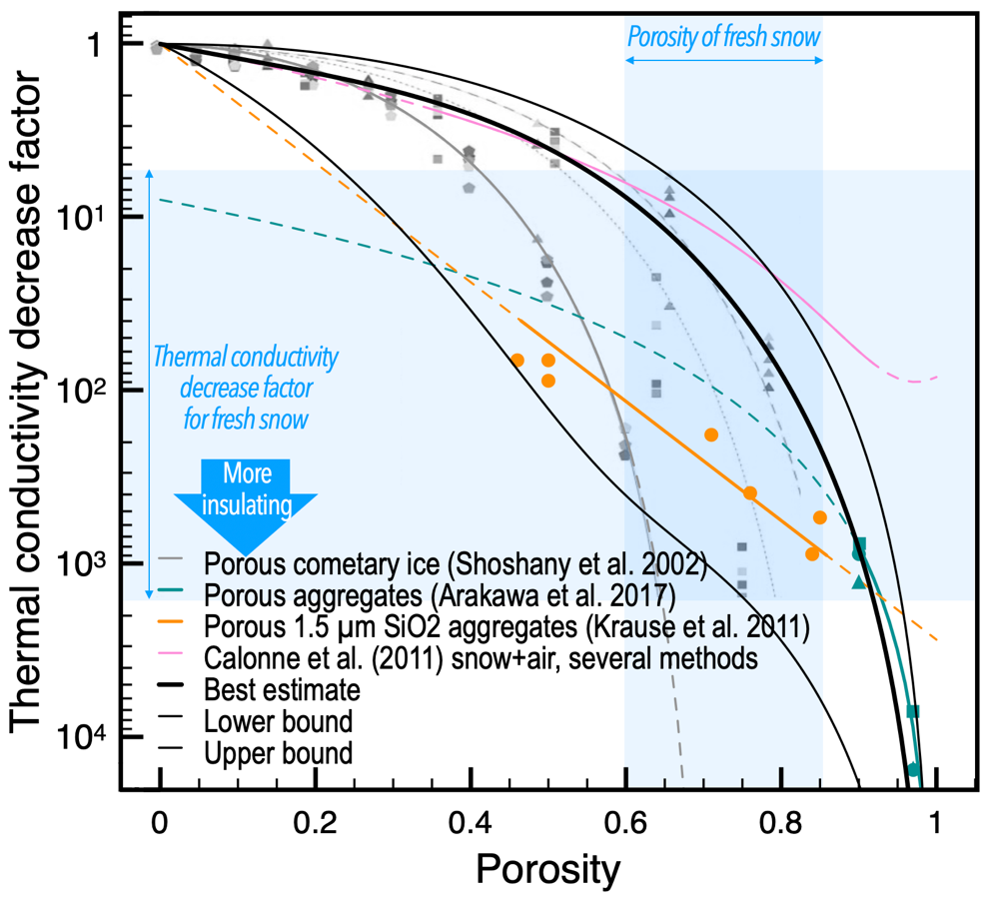
Figure 1. Effect of porosity φ on the thermal conductivity k. The solid black curves are the relationships considered here (see text). The orange, pink, and teal curves show relationships that were only validated in the regimes where the curves are solid. The orange curve is a thermal conductivity in W m⁻¹ K⁻¹ (rather than a decrease factor). Data points of a given color are from the same source as the fit curve(s) of that color.

The variation seen in Fig. 1 can mainly be explained by two factors. First, the data of Calonne et al. (2011) (pink curve) were obtained for snow on Earth, in which the pores contain air (k ≈ 0.02 W m⁻¹ K⁻¹) rather than vacuum (k = 0), which explains why this relationship predicts lower decrease factors (higher thermal conductivities) at high porosity. This makes thermal conductivity data acquired for freshly fallen snow on Earth, whose porosity ranges between 60 and 85% (Albert & Perron 2000, Calonne et al., 2011; Proksch et al., 2016) an unsuitable basis for application to Enceladus. Second, the thermal conductivity does not decrease as much if there is a distribution of pore sizes rather than a uniform size, as shown by the results of Shoshany et al. (2002) on Fig. 1: the pentagon symbols are for a single pore size, the squares for pore sizes following approximately a power law of index 3 and spanning a factor 50, and the triangles for pore sizes following the same distribution, but whose sizes span a factor 2500. For a given porosity, the thermal conductivity is thus multiplied roughly by (1/decrease factor)^{1/(log size range)}, as shown by the solid, dotted, and dashed gray curves in Fig. 1. The data of Krause et al. (2011) and Arakawa et al. (2017) were obtained for a single, µm-scale grain size. The effect of sintering in raising the thermal conductivity of porous material is not shown in Fig. 1.
Enceladus plume particles observed and sampled by Cassini also seem to follow a power-law size distribution of index 3 to 4 (e.g., Hedman et al., 2009; Porco et al., 2017). Grains 0.1 to several microns in size were detected by Cassini which was not equipped to detect grains with sizes ranging between a few nanometers and 0.1 µm; such smaller grains escape to space anyway (Postberg et al., 2018). The micron-sized grains have been hypothesized to form from bursting bubbles, in which case the upper bound on grain sizes can approach 1 mm (Porco et al. 2017; Postberg et al. 2018 and references therein). Grains larger than a few microns are thought to be launched at lower velocities and fall back on the surface. Boulders 10-100 m in size are likely generated from mass wasting, tectonic deformation, and possibly during cryovolcanic eruptions, and follow a steeper size distribution (Martens et al., 2015; Pajola et al., 2021). Thus, the size range of plume grains spans at least a continuous factor ~50, and likely many more orders of magnitude; without compaction, the size distribution of pores mirrors it (Netto, 1993; Shoshany et al., 2002).
The likely broad range of pore sizes in Enceladus snow allows us to identify a best-estimate k-φ relationship that overlaps with the data of Shoshany et al. (2002) appropriate for a power-law size distribution covering a broad size range, and with the results of Arakawa et al. (2017) at very high porosity. This relationship, shown as a thick black curve in Fig. 1, is given by:
k(φ) = k(φ=0) [(1 – φ) (φ –1)² + φ (1– φ)^{4φ}] (4)
where we sought to keep the coefficients simple integers. This linear combination in φ emphasizes at low porosity a second-order polynomial, similarly to the relationship adopted by Calonne et al. (2011); and at high porosity a power law whose index depends on φ, similarly to that determined by Shoshany et al. (2002) albeit without a porosity threshold so that k vanishes at φ = 1.
We also identify conservative upper and lower bounds on the decrease factor that bracket all relevant data points shown in Fig. 1, in case, e.g., the pore size in Enceladus snowpack is uniform. The least conservative relationship is given by:
k(φ) = k(φ=0) (1– φ)^{2.5φ} (5)
and the most conservative relationship by:
k(φ) = k(φ=0) (1–φ) [ (1–φ^{3/2}) (1–φ)^{4φ+4}
+ 0.5 φ^{3/2} e^{–5/(1–φ)}
+ 0.5 φ^{3/2} 2(9πγ(1–ν²)/(2Yr))^{1/3}(1–φ)² ] (6)
where the square brackets comprise a φ^{3/2}-weighed sum of three terms. The first is a power-law term akin to that of the above two equations and emphasized at low porosity. The second has an exponential form as in the relationship derived by Krause et al. (2011) but made to vanish at φ = 1. The third term is the relationship derived by Arakawa et al. (2017) with quantities appropriate for water ice: a surface energy γ = 0.1 J m⁻², Poisson’s ratio ν = 0.25, and Young’s modulus Y = 7 GPa. The grain size r is set to 0.75 µm as in Arakawa et al. (2017); the relationship is not very sensitive to r.
We opt to use equations (4–6) and, in each case, we adjust the surface porosity to match the surface thermal inertia (§2.1). The most conservative k-φ relationship results in the lowest surface porosity, and vice versa. Using the surface thermal inertia to ground our estimated ice shell properties prevents larger uncertainties on surface porosity and k(φ) from compounding in an unrealistically conservative fashion (i.e., incompatible with the measured thermal inertia at more than a four-sigma level; likelihood < 10⁻⁴).

2.4 Absorbed solar heat flux
The absorbed solar heat flux on a local patch of the surface, neglecting any topography, is given by
Q_{solar} = F⨀(1–a) sin(α_{avg}). (7)
For Enceladus, we assume an albedo a = 0.8 and a solar flux at 9.5 AU of F⨀ = 15.1 W m⁻². At high latitudes Φ, the maximum Sun elevation angle (α) is α_{max} = (ε + 90º – Φ) at noon on the southern summer solstice. Since Enceladus’ and Saturn’s equators are essentially coplanar (Baland et al., 2016), the obliquity ε of Enceladus is assumed to be equal to Saturn’s obliquity of ≈27º (i.e., Enceladus and Saturn experience the same seasons). Because we are interested in the long-term behavior of a ²³⁸Pu buried below the diurnal and seasonal thermal skin depths of the ground, it is relevant to average α over a Saturn year (29.5 Earth years), which is shorter than the half-life of ²³⁸Pu decay. South of the polar circle at 90º – ε ≈ –63º latitude, which essentially encircles the SPT and landing locations of high scientific interest due to high plume fallout (Southworth et al., 2019), the average Sun elevation angle at noon (for days when it rises above the horizon) over a Saturn year is α_{max}×2/π, and the average Sun elevation angle at any time of day between sunrise and sunset is α_{max}×(2/π)². Also accounting for nighttime when effectively α = 0 halves that average, yielding
α_{avg} = α_{max}×2/π² = (ε + 90º – Φ)×2/π². (8)
Thus, on Enceladus α_{avg} ≈ 5.5º at the south pole and 7.5º, 9.5º, and 11.5º at –80º, –70º, and –60º latitude, respectively. This corresponds to average absorbed solar fluxes Q_{solar} of 0.29, 0.39, 0.50, and 0.60 W m⁻² at these respective latitudes. This is slightly approximated at –60º latitude, which is slightly north of the polar circle. At latitudes 90º – ε > Φ > ε, the Sun elevation angle at noon varies between ε + 90º – Φ (summer solstice) and –ε + 90º – Φ (winter solstice), so α_{avg} = (4ε/π – ε + 90º – Φ)/π. At the equator, α_{avg} = (90º – 2ε/π)/π.
In assessing the exogenic heat input to Enceladus’ surface, we neglect sunlight reflected by Saturn, as well as Saturn’s endogenic thermal emission (about the same value as reflected solar radiation) on the Saturn-facing hemisphere of tidally locked Enceladus. This additional input is about 2 F⨀ (1–a_{Saturn}) R_{Saturn}²/(4 a_{Enceladus}²) sin(90º – Φ) ≈ 0.15 W m⁻² at –60º, given an albedo a_{Saturn} = 0.34 and that Enceladus’ semi-major axis a_{Enceladus} is about 4 × R_{Saturn}. This neglects the fact that a fraction of Saturn’s disk, of angular radius arctan(R_{Saturn}/ a_{Enceladus}) ≈ 14º, is always above and nearly always below the horizon as viewed from the SPT. In any case, this flux is at most about a quarter of the solar flux.

2.5 Endogenic heat flux
Given uncertainties regarding the internal structure of the ice shell in Enceladus’ SPT, we estimate the endogenic heat flux from the energy balance needed to obtain a given surface temperature T_{surf}. The endogenic heat flux is given as:
Q_{endo} = ε_{IR} σ_{SB} T_{surf}⁴ – Q_{solar}, (9)
with ε_{IR} = 0.98 the infrared emissivity of surface ice and snow and σ_{SB} ≈ 5.67×10⁻⁸ SI the Stefan-Boltzmann constant. For a given latitude, we only consider T_{surf} such that Q_{endo} > 0. With the above assumptions for Q_{solar}, the minimum temperature for Q_{endo} > 0 is 48 K at the south pole and 58 K at latitude –60º. Assuming α = ε = 27º, that temperature becomes 71 K. For T_{surf} = 85 K, Q_{endo} = 3.04 W m⁻² assuming –60º latitude average solar illumination or Q_{endo} = 3.36 W m⁻² at the pole. The latter flux corresponds to the 15.8 GW of SPT endogenic power measured by Howett et al. (2011) from Cassini/CIRS measurements being emitted through an area of 4700 km², equivalent to the area within 9º of the pole or the area within 4 km of four tiger stripes each 150 km long. In practice, the SPT emitted power also includes a component of lower heat flux over a broader area. These fluxes also exceed the maximum values of 3.0^{+0.2}_{-1.0} W m⁻² determined by Le Gall et al. (2017) from Cassini microwave radiometry of what seem to be recently active fractures distinct from the tiger stripes.

2.6 Process of downward transport
The above §2.1–2.5 provide the means of computing an ice shell structure. In the rest of §2, we describe means of computing downward transport through this ice shell.
Downward transport is due to ice sublimation if the RTG is situated in the crust at a hydrostatic pressure P = ρ_{i}(1–φ)gd below the H₂O triple point pressure of 611 Pa, or if the porosity is sufficient to not hold the vapor pressure (percolation limit taken to be φ = 0.05; Golden et al., 2007; results are insensitive to this limit). Otherwise, downward transport is due to melting.
In either regime, when the downward rate is small enough (e.g., < 1 mm/year) that other processes such as burial under plume fallout (Southworth et al., 2019) begin to dominate, the RTG is deemed to have stalled. We stop tracking the descent past 1000 years, the “biological exploration period” (§1), which is 11 half-lives of ²³⁸Pu (the RTG power has decreased by a factor 2¹¹).

2.7 Evolution in time
Whether downward transport is stalled and at what depth thus depends on the relative rates of either sublimation or melting, and of radioactive decay. Comparatively, the rate of burial under plume fallout is negligible, at most on the order of mm yr⁻¹ (Southworth et al., 2019). The time ∆t needed to reach depth d + ∆d is determined from a descent rate dd/dt as ∆d / (dd/dt). We repeat the calculation for as many depths as needed until it can be determined whether the RTG descent stalls, or the RTG reaches the ocean. The determination of the descent rate dd/dt differs depending on whether the descent takes place by sublimation or by melting.
The RTG power q decreases significantly on a timescale of years as:
q(t) = q_{BOL} exp(–t×ln(2)/t_{1/2}), (10)
with q_{BOL} = 4 kW (the generated thermal power at the beginning of life of a Next-Generation RTG) and t_{1/2} = 87.74 years the half-life of ²³⁸Pu. In the case of the Enceladus Orbilander concept, landing nominally takes place ≈17 years after beginning of RTG life (14 years after launch), at which point q(t) ≈ 3.50 kW for each RTG. We set t = 16 years after RTG beginning of life to account for an earlier (off-nominal) landing and/or a launch sooner than 3 years past beginning of life.
In the sublimation regime, we assume that the dynamics are dominated by H₂O sublimation. Other chemical species (e.g., NH₃, N₂, CO, CO₂) can sublimate faster, but those species are expected to either escape as vapor (as measured by Cassini; Waite et al., 2009, 2017) or, if present in the ice, be trapped as hydrates of (except for NH₃) higher viscosity than water ice and which may be more stable than water ice at ice shell conditions (e.g., Mousis et al. 2015; Combe et al., 2019). In any case, analysis of plume material suggests that its fallout contains less than a few percent non-H₂O material, which would not affect the mass of sublimated H₂O (and thus the rate of descent) by more than a few percent.
The descent rate in m s⁻¹ by H₂O ice sublimation is given by:
dd/dt = q(t) / (L_{subl}(T) ρ_{i}(1 – φ) πR_{RTG}²) (11)
with R_{RTG} the radius of the cylindrical RTG and L_{subl}(T) the temperature-dependent enthalpy of sublimation, whose expression for T > 30 K in J kg⁻¹ is taken from Murphy and Koop (2005):
L_{subl}(T) = (46782.5 + 35.8925 T − 0.07414 T² + 541.5 exp[−(T /123.75)²]) / M_{w} (12)
with M_{w} the molecular mass of water (0.018 kg mol⁻¹).
In the melting regime, the descent rate in an inviscid fluid is given by (Ulamec et al., 2007):
dd/dt = q(t) / ((C_{p} (T_{melt} – T₀) + L_{melt}) ρ_{i}(1 – φ) πR_{RTG}²) (13)
with T_{melt} its melting temperature and L_{melt} = 334 kJ kg⁻¹ its enthalpy of melting.
In these equations, conductive losses along the RTG length are neglected, but this is not justified if dd/dt R ≤ κ, i.e., if dd/dt ≲ 0.1 km yr⁻¹. Conductive losses can be calculated in terms of power loss as a function of local temperature, RTG shape, and descent velocity as (Ulamec et al., 2007):
dd/dt = q(t) / [ ((C_{p} (T_{melt} – T₀) + L_{melt}) ρ(1 – φ) πR_{RTG}²)
+ 932 (L_{RTG}/(R_{RTG}² dd/dt))^{0.726} R_{RTG}² (T_{melt} – T₀) ]. (14)
The second term in the denominator approximates conductive losses and is appropriate for 5×10⁴ s m⁻² < L_{RTG}/(R_{RTG}² dd/dt) < 10⁸ s m⁻², which is verified unless the RTG descent is close to stalling (dd/dt < 1.3 m yr⁻¹). The first term in the denominator is applicable to the melting regime and is to be replaced by the denominator of equation (11) for the sublimation regime.
Equation (14) is solved numerically for dd/dt through a binary search. We have verified a posteriori that at depths of sufficiently high pressure and low porosity that descent takes place by melting (§2.6), the RTG-ice interface is indeed warmer than 240–250 K, the solidus temperature of ice bearing salt or ammonia antifreeze impurities such as those measured in Enceladus’ plume (Waite et al., 2009; Postberg et al., 2018, and references therein). At low degrees of partial melting, the viscosity of the ice-melt mixture could impede descent if it is greater than ~10⁴ Pa s. In viscous slurries, the descent velocity is likely limited by that of constricted Poiseuille flow in the liquid annulus of thickness b << R_{RTG} between the RTG surface and the ice, given by (Rosenhead, 1963):

dd/dt ≈ 1/4 (ρ_{RTG} – ρ) g / µ(T) [ R_{RTG}² – (R_{RTG} + xb)²
+ ((R_{RTG}+b)² – R_{RTG}²) × ln(1+xb/R_{RTG}) / ln(1+b/R_{RTG}) ] (16)

where x is the fraction of the distance b between the RTG surface and the ice. For an RTG density ρ_{RTG} = 1400 kg m⁻³ (Bennett et al., 2006), b = R_{RTG}/25, and x = 0.5, dd/dt ~ 2×(10⁴ Pa s / µ) m yr⁻¹. Because the composition and abundance of impurities in Enceladus’ ice shell is not yet accurately known, we conservatively neglect viscous effects going forward.

The approach described in the above sections provides results comparable to those of the Europa Tunnelbot study (Oleson et al., 2019). The goal of that study was to reach the ocean of Europa at depth 20 km within 3 years by melting. An assumed nonporous ice shell 20 km thick is obtained by setting T_{surf} = 98 K, in line with temperatures determined by Trumbo et al. (2018), assuming an average Sun elevation angle 22.5º (latitude 20º) which yields an endogenic heat flux 0.029 W m⁻². One of three designs considered for the Tunnelbot was based on an RTG with heat sources (q ≈ 12.5 kW at the time of landing) packed within a probe R_{RTG} = 0.25 m in radius. With these parameters, the above model predicts that descent by conductive coupling is achieved in 1.5 years if the probe length is 1.1 m (the length of the stack of radioactive power sources) and up to 6.4 years if the probe length is 5.72 m (the length of the full Tunnelbot probe). Because the temperature and associated conductive heat losses of the Tunnelbot are expected to be highest at the heat sources within 1.1 m of the tip, the descent time should be bounded by these two values, and thus be close to the study’s goal of a ≤ 3-year descent.

2.8 Radiative coupling

If the RTG is radiatively coupled to the ice at the surface (Scenarios 1 through 3), we compute an H₂O ice sublimation rate S₀ as (Andreas, 2007):
S₀ = e_{sat}(T) sqrt(M_{w}/(2πRT)) (17a)
e_{sat}(T) = exp(9.550426 – 5723.265/T + 3.53068 ln(T) – 0.00728332 T) (17b)
Here, e_{sat}(T) is the saturation vapor pressure (in Pa), i.e., the ice-vapor boundary in the H₂O phase diagram, and T is determined from a model of the Orbilander spacecraft. Expression (17b) is adopted from Murphy & Koop (2005). The term R is the ideal gas constant (8.314 J mol⁻¹ K⁻¹). S₀ has units of a mass flux, kg m⁻² s⁻¹. We convert it to a mass sublimation rate:
dm/dt = (2πL_{RTG} R_{RTG} + πR_{RTG}²)S₀ (18)
and a corresponding downward transport rate:
dd/dt = dm/dt / (ρ_{i}(1 – φ) A) (19)
where A is the spacecraft’s area per RTG, 9 m².

Quantity | Symbol | Value / Unit | Notes / References
Spacecraft cross-section (per RTG) | A | 9 m² | Based on Orbilander mechanical configuration
Albedo | a | 0.8 | Howett et al. (2010)
Heat capacity of water ice | C_{p} | 773×T/(100 K) J kg⁻¹ K⁻¹ | Desch et al. (2009)
Porosity compaction timescale | 1/c | 10⁻¹¹ exp(60000/(RT)) yr | Arthern et al. (2010)
Depth | d | m
Depth step | ∆d | 0.01-1 m
Saturation vapor pressure of H₂O | e_{sat} | Pa | Nonlinear dependence on temperature (Murphy & Koop, 2005)
Plume fallout accumulation rate | F | ≤ 0.1 mm yr⁻¹ | Southworth et al. (2019)
Solar heat flux at 9.5 AU | F⨀ | 15.1 W m⁻²
Sintering neck fraction | f_{neck} | 0–1
Enceladus surface gravity | g | 0.113 m s⁻²
Thermal conductivity of H₂O ice | k | 567/T W m⁻¹ K⁻¹ | Klinger (1980)
RTG fin width | L_{fins} | 0.1 m | Next-Generation RTG
Enthalpy of melting of water | L_{melt} | 334 kJ kg⁻¹
Characteristic RTG dimension | L_{RTG} | 1 m
Enthalpy of sublimation of water | L_{subl} | (46782.5 + 35.8925 T  − 0.07414 T² + 541.5 exp[−(T /123.75)²]) J/mol | Murphy and Koop (2005)
Molar mass of H₂O | M_{w} | 0.018 kg mol⁻¹
Endogenic heat flux across ice shell | Q_{endo} | W m⁻²
Locally absorbed solar heat flux | Q_{solar} | W m⁻²
RTG power | q | W
Beginning-of-life RTG power (per RTG) | q_{BOL} | 4000 W
Ideal gas constant | R | 8.314 J mol⁻¹ K⁻¹
RTG radius | R_{RTG} | 0.25 m
H₂O ice sublimation rate | S₀ | kg m⁻² s⁻¹ | Andreas (2007)
Temperature with RTG heating | T | K
Local ice/snow temperature without RTG heating | T₀ | K
Surface temperature | T_{surf} | 50–90 K | Abramov & Spencer (2009); Howett et al. (2011); Le Gall et al. (2017)
Time | t | s
²³⁸Pu half-life | t_{1/2} | 87.74 years
Time step | ∆t | s | A function of the depth step and sublimation rate
Solar elevation angle | α | º | Averaged over Saturn year in Q_{solar} calculation
Obliquity | ε | 26.73º | Obliquity of the Saturn system
Surface snow and ice emissivity | ε_{IR} | 0.98
H₂O ice density | ρ_{i} | 917–0.13×(T₀-273.15) kg m⁻³ | Melinder (2007)
Sintering neck development timescale | τ_{neck} | 1.204×10⁸⁸ T^{–39.26} yr | Molaro et al. (2019) for 10 µm grains
Latitude | Φ
Porosity | φ

Table 2. Key model quantities. Some values are specific to Enceladus and the Enceladus Orbilander mission concept.

- Results

3.1 Conductive coupling case
Results of the conductive calculations for scenarios (3) and (4) are shown in Fig. 2 and 3 as applied to the case of a Next-Generation RTG at Enceladus’ SPT. Even in a non-conservative case, an RTG conductively coupled to the ice reaches the ocean. To illustrate this, we assume a surface thermal inertia of 25 SI, typical of the SPT but rather high for Enceladus’ surface overall. This corresponds to a surface porosity of 0.89 for the typical relationship of Fig. 1, 0.93 for the conductive endmember k-φ(1–f_{neck}) relationship, and 0.75 for the insulating endmember. The surface temperature is set to between 58 and 70 K to yield an ice shell thickness 15 km ≳ d_{shell} ≳ 0.5 km (Fig. 2), bracketing current estimates (Hemingway & Mittal, 2019), all for an illumination at –60º latitude.

Calculations of ice shell structure indicate a sharp rise in temperature, from T_{surf} to 125–150 K, in the upper meter to tens of meters due to the assumed unsintered near-surface porosity (Fig. 2a). Deeper, porosity is retained down to about half of the ice shell thickness (Fig. 2d) but does not decrease the thermal conductivity relative to that of compact water ice because the fallout material is sintered (Fig. 2b).

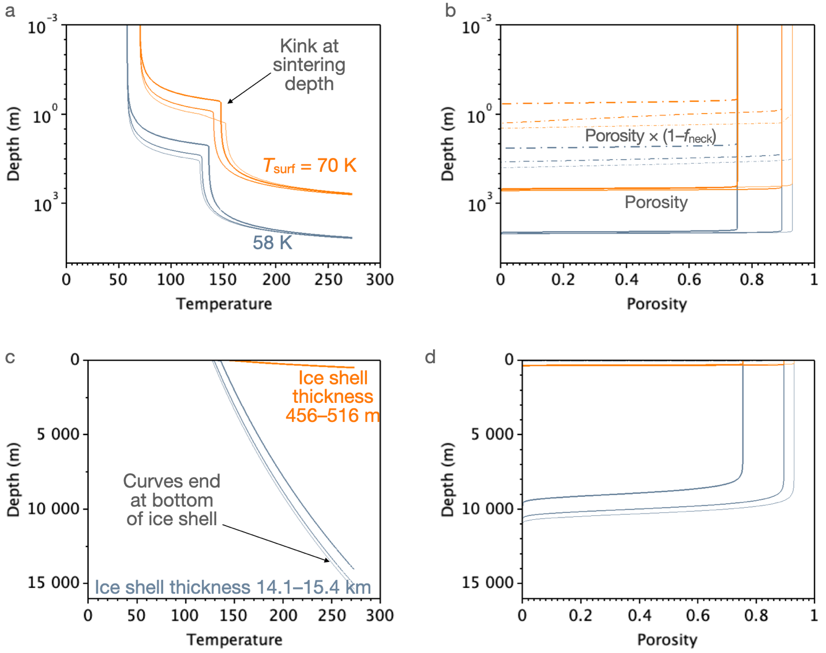
Figure 2. Ice shell structure for a surface thermal inertia of 25 J m⁻² K⁻¹ s^{-1/2} and a surface temperature of 58 K (blue curves) or 70 K (orange curves) at latitude –60º. a,c: Temperature profiles through the ice shell as a function of depth on a logarithmic and linear scale, respectively. Line thicknesses denote different porosity-thermal conductivity relationships (see Fig. 1), from least (thinnest) to most (thickest) conservative (equations 4 to 6, respectively). b,d: Porosity (solid curves) and effective porosity used to calculate thermal conductivity accounting for sintering (dot-dashed curves) as a function of depth on a logarithmic and linear scale, respectively.

Irrespective of the surface temperature, for reasonable ice shell thicknesses the RTG reaches the ocean in less than one ²³⁸Pu half-life, between 0.5–1 year for T_{surf} = 70 K and 24–40 years for T_{surf} = 58 K (Fig. 3). In the first two thirds of the ice shell where the porosity is above the 5–10% percolation threshold, descent takes place by sublimation. Deeper, melting hastens descent due to the lower enthalpy of melting relative to that of sublimation. At this fixed surface thermal inertia, the uncertainty linked to the k-φ relationship (shaded zones in Fig. 3) is generally smaller than the differences obtained by changing the surface temperature by a few degrees.

The conditions needed for the RTG descent to stall are T_{surf} < 57.6 K, corresponding to an ice shell thickness > 40 km. This is probably unrealistically high (Hemingway & Mittal, 2019, and references therein). [The porous ice shell structure in our model does not seem to affect estimates of ice shell thickness by more than 50%: a 12.7-km thick, nonporous ice shell of density 925 kg m⁻³ atop a 49-km thick ocean of density 1020 kg m⁻³ surrounding a core of radius 191 km and density 2400 kg m⁻³ yields the same bulk density (1.61×10³ kg m⁻³) and moment of inertia (C = 0.335 MR²; Iess et al., 2014) as a 8.3-km thick ice shell whose upper 2/3 have density 185 kg m⁻³ (i.e., 80% porosity), a 41-km thick ocean, and a core of radius 203 km and density 2260 kg m⁻³.] For T_{surf} = 57.5 K, we find Q_{endo} = 6.75 mW m⁻², which yields an ice shell 67 km thick, and the RTG descent stalls at 27 km depth (Fig. 3).

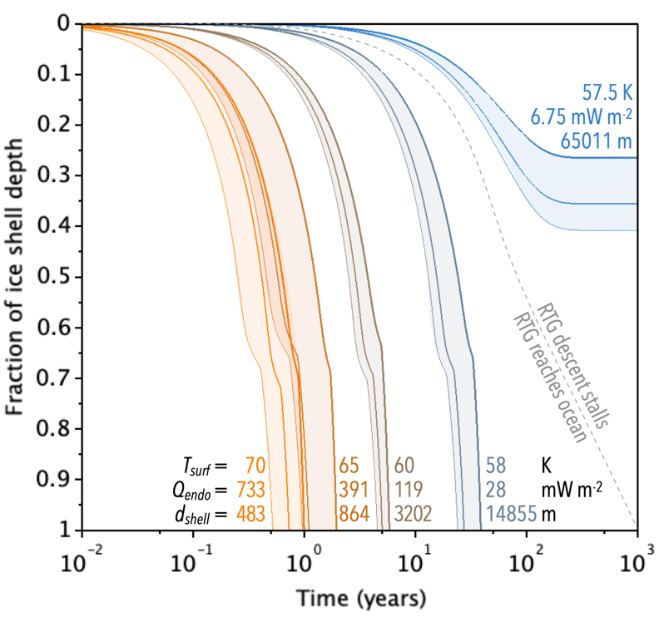
Figure 3. Depth, relative to ice shell thickness d_{shell}, of a conductively coupled RTG as a function of time. Colors indicate surface temperatures T_{surf}, which are linked to ice shell thicknesses and endogenic heat fluxes Q_{endo}. As in Fig. 2, different line thicknesses indicate different relationships between porosity and thermal conductivity (see Fig. 1). The kink in the curves about two thirds of the way through the ice shell indicates a transition from descent by sublimation to faster descent by melting.

Since the RTG is found to reach the ocean at nominal conditions, we do not carry out computations in more conservative conditions such as a lower surface thermal inertia, higher surface temperature, ice with antifreeze impurities such as NH₃, or for parts of an RTG (General Purpose Heat Sources –GPHS– or the iridium clads that they contain and that encapsulate the plutonium fuel) whose higher power per unit mass could overcome their smaller ratio of volume to surface area in facilitating descent in case the RTG breaks up.

  - Radiative coupling case
If the RTG is only radiatively coupled to the ice or snow (Scenarios 1, 2, 3 of Table 1), RTG heat is not transferred to the ground nearly as efficiently and the RTG does not reach the ocean for any realistic parameter combinations.
These boundary conditions have been included in a detailed thermal model of the Enceladus Orbilander on the (assumed flat) surface of Enceladus. The model includes the thick ice shell and the effects of porosity but no snow. Radiative transfer, to the ground, the spacecraft, and to space, is calculated via ray tracing.
The nominal distance from the RTG cores to the surface is sufficient to ensure that heat radiated from the RTGs does not warm up the ice by more than 5 K, even if the lander is tilted such that the RTG fins touch the surface (Scenario 2). Thus, the vast heat sink of the Enceladus surface, even at low temperatures and conductivity, does not significantly heat up. Applying equations (17–19) with T being the ambient temperature raised by 5 K, the RTG does not excavate the ice (penetration depth < 1 mm) unless T_{surf} > 90 K (i.e., Q_{endo} > 3.0 W m⁻²). Such surface temperatures are encountered only within distances of tiger stripe vents closer than the spatial resolution of Cassini’s Composite Infrared Spectrometer (≥ 0.8 km; Howett et al., 2011; but more conservatively ≤ 10 km based on their Fig. 3). These results were obtained for a surface thermal inertia of 2 J m⁻² K⁻¹ s^{-1/2}, a 4-σ lower bound (Howett et al., 2010) with probability < 10⁻⁴ that Enceladus’ ice shell is this porous and insulating. In these conservative end-member conditions, the ice shell is improbably thin, with thickness 95 to 109 m.
The maximum plume fallout rate predicted (1 mm yr⁻¹; Southworth et al., 2019) is insufficient to bury the spacecraft during the “period of biological exploration”. Thus, for a nominal landing and execution of the prime mission, the lander remains on the surface at end of mission with no likelihood of contaminating the subsurface ocean. This also holds for an off-nominal landing where the lander is tilted such that an RTG is in contact with the ground (Scenario 2).

- Discussion
Our model results suggest that nominal landings on Enceladus’ SPT (scenario 1; §3.2) only pose a planetary protection risk if T_{surf} > 90 K. This holds true even in the case of an off-nominal landing that results in a tilted spacecraft with RTGs in contact with the surface (Scenario 2; §3.2). Published analyses of Cassini data to date allow preliminary assessments of locations satisfying T_{surf} < 90 K, which suggests that there exist scientifically compelling landing locations that meet this criterion (Fig. 4). These preliminary identifications can be updated by analyzing Cassini datasets in greater depth and would need to be refined and updated by a lander mission prior to landing. In addition to thermal emission spectrometry, topographic measurements would quantify terrain slope, and radar measurements would help identify keep-out areas, if they exist, where the ice shell is not monolithic, e.g., subsurface crevasses or cavities filled with gas (as suggested by Combe et al., 2019) or where the ice-liquid water interface is within hundreds of meters of the surface.
However, an RTG embedded in (and thus conductively coupled to) snow or ice would likely reach a subsurface liquid reservoir (Scenarios 3 & 4; §3.1). Accordingly, to comply with planetary protection policy, landed missions to Enceladus must ensure that the combined likelihood of the RTG detaching from the spacecraft, becoming conductively coupled to the surface, and reaching the ocean with viable spores is below the policy’s 10⁻⁴ threshold. Specific considerations for this scenario are discussed below and summarized in Table 3.
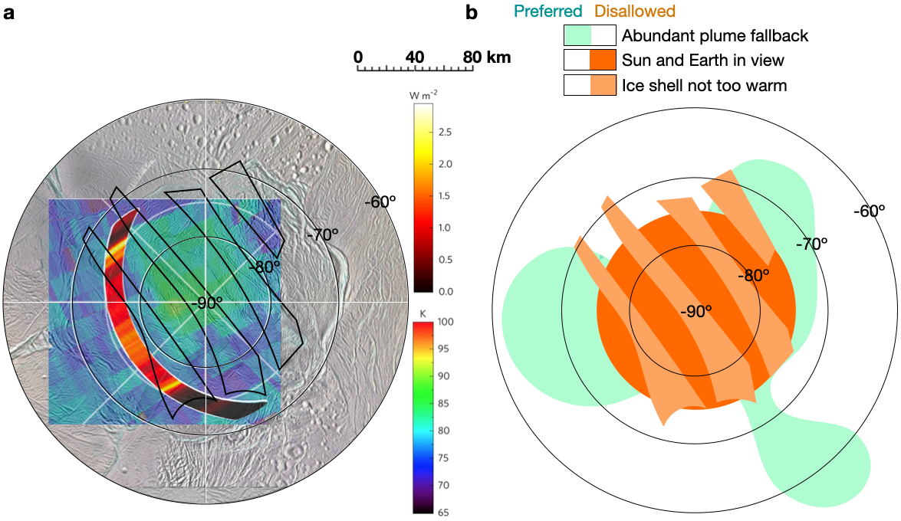
Figure 4. Planetary protection constraints on landing site selection: a. ice shell thermal conditions away from local maxima (T_{surf} < 90 K; Q_{endo} < 3 W m⁻²). Black outlines are regions of relatively high surface temperatures (non-negligible thermal emission) identified by Howett et al. (2011). The Cassini/CIRS-derived map of T_{surf} (cool colors) and Cassini radar-derived strip map of minimum Q_{endo} are reproduced from Le Gall et al. (2017). T_{surf} in the radar strip are similar to surroundings (< 80 K). b. Overlap of conditions favorable to (teal) or precluding (orange) suitable landing sites. In addition to the thermal criteria shown in panel (a), this combined map includes consideration of two additional criteria: 1. high plume fallout (based on maps from Southworth et al., 2019) and 2. the Sun and Earth being in view. The latter two are specific to the sampling strategy and timing of the Enceladus Orbilander mission concept but illustrate additional desirable qualities that may influence landing site selection. Although additional criteria could need to be considered (e.g., topographic highs to facilitate view of the Sun and Earth; low slope angles), available data suggest that there exist SPT locations that satisfy all landing site conditions. Bottom of maps is 0º longitude.

Scenario | Approach to Address Compliance with Planetary Protection Policy
(1) Nominal landing | Landing site should be sufficiently cold (< 90 K surface)
(2) Intact lander tilted
(3) RTG drops off after landing | • Radiative coupling: same as for scenarios (1) and (2)  • Conductive coupling: same as for scenario (4)
(4) RTG impaled from orbit | • Bioburden reduction of RTG mounting brackets  • RTG itself, including fins, GPHS, and Ir clads, is hot enough to be effectively sterile
Table 3. Possible approach to ensuring compliance with planetary protection policy for each scenario.

The likelihood of an off-nominal landing with detached RTGs resulting in the introduction of ≥ 1 viable microorganisms in the ocean, I_{V}, can be estimated as the product of three factors: the likelihood of spacecraft failure, P(S_{f}); the likelihood of RTG detachment, P(R_{D} | S_{f}); and the likelihood that there is at least one viable microbe on the hardware, P_{b} (unaffected by the above prior events).
The probability of spacecraft failure is arguably dominated by the likelihood of landing failure, previously estimated at P(S_{f}) = 0.33 based on the history of planetary missions (Lorenz, 2019). Terrain-relative navigation (TRN) enables spacecraft to autonomously respond to the realities of the surface in real time, thus helping decrease landing risk even if surface images of sufficient resolution are not already available. Recent demonstrations of TRN include delivery of the Perseverance rover on Mars (Johnson et al., 2022) and guidance of the Touch-And-Go sampling at asteroid Bennu by OSIRIS-REx (Ketzandanner et al., 2022). TRN will be used on the upcoming Double Asteroid Redirection Test (DART; Chen et al., 2018) and Dragonfly (McGee et al., 2018).
For the case of Enceladus orbit, P(S_{f}) is also a function of the orbital navigation error, given the need for autonomous trajectory correction once each orbit to maintain the orbit in the presence of gravitational perturbations by Saturn for ~10³ orbits (every 12 hours for 1.5 years, in the Orbilander mission concept). No navigation issues, recoverable or otherwise, were reported for the combined ≈300 orbits of Saturn by the Cassini spacecraft (Lorenz, 2019), which also required navigation corrections essentially at each orbit. However, even for the successful Cassini and Juno prime missions, unexpected trajectory replanning was necessary. In the case of Cassini, this was to mitigate a predicted Doppler shift communication issue due to a design flaw of the Huygens lander (e.g., Strange et al., 2002). For Juno, a crucial periapsis reduction maneuver was cancelled with a few days’ notice due to unexpected behavior of check valves while pressurizing the spacecraft’s main engine (Pavlak et al., 2017). Aside from the potential for unexpected replanning, orbiting Enceladus would require capabilities for autonomous navigation because the 12-hour orbital period, not much greater than the round-trip light time (about 2.6 hours), is too short for human-in-the-loop determination and uplink of trajectory corrections (MacKenzie et al., 2020). These capabilities have not previously been deployed in the outer solar system but are an area of active development. For example, onboard optical limb localization algorithms (e.g., Christian et al., 2015, 2021) have been tested to be accurate on Cassini data (Hollenberg et al., 2019). Thus, P(S_{f}) is clearly of order 0.1–1, with an upper bound P(S_{f}) < 1.
To attempt to constrain the likelihood of RTG detachment, the anticipated deceleration upon embedding in snow from orbit or during landing (initial velocity upper limit of 200 m s⁻¹; §1) is compared to accelerations to which hardware is subjected during qualification tests. RTGs have been tested for longitudinal and lateral accelerations of up to ≈250 m s⁻² and 200 m s⁻², respectively (e.g., DoE, 1973, Table V-3), but RTG mounts presumably are only qualified together with the full spacecraft for the launch environment, with typical accelerations up to ≈60 m s⁻². Upon contact with the surface of Enceladus, the deceleration would be ≥ 60 m s⁻² if the spacecraft is uniformly decelerated and stopped in < 3.3 s, or more time if the initial velocity is lower (e.g., if failure occurs during landing descent maneuvers). Such decelerations likely exceed accelerations for which the RTG mounts are qualified. Therefore, an upper limit of P(R_{D} | S_{f}) ≤ 1 is assumed for the likelihood of detachment of either of Enceladus Orbilander’s two mounted RTGs upon embedding into the surface.
The expected number of viable microorganisms on RTGs or the elements they contain (GPHS, Ir clads) is zero because the RTGs’ own power output is such as to render them sterile. The typical sterilization method for laboratory equipment and surgical tools is exposure to temperature of 121ºC for several hours at Earth’s atmospheric pressure (1 bar). The RTG temperature can be roughly estimated (conservatively assuming perfect emissivity) as:
(q(t)/[(2 πR_{RTG}² + 16 L_{RTG}L_{fins}) σ_{SB}])^{1/4} = 419 K = 146ºC (20)
at the time of landing (assuming q(t) = 3.5 kW 17 years past beginning of life and other parameters as in Table 2) and 158ºC around the time of launch (3 years past beginning of life). The summed terms represent the surface area of the two ends of a Next-Generation RTG cylinder and 8 fins of width L_{fins} = 10 cm each radiating from both sides. Detailed modeling of the entire designed Enceladus Orbilander on the surface of Enceladus shows that at the time of landing, the central part of a Next-Generation RTG cylinder is at 165ºC with the fins at 125ºC (see Fig. 5 for illustration of cooler fins in the case of the Multi-Mission RTG). Any microorganisms on the RTG would be exposed to such high temperatures in vacuum for 14 years, which represents a sterilizing environment superior to standard laboratory practices.

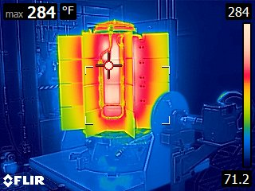
Figure 5. Thermal image of the Mars2020 Multi-Mission RTG (MMRTG) acquired at Idaho National Laboratory (Lorenz and Clarke, 2020) a few months before its launch, showing how the fin tip temperature is cooler than the cylindrical housing. In this case, the color scale minimum and maximum are about 22 and 144ºC (295 K and 417 K), respectively, with the coolest fin temperatures at about 50ºC. The MMRTG’s heat output (2 kW) is lower than the Next-Generation RTG’s, and convective cooling in Earth’s atmosphere also acts to decrease temperatures, despite back-radiation from the surrounding warm room. For comparison, equation (20) predicts a MMRTG temperature of 79ºC (352 K) in vacuum, assuming L_{fins} = 2×R_{RTG} = 0.2 m and L_{RTG} = 0.7 m. INL Photo.

RTG temperatures do not preclude the possibility of microbial survival on cooler parts attached to the RTG that could detach with it. The largest piece of hardware that could detach with an RTG and still reach the ocean would be one with a cross section not much larger than the RTG’s, such that the RTG is conductively coupled to (i.e., contacts) the surrounding ice. This includes the bracket used to attach the RTG to the spacecraft, as well as other spacecraft parts if scenario 3 results from a crash during the landing maneuvers in which additional detached parts, which would remain near the spacecraft, could fall in the hole dug by the RTG and descend with it.
Evidence for microorganismal survival in the UV-irradiated, vacuum environment of space (e.g., Kawaguchi et al., 2020, and references therein) suggests that unsterilized cool spacecraft parts attached to an RTG that could detach with it during an off-nominal landing could retain part of their bioburden (P_{b} ≤ 1). The worst-case likelihood of conductive coupling scenarios resulting in contaminating the ocean is therefore I_{V} = P(S_{f}) × P(R_{D} | S_{f}) × P_{b} ≤ P_{b} . The mounting brackets can be readily sterilized completely on the ground using several methods (e.g., dry-heat microbial reduction, oxidants, radiation, solvents), and the level of sterility validated before launch. This may not be the case for all spacecraft parts that could detach and sink with the RTG following a hard landing. Such parts would need to be identified, and one should determine whether the likelihood of any such part reaching the ocean with the RTG is low enough for I_{V} to be below 10⁻⁴. One could envision this leading to requirements on the spacecraft structure, e.g., that any unsterilized part remain enclosed within the spacecraft bus should the shock undergone during a hard landing be below an identified threshold – since for harder landings the greater spatial spread of spacecraft parts would lower the likelihood of co-location of unsterilized debris with a detached RTG. Following pre-launch bioburden reduction, recontamination would have to be prevented using, e.g., biobarriers (Hand et al., 2016; Eigenbrode et al., 2021).

- Conclusions
RTG-powered landed missions to icy worlds must ensure a sufficiently small likelihood of any microorganism-bearing part of the landed element reaching the ocean. To quantify this likelihood, four scenarios have been identified (Table 1). For Scenarios 1 (nominal) and 2, the landed hardware does not pose a planetary protection risk because there exist scientifically compelling landing sites where the mechanism of transport to a subsurface liquid water environment (burial under plume fallout) operates on timescales of > 10⁶ years that vastly exceed the biological exploration period (10³ years). Ensuring this lack of planetary protection risk restricts the choice of landing location (Fig. 4), but for these scenarios, the probability of inadvertent contamination of the ocean is zero.
For Scenarios 3 & 4, the mechanism of transport of microorganism-bearing hardware to a subsurface liquid water environment is sublimation or melting of ice by the heat source that contacts it. The probability of inadvertent contamination of the ocean is nonzero and given by I_{V} = P(S_{f}) × P(R_{D} | S_{f}) × P_{b}, where:
- P(S_{f}) ≥ 0.33 is the likelihood of spacecraft failure based on the history of planetary spaceflight;
- P(R_{D} | S_{f}) ≤ 1 because the impact deceleration likely exceeds the acceleration that RTG-spacecraft interfaces are verified to withstand;
- P_{b} ≤ 1 without bioburden reduction on unsterilized hardware parts that may descend with the RTG (itself sterile due to its high temperatures), e.g., RTG mounting brackets. This warrants bioburden reduction on the majority of spacecraft hardware such that P_{b} < 10⁻⁴ (i.e., I_{v} < 10⁻⁴), which can be readily achieved with standard techniques (e.g., dry-heat microbial reduction, oxidants, radiation, solvents), and demonstration of likelihood < 10⁻⁴ that any unsterilized part would be co-located with a detached RTG in a hard landing.
To arrive at these conclusions, we have modeled the descent in the ice shell of spacecraft hardware due to sublimation and melting induced by an RTG, the hottest element a spacecraft can carry. Descent is greatly facilitated if the RTG core directly contacts the surrounding ice and/or snow (conductive coupling; off-nominal landing scenario) rather than warming them from a distance (radiative coupling) by contacting the surface only through its fins (off-nominal) or being mounted on the lander (nominal). In the off-nominal conductive coupling case, we find that an RTG would reach the ocean. In the radiative coupling case, the descent is stalled unless the surface is warmer than 90 K (endogenic heat flux greater than 3 W m⁻² at –60º latitude). Our implementation of the model, provided as supplementary material to this article, can be rerun with updated properties as they are determined.
On airless ocean worlds at and beyond Saturn’s heliocentric distance, surfaces are sufficiently cold, and/or surface heat fluxes sufficiently low, to preclude RTG-induced transport of spacecraft hardware to the subsurface ocean, save for kilometer-scale endogenic hot spots that can be identified and, nominally, avoided. The Jovian moons are warmer (T_{surf} ≈ 100 K at Europa) but have thicker ice shells and are not expected to be substantially covered in snow, save for any potential effects of space weathering that would presumably increase with increasing surface age. According to our analysis, RTG-powered landed missions would only need to demonstrate (beyond what has been done for flybys and orbiters) a low likelihood of a detached RTG carrying unsterilized hardware contacting warm and/or snow-blanketed areas of the surface. Alternatively, at Jupiter’s distance from the Sun, solar power is a viable long-term energy source as demonstrated by the Juno, JUICE, and Europa Clipper missions. Thus, our results show that long-lived landed missions to ocean worlds can readily be designed to comply with forward planetary protection policy.

Acknowledgements
We thank two anonymous reviewers and the Associate Editor whose comments significantly helped improve this manuscript, the Enceladus Orbilander engineering study team at JHUAPL for designing this lander implementation, as well as the Orbilander science team for motivating this study and mission architecture. This work was supported by NASA Planetary Mission Concept Study award 80NSSC20K0136. The full list of team members is available in the study report at
https://science.nasa.gov/solar-system/documents. A SciLab implementation of the model is available as supplementary online material.

References

Abramov, O. and Spencer, J.R. (2009) Endogenic heat from Enceladus' south polar fractures: New observations, and models of conductive surface heating. Icarus 199:189-196.
https://doi.org/10.1016/j.icarus.2008.07.016.

Albert, M.R. and Perron, F.E. (2000) Ice layer and surface crust permeability in a seasonal snow pack. Hydrological Processes 14:3207-3214. https://doi.org/10.1002/1099-1085(20001230)14:18%3C3207::AID-HYP196%3E3.0.CO;2-C.

Andreas, E.L. (2007) New estimates for the sublimation rate for ice on the Moon. Icarus 186:24-30. https://doi.org/10.1016/j.icarus.2006.08.024.

Arakawa, S., Tanaka, H., Kataoka, A., and Nakamoto, T. (2017) Thermal conductivity of porous aggregates. Astronomy & Astrophysics 608:L7. https://doi.org/10.1051/0004-6361/201732182.

Arthern, R.J., Vaughan, D.G., Rankin, A.M., Mulvaney, R. and Thomas, E.R. (2010) In situ measurements of Antarctic snow compaction compared with predictions of models. Journal of Geophysical Research: Earth Surface 115:F3011. https://doi.org/10.1029/2009JF001306.

Baland, R.M., Yseboodt, M., and Van Hoolst, T. (2016) The obliquity of Enceladus. Icarus 268:12-31. https://doi.org/10.1016/j.icarus.2015.11.039.

Bennett, G., Lombardo, J., Hemler, R., Silverman, G., Whitmore, C., Amos, W., Johnson, E., Schock, A., Zocher, R., Keenan, T., Hagan, J., and Englehart, R. (2006) Mission of daring: The general-purpose heat source radioisotope thermoelectric generator. 4th International Energy Conversion Engineering Conference and Exhibit (IECEC), 4096. https://doi.org/10.2514/6.2006-4096.

Buratti, B.J., Dalba, P.A., Hicks, M.D. and Chang, J.P. (2014) Enceladus: Surface Texture and Roughness as Clues to What Lies Beneath. Lunar and Planetary Science Conference, abstract 2038. https://www.hou.usra.edu/meetings/lpsc2014/pdf/2038.pdf.

Calonne, N., Flin, F., Morin, S., Lesaffre, B., du Roscoat, S.R. and Geindreau, C. (2011) Numerical and experimental investigations of the effective thermal conductivity of snow. Geophysical Research Letters 38:L23501. https://doi.org/10.1029/2011GL049234.

Carvano, J.M., Migliorini, A., Barucci, A., Segura, M. and CIRS Team (2007) Constraining the surface properties of Saturn's icy moons, using Cassini/CIRS emissivity spectra. Icarus 187:574-583. https://doi.org/10.1016/j.icarus.2006.09.008.

Chen, M., Atchison, J., Carrelli, D., Ericksen, P., Fletcher, Z., Jenkins, S., Jensenius, S., Mehta, N., Miller, T. and O’Shaughnessy, D. (2018) Small-Body Maneuvering Autonomous Real-Time Navigation (SMART Nav): Guiding a Spacecraft to Didymos for NASA’s Double Asteroid Redirection Test (DART). Proc. Advances in the Astronautical Sciences AAS/AIAA Guidance, Navigation and Control 164:18-063.

Choukroun, M., Molaro, J.L., Hodyss, R., Marteau, E., Backes, P., Carey, E.M., Dhaouadi, W., Moreland, S. and Schulson, E.M. (2020) Strength evolution of ice plume deposit analogs of Enceladus and Europa. Geophysical Research Letters 47(15), e2020GL088953. https://doi.org/10.1029/2020GL088953.

Christian, J.A. (2015) Optical navigation using planet’s centroid and apparent diameter in image. Journal of Guidance, Control, and Dynamics 38:192-204. https://doi.org/10.2514/1.G000872.

Christian, J.A. (2021) A tutorial on horizon-based optical navigation and attitude determination with space imaging systems. IEEE Access 9:19819-19853. https://doi.org/ 10.1109/ACCESS.2021.3051914.

Combe, J.P., McCord, T.B., Matson, D.L., Johnson, T.V., Davies, A.G., Scipioni, F. and Tosi, F. (2019) Nature, distribution and origin of CO₂ on Enceladus. Icarus 317:491-508. https://doi.org/10.1016/j.icarus.2018.08.007.

COSPAR (2021) Policy on Planetary Protection. http://cosparhq.cnes.fr/assets/uploads/2021/07/PPPolicy_2021_3-June.pdf. (Accessed Dec. 10, 2021.)

Department of Energy (1973) SNAP Pioneer F & G – Final Report. DOE/ET/13512—T1, publicly released in 2006. https://www.osti.gov/servlets/purl/5352675. (Accessed June 30, 2021.)

Desch, S.J., Cook, J.C., Doggett, T.C. and Porter, S.B. (2009) Thermal evolution of Kuiper belt objects, with implications for cryovolcanism. Icarus 202:694-714. https://doi.org/10.1016/j.icarus.2009.03.009.

Eigenbrode, J.L., Gold, R., Canham, J.S., Schulze, E., Davila, A.F., Seas, A.A., Errigo, T., Kujawa, F., Kusnierkiewicz, D., Lorentson, C.C. and McKay, C. (2021) Contamination Control for Ultra-Sensitive Life-Detection Missions. Frontiers in Space Technologies, 6:734423. https://doi.org/10.3389/frspt.2021.734423.

Getzandanner, K.M., Antreasian, P.G., Moreau, M.C., Leonard, J.M., Adam, C.D., Wibben, D., Berry, K., Highsmith, D. and Lauretta, D. (2022) Small Body Proximity Operations & TAG: Navigation Experiences & Lessons Learned from the OSIRIS-REx Mission. AIAA SCITECH 2022 Forum, abstract 2387. https://doi.org/10.2514/6.2022-2387.

Grasset, O., Bunce, E.J., Coustenis, A., Dougherty, M.K., Erd, C., Hussmann, H., Jaumann, R. and Prieto-Ballesteros, O. (2013) Review of exchange processes on Ganymede in view of its planetary protection categorization. Astrobiology 13:991-1004. https://doi.org/10.1089/ast.2013.1013.

Hand, K.P., Murray, A.E., Garvin, J.B., Brinckerhoff, W.B., Christner, B.C., Edgett, K.S., et al. (2017) Report of the Europa Lander Science Definition team. National Aeronautics and Space Administration. Available online at: https://europa.nasa.gov/system/downloadable_items/50_Europa_ Lander_SDT_Report_2016.pdf

Hedman, M.M., Nicholson, P.D., Showalter, M.R., Brown, R.H., Buratti, B.J. and Clark, R.N., (2009) Spectral observations of the Enceladus plume with Cassini-VIMS. The Astrophysical Journal 693:1749. https://doi.org/10.1088/0004-637X/693/2/1749.

Hemingway, D.J. and Mittal, T. (2019) Enceladus's ice shell structure as a window on internal heat production. Icarus 332:111-131. https://doi.org/10.1016/j.icarus.2019.03.011.

Hollenberg, C.L., Christian, J.A., Bhaskaran, S. and Owen, W.M. (2019) Centroiding Performance for Horizon-Based Optical Navigation with Cassini Images of Dione and Rhea. AAS Space Flight Mechanics Meeting, abstract 19–494.

Howell, S.M. and Pappalardo, R.T. (2019) Can Earth-like plate tectonics occur in ocean world ice shells? Icarus 322:69-79. https://doi.org/10.1016/j.icarus.2019.01.011.

Howett, C.J.A., Spencer, J.R., Pearl, J., and Segura, M. (2010) Thermal inertia and bolometric Bond albedo values for Mimas, Enceladus, Tethys, Dione, Rhea and Iapetus as derived from Cassini/CIRS measurements. Icarus 206:573-593. https://doi.org/10.1016/j.icarus.2009.07.016.

Howett, C.J.A., Spencer, J.R., Pearl, J., and Segura, M. (2011) High heat flow from Enceladus’ south polar region measured using 10–600 cm⁻¹ Cassini/CIRS data. Journal of Geophysical Research: Planets 116:E3003. https://doi.org/10.1029/2010JE003718.

Iess, L., Stevenson, D.J., Parisi, M., Hemingway, D., Jacobson, R.A., Lunine, J.I., Nimmo, F., Armstrong, J.W., Asmar, S.W., Ducci, M. and Tortora, P. (2014) The gravity field and interior structure of Enceladus. Science 344:78-80. https://doi.org/10.1126/science.1250551.

Johnson, A.E., Aaron, S.B., Ansari, H., Bergh, C., Bourdu, H., Butler, J., Chang, J., Cheng, R., Cheng, Y., Clark, K. and Clouse, D. (2022) Mars 2020 Lander Vision System Flight Performance. AIAA SciTech 2022 Forum, abstract 1214. https://doi.org/10.2514/6.2022-1214.

Kawaguchi, Y., Shibuya, M., Kinoshita, I., Yatabe, J., Narumi, I., Shibata, H., Hayashi, R., Fujiwara, D., Murano, Y., Hashimoto, H., Imai, E., et al. (2020) DNA damage and survival time course of deinococcal cell pellets during 3 years of exposure to outer space. Frontiers in Microbiology 11:2050. https://doi.org/10.3389/fmicb.2020.02050.

Klinger, J. (1980) Influence of a phase transition of ice on the heat and mass balance of comets. Science 209:271. https://doi.org/10.1126/science.209.4453.271.

Krause, M., Blum, J., Skorov, Y.V., and Trieloff, M. (2011) Thermal conductivity measurements of porous dust aggregates: I. Technique, model and first results. Icarus 214:286-296. https://doi.org/10.1016/j.icarus.2011.04.024.

Le Gall, A., Leyrat, C., Janssen, M.A., Choblet, G., Tobie, G., Bourgeois, O., Lucas, A., Sotin, C., Howett, C., Kirk, R., Lorenz, R.D., West, R.D., Stolzenbach, A., Massé, M., Hayes, A.H., Bonnefoy, L., Veyssière, G., and Paganelli, F. (2017) Thermally anomalous features in the subsurface of Enceladus’s south polar terrain. Nature Astronomy 1:0063. https://doi.org/10.1038/s41550-017-0063.

Lorenz, R.D. (2012) Thermal Drilling in Planetary Ices: An Analytic Solution with Application to Planetary Protection Problems of Radioisotope Power Sources. Astrobiology 12:799-802. https://doi.org/10.1089/ast.2012.0816.

Lorenz, R.D. (2019) Calculating risk and payoff in planetary exploration and life detection missions. Advances in Space Research 64:944-956. https://doi.org/10.1016/j.asr.2019.05.026.

Lorenz, R.D., and Clarke, E.S. (2020) Influence of the Multi-Mission Radioisotope Thermoelectric Generator (MMRTG) on the local atmospheric environment. Planetary and Space Science 193:105075. https://doi.org/10.1016/j.pss.2020.105075.

MacKenzie, S.M. et al. (2020) Enceladus Orbilander. Planetary Mission Concept Study report for the 2023-2032 Decadal Survey. Available online at: https://science.nasa.gov/science-pink/s3fs-public/atoms/files/Enceladus%20Orbilander.pdf.

MacKenzie, S.M., Neveu, M., Davila, A.F., Lunine, J.I., Craft, K.L., Cable, M.L., Phillips-Lander, C.M., Hofgartner, J.D., Eigenbrode, J.L., Waite, J.H. and Glein, C.R. (2021) The Enceladus Orbilander Mission Concept: balancing return and resources in the search for life. The Planetary Science Journal, 2:77. https://doi.org/10.3847/PSJ/abe4da.

Martens, H.R., Ingersoll, A.P., Ewald, S.P., Helfenstein, P., and Giese, B. (2015) Spatial distribution of ice blocks on Enceladus and implications for their origin and emplacement. Icarus 245:162-176. https://doi.org/10.1016/j.icarus.2014.09.035.

McGee, T.G., Adams, D., Hibbard, K., Turtle, E., Lorenz, R., Amzajerdian, F. and Langelaan, J. (2018) Guidance, Navigation, and Control for Exploration of Titan with the Dragonfly Rotorcraft Lander. AIAA Guidance, Navigation, and Control Conference, abstract 1330. https://doi.org/10.2514/6.2018-1330.

Melinder, Å. (2007) Thermophysical properties of aqueous solutions used as secondary working fluids (Doctoral dissertation, KTH). https://www.diva-portal.org/smash/get/diva2:12169/FULLTEXT01.pdf

Molaro, J.L., Choukroun, M., Phillips, C.B., Phelps, E.S., Hodyss, R., Mitchell, K.L., Lora, J.M. and Meirion‐Griffith, G. (2019) The microstructural evolution of water ice in the solar system through sintering. Journal of Geophysical Research: Planets 124, 243-277.
https://doi.org/10.1029/2018JE005773.

Mousis, O., Chassefiere, E., Holm, N.G., Bouquet, A., Waite, J.H., Geppert, W.D., Picaud, S., Aikawa, Y., Ali-Dib, M., Charlou, J.L. and Rousselot, P. (2015) Methane clathrates in the solar system. Astrobiology 15:308-326. https://doi.org/10.1089/ast.2014.1189.

Murphy, D.M. and Koop, T. (2005) Review of the vapour pressures of ice and supercooled water for atmospheric applications. Quarterly Journal of the Royal Meteorological Society 131:1539-1565. https://doi.org/10.1256/qj.04.94.

NASA (2020) Radioisotope Power Systems – Safety and Reliability. https://rps.nasa.gov/about-rps/safety-and-reliability. (Accessed Dec. 18, 2020.)

National Research Council (2012) Assessment of Planetary Protection Requirements for Spacecraft Missions to Icy Solar System Bodies. Washington, DC: The National Academies Press. https://doi.org/10.17226/13401.

Netto, A.S.T. (1993) Pore-size distribution in sandstones. AAPG Bulletin 77:1101-1104. https://doi.org/10.1306/BDFF8DF8-1718-11D7-8645000102C1865D.

Oleson, S., Newman, J.M., Dombard, A., Meyer-Dombard, D., Craft, K., Sterbentz, J., Colozza, A., Faller, B., Fittje, J., Gyekenyesi, J., Jones, R., Landis, G., Lantz, N., Mason, L., McCarty, S., McKay, T., Packard, T., Schmitz, P., Turnbull, E., and Zakrajsek, J. (2019) Compass Final Report: Europa Tunnelbot. NASA/TP—2019-220054. https://ntrs.nasa.gov/archive/nasa/casi.ntrs.nasa.gov/20190026714.pdf.

Pajola, M., Lucchetti, A., Senter, L. and Cremonese, G. (2021) Blocks Size Frequency Distribution in the Enceladus Tiger Stripes Area: Implications on Their Formative Processes. Universe 7:82. https://doi.org/10.3390/universe7040082.

Porco, C.C., Dones, L. and Mitchell, C. (2017) Could it be snowing microbes on Enceladus? Assessing conditions in its plume and implications for future missions. Astrobiology 17:876-901. https://doi.org/10.1089/ast.2017.1665.

Postberg, F., Clark, R.N., Hansen, C.J., Coates, A.J., Dalle Ore, C.M., Scipioni, F., Hedman, M. and Waite, J. (2018) Plume and surface composition of Enceladus. In Enceladus and the icy moons of Saturn (eds. P. Schenk. et al.), Univ. Arizona Press, Tucson, pp. 129-162.

Pavlak, T.A., Johannesen, J.R. and Bordi, J.J. (2017) Juno Trajectory Redesign Following PRM Cancellation. AAS/AIAA Astrodynamics Specialist Conference, abstract 573. https://trs.jpl.nasa.gov/handle/2014/47545.

Proksch, M., Rutter, N., Fierz, C., and Schneebeli, M. (2016) Intercomparison of snow density measurements: bias, precision, and vertical resolution. The Cryosphere 10:371-384. https://doi.org/10.5194/tc-10-371-2016.

Rosenhead, L. (1963) Laminar boundary layers; an account of the development, structure, and stability of laminar boundary layers in incompressible fluids, together with a description of the associated experimental techniques. Clarendon Press, Oxford, UK.

Shoshany, Y., Prialnik, D., and Podolak, M. (2002) Monte Carlo modeling of the thermal conductivity of porous cometary ice. Icarus 157:219-227. https://doi.org/10.1006/icar.2002.6815.

Southworth, B.S., Kempf, S., and Spitale, J. (2019) Surface deposition of the Enceladus plume and the zenith angle of emissions. Icarus 319:33-42. https://doi.org/10.1016/j.icarus.2018.08.024.

Strange, N., Goodson, T. and Hahn, Y. (2002) Cassini tour redesign for the Huygens mission. AIAA/AAS Astrodynamics Specialist Conference and Exhibit, abstract 4720. https://arc.aiaa.org/doi/pdf/10.2514/6.2002-4720.

Trumbo, S.K., Brown, M.E. and Butler, B.J. (2018) ALMA thermal observations of Europa. The Astronomical Journal 156:161. https://doi.org/10.3847/1538-3881/aada87.

Ulamec, S., Biele, J., Funke, O. and Engelhardt, M. (2007) Access to glacial and subglacial environments in the Solar System by melting probe technology. Rev Environ Sci Biotechnol 6:71–94. https://doi.org/10.1007/s11157-006-9108-x.

Verbiscer, A.J., French, R.G. and McGhee, C.A. (2005) The opposition surge of Enceladus: HST observations 338–1022 nm. Icarus 173:66-83. https://doi.org/10.1016/j.icarus.2004.05.001.

Waite, J.H., Lewis, W.S., Magee, B.A., Lunine, J.I., McKinnon, W.B., Glein, C.R., Mousis, O., Young, D.T., Brockwell, T., Westlake, J. Nguyen, M.J. et al. (2009) Liquid water on Enceladus from observations of ammonia and 40 Ar in the plume. Nature 460:487-490. https://doi.org/10.1038/nature08153.

Waite, J.H., Glein, C.R., Perryman, R.S., Teolis, B.D., Magee, B.A., Miller, G., Grimes, J., Perry, M.E., Miller, K.E., Bouquet, A., Lunine, J.I. et al. (2017) Cassini finds molecular hydrogen in the Enceladus plume: evidence for hydrothermal processes. Science 356:155-159. https://doi.org/ 10.1126/science.aai8703.

