Supplementary material

Integrated atmospheric and topographic correction improve forest mapping using Landsat imagery H. Yin, B. Tan, D. Frantz and V. C. Radeloff
Table 1A. Comparisons of existing methods for topographic correction
Group | Method | Reference | Advantages | Limitations
Stand-alone models | Band rationing | Ekstrand, 1996 | Easy to implement | Outputs have no physical meaning;  Over correction may happen;  Often require land cover maps to obtain empirical coefficients;  Problematic under low illumination conditions
Stand-alone models | Cosine correction | Teillet et al., 1982 | Easy to implement
Stand-alone models | Minnaert model | Minnaert, 1941 | Easy to implement
Stand-alone models | C-correction | Meyer et al., 1993; Teillet et al., 1982 | Easy to implement
Stand-alone models | Slope matching | Nichol et al., 2007 | Easy to implement
Integrated atmospheric and topographic models | 5S model+topographic correction | Hill et al., 1995 | Model the full path of radiance;  Separate the direct and diffuse radiations | Requires additional auxiliary data;  Computation demanding;  Model can be very complex
Integrated atmospheric and topographic models | Radiative transfer theory based correction | Li et al., 2012
Integrated atmospheric and topographic models | Path Length Correction | Yin et al., 2017
Integrated atmospheric and topographic models | MODTRAN 4 radiative transfer model based correction | Santini and Palombo, 2019
Integrated atmospheric and topographic models | Integrated Radiometric Correction (IRC) | Kobayashi and Sanga‐Ngoie, 2009

Ekstrand, S., 1996. Landsat TM-Based Forest Damage Assessment: Correction for Topographic Effects. Photogramm. Eng. Remote Sens. 62, 151–161.
Hill, J., Mehl, W., Radeloff, V.C., 1995. Improved forest mapping by combining corrections of atmospheric and topographic effects in Landsat TM imagery, in: Askne (Ed.), Sensors and Environmental Applications of Remote Sensing. Balkena, Rotterdam.
Kobayashi, S., Sanga‐Ngoie, K., 2009. A comparative study of radiometric correction methods for optical remote sensing imagery: the IRC vs. other image‐based C‐correction methods. Int. J. Remote Sens. 30, 285–314. https://doi.org/10.1080/01431160802356781
Li, F., Jupp, D.L.B., Thankappan, M., Lymburner, L., Mueller, N., Lewis, A., Held, A., 2012. A physics-based atmospheric and BRDF correction for Landsat data over mountainous terrain. Remote Sens. Environ. 124, 756–770. https://doi.org/10.1016/J.RSE.2012.06.018
Meyer, P., Itten, K.I., Kellenberger, T., Sandmeier, S., Sandmeier, R., 1993. Radiometric corrections of topographically induced effects on Landsat TM data in an alpine environment. ISPRS J. Photogramm. Remote Sens. 48, 17–28. https://doi.org/10.1016/0924-2716(93)90028-L
Minnaert, M., 1941. The reciprocity principle in lunar photometry. Astrophys. J. 93, 403. https://doi.org/10.1086/144279
Nichol, J., Hang, L.K., Sing, W.M., 2007. Empirical correction of low Sun angle images in steeply sloping terrain: a slope‐matching technique. http://dx.doi.org/10.1080/02781070500293414 27, 629–635. https://doi.org/10.1080/02781070500293414
Santini, F., Palombo, A., 2019. Physically Based Approach for Combined Atmospheric and Topographic Corrections. Remote Sens. 11, 1218. https://doi.org/10.3390/rs11101218
Teillet, P.M., Guindon, B., Goodenough, D.G., 1982. On the slope-aspect correction of multispectral scanner data. Can. J. Remote Sens. 8, 84–106. https://doi.org/10.1080/07038992.1982.10855028
Yin, G., Li, A., Zhao, W., Jin, H., Bian, J., Wu, S., 2017. Modeling Canopy Reflectance Over Sloping Terrain Based on Path Length Correction. IEEE Trans. Geosci. Remote Sens. 55, 4597–4609. https://doi.org/10.1109/TGRS.2017.2694483

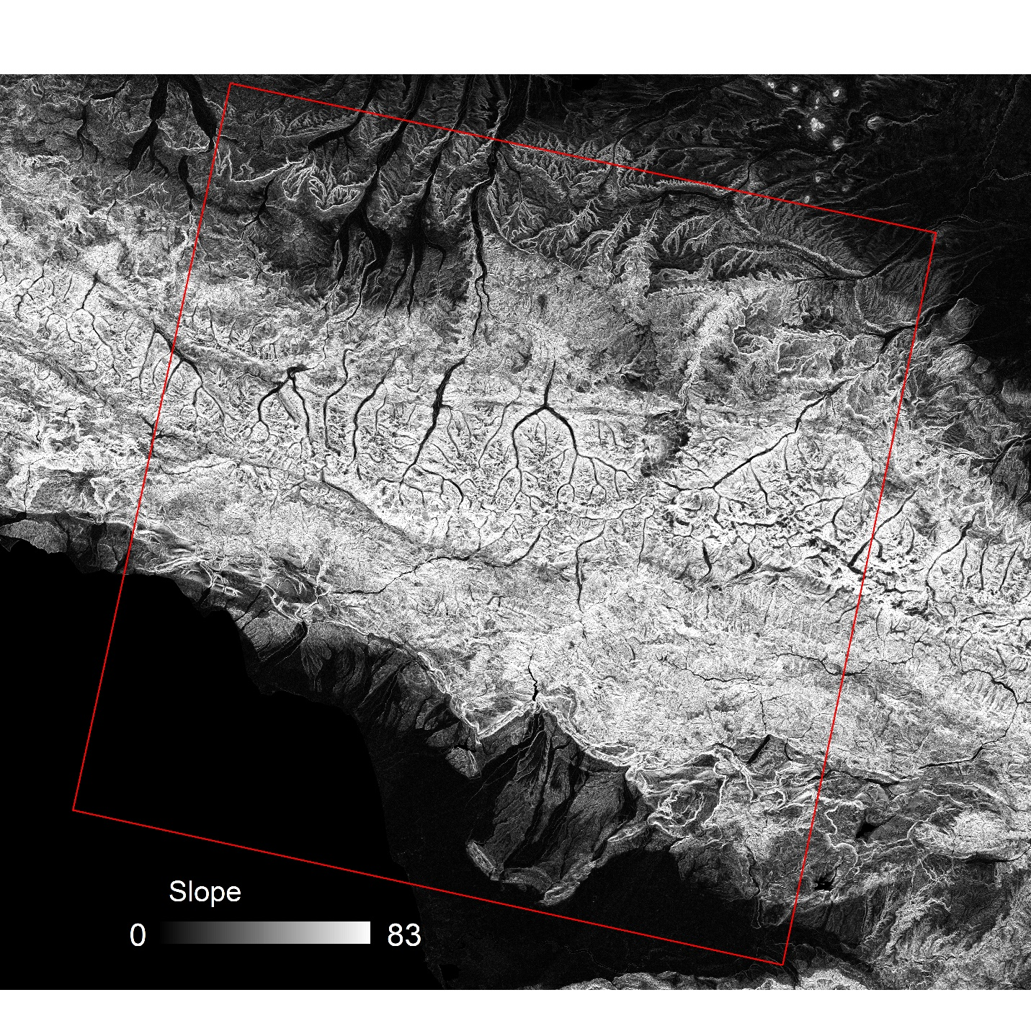

Fig. 1A. The slope (degree) of the study area, calculated from SRTM DEM dataset

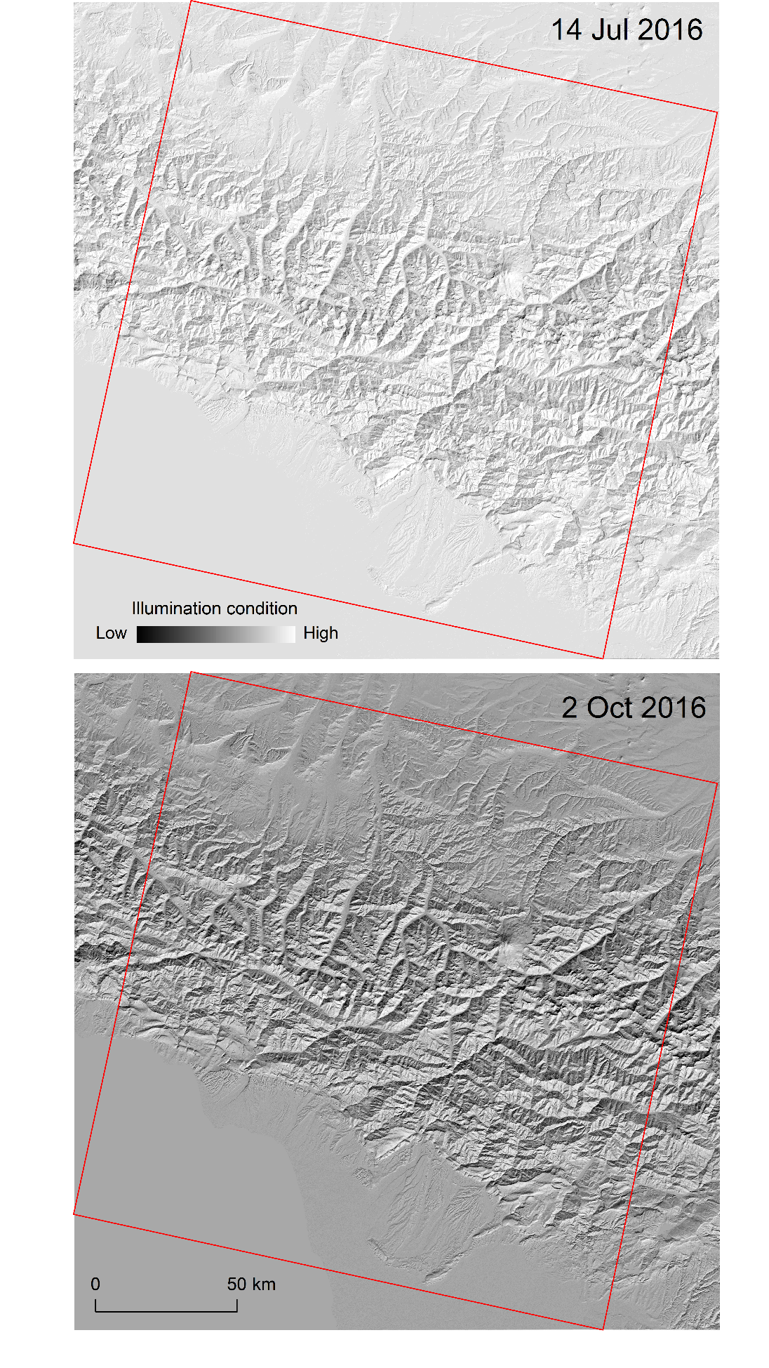

Fig. 2A. The illumination condition for the selected imagery.
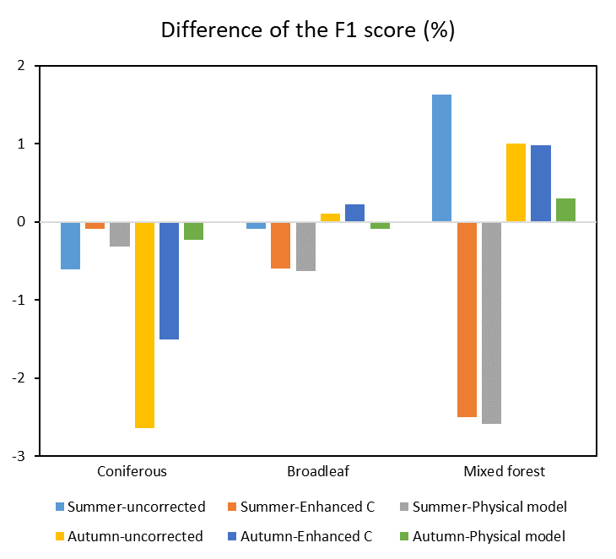

Fig. 3A. The difference of the F1 score with and without NDVI for classification. Positive values indicate higher mapping accuracy while negative value indicate lower mapping accuracy after adding NDVI.

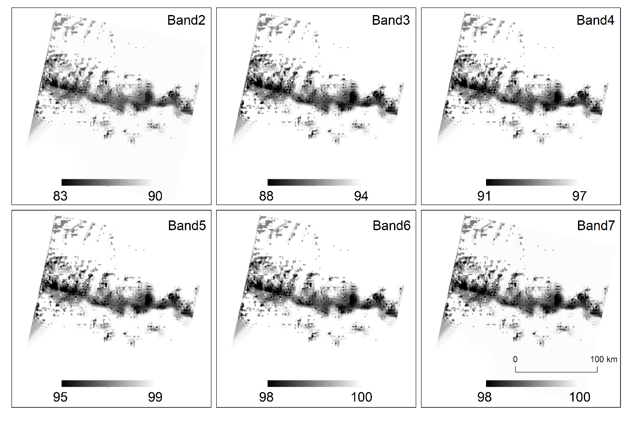Fig. 4A. The ratio (%) of the direct irradiance derived from the 6S model for July 14, 2016.

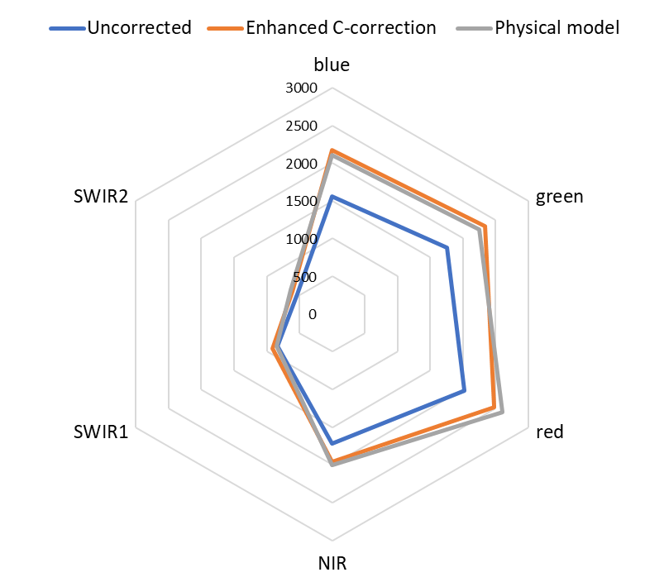
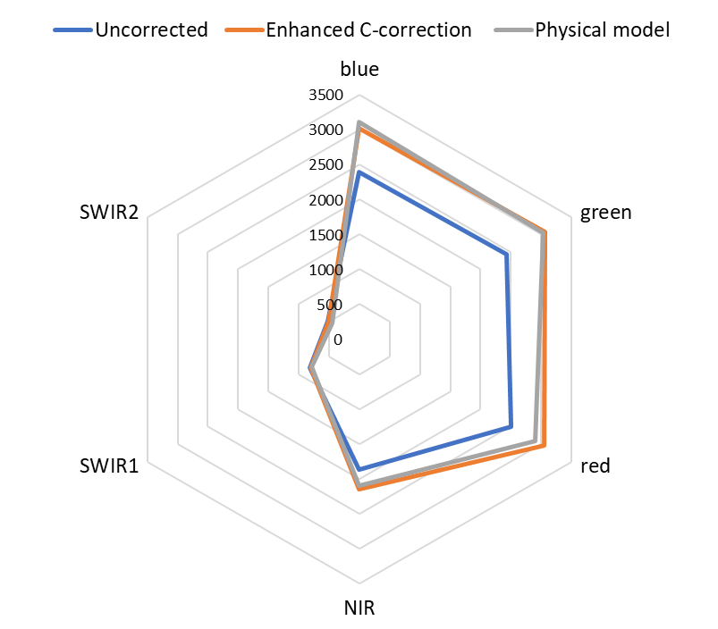

Fig. 5A. The separability index (SI) within the training samples for summer (top) and autumn (bottom) imagery. The separability index was calculated as SI=SD {median₁, …, median₇}, where SD the standard deviation and median indicates and the median value of the reflectance values within each land cover class.

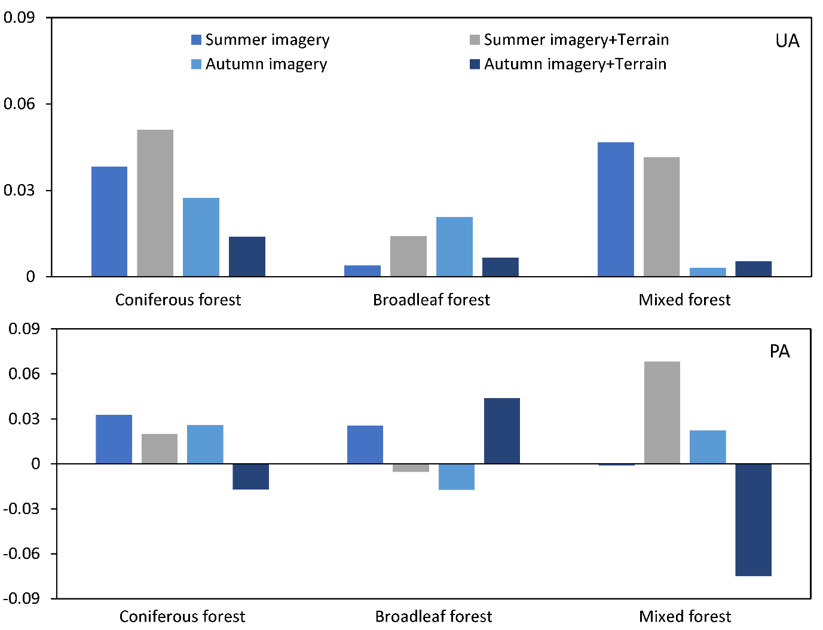

Fig. 6A. Differences in mapping accuracy using two versions of FORCE software (i.e. v.1.1, v3.6.3). Positive value of accuracy indicates higher mapping accuracy, while negative values indicate lower mapping accuracy using the v.3.6.3.
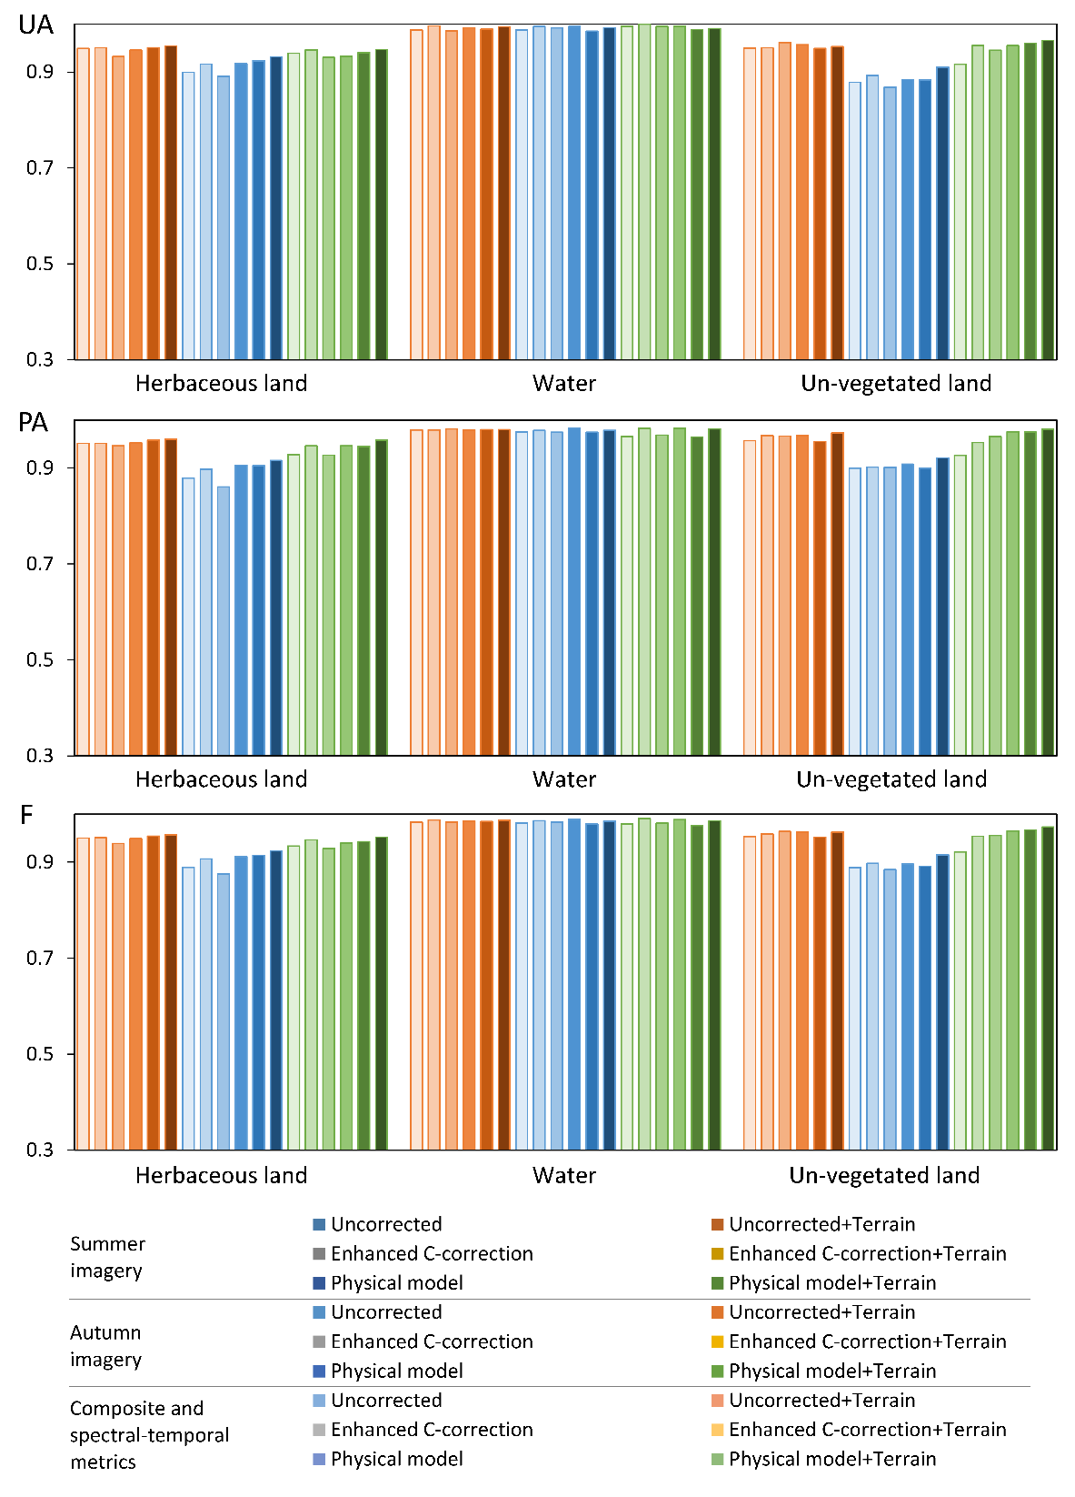

Fig. 7A. User’s accuracy (UA), producer’s accuracy (PA) and F-measure (F) of herbaceous land, water and un-vegetated land for 18 sets of input variables. The bars indicate the accuracies without applying the FORCE QA mask.

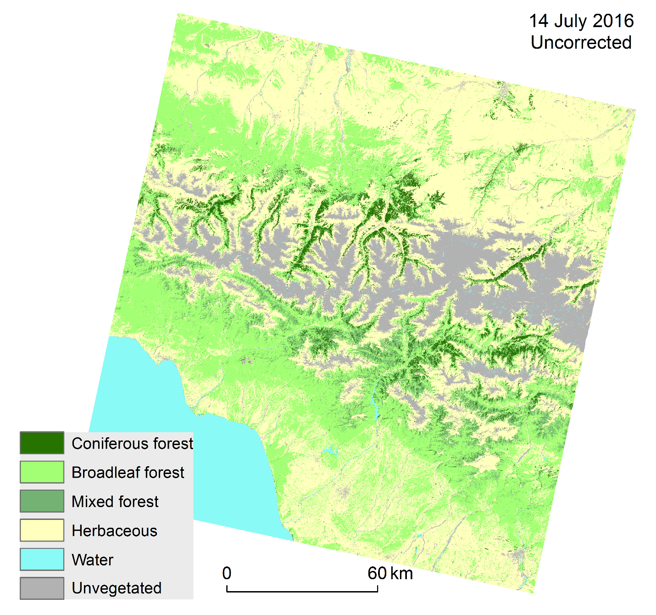

Fig. 8A. Forest classification using uncorrected imagery obtained on 14 July 2016.
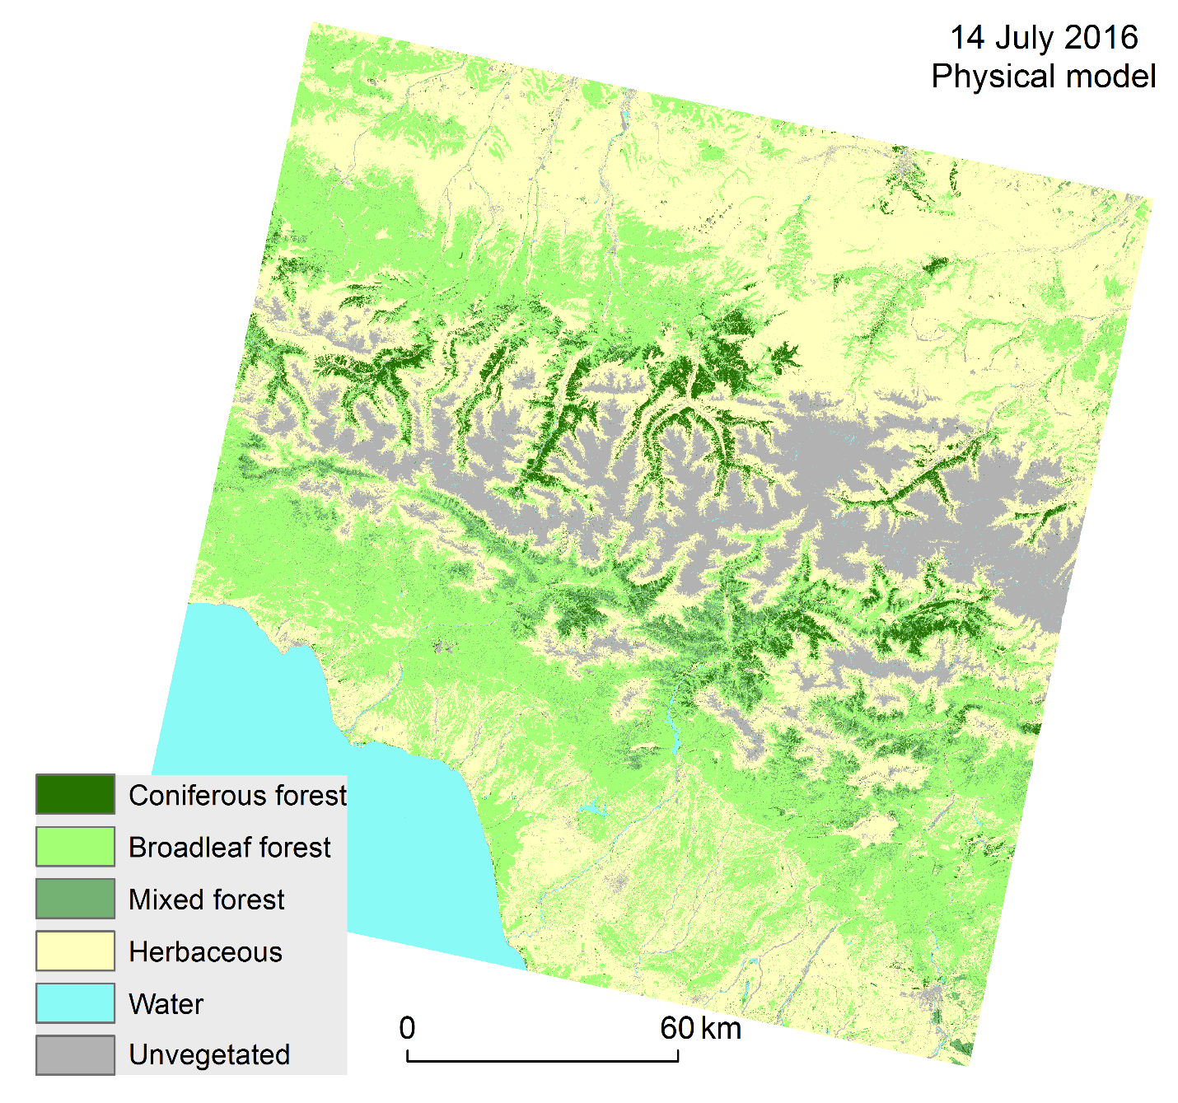

Fig. 9A. Forest classification using the physical model corrected imagery obtained on 14 July 2016.

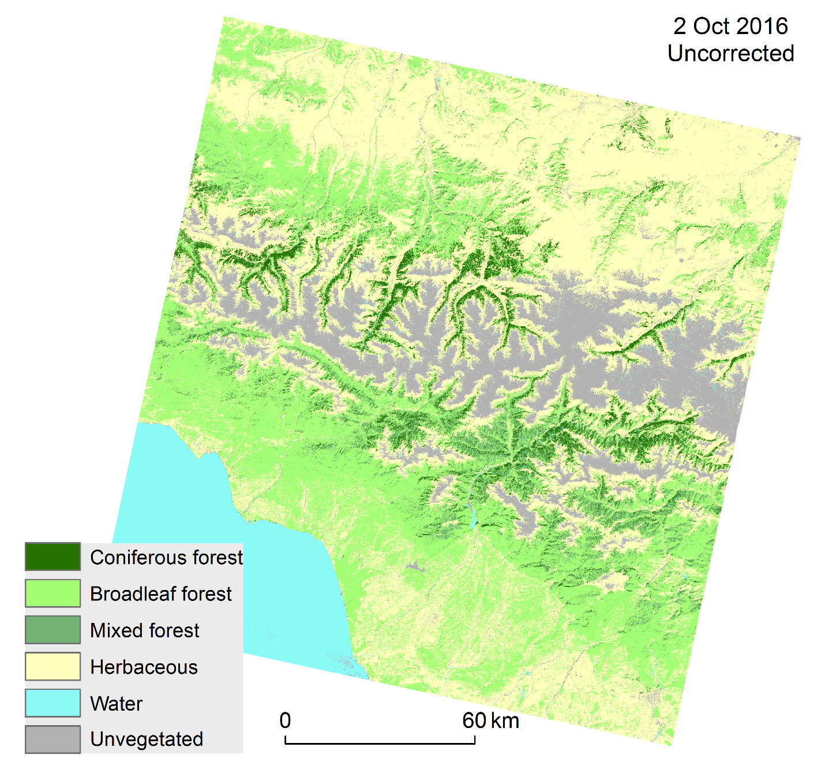

Fig. 10A. Forest classification using uncorrected imagery obtained on 2 October 2016.
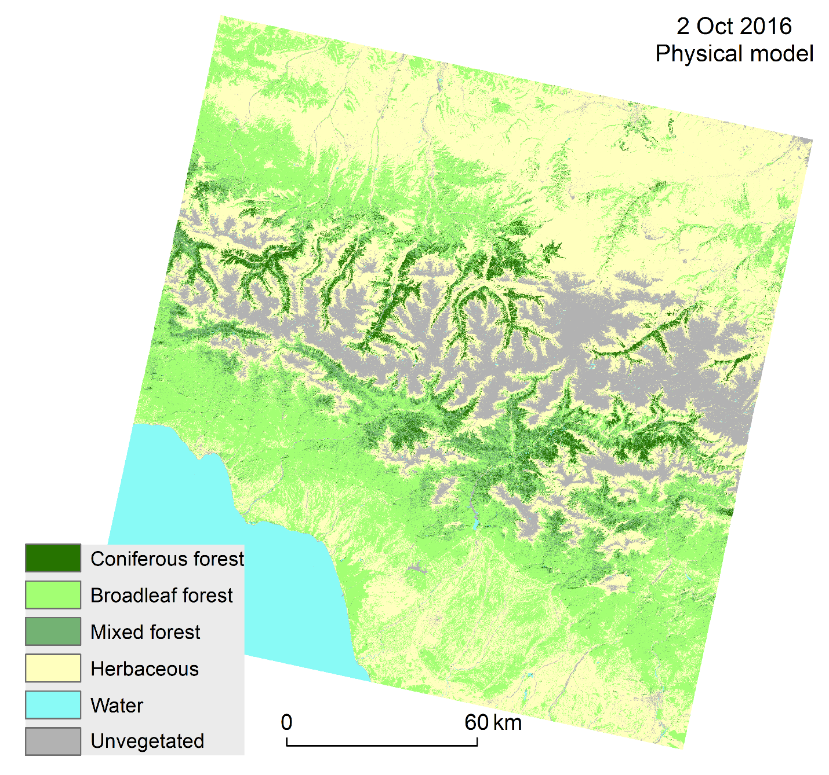

Fig. 11A. Forest classification using the physical model corrected imagery obtained on 2 October 2016.

