Implementaton of the solar exclusion zone burn through maneuvers for dscovr to preserve fuel for the gyro-less spacecraft in a sun-earth l1 lissajous orbit
(Preprint) AAS 22-605
Jason Long, John Lorah, Edward Malinowski*, Joseph Park*, Jeremy Petersen
DSCOVR (Deep Space Climate Observatory) is a National Oceanic and Atmospheric Administration (NOAA) space weather, space climate, and Earth observation satellite operating in a Sun-Earth L1 Lissajous orbit. This report summarizes the two-burn maneuver campaign performed in Summer 2021 to transfer DSCOVR from the collapsing phase into the expansion phase of the Lissajous orbit to avoid the Solar Exclusion Zone (SEZ). The two-maneuver campaign performed in July and August 2021 was successful and resulted in saving the mission 31 kilograms of fuel and 100 m/s of delta-v reserved for SEZ maneuvers which are no longer required until 2026 or 2027.
Introduction
DSCOVR (Deep Space Climate Observatory) is a National Oceanic and Atmospheric Administration (NOAA) space weather, space climate, and Earth observation satellite operating in a Sun-Earth L1 Lissajous orbit such that the orbit track never extends beyond 15 degrees from the Earth-Sun line. Launched on February 11, 2015 out of Cape Canaveral, FL on a Falcon 9, the Lissajous orbit insertion maneuver placed DSCOVR into the expansion phase of the Lissajous orbit just outside of the 4-degree Solar Exclusion Zone (SEZ) to maximize the time outside of the SEZ.¹
Beginning in October 2020 SEZ maneuvers were performed once every three months to keep DSCOVR in the collapsing phase of the Lissajous orbit just prior to violation of the SEZ¹ The location of each SEZ maneuver was at or near when the z-velocity in the rotating libration point (RLP) frame was close to zero. This corresponded to the northern and southern extremes of the Lissajous orbit relative to the ecliptic plane. The SEZ maneuvers were directed towards the South Ecliptic Pole (SEP) and North Ecliptic Pole (NEP) for burns located in the northern and southern point of the orbit, respectively. The same SEZ avoidance strategy was performed by ACE (Advanced Composition Explorer) between 1999 and 2001 but was later abandoned in 2001 to save fuel for a longer extended mission.²

Figure 1. RLP YZ projection for DSCOVR from 2017 projected out to 2027. Maroon, orange, and green represent definitive ephemeris history starting in the expansion phase in maroon, the collapsing phase in orange, and the SEZ control phase in green. The blue region is the transition from the collapsing phase into expansion phase that will be discussed in this paper while the purple region is the long-term propagation to show the successful transition to the expansion phase. The light gray region is a forward propagation if no active SEZ control were performed.

Figure 2. SEV angle history for DSCOVR from 2017 projected out to 2027. The same color scheme from Figure 1 is used for Figure 2.
Originally the SEZ maneuvers for DSCOVR were intended to maintain a 4-degree Sun-Earth-Vehicle (SEV) angle minimum but were updated to a 2-degree target. This was due to a delay caused by the shortened lifespan of the miniature inertial measurement unit (MIMU). NOAA and NASA engineers developed a modified attitude control system (ACS) to operate with the star tracker as the sole sensor for normal operations. Thruster operations were a major challenge for the star tracker (ST) only ACS system; burns had to be performed more slowly to allow the star tracker to maintain lock on stars and to limit input torques since the Reaction Wheel Assembly (RWA) was the only ACS actuator. As the engineering team gained experience and additional data, the team was able to develop scripts to conduct extended thruster burns to accommodate the new ACS operations. These longer burns were approximately fifteen times longer compared to when the MIMU was available. With this additional experience, the DSCOVR team felt comfortable executing the longer burns required for the SEZ maneuver.
The SEZ maneuvers require considerable fuel and ground resources along with extended interruptions of mission data. If the SEZ maneuvers were simply terminated, like ACE, DSCOVR would have flown through the SEZ multiple times before the orbit finally expanded again. Unlike ACE which flew through the SEZ once the SEZ maneuvers were abandoned, the DSCOVR project did not want to fly through the SEZ to reach the expansion phase of the Lissajous to avoid communications issues due to interference from the Sun. Figures 1 and 2 shows the evolution of the orbit in the RLP-YZ project and SEV angle in light gray if the SEZ maneuvers were simply abandoned. This would have led to approximately 180 days and 50 days within the 4-degree and 2-degree SEZ, respectively.
The implementation of the SEZ avoidance strategy is visible in the green curve in Figure 1 which shows an RLP-YZ projection of the orbit between 2017 and 2027 along with Figure 2 which shows the SEV angle across the same time span. The maroon, orange, and green curves represent definitive ephemeris history starting in the expansion phase in maroon, the collapsing phase in orange, and the active SEZ control phase in green. Figure 2 shows the SEV angle being controlled to the 2-degree target during the green phase. The cost of each SEZ maneuver was approximately 6-7 meters/second (m/s) leading to a yearly cost of approximately 24-28 m/s. Continuing this three-month cadence indefinitely, along with routine station-keeping maneuvers, would consume the remaining propellant by 2030 or 2031.
The focus of this paper is to outline the investigation that began in the Fall of 2020 to determine the possibility of performing a series of maneuvers to place DSCOVR directly into the expansion phase of the Lissajous orbit just beyond the SEZ. The results of the paper showed that a two-maneuver campaign in the Summer of 2021 was sufficient to place DSCOVR directly into the expansion phase of the Lissajous orbit. The two-maneuver sequence was composed of a departure burn and an insertion burn. The departure burn was applied at or near RLP-Z velocity component of zero which placed DSCOVR on a transfer arc between the collapsing phase and expansion phase of the Lissajous orbit. The follow-on insertion burn was performed at or near the next crossing of the RLP-XZ plane (RLP-Y = 0) to adjust the velocity vector to the desired components. The maneuvers were successfully performed in July and August 2021 and the results and success of each maneuver are covered in detail. Overall, the cost of the two maneuvers was 32.44 m/s, which is slightly larger than a year’s worth of SEZ maneuvers. This saved the mission approximately 100 m/s over the next four years and simplified operations as SEZ maneuvers were no longer required until 2026 or 2027.

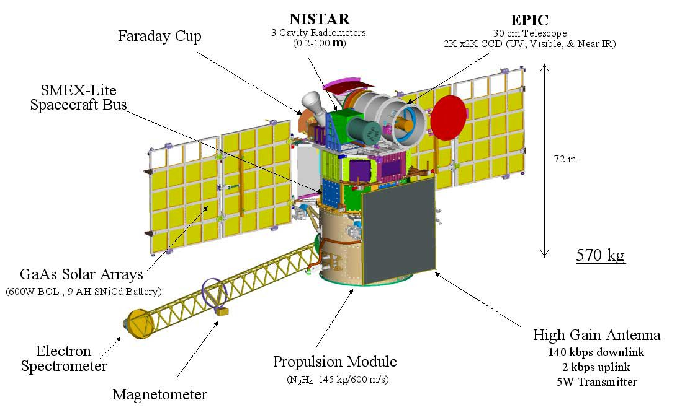
Figure 3. Visual overview of DSCOVR including the instrument suite.

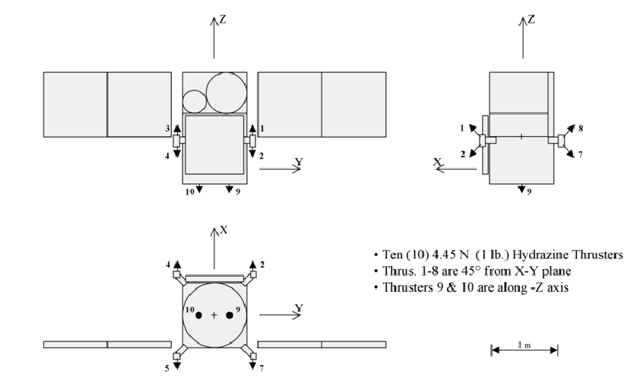
Figure 4. Thruster orientation overview for DSCOVR.¹
spacecraft overview
The primary mission for DSCOVR is to provide continuous solar wind data from an orbit at the Sun-Earth L1 point, providing continuity to the solar wind data set concurrently produced by ACE. The PlasMag Magnetometer (Mag) and Faraday Cup (FC) components are the instruments that supply the data to meet the primary mission objective. The secondary mission objective of DSCOVR is to perform additional solar physics science using a third component of the PlasMag Suite, the Electron Spectrometer Assembly (ESA), as well as the Pulse Height Analyzer (PHA). Additionally, long-range Earth observations are conducted utilizing a pair of Earth-pointing instruments, the Earth Polychromatic Imaging Camera (EPIC) and National Institute of Standards and Technology (NIST) Advanced Radiometer (NISTAR).
The DSCOVR satellite, depicted with several of its instruments in Figure 3, is based on the Small Explorers (SMEX)-Lite spacecraft bus architecture, which was a predominately single-string system developed by NASA and derived from proven concepts utilized on prior NASA Goddard Space Flight Center (GSFC) SMEX missions. The bus is about 1 meter wide and 1.8 meters tall (including the top-deck mounted science instruments). The launch mass was approximately 573 kg, including a fuel load of 145 kg. DSCOVR is a three-axis stabilized spacecraft that utilizes a typical complement of sensors and actuators (Star Trackers (ST), Inertial Reference Unit (IRU), Coarse and Digital Sun Sensors (CSS and DSS), and Reaction Wheel Assemblies (RWAs)) to maintain the desired attitude. The attitude is also maintained using a propulsion system, which is used to unload excessive momentum that builds up in the RWA and to perform station-keeping maneuvers to balance the orbit energy. Power is generated via two fixed Solar Array panels pointed towards the Sun by virtue of the attitude control design.
DSCOVR has a mono-propellant hydrazine blowdown propulsion system with a single 28-inch diameter fuel tank with a diaphragm separating the fuel and the gaseous nitrogen pressurant. The mounting arrangement, locations, and orientations of the ten 4.45 N thrusters are visible in Figure 4. Thrusters 9 and 10, mounted on the -Z (bottom) deck, apply thrust in the body +Z direction and are used only for imparting delta-v. While there are orbit maneuver modes where sub-sets of Thrusters 1 through 8 can be used to impart delta-v, it was decided to use Thrusters 9 and 10 exclusively for delta-v shortly after NOAA assumed operations. The attitude transients using Thrusters 1-8 for delta-v maneuvers are significantly greater during a burn. The tank bladder is in the body XY plane which results in hydrazine slosh when using Thruster 1-8 for delta-v maneuvers. Using Thrusters 9 and 10 eliminates the thruster slosh and provides a smoother attitude profile which is beneficial for the Star Tracker only ACS mode that is now required due to the failure of the Miniature Inertial Measurement Unit (MIMU) discovered in November 2018.
Miniature Inertial Measurement Unit Failure
Starting in mid-November 2018 DSCOVR operations engineers observed an accelerating drop in the laser intensity of the DSCOVR Miniature Inertial Measurement Unit (MIMU) Z-Axis laser, along with an increase in gyro drift along the +Y-axis. The decrease in laser intensity is a known failure signature, but this was far premature from the expected unit life; engineers determined the reduced life was a result of an elevated thermal environment. While the temperature was within operational specifications, the higher temperatures accelerated the rate of neon depletion that limits unit life.
A Tiger Team met on June 25, 2019 to discuss the problem and potential solutions. The value of failure for the laser was assumed to be around 0.5 micro-amps (based on other missions). The value was 0.98 micro-amps as of June 26, 2019, so based on trends, the estimate for failure if left on continuously was approximately five weeks from this date. This degradation is halted while the MIMU is turned off, however, a review of the electrical subsystem showed that the MIMU and the Star Tracker (ST) were wired together, i.e., if the MIMU is turned off, the Star Tracker would be turned off as well. This eliminated the solutions where the Star Tracker alone could be used in lieu of the MIMU for normal operations with the MIMU powered on only for critical operations.
The team recommended placing the satellite into Safe Hold mode to halt the degradation of the Z-axis laser since Safe Hold was the only mode where the MIMU was not used operationally to control attitude. NASA Flight Software Sustaining Engineering (FSSE), NASA Attitude Control Subsystem (ACS) Engineers, and the NOAA operations team worked to develop a flight software (FSW) solution to use the Star Tracker only for attitude solutions. DSCOVR was held in this storage configuration through the development, except for brief intervals where the MIMU was powered on and the spacecraft was returned to nominal mode to perform station keeping and momentum management operations.
FSSE delivered the ACS FSW patch on February 05, 2020. The patch was uploaded and installed on February 06, 2020. Checkout and validation activities were conducted from February 06-24, 2020, and the satellite was formally returned to operations on March 02, 2020. The patch was primarily a modification of the attitude control task (AC), which was modified to perform the calculations to compute rates derived from the star tracker quaternions; this update used a filter used by Lunar Reconnaissance Orbiter (LRO), which had experienced a similar issue. However, LRO did not have the interdependence of its star tracker and MIMU; this enabled LRO to conduct normal operations using only the Star Tracker while preserving MIMU life for use in critical maneuver operations.
The thruster operations required for station-keeping (DV) and momentum management (DH) were a particular challenge for DSCOVR. With the MIMU active, test firings were conducted to characterize the thruster/ACS performance and a strategy was developed for this aspect of ST-only operation where the ACS system must control perturbations using only the reaction wheels. To limit these perturbations during station-keeping, DSCOVR restricted those operations to use only the two thrusters aligned with the body-Z axis. By their nature, DH firings produce significant perturbations. A scheme was developed to perform DH by a series of three shortly spaced firings followed by a settling interval, repeated as needed. As the result of misalignment and offset of the DV thruster set, there is some accumulation of momentum in the off-axes. This requires that intervals of DH be interleaved with DV.
Initially, all thruster operations were performed using Relative Time Sequence (RTS) command loads. Later, NOAA engineers developed an automated ground procedure to execute the DH operation. NOAA engineers then worked with the NASA FSSE team to develop a FSW proc to control execution of the DV sequence. With this implementation, the DV thruster duty cycle is approximately 1/15, due to the required DH intervals.
sez maneuver history
Originally the SEZ maneuvers for DSCOVR were intended to maintain a 4-degree Sun-Earth-Vehicle (SEV) angle minimum. However, the SEV had closed to about 2 degrees during the safehold storage interval. Beginning in October 2020 SEZ maneuvers were initiated to maintain the SEV at 2 degrees. These were performed once every three months to keep DSCOVR in the collapsing phase of the Lissajous orbit just prior to violation of the SEZ.¹ The location of each SEZ maneuver was at or near when the z-velocity in the rotating libration point (RLP) frame was close to zero. This corresponded to the northern and southern extremes of the Lissajous orbit relative to the ecliptic plane. The SEZ maneuvers were directed towards the South Ecliptic Pole (SEP) and North Ecliptic Pole (NEP) for burns located in the northern and southern point of the orbit, respectively. The same SEZ avoidance strategy was performed by ACE between 1999 and 2001 but was later abandoned in 2001 to save fuel for a longer extended mission.² A summary of the SEZ maneuvers executed on DSCOVR is available in Table 1. The total cost for the SEZ maneuvers equated to approximately 25.6 m/s of delta-v per year which would have consumed the remaining propellant by 2030 or 2031.
Table 1. SEZ maneuver history for DSCOVR.
SEZ Maneuver Date  (YYYY-MM-DD) | Maneuver Delta-V (m/s)
2020-10-01 | 6.98
2021-01-20 | 6.18
2021-04-12 | 6.01

With the SEV having closed to 2 degrees, NOAA engineers considered the feasibility of executing an extended maneuver to push the DSCOVR orbit through to the expanding phase of the Lissajous orbit. This extended maneuver provided the potential for both long term fuel savings and simplified operations. With confidence gained in the system performance using the onboard DV script, this extended duration maneuver became plausible, and the NOAA team reached out to Goddard Flight Dynamics Facility (FDF) team to further develop a strategy.

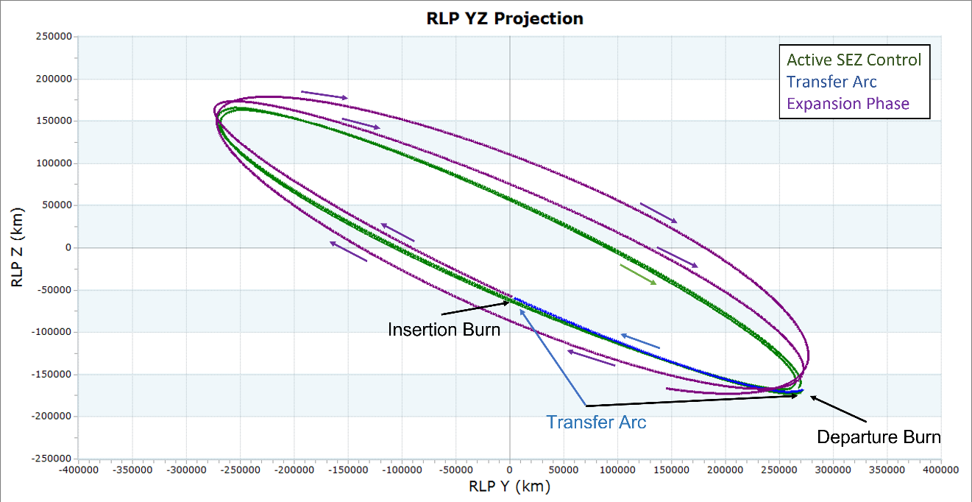
Figure 5. Example of the two-maneuver burn through sequence. There is a departure burn which places the spacecraft on a transfer arc for approximately one-quarter of a rev at which point an insertion burn is performed at the RLP-XZ plane to match the state at the expansion phase of the Lissajous.
Development of the burn through strategy
Given the expensive fuel costs of the SEZ maneuvers outlined in Table 1, it was of great interest to the team to determine if it was possible to jump from the collapsing phase of the Lissajous to the expansion phase of the Lissajous. Maintaining the current SEZ maneuver cadence of approximately 26-28 m/s per year would result in the mission running out of fuel by 2030 or 2031. It was also of great interest to the team to reduce the maneuver planning complexity by no longer needing to perform the SEZ maneuvers every three months. Removing the SEZ maneuvers would simplify operations to only routine station-keeping maneuver when necessary. An investigation began in the Fall of 2020 to determine if DSCOVR had the delta-v necessary to meet this request.
It became apparent very quickly that a two-burn strategy would be required to meet this goal. The two-burn strategy would become known internally as the burn through strategy. A visualization of the burn through strategy in the RLP-YZ projection is available in Figure 5 while the corresponding SEV angle plot can be found in Figure 6.
Intuitively, two maneuvers are necessary to provide six conditions for a differential corrector to adjust to target a full six-dimensional state vector comprised of three position and three velocity components. The first burn of the two-burn sequence was called the departure burn. The purpose of the departure burn was to place the spacecraft onto a transfer arc from the collapsing phase of the Lissajous orbit directly into the expansion phase of the Lissajous orbit approximately one-quarter orbit revolution later. The vary conditions for the departure maneuver was the delta-v vector while the achieve condition was the position component in the RLP frame at the next RLP-XZ plane crossing. A differential correction process was used to solve for the delta-v vector that achieves the desired RLP position components at the next crossing of the RLP-XZ plane. A second burn was required at the following RLP-XZ plane crossing and was called the insertion burn. The vary condition for the insertion burn was once again the delta-v vector while the achieve condition was the RLP velocity vector. Simple vector math was used to calculate the delta-v vector required to adjust the velocity to the desired state. After completion of the insertion burn, the spacecraft achieved the full six-dimensional target state and transitioned into the expansion phase of the Lissajous orbit.
With the basic premise of the burn through strategy outlined, two analyses were performed to understand the problem trade space. The first analysis was figuring out how to generate a target state for the two-maneuver sequence. The second analysis was understanding the trade space for the optimal location for the departure burn along with the trade space for varying the target state. The summation of the two analyses would determine if the burn through strategy was feasible from a delta-v perspective.

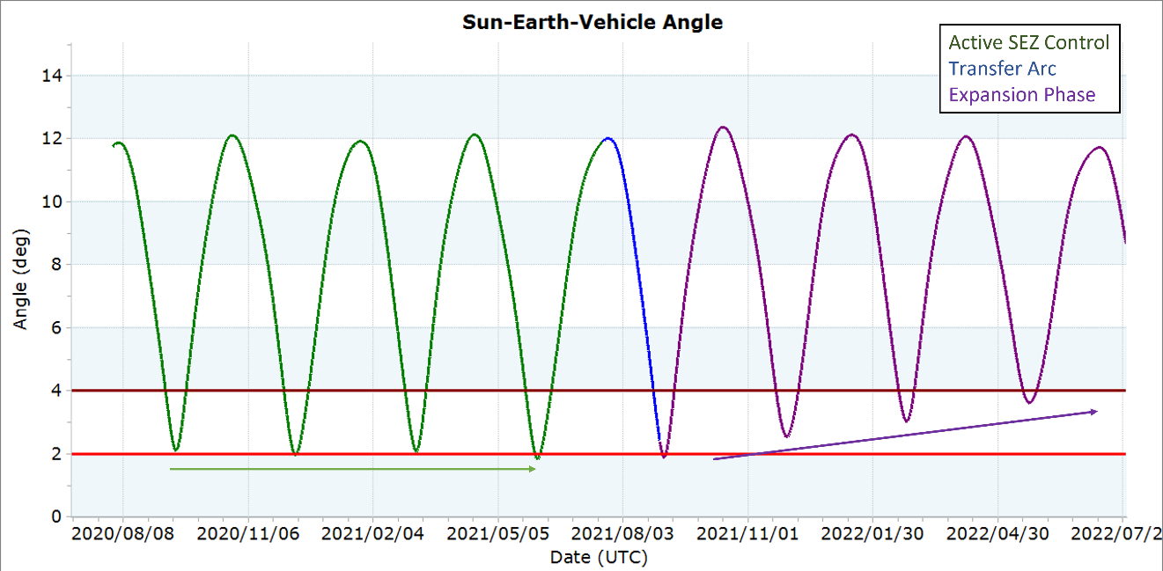
Figure 6. Example of the two-maneuver burn through sequence. The green region shows the active SEZ control while the purple region confirms that the spacecraft has entered the expansion phase of the Lissajous orbit after completion of the transfer arc in blue.
Generation of the Target State
Generation of the target state turned out to be relatively straightforward. Instead of trying to create a target state analytically, states from a long-term orbit propagation with no active SEZ control could be pulled directly to generate sample target states. An example of this method is shown in Figure 7 which contains both the orbit propagation and the SEV angle history. The orbit shown in Figure 7 was propagated forward in time with no active SEZ control. The long-term trajectory collapsed into the ecliptic plane and then naturally entered the expansion phase of the Lissajous orbit. The orange and purple arrows denote the two RLP-XZ plane crossings in the expansion phase that bound the 2-degree SEV angle requirement. Along with the state, the SEV angle for those states can be collected. The target state for the burn through sequence can either be one of the two states pulled directly from the long-term orbit propagation or a simple spreadsheet tool can be constructed to linearly interpolate the RLP state for any desired SEV angle target. An example of the simple spreadsheet is shown in Figure 8. The orange and purple state from the spreadsheet in Figure 8 correspond to the orange and purple state in Figure 7. The orange and purple states contain both the full six-dimension state in the L1-centered RLP frame as well as the corresponding SEV angle of 1.763 degrees for the orange state and 3.101 degrees for the purple state. The user can input the desired SEV angle at the RLP-XZ plane crossing in the green box, for example 2.250 degrees, and the linearly interpolated state is output in blue boxes. The position components of the linearly interpolated state become the achieve conditions for the departure burn while the velocity components of the linearly interpolated state become the achieve conditions for the insertion burn. This simple linear interpolation scheme was useful for trade study purposes when trying to determine what the final target state should be. A simple adjustment of the desired SEV angle would output a target state for the departure and insertion burn.

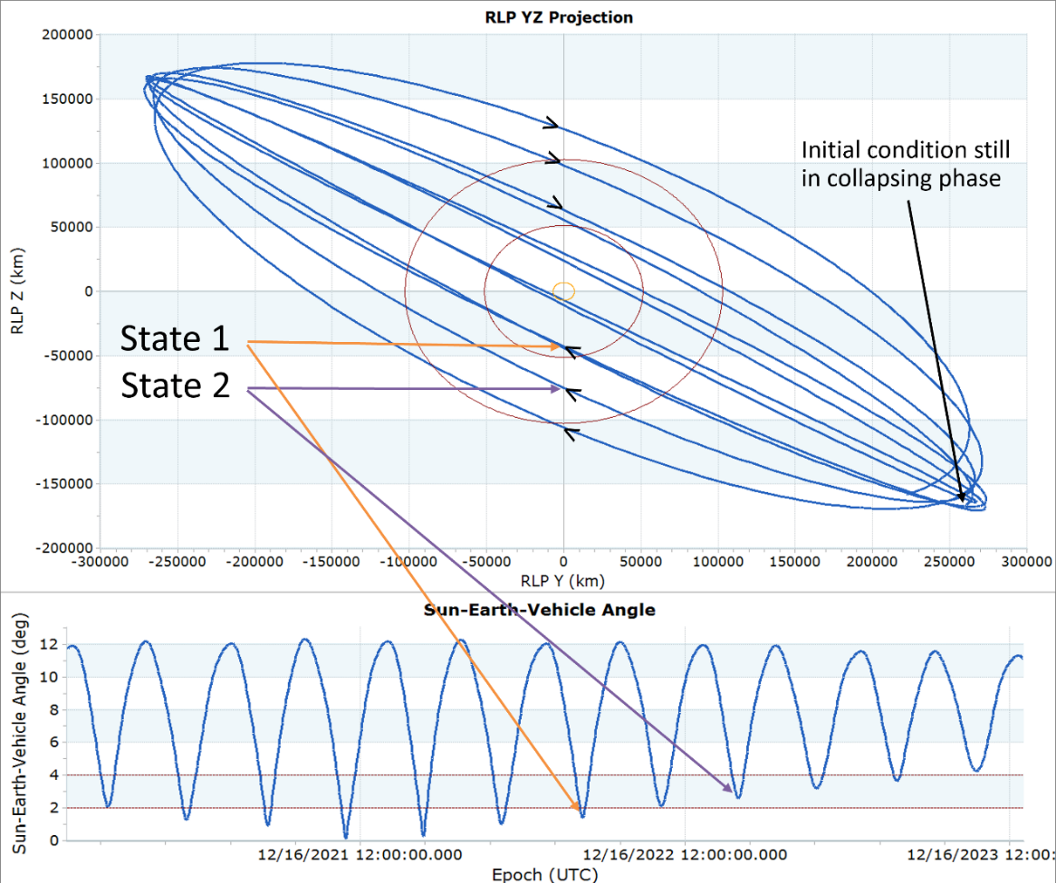
Figure 7. Demonstration of finding sample target states for the expansion phase of the Lissajous orbit. Instead of calculating an analytical solution, the Lissajous orbit can be propagated forward in time with no active SEZ control to find the natural evolution of the orbit and the natural target states in the expansion phase.
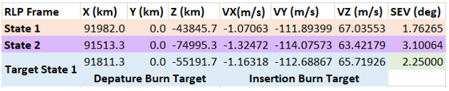
Figure 8. Demonstration of the linear interpolation spreadsheet that can be used to create any desired target state as a function of the SEV angle at the target state.
A common concern when working with the three-body problem is the transformation of the problem into the full ephemeris model. One concern of this method for finding the target state was whether the state in the RLP frame could be applied at any arbitrary epoch. The linear interpolation method did rely on working with states in the L1-centered RLP frame, so transformation of the state to any arbitrary epoch was a valid concern. Over the course of this investigation, the results showed that the linear interpolation method worked when applying the desired target state at any arbitrary epoch. The general orbit dimensions for the long-term orbit propagation with no active SEZ control were shown to match the long-term orbit propagation with the burn through strategy applied. Figure 9 visualizes this agreement for an example use case. The blue trajectory is the long-term reference trajectory with no active SEZ control while the green trajectory is the trajectory with the burn through strategy applied to skip directly from the collapsing phase of the Lissajous to the expansion phase of the Lissajous. While the orbits were not perfectly identical, the general shape and orbit dimensions were nearly identical indicating that applying the linearly interpolated state at an arbitrary epoch was viable.
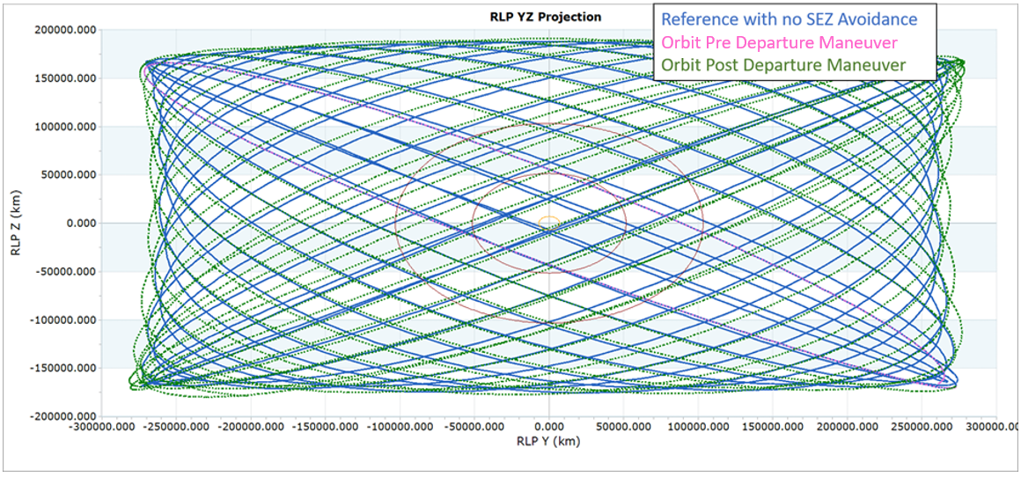
Figure 9. Visual demonstration that the trajectory after burn through technique, in green, results in roughly the same orbit dimensions as the reference trajectory in blue.
Understanding the Departure Burn Location and Target State Trade Space
The second part of the analysis was to better understand the trade space to help determine when to perform the departure burn, the SEV angle of the target state, and whether the maneuver size was reasonable enough to warrant application of the burn through strategy. This study was broken down into two simple trades to answer these three questions: study how the delta-v cost varied by departure maneuver date/location and study how the delta-v cost varied by adjusting the SEV angle of the target state.
The first trade study looked at the location for the departure maneuver. The quarterly SEZ maneuvers were performed at the northern and southern extremes of the orbit which made it a natural location to begin this trade study. A simple trade study was performed to look at the change in the departure maneuver cost as a function of the departure date in 5-day increments in July 2021. This date corresponded to the southern RLP-Z amplitude extreme of the orbit and the location is visually shown in Figure 5. The target state for the departure and insertion maneuvers remained the same therefore the only metric driving delta-v variation was the epoch/location for the departure maneuver. Figure 10 shows the results of the trade study in table and graph format from an early phase of the analysis. While the delta-v values for the actual burn through campaign were different, the trends from this analysis were used to determine feasibility.
There were a few interesting results from Figure 10 worth discussing to help build the overall conclusion. First, the solutions in Figure 10 were all feasible solutions from a fuel budget perspective. The yearly cost for the SEZ avoidance maneuvers was approximately 24-28 m/s. The solutions from the first cut of the analysis were within the 38-50 m/s range, which was close enough to the yearly SEZ avoidance maneuver cost to allow for fuel savings over a four-to-five-year period. Second, the overall minimum delta-v solution occurred when the departure maneuver coincided with the orbit location when the RLP-Z component of velocity equals zero while the minimum delta-v for the departure maneuver coincided closer to the orbit location when the RLP-Y component of velocity was near zero. The sensitivities in the insertion maneuver cost drove the location of the overall minimum delta-v solution away from the departure minimum solution. Over the 25-day period in the study, the range of insertion maneuver delta-v was 16.5 m/s while the range in departure maneuver costs was only 7 m/s. In this scenario, the location of the departure maneuver had a larger impact on the cost of the insertion burn than the cost of the departure burn itself and that drove the location of the overall minimum solution. There was an optimal window for the overall minimum delta-v cost around when the RLP-Y and RLP-Z velocity components of the orbit were close to zero. The fact that this optimal window was a few days in duration and the difference in the delta-v solutions was only 1.7 m/s was welcoming from a planning and contingency perspective. This gave the maneuver planners a little leeway in the event of spacecraft contingency requiring a delay in the maneuver execution. That said, the optimal window was only a few days long. The delta-v for the solution ten days after the overall minimum solution was already 20 m/s higher. Any delays longer than a few days warranted pushing the burn through campaign three months to the following RLP-Z amplitude orbit extreme to maintain a lower delta-v cost.

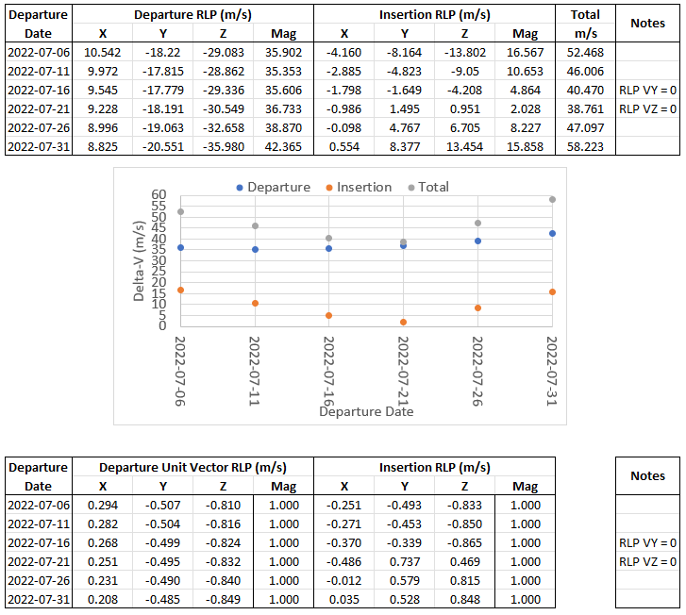
Figure 10. Departure trade study results in both table and graph format. The top table is the full vector while the bottom table is the unit vector.
The second trade study involved the target state sensitivity. For this trade study, the departure burn epoch was fixed to the overall minimum solution from the previous trade study when the RLP-Z component of velocity was zero. The target state at the following RLP-XZ plane crossing was varied which resulted in a different target for the departure burn and the insertion burn for each sample in the trade. The minimum and maximum RLP-XZ plane SEV angle were set based on the example from Figure 7 with two intermediate values calculated. The results of the target state trade study are in Figure 11. The second column in the table is the SEV angle at the following RLP-XZ plane crossing and was the parameter set in the linear interpolation spreadsheet. This value did not correspond to the minimum SEV angle for the orbit though. The location of the minimum SEV angle occurred a few days after crossing the RLP-XZ plane. The third column captures the minimum SEV angle which was an important value to know when setting the final target state for the burn through campaign.

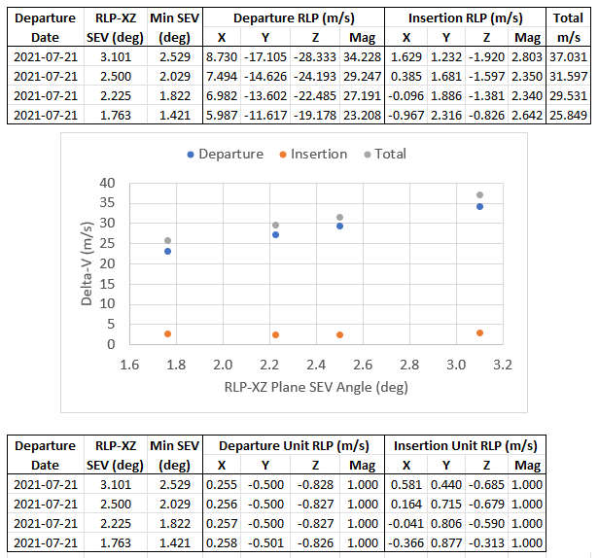
Figure 11. Target state trade study in both table and graph format. The top table is the full vector while the bottom table is the unit vector.

The results of the second trade study were straight forward. The overall delta-v cost increased as the RLP-XZ plane SEV target angle increased. The largest impact was to the cost of the departure maneuver as the range of the departure maneuver was about 10 m/s while the cost to the insertion maneuver barely moved with a range of 0.2 m/s. Closer to execution of the burn through maneuver, a decision would be required to select a specific target.
Adjustment of the Insertion Burn Strategy to Account for Long Term Station-Keeping and Attitude Constraints
While the insertion burn magnitude from Figure 11 did not change much, the maneuver unit vector changed. This same behavior appears in the departure trade study from Figure 10 as well. The maneuver unit vector for the departure burn was consistent, however, the maneuver unit vector for the insertion burn varied quite a bit. This posed concern if the spacecraft was unable to orient itself within mission constraints to achieve the desired delta-v vector and magnitude. The primary constraint is ensuring the spacecraft attitude results in a power positive configuration. Ideally the body-X axis remains within 35 degrees of the spacecraft-to-Sun vector to remain in a power positive configuration. While DSCOVR remains in a power positive configuration up to 40 degrees, there is a flight software failure detection and handling (FDH) trigger for the spacecraft exceeding 35 degrees for more than a few seconds at which point a safe-hold is triggered. The primary thrusters used for maneuvers are oriented along the body Z-axis, as shown in Figure 4, which allows for delta-v in the RLP-YZ plane directions while maintaining a roughly zero-degree angle between the body-X axis and the spacecraft-to-Sun vector. The RLP-X component of the delta-v vector will be the driving factor in whether the spacecraft remains in a power positive configuration.
In addition, there was earlier discussion regarding the impacts of taking a target state and applying it to any arbitrary epoch. The results showed that using the linear interpolation method was a success as the long-term orbit dimensions were nearly identical. The one penalty involved was the cost for the next station-keeping maneuver. To plan station-keeping maneuvers, DSCOVR uses a differential corrector to adjust the maneuver size required to achieve a zero RLP-X velocity at the third or fourth crossing of the RLP-XZ plane. This is a common targeting algorithm used for many libration point missions including ACE, Wind, Solar and Heliospheric Observatory (SOHO), and the James Webb Space Telescope (JWST).^{2,3} The primary implementation difference for DSCOVR is that the maneuver unit vector for station-keeping maneuvers is fixed in the RLP-Y direction to meet spacecraft attitude requirements. When matching the state at the insertion burn, sometimes the delta-v cost for the following station-keeping maneuver could be large. N-body gravity perturbations do have an impact on the sensitivity of the orbit, especially when targeting a condition as specific as a perpendicular crossing of the RLP-XZ plane downstream. The cost of the following station-keeping maneuver after execution of the burn through strategy did not prevent execution of the burn through strategy, but because station-keeping maneuvers for Sun-Earth L1 or L2 orbits are sensitive to the errors of the previous station-keeping maneuver, it is always of interest to try and minimize the current station-keeping maneuver size to help reduce the cost of future station-keeping maneuvers. This warranted an investigation into slight adjustments to the insertion burn strategy to see if adjustments could be made to reduce the size of the following station-keeping maneuver. Four strategies for the insertion burn were developed:
- Full strategy: The full insertion burn strategy was the nominal strategy outlined in the previous sections where the insertion burn is performed to match the desired target state.
- No Vx strategy: The no Vx insertion burn strategy only matched the RLP-Y and RLP-Z components of velocity. It ignored the RLP-X component. This resulted in a very safe power positive configuration as the angle between the body-x axis and the spacecraft-to-Sun vector was essentially zero. The downside of this strategy was that the following station-keeping maneuver would be much larger to compensate for the lack of RLP-X velocity matching during the insertion burn.
- Hybrid strategy: This insertion burn strategy matched the RLP-Y and RLP-Z components of velocity and adjusted the spacecraft attitude to allow for as much matching of the RLP-X component of velocity as possible while maintaining a power positive state. The amount of delta-v savings from this strategy depended on size of the RLP-X insertion burn unit vector but it always resulted in a lower delta-v cost than the no Vx strategy but at the cost of a less power positive spacecraft configuration. For this study, a limit of 20 degrees was used to demonstrate the technique, but any value up to 35 degrees could be selected.
- Station-keeping (SK) strategy: This strategy ignored targeting the insertion state itself and simply executed a nominal station-keeping maneuver to ensure energy balancing of the orbit and a perpendicular crossing of the RLP-XZ plane downstream. This strategy was only viable if the timing of the departure burn was ideal resulting in a lower insertion burn size. The net benefit was that the angle between the body x-axis and the spacecraft-to-Sun vector was essentially zero since station-keeping maneuvers place the delta-v along the RLP-Y axis.
Figure 12 contains results of the four different insertion burn strategies. The full strategy had the lowest overall delta-v cost, followed by the station-keeping strategy, the hybrid strategy, and then the no Vx strategy as the most expensive. The increase in cost for the hybrid and no Vx strategy came from the increased cost of the station-keeping maneuver following the insertion burn. Fortunately, the full and SK strategy did not require a dedicated station-keeping maneuver for this scenario. For a different insertion state, it was possible for the station-keeping strategy to become the most expensive option, particularly if the required delta-v in the RLP-Y or RLP-Z direction for the full strategy becomes much larger than this example.
The lower delta-v cost for the full strategy did come at a cost of the highest sun angle and therefore the highest potential for power issues during the insertion burn. For a different scenario, it was possible that the sun angle for the full strategy might result in an attitude that is not power positive and therefore one of the other three strategies would be required to ensure a power positive orientation during maneuver execution. The selection of the insertion burn strategy depended on the final departure time and insertion state selection closer to the actual execution of the burn through campaign. The analysis showed that there are multiple strategies available if the full strategy is no longer viable.
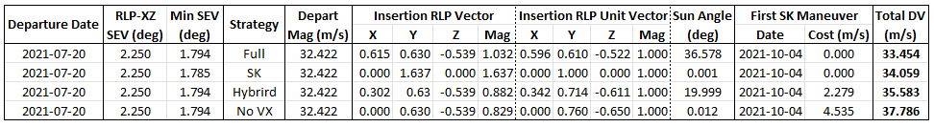
Figure 12. Comparison of the different insertion burn strategies.
Contingency Analysis
The last piece of analysis performed was contingency analysis that looked at two strategies for recovery from a partial performance of the critical departure burn: perform a correction maneuver in between the original departure burn and the insertion burn or wait half an orbit revolution to perform a second departure burn. The primary benefit of performing a correction burn in between the original departure burn and insertion burn was that it would allow for a correction to the orbit before the SEV dropped too low. The disadvantages of a correction burn were a very aggressive timeline which might not be manageable from a DSN scheduling perspective or maneuver planning perspective, in addition to larger delta-v costs. The primary benefit to waiting half an orbit revolution to perform the correction burn was the reduced delta-v cost and reduced stress with regards to DSN scheduling and maneuver planning. However, if the partial performance of the departure burn was between 20-70%, then the SEV angle would drop below one degree which could be an issue for communications.
The minimum SEV angle as a function of departure burn performance forms a u-shape, as visible in Figure 13. If the partial performance were between 20-70%, then the resulting minimum SEV angle with no correction applied would fall below one degree. Interestingly, 50% performance was the threshold for whether the resulting orbit transitioned into the expansion phase or remained in the collapsing phase.
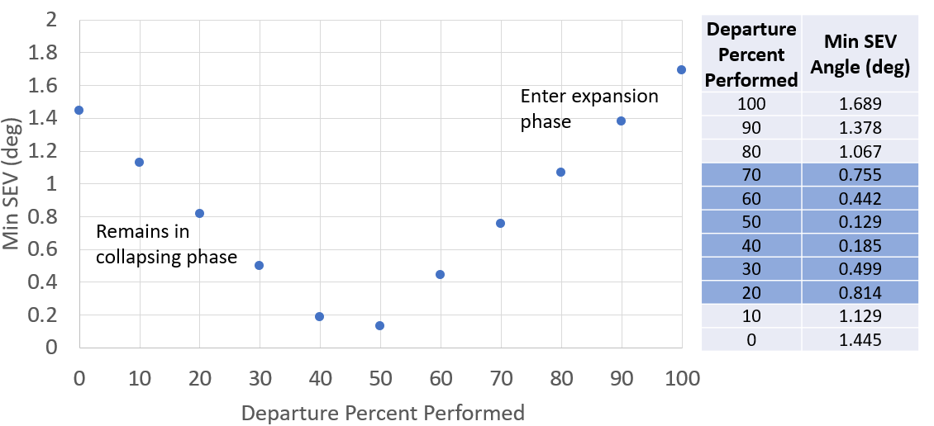
Figure 13. The minimum SEV angle achieved as a function of partial departure burn performance.
The first response studied was to perform a correction burn between the nominal departure and nominal insertion burn to correct for the partial departure burn as soon as possible. This burn would target the same conditions as the original departure burn. The positive aspect of this strategy was that it would prevent the trajectory from falling below an unacceptable SEV limit. The challenges with the strategy were numerous: it required a tight timeline that might not be feasible from a DSN schedule perspective, there might not be time to collect enough tracking data to generate a quality OD solution necessary for maneuver planning, there might not be time to diagnose the spacecraft anomaly that triggered a partial burn before performing the correction burn, and this strategy would cost more delta-v than simply waiting half an orbit revolution to perform the correction burn at the following RLP-Z amplitude extreme.
Figure 14 shows the results of the fast correction burn study. The figure contains three different colored data sets representing different execution times for the correction burn after the conclusion of the partial departure burn (7 days, 14 days, or 21 days). The total delta-v cost required for the partially completed departure burn, correction burn, and following insertion burn are displayed as a function of the percent performance of the original departure burn. As expected, the delta-v cost was minimized when performing the correction burn as soon as possible. The cost when waiting only 7 days was not prohibitively expensive but became worrisome when waiting 21 days for partial burns below 50%.
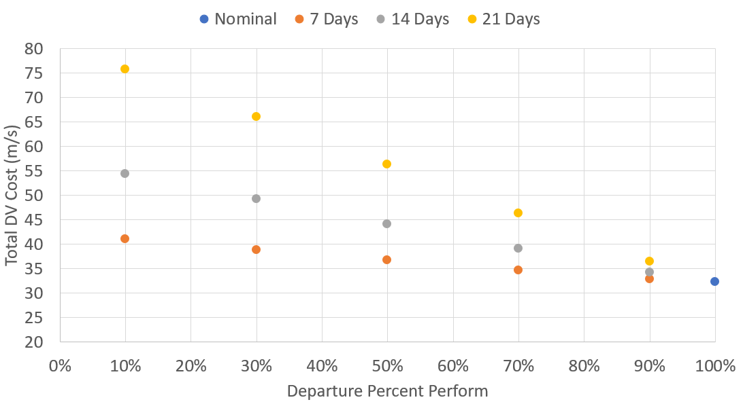
Figure 14. Quick trade study looking at performing a correction burn as soon as possible after the partial departure burn.
An alternative approach in the event of a partial departure burn was simply waiting to perform the correction maneuver until the next half revolution of the orbit when the spacecraft reached the next RLP-Z amplitude extreme. The benefits of this strategy were reduced delta-v costs and a less strict timeline. However, the primary drawback was that for partial burns between 20-70%, the spacecraft SEV angle would fall below 1 degree for at least one week which could cause communications issues. Figure 15 contains the results of this simple trade in table and graph format. The cumulative delta-v cost when waiting half an orbit revolution remained rather flat as a function of the departure burn percent performance, unlike the results from the alternative scenario in Figure 14, making it an attractive solution for the contingency scenario if the minimum SEV angle was not a danger to spacecraft operations.
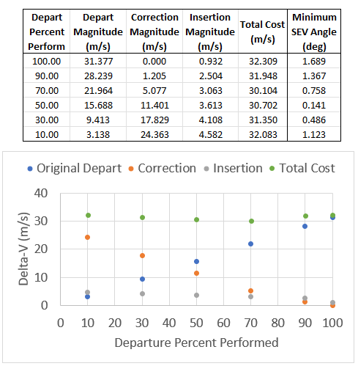
Figure 15. Quick trade study results looking at performing the correction burn half of an orbit revolution later.
burn through execUtion Summary
Once it became clear that the analysis showed the burn through strategy was viable and would save the mission fuel, several DSN passes were scheduled to lock in dates for the departure and insertion burn. Fortunately, the mission was able to acquire DSN passes for ideal dates for both the departure burn and the insertion burn. A DSN pass was scheduled for the departure burn on July 20, 2021 which coincided with the optimal departure maneuver timing while a DSN pass was scheduled for August 30, 2021 to coincide with the following crossing of the RLP-XZ plane and insertion burn location. In addition, a contingency pass was scheduled for August 09, 2021, which is approximately 20 days after the departure burn, and could have been used to perform a correction maneuver, if necessary, in the event of a partial departure burn contingency scenario.
Closer to the departure timing, it was decided that the target SEV angle at the RLP-XZ plane crossing would be approximately 2.2 degrees which resulted in a minimum SEV angle of approximately 1.9 degrees. While this target does violate the 2-degree threshold, it was decided that the limited amount of time spent under the 2-degree limit was acceptable. In addition, there had been no hints of any communications issues over the past year of SEZ maneuver executions which provided confidence to allow the spacecraft to drop slightly below the 2-degree threshold. Selecting a minimum value of 1.9 degrees allowed for delta-v savings and created a favorable attitude profile for the insertion burn.
The departure burn was performed on July 20, 2021 at 10:08 UTC and required a planned burn duration of 16.72 hours resulting in a planned delta-v of 31.58 m/s. The angle between the body x-axis and the spacecraft-to-Sun vector at the start of the maneuver was 14.6 degrees, which falls within the power positive attitude limits and posed no problems with regards to spacecraft health. Because the burn plan duration was 16.72 hours, the burn was split across several DSN contacts with parts of the burn performed in the blind. DSN support was scheduled for initiation of the burn, a pass in the middle of the burn to monitor telemetry, and a pass at the conclusion of the burn to perform instrument recovery. The maneuver was executed autonomously via the onboard delta-v script. Had there been any problems, the onboard fault management system would have tripped and triggered a transition into safe mode. In the event of a transition to safe mode, the plan was to recover the spacecraft as soon as possible and continue execution of the burn through to completion of the burn or through to the end of the planned DSN support.
Upon completion of the departure maneuver, the maneuver reconstruction showed that the departure burn was 17.65 hours in duration and achieved 31.61 m/s of delta-v, which is 0.1% hot relative to the planned delta-v of 31.58 m/s. Overall, the departure burn went off without any significant issues. The insertion burn, however, would not be as simple.
The insertion burn was performed on August 30, 2021 at 14:46 UTC. The nominal insertion burn plan used the full insertion burn strategy with a duration of 28.71 minutes resulting in a planned delta-v of 0.829 m/s. The actual execution of the maneuver was delayed by 1.5 hours as DSCOVR tripped into safehold after the star tracker went lost-in-space (LIS) and tripped the power positive limit. A few minutes before reaching the target attitude, the digital sun sensor (DSS) flagged as invalid. Engineers forced the course sun sensor (CSS) to be used for the insertion burn. It was known that the CSS was misaligned due to the solar arrays not being fully deployed. The CSS read that the sunline was at 33.75 degrees, which was still within the 35-degree margin for the power positive FDH limit and allowed for the full strategy to be implemented for the insertion burn. The maneuver burn proceeded using the CSS and was completed nominally. The maneuver reconstruction showed that the insertion burn was 26.87 minutes in duration and achieved 0.827 m/s of delta-v, which is 0.24% cold relative to the planned delta-v of 0.829 m/s.
Post maneuver evaluation determined that a possible cause for the safe hold trigger just prior to the insertion burn was that the DSS was shaded in some way. Current documentation does not state any attitude constraints for the DSS, however, analysis showed that the position of the magnetometer could potentially impact the reading of the DSS at certain attitude angles. As of Summer 2022, work is underway to determine if additional warnings could be added into the attitude ground system tools to warn of future issues regarding magnetometer interference with the DSS.
Overall, the cost of the two-maneuver burn through campaign was 32.44 m/s, which is slightly larger than one year’s worth of SEZ maneuvers. The successful application of the burn through strategy is visible in Figure 2 as the first few months of the purple curve are based on the definitive ephemeris. This confirms that the burn through campaign successfully transitioned DSCOVR from the collapsing phase of the Lissajous into the expansion phase of the Lissajous.
Conclusion
The analysis performed in this investigation demonstrated the feasibility for the burn through campaign that was successfully implemented in the Summer of 2021. The mission will save approximately 100 m/s of delta-v as SEZ maneuvers are no longer necessary now that the spacecraft has fully transitioned back into the expansion phase of the Lissajous. Long-term propagation of the current orbit shows the spacecraft will remain outside of the 2-degree SEV angle limit until 2026 or 2027 at which point active SEZ control can be used again or another burn through campaign can be performed using the techniques developed in this investigation.
REFerences
¹ Roberts, C., Case, S., Reagoso, J., Webster, C., “Early Mission Maneuver Operations for the Deep Space Climate Observatory Sun-Earth L1 Libration Point Mission”. AIAA/AAS Astrodynamics Specialist No. GSFC-E-DAA-TN25055. 2015.

² Roberts, C., “Long Term Missions at the Sun-Earth Libration Point L1: ACE, SOHO, and WIND”, AAS 11-485.
³ Petersen, J., “L2 Station Keeping Maneuver Strategy for the James Webb Space Telescope”, AAS 19-806.

ASRC Federal Data Networks, 7000 Muirkirk Meadows Dr #100 Beltsville, MD 20705. first.last@noaa.gov
Pearl River Technologies LLC, 1704 Airport Blvd, Suite B, Melbourne, FL 32901. john.m.lorah@nasa.gov
a.i. solutions, Inc., 4500 Forbes Blvd Suite 300, Lanham, MD 20706. jeremy.petersen@ai-solutions.com
The RLP frame for DSCOVR is defined with the x-axis aligned along the Sun to Earth-Moon barycenter vector, the z-axis aligned along the North Ecliptic Pole (NEP), and the y-axis completes the right-handed triad.
Three-week arcs are typically used for the batch least squares orbit determination solution for DSCOVR.²

