Environmental testing of contamination sensitive instruments and optics in non-cleanliness-controlled facilities
Craig B. Jonesª, Eve M. Wooldridge^{b}, Alan C. Abeel^{b}, Colette D. Lepage^{c}
ªKBR, Inc., 8120 Maple Lawn Blvd, Fulton, MD, USA 20759.
^{b}NASA Goddard Space Flight Center, 8800 Greenbelt Rd., Greenbelt, MD, USA 20771.
^{c}Peraton, 7855 Walker Dr. Suite 400, Greenbelt, MD 20771

Abstract
The James Webb Space Telescope (JWST) Optical Telescope Element + Integrated Science Instrument Module (OTIS) went through environmental testing at the Goddard Space Flight Center. The vibration and acoustic tests occurred outside of cleanrooms. These areas are typically around ISO Class 8, far out of specifications for JWST. Through collaboration between the OTIS Mechanical and Contamination Engineering teams, a portable clean enclosure was designed, built, and verified to prevent contamination of the sensitive OTIS assembly. This manuscript describes the process of designing and building this enclosure, including materials selection and High Efficiency Particle Air (HEPA) filtration. This enclosure also provided environmental control with a portable air conditioning unit to control the relative humidity level enabling personnel to work within it. The manuscript emphasizes working in a systematic order to maintain cleanliness and integrity. “Clean as you go” during construction was a top priority to ensure that this critical Ground Support Equipment (GSE) was acceptable. The process of installing the walls and then sealing their internal and external surfaces with approved films was critical to maintaining OTIS integrity. This proved important because OTIS was in the enclosure for months longer than originally planned. This manuscript concludes by reviewing the process used to verify that the OTIS clean enclosure could achieve acceptable contamination level fallout accumulation for use during the vibration and acoustic testing and then verifying that the predicted performance was achieved after testing was complete.

INTRODUCTION
Contamination-sensitive instruments and spacecraft have a long history of environmental testing in non-clean areas. Typically, they can be bagged to protect them from contamination during transport and testing. At the NASA Goddard Space Flight Center (GSFC), planning for environmental testing for the Optical Telescope Element (OTE) + Integrated Science Instrument Module (ISIM), or OTIS, required contamination protection. However, OTIS was too large and complicated for simply covering it. In order to protect OTIS, an entire, portable clean enclosure was necessary for transporting and testing outside the cleanroom. It was also necessary for the tent to accommodate personnel access to connect and disconnect the crane from OTIS lift points during vibration testing. The tent would also be subject to acoustic loads, so the structure needed to be strong enough to survive the acoustic loads, and the tent film needed to allow for transmission of acoustic wavelengths required for OTIS qualification. Finally, ISIM purge would be continuous throughout testing. This paper will present the tent design, testing, and logistics for OTIS requirements. The tent is shown in Figure 1.

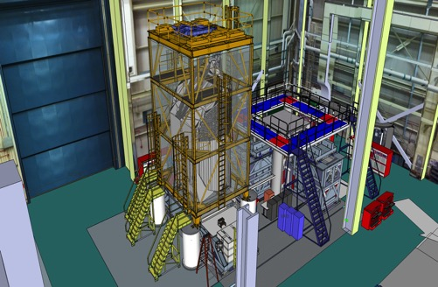

Figure 1. The OTIS environmental enclosure on the vibration table. (Drawing Credit: NASA)

Planning and Design process
The planning process for the OTIS tent/enclosure was a collaborative effort between Contamination Control (CC)
Engineering and Mechanical Engineering that took months before constructing the first beam. The effort in this process made each group appreciate other viewpoints.

Tent construction materials
The tent curtain materials needed to accommodate acoustic, electro-static discharge (ESD) and contamination requirements were made of:
- Inner layer 0.1270 mm (5 mil) Melinex
- Outer layer 0.0508 mm (2 mil) Dunshield
- Outermost layer 0.1016 mm (4 mil) polyethylene.
The purpose of adding three layers of film was to provide clean ingress back into the Spacecraft Systems Development and Integration (SSDIF) cleanroom after vibration testing and then again after acoustic testing. After vibration testing, the outer polyethylene layer was removed, and after acoustic testing the (now) outer Dunshield layer was removed. Melinex windows were required in the dark grey Dunshield layer to provide clear visibility of OTIS, whereas the Melinex and polyethylene did not require windows because they already provided good visibility. The windows with Dunshield film after vibration testing was complete and viewing for crane access was no longer needed. In addition, a top section was added after vibration testing, called the “Yarmulke”, to keep the roof clean during transport.

Prior to constructing the enclosure, the structural aluminum beams were treated with clear Iridite to help reduce particle shedding due to corrosion, and the high strength fastening hardware was thoroughly cleaned by the NASA CC technicians. Six High Efficiency Particulate Air (HEPA) filters were installed in the enclosure ceiling to provide clean downflow of air for when personnel connected and disconnected crane lift points. Four painted platforms were installed inside the enclosure for safe personnel access to the crane lift points. Dunshield film was added to the underside of each platform to prevent dirt trekked by cleanroom boot soles from depositing onto OTIS’s sensitive surfaces.

An expanded view of the tent film design is shown in Figure 2.

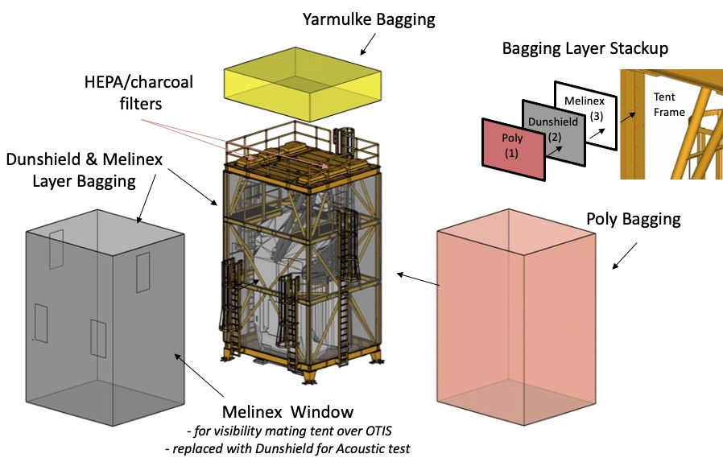

Figure 2. An expanded view of the enclosure material layered.

Structure design
The tent design consisted of a three story Iridited aluminum structure joined together with high strength fasteners. The structure was designed to incorporate interface points that would allow attachment of lift sling hardware to OTIS and allow it to be lifted with the tent as one assembly. The lift hardware that attached OTIS to the tent was located in the interior of the tent. Platforms staged at the second and third levels allowed technicians access, through swinging doors, to these locations after they climbed up caged ladders attached to the sides of the tent structure. The tent also included features at its base that would interface the tent and OTIS to test facilities used in the mechanical verification process.

Finishing touches: acoustic platform coating and bottom close-out
The acoustic platform was finished with a white powder coating. This type of coating was chosen for ease of cleanability and steel substrate humidity protection.

A Dunshield closeout diaper was made to attach to the rim of the bottom of the tent with a considerable amount of slack to prevent damage to the Dunshield during Vibration testing, as shown in Figure 3. This diaper protected the interior from external contamination during operations outside of a cleanroom.
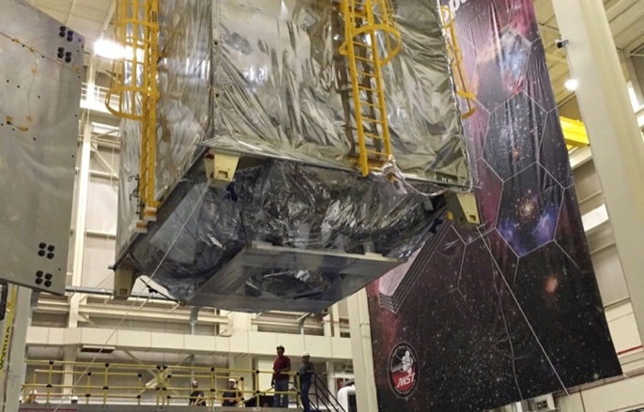
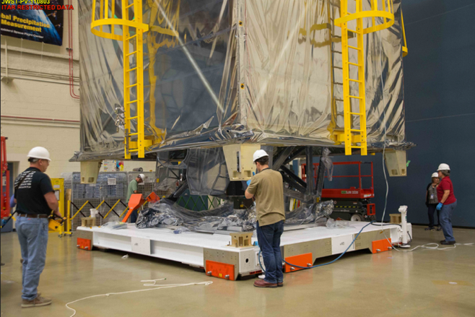
Dunshield
“Diaper”

Figure 3. The tent with Dunshield diaper. (Photo credits: NASA/Chris Gunn)

OTIS enclosure particulate contamination testing
The tent structure was built using a “clean as you go” approach, as sections were fitted and would quickly become inaccessible due to the structure design. Once built and fitted with the HEPA filters in the ceiling and the film walls, the empty tent was subject to tests to verify that it would survive acoustic testing. Vibration testing of the tent was not necessary because the tent would be isolated from the vibration fixture. It was also necessary to test the particulate fallout in the tent to verify HEPA filter efficacy as designed for this use and to test particulate fallout without the HEPA filters operating.

HEPA filter testing
While the enclosure was in a dirty high bay environment, a similar environment in which the tent containing OTIS would be exposed during vibration and acoustic tests, air particle measurements were taken in various locations inside the tent. Platforms inside the tent provided limited access to the HEPA filters. So, where access was possible, air particle leak testing and air velocity measurements were taken within a few feet from the filter faces on two separate occasions. The results for the second set of measurements are shown in Figure 4 and Figure 5.
Air Flow Measurements
- Airflow, while not uniform, was acceptable.

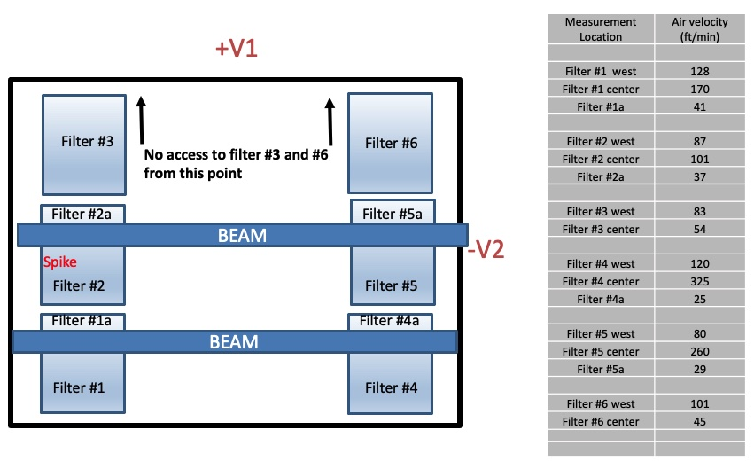
Figure 4. Tent ceiling diagram and results for testing air flow rate from the filters.

Air Particle Leak Test
- All air particle counts were better than International Organization for Standardization (ISO) Class 5.
- An unrepairable leak on Filter #2 causing a spike in air particles remained. However, the particle counts were lower compared to the first leak test, and the spike was on the edge behind the mirrors, so this was acceptable.
- The air particle spike that appeared on Filter #6 during the first leak test was no longer apparent once the edge of the HEPA filter module was sealed from the outside of the tent with tape.
- Overall, counts were consistently lower compared to the first leak test.
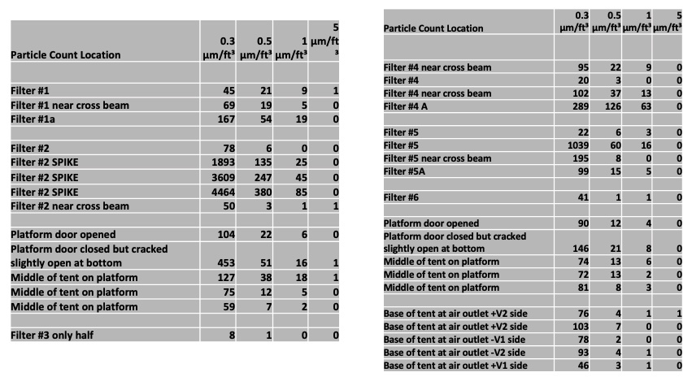
Figure 5. Air particle counts during leak tests.

Particle fallout testing
To collect particle fallout during acoustic testing, Gel-Paks and silicon wafers were placed on the tent wall structure and on the floor. Gel-Paks were used to reduce the potential shifting of particles and possible redistribution close to the OTIS flight hardware when subjected to acoustic loads. Fallout was measured in Percent Area Coverage (PAC) on an Image Analyzer (IA).

Particle Fallout: Acoustic Test #1
All samples contained aluminum and aluminum anodized particles, and the PAC exceeded the test allocation of 0.032 PAC in all but one locations, as shown in Figure 6.

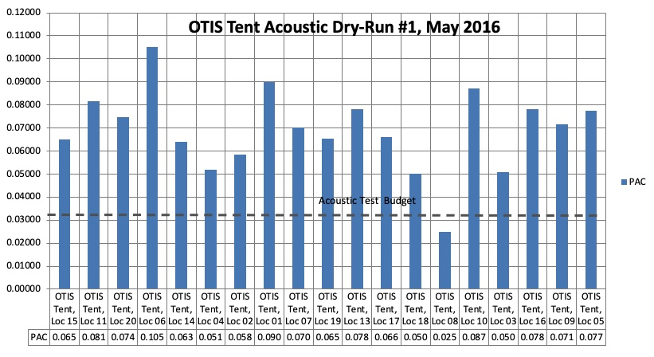
Figure 6. Acoustic Dry-Run #1 PAC results.

After the first acoustic test on the tent, there was a considerable amount of metal particles. Evidence was pointing to improper cleaning of individual metal beams and joints of the enclosure, so changes had to be made to eliminate the contamination. First, all joints and beams were thoroughly cleaned and then covered with Dunshield film. To cover each section adequately, personnel worked from two manlifts so every joint could be reached. The ceiling area between the tent filters was covered with Dunshield to isolate all joints that could have metal particles in the ceiling area. To ensure all sources of contamination had been eliminated, a second acoustic test was needed. The second test would delay the overall schedule, but the contamination risk to the flight hardware was too significant. The CC team emphasized the importance of demonstrating that the tent was safe enough from a cleanliness perspective to house the sensitive flight OTIS. Mission project management ultimately agreed with the CC team, and a second acoustic test was performed. Figure 7 shows the modifications implemented in the enclosure.

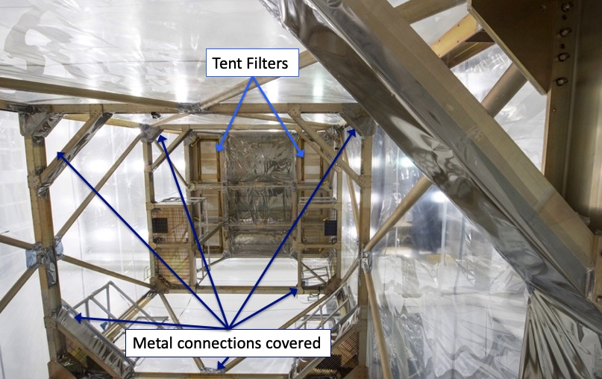
Figure 7. Locations fixed to prevent release of metal particles during acoustic testing. (Photo credit: NASA/Chris Gunn)
Particle Fallout: Acoustic Test #2
To verify the tent structure reinforcements were sufficient to protect OTIS, a second acoustic test was performed on the tent. Indeed, the reinforcements were effective, and OTIS could be placed in the tent with confidence that the tent would not be a contamination source. The excellent PAC results are shown in Figure 8. no metallic particles were observed on the samples. After the test, the CC team was elated!

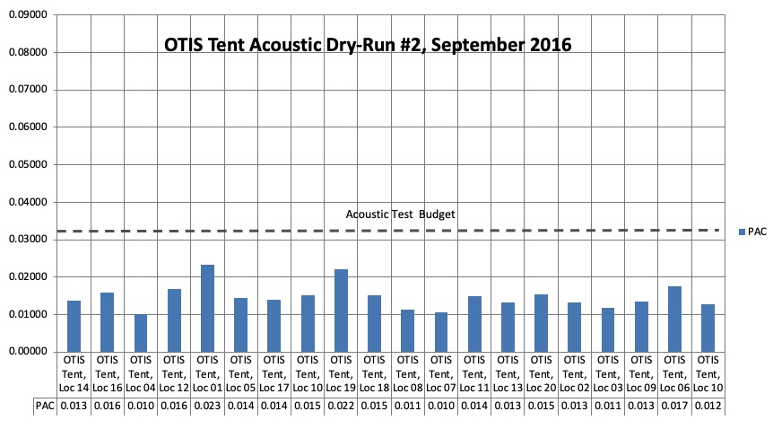
Figure 8. Acoustic Dry-Run #2 PAC results.

Particle Fallout: Vibration Testing Check-out
While the tent itself would not be subject to vibration loads imposed on OTIS, OTIS would be on the vibration table under the tent for an extended time. This period necessitated an assigned allocation of 0.016 PAC from the overall contamination budget. To gauge the tent’s ability to provide a suitable environment for meeting this allocation, silicon wafers were deployed inside the tent during a mechanical fit-check activity on three sides of the second and third levels. Those locations best represented OTIS’s critical optics and were reasonably accessible. The wafers were subsequently scanned with the IA to measure the accumulated particle fallout on each wafer, and as shown in Figure 9, all results complied.

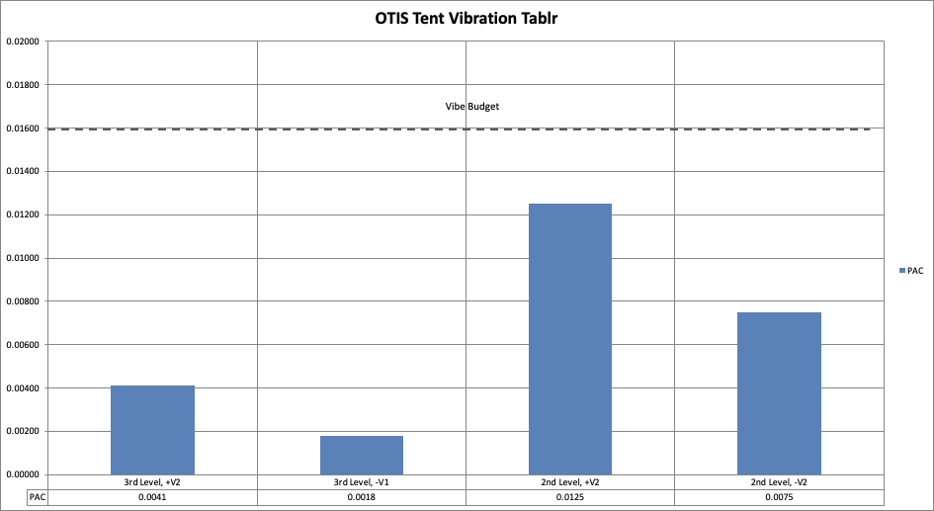
Figure 9. Particle fallout during OTIS tent to vibration table fit check.

Particle Fallout: Empty tent, HEPA filters off
Before the test, periods of time were expected with OTIS in the tent without the HEPA filters turned on. When cleaned items are bagged, protection from particulate accumulation is expected. Would the empty tent act as a large bag around OTIS? To test this, silicon wafers were deployed in the tent for just under 4 days, against which the PAC allocation was 0.0005 PAC/day and 0.0020 PAC for the entire test. As shown in Figure 10, the tent successfully acted as a bag. Wafer placement is shown in Figure 11.

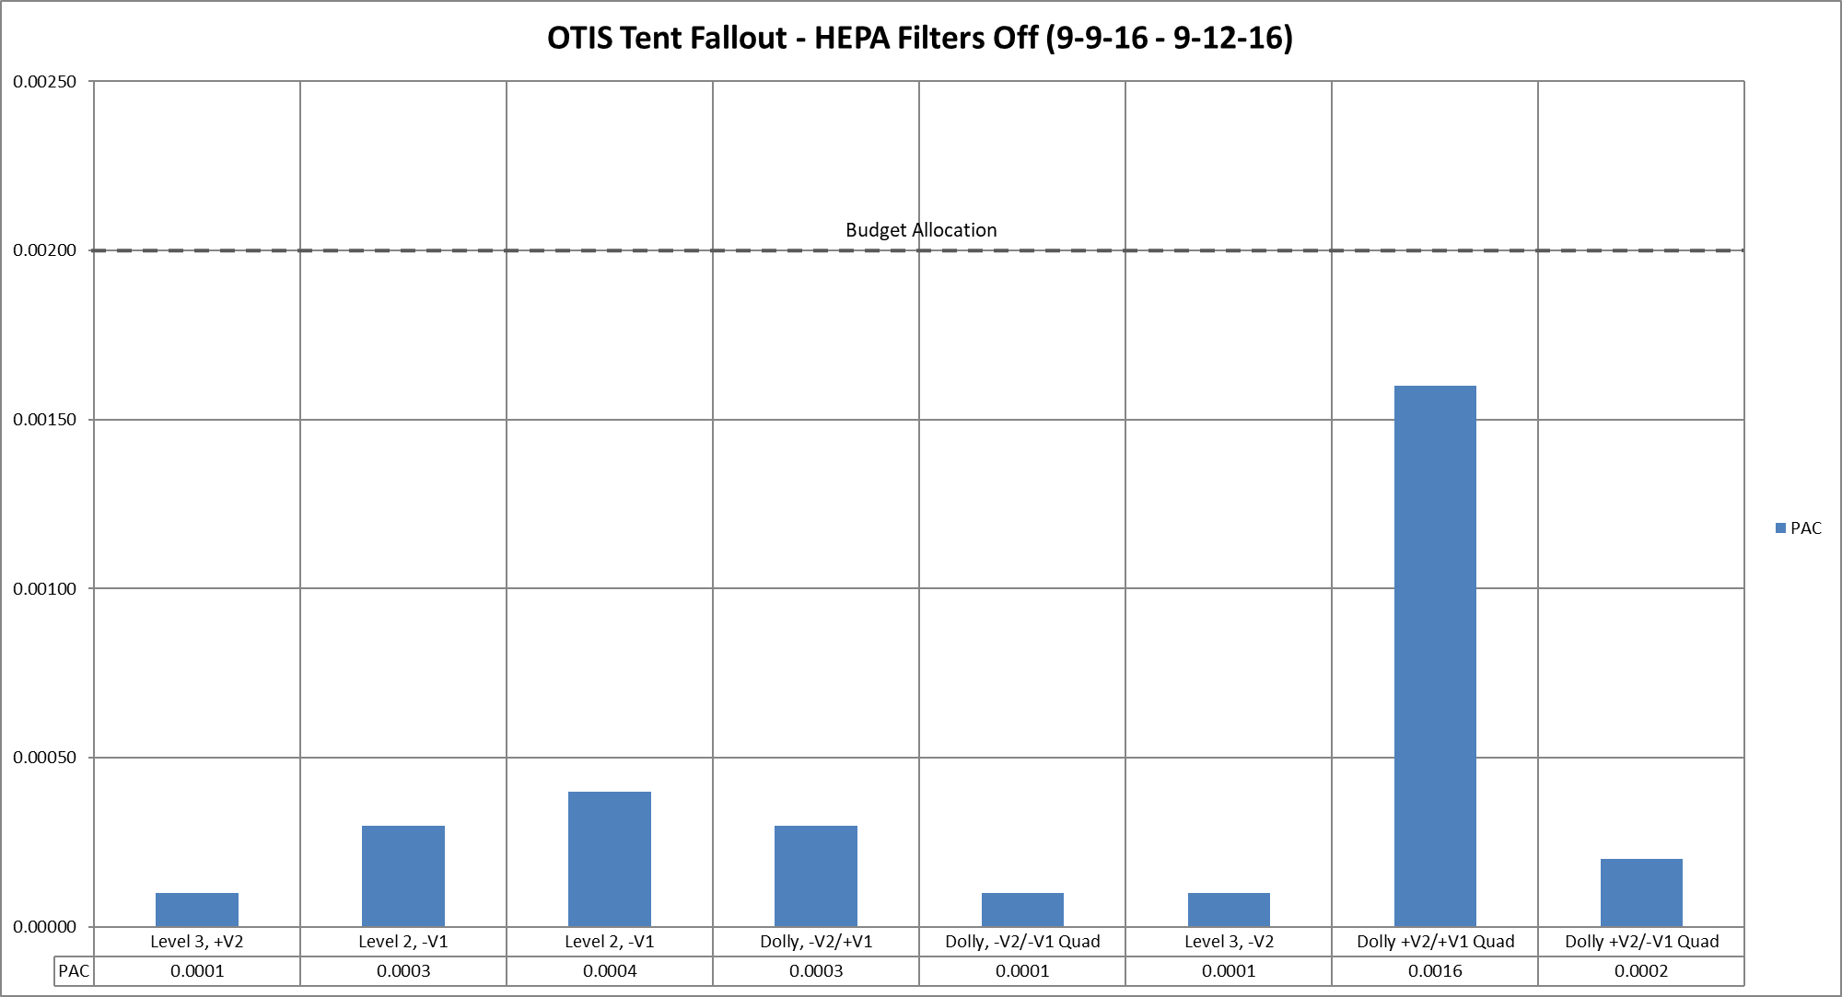

Figure 10. Empty tent particulate fallout.

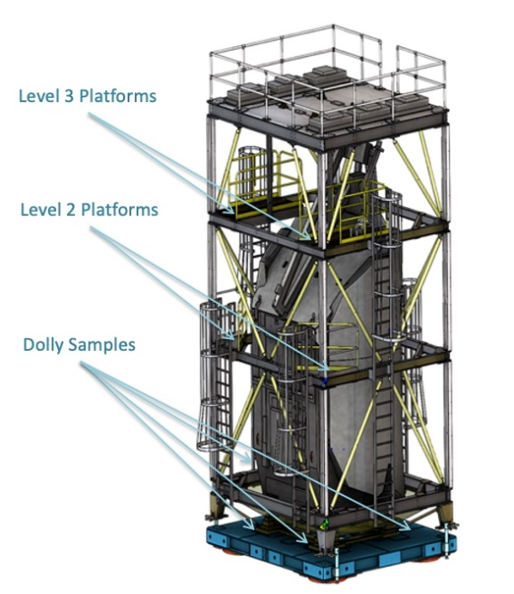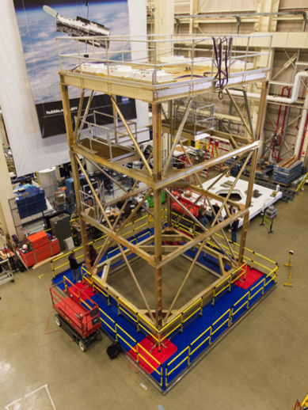

Figure 11. Empty tent sample locations and photograph of the empty tent. (Photo credit: NASA)

OTIS Mechanical and Environmental Test results
OTIS acoustic and vibration testing occurred shortly after the vibration table fit check. To monitor particle fallout during the test series, 17 wafers were deployed throughout the tent on all three levels. Since OTIS would not be removed from the tent between acoustic and vibration testing, the single set of wafers was used for both tests.

A technical difficulty occurred during vibration testing, which required OTIS to be under the tent and out of the cleanroom for longer than expected. Given that the 0.100 PAC allocation was cumulative and not a rate, the tent had to perform even better to still comply with the budget. In the end, OTIS was in the tent for over 4 months. This was over 3 months longer than planned, providing an example of the importance of worst-case planning. Too often, management will declare the best-case scenario as reason to compromise in important areas. Examples like this demonstrate the need to prepare for contingencies. Results from the test series are presented in Figure 12.

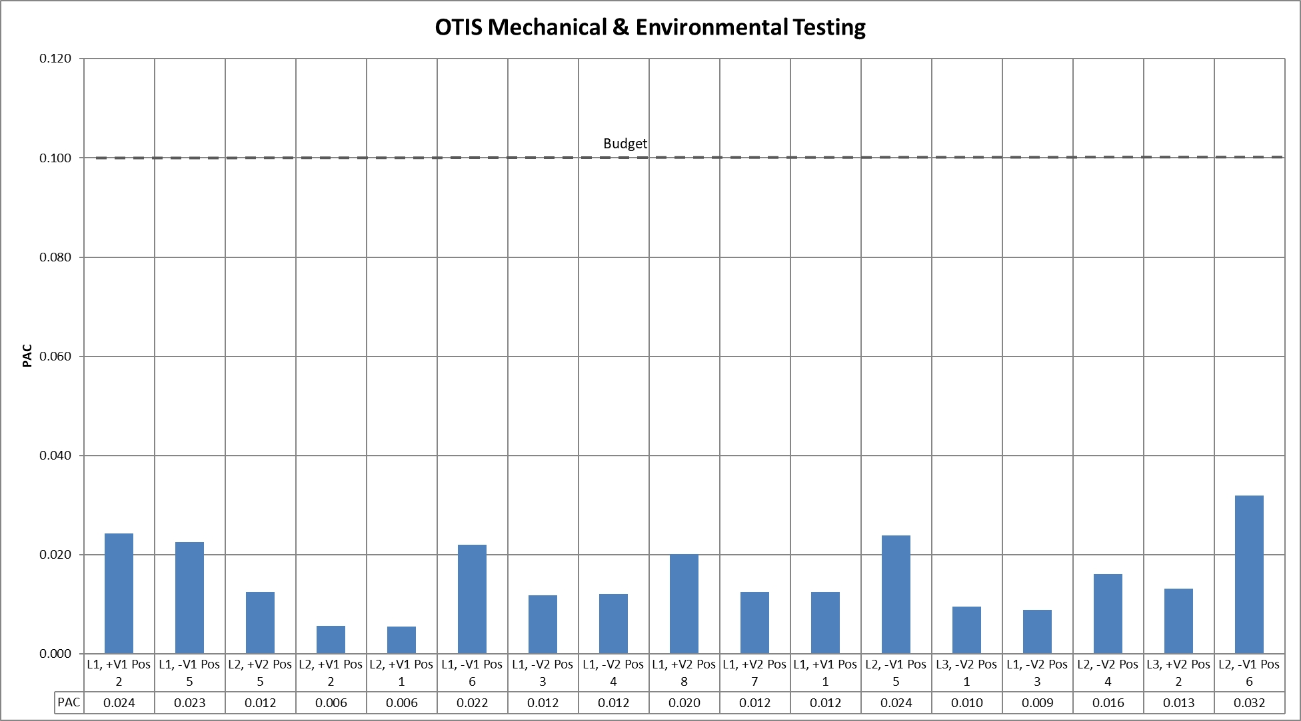

Figure 12. Particle fallout results from OTIS Mechanical and Environmental Testing.
The average particle fallout accumulation from the test series was 0.016 PAC, and none of the individual wafers showed a deposition greater than 32% of the allocation despite the extended time inside of the tent.

Purge

The ISIM instruments required continuous purging, which meant working out how to connect purge during the air pad and lifting operations and during OTIS transitions into and out of the tent. Manufactured Air was used as the purge source to avoid the personnel protection risks associated with gaseous nitrogen. Each instrument had its own purge line, and the purge was continuously monitored by both personnel and instrumentation. An emergency purge-source backup was in place and staged near OTIS.

The purge panel was located on the backside of the ISIM structure, as shown in Figure 13. The instrument lines were bundled and routed down the structure and across the tent floor-dolly as shown in Figure 14.

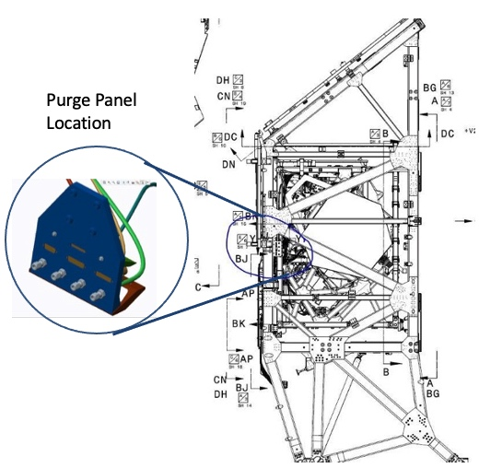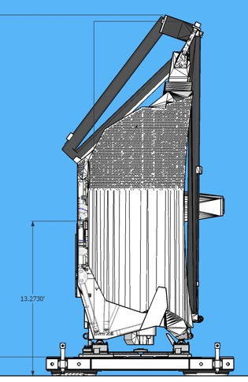
Purge
Panel
Location

Figure 13. Purge panel location.

Routing of 4 instrument pigtails

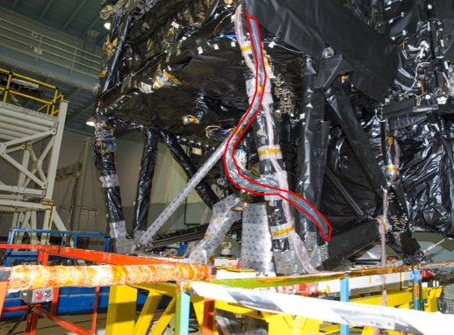

Figure 14. Purge line pigtails routing.

Managing purge transitions were performed as follows:

- In the SSDIF cleanroom, preparing for the move to the vibration table, the purge pigtails were routed out of the bottom of the bagging of the tent. Before moving OTIS & the tent out of SSDIF to the Vibe Test Area, the purge was transferred from House purge supply to the traveling bottle purge supply.

- Once outside SSDIF, the first tests were the x and y horizontal vibe tests. OTIS was air padded on its dolly next to the Horizontal Vibe Table, and the purge was transferred from bottle to house supplied clean air. OTIS was then lifted and secured to the Horizontal Vibe Table. The purge continued to run during lifting operations and Vibe test preparations. During Vibe test runs, the NIRSpec purge line was turned off in order to protect the Microshutters from fibers, and once each run was complete, the NIRSpec purge was turned back on.

- For the z-axis, OTIS was lifted to the Vertical Vibe Table. Purge continued to run during lift operations and vibe test preparations, and the NIRSpec purge line turned off during each run. After the z-axes runs were finished, OTIS was lifted back to the Dolly, and then purge was transferred back to the traveling bottle purge for air-padding back to the SSDIF cleanroom.

- Once back in the SSDIF cleanroom, purge returned to house supply (GN2) and the Clean Tent was reconfigured for the Acoustic test. (Ladders and Fans no longer needed were removed.). Before moving OTIS in the Clean Tent out of SSDIF, the purge was transferred from House to the traveling bottle purge supply (manufactured air).

- Outside SSDIF, OTIS was air padded into the Acoustic Chamber. Purge was transferred from bottle to house supplied clean air (both manufactured air), and continued during Acoustic test preparations. During test runs, the NIRSpec purge was turned off, then turned back on after each run completion. OTIS was then air padded from the Acoustic Chamber back to SSDIF, and the purge returned to house supply (GN2).

Working through the test details
The test flow was detailed, with the tent installation taking place in the SSDIF cleanroom and then air-padded to the vibration table. The crane was used to lift OTIS in its tent to the table and then for each reorientation to the next axis. The flow plan provided details for planning of CC and purge procedures at each step.

Vibration Test Details
The vibration testing flow followed the path outlined in Figure 15.

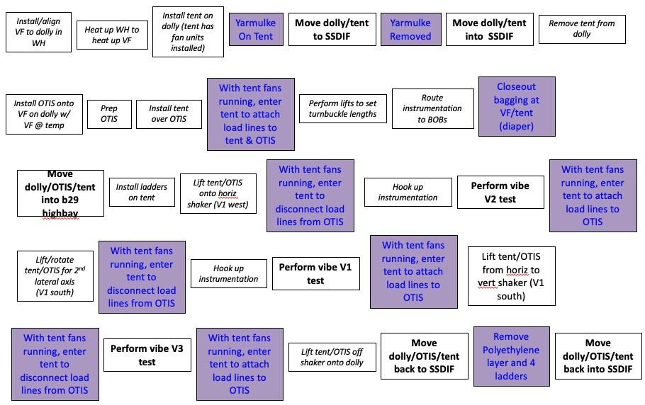
Figure 15. Vibration Test Flow. Vibration fixture (VF); Breakout boxes (BOBS)
Empty tent preparations began in the White House cleanroom, and then OTIS was installed inside the SSDIF. A drape, nicknamed the Yarmulke and shown in Figure 2, was placed on top of the tent to protect from particulate accumulation during the transfer between cleanrooms. Once in the SSDIF, the tent lid and sides were craned off the dolly for OTIS’s installation. After OTIS was secured to the dolly, the lid and sides were then installed to encapsulate OTIS, shown in Figure 16. The HEPA-filter fans could then be powered on. Instrumentation and other test preparation required some personnel to enter the tent, but this was minimized to limit the introduction of any contaminants.
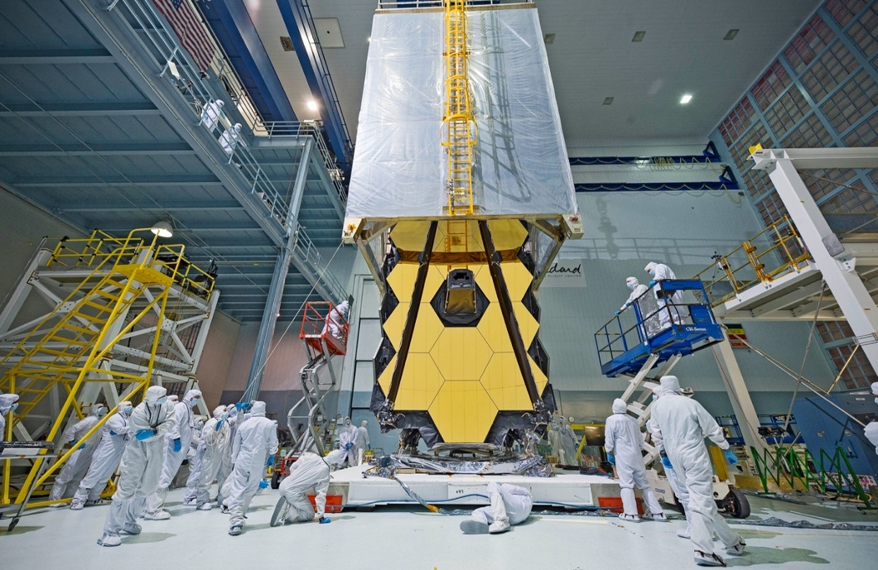
Figure 16. Installation of the tent lid and sides over OTIS in the SSDIF. (Photo Credit: NASA/Chris Gunn)

The OTIS-tent combination was then moved outside SSDIF and lifted to the Vibe Table, as shown in Figure 17.
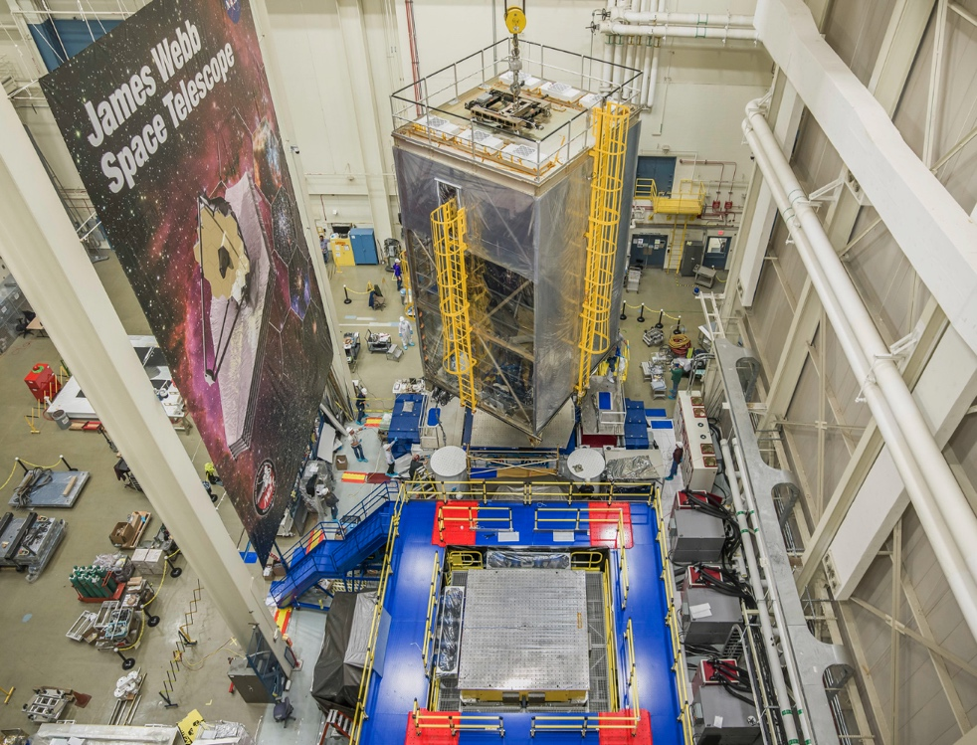
Figure 17. Crane lift of the OTIS-tent combination onto the vibration table. (Photo Credit: NASA/Chris Gunn)
The fans remained on while personnel entered to finalize the instrumentation and other set up, but had to be powered off for actual testing. Three vibration series were conducted, and the OTIS-tent combination had to be reoriented with a crane between each test. This required personnel to enter the tent, so the fans were re-initiated each time. At the conclusion of the third test, the OTIS-test combination was lifted off the vibration table and moved back into SSDIF.

Acoustic Test Details
The acoustic testing flow followed the path outlined in Figure 18.

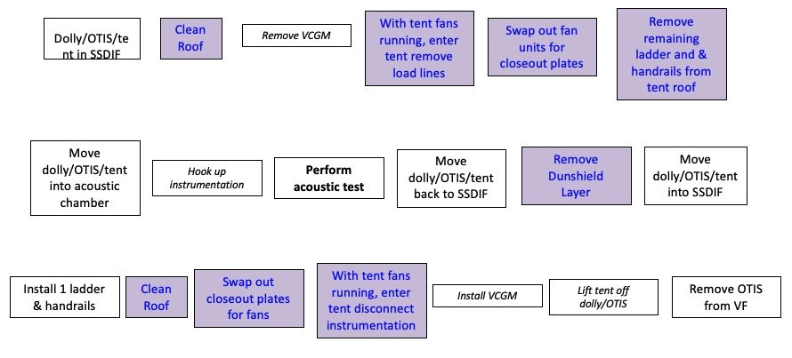
Figure 18. Acoustic Test Flow. Vertical center of gravity mechanism (VCGM)
The OTIS-tent combination returned to the SSDIF after vibration testing because the filter-fan units could not withstand the acoustic environment. They had to be replaced by heavy duty closeout plates, and that replacement required exposing the interior of the tent with OTIS inside. That could only safely be done inside of a cleanroom qualified for flight hardware exposure. Once the closeout plates were installed, the OTIS-tent combination was moved from the SSDIF to the acoustic facility, as shown in Figure 19.
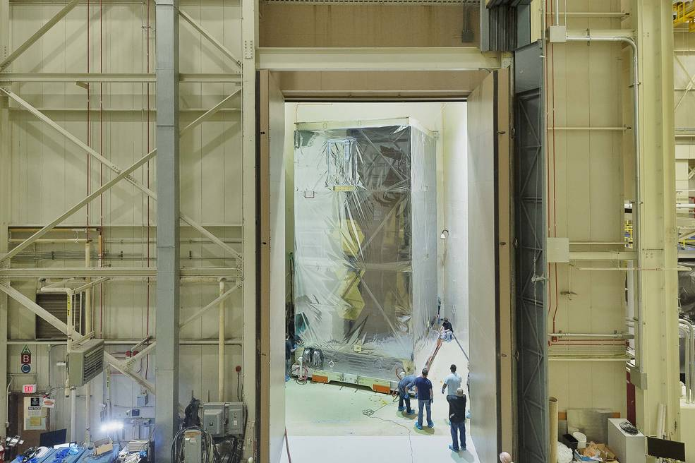
Figure 19. The OTIS-tent combination entering the acoustic facility. (Photo Credit: NASA/Chris Gunn)
Fortunately, acoustic testing did not require any personnel entering inside the tent, so missing the HEPA-filter fans was affordable. At the conclusion of the acoustic test, the OTIS-test combination returned to the SSDIF where the closeout plates were removed, and the fans reinstalled. Although testing was complete, personnel would need to enter the tent to disconnect instrumentation and prepare OTIS for removal from the tent. The crane was then rigged, and the tent lid and sides removed.

Lessons learned during this process
- The importance of being prepared for worst case scenarios. OTIS was going to “only be in the tent for 2 weeks”. That 2 weeks turned into over 3 months. Shortly after the vibration anomaly that resulted in the long delay happened, the CC team was asked about the contamination threat of remaining in the tent for a longer period. We were able to respond with confidence that OTIS would be well-protected against contamination based on the second acoustic test and the extensive particulate fallout testing performed. Final fallout results proved this assurance; thanks to the extensive testing performed, the CC team had not been worried.

- The importance of walking through each step of the process to be sure every detail was accounted for. For example, as we did this, we realized that while Dunshield and Melinex were the optimum films, we also had to account for keeping the outer Dunshield layer clean so OTIS in the tent could be moved back into the SSDIF cleanroom for acoustic test reconfiguration. This was solved with adding the outer polyethylene layer. In addition, after the acoustic test OTIS in the tent would again be moved from uncontrolled areas into the SSDIF cleanroom. At that point, the Dunshield layer was removed.

- The correct English spelling of Yarmulke :-P.

Conclusion
The extensive planning and testing put into the OTIS clean tent enclosure, with excellent collaboration between the OTIS mechanical and contamination control groups, were well-rewarded with the exceptional particulate contamination results shown in Figure 12. With an average particle fallout accumulation of 0.016 PAC, and none of the individual wafers showing a deposition greater than 32% of the allocation despite the extended time inside of the tent, OTIS was in a condition of cleanliness better than that required to ship to the Johnson Space Center for its cryogenic vacuum testing. The OTIS clean tent enclosure protected JWST well, and the same tent is now planned for use for the Roman Space Telescope vibration and acoustic testing.

acknowledgements

The authors are grateful for the collaboration and exceptional work performed by the OTIS Mechanical Team and the Sierra Lobo CC & logistics teams.

