Comparative Technology Assessment for Graphene ACT-17
(ACT-QRS-17-0030)
The initial design goal of the project focused on an ultra-fast, broadband detector operating at room temperature using graphene heterostructures. This focused the design effort to use graphene sheets, primarily as a transport (collection) mechanism in addition to being a secondary absorber material. Graphene is a zero bandgap material, meaning it is able to collect broadband photons, albeit with very low efficiency.
Table 1 shows some common commercial photonic technologies with a few figures of merit. It is worth noting the types of detectors are “standard” photodiodes, no Geiger Mode or Avalanche Photodiodes. Compared to commercial products, this work shows very promising detectors operating at room temperature for very weak signals, as shown by the very high responsivity and specific detectivity. Downsides include the very low maturity level, the high amplification external equipment to enable readout and digitization, i.e. no on-chip Read Out Integrated Circuit (ROIC), and low quantum efficiency.
Table 1: Commercial Detector Technologies
 | Silicon | HgCdTe | InGaAs | This Work (Ta₂O₅)
Wavelength Range (nm) | 300 - 1000 | 300 – 2400 | 800 - 2600 | 460 – 10600
Operating Temperature (K) | 298 | 180 | 260 | 298
Responsivity (A/W) | 1 | 8 x 10⁴ | 10 | 3.0 x 10⁶
Specific Detectivity (D*,Jones) | 3 x 10⁹ | 3 x 10¹⁰ | 1 x 10⁷ | 6.5 x 10¹⁴
Quantum Efficiency (%) | 90 | 60 | 85 | 3
Response Time (ns) | 1,000 | 100 | 20 | 20
Quantum-Cascade Detectors (QCD) essentially create individual pixels comprised of doped structures between two bound states in a quantum well often with graphene. The advantage of a QCD compared to this work is improved collection efficiency (~60% vs ~3%) albeit operating at very specific bands (ex. 5.1 – 5.5µm vs 0.3 – 10.6µm). QCDs are lower noise detectors since they do not require voltage biasing. Both structures benefit from customized absorption layers and fast response times.
Graphene heterostructure detectors show potentially promising results in specific applications, such as sensing in the THz region for security or biomedical applications. Graphene heterostructures can be designed in such a way to select a peak responsivity as a function of applied bias voltage, thereby creating an “electronic” filter, however such application is many years away from practical implementation on a scientific instrument.
Additionally, graphene layers are able to be added to existing technologies, such as Si, InGaAs, or HgCdTe to improve response times and, in some cases, increase responsivity.
For this work, the TRL assessment is to have risen the TRL from TRL=2 to TRL=3. The beginning of the project identified a potential use for the technology (broadband sensing for Earth Radiation Budget measurement) along with initial theoretical results, indicating an entry TRL=2. The end of the project showed simulation models compared to experimental results of laboratory demonstrations for specific wavelengths of interest, thereby broadly validating the analytical prediction, indicating an exit TRL=3.

Graphene and Plasmonic Enhanced Long-Wavelength Photodetectors for Earth Radiation Budget Instruments

We have fabricated graphene photodetectors operating from the deep-ultraviolet to mid-infrared region with high sensitivity and ultrafast response at room temperature by coupling graphene with p-type semiconductor photosensitizer and plasmonic structure including InSb, Si, Ta₂O₅ thin films (5 nm) grown by e-beam evaporation. Photons with energy higher than the energy of defect centers release holes from neutral acceptors. The holes are transferred into graphene, leaving behind ionized acceptors. Due to the advantage of two-dimensional heterostructure including homogeneous thickness, extending in a two-dimensional plane, and large contact area between the semiconductor thin film and graphene, holes are transferred rapidly to graphene and recirculated during the long lifetime of ionized acceptors. The photodetectors achieve a high photo-responsivity (up to 3.0 × 10⁶ A/W), ultrafast response time (faster than 20 ns), and a specific detectivity (up to ∼ 6.5 × 10¹⁴ Jones).¹⁻⁶ The work provides a method for achieving high-performance photodetectors operating in the deep-ultraviolet to mid-infrared region. The photodetectors can be integrated to fabricate image sensors or arrays such as a charged-coupled device (CCD) or CMOS camera.
Our results have been published in several papers. The research team has published three papers in high impact journals and three conference papers, including Nanoscale, ACS Applied Nano Materials, Proceedings of SPIE. Three more manuscripts are under preparation for publication. Several talks were presented in international conferences including American Physical Society March Meeting, SPIE conference. The software simulations have shown a good agreement between experiment and theoretical prediction. The codes can be used to predict the performance of the devices.
1. Y. Wang, V. X. Ho, Z. N. Henschel, M. P. Cooney, and N. Q. Vinh, “Interfacial Photogating Effect for Hybrid Graphene-Based Photodetectors”, ACS Applied Nano Materials 4, 8539 (2021).
2. V. X. Ho, Y. Wang, M. P. Cooney, and N. Q. Vinh, “Graphene-Ta₂O₅ Heterostructure Enabled High Performance, Deep-Ultraviolet to Mid-Infrared Photodetection”, Nanoscale 13, 10526 (2021).
3. Y. Wang, V. X. Ho, Z. N. Henschel, M. P. Cooney, and N. Q. Vinh, “Effect of High-κ Dielectric Layer on 1/f Noise Behavior in Graphene Field-Effect Transistors”, ACS Applied Nano Materials 4, 3647 (2021).
4. Y. Wang, V. X. Ho, Z. N. Henschel, Prashant Pradhan, L. Howe, M. P. Cooney, and N. Q. Vinh, “Graphene Photodetector Based on Interfacial Photogating Effect with High Sensitivity”, Proceedings of SPIE 11503, 1150306 (2020).
5. Y. Wang, V. X. Ho, P. Pradhan, M. P. Cooney, and N. Q. Vinh, “Graphene-Germanium Quantum Dot Photodetector with High Sensitivity”, Proceedings of SPIE 11088, 110888 (2019).
6. V. X. Ho, Y. Wang, M. P. Cooney, and N. Q. Vinh, “Graphene-Based Photodetector at Room Temperature”, Proceedings of SPIE 10729, 1072907 (2018).
A large number of graduate and undergraduate students have obtained academic training from the project. The project has supported three PhD students (Leslie Howe, Yifei Wang and Vinh X. Ho) in the research, including clean-room fee, materials, salary support.
The COVID issue has pushed the performance of the project in a difficult situation. The VT clean-room was closed for a few months, but the research team managed the schedule to obtain great results for the project.
The research team appreciates the support from Earth Science Technology Office (ESTO) and NASA. The work has led to a high level of understanding the fabrication and performance of photodetectors based on graphene and semiconductor nanostructures. A large number of devices were fabricated and characterized. A number of important papers have been published. The work cannot be done without the support. A large number of students including graduate and undergraduate students at Virginia Tech have been involved to the project. They obtained a great training at the high research level including fabrication micro/nano-devices in clean-rooms, characterization microelectronic devices in optics and electronics, research experience in nanoscience and nanotechnology, computation and simulation methods. We really appreciate the support from NASA, ESTO, Langley Research Center. We gratefully thank Dr. Mike Cooney for his input and collaboration in the project.

1. Photodetector fabrication
We have fabricated hybrid graphene/semiconductor heterostructures for photodetectors in the Virginia Tech’s cleanroom. The active area of the graphene photodetector devices consists of a graphene sheet and a 5-nm semiconductor layer including nitrogen-doped tantalum oxide (N-Ta₂O₅), Si, and InSb materials. Graphene acts as a carrier transport channel, and the semiconductor thin film is used as a strong photon absorbing material containing ionized acceptors. The active area is placed on top of a Si/SiO₂ wafer as illustrated in Figure 1. The structure shows a high photo-response over a large volume of the optical active thin film. The semiconductor layer is doped with nitrogen or boron to form acceptor centers during the e-beam evaporation deposition. The layer contains shadow/deep acceptor centers with energy levels in the band gap of the semiconductor materials. Photons with energy higher than the energy gap of the semiconductor materials or the energy of acceptor centers release holes from the neutral acceptors. The holes are transferred into the graphene channel, leaving behind ionized acceptors (negative charges). Due to the high carrier mobility of graphene sheet, holes are recirculated during the long lifetime of ionized acceptors. The graphene/semiconductor heterostructure photodetectors offer a large spectral sensitivity from deep ultra-violet (UV) to mid-infrared (MIR) region with very fast operation time at room temperature.
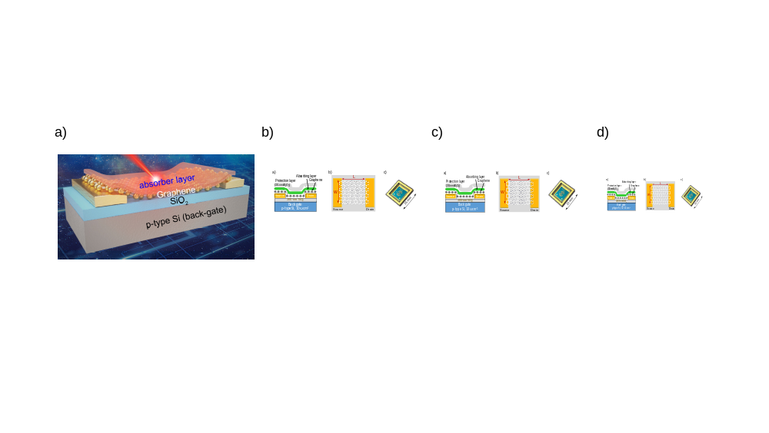
Figure 1. Schematic structure of our graphene photodetector device including (a) three-dimension view, (b) the cross-section showing source, drain, back gate contacts together with graphene, absorber layer, and 30-nm Al₂O₃ layers, (c) the top view of the graphene photodetector with the length (L) and distance (D) between source and drain, and (d) a picture of the graphene photodetector device.

Specifically, the graphene/semiconductor heterostructure photodetectors have fabricated on a p-doped Si wafer (1 – 10 Ω.cm). The surface of the Si wafer was covered by a 300-nm silicon dioxide and patterned with alignment marks. A metal back-gate directly contacting to the Si substrate was designed using photolithography. Metal source and drain contacts (Cr/Au with 10/100-nm thickness) for transport measurements were deposited directly onto the wafer by photolithography to form a field effect transistor (FET).
The chemical vapor deposition (CVD) monolayer graphene film on a copper foil from Graphenea Inc. was transferred onto the Si/SiO₂ substrate. The CVD graphene on the Cu foil was spin-coated by poly-(methyl-methacrylate) (PMMA), then the Cu foil was removed by using 0.3 M ammonium persulfate solution for 2 hours. Graphene with the PMMA film was rinsed with high purity deionized water and transferred onto the Si/SiO₂ wafer with metal contacts. The sample was baked at 120 ºC for 15 minutes, then cleaned PMMA by acetone for 1 hour. Photolithography and oxygen plasma etching were employed to fabricate graphene patterns between metal contacts. The process eliminates photoresist residue that cannot remove completely by acetone during lift-off steps. After that, a 5-nm N-Ta₂O₅ layer, or a narrow bandgap semiconductor was deposited on the top of the CVD graphene by e-beam thermal evaporation with a rate of 0.1 Å per second. The device was covered with a 30-nm Al₂O₃ film using the atomic layer deposition method at 300 ºC. The optically active and Al₂O₃ layers cover the entire surface, thus photolithography was used to redefine source, drain, and back-gate contacts. A schematic diagram of the graphene/semiconductor heterostructure photodetector is shown in the Figure 1. The gap, L, between source and drain contacts and the width of the active area, W, have been varied (Figure 1c).

2. Photodetector characterization
The electrical and optical characteristics were performed in our laboratories at Virginia Tech. Two Keithley 2400 source-meters units have been used. The first unit, a Keithley 2400, is used to control the back-gate voltage, V_{BG}. The second unit, a Keithley 2450, is used to set a constant voltage between source and drain, V_{SD}, and to measure the drain current, I_{DS}. Several light sources have been employed in the experiments. In the UV to near infrared (NIR) region, a broadband UV-NIR lamp light source (Edmund, #87-300), a diode-pumped laser operating at 532 nm and a fiber laser lasing at 1.53 μm have been used. For MIR experiments, several quantum cascade lasers (QCLs) lasing at 4.55, 8.35 μm and a CO₂ laser operating at 10.6 μm are employed. Half-wave plates and polarizing beam-splitters are used to control the laser power. To control the power and wavelength of incoherent light sources, neutral density filters and band pass interference filters are employed. A lens system and a diaphragm with a 2-mm diameter are used to form a uniform intensity distribution on the photodetector. By knowing the active size and intensity, the power of the light incident upon the graphene/semiconductor heterostructure photodetectors can be estimated.
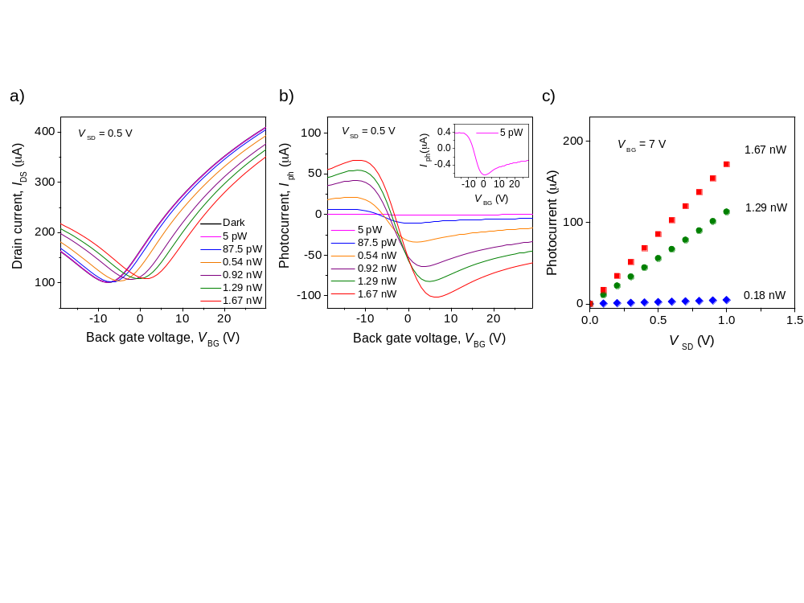
Figure 2: (a) I–V_{BG} characteristics of the graphene – Ta₂O₅ photodetector under different illumination powers, and 0.5 V source–drain bias voltage. The wavelength is 532 nm with a spot size of 2 mm, covering the entire photodetector. (b) Photocurrent curves under different illumination powers as a function of back gate voltage. The magnitude of photocurrent increases with illumination power. (c) The photocurrent increases linearly with the source–drain bias voltage.

The effect of light illumination on the graphene/semiconductor heterostructure photodetector with the gap between source and drain contacts, L, of 30 μm, and the width of the active area, W, of 30 μm (W/L = 1) is shown as an example in Figure 2. Specifically, we have observed the source-drain current, I_{DS}, with and without illumination of a single-frequency laser diode operating at 532 nm as a function of the back-gate voltage, V_{BG}. The power of the pump laser was varied from 300 fW to 7.5 nW. Figure 2a shows transfer characteristic (I-V) curves of our device for the source-drain bias voltage, V_{SD}, of 0.5 V. A shift of ~11 V of the charge neutrality point (CNP) voltage (V_{Dirac}) of the transfer characteristic curves toward positive of the back-gate voltage, V_{BG}, has been observed with increasing illumination power. The photocurrent increases for V_{BG} < V_{Dirac} where the carrier transport is hole-dominated. In this case photo-generated holes were transferred from the semiconductor thin film to graphene, leaving behind ionized acceptors. Thus, a high photocurrent has been observed. For V_{BG} > V_{Dirac}, where the carrier transport is electron-dominated, the illumination leads to a decrease in photocurrent due to the recombination occurring between holes transferred from the optically active semiconductor layer to graphene and electrons induced by the back gate. As long as the acceptors in the semiconductor layer remain ionized (negative charge), holes in the graphene layer are recirculated, resulting in a high gain in the graphene/semiconductor heterostructure device.
By subtracting the dark-current from the illumination-current, we can determine the net photocurrent (I_{ph} = I_{illumination} – I_{dark}) of the device. The photocurrent curves under different illumination powers are plotted in Figure 2b. A net photocurrent of ~100 μA has been observed at V_{BG} = 8 V and V_{SD} = 0.5 V. It demonstrates that the magnitude of the photocurrent increases with illumination power.
To gain insight into the characteristics of the graphene/semiconductor heterostructure, we have carried out the power dependence of the photocurrent (Figure 3a) as well as determined the photo-responsivity (Figure 3b), R_{ph} = I_{ph}/P, of the photodetector for the 532-nm illumination, at V_{BG} = 7.0 V for three values of the source-drain voltage, V_{SD}, of 0.1, 0.5, and 1 V. Under low illumination power of 300 fW, the device shows a photo-responsivity of 1.25 × 10⁵ A/W, suggesting that graphene as well as semiconductor layers efficiently convert the photon energy into a large electrical current. The photocurrent increases linearly with illumination power from 300 fW to ~ 2 nW (almost four orders of magnitude) and grows slowly at high illumination power. In an equivalent way, the photo-responsivity shows a constant value at low illumination power and reduces after that (Figure 3b). The photo-responsivity reduces when the excitation power is higher than 2 nW. At low illumination power, ionized acceptors in the semiconductor layer are well separated from photon-generated electron-hole pairs, thus a high gain from the photogating effect has been obtained. As we increase the illumination power, a higher concentration of electron-hole pairs is introduced. When all acceptor centers are ionized, electrons and holes can recombine in the picosecond timescale. These holes will not take part in the charge transfer process, and thus, the photo-responsivity reduces.
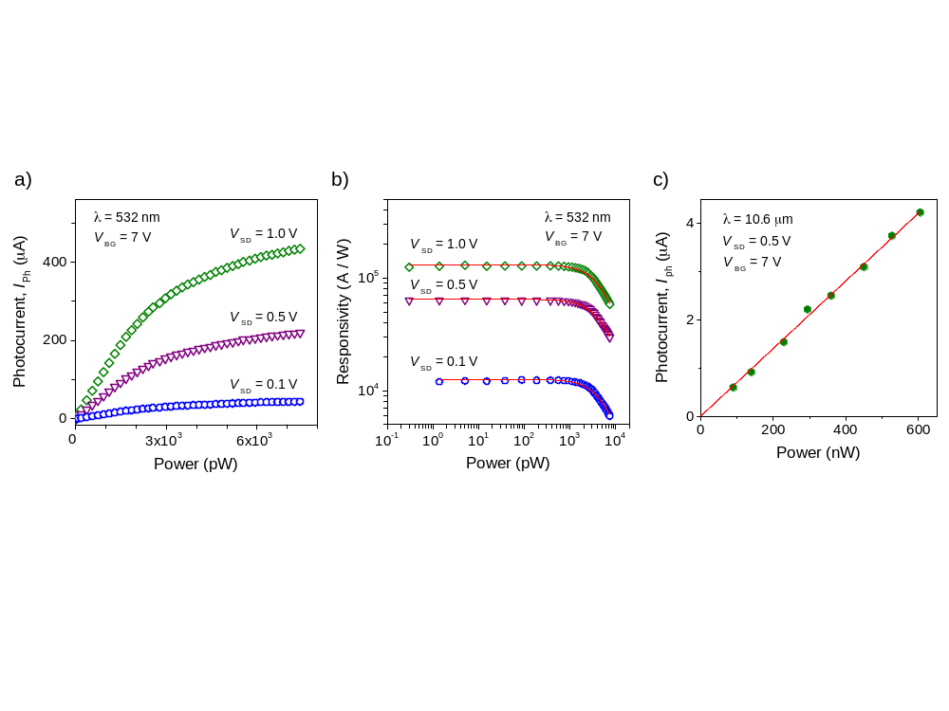
Figure 3: (a) Power dependence of photocurrent under different source–drain bias voltage using the lock-in technique at V_{BG} = 7.0 V for three values of the source-drain voltage, V_{SD}, of 0.1, 0.5 V, and 1 V. The photocurrent increases linearly with light intensity, and grows slowly at high illumination power. (b) The photo-responsivity shows a constant value at low illumination power and reduces at high excitation power. (c) Power dependence of photocurrent using a CO₂ laser (λ = 10.6 μm) for excitation at V_{BG} = 7.0 V. A linear increase of photocurrent with illumination power has been observed.

The photo-responsivity of photodetectors strongly depends on the carrier dynamics. The carrier lifetime can be expressed as a function of illumination power, $T_{\text{carrier}}=T_{0}/\left(1+{\left(P/P_{0}\right)}^{m}\right)$, $T_{0}$ is the lifetime of carriers at low illumination power (P→0), $P_{0}$ is the illumination power in which acceptor centers are fully ionized, and m is a phenomenological fitting parameter (m ≈ 1). Due to the high mobility of carriers in graphene, holes will recirculate between drain and source electrodes many times during the long lifetime of the ionized acceptors resulting in a high responsivity or a high gain. The photocurrent can be defined as $I_{\text{ph}}=αqηN_{\text{ph}}T_{\text{carrier}}/(L/V),$ where q is the elementary charge, α is the carrier transfer efficiency from the semiconductor thin film to graphene, η is the internal quantum efficiency of the carrier photogeneration in the semiconductor thin film layer, N_{ph} is the number of photons absorbed per unit time, and $V=μV_{\text{SD}}L^{-1}$ is the carrier drift velocity. For a device with L = 30 μm, V_{SD} = 0.5 V, the carrier transit time in the graphene channel, $T_{t}=L/V=L^{2}μ^{-1}V_{\text{SD}}^{-1}$, is estimated to be ~0.1 ns. The gain of this structure can be determined:
$G=\frac{N_{\text{hole}}}{N_{\text{ph}}}=\frac{I_{\text{ph}}/q}{N_{\text{ph}}}=αη\left(\frac{T_{0}}{T_{t}}\right)\frac{1}{1+{\left(P/P_{0}\right)}^{m}}$ (1)
The first term of Eq. 1 is the expression for the gain, which is defined as the ratio of the carrier lifetime at low illumination power to the carrier transit time, and the second term regards for the full ionization of acceptor centers at high intensity. The long lifetime of ionized acceptors combined with the fast carrier transit time results in a gain as high as G ~ 1 × 10⁵. The decreasing of the gain at high illumination power is an indication of full ionization. The solid lines in Figure 3b are fitting curves to experimental data with P₀ = ~2.1 nW and m ~ 1.15.
To examine the MIR response, we have conducted experiments with QCLs (λ = 4.55 and 8.35 μm) and a CO₂ laser (λ = 10.6 μm) under the conditions of source-drain voltage, V_{SD}, of 0.5 V, and back-gate voltage, V_{BG}, of 7.0 V. The photocurrent as a function of illumination power is shown in Figure 3c using the CO₂ laser as a light source. A linear behavior of the photocurrent with the illumination power has been observed. From the results, the photo-responsivity in the MIR region of 7.2 A/W has been obtained.
In addition, the photocurrent shows a linear dependence on the source-drain bias voltage, V_{SD}, (Figure 2c) suggesting that higher photo-responsivity can be readily obtained by applying a higher bias voltage. As can be seen from Figures 3a and 3b, with V_{BG} = 7.0 V, the photo-responsivity of the device at V_{SD} = 1.0 V is higher than those from a lower voltage between source and drain.
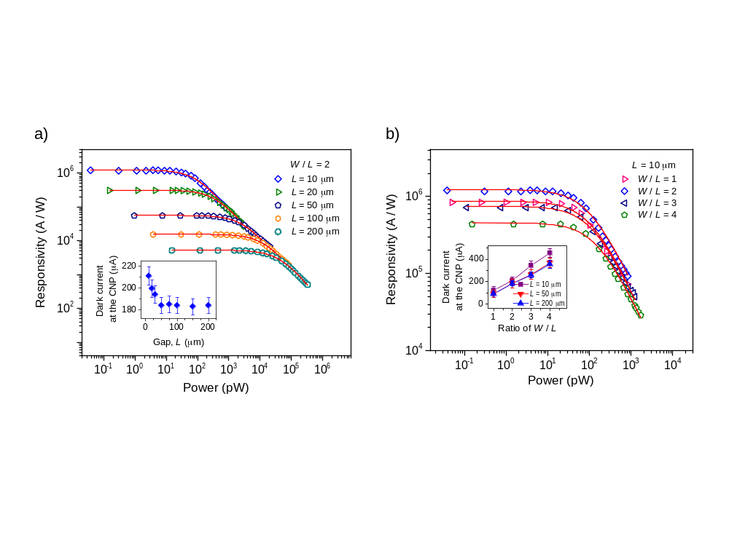
Figure 4: The measured photo-responsivity for graphene-Ta₂O₅ photodetectors with different graphene sheet dimensions. (a) The measured photo-responsivity of photodetectors for the ratio W/L = 2 with different gaps, L, between source and drain as a function of illumination power. The solid curves are the best fit to the data using the function in Eq. 1. Inset: the dark-current at the charge neutrality point as a function of gap, L, between source and drain. The dark-current increases significantly when the gap becomes narrower. (b) The measured photo-responsivity for L = 10 μm with different ratios W/L as a function of illumination power. Inset: the dark-current at the charge neutrality point as a function of the ratio of W/L.

3. Characterization of physical parameters of photodetectors
The photo-responsivity depends strongly on physical parameters of the devices. Specifically, the photo-responsivity depends on geometrical parameters, including the distance, L, between source and drain contacts, and the width, W, of the active area. A simple electrical circuit has been developed for graphene photodetectors. The photocurrent for low illumination power is solved as:
$I_{\text{ph}}=I_{\text{illumination}}-I_{\text{dark}}=\frac{V_{\text{SD}}}{R_{\text{0}}+\frac{W/L}{\left(n+∆n\right)eμ}}-\frac{V_{\text{SD}}}{R_{\text{0}}+\frac{W/L}{neμ}}≈\frac{V_{\text{SD}}∆neμ}{{\left(R_{\text{0}}neμ\left(W/L\right)+1\right)}^{2}}\left(W/L\right)$ (2)
where $R_{\text{0}}$, $R_{\text{illu}}$ and $R_{\text{D}}=\left(L/W\right)/\left(nqμ\right)$ are the contact resistance of the graphene/semiconductor heterostructure with electrodes, the total resistance with light illumination of the active area, and the total resistance under the dark condition, respectively. n is the carrier concentration in the graphene/semiconductor area. Figure 4a inset shows the dark current at the CNP (the minimum current of the transfer characteristic curves) as a function of the gap, L, for W/L = 2. With V_{SD} = 0.5 V, the total resistance under dark conditions, $R_{\text{D}}$, is ~2.7 kΩ. The dark resistance values are close with other reports. When the device is illuminated, a number of carriers are generated from the semiconductor light-absorbing layer and transferred to electrodes. $∆n$ is the carrier concentration variation in the active area of the device.
Fixing the ratio of the width and the gap (W/L), the photocurrent, I_{ph}, is proportional to the carrier concentration variation, Δn. Thus, to increase the photo-responsivity of the detector, reducing the active area will enhance the carrier concentration variation, Δn. Figure 4a shows that for a fixed W/L ratio, the photo-responsivity increases several orders of magnitude from W/L = 400/200 μm to the W/L = 20/10 μm. When the active area was reduced with a fixed W/L ratio, the length, L, also was reduced. With a shorter gap between source and drain, the dark current increases significantly (Figure 4a, inset), thus, reducing the performance of the device.
The smaller active area provides a high photo-responsivity, however, the dark-current, I_{D}, as well as the photocurrent, I_{ph}, vary with the width, W, of the active area. For a fixed gap between source and drain, L, the dark current (inset of Figure 4b) increases when the width, W, increases. We have varied the W/L ratio for L = 10 μm, i.e., W/L = 20/10 μm, W/L = 30/10 μm, W/L = 40/10 μm (Figure 4b). The highest photo-responsivity was obtained for the W/L = 20 μm/ 10 μm device. With increasing the width, a higher photo-responsivity is obtained. However, increasing the width beyond 20 μm decreases the photo-responsivity. The decreasing photo-responsivity with a width larger than 20 μm is a result of the recombination of carriers at defects on the monolayer graphene. The monolayer graphene was grown on copper foil by the CVD method and the monolayer graphene consists of single-crystalline grains with sizes from 10 to 20 μm. Carriers produced by photon absorption strongly recombine at defects or grain boundaries. Thus, when the width increases, the photocurrent and the photo-responsivity were slowly increased. For the best performance, the optimal parameters are L = 10 um and W = 20 um. With this structure, the photodetector can detect the light intensity as low as 27 fW (0.135 mW/m²) in the visible region.
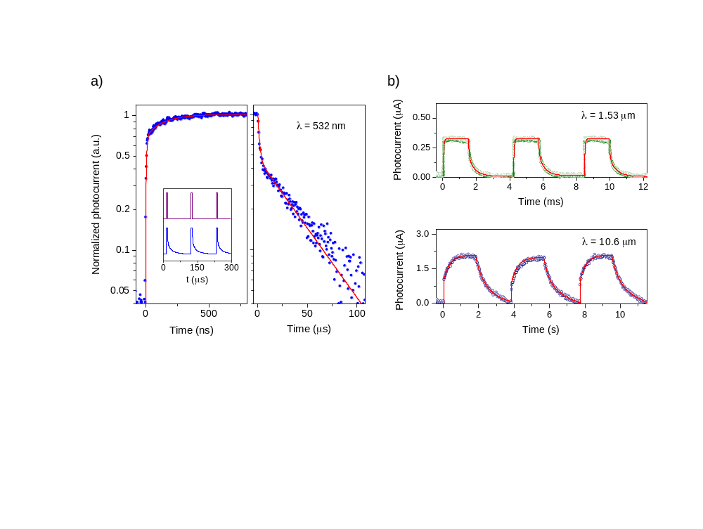
Figure 5: Photocurrent response of the graphene-Ta₂O₅ photodetector to on/off illumination with V_{SD} = 0.5 V; V_{BG} = -7 V. (a) The photocurrent response shows fast response and recovery time for photon with λ = 532 nm. (b) The fast response and recovery time of the photocurrent under NIR illumination with λ = 1.53 μm. (c) The photocurrent response demonstrates the fast response time in the MIR region for photon with λ = 10.6 μm.
4. Characterization of response time of photodetectors
To define the impact of a photodetector on the performance and speed, we characterize the response time of our devices. Response time was measured using a low noise current amplifier (DLPCA-200, FEMTO) and an oscilloscope to monitor the temporal dynamics of the photocurrent under different illumination power. To obtain the ultra-fast response, an Acousto-Optic Modulators (AOM) using a TeO₂ crystal produced ultrafast laser pulses from a continuous-wave laser. Using this system, laser pulses are generated with the rise time of 20 ns. The photocurrent appears periodically (Figure 5a, inset) with the pulse duration of 6.3 μs under the 532-nm laser illumination, V_{SD} = 0.5 V, and V_{BG} = -7 V at room temperature. For the device with an active area of 20 × 10 μm, the response time is estimated to be ∼125 ns (from 10 to 90% of the peak photocurrent), while the recovery time is 41 μs (from 90 to 10% of the peak photocurrent). The signal in Figure 5a shows an ultrafast response time. The increasing of photocurrent with the illumination time can be fitted to an exponential function with two time constants: $I_{ph}=I_{0}-I_{1}exp\left(-t/τ_{1}\right)-I_{2}\exp\left(-t/τ_{2}\right)$, in which $τ_{1}$ is ~20 ns (the rise time of the AOM system), and $τ_{2}$ is 325 ns. The short rise time, $τ_{1}$, represents the hole transfer time to electrodes, whereas the longer time constant, $τ_{2}$, corresponds to the hole transfer time from an accepter center to graphene. Similarly, the decreasing of photocurrent with time when the light is turned off can be fitted to an exponential function: $I_{ph}=I_{1}\left(\exp\left(-t/τ_{3}\right)\right)+I_{2}\left(\exp\left(-t/τ_{4}\right)\right)$ with two decay time constants, $τ_{3}=500$ ns, and $τ_{4}=45$ μs. The short decay time constant, $τ_{3}$, can be attributed to the charge transfer between accepter centers in the semiconductor layer because it is similar to $τ_{2}$. The slowest time $τ_{4}$ may represent the lifetime of ionized acceptor centers. Using the e-beam evaporation to make the nanometer semiconductor light-absorbing layer, fast dynamics including the response and the recovery time of the photocurrent has been obtained. These values are orders of magnitude faster than those from previous reports.⁷⁻¹³
The response time of the devices in the MIR (Figure 5c) is slower compared with those from the UV to NIR region (Figure 5a,b). The response time at 10.6 μm shows two components. The fast component is faster than 1 ms (limitation of our test system), and the longer component is 300 ms. The fast component originates from the transit time of holes in the graphene channel, while the longer comes from the lifetime of surface trapping centers.
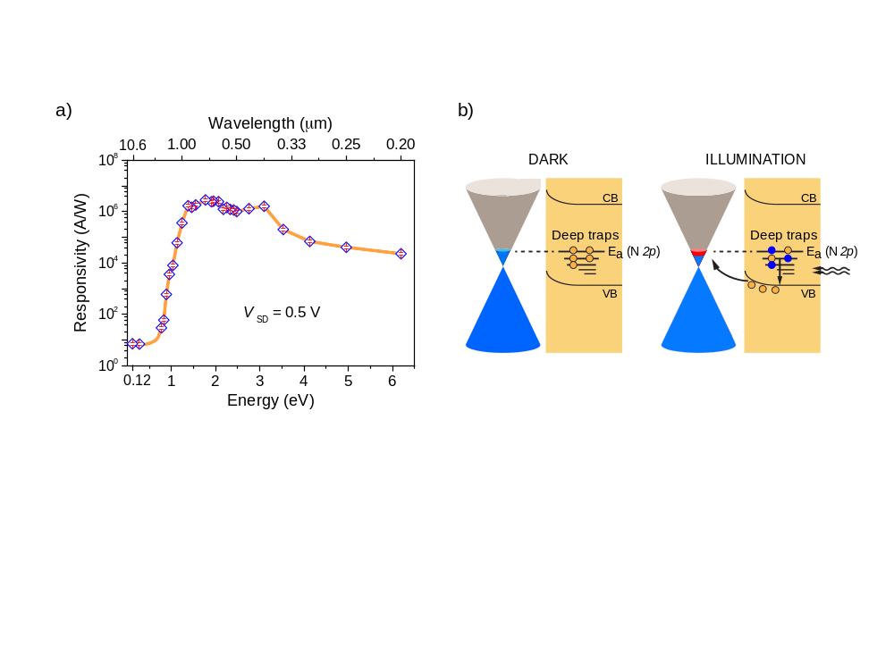
Figure 6: Spectral sensitivity of the graphene-Ta₂O₅ heterostructure device (W×L = 20×10 μm). (a) Photo-responsivity of the device as a function of excitation photo-wavelength from 200 nm to 10.6 μm (or from 0.12 to 6.2 eV). The blue diamond dots are experimental data, and the orange line is a guide to eyes. (b) Schematic diagram of energy band structures of graphene and the 5-nm N-Ta₂O₅ layers together with the tendency of charge transfer between layers. The blue dots present for the ionized acceptor centers, while hollow dots stand for holes.

5. Engineering nanostructures to obtain high photoconductive gain and broadband photodetection
To characterize the broadband photo-response of the devices, photo-responsivity as a function of illuminated photon energy has been measured. The photo-responsivity shows a broadband spectrum from the MIR to UV region (Figure 6a). Specifically, the photo-responsivity at the MIR region (10.6 μm or 0.12 eV) is 7.2 A/W, and significantly sensitive in the range from the near infrared (1.53 μm or 0.81 eV) to the deep UV (200 nm or 6.2 eV) region in the order of 10⁶ A/W. The spectral photo-responsivity of the device containing 5-nm N-Ta₂O₅ layer shows an onset at ~ 1 eV.
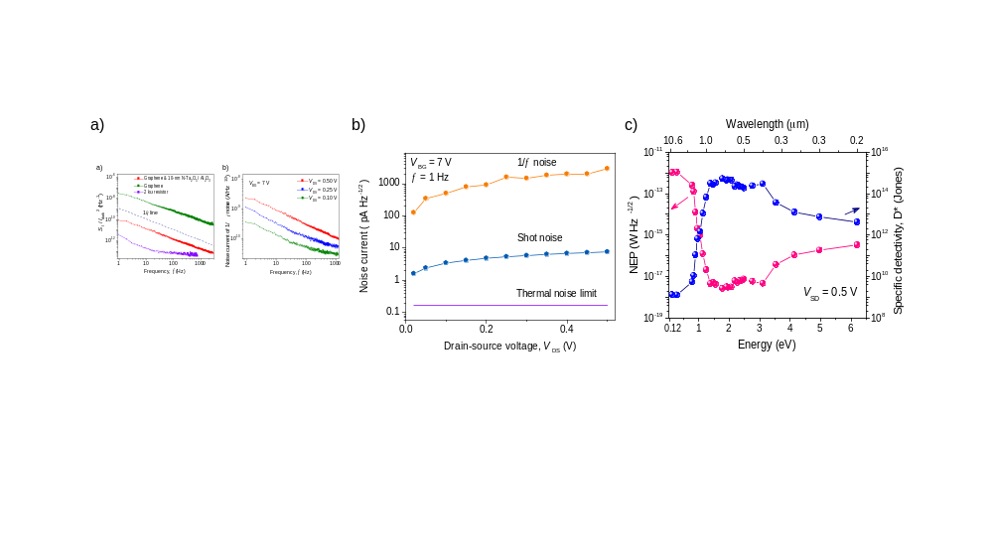
Figure 7. (a) Current density of $1/f$ noise for the graphene-Ta₂O₅ photodetector with W×L = 20×10 μm at V_{BG} = 7 V, at a modulation frequency of 1 Hz. (b) Noise current of $1/f$ noise, shot noise, and thermal noise of the graphene/semiconductor photodetector as a function of drain-source voltage, V_{DS}. (c) Spectral dependence of the NEP and specific detectivity (D*) of the photodetector device at room temperature.

6. Evaluate the specific detectivity (D*) and the noise equivalent power (NEP)
To evaluate the capability of weak light detection of a photodetector, two key metrics including the specific detectivity (D*) and the noise equivalent power (NEP) have been examined by considering the shot noise, thermal noise, and 1/f noise. The noise-equivalent-power (NEP) as well as the specific detectivity (D*) are important parameters of a photodetector, which are expressed as
$D^{*}=\frac{\sqrt{A×∆f}}{NEP}$ (3)
where $∆f$ is the bandwidth in hertz, and A is the area of the device in cm². The NEP can be evaluated by considering the current density of $1/f$ noise, shot noise, and thermal noise of graphene/semiconductor photodetectors (Figure 7).
The noise-power spectral density is characterized using a single-channel 100 kHz FFT spectrum analyzer (SR770) for the graphene/ semiconductor photodetector with W × L = 20 × 10 μm². The noise-power spectral density was acquired by a current preamplifier with a sampling rate of 1 Hz at V_{DS} = 0.5 V and V_{BG} = 7 V. To evaluate the noise-power spectral density, the power spectral density ($S_{\text{I}}$) of $1/f$ noise (or the Flicker noise) in the dark can be expressed:
$S_{\text{I}}\left(1/f\right)= \frac{AI_{\text{dark}}^{2}}{f^{β}}$ , (4)
where A is the noise amplitude (dimensional less), and β is close to 1. The normalized noise-power spectral density is plotted in Figure 7b. The spectra are dominated by 1/f noise up to 1 kHz. The normalized noise-power spectral density for a graphene field effect transistor device without the semiconductor layer resembles closely with previous measurements for single-layer graphene devices. Our graphene/ semiconductor photodetectors encapsulated with an ALD Al₂O₃ layer reduce noise by two orders of magnitude. Background noise of our system was characterized with a 2 kΩ resistor. A similar structure with an encapsulated Al₂O₃ layer shows significantly improvement of the 1/f noise.¹⁴ The noise current of $1/f$ noise, $σ\left(1/f\right)=\sqrt{S_{I}\left(1/f\right)}$ depends on the bias between drain and source, V_{DS}. Figure 7b shows the noise current of $1/f$ noise of the graphene/semiconductor device for three values of V_{DS}. Thus, we have estimated the NEP value from the power spectral density of $1/f$ noise is ∼ 2.9 nA/$\sqrt{Hz}$ under V_{DS} = 0.5 V and V_{BG} = 7 V, at a modulation frequency of 1 Hz.
The shot noise is estimated by using:
$S_{I}(\text{shot}) = \sqrt{2qI_{\text{dark}}}$ (5)
where q is the elemental charge, and I_{dark} is the dark current of the device.¹⁵ Figure 7b shows the dark current, I_{dark}, at the charge neutrality point as a function of back gate voltage. The calculated shot noise is ∼ 7.64 (pA/$\sqrt{\text{Hz}}$).
The thermal noise is calculated by using Nyquist’s equation:
$S_{I} \left(\text{thermal}\right) = \sqrt{4k_{\text{B}}T/∆R}$ (6)
where $k_{\text{B}}$ is the Boltzmann’s constant, T is the temperature, and ΔR is the differential resistance of the device in the dark. The thermal noise at room temperature is estimated ∼ 0.17 (pA/$\sqrt{\text{Hz}}$). The current density of $1/f$ noise, shot noise, and thermal noise limit of the graphene/semiconductor photodetector as a function of source-drain voltage have been presented in Figure 7c.
The frequency-dependence of the noise current for the photodetector at room temperature was measured under V_{SD} = 0.5 V and V_{BG} = -7 V at the modulation frequency of 1 Hz. The NEP values ($NEP ={\sqrt{ {S_{\text{I}}\left(\text{shot}\right)}^{2}+{S_{\text{I}}\left(\text{thermal}\right)}^{2}+{S_{\text{I}}\left(1/f\right)}^{2}}}/{R_{\text{ph}}}$) are achieved as low as 2.7 × 10⁻¹⁸ and 1.1 × 10⁻¹² (W/Hz^{-1/2}) in the UV-to-NIR region and the MIR region, respectively (Figure 7c). This yields specific detectivity values, $D^{*}=\sqrt{A}/\text{NEP}$, (A is the area of the detector) in the order of 6.5 × 10¹⁴ and 1.8 × 10⁹ (Jones) for the UV-to-NIR and MIR regions, respectively (Figure 7c). The small values of NEP or large values of D* indicate that graphene/semiconductor heterostructure photodetectors can be well used for weak light detection from deep UV to MIR region.

7. Conclusions
In summary, we have fabricated and demonstrated graphene/semiconductor heterostructure photodetectors with improved photo-responsivity and ultrafast response speed. The structure extends the photo-detection of graphene hybrid phototransistors from UV-VIS region into the MIR region. The photodetectors can be integrated to fabricate image sensors or arrays such as a charged-coupled device (CCD) or CMOS camera.

8. References
1. Yifei Wang, V. X. H., Prashant Pradhan, Michael P. Cooney, and Nguyen Q. Vinh, Interfacial Photogating Effect for Hybrid Graphene-Based Photodetectors. ACS Appl. Nano Mater. 2021, 4, 8539-8545.
2. Ho, V. X.; Wang, Y.; Cooney, M. P.; Vinh, N. Q., Graphene-Ta₂O₅ Heterostructure Enabled High Performance, Deep-Ultraviolet to Mid-Infrared Photodetection. Nanoscale 2021, 13, 10526-10535.
3. Wang, Y.; Ho, V. X.; Henschel, Z. N.; Cooney, M. P.; Vinh, N. Q., Effect of High-K Dielectric Layer on 1/f Noise Behavior in Graphene Field-Effect Transistors. ACS Appl. Nano Mater. 2021, 4, 3647-3653.
4. Wang, Y.; Ho, V. X.; Henschel, Z. N.; Pradhan, P.; Howe, L.; Cooney, M. P.; Vinh, N. Q., Graphene Photodetector Based on Interfacial Photogating Effect with High Sensitivity. Proc. SPIE 2020, 11503, 1150306.
5. Wang, Y.; Ho, V. X.; Pradhan, P.; Cooney, M. P.; Vinh, N. Q., Graphene-Germanium Quantum Dot Photodetector with High Sensitivity. Proc. SPIE 2019, 11088, 1108809.
6. Ho, V. X.; Wang, Y.; Cooney, M. P.; Vinh, N. Q., Graphene-Based Photodetector at Room Temperature. Proc. SPIE 2018, 10729, 1072907.
7. Liu, C. H.; Chang, Y. C.; Norris, T. B.; Zhong, Z. H., Graphene photodetectors with ultra-broadband and high responsivity at room temperature. Nat. Nanotechnol. 2014, 9, 273-278.
8. Liu, J. J.; Yin, Y. L.; Yu, L. H.; Shi, Y. C.; Liang, D.; Dai, D. X., Silicon-graphene conductive photodetector with ultra-high responsivity. Sci Rep-Uk 2017, 7, 40904.
9. Konstantatos, G.; Badioli, M.; Gaudreau, L.; Osmond, J.; Bernechea, M.; de Arquer, F. P. G.; Gatti, F.; Koppens, F. H. L., Hybrid graphene-quantum dot phototransistors with ultrahigh gain. Nat. Nanotechnol. 2012, 7, 363-368.
10. Guo, W. H.; Xu, S. G.; Wu, Z. F.; Wang, N.; Loy, M. M. T.; Du, S. W., Oxygen-Assisted Charge Transfer Between ZnO Quantum Dots and Graphene. Small 2013, 9, 3031-3036.
11. Sun, Z. H.; Liu, Z. K.; Li, J. H.; Tai, G. A.; Lau, S. P.; Yan, F., Infrared Photodetectors Based on CVD-Grown Graphene and PbS Quantum Dots with Ultrahigh Responsivity. Adv. Mater. 2012, 24, 5878-5883.
12. Ni, Z. Y.; Ma, L. L.; Du, S. C.; Xu, Y.; Yuan, M.; Fang, H. H.; Wang, Z.; Xu, M. S.; Li, D. S.; Yang, J. Y.; Hu, W. D.; Pi, X. D.; Yang, D. R., Plasmonic Silicon Quantum Dots Enabled High-Sensitivity Ultrabroadband Photodetection of Graphene-Based Hybrid Phototransistors. ACS Nano 2017, 11, 9854-9862.
13. Chen, S. Y.; Lu, Y. Y.; Shih, F. Y.; Ho, P. H.; Chen, Y. F.; Chen, C. W.; Chen, Y. T.; Wang, W. H., Biologically inspired graphene-chlorophyll phototransistors with high gain. Carbon 2013, 63, 23-29.
14. Peng, S. G.; Jin, Z.; Zhang, D. Y.; Shi, J. Y.; Mao, D. C.; Wang, S. Q.; Yu, G. H., Carrier-Number-Fluctuation Induced Ultralow 1/f Noise Level in Top-Gated Graphene Field Effect Transistor. ACS Appl. Mater. Interfaces 2017, 9, 6661-6665.
15. Kufer, D.; Konstantatos, G., Photo-FETs: Phototransistors Enabled by 2D and OD Nanomaterials. ACS Photonics 2016, 3, 2197-2210.

As currently tested in the lab, simulations show >50,000nm.
Responsivity is a measure of a detectors effectiveness in producing an output electrical signal and is measured at specific wavelengths and temperatures.
Higher detectivity is useful for detecting weaker signals. Specific detectivity is the detectivity normalized to a unit detector area (1m²) with bandwidth 1 Hz.
Peak quantum efficiency across spectral range

