Journal of Advances in Modeling Earth Systems
Supporting Information for
Constraining clouds and convective parameterizations
in a climate model from past climate

Riovie D. Ramos^{1*}, Allegra N. LeGrande^{2*}, Michael L. Griffiths^{1*}, Gregory S. Elsaesser^{2,3}, Daniel T. Litchmore^{2,3}, Jessica E. Tierney⁴, Francesco S. R. Pausata⁵ and Jesse Nusbaumer⁶

¹Department of Environmental Science, William Paterson University, Wayne, NJ, USA.
²NASA Goddard Institute for Space Studies, New York, NY, USA.
³Columbia University, New York, NY, USA.
⁴Department of Geosciences, The University of Arizona, Tucson, AZ, USA.
⁵Department of Earth and Atmosphere Sciences, University of Quebec in Montreal, Montreal, Canada
⁶Climate and Global Dynamics Laboratory, National Center for Atmospheric Research, Boulder, CO, USA.

Contents of this file

Text S1
Text S2
Figures S1 to S10

Introduction
This supporting information includes: (1) a discussion about the differences between re-tuning (i.e., balancing into radiative equilibrium) each parameter after each perturbation (Text S1) and without and associated figures (Figure S1 to S5), (2) spatial and temporal 𝛿¹⁸O_{p}-SAT and 𝛿¹⁸O_{p}-PREC relationships (TeSt S2), (3) comparison of simulated 𝛿¹⁸O_{p} (weighted and unweighted) and 𝛿¹⁸O_{s} for each time slice experiments and anomalies with respect to the pre-industrial period (Figure S6-S10).

Text S1. Spatial patterns in PPE spread and sensitivity to perturbations in clouds and convective parameterizations: balanced versus unbalanced versions
Using the balanced version, the largest spread in precipitation (PREC) in our PPE runs occurs over the tropics including the Intertropical Convergence Zone (ITCZ), the South Pacific Convergence Zone (SPCZ) and the Maritime Continent in all time periods (Figure S1). For surface air temperature (SAT), highest spread are confined over the continents – an expected consequence of prescribing sea surface temperatures in our simulations. In all time periods, the largest spread occurs over interior Antarctica, Greenland, and Siberia (Figure S1). Relative to the PI period, this variability during the LGM is amplified over Siberia Arctic Ocean and Himalayas – a surprise that clouds and convective parameters, thought to be most important in the tropics and convective zones, should be so sensitive to the difference in glacial ice sheet extent. For 𝛿¹⁸O_{p}, large spread occurs over the tropics around the 20° latitude bands in both hemispheres with a maximum spread over the western and central Africa in all time periods (Figure. S1). These observations are consistent with the unbalanced version, but the overall variability is amplified across all variables and periods (Figure S2).

The overall large spatial spread in the unbalanced version has resulted in more regions of low sensitivity scores (Figure S3 and S4), likely induced by the changes in spatial extent of mean SAT, PREC and 𝛿¹⁸O_{p} from perturbing parameters without re-tuning to radiative equilibrium, which limits how far these parameters push the climate system. This high standard deviation reduces the number of sites that can constrain model biases associated with different cloud and convective parameter choices given our criteria that the spread amongst ensemble members themselves exceed the standard deviation within a single simulation, thus unbalanced runs are less desirable particularly in considering paleoclimate simulations with larger forcing.

An analysis of satellite scoring metrics reveals some systematic variations in scores for the PPE runs that are not re-balanced relative to the balanced PPE (Figure S5). For the balanced runs, for any given variable, there is a “checkerboard” appearance in the skill scores (i.e., more alternating improvement and degradation in the RMSE change plots) such that for one given run, there is more randomness to the skill score changes upon balancing. The opposite is observed for the unbalanced runs, where the impact of changing one physical parameter has a clearer systematic impact on aggregated groups of cloud, precipitation or thermodynamic variables. One interpretation is that the act of balancing, which requires a perturbation of a parameter not initially perturbed, adds dimensionality to the impacts and may sometimes enhance or remove the initial impact of the parameter tuning (e.g., compensating errors), thus adding noise to the skill scores. Furthermore, the overall changes in the skill scores are smaller when considering the proxy sites only (Figure S5). Thus, not only is a less convectively active atmosphere easier to simulate over the considered proxy locations; it may also be less susceptible to further changes in the new climatological states upon re-balancing.

Overall, the variations in scores from a balanced PPE to unbalanced PPE does suggest that interpretations of climate model PPEs designed to be in agreement with (or at least directly comparable to) observations should consider whether the PPEs were balanced or not since the act of radiative balancing itself, a necessary procedure to create a usable climate model configuration, will likely remove a non-negligible percentage of the systematic changes induced by single parameter perturbation methods.

Text S2. 𝛿¹⁸O_{p}-SAT and 𝛿¹⁸O_{p}-PREC relationship
To evaluate the temperature and precipitation effect on 𝛿¹⁸O_{p}, we calculated the simulated and observed 𝛿¹⁸O_{p}-SAT and 𝛿¹⁸O_{p}-PREC spatial gradients based on our proxy site locations following the calculations outlined in {Schmidt et al., 2007; Werner et al., 2016; Cauquoin et al., 2019}. Under PI conditions, the simulated spatial 𝛿¹⁸O_{p}-SAT relationship for sites with mean annual SAT below 20°C is in close agreement with that of our proxy sites for all parameterizations (PPE mean modelled spatial gradient, 0.522‰ °C⁻¹, r² = 0.496 vs. proxy, 0.457‰ °C⁻¹, r² = 0.565). A close agreement between the modelled and observed 𝛿¹⁸O_{p}-PREC relationship for low latitude sites with mean annual SAT greater than or equal to 20°C is similarly evident for all simulations (PPE mean modelled spatial gradient, -0. 231‰ mm⁻¹ day, r² = 0.643 vs observed, -0.310‰ mm⁻¹ day, r² = 0.642). The spread among 𝛿¹⁸O_{p}-SAT and 𝛿¹⁸O_{p}-PREC spatial gradients is small (σ < 0.05, Table S1 in the supporting information), indicating that 𝛿¹⁸O_{p}-SAT and 𝛿¹⁸O_{p}-PREC relationships do not change drastically with each parameterization change under PI conditions.

The spatial relationship between 𝛿¹⁸O_{p}-SAT and 𝛿¹⁸O_{p}-PREC under MH conditions are very similar to the PI ones (PPE mean modelled spatial 𝛿¹⁸O_{p}-SAT gradient, 0.529‰ °C⁻¹, r² = 0.463 vs. proxy, 0.412‰ °C⁻¹, r² = 0.528 and 𝛿¹⁸O_{p}-PREC gradient, -0. 233‰ mm⁻¹ day, r² = 0.682 vs observed, -0.351‰ mm⁻¹ day, r² = 0.704), comparably showing small spread among different parameterizations (σ < 0.05). Relative to the PI, we calculated the temporal 𝛿¹⁸O_{p}-SAT and 𝛿¹⁸O_{p}-PREC relationships considering only the grid cells with significant isotopic and climatic changes and where simulated SAT is below 20°C for both PI and MH (e.g. Cauquoin et al., 2019. Only 6.8% of the selected grid cells show a temporal 𝛿¹⁸O_{p}-SAT gradient close to the PI spatial gradient (0.4 to 0.6‰ °C⁻¹) and more than 62.8% of the grid cells are below 0.5‰ °C⁻¹. For 𝛿¹⁸O_{p}-PREC, an even smaller percentage of selected grid cells exhibit temporal gradients close to -0.2 to 0.4‰ mm⁻¹ day.

Under LGM conditions, the spatial relationship between 𝛿¹⁸O_{p}-SAT (PPE mean modelled temporal 𝛿¹⁸O_{p}-SAT gradient, 0.584‰ °C⁻¹, r² = 0.379 vs. proxy, 0.717‰ °C⁻¹, r² = 0.361 are different than that of the PI likely due to the significant reduction in the number of proxy sites during this period. The spread among parameterizations remains low (σ < 0.03). Similar to MH-PI, the calculated temporal 𝛿¹⁸O_{p}-SAT gradient (following Werner et al., 2016) is below the PI spatial gradient for most of the selected grid cells (90%), with only 1.5% showing similar values as that of PI. These results are broadly consistent with those presented in Schmidt et al., 2007, Werner et al., 2016 and Cauquoin et al., 2019 although these studies used fully coupled models.
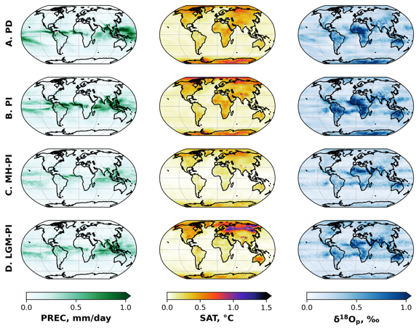
Figure S1. Spatial patters in PPE spread of precipitation (PREC), surface air temperature (SAT), 𝛿¹⁸O_{p} using the balanced runs. A total of 19 simulations of different cloud and convective parameterizations were used to assess spatial variability (i.e., standard deviation) for each time period (a-d).

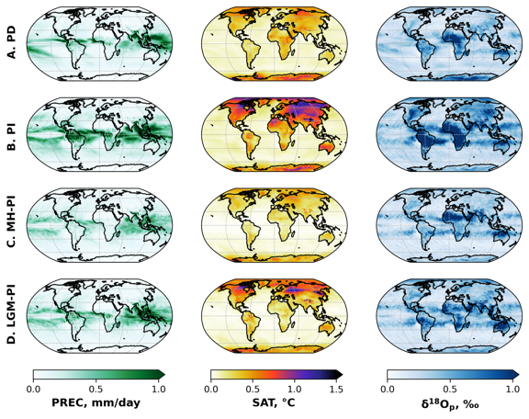
Figure S2. Same as Figure S2 but using the unbalanced runs.
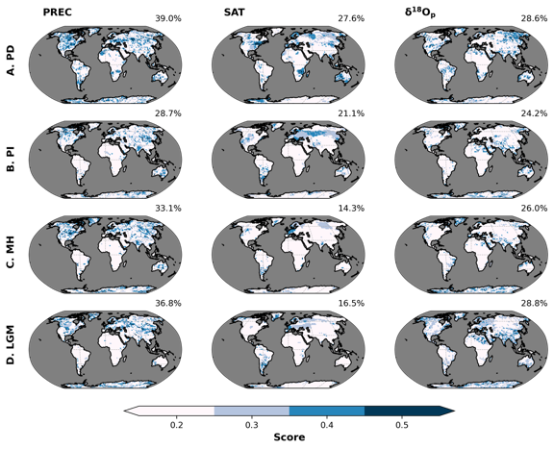 Figure S3. Spatial patterns in sensitivity of precipitation (PREC), surface air temperature (SAT), and 𝛿¹⁸O_{p} to perturbed cloud and convective parameters for different time periods (a-d) using the unbalanced runs. Shading represents the scores or the fraction of the total number of ensembles members per grid box showing significant difference from the PPE mean. The higher the score, the more sensitive a location is to parameter changes. The oceans are masked to highlight changes on land for these atmosphere-only simulations. Percentages reported at the top right of each panel indicate the fraction of land surface (using PD configuration to facilitate comparison across time periods) having a score greater than 0.2.

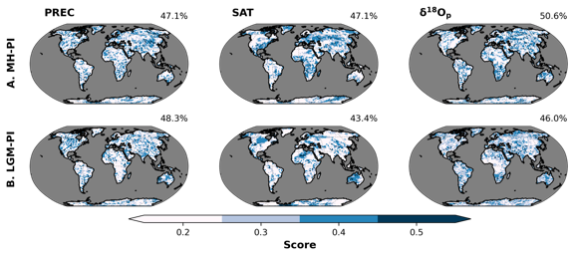
Figure S4. Same as Figure S4 but for (a) MH-PI and (b) LGM-PI anomalies using unbalanced runs.

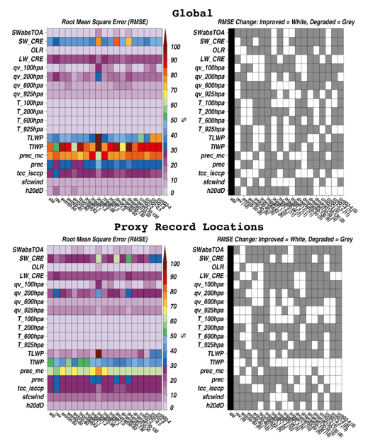

Figure S5. Comparison of model with satellite data using unbalanced runs. (top left) Global model-satellite RMSE scores for absorbed shortwave (SW) radiation at the top of the atmosphere (SWabsTOA), SW cloud radiative effects (SW_CRE), outgoing longwave radiation (OLR), longwave (LW)_CRE, water vapor (qv) and temperature (T) at various levels, total (cloud+precipitating) liquid and ice water paths (TLWP, TIWP), convective and total precipitation (prec_mc, prec), ISCCP satellite cloud cover (tcc_isccp), 10-meter surface wind speeds (sfcwind) and 𝛿D. (top right) binary white-gray shading indicating if RMSE scores improved for a given ensemble member relative to std, with numbers in parenthesis indicating the number of metrics exhibiting improvement. (bottom row) As in the top row, but only for model and satellite grid boxes co-located with paleo-proxy sites.
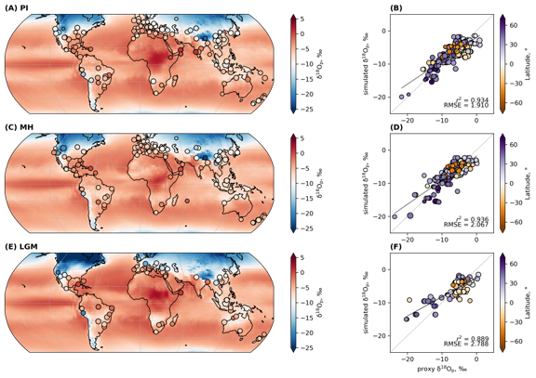
Figure S6-a. Comparison of simulated 𝛿¹⁸O_{p} with speleothem 𝛿¹⁸O for the standard (std) parameterization. Global distribution of simulated 𝛿¹⁸O_{p} (background) and speleothem 𝛿¹⁸O, converted to their drip water equivalents (see Section 2) under (a) PI (n = 257), (c) MH (n = 195) and (e) LGM (n = 81) conditions. Scatterplots between simulated and proxy 𝛿¹⁸O_{p} for the respective time periods (b, d, f). Black lines represent the weighted least squares regression fits to data points while the gray dashed lines represent the 1:1 line. Weighted r² is reported in the lower right corner of each scatterplot. The size of the circles in all plots are scaled to the sensitivity scores derived in Figure 1 of the main text.

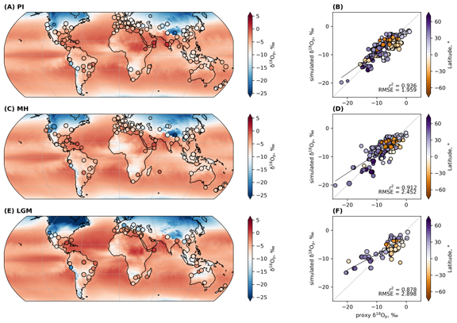
Figure S6-b. Same as Figure S2-a but for the rain re-evaporation above the cloud base (rev) parameter change change.

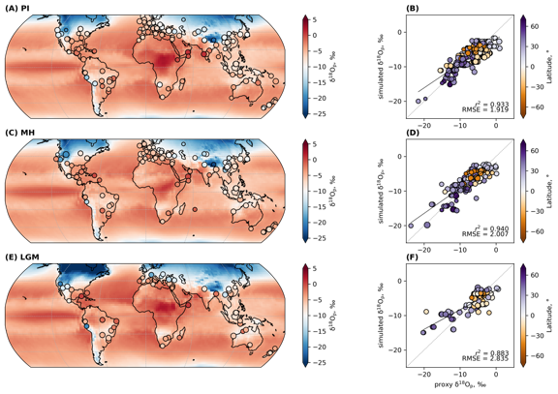
Figure S6-c. Same as Figure S6-a but for the entrainment rate for plume (entr50-50) parameter change.

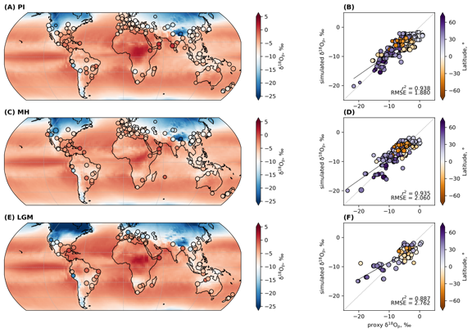
Figure S6-d. Same as Figure S6-a but for the entrainment rate for plume (entr60-40) parameter change.

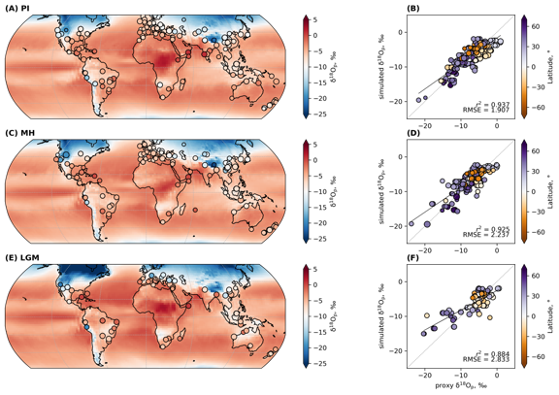
Figure S6-e. Same as Figure S6-a but for the entrainment rate for plume (entr20-80) parameter change.

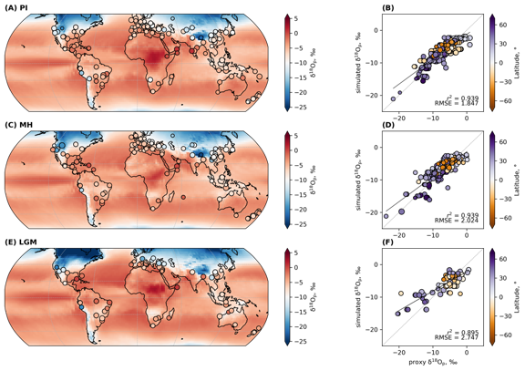
Figure S2-f. Same as Figure S6-a but for the convection adjustment time (tconvadjX2) parameter change.

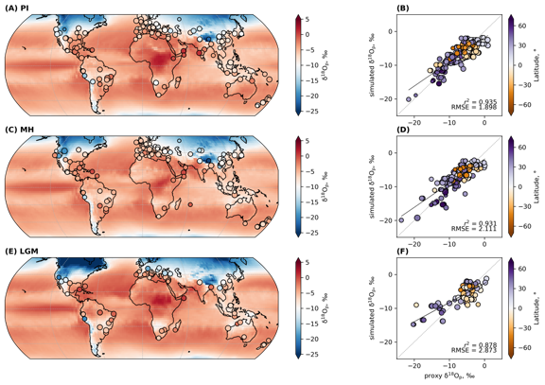
Figure S6-g. Same as Figure S6-a but for the convective trigger (trigger1.1) parameter change.

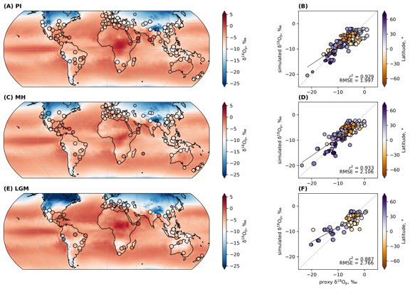
Figure S6-h. Same as Figure S6-a but for the convective trigger (trigger1.2) parameter change.

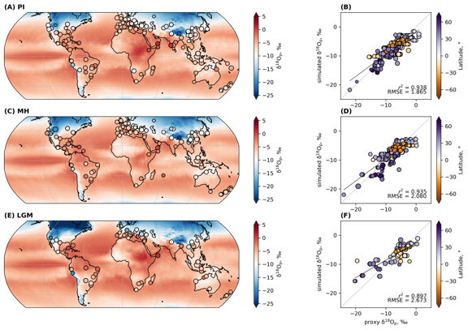
Figure S6-i. Same as Figure S6-a but for the convective trigger (trigger0.99) parameter change.

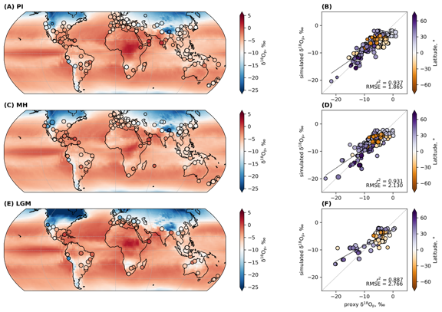
Figure S6-j. Same as Figure S6-a but for the convective trigger (trigger1.3) parameter change.
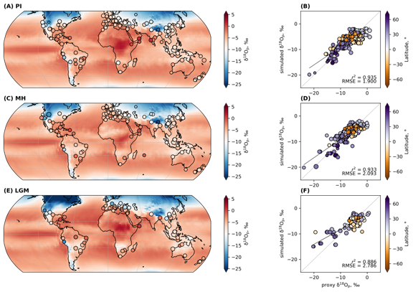
Figure S6-k. Same as Figure S6-a but for the convective trigger (trigger1.0) parameter change.

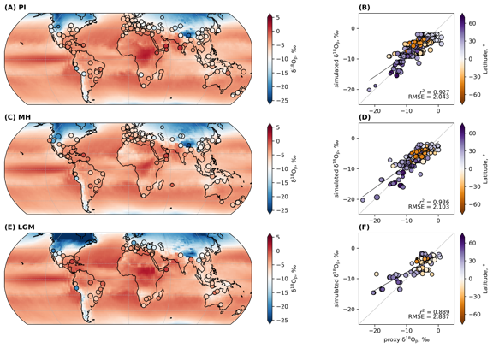
Figure S6-l. Same as Figure S6-a but for the cloud droplet radius (droprad50-50) parameter change.

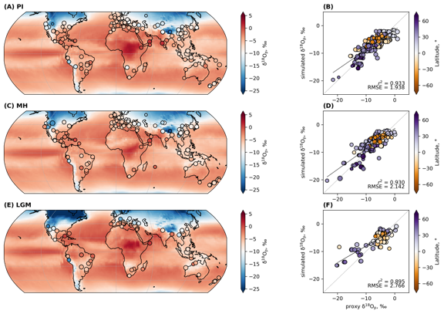
Figure S6-m. Same as Figure S6-a but for the cloud droplet radius (droprad50-130) parameter change.

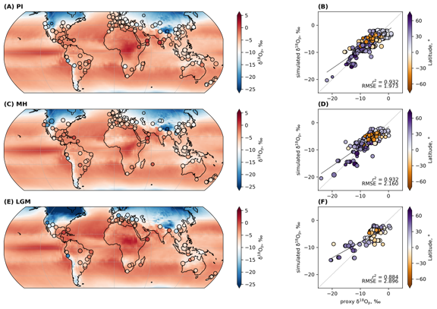
Figure S6-n. Same as Figure S6-a but for the cloud droplet radius (droprad130-50) parameter change.

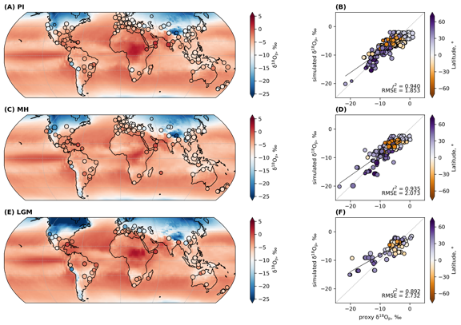
Figure S6-o. Same as Figure S6-a but for the cloud droplet radius (droprad30-130) parameter change.

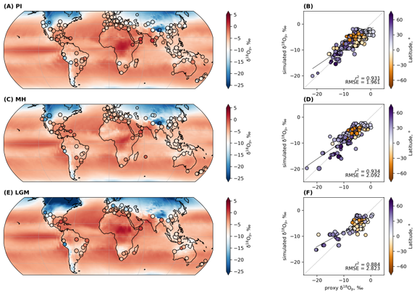
Figure S6-p. Same as Figure S6-a but for the critical cloud water content (critQ2-2) parameter change.

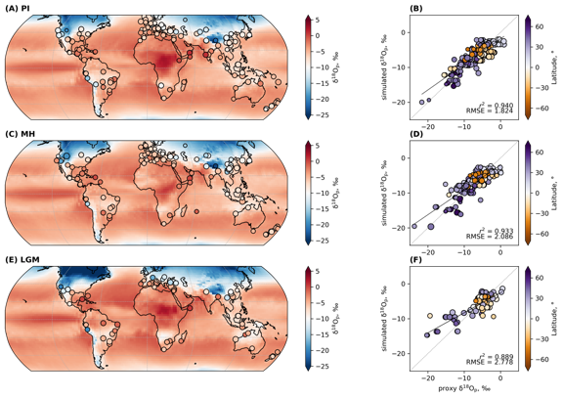
Figure S6-q. Same as Figure S6-a but for the critical cloud water content (critQ1-0.5) parameter change.

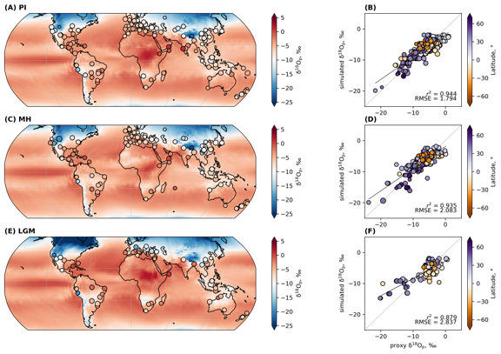
Figure S6-r. Same as Figure S6-a but for the critical cloud water content (critQ1-4) parameter change.

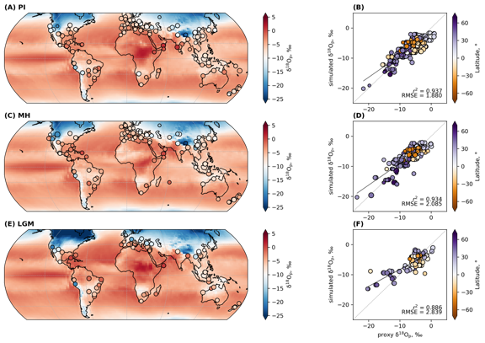
Figure S6-s. Same as Figure S6-a but for the critical cloud water content (critQ2-4) parameter change.

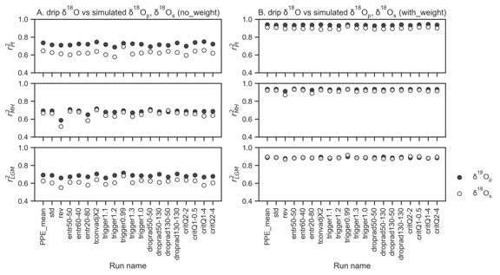

Figure S7. (a) Non-weighted vs (b) weighted r² values between simulated 𝛿¹⁸O_{p} and SISAL 𝛿¹⁸O for each time period. All speleothem 𝛿¹⁸O were converted to their drip water equivalent.

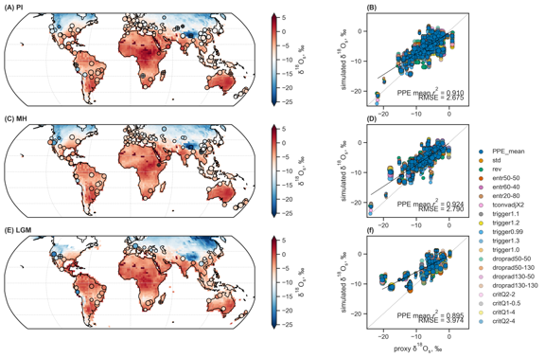
Figure S8. Comparison of simulated 𝛿¹⁸O_{s} with speleothem 𝛿¹⁸O. Global distribution of simulated 𝛿¹⁸O_{s} (background) and speleothem 𝛿¹⁸O, converted to their drip water equivalents (See Materials and Methods) under (a) PI, (c) MH and (e) LGM conditions. Background and extracted data points are from the PPE mean. SISAL 𝛿¹⁸O points with standard deviation greater than 1 are marked with ‘+’. Scatterplots between simulated and proxy 𝛿¹⁸O_{s} for the respective time periods (b, d, f). PPE members are differentiated by color. Black lines represent the weighted least squares regression fits to data points while the gray dashed lines represent the 1:1 line. Weighted r² for the PPE mean is reported in the lower right corner of each scatterplot. The size of the circles in all plots are scaled to the sensitivity scores derived for each 𝛿¹⁸O_{s} simulation.

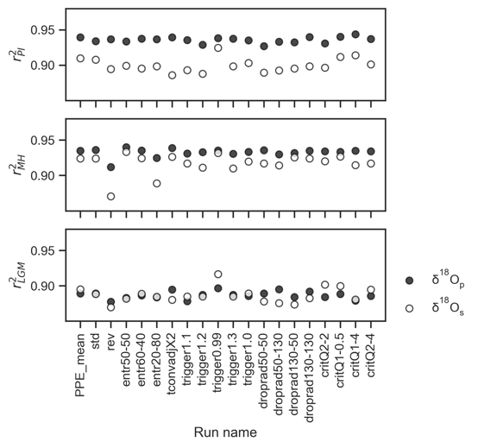
Figure S9. Weighted r² values between simulated 𝛿¹⁸O_{p} (filled circles; n_{PI} = 257, n_{MH} = 195, n_{LGM} = 81) and 𝛿¹⁸O_{s} (hollow circles: n_{PI} = 248, n_{MH} = 186, n_{LGM} = 77) and SISAL 𝛿¹⁸O for each time period. All speleothem 𝛿¹⁸O were converted to their drip water equivalent.

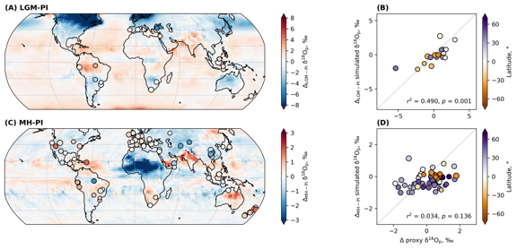
Figure S10-a. Comparison of simulated 𝛿¹⁸O_{p} anomalies (background) with speleothem 𝛿¹⁸O (filled circles) for each time slices: (a) LGM-PI (n = 17), (c) MH-PI (n = 79) for the standard (std) parameter. Background and extracted data points are from the PPE mean. Scatterplots between simulated and proxy 𝛿¹⁸O_{p} for the respective time periods (d, d). PPE members are differentiated by color. Gray dashed lines represent the 1:1 line. Weighted r² for the PPE mean is reported in the lower right corner of each scatterplot. The size of the circles in all plots are scaled to the sensitivity scores derived in Figure 2 of the main text.

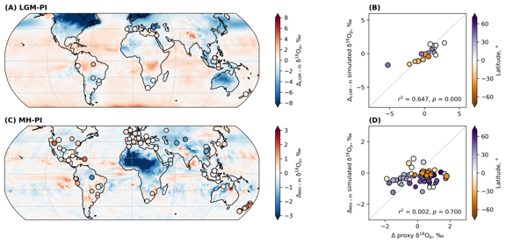
Figure S10-b. Same as Figure S10-a but for the rain re-evaporation above the cloud base (rev) parameter change.

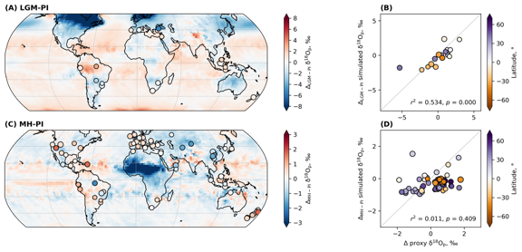
Figure S10-c. Same as Figure S10-a but for the entrainment rate for plume (entr50-50) parameter change.

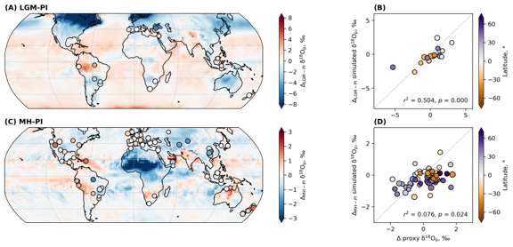
Figure S10-d. Same as Figure S10-a but for the entrainment rate for plume (entr60-40) parameter change.

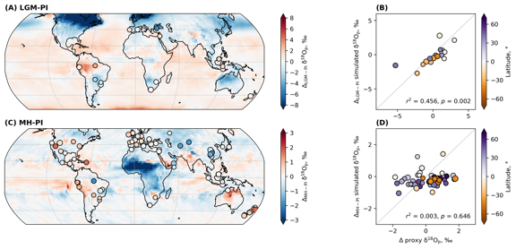
Figure S10-e. Same as Figure S10-a but for the entrainment rate for plume (entr20-80) parameter change.

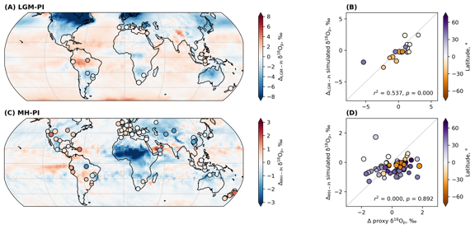
Figure S10-f. Same as Figure S10-a but for the convection adjustment time (tconvadjX2) parameter change.

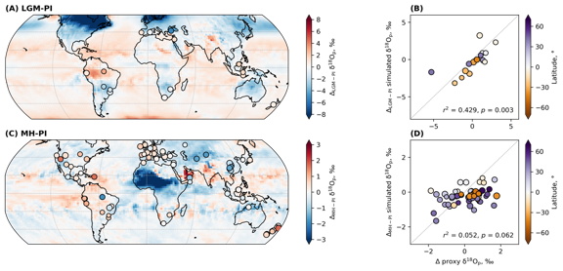
Figure S10-g. Same as Figure S10-a but for the convective trigger (trigger1.1) parameter change.

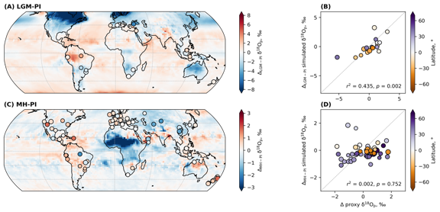
Figure S10-h. Same as Figure S10-a but for the convective trigger (trigger1.2) parameter change.

Figure S10-i. Same as Figure S10-a but for the convective trigger (trigger0.99) parameter change.

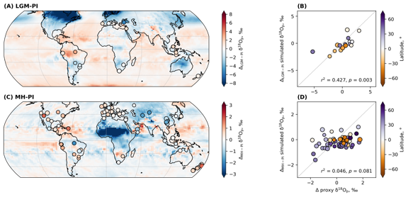
Figure S10-j. Same as Figure S10-a but for the convective trigger (trigger1.3) parameter change.

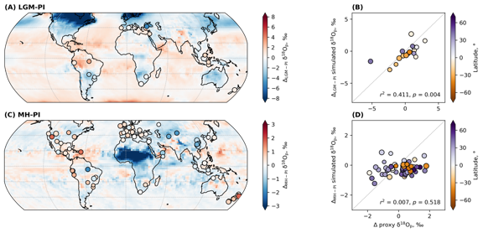
Figure S10-k. Same as Figure S10-a but for the convective trigger (trigger1.0) parameter change.

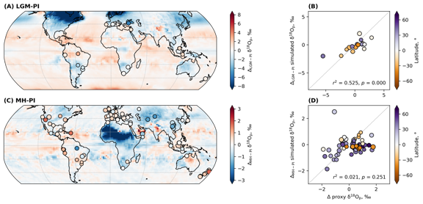
Figure S10-l. Same as Figure S10-a but for the cloud droplet radius (droprad50-50) parameter change.

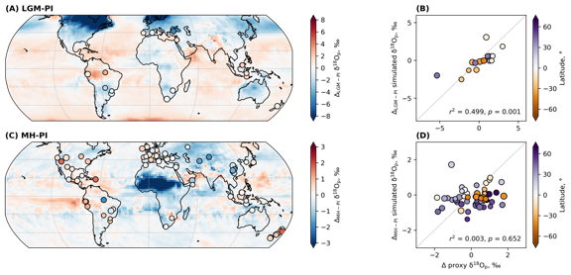
Figure S10-m. Same as Figure S10-a but for the cloud droplet radius (droprad50-130) parameter change.

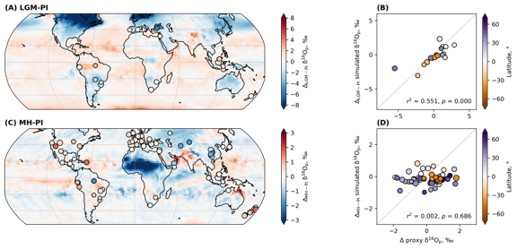
Figure S10-n. Same as Figure S10-a but for the cloud droplet radius (droprad130-50) parameter change.

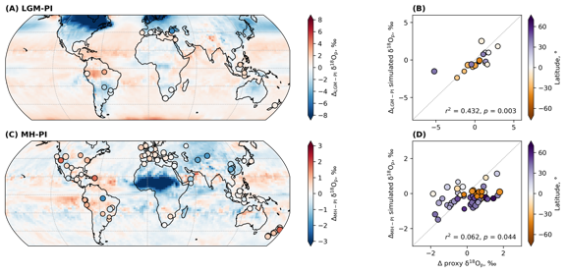
Figure S10-o. Same as Figure S10-a but for the cloud droplet radius (droprad130-130) parameter change.

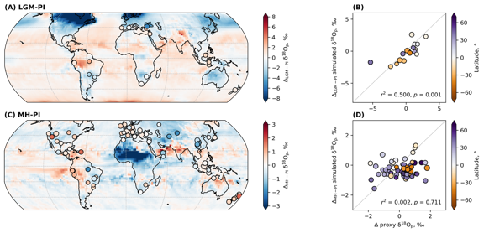
Figure S10-p. Same as Figure S10-a but for the critical cloud water content (critQ2-2) parameter change.

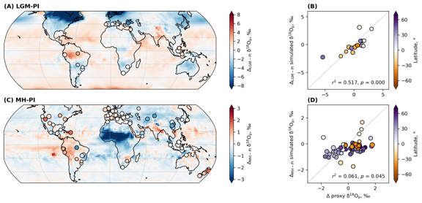
Figure S10-q. Same as Figure S10-a but for the critical cloud water content (critQ1-0.5) parameter change.

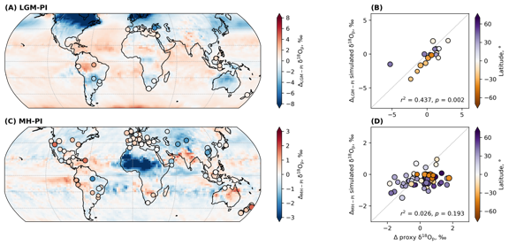
Figure S10-r. Same as Figure S10-a but for the critical cloud water content (critQ1-4) parameter change.

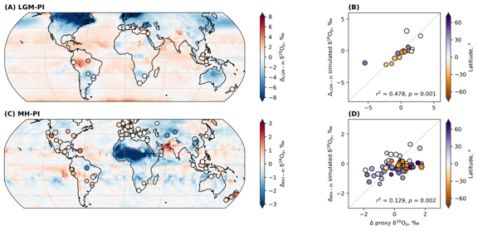
Figure S10-s. Same as Figure S10-a but for the critical cloud water content (critQ2-4) parameter change.

