IAC-22-B3.1.TBD

Artemis Lunar Mission Availability & Design

Nujoud Fahoum Merancyª, Michele Digiuseppe^{b}, Dr. George Nelsonª

ª Exploration Mission Planning Office, National Aeronautics and Space Administration (NASA) Johnson Space Center, 2101 NASA Parkway, Houston, Texas, USA 77058
^{b} Advanced Exploration Systems, National Aeronautics and Space Administration (NASA) Johnson Space Center, 2101 NASA Parkway, Houston, Texas, USA 77058

Abstract

The National Aeronautics and Space Administration’s (NASA) Artemis Program is leading international space exploration in a return to human lunar missions. The mission design underpinning this program is a critical aspect in the integration of the multiple vehicles, processes, and capabilities to execute the most demanding human spaceflight missions to date. Frequently mission design is characterized solely by its trajectory and the associated delta-velocity to achieve the end-to-end mission on a single day of flight. However, in practical terms for spaceflight missions, actual performance must characterize the translation delta-velocity demand, integrated power and thermal, crew day operations, commodities limitations, launch vehicle opportunities, and numerous additional factors across numerous launch day dependent variables. These factors together provide a unified set of mission design constraints that must all be met in order to execute a fully integrated mission. The frequency of achieving all of the mission design constraints is thus characterized as mission availability. The mission availability reflects the number of opportunities in any given period (month, year, etc.) for which an end-to-end mission could be launched. Ensuring adequate mission availability for the Artemis Program is necessary to support long term viability and sustainability of human lunar exploration. This paper will characterize the driving factors in the Artemis mission availability including vehicle specific effects from the Space Launch System (SLS), Orion Multi-Purpose Crew Vehicle, Gateway, Human Landing System (HLS) and other contributing projects. This analysis will also summarize the relevant factors that future vehicles and projects should consider for the integration and expansion of exploration capabilities with the Artemis Program.
Keywords: (Artemis, Lunar, Architecture, Mission Planning, Mission Availability)

Acronyms/Abbreviations
CPL Co-manifest Payload
EUS Exploration Upper Stage
EVA Extravehicular Activity
HLS Human Landing System
ICPS Interim Cryogenic Propulsive Stage
LEO Low Earth Orbit
NASA National Aeronautics and Space Administration
NRHO Near-Rectilinear Halo Orbit
SLS Space Launch System
TEI Trans-Earth Injection

- Introduction
The Artemis Program is leading international space exploration in a return to human lunar missions. The mission design and architecture underpinning this program is a critical aspect in the integration of the multiple vehicles, processes, and capabilities to execute the most demanding human spaceflight missions to date. While the rationale for competing architectures can be driven by many factors, the success of any architecture is determined by the resulting vehicles and capabilities when integrated together to form a complete mission. In measurable terms, the opportunity frequency at which that end-to-end mission can be accomplished is one significant measure of architecture viability. This opportunity frequency for Artemis is referred to as Mission Availability.
Mission Availability is the combined effect of individual constraints, capabilities, and performance of each individual vehicle or contributing program and is catalogued by the number and frequency of viable launch days in a calendar year. Ensuring an adequate number and/or distribution of launch opportunities as a measure of integrated performance will provide an on-going metric of architecture success. A mission opportunity can only be considered viable if it meets all disparate constraints across vehicles for the entirety of the mission (see Fig 1.).
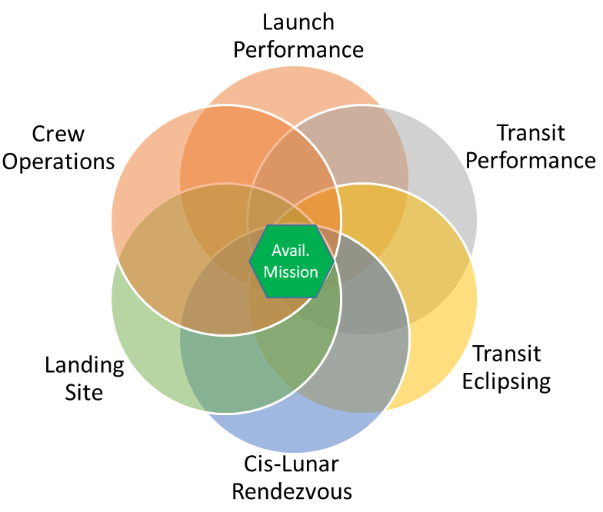
Fig. 1. Example diagram illustrating availability at the intersection of all constraints.

Often, constraints or performance characteristics experienced on one vehicle can have ripple effects on the architecture necessitating continuous integrated mission design efforts. Mitigation of constraints or performance limitations regularly require shared solutions across multiple programs through iterative mission design or vehicle modifications. Constraints and limitations can either be correlated or uncorrelated. It is the combination of multiple constraints that result in the total mission availability. After a brief summary of current Artemis mission design, this paper will discuss several notable contributions to Mission Availability in the Artemis architecture.

2. Artemis Architecture
The key characteristics of Artemis planning are to support extensible capabilities for sustained lunar and deep space exploration. This architecture utilizes a distributed launch approach for several vehicles performing different functional roles in the architecture [1]. These vehicles principally include the Space Launch System (SLS), Orion Multi-Purpose Crew Vehicle, Gateway, and Human Landing System (HLS).
SLS and Orion are responsible for the crew transport to cis-lunar space and return to Earth. SLS includes two significant variants of Block 1 and Block 1B where Block 1B upgrades the Earth departure stage to the Exploration Upper Stage. Gateway provides an orbital platform for extended cis-lunar operations in an elliptical polar orbit about the moon called a Near-Rectilinear Halo Orbit (NRHO). Lastly, the HLS provides transport from NRHO to the lunar South Pole surface. Additional elements on the surface will extend the mission capabilities in the future; however, they are excluded from this discussion to focus on the in-space mission design portions.
For either launch vehicle configuration, the mission plan begins with a launch from the Kennedy Space Center using the Exploration Ground Systems Program into a Low Earth Orbit (LEO). From LEO, the SLS upper stage will complete the Earth departure and send Orion to a lunar intercept. Orion will perform targeting burns to rendezvous with the Gateway and/or HLS pre-staged and awaiting in NRHO. During transit, Orion supports the crew with life support resources and is powered by solar arrays for the primary energy source.
Following Orion docking to Gateway-HLS the Gateway and HLS become the primary crewed elements and life support system. Two astronauts will transfer to the HLS and at the appropriate departure point in NRHO descend to a Low Lunar Orbit and then perform a powered descent to the surface. During the lunar sortie, 2 crew will remain in the Gateway-Orion stack. The mission proceeds with a 6.5-day surface stay, including multiple Extra-Vehicular Activity (EVA) and science operations. At the conclusion of the surface stay, the astronauts ascend in HLS to depart the moon’s surface and return to the NRHO performing a lunar orbit rendezvous with the Gateway.
At the optimal Earth departure point, the crew will have previously ingressed Orion and will undock from Gateway to begin the journey home. Orion will perform the lunar flyby burn and trans-earth injection (TEI) targeting a splashdown off in the Pacific Ocean near the coast of San Diego, California. This return time is minimized as a direct return to protect for potential systems faults that could have occurred earlier in the mission or after departing Gateway. Upon safe touchdown in the ocean, US Navy and NASA recovery forces will have been pre-staged awaiting crew extraction and return to land.
This sequence of vehicle operations and events together comprise the mission design which requires integration and coordination across all supporting programs (see Fig. 2).

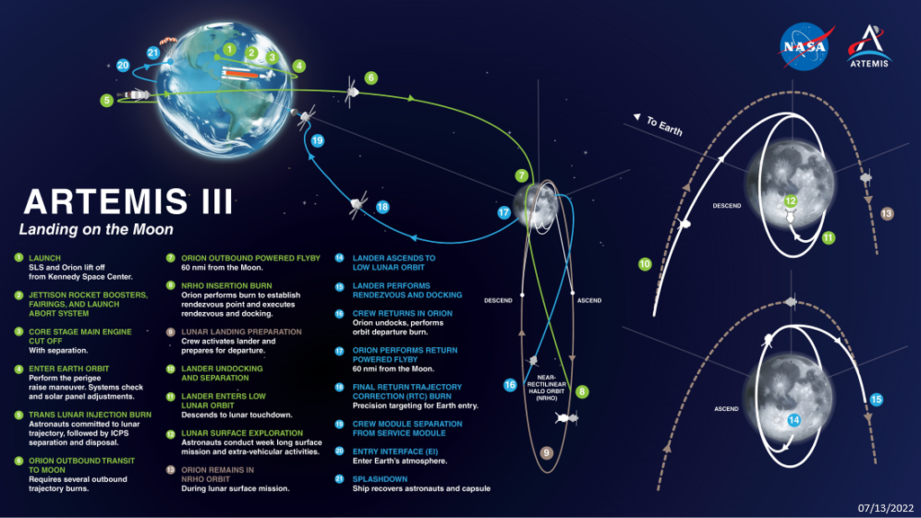
Figure 2. Artemis mission design architecture utilizing the Gateway NRHO orbit.

3. Key Availability Contributions
Typical mission design efforts during early architecture development focus on key performance metrics like delta-velocity and propulsive needs. Systems are then sized for structure and support systems, such as, power and thermal. However, the transition from study to flight passes through a number of real-world design challenges that fill out that actual capabilities and identify operational constraints.
Included here are high level discussions of some of the primary drivers to the mission design of Artemis. These drivers have been identified through the wider NASA and support contractor efforts through Artemis I development and initial planning for subsequent missions. This list is representative of constraints that must be considered in the mission design but is by no means a complete and exhaustive list of all constraints. Where possible, variations in mission design and techniques used to mitigate or reduce the impact of constraint will be presented.
For the purposes of this paper, the discussion of mission availability is limited to the crewed mission portion of Artemis and does not reflect challenges in cargo or pre-deployed elements which may have similar considerations.

3.1 Launch Performance
One of the most obvious and significant factors in any mission design is the launch vehicle itself. Artemis utilization of the SLS system must also account for differences in the Block 1 and Block 1B configurations. These SLS variants significantly differ in the upper stage element where the Block 1 Interim Cryogenic Propulsion Stage (ICPS) will be used for the first three missions and the greater capabilities of the Exploration Upper Stage (EUS) will be available beginning on Artemis IV and beyond.

3.1.1 SLS Block 1
During SLS B1 missions, the mission design incorporates staging from an elliptical Earth parking orbit to maximize Core Stage contributions to the energy transfer. While this maximization of performance enables large payload lunar transfer, this elliptical orbit dominates the portion of the lunar month for which launches are available (see Figure 3). Actual availability can range from a few days up to two weeks a month depending on the payload mass, target transfer orbit, and other factors. In particular, this launch configuration illustrates the key relationship of the launch site at the Kennedy Space Center to the lunar orbital position.

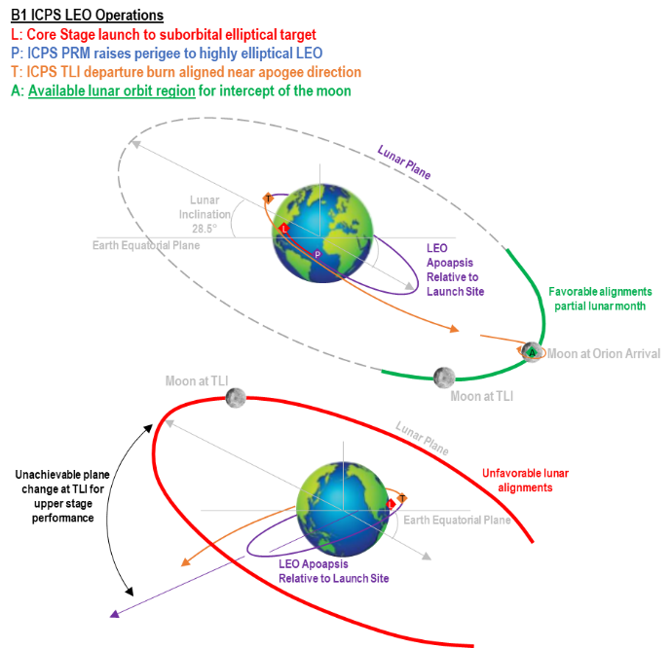
Fig. 3: SLS Block 1 elliptical Earth parking orbit availability alignment with Lunar position at launch

3.1.2 SLS Block 1B
For Artemis IV and beyond, the addition of the EUS provides two major capability upgrades, the Co-Manifest Payload (CPL) capability to launch with Orion and a mission design change to utilize a circular Earth parking orbit (see Figure 4). This circular Earth parking orbit is targeted by the Core Stage on ascent and depleted with the higher payload masses. From this parking orbit, the EUS performance provides the Trans-Lunar Injection capability for Orion with the CPL. In general, the capabilities of the EUS enable near continuous launch performance for the integrated stack.

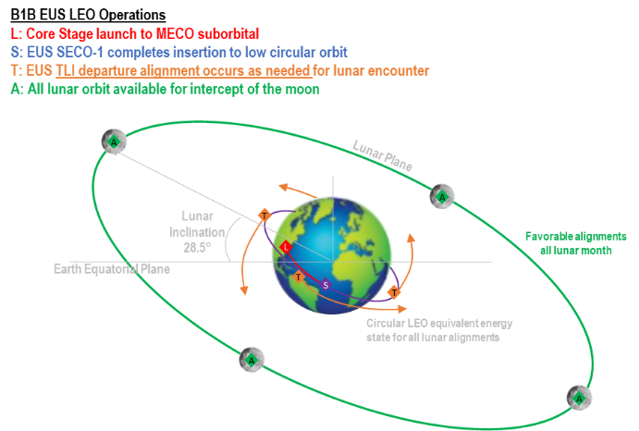
Fig. 4: SLS Block 1B circular Earth parking orbit is largely indifferent to Lunar relative position at launch.

3.2 Transit Performance
While the SLS B1 upper stage dominates launch availability for early Artemis missions, later missions with the SLS B1B EUS realize significant effect from the mass of the CPL Orion is required to transfer (see Figure 4). Once EUS has completed the Trans-Lunar Injection, Orion propulsive capabilities are utilized for NRHO insertion, rendezvous & docking, and crew departure and Earth return. The addition of CPL mass for NRHO insertion and rendezvous & docking operations is additional demand on the Orion translational capability.

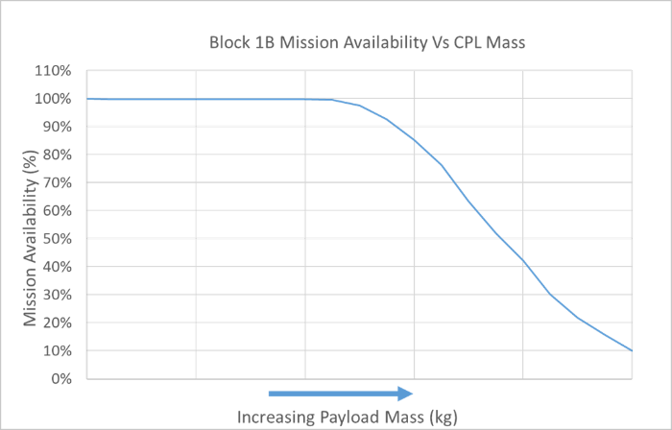
Fig. 4: Mission availability computed as a function of increasing CPL mass.

As CPL mass increases, the propellant tanks on Orion remain with fixed capabilities. By simple first order mechanics, it therefore follows that a finite limit of capability exists to complete equivalent delta-velocity of insertion maneuvers. Actual delta-V of insertion varies over the lunar month and year and thus availability is affected by both the mass and the orbit insertion variation, thus resulting in availability that can be converted to a percent of initial launches. Ultimately, any available mission and CPL mass may be flown; however, the probability of launch and mission success becomes a risk factor to the program. Missions with high CPL mass would have fewer available launch opportunities and therefore be more susceptible to weather or secondary issues precluding launch during any given launch period.

3.3 Transit Eclipsing
Vehicle sizing for power and thermal performance are typically driven by the insolation and eclipsing cycles of the destination orbit. For example, craft in either Low Earth or Low Lunar orbits have approximately 60 minutes of sunlight and 30 minutes of shadow per orbit. For solar array and radiator based power and thermal, batteries and radiators would be sized accordingly as is the case for Orion. However, transit conditions from the Earth to the Moon or during phasing maneuvers around the moon can induce shadows on the order of multiple hours (see Figure 5).

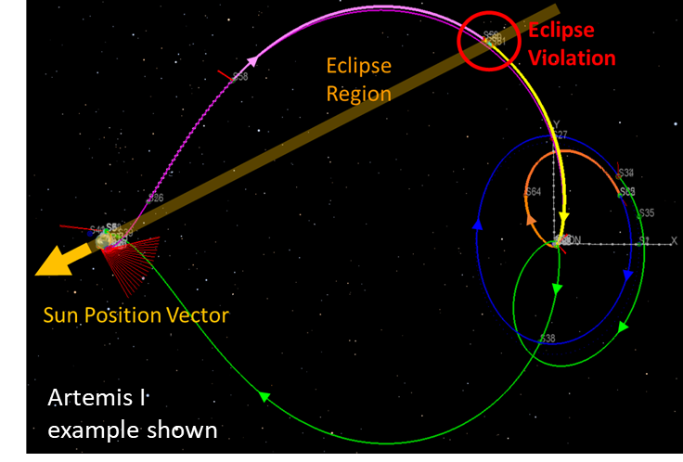
Fig. 5: Example of multiple hour eclipse during Earth-Moon transit as analysed from representative Artemis I mission profile.

These types of eclipse events predictably correspond to phases of the lunar month and solar season. However, it is impractical to increase vehicle battery mass for single events in transit. As a result, these particular launch days are excluded from consideration based on the vehicle’s actual capability.
Mission designers have utilized several techniques to reduce the impact of the unavailable launch days through tailoring of the flight trajectory. Given the known duration limits of eclipsing, techniques such as variations in inclination or departure angles are applied to avoid long shadow events. This type of mitigation has been highly successful when applied for Artemis I; however, is only possible to the limits of available propellant performance margin. These types of design trades are emblematic of the need for iterative mission design.

3.4 Cis-Lunar Rendezvous
A significant feature of the Artemis architecture, as compared to Apollo, is distributed launch sequence of vehicles given the performance demand of Lunar South Pole missions. Thus, cis-lunar rendezvous is a key constraint when planning launch day and times. With the near seven-day orbital period of NRHO, vehicle rendezvous must be timed for the arriving vehicle to intercept the pre-staged vehicle, such as Gateway or the HLS. Ideal orbit insertion cost occurs for arrival during NRHO apolune approach which also supports near-linear docking dynamics (see fig 6).

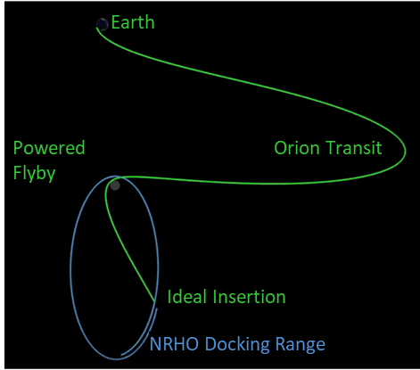
Fig. 6: Orion transit and NRHO insertion as viewed in Earth-Moon Rotating Reference Frame.

Using fixed Orion transit conditions under this scenario, it would allow rendezvous with a vehicle in NRHO once every seven days. This type of constraint was identified very early in the mission design process and would have been an impediment to sustaining mission success. The mitigation for this constraint is to allow variable duration in the transit such that multiple consecutive launch days can target similar arrival times in NRHO to setup rendezvous. The range of NRHO insertion is also varied to allow later arrival intercepts for rendezvous during apolune approach for additional flexibility (see figure 7). As a result, this variation in transit times and arrivals provide a significant improvement to the mission opportunities. The limits of this technique are constrained by available crew consumables carried by Orion and allocated to this phase of the mission.

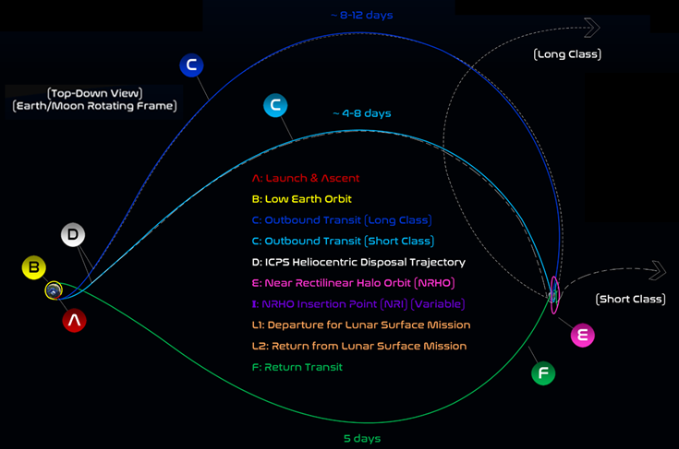
Fig. 7: Variable Short-Class and Long-Class Orion transit durations illustrated by the above top down Earth-Moon Rotating Reference Frame mission diagram.

3.5 Landing Site
A key objective of the Artemis campaign is to achieve landing and exploration on the Moon’s South Pole. While any lunar landing is a considerable challenge, several environmental factors associated with the South Pole affect mission availability. Sunlight, topographical constraints, and communications contribute to overall mission availability and suitability in selecting a site.

3.5.1 Site Topographical Constraints
To screen for temporal constraints at the landing site, the initial locations must be identified for physical characteristics to support safe landing. In particular, the ground slope, size of the area, frequency and scale of geology like boulders in the region, and quality of known mapping data must be considered. This initial set of constraints may in part be Human Landing System vehicle specific (e.g. ground slope) but in general the areas of greatest quality occur on peaks and ridges where terrain is relatively flat. In addition, these locations are typically most associated with the best lighting as discussed in the following section.
Using basic site screening, evaluating for safety and freedom from hazards, these sites can be assessed against the constraints related to temporal variations. Additional considerations of science value and relative location to areas of scientific of interest will factor into the final site selection when the integrated availability has been assessed. Early assessments of potential Artemis landing sites have been discussed in the Lunar Exploration Analysis Group as recently as August 2022. [4]

3.5.2 Solar Lighting Conditions
With respect to sunlight, the general constraint is that lighting must be available for the duration of the mission inclusive of descent, surface operations, and ascent to allow adequate visibility, thermal, and/or power conditions. The sunlight varies with both lunar month rotation and across seasonal variations due to the axial tilt relative to the sun. Similar to Earth, the Moon’s South Pole ‘summer’ occurs in the months from October to March with some areas receiving near continuous light, in particular at higher elevations on peaks and crater ridges (see figure 8).

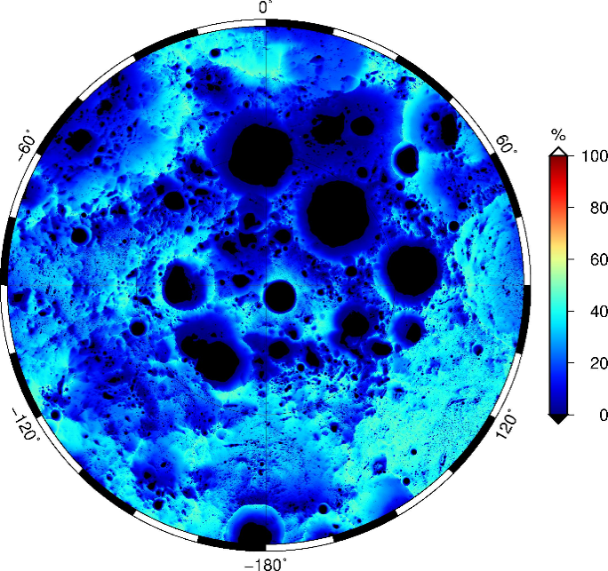
Fig. 8: Map of solar illumination, averaged over hourly timesteps spanning 18.6 years, for the south polar region for latitude 85S-90S. [1]

Additionally, the sun elevation above the horizon never exceeds ~6° and this oblique angle can cause significant local terrain variations and shadowing effects. The combined effects of lighting result in significant variations between even two adjacent touchdown sites and across regions (see figure 9).

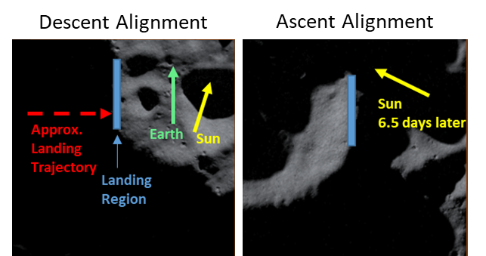
Fig. 9: Sunlight variations across representative region lunar site within single lunar sortie duration.

3.5.2 Earth Line-of-Sight
The other significant temporal condition for the Lunar South Pole reflects the need for vehicle communication to Earth. This communication path can be satisfied either through direct Earth Line-of-Sight in which the vehicle communicates to Earth based ground stations directly or through orbiting relay satellite assets. The solution utilized on a mission can have profound effects on the integrated availability.
If Earth direct line-of-sight is used, the effect on mission availability is highly specific to the landing site chosen. Areas nearest the pole experience the most significant constraints due to the libration (or wobble) of the Moon with respect to Earth. As latitude decreases in the Earth’s direction, line of sight approaches continuous coverage (see Figures 10 & 11). Given the location and libration of the moon, the effect is constraints of only 2-3 weeks per lunar month of landing site availability. Since a crewed mission requires communication throughout the surface mission, the impact to mission availability could be quite significant. As a result, considerations of mitigation for this constraint are highly desired.

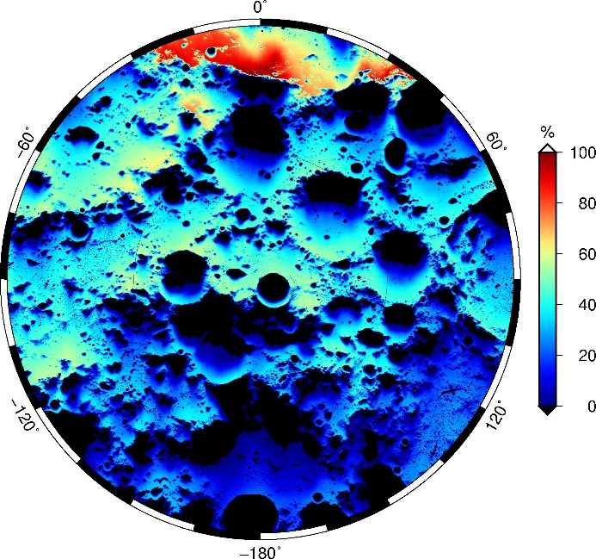
Fig. 10: Map of Earth visibility, averaged over hourly timesteps spanning 18.6 years, for the south polar region for latitude 85S-90S.

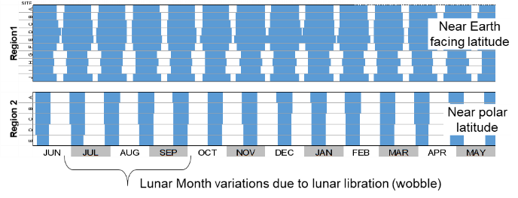
Fig. 11: Earth line of sight variations across regions and sites within regions reflect lunar rotational and local topographic effects.

If lunar orbiting relay satellites are available, the effect of the location and/or lunar libration has the potential to be fully mitigated. The NASA Space Communication and Navigation program is currently assessing lunar communication relay services. These services, once available, have the potential to fully mitigate the constraints on landing sites if sufficient relays and timing are applied [5]. Additionally, when deployed, the Gateway will provide relay coverage of the South Pole. From the Gateway’s staging in a Near-Rectilinear Halo Orbit, the vehicle will have a continuous view of Earth and a simultaneous view of the lunar South Pole for the majority of its orbit. This alignment will provide additional relay capability for either the lander or any other surface-based assets.

3.6 Crew Operations
Lastly, a major consideration in the mission design of Artemis is the support of the humans in the system. As the major objective of exploration is to safely deliver crews to the surface of the Moon and return them safely, the integration of the crew operations, timeline, and consumables are a significant factor in the success throughout the mission. Principally, the total quantity of consumables, such as food, water, and oxygen, present the duration bounds for the length of the mission and within different phases of operations.
For example, the total available commodities on Orion at launch can support 4 crew for up to 21 days. When considering the variable length of launch to the outbound arrival at NRHO added to the duration of the return trip, these present the maximum length for mission design. Further, the system must account for potential failure modes and abort and additional deductions in the timeline must be taken to protect for these situations. Crew consumables are tracked and allocated across all vehicles in the architecture to ensure integrated end-to-end mission design success.
Other types of human-in-the-loop mission design consideration include crew activity schedules. Significant burns and events must be planned within available crew workdays and ensure appropriate time for other activities, such as meals and sleep schedules. For example, the timeline of operations and docked period of Orion with HLS and/or the Gateway in NRHO prior to the lander descent to the surface must support hatch opening, ingress, equipment transfer, and preparation needs. This type of minimum duration limits the rendezvous period and subsequently the integrated mission availability.
Understanding these integrated crew timeline constraints is a key function of the Flight Operations support to integrated mission design. When identified in the iterative process, crew related activity constraints can at times be mitigated by adjusting burn timing, trajectories, and/or integrated operations.

4. Integrated Mission Availability
During Apollo, the final launch availability for any given landing site at the equatorial regions of the Moon was one day per month for the most challenging J-mission class [2]. The Apollo scheme chose a single day per month for the prime launch opportunity and overall mission availability in subsequent months varied time in space and descent techniques to provide two days per month. As demonstrated, this supported a successful series of Apollo missions; however, reflects the complex and challenging efforts required to achieve lunar exploration missions.
From the above discussion of Artemis mission planning constraints, the initial analysis for a Artemis mission availability will be quite challenging as is expected for any lunar exploration mission. Teams are currently working across the enterprise to ensure the overall success of Artemis by ensuring reliable and frequent enough launch opportunities to support the integrated mission and are optimistic to succeed. More importantly from these initial analyses, major drivers and sensitivities to availability have been identified. These sensitivities and mission design integration will be applied in the development effort moving forward, such as pursuit of the lunar comm relay, to mitigate constraints and optimize the mission design across programs.
The continued analysis and integration of availability is a significant forward work item to ensure a successful architecture. Mission Availability analysis is an iterative process through design and development. The integrated mission design is an underpinning capability to ensure the success of all contributing vehicles and will continue up to and including when actual flight operations begin. Lessons learned from the early development in Artemis programs will feed forward into future architecture upgrades, element definition, and sustaining missions. Further, these lessons should be considered for future vehicles, commercial enterprises, and/or other development programs as humanity expands a sustainable footprint to the lunar vicinity and beyond.

5. Conclusions
The Artemis Program represents a significant leap forward in the capability for lunar exploration. The achievability of the architecture and the integration across multiple vehicles and launches is ensured through constant integration efforts of the wider team. Each program and contributing vehicle will be constrained by the performance, capability, and demands of the system designs. Ensuring mission success requires the integration of all vehicles into a sufficient mission design. This success of this mission design and the overall program risk can be monitored through the integrated mission availability.
Current Artemis mission design has identified key drivers and sensitivities in vehicle contributions and has established a baseline availability. This availability reflects contributions from vehicle performance, environmental constrains such as solar eclipsing, rendezvous, landing sites, and crew constraints. The integration of constraints will be manged through the design and development in the mission design process. A significant factor in the mission design process is early identification and modification of mission designs to mitigate constraints as possible.
Overall, the analysis of mission design represents a key system engineering and integration function to ensure the success of Artemis.

References
[1] Nujoud F. Merancy, Michael Sarafin, Dr. Jennifer Gruber, Human Lunar Mission Design: Then and Now, IAC-19-B3.1.9, 70th International Astronautical Congress (IAC), Washington D.C., United States, 21-25 October 2019.
[2] Erwan Mazarico, Lunar Polar Illumination, https://pgda.gsfc.nasa.gov/products/69, (accessed 06.09.21).
[3] J. O. Cappellari Jr. (Editor), Where on the Moon? A Systems Engineering Problem, The Bell System Technical Journal. Vol 51. (May-June 1972).
[4] Lunar Exploration Analysis Group, https://www.lpi.usra.edu/leag/, (accessed 11 Aug 2022).
[5] Near Space Network (NSN) Services Draft Request for Proposals, https://sam.gov/opp/d559d6c4e47d4b269f87b55313a3e2ed/view, 4 Aug 2022 (accessed 9 Aug 2022).

