A Theoretical Model of Static and Dynamic Field-of-View (FOV) using NASA’s Neutral Buoyancy Laboratory (NBL)
Harry L. Litaker, Jr and Robert L. Howard Jr.
¹Leidos Incorporated, Houston, TX, 77598, United States of America
²NASA Johnson Space Center, Houston, TX, 77058, United States of America

Nathan R. Moore
³NASA Johnson Space Center, Houston, TX, 77058, United States of America
Developing an objective field-of-view methodology for studying vehicle window placement has been somewhat difficult. It is not surprising that considerable effort has been directed at specific problems of visibility from vehicles. Aeronautical design engineers know when designing an aircraft cockpit, the pilot must have an adequate view for approaching and landing on an airfield. However, compromise between the ergonomic preference for the largest possible viewing envelope and the practicalities of arranging a structure that is lightweight and strong will always plague the cockpit’s transparent area’s size and shape. The human’s visual sense, when operating any kind of vehicle, is the main source of the vast majority of information needed to drive or fly safely. However, vehicle design can affect a driver’s visual performance for satisfying their need for information. For any vehicle, be it an automobile or a spacecraft, the visibility quantity is the sum total of the visual access to the environment as defined by the window placement of that vehicle. The Alternate Multiple Mission Space Exploration Vehicle (AMMSEV) configuration is much like a large cargo truck where there is no direct visual access to the rear of the vehicle or the rear sides of the vehicle; thus, making the forward and side views of greater importance to the situational awareness of the crew if obstructions are creating visual issues. The National Aeronautics and Space Administration (NASA) tested a new theoretical model for Field-of-View (FOV) of spacecraft windows in NASA’s own Neutral Buoyancy Laboratory (NBL). The NBL is an essential tool for design, testing and development of future space exploration hardware for upcoming NASA operational missions. Using water, with its natural propensity for giving a human the perception of dynamic body motion under a weightless or partial gravity conditions, gives human factors investigators a vigorous space-like environment to study new methods of collecting dynamic field-of-view for future exploration vehicle designs.
- Nomenclature

AMMSEV | Alternate Multiple Mission Space Exploration Vehicle
ANSUR | Anthropometric Survey of US Army Personnel
Average conv | Average Convergence
cm | centimeters
CAD | Computer Aided Drawing
Front | FOV lines extend back into cabin from front view
Side | FOV lines extend back into cabin from vehicle’s side view
Top | FOV lines extend back into cabin from a top view
ft³ | cubic feet
m³ | cubic meter
D zone1 | Dead Zone 1
D zone2 | Dead Zone 2
D zone c | Dead Zones Combined
⁰ | Degree
D | Diopter
DCWU | Display and Control Window Unit
Down | Down Field-of-View Angle
EVA | Extravehicular Activity
EMU | Extravehicular Mobility Unit
ft | feet
FOV | Field-of-View
GEN 2A | Generation 2A Exploration Space Vehicle
HUT | Hard Upper Torso
Hor FOV | Horizontal Field-of-View
HITL | Human-in-the-Loop
ID | Internal Diameter
kg | kilograms
kl | kiloliters
Kpa | kilopascal
1/6-G | Lunar Gravity (G)
M | Mean
m | meters
0-G | Microgravity
ABF | NASA’s Anthropometry and Biomechanics Facility
HISR | NASA’s Human Integration System Requirements
JSC | NASA's Johnson Space Center
NBL | NASA's Neutral Buoyancy Laboratory
RATS | NASA's Research Analog Test Studies
NASA | National Aeronautics and Space Administration
OD | Outer Diameter
% | Percent
PVC | Polyvinyl Chloride Pipe
lbs. | pounds
psi | pounds per square inch
RHC | Rotational Hand Controller
n | Sample Size
cm² | square centimeters
in² | square inches
SD | Standard Deviation
SPTM | Suit Port Transfer Unit
∑ | Sum
THC | Translational Hand Controller
Ver FOV | Vertical Field-of-View

- Introduction
The purpose of the evaluation was to obtain investigative and preliminary human-in-the-loop (HITL) data to assist in shaping a theoretical model on field-of-view (FOV) using the prototype spacecraft called the Alternate Multiple Mission Space Exploration Vehicle (AMMSEV) while under lunar gravity (1/6-G) conditions. Two suit port window configurations were tested while subjects were in the Extravehicular Mobility Units (EMUs) space suits. The study objective was to evaluate the gross FOV of a suited crew member through the AMMSEV suit port window design concepts while obtaining data to begin to validate shaping a theoretical model for dynamic FOV parameters. The value of such underwater testing provides a unique simulated gravity environment in which a test subject was able to position his/her body in way that cannot be done in any other testing facility. Vehicle design engineers as well as human factors engineers gained valuable operational insight by using this test methodology during these early phases of design. This understanding will aid mission operations, vehicle and interior designers as to what is the most efficient way to perform tasks within that particular vehicle, where areas or sections should be located, and which configuration could be the most optimum for crew performance and efficiency. Taking these lessons learned investigators will integrate design modifications into the next generation vehicle.

- Background
Developing an objective field-of-view methodology for studying vehicle window placement has been somewhat difficult. It is not surprising that considerable effort has been directed at specific problems of visibility from vehicles. Aeronautical design engineers know when designing an aircraft cockpit, the pilot must have an adequate view for approaching and landing on an airfield. However, compromise between the ergonomic preference for the largest possible viewing envelope and the practicalities of arranging a structure that is lightweight and strong will always plague the cockpit’s transparent area’s size and shape; therefore, being a compromise between the aerodynamic and structural needs on one hand and those of the crew on the other [1] Skillen (2007) [2] stated that “visual fields are a measure of the area from which one is able to perceive visual signals, when one’s eyes are in a stationary position and looking straight ahead.” The human’s visual sense, when operating any kind of vehicle, is the main source of the vast majority of information needed to drive or fly safely. In fact, a study conducted by Gioia and Morphew (1968) [3] reported that 90% of information drivers need for safe driving is obtained visually. However, vehicle design can affect a driver’s visual performance for satisfying their need for information. Henderson, Smith, Burger and Stern (1984) [4] stated the vehicle must provide visual access to the driving environment “by permitting an adequate field of view (FOV) [since] a variety of vehicle, driver, and environmental characteristics influence both the quantity of FOV and the driver’s visual accessibility to their environment.” For any vehicle, be it an automobile or a spacecraft, the visibility quantity is the sum total of the visual access to the environment as defined by the window placement of that vehicle.
Being a natural driving factor of window placement, adequate FOV is required to afford the operator visual access to their external environment to facilitate optimal performance. The AMMSEV configuration is much like a large cargo truck where there is no direct visual access to the rear of the vehicle or the rear sides of the vehicle; thus, making the forward and side views of greater importance to the situational awareness of the crew if obstructions are creating visual issues. This also holds true for aircraft windows in respect to the effects of visual conformality on the pilot’s flight path control and hazard avoidance performance [5].

What is surprising is the limited attention paid to the issue of direct visibility (i.e., how well or much an operator can see or should see directly through the opening in the vehicle) [4]. An extensive literature review revealed little to no laboratory or field experiments which evaluated direct visual performance as a function of vehicle characteristics (i.e., window geometry or placement) affecting direct visibility within the confines of an automobile, aircraft or spacecraft, when developing a new vehicle design. With this in mind, investigators of this study have decided to pool together the methods used from the literature review and develop a theoretical methodology for objectively understanding the impacts of conceptual window designs and be able to quantifiably down select between design candidates.
- Study Design
- Subjects and Experience
Four test subjects, all male astronauts, were employed for this evaluation accomplished a field-of-view (FOV) test with two different window configurations. All had been certificated to use the EMU space suit. Suit technicians and the Neutral Buoyancy Laboratory’s (NBL) safety personnel were on hand to prep and assist all suited subjects during the study.
To fully understand the results from this study, several aspects must be taken in account. First, as stated previously, four astronauts, all male, consented to be test subjects for this evaluation. Three of the subjects had actual space flight Extra Vehicular Activity (EVA) experience and one has not experienced space flight currently. The total EVA flight time recorded by the subjects was 66 hours (M = 16.5, SD = 19.97). All subjects had extensive NBL experience with a total of 1,100 hours (M = 217, SD = 60.1) in the pool (Table 1).

Table 1. Male Test Subject EVA Flight Hours and NBL Experience Hours
Subject | EVA Flight Hours | NBL Experience Hours
S-1 | 45 | 450
S-2 | 15 | 250
S-3 | 6 | 300
S-4 | 0 | 100

Secondly, to aid in understanding how the interior configuration and volume can affect a suited crew member’s body posture and FOV, the subjects’ height was taken into consideration and their population percentile was calculated for stature (Table 2). Both subject weight and stature was self- reported with 1/6-G and percentile calculated off these recorded measurements.

Table 2. Male Test Subject Stature for the AMMSEV
Subject | Stature (in cm) | Stature (in inches) | *Percentile (%) ²
S-1 | 182.88 | 72 | 74
S-2 | 185.42 | 73 | 84
S-3 | 177.8 | 70 | 46
S-4 | 177.8 | 70 | 46
*Source: The 1988 Anthropometric Survey of US Army Personnel (ANSUR) (ref. Natick/TR-89/044) and NASA's Constellation Program Human-Systems Integration Requirements Document, CxP 70024, Rev. D. Percentile calculations made by the Space Life Sciences Habitability and Human Factors (SF3) Anthropometry and Biomechanics Facility (ABF).
NOTE #1: NASA’s Human Integration System Requirements (HSIR) and Orion stature requirement for the vehicle is based on both male and female. Minimal clothed stature range is 148.6cm (58.5 in) to 194.6cm (76.6 inches) according to HSIR Rev D, pg. 341.
²NOTE #2 The above percentile figures are for the male population only. The study does not address how small females would be affected, partially due to the fact that subjects were on an “as available” basis during previously planned NBL tests and were not selected to specifically to represent anthropometric diversity for this test, and partially due to the fact that there are no EMUs currently sized to accommodate small females.

Third, for weighing the crew out from a 0-G gravity environment to a 1/6-G environment, the NBL support divers added various amounts of weight to the leg and ankle of the subject. By using a simulated suit weight of 250 pounds (lbs.) (113.4 kilogram (kg)) plus the weight of the test subject divided by 6 (Subject = Subject Weight + 250 lbs. = Total; Total / 6 = Amount of weight to add for a 1/6-G weigh out) (e.g. S1 = 158 + 250 = 408; 408/6 = 68lbs) would give the appropriate weight to be added to the test subject beyond their neutral weight-out to calculate them for 1/6-G. Table 3 illustrates the calculated 1/6-G weight out for each test subject.

Table 3. Male Test Subject Weight Out For 1/6-G
Subject | Weight (lbs.) | Weight (kg) | Lunar Weight (lbs.) | Lunar Weight (kg)
S-1 | 195 | 88.45 | 74.5 | 33.79
S-2 | 165 | 74.82 | 69.2 | 31.39
S-3 | 158 | 71.67 | 68 | 30.84
S-4 | 180 | 81.65 | 71.7 | 32.52
- AMMSEV Test Equipment
The evaluation took place at Johnson Space Center’s (JSC) Sonny Carter Training Center in the Neutral Buoyancy Laboratory’s (NBL) pool. The pool is 202 feet (ft) long (60.96 meters (m)), 102 ft wide (31.1 m), 40 ft deep (12.2 m) and holds 6.2 million gallons (23,469.6 kiloliters) of water. The pool has standard filtering and chlorinating equipment (Figure 1) which recycles the water of the entire pool every 19 .6 hours. For this evaluation, several test articles were employed. First, two Extravehicular Mobility Units (EMUs) with planar Hard Upper Torsos (HUTs) were provided for each test run (Figure 2). The EMU’s environmental control system provides nitrox breathing air and water cooling through life-support umbilicals attached to the back of the EMU [6]. The suits were pressurized to 4.3 pounds per square inch (psi) (6.89 kilopascal (KPa)). Mockup suit umbilicals were also used and consist mainly of a garden hose pipe material with soft goods as coverings approximately 5 ft (1.52 m) in length. The AMMSEV vehicle mockup was constructed of ¼ inch (0.64 cm) thick fiberglass with dimensions of 130.5 inches (3.31 m) in length, 125 inches (3.18 m) in width, and 92 inches (2.34 m) in height with a pressurized interior volume of 481.97 ft³ (13.65 m³) (Figure 3). The vehicle was elevated 3 ft (0.91 m) off the pool floor. The interior structures, GEN 2B nose, displays and controls and suit port windows for this test were constructed of corrosion-resistant metals, and plastics which met the NBL materials protocol. For the FOV portion of the test, a three-panel grid made of 1 1/2-inch (3.81 cm) Internal Diameter (ID) by 1 ¾ inch (4.45 cm) Outer Diameter (OD) Polyvinyl Chloride (PVC) pipe with 1/2-inch (1.27 cm) diameter black polypropylene rope surrounded the aft section of the vehicle to measure both horizontal and vertical visual planes (Figure 4). The two side panels measure 15 ft (4.75 m) high by 5 ft (1.54 m) wide. The front panel measures 15 ft (4.57 m) high by 10 ft (3.05 m) wide. The fully assembled grid device was placed approximately 3 ft (0.91 m) from the vehicle’s aft suit port windows to be tested. Each of the grid’s squares measured 1 foot (30.5 cm). Approximately 770 ft (213.4 m) of rope was used to construct the FOV grid. Labeling for the grid was placed at every other square and was accomplished via plastic placards on which were placed waterproof labels of the coordinate system values for that square.

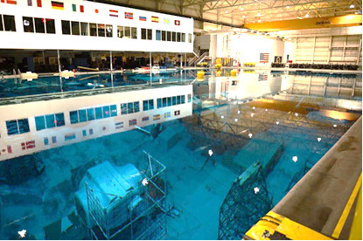
Fig. 1 The Neutral Buoyancy Laboratory pool at Johnson Space Center’s (JSC) Sonny Carter Training Center.

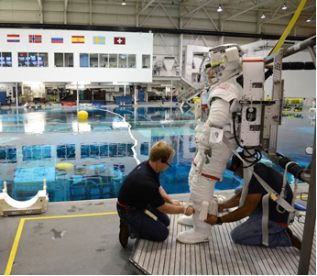
Fig. 2 A suit technician prepping a crewmember in an Extravehicular Mobility Unit (EMU) space suit used for suited tests in the NBL.

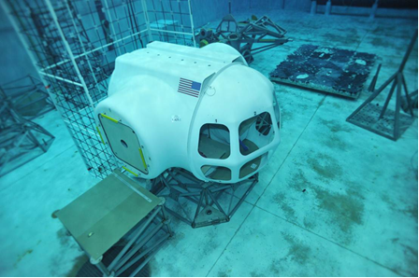
Fig. 3 The AMMSEV glassy mockup and FOV test apparatus sitting on the NBL pool floor.

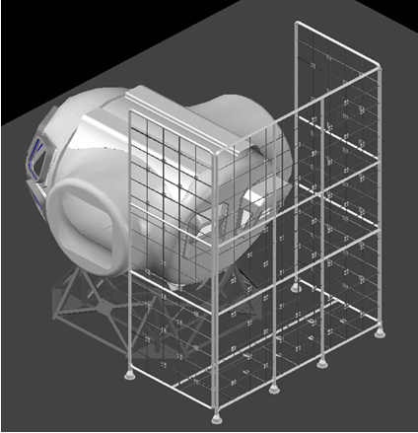
Fig. 4 A Computer Aided Drawing (CAD) of the study’s field-of-view grid around the AMMSEV.

- Study Approach
The test crew assessed the field of view from two differently designed aft suit port window configurations in the AMMSEV while in 1/6-G. Each test subject was asked to maneuver up to one of the windows located on the vehicle’s aft bulkhead using the stair climb type body posture as if they were in a flying position and to hold still in that posture for the remainder of the session. Once situated, the investigators took several eye point measurements referencing these measurements around the window frame and to the top of the EMU helmet. With these measurements completed, individually each crewmember was asked to look out at the FOV grid out the window in front of them and tell the investigators what grid number(s) they saw as their eyes navigated around the extents of the window. When both crewmembers were finished with their respective window, investigators, if time permitted, had the crew switch window positions and repeated the test. In this matter, investigators collected data for both the horizontal plane angle of view and the vertical plane angle of view. Table 4 outlines each of the human factor measures and the frequency of data collection. At the conclusion of the evaluation a debriefing session focused on any frequent or continuing issues experienced during from the test that was not stated previously while collecting the real-time visual data. Recorded communications loops and transcriptions of subject comments and ratings were done post-test to minimize the impact to crew time while the crew was waiting for the data collector to record comments in a datasheet.

Table 4. Human Factors Data Collection Measures
Area of HF Study | Measures for Data Collections | Frequency
Field-of-View (FOV) | Measuring the horizontal and vertical planes of all vehicle window configurations | Real Time
Video Analysis | All tasks | Post Analysis

Due to the small sample size for this test (n = 4), investigators were not expecting to be able to determine small differences in the subject’s preferences between the different configurations but rather only to determine whether there were obviously preferable or non-preferable configurations, or major deficiencies among the configurations that the test team examined. The FOV data collected for all visual planes was visually displayed by individual subject and an overall FOV analysis using CAD software along with subjective comments; was conducted to compare the two suit port window configurations. The graphs show both the horizontal and vertical visual planes to the FOV grid. Investigators then extrapolate the planes further out to a surface and inward for a more precise eye-point measurement to complete geometry representing a visual cone starting at the eye-point. Angles of view were expressed in tables following the FOV cone graphs.
The AMMSEV vehicle mockup is the constructed of ¼ inch (0.64 cm) thick fiberglass with outer dimensions of 130.5 inches (3.31 m) in length, 125 inches (3.18 m) in width, and 92 inches (2.34 m) in height with a pressurized interior volume of 481.97 ft³ (13.65 m³) as previously stated. The interior dimension of the vehicle mockup is 88 inches (223.5 cm) in diameter with a maximum interior height (from the sub flooring to ceiling) of approximate 84.5 inches (214.6 cm) (Figure 5). With the main floor installed the height in the vehicle, from floor to ceiling, is reduced by approximately 7 ½ inches (19.1 cm). The bench height, from subfloor to top of bench, is approximately 24 ¼ inches (61.6 cm) with the bench top measuring 28 ½ inches (72.4 cm) in width. The aisle way measured 24 inches (60.9 cm) in width. The dimensions of the suit port windows will be presented in a later section. The implications of these vehicle measurements for this study are the team is assessing standing operations for a shell that was initially designed for operations in a seated state and has limitations for the full stature of the tallest crewmembers. Another implication to consider is that small females may actually have an easier time operating the AMMSEV (The maximum stature crewmember would be approximately 4 inches (10.2 cm) taller than the tallest test subject used in this study).

Fig. 5 Exterior/interior dimensions of the AMMSEV mockup without nose module. All units are in inches (“).
- Results and Discussion
Research has shown visual perception is the main source of information when operating a vehicle [7]. The normal visual field of a human extends approximately 60˚ toward the nose in each eye, to 100˚ away from the nose and approximately 60˚ above and 75˚ below the horizontal meridian. Improving on the methodology used with the Generation (GEN) 2A side window evaluation during the 2011 Research Analog Test Studies (RATS) test, the AMMSEV 2 configuration evaluated the field of view from the aft bulkhead. The aft bulkhead is angled downward at 10° to aid the crewmember into translating through the suit port into an EVA suit (Figure 6) in the nominal suit port configuration. Using this downward angle, vehicle designers want to explore the feasibility of using suit port openings, Display and Control Window Units (DCWUs) are mounted in the suit ports, where suits or suit port transfer modules (SPTMs) would normally be mounted, thus transforming what had been the aft of the cabin into the new forward section. Each DCWU includes one or more windows for visibility, a 15 inches (38.1 cm) display with Orion edge keys, a Rotational Hand Controller (RHC) on the right, and a Translational Hand Controller (THC) of the left. The entire DCWU mounts in the existing suit port volume, allowing the same aft bulkhead to be used for the AMMSEV as for any other configuration of the spacecraft. Two DCWU designs were tested, referred to in this evaluation as the “Red” window and the “Blue” window for two suit port window designs. The Red window has one rectangular center window incorporated into a downward angled rectangular protrusion from the vehicle and two small, triangular side windows, while the Blue window has a rectangular center window and no side windows The Red window was located on the starboard side of the vehicle and Blue window was located on the port side of the vehicle and incorporated into a downward angled hybrid that protrude outside of the vehicle at the top of the window, and into the mold line at the bottom of the window (Figure 7). The Red window was angled at 24° making it a potential 66° vertical viewing angle while the Blue window as angled at 30° making it a potential 60° vertical viewing angle (Figure 8). The calculation includes the 10° aft bulkhead angle as previous described. Dimensions of the windows are as follows: The Blue window center panel is 17 inches (43.2cm) in length by 15 inches (38.1 cm) in width with a surface area of 255 inches² (647.7 cm²) (Figure 28); the Red window center panel is 17 inches (43.2 cm) by 15 inches (38.1 cm) (255 in² [647.7 cm²]) with each side panel measuring 7 inches (17.8 cm) in width at the top by 15 ½ inches (39.4 cm) in length on the front angle by 3 ¾ inches (9.53 cm) in width on the bottom by 14 ½ inches (36.8 cm) in length on the straight side (Figure 9) with each panel have approximately 108.5 in² (275.6 cm²) in surface area; thus, giving a total surface are for the Red window at approximately 472 in² (1,198.9 cm²) Both windows had a 15 inch (38.1 cm) display with the Orion edge keys and two controllers (THC and RHC) at each station. The hypothesis of this investigation is to determine whether fewer small windows closer to the operator could result in similar or improved field-of-view of piloting than the array of window designed for seated operations in the AMMSEV configuration, saving mass without degrading performance as was demonstrated in the Apollo Lunar Module window configuration.

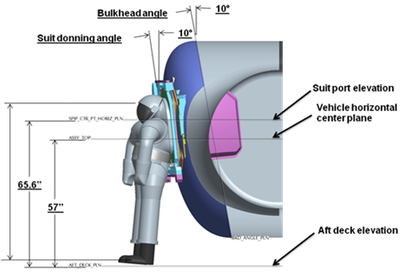
Fig.6 The CAD shows the aft bunk head design angle.

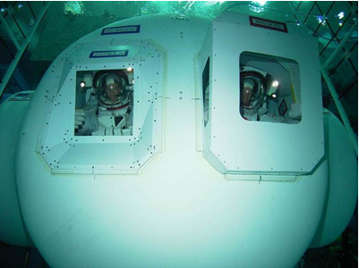
Fig. 7 This photo illustrates the two aft DCWU concepts. The window on the left is the Blue Window and the window on the right is the Red Window.

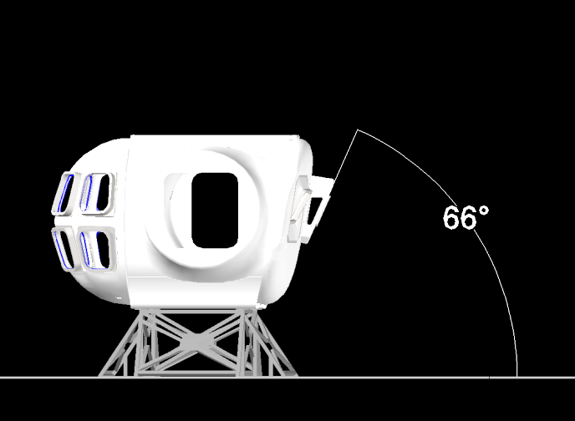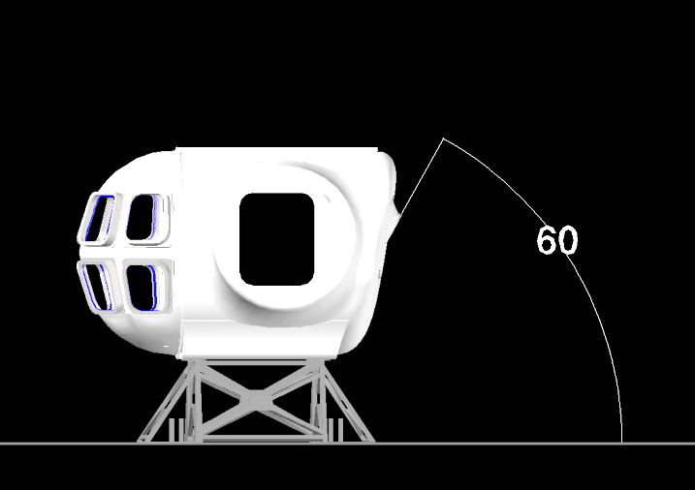
Fig. 8 The left drawing shows the Red Window viewing angle (66°), while the right drawing shows the Blue Window viewing angle (60°).

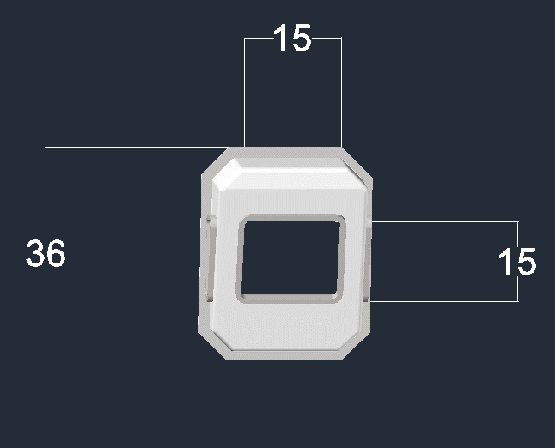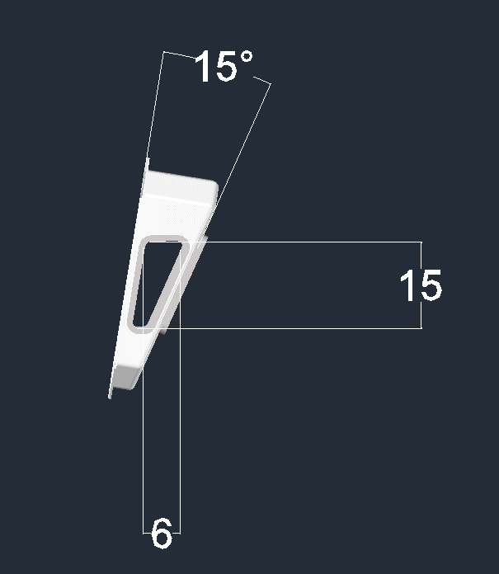
B
A
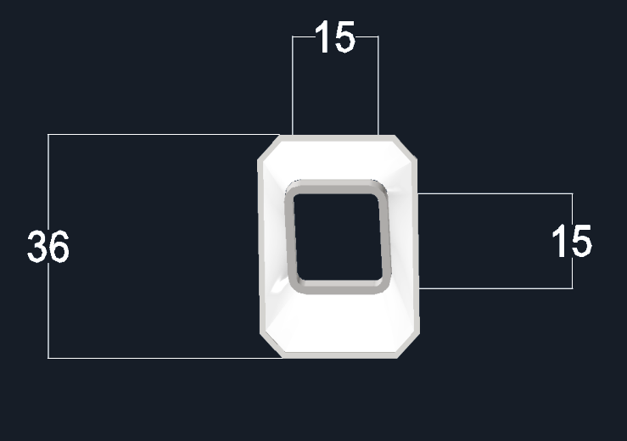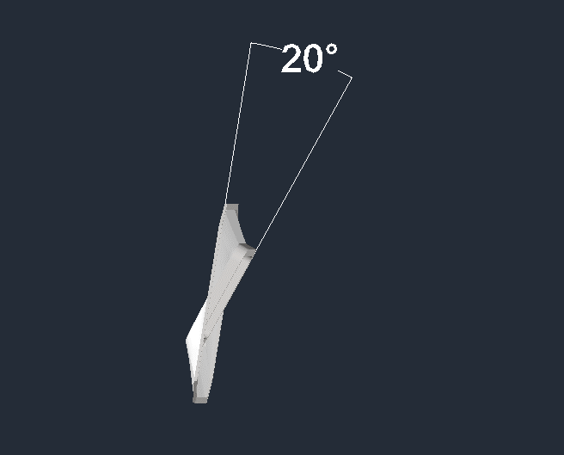
D
C
Fig. 9 Upper drawings, A and B, are the front and side views of the Red Window, while the lower drawings, C and D, and the front and side views of the Blue Window. Note all units are in inches.

When preparing for the FOV session, investigators asked the crews to get into a comfortable body position as if flying the vehicle and once in that position, to keep their heads still (the data and analysis showing static vs. dynamic FOV showed that some did this better than others). All body positions were a modified stair climb standing position. Crews were measured by the test team for an approximate eye-point using the upper center portion of the window frame to the top of the helmet on the crewmember as one reference point (horizontal) and the front of the display to the bottom of the helmet for a second reference point (vertical) (Figures 10 and 11). These field measurements were used as a gross starting point for the FOV analysis which used Computer Aided Design (CAD) software to plot coordinates, generate FOV cone geometry, and verify the eye-points using convergence calculations. While viewing out the appropriate window configuration, the crew would fixate on the FOV grid which consisted of two 5 x 15-foot (1.52 x 4.57 m) side panels and one 10 x 15-foot (3.05 x 4.57 m) center panel containing ropes which formed 1 foot by 1-foot squares. Note that the test team added a fourth-floor panel which measured 2 1/2 x 10 feet (0.76 x 3.05 m) in case the crew could see down further than expected (Figure 12).
As mentioned, the FOV device consisted of a PVC frame, with a grid of rope stretched both horizontally and vertically to make a 12-inch (30.5 cm) grid. Labels were affixed to the intersections of the ropes, and were labeled on the horizontal plane of the grid using letters A-U from left to right (included the PVC frame) while the vertical plane of the grid was labeled using numbers 1-18 (with 1 starting at the floor and 18 being the top of the PVC frame) (Figure 13) what about a CAD image showing the FOV device? This figure is good, but it’s only a top photo. We can show the coordinate placards too). The grid had a total of 358 1-foot (0.30 m) squares with the intersections of 145 of these squares being labeled using a 3 x 3 inch (7.62 x 7.62 cm) white plastic label placard with 2 ¾ inch (6.98 cm) black on white coordinate labels consisting of a letter and a number on every other intersection. The FOV center panel was approximately 44 inches (111.8 cm) from the closest point on the vehicle at the top of the aft bulkhead while the side panels touched the side hatch tunnels at the outer rim on either side and was approximately 24 inches (60.9 cm) away from the body of the vehicle. The mockup vehicle was stationed on a 56 x 56-inch (142.2 x 142.2 cm) platform 3 feet (0.91 m) above the pool floor.

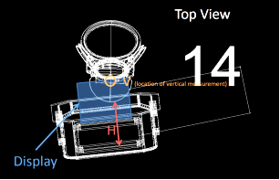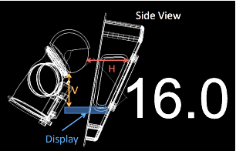
Fig. 10 These drawings illustrate how the eye-point was measured in the field and what reference points on both the vehicle and the human were selected.

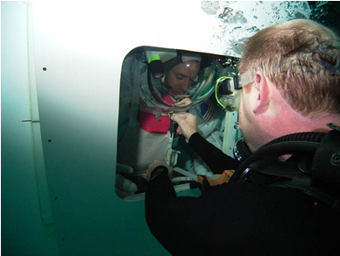
Fig. 11 This illustrates how a member of the test team was actually taking the vertical measurement in the field.

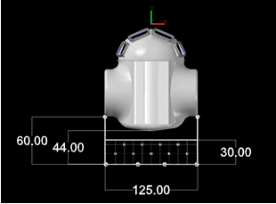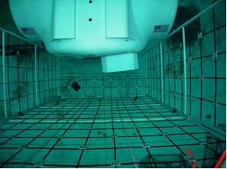
Fig. 12 The left drawing shows the measured distances of the FOV test apparatus in relation to the test vehicle. All units are in inches. The right photo shows the actual FOV grid and vehicle in the test environment.

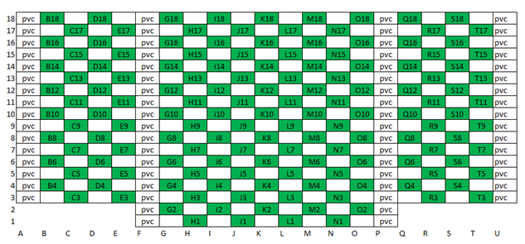
Fig. 13 The labeling pattern and coordinate system which was used for the FOV test grid.
With all field eye-point measurements collected, the crews called out their FOV using the coordinates on the grid while investigators recorded their data. Investigators collected three overall sets of data points for the Blue window and four sets of data points for the Red window. Once investigators had the field FOV data, three-dimensional geometry was generated using this data, combined with pre-existing three-dimensional models of the vehicle, and FOV device. This analysis was conducted using the CAD software program for analysis. Detailed measurements were taken pre and post-test to ensure the validity and accuracy of the computer model. Specifically, the model included the vehicle, mounting stand, FOV grid, FOV labels, window configurations, and the NBL pool floor were all accurately reproduced. To understand the procedure used for the FOV analysis, we will take the Blue window as an example. Investigators took each individual test subjects called-out FOV data, for each window configuration, and modeled a polygon by plotting the field coordinate data from the crew onto the computer model of the FOV grid test apparatus (Figure 14). With the window configuration model at the precise position in the vehicle and the proper distance from the grid, the test team drew lines from the plotted data points (making a polygon) on the grid to the model window extents (Figure 15); thus, creating a cone. These vision lines were then extended beyond the FOV grid device to the NBL pool floor (or to a certain distance out if not intersecting the floor). The lines were also extended from the front of the window to a convergence intersection behind the window to calculate the theoretical eye-point (Figure 16). To aid in the visual understanding of the data, shaded geometry was added to the FOV cone from the front of the window forward (Figure 17). Finally, by adding the vehicle and stand to the visual model a final presentation of the FOV cone analysis was developed (Figure 18).

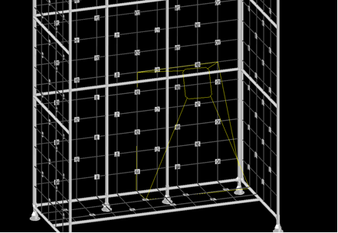
Fig. 14 First step in plotting the field visual data involved plotting the field data points onto a computer model of the FOV grid.

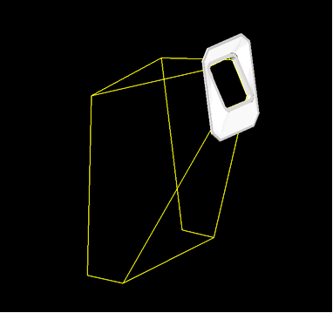
Fig. 15 Next modeling the precise position of the window, lines were drawn from the data points of the grid to the window extents.

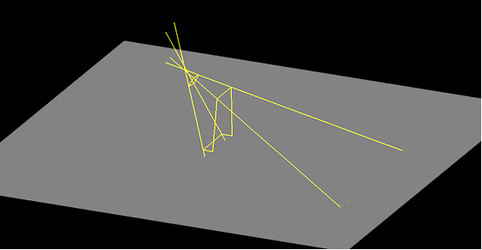
Fig. 16 The FOV lines were then extended beyond the FOV grid to the NBL pool floor in front of the window, while behind the window lines continued until a convergent intersection was formed for the eye-point.

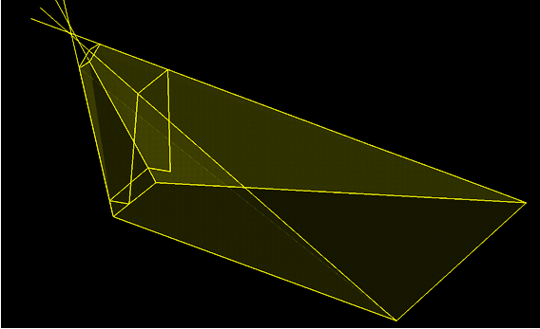
Fig. 17 To aid with visualization of the data, geometry and shading were added.

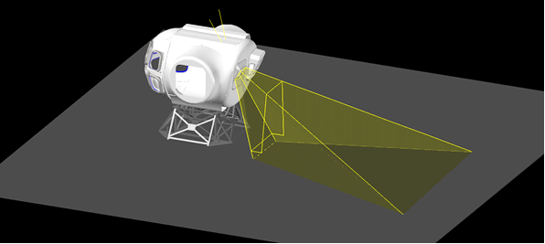
Fig. 18 The final visual presentation for one test subject’s Blue Window FOV field data.

From these types of visual representations of the field FOV data, investigators were able to calculate the horizontal and vertical angles of the viewing field. Using our previous Blue window example, a simple calculation was generated for each individual and each window angle (Figure 19).

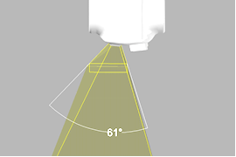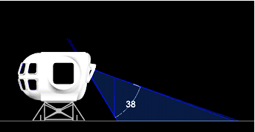
Fig. 19 The left drawing illustrates the calculation for the horizontal angle (61°), while the right drawing illustrates the calculation for the vertical angle (38°).

As mentioned, convergence of the visual lines behind the chosen window configuration was also analyzed to gain an understanding about each subject’s eye point status. It was difficult, at best, for the test team to collect accurate eye point data while in the water since the eye was shielded by the suit helmet. Additionally, with the subject’s head inside a suit helmet filled with air, looking through a glass-like material with a complex geometry, while in a watery environment, investigators had to consider the diopter effect on the subject’s focal points and distances. For the diopter equation (1), one diopter (D) is equal to 1/target distance in meters (m)[8] [9].

Eq. (1) 1D = 1/target distance (in meters)

For this study using 1D = 1/1.12 m (the FOV grid was located 44 inches (111.8 cm) or 3.67 feet (1.12 m) from the vehicle), 1D = 0.89 m (2.92 ft). In this case, according to several highly experienced NBL astronaut divers, the suit helmet gave the test subject a diopter effect of 2D which equals to 1.46 feet (0.45 m) refer to equation (2).

Eq. (2) 2D = 1/target distance (in meters)

Thus, the greater the diopter value, the closer the focal point. So, in this case, the test subjects perceived the FOV grid 1.46 feet (0.45 m) closer to them than if the test was performed in an all-air environment. Since the grid itself was constructed of 1-foot (0.30 m) squares, the accuracy at best from test subjects would only be 1 foot (0.30 m); thus, the test team decided the 2D effect was too minimal to affect the analysis of the collected field data to be a concern. With this in mind, investigators calculated a convergence number (eye-point) for each visual line by using the distance from the window frame to the intersection of where the particular visual line intersected with another visual line. The front, top and bottom side views of the window were used for these calculations (Figure 20).

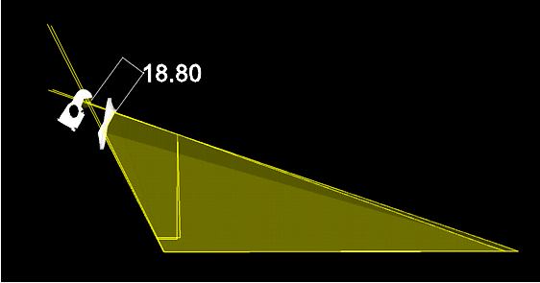
Fig. 20 An example of how the convergence number was calculated by extending the visual lines to back beyond the window for an estimated eye-point.

In Table 5, several convergence calculations were made across the entire window area. Note all units in the table are in inches. Distances were also calculated. With all the measurements collected, an average was calculated for the convergence across the three measurements (Equation (3)).

Where:
Average conv = Average (average of all three angles)
Front = FOV lines extend back into cabin from front view
Top = FOV lines extend back into cabin from a top view
Side = FOV lines extend back into cabin from vehicle’s side view

Eq. 3 Average conv = (Front + Top + Side)

For example, taking S-1’s data in Table 5 and using the simple averaging equation of convergence, the average convergence calculation for S-1 is 2.06 inches (5.23 cm). This would indicate a low overall convergence number for this window meaning the FOV lines were tightly grouped around a center convergence point (Figure 21). This means that the subject was not moving their head/body position in the suit during the actual field measurement keeping all the FOV lines tightly grouped together indicating a statistic and calculated visual pattern (Figure 22).

Table 5. Calculations of the Convergence (Eye Point) and Distance for the Blue Window Configuration
Window | Test Day | Subject | Eye Point Data (in inches)
Window | Test Day | Subject | Front | Top | Side | Average conv
Blue | 1 | S-1 | 2.5 | 2.39 | 1.3 | 2.06
Blue | 2 | S-3 | 5.17 | 5.13 | 1.42 | 3.91
Blue | 2 | S-4 | 11.79 | 7.2 | 5.69 | 8.23
NOTE: All units of convergence and distance are in inches.

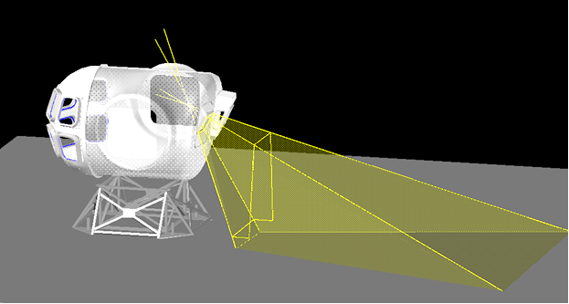
Fig. 21 This is an example of a tight convergence using S-1’s data (low convergence number). Note how tight intersections of the FOV (visual) lines.

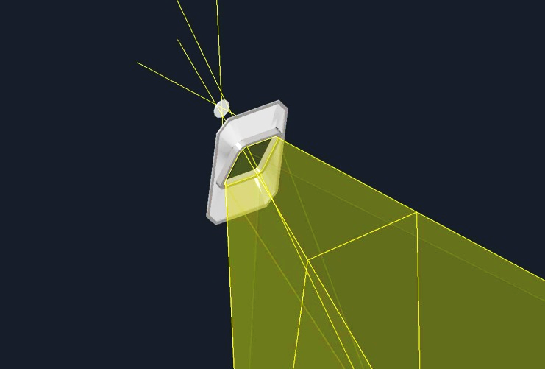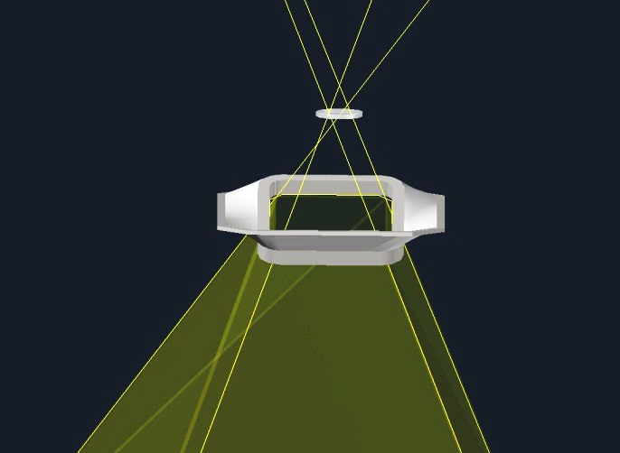
Fig. 22 The right drawing shows a closer side view of S-1’s eye-point, while the left drawing shows S-1’s eye-point and head position in a top view. Note how tightly grouped the convergence lines are and how small the eye-point area is indicated by the white circle illustrating a very static position.

An example of a loose convergence of FOV lines can be demonstrated usingS-4’s data in row 3. S-4’s average convergence was calculated at 8.23 inches (20.9 cm). This indicates that the intersections of the FOV lines are loosely grouped around a center point giving a higher average convergence number (Figure 23). Investigators believe this indicates that the subject was moving their head/body position in the suit during the actual field measurement making all the FOV lines varied around the center point indicating a dynamic and unpredictable visual pattern (Figure 24).

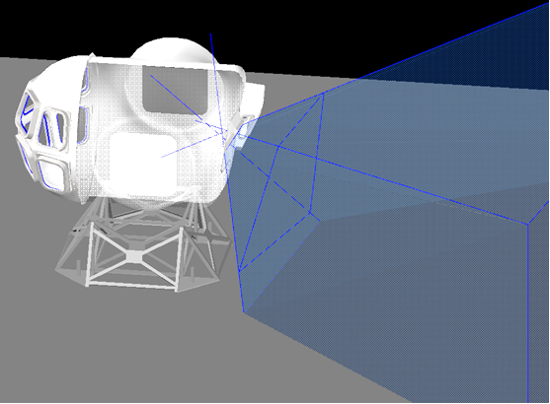
Fig. 23 This is an example of a loose convergence using S-4’s data (high convergence number). Note the variability in the intersection of the visual lines, as well as a broader FOV, consistent with an operator moving their head to maximize FOV.

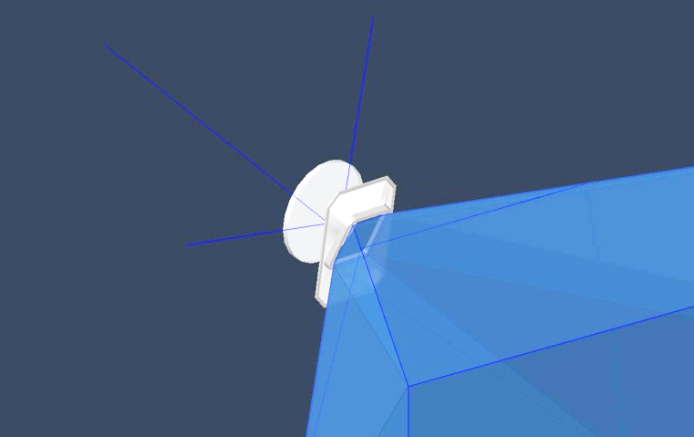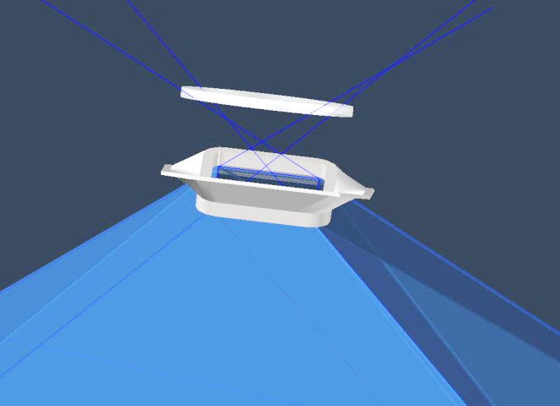
Fig. 24 The right drawing shows a closer side view of S-4’s eye-point, while the left drawing shows S-4’s eye-point and head position in a top view. Note how loosely grouped the convergence lines are and how large the visual eye-point area is indicated by the white circle illustrating a very dynamic position.

Considering all these focal point data, investigators were able to model the convergence point of the visual lines for all the test subjects in each window configuration. By extended the visual field lines beyond the back of the window, some interesting data trends formed about what actually happened during the field portion of the FOV test. As mentioned earlier, crews were instructed to find a comfortable flying position and then keep their head still; however, the convergence data analysis indicates a different story. When examining the convergence or eye-point data from the test crews, Crew 1 had tighter FOV line convergence than when compared to Crew 2’s convergence data for the Blue window configuration. This indicates the crewmember’s eye-point of Crew 1 did not move much once the FOV test session began. This, in turn, gave the investigators a good tight visual pattern of the windows FOV from a single eye-point (Figure 25). However, both crewmembers of Crew 2, with the higher convergence numbers, indicated a very dynamic range of either head or body motion or both during the collection of the FOV data (Figure 26). This also affected both the angle of view (horizontally and vertically) as well as the dead zone or blind spot areas (Table 6). Since the Blue window was a single center panel window, no dead zones were recorded; however, the angle of view varied greatly between the test crews. Only one data point for Crew 1, the angle of view for the Blue window was a horizontal angle (Hor FOV) of 61° (which is the maximum FOV angle as measured along the horizontal axis of the window) with a vertical angle (Ver FOV) of 44° (which is the maximum FOV angle as measured along the vertical axis of the window) and a down angle (Down) of 27° (which is the measurement of the angle from true vertical to the closest line of the FOV) with an eye-point distance of 16 inches (40.6 cm) from the center point of the window. Crew 2’s angle of view for the Blue window ranged from a Hor FOV of 132° - 141° with a Ver FOV range of 89° - 93°, and a Down range of 7° - 13° (Figures 27 and 28) with eye-point distances of 6.62 inches (16.8 cm) (S-3) and 8.00 inches (20.3 cm) (S-4) indicating these subjects were much closer to the center point of the window. Comments about the Blue window configuration were consistent between the crews. They reported the view from the Blue window configuration was restrictive with no peripheral vision. Subjects also observed that the outboard arm interfered with the flight control due to the vehicle wall structure when using this window configuration.

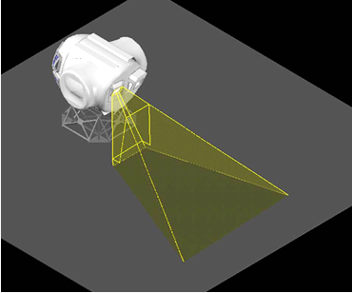
Fig. 25 The Blue Window FOV cone pattern of S-1. Note, due to the tight convergence number, this subject’s FOV is somewhat limited which would be expected with a static eye-point.

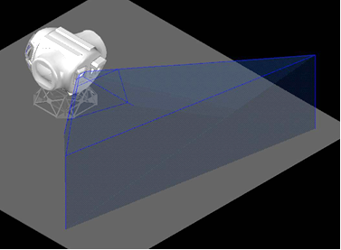
Fig. 26 The Blue Window FOV cone pattern of S-4. Note, due to the high convergence number, this subject’s
FOV has a wider range which would be expected with a dynamic eye-point.

Table 6. Calculations of the Field-of-View Angle and Dead Zones for the Blue Window Configuration
Window | Test Day | Subject | FOV Data
Window | Test Day | Subject | Hor FOV⁰ | Ver FOV⁰ | Down⁰
Blue | 1 | S-1 | 61 | 44 | 27
Blue | 2 | S-3 | 132 | 93 | 13
Blue | 2 | S-4 | 141 | 89 | 7

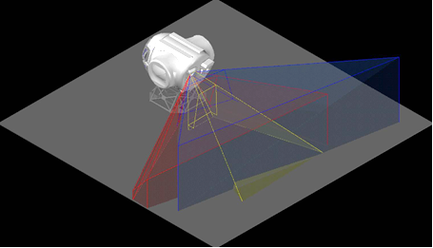
Fig. 27 The top composite view of the Blue Window for S-1 (yellow), S-3 (blue), and S-4 (red).

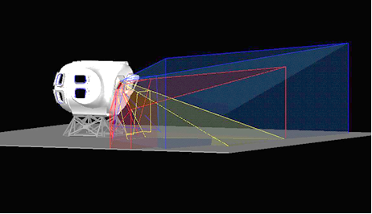
Fig. 28 The side composite view of the Blue Window for S-1 (yellow), S-3 (blue), and S-4 (red).

Using the same calculations for convergence, investigators examined the four Red window FOV data points collected during the test. The Red window consists of three panes—two side panels and one center panel. Note to the reader, the visual presentations of the Red window panels will be shaded as if one is standing inside the cabin at the window. Thus, the right-side panel is the red shade, the center panel is the blue shade, and the left side panel is shaded in yellow. In Table 7, each test subject’s combined data (Reb Comb) for the Red window is shown. Subject 1 (S-1) still had the overall lower, tighter convergence numbers having an average convergence of 6.10 inches (15.5 cm) (Figure 29) indicating very little head movement while S-2 with an average 13.30 inches (33.8 cm) indicated more head movement. Sense Crew 1 consisted of S-1 and S-2 and Crew 2 represented S-3 and 4, Crew 1 tended to have a greater variability in their average convergence scores when compared to Crew 2. During testing, it was observed the calculated eye-point distances for Crew 1 tended to be further back from the window (S-1 16.94 inches (43.0 cm) and S-2 17.10 inches (43.4 cm)) when compared to Crew 2’s average calculated distance (S-3 14.05 inches (35.7 cm) and S-4 9.84 inches (24.9 cm)). Eye-point distance from the window also has an effect on the subjects’ perception of their FOV (Figure 31).

Table 7. Calculations of the Convergence (Eye Point) and Distance for the Red Window Configuration
Window | Test Day | Subject | Eye Point Data (in inches)
Window | Test Day | Subject | Front | Top | Side | Average conv
Red Comb | 1 | S-1 | 4.94 | 8.55 | 4.8 | 6.1
Red Comb | 1 | S-2 | 14.87 | 10.4 | 14.62 | 13.3
Red Comb | 2 | S-3 | 12.03 | 18.56 | 5.75 | 12.11
Red Comb | 2 | S-4 | 11.57 | 18.71 | 5.09 | 11.79
NOTE: All units of convergence and distance are in inches.
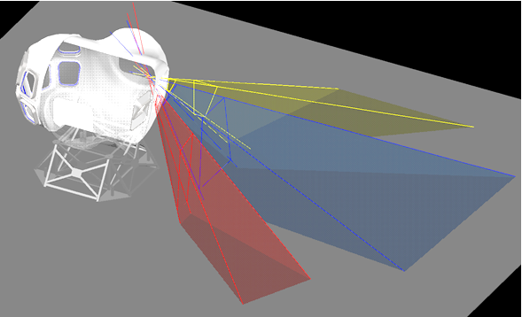
Fig. 29 The Red Window FOV cone pattern of S-1 with the right-side panel (red), the center panel (blue), and the left side panel (yellow). Note the defined visual fields between the three different window panels indicated a low convergence number (6.10). The visual range and dead zones are predictable of a static eye-point.

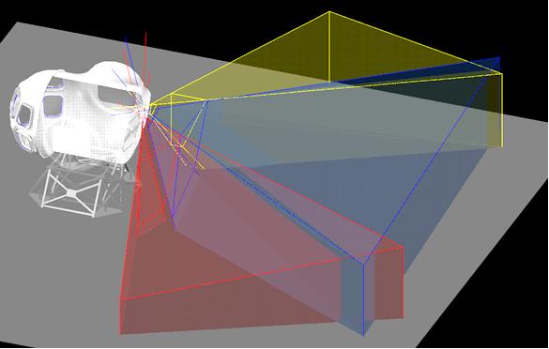
Fig. 30 The Red Window FOV cone pattern of S-3. Note the overlapping visual fields between the three different window panels indicated a high convergence number (12.11). The visual range and dead zones are unpredictable and indicates a more dynamic eye-point.

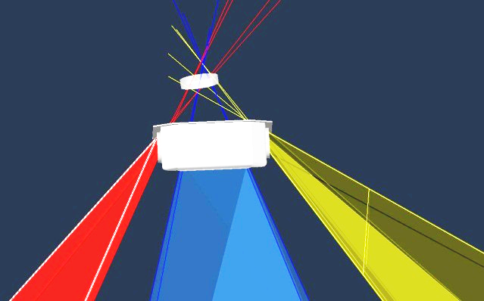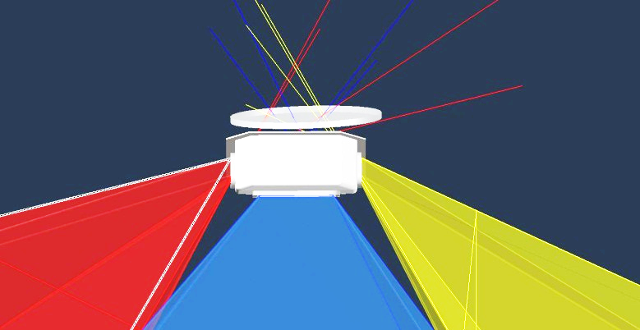
Fig. 31 The Red Window drawing on the left is S-1’s eye-point area and body distance from the center of the window, while the right drawing is S-3’s eye-point area and body distance from the center of the window.

Unlike the single panel Blue window, the Red window has three panels; thus, dead zones or blind spots exist with this configuration. Investigators were able to measure and calculate these dead zones along with visual angle (Table 8). The panel data was combined for the Red window (Red Comb). Using Table 8, the “Dead Zone 1” (D zone 1) is the angular measurement of the horizontal FOV angle lost due to the space between the left and center panels of the Red window. The second dead zone angular measurement is “Dead Zone 2” (D zone 2) which is the angular measurement of the horizontal FOV angle lost due to the space between the center and right panels of the Red window. Finally, “Dead Zone Combined” (D zone c) (∑) is the angular measurement of combined horizontal FOV angle lost due to both dead zones (D zone 1 and D zone 2) (Figure 32). The combined dead zone is calculated by taking the sum of dead zones 1 and 2 (3quation (4)).

Where:
∑ = The sum of all Dead Zones in degrees (Dead Zones Combined (D zone c))
D zone 1 = angular measurement of horizontal FOV lost due to space between left and center panels in degrees
D zone 2 = angular measurement of horizontal FOV lose due to space between right and center panels in degrees

Eq. 4 ∑ (D zone 1 + D zone 2)

For example, taking S-1 dead zone data from Table 8 and using to formula the following calculation follows: ∑ (8° + 8°), ∑ 16°. Thus, each dead zone between the side panels in relation to the center panel is 8° with the combined total of 16°. Negative dead zone angles can also be seen. A negative dead zone angle indicates no FOV lost although items close to the vehicle might not be seen. In the case of S-3’s FOV data, investigators calculated a -25° dead zone between the side panels and the center panel. This indicates an overlapped of S-3 FOV where no dead zones were recorded (Figure 33). This could be due to the subject’s dynamic eye-point positioning and close eye-point distance to the center of the window where head or body motion (or both) was being accomplished to get the best FOV while investigators were collected the field data.

Table 8. Calculations of the Field-of-View Angle and Dead Zones for the Red Window Configuration
Window | Test Day | Subject | FOV Data |  |  | Dead Zone Data
Window | Test Day | Subject | Hor FOV⁰ | Ver FOV⁰ | Down⁰ | D zone1⁰ | D zone2⁰ | D zone c⁰
Red Comb | 1 | S-1 | 114 | 52 | 19 | 8 | 8 | 16
Red Comb | 1 | S-2 | 127 | 53 | 15 | 7 | 8 | 15
Red Comb | 2 | S-3 | 139 | 74 | 14 | -25 | -25 | -50
Red Comb | 2 | S-4 | 167 | 90 | 0 | 4 | 8 | 12

Fig. 32 A horizontal FOV analysis showing the dead zones or blind spot areas between the side panels and the center panel of the Red Window.

Fig. 33 A horizontal FOV analysis of S-3 showing a negative dead zone between the side panels and the center panel of the Red Window.

This would also affect visual angle as well. The overall range of Crew 1’s visual angle, which includes all the Red window panels, on the horizontal visual plane angle, ranged from 114° - 127° with a vertical visual plane angle range of 52° - 53° and downward angle range of 15° - 19° (Figure 34). Note all visual plane angles have little variation, indicating a rather stable eye-point when the data was collected. In contrast, Crew 2’s overall range of horizontal visual plane angle was 139° - 167° with a vertical visual plane angle of 74° - 90° and a downward angle range of 0° - 14° (Figure 35). The horizontal plane angle difference between Crew 1 and Crew 2 is 15°, while the vertical plane angle difference between crews is also 15° and the downward angle difference is 10°; thus, indicating a rather dynamic eye-point position with closer distances to the window and some type of head or body motion which extends the visual range from all angles. As for the downward angle difference, it was observed by the investigators during post video analysis that crews tended to do a slight bouncing motion inside the cabin between FOV call outs (Figure 36). This could be another reason why differences between crews are being noticed. Subjective comments collected from the crews on the Red window configuration indicated the display placement was better for this configuration than for the Blue window configuration. It was perceived to take up much less volume in the cabin due the Red windows structure being pushed outward from the cabin interior as compared to the inward location of the display at the Blue window station. Crews stated they could get into a better body position using the Red window configuration as compared to the Blue window configuration. They did suggest increasing the center panel window with to the left and right by a couple inches but did not specific a particular width. Finally, when asked by investigators which window configuration they would choose, all subjects preferred the Red window. It becomes evident why all the crews choose the Red window configuration over the Blue window configuration by viewing a composite of all the FOV lines for each crewmember in both the vertical and horizontal planes (Figure 37). As the analysis of the field FOV data suggest, the overall vertical visual field range for the Red window is 0° - 90° while the Blue window is 7° - 93° (including the downward angle) giving a difference of only 4°. The overall horizontal visual field range for the Red window is 21° - 167° while the Blue window ranges from 61° - 141° giving a significant difference of 66°.

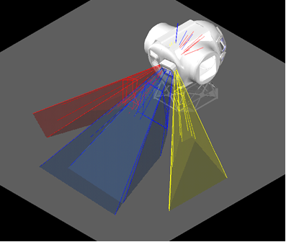
Fig. 34 Crew 1’s composite FOV for the Red Window.

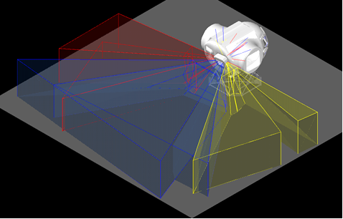
Fig. 35 Crew 2’s composite FOV for the Red Window.

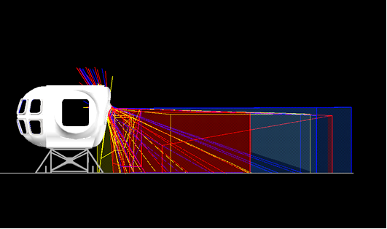
Fig. 36 An overall composite of all subjects’ FOV vertical data for the Red Window.

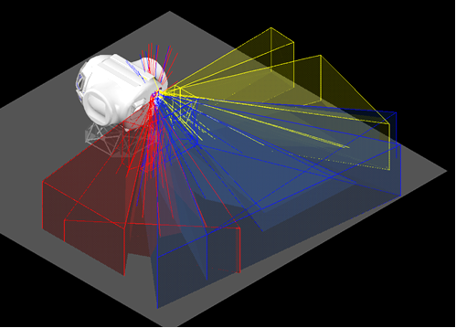
Fig. 37. An overall composite of all subjects’ horizontal FOV lines for the Red Window.

Therefore, this visual analysis gave investigators a glimpse into how the visual pattern becomes unpredictable and wider from a more dynamic eye-point where the individual is moving their head/body position to obtain the best view. Investigators believe this comparison between the two crews, with such different eye-point strategies, could make it easier to understand dynamic eye-point scenarios in a more real-world situation (Figure 38).

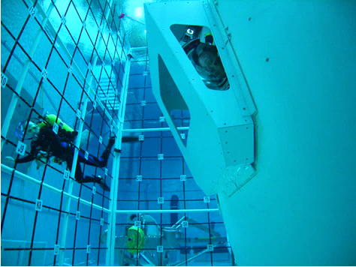
Fig. 38 Using this method of measuring FOV in an underwater environment proved successful with both the test subjects and the test team.
- Conclusion
The field-of-view (FOV) test examined two aft suit port window concepts after which all tested crewmembers preferred the Red window, with its three panels, over the Blue window, with its single center panel. The analysis of the visual fields for both window concepts were conclusive in that the FOV data illustrated, the overall vertical visual field range for the Red window as 0° - 90° while the Blue window was 7° - 93° (including the downward angle) giving a difference of only 4°. The overall horizontal visual field range for the Red window was 21° - 167° while the Blue window ranged from 61° - 141° giving a significant difference of 66°. Visual line convergence aided the investigators in understanding how static versus dynamic eye-points affect measured FOV.
For future research, it would be beneficial to examine four-crew scenarios by adding an additional two suited crewmembers. It would also be beneficial to increase the study population to obtain more robust trend knowledge on the vehicle’s design which would better inform human factors investigators on how human would truly work with such a vehicle configuration when put into different gravity environments. By continuing a human-centered design approach and collaborating with designers and engineers to capture valuable information about the design, the aim of such approach, is to enhance human performance and ergonomics which would lead future exploration vehicle designs and operational procedures.

References
[1] Jarrett, D.N. (2005). Cockpit Engineering, Ashgate Publishing Company, Burlington, VT.
[2] Skillen, J. (2007). “Understanding visual fields: The visual pathway and methods to measure visual fields,” Scottish Sensory Centre presentation on 2 November 2007. Retrieved 03 March 2011 online at http://www.ssc.education.ed.ac.uk/courses/vi&multi/vnov072i.html
[3] Gioia, A.J. & Morphew, C.E. (1968). Evaluation of driver vision. General Motors Corp., 1968.
[4] Henderson, R.L., Smith, R.L., Burger, W.J., & Seymour, D.S. (1984). “Visibility from motor vehicles,” Society of Automotive Engineers, Paper Number 830567, pp 2.706-2.730.
[5] Comstock, Jr., J.R., Rudisill, M., Kramer, L.J., & Busquets, A.M. (2002). “Vertical field of view reference point study for flight path control and hazard avoidance,” NASA/ Langley Research Center, NASA/TP-2002-211954, November 2002.
[6] Jairala, J.C., Durkin, R., Marak, R.J., Sipila, S.A., Ney, Z.A., Parazynski, S.E. and Thomason, A. H. (2012). EVA development and verification testing at NASA’s neutral buoyancy laboratory,” American Institute of Aeronautics and Astronautics.
[7] Recarte, M.A. & Nunes, L.M. (2000). “Effects of verbal and spatial-imagery tasks on eye fixations while driving,” Journal of Experimental Psychology: Applied, Vol. 6, No 1, pp 31-43.
[8] Sanders, M.S. & McCormick, E.J. (1993). “Human Factors in Engineering and Design,” 7th ed, McGraw-Hill: New York, NY.
[9] Schwartz, S.H. (199). “Visual Perception,” 2nd ed, McGraw-Hill: New York, NY.

Senior Human Factors Design Engineer, Human Systems Engineering and Integration Division.
Habitability Domain Lead, Human Systems Engineering and Integration Division, AIAA Senior Member.
Center for Design and Space Architecture Design and Fabrication Lead, Human Systems Engineering and Integration Division.

