Rapid Assessment of a Lunar Surface Laboratory Module
Harry L. Litaker, Jr.  NASA/Leidos Incorporated  2101 East NASA Parkway  Houston, TX 77058  harry.l.litaker@nass.gov | Dr. Robert L. Howard, Jr.  NASA Johnson Space Center  2101 East NASA Parkway  Houston, TX 77058  robert.l.howard@nasa.gov

Abstract—Johnson Space Center has piloted an innovation team known as the Forge to perform rapid turnaround, concurrent engineering studies. The Forge is intended to be able to pull together a team of strategically selected domain experts to innovatively solve a specified problem within a short period of time. The Forge’s inaugural project was the development of a Lunar Surface Laboratory Module concept. The lab module is intended as an option for the NASA Lunar Architecture Team and may allow for increased science productivity and return on investment than with only the Surface Habitat. The Forge team developed two concepts, a stationary laboratory and a mobile laboratory. Human factors evaluations have been conducted to determine the acceptability of the resulting design concepts. The human factors evaluations conducted include a card sort evaluation of the laboratories by science discipline and the System Usability Scale (SUS). The card sort focused subject matter expert expectations for the relative positioning of the laboratory functional areas, determining whether a given lab area should be adjacent to, or separated from, another. The SUS focused on layout efficiency. Both used human factors personnel and both life and physical scientists as subject matter experts. Each of these evaluations will focus primarily on objective data with limited subjective comments, reducing the time required for processing responses. The results of the card sort and SUS evaluations and their implications will be discussed. Based on the evaluation data, an overall acceptability of the Lunar Surface Laboratory Module produced by the Forge study can be determined. Lessons learned and recommendations for future use of human factors rapid assessment processes in early design trades will also be provided.
Table of Contents
1. Introduction 1
2. Background 2
3. Initial Forge Study Concepts and Completed Forward Work 2
4. Methodology 8
5. Results and Discussion 10
6. Conclusions 16
Acknowledgements 16
References 16
Biography 17

Introduction
The Johnson Space Center (JSC) Innovation Team known as the Forge is a pilot program that provides a place for individuals, groups, Programs or Organizations to explore their ideas or hammer out issues. The concurrent design setting brings together the diverse knowledge, expertise, and tools that NASA already has but in a more efficient framework to develop, explore and support innovative ideas both technique and non-technique. Figure 1 shows how the Forge process works.
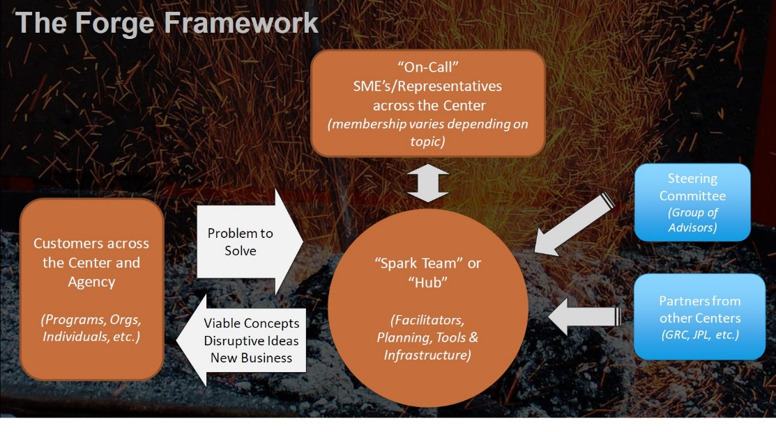
Figure 1. The Forge Framework.
The Forge project assessed in this paper is a lunar lab concept for future Artemis Lunar missions. The goal was to demonstrate the Forge/Innovation Team in a design study setting and understand the effectiveness in creating a more collaborative and innovative workforce when examining lunar lab design concepts. The team came up with 10 different design concepts and down selected to two. The aim is to provide a concept for a separate science-focused module on the moon as an option/reference for the Lunar Architecture Team to consider as an expansion option for the Artemis Base Camp.

Background
After the 2024 return mission to the Moon, the focus of the Artemis will be on sustainable lunar surface operations. In order to reach what has been described as a sustained operations phase, several missions will need to be flown to deliver the associated assets to the lunar surface. The Artemis architecture will have reached the sustained operations phase when a Human Landing System (HLS) can deliver four crew to the lunar surface and there is both a Pressurized Rover (PR) and a Surface Habitat (SH) available to receive them. Currently, lunar surface missions during this phase will be approximately 33 days in duration. Both the Surface Habitat and Pressurized Rover will have habitation capabilities for a crew of two, so the crew will be split up between the elements. They may swap habitation assignment midway through the surface mission. Another asset available to the crew will be the unpressurized Lunar Terrain Vehicle (LTV). The LTV can be used by the Surface Habitat crew or by the Pressurized Rover crew depending on the demands of a particular mission or operation. Nominal operations will have the Pressurized Rover returning to the SH roughly once a week to perform suit maintenance, resupply of consumables and purge waste.
The Pressurized Rover contains a cockpit, sleep bunks with privacy curtains, water dispenser, toilet, small exercise device, ISS-equivalent medical kit, stowage compartments and suitports. Figure 2 features a render of the NASA reference configuration of the Pressurized Rover as of mid-summer 2021. Extravehicular Activity (EVA) science tools and sample collection containers are stored externally.
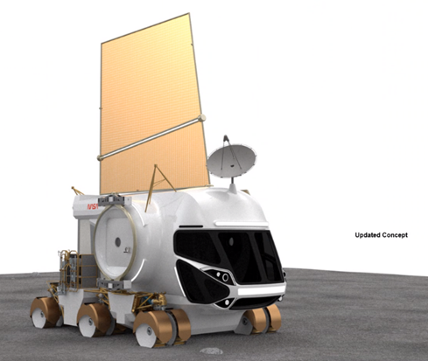
Figure 2. NASA Reference Pressurized Rover.
The NASA reference configuration of the Surface Habitat is a hybrid inflatable/aluminum element that includes two private crew quarters, waste and hygiene facilities, meal preparation and consumption, vehicle subsystems monitoring and commanding, storage, exercise, medical, maintenance, and a suitport-airlock (Figure 3).
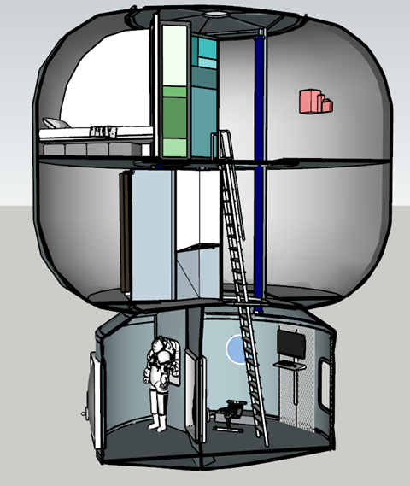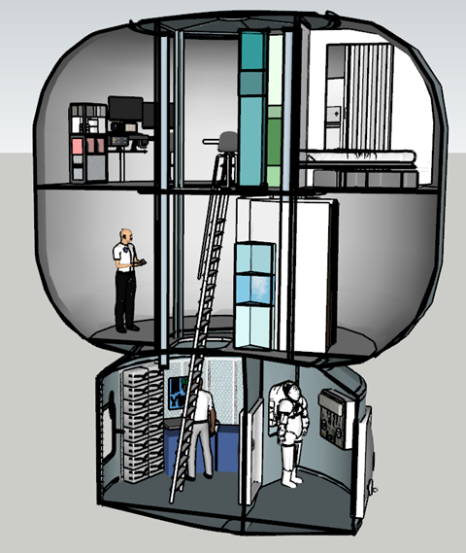
Figure 3. NASA Reference Concept for the Surface Habitat.
The NASA Reference HLS vehicle was used by the Lunar Architecture Team as the assumed lander for design studies, and as such was used by the Forge study. Its mass constraint of 12 metric tons cargo down mass limits SH outfitting. Consequently, there are no dedicated science instruments in the Surface Habitat as their presence would raise the SH mass over the 12-ton limit. Additionally, the Surface Habitat will not be offloaded., but instead will remain on top of the lander.

Initial Forge Study Concepts and Completed Forward Work
The impact of the 12-ton HLS cargo limit on the SH is what prompted the Forge team to use its pilot study to develop lunar surface laboratory concepts that could be added to the Artemis Base Camp architecture after it has reached the sustained phase. [1] Two different concepts were created: a stationary laboratory and a mobile laboratory. In both cases, the laboratory is staffed and operated by the two assigned Surface Habitat crew.
In the case of the stationary laboratory, the entire laboratory is permanently docked to the Surface Habitat, connected by a vertical tunnel. In the case of the mobile laboratory, the entire laboratory is mobile and does not dock to the Surface Habitat.
As has been noted in Forge reports, [1] the original intent was to develop a single laboratory concept. Developing two concepts in parallel resulted in more forward work at the end of the study than had initially been planned. As a result, the human factors team was not able to conduct its intended evaluations without first completing some of the Forge-identified forward work.
The planned human factors evaluations are intended to assess the usability of the two laboratory concepts and overall habitability for the crew assigned to the Surface Habitat. This requires a clear definition of the architectures surrounding each concept and the layout of all pressurized volumes. But at the end of the Forge study period, both concepts required additional work to resolve discrepancies.

Stationary Laboratory
The Mass Equipment List (MEL) in Table 1 represented the work completed by the end of the Forge study period but forward work was identified, including a need to redistribute subsystems and science equipment between the modules. [1] This is evident after an initial read of the table.
Table 1. Stationary Laboratory Initial Mass Equipment List [1]
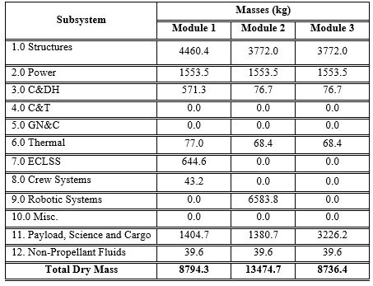
Module 2 is over the 12-ton mass limit, but upon further inspection Module 2 is not needed at all. It is carrying 1380.7 kg of science equipment. This mass can be divided between modules 1 and 3, eliminating the need for module 2. This does not, however, reduce the number of lunar landings required. The 6583.8 kg listed under Robotic Systems is actually the All-Terrain Hex-Limbed Extra-Terrestrial Explorer (ATHLETE) robot used to remove the modules from their landers and transport them to the Surface Habitat for integration. It, and 688.4 kg from Module 1 (representing the inflatable vertical tunnel used to mate the science labs with the Surface Habitat), are moved to a pre-deploy flight as shown in Table 2.
Table 2. Stationary Laboratory Adjusted Mass Equipment List
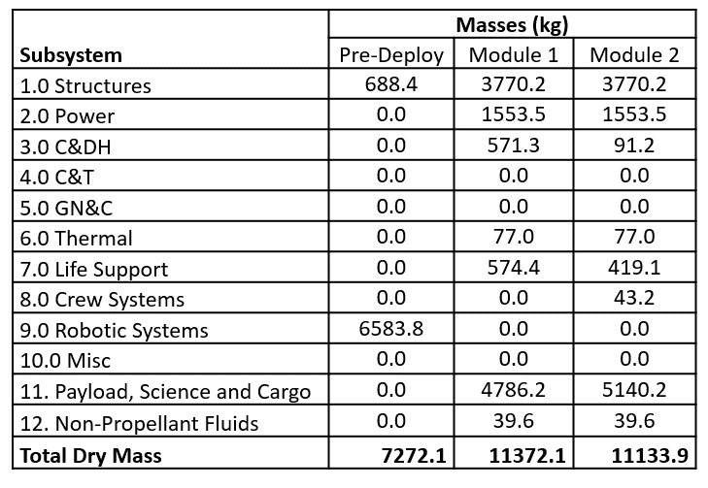
Only one module layout was completed during the study, representing a non-specific science module. [1] There was little actual connection between this layout and the science equipment selected for the laboratories. As shown in Figure 4, the layout does include a single glovebox and a sample transfer lock, but the transfer lock is in the wrong place. The transfer lock is supposed to be connected to the glovebox interior, thus allowing geology samples to be studied in the glovebox without them ever entering the cabin interior. Also, placing the transfer lock on the docking hatch as has been done in Figure 4 blocks access to the lab module, preventing the Pressurized Rover from docking to the Surface Habitat / Laboratory Module complex. Otherwise, everything is a replication of a notional stowage volume and a central table. No useful information could be obtained from evaluating this layout as it is a placeholder, not the actual laboratories created by the study.
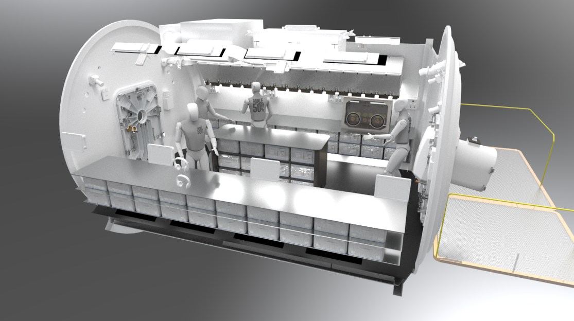
Figure 4. Notional Lab Interior. [1]
Figure 5 shows a render completed several months after the Forge study that updates the number and placement of the two lab modules docked to the Surface Habitat. A few of the external science instruments are missing but the render is generally consistent with the revision of the MEL in Table 2.
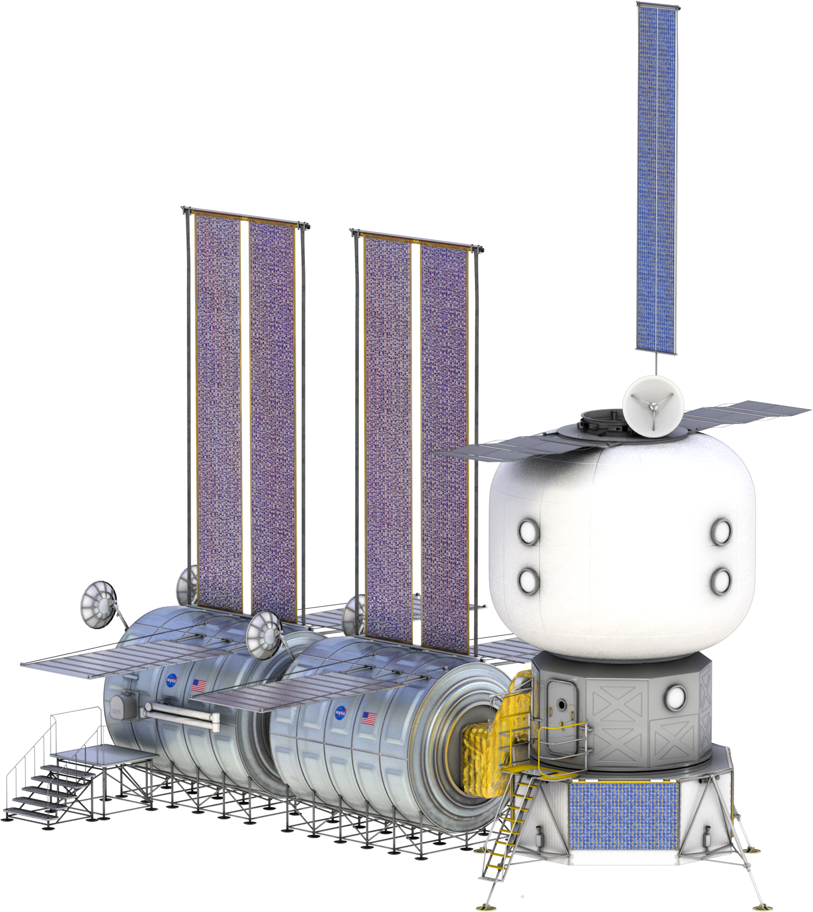
Figure 5. Notional Stationary Lab Render. [1]
In order to perform an assessment of the stationary laboratory concept, the previously mentioned inconsistencies and omissions needed to be corrected. Figure 6 and Figure 7 replaced the generic, non-specific science layout in Figure 4 with one corresponding to the science equipment listed in the adjusted MEL from Table 2. In so doing, science disciplines were also separated, placing equipment in Module 1 to support biology and human research and placing equipment in Module 2 to support physics and geology. Each module is roughly similar in size to an International Space Station (ISS) node module, measuring approximately 4.54 meters in diameter and 6.63 meters in length.
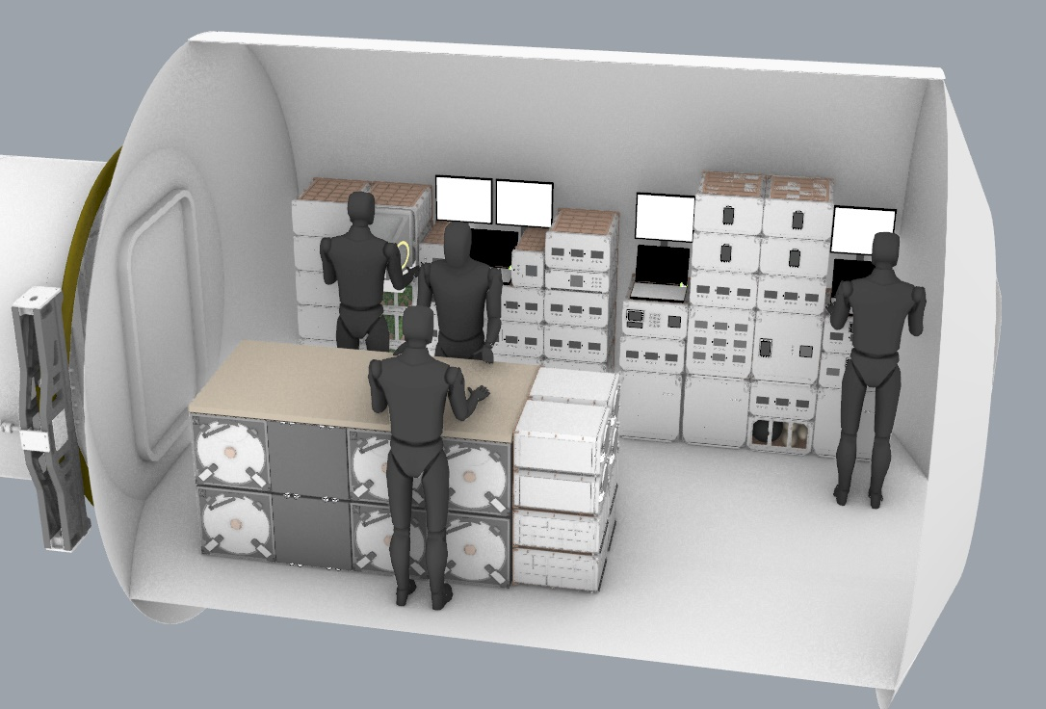
Figure 6. Biology and Human Research Laboratory Interior (Module A).
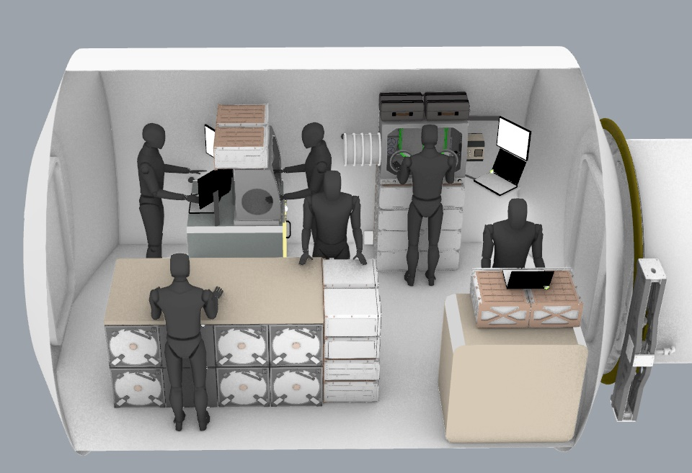
Figure 7. Physics and Geology Laboratory Interior (Module B).
Figure 8 incorporates some details not illustrated in the Figure 5 render showing the lab modules docked to the Surface Habitat. The Biology and Human Research Laboratory Module is docked to the Surface Habitat via the vertical tunnel. The Physics and Geology Laboratory Module is docked to the other end of the Biology and Human Research Module. Shirtsleeve transfers to the laboratory can be accomplished when the Pressurized Rover is docked to the laboratory.
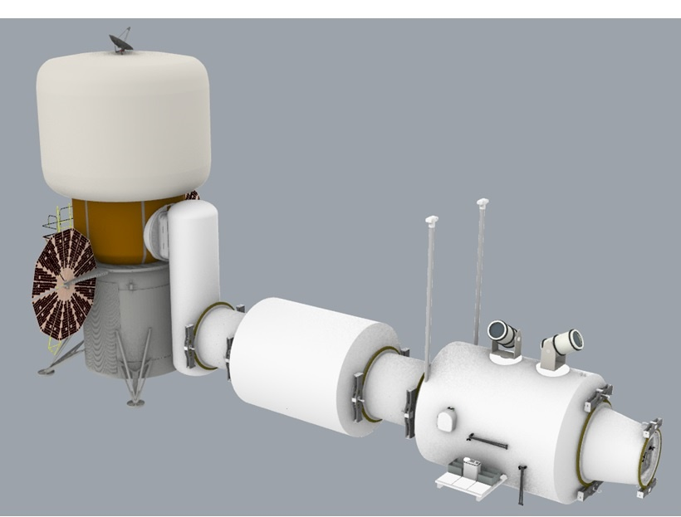
Figure 8. Updated Render of the Stationary Lunar Lab.

Mobile Laboratory
Just as with the Stationary Laboratory, the Mobile Laboratory MEL in Table 3 was identified for forward work. [1] This forward work is of such significance that habitability and human factors assessments could not take place until the work was completed.
Table 3. Mobile Laboratory Initial MEL [1]
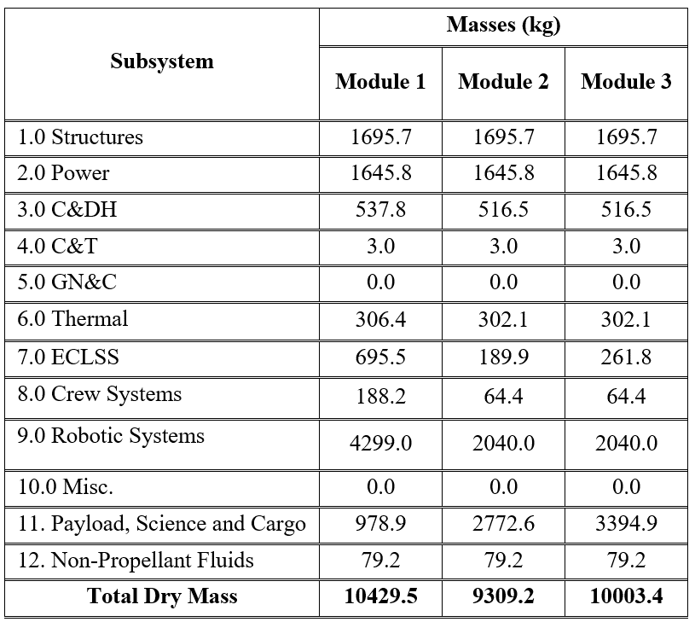
The first adjustment needed concerns the Robotic Systems mass for module 1. This 4299 kg mass includes an estimated 2500 kg offloading ramp. The ramp is not carried around with the lab module, so it does not need to be included in the module’s dry mass.
(There are additional questions concerning the offloading ramp, but they do not impact human factors and habitability evaluations. For instance, can the ramp be removed from one lander and carried to another or does every lander need its own ramp? Does it really require a 2500 kg mass?)
While the individual modules are within the performance envelope of the NASA reference lunar lander (e.g. < 12 metric tons), they may be oversized for their assumed chassis. The Forge team used the NASA reference Pressurized Rover as the basis of the mobile laboratory’s mobility system. Unfortunately, the mobile laboratory masses significantly exceed that of the PR, and it is not clear that the PR chassis can operate effectively (or at all) with this much weight. Within the time span of the Forge study (five meeting days spread across five weeks) there was no credible means to develop an entirely new mobility system and thus use of the PR mobility system is logical, but carries the limitations of the PR system. One cannot assume that it has additional performance margin beyond that identified by the PR team.
The spring 2021 configuration of the NASA reference PR has an estimated total mass (including summer 2021 estimates for payloads, crew, and other cargo that might be placed upon it) of less than 7700 kg. It is therefore immediately obvious that the mobile laboratory must consist of more than the three modules shown in Table 3 and Figure 9.
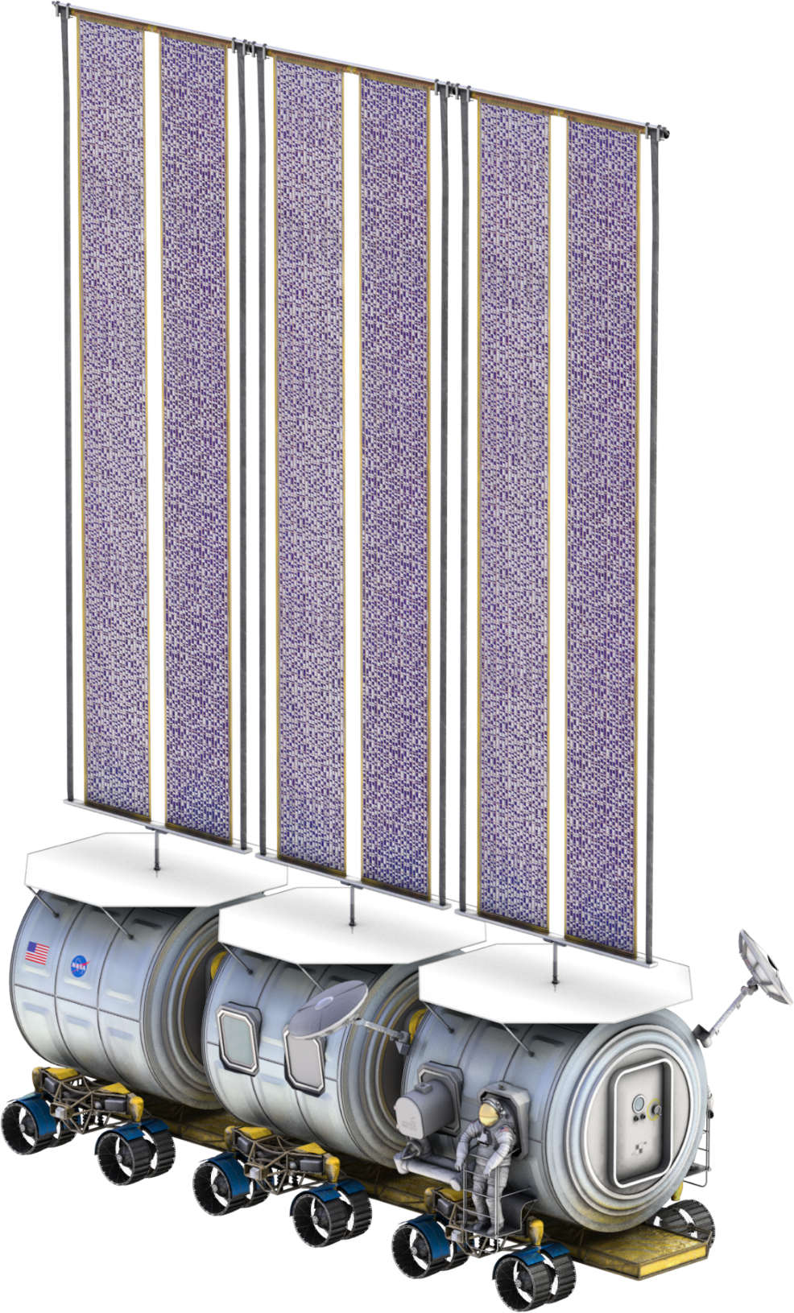
Figure 9. Initial Render of the Mobile Lunar Lab. [1]
Other challenges with the three-module configuration are architectural. While the Forge study did not complete a notional layout similar to that performed for the stationary concept prior to the final team meeting, it is clear from familiarity with the NASA reference PR that there is no room in Module 1 for the nominal PR habitation plus any meaningful science outfitting. Correspondingly, the Forge team created a render at the end of the study, shown in Figure 10, of an old variant of the Pressurized Rover being used as an additional module.
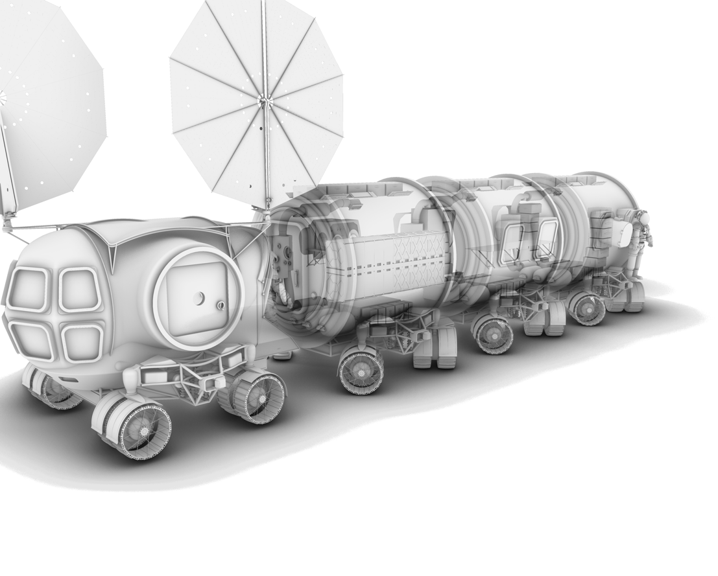
Figure 10. Mobile Laboratory with Additional Pressurized Rover-Derived Module. [1]
Another architectural challenge remains. Figure 11 shows both a science transfer lock and an active suit port on the rearmost module, suggesting it serves both geology and extra-vehicular activity (EVA) functions. In a contingency, crew may need to ingress the mobile lab via an airlock. There may also be operational reasons to do so, such as the deploy or recovery of science instruments. However, the science instruments inside the lab modules are intended for pressurized operations and could be damaged by exposure to vacuum. Additionally, there is insufficient volume inside the laboratory modules to don/doff spacesuits. While it may be possible to don/doff a suit in lunar gravity in a Pressurized Rover cabin (Module 1), it is undoubtedly awkward and would transfer significant dust to the cabin interior. Thus, the geology lab is not an appropriate location for airlock functionality, neither are any of the other modules. Thus, a fifth module is needed for EVA support.
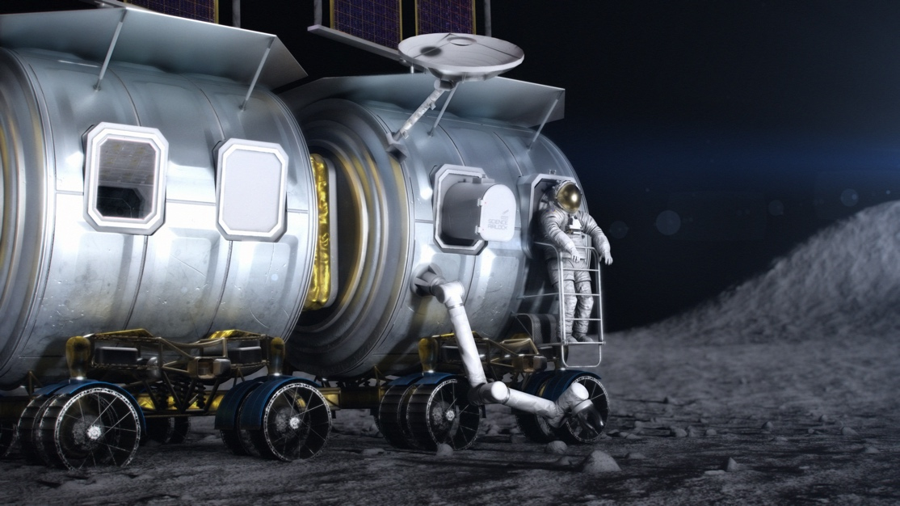
Figure 11. Mobile Laboratory Module Featuring Both Suitport and Science Transfer Lock Functionality. [1]
The five-module architectural solution also matches a mass allocation that uses the PR MEL as the first module and as a baseline for the others, replacing the crew systems mass with science or EVA equipment masses in modules 2-5.
All of the modules are derived from the NASA reference third generation Pressurized Rover cabin, though the barrel lengths have been stretched to roughly equal the length of the chassis. Each of modules 2-5 are approximately 2.24 meters in diameter by 4.97 meters in length (Figure 12). The modules dock front-to-back and travel as a single docked unit.
Module 1 (a modified PR) provides crew habitation and driving operations; Module 2 supports biology and human research; Module 3 supports Physics; Module 4 supports geology; and Module 5 supports EVA. Without releasing specific details of the PR MEL, the resulting masses for the five-module configuration vary from 7224.1 kg (Module 5 – EVA) to 7682 kg (Module 4 – Geology). This updated mobile laboratory is shown in Figure 12 and Figure 13.
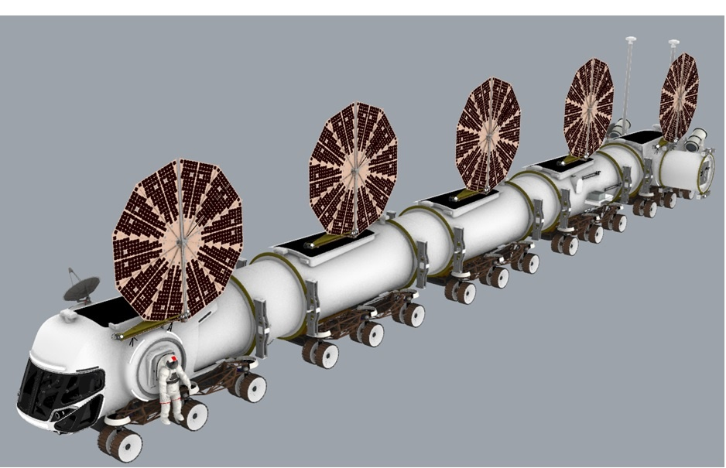
Figure 12. Updated Render of the Mobile Lunar Laboratory – Forward View.
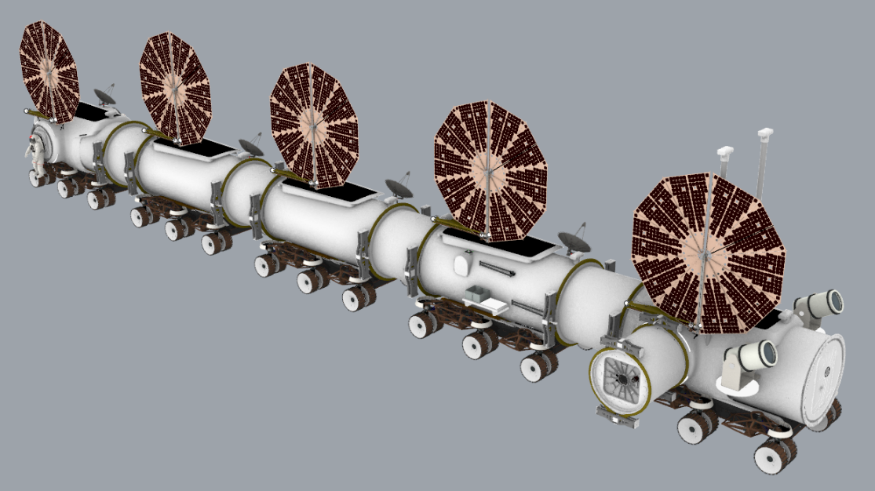
Figure 13. Updated Render of the Mobile Lunar Laboratory – Rear View.
The solar array and radiation configurations shown in the updated modules reflect the spring 2021 configurations of the NASA reference Pressurized Rover. Both solar and thermal systems are undergoing redesign within the PR team as of the time of this writing and rather than use an intermediate configuration that is in flux, the spring configuration is being retained.
The first module, the Habitation Module, shown in Figure 14, is a modified Pressurized Rover. The modifications are in the aft section of the rover so that it can dock to the other modules, and suitports replace the side hatches. The crew must remain in the Habitation Module when the laboratory is in motion.
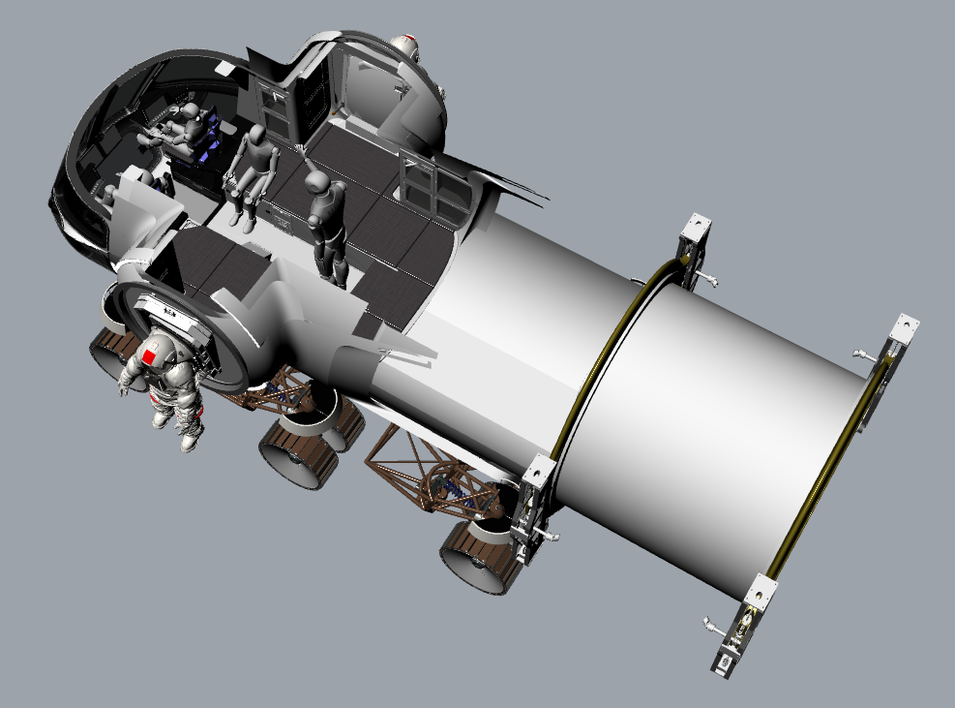
Figure 14. Mobile Laboratory Habitation Module.
The middle three modules are dedicated laboratory modules. Module 2, shown in Figure 15, is the Biology and Human Research Laboratory, while Module 3, shown in Figure 16, is a Physics Laboratory and Module 4, shown in Figure 17, is the Geology Laboratory. These laboratory modules only have forward and aft docking ports, with no side hatches or suitports. Module 4 does have a science airlock connected directly to an internal glovebox.
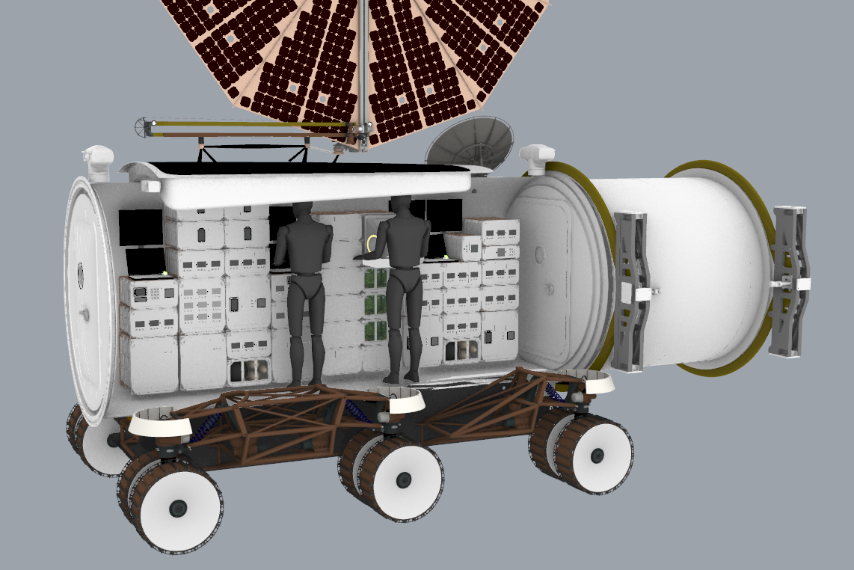
Figure 15. Mobile Laboratory Biology and Human Research Module.
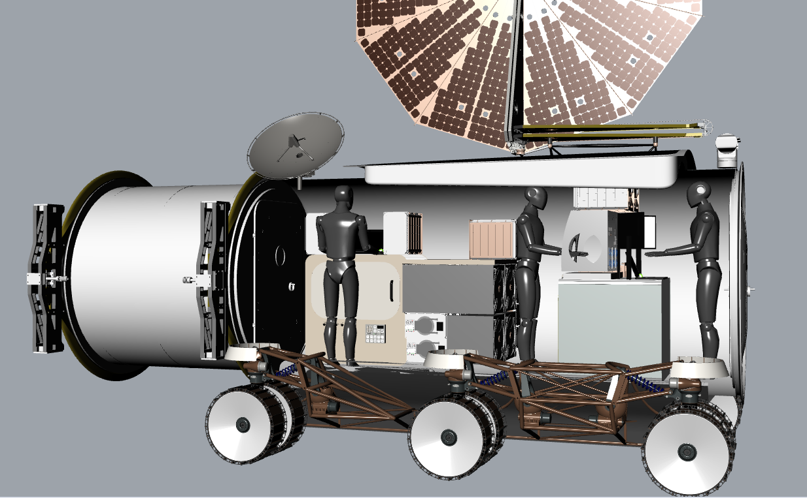
Figure 16. Mobile Laboratory Physics Module.
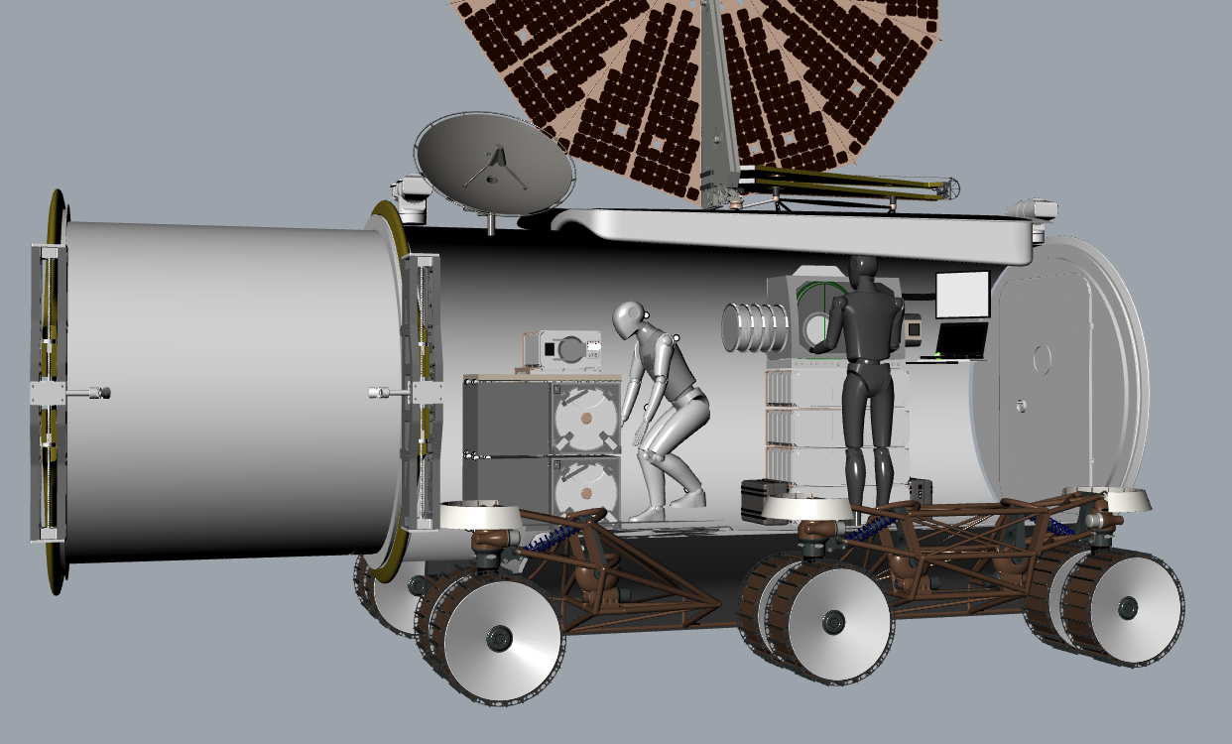
Figure 17. Mobile Laboratory Geology Module.
The fifth module is the EVA Module, shown in Figure 18. It has two suitports and an airlock. It is based on the Pressurized Rover pressure shell with several differences. It has forward and aft docking ports and the side hatches are replaced with suitports.
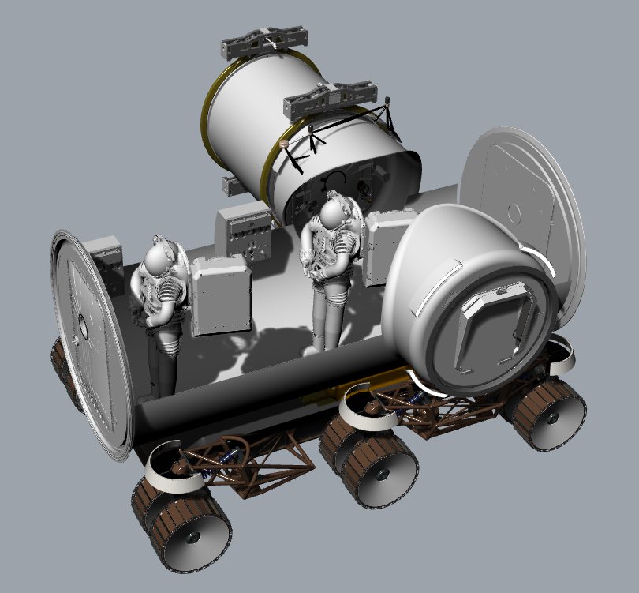
Figure 18. Mobile Laboratory EVA Module.
The Surface Habitat crew must leave the habitat EVA via the habitat airlock in order to utilize the mobile laboratory or conduct traverses with it. The mobile laboratory can dock to the Pressurized Rover via the EVA Module side docking adapter which docks to the Pressurized Rover’s Side hatch. In a contingency situation, a Pressurized Rover can dock at the suitport locations in the Habitation Module. However, the mobile laboratory cannot dock with the Surface Habitat. The Surface Habitat crew must go EVA to move between the habitat and the laboratory. Docking to the Surface Habitat would require a vertical pressurized tunnel similar to the one used by the Stationary Laboratory and a means (such as the ATHLETE) to transport the tunnel from its lander to the Surface Habitat and connect it. This would add a sixth lunar cargo landing to the mobile laboratory system.

Methodology
With these two lunar laboratory concepts in mind, the purpose of the study was to obtain preliminary data on human interfaces and configuration habitation layout for a lunar science mission for each concept. This will be completed in two phases. Phase One has been completed and is the subject of this paper. The data collected in Phase One was used to compare the advantages and disadvantages of the two concepts in order to down select to one configuration.
In order to collect the data required, two groups of experts (Expert Group A included Geology, Space Biology, and Physical Science. Expert Group B included Human Research and Human Factors) participated in two on-line surveys. For this phase of testing, the human factors team decided on two avenues for collecting the needed survey responses and counterbalanced the way the surveys were administered. The first of these surveys was a card sort task. The card sorting method is used to help design or evaluate a design configuration layout. In a card sorting session, participants organize topics or functional areas into categories that make sense to them. This type of data collection is beneficial in that it helps the team understand the expectations of the users and can be used to help optimize the interior/exterior layout. The team used a digital card sort that represented the areas of interest and then asked the participants to decide which of the listed functional elements should go into which proposed area, shown in Figure 19 and Figure 20.
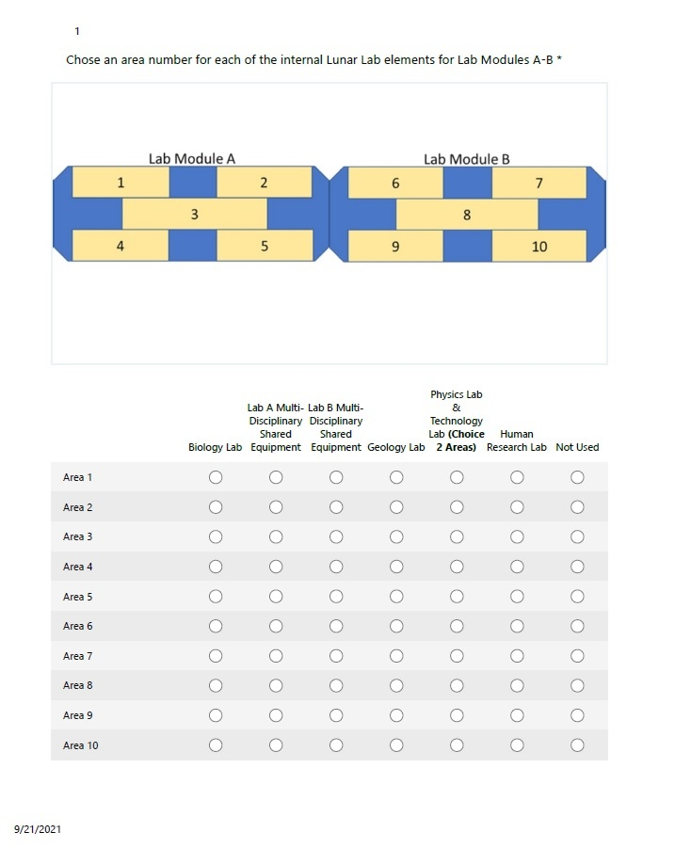
Figure 19. Example of the card sort task for Concept 5.

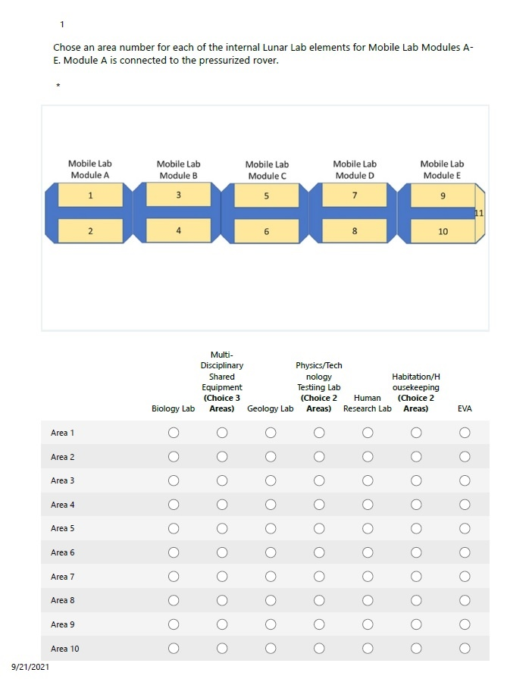
Figure 20. Example of the card sort task for Concept 7.

The next data collection tool implemented was a modified System Usability Scale (SUS) survey, shown in Figure 21 and Figure 22. The SUS is a survey that is used to assess the usability of a variety of products [2], [3] and is intended to measure perceived ease-of-use. The reliability of the SUS has been extensively studied. For example, in a study conducted by Bangor, Kortum, and Miller (2008) [4], they examined the results of 2,324 SUS surveys from 206 usability tests over a ten year period and found the SUS was highly reliable (alpha = 0.91) over a wide range of interface types [2], [5]. The 2008 study also confirmed the SUS was predictive of impacts of changes to the interface when multiple changes to a single product were made over a number of iterations [2]. The survey consists of only ten statements, each having a five-point scale ranging from Strongly Disagree to Strongly Agree. There are five positive statements and five negative statements, which alternate [2]. The method of calculating the SUS score requires the investigator to first sum the score contributions from each item. The contribution range of each SUS item will range from 0 to 4; thus, for items 1,3,5,7 and 9 the score contribution is the scale position minus 1, while for items 2,4,6,8 and 10 the contribution is 5 minus the scale position. Finally, the investigator multiplies the sum of the scores by 2.5 to obtain the overall value of the system’s usability. SUS scores have a range of 0 to 100. To be considered above average (with a percentile of 50% or greater), a SUS score of 68 or higher is needed. This is based on an average SUS score from 500 studies [6], [7], [5].
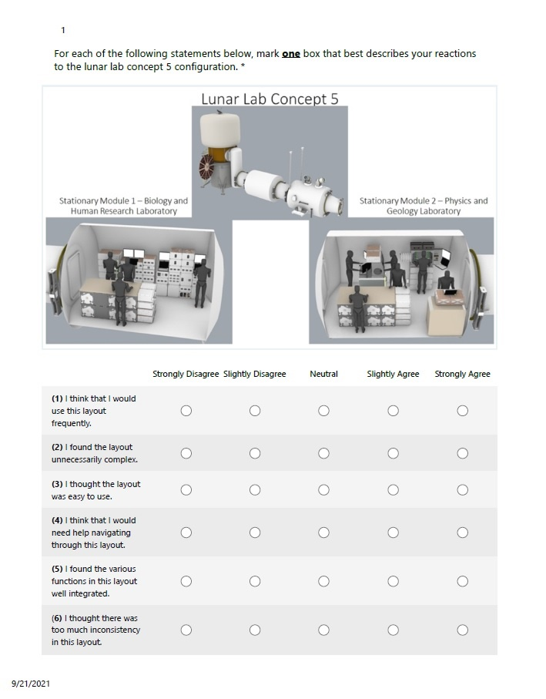
Figure 21. Example of the SUS for Concept 5.
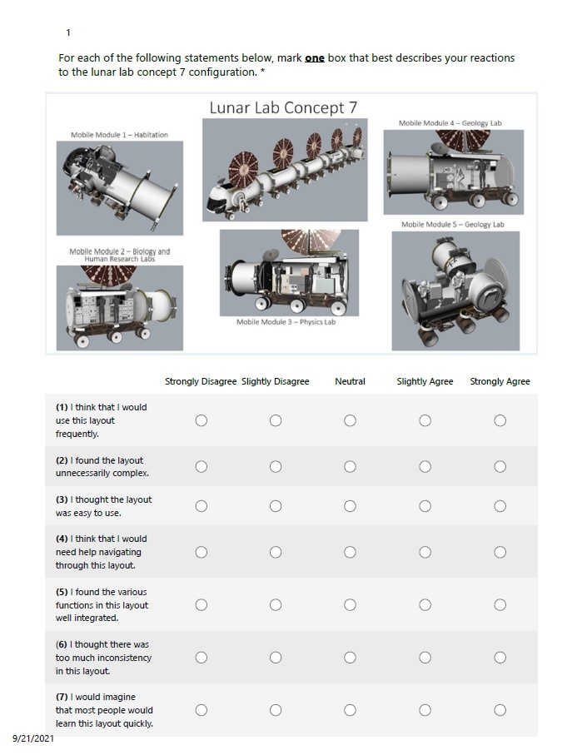
Figure 22. Example of the SUS for Concept 7.

Though not discussed in the paper, Phase Two testing will implement two other surveys-the Capability Assessment Survey and the Science Productivity Survey. The Capability Assessment ratings are used to identify which capabilities of a particular design are required, which might enhance the design and which capabilities provide marginal or no meaningful enhancement and can therefore be excluded, which could result in cost savings without impacts to the mission success. The capability assessment scale is a 10-point scaled used to rate the extent to which candidate capabilities might enable and enhance future configurations, shown in Figure 23. The scale has been used in several NASA analog tests with the latest being the Broad Agency Announcement (BAA) NextSTEP Ground Habitat Testing. The scale consists of five categories: essential/enabling (impossible or highly inadvisable to perform the mission without this capability), significantly enhancing (capability is likely to moderately enhance one or more aspect of the design), moderately enhancing (capability is likely to moderately enhance one or more aspects of the design or significantly enhance the design on rare occasions), marginally enhancing (capability is only marginally useful or useful only on very rare occasions), and little to no enhancement. Each category incorporates two numerical ratings to discriminate preferences.
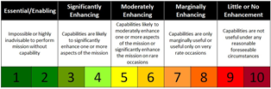
Figure 23. The Capability Scale.

The science productivity survey will collect data on how to optimize the design layout for best scientific task performance. Productivity is commonly defined as a ratio between the output volume and the volume of inputs. In this case, the quantity of science being accomplished during a set amount of time and constraints. Data for this area will aid in the understanding of the amount of equipment and placement of equipment either within or outside of the concept module designs to optimize crew performance. Questions would inquire about the quantity of items needed and if they are placed in the correct module(s).

Results and Discussion
Originally, there were ten lunar lab concepts that the innovation team proposed. Through a team down-selection process, [1] these concepts were down-selected to the two that were developed during the course of the Forge study and that are evaluated here—Concept 5, a multi-module stationary lunar lab and Concept 7, a multi-module mobile lunar lab. Thirteen experts from five science disciplines participated in the study. In order to counterbalance the study, the participants were divided into two groups A and B. Group A examined the stationary lab first then the mobile lab, while Group B studied the mobile concept first and finished up with the stationary concept. Table 4 illustrated the discipline classes and the number of participants in each class. These experts were asked to score two different tests on each design concept: 1) A card sort test and 2) the SUS test.
Table 4. Expert Disciplines
Disciplines | Number of Participants
Geology | 3
Space Biology | 2
Physical Science | 3
Human Research | 1
Human Factors | 4

Card Sort Results
For vehicle designers, it is essential to involve different users when evaluating their design(s) [8]. Card sorting has roots in the cognitive sciences and is widely accepted as a research method to inform a design [9] and to elicit participant’s underlying mental models about a conceptual configuration [10]. This type of analysis has been used for conceptual building façade design [8], urban planning [9], and architectural aesthetics [11] [12]. A qualitive frequency distribution analysis of the functional elements was mapped to the preferred location areas, both internally and externally, for each vehicle configuration.
The participants were asked to place six to seven functional elements within the interior of the vehicles and three to four functional elements on the exterior of the vehicles depending upon the design. Given a blank top-view with specific areas for each vehicle configuration, the experts placed each functional element into a specific area. The highest frequency of where each functional element was placed within a specific area was used to map the overall layout.
Stationary Lunar Lab
For the dual module stationary lunar lab, the six functional elements consisted of a biology lab, multi-disciplinary shared equipment for lab A, multi-disciplinary shared equipment for lab B, physics and technology lab, and a human research lab. For the exterior, functional elements included a back porch, minus 200C freezer, two external manipulator robotic arms, two external mounted video cameras and masts, and two telescopes. The internal layout was a blank top-view type floorplan consisting of ten areas, shown in Figure 24, while the exterior was three blank three quarter views consisting of eleven areas, shown in Figure 25 and 26.
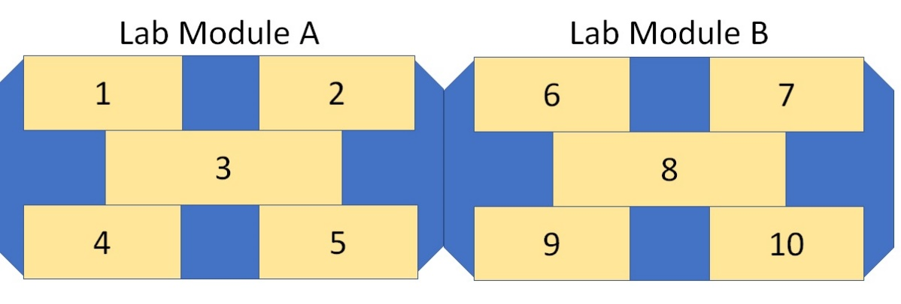
Figure 24. Interior top-view layout of the stationary lunar lab.

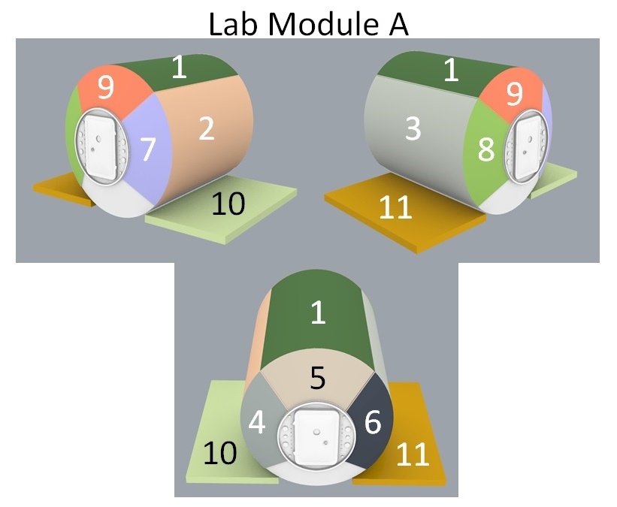
Figure 25. Three-quarter view external layout of the stationary lunar lab A.
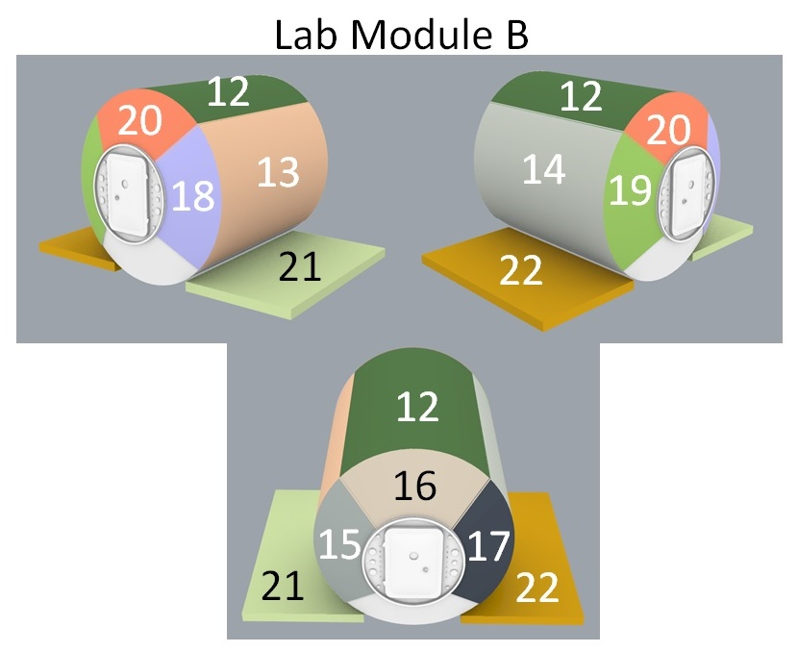
Figure 26. Three-quarter view external layout of the stationary lunar lab B.

Results from the card sort task for the stationary lunar lab modules illustrates the need to keep “clean” versus “dirty” elements separate to control and reduce cross-contamination between modules, as indicated in Figure 27. In Lab Module A, the majority of experts placed the Biology Lab in Area 1 (ƒ9) with Area 4 as an alternate location. The Human Research Lab was located at opposite end of the module for the Biology Lab in Area 5 (ƒ6). Finally, the Multi-Disciplinary Shared Equipment placed in the center—Area 3 (ƒ7). For Lab B, Area 6 and Area 8 was the most popular for locating the Physic/Technology Testing Lab (ƒ7) and Multi-Disciplinary Shared Equipment (ƒ7), respectfully. About half of the experts chose Area 10 for the Geology Lab (ƒ5). Alternate areas for the Physics/Technology Test Lab includes Areas 7 and 9.
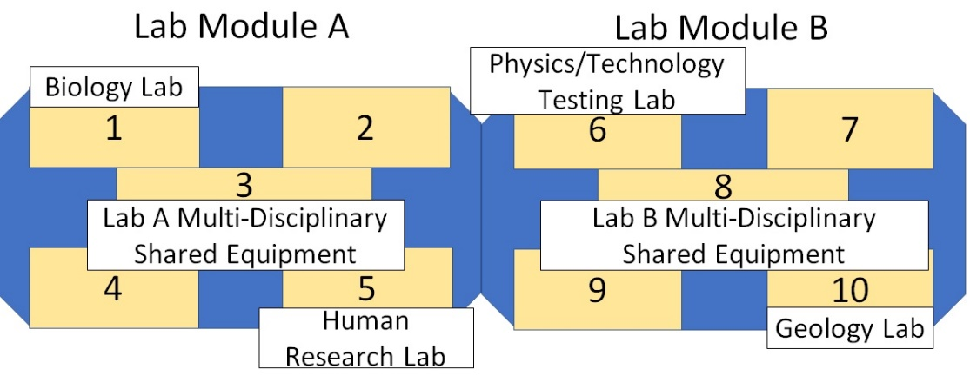

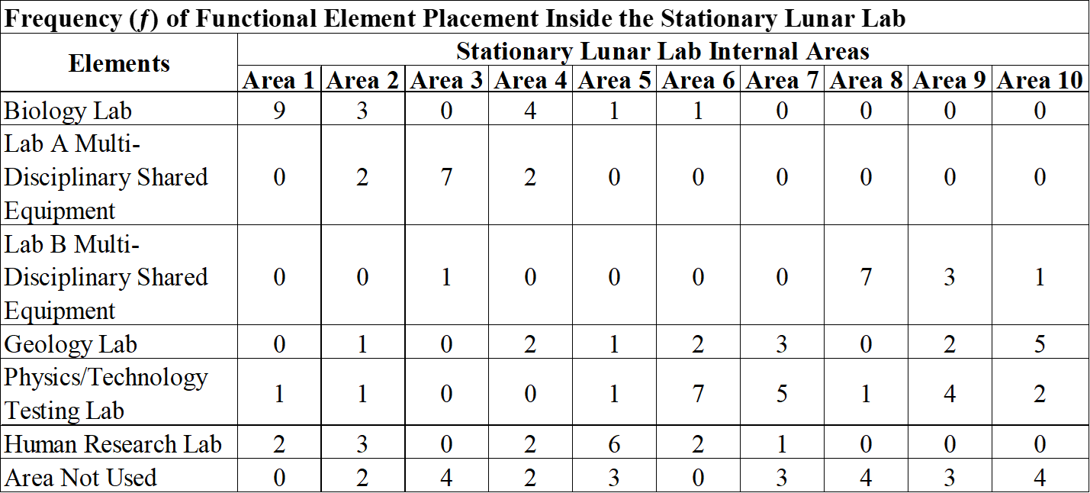
Figure 27. Frequency (ƒ) mapping of the six functional elements within the two stationary lunar lab modules.

In both modules, experts located the Multi-Disciplinary Shared Equipment in the center of the space. This was to reduce the time it would take to translate across the module to grab a tool. Though it sounds somewhat insignificant, crew time spent translating to find tools can add up over the mission and significantly impact crew productivity over time. Having shared tools centrally located aids in reducing the overall time lost, assuming the commonality of the tools outweighs the risk of cross-contamination between labs. However, some experts indicated these areas should be reserved for translation paths. Further analysis will be needed to assess this finding. In the areas of the Physics/Technology Testing Lab, experts noted provisions should be made to enable external attachments of physics experiments which would require a small airlock. This also holds true for the Geology Lab as a small airlock would bring in geological and lunar dust samples while reducing lunar dust contamination. Geology experts also indicated an external transfer port would be needed inside a glovebox for sample analysis and further reduce lunar dust contamination within the stationary lunar lab modules. As for areas that were not assigned a functional element, experts suggested these areas would be favorable for future lab expansion or increased stowage and should be equally spread across the modules.
Externally, experts could spread out the four functional elements between the two modules. For Lab Module A, the Telescopes 1 and 2 were assigned Area 1 (ƒ8) by the experts, while the External Manipulator Robotic Arms 1 and 2 were assigned Area 2 (ƒ5). It should be noted that both the Telescopes and Robotic Arms come in pairs and were not allowed to be separated by the design team. As for Lab B, the External Mounted Video Cameras and Masts were positioned in Area 20 (ƒ4) and the Back-Porch minus 200⁰C Freezer was located in Area 21 (ƒ6), shown in Figures 28 and 29.
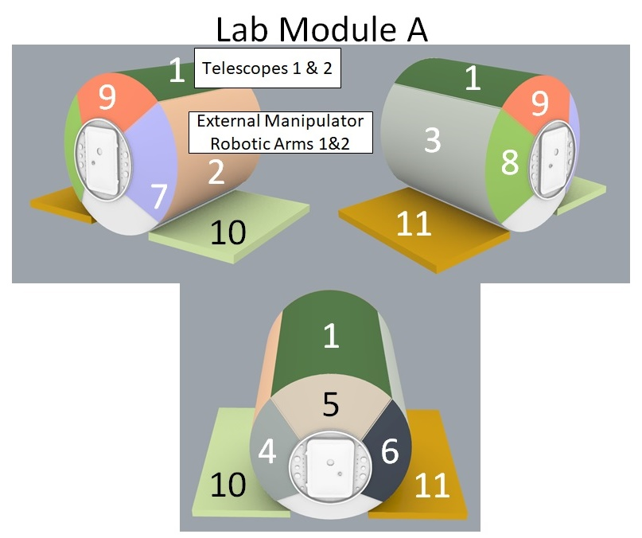
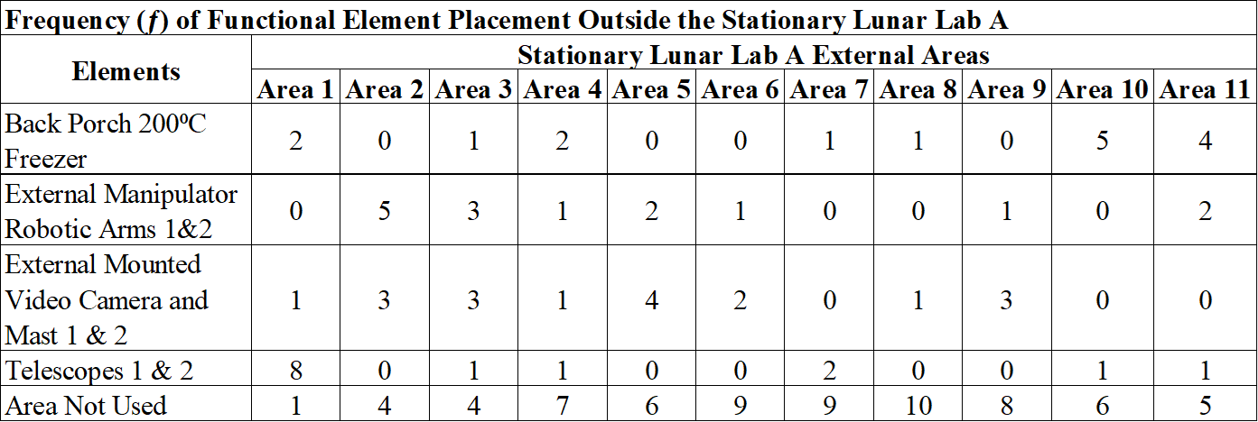
Figure 28. Frequency (ƒ) mapping of the four functional elements outside the two stationary lunar lab A.

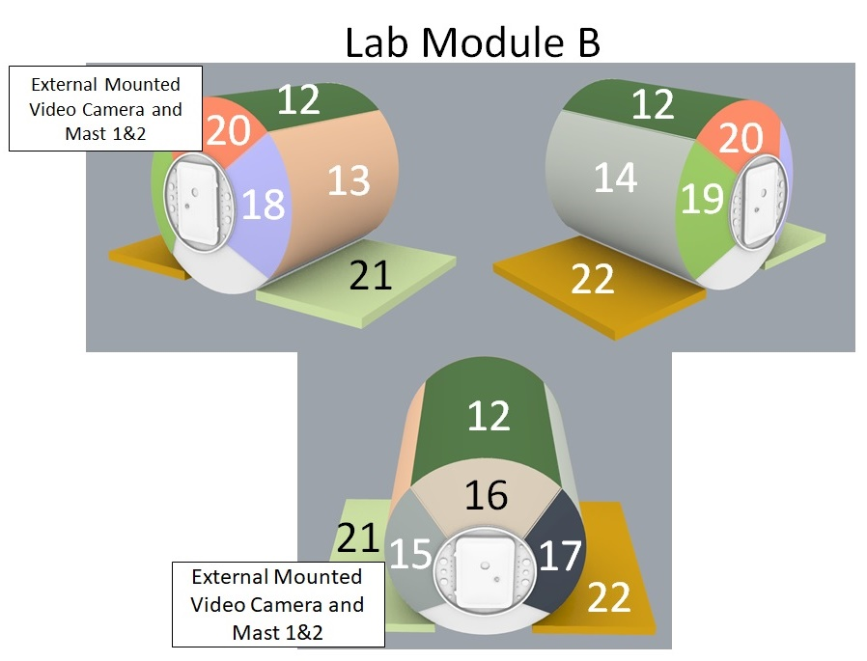
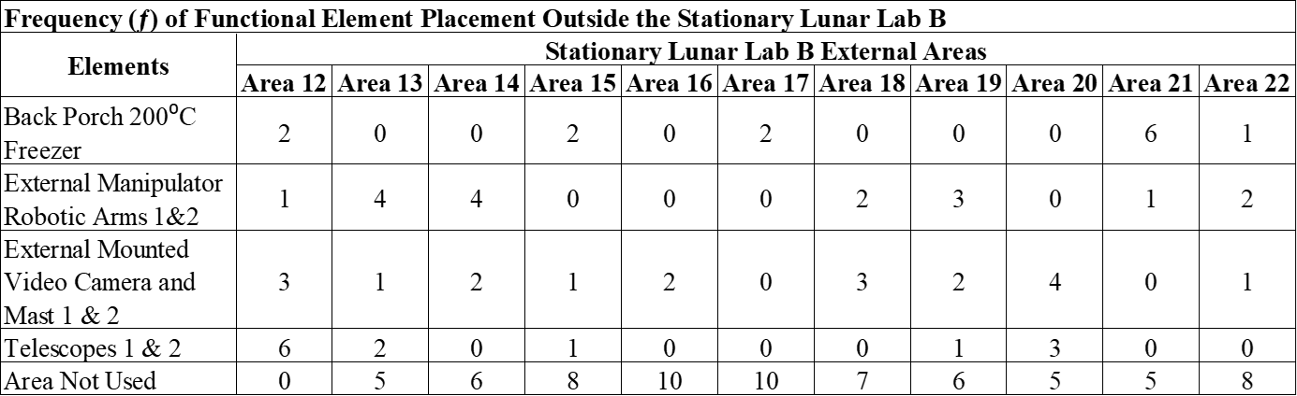
Figure 29. Frequency (ƒ) mapping of the four functional elements outside the two stationary lunar lab B.

Experts expressed that they wanted to separate any functional element that came in pairs to be able to place these items on both modules. Most wanted to position the robotic arms across the two modules in Areas such as Area 14 and Area 21. This way the arms have access to the Back Porch Freezer location outside Lab Module B, while at the same time having access to the Pressurized Rover (PR) outside Lab Module A. Separating these item pairings would increase the capability across the stationary lunar lab modules. Experts placed the telescopes up high on the lab exterior to get them “out of the way” of other operations around the vehicle. This also held true for the mast video cameras. The experts stated this would maximize the flexibility for pointing the telescopes in any direction around the lab. As for the mast cameras, this flexibility gives the crew a way to monitor the surface habitat and other assets. Additionally, assuming the robotic arms have cameras, this would only leave one side of the surface base that would not be able to be monitored by crew. Experts also indicated that having sampling staging areas outside the lunar lab would be a nice to have feature.

Mobile Lunar Lab
In the five module mobile lunar lab concept seven interior functional elements were considered which included a biology lab, a multi-disciplinary shared equipment area, geology lab, physics and technology lab, a human research lab, an area for housekeeping and an area for EVA. External functional elements included two external manipulator robotic arms, two external mounted video cameras and masts and two telescopes. Both internal and external layouts were top-view floorplan style layouts with eleven specific areas identified (Figure 30).
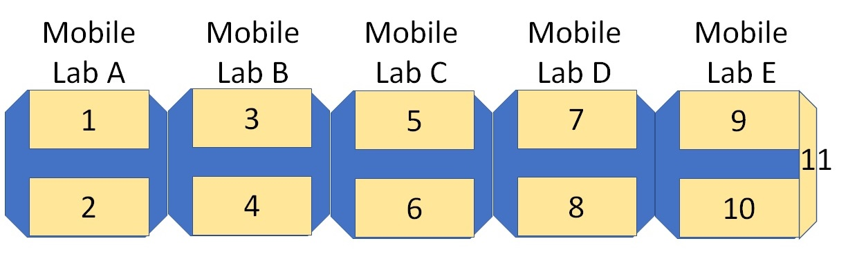
Figure 30. Interior and exterior top-view layout of the mobile lunar lab.

Card sort results for the interior layout of the mobile lunar lab concept indicated experts were not as cohesive as with lab locations in the stationary lunar lab concept design. Several functional lab elements had frequency counts as low as 33% from the total sample population, which makes the confidence of the analysis not as high. However, in these functional areas, these counts were the highest for that specific area and will be reported for completeness. In mobile lab module A, essentially the Pressurized Rover where all crew habitation activities take place, the majority of experts placed Habitation/Housekeeping functional element in Area 1 (ƒ7) with an alternate location in Area 2. Lab module B housed both the biology lab in Area 3 (ƒ4) and Human Research Lab in Area 4 (ƒ4), while lab module C houses the Multi-Disciplinary Shared Equipment in Area 5 (ƒ8) with an alternate location in Area 6. Experts place the Physics/Technology Testing Lab in Area 8 (ƒ6), while Area 9 was designated as an alternate location is in lab module D. Also located in lab module E is the Geology Lab in Area 10 (ƒ4) and the EVA area in Area 11 (ƒ11) (Figure 31).
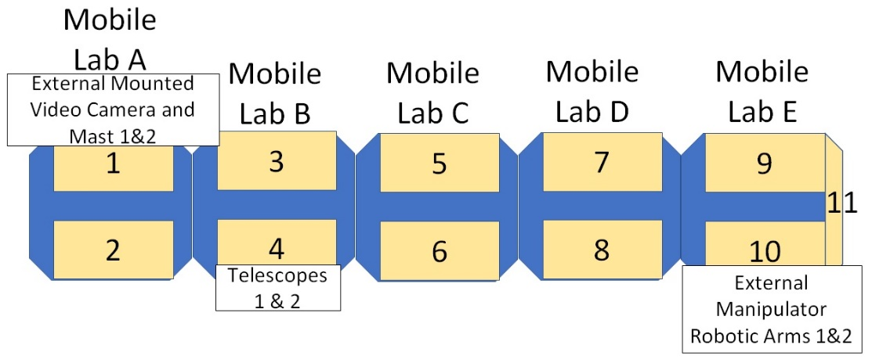
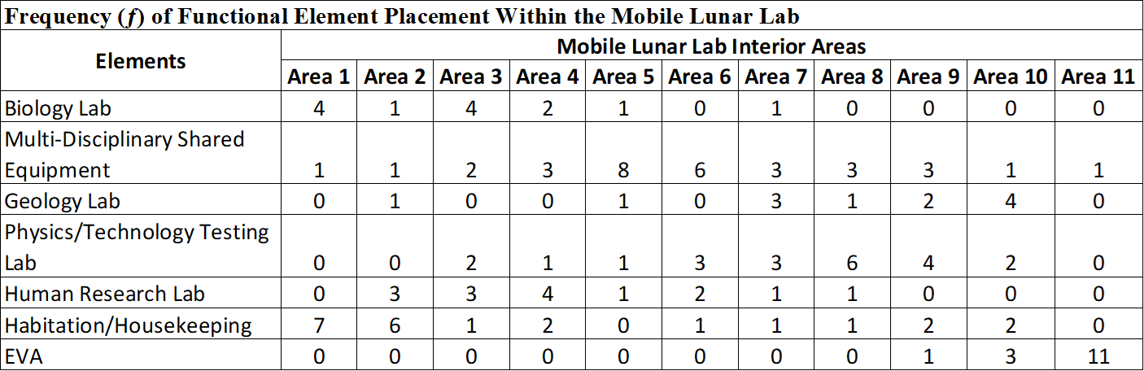
Figure 31. Frequency mapping of the seven functional elements within the five mobile lunar lab modules.

Figure 32 shows data for the mobile lab. Here, the participants cleverly positioned all “clean” elements at the front of the train in modules A and B, while using module C as a soft barrier for the “dirtier” elements in modules D and E. In essence module C becomes the control for cross-contamination between the front half and the back half of the train. Additionally, assuming there are shared tools between labs, each area in module C can be specified for those labs. For example, Area 5 could house all the shared tools and equipment for the Biology and Human Research Labs, while Area 6 could house all the equipment for the Physics and Geology Labs; thus, reducing cross-contamination even further. The experts also noted that housekeeping will need to be in two locations—one in lab A and another in lab E to reduce contaminating the entire train. With EVA at the end of the train, minimizing the contamination and dust within the train is a must and having another housekeep area in with the EVA section reduces the risk of crew traversing the vehicle with contaminants on them that could affect science operations. Additionally, having the Geology Lab and EVA in one module gives the crew an option of dropping off that module at another location while continuing with a subset of modules. Of course, as previously noted, the participant desire to combine Geology and EVA within one module may not be volumetrically possible given the size of the module and it may not be operationally possible due to the need to take the EVA module to vacuum.
Only three of the five modules had external elements positioned on them. Mobile Lab A has the External Mounted Mast Video Cameras placed in Area 1 (ƒ5). Lab B housed both Telescopes 1 and 2 in Area 4 (ƒ7). Finally, the External Manipulator Robotic Arms 1 and 2 were located in Area 10 (ƒ4) of mobile lab module E. Experts did not place any elements on the outside of lab modules C and D.
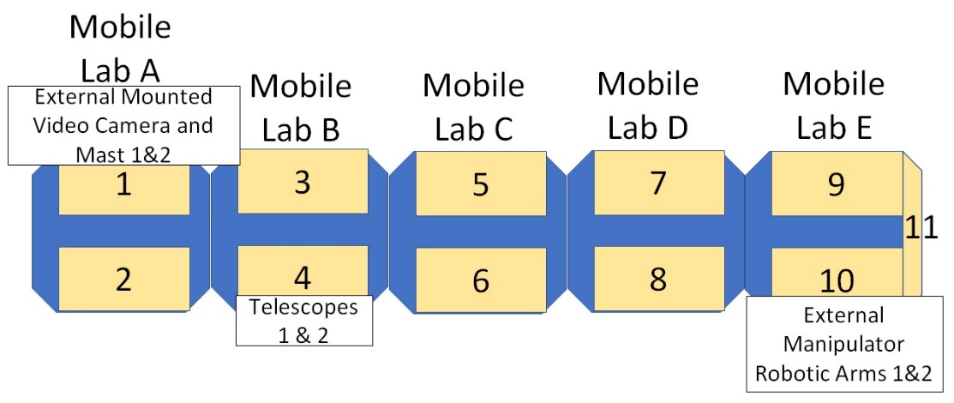
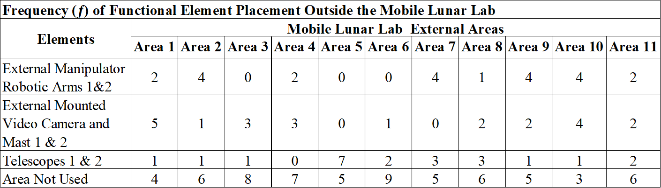
Figure 32. Frequency mapping of the three functional elements outside the mobile lunar lab.

The External Mounted Mast Video Cameras were placed at the front of the train with module A for early detection of hazards while in transit. Once at the chosen lunar site, the crew can use the cameras to inspect the rest of the vehicle as well as monitor EVA operations outside on the lunar surface. If a module or a subset of modules were to be deployed, then the crew would be able to monitor the safety of the operation. As with the telescopes and robotic arms on the stationary lunar lab, experts wanted to separate the pairings to increase capability of operations. For the mobile lunar lab, experts wanted to place the Telescopes on separate modules to maximize their flexibility. Additionally, if some subset of modules are deployed and left behind, having a telescope on that deployed subset would increase science capabilities while still having a telescope on the moving portion of the train, effectively having a science asset in two locations instead of only one. This same line of thought is true for separating the robotic arms. For example, one robotic arm can be located in Area 11 for sample delivery with another could be positioned in Area 7 to reconfigure multidisciplinary science without interfering with sample delivery.

SUS Results
With the SUS test, the participants answered the ten questions to rate the usability and practicality of each vehicle design concept. Unlike the card sort test where the participants were given only a blank layout, vehicle designers created a hypothetical layout for the experts to score. Experts saw both an external view of each vehicle as well as internal views. The Stationary Lab is shown in Figure 33, Figure 34, and Figure 35. The Mobile Lab is shown in Figure 36, Figure 37, Figure 38, Figure 39, Figure 40, and Figure 41.
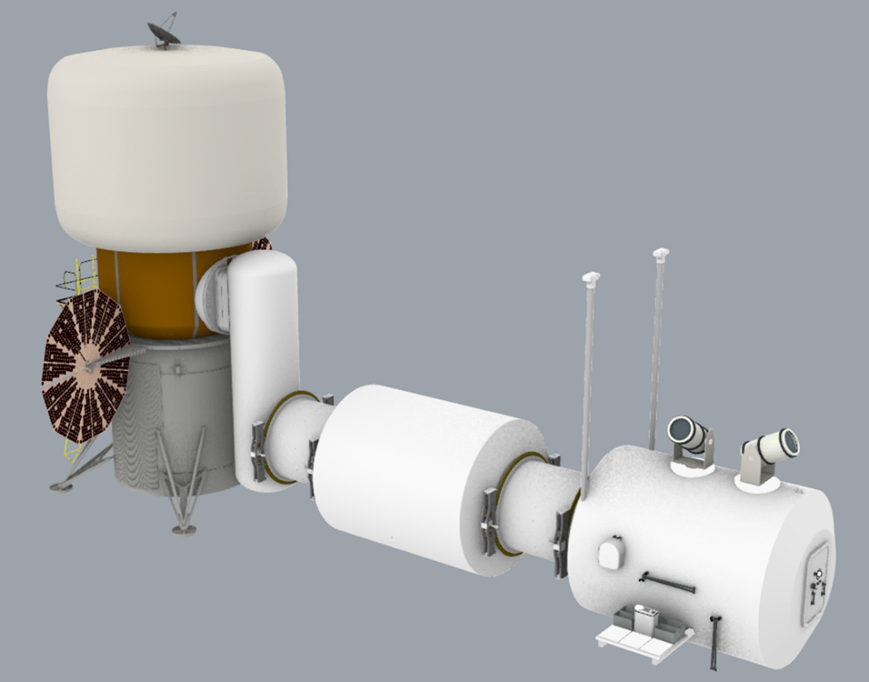
1
Figure 33. Stationary Lunar Lab Exterior

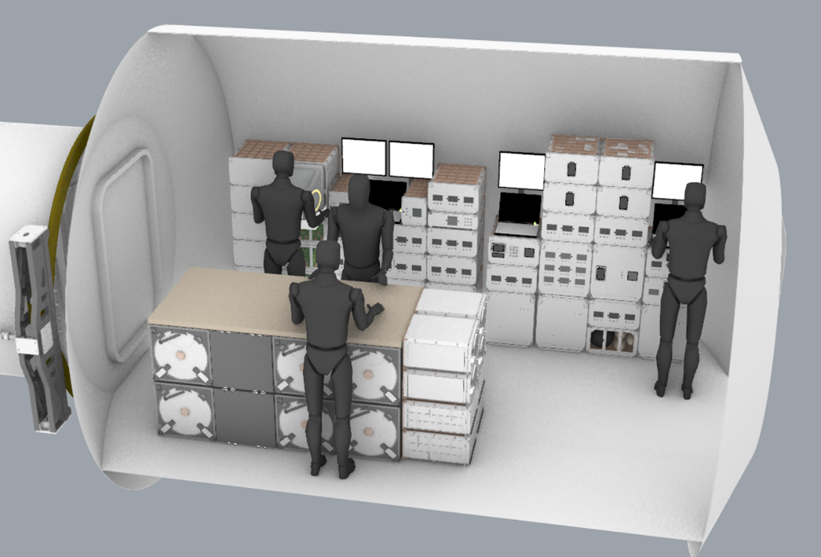
2
Figure 34. Stationary Lunar Lab Module A – Biology and Human Research
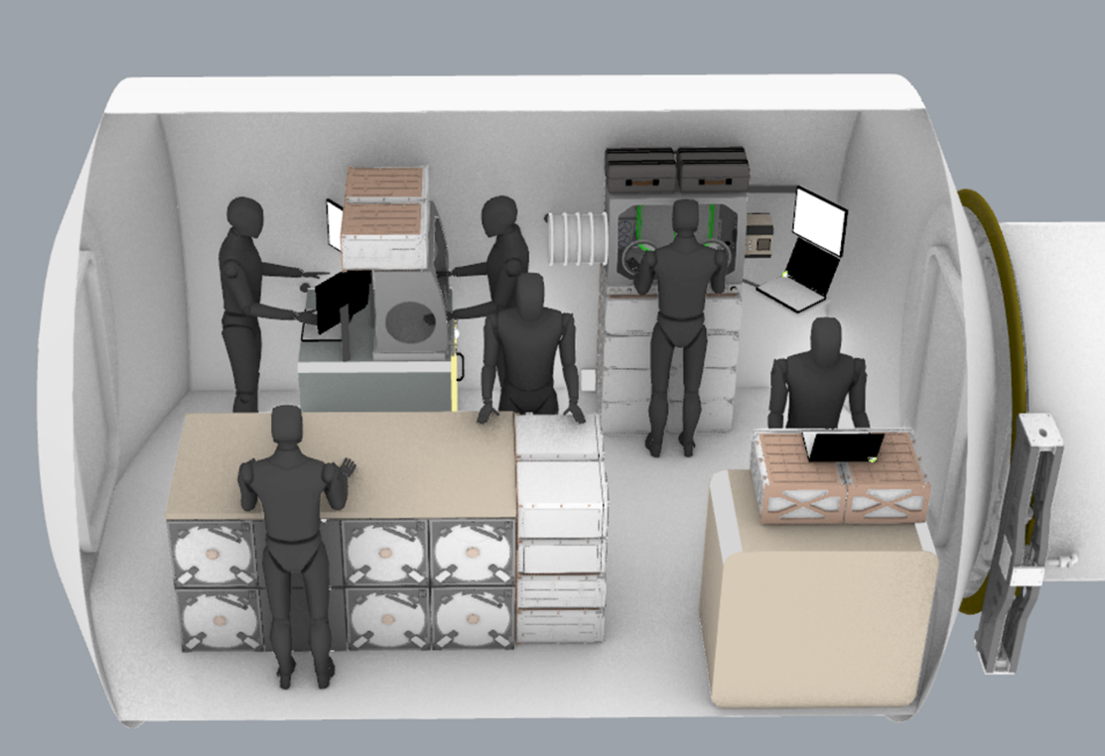
3
Figure 35. Stationary Lunar Lab Module B – Physics and Geology
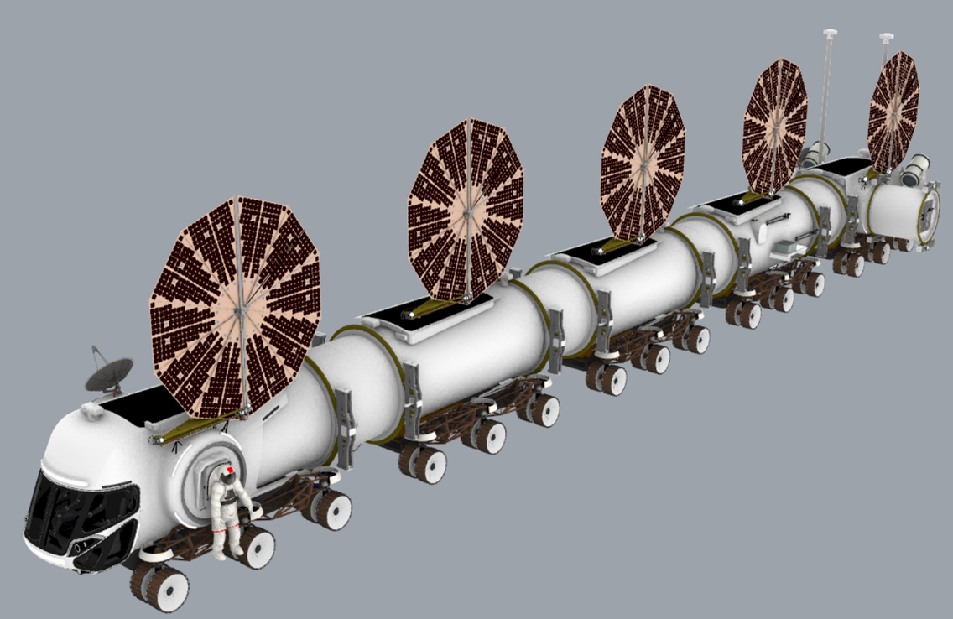
1
Figure 36. Mobile Lunar Lab Exterior

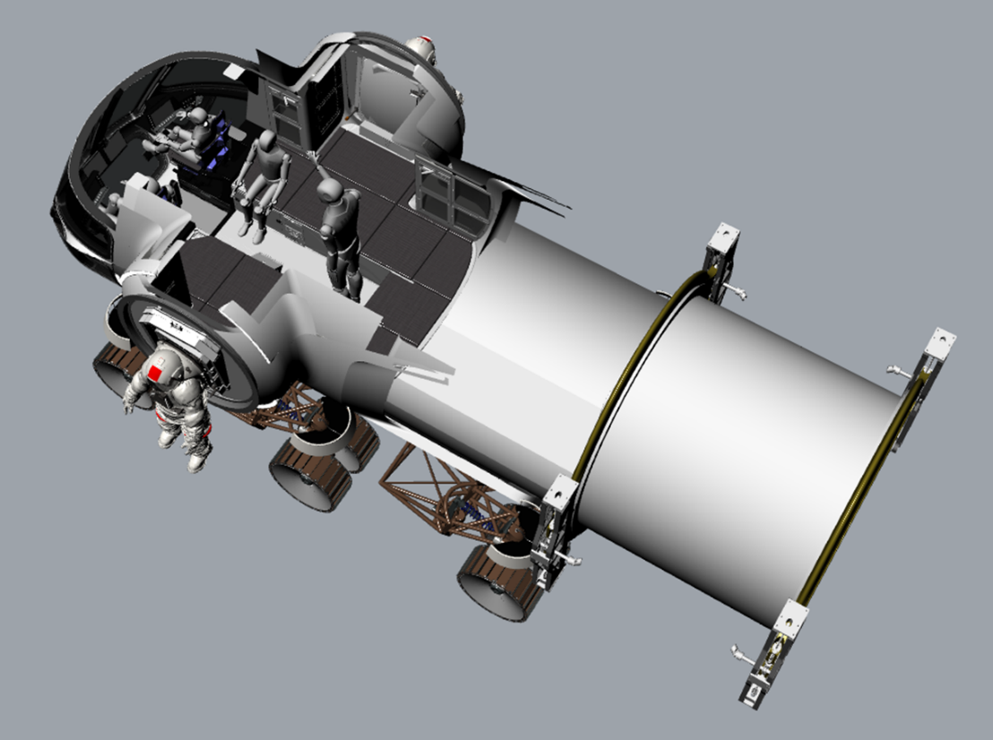
2
Figure 37. Mobile Lunar Lab Module A – Crew Habitation

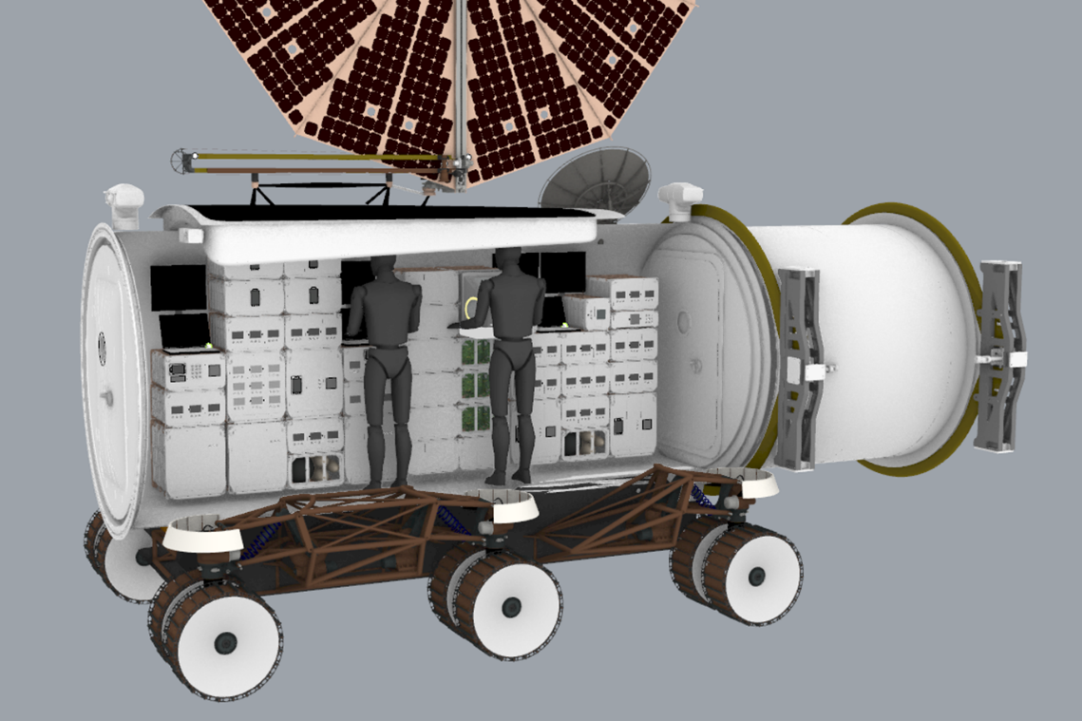
3
Figure 38. Mobile Lunar Lab Module B – Biology and Human Research
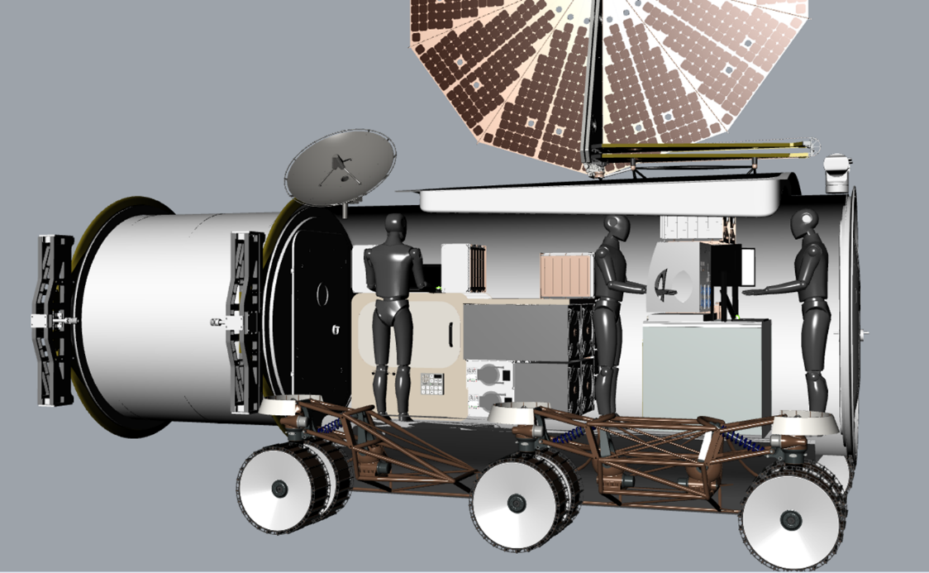
4
Figure 39. Mobile Lunar Lab Module C – Physics

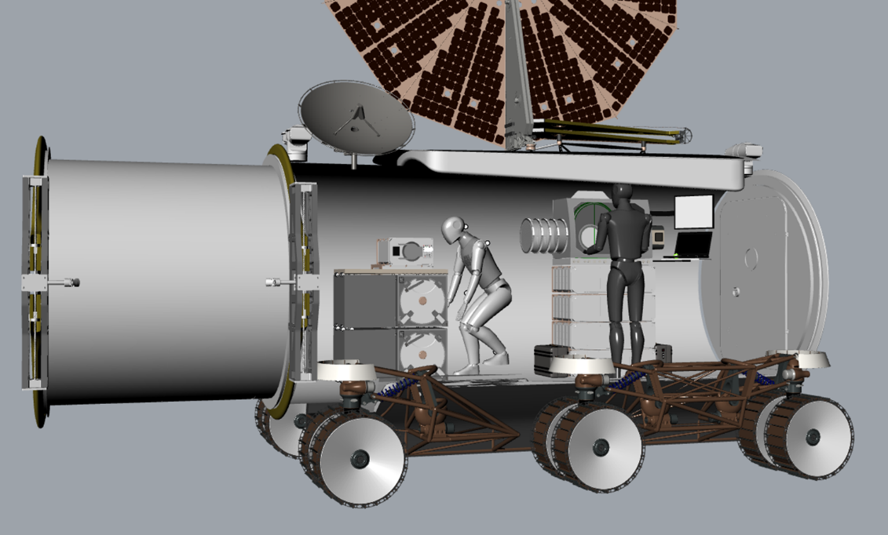
5
Figure 40. Mobile Lunar Lab Module D – Geology

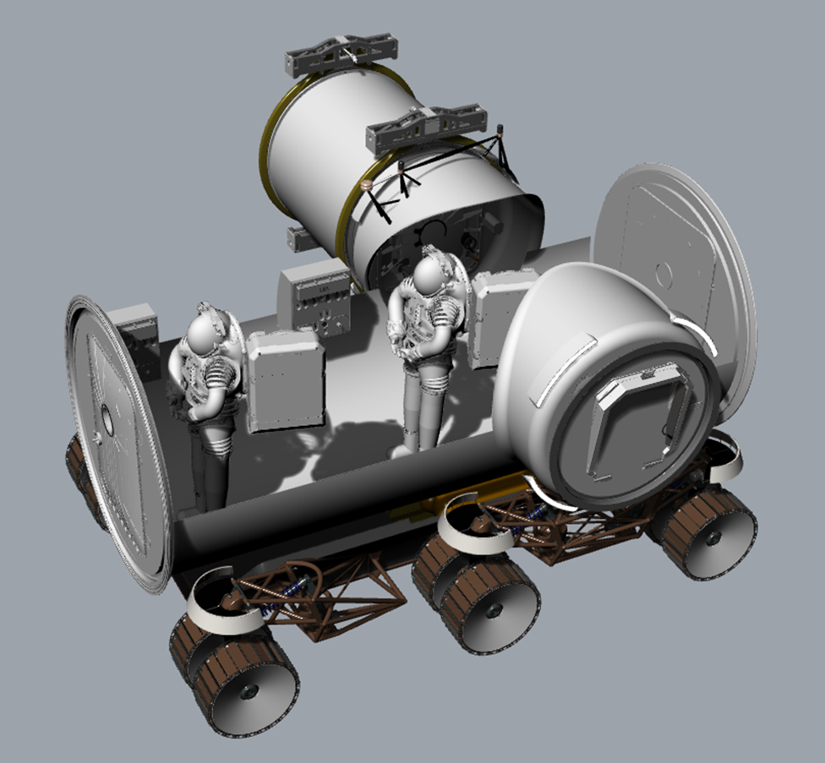
6
Figure 41. Mobile Lunar Lab Module E – EVA

The SUS is technology agnostic; therefore, it is justified to use the SUS for this study. When using the SUS Likert-type scale, a Cronbach Alpha (α) coefficient is calculated to provide a measure of the scale’s internal consistency [13], [14], expressed as a number between 0 and 1. The interpretation of coefficient values is shown in Table 5 and indicates the extent to which all items within the test measure the same concept or construct [13].
Table 5. Cronbach Alpha Range and Interpretation [16], [14], [17]
Cronbach’s Alpha (α) | Internal Consistency Interpretation
0.9 – 1.0 | Excellent
0.8 – 0.9 | Good
0.7 – 0.8 | Acceptable
0.6 – 0.7 | Questionable
0.5 – 0.6 | Poor
0.5 >0.0 | Unacceptable

The SUS scores in this test indicated excellent internal consistency as shown by the Cronbach Alpha (α) scores (Stationary Lab α = 1.0; and Mobile Lab α = 1.0, respectfully). Table 6 and Figure 42 show how the subjects scored the two conceptual configurations. To create a clearer picture of the SUS score results, Bangor, Kortum, and Miller (2009) [15] studies the effects of having an adjective rating scale accompany the SUS scores. The researchers noted that having an easy-to-understand reference point made communicating the results of the SUS scores more understandable to a larger audience. The adjective scale used in Figure 42 is based off the standard letter grade scale, shown in Table 7, where scores in the 90s are excellent, the 80s are considered good, scores in 70s were acceptable. Bangor et al. (2009) [15] noted that for scores below a 70 usability issues become a cause for concern.
Table 6. Overall Median SUS Scores for Two Lunar Lab Concept Designs
Configuration | SUS Overall Scoreꞌ | Standard Deviation | Cronbach’s Alpha²
Stationary Lunar Lab | 70.0 | 18.3 | 1.0
Mobile Lunar Lab | 62.5 | 22.9 | 1.0
NOTE¹: A SUS score > 68 (the 50th percentile) is considered above average. This is based on average SUS scores of over 500 studies [6].
NOTE²: Cronbach Alpha (α) internal consistency range is a follows: α < 0.5 is Unacceptable; 0.5 ≤ α ≤0.6 is Poor; 0.6 ≤ α ≤ 0.7 is Acceptable; 0.7 ≤ α ≤ 0.9 is Good; and α ≥ 0.9 is Excellent; thus, an α > 0.70 indicates a good internal reliability.

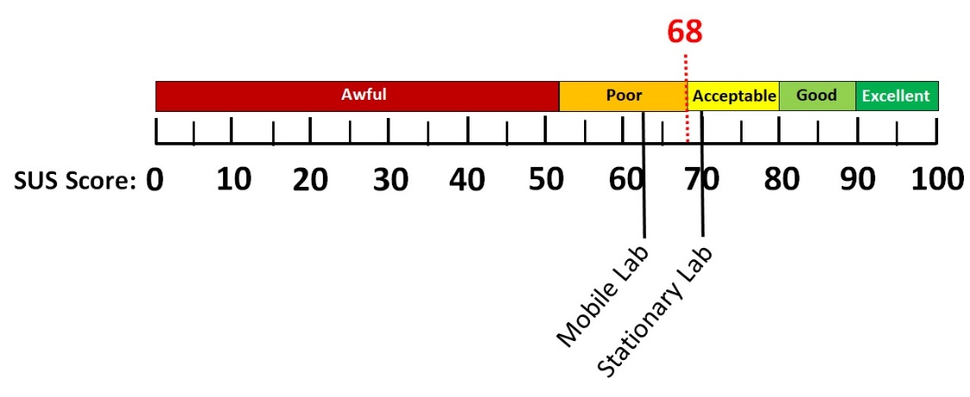
Figure 42. Mapping the SUS scores with adjectives. Note as SUS score of 68 or higher is considered above average (50% or greater)
For this rapid assessment of two lunar lab concepts, spacecraft experts scored the usability of the stationary lunar lab higher than the mobile lunar lab concept. A major factor contributing to this difference was the perceived (and actual) difference in volume. The stationary lab has a volume slightly greater than 200 m³, with each module slightly greater than 100 m³ in pressurized volume, while the mobile lab has a volume slightly under 100 m³ and a pressurized volume of almost 20 m³ per module.
The stationary lab space was perceived as being more open when compared to the mobile lab. Several experts thought the mobile lab layout made the workspaces too narrow and restrictive; thus, appearing to not be an efficient use of volume as most of the volume is reserved for translation between modules. Translation times in the mobile lab could take longer reducing crew productivity as compared to the stationary lab and lead to some layout complexity issues.
With respect to the internal layout configuration, both concept layouts were deemed simple and straightforward with a clear purpose for each module. Separation of bioscience from non-bioscience was consistent in both concepts. Participants thought bench space in the stationary concept was good overall; whereas, the bench space in the mobile concept was lacking and could impede both general usability and science.
As for navigating through the layouts, participants liked the more spacious feeling in the stationary lab when compared to the narrow mobile lab; however, due to both layouts being relatively small and simple in nature, navigating through the configurations was not perceived to be an issue. It is worth noting that one expert would like to see a comparison between the impacts of the crew task demands and opportunity cost of crew time between the stationary and mobile concepts. The test team will be examining these aspects in future testing.

Conclusions
Working with an innovation team like the Forge to perform rapid engineering design study turnarounds with the intent of being able to pull together a team of strategically selected domain experts to innovatively solve a specified problem within a short period of time has been an challenging and rewarding experience. Testing two lunar lab design concepts using this innovative method has proven successful in helping to understand the usability of each configuration and has given guidance to the team as to which configuration would be the best design to continue improving.
Using a card sort task, experts gained design test guidance as to how each configuration could be efficiently laid out with the functional elements given. Both configurations have promise as the analysis showed areas of advantage and concern. In this study, the card sort task was not meant to aid in the down-select process, but to inform the team on how an efficient layout could be accomplished in each vehicle design.
The SUS analysis, however, was implemented in order to aid in decision making. Both configurations were considered simple and straightforward, making navigating through the layouts easy. Cross-contamination in both designs was also well thought out. However, the overall SUS scores assessing the usability of the proposed layouts indicated that the stationary lunar lab was preferred over the mobile lunar lab concept. The main factor was the perception of volume within the vehicles. Experts deemed the volume as more spacious in the stationary concept when compared to the narrow volume in the mobile concept, making the workspaces seem more restrictive.
To further enhance the understanding of each layout and the placement of functional elements, the test team would suggest doing a series of task analysis scenarios within each layout to optimize and verify the best configuration possible for each vehicle.
Acknowledgements
The Forge study was funded by the NASA Johnson Space Center Engineering Directorate.
References
- Interbartolo, M., O'Neill, W., Bannon, M., Howard, R., Montoya, B., Litaker, H., Black, J. (2021). "The Lunar Lab Initiative," 2021 IEEE Aerospace Conference, March 2021, Big Sky, MT.
- Bangor, A., Kortum, P., and Miller, J. (2009). “Determining what individual SUS scores mean: Adding an adjective rating scale,” Journal of Usability Studies, Vol 4, Issue 3, May 2009, pp. 114-123.
- Brooke (1996). SUS: A "quick and dirty" usability scale. In P. Jordan & B. Thomas (Eds.), Usability evaluation in industry (pp. 189-194). London: Taylor & Francis.
- Bangor, A., Kortum, P., and Miller, J.A. (2008). “The system usability scale (SUS): An empirical evaluation,” International Journal of Human-Computer Interaction, Vol 24, Issue 6.
- Lewis, J.R. and Sauro, J. (2009).” The factor structure of the system usability scale,” Human Centered Design (pp. 94-103). Springer Berlin Heidelbreg.
- Sauro, J. (2011). “Measuring usability with the system usability scale (SUS).” Retrieved on line January 10, 2014 at https://www.measuringusability.com/sus.php
- Brooke, J. (2013). “SUS: A retrospective,” Journal of Usability Studies, Vol. 8, Issue 2, February 2013, pp. 29-40.
- Ghomeishi, M. (2021). “Aesthetic preferences of laypersons and its relationship with the conceptual properties on building façade design,” Journal of Asian Architecture and Building Engineering 2021, Vol. 20 No. 1, 12-28.
- Henriques, D.P., Greenhalgh, P. and Dalton, R. (2017). “Measuring the impact of future visions through card sorting: From user experience to participatory planning (a pilot study),” Proceedings of the Incubators Conference at the KU Leuven, Facility of Architecture, Brussels 10-11 April 2017.
- Paul, C.L. (2014). “Analyzing card-sorting data using graph visualization,” Journal of Usability Studies, Vol. 9, Issue 3. May 2014, pp. 87-104.
- Stamp, A.E., III (2000).” Psychology and the aesthetics of the built environment,” Norwell, MA: Kluwer Academic.
- Araya, F., Faust, K.M. and Kaminsky, J.A. (2019). “Public perceptions from hosting communities: The impact of displaced persons on critical infrastructure.’ Sustainable Cities and Society 48: 101508.
- Tavakoi, M. & Bennick, R. (2011). “Making sense of Cronbach’s Alpha,” International Journal of Medical Education, Vol 2, 2011, pp. 53-55.
- Gliem, J.A. & Gliem, R.R. (2003). “Calculating, interpreting, and reporting Cronbach’s Alpha reliability coefficient for Likert-type scales,” 2003 Midwest Research to Practice Conference in Adult, Continuing, and Community Education
- Bangor, A., Kortum, P., and Miller, J. (2009). “Determining what individual SUS scores mean: Adding an adjective rating scale,” Journal of Usability Studies, Vol 4, Issue 3, May 2009, pp. 114-123.
- Glen, S. (2021). “Cronbach’s Alpha: Simple Definition, Use and Interpretation,” From StatisticsHowTo.com: Elementary Statistics for the rest of us!, on-line at https://www.statisticshowto.com/probability-and-statistics/statistics-definitions/cronbachs-alpha-spss/
- Georgy, D. & Mallery, P. (2003). SPSS for Windows step by step: A simple guide and reference. 11.0 Update (4th ed.). Boston: Allyn & Bacon.
Biography
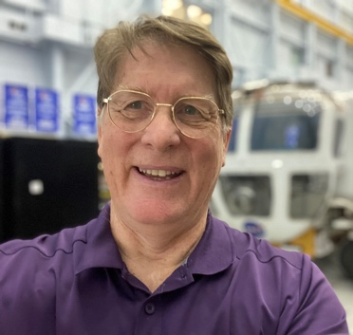
Harry L. Litaker, Jr., is a Senior Human Factors Design Engineer for Leidos working with the Human Systems Engineering and Integration Division of the Human Health and Performance Directorate at Johnson Space Center. He received his Bachelor of Science degree in Communications from Western Carolina University and a Masters in Aeronautical Science degree from Embry-Riddle Aeronautical University in Human Factors Engineering and Safety Engineering. He has extensive human factors experience in spacecraft design, aviation and airport safety, human-machine interfaces, virtual reality simulation testing and communications. He has worked for the US military conducting human factors evaluation of prototype vehicles and human performance. Currently, Mr. Litaker is the contractor human factor lead for the Lunar Surface Mobility project, the Orion Aft Stowage IVA System (OASIS) and the Orion Speech Intelligibility Testing. His lead responsibilities have also supported the Mars Ascent Vehicle (MAV) design testing, performance research with the Low-Latency Teleoperations (LLT) study, for the Evolvable Mars Campaign (EMC), the Small Pressurized Rover (SPR) and Unpressurized Rover (UPR) project, the Multiple Mission Space Exploration Vehicle (MMSEV) Near Earth Asteroid (NEA) project, the Habitable Airlock (HAL) project, the Broad Agency Announcement (BAA) Cislunar Habitat testing, and the Altair Lunar Lander program. Mr. Litaker has conducted human performance and design research studies in such exploration analog environments as the Desert Research and Technologies Studies (DRATS), the NASA Extreme Environment Mission Operations (NEEMO), and in practical gravity simulators.
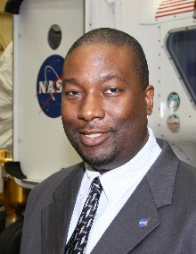
Dr. Robert L. Howard. Jr. is the Habitability Domain Lead in the Habitability and Human Factors Branch and co-lead of the Center for Design and Space Architecture at Johnson Space Center in Houston, TX. He leads teams of architects, industrial designers, engineers, and usability experts to develop and evaluate concepts for spacecraft cabin and cockpit configurations. He has served on design teams for several NASA spacecraft study teams including the Orion Multi-Purpose Crew Vehicle, Orion Capsule Parachute Assembly System, Altair Lunar Lander, Lunar Electric Rover / Multi-Mission Space Exploration Vehicle, Deep Space Habitat, Waypoint Spacecraft, Exploration Augmentation Module, Asteroid Retrieval Utilization Mission, Mars Ascent Vehicle, Deep Space Gateway, as well as Mars surface and Phobos mission studies. He received a B.S. in General Science from Morehouse College, a Bachelor of Aerospace Engineering from Georgia Tech, a Master of Science in Industrial Engineering with a focus in Human Factors from North Carolina A&T State University, and a Ph.D. in Aerospace Engineering with a focus in Spacecraft Engineering from the University of Tennessee Space Institute. He also holds a certificate in Human Systems Integration from the Naval Postgraduate School and is a graduate of the NASA Space Systems Engineering Development Program.

