IAC-22-B3.3.11

Planetary Surface Operations and Utilization: How ISS and Artemis Missions Can Be Used to Model Human Exploration of Mars

Stephen J. Hoffman, Ph.D.ª*, Michelle A. Rucker^{b}, Torin McCoy^{c}

ª The Aerospace Corporation, 2525 Bay Area Boulevard, Suite 600, Houston, Texas, USA 77058, stephen.j.hoffman@nasa.gov
^{b} National Aeronautics and Space Administration (NASA), Johnson Space Center, 2101 East NASA Parkway, Houston, Texas, USA 77058, michelle.a.rucker@nasa.gov
^{c} National Aeronautics and Space Administration (NASA), Johnson Space Center, 2101 East NASA Parkway, Houston, Texas, USA 77058, torin.mccoy-1@nasa.gov
* Corresponding Author

Abstract

As NASA moves forward with plans to send astronauts to the Moon under Artemis missions and prepare for human exploration of Mars, the Agency is developing a set of high-level objectives for human spaceflight, identifying 50 points falling into four overarching categories of exploration. An element in NASA’s overall process of achieving these objectives is to leverage its assets and missions – such as the many crew increments sent to the International Space Station and future Artemis expeditions sent to the Moon – to develop more robust spaceflight systems and build a culture of interplanetary human exploration. This paper describes several examples of how NASA is exercising a process to achieve these objectives for future human Mars surface missions; both (a) building on lessons learned from ISS missions and maturing plans for Artemis missions, and (b) using human Mars mission planning to inform the plans for future ISS and Artemis missions so that the knowledge gained will reduce uncertainty and risk for Mars. One focal point for this two-way interaction between ISS and Artemis with future human Mars missions is a document titled “Reference Surface Activities for Crewed Mars Mission Systems and Utilization” (HEOMD-415), which describes the systems and operations of the crew thought necessary for the first human Mars surface mission. The details described in this paper will address three specific aspects of HEOMD-415 that have been influenced by ISS and where HEOMD-415 is influencing plans in ISS, Artemis, research and technology development, and other related aspects: (1) crew (activity planning and medical), (2) Mars surface infrastructure, and (3) communication and navigation support. The paper will close by describing near-term opportunities for tests and analogs relevant to these aspects of HEOMD-415.

Keywords: Mars, Human Spaceflight, Analogs, NASA

Acronyms/Abbreviations
ASU Arizona State University
BASALT Biologic Analog Science Associated with Lava Terrains
DOE Department of Energy (U.S. Government)
D-RATS Desert Research and Technology Studies
DST Deep Space Transport
ESDMD Exploration Systems Development Mission Directorate (NASA)
EVA Extra-Vehicular Activity
FSP Fission Surface Power.
HEOMD Human Exploration and Operations Mission Directorate (NASA)
HMTA Health and Medical Technical Authority (NASA)
HRP Human Research Program (NASA)
ISRU In Situ Resource Utilization
ISS International Space Station
IVA Intra-Vehicular Activity
JPL Jet Propulsion Laboratory (NASA)
KRUSTY Kilopower Reactor Using Stirling TechnologY
MAV Mars Ascent Vehicle
MDS Mars Descent System (lander)
NASA National Aeronautics and Space Administration
NEEMO NASA Extreme Environment Mission Operations
NEP Nuclear-Electric Propulsion
PR Pressurized Rover
PMA Pressurized Mating Adapter
SE&I Systems Engineering and Integration
SMD Science Mission Directorate (NASA)
STMD Space Technology Mission Directorate (NASA)
TH Transit Habitat

- Introduction
As NASA moves forward with plans to send astronauts to the Moon under Artemis missions to prepare for human exploration of Mars, the Agency is developing a set of high-level objectives for human spaceflight, identifying 50 points that fall into four overarching categories of exploration [1]. The four chosen categories include:
- Transportation and habitation,
- Moon and Mars infrastructure,
- Operations, and
- Science.
NASA’s Deputy Administrator Pam Melroy has stated that these objectives “…will inform our exploration plans at the Moon and Mars for the next 20 years” as part of a “blueprint” for sustained human presence and exploration throughout the solar system [2]. An element in NASA’s overall process of achieving these objectives is to leverage its assets and missions – such as the many crew increments sent to the International Space Station (ISS) and future Artemis expeditions to be sent to the Moon – to develop more robust spaceflight systems and build a culture of interplanetary human exploration.
This paper describes an example of how NASA is exercising a process to achieve these objectives for future human Mars surface missions by both (a) building on lessons learned from ISS missions and maturing plans for Artemis missions, but also (b) using human Mars mission planning to inform present day ISS activities and Artemis mission plans so that knowledge gained from these missions can help reduce uncertainty and risk for Mars.
One focal point for this two-way interaction between ISS and Artemis with future human Mars missions is a document titled “Reference Surface Activities for Crewed Mars Mission Systems and Utilization” (HEOMD-415) [3], which describes the systems and operations of the crew thought necessary for the first human Mars surface mission. Details in this document incorporate ISS experience and existing Artemis plans. But assumptions made in this document regarding human Mars mission planning have also prompted further dialogue regarding uncertainties and/or gaps in knowledge for certain systems (including the human system) and operations. This process is an essential part of the roadmap that will guide mission objectives and research for both the ISS and Artemis programs and, in doing so, help achieve NASA’s high-level objectives for human spaceflight. This example does not describe a single interaction among all these programs but rather an iterative process that will continue for many years to come.

1.1 NASA’s Current Mars Mission Scenario as an Example for Evaluating Blueprint Objectives
NASA’s last Mars reference architecture [4], published in 2009, outlined a mission scenario in which a crew of 6 explored the martian surface for approximately 500 sols (a “sol” is a martian day, lasting approximately 24 hours and 40 minutes). This scenario placed an emphasis on extensive infrastructure – such as in situ resource utilization (ISRU) to manufacture propellant for a crew ascent vehicle and multiple pressurized rovers for long-range traverses – to support a robust surface exploration capability. In 2019, senior NASA leadership challenged its engineers and analysts to develop a much different architecture and mission profile, this one designed for a very short round-trip duration, with only a 30-sol surface stay for two crew, and minimal surface infrastructure for the first human mission. There were several motivations for this shorter duration mission, including a risk assessment that indicates shorter missions could reduce crew health risk [5], as well as emerging transportation technologies that have the potential to make a short round-trip mission possible. This new scenario also fits well in a larger process of building confidence in the systems and operations envisioned for a robust exploration of the martian surface before committing a crew to longer, more challenging scenarios or to a particular site.
A description of the resulting 30-sol Mars surface mission has been documented in NASA’s HEOMD-415 “Mars Surface Activities for Crewed Mission Systems and Utilization Reference Mission,” anchoring the shorter end of possible surface stay durations. It is important to note that NASA has made no decisions at this time regarding human Mars mission objectives, durations, or architectures, and this document is intended to aid in analysis of options. As such, it fits well into the process outlined above by providing a focal point to assess what aspects of this scenario (or other similar scenarios) can be shown as feasible based on known capabilities and mission experience. It will also indicate opportunities where NASA’s current missions can be used to grow capabilities and mission experience to meet the goals set forth in the Blueprint Objectives.
The next several sections describe key features of the HEOMD-415 document. This will aid in the subsequent discussion of several specific examples that illustrate the process of assessing Blueprint Objectives using HEOMD-415 and similar documents currently being developed by NASA. But this publicly available document should be reviewed in its entirety to obtain a fuller understanding of this human Mars mission scenario.

2. A 30-sol Mars Surface Mission Scenario
HEOMD-415 details daily activity timelines for crewed exploration on Mars to meet high-level NASA objectives, working within certain planning constraints and considerations. Its purpose was to estimate how much time during each martian sol might be available for exploration activities, (also referred to as utilization activities in this document), after accounting for crew and equipment care. These results are one of the factors taken into consideration as specific goals and objectives are assembled into a mission plan.

2.1 Mars Round-Trip Mission Description for a 30-sol Surface Mission
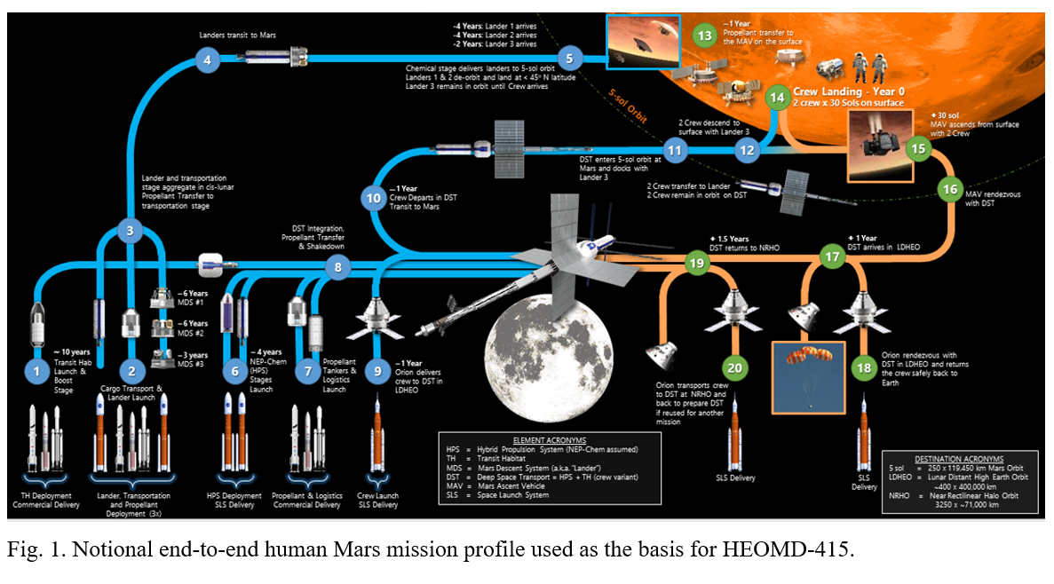
NASA’s Exploration Systems Development Mission Directorate’s (ESDMD’s) Systems Engineering and Integration (SE&I) Office is chartered with developing architectures and mission profiles for eventual human missions to Mars. At the ESDMD-level, the first Mars mission objective is to land humans on the surface of Mars and return them, and their return cargo, safely to Earth. The landing site for this first mission will be driven by crew safety, available capabilities, knowledge of the Mars environment, and science priorities. ESDMD’s top priority for the crew once they land and validate habitation/exploration/ascent capabilities will be to perform high priority utilization tasks, the details of which are expected to be established by NASA’s Science Mission Directorate (SMD), the Space Technology Mission Directorate (STMD), and other science/research organizations such as the Human Research Program (HRP) and other partnering Agencies, using systems and processes provided by those organizations and approved by relevant authorities across the Agency. The process for selecting and prioritizing these utilization tasks has yet to be defined, so this timeline only indicates blocks of time available for extra-vehicular (EVA) or intra-vehicular (IVA) utilization activities.
This analysis uses the round-trip mission profile depicted in Figure 1. This Figure depicts just one of several Mars transportation system concepts currently being evaluated. It is important to note that the mission profile details will vary with different transportation systems and trajectory types. But the scenario used for this particular analysis presumed crew and cargo would be delivered on separate vehicles, with cargo pre-deployed to Mars by one or more trajectory opportunities prior to crew arrival. However, actual crew surface operations are independent of the transportation system selected or cargo arrival timing.
The overall mission profile illustrated in Figure 1 both sets the context for and defines certain criteria used in the surface mission timeline described below (and in HEOMD-415). The specific portion of this overall mission described in this paper begins with the arrival of the crew in their Deep Space Transport (DST) at Mars and concludes once the surface crew returns to the DST and it departs for Earth.
Upon arrival at Mars, the DST enters a 5-sol Mars orbit (5-sol referring to the period of this elliptical orbit) for a 50-Earth day loiter. This allows a 30-Earth day surface stay period with up to 10 Earth days before and after to account for vehicle staging and phasing. After rendezvous with their Mars Descent System (MDS, or lander), carrying a Pressurized Rover (PR) – derived from lunar experience – as part of its payload, two of the four crew members transfer to the PR via a pressurized mating adapter (PMA) for descent to the martian surface. Prior to initiation of the surface mission, the crew will have verified that surface power infrastructure (the Fission Surface Power system, or FSP) is functioning and their Mars Ascent Vehicle (MAV) plus other surface infrastructure, all of which were pre-deployed to the surface, are ready for use.
The two crew remaining on-orbit tend the DST, which serves as a communications relay back to Earth during the surface mission. The orbital crew can aid the surface crew by handling remote tasks, such as telerobotic operation, monitoring of surface assets, or data analysis to support next-day planning and coordination with subject matter experts on Earth. The orbital crew may also use their vantage point for Mars surface or Phobos/Deimos observations.

2.2 Mars Surface Mission Timeline
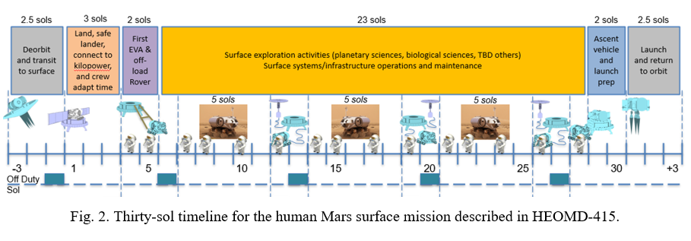
As currently described in HEOMD-415, the Mars surface mission can be divided into six major phases, as depicted in Figure 2. The timeline described in the following sections begins with two crew arriving at their landing site and concludes when the crew leaves in their MAV. Details of crew activities during each of these phases are described in Appendix A; timelines for activities outside of this period (e.g., the transit to and from Mars) will be described in other NASA documents.

3. Using ISS and Artemis Missions to prepare for Mars Surface Missions
Using past experience and leveraging present activities is not a new way of preparing for future missions. But NASA’s current effort to deliberately coordinate activities across several programs spanning potentially decades of time is becoming a hallmark of the process to accomplish a more expansive set of objectives making up the “… blueprint for sustained human presence and exploration throughout the solar system” [6]. There are many examples of how this could be implemented, but just a few of these will be described in the following sections to illustrate the range of possibilities and opportunities specific to the 30-sol Mars surface missions, closing with a description of the general approach to be used to formalize this process of leveraging NASA assets and missions to achieve its Blueprint Objectives across a broader spectrum of future missions.

3.1 Mars Surface Mission Detailed Timeline Development
Returning to the previous discussion of additional detail for a 30-sol Mars surface mission timeline, lessons learned from decades of ISS operations as well as surface mission analogs (e.g., NASA Extreme Environment Mission Operations (NEEMO) [7], Biologic Analog Science Associated with Lava Terrains (BASALT) [8], Desert Research and Technology Studies (D-RATS) [9], etc.) provide guidance for the type and duration of non-utilization driven activities that are likely to be independent of utilization driven activities (possibly constraining the utilization driven activities that can be accomplished). The primary source used for these guidelines is SSP 50261-02 “ISS Generic Groundrules and Constraints Part 2: Execute Planning” [10]; other sources are noted as they are applied. These documents were used as a starting point, with timeline-related information anchored in actual human spaceflight activities. Figure 3 summarizes crew time usage resulting by following the guidance and lessons learned from these various sources.
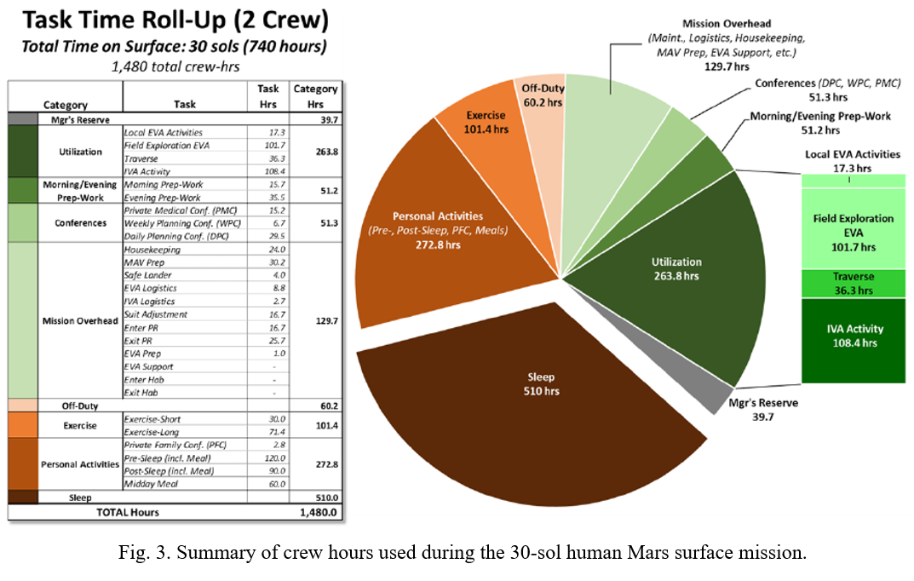
This result provides a first look at the activities that could be accomplished by a two-person crew on Mars with activity type and duration information anchored in actual human spaceflight activities. This view can now be used to make judgments about where these activities can or should be changed and, more importantly, it can be used in current research programs and analogs to refine our understanding of these activities when applied to a Mars surface mission and to improve our knowledge of crew capabilities across a wide range of missions. For example, NASA programs such as the Human Research Program [HRP], or terrestrial analogs such as NEEMO or D-RATS, can take this timeline and use it to inform their tests and research. As results from their specialized research become available, this timeline will be adjusted to account for the new information. This illustrates the two-way interaction between current human spaceflight activities and preparations for future missions.

3.2 Crew Readaptation to a Gravity Environment
In Appendix A, a brief mention is made of allowing at least three sols for crew re-adaptation to Mars gravity. There is more complexity behind this statement that deserves further explanation and provides another example of not only leveraging existing experience but also informing future research.
The transit from Earth to Mars is assumed to last for several months and to take place in a microgravity environment. Extended durations in microgravity are known to cause multiple changes in the human body that must be addressed after re-entering a gravity environment before the crew can safely carry out many activities [11]. Experience gained from decades of extended duration flights on ISS by scores of astronauts has led to a better understanding of these effects as well as countermeasures that can mitigate them during flight. But some amount of time is still required by the crew after returning to a gravity environment to readapt to the point where they can safely perform important tasks, such as working in an EVA suit or driving a pressurized rover. In preparing this 30-sol mission timeline, the medical community was consulted for a reasonable allocation of time to accommodate this readaptation. Guidance provided by NASA’s Health and Medical Technical Authority [HMTA] provided a 3- to 7-sol range for crew to readapt to a gravity environment as informal guidance (HMTA memo M-QA-2021-089). Although research and countermeasure development will continue, this range is likely to persist, as there is significant readaptation variation across individuals. For the 30-sol Mars surface mission analysis, a 3-sol gravity re-adaptation period is assumed for planning, as this represents the stressing case for total EVA hours carried out by the crew, and for the logistics needed to support this level of activity. During an actual mission, this re-adaptation period will be extended until the crew is considered fit to carry out the more challenging surface mission activities, with the associated reduction in planned demand on logistics and EVA system utilization. Crew fitness will continue to be monitored throughout the surface mission and activities are assumed to progress from simple/less strenuous to more complex/more strenuous, based on the crew’s observed readaptation to the martian surface environment.

3.3 Crew Health and Performance Readiness for Mars Missions
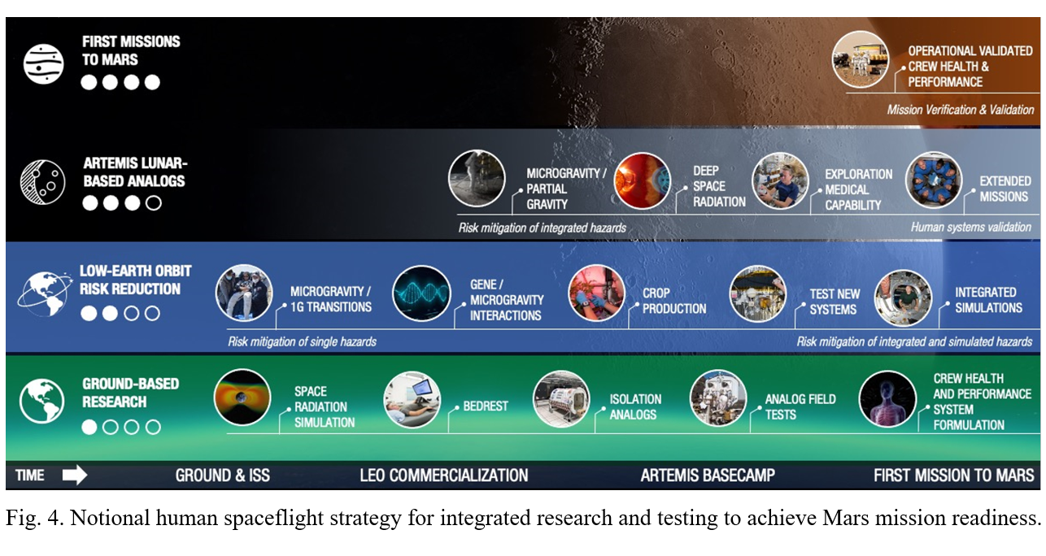
Readaptation to a gravity environment is but one crew health consideration that must be addressed to reduce overall crew health risk to an acceptable level. The human system is complicated, and Mars mission planning involves mission durations and scope that often extend well beyond existing scientific evidence bases. These missions are challenging due to radiation, distance from Earth, closed environments, isolation, and gravity vectors [12]. Some of the risk can be mitigated by having an adequately scoped and informed crew health and performance system, which will be critically important given the distance from Earth, communication delays, and other challenges. These can be especially critical if a crew health anomaly is encountered. Aborting from a Mars mission – a solution of last resort for ISS and likely for Artemis missions – has vastly different characteristics from those more typical of an ISS mission or even a lunar mission [13]. The most important difference between these abort types being a duration measured in months (instead of the hours or possibly days typical of an ISS or lunar mission abort) regardless of the propulsion system and trajectory chosen.
All these considerations speak to the fact that, despite medical research advances, there is still much to learn regarding the effects of spaceflight hazards on the human body and potential mitigations for those effects (including both preventative and diagnostic care). The integrated approach suggested by the Blueprint Objectives indicates an effective way of achieving the appropriate level of crew health and performance readiness needed for future Mars missions. Figure 4 illustrates one possible approach for integrating a range of relevant research and testing across programs and time to achieve this objective.

3.4 Mars Surface Mission Infrastructure
In addition to these examples in which crew health and mission timeline issues are leveraging NASA assets and missions, this tenet is being extended to infrastructure identified for human Mars surface missions. Two examples will be discussed here to illustrate the benefit of this approach: use of small aerial vehicles to support crew activities and larger scale nuclear systems as the primary power source for all planned surface systems.

3.4.1 Small Aerial Support Vehicles
The success of the Ingenuity Mars Helicopter (Figure 5) has highlighted several applications that would benefit future human Mars missions beyond the obvious scientific role as an aerial sensor platform. Planning activities assume advanced versions of this vehicle would be available as an element in the first human Mars surface mission and this will be documented in the next revision of HEOMD-415.
Discussions are underway between human mission planners and the Ingenuity team, to explore ways that Ingenuity and the recently announced pair of helicopters added to the Mars Sample Return mission could be leveraged to demonstrate operations or capabilities with crew risk mitigation potential. A few of the applications being discussed include the following:
- Scouting a rover traverse path to identify points of interest or hazards
- Demonstrating the capability to precisely deploy navigation aids for future landers
- Demonstrating the capability to deploy communication relays or to function as a relay to extend line-of-sight communication.

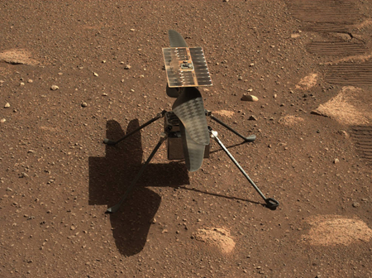
Fig. 5. Ingenuity Mars Helicopter, or a derivative, has possible applications for future human Mars missions. (Credits: NASA/JPL-Caltech/ASU)

Proof of concept demonstrations of all the options are now candidates for NASA’s terrestrial analog research and demonstration programs. Results from all these tests will inform plans for future human Mars missions, such as the one described in HEOMD-415.

3.4.2 Centralized Fission Surface Power
A centralized power source to support human Mars surface missions has often included a discussion of the advantages and disadvantages of solar-based power generation and fission-based power generation. Analyses conducted for the Design Reference Architecture 5.0 [4] and the following Evolvable Mars Campaign [14, 15] both concluded that a fission power source was better suited to this mission. Even without an assumed ISRU requirement, this latest Mars surface mission description favors a fission power source [16]. The rationale for this now focuses on the duration that several mission critical elements must have uninterrupted power on the surface before the crew arrives. With the first cargo lander arriving as much as seven years prior to the crew, there is an extended period during which a global dust storm, potentially lasting for several months, could occur. Protecting for this possibility leads to a solar array and power storage solution that is quite massive and complex to deploy; fission-based power is essentially unaffected by dust storm severity and duration and has the added benefit of being unaffected by the martian day/night cycle.
NASA has partnered in recent years with the U.S. Department of Energy (DOE) to demonstrate fission-based power sources that operate in space environments and deliver power in the range anticipated for future human missions. In 2018, the Kilopower Reactor Using Stirling TechnologY (KRUSTY) Nuclear Ground Test was successfully completed. As configured, this demonstration reactor could deliver up to approximately 10 kWe for planetary missions [17]. NASA and DOE recently selected three contractors to develop concepts that could deliver up to 40 kWe for similar planetary missions [18]. These efforts span the range of Mars surface mission power needs as they are currently understood [19] and will inform future updates to HEOMD-415. But further analysis associated with HEOMD-415 power needs will also inform the detailed designs of the most resent contracted effort, as will the anticipated lunar surface demonstration of a reactor as part of the Artemis Program.

4. General Approach to Evaluating and Incorporating Mars Surface Mission Concepts to Satisfy Blueprint Objectives
The examples described in the previous section cover a wide range of operations, technologies, and general knowledge needed to carry out a successful human Mars surface mission. Many of these examples were carried out at a time when the need was opportunity specific. With the advent of the Blueprint Objectives, there is now an overarching framework for human exploration of the solar system, and these examples can also be seen as representative of the need to develop more robust spaceflight systems and to build a culture of interplanetary human exploration.
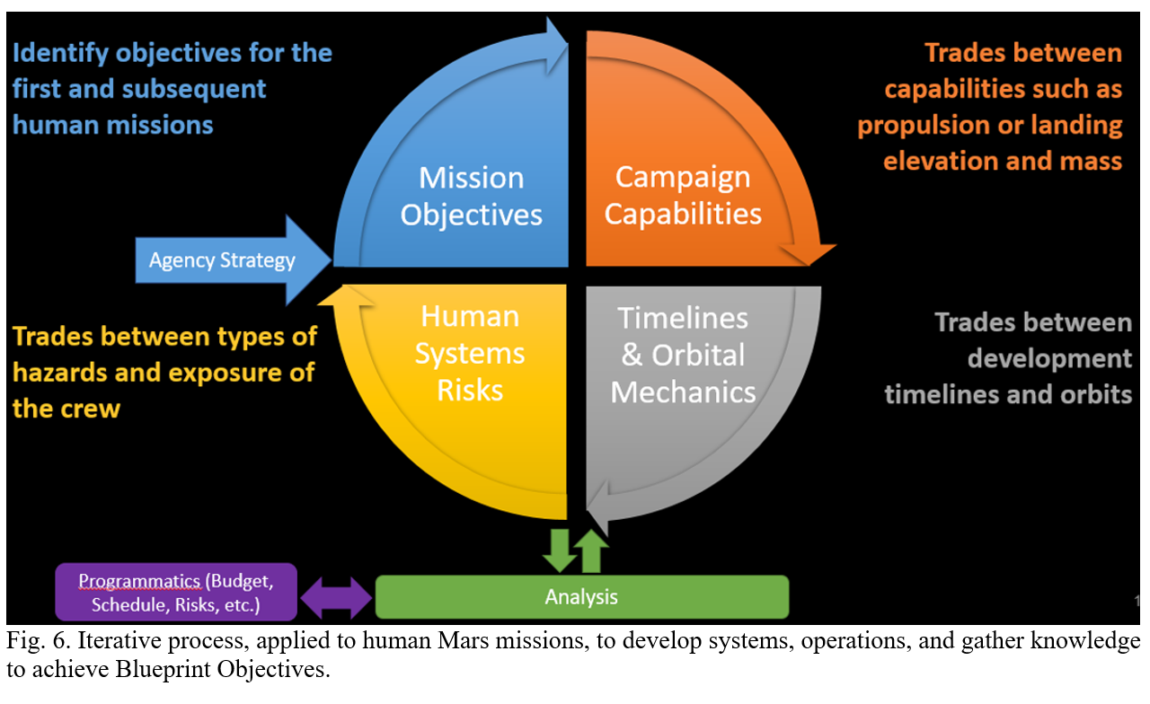
With the Blueprint Objectives as a framework, there is also a process emerging for putting forward concepts such as that described in HEOMD-415 and testing their viability using NASA’s assets and missions – such as the many crew increments sent to the ISS and future Artemis expeditions to be sent to the Moon – to both improve these concepts and ultimately accomplish the Blueprint Objectives. This emerging process, shown in Figure 6, illustrates this process as applied to early human Mars missions (but equally applicable to other missions). It indicates that NASA’s strategy – now guided by Blueprint Objectives – is the initiating event, followed by successive steps that can each use Agency assets or operations to test its viability, until the process returns to the initiating event with information regarding the degree to which Blueprint Objectives can be satisfied. Additionally, gaps in knowledge, technology, or operations are identified that could initiate another cycle through the process.
Figure 7 illustrates several opportunities currently in operation or being planned by NASA that are of increasing duration, complexity, and fidelity for testing these emerging human Mars mission concepts. With the addition of on-going terrestrial analogs, these testing opportunities could greatly benefit a diverse range of Mars mission aspects where knowledge is deficient or concepts lack maturity, such as:
- Long duration spaceflight impacts on crew
- Human spaceflight systems in the relevant environment over durations representative of those for a Mars mission (e.g., platform architecture, logistics, operations, etc.)
- Risk mitigation strategies for crew, systems, and concepts of operation
- Collection of scientific knowledge for both fundamental discovery and exploration benefit.
One final benefit from following this approach and using these opportunities is the demonstration of both strategic and tactical leadership, as well as the development of capabilities for integrating diverse utilization needs across NASA organizations and potential NASA partnering entities to achieve mission goals and Blueprint Objectives.

5. Conclusion
This paper has described several examples of how NASA is exercising a process to develop more robust spaceflight systems and build a culture of interplanetary human exploration that is guided by Blueprint Objectives being developed by the Agency. This process incorporates iterative steps building on lessons learned from NASA assets and operations – such as ISS missions and developing plans for Artemis – to mature plans for future human Mars missions, and to use these plans to inform activities for future ISS and Artemis missions. The knowledge gained from these will reduce uncertainty and risk for Mars. One focal point for this two-way interaction between ISS and Artemis with future human Mars missions is a document titled “Reference Surface Activities for Crewed Mars Mission Systems and Utilization” (HEOMD-415), which describes the systems and operations of the crew thought necessary for the first human Mars surface mission. The examples described in this paper address three specific aspects of HEOMD-415 that have been influenced by ISS and where HEOMD-415 is influencing plans in ISS, Artemis, several NASA Directorates, and other entities: (1) crew (activity planning and medical), (2) Mars surface infrastructure, and (3) communication and navigation support. Finally, the paper closed with a description of opportunities for tests and analogs relevant to these aspects of HEOMD-415 and to other future human spaceflight missions.

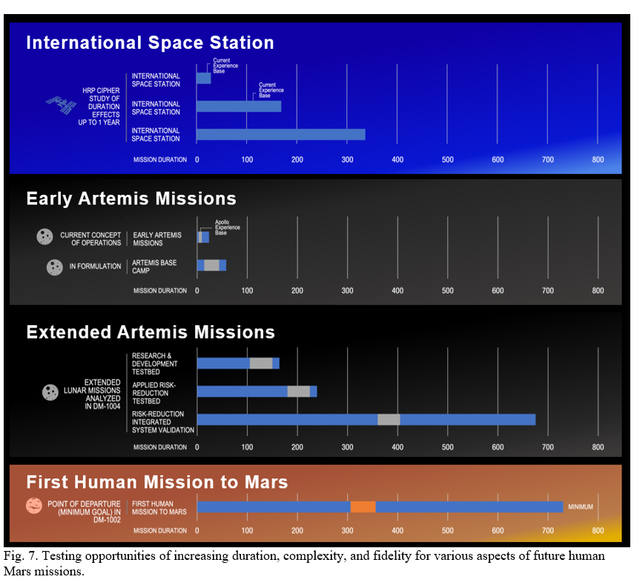
****

Appendix A: Mars Surface Mission Timeline

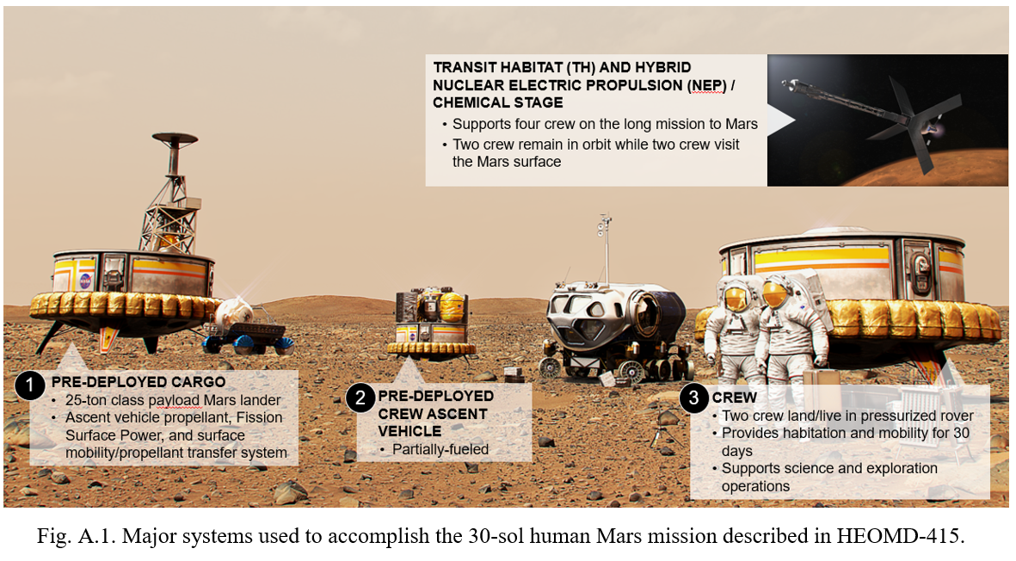
The 30-sol Mars surface mission described in HEOMD-415 relies on a specific set of systems to accomplish its mission objectives. All these mission assets are shown in Figure A.1. As noted above for the transportation system, the landers and surface assets depicted are notional and represent a small selection of concepts under evaluation. It must also be noted that no final decisions have been made regarding the details described in these sections, and this schedule of activities is likely to change as systems are refined, utilization objectives are better defined, and integrated operations analyses are completed. The following information should be used solely for analysis purposes and operational assessments.
The surface mission actually begins in orbit after the surface mission crew undocks from the transit habitat (TH – the habitable element of the DST) and initiates the 2.5-sol independent flight from the TH, through the martian atmosphere, to landing on the surface.
In this particular mission concept, two crew arrive on the surface inside a pressurized rover, carried as payload on an MDS, landing no more than one kilometer away from two previously deployed MDS cargo landers. The crewed lander is robotically connected to the pre-deployed surface power grid. After allowing at least three sols for crew re-adaptation to a gravity field, the PR and utilization equipment are off-loaded from the lander and the surface exploration activities begin. During the gravity re-adaptation period crew will exercise, reconfigure the PR cabin as needed, inspect and prepare their EVA equipment, and telerobotically inspect their surface equipment. Following medical clearance, the first EVA occurs on Sol 4, when the PR cabin is depressurized and both crew egress through the PR side hatch.
On Sol 5, crew perform another 2.5-hour EVA with the primary objective of off-loading the PR – an activity that is assumed to be carried out while the crew is outside of the PR. A second 1.5-hour EVA is conducted following a mid-day meal to complete off-loading other cargo from the MDS deck and any final PR preparations before extended traverses begin.
Due to limited rescue options and contingency equipment, crewed exploration around the landing zone is expected to extend to no more than a 20 kilometer (approx.) radius, though the crew may deploy robotic assets to explore farther. While exploring sites of interests – either in person or using robotic assets – examples of some things the crew might be asked to do include describing what they find at each site by means of verbal recordings, imagery at differing wavelengths, and mapping of important features. Information from these descriptions will be collected by the crew themselves at the surface, but they may also use small aerial vehicles to gather similar information from above, taking advantage of the different perspective. They could collect samples, take environmental readings, and conduct a host of site-specific experiments. Specific details of these utilization activities will be determined by such factors as scientific objectives set for the mission and site selection, all of which are still under discussion.
On Sol 7 the crew begin their first excursion away from the landing site, driving to the first exploration site planned for this surface mission. The crew spends the remainder of this sol and the next three sols conducting a number of EVA and IVA activities to explore this particular site. The constraining factor for crew returning to the landing site is the current energy storage capacity on-board the PR. Solar arrays are not assumed on the PR at this time due to several factors, including the physical size of the array needed at Mars distances from the Sun and the difficulty of driving the PR with a deployed array of this size. Thus, on the morning of Sol 11, crew will drive the PR back to the landing site and connect it to the surface power grid to recharge its energy storage system. The remainder of the day will be used for housekeeping and routine maintenance on the PR and EVA systems.
On Sol 12 crew conduct their first logistics restocking and trash removal operation while still attached to the surface power grid. Trash will be stored in sealed containers and placed at a location on the surface next to the MDS as its permanent disposal location. (Note: this disposal location reflects the current best guidance available, including planetary protection considerations. The approach to disposal will be revisited as new guidance becomes available.) Sol 13 will be an off-duty day– following ISS crew planning guidelines – with the crew remaining inside the PR for the entire sol.
Two additional traverses to exploration sites of interest, each traverse of 5 sols duration followed by 2 sols for recharge and logistics restocking, are planned before the surface mission moves on to its next phase.
On Sol 28 the crew drives the PR to the MDS carrying the MAV, connects to the ground power grid via this lander and docks with the MAV using a pressurized tunnel to connect the two vehicles. The remainder of Sol 28 plus all of Sol 29 are used for EVA or IVA activities necessary for MAV departure. Prior to departure, return cargo and equipment that has been exposed to the martian surface environment will be prepared in accordance with applicable planetary protection requirements and guidelines being developed under purview of NASA's Planetary Protection Officer. The crew will be wearing their clean launch/entry suits to mitigate dust transfer back to Earth, in accordance with anticipated planetary protection best practices. EVA suits are left behind on the surface to further mitigate dust transfer.
On the day of launch (nominally Sol 31), the PR and tunnel will be undocked from the MAV and the PR will be remotely driven (without crew on board) a safe distance away from the MAV (nominally 1 kilometer) to a location where the MAV launch can be observed. The crew launches in the MAV and spends the next 2.5 sols flying to the DST.
To build realistic detail into this 30-sol mission timeline – as well as assessing the extent of utilization activities that can be accomplished – all the tasks the crew will perform need to be properly accounted for and the capabilities and limitations of a human crew need to be reflected in the assigned durations for these tasks. Among the tasks that the crew must perform, it is typically the high-profile utilization-driven tasks associated with planetary science, human performance research, technology demonstrations, etc. that are of greatest interest to stakeholders and receive the most attention, such as astronauts on EVA or driving a rover while exploring an alien landscape for the first time. And because of this high level of interest, there is also typically an assumption that most of the crew time is spent carrying out these tasks. But the opposite is usually the case.
This observation is revealed most convincingly by implementing one of the tenets proposed for refining and evolving NASA’s Blueprint Objectives, namely by leveraging NASA’s assets and missions in terrestrial analogs, the ISS, and planned Artemis missions. Specific examples are discussed in the next section – beginning with building realistic detail into the 30-sol mission timeline – that illustrate how this tenet is being applied now and in the future to various aspects of the 30-sol Mars surface mission.

References
- NASA, “Moon to Mars Objectives,” https://www.nasa.gov/sites/default/files/atoms/files/moon-to-mars-objectives-.pdf (accessed 22.07.22).
- NASA, “Update: NASA Seeks Comments on Moon to Mars Objectives by June 3,” Release 22-044, 17 May 2022, https://www.nasa.gov/press-release/update-nasa-seeks-comments-on-moon-to-mars-objectives-by-june-3 (accessed 20.05.22).
- NASA, “Reference Surface Activities for Crewed Mars Mission Systems and Utilization,” HEOMD-415, NASA NTRS Document ID 20220000589, 24 January 2022.
- Mars Architecture Steering Group, Human Exploration of Mars Design Reference Architecture 5.0 Addendum, NASA/SP-2009-566-ADD Houston, TX: NASA; 2009 Jul. NASA/SP-2009-566-ADD.
- E. Antonsen, M. Van Baalen, Comparison of Health and Performance Risk for Accelerated Mars Mission Scenarios, Houston, TX; 2021 Feb. Report No.: NASA/TM-20210009779.
- NASA, “NASA Deputy Administrator Pam Melroy’s Plenary Remarks at the 37th Space Symposium,” 37th Space Symposium, 5 April 2022, https://www.youtube.com/watch?v=fqs10YtCb7s (accessed 22.07.22).
- M.L. Reagan, et al, “NASA Extreme Environment Mission Operations (NEEMO),” LPI Contribution 8036, Workshop on Terrestrial Analogs for Planetary Exploration, 16–18 June 2021, https://www.hou.usra.edu/meetings/terrestrialanalogs2021/pdf/8036.pdf (accessed 08.08.22).
- K.H. Beaton, et al, “Strategies for Future Human Planetary Exploration Missions Gleaned from the NASA BASALT Research Program,” LPI Contribution 8071, Workshop on Terrestrial Analogs for Planetary Exploration, 16–18 June 2021, https://www.hou.usra.edu/meetings/terrestrialanalogs2021/pdf/8071.pdf (accessed 08.08.22).
- B.A. Janoiko, et al, “Desert Research and Technology Studies (D-RATS),” LPI Contribution 8095, Workshop on Terrestrial Analogs for Planetary Exploration, 16–18 June 2021,https://www.hou.usra.edu/meetings/terrestrialanalogs2021/pdf/8095.pdf (accessed 08.08.22).
- NASA, SSP 50261-02 “ISS Generic Groundrules and Constraints Part 2: Execute Planning.”
- NASA, “The Human Body in Space,” 02 February 2021, https://www.nasa.gov/hrp/bodyinspace (accessed 08.08.22).
- NASA Human Research Program, “5 Hazards of Spaceflight Videos,” https://www.nasa.gov/hrp/hazards (accessed 22.7.22).
- P. Chai, Min Qu, Human Mars Mission Transit Abort Options for Ballistic High Thrust and Hybrid Transportation Systems, AIAA ASCEND 2022. Las Vegas, Nevada, 24-26 October 2022.
- M.A. Rucker, “Integrated Surface Power Strategy for Mars,” Nuclear and Emerging Technologies for Space (NETS) 2015 Albuquerque, NM, February 23-26, 2015.
- M.A. Rucker, et al., “Solar Vs. Fission Surface Power for Mars,” AIAA SPACE, AIAA-2016-5452, Long Beach, 2016.
- M.A. Rucker, et al., “NASA’s Strategic Analysis Cycle 2021 (SAC21) Human Mars Architecture,” IEEE Aerospace Conference, Big Sky, Montana, March 5 - 12, 2022.
- M.A. Gibson, et al., “The Kilopower Reactor Using Stirling TechnologY (KRUSTY) Nuclear Ground Test Results and Lessons Learned,” NASA GRC, 2018.
- NASA, “NASA Announces Artemis Concept Awards for Nuclear Power on Moon,” Press release 22-062, 21 June 2022.
- M.B. Chappell, et al, “Human Mars Mission Surface Power Impacts on Timeline and Traverse Capabilities,” Doc. ID 20210022250, IEEE Aerospace Conference, Big Sky, Montana, 5-12 March 2022.

