Terra and Aqua MODIS Collection 7 Level 1B Algorithm

Amit Angal,a* Xiaoxiong Xiong,b Tiejun Chang,a Kevin Twedt,a Xu Geng,a Aisheng Wu,a and Emily Aldoretta a
a Science Systems and Applications Inc., 10210 Greenbelt Road, Lanham, MD 20706
b Sciences and Exploration Directorate, NASA GSFC, Greenbelt, MD 20771
Abstract. MODIS continues to be an important instrument for NASA’s Earth Observing System (EOS). Terra and Aqua MODIS have produced more than 22 and 20 years of global datasets that have significantly helped scientists better understand the Earth’s systems respectively. The MODIS Level-1B (L1B) algorithms use the uncalibrated, geolocated Earth scene observations as input and convert the instrument response into calibrated reflectance and radiance, which are used to generate the downstream science products. The sustained calibration and characterization activities undertaken by the MODIS Characterization Support Team have resulted in several upgrades to the L1B algorithms in order to maintain accurate calibration in the data products. In this paper, we present an overview of the L1B algorithm designated as Collection 7. Various algorithm enhancements both in the reflective bands and thermal bands characterization, are currently under science testing and evaluation. Once applied in data processing (projected in early 2023), they are expected to manifest in improved science products, both in terms of radiometric accuracy and long-term stability.

Keywords: MODIS, Terra, Aqua, Level 1B, Collection 7

*First Author, E-mail: amit.angal@ssaihq.com

Introduction
Throughout their entire missions, the complementary duo of the Terra and Aqua Moderate Resolution Imaging Spectroradiometer (MODIS) instruments have facilitated the generation of a variety of data products which support a number of scientific applications. Designed with a mission lifetime of 6 years, the Terra and Aqua MODIS instruments continue to perform beyond expectations. Both MODIS instruments were built by Raytheon Santa Barbara Remote Sensing in Goleta, CA and underwent extensive preflight characterization at the vendor facility. Table 1 is a summary of the MODIS spectral bands, including their spectral bandwidths, noise characterization requirements, and primary science applications. MODIS bands 1-19 and 26, covering the wavelengths from 0.4 to 2.2 µm, are the reflective solar bands (RSBs) and bands 20-25 and 27-36, covering the wavelengths from 3.75 to 14.24 µm, are the thermal emissive bands (TEBs). The 36 spectral bands are located according to their wavelengths on 4 focal plane assemblies (FPAs): visible (VIS), near-infrared (NIR), short- and mid-wave infrared (SMIR), and long-wave infrared (LWIR).¹⁻⁴

A major improvement of the MODIS instrument over its heritage sensors was its stringent calibration requirements. The radiometric calibration uncertainty requirements for the RSB are 2% in reflectance and 5% in radiance, while the TEB uncertainty requirements are 1% in radiance, with exceptions of 0.5% for bands 31 and 32, 0.75% for band 20, and 10% for band 21. These requirements are specified at typical scene radiance levels for observations made with scan angles between ± 45°.⁵ In order to meet these stringent calibration requirements, MODIS was designed with a suite of on-board calibrators (OBCs), which include a solar diffuser (SD), a solar diffuser stability monitor (SDSM), a blackbody (BB), and a spectro-radiometric calibration assembly (SRCA). In addition, the space-view (SV) port enables measurements of the instrument background as well as regular lunar views achieved via spacecraft roll maneuvers.

Table 1 MODIS design specifications

RSB | CW (µm) | BW (µm) | L_{typ} (W/m²/Sr/µm) | SNR | Primary Use
1 | 0.645 | 0.050 | 21.8 | 128 | Land/cloud/aerosols boundaries
2 | 0.858 | 0.035 | 24.7 | 201 | Land/cloud/aerosols boundaries
3 | 0.469 | 0.020 | 35.3 | 243 | Land/cloud/aerosols properties
4 | 0.555 | 0.020 | 29.0 | 228 | Land/cloud/aerosols properties
5 | 1.240 | 0.020 | 5.4 | 74 | Land/cloud/aerosols properties
6 | 1.640 | 0.024 | 7.3 | 275 | Land/cloud/aerosols properties
7 | 2.130 | 0.050 | 1.0 | 110 | Land/cloud/aerosols properties
8 | 0.412 | 0.015 | 44.9 | 880 | Ocean color/phytoplankton/biogeochemistry
9 | 0.443 | 0.010 | 41.9 | 838 | Ocean color/phytoplankton/biogeochemistry
10 | 0.488 | 0.010 | 32.1 | 802 | Ocean color/phytoplankton/biogeochemistry
11 | 0.531 | 0.010 | 27.9 | 754 | Ocean color/phytoplankton/biogeochemistry
12 | 0.551 | 0.010 | 21.0 | 750 | Ocean color/phytoplankton/biogeochemistry
13 | 0.667 | 0.010 | 9.5 | 910 | Ocean color/phytoplankton/biogeochemistry
14 | 0.678 | 0.010 | 8.7 | 1087 | Ocean color/phytoplankton/biogeochemistry
15 | 0.748 | 0.010 | 10.2 | 586 | Ocean color/phytoplankton/biogeochemistry
16 | 0.869 | 0.015 | 6.2 | 516 | Ocean color/phytoplankton/biogeochemistry
17 | 0.905 | 0.030 | 10.0 | 167 | Atmospheric water vapor
18 | 0.936 | 0.010 | 3.6 | 57 | Atmospheric water vapor
19 | 0.940 | 0.050 | 15.0 | 250 | Atmospheric water vapor
26 | 1.375 | 0.030 | 6.0 | 150 | Cirrus clouds water vapor
TEB | CW | BW | T_{typ} | NEdT | Primary use
20 | 3.75 | 0.18 | 300 | 0.05 | Surface/cloud temperature
21 | 3.96 | 0.06 | 335 | 0.20 | Surface/cloud temperature
22 | 3.96 | 0.06 | 300 | 0.07 | Surface/cloud temperature
23 | 4.05 | 0.06 | 300 | 0.07 | Surface/cloud temperature
24 | 4.47 | 0.07 | 250 | 0.25 | Atmospheric temperature
25 | 4.52 | 0.07 | 275 | 0.25 | Atmospheric temperature
27 | 6.72 | 0.36 | 240 | 0.25 | Water vapor
28 | 7.33 | 0.30 | 250 | 0.25 | Water vapor
29 | 8.55 | 0.30 | 300 | 0.05 | Cloud properties
30 | 9.73 | 0.30 | 250 | 0.25 | Ozone
31 | 11.03 | 0.50 | 300 | 0.05 | Surface/cloud temperature
32 | 12.02 | 0.50 | 300 | 0.05 | Surface/cloud temperature
33 | 13.34 | 0.30 | 260 | 0.25 | Cloud top altitude
34 | 13.64 | 0.30 | 250 | 0.25 | Cloud top altitude
35 | 13.94 | 0.30 | 240 | 0.25 | Cloud top altitude
36 | 14.24 | 0.30 | 220 | 0.35 | Cloud top altitude

Since launch, the MODIS Characterization Support Team (MCST) at the NASA’s Goddard Space Flight Center has performed the calibration operations, characterized the on-orbit instrument behavior, and facilitated the Level-1B (L1B) product generation through regular code and look-up-table (LUT) updates. MCST’s sustained calibration effort includes routine tracking of the instrument performance and enhancement of the methodology and algorithms as new information is gathered. These algorithms and enhancements periodically culminate into a reprocess of the entire data record of the MODIS L1B, as well as many key science products. The version of the L1B algorithm is maintained separately for Aqua and Terra MODIS to accommodate the characteristics and events unique to each instrument, with the latest version (Collection 6.1) released September 2017 for both Terra and Aqua.

With the continued aging of both instruments and the imminent phase where the spacecrafts will exit their constellations and start drifting away from their nominal equator crossing times, MCST, together with the MODIS Sensor Working group (MsWG) and MODIS science disciplines, has identified and tested several calibration algorithms updates and improvements. These changes are part of the new version of the L1B algorithm, Collection 7, that was recently (March 2021) made available by MCST for science testing and subsequent reprocessing. As of February 2022, the Collection 7 L1B code and LUTs delivered by MCST are undergoing science testing.

This paper is an update to our previous publications on MODIS L1B algorithms and data collections focused on Collection 5 and Collection 6 (Toller et.al, 2008, 2013).⁶⁻⁷ It provides an overview of MODIS L1B data products and their development over the entire mission of each instrument. The focus of this paper is the various calibration algorithm improvements along with their impacts on the L1B products and comparisons relative to the C6.1 products. In the final section, a summary of this work is provided along with a forecast of potential adjustments and updates that would be required to continue producing high-quality data products as both instruments will continue operating and making the same or similar science measurements after exiting their current constellations.

2 L1B Data Products and Development

2.1 Calibration Algorithm Overview
A full aperture V-grooved flat panel BB with 12 thermistors embedded in its substrate provides the primary calibration for the MODIS TEBs. The TEBs employ a quadratic algorithm in their calibration, with a periodic warmup and cooldown activity used to derive and update the detectors’ offset ($a_{0})$ and non-linear ($a_{2})$ terms on-orbit via an offline look-up-table (LUT). The first order coefficient ($b_{1})$ is determined each scan from the BB except for band 21 (low-gain band for fire detection), which uses fixed gain coefficients due to a limited dynamic range of the BB temperatures. The top-of-atmosphere (TOA) Earth-scene radiance ($L_{EV})$ is given by

$L_{EV}= \frac{1}{{RVS}_{EV}} \{$ $a_{0}$ + $b_{1}{dn}_{EV}$ + $a_{2}{dn}_{EV}^{2}$ – (${RVS}_{SV}- {RVS}_{EV})L_{SM}$ } . (1)

The emission of the scan mirror (L_{SM}) varies with the scan angle, which is described by the response versus scan angle (RVS) as a function of the angle of incidence (AOI), and ${dn}_{EV}$ denotes the background subtracted EV response. Electronic crosstalk between the Terra MODIS photovoltaic (PV) LWIR bands (27-30) was identified during the prelaunch characterization. An on-orbit correction based on lunar observations is implemented to mitigate the crosstalk behavior observed for these bands, starting from C6.1. Also included is a correction to the $b_{1}$ coefficient for bands 33, 35, and 36 on Aqua MODIS, which saturate when the BB exceeds certain temperatures and is therefore unable to provide a scan-by-scan calibration.⁸⁻⁹

A solar diffuser with a known bi-directional reflectance function (BRF) that was characterized prelaunch, together with a solar diffuser stability monitor to track the on-orbit changes in the BRF, provide the primary reflectance-based calibration for the MODIS RSB. The Earth-view (EV) reflectance factor $ρ_{EV}cos⁡(θ_{EV})$ can be expressed as follows,

$ρ_{EV}cos⁡(θ_{EV})$ = $m_{1}{dn}_{EV}d_{ES (EV)}^{2}$ , (2)

where $m_{1}$ is the reflectance calibration coefficient, ${dn}_{EV}$ is the EV ‘corrected’ digital number (corrected for instrument background, temperature variation, and RVS dependence), and $d_{ES}$ is the Earth-Sun distance at the time of the EV observation. The $m_{1}$ values are computed from regular SD calibration views and updated via an offline LUT. The RVS for each band was measured during the prelaunch characterization; however, on-orbit the temporal changes in the RVS need to be monitored at AOIs other than the SD. For a majority of RSBs, this is achieved using lunar measurements acquired at an AOI of 11.25°, complementing the SD measurements acquired at 50.25° (termed ‘OBC-based’ RVS). However, in the case of some RSBs, mostly at short wavelengths, this approach is insufficient to accurately characterize the scan angle dependence and therefore supplemental responses from pseudo-invariant desert sites are used to derive the ‘EV-based’ RVS. Electronic crosstalk and out-of-band responses were identified to be an issue in the SWIR bands of Terra MODIS during the prelaunch characterization. On-orbit, a correction to mitigate these effects has been in place since the beginning of the mission that relies on a linear relationship between the receiving (SWIR) band and a reference thermal band co-located on the LWIR/MWIR FPA. ¹⁰⁻¹¹

A more detailed description of the MODIS TEB and RSB calibration algorithms and their evolution through various L1B versions is well documented and can be found in previous publications. ⁶⁻⁷ In the next section, we will briefly review the historic L1B collections and the associated calibration and code changes.

2.2 Brief Overview of the Previous L1B Collections
The L1B code generates data products containing calibrated radiances for all 36 MODIS bands, and reflectance for the RSBs. The L1B software was developed to implement the calibration algorithms for MODIS and transform raw science data, organized in five-minute granules by the Level-1A software system, into calibrated data products. The L1B software produces three files containing the EV data acquired at three nadir spatial resolutions of 1 km, 500 m, and 250 m. The scientific EV data are stored in the HDF4 file format as 16-bit unsigned integer scientific data sets (SDS), referred to as scaled integer (SI) SDS. Also included in each L1B file is an SDS denoting the per-pixel uncertainty values consisting of an unsigned integer between 0 and 15, with 15 indicating the largest uncertainty, which can be converted to percentage uncertainty using the SDS attributes. Data quality information is also provided in each L1B product, such as detector quality attributes, as well as reserved SI fill values that correspond to conditions that prevent a pixel from being calibrated. An additional HDF4 formatted file containing the on-board calibrator data and telemetry points is also produced by the L1B code.^{6,7,12}

The MCST maintains a complete record of all L1B code releases used to produce the data, including the version number, source code changes since the last release, and the motivations behind these modifications. The codes for Terra and Aqua MODIS were separately developed and are maintained individually and require a total of 103 and 107 LUTs (as of February 1, 2022, in Collection 6.1), respectively, to produce the calibrated products. While a majority of the LUTs are static, a few LUTs related to the RSB and TEB are updated frequently to account for changes in the behavior of the instruments. The first Terra post-launch code was put into operation in March 2000 with version number 2.3.2 where the first digit denotes the “Collection”. Subsequent enhancements have been made to both the Terra and Aqua codes and are presented in Table 2.

The key developmental milestones listed in Table 2 include the latest Collection, C6.1, which started in September 2017. The primary motivation for the release of C6.1 was to implement a correction for the significant increase in PV LWIR band electronic crosstalk that was observed after the February 2016 safe mode event on the Terra spacecraft. The implementation of this correction warranted an algorithm and L1B code change as well as a subsequent reprocessing of the L1B data record¹³. Additionally, the Aqua MODIS data record was also reprocessed in C6.1 with an improved RVS characterization for some VIS/NIR bands (bands 1-4). As of February 1, 2022, a total of 135 LUT updates have been delivered for Terra and Aqua MODIS C6.1 collectively.

Table 2 L1B Algorithm Developmental Milestones

L1B MILESTONE | DATE
Start Coding | 1993
Beta 1 Heritage Delivery | January 1994
Beta 2 Delivery (Demonstrate portability) | October 1994
Software Requirements Review | March 1995
Beta 3 Delivery (Exercise SDP Toolkit interfaces) | April 1995
Preliminary Design Review for version 1 | June 1995
Critical Design Review for version 1 | December 1995
Version 1 Delivery (All major functions, interfaces, messages) | March 1996
Preliminary Design Review for version 2 | September 1996
Critical Design Review for version 2 | December 1996
Version 2 Terra Launch-Ready Delivery | February 1997
Re-delivery of Version 2 (L1A and geo-location compatible) | September 1997
Pre-launch Code version 2.1.3 | March 1999
Terra Post-launch Code version 2.3.2 (Collection 2) | March 2000
Terra Code version 3 (Collection 3) | May 2001
Aqua Code version 3 (Collection 3) | April 2002
Aqua Code version 4 (Collection 4) | October 2002
Terra Code version 4 (Collection 4) | January 2003
Terra Code version 5 (Collection 5) | March 2005
Aqua Code version 5 (Collection 5) | July 2005
Aqua Code version 6 (Collection 6) | February 2012
Terra Code version 6 (Collection 6) | August 2012
Terra Code version 6.1 (Collection 6.1) | September 2017
Aqua Code version 6.1 (Collection 6.1) | September 2017

2.3 Collection 6.1 Algorithm Review
The motivation behind the release of the C6.1 L1B mission reprocessing was to correct crosstalk effects observed in the Terra PV LWIR bands 27-30 based on feedback from the user community and the MODIS science team. The significant increase in PV LWIR crosstalk observed post-safe mode further deteriorated the quality and usability of the atmospheric science products. In addition to the EV scenes, the crosstalk contamination can also be seen in the observations of the Moon through the SV port, where the dark background of space surrounding the bright lunar image shows the contamination features clearly and therefore facilitates and effective isolation and correction of crosstalk effects. Regular lunar observations were used to derive the crosstalk correction, as the source of the contaminating signal was clearly discerned based on the spatial offsets of the bands on the FPAs. The crosstalk correction coefficients, $c_{i,j}$, are a matrix with the linear coefficient values mapping the detector receiving contamination (i) to each of the detectors sending the contamination (j). The correction is applied to background-corrected digital counts for the BB and EV data sectors to derive the calibration coefficients and the EV-scene radiance respectively, and is expressed as follows:

${dn}_{corr}(d_{i}$,s,f) = ${dn}_{un-corr}\left(d_{i},s,f\right)-\sum_{j}{c_{i,j}{dn}_{un-corr}(d_{j},s,f+∆f_{j})}$ , (3)

where d is the detector, s and f represent the scan and frame numbers, respectively, and $∆f_{j}$ is the relative frame offset of detector j with respect to detector i. A significant restructuring of the TEB calibration module of the L1B code was required to incorporate these changes. The code change was implemented such that it also accommodated future needs to extend such crosstalk correction to other TEB of both instruments, details of which are discussed in the next sections. The remaining algorithms for the TEB calibration largely remained the same as implemented in C6 and are discussed in detail in previous works.⁸⁻⁹ In addition to improved image quality and radiometric accuracy due to the electronic crosstalk correction, the performance of several detectors in Terra MODIS bands 27-30 was restored, therefore prompting an update to the quality assurance (QA) LUT.¹³

Another significant change introduced in the C6.1 L1B reprocess was the extension of applying EV-based RVS to bands 1-4 of Aqua MODIS. As was the case in C6, the decision to apply EV-based RVS was based on the multi-year reflectance drifts observed in the measurements of the North African desert sites. While this did not warrant an L1B code change, a set of mission long LUTs for the gain (1/$m_{1})$ and RVS were delivered that resulted in mitigation of the long-term reflectance drifts observed in these bands in the C6 L1B. To also maintain the C6 L1B consistency, this change was implemented in forward production in the C6 L1B starting July 2016. A partial time period of Terra MODIS RSB data, from 2012 to 2017, was also reprocessed as a part of C6.1 for bands 1 and 2 to reduce the uncertainties associated with the forward LUT prediction. In C6.1 Aqua MODIS L1B, EV-based RVS characterization is applied to bands 1-4, 8, and 9, OBC-based RVS is applied to bands 10-19, and prelaunch RVS is utilized for bands 5, 6, 7 and 26. In C6.1 Terra MODIS L1B, EV-based RVS characterization is applied to bands 1-4, and 8-10, OBC-based RVS is applied to bands 11-19, and prelaunch RVS is utilized for bands 5, 6, 7 and 26. As both instruments continue to operate more than a decade beyond their designed life, it is expected that more RSB will need to rely on the use of EV-based RVS characterization.^{14, 15}

Also updated are the uncertainty LUTs that are used to generate a per-pixel uncertainty in the MODIS L1B product. In general, most RSB continue to meet the 2% specification at typical radiance, but a few bands have exceeded this specification, such as the short wavelength bands of Terra MODIS that have experienced large impacts due to changes in their polarization sensitivity. The primary reason behind this non-compliance is the use of the desert responses, which are not corrected for polarization changes, to derive the on-orbit gains for these bands. Subsequently, algorithm enhancements were identified for the Collection 7 L1B reprocess that will reduce the impacts of the polarization sensitivity changes on the EV response in Terra MODIS bands 3, 4, 8-10 and will likewise improve the accuracy of the calibrated L1B reflectance.¹⁶

As introduced earlier, the MODIS SWIR bands (5-7, 26), particularly in Terra MODIS, have a known issue with out-of-band response as well as electronic crosstalk from the TEB on the same focal plane. Since early in the mission, a linear correction algorithm has been implemented in the MODIS L1B products based on the response from the sending band and the crosstalk correction coefficient that is expressed as follows:

${dn}_{corr-EV}={dn}_{un-corr-EV}-x_oob_1∙{dn}_{sending}$ , (4)

where the ${dn}_{corr-EV}$ and ${dn}_{un-corr-EV}$ represent the corrected and uncorrected digital output from EV responses, $x_oob_1$ is the crosstalk coefficient and ${dn}_{sending}$ is the sending band response. A similar correction is also applied to the SD calibration measurements. The sending bands in the cases of Terra and Aqua MODIS were chosen to be bands 28 and 25, respectively. After the Terra MODIS safe mode event, a significant degradation in the performance of the SWIR band radiometric accuracy and image quality was observed due to the increase in the electronic crosstalk in sending band 28. As a result, a change was implemented in the C6.1 (and C6) L1B to use band 25 as the sending band in the crosstalk correction of the Terra MODIS SWIR bands. Results indicated a significant improvement in the subframe-to-subframe and detector-to-detector striping in the calibrated L1B imagery and an improvement in the on-orbit gain stability. While this change was implemented in the forward production starting July 2019, it was also demonstrated and identified that the Collection 7 L1B reprocess should incorporate this change for the entire time series of Terra MODIS data record.¹⁷

3 Algorithm Improvements

3.1 L1B Code and Format Improvements
After the electronic crosstalk correction was implemented for the Terra MODIS PV LWIR bands in C6.1, a comprehensive survey was performed to assess the crosstalk impacts on all the TEBs of both Terra and Aqua MODIS. In the C7 L1B product, the crosstalk correction was extended to apply to all detectors of Aqua MODIS bands 27, 29, and 30, select detectors in the Aqua MWIR bands (detector 1 of bands 20, 22, 23, 24 and 25), and select detectors in Terra MWIR bands (detector 8 of band 22, detector 1 and 10 of band 23, and detector 1 of band 24). The implementation of this crosstalk correction in the L1B code is like the implementation for the Terra PV LWIR bands in C6.1 and is expected to improve the image quality and radiometric accuracy in these bands.^{18, 19}

The MODIS bands are spatially co-registered, and a frame shift is required to locate the sending pixel that temporally matches the receiving pixel during the crosstalk correction. The amount of frame shift is determined by the relative position between the sending and receiving bands on the FPA. In C6.1 for Terra MODIS bands 27-30, a crosstalk correction from the sending band is not applied if the position of the sending pixel is past the edge of a scan (out of bounds) after the frame shift. As a result, some of the pixels towards the edge of each scan remain only partially corrected for crosstalk and show anomalous behavior. This artifact has been mitigated in C7 by performing an average of 3 pixels at the edge of the scan to estimate the sending signal for the out of bounds cases. Results indicate noticeable improvements in the cases of bands 27-30 of Terra MODIS that experience the largest impact due to crosstalk. With the improvement of the crosstalk correction made in C7, an enhanced uncertainty algorithm has also been developed and implemented in the L1B to account for the uncertainty due to the crosstalk correction for PV LWIR and MWIR bands.

In addition to the above-described changes, a few minor improvements were made to the code to better account for the changing instrument behavior. One such improvement is to the calculation of the dynamic range in the RSBs to account for the large temporal changes in the RVS of the VIS bands. While this does not impact the radiometric calibration, it does result in fewer pixels being flagged as out of the dynamic range, particularly for the bands that have experienced large changes in the RVS.

As introduced earlier, the MODIS L1B data has been provided in an HDF4 format since the mission beginning. HDF4 is an older hierarchical data format compared to HDF5, with this latest version being promoted by the HDF group, the publisher of the libraries and standards for these formats. A wider variety of remote sensing products, including the L1B data from the follow-on VIIRS instrument, have adopted the use of HDF5 format. As a result, the data format for the C7 MODIS product will also be upgraded from HDF4 to HDF5/NetCDF4. In order to facilitate a transition of the output to HDF5/NetCDF4, an application programming interface (API) was developed by the NASA’s Land Data Operational Products Evaluation (LDOPE) team that incorporates the L1B code changes described above. Additional details regarding the API and the plan for science data products is beyond the scope of the discussion of this paper.

3.2 RSB Algorithm Improvements
The major algorithm improvements for the Terra MODIS RSBs in C7 include an enhanced crosstalk correction for the SWIR bands, several improvements in the RVS characterization for the short-wavelength VIS bands, and an application of the time-dependent RVS for the SWIR bands 5 and 26. Improvements in Aqua MODIS RSBs include improvements in the RVS characterization fitting techniques. Since the RSBs employ a polynomial fitting in their LUT generation on a routine basis, an entire mission reprocess with a consistent fitting mechanism reduces some of the uncertainties caused by the fitting predictions.¹⁹ This section briefly describes these improvements with select examples. Further information about each of these calibration algorithm improvements has been documented previously.

As briefly introduced in section 2.3, the mission-long SWIR crosstalk correction coefficients for Terra MODIS were derived using band 25 as a sending band and applied to the calibration coefficient computation ($m_{1}$) as shown in Equation 2. and L1B product via a time-dependent LUT.

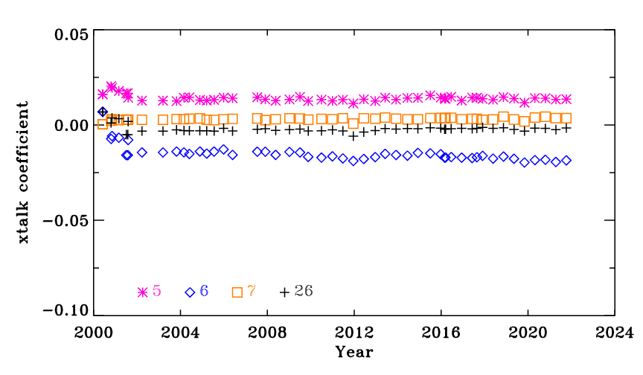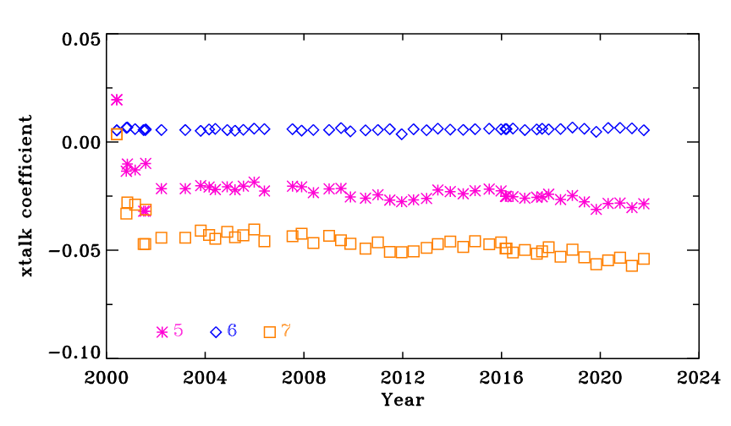
Fig. 1 Terra SWIR crosstalk coefficients for the center detector (detector 10) of each SWIR band derived from NTDM observations for subframe 1 (left) and subframe 2 (right).

Fig. 1 shows the SWIR crosstalk coefficients, derived from night-time-day-mode (NTDM) observations, for the center detector of each SWIR band. As seen from the figure, the subframe 2 coefficients for bands 5 and 7 have noticeable separation relative to subframe 1 and a modest temporal drift. A similar behavior is observed in subframe 1 of band 6. This is a known behavior related to the differences in the clocking sequence for these bands. Early in the mission, the electronic crosstalk had significant changes in its behavior corresponding to the times of the instrument configuration changes, seen as the relatively large jumps in the values for some cases in Fig. 1. As a result, a step LUT is employed before May 1, 2003. After this time, the instrument configuration has remained the same and a linear fit to the measured points is used for the LUT coefficients. This has been demonstrated to show a marked improvement in the image quality of the 500 m (HKM) L1B product with a noticeable reduction in the subframe-to-subframe and detector-to-detector striping. Similar improvements are also observed in the C6.1 L1B after July 2019, when this approach was implemented in forward production.¹⁷

Terra MODIS has a known sensitivity in the short wavelength RSBs to polarization, as identified in the prelaunch characterization. Significant changes to the polarization sensitivity have been observed for these bands (bands 3, 8, 9 and 10) on-orbit, particularly towards the end of scan. The desert observations used to derive the RVS are not corrected for polarization effects, and this has led to significant errors in the derived LUTs and subsequently the L1B products. The NASA Ocean Biology Processing Group (OBPG) has previously formulated a correction to mitigate the impacts on the ocean color products, a strategy that has also been adopted by the other science disciplines using Terra MODIS products.²⁰ In C7, the desert responses are corrected using the OBPG-derived coefficients before their use in the RVS characterization. This has led to a significant improvement in the gain estimation for these bands, particularly at large AOIs. Aqua MODIS has not shown any evidence of changing polarization sensitivity on-orbit and hence no correction is applied to the desert data before RVS characterization. In C6.1, the desert responses from select AOIs (12 for Terra and 13 for Aqua) from Libya 1, Libya 2, and Libya 4 desert sites were chosen for the RVS characterization. To achieve an improved coverage across AOI in C7, desert responses from additional AOIs of these sites are used. The semi-empirical bidirectional reflectance distribution function (BRDF) correction, previously applied in C6.1, is applied to all these desert responses in addition to the polarization correction for bands 3, 8, 9 and 10 for Terra MODIS.¹⁶

The EV-based RVS algorithm was formulated during the first decade of the instrument operation and relies on the 16-day repeatability of the desert observations. As both Terra and Aqua spacecrafts enter their constellation exit phases, these 16-day repeatable observations will no longer be available due to the orbit decay. To account for this change, C7 implements an RVS characterization approach where the desert observations are binned each month and fitted against AOI first and then with time. Results have shown that this approach has produced comparable results with the C6.1 approach of time-first (and then AOI-fit) fitting. Other minor fitting upgrades have also been incorporated in C7, resulting in improved characterization of the instrument response as derived from the desert observations.

As introduced earlier, the EV-based RVS approach was applied to bands 1-4 and 8-10 of Terra MODIS and bands 1-4 and 8-9 of Aqua MODIS, with OBC-based or prelaunch RVS applied to the other bands. As the instruments continue to operate two decades since launch, degradation of the performance in other bands, especially of Terra MODIS, has warranted the EV-based approach to be extended to more bands. In particular, bands 11 and 12 of Terra MODIS will employ ocean scene data and a ratio-based approach to derive the on-orbit RVS with spectrally matching band 4 as a reference.²¹ Results have shown that this approach mitigates the long-term reflectance drifts seen in C6/C6.1 calibration for these bands. Also, the Terra MODIS SWIR bands, having used prelaunch RVS in the calibration through C6.1, will now use time dependent RVS using the observations from deep convective clouds (DCC) to account for the long-term drifts. The DCC data are used to generate an on-orbit RVS for bands 5 and 26 and to correct for inaccuracies of the SD calibration ($m_{1})$for all four SWIR bands. Together with the SWIR crosstalk algorithm update, the on-orbit RVS updates are expected to significantly improve the image quality and radiometric accuracy of the Terra MODIS SWIR bands.²² In comparison, the continued excellent performance of Aqua MODIS has not warranted the EV-based RVS characterization approach to be extended to additional bands compared to C6.1.

In addition to the already-discussed changes to the $m_{1}$, RVS, and SWIR crosstalk LUTs, minor updates were also made to the uncertainty algorithm and the $E_{sun}$ LUT. The uncertainty in the reflectance product for C7 is mostly the same as in C6.1, but several small changes are observed as a result of the RSB algorithm changes. The bands in Terra MODIS that use EV data in C7 for the first time, bands 5-7, 11-12, and 26, have slightly larger uncertainty in C7 compared to C6.1 due to the larger noise in the EV trends compared to the on-board calibration data. The Terra MODIS bands that use a polarization correction in C7 also see a change (decrease) near end of scan, due to the removal of polarization-induced noise from the desert trends used for calibration. In all cases, the C7 uncertainty values should be more accurate and more consistent across the missions. The $E_{sun}$ LUT provides the values of solar spectral radiance integrated over the relative spectral response of each individual detector for use in converting the reflectance product to radiance. The $E_{sun}$ values have been re-calculated for C7 to fix a slight discrepancy in the previously used values. The only impact is a shift in the band 1 radiance product of about 0.5% for both Terra and Aqua MODIS, but the reflectance product for band 1 is not affected and no other bands see any change.

With these algorithm changes, all calibration LUTs over the entire missions are regenerated for C7 using consistent algorithms and fitting strategies, which will reduce errors associated with the inaccuracies of forward prediction. All these algorithm enhancements were shown to produce an improved L1B product in terms of long-term stability, image quality, and radiometric accuracy. In Section 4, some examples related to these improvements, as well as an impact assessment on the L1B products, are presented.

3.3 TEB Algorithm Improvements
The major algorithm improvements for Terra MODIS TEBs in C7 include the crosstalk correction for select MWIR detectors and additional corrections to the $a_{0}$ and $a_{2}$ coefficients in various bands to a) reduce the cold scene bias and mirror-side differences and b) improve the calibration stability. Improvements in Aqua MODIS TEB in C7 include crosstalk correction for select detectors and bands in the MWIR and LWIR wavelength range, as well as $a_{0}$ and $a_{2}$ updates to reduce mirror-side differences and improve the calibration stability. This section briefly describes these improvements with select examples. Further details about each of these calibration algorithm improvements can be found in these references. ^{13,18,23}

Like the Terra PV LWIR bands, lunar observations were used to evaluate the crosstalk effects in the Terra and Aqua MWIR bands and Aqua LWIR bands. A common phenomenon for individual detector contamination in the MWIR bands occurs between detector 10 of a band that is beginning its electronic sampling and detector 1 of a band that has just finished its electronic sampling. This contamination appears as an individual peak on the detector 1 signal that precisely aligns with the detector 10 sending signal from the next sampled band. As a result, detector 1 of bands 21-26 receives electronic signal contamination from sending detector 10 of the corresponding SMIR band, which manifests as striping of varying magnitudes in the calibrated Earth-scene imagery. A set of correction coefficients derived from the regular lunar observations was used to correct these effects, resulting in improved image quality and radiometric accuracy. The crosstalk correction coefficients for bands 23 and 24 (detector 1) are shown in Fig. 2. In comparison, the crosstalk correction coefficient values for other detectors in these bands are around zero, indicating significantly lower impacts due to electronic crosstalk. The gradual temporal decline in the crosstalk coefficients, particularly in band 24, indicates a change in the electronic crosstalk behavior. In Section 4, the improvements in the calibrated EV imagery after the application of these crosstalk correction coefficients are shown. A similar set of coefficients was derived for the other detectors that were identified as candidates for electronic crosstalk correction in C7. Like Terra, Aqua PV LWIR band crosstalk contamination increases with time, especially after safe mode in April 2022. The crosstalk correction shows a significant enhancement of L1B image quality and calibration improvement.

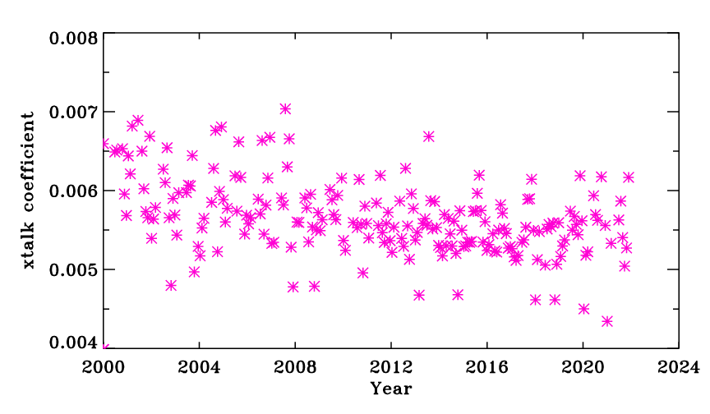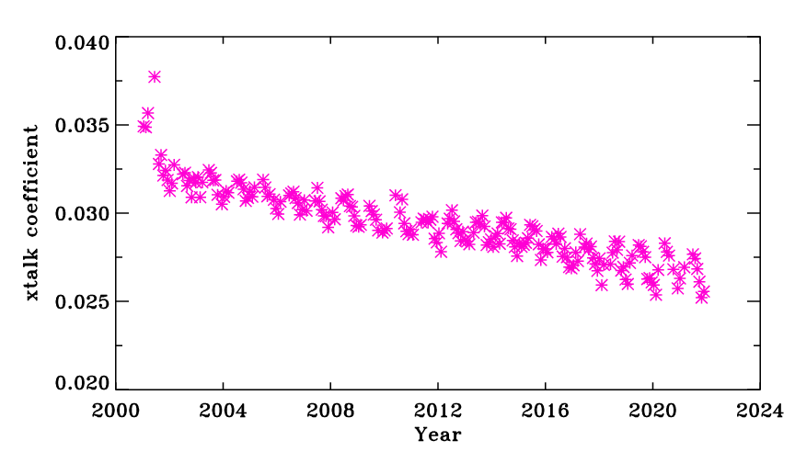
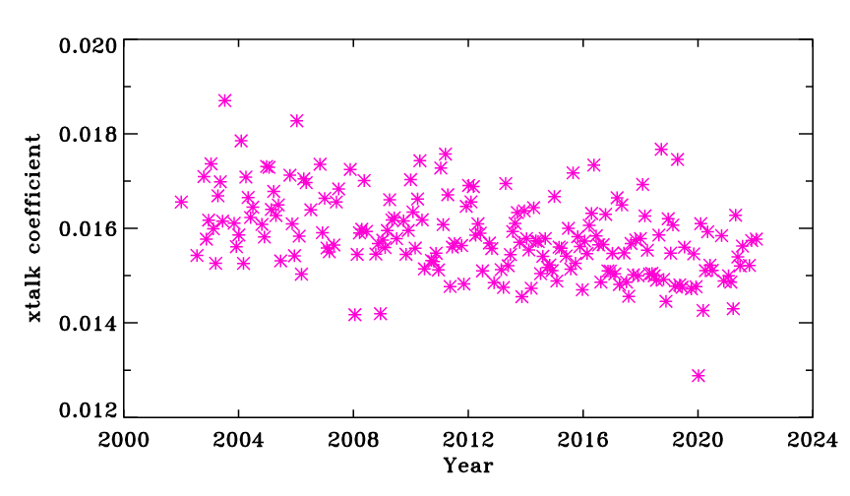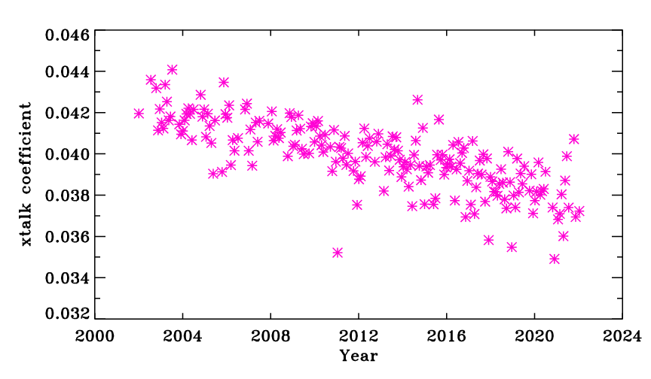

Fig. 2 Terra (top) and Aqua (bottom) electronic crosstalk correction coefficients from regular lunar observations for detector 1 of bands 23 (left) and 24 (right). The sending band for band 23 is band 25 and for band 24 is band 26. The contributions from the remaining sending bands are minimal and are not shown in these plots.

In C7, the estimation of the offset and non-linear coefficients was improved for several TEBs of both instruments. In the case of Terra MODIS, a correction to the offset coefficient ($a_{0})$ is performed for bands 20, 29, and 30. This correction for bands 20 and 29 is derived based on the differences in the cold scene brightness temperature (BT) measurement between MODIS and the Infrared Atmospheric Sounding Interferometer (IASI) and the trending derived from the quasi-deep convective clouds (qDCC) method. The correction for band 30 is derived from trends and mirror side differences from the Dome-C site. The application of this correction has demonstrated an improvement in the cold-scene bias. Also revealed from the inter-sensor comparisons with IASI and the Earth-scene trends was a long-term calibration drift in the Terra MODIS PV LWIR bands, especially band 30 brightness temperatures. A semi-empirical approach with constant offset and non-linear coefficients after 2003 for band 30 mitigates the observed long-term drifts. An algorithm for additional correction to the band 30 calibration coefficients ($a_{0}, a_{2})$was developed and applied that mitigated the remaining long-term drift. The Terra MODIS instrument underwent several electronic configuration changes early in its mission that affected the instrument response. Results from the cold scene targets, such as deep convective clouds, revealed mirror side differences and discontinuities in the brightness temperature trends for the photoconductive LWIR bands (bands 31-36). Subsequent analyses showed that an additional correction to the offset coefficient ($a_{0})$ to the LUTs between 2000 and 2003 resulted in a mitigation of these artifacts.^{23,24}

Like Terra MODIS, improvements to the offset and non-linear calibration coefficients were also incorporated in the C7 TEB calibration for Aqua MODIS. A formatter reset event that occurred in January 2018 resulted in a significant change in the behavior of the mirror side differences, with the dominant impacts observed in cold scenes. As the measurement bias at cold scene temperatures is dominated by the offset term in the calibration equation, extensive efforts were undertaken to develop a model to estimate the offset bias between the two mirror sides. A set of correction coefficients were derived from the qDCC trending and other cold scene targets, resulting in significant reduction of these effects. Terra MODIS also experienced a formatter reset in March 2022 that also caused a similar change in the behavior of the mirror side difference particularly at cold scenes. The calibration offset correction has been adjusted accordingly to maintain the calibration accuracy.

In addition to these improvements, the entire mission LUTs were reprocessed using a set of consistently processed coefficients. A mission-long set of calibration coefficient corrections are derived via an offline LUT for the key calibration parameters such as $a_{0}, a_{2},$ $b_{1}$ (which is given special consideration in some bands), crosstalk coefficients, and calibration uncertainty coefficients. For the Aqua MODIS MWIR bands 20 and 22-25, the prelaunch offset coefficient ($a_{0})$ with mirror-side correction and on-orbit derived non-linear coefficient ($a_{2})$ are used. For the PV LWIR bands 27-30, the prelaunch offset coefficient ($a_{0})$ with mirror-side correction and on-orbit derived non-linear coefficient ($a_{2})$ are also used. Similar to Terra band 30, a semi-empirical approach with constant setting of the offset and non-linear coefficients after 2012 for Aqua bands 27-30 further improved small but noticeable long-term drifts.

All these algorithm enhancements were shown to produce an improved L1B product in terms of long-term stability, image quality, and radiometric accuracy.^{25,26} In the next section, some examples related to these improvements as well as an impact assessment on the L1B products are presented.

4 Impact Assessments
Various improvements to the C6.1 calibration algorithm and the corresponding LUTs have been implemented and are expected to yield a more radiometrically accurate C7 L1B product. These algorithm changes also result in at-sensor reflectance differences between the two collections that the science users need to be aware of. In this section, along with some examples of key calibration improvements, an assessment of the at-sensor changes in the reflectance, radiance, and brightness temperatures is provided for both the reflective and thermal emissive bands.

4.1 RSB Assessment

As discussed earlier, the improvements in the shortest wavelength bands of Terra MODIS are expected to yield a more stable and radiometrically accurate L1B product. Fig. 3 (a) – (c) shows the TOA reflectance trending over the Libya 4 site for band 8 at three different frames (AOIs): frame 179 (beginning of scan), frame 642 (nadir), and frame 1208 (end of scan). The TOA reflectances, which are normalized to the mission beginning, are corrected for BRDF effects as well as the changes in the polarization sensitivities using the coefficients derived by NASA OBPG. While modest differences are observed between the C6.1 and C7 time-series at frames 179 and 642, significant (up to 15%) improvements are observed at the end of scan. This is an expected result as the magnitude of the polarization impacts are profound towards the end of scan. The large magnitude improvements towards the end of scan are indicative of the gain inaccuracies in the C6.1 L1B; however, they do not necessarily imply errors in the suite of MODIS science products, as a large majority of the products employ the OBPG-based or equivalent correction for changes in the polarization sensitivities. With the correction now included in the L1B, the necessity and the magnitudes of these corrections applied in the downstream products is expected to diminish significantly. Similar improvements in the long-term reflectance trends are also observed in the other VIS and NIR bands of Terra MODIS that rely on desert responses for their RVS characterization. Bands 11 and 12 are also expected to show improved long-term stability due to the inclusion of better RVS characterization using an inter-band calibration approach, where a stable reference band (band 4) is used to normalize the trends to reduce the noise in the EV observations. Using C6.1 L1B, a reflectance drift of about 3% is observed at nadir for band 11 that is effectively mitigated to be within 1% in C7 with the inter-band calibration approach. Starting in C6.1, a detector dependent RVS algorithm was employed for the selected short-wavelength bands (Terra MODIS bands 3, 8-12 and Aqua MODIS bands 8-12) that resulted in the reduction of the detector-to-detector striping in the L1B products. In C7, this algorithm was extended to include Terra MODIS band 4, also yielding a similar reduction in striping post-correction. Improvements are also noted in the SWIR bands of Terra MODIS, particularly bands 5 and 26, which employ a time dependent RVS in C7, which in turn results in an improved long-term stability in the EV trends. This time dependent RVS combined with other SWIR calibration improvements has shown reflectance drift improvements up to 2% for band 26 at nadir, with band 5 showing improvements up to 4% at nadir.

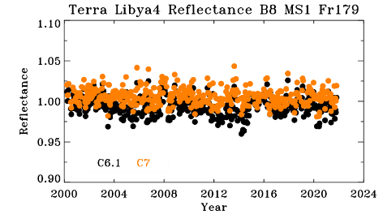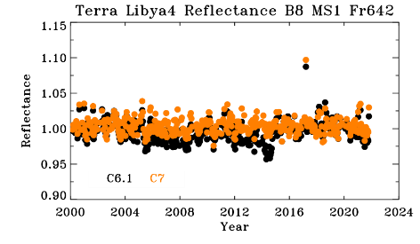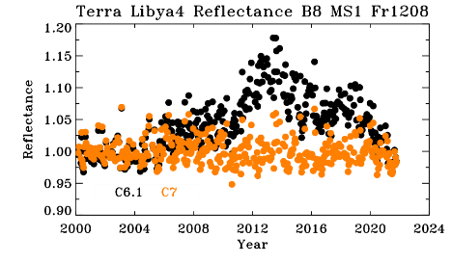
(a) (b) (c)
Fig. 3 (a)-(c) Terra MODIS C6.1 (black) and C7 (orange) normalized TOA reflectance over Libya 4 for band 8 (412 nm) mirror side 1 at three different frames (AOIs). Both datasets are corrected for BRDF effects as well as the changes in polarization sensitivity and are normalized to mission start.

Another improvement in C7 is an improved fitting methodology in the RVS characterization for the bands using the desert responses. The AOI-first fitting approach and the sliding window average (SWA) technique used in the time fitting of the responses for each mirror side has improved the reflectance mirror-side differences (mirror-side striping) in addition to the long-term stability. Fig. 4 (a)-(c) shows the reflectance mirror side differences for band 8 at the three different frames. Similar to the behavior seen in Figure 3(c), significant reflectance mirror side differences are observed in C6.1 as a result of trends uncorrected for polarization sensitivity, a behavior that is largely corrected in C7. A similar improvement is also observed for the other Terra MODIS bands that use the polarization corrected desert responses in C7.

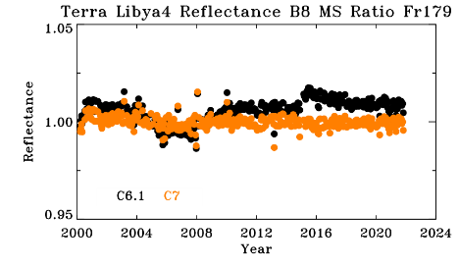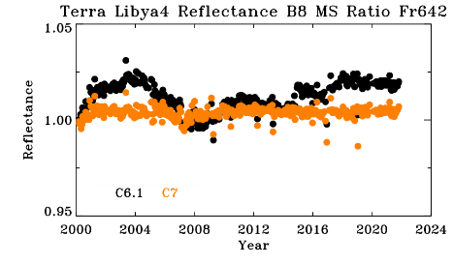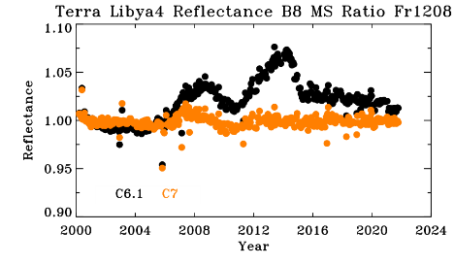
(a) (b) (c)

Fig. 4 (a)-(c) Terra MODIS C6.1 (black) and C7 (orange) normalized TOA reflectance mirror-side ratios (MS1/MS2) over Libya 4 for band 8 (412 nm) at three different frames (AOIs). Both datasets are corrected for BRDF effects as well as the changes in polarization sensitivity.

In comparison with Terra MODIS, no noticeable changes have been reported in the polarization sensitivity in the case of Aqua MODIS short wavelength bands. As a result, only minor improvements have been observed in the C6.1 reflectance time series, where some errors due to forward LUT prediction are corrected in C7. Fig. 5 (a)-(c) shows the C6.1 and C7 Libya 4 TOA reflectance time series for band 8 at three different frames. Apart from some biases observed between the years 2012 and 2018, a good agreement is observed between the C6.1 and C7 L1B. Similar agreement is also observed across the other RSB for Aqua MODIS. The improvements in the RVS fitting methodologies also manifest in improved mirror side differences in the C7 time series as shown in Fig. 6 (a)-(c).

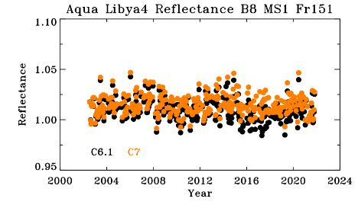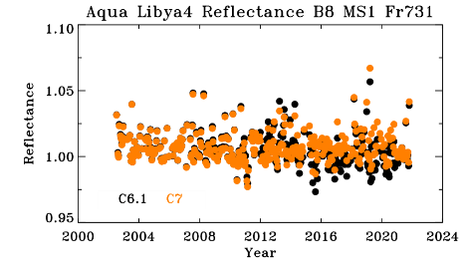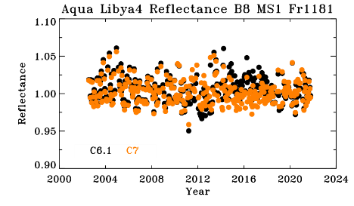
(a) (b) (c)
Fig. 5 (a)-(c) Aqua MODIS C6.1 (black) and C7 (orange) normalized TOA reflectance over Libya 4 for band 8 (412 nm) mirror side 1 at three different frames (AOIs). Both datasets are corrected for BRDF effects.

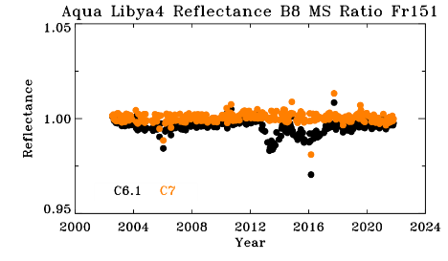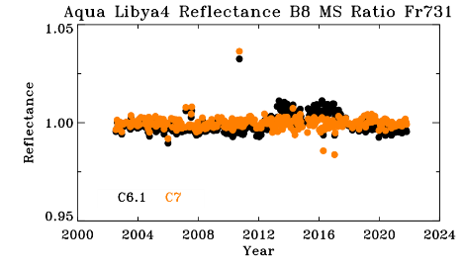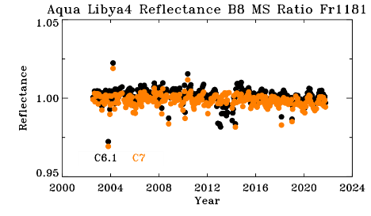
(a) (b) (c)
Fig. 6 (a)-(c) Aqua MODIS C6.1 (black) and C7 (orange) normalized TOA reflectance mirror side ratios (MS1/MS2) over Libya 4 for band 8 (412 nm) at three different frames (AOIs). Both datasets are corrected for BRDF effects.

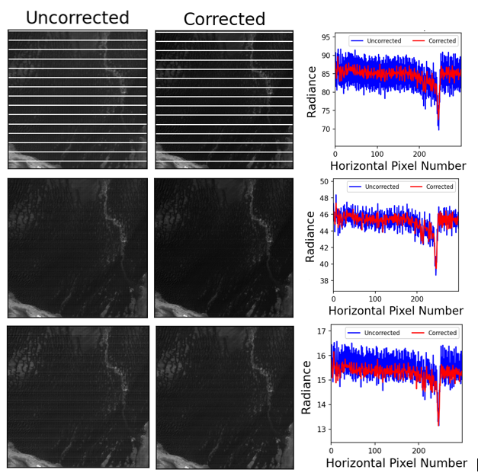

Fig. 7 Terra MODIS C6.1 (uncorrected/blue) and C7 (corrected/red) EV scene for granule 2016098.1055 for (top) band 5 (1.24 µm), (middle) band 6 (1.64 µm), and (bottom) band 7 (2.13 µm). The repeatable bright stripe in band 5 is attributed to an inoperable detector that is assigned a fill value

Historically, the SWIR bands on both Aqua and Terra MODIS have exhibited crosstalk behavior due to both an optical leak from the MWIR bands and electronic crosstalk, which has shown to have a larger impact on one subframe over the other. Throughout the mission, Aqua MODIS has used band 25 (4.52 µm) as a reference to correct for this crosstalk, with Terra MODIS using band 28 (7.28 µm) in previous collections. After the 2016 safe-mode event, several LWIR bands began showing significant increase in their own crosstalk behavior, which is unrelated to the SWIR crosstalk. Due to this increased behavior, band 28 could no longer accurately characterize the crosstalk behavior detected in the SWIR bands without introducing additional crosstalk signal. Starting in July 2019, the reference band for this correction on Terra MODIS was switched to band 25, with a scaling factor applied to avoid any discontinuity in the reflectance product. In C7, this scaling factor is no longer applied, with the entire-mission reflectance using the improved crosstalk correction in the SWIR bands. The corrected (C7) and uncorrected (C6.1) line profiles of band 5, 6, and 7 can be seen in Fig. 7 (a-c), respectively, showing the subframe (vertical) striping has been significantly reduced.

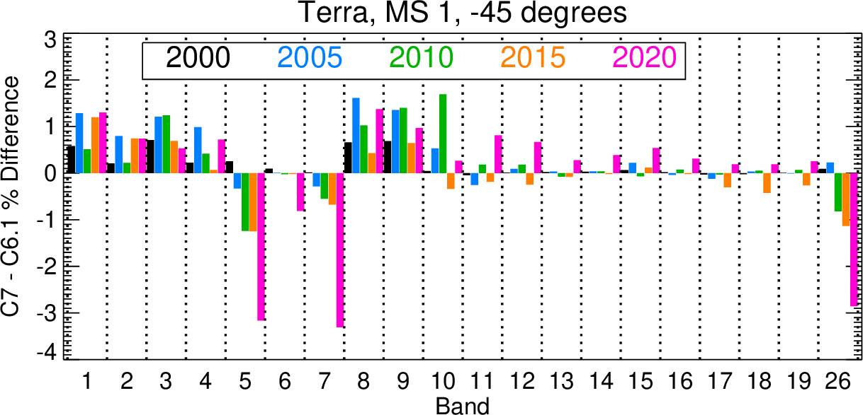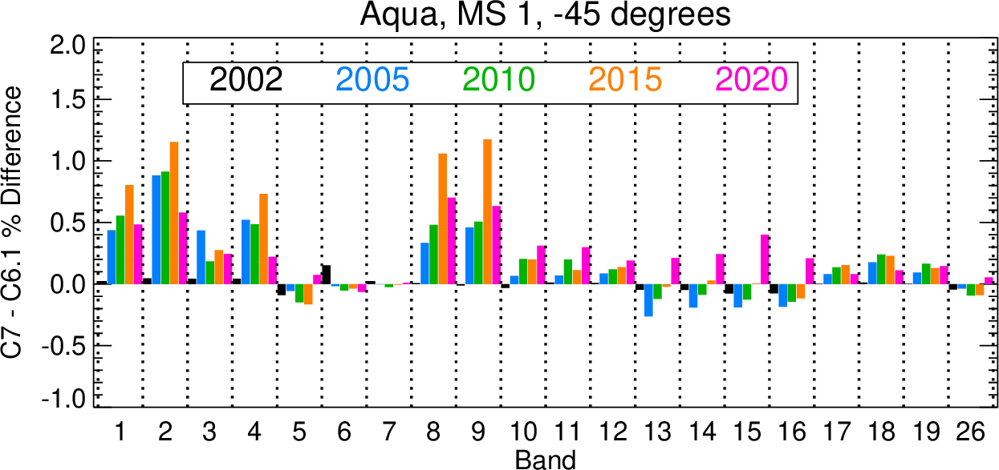
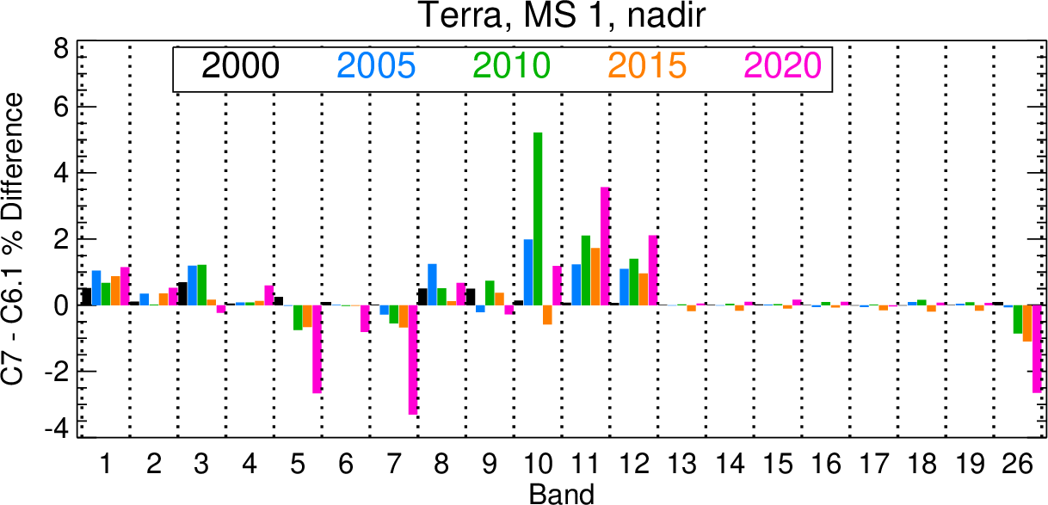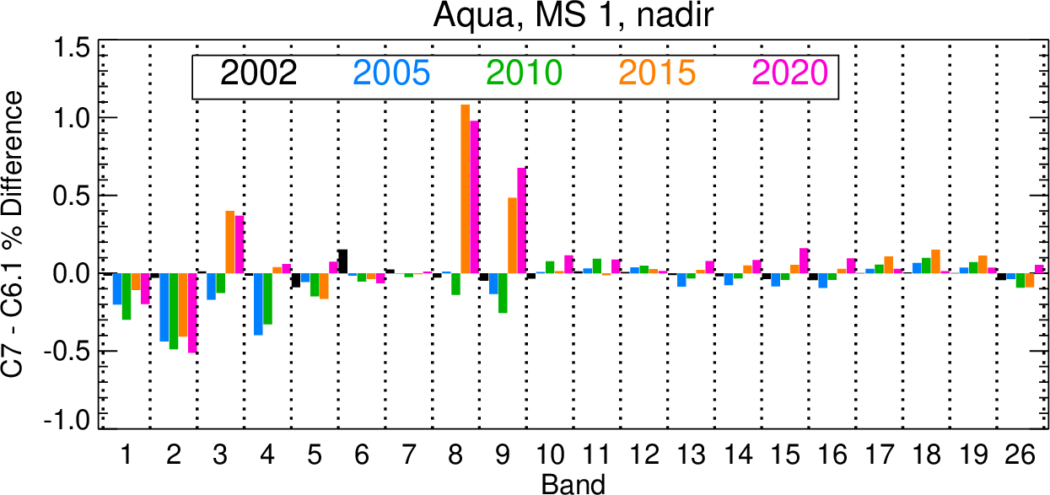
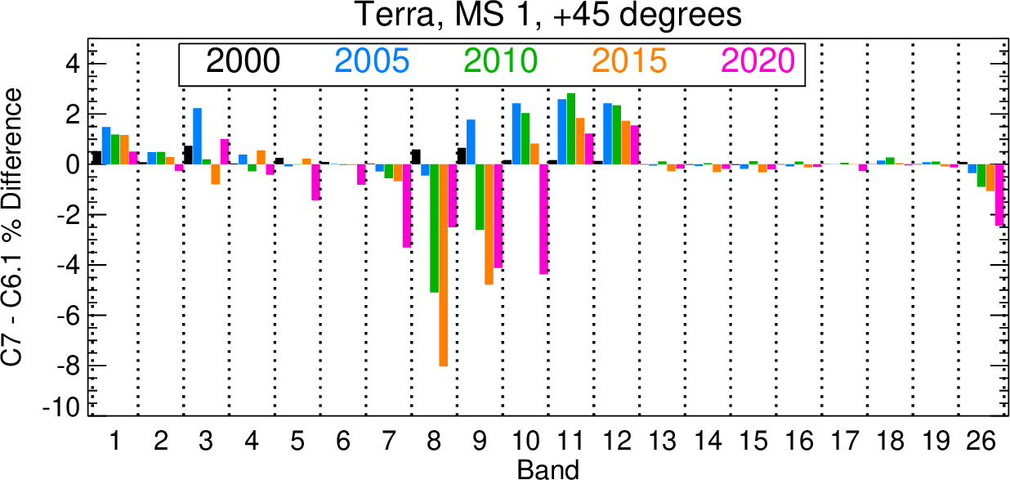

Fig. 8 Expected TOA reflectance differences between C6.1 and C7 for five representative years for the RSB of Terra and Aqua MODIS at three different AOIs (-45 degrees = beginning of scan, nadir, +45 degrees = end of scan). Note that plot ranges are different for Terra and Aqua MODIS for each scan-angle.

Collection 7 has several improvements over its predecessors, which have been discussed here in great length. The TOA reflectance ($m_{1}$/RVS) differences between C6.1 and C7 for both Aqua and Terra MODIS at beginning of scan, nadir, and end of scan are shown in Fig. 8. Overall, the reflective bands that utilize the EV correction approach (Terra bands 1-4, 8-12, 5-7, 26; Aqua bands 1-4, 8, 9) show the largest differences between the two collections across the mission. The Terra MODIS SWIR bands show similar differences across all three AOIs, with the end of scan showing the least change between the two collections. The VIS bands (bands 8-10) have the largest changes over the mission, with band 8 having an 8% difference at end of scan in 2015 due to the increased polarization impact that was previously unaccounted for in C6.1. Terra bands 11 and 12 also show significant differences at nadir and end of scan due to their use of the EV ratio approach with band 4 to correct for their long-term drifts in C6.1 The rest of the Terra bands that utilize the EV correction approach (bands 1-4) have the smallest impact between the two collections, as the only differences is the implementation of the AOI-first RVS algorithm. The Aqua MODIS differences between C6.1 and C7 are on a much smaller scale, showing less than 1.5% for all bands at all AOIs across the mission. This is expected as Aqua MODIS has better performance over Terra MODIS.

4.2 TEB Assessment

The calibration algorithm improvements and crosstalk corrections enhance the L1B product accuracy and image quality. The crosstalk correction, especially the correction for selected detectors of MWIR bands, gives significant imagery quality improvement. Fig. 9 shows two examples of comparisons between the uncorrected and corrected results of Terra and Aqua band 24 using granules from day 2021/296 and day 2019/284, respectively. In the case of Aqua band 24, the contamination of detector 1 is from the crosstalk from detector 10 of RSB band 26. Since band 26 receives strong signals over low BT ice and clouds in daytime, the image striping is dominant in these low BT scenes. Terra band 24 also shows a significant crosstalk contamination for detector 1 as shown in Fig. 9, although the magnitude of the striping before the correction is lower than the same detector of Aqua band 24. The effectiveness of the crosstalk correction can also be examined by plotting the radiance profile along the track direction since all detectors within the band are assembled in the same direction. Fig. 9 also shows extracted profiles from the two images before and after the correction that show significant reduction of large striping at low radiances. The magnitudes of the crosstalk coefficients for other detectors of both MWIR and LWIR bands vary among bands and detectors but are generally much smaller than those shown for detector 1 of band 24, except for the PV LWIR bands on Terra MODIS that are already corrected in C6.1. For detectors with lower crosstalk, the impact on image striping is difficult to observe in the visual examination of the imagery. However, examination of detector-to-detector differences by histogram indicates a noticeable improvement after the crosstalk correction is applied. With the additional crosstalk correction applied in C7, the uncertainty of the contaminated detectors is assessed and is added to the uncertainty calculation for the L1B product. The crosstalk uncertainty algorithm and its contribution to the total uncertainty of the L1B product has also been improved.

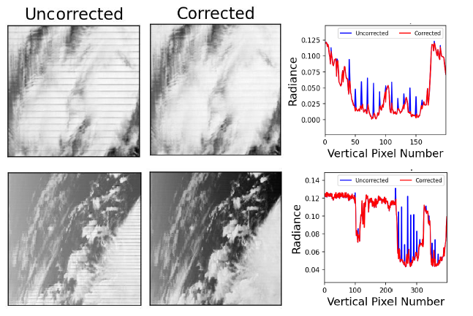
Fig 9. Example image comparisons between the uncorrected and corrected results of Terra (top) and Aqua (bottom) band 24 using granules on day 2021/296 and day 2019/284, respectively. Also shown are the along track profiles of two images before and after correction.

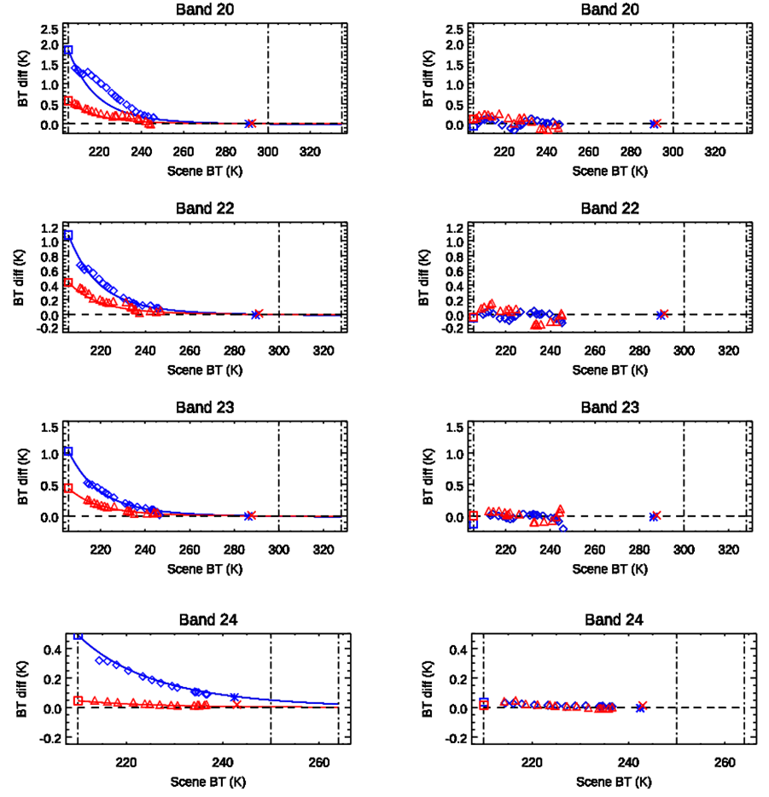
Fig. 10 Mirror-side differences (MS1 – MS2) for Aqua MWIR bands 20 and 22-24. The squares represent qDCC results and the lines define the model. Diamonds and triangles describe the Dome-C results, while asterisks and crosses depict the ocean scenes. Left panel is from C6.1 and right panel is for C7. Results before the Aqua MODIS formatter reset in January 2018 are shown in blue and results after the reset are shown in red. The vertical dashed lines (from left to right) are DCC BT, typical BT and maximum BT.

Another improvement is the $a_{0}$ correction in Aqua MODIS that has resulted in an improved mirror side consistency. The C6.1 Aqua MODIS $a_{0}$ are derived from pre-launch measurements with adjustment for on-orbit temperature variations. It was observed that the on-orbit electronic configuration changes have an impact on the $a_{0}$ parameter and the relative difference between the mirror sides. This mirror side difference was further evident after the formatter reset event in January 2018, with a larger effect observed in the MWIR bands. The $a_{0}$ adjustment parameters derived via a model for the two mirror sides are applied in C7 using results from qDCC measurements. More details about this model derivation can be found here.²³ As shown in Fig. 10, the qDCC measurement and model results agree quite well with Dome-C and the ocean scenes for most bands. The C7 results shown in the right panel are corrected using the model shown in the left panel.

Fig. 11 provides BT differences between C6.1 and C7 using the $a_{0}$ and $a_{2}$ coefficient correction and calibration algorithm changes for the Aqua and Terra TEBs. The BT differences shown in the charts also include the effect of LUT update procedure changes, where the timestamps of the LUTs are not the same between C6.1 and C7. Since the impacts are BT dependent and change with time, the assessment is performed at levels of 0.3 typical radiance, typical radiance, and maximum radiance for three select years. The major differences between the two collections are seen in the PV LWIR bands, as the calibration algorithm has significant changes at levels of typical radiance and maximum radiance in these bands for both Terra and Aqua. A semi-empirical algorithm for the a₀ and a₂ coefficients for Aqua bands 27 to 30 and Terra band 30 is used, where the coefficients of these bands are set to be constant after 2012 for Aqua and 2003 for Terra, respectively, to improve radiometric stability. Thus, Terra band 30 and Aqua bands 29 and 30 show large differences between C6.1 and C7 as seen in Fig. 11. Impacts of crosstalk correction are significant for certain detectors and dependent on scene type. The differences between C6.1 and C7 for other Terra TEBs are small, mainly due to the adjustment in the a₀ and a₂ LUT timestamps. The associated uncertainty indices (UI), which are a measure of the radiance uncertainties, are provided in the L1B product on a pixel-by-pixel level. The algorithm for estimating the uncertainty is based on a perturbative approach by assuming that each uncertainty term contained in the calibration algorithm is independent. The radiance uncertainty is calculated by combining all the uncertainty terms using the root mean square. In C7, the UI LUTs are reprocessed and updated over both Terra and Aqua missions.

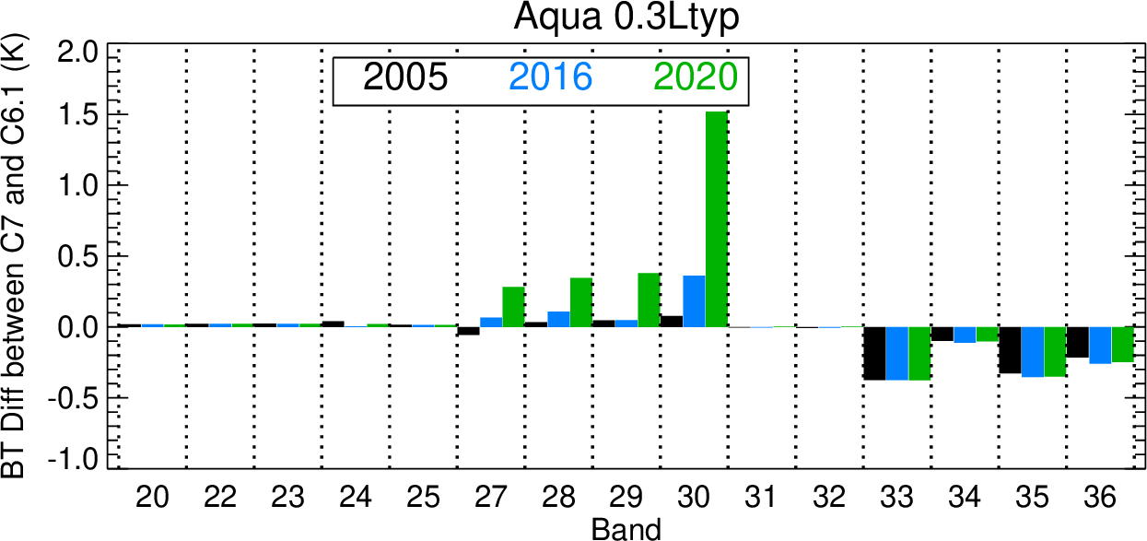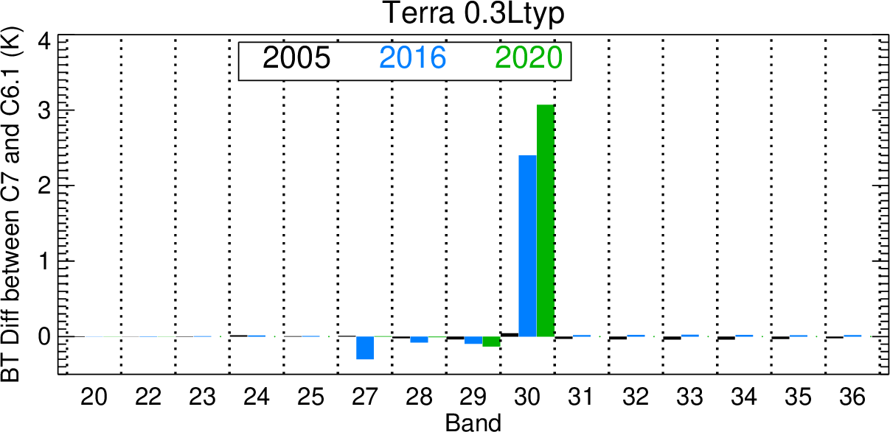
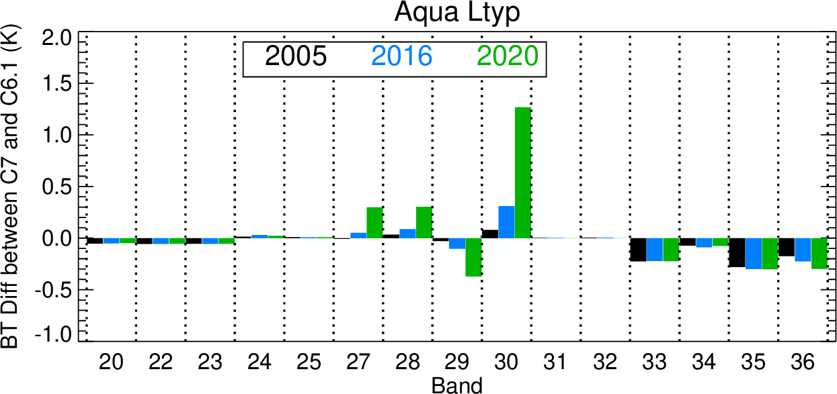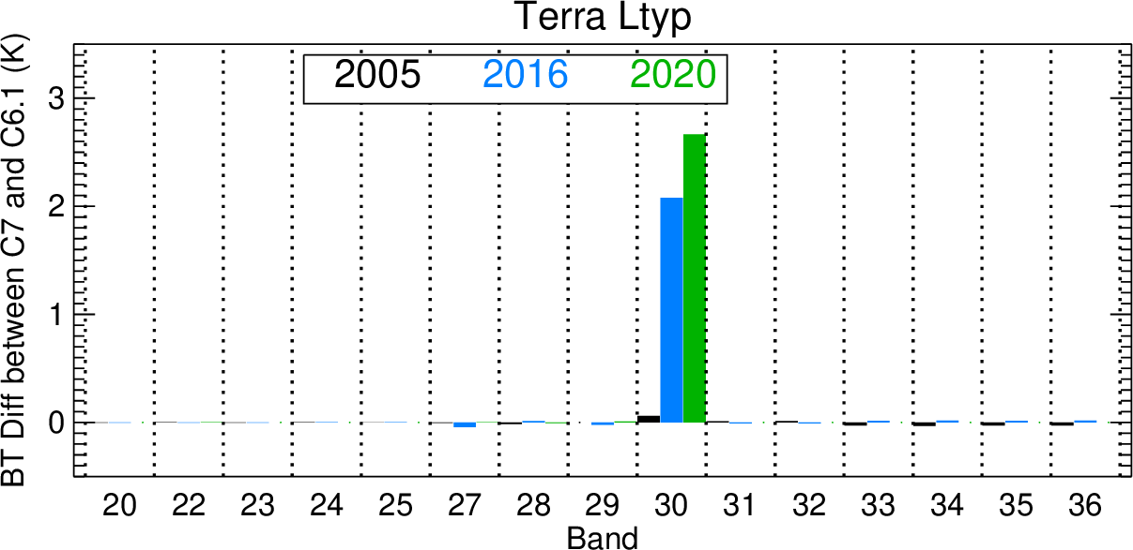
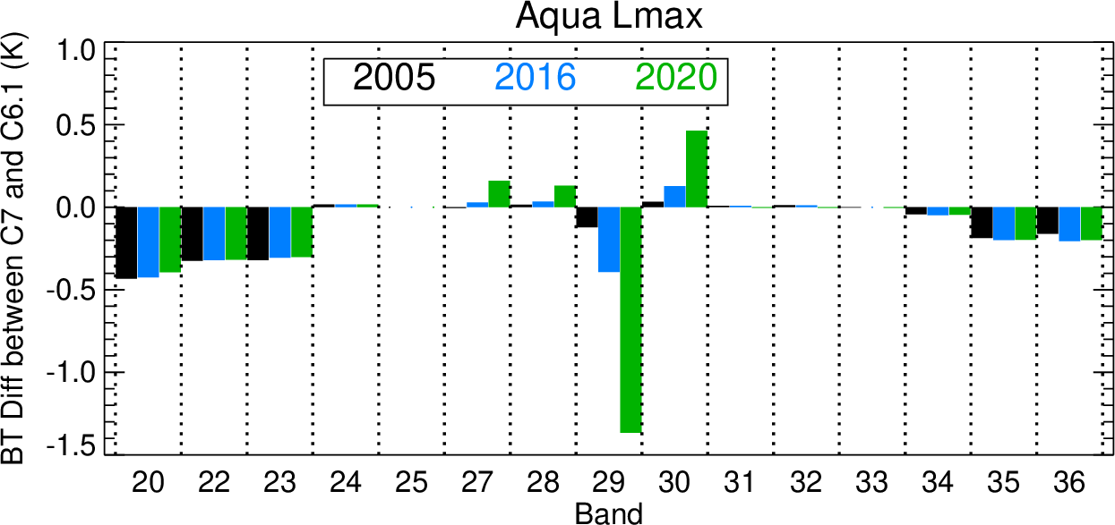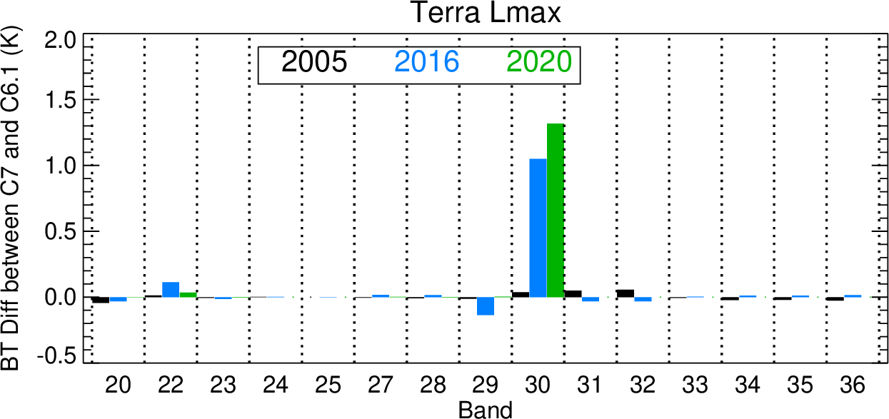

Fig. 11 BT differences between C7 and C6.1 (C7-C6.1) using the a₀ and a₂ coefficient correction and calibration algorithm changes for Aqua and Terra TEBs. The assessment is at levels of 0.3 typical radiance, typical radiance, and maximum radiance for 2005, 2016 and 2020. Note that the plot ranges differ between Terra and Aqua MODIS for each radiance level.

5 Summary
Over the last two decades Terra and Aqua MODIS have successfully provided near-daily global observations of the Earth’s land, atmosphere, and oceans. Various improvements made to the L1B algorithm in preparation for the C7 processing are discussed in this work, along with assessments and comparisons with the current operational product (C6.1). Improvements in the RVS in the short-wavelength RSB, electronic crosstalk characterization enhancements, TEB gain and offset parameter estimation improvements and upgrades to the L1B code together are expected to facilitate improved downstream science products by providing an L1B product that is superior to C6.1. Once the C7 L1B processing is undertaken (projected in early 2023), the MCST will continue to provide regular forward LUT updates. As the instruments continue to age, a degradation in their performance is expected, and algorithm modifications to adapt to these changes are expected. Furthermore, as both Terra and Aqua spacecraft exit their constellations and drift away from their nominal operational altitude, some changes to the RSB characterization approaches or strategies will be necessary. In particular, the RVS characterization algorithms for the short wavelength RSB that rely on regular observations of the North African desert sites to supplement the solar and lunar measurements will need to adapt to the changing orbits.

Acknowledgements

The authors would like to thank all members of the MODIS Characterization Support Team for their efforts with the Collection 7 L1B development. The authors would also like to thank Truman Wilson and Kevin Vermeesch for a technical review of this paper. In addition, the authors would also like to thank the members of the MODIS science team for their feedback which resulted in substantial improvements to the L1B code.

References

- V.V. Salomonson, W.L. Barnes, X. Xiong, S. Kempler, and E. Masuoka, "An Overview of the Earth Observing System MODIS Instrument and Associated Data Systems Performance", Proceedings of IGARSS, 2, 1174 – 1176 (2002).

- X. Xiong , M. D. King, V. Salomonson, W. Barnes, B. N. Wenny, A. Angal, A. Wu, S. Madhavan, and D. Link, "Moderate Resolution Imaging Spectroradiometer on Terra and Aqua Missions", John Wiley & Sons, Ltd, 9781118945179, 53-89, (2015).

- V. Salomonson, W. Barnes, P. W. Maymon, H. Montgomery, and H. Ostrow, "MODIS: Advanced Facility Instrument for Studies of the Earth as a System", IEEE Trans. Geosci. Remote Sens., 27,2, pp. 145-153, (1989).

- W.L. Barnes and V.V. Salomonson, "MODIS: A global image spectroradiometer for the Earth Observing System," Critical Reviews of Optical Science and Technology, CR47, 285-307 (1993).

- X. Xiong et al., “Updates of moderate resolution imaging spectroradiometer on-orbit calibration uncertainty assessments,” J. Appl. Remote Sens. 12(3), 034001 (2018).

- G. Toller et al., “Status of earth observing system terra and aqua MODIS Level 1B algorithm,” J. Appl. Rem. Sens. 2(1), 023505 (2008), http://dx.doi.org/10.1117/1.2839442.

- G. Toller, X. Xiong, J. Sun, B. N. Wenny, X. Geng, J. Kuyper, A. Angal, H. Chen, S. Madhavan, and A. Wu, "Terra and Aqua Moderate-resolution Imaging Spectroradiometer Collection 6 Level 1B Algorithm," Journal of Applied Remote Sensing, 7, 1, (2013).

- X. Xiong, K. Chiang, A. Wu, W.L. Barnes, B. Guenther, and V. Salomonson, "Multiyear On-orbit Calibration and Performance of Terra MODIS Thermal Emissive Bands," IEEE Transactions on Geoscience and Remote Sensing, 46,6, 1790-1803, (2008).

- X. Xiong et al., “Aqua MODIS thermal emissive bands on-orbit calibration, characterization, and performance,” IEEE Trans. Geosci. Remote Sens. 47(3), 803–814 (2009).

- X. Xiong, J. Sun, W. Barnes, V. Salomonson, J. Esposito, H. Erives, and B. Guenther, "Multi-year On-orbit Calibration and Performance of Terra MODIS Reflective Solar Bands," IEEE Transactions on Geoscience and Remote Sensing 45,4, 879-889, (2007).

- X. Xiong, J. Sun, X. Xie, W. Barnes, and V. Salomonson, "On-Orbit Calibration and Performance of Aqua MODIS Reflective Solar Bands", IEEE Trans. Geosci. Remote Sens., 48,1, 535-546, (2010).

- A. T. Isaacman, G. Toller, W. Barnes, B. Guenther, and X. Xiong, "MODIS Level 1B calibration and data products, Earth Observing Systems VIII", Proc. SPIE, vol. 5151, 552-562, (2003).

- T. Wilson, A. Wu, A. Shrestha, X. Geng, Z. Wang, C. Moeller, R. Frey, and X. Xiong, "Development and implementation of an electronic crosstalk correction for bands 27-30 in Terra MODIS collection 6," Remote Sens. 9, 6, 569, (2017).

- A. Angal, X. Xiong, A. Wu, X. Geng, and H. Chen, "Improvements in the On-Orbit Response Versus Scan Angle Characterization of the Aqua MODIS Reflective Solar Bands", IEEE Transactions on Geoscience and Remote Sensing, 56, 3, 1728-1738, (2018).

- J. Sun, X. Xiong, A. Angal, H. Chen, A. Wu, and X. Geng, "Time-Dependent Response Versus Scan Angle for MODIS Reflective Solar Bands", IEEE Transactions on Geoscience and Remote Sensing, 52, 6, pp. 3159-3174, (2014).

- A. Angal, X. Geng, X. Xiong, K. Twedt, A. Wu, D. Link, and E. Aldoretta, "On-Orbit Calibration of Terra MODIS VIS Bands Using Polarization-Corrected Desert Observations", IEEE Transactions on Geoscience and Remote Sensing, 58, 8, 5428-5439, (2020).

- X. Xiong, A. Angal, Y. Li, and K. Twedt, "Improvements of on-orbit characterization of Terra MODIS short-wave infrared spectral bands out-of-band responses", Journal of Applied Remote Sensing, 14, 4, 047503, (2020).

- T. Wilson, A. Shrestha, and X. Xiong, "Electronic crosstalk impact assessment in the Terra MODIS midwave infrared bands", Proc. SPIE, Sensors, Systems, and Next-Generation Satellites XXI, 10423, 104231Z, (2017).

- G. Keller, T. Wilson, X. Geng, A. Wu, Z. Wang, and X. Xiong, "Aqua MODIS Electronic Crosstalk Survey: Mid-Wave Infrared Bands", IEEE Transactions on Geoscience and Remote Sensing, 57, 3, 1684-1697, (2019).

- G. Meister, R. E. Eplee, and B. A. Franz, “Corrections to MODIS Terra calibration and polarization trending derived from ocean color products,” in Proc. Earth Observing Syst. XIX, vol. 9218, 2014, Art. no. 92180V, (2014).

- X. Geng, A. Angal, Y. Li, K. A. Twedt, and X. Xiong, “Improvements in the on-orbit response versus scan angle characterization for the MODIS ocean color bands,” Proc. SPIE 11151, 1115124 (2019).

- Q. Mu, X. Xiong, K. Twedt, A. Angal, X. Geng, "Characterization of the on-orbit response versus scan angle for Terra MODIS SWIR bands in Collection 7", Journal of Applied Remote Sensing, 16(2), 024520, (2022)

- T. Chang, X. Xiong, A. Shrestha, C. P. Diaz, “Methodology development for calibration assessment using quasi‐deep convective clouds with application to Aqua MODIS TEB. Earth and Space Science, 7, issue 1, 1-15. (2020)

- T. Chang, X. Xiong, A. Shrestha, and C. P. Diaz, "Normalization method and application for MODIS TEB assessments using Earth scene measurements", Earth and Space Science, 8, 5, pp. e2020EA001539, (2021).

- K. Twedt, E. Aldoretta, A. Angal, H. Chen, X. Geng, Y. Li, Q. Mu, K. Vermeesch, and X. Xiong, "MODIS reflective solar bands calibration improvements for Collection 7", Proc. SPIE 11858, Sensors, Systems, and Next-Generation Satellites XXV, pp. 118580S, (2021).

- T. Chang, A. Shrestha, C.P. Diaz, N. Chen, A. Wu, T. Wilson, Y. Li, and X. Xiong, "MODIS thermal emissive bands calibration improvements for Collection 7", Proc. SPIE 11858, Sensors, Systems, and Next-Generation Satellites XXV, pp. 118580R, (2021).

Caption List:

Table 1 MODIS design specifications
Table 2 L1B Algorithm Developmental Milestones

Fig. 1 Terra SWIR crosstalk coefficients for the center detector (detector 10) of each SWIR band derived from NTDM observations for subframe 1 (left) and subframe 2 (right).

Fig. 2 Terra (top) and Aqua (bottom) electronic crosstalk correction coefficients from regular lunar observations for detector 1 of bands 23 (left) and 24 (right). The sending band for band 23 is band 25 and for band 24 is band 26. The contributions from the remaining sending bands are minimal and are not shown in these plots.

Fig 3. Terra MODIS C6.1 (black) and C7 (orange) normalized TOA reflectance over Libya 4 for band 8 (412 nm) mirror side 1 at three different frames (AOIs). Both datasets are corrected for BRDF effects as well for the changes in polarization sensitivity and are normalized to mission start.

Fig. 4 Terra MODIS C6.1 (black) and C7 (orange) normalized TOA reflectance mirror-side ratios (MS1/MS2) over Libya 4 for band 8 (412 nm) at three different frames (AOIs). Both datasets are corrected for BRDF effects as well for the changes in polarization sensitivity.

Fig. 5 Aqua MODIS C6.1 (black) and C7 (orange) normalized TOA reflectance over Libya 4 for band 8 (412 nm) mirror side 1 at three different frames (AOIs). Both datasets are corrected for BRDF effects.

Fig. 6 Aqua MODIS C6.1 (black) and C7 (orange) normalized TOA reflectance mirror side ratios (MS1/MS2) over Libya 4 for band 8 (412 nm) at three different frames (AOIs). Both datasets are corrected for BRDF effects.

Fig. 7 Terra MODIS C6.1 (uncorrected/blue) and C7 (corrected/red) EV scene for granule 2016098.1055 for (top) band 5 (1.24 µm), (middle) band 6 (1.64 µm), and (bottom) band 7 (2.13 µm).

Fig. 8 Expected TOA reflectance differences between C6.1 and C7 for five representative years for the RSB of Terra and Aqua MODIS at three different AOIs (-45 degrees = beginning of scan, nadir, +45 degrees = end of scan). Note that plot ranges are different for Terra and Aqua MODIS for each scan-angle.

Fig. 9 Example image comparisons between the uncorrected and corrected results of Terra (top) and Aqua (bottom) band 24 using granules on day 2021/296 and day 2019/284, respectively. Also, shown are the along track profiles of two images before and after correction.

Fig. 10 Mirror-side differences (MS1 – MS2) for Aqua MWIR bands 20 and 22-24. The squares represent qDCC results and the lines define the model. Diamonds and triangles describe the Dome-C results, while asterisks and crosses depict the ocean scenes. Left panel is from C6.1 and right panel is for C7. Results before the Aqua MODIS formatter reset in January 2018 are shown in blue and results after the reset are shown in red. The vertical dashed lines (from left to right) are DCC BT, typical BT and maximum BT.

Fig. 11 BT differences between C7 and C6.1 (C7-C6.1) using the a₀ and a₂ coefficient correction and calibration algorithm changes for Aqua and Terra TEBs. The assessment is at levels of 0.3 typical radiance, typical radiance, and maximum radiance for 2005, 2016 and 2020. Note that the plot ranges differ between Terra and Aqua MODIS for each radiance level.

