Morphological evolution and transition at nanoscale in BSTO ceramic materials

N. B. Singh, Ching Hua Su*, Fow-Sen Choa, Bradley Arnold, Brian Cullum and K. D. Mandal**

University of Maryland, Baltimore County, Baltimore MD, USA
*NASA Marshall Space Flight Center, Huntsville, AL, USA
**Indian Institute of Technology, Banaras Hindu University Varanasi (UP) India

ABSTRACT
Considerable efforts have been devoted for the development of low cost ferroelectric and clean energy storage multifunctional materials. Modification in design and production of a low cost material with well proven process provides pathway for high energy density dielectric energy storage. We studied fluorine doped a commercially well-established material system barium strontium titanate with two different concentrations of dopants and studied the morphological transition and its effect on properties. It was observed that sample with higher concentration transitioned much faster into glassy state, followed by growth of fibers which turned into a self-arranged bird nest type shape. The sample with lower concentration changed slowly into glassy state and only few fibers were farmed. Dielectric was highly dependent on processing methods and shows variation with crystallinity of material, temperature and cooling conditions during processing. In the higher concentration range, we observed nano-scale interface breakdown very similar to that of solid-liquid interface breakdown during crystal growth.

Keywords: dielectric, barium strontium titanate, energy storage, sintering, nanoparticles, glass

- INTRODUCTION
Since past few years we have been studying synthesis and characterization of bulk and nanoengineered multifunctional industrially important dielectric and ferroelectric materials for variety of optical and electronic devices, energy storage, ferroelectric and magnetic devices and systems. Measured properties such as bandgap, resistivity and dielectric constant value are highly process dependent and show variation with particle size of source material, temperature and cooling conditions during processing. This may be the reason for different values reported by different investigators in perovskite materials [1-3] including as calcium copper titanate. To understand the problems related to uncertainty and variation of electrical properties, we have prepared nanoparticles based ternary compounds and studied electronic, optical and thermal characteristics including phase transition.

Synthesis and growth of industrially important material Barium strontium titanate (Ba_{1–}xSrxTiO₃), BSTO ceramics has been performed by sintering and other variety of methods including direct reaction followed by sintering and sol–gel methods. It has been demonstrated that grain sizes were dependent of constituent composition of the BSTO ceramics. The size decreased from 15 to 2 μm with increasing Sr molar fraction. It has been demonstrated that temperature transition from ferroelectric to paraelectric phase (Curie temperature: TC) decreased linearly from 125 to −30 °C as Sr molar fraction increased. Panomsuwan and Manuspiya [4] have shown that for the range of 1 to 100 KHz frequency range the dielectric constant exhibited frequency-independent behavior. They indicated that a diffuse dielectric constant peak was evident for BSTO due to the effect of fine-grained size. Also, the polarization–electric field at room temperature showed a well-defined hysteresis loop for BSTO in certain composition range indicating their ferroelectric characteristics. In the past we have extensively studied Calcium copper titanate, CaCu₃Ti₄O₁₂(CCTO) system [1-3] which was proposed by Subramanian et al. [5] and by using a very small crystal. We demonstrated that [6] one can achieve a dielectric value >1000, 000 at low frequency even in polycrystalline materials by controlling the morphology. However, resistivity still remains a big road-block for the breakdown of the material at high voltage. It has been described by Gorzkowski et al [6] that that many commercial but military components, systems and weapons require high pulse power capacitors. This means a high breakdown voltage material is needed. Also, the pulse power can be achieved by increasing the resistivity of the material. Gorzkowski and co-workers [6] added aluminium oxide to the BSTO system and produced glass ceramics to demonstrate a dielectric constant of 1000 and a significantly high breakdown strength of the material. In addition, they tested addition of BaF₂ which showed further improvement in the energy density significantly. We have been working to improve properties of BSTO and CCTO to achieve high resistivity and hence pulse power by substituting fluorine. In this paper we have reported results of two concentrations of fluorine and its effect on the morphology and performance of the BSTO system.

- EXPERIMENTAL METHODS

Two major processing methods entitled as semi-wet method and high temperature ceramic sintering methods using carbonates and oxides of the parent components have been extensively used [3,4]. Both methods are used for the synthesis and processing including grain growth. The semi-wet methods uses relatively low temperature to achieve large multi-crystalline samples. In the present study compound was prepared by using conventional synthesis process using carbonates and oxides of the parent components. .

2.1 Materials Synthesis and grain growth: The details of synthesis and grain growth are described in reference [3] extensively. For the present study we chose two concentrations described as Ba_{0.5}Sr_{0.5}TiF_{x}O_{3-x} (x=0.25 and 0.5) BSTFO by using barium fluoride, barium carbonate, strontium carbonate and titanium dioxide. The parent components were supplied by Alfa Aesar. The listed purity was better purity than 99%. These chemicals were used without further purification. The samples ranging up to 5-12 g were synthesized. All parent components were placed in a furnace at 110⁰C to driveaway moisture. Two compositions of the BSTO with x=0.25 and x=0.50 were prepared by mixing the source materials and were grinded to make uniform particle size. After weighing two compositions with x=0.25 and 0.5, they were mixed several times in mortar. The mixture was placed in a wig-L-bug grinding system for further mixing. For mixing a small holder contacting 2-3 gm mixture was used in the sample holder of wig-L-bug. The final particles sizes were in the range of 50 to 100 μm. The mixture was pressed to prepare pellets using the pressure in the range of 7000 to 8000 lb/inch². The pellet size was 12 mm in diameter. The sample was prepared in two stages to insure homogeneous mixing. Both samples were placed at 400⁰C for 24 hours followed by raising temperature in the range of 900ºC for sintering and grain growth. The temperature of the sample with x=0.5 was raised in longer time (36 hours) compared to sample containing x=0.25..

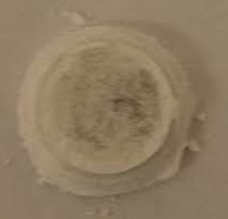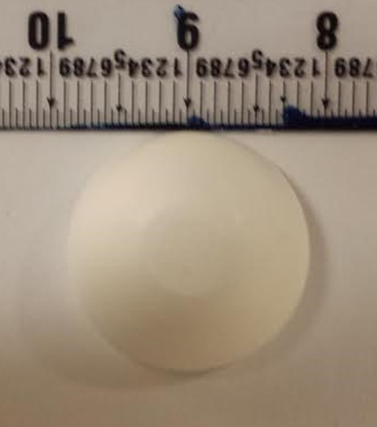
- (b)

Figure 1. Annealed pellets with (a) x=0.25 and (b) x=0.50 compositions of BaF₂. The material with lower fluoride concentration showed partially glassy behavior for identical annealing time.

2.2 Sample characterization: We polished and prepared the materials in geometry of parallel-plate capacitors. The sample thickness ranged from 1 to 2 mm (thinned and polished). The uniform thickness was achieved for the sample by polishing samples on a very fine sand paper followed by cleaning with soft tissues wet with acetone. The reactivity of the pellets with silver was evaluated by holding samples for several days. The material does not react with silver or gold and long-term stability is extremely good. We used silver pastes as the electrode. Electrodes were made with silver paint for the measurements..

2.3 Electrical resistivity and dielectric constant measurements: Electrical resistance and dielectric constant were measured with an Agilent/HP 4284A LCR meter for both classes of samples. The measurements were made for various frequency range at room temperature at several bias voltage using a parallel-resistance model of complex-impedance measurements and measuring current from a dc voltage bias.

2.4 Morphological study: The morphological studies were made by both optical microscope and scanning electron microscope using a NOVA NANOSEM 450 system. The data were collected using the 20KeV source. The EDX studies for the compositional analysis was performed by exposing to monochromatic X-rays (Al or Mg X-rays) and the ejected electrons intensities and measuring kinetic energies. In this system electrons emitted from the top ~10 nm layers are collected.

- RESULTS AND DISCUSSION

The samples prepared for dielectric and resistivity measurements were mostly in the range of 2.0 to 6.0 gm. The diameter of samples was in the range of 10 to 13 mm. To keep the processing parameters identical for both compositions, pellet formation, annealing and sintering temperatures were kept identical. In each case an identical pressure of 7000 to 8000 lb/inch² was used for pressing for a period of 30 to 60 minutes. In both cases of these samples, we cooled samples by shutting down the power of the furnace and temperature reached to room temperature in approximately 9-10 hours. The surface and bulk micromorphology observed by optical microscope indicated very smooth surface for the sample with higher fluorine concentration compared to the sample of lower fluorine concentration. This sample has surfaces were glossy and very shining. Both samples were free from gross defects such as bubbles and voids.

As listed in the experimental section we prepared mixtures of BSTO was in the range of Ba_{0.5}Sr_{0.5}TiO₃. But fluorine concentration was varied by using BaF₂ in place of BaCO₃. So, before the processing the composition was Ba_{0.5}Sr_{o.5}TiO_{3-x}F_{x} (x=0.50 and x=0.25) . It appears that fluorine concertation changed significantly since samples were processed in the air. To avoid evolution of fluorine we had chosen lower sintering temperature compared to usually higher temperature when oxides or carbonates are used for sintering. There was no attempt to control the atmosphere during sintering. The compositional analysis of the processed sample was determined by using XPS. After scanning compositions at several positions of the samples, we did not observe significant composition variation. We observed that both samples after processing showed fluorine concentration in the range of 3.9% and 1.8% respectively. Due to limitation of this instruments better concentration limit was not possible.

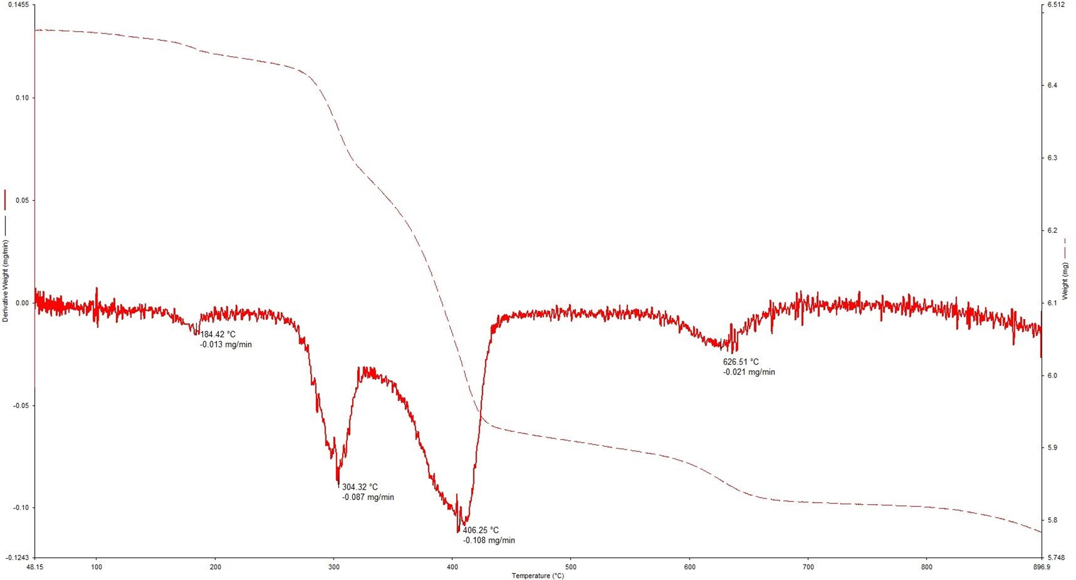

Figure 2. Thermal gravimetric analysis of sample with lower fluorine concentration

Figures 2 and 3 show the results of thermal analysis of both samples. The thermal gravimetric analysis of both processed samples showed very different characteristics. As shown in these figures, the material with higher fluorine concentration showed glassy at lower temperature and no sign of crystallites after 30 minutes of sintering temperature. We will discuss the transition in following section. The sample with lower fluorine concentration showed several peaks and within the applied sintering time. Unlike the higher fluorine concentration sample, it did show partial melting and crystallization of the material. However, it did not show formation of fibers from glassy part of the sample.

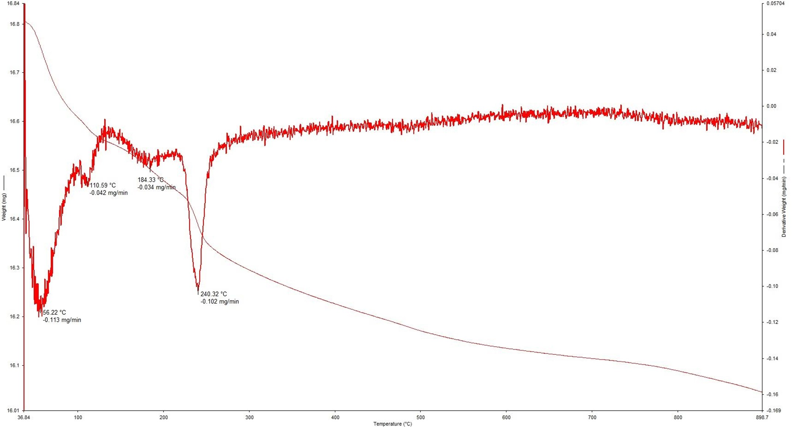

Figure 3. Thermal gravimetric analysis of sample with lower fluorine concentration

As shown in previous studies using CaCu₃Ti₄O₁₂ perovskite material it was shown that the substitution and doping of perovskite class of materials have significant changes in the morphology, resistivity and dielectric properties. Figure 3 shows the morphology of the sample with lower fluorine concentration with increasing magnification. A major part of the sample showed crystals in the range of 0.2 to 0.9 μm sizes in length. Almost all these crystallites were facetted crystals. The details of the mechanism due to impurities modification are discussed in references 7 and 8. Similar findings with different morphologies were observed for the BSTO by Bomli and Milne [9] where they used BSTO sintered at 1350 C with different powder beds during sintering. But the role of the change in the surface energy anisotropy has not been explored. It has been demonstrated based on direct observations of organic materials [10-11] that surface energy anisotropy affects the nucleation and morphologies significantly.

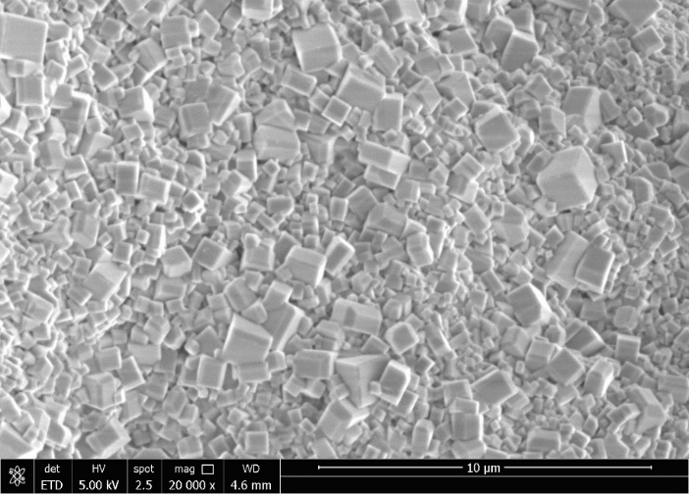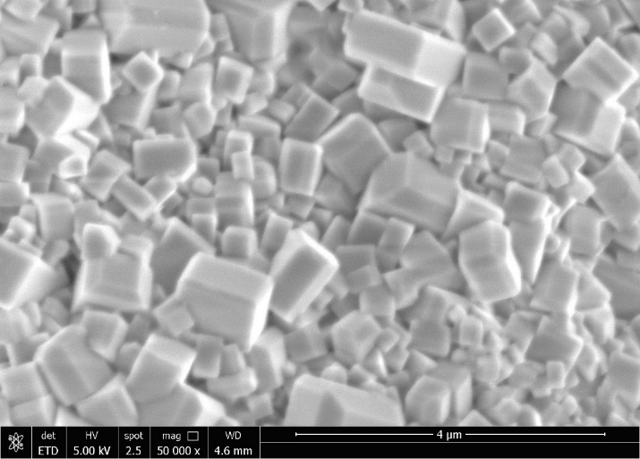
- (b)

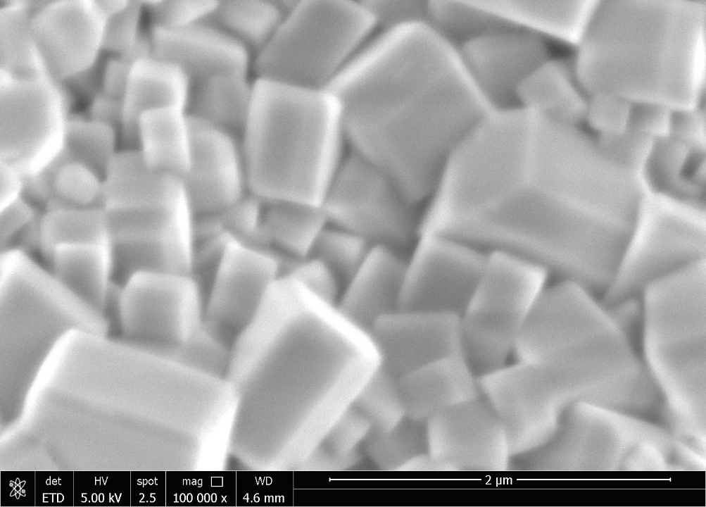
(c)
Figure 4. Morphologies of the sample with increasing concentration of fluorine.

Figure 4 shows the morphologies with increasing magnifications for the sample with lower fluorine concentration. It is very clear that these facets show three dimensional shapes and when compared with pure BSTO, these crystals vary in sizes and also in uniformity.
The morphology shown in Figure. 4 is similar to that reported in reference 7 and 8 where lead oxide (PbO) was used as dopant where formation of cubes and faceted grains formation were explained by the Ledge Coarsening Mechanism (LEM) in which the diffusion rate and the surface attachment rates are comparable. As explained by Shiflet et al. [12] the LEM can describe in great details the transformation of coarsening cubes. It appears that use of fluoride compound affects the surface energy. The Wulff shape automatically transforms into the shape that minimizes the total surface energy for a fixed volume of material.

When we quenched the sample by turning off the furnace power the transition from crystallites to glassy state started. Figure 5 shows that crystallites merged together and started forming large clusters of the material. Father annealing for a period of 50 hours showed more extensive merging of grains and formation of diminishing shapes . There were grain boundaries even after extended time of sintering but did not show fiber or nanowire formation like samples of larger concentration of fluorine. As shown in Figure 6 large boundaries as shown in Figure 6(b) extended up to 20-30 μm range. In both Figure 6 (a) and Figure 6 (b) engulfment of faceted grains can be observed. Figure 5 also shows boundary where large clusters are shown merging in a smooth material.

When we increased the processing temperature to 900ºC, glass formation process started. The morphology of quenched surface is shown in Fig. 5 indicating the merging of nano cubes and glass formation. This process started by merging the cubes at edges followed by evolution of large phase mixing. Although melting point of barium fluoride is well above 1365ºC, even temperature of 900ºC was high enough for glass formation. This indicated that BaF₂ acted as flux and enhanced the coarsening.

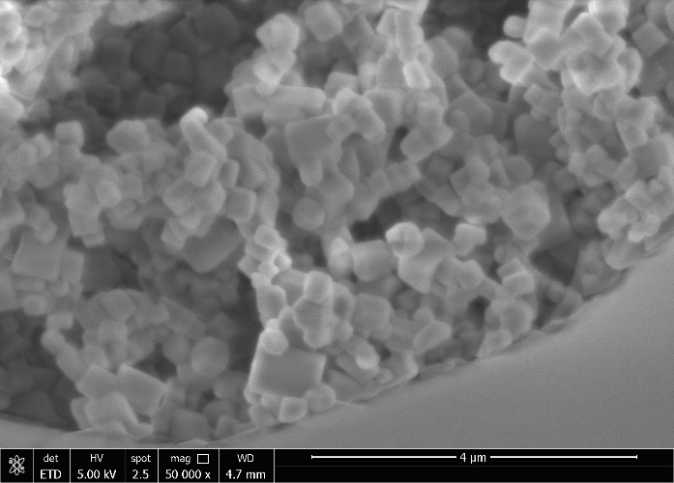

Figure 5. Transition in the sample with lower concentration

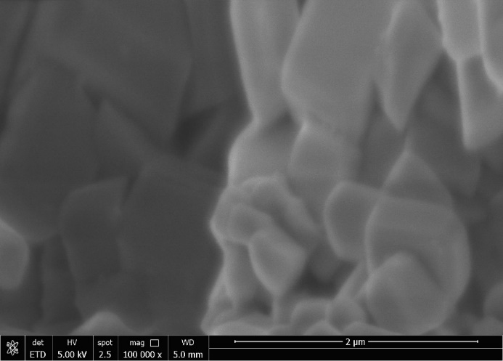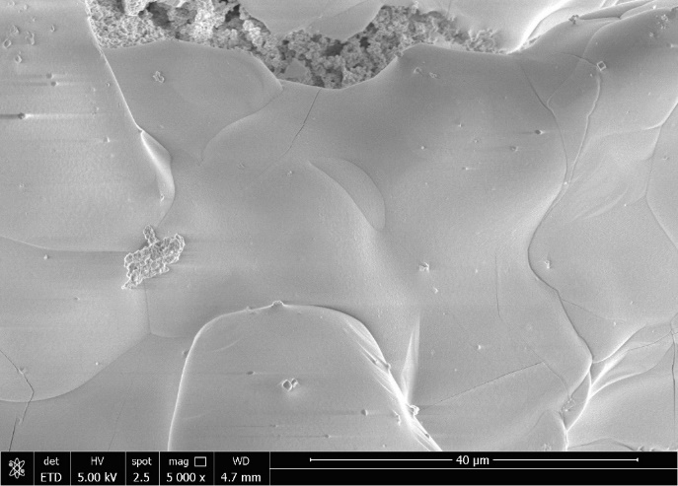
- (b)

Figure 6. Father annealing for more than 50 hours showed (a) merging of grains at high magnification. (b) There were grain boundaries even after extended time of sintering but did not show fiber or nanowire formation

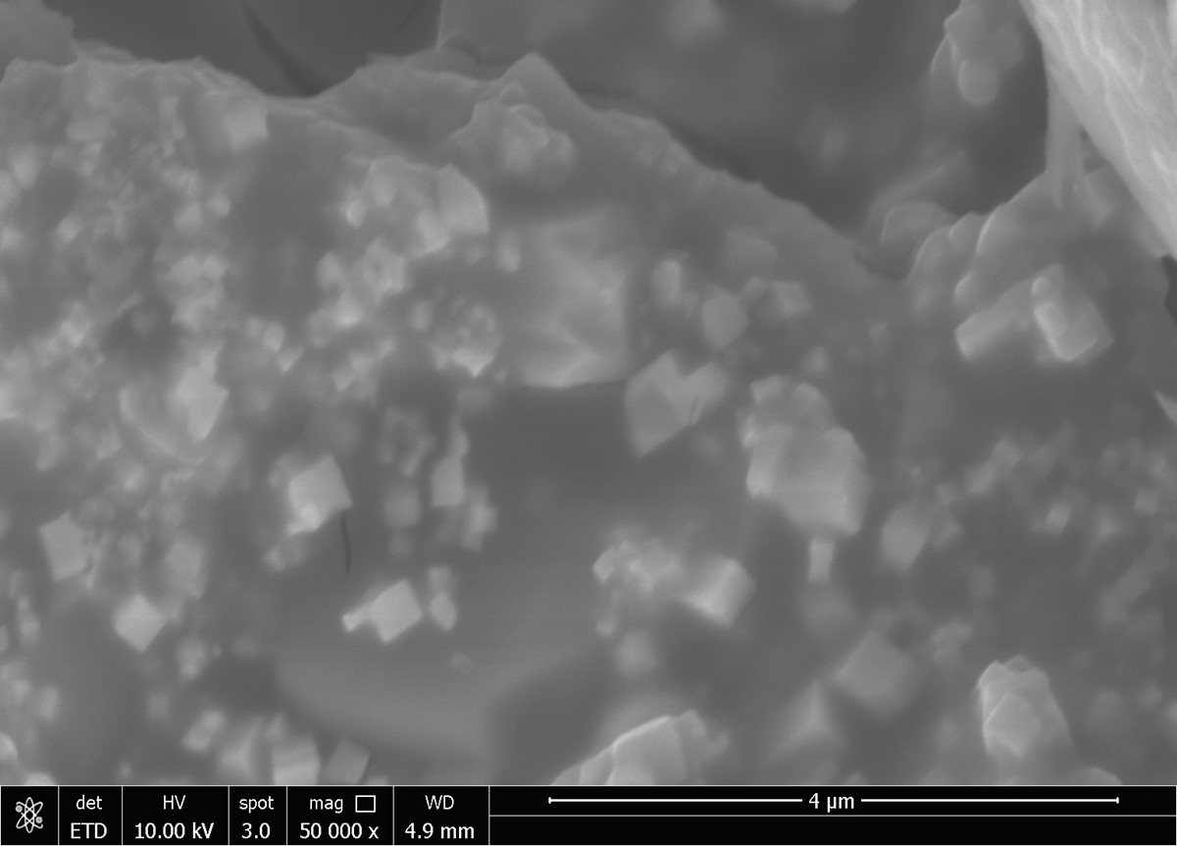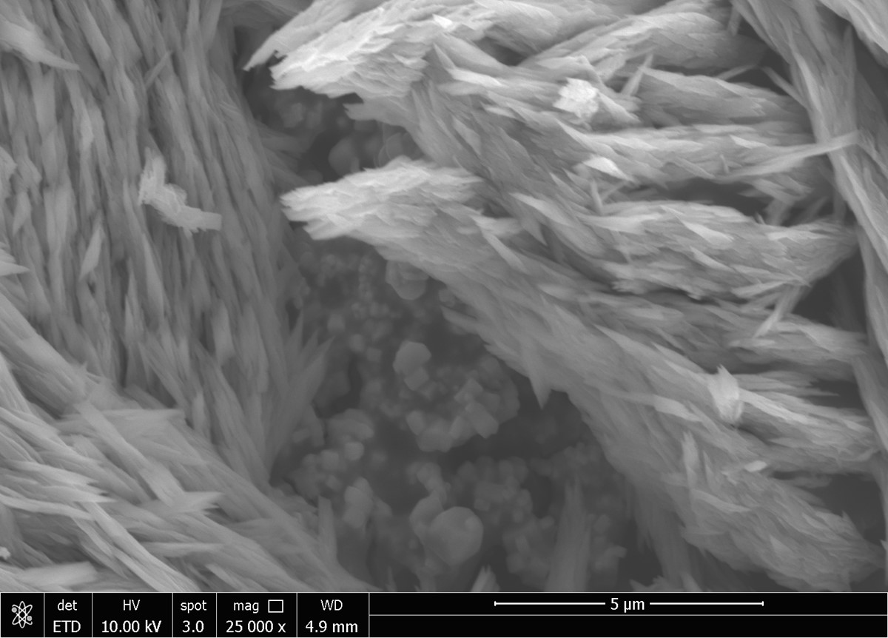
Figure 7. Evolution of morpholgy from glassy phase (a) particles interface to (b) showing particles into nano and microfibers, The morphology of sample processed in furnace at 900ºC, and material was soaked for a period of 5 hours. Morphology shows merging of cubes and filling of voids merged semi developed glasses with few shaped grains.

The sample with higher concentration of fluorine showed similar behavior at the early stage of the grain growth. However, with increasing time span of annealing and grain growth transition was very dramatic. Figure 7 shows the evolution of different stages of the morphologies. Figure 7(a) shows that after soaking of 5 hours at 900C cubes appear to be surrounded by a partial melt and then start dissolving. At this stage these facets disappeared. Morphology shows merging of cubes and filling of voids merged semi developed glasses with few shaped grains. When this sample was quenched, we observed the rapid formation of glassy phase. As shown in Figure 7 (b) particles change into nano and microfibers before complete transformation. The formation of these nanofiber formation is not completely understood. However, it can be explained on the basis of interface breaking in the semi glassy zones (similar to mushy zone) for the nucleation of nano scale fibers and fast growth due to quenching. One can understand formation based on the basis of classical theories developed for the whisker growth. Most of the models based on classic theory describe impingement of atoms on the whisker sides, and diffusion of adatoms to the whisker tip. The adatoms are incorporated at the tip for further growth. In absence of experimental data, it is extremely difficult to compare growth results of these fibers with any existing model for the nucleation and the impingement of atoms on nucleated tip and formation of shape.

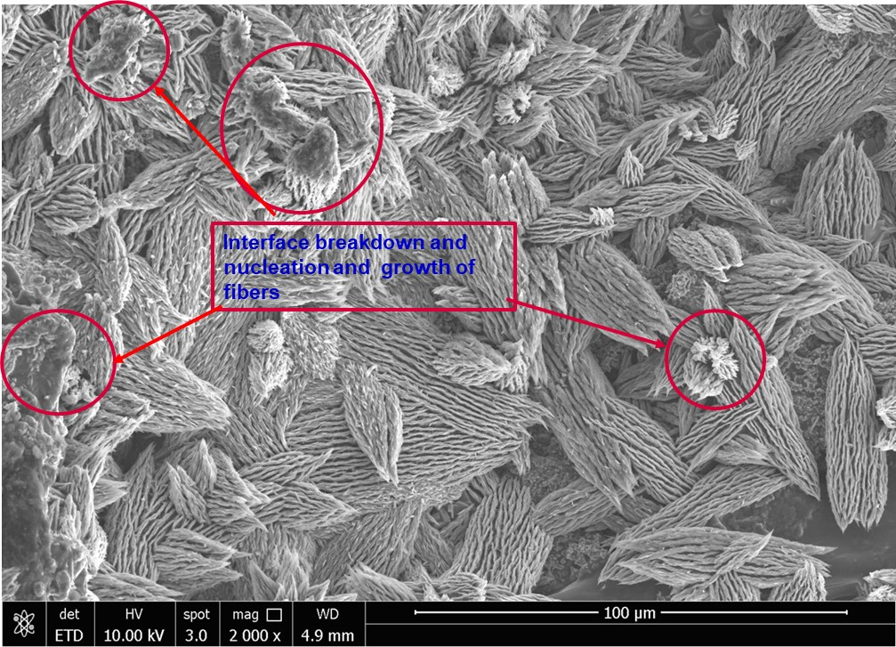

Figure 8. Self assembled in complex shape nanowire surrounded structure

The samples processed in large span of time (>50 hrs) showed very unique morphologies and transition of nanoparticles into naofibers and shapes consisted of nanowires. The continuation of coarsening results into rearrangements of fibers forming complex structured nets shown in Figure 8. Ultimately these fibers rearrange and very complex structure is formed by self shaping mechanism to form brd nest type self assemled structures . The mechanism of self shape formation requires more research. The nano and microwire formation from the particless shown in Figure 8 to self assembled in complex shape nanowire surrounded structure has not beent observe earlier. It needs to be explored further in future study. By observing the shapes, it appears that the interface energy anisotropy plays very important role in governing the direction of bundle of these structures. Another factor which is not observed earlier is interface breakdown to initiate nanowires from the trapped liquidus spots. We have marked these nucleation sites to indicate similarity of interface breakdown similar to the constitutional supercooling. Since time to cool to room temperature is several hours, it provides enough between solid and mushy liquidus state for rearrangement of wires to form unique shapes observed in Figure 8.

As we mentioned in the introduction, ferroelectric and dielectric behavior of the BSTO has been explored extensively. However, study by Panomsuwan and Manuspiya [4] on BSTO was performed the frequency range of 1 to 100KHZ for dielectric and ferroelectric behavior. The present study was also in the range of 100 Hz to 1000KHz. The method and brief preliminary results for the BSTO on the dielectric capacitance and resistivity were briefly reported in reference 2.

Figure 9. Measured capacitance for fluorine doped BSTO samples. For a 75 hours annealed samples there was no significant difference in dielectric constant and resistivity.

For both classes of pellets, we had fabricated the thickness of 2 mm and spot electrode size of 2mm size. The measured capacitance is shown in Figure 9. This resulted into dielectric content in the range of 1200 to 1400 and almost constant for the studied frequency range. As shown in reference 2, values were constant for the bias voltage of 50mV to 1V bias range. It was observed that both samples after annealing of 75 hours demonstrated very little change in the dielectric constant and resistivity. This indicates that fluorine doped samples show slightly less tunablility of dielectric constant with frequency in Hz to KHz range. The resistivity in 100KHz range of in low 10⁸ ohm/cm range. These values of dielectric constant and resistivity are slightly higher than some of the literature values reported for pure BSTO. But it should be mentioned that properties of this class of materials are very process dependent. These values are slightly better than BSTO with Ba_{0.5}Sr_{0.5}Tio₃ literature data. The addition of different amount of fluorine does change the space charge polarization, and hence the properties including dielectric loss could be affected between conductive particles. This study indicates that even smaller amount of fluorine affects the polarization and hence large amount may not be required. The addition of larger amount of fluorine produced glassy phase and nano and microfibers. Also, first time it was observed the nucleation and growth of fibers which turn into self-organized structures.

- CONCLUSION

BSTO samples with two concentrations of fluorine was prepared and characterized. We did not observe any significant and adverse effect of different amount of fluorine on the resistivity or dielectric properties of the samples. In the case of large concentration of fluorine, we observed significant morphological transition including morphology from nanoparticle to nanowire and microwire. In certain processing conditions and composition range, a stable self-assembled structures and glassy morphology was observed. In this paper we report the results of BSTO system due to substitution of fluorine. We observed that similar to the solid-liquid breakdown, nano- and microparticles show huge transition into nanowires and fibers. This transition enables possibility of designing conformal materials for variety of applications without significant decrease in their performance. The fluorine addition enables low sintering temperature for the composites for large production and practical applications. Also, since the fluorine doping transitioned into very smooth glassy state this approach has potential to produce BSTO capacitors in glassy and fibrous states.

ACKNOWLEDGEMENTS
The authors would like to acknowledge the supports of Space Life and Physical Sciences Division, Human Exploration and Operations Mission Directorate, NASA Headquarter. The authors are also grateful to several students including Stacey Sova, Puneet Gill for their help and Northrop Grumman for providing the chemicals for this project.

- REFERENCES

1. Narsingh B Singh, John J Talvacchio, Marc Sherwin, Andre Berghmans, David J Knuteson, David Kahler, Brian Wagner, John D Adam: High dielectric capacitor materials and method of their production, US7830644, November 9, (2010)
2. N. B. Singh, A Berghmans, D. Knuteson, J. Talvacchio, D. Kahler, M House, B. Schreib, B. Wagner and M. King, Evolution of microstructure due additives and processing, Ceramic Transaction, 235, 65-76 (2012).
3. N. B. Singh, Ching Hua Su, Fow-Sen Choa, Brad Arnold, Lisa Kelly, K. D. Mandal, Narayan Singh and Christopher Cooper, “Morphological transition and evolution of shapes in glassy state; BST dielectric material” Edited by Amar Bhalla, Morsei Mohmoud, Narottam Bansal, Danilo Surovov, Ruyan Guo, Rick Ubic, Jake Amoroso, Cory Travelpiece, Naveen Manjooran, Gary Pickrell and Dinesh Agarwal, Advances in Ceramics for Environmental Functional Structural and Energy Applications 11, 69-80 (2020)

4. Gasidit Panomsuwan and Hathaikarn Manuspiya, Structural and dielectric properties of sol–gel derived Ba_{1–}xSrxTiO₃ (0 ≤ x ≤ 0.5) ceramics for energy storage applications, Mater. Res. Express 6 026310 (2019)
5. N. C. Homes, T. Vogt, S. M. Shapiro, S. Wakimoto, and A. P. Ramirez, Science 293, 673 (2001).
6. E. P. Gorzkowski,, M. J. Pan, B. Bender, B. and C. C. Wu, Glass-ceramics of barium strontium titanate for high energy density capacitors, J. Electroceramics,18, 269. (2007).
7. N. B. Singh, M. Gillan, David House, Ravali Yanamaddi, Vishnu Razdan, Brad Arnold, “Effect of substitution and impurities on dielectric properties and resistivity of CaCu₃Ti₄O₁₂” J. Emerging Materials Research 2, 6, 344-347 (2013).
8. N. B. Singh, A Berghmans, D. Knuteson, J. Talvacchio, D. Kahler, M House, B. Schreib, B. Wagner and M. King, Evolution of microstructure due additives and processing, Ceramic Transaction, 235, 65-76 (2012).
9. P. Bomlai, and S.J. Milne, Properties of barium-strontium titanate PTCR ceramics sintered on different powder beds. J Mater Sci 42, 6803–6808 (2007). https://doi.org/10.1007/s10853-006-1400-1
10. N B Singh and M E. Glicksman, Effect of anisotropy on dendritic morphology, J. Crystal Growth, 98, 277, (1989).
11. M. Chopra, N. B Singh and M Glicksman “Fundamentals of dendritic growth in alloys I”, Met. Trans. A, 19A (1987) 3087.
12. J. Shiflet, H. I. Aaronson, and T. H. Courtney, “Kinetics of Coarsening by the Ledge Mechanism,” Acta Metall., 27, 3, 377-385 (1979).

