Western Sonoran Desert Water Resources
Evaluating Rock Pool Hydroperiod Fluctuation using Climate Variables to Inform Habitat Monitoring and Protection in the Western Sonoran Desert

Technical Report
Final – August 11th, 2022

Anne Britton (Project Lead)
Deirdre An
Seamus Geraty
Charles Nixon

Advisors:
Molly Woloszyn, NOAA National Centers for Environmental Information, National Integrated Drought Information System (Science Advisor)
Dr. Douglas Rao, NOAA National Centers for Environmental Information, North Carolina Institute for Climate Studies (Science Advisor)

Fellow:
Katie Lange (NCEI Fellow)

1. Abstract
Ephemeral freshwater rock pools, known as tinajas, have great biologic and cultural importance as sources of surface water in the western Sonoran Desert (WSD). Tinaja flooding and drying cycles, known as hydroperiods, vary based on meteorologic and climatologic conditions; however, a lack of extensive research relating climatic impacts to tinajas puts these critical ecosystems further at risk. The National Park Service (NPS) and the University of Arizona monitor the physical and ecological condition of tinajas in Organ Pipe Cactus National Monument (OPCNM), AZ, using resource-intensive strategies: in situ trail cameras and direct measurements. To aid monitoring efforts, the NASA DEVELOP team aimed to incorporate remote sensing into NPS strategies by analyzing spatiotemporal climate data and tinaja hydroperiods in OPCNM between 1979–2022. Using Aqua and Terra Moderate Resolution Imaging Spectroradiometers (MODIS), University of Idaho Gridded Surface Meteorological Dataset (gridMET), and OpenET data, the team generated climatology maps and time series for OPCNM. The team compared these data to daily in situ hydroperiod observations from the University of Arizona between 2019–2022. Climate maps and time series showed increases in temperature and solar radiation (p<0.05), while analyses of in situ data showed correlations of hydroperiods with precipitation and evapotranspiration. End products identified high-risk tinajas and demonstrated that Earth observations can successfully be correlated with in situ hydroperiod observations. These results will support NPS efforts to prioritize water resource management and inform protocols driving the conservation of tinajas in OPCNM.
Key Terms
remote sensing, tinajas, drought, hydroclimate, climatology, in situ data, Sonoran Desert, National Park Service

2. Introduction

2.1 Background Information
As warming and drying climate trends continue to negatively impact the greater North American Southwest, effective land management increasingly relies upon understanding the ecological impacts of limited water resources. In the western Sonoran Desert (WSD), water-reliant ecosystems are likely to be increasingly impacted by hydrological and ecological drought (Arizona State Climate Office, 2022; Crausbay et al., 2017). As a result, managers of protected areas in the WSD must make water resource management decisions that impact species reliant on surface waters such as freshwater rock pools, known in the WSD as tinajas.
The National Park Service (NPS) manages areas within the WSD containing tinajas, including several within the study area of Organ Pipe Cactus National Monument (OPCNM) (Figure 1). OPCNM is a biosphere reserve located in southern Arizona near the border of the Mexican state of Sonora. While OPCNM makes up only a portion of the Sonoran Desert, its climate and geography are generally representative of the desert as a whole.
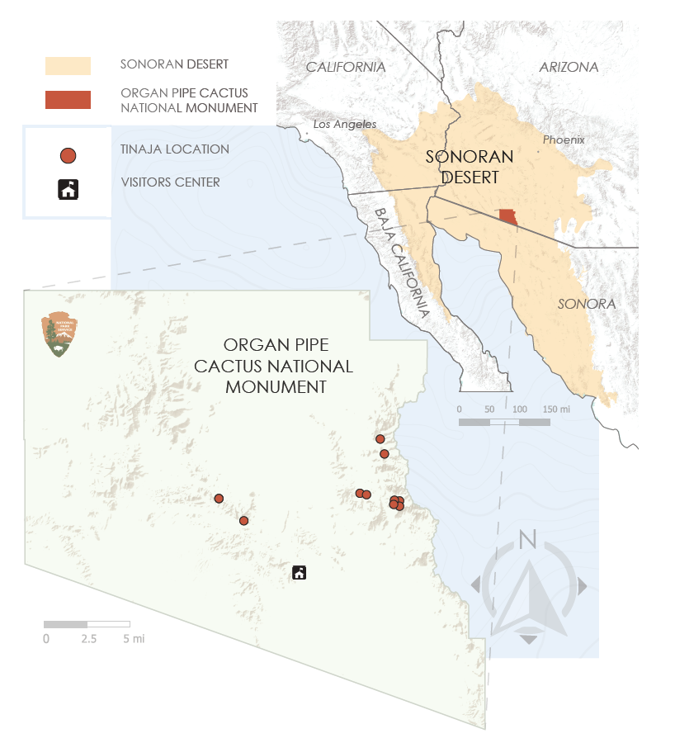
Figure 1. The project study area, Organ Pipe Cactus National Monument, is situated in the western Sonoran Desert. The ten tinajas of interest are indicated by red circles on the map.

Tinajas form in exposed rock through natural processes and are important habitats for a variety of organisms (Chan et al., 2005; Jocque et al., 2010). Depending on precipitation and evaporation rates, tinajas can range from shallow puddles to deep pools and typically go through filling and drying cycles described as hydroperiods (Chan et al., 2005; Hulsmans et al., 2008). In the WSD, tinajas may be dry for most of the summer and variably wet throughout the rest of the year (Chan et al., 2005). The scarce nature of these water resources has led to the specialization of many desert species that rely on tinajas as critical habitat (Jocque et al., 2010; U.S. National Park Service, 2022). The shortening of tinaja hydroperiods driven by climate change stresses these species (U.S. National Park Service, 2022). Tinajas also represent important cultural landmarks for the Tohono O’odham nation, who have historically used them as a water source along a seasonal overland travel route to the Gulf of California (Hartman & Thurtle, 2001). Diminishing hydroperiods may result in a loss of this cultural heritage.
While there is ample research surrounding the biology and community structure of organisms that rely on tinajas, there is limited research on spatiotemporal changes in tinaja hydroperiods and their relationship to climate variables (Hulsmans et al., 2008). To fill this gap, the team conducted research across two differing time periods. The team used a 43-year period between 1979–2022 to analyze spatiotemporal trends of various climate variables that may affect tinaja hydroperiods. The team also used daily in situ tinaja hydroperiod observations from The University of Arizona between 2019–2022 and associated climate variables to further examine the environmental factors affecting tinaja hydroperiods.

Remote sensing data products are available for numerous types of hydrologic data and are often compared with ground-level or in situ observations (Tang et al., 2009). Aqua and Terra MODIS specifically are often used due to their high temporal resolutions (Alonso et al., 2020; Ma & Zang, 2018). Remote sensing is particularly beneficial for inaccessible areas, such as tinajas within the study area, allowing for spatially and temporally explicit data (Tang et al., 2009).

2.2 Project Partners & Objectives
The team partnered with the NPS at OPCNM and the University of Arizona. NPS staff at OPCNM approach the management of surface water resources with the general philosophy of maintaining an unmodified desert ecosystem. However, currently staff are considering implementing additional mitigation and protection projects in response to warming and drying trends across the WSD. Prior to this project, partners did not regularly use Earth observations and remote sensing techniques to inform decision making.
The primary objectives of this study were to: 1) perform time series analyses of climatic variables over the study period within the WSD, 2) produce climatology maps and analyze spatiotemporal patterns of climate normals and variability over the study period to identify regions historically susceptible to water scarcity, and 3) perform a hydroperiod analysis using environmental variables and in situ observations to quantify wet and dry periods and their influence on tinaja hydroperiods. These end products can both inform NPS water resource decisions, such as initiating habitat mitigation projects and restricting public access to tinajas and educate the public about the ecological and cultural importance of tinajas. Additionally, these end products may allow the NPS to model future hydroperiods to further inform water resource decision-making.

3. Methodology

3.1 Data Acquisition
The Google Earth Engine (GEE) Python Application Programming Interface (API) was utilized to acquire the following NASA Earth observations: Terra MODIS 8-day evapotranspiration (ET) data and Aqua MODIS daily daytime and nighttime land surface temperature (LST) data (Table 1). The team acquired several ancillary geospatial datasets to supplement NASA Earth observations and provide further climatological data (Table 2). Solar radiation, wind, air temperature, and precipitation data were gathered from the University of Idaho gridMET Dataset using GEE Python API. Using the OpenET API key, the team downloaded OpenET evapotranspiration data by querying data from a 1 square acre buffer centered around each tinaja’s coordinate point and exporting to a CSV file. Additionally, partners at the University of Arizona shared in situ tinaja hydroperiod observations derived from camera footage within OPCNM.

Table 1
NASA Earth observations utilized for climatology
Earth Observation Product | Variable | Spatial Resolution | Temporal Resolution | Time Period
MOD16A2: MODIS/Terra Net Evapotranspiration 8-Day L4 Global 500m SIN Grid V006 | Evapotranspiration | 500 meters | 8 days | 2001–Present
MYD11A1: MODIS/Aqua Land Surface Temperature/Emissivity Daily L3 Global 1km SIN Grid V006 | Daytime & Nighttime LST | 1 kilometer | Daily | 2002–Present

Table 2
Ancillary data used for climatological and in-situ analyses
Ancillary Data Product | Variable | Spatial Resolution | Temporal Resolution | Time Period
University of Idaho Gridded Surface Meteorological Dataset (gridMET) | Solar Radiation  Wind  Air Temperature  Precipitation | 4 kilometers | Daily | 1979–Present
University of Arizona Camera Footage Hydroperiod Time Series | Tinaja Water Levels | N/A | Daily | 2019–Present
OpenET | Evapotranspiration | 30 meters | Monthly | 2019–Present

3.2 Data Processing

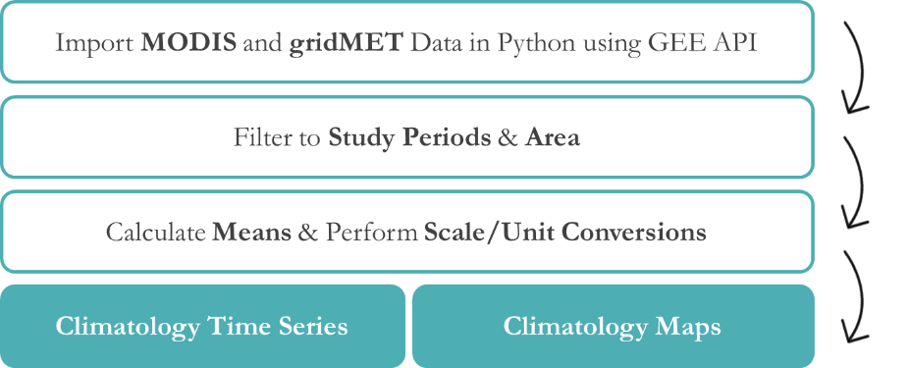
Figure 2. Overview of the data processing pipeline for Climatology Time Series (Section 3.2.1) and Climatology Maps (Section 3.2.2).

3.2.1 Climatology Time Series
To process Aqua MODIS daily daytime and nighttime LST data, the team imported the data as an Image Collection into the GEE Python API in Google Colab. The team filtered the data between July 4, 2002 (i.e., the first date of available data after Aqua MODIS’s launch)–June 1, 2022. The team imported the study area shapefile, converted it to a GEE object, and used a reducer function to create new image collections made up of daily means across the study area for daytime and nighttime LST. To bring the reduced data into a workable form for a time series, the team converted the image collection into a list of lists using the GEE.toList reducer; for each image, this created a list containing an image’s date and mean daytime and nighttime LST values for the study area. Using the.DataFrame constructor in pandas, an open-source library that allows for data manipulation in Python, the team converted this list of lists to a data frame. The team set the resulting date column as the index and calculated the real value of the mean daytime and nighttime LST data. This was done by multiplying the documented scale factor of 0.02 by the valid data and adding the resulting real value as a column to the data frame. The result of this initial processing was a single data frame representing daily mean values of daytime and nighttime LST for the study area. Additionally, MODIS LST values were converted from Kelvin to Fahrenheit to allow better communication with the public.

The team used a similar procedure with minor changes to process Terra MODIS 8-day ET data. Because Terra MODIS data were collected before the launch of Aqua data, the team imported MODIS ET data across the product’s full range between January 1, 2001– June 1, 2022. After converting the data into a data frame, the team multiplied the 8-day mean data by a scale factor of 0.01 to retrieve valid data values. Similarly, the team processed gridMET variables: first filtering gridMET data between January 1, 1979 (the earliest date possible for the dataset)–June 1, 2022, and then manipulating maximum and minimum air temperature, precipitation, wind velocity, and solar radiation into a data frame. Using the pandas data frame reducer, the team produced additional data frames containing monthly and yearly mean values for each climate variable, with the exception of gridMET precipitation data, which were reduced to monthly and yearly accumulated rainfall by adding all values within a specified time period. These data allowed for additional flexibility in the spatial resolution of analyses. To produce time series depicting climate anomalies, climate data is typically averaged over part or all of the chosen timescale. The team chose a ten-year base period from 2003–2012 from which a mean was derived. This mean was then subtracted from yearly mean values to produce an anomaly column within the data frame of each climate variable.

3.2.2 Climatology Maps
To create climate normal, change, and variability maps from Aqua MODIS LST, Terra MODIS ET, and gridMET data, the team first imported each dataset into the GEE Python API in Google Colab as a GEE Image Collection. For climate normal maps, these imports were filtered to dates ranging between July 4, 2002–June 1, 2022. The team clipped the image collection for each band to the study area shapefile (converted to a GEE object), and used a mean reducer to reduce the data, producing a single climate normal GeoTIFF for each band. In each GeoTIFF, every pixel represented the average value for that cell for the respective band across the entire date range. For change maps, this process was repeated for the periods of July 4, 2002–June 1, 2011 and July 4, 2012–June 1, 2022 to generate GeoTIFFs representing average pixel values for only these shortened periods in preparation for raster subtraction. For variability maps, the team substituted a standard deviation reducer for the mean reducer in the above procedure to produce standard deviation GeoTIFF rasters covering the time period from July 4, 2002–June 1, 2022.

The team used ArcGIS Pro v2.9.3 to perform further processing on the GeoTIFFs and prepare final map products. First, the team used the raster calculator tool to convert temperature normals and standard deviation rasters to Fahrenheit from Kelvin. Once units were converted, the team used raster calculator to calculate change and variability maps. The team used rasters representing decadal averages (2002–2011 and 2012–2022) to generate the change rasters, subtracting the 2012–2022 rasters from the 2002–2011 rasters for each variable. To produce climate variability rasters, the team divided the standard deviation rasters by the climate normal rasters for each variable.

3.2.3 Hydroperiod Analysis
In situ data from the University of Arizona provided a unique opportunity to look at qualitative, categorical data alongside remotely sensed climate variables. In situ data provided the baseline of the hydroperiod analysis, representing the duration of wet and dry periods for each tinaja listed in Table A1. Partners formatted the dataset categorically based on daily observations of water levels from wildlife cameras situated at each tinaja. The dataset included values from 0 to 3: 0 = dry, 1= nearly dry, 2= contracting, 3= full. Other categorical data included null values indicating no data, and “w” and “d” values that were based on limited, non-camera observations. To clean this data, the team considered grey cells along with “w” and “d” values to be null values. Cleaned hydroperiod values were further simplified into three categories: wet, dry, and null (Table A2). The team classified values equaling 1, 2, and 3 as “wet” days where the tinaja contained any amount of water, and classified 0s as “dry” days. The team then summarized the data using Excel to total the count of wet days each month per tinaja.

The team imported environmental variables for the in-situ study period of July 2019–May 2022 using the GEE Python API on Google Colab. Each tinaja’s coordinate location was written onto a CSV file and batch processed using the Google Colab Python API to pull all datapoints for the in-situ time frame of July 2019– May 2022 for GridMET solar radiation, precipitation, wind velocity, and minimum and maximum air temperature. The team exported the resulting data frames to a CSV file, and processed all climatology variables by month using Excel’s Virtual Basic for Applications (VBA). Monthly averages were then exported onto separate CSV files. The team aligned OpenET data with the in-situ data by including only the months between July 2019–May 2022. Since data pulled from OpenET is a monthly average, no further actions were needed to prepare the data for Spearman's correlations.

3.3 Data Analysis
3.3.1 Climatology Time Series
Time periods for climatological analyses vary depending on the study being conducted. Long-term climate trends can be better detected apart from annual or decadal variability when studies span a longer time period. 30-year studies are typical, but a period of as many as 40 years will better reveal trends (Yang et al., 2013). However, shorter periods are acceptable when data are limited (Henson et al., 2010; World Meteorological Organization, 2017). The team produced climatology time series for each variable by graphing the anomaly data across the full time period of the respective variable. The team performed a linear regression for each variable across its date range to investigate statistically significant climate trends over time. Slopes for each linear regression were calculated to determine the average change per year for each climate variable. Additionally, the team plotted monthly decadal averages across two decades for MODIS data (2002–2011, 2012–2021), and four decades for gridMET data (1982–1991, 1992–2001, 2002–2011, 2012–2021) to visualize monthly and seasonal changes in climate variables over time.

3.3.2 Climatology Maps
The team produced climate normal, change, and variability rasters for all variables studied in the project. Normal rasters represented the average of each variable’s numeric value per raster cell over the entire study period. Change rasters represented the amount of change for each variable between 2002–2011 and 2012–2022 and were used to visualize where the greatest changes occurred in the study area. Variability maps were generated in ArcGIS Pro by dividing the standard deviation rasters of each variable over the entire study period by the normal rasters and indicated areas within OPCNM with high variability where a longer study period would benefit efforts to detect trends in the climate data. The relatively short study period together with large variability in parts of OPCNM suggests that trend results may have a higher uncertainty. Better trend estimates may be determined in these areas with longer time scales in future studies.

3.3.3 Hydroperiod Analysis
The team selected five tinajas (Algae Alcove, Alamo South, Javelina, Pinkley, and Wild Horse) that had one or fewer null values in their data as a focus for correlations with environmental variables. The data for the remaining tinajas (Alamo North, Bighorn Baño, Juniper Pool, Hole Pool, and Puerto Blanco) included multiple days when the trail camera was malfunctioning, resulting in significant missing data (Figure A1). The team initially visualized tinaja hydroperiods with a line plot showing cleaned values in the dataset over time (Figure A2). Tinaja datasets that showed the total amounts of wet and dry days per year were plotted by year on a line graph to discern seasonal patterns occurring over the study period. Processed OpenET, Aqua MODIS, Terra MODIS, and gridMET variables were graphed on a dual, normalized y-axis with the corresponding in situ data monthly dry and wet day counts for each tinaja, with emphasis placed on the five tinaja sites with the least number of null values.

Due to the categorical nature of the in-situ data, the team performed a nonparametric Spearman’s correlation performed in Microsoft Excel, which ranks both ranges of data, to examine relationships between environmental variables and hydroperiods. For each tinaja wet and dry monthly count dataset, the full months of the study period were ranked largest to smallest in Excel’s VBA. The monthly averages of each environmental variable were also ranked smallest to largest, and the two ranked data sets were input into the Spearman’s correlation coefficient to produce an Rs value. A p-value was then calculated using the n value (32, which derives from the total number of entries, 34, subtracted by 2). The team repeated this for each tinaja and each environmental variable to produce a matrix showing the Rs values for each outcome. The team graphed each significant correlating pair on a dual y-axis to visualize the monthly wet day count and the monthly average for the significant environmental variable.

The team used a raster showing the change in average daytime LST between 2002–2011 and 2012–2021 overlaid with the tinaja points to preliminarily identify which tinajas may be located in at-risk areas. This was compared to the 2019–2022 hydroperiod data for each tinaja to determine if each individual site experienced dry periods or null values. The team created a final map product identifying tinajas that can be considered at-risk due to these trends. Overall daytime LST was used for this end product due to temperature’s important role in ET and its significant rate of increase in OPCNM between 1979–2012 (Hulsman et al., 2008).

4. Results & Discussion

4.1 Analysis of Results
4.1.1 Climatology Time Series
The most statistically significant changes over time occurred in gridMET air temperature minimums across OPCNM (Table 3). Between 1979–2021, the data showed an average increase of 0.07 °F/year, resulting in an approximate overall increase of 3°F since 1979 (Table 3; Figure B1). However, the change of air temperature appears to be nonlinear as over the past 20 years the average increase was 0.10°F/year, making up an approximate overall increase of 2°F in the last 20 years alone. Both of these rates are higher than overall global rates of temperature rise (National Oceanic and Atmospheric Administration [NOAA], 2022). This trend is more evident in the summer months of June through September (Figure B2). Analysis also showed a significant rise in gridMET solar radiation between 1979–2021 (Table 3; Figure B3). Solar radiation increased by 0.18 W/m2/year on average, indicating an 8 W/m² increase over this period, with an elevated rate of change seen August–October (Figure B4). The increasing trend in solar radiation found in this study differs from the global trend of decreasing solar radiation over the past 40 years (NOAA, 2022). Other significant trends included Aqua MODIS nighttime LST and gridMET maximum air temperature (Table 3). Linear regressions of Aqua MODIS daytime LST, Terra MODIS ET, and gridMET precipitation and wind data did not show any significant trends over the study period (p > 0.05).

Table 3
R², p-values, and slopes for climate variables utilized in the climatology timeseries and maps
Climate Variable & Time Period | R² | p-value | Trend
Aqua MODIS Daytime LST: 2003–2021 | 0.35 | 0.06 | 0.10 °F/year
Aqua MODIS Nighttime LST: 2003–2021 | 0.19 | 0.01* | 0.11 °F/year
Terra MODIS ET: 2001–2021 | 0.01 | 0.72 | 4.00E-4 kg/m2/year
gridMET Maximum Air Temperature: 1979–2021 | 0.12 | 0.02* | 0.03 °F/year
gridMET Minimum Air Temperature: 1979–2021 | 0.44 | 1.06E-06* | 0.07 °F/year
gridmet Solar Radiation: 1979–2021 | 0.37 | 1.43E-05* | 0.18 W/m2/year
gridmet Wind Velocity: 1979–2021 | 0.03 | 0.24 | 3.00E-3 m/s/year
gridmet Precipitation: 1979–2021 | 0.04 | 0.23 | -1.08 mm/year
The * indicates a significant trend (p<0.05).

Visual inspection of monthly decadal averages also shows seasonal shifts over time. gridMET precipitation monthly decadal averages from the decades of 1982–1991, 1992–2001 and 2002–2011, show peak rainfall in OPCNM occurring in August. The 2012–2021 monthly average shows this peak shifting to July (Figure B5). Additionally, while peak ET occurred in February during the 2002–2011 monthly average, the 2012–2021 monthly average shows peak ET occurring in January. Furthermore, ET increased most drastically between the 2002–2011 and 2012–2021 averages between July and September (Figure B6).

4.1.2 Climatology Maps
The team used climatology maps to easily determine which parts of the study area are experiencing the highest amounts of change over time. There is an overall warming trend in the study region during the research period. Most strikingly, Aqua MODIS nighttime LST and gridMET minimum and maximum air temperature all increased at the eastern side of the national monument (Figures C1–C3). The ET change map showed that ET increased on the eastern side of the study area, while there were small areas in the northwestern part of the study area showing a decreasing trend for ET (Figure C4). Increases in ET may be related to rising temperatures resulting in more plant activity and direct evaporation, which could place the tinajas in these areas at risk. Variability maps for gridMET minimum air temperature (Figure C6) and MODIS nighttime LST and ET (Figures C7, C8) showed low variability in these areas over the study period, supporting the data shown in the temperature change maps. Variability was higher for maximum air temperature (Figure C5), suggesting that there may be higher uncertainty in the trend estimates for the maximum air temperature due to the limited study period duration.

4.1.3 Hydroperiod Analysis
Tinaja hydroperiod graphs for Alamo North, Alamo South, Pinkley, Javelina, and Juniper showed that during the months January–March and August–October, more than half of all days had recorded water. For the months of April–July, tinajas were often saturated for less than half of the month (Figure D1 &D2). Bighorn Baño and Algae Alcove remained full for the majority of the monitoring period. This establishes that the general wet season for these tinajas is around January–March and August–October, while the dry season tends to fall around the months of April–July. These data follow the pattern of drought and monsoons which occur in the summer and fall months respectively and July in particular (US National Park Service, 2022).

Results of Spearman’s correlations between the total wet days per month and each environmental variable showed that the strongest positive correlations were with Terra MODIS ET and GridMET precipitation (Table 4). The highest Rs (Spearman correlation coefficient) value correlated monthly MODIS ET with wet days per month for Pinkley tinaja. This represents a significant moderate positive correlation between ET and wet days per month. Juniper, Alamo South, and Wild Horse tinajas also showed a significant moderate positive correlation with monthly MODIS ET (Rs > 0.5) (Table 4).

Table 4
Tinaja and climatology variable correlations (Rs values) using Spearman's rank correlation-
Tinaja | MODIS ET | Precip | OpenET | Max Air Temp | Min Air Temp | Day Time LST | Night Time LST | Wind Velocity | Solar Radiation
Pinkley | 0.696 * | 0.533 * | -0.081 + | -0.260 * | -0.168 + | -0.379 * | -0.202 + | -0.054 + | -0.322 *
Juniper | 0.642 * | 0.194 + | 0.037 + | -0.439* | -0.350 * | -0.498 * | -0.370 * | -0.276 ~ | -0.348 *
Alamo South | 0.507 * | 0.574 * | 0.228 ~ | 0.082+ | 0.127 + | 0.026 + | 0.102 + | 0.162 + | 0.162 +
Wild Horse | 0.423 * | 0.016 + | 0.223 + | -0.255 ~ | -0.115 + | -0.138 + | -0.148 + | 0.046 + | 0.066 +
Algae Alcove | 0.135 + | 0.274 ~ | -0.033 + | -0.005 + | 0.076 + | -0.040 + | 0.033 + | 0.000+ | -0.067 +
* p value is < 0.05; ~ p value is < .10; + p value is > .10; colors range from darker green for high positive Rs values to darker red for low negative Rs values

The correlation between total wet days per month and gridMET precipitation also showed two significant moderate positive correlations with the tinajas Pinkley and Alamo South (Table 4). When visualized in conjunction with precipitation and ET, graphs for Pinkley’s hydroperiods show lags (Figure 3). For precipitation, a lag occurs between a precipitation event and tinaja saturation, indicating filling. For ET, the lag occurs between filling and a spike in ET, indicating drying. Note that MODIS ET values seem to cap at the value of 0.6 kg/m^2 (Figure 3).

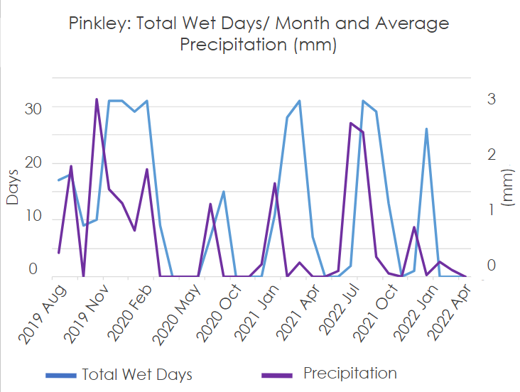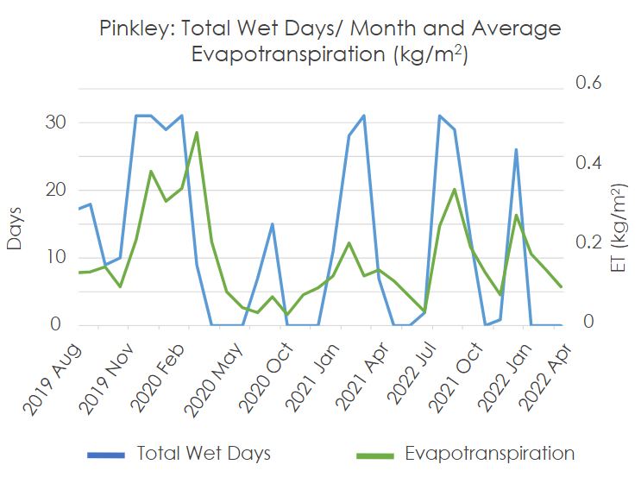
Figure 3. Pinkley days per month saturated graphed with average precipitation (mm) per month and total ET (August 2019–April 2022).

Between Juniper and Pinkley, there were four other negative correlations that showed low-moderate significance with Rs values between 0.300 and 0.500 with significant p values (Table 4). Pinkley tinaja showed a correlation Rs value of -0.379 between total days saturated per month with daytime LST averages per month. Juniper tinaja had Rs values of -0.439, -0.350, -0.498, and -0.370 for the correlations of saturation counts per month with the average monthly daily maximum air temperature, daily minimum air temperature, and daily daytime and nighttime LST averages, respectively. The best Rs value for negative correlations was between Juniper’s total wet days per month and daytime LST averages per month with an Rs of -0.498 (Figure D3).

Mean daily air temperature is a component of the formula for ET (Hulsman et al., 2008), therefore, it would fall in line that the temperature would be inversely related to the filling of the tinaja. This suggests that as temperatures increase, it is more likely that a tinaja will experience fewer wet days. Of the ten sites, three tinajas (Alamo South, Puerto Blanco, and Pinkley) were identified as high risk due to increasing daytime LST that would result in a higher rate of ET, and all three experienced seasonal dry periods (Figure 4). Two sites, Puerto Blanco and Alamo South, were missing more than 20% of their in-situ data due to trail camera malfunctions. Each of these three sites was situated in an area where the timeframe of 2012–2021 saw an increase in daytime LST. For Puerto Blanco, an increase of 0.70 °F was seen, and for Alamo South and Pinkley, each site saw a respective 0.50 and 0.47 °F increase. This was determined using the raster grid map of the daytime LST of the study site overlaid with the tinaja points. Conversations with the team’s partners confirmed this assessment and the map below was produced highlighting the change in daytime LST and high-risk tinajas.

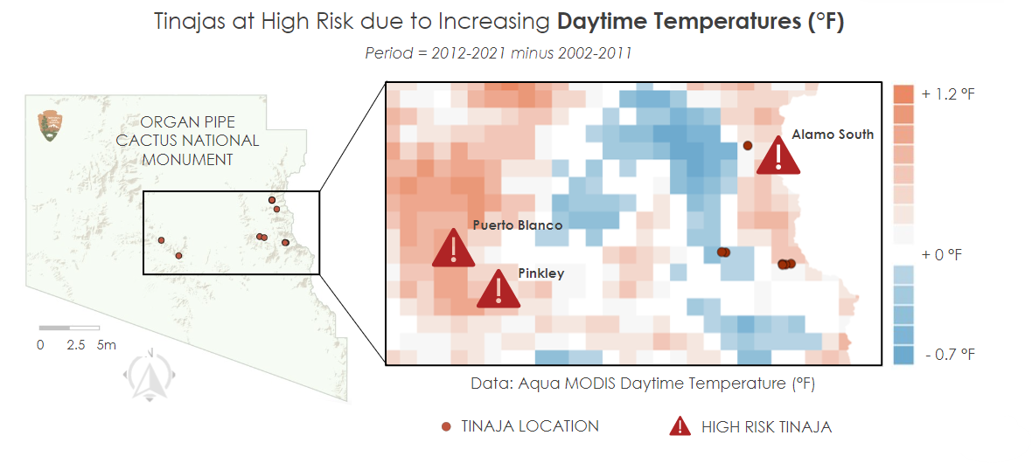
Figure 4. Aqua MODIS change in average daytime LST between 2002–2011 and 2012–2021. Tinajas at high risk for shortening hydroperiods due to increasing daytime LST are indicated by red exclamation marks.

4.2 Future Work
There remains a notable opportunity to extend and expand upon the analysis conducted for this study. Considering partner priorities, project time frame and other limiting factors, the team decided to limit the study area to OPCNM. Although OPCNM spans 500 square miles, it only represents a small proportion of the Sonoran Desert (U.S. National Park Service, 2019). In communications with partners, the NPS highlighted additional regions of interest for study including Pinacate and Gran Desierto de Altar Biosphere Reserve (Mexico), Cabeza Prieta National Wildlife Refuge, Barry M. Goldwater Range, and the Sonoran Desert National Monument. Extending climatology time series and maps to these regions may improve the analysis and comparison of regional and sub-regional climate trends. The University of Arizona has additional in situ data across a number of tinajas in Pinacate and Gran Desierto de Altar Biosphere which would work to supplement the findings of the hydroperiod analysis in this study.

To further explore the hydroperiod analysis, additional data sources and variables can be examined to identify additional factors, climatological or otherwise, that influence tinaja hydroperiods. Additional variables to be considered include topography, aspect, land cover type, normalized difference vegetation index and normalized difference moisture index. It may also be possible to do additional spatial analyses using high resolution aerial imagery such as that from the National Agricultural Imagery Program or Planet to assess hydroperiods, though the low temporal resolution of such datasets and the likely difficulty of identifying smaller tinajas must be noted. Moreover, the lag time shown in the correlations between the tinaja’s total days saturated per month and climate variables such as ET and precipitation could also be analyzed further. Additionally, the work in this project can serve as an exploratory baseline for the possibilities of modeling future hydroperiods to further inform NPS water resource decision-making and conservation practices.

5. Conclusions
Through the generation of climatological maps and time series, the team provided an analysis of climate trends within OPCNM over a 43-year time period. The team visualized and assessed climate trends through the use of Aqua MODIS, Terra MODIS, and gridMET data, and found significant trends across minimum air temperature, maximum air temperature, nighttime LST, and solar radiation data. Findings demonstrate not only increased temperatures and solar radiation across the study area, but also non-linear increases in warming and drying rates overall in OPCNM. Additionally, long term climatology findings show that intrannual precipitation patterns may be shifting, as the month with peak precipitation has moved from August to July during the last decade. Time series data coupled with climatology maps further demonstrate where in OPCNM the most rapid changes are taking place, with various portions of the study area showing increases in LST and ET.

Despite only having access to a limited period of in situ qualitative hydroperiod data, the team demonstrated that it is feasible to correlate in situ data with environmental factors to understand potential relationships. Analyses showed that hydroperiod data from four tinajas moderately correlated with Terra MODIS ET and gridMET precipitation values when aggregated to a monthly scale. While in situ data were limited, results suggest that tinaja hydroperiods may shorten in response to warming LST and air temperatures that result in higher rates of ET and decreased precipitation. As such, the combination of in situ tinaja hydroperiod data with spatiotemporal Earth observations provided a way to highlight tinajas that may be at a heightened risk due to warming and drying in the region.
The results and end products produced by this research will enable a better understanding of the changing environment for our partners with the NPS. This analysis can help advise NPS management in setting policies, such as closing portions of the land to visitors in order to mitigate potential damage to more affected tinajas. With no such efforts in place currently and with increased pressure on organisms that rely on tinajas, especially species specifically adapted to use the resources provided by the tinajas, the NPS can use the analysis provided to build a timeline and determine where further conservation and mitigation efforts might be needed. Moving forward, the team hopes that further research can be done to expand the study area to include in situ hydroperiod data from Pinacate and Gran Desierto de Altar Biosphere Reserve.

6. Acknowledgments
The team would like to thank project partners Ami Pate and Susan Washko from the National Park Service at Organ Pipe Cactus National Monument and the University of Arizona, respectively, for providing extensive resources and knowledge to ground our project. This work was also made possible by our advisors from NOAA National Centers for Environmental Information, Dr. Douglas Rao and Molly Woloszyn, and Fellow Katie Lange from NASA DEVELOP. Finally, we thank DEVELOP Project Coordination Fellows Tamara Barbakova and Sophia Skoglund for their guidance and edits.

The team acknowledges the importance of these water sources to the humans of the Sonoran Desert, from the indigenous people that lived and traveled through the desert to the historic-era explorers, ranchers, and miners, and into the modern era where people continue to visit these essential resources.

Maps throughout this work were created using ArcGIS software by Esri. ArcGIS and ArcMap are the intellectual property of Esri and are used herein under license. All rights reserved.

Any opinions, findings, and conclusions or recommendations expressed in this material are those of the author(s) and do not necessarily reflect the views of the National Aeronautics and Space Administration.

This material is based upon work supported by NASA through contract NNL16AA05C.

7. Glossary
API – Application Programming Interface
Climate normal – A multi-decade average of a climatological variable
Earth observations – Satellites and sensors that collect information about the Earth’s physical, chemical, and biological systems over space and time
ET – Evapotranspiration, or a process through which water is transferred to the atmosphere from the land by both evaporation from the soil surface and transpiration from plants
GEE – Google Earth Engine
GeoTIFF – A raster image file type used to store satellite and aerial imagery data and geographic metadata
GIS – Geographic Information Systems
gridMET – University of Idaho Gridded Surface Meteorological Dataset
Hydroperiod – The length of time that there is standing water in a tinaja
List of lists – A Python list that has other lists as elements, i.e., sublists
LST – Land surface temperature, or the radiative temperature of the Earth’s surface derived from solar radiation
MODIS – Moderate Resolution Imaging Spectroradiometer
NPS – National Park Service
OPCNM – Organ Pipe Cactus National Monument
p value – measures the probability of obtaining the observed results, assuming that the null hypothesis is true; the lower the p-value, the greater the statistical significance of the observed difference
Rs – The Spearman correlation coefficient, which ranges from +1 to –1; a Rs of +1 indicates a perfect association of ranks, a rs of zero indicates no association between ranks and a rs of -1 indicates a perfect negative association of ranks
Tinaja – A term used in the North American Southwest to refer to surface water retained by large depressions in rocks
VBA – Visual Basic for Applications
WSD – Western Sonoran Desert

8. References
Abatzoglou, J. T. (2013), Development of gridded surface meteorological data for ecological applications and modelling [Data set]. International Journal of Climatology, 33(1), 121–131. https://doi.org/10.1002/joc.3413
Alonso, A., Muñoz-Carpena, R., & Kaplan, D. (2020). Coupling high-resolution field monitoring and MODIS for reconstructing wetland historical hydroperiod at a high temporal frequency. Remote Sensing of Environment, 247, 111807. https://doi.org/10.1016/j.rse.2020.111807
Arizona State Climate Office. (2022, June 21). Drought. https://azclimate.asu.edu/drought/
Chan, M. A., Moser, K., Davis, J. M., Southam, G., Hughes, K., & Graham, T. (2005). Desert potholes: Ephemeral aquatic microsystems. Aquatic Geochemistry, 11(3), 279-302. https://doi.org/10.1007/s10498-004-6274-8
Crausbay, S. D., Ramirez, A. R., Carter, S. L., Cross, M. S., Hall, K. R., Bathke, D. J., Betancourt, J. L., Colt, S., Cravens, A. E., Dalton, M. S., Dunham, J. B., Hay, L. E., Hayes, M. J., McEvoy, J., McNutt, C. A., Moritz, M. A., Nislow, K. H., Raheem, N., & Sanford, T. (2017). Defining ecological drought for the twenty-first century. Bulletin of the American Meteorological Society, 98(12), 2543–2550. https://doi.org/10.1175/BAMS-D-16-0292.1
Hartmann, G. H., & Thurtle, M. C. (2001). The Archaeology of Tinajas Altas, a Desert Water Hole in Southwestern Arizona. KIVA: Journal of Southwestern Anthropology and History, 66(4), 489–518. https://doi.org/10.1080/00231940.2001.11758444
Henson, S. A., Sarmiento, J. L., Dunne, J. P., Bopp, L., Lima, I., Doney, S. C., John, J., & Beaulieu, C. (2010). Detection of anthropogenic climate change in satellite records of ocean chlorophyll and productivity. Biogeosciences, 7(2), 621–640. https://doi.org/10.5194/bg-7-621-2010
Hulsmans, A., Vanschoenwinkel, B., Pyke, C., Riddoch, B. J., & Brendonck, L. (2008). Quantifying the hydroregime of a temporary pool habitat: A modelling approach for ephemeral rock pools in SE Botswana. Ecosystems 11, 89–100. https://doi.org/10.1007/s10021-007-9110-3
Jocque, M., Vanschoenwinkel, B., Brendonck, L. (2010). Freshwater rock pools: a review of habitat characteristics, faunal diversity and conservation value. Freshwater Biology, 55(8), 1597-1602. https://doi.org/10.1111/j.1365-2427.2010.02402.x
Ma, F., Wang, Q., & Zhang, M. (2018). Dynamic changes of wetland resources based on MODIS and Landsat image data fusion. EURASIP Journal on Image and Video Processing, 2018(1), Article 63. https://doi.org/10.1186/s13640-018-0305-7
Melton, F. S., Huntington, J., Grimm, R., Herring, J., Hall, M., Rollison, D., Erickson, T., Allen, R., Anderson, M., Fisher, J. B., Kilic, A., Senay, G. B., Volk, J., Hain, C., Johnson, L., Ruhoff, A., Blankenau, P., Bromley, M., Carrara, W., Daudert. B., Doherty. C., Dunkerly, C., Friedrichs, M., Guzman, A., Halverson, G., Hansen. J., Harding, J., Kang, Y., Ketchum, D., Minor, B., Morton, C., Ortega-Salazar, S., Ott, T., Ozdogan, M., ReVelle, P. M., Schull, M., Wang, C., Yang, Y.,Anderson, R. G. (2021). OpenET: Filling a critical data gap in water management for the western United States [Data set]. JAWRA Journal of the American Water Resources Association. https://doi.org/10.1111/1752-1688.12956
National Oceanic and Atmospheric Administration. (2022). Climate Change: Global Temperature. NOAA Climate. https://www.climate.gov/news-features/understanding-climate/climate-change-global-temperature
National Oceanic and Atmospheric Administration. (2022). Climate Change: Incoming Sunlight. NOAA Climate. https://www.climate.gov/news-features/understanding-climate/climate-change-incoming-sunlight
Running, S., Mu, Q., & Zhao, M. (2017). MOD16A2 MODIS/Terra Net Evapotranspiration 8-Day L4 Global 500m SIN Grid V006 [Data set]. NASA EOSDIS Land Processes DAAC. https://doi.org/10.5067/MODIS/MOD16A2.006
Tang, Q., Gao, H., Lu, H., & Lettenmaier, D. P. (2009). Remote sensing: Hydrology. Progress in Physical Geography: Earth and Environment, 33(4), 490–509. https://doi.org/10.1177/0309133309346650
U.S. National Park Service. (2022). Climate and Water Monitoring at Organ Pipe Cactus National Monument. NPS. https://www.nps.gov/articles/sodn_orpi_climateh20_18.htm
U.S. National Park Service. (2019). Sonoran Desert Network Ecosystems. NPS. https://www.nps.gov/im/sodn/ecosystems.htm
Wan, Z., Hook, S., & Hulley, G. (2015). MYD11A1 MODIS/Aqua Land Surface Temperature/Emissivity Daily L3 Global 1km SIN Grid V006 [Data set]. NASA EOSDIS Land Processes DAAC. https://doi.org/10.5067/MODIS/MYD11A1.006
Wang, D. (2017). MODIS/Terra+Aqua Surface Radiation Daily/3-Hour L3 Global 5km SIN Grid V006 [Data set]. NASA EOSDIS Land Processes DAAC. https://doi.org/10.5067/MODIS/MCD18A1.006
World Meteorological Organization. (2017). WMO Guidelines on the Calculation of Climate Normals. WMO/TD-No. 1203. Geneva. https://library.wmo.int/doc_num.php?explnum_id=4166
Yang, J., Gong, P., Fu, R., Zhang, M., Chen, J., Liang, S., Xu, B., Shi, J., & Dickinson, R. (2013). The role of satellite remote sensing in climate change studies. Nature Climate Change, 3(10), 875–883. https://doi.org/10.1038/nclimate1908

9. Appendices

Appendix A: In Situ Data Values
Table A1
List of tinajas and coordinates in the monitored study at Organ Pipe Cactus National Monument
Tinaja Name | Latitude | Longitude
Alamo North | 32.077123 | -112.715135
Alamo South | 32.05679 | -112.70876
Algae Alcove | 32.01541 | -112.6951
Bighorn Baño | 32.0154 | -112.69511
Hole Pool | 32.01573 | -112.69678
Javelina | 32.02292 | -112.73364
Juniper Pool | 32.01535 | -112.69659
Pinkley | 31.99923 | -112.85162
Puerto Blanco | 32.0184 | -112.87697
Wild Horse | 32.0217 | -112.72696

Table A2
Original and cleaned tinaja hydroperiod values for the University of Arizona Camera Footage Time Series dataset
Category | Original Excel Value | Cleaned Value
Dry | 0 | 0
Nearly dry | 1 | 1
Contracting | 2 | 2
Full | 3 | 3
Wet but depth unknown | w | null
Observed dry; no other data | d | null
No photos; camera malfunction | gray fill | null

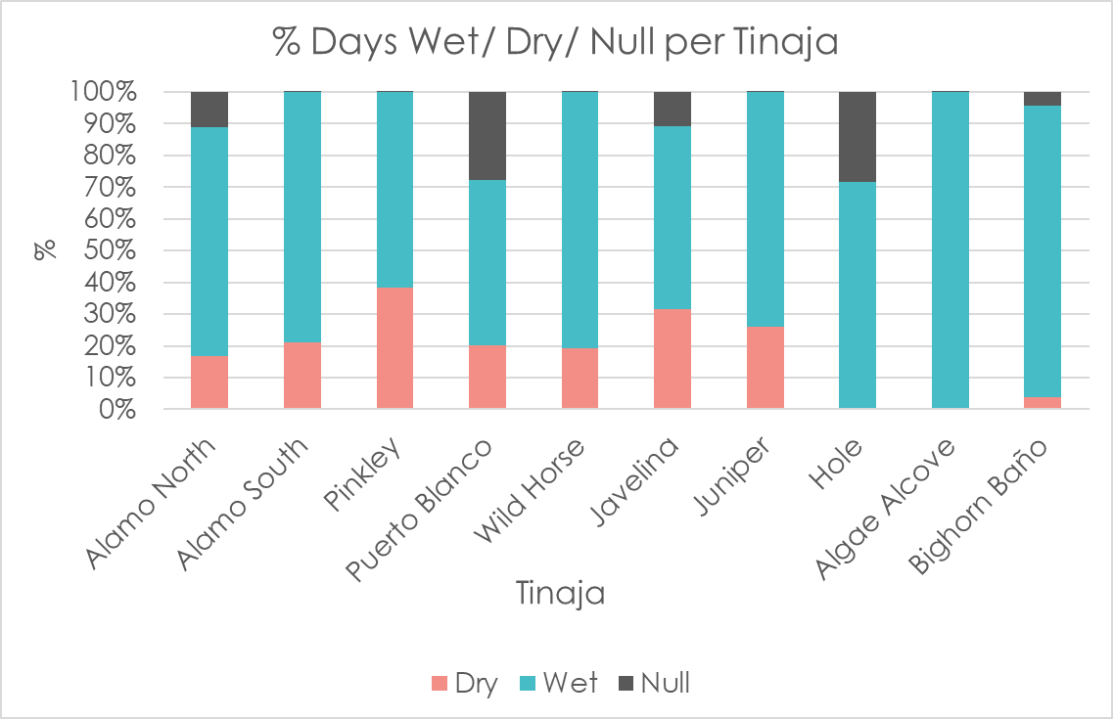
Figure A1. Each tinaja’s hydroperiod status: dry, wet and null values by percentage of total days.

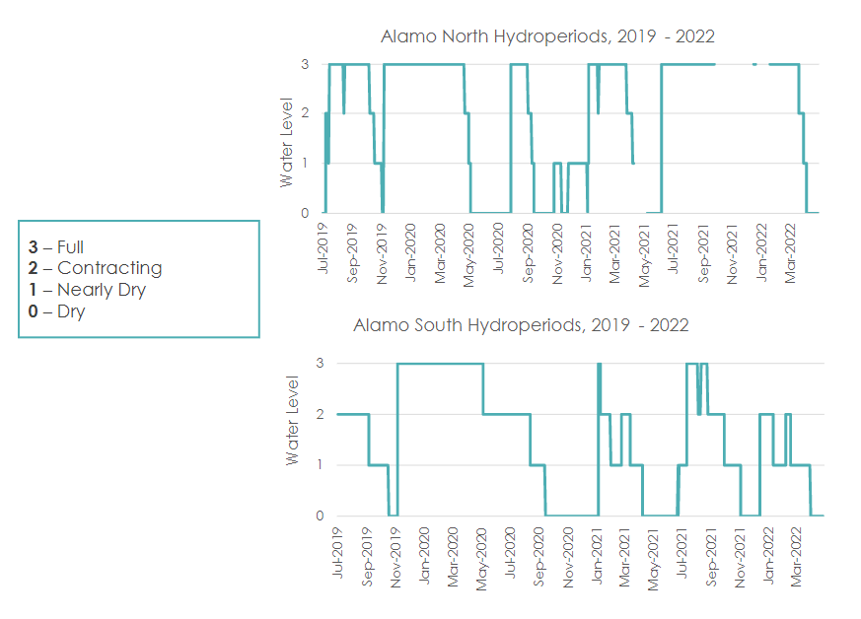
Figure A2. Alamo North and Alamo South tinaja hydroperiods from 2019–2022.

Appendix B: Climatology Time Series Results

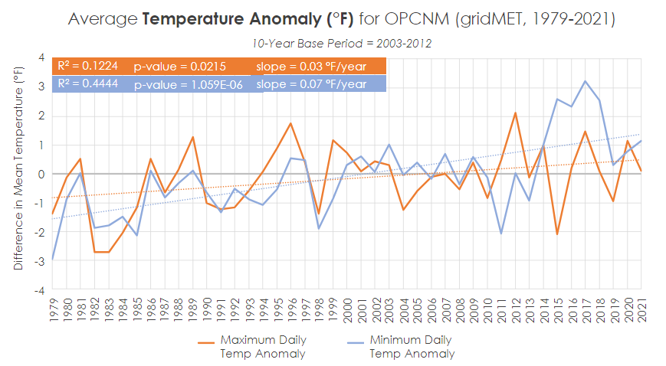
Figure B1. Average air temperature anomaly °F for OPCNM (from gridMET, 1979–2021).

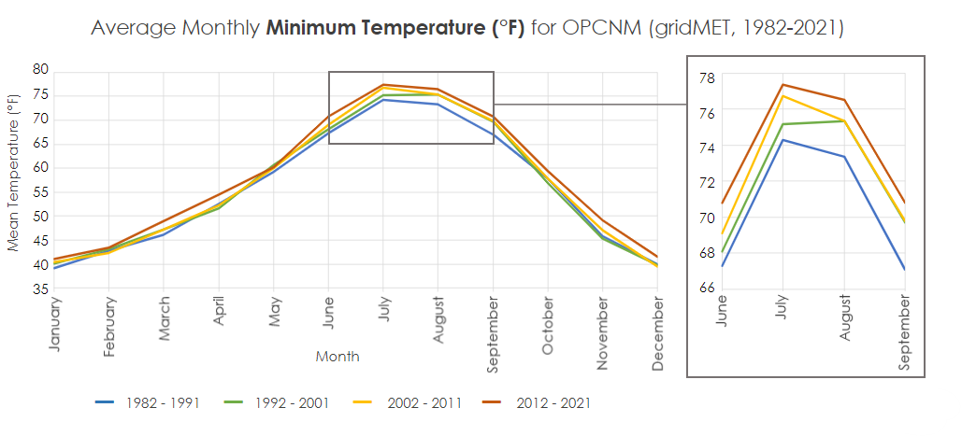
Figure B2. Average monthly minimum air temperature °F for OPCNM across four decades (from gridMET, 1982–2021).

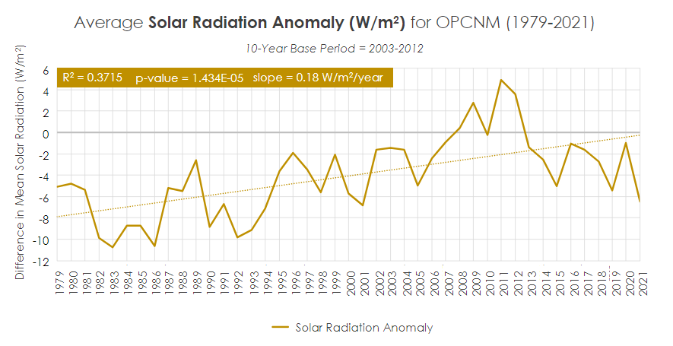

Figure B3. Average solar radiation anomaly (W/m²) for OPCNM (from gridMET, 1979–2021).

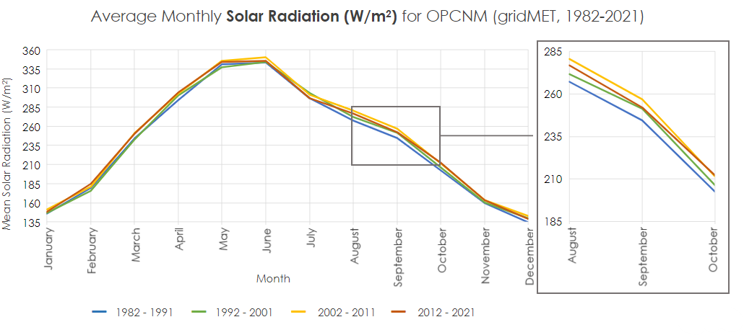
Figure B4. Average monthly solar radiation (W/m²) for OPCNM across four decades (from gridMET, 1982–2021).

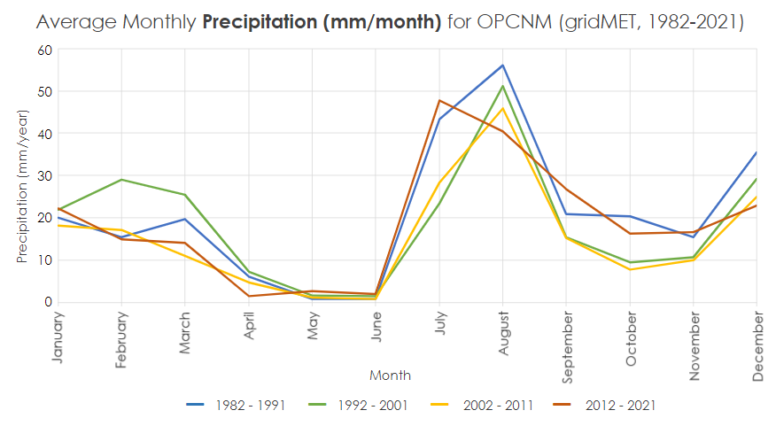
Figure B5. Average monthly precipitation (mm/month) for OPCNM across four decades (from gridMET, 1982–2021).

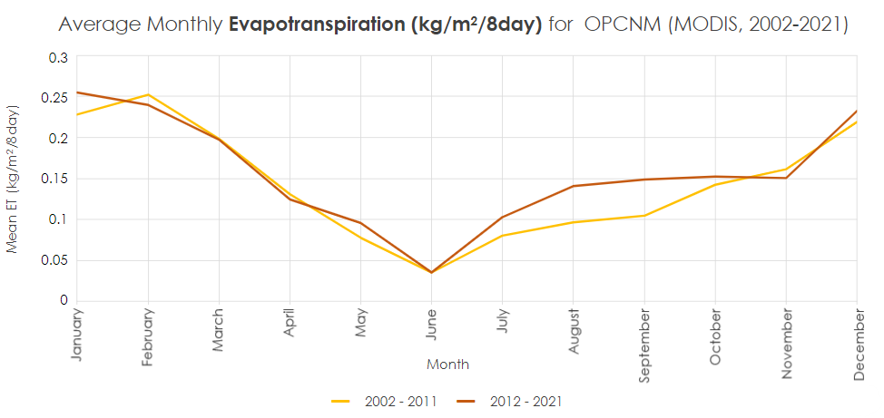
Figure B6. Average monthly ET (kg/m²/8day) for OPCNM across two decades (from Terra MODIS, 2001–2021).

Appendix C: Climatology Maps Results
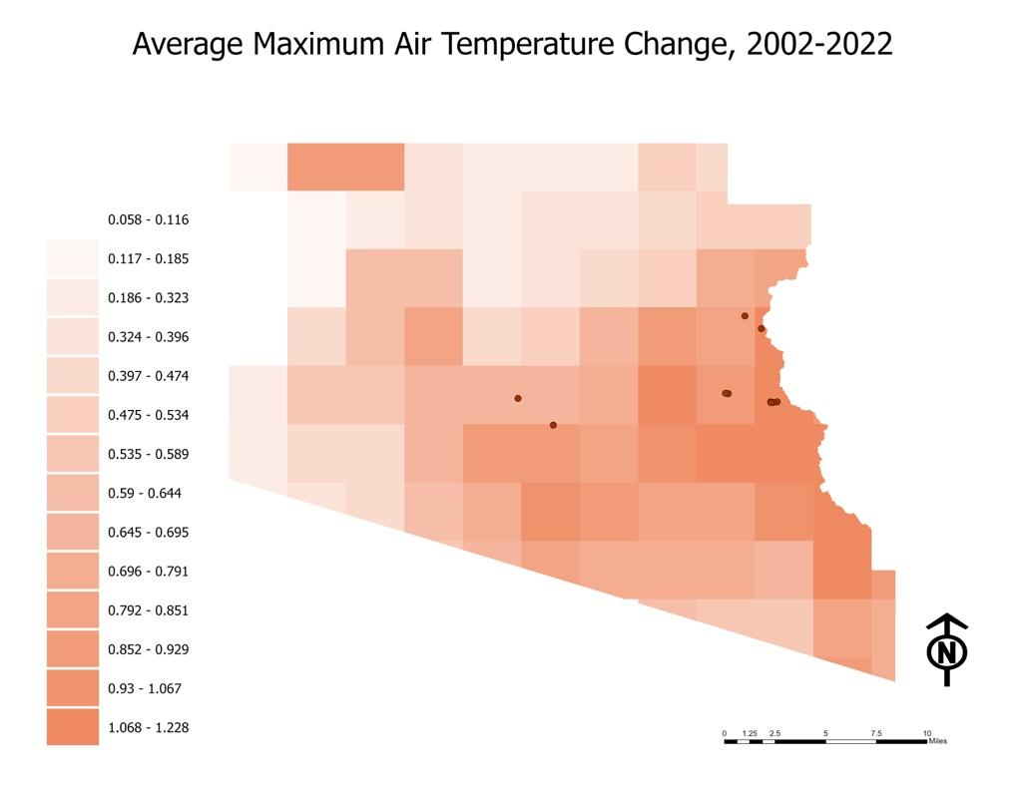
0.058-0.116
0.117-0.185
0.186-0.323
0.324-0.396
0.397-0.474
0.475-0.534
0.535-0.589
0.590-0.644
0.645-0.695
0.696-0.791
0.792-0.851
0.852-0.929
0.930-0.1067
1.068-1.228
Average Maximum Air Temperature Change, 2002-2022

Figure C1. Average Maximum Air Temperature Change (°F ) for OPCNM (from gridMET, years 2012–2022 minus years 2002–2011)
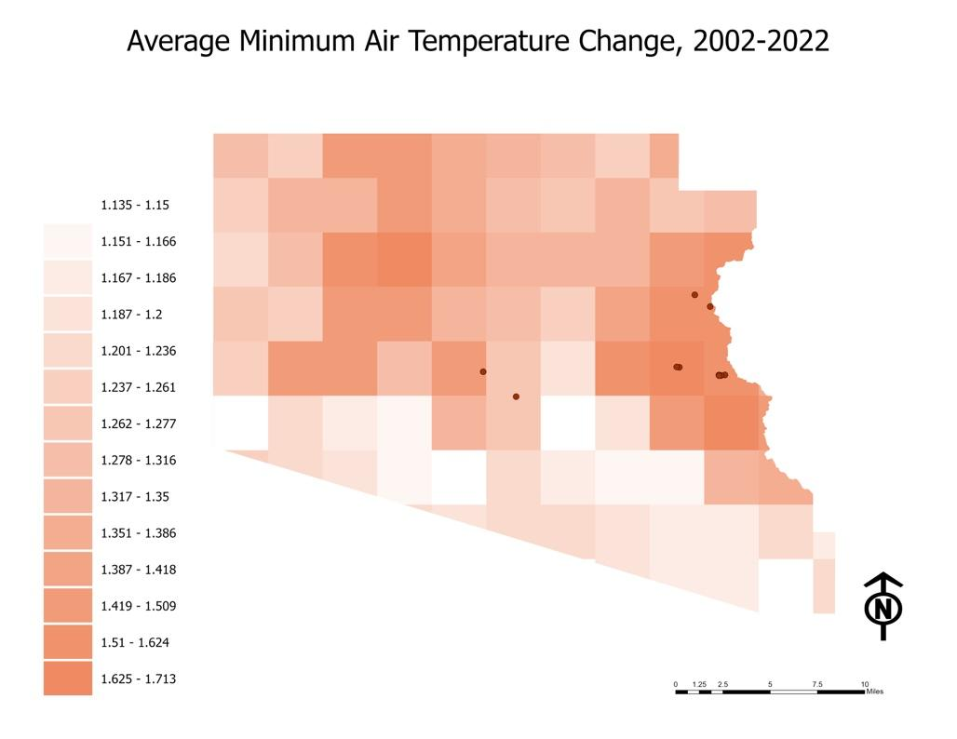
1.135-1.150
1.151-1.166
1.167-1.186
1.187-1.200
1.201-1.236
1.237-1.261
1.262-1.277
1.278-1.316
1.317-1.350
1.351-1.386
1.387-1.418
1.419-1.509
1.51-1.624
1.625-1.713

Average Minimum Air Temperature Change, 2002-2022
Figure C2. Average Minimum Air Temperature Change (°F ) for OPCNM (from gridMET, years 2012–2022 minus years 2002–2011)
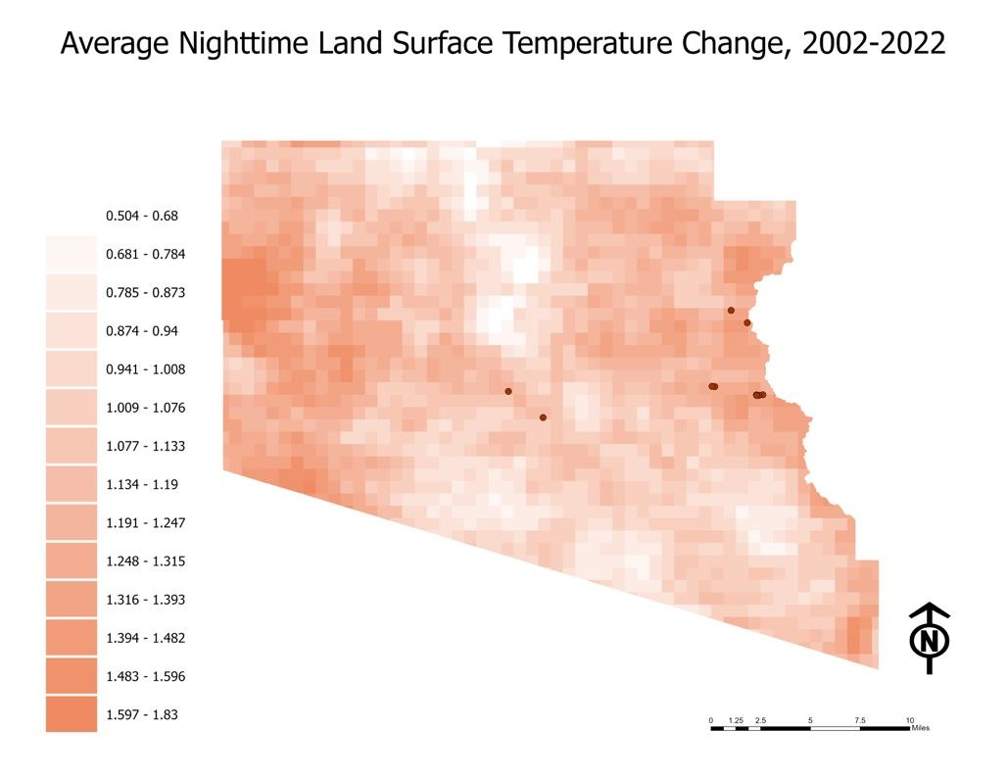
0.504-0.680
0.681-0.784
0.785-0.873
0.874-0.940
0.941-1.008
1.009-1.076
1.077-1.133
1.134-1.190
1.191-1.247
1.248-1.315
1.316-1.393
1.394-1.482
1.483-1.596
1.597-1.830

Average Nighttime Land Surface Temperature Change, 2002-2022
Figure C3. Average Nighttime LST Change (°F ) for OPCNM (from Terra MODIS, years 2012–2022 minus years 2002–2011)
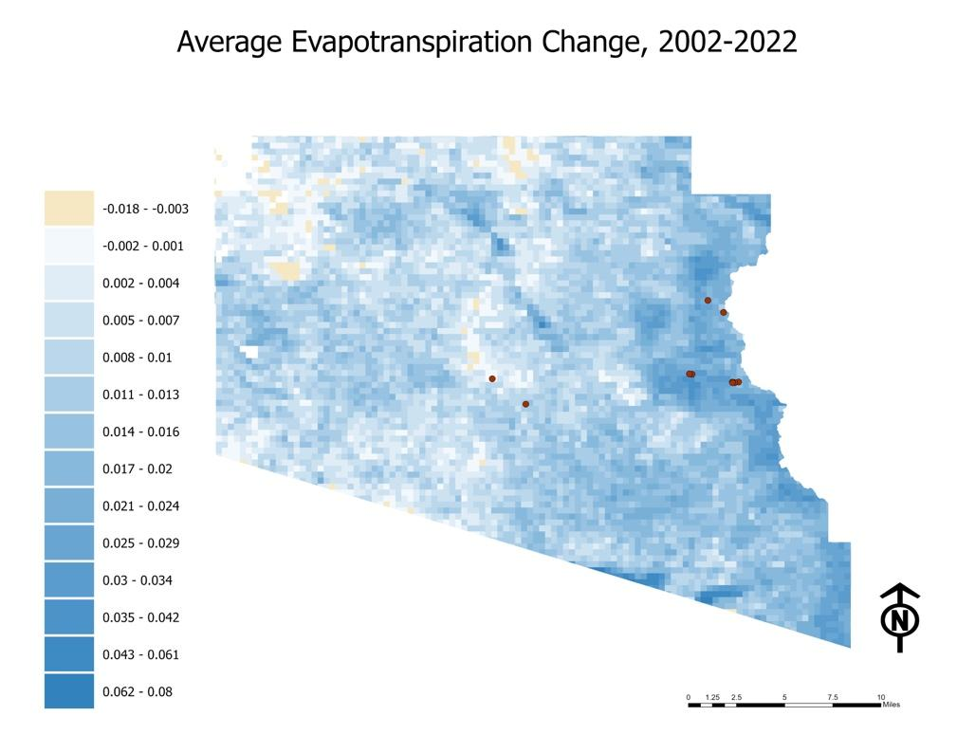
-0.018- -0.003
-0.002- -0.001
0.002-0.004
0.005-0.007
0.008-0.010
0.011-0.013
0.014-0.016
0.017-0.020
0.021-0.024
0.025-0.029
0.030-0.034
0.035-0.042
0.043-0.061
0.062-0.080

Average Evapotranspiration Change, 2002-2022
Figure C4. Average ET Change (kg/m²) for OPCNM (from Terra MODIS, years 2012–2022 minus years 2002–2011)

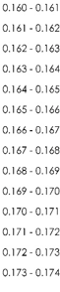
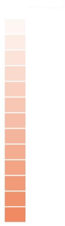
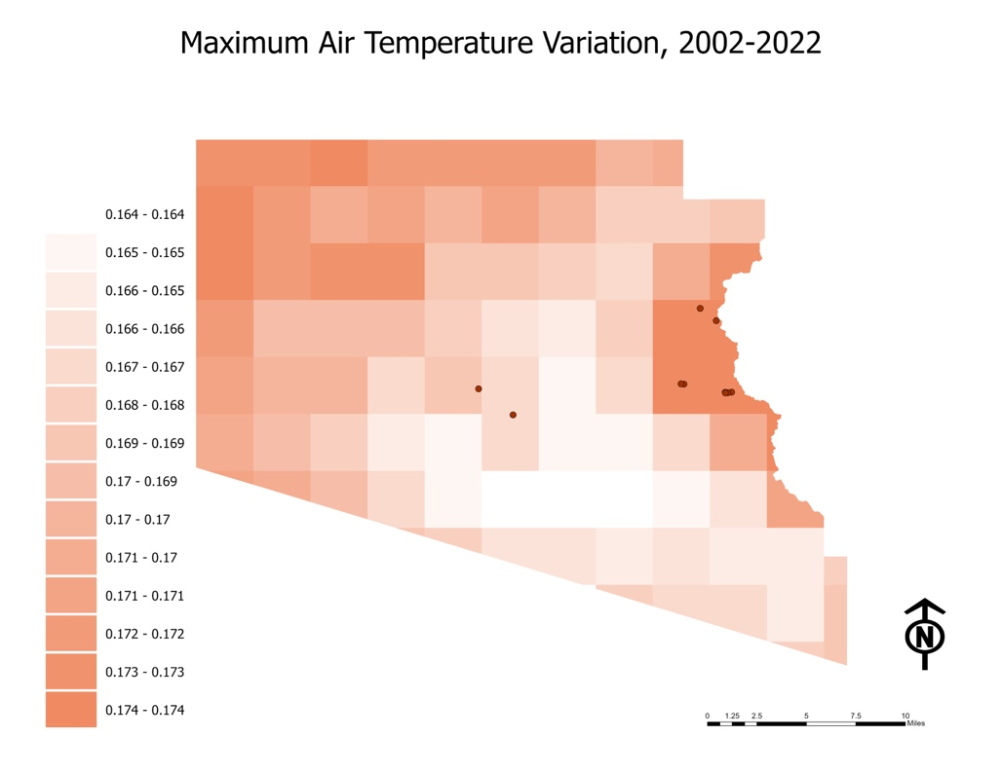
Maximum Air Temperature Variability, 2002-2022
Figure C5. Maximum Air Temperature Variability for OPCNM(from gridMET, years 2002–2022)
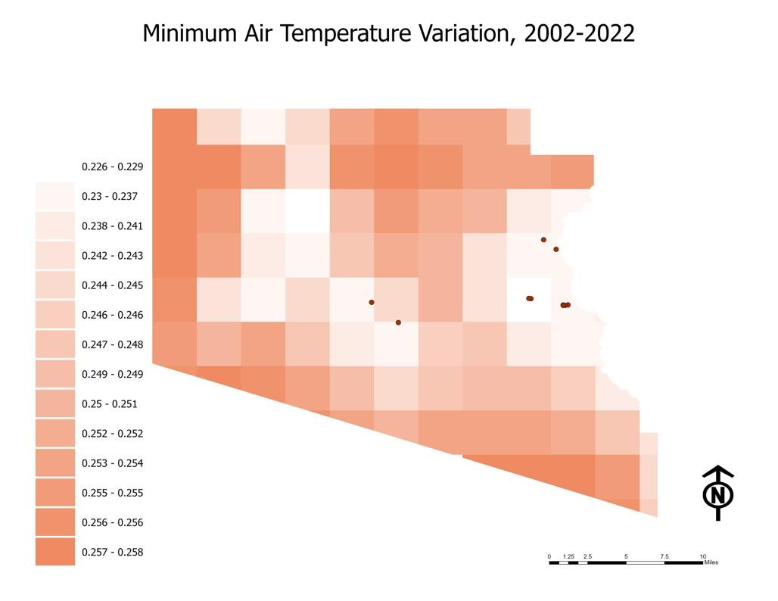

0.226-0.229
0.230-0.237
0.238-0.241
0.242-0.243
0.244-0.245
0.246-0.246
0.247-0.248
0.249-0.249
0.250-0.251
0.252-0.252
0.253-0.254
0.255-0.255
0.256-0.256
0.257-0.258
Minimum Air Temperature Variability, 2002-2022
Figure C6 Minimum Air Temperature Variability for OPCNM (from gridMET, years 2002–2022)

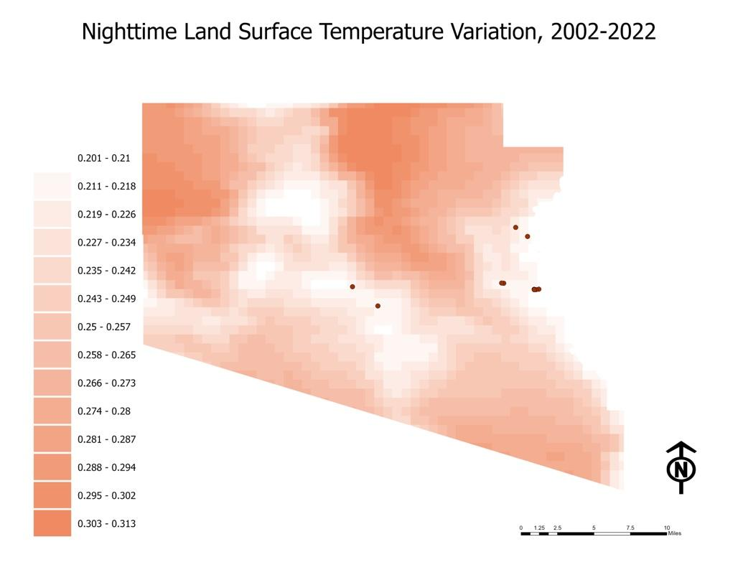
0.201-0.210
0.211-0.218
0.219-0.226
0.227-0.234
0.235-0.242
0.243-0.249
0.250-0.257
0.258-0.265
0.266-0.273
0.274-0.280
0.281-0.287
0.288-0.294
0.295-0.302
0.303-0.313

Nighttime Land Surface Temperature Variability, 2002-2022
Figure C7. Nighttime LST Variability for OPCNM (from Terra MODIS, years 2002–2022)

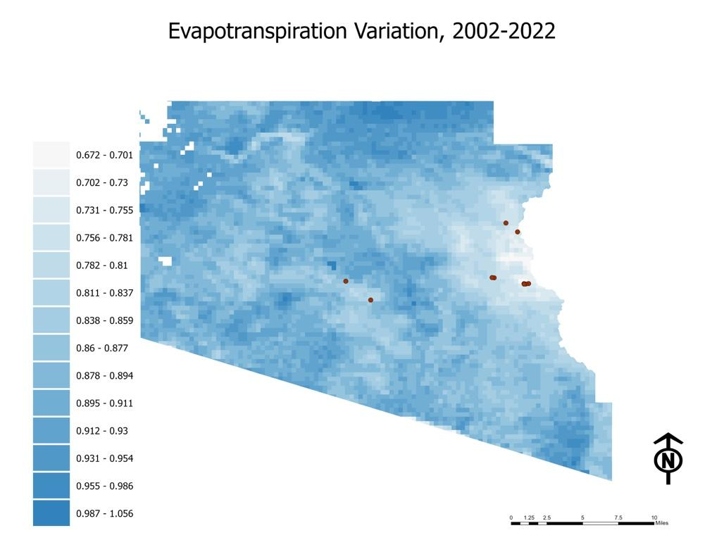
Evapotranspiration Variability, 2002-2022
0.672-0.701
0.702-0.730
0.731-0.755
0.756-0.781
0.782-0.810
0.811-0.837
0.838-0.859
0.860-0.877
0.878-0.894
0.895-0.911
0.912-0.930
0.931-0.954
0.955-0.986
0.987-1.056

Figure C8. ET Variability for OPCNM (from Terra MODIS, years 2002–2022)
Appendix D: Hydroperiod Analysis Results

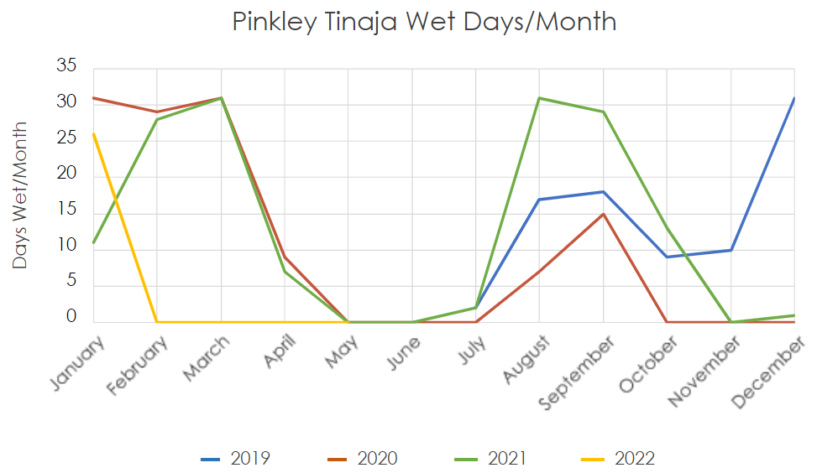
Figure D1. Pinkley days per month saturated derived from in situ data, graphed in yearly periods July 2019–May 2022.

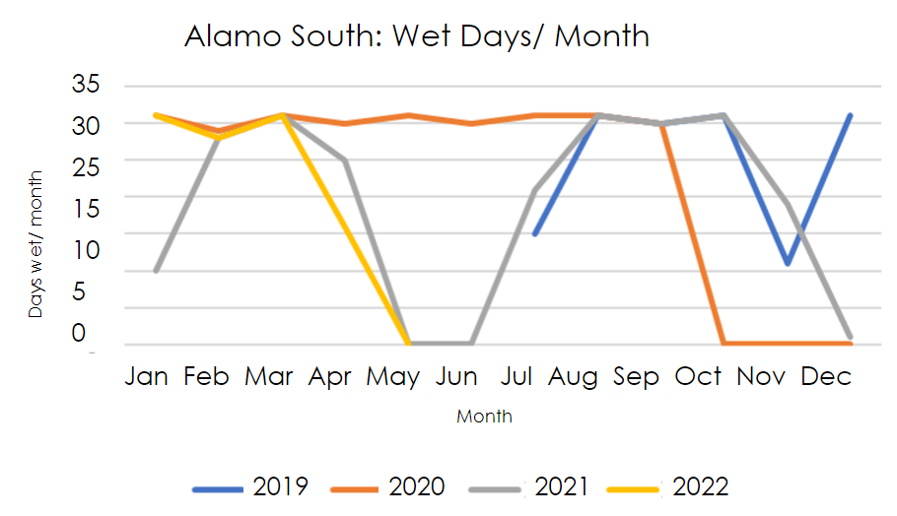
Figure D2. Alamo South days per month saturated derived from in situ data, graphed in yearly periods July 2019–May 2022.

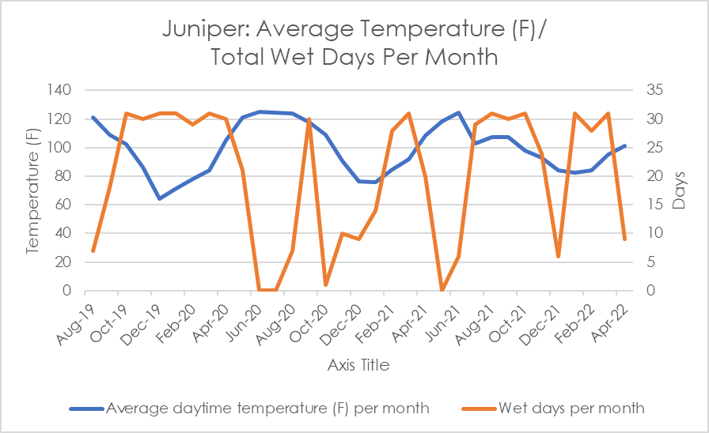
Figure D3. Juniper tinaja, total wet days per month and average daytime LST (August 2019–April 2022).

