PACE OCI Short-Wave Infrared Detection Assembly frequency-dependent linearity characterization and uncertainty analysis
Kenneth J. Squire^{*a}, Jacob K. Hedeliusª, David K. Moserª, James Q. Petersonª, Eric T. Gorman^{b}, Emily Kan^{b}, D. Brent Mott^{b}, Ulrik B. Gliese^{c}, and Gerhard Meister^{b}
ªSpace Dynamics Laboratory, 416 East Innovation Ave, North Logan, UT USA 84341
^{b}NASA Goddard Space Flight Center (GSFC), 8800 Greenbelt Rd, Greenbelt, MD USA 20771
^{c}KBR Inc., 8120 Maple Lawn Blvd, Fulton, MD 20759, USA
ABSTRACT
The Ocean Color Instrument (OCI), the primary payload of the Plankton, Aerosol, Cloud, ocean Ecosystem (PACE) observatory, will collect data to monitor the health of Earth’s oceans and atmosphere. The Short-Wave Infrared (SWIR) Detection Assembly (SDA) was built and characterized by the Utah State University Space Dynamics Laboratory (SDL) and is a subsystem of OCI. The SDA measures seven bands centered at 940, 1038, 1250, 1378, 1615, 2130, and 2260 nm, with standard- and high-gain varieties for the 1250 and 1615 nm bands, resulting in nine total detection configurations in the SWIR. The delivery of high-quality science data is critically dependent upon accurately characterizing the linearity of the SDA. Two metrology techniques were employed to measure the linearity and characterize the frequency-dependent linearity uncertainty of the system. The first technique used superposition linearity measurements to determine the DC linearity, and the second technique involved an oscillating small-signal response at seven frequencies to determine the frequency-dependent linearity. Discrepancies between the DC and frequency-dependent linearities constrain the uncertainty between the two. Examining the difference between these two methods for all SDA channels, we find most channels experience an uncertainty below 0.2% with a worst-case measurement uncertainty of 0.31%. Averaging SDA channels with similar detectors, optical filters, and electronics to simulate the flight-like data products yields a worst-case frequency-dependence linearity uncertainty of 0.12%, demonstrating minimal frequency dependence, implying an excellent linearity knowledge. Detailed performance knowledge, including linearity performance, verifies data quality and builds confidence in the success of the PACE mission.
Keywords: Linearity, calibration, OCI, InGaAs, HgCdTe

Introduction
Plankton, Aerosol, Cloud, ocean Ecosystem (PACE) is an Earth-sensing mission planned to launch late 2023 or early 2024 with the objective of extending high-quality ocean biological and ecological, biogeochemical, cloud and aerosol particle NASA data records that began in the 1990s¹. The spacecraft will be in a sun-synchronous polar orbit with an ascending node of approximately 13:00 local time, an inclination of 98°, and an orbit height of 677 km, resulting in 14.5 orbits per day with two-day global coverage. The Ocean Color Instrument (OCI), the primary instrument of the PACE mission, contains a hyperspectral scanning radiometer covering the visible to near infrared (NIR) with a 5 nm spectral point spacing and a Short-Wave Infrared (SWIR) Detection Assembly (SDA). The SDA uses InGaAs detectors to measure four spectral bands centered at 940, 1038, 1250, and 1378 nm and HgCdTe detectors for three bands centered at 1615, 2130, and 2260 nm. Both the 1250 and 1615 nm bands have standard- and high-gain configurations, resulting in nine total detector-electronics configurations. Two different configurations are physically paired into each of the 16 SWIR Detection Subassemblies (SDSs). Between two and eight SDSs of each band combination are integrated into the SDA to increase signal-to-noise ratio (SNR), resulting in a total of 16 SDS units and 32 detectors.
Because the OCI scanner translates spatial structures into temporal frequencies in the SDA, frequency-dependent detector linearity directly impacts SDA measurement accuracy. Early in component-level screening, linearity measurements were performed on candidate InGaAs and HgCdTe detectors. During these measurements, the baseline HgCdTe detectors, when measured under flight-like conditions including underfill of the detector active area, were found to be heavily dependent on modulation frequency. This frequency dependency resulted in the baseline HgCdTe detectors being deemed uncalibratable, and the decision was made to use the backup HgCdTe detectors for the flight units. During the integration and testing phase of the OCI instrument at Goddard Space Flight Center (GSFC), the SDA linearity will be characterized using the Goddard Laser for Absolute Measurement of Radiance (GLAMR)²⁻³. The continuous wave output from the GLAMR tunable laser is varied, and the SDA response is recorded across the dynamic range. GLAMR is well calibrated, and the spectral and radiometric output are known and controllable. However, the planned test configuration measures the linearity with constant illumination and does not facilitate frequency-dependent linearity characterization. Frequency-dependent nonlinearity uncertainties cannot be resolved by performing measurements solely with a DC source. Investigating the SDA instrument linearity as a function of modulation frequency is necessary to constrain the linearity response expected to match on-orbit conditions.
To this end, two linearity measurement techniques were employed during the build phase at SDL to characterize the SDA linearity. The first is performed with a continuous light source and a beamconjoiner to control excitation levels, while the second is measured using the small-signal response (SSR) to an oscillating source⁴. The dual tests allow the linearity characterization when illuminated with a continuous source, as well as to quantify the uncertainty introduced from the frequency-dependent nonlinearity component. The measurement and analysis methodologies are explained in this paper, and a comparison of the results is performed.

Flux Addition Method
The first linearity technique employs the superposition linearity measurement and relies on the fact that flux is linear. By definition, if source $θ_{a}$ is combined with source $θ_{b}$, the resulting $θ_{a}+θ_{b}$ is equal to a total source output $θ_{a+b}$. Likewise, if detector output signals $S_{a}$ and $S_{b}$ are responses to being excited by flux levels $θ_{a}$ and $θ_{b}$, respectively, the response $S_{a+b}$ to flux $θ_{a+b}$ for a system that is perfectly linear is $S_{a}+S_{b}$. Assuming the flux levels are stable, any deviation in detector response can be attributed to nonlinearities in the detector under test (DUT). This is all performed with a continuous source and is used to measure the DC nonlinearity effects present in the detector.

Beamconjoiner Introduction
A flux addition linearity measurement method has been implemented by Howard Yoon at the National Institute for Standards and Technologies (NIST)⁵. The name given to this hardware implementation is known as the beamconjoiner method. SDL, in consultation with Yoon, built a beamconjoiner system for measuring the DC linearity of the SDA.
A schematic of the system is shown in Figure 1 below. A stable, collimated quartz tungsten halogen (QTH) lamp is shined into the beamconjoiner system. The QTH light goes through a filter wheel (Filter Wheel #1) with 7 positions: open, closed, and five neutral density (ND) filters used for large-scale changes to the signal intensity seen by the DUT. The light is then split into two paths using a 50:50 beamsplitter. Both paths reflect off mirrors and go through additional filter wheels (Filter Wheels #2 and #3), each containing five ND filters, an open position, and a blocked position. The arms are recombined using another 50:50 beamsplitter, and the recombined beam proceeds to illuminate the DUT.
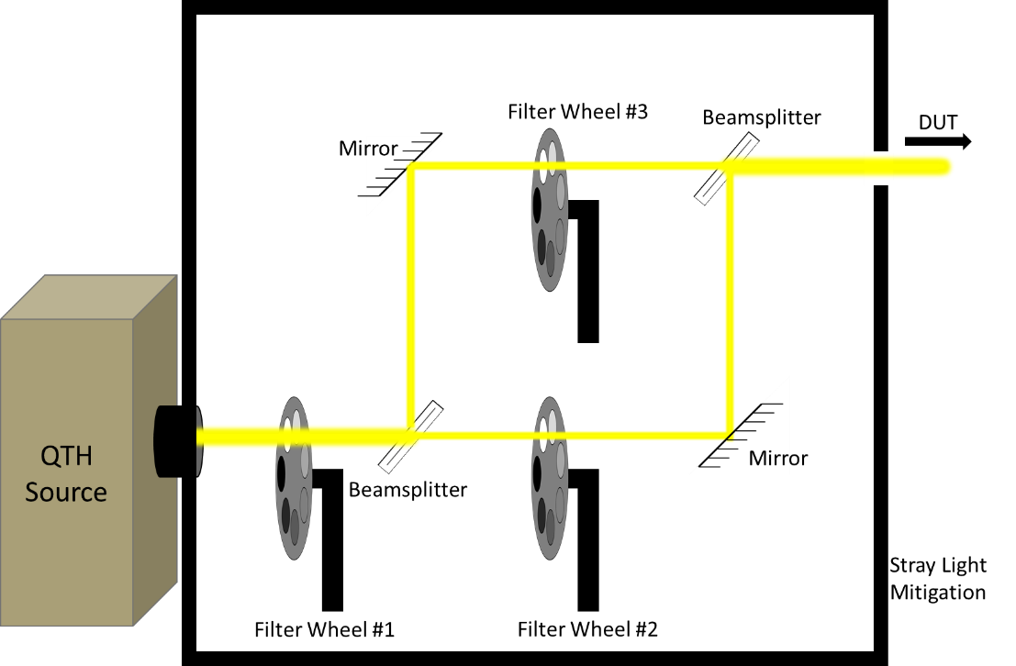
Figure 1. Schematic demonstrating the conditioning of the source as it progresses through the beamconjoiner. Filter Wheel #1 makes large level adjustments, while each path can be individually filtered or blocked with Filter Wheel #2 and #3 to produce $θ_{a}$, $θ_{b}$ or $θ_{a+b}$.
The beamconjoiner was used to characterize the SDA linearity performance while in a thermal vacuum (TVAC) chamber under vacuum and at hot and cold qualification temperatures. Fiber optics coupled each SDS to an integrating sphere external to the TVAC chamber. The beamconjoiner was directed into the integrating sphere and used to illuminate all 32 channels simultaneously. The beamconjoiner progresses through 7³=343 randomized filter combinations, pausing at each, allowing the SDA to collect 10 seconds of data for each combination. Dark measurements are taken after every fifth filter combination by rotating all filter wheels to the blocking positions. The dark measurements allow for trend analysis of the SDA dark noise and correction of detector dark offset drift over time. The dark offset corrections ensure that any changes in response can be attributed to the response characteristics of the SDA response.

Beamconjoiner Data Analysis
Once SDA data was recorded, each channel’s dark-corrected average response across the 10-second collect was calculated. The subsequent beamconjoiner linearity analysis has been described in detail elsewhere⁵⁻⁷ but will be summarized here. For each channel of the SDA, we assume there is a polynomial that accurately defines its operation. A representative n^{th}-order polynomial is shown in Eq. (1)
$θ=r_{0}+r_{1}S+r_{2}S^{2}+r_{3}S^{3}+…+r_{n}S^{n}$, (1)
where $S$ is the measured system response to the illumination, the polynomial coefficients ($r$) are inherent characteristics of the system, and $θ$ is the illumination level. If a given flux $θ_{a}$ on the detector produces a signal response ${S_{}}_{a}$, and flux $θ_{b}$ produces $S_{b}$, an incoming flux $θ_{a+b}=θ_{a}+θ_{b}$produces a response $S_{a+b}$ that will equal $S_{a}+S_{b}$ for a linear detector. Using these three measurements, variations of Eq. (1) can be produced.
$$θ_{a}=r_{0}+r_{1}S_{a}+r_{2}S_{a}^{2}+r_{3}S_{a}^{3}+…+r_{n}S_{a}^{n}$$
$θ_{b}=r_{0}+r_{1}S_{b}+r_{2}S_{b}^{2}+r_{3}S_{b}^{3}+…+r_{n}S_{b}^{n}$ (2)
$$θ_{a+b}=r_{0}+r_{1}S_{a+b}+r_{2}S_{a+b}^{2}+r_{3}S_{a+b}^{3}+…+r_{n}S_{a+b}^{n}$$
Assuming there is a strong linear component, then $r_{1}$ is nonzero and close to 1. We can scale the polynomial coefficients as $r^{*}=r_{0}/r_{1}$ and rearrange to get the following system of equations.
$${S_{a}=θ}_{a}-r_{0}^{*}-r_{2}^{*}S_{a}^{2}-r_{3}^{*}S_{a}^{3}-…-r_{n}^{*}S_{a}^{n}$$
${S_{b}=θ}_{b}-r_{0}^{*}-r_{2}^{*}S_{b}^{2}-r_{3}^{*}S_{b}^{3}-…-r_{n}^{*}S_{b}^{n}$ (3)
$${S_{a+b}=θ}_{a+b}-r_{0}^{*}-r_{2}^{*}S_{a+b}^{2}-r_{3}^{*}S_{a+b}^{3}-…-r_{n}^{*}S_{a+b}^{n}$$
When including all measurements performed during the beamconjoiner test and creating similar equations, we create an overdetermined matrix as shown below.
$\left[\begin{matrix}1 & 0 & … & 0 & 0 & 0 & … & 0 & -1 & -S_{a1}^{2} & … & -S_{a1}^{n} \\ 0 & 1 & … & 0 & 0 & 0 & … & 0 & -1 & -S_{a2}^{2} & … & -S_{a2}^{n} \\ ⋮ & ⋮ & ⋱ & ⋮ & ⋮ & ⋮ & ⋱ & ⋮ & ⋮ & ⋮ & ⋱ & ⋮ \\ 0 & 0 & … & 1 & 0 & 0 & … & 0 & -1 & -S_{an}^{2} & … & -S_{an}^{n} \\ 0 & 0 & … & 0 & 1 & 0 & … & 0 & -1 & -S_{b1}^{2} & … & -S_{b1}^{n} \\ 0 & 0 & … & 0 & 0 & 1 & … & 0 & -1 & -S_{b2}^{2} & … & -S_{b2}^{n} \\ ⋮ & ⋮ & ⋱ & ⋮ & ⋮ & ⋮ & ⋱ & ⋮ & ⋮ & ⋮ & ⋱ & ⋮ \\ 0 & 0 & … & 0 & 0 & 0 & … & 1 & -1 & -S_{bn}^{2} & … & -S_{bn}^{n} \\ 1 & 0 & … & 0 & 1 & 0 & … & 0 & -1 & -S_{a1+b1}^{2} & … & -S_{a1+b1}^{n} \\ ⋮ & ⋮ & ⋱ & ⋮ & ⋮ & ⋮ & ⋱ & ⋮ & ⋮ & ⋮ & ⋱ & ⋮ \\ 0 & 0 & … & 1 & 0 & 0 & … & 1 & -1 & -S_{an+bn}^{2} & … & -S_{an+bn}^{n}\end{matrix}\right]\left[\begin{matrix}θ_{a1} \\ θ_{a2} \\ ⋮ \\ θ_{an} \\ θ_{b1} \\ θ_{b2} \\ ⋮ \\ θ_{bn} \\ r_{0}^{*} \\ r_{2}^{*} \\ ⋮ \\ r_{n}^{*}\end{matrix}\right]= \left[\begin{matrix}S_{a1} \\ S_{a2} \\ ⋮ \\ S_{an} \\ S_{b1} \\ S_{b2} \\ ⋮ \\ S_{bn} \\ S_{a1+b1} \\ ⋮ \\ S_{an+bn}\end{matrix}\right]$ (4)
U_{m} $θ_{m}$ S_{m}
This is an iterative process and requires an initial guess as to the order $n$ of the polynomials. Using the Levenberg-Marquardt Algorithm, we then solve for the $θ_{m}$ matrix, which includes the flux values and polynomial coefficients to Eq. (3). A polynomial response function (Eq. 2) is made from the polynomial coefficients and used to calculate predicted flux values. Predicted flux values are compared against the extracted flux values from $θ_{m}$. If residuals between the predicted and extracted flux values show a trend, a higher polynomial function is used, and the analysis is repeated. For these measurements, we determined a 6th-oder polynomial response function was optimal.
Once the appropriate polynomial order has been identified, the linearity and linearity correction can be calculated using Equations 5 and 6, where $θ$ represents the extracted flux values, S is the measured system responses, and R is the calculated flux values from the response function.
$Linearity=\frac{S}{θ}$ (5)
$Linearity Correction=\frac{R}{S}$ (6)
SDA linearity corrections using this DC method are shown in comparison with the small-signal linearity results in the Results section below.

Small Signal Linearity
The second linearity measurement technique relies on the fact that a linear detector will have the same response to a small signal regardless of where it occurs along the dynamic range. To perform this measurement, a small signal source sent through a chopper wheel is combined with a second continuous source used to step across the dynamic range, as depicted in the example signal shown in the Figure 2. The system output is recorded, and the SSR is extracted using a Fourier transform. The SSR is compared to the offset level. Any deviation in the SSR is attributed to detector non-linearity. To ensure accurate measurements, stable sources and choppers are required.
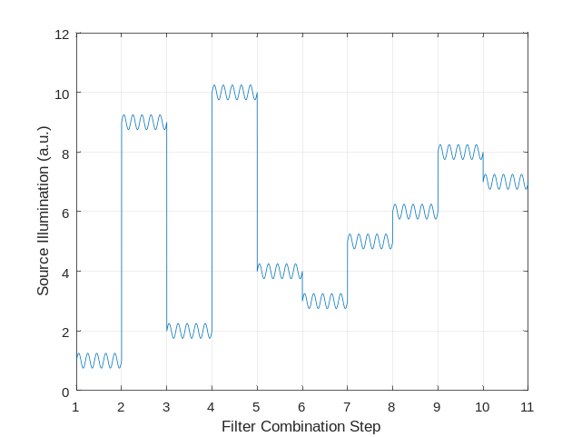
Figure 2. Representative illumination seen by the detector during small-signal linearity measurements. The AC signal is held constant, while the DC is stepped randomly through predefined levels of the dynamic range. During post-collection analysis, the AC response is extracted at each level along the dynamic range to determine detector linearity.
To characterize the linearity of the SDA, the instrument was placed in a TVAC chamber with fibers connected to each SDS on one end and an integrating sphere on the other (Fig. 3). One QTH lamp, used for the offsets, was attached to the integrating sphere with a variable aperture between the source and the sphere port. A second external QTH lamp was spatially filtered with an iris to achieve the desired magnitude of the small signal and then passed through a chopper wheel before entering the integrating sphere. Both QTH lamps were stabilized prior to data collection.
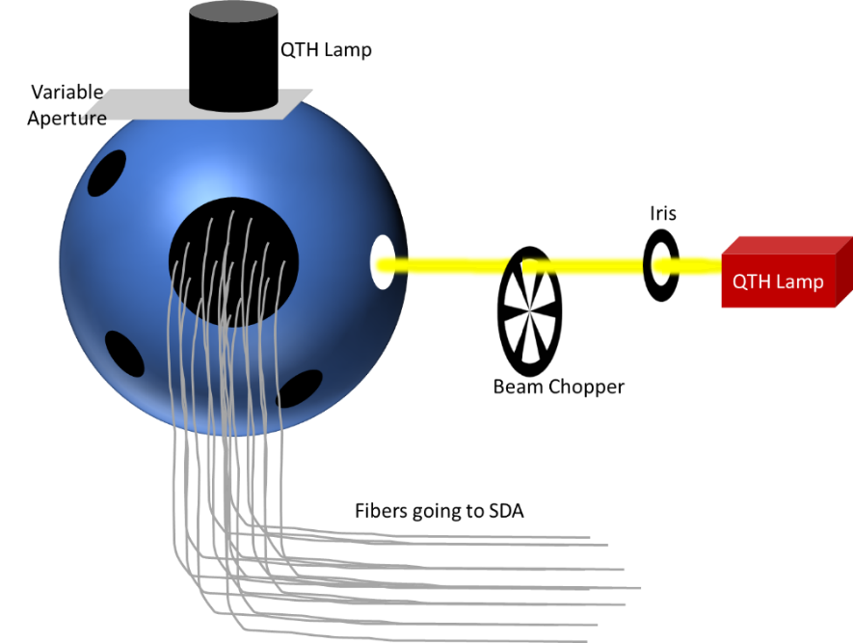
Figure 3. Schematic depicting small-signal linearity test setup. The variable aperture spatially filters the attached QTH lamp for offset setting, while the external spatially filtered and chopped QTH is used to produce the small AC signal. The fibers attached to the integrating sphere are uniformly illuminated and deliver the light to the SDA within the TVAC chamber
Fifty randomized offset levels across the measurement range were each held for 10 seconds of data collection. This set of measurements is called a ramp. Five ramps were performed with different small-signal amplitudes and offset-level ranges to cover the full dynamic range of the SDA. The small signal was manipulated between ramps to ensure high SNR, but during the ramp, the AC signal was maintained constant. This allowed accurate characterization at both high- and low-offset regions. Each ramp contains overlapping offset values to allow for the linearity correction to be scaled relative to the others to form a correction across the full dynamic range of the detector.
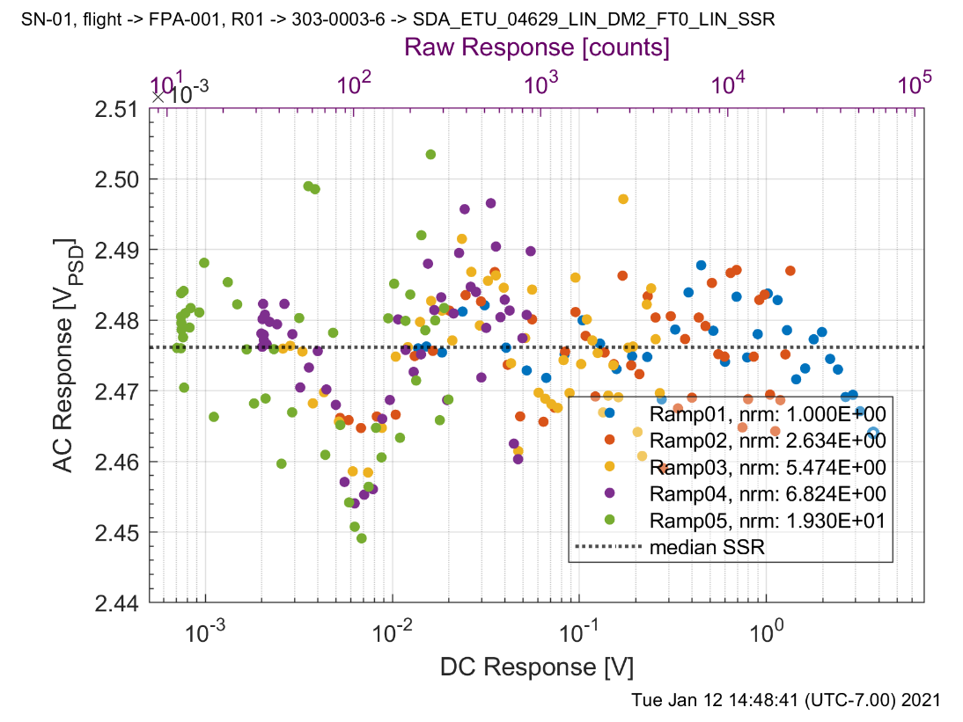
Figure 4. Example small-signal linearity responses for five different ramps tied together and on the same plot. Nonlinearity features are observed in multiple ramps and have good agreement indicating the linearity of the detector across the full dynamic range can be represented using this approach. Values in the legend are scaling factors applied to the different ramps to normalize them together.
The small signal linearity results were analyzed using the differential method described in the NIST Technical Note 1376 [4]. The system SSR was extracted and plotted with respect to the DC response as shown in Figure 4 above. The inverse of the scaled SSR is integrated as a function of the DC offset level. This creates an unscaled linearity correction function. Scaling is performed by choosing a tie point at which the linearity is set equal to one, and the linearity response across the rest of the measurement range is with respect to that point. For our analysis, we used the bright radiance we expect to see in orbit for each SDA channel, L_{bright}, as the tie point. Figure 5 shows an example of the analysis, and the black dots are the small-signal responses seen in Figure 4. The green dots represent the relative source input compared to the offset-level response, scaled at L_{bright}. The linearity correction factor is calculated by dividing the relative source input by the offset level and is shown in Figure 5b. The small-signal linearity measurement and analysis was repeated for small-signal frequencies of 10, 40, 100, 400, 1000, 4000, and 10000 Hz to investigate the frequency dependence of the SDA channels’ linearity.
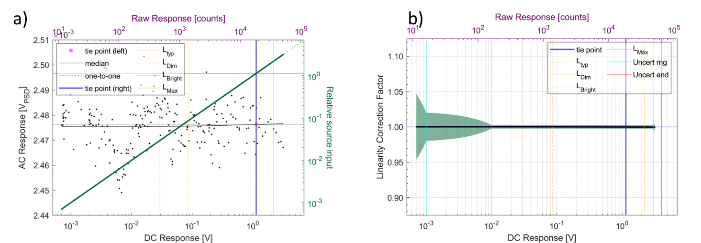
Figure 5. Small-signal linearity processing example. a) Black points represent the extracted small-signal response of the detector, and green points show the relative source input. b) The linearity correction factor is calculated by dividing the relative source input by the DC response of the detector and is plotted with respect to the DC response with green error bars showing uncertainty.

Results
Results from the DC linearity characterization and frequency-dependent linearity characterization are compared. The average of the seven frequency-dependent linearity measurements and their standard deviation are calculated and plotted in red, along with the DC correction in blue in Figure 6a. The frequency-dependent linearity correction and the DC correction were tied together at the high radiance level expected to see on orbit (L_{high}).
The deviation of the frequency-dependent correction from the DC correction was calculated by normalizing the average frequency-dependent linearity correction by the DC correction, shown in red in Figure 6b. This deviation constrains the uncorrectable uncertainty of the frequency-dependent linearity. This is insightful due to the continuous source nature of the GLAMR calibration being performed at GSFC. The gray region represents the uncertainty requirements as a function of radiance. In Figure 6a, the gray region is for reference only and not comparison against the non-linearity, whereas in 6b, the results can be directly compared against the requirements.
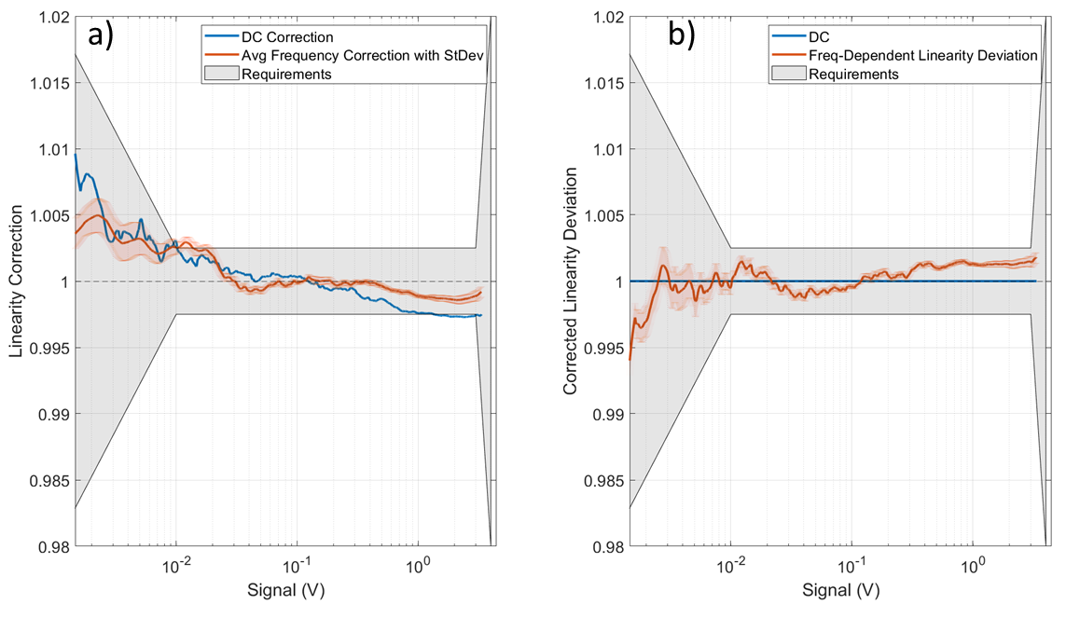
Figure 6. a) Comparison of linearity correction using beamconjoiner (DC Correction) and the small signal linearity average correction for various frequencies. The requirements are shown for reference and not for comparison in this plot. b) Frequency-dependent linearity deviation is shown with respect to signal by correcting the small signal linearity results by the beamconjoiner measurement. The grayed out requirements region denote the requirements of the SDA performance.
To achieve a single figure of merit, the frequency-dependent linearity deviation (D_{freq}) was averaged across the region from L_{low} to L_{high}. Eq. (7) was used, where N is the number of samples in the region of interest, and $U_{linearity}$is the frequency-dependent uncertainty of the linearity.
$U_{linearity}=\frac{\sum_{L_{low}}^{L_{high}}{\left|1-D_{freq}\right| }}{N}$ (7)
$U_{linearity}$ was calculated for measurements performed at hot and cold qualification temperatures for each SDA channel. The results are shown in Figure 7 below.
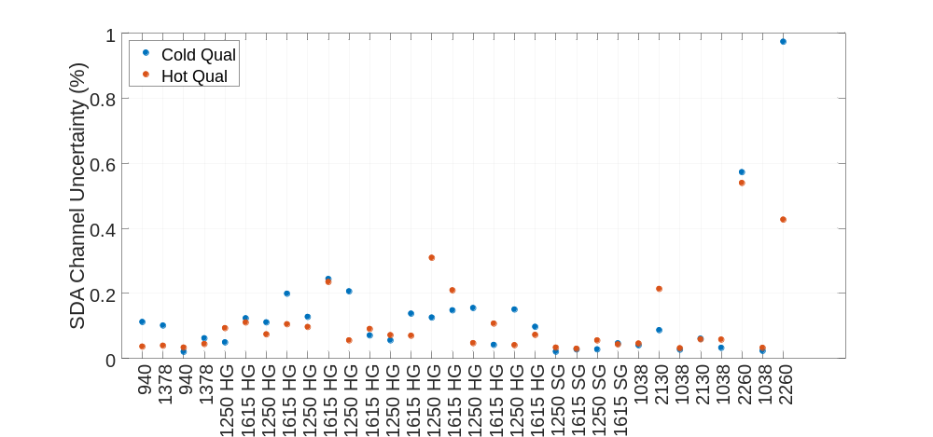
Figure 7. Frequency-dependent linearity uncertainty for each SDA channel at hot and cold qual temperatures.

On orbit, OCI operates in a Time Delay Integration (TDI) architecture that sums the response across all SDA channels of similar configuration. This increases SNR to ensure higher-quality data and is the mode of operation that is of interest. To achieve the TDI uncertainty, the $U_{linearity}$ for each SDA channel wavelength and gain configuration are averaged and provided in Figure 8 below.
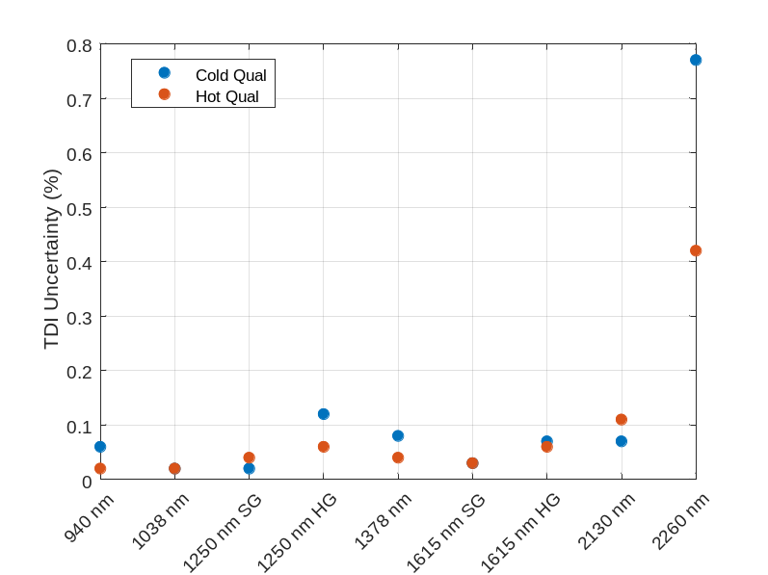
Figure 8. Frequency-dependent linearity uncertainty for TDI channels at hot and cold qual temperatures.

In both the TDI and the individual SDA channel tables, the $U_{linearity}$ is large for the 2260 nm band. This is due to ground support test equipment (GSE) limitations that result in low signal-to-noise ratio, i.e., the QTH lamp used has lower signal at the longer wavelengths. The HgCdTe detectors used at 2260 nm were the same detectors used at 1615 and 2130 nm. These other channels have small TDI uncertainties, on the order of 0.1% or less. This indicates that while the 2260 nm uncertainty is high due to GSE limitations, it is reasonable to assume that the actual detector uncertainty is much lower, as we expect it will not vary largely among the 1615, 2130, and 2260 nm bands.

Summary
The linearity of a system must be well understood to draw scientific conclusions from the collected data. OCI will be calibrated using a continuous source, but frequency-dependent linearity may better match conditions on orbit. To mitigate the risk of using a linearity calibration method that does not match on-orbit conditions, linearity measurements were performed at the SDA subsystem level using both a continuous source approach, as well as a frequency-dependent linearity approach. The two methods were compared, and the frequency-dependent nonlinearity uncertainty was less than approximately 0.1% for all SDA channels. This uncertainty is small enough to be included in the uncorrectable portion of the error budget, and confidence can be had in data collected by OCI in orbit.

References
[1] Gorman, N., Kubalak, D., Patel, D., Dress, A., Mott, D., Meister, G., and Werdell, P., “The NASA Plankton, Aerosol, Cloud, ocean Ecosystem (PACE) mission: an emerging era of global, hyperspectral Earth system remote sensing,” Sensors, Systems, and Next-Generation Satellites XXIII, vol 11151 (2019).
[2] Woodward IV, J., Brown, S., and Lykke, K., “Optical Parametric Oscillator” (U.S. Patent No. 10,156,771), U.S. Patent and Trademark Office (2018).
[3] McAndrew, B., McCorkel, J., Shuman, T., Zukowski, B., Traore, A., Rodriguez, M., Brown, S., and Woodward, J., “Goddard Laser for Absolute Measurement of Radiance for Instrument Calibration in the Ultraviolet to Short Wave Infrared,” 2018 Conference on Lasers and Electro-Optics (2018).
[4] Yang, S., Vayshenker, I., Li, X., Scott, T., and Zander, M., “Optical Detector Nonlinearity: Simulation,” National Institute of Standards and Technology, Boulder, Colorado (1995).
[5] Yoon, H., Butler, J., Larason, T., and Eppeldauer, G., “Linearity of InGaAs Photodiodes,” Metrologia, pp. S154–S158 (2003).
[6] Thompson, A. and Chen, H. “Beamcon III, a Linearity Measurement Instrument for Optical Detectors,” Journal of Research of the National Institute of Standards and Technology, pp. 751–755 (1994).
[7] Hamadani, B., Shore, A., Roller, J., Yoon, H., and Campanelli, M., “Nonlinearity measurements of solar cells with an LED-based combinatorial flux addition method,” Metrologia, vol. 53, no. 1, pp. 76–85 (2016).

