Wichita Climate
Using Satellite Data to Identify Neighborhoods Vulnerable to Extreme Heat
for Equitable Climate Mitigation and Planning

Technical Report
Final – August 11th, 2022

Brooke Laird (Project Lead)
Melissa Ashbaugh
Muskaan Khemani
Sadie Murray

Advisors:
Dr. Kent Ross (NASA Langley Research Center)
Lauren Childs-Gleason (NASA Langley Research Center)

Fellow:
Marco Vallejos (VEJ Fellow)

1. Abstract
Wichita, Kansas is facing a host of climate threats, one being extreme heat that is manifested through the urban heat island (UHI) effect. The uneven distribution of heat risk in Wichita across socioeconomic status is an environmental justice issue. We worked with the City of Wichita to map heat exposure, tree canopy, and heat risk in order to support the City's climate resilience initiatives. To visualize heat exposure, we quantified and mapped average summer heat from 2013–2021 using Landsat 8 Operational Land Imager (OLI) and Thermal Infrared Sensor (TIRS) Land Surface Temperature (LST) and Aqua Moderate Resolution Imaging Spectroradiometer (MODIS) night-time LST. To understand tree canopy cover gaps, we created a tree canopy map using 2021 PlanetScope imagery, which identified 20% more trees than the US Geological Survey’s (USGS) National Land Cover Database (NLCD) tree canopy coverage estimates for Wichita. To characterize high risk areas, we used socioeconomic census data and existing social vulnerability indices, highlighting populations that were exposed and vulnerable to extreme heat. The spatial analyses demonstrated that heat exposure is concentrated in the city center and southwest Wichita, areas that are also low in tree canopy coverage. The three census block groups and 17 census tracts with the highest heat risk primarily circle the city center, in areas home to more socially vulnerable populations and near enough to the dense urban center to feel significant urban heat island effects.

Key Terms: environmental justice, tree canopy cover, urban heat island, heat vulnerability, climate, Landsat, Planet

2. Introduction
2.1 Study Area
Wichita is the largest city in Kansas with a population of approximately 397,000. Originally built on the lands of the indigenous Wichita people in 1864, Wichita has steadily grown, transforming from a trading post into an entrepreneurial center and the “Air Capital of the World” (City of Wichita, n.d.). The city is predominantly White, with large Black/African American and Latino/Hispanic populations, and has a median household income of $53,500, which is $17,500 below the national median of $67,500 (US Census Bureau, 2020).

Kansas summers have warmed by 1.3 degrees (F) since 1970, and the state is set to see the number of days above 100 degrees quadruple by 2050 (Spicer, 2021). Temperature changes are linked to both climate change and urban heat island (UHI) effects. UHI effects occur when conditions related to the built environment, such as concentration of impervious surfaces and loss of tree canopy cover, cause heat to be absorbed and re-emitted, creating pockets of heat or “heat islands.” These heat islands are at higher temperatures than outlying areas and natural landscapes (United States Environmental Protection Agency [EPA], 2014).
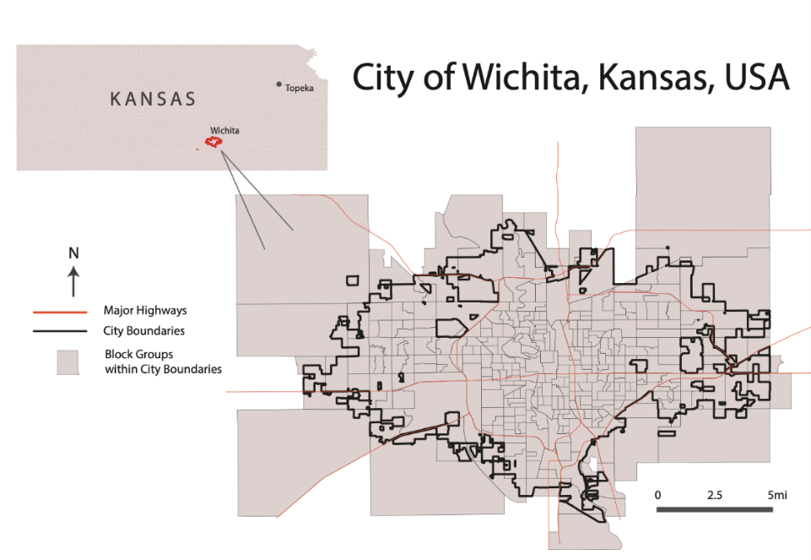
Figure 1: Reference map for the City of Wichita
2.2 Environmental Justice
Extreme heat is a climate, public health, and environmental justice problem. Vulnerable communities, including Black, Indigenous, and People of Color (BIPOC), low-income, and older populations, face disproportionate impacts of extreme heat (Hsu et al., 2021). These impacts can include higher energy burden from cooling costs and loss of wages through decreased productivity. Heat also affects health and quality of life, particularly for those with health issues such as asthma and heart disease. Every year more than 600 people die from heat related causes in the US, making extreme heat the leading cause of weather-related deaths (EPA, 2016; Centers for Disease Control and Prevention, 2022).

Due to historical discriminatory practices such as redlining, marginalized communities are overburdened with exposure to environmental problems. In many instances, communities of color face an increased risk of urban heat due to limited proximity to green space and the availability of tree cover. At the same time, these areas are often underfunded and thus lack resources to improve social welfare (Borunda, 2021). As cities look to address the widespread threat of extreme heat, it is essential that responses and resource allocation specifically prioritize the most vulnerable communities, balancing the benefits and burdens from environmental decisions.

2.3 Remote Sensing Approach
Land surface temperature (LST), derived from Landsat imagery, can be used as a proxy for air temperature, which is useful to understand how extreme heat affects people. (Mutiibwa & Strachan, 2015). Additionally, LST can be used to measure how extreme heat disproportionately affects historically exploited communities. Remote sensing can show how spatially discrete policies, like redlining, have left communities of color exposed to dangerous conditions. Previous studies have used this approach to investigate heat, demonstrating that in some cases, temperatures can vary by as much as 55 °F (Hoffman et al., 2020). Thus, spatially explicit studies are helpful when investigating extreme heat because stakeholders can better identify areas particularly vulnerable and impacted by the phenomena (Hondula et al., 2014). This project uses various remotely sensed data and established methodologies to map heat exposure (May–Sep, 2013–2020), tree canopy coverage (May–Sep 2021), and heat vulnerability (May–Sep 2020).

2.4 Project Partners & Objectives
We partnered with the City of Wichita to assess heat exposure and heat risk. The City of Wichita is in the process of developing a Climate Adaptation and Mitigation Plan, along with formulating tree canopy policies to mitigate the effects of extreme heat. To assist their decision-making process, we conducted an analysis of urban heat exposure, heat risk based on socio-economic vulnerabilities, and tree canopy coverage. While the City of Wichita has a general sense of the areas that suffer from high heat exposure and the communities that have high heat risk, our deliverables will assist in displaying these injustices. High-resolution data identifying vulnerable populations allows the City of Wichita to better allocate its resources to build climate resiliency across communities.

To accomplish this, we had three project objectives. First, to map heat exposure, tree canopy coverage, and climate-related social vulnerabilities to improve the city’s knowledge of heat risk. Second, to formulate deliverables that are clear and easily digestible for a non-expert audience to understand heat impacts. Third, to establish a path for the City of Wichita to partner with community organizations and individuals to reduce heat burden disparities.

3. Methodology
3.1 Data Acquisition
3.1.1 Land Surface Temperature
To calculate daytime LST, we utilized Landsat 8 OLI/TIRS Surface Reflectance Data (30 m). For nighttime LST we utilized MYD11A1.006 MODIS Aqua Land Surface Temperature and Emissivity Daily Global Data (1km). We acquired the data using a Google Earth Engine (GEE) script created by the Fall 2020 Arizona – Tempe Urban Development II project (Boogaard et al., 2020). We filtered the dataset to obtain images from the years 2013 until 2021 during the summer months of May to September and limited the study area to the city boundaries of Wichita.

3.1.2 Tree Canopy Cover
To create the tree canopy map, we utilized PlanetLab imagery. To access the Planet imagery via GEE, we requested 87 scenes from May–September 2021. Once we received access, the imagery was imported as an asset into GEE. We searched scenes to find the least cloudy images and images from the same date to ensure continuity between the scenes. We mosaicked together scenes to create a large tile comprising our study region and exported the image as a GEE asset.

3.1.3 Heat Risk
To create the heat risk map, we complemented our LST data with social vulnerability factors. Our team used the Centers for Disease Control and Prevention Social Vulnerability Index (CDC SVI), the Council on Environmental Quality’s Climate and Economic Justice Screening Tool (CEJST), and 2020 American Community Survey (ACS) data. We retrieved CDC SVI and CEJST data from their respective websites and downloaded the data as shapefiles. We downloaded ACS data in R Studio using the Tidycensus Package, focusing on income, race, and age: three variables that correlated with heat risk and identified as important in Hondula et al. (2014), Hsu et al. (2021), and by our partner organization.

Table 1.
Earth observations and socioeconomic data sources
Data | Source and Processing | Use | Study Period
Landsat 8 OLI/TIRS Surface Reflectance Data | Acquired and processed in GEE | Input in UHEAT 1.0 to calculate daytime land surface temperature (LST) | May–September,  2013–2021
Aqua MODIS | Acquired and processed in GEE | Input in UHEAT 1.0 to calculate nighttime LST | May–September,  2013–2021
PlanetLab Imagery | Acquired through PlanetLab and processed in GEE | Reference imagery for fine-scale tree canopy cover map | May–September, 2021
2020 United States American Community Survey | Acquired through Tidycensus and processed in Excel and ArcGIS Pro | Calculate social vulnerability to generate heat risk map | 2020
2018 Centers for Disease Control and Prevention (CDC)/ Agency for Toxic Substances and Disease Registry/ Geospatial Research, Analysis, and Services Program. (ATSDR) Social Vulnerability Index (SVI) | Acquired through CDC site and processed in ArcGIS Pro | Calculate social vulnerability to generate heat risk map | 2018
Climate and Economic Justice Screening Tool (CEJST) | Acquired through the Council on Equity screening tool site and processed in ArcGIS Pro | Calculate social vulnerability to generate heat risk map | 2021
USGS National Land Cover Database (NLCD) | Acquired through USGS site | Compare to team generated high-resolution tree mask | 2019

3.2 Data Processing
3.2.1 Heat Exposure
To calculate daytime LST from Landsat 8, we used the UHEAT 1.0 GEE script developed by Boogaard et al. (2020). We selected parameters for start year (2013), end year (2020), start day of year (121), end day of year (273), geography (Wichita boundary shapefile), and display (true) within GEE. The script then calculated Normalized Difference Water Index (NDWI), Normalized Difference Vegetation Index (NDVI), Normalized Difference Built-up Index (NDBI), albedo, daytime LST, and nighttime LST (which was calculated from MODIS data). The GEE script produced TIFF Files of NDWI, NDVI, NDBI, albedo, daytime LST, nighttime LST, and an aggregated CSV file of the biophysical variables at the block group level (Boogaard et al., 2020). In QGIS, we then joined the GEOID field of the aggregated CSV file and a shapefile of Wichita’s Census Block Groups. Processing was repeated with the same parameters at the census tract level within GEE and QGIS.

3.2.2 Tree Canopy Cover
To assess tree canopy cover, we used a Random Forest (RF) supervised classifier and a Classification and Regression Trees (CART) on PlanetLab imagery. We performed the CART classification using a GEE script developed by the 2019 NASA DEVELOP Southern Maine Health & Air Quality team and adapted the code to perform a Random Forest Classification in place of the CART classifier (Beaudry et al., 2019). To train the supervised classifier in GEE, we generated 731 random points across 5 landcover classes, with a minimum of 50 points per landcover class. A greater amount of point data for the tree class was chosen–approximately 250 points–to increase the precision of the tree canopy cover map. Eighty percent of points were used to train the classifier, while the remaining 20% were used to validate classification results. To enhance classification accuracy, we used the spectral indices NDVI and NDWI as bands in the classifier, in addition to the existing red, green, blue, and near-infrared bands. After performing the supervised classification, we created a tree canopy cover map in GEE from a binary layer with classes for tree canopy or not tree canopy.

3.2.3 Heat Risk Analysis
To create census block group (CBG) level risk analysis, we normalized socioeconomic variables by CBG population using the 2020 US Census Bureau data in Excel. Using ArcGIS Pro, we then filtered through the variables to designate populations as low-income, non-white, and of vulnerable age. Low-income was defined as below the federal poverty line. To classify non-white populations, we aggregated all census blocks that were designated as non-white, whether it be defined through race or ethnicity. For age, we designated blocks having vulnerable age groups if they had more than 10% of its population over age 65. Whichever populations were low-income, non-white, and above 65 were assigned a score of 1 each. Then, the scores were added together to get a risk score (0 = no risk, 1 = low risk, 2 = medium risk, 3 = high risk). We joined socioeconomic data at the block group level with block group LST data from the UHEAT 1.0 GEE code outputs by linking together the GEOID fields (Boogaard et al., 2020).

To create census tract level risk analysis, we combined daytime LST aggregated by census tract, CDC SVI data, and CJEST data. CDC SVI and CJEST were only available at the tract level. We clipped CDC SVI and CEJST data to Wichita boundaries in ArcGIS Pro. We then joined the three datasets by GEOID to create a single layer with vulnerability and exposure by census block group. Details on daytime LST processing are included in section 3.2.1.

3.3 Data Analysis
3.3.1 Heat Exposure
To create the heat exposure maps we visualized the mean temperature data in ArcGIS Pro. Daytime LST and nighttime LST were displayed through choropleth maps. Maps were based on gradient symbology for the mean surface temperatures.

3.3.2 Tree Canopy Cover
To validate the tree canopy cover results, using code we randomly selected 20% of our reference points as validation data and created an error matrix in GEE. After validating our classification with PlanetLab imagery, we compared the results of the tree canopy cover map with the tree canopy classes from the National Land Cover Dataset (NLCD). The resulting tree canopy cover map was also compared to the USGS NLCD to better understand the accuracy of the USGS NLCD tree canopy cover map in Wichita (Figure A1). We compared the tree canopy cover map we created to the USGS NLCD tree canopy cover by generating a scatterplot of the relationship between the two maps, as well as creating a map comparing the two so that we could understand not just how similar the two landcover maps were but where the biggest variations were located spatially (Figure A2).

3.3.3 Heat Risk Analysis
To classify heat risk by census block group, we leveraged the intersection of the upper quantile of our heat exposure and our heat vulnerability maps. Areas were considered ‘vulnerable’ if they were 25% above the city average for any of our three variables measuring vulnerability. All three vulnerability variables were combined into a score from 0 to 3, with 0 representing a census block group that didn’t meet our criteria for ‘vulnerable’ for any of our variables and 3 representing a census block group that met our criteria for ‘vulnerable’ for all three variables. We multiplied the heat score by the heat exposure to calculate heat risk for each census block group.

To classify heat risk by census tracts, we created a risk definition based on mean daytime LST and the overall SVI score, labeled “RPL_THEMES” in the CDC SVI shapefile. We mapped the relationship between LST and vulnerability in ArcGIS Pro using the Bivariate Colors option within the symbology settings. In addition, we assigned a risk value to each tract in Excel. We assigned high, medium, and low SVI and mean LST scores based on terciles. We then combined SVI and mean LST into a single risk variable: High/Medium/Low Exposure – High/Medium/Low Vulnerability. High Exposure – High Vulnerability tracts were in the highest tercile of SVI score and in the highest tercile of mean LST and were considered highest risk. A detailed list of high-risk census blocks and tracts is documented in Table A3 and A4.

4. Results & Discussion
4.1 Land Surface Temperature
According to the analysis, the areas that have the highest heat exposure are in central and southwestern Wichita. Generally, heat exposure decreases as you move from the city center. The daytime land surface temperature shows heat trends at a finer spatial resolution (Figure 1), showing variations between block groups. Nighttime LST is at a coarser spatial resolution, and it generally shows that heat is concentrated in the city center (Figure 2). Figure 3 shows the change in land surface temperature, with blocks in central and southwest Wichita experiencing large swings in daytime and nighttime temperature.

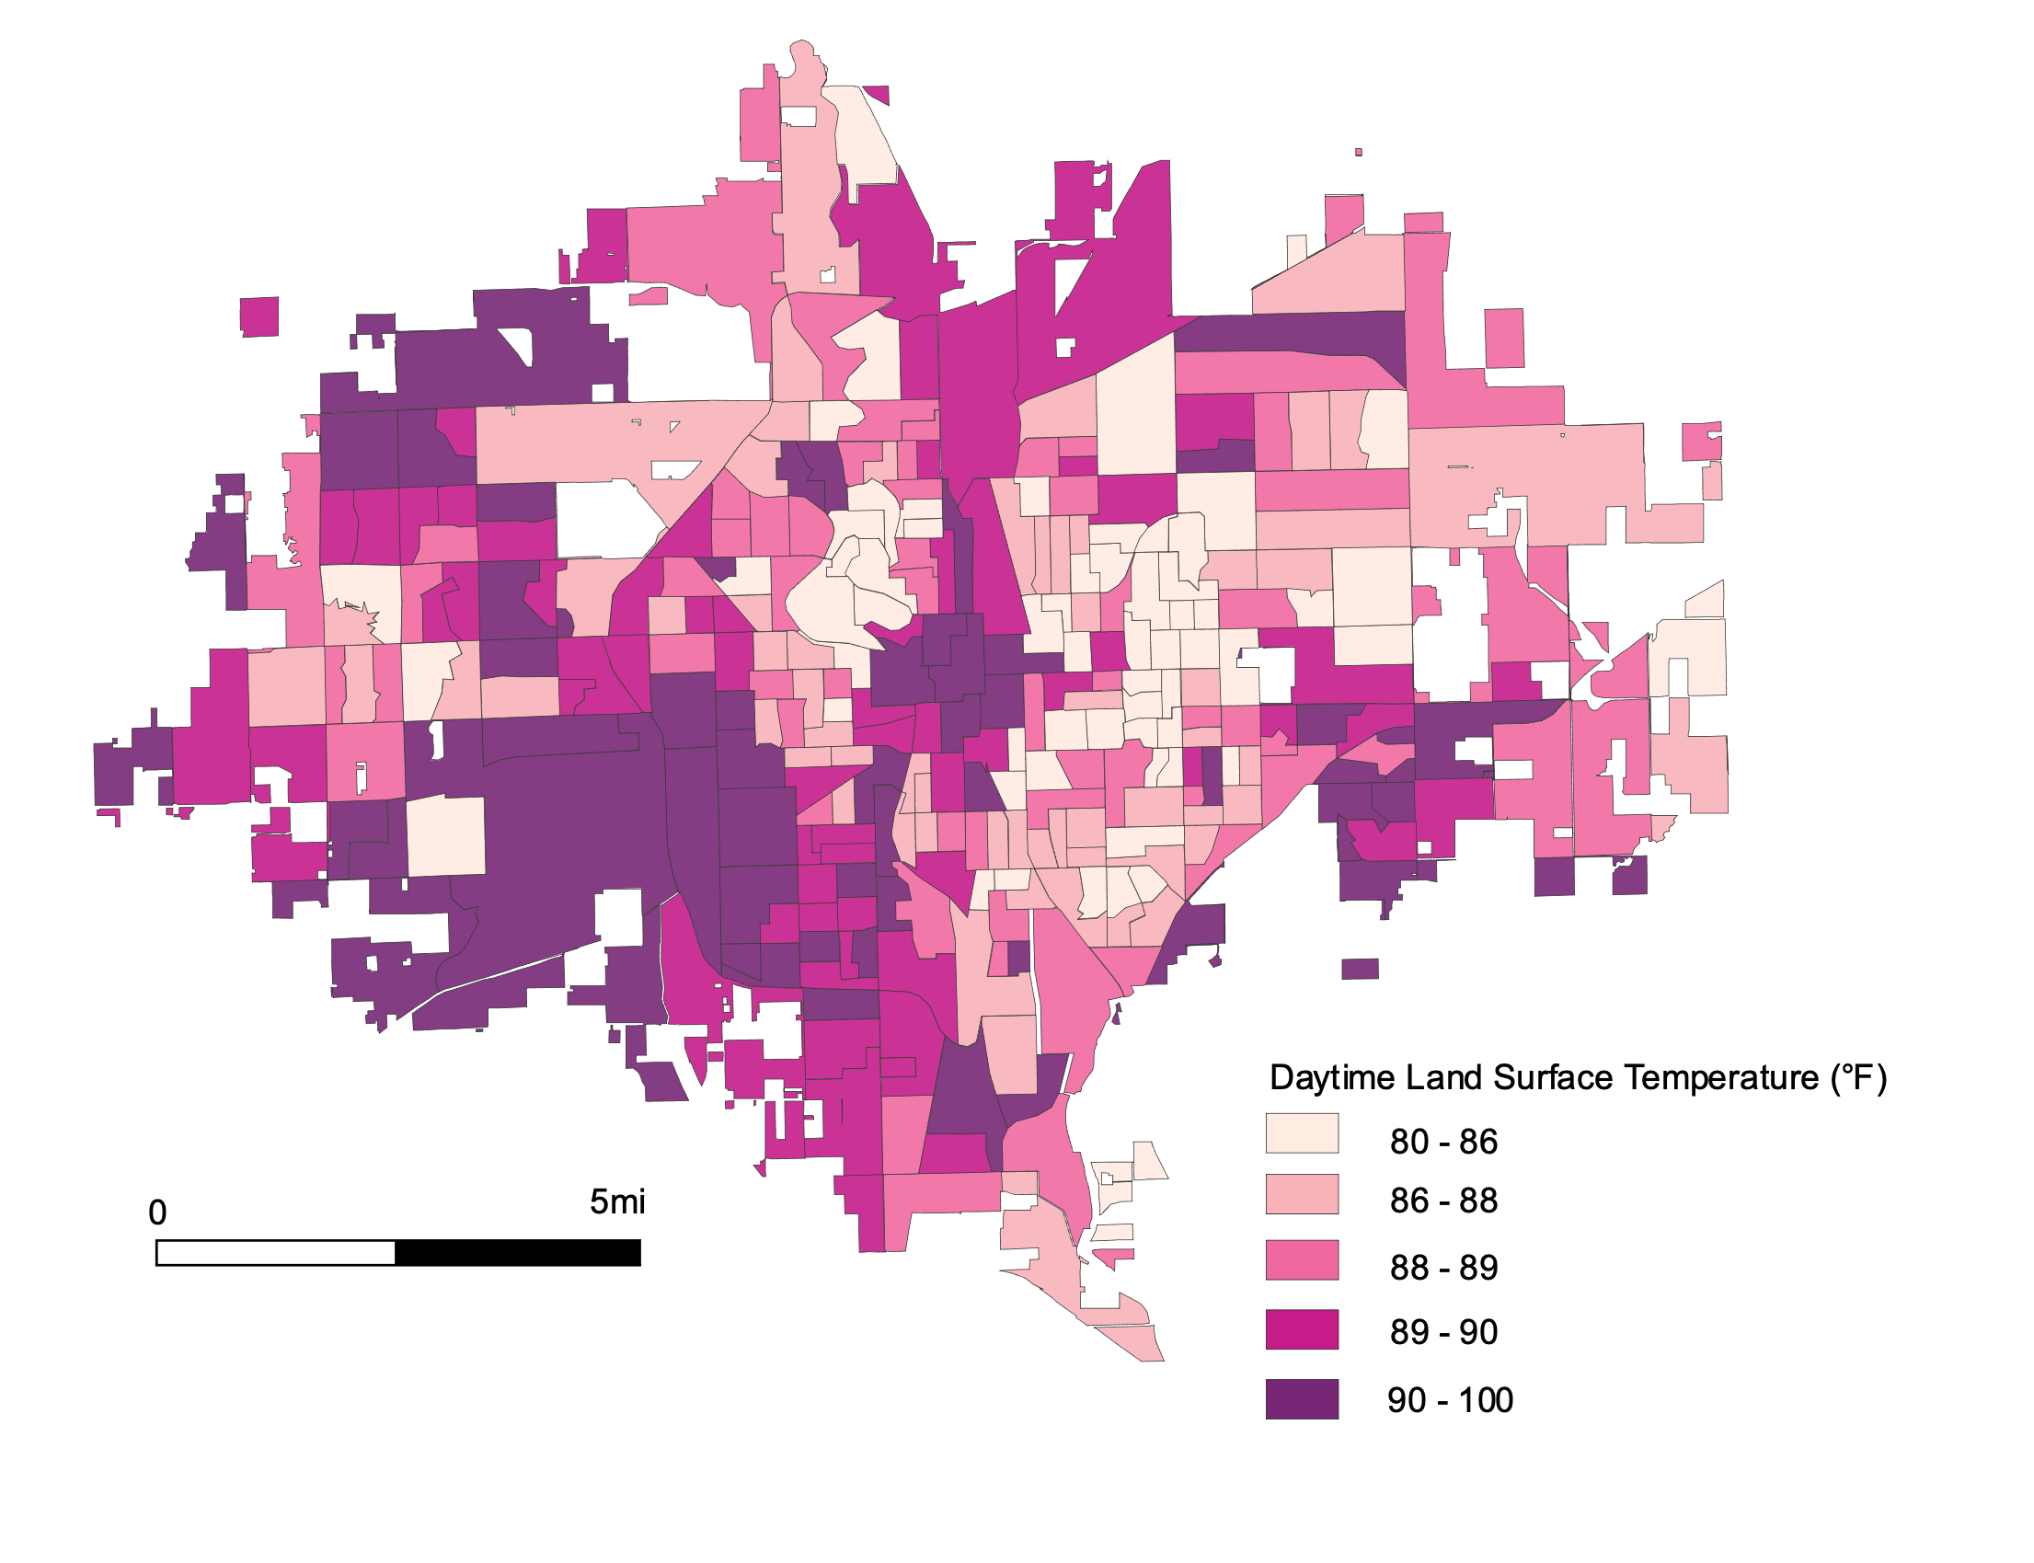
Figure 1. Daytime LST at the Census Block Level
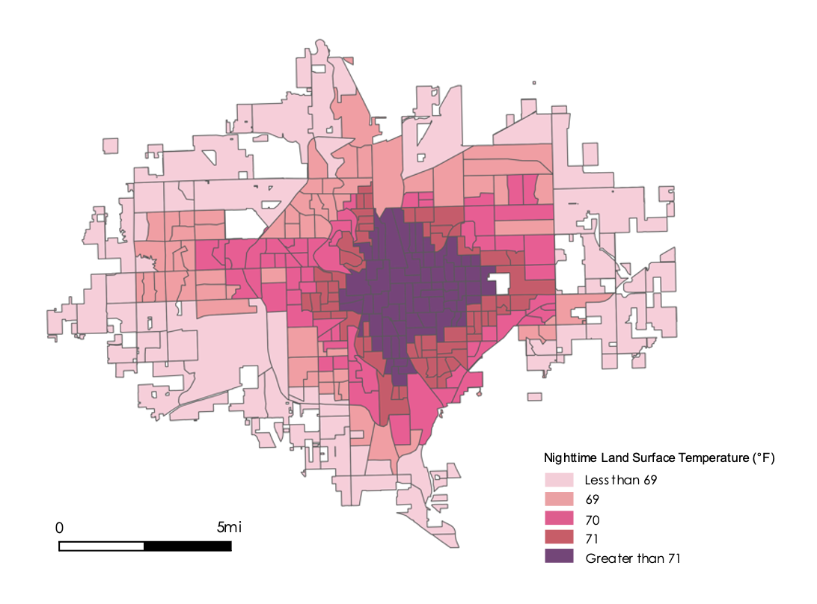
Figure 2. Nighttime LST at Census Block Level
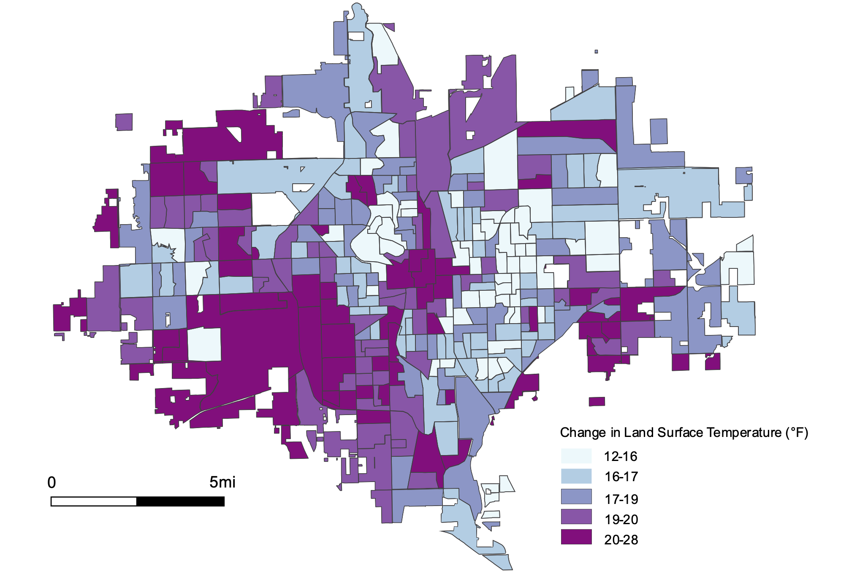
Figure 3. Change in LST between daytime and nighttime at Census Block Group Level

4.2 Tree Canopy
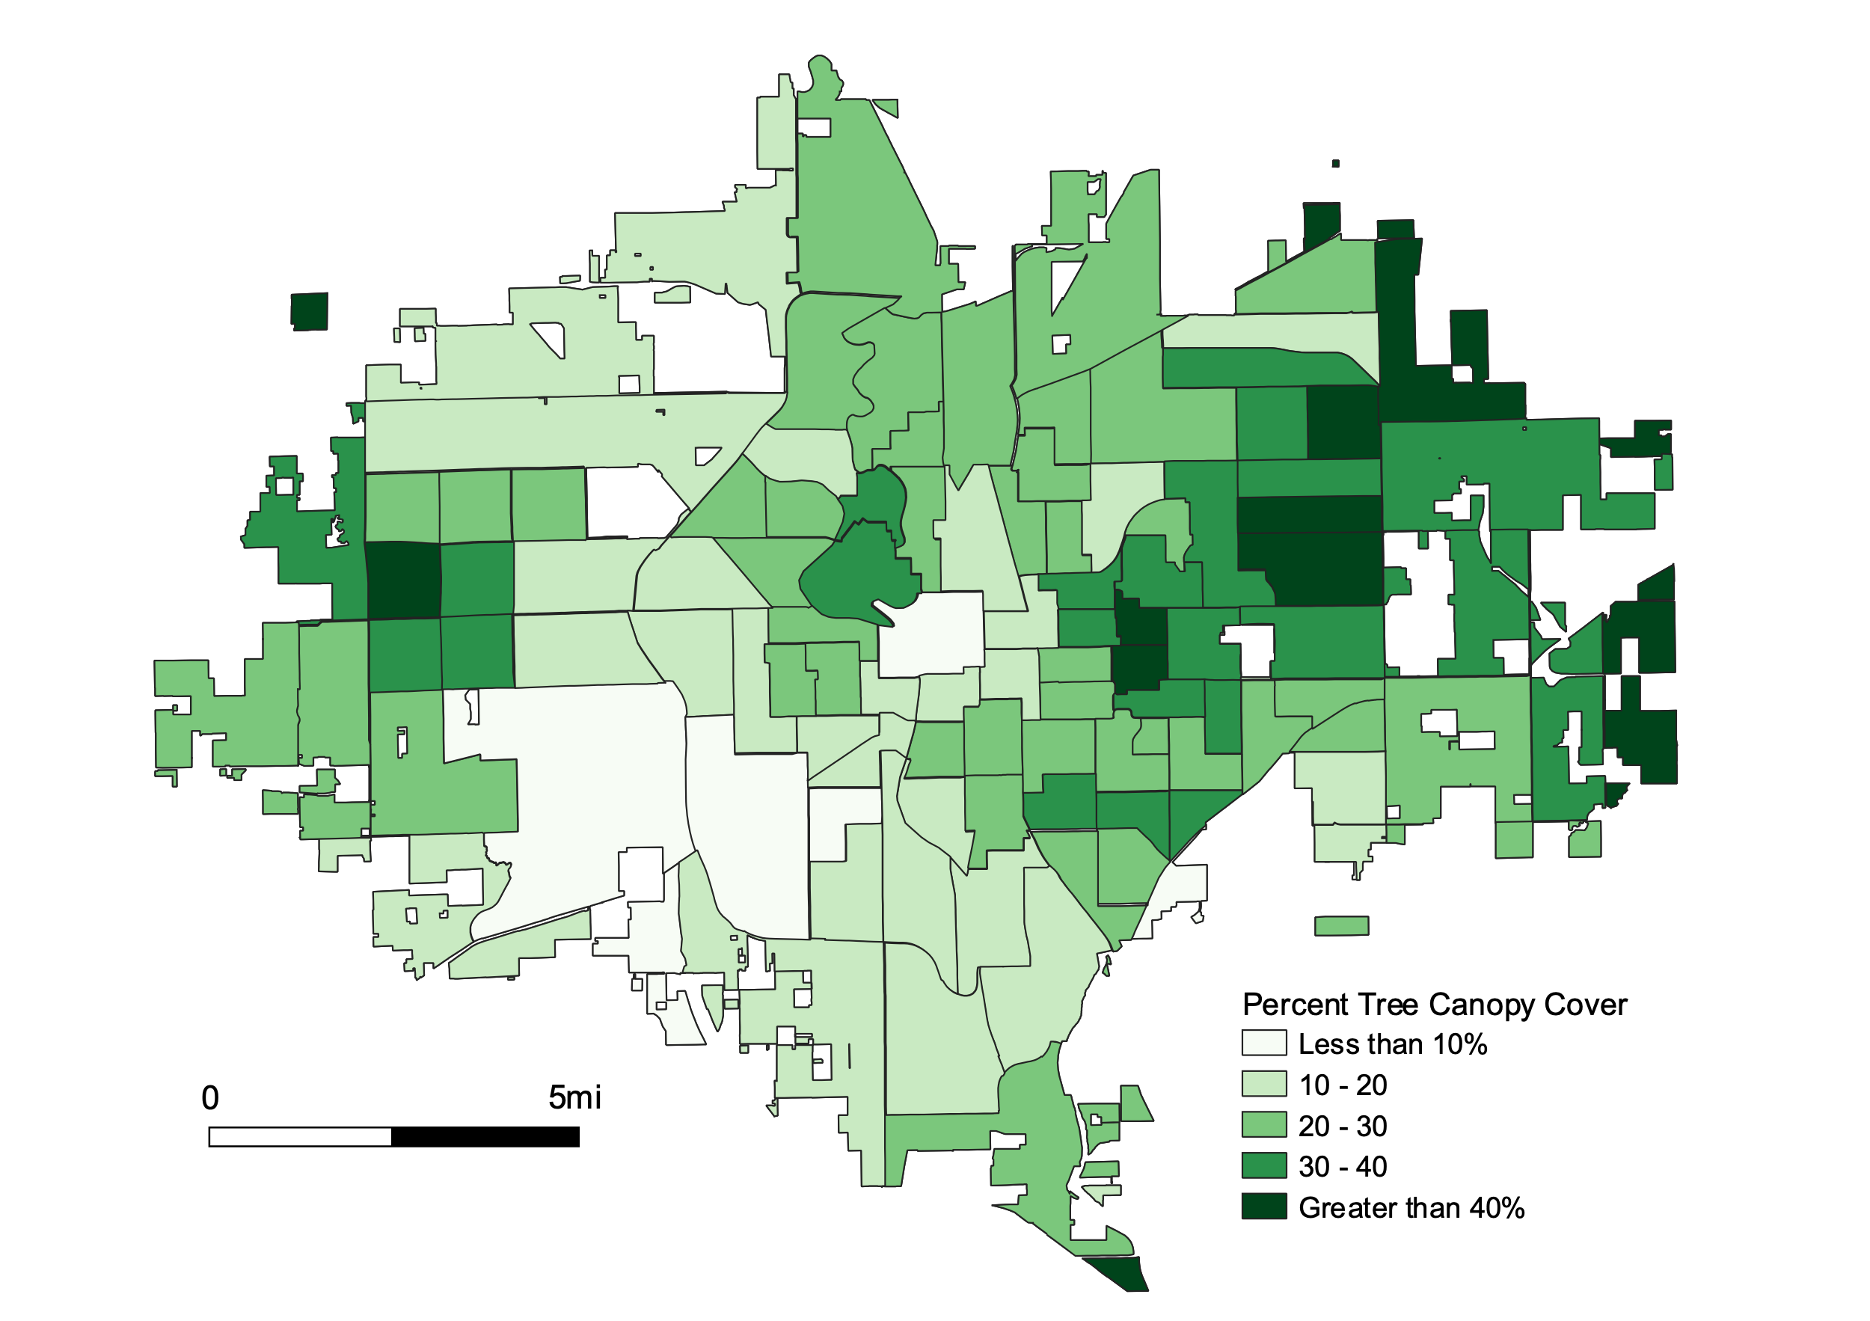
Our classification showed that tree canopy coverage is drastically greater on the eastern side of Wichita and lacking in and around the city center (Figure 4). In contrast, tree canopy coverage is lacking in and around the city center and in southwestern Wichita. The areas that do not have much (> 20%) tree cover match areas of high daytime LST (Figure 1). Results from the error matrix revealed that the RF landcover classification of the simplified tree versus non-tree binary was 99% accurate (Figures A1 and A2). We also ran a classification and regression trees (CART) algorithm, but it was less accurate (93%), and therefore was not used in further analysis steps.

Figure 4. Tree Canopy Cover Map at Census Tract Level
4.3 Heat Risk
We identified 3 high risk census block groups using age, race, and income data as proxies for heat vulnerability (Figure 5). Residents in these block groups were more likely to be older than 65, non-white, and/or below the federal poverty line and experienced high average LSTs. We also performed a regression analysis of our socioeconomic variables that demonstrated both race and income had a statistically significant (p<0.05) relationship with heat exposure, with income having a p-value below 0.001, indicating historically marginalized populations live in more exposed areas.

We identified 17 high risk census tracts, displayed in dark purple, which were considered highly vulnerable by the CDC SVI and had high average temperatures (Figure 6). Of those, 82% are also identified as environmentally disadvantaged by the Climate and Economic Justice Screening Tool (CEJST). The CEJST classification may be particularly useful for the City of Wichita to consider when designing heat mitigation projects, as these areas are eligible for Federal Justice40 funding, which aims to provide 40% of the benefits from Federal programs to disadvantaged communities (The White House, 2022). High risk tracts circle the city center, where heat exposure and vulnerability are concentrated. People living in these areas are most likely to suffer negative heat consequences. High exposure tracts with medium vulnerability were clustered in southwest Wichita. Medium exposure and high vulnerability tracts were mainly in eastern Wichita. Together, our two risk indices identify areas of Wichita at the highest risk of negative impacts from heat.

Figure 5. Heat Risk Map at Census Block Level using income, race, and age to define vulnerability. Grey areas indicate tracts with no data.
Figure 6. Heat Risk Map at Census Tract Level using CDC SVI data
4.4 Limitations and Future Work
There are limitations to this study’s ability to assess heat risk, as well as opportunities for future research to build on our findings. First, there is a lack of localized data in our preliminary results. Our partner, the City of Wichita, provided invaluable local information. However, there was limited acquisition and implementation of residents' knowledge about the lived experience. For example, we relied on Planet imagery to determine whether an area was lacking tree cover and was therefore vulnerable to heat. However, an area with low tree canopy cover could be in an area with strong social connections and mutual aid networks, making residents well adapted to heat and incorrectly characterized in our risk map.

Future DEVELOP participants can work with the city government to engage the broader Wichita community in our research process. By partnering with Wichita citizens who are most affected by heat to understand their personal experiences — including what activities are disrupted by heat and what times of year/day residents are most burdened by heat — the research products will be a better reflection of local needs. Participants of the following project term will expand our research to include more community input, strengthening our results and future analysis.

Second, LST is not a perfect indication of how heat is experienced in communities. It is a proxy for understanding air temperature that does not provide a holistic representation of heat exposure. Information including indoor heat temperature, length of heat waves, and heat anomalies occurring outside of summer months may better correlate with the effects on physical and mental health, livelihoods, security, and access to resources at the individual level. We also recommend future analysis to incorporate other measurements of heat, such as estimated wet-bulb temperature (Willet & Sherwood, 2012).

Third, we recognize that extreme heat is just one of many environmental and social problems affecting Wichita communities. Wichita has several Superfund and industrial sites within the city boundaries, which can contribute to health issues by concentrating pollutants in low-income areas at standards that exceed those set by the EPA. Our risk data includes CJEST compiled environmental and social disadvantage estimates by census tract, which provide context on some additional community burdens. Future research could incorporate both community specific variables and a greater variety of variables to represent additional community burdens such as renter population, hospitalization rates, reliability of public transportation, household size, access to public restrooms or water fountains, and more. Incorporating these explicitly into risk analysis will help account for the fact that environmental injustice stems from more than just one hazard.

Additionally, we built our census block group risk assessment by equally weighing three variables: race, income, and age. There are many other factors that influence an individual's exposure, vulnerability, and risk to heat. The block group assessment could be more robust if more variables were incorporated, such as energy burden or information about housing type. One group we believe that is particularly important to include is unhoused populations, who lack options to escape high outdoor temperatures. In 2014, the Sedgwick County Government estimated the existence of 600 unhoused people in Wichita, but census data often misses these individuals (Sedgwick County Government, 2022). Future research should focus on including this population in the risk assessment and understanding adaptation approaches tailored to their needs.

5. Conclusions
We found that heat exposure is concentrated in the city center and southwest Wichita, areas that are also low in tree canopy coverage. However, the areas of highest heat risk primarily circle the city center, in blocks and tracts home to more socially vulnerable populations and near enough to the dense urban center to feel significant urban heat island effects. These findings convey problems of spatial inequity across the Wichita landscape.

We identified 3 census block groups and 17 census tracts which the City of Wichita can focus on in future heat mitigation efforts, such as tree planting and maintenance, cooling center siting, targeted programs to manage energy burden, and the development of their Climate Adaptation and Mitigation Plan. By prioritizing areas of Wichita that face increased urban heat risk, our partners will be better equipped to develop neighborhood-specific climate mitigation strategies. Recognizing that certain areas and populations within a jurisdiction experience different environmental burdens and benefits is necessary for environmental justice centered climate adaptation, which must work to alleviate those disparities.

Furthermore, by providing the city of Wichita with an urban heat analysis that specified by block group the city can investigate other components of heat risk in the most vulnerable communities, such as indoor heat risk and air quality. This will allow for greater collaboration with the community and will put environmental justice principles into action. Additionally, it will help guide the heat mitigation actions that will have the biggest impact on Wichita residents.

6. Acknowledgments
6.1 Land Acknowledgement
As a team, we acknowledge our position as researchers who are geographically removed from our study area of Wichita, Kansas. Our geographical distance leads to an inability to fully understand the risks and impacts of urban heat at the community level. We benefitted greatly from the input of our partner, the City of Wichita, but by conducting our research without input from non-governmental community members, there are missing components to our analysis.

We acknowledge that in our map products, we utilize city boundaries and state lines that reflect colonist constructions of the landscape, disregarding the existence of indigenous communities that have been stewards of this land far before colonialization. Furthermore, as participants in the NASA DEVELOP National Program, we acknowledge that many of the inequities that exist within a city are a result of discriminatory government policies that disenfranchise minority and low-income communities. Current heat inequities are a manifestation of historic and present governmental policies. While NASA DEVELOP does not prescribe policy, it is our hope that research grounded in environmental justice principles can expose past injustices and illuminate ways forward that would right these historic wrongs.

As we consider components of environmental justice in Wichita’s landscape, it is essential to acknowledge the past history of indigenous people who have had their land stolen by colonists. The word Wichita originates from the Choctaw word and means “big arbor” or “big platform,” to express descriptions of the long grass in the region. We would like to acknowledge the unceded indigenous land that Wichita is on, which includes the Osage, Kiowa, Wichita and Sioux Peoples. Additionally, we would like to acknowledge four federally recognized Native nations: The Prairie Band Potawatomie, the Kickapoo Tribe in Kansas, the Iowa Tribe of Kansas and Nebraska, and Sac and Fox Nation of Missouri in Kansas and Nebraska. The United States has a complex and violent history of stolen land from indigenous people, and we recognize that the demarcation and isolation of Native nations contradict indigenous philosophies of unity, holistic living, and interconnectedness.

We would also like to acknowledge the unceded indigenous land where our team members worked. The land that Boston, MA is situated on is of the Massachusett, Pawtucket, and their neighbors the Wampanoag, and Nipmuc Peoples. Brooklyn, NY is located on land of Lenape People. Chapel Hill, NC is located on Occhaneechi, Lumbee, Coharie, Haliwa-Saponi, Eastern Band of Cherokee, Meherrin, Tuscarora, Sappony and Waccamaw-Siouan Nations. Darien, CT sits on the land of the Munsee Lenape, Schaghicoke, and Wappinger tribes. These groups were the first caretakers of the land, the first individuals to build relations with the living and non-living environment that we all benefit from.

6.2 Thank You
Thank you to Dr. Kenton Ross (NASA Langley Research Center), Lauren Childs-Gleason (NASA Langley Research Center), Marco Vallejos (DEVELOP VEJ Fellow), and Remi Work (DEVELOP VEJ Assistant Fellow) for their science advice, guidance, feedback, and support throughout the project. A special thank you to our partner Nina Rasmussen from the City of Wichita for her valuable time, ample guidance, and dedication to pursuing an environmentally just city. Finally, we thank the DEVELOP Project Coordination Fellows Tamara Barbakova and Sophia Skoglund for their guidance and editing.

Maps throughout this work were created using ArcGIS® software by Esri. ArcGIS® and ArcMap™ are the intellectual property of Esri and are used herein under license. All rights reserved.
PlanetScope Imagery courtesy of Planet Labs, Inc.

Any opinions, findings, and conclusions or recommendations expressed in this material are those of the author(s) and do not necessarily reflect the views of the National Aeronautics and Space Administration.
This material is based upon work supported by NASA through contract NNL16AA05C.

7. Glossary
Air Temperature – How hot the air is above the ground
Earth observations – Satellites and sensors that collect information about the Earth’s physical, chemical, and biological systems over space and time
Environmental Justice (EJ) – The fair treatment and meaningful involvement of all people in the development, implementation, and enforcement of environmental laws, regulations, and policies (EPA, 2022). The concept has been defined in 17 principles pioneered by Dr. Robert Bullard during the First National People of Color Environmental Leadership Summit (The First National People of Color Environmental Leadership Summit, 1991)
Evapotranspiration (ET) – The sum of evaporation and transpiration, which is the amount of water that vaporizes from land into the air over a set period of time (Sharp et al., 2020)
Heat Exposure – The heat an area or individual is exposed to due to heat events
Heat Vulnerability – The likelihood that people within an exposed area will suffer negative impacts from heat exposure
Heat Risk – The likelihood of adverse effects from heat as a result of heat exposure and heat vulnerability
Land Surface Temperature (LST) – A measure of how hot the ground is
Landsat – A joint NASA and USGS program offering satellite imagery of the Earth’s surface since 1972
MODIS – Moderate Resolution Imaging Spectroradiometer
Near Infrared (NIR) – The region within the electromagnetic spectrum that has a wavelength range from 750 to 2500 nanometers (nm)
Normalized Difference Built-up Index (NDBI) – An index based on the NIR and SWIR bands to highlight built-up areas
Normalized Difference Vegetation Index (NDVI) – An index based on the NIR and Red bands to highlight vegetated areas
Normalized Difference Water Index (NDWI) – An index based on NIR and SWIR bands to highlight water
Remote Sensing – The process of acquiring information about an area without making physical contact, typically via satellite or aircraft
Shortwave Infrared (SWIR) – The region within the electromagnetic spectrum that has a wavelength range from 1400 and 3000 nm.
Superfund Site – An EPA designation of highly contaminated areas
Tree Canopy – The aboveground portion of trees
Urban Heat Island – An urban area where temperatures are higher than in surrounding rural areas, often due to a concentration of impervious surfaces

8. References
AppEEARS Team. (2022). Application for Extracting and Exploring Analysis Ready Samples (AppEEARS). Ver. 3.6. NASA EOSDIS Land Processes Distributed Active Archive Center (LP DAAC), USGS/Earth Resources Observation and Science (EROS) Center, Sioux Falls, South Dakota, USA. Accessed June 30, 2022. https://appeears.earthdatacloud.nasa.gov

Beaudry, B., Berman, M., Colmenares, M., & Gambino, C. (2019). Southern Maine Health & Air Quality: Examining Tick-Borne Illness Risk by Evaluating Land Cover and Tick Habitat Suitability in Southern Maine [Unpublished manuscript]. NASA DEVELOP National Program, Massachusetts—Boston.

Boogaard, S., Dialesandro, J., Steiner, B., & Pang, Y.S.A. (2020). Tempe Urban Development II: Establishing an Urban Heat Exposure Severity Score for Infrastructure Prioritization in Tempe, Arizona, Using NASA Earth Observations and LiDAR. NASA DEVELOP National Program, Arizona– Tempe. https://ntrs.nasa.gov/citations/20205011643

Borunda, A. (2021, May 3). Racist housing policies have created some oppressively hot neighborhoods. National Geographic. https://www.nationalgeographic.com/science/article/racist-housing-policies-created-some-oppressively-hot-neighborhoods?rid=497634F2CCB695E0CC39205507279BCC&amp;cmpid=org

Centers for Disease Control and Prevention, Agency for Toxic Substances and Disease Registry, Geospatial Research, Analysis, and Services Program. (2018). CDC/ATSDR Social Vulnerability Index 2018 Database Kansas. [Data set] https://www.atsdr.cdc.gov/placeandhealth/svi/index.html

Centers for Disease Control and Prevention. (2022, June 17). Extreme Heat | Natural Disasters and Severe Weather. CDC. https://www.cdc.gov/disasters/extremeheat/index.html

City of Wichita. (n.d.). About Wichita. Retrieved August 8, 2022, from https://www.wichita.gov/Pages/About.aspx

Council on Environmental Quality. (n.d.). Climate and Economic Justice Screening Tool. Retrieved August 9, 2022, from https://screeningtool.geoplatform.gov

Dewitz, J. (2021). National Land Cover Database (NLCD) 2019 Products (ver. 2.0, June 2021). U.S. Geological Survey. https://doi.org/10.5066/P9KZCM54

Hoffman, J., Shandas V., Pendleton N. (2020) The effects of historical housing policies on resident exposure to Intra-urban heat: A study of 108 US urban areas. Climate. 8(1), 12. https://doi.org/10.3390/cli8010012

Hondula, D. M., Davis, R. E., Saha, M. V., Wegner, C. R., & Veazey, L. M. (2014). Geographic dimensions of heat-related mortality in seven U.S. cities. Environmental Research, 138, 439–452. https://doi.org/10.1016/j.envres.2015.02.033

Hook, S., & Hulley, G. (2019). ECOSTRESS Land Surface Temperature and Emissivity Daily L2 Global 70 m V001 [Data Set]. NASA EOSDIS Land Processes DAAC. https://doi.org/10.5067/ECOSTRESS/ECO2LSTE.001

Hook, S., & Fisher, J. (2019). ECOSTRESS Evapotranspiration PT-JPL Daily L3 Global 70 m V001 [Data Set]. NASA EOSDIS Land Processes DAAC. https://doi.org/10.5067/ECOSTRESS/ECO3ETPTJPL.001

Hsu, A., Sheriff, G., Chakraborty, T., Manya, D. (2021). Disproportionate exposure to urban heat island intensity across major US cities. Nature Communications 12, 2721 (2021). https://doi.org/10.1038/s41467-021-22799-5.

Mutiibwa, D., Strachan, S. & Albright, T. (2015). Land surface temperature and surface air temperature in complex terrain. IEEE Journal of Selected Topics in Applied Earth Observations and Remote Sensing, 8, 1-13. https://doi.org/10.1109/JSTARS.2015.2468594.

Sedgwick County Government. (2022). Homelessness| Sedgwick County, Kansas. https://www.sedgwickcounty.org/comcare/homelessness/
Sharp, R., Douglass, J., Wolny, S., Arkema, K., Bernhardt, J., Bierbower, W., Chaumont, N., Denu, D., Fisher, D., Glowinski, K., Griffin, R., Guannel, G., Guerry, A., Johnson, J., Hamel, P., Kennedy, C., Kim, C.K., Lacayo, M., Lonsdorf, E., Mandle, L., Rogers, L., Silver, J., Toft, J., Verutes, G., Vogl, A. L., Wood, S, and Wyatt, K. (2020). InVEST 3.11.0.post55+ug.geeeb7c3 User’s Guide. The Natural Capital Project, Stanford University, University of Minnesota, The Nature Conservancy, and World Wildlife Fund. https://invest-userguide.readthedocs.io/en/latest/index.html

Spicer, S. (2021) What’s in a degree? How a rise in temperature is changing Kansas life and environment. Kansas https://www.kansas.com/news/state/article251548573.html

The First People of Color Environmental Leadership Summit. (1991). The Principles of Environmental Justice (EJ). https://www.ejnet.org/ej/principles.pdf

The White House. (2022, February 18). CEQ Publishes Draft Climate and Economic Justice Screening Tool, Key Component in the Implementation of President Biden’s Justice40 Initiative. The White House. https://www.whitehouse.gov/ceq/news-updates/2022/02/18/ceq-publishes-draft-climate-and-economic-justice-screening-tool-key-component-in-the-implementation-of-president-bidens-justice40-initiative/

US Census Bureau. (2020). American Community survey 5-year data (2009-2020). [Data set]. Census.gov. https://www.census.gov/data/developers/data-sets/acs-5year.html

United States Environmental Protection Agency. (2014, June 17). Learn About Heat Islands [Overviews and Factsheets]. https://www.epa.gov/heatislands/learn-about-heat-islands

United States Environmental Protection Agency. (2016, July 1). Climate Change Indicators: Heat-Related Deaths [Reports and Assessments]. https://www.epa.gov/climate-indicators/climate-change-indicators-heat-related-deaths

Willett, K. M., & Sherwood, S. (2012). Exceedance of heat index thresholds for 15 regions under a warming climate using the wet-bulb globe temperature. International Journal of Climatology, 32(2), 161–177. https://doi.org/10.1002/joc.2257

9. Appendix A
Table A1.
Confusion Matrix for PlanetLab Imagery RF Classification.
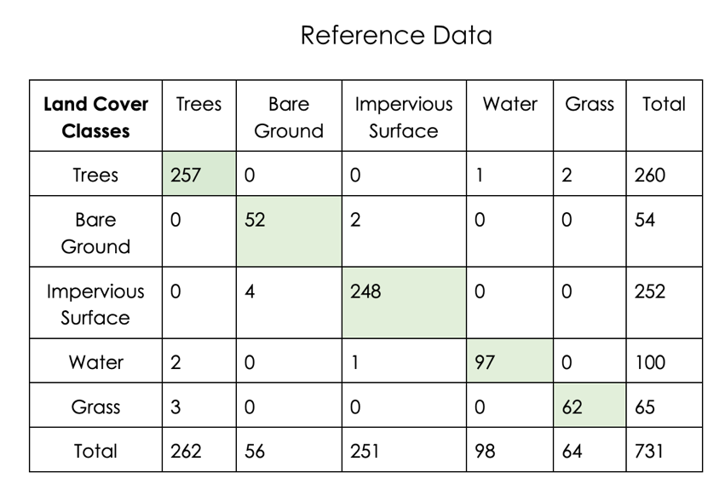
* Overall accuracy was 98%

Table A2.
Confusion Matrix for PlanetLab Imagery RF Classification, using the tree/non-tree binary.
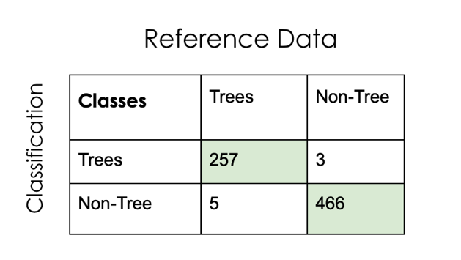

* Overall accuracy was 99%

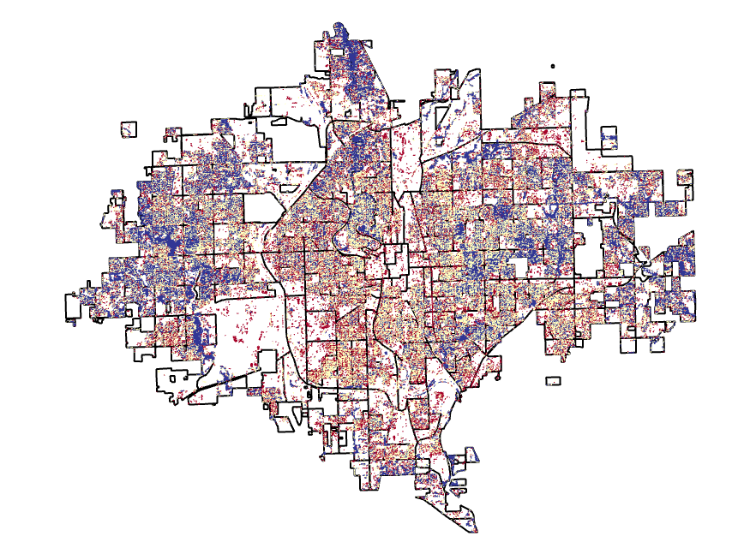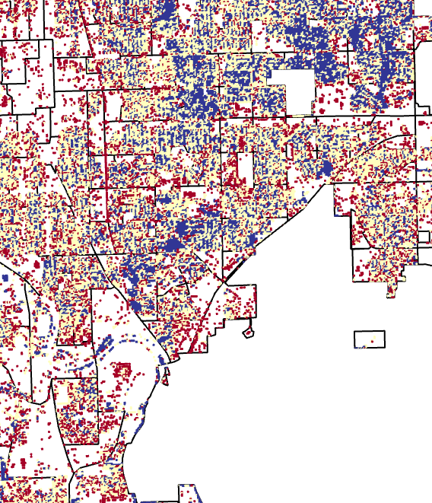
Figure A1. Difference in tree canopy cover between our classification and the NCLD Tree Canopy Cover Classification. Yellow or red colors indicate areas where we estimated more trees than the GEE model and dark blue indicates areas where we estimated less.

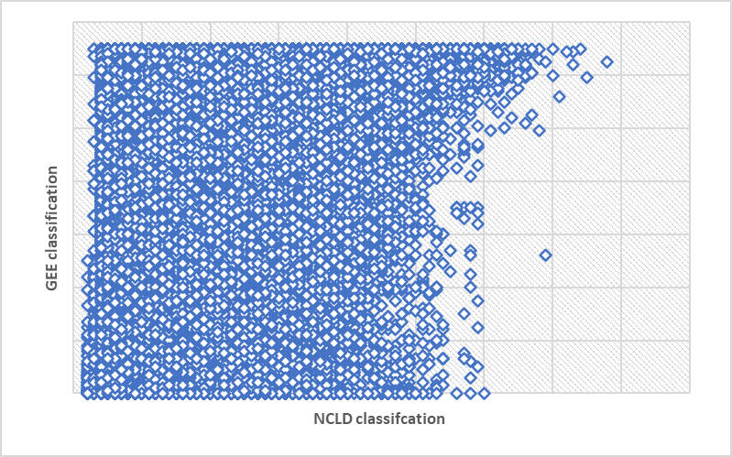Figure A2. Comparison of percent tree canopy cover between our GEE classification and the NCLD Classification. The correlation co-efficient for this data is 0.4001.

Table A3.
Details on the 3 census block groups identified as high risk.
Census Block Group | Risk Score | Mean LST (F) | Income | Race (% non-white) | Age (% above 65)
201730091005 | 3 | 92 | $22,688 | 27% | 18%
201730040002 | 3 | 91 | $21,532 | 38% | 31%
201730070001 | 3 | 91 | $27,703 | 36% | 13%

Table A4.
Details on the 17 census tracts identified as high risk.
Census Tract | High Risk (High CDC SVI and High LST) | High Risk (CJEST Disadvantaged and High LST) | Mean LST (F)
20173008900 | Yes | No | 93
20173009000 | Yes | No | 93
20173000900 | Yes | No | 93
20173003200 | Yes | Yes | 93
20173003000 | Yes | Yes | 93
20173003400 | Yes | Yes | 93
20173002700 | Yes | Yes | 93
20173006800 | Yes | Yes | 93
20173005200 | Yes | Yes | 93
20173002600 | Yes | Yes | 93
20173000300 | Yes | Yes | 93
20173004000 | Yes | Yes | 93
20173001800 | Yes | Yes | 93
20173007000 | Yes | Yes | 93
20173005100 | Yes | Yes | 93
20173005900 | Yes | Yes | 93
20173000400 | Yes | Yes | 93

