**ENUMERATION AND FLUORESCENCE *IN SITU* HYBRIDIZATION OF MICROBIAL BIOBURDEN ON CLEANROOM SURFACES.** C. J. Huff1, K. M. Green1, A. B. Regberg2, H. V. Graham3, J. P. Dworkin3, E. N. Lalime3, A. B. Congedo3, A. H. Chung3, D. E. Pugel3, and D. S. Jones1,4, 1New Mexico Institute of Mining and Technology, 2NASA Johnson Space Center, 3NASA Goddard Space Flight Center, 4National Cave and Karst Research Institute, Carlsbad, NM USA ([daniel.s.jones@nmt.edu](mailto:daniel.s.jones@nmt.edu), 801 Leroy Place, Socorro, NM 87801).

**Introduction:** Microorganisms are everywhere on Earth, even in the cleanest of places. Spacecraft assembly cleanrooms can harbor low levels of living and dead microbial cells (e.g., [1,2]), and cleanroom bioburden can also include organic molecules from industrial sources and *in situ* biomass. Life detection missions require careful attention to avoid contaminants that can be easily convoluted with analytical targets.

We are evaluating epifluorescent microscopy and fluorescence *in situ* hybridization (FISH) as methods to complement organic contamination detection techniques. Epifluorescent cell counting offers an accurate and cost-effective way to quantify low levels of surface biomass. FISH could allow for the identification of residual organisms, and can be targeted to detect active populations of specific organisms such as bacteria known to resist cleaning procedures. This effort is part of a larger study that is concentrated on characterizing the surface and airborne molecular organic contamination background in Johnson Space Center (JSC) Astromaterials curation laboratories and Goddard Space Flight Center (GSFC) spacecraft assembly rooms, and understanding contaminants in the context of cleaning procedures and residual bioburden.

**Methods:** Samples were collected by swabbing surfaces in ISO 5 and ISO 7 equivalent cleanrooms at JSC. Swabs for FISH were fixed in 4% paraformaldehyde (PFA) for 3 hours and then stored in 1:1 ethanol:PBS, while swabs for cell counting were stored in 4% PFA until analysis to avoid any cell loss during centrifugation that could impact quantification of very low biomass samples. Cell counting was performed with SYBR Gold as in [3], but adapted for very low biomass. FISH was performed as in [4], using DAPI as a counterstain for all DNA-containing cells. Negative controls included wells with no probe applied, to test for natural fluorescence, as well as the nonsense probe NONEUB (reverse complement of EUB338) to evaluate non-specific probe binding.

**Results and Discussion:** Cleanroom surfaces had102-103 cells cm-2. The extremely low biomass of these samples was challenging for enumeration, and required careful and routine use of “field” and laboratory blanks.

FISH was performed with the general archaeal and bacterial probes ARCH915 and EUB338 (EUBMIX, [4]), probe GAMBET ([4]), and PSE227, which targets the genus *Pseudomonas* [5]). The latter two probes were 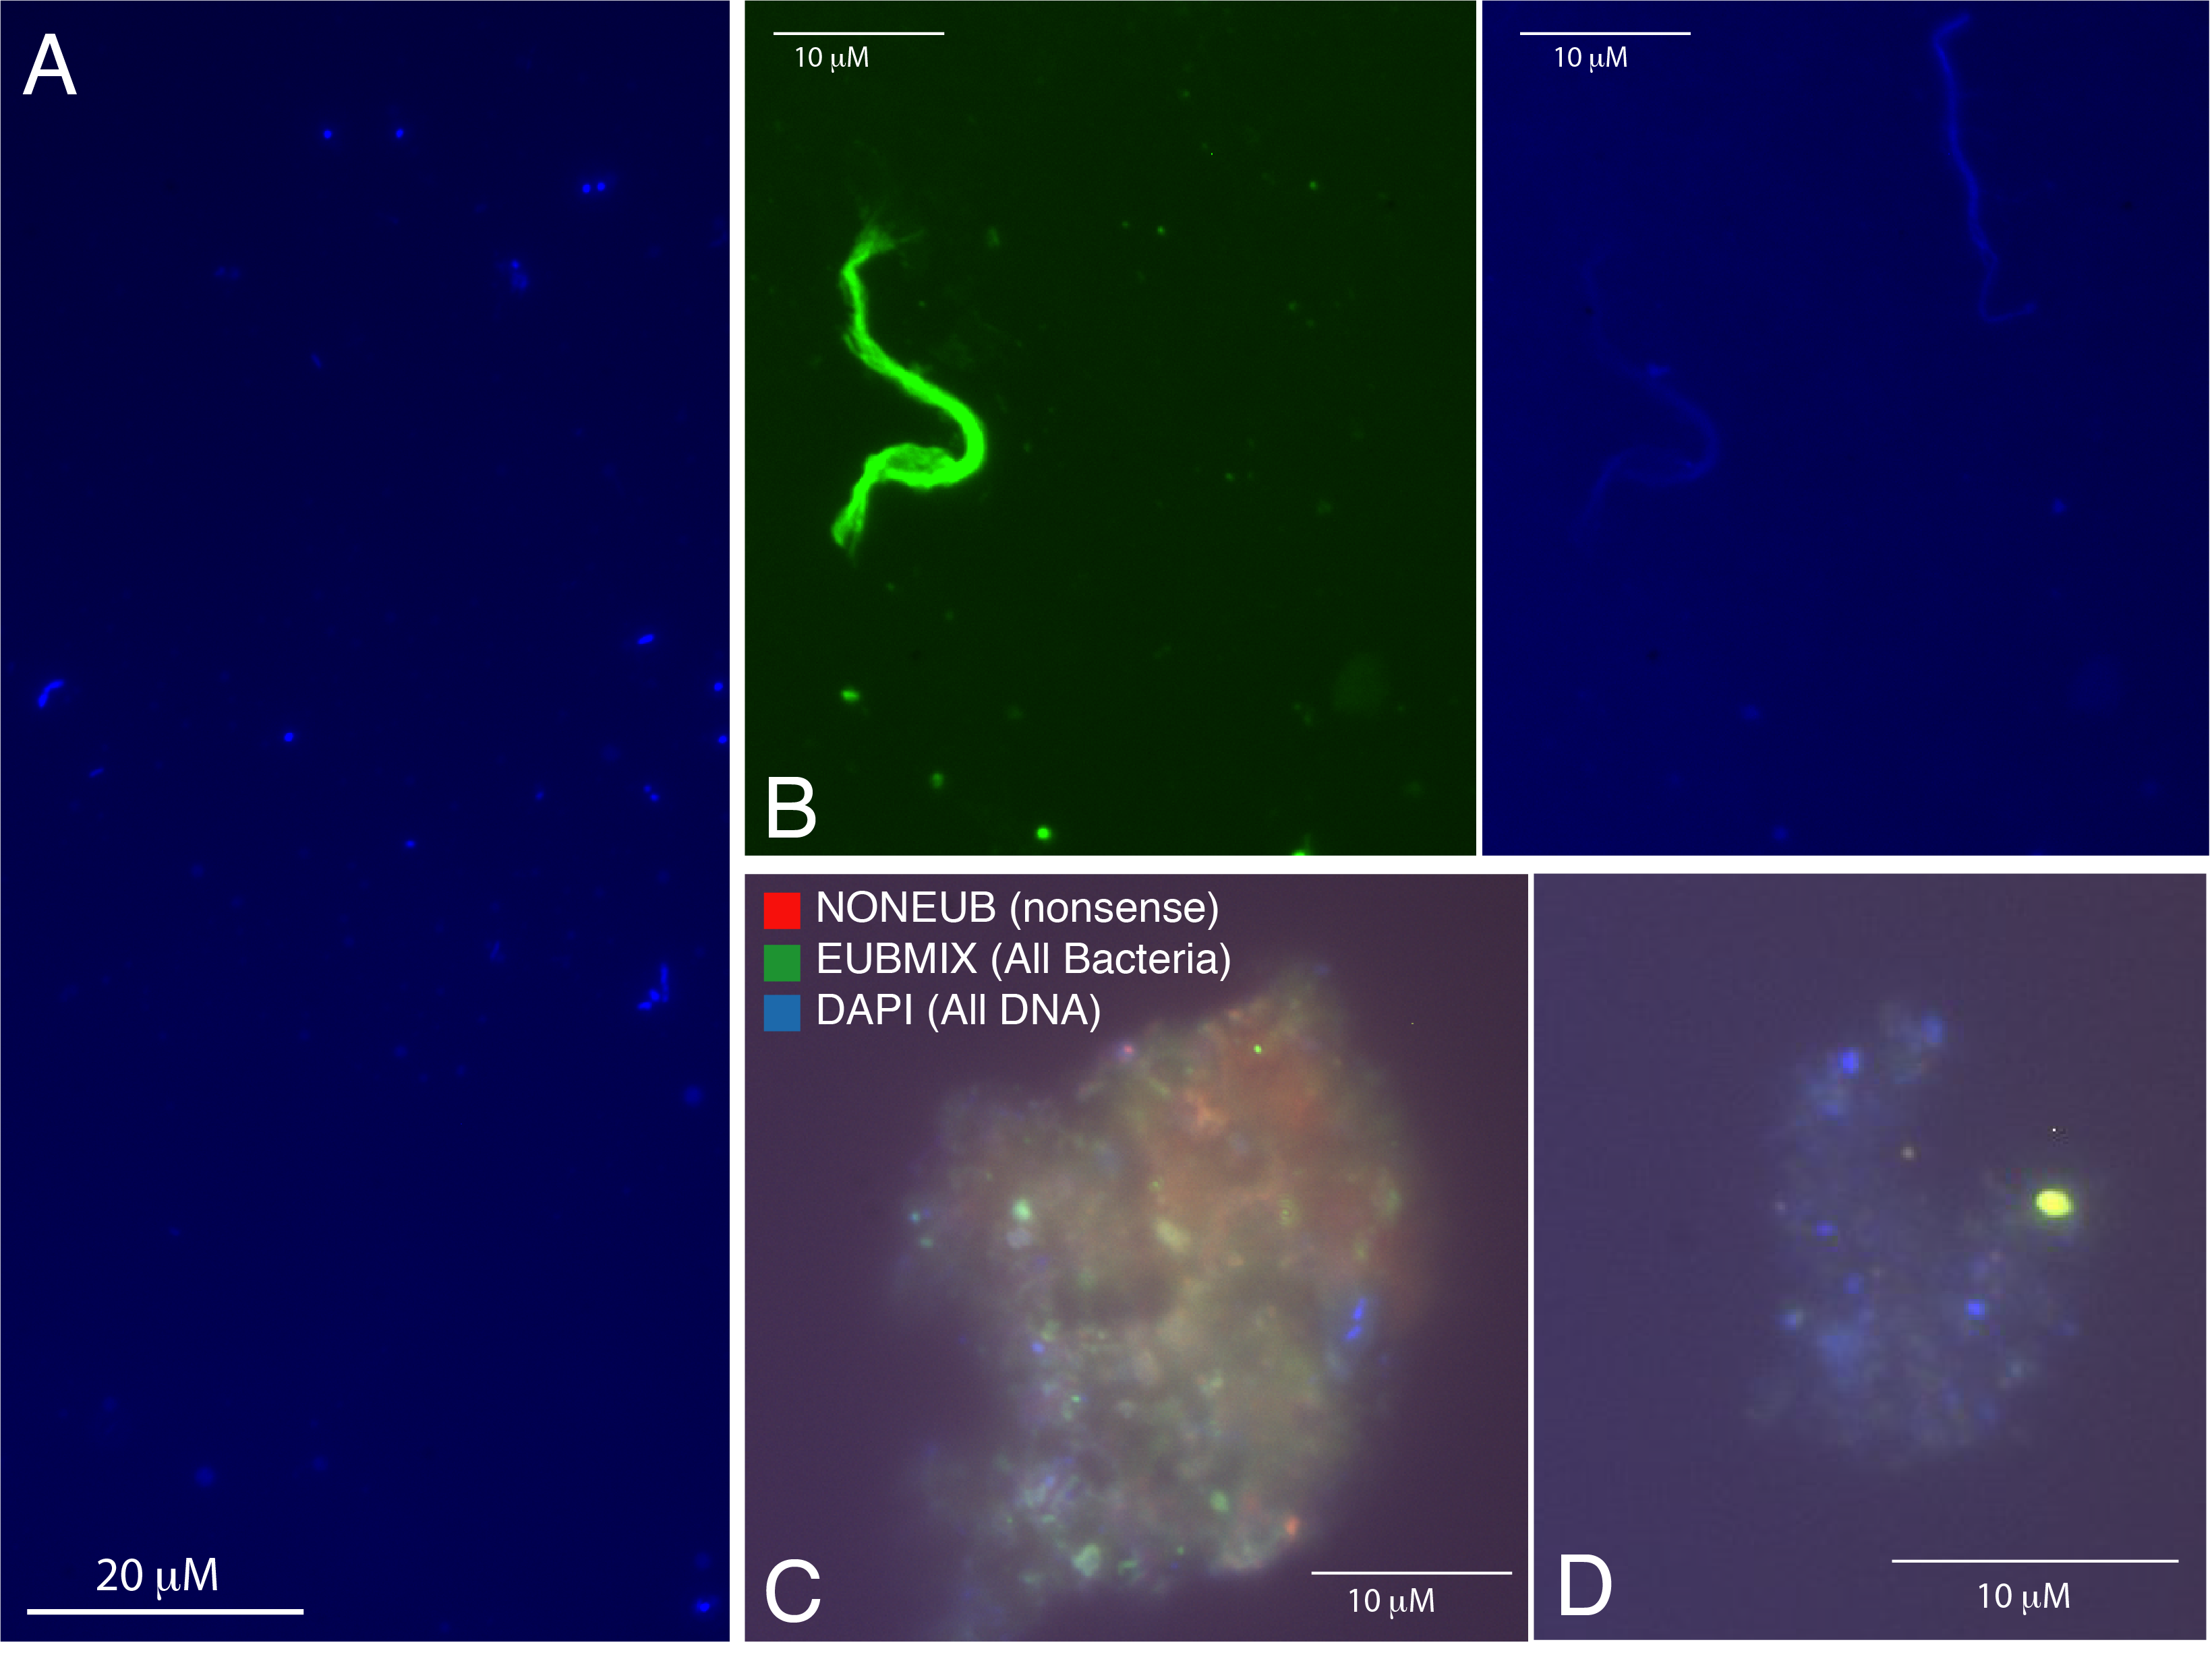 **Figure 1.** (A) DAPI-stained cells, (B) putative textile fibers (same field under two fluorescent filters), and (C, D) representative FISH images.

selected because *Pseudomonas* spp.and other Gammaproteobacteria have not been isolated from cleanroom surfaces but do appear frequently in rRNA gene libraries from these surfaces.

While some active bacteria were identified (Fig. 1c), most cells detectable by DAPI did not have a strong or any fluorescent signal (e.g., Fig. 1d), indicating that the vast majority of cells are dead or inactive. This suggests that cleaning protocols are effective at inactivating microbial contaminants, but that dead or inactive cells can remain on surfaces. Cells were often clumped in a weakly autofluorescent matrix, possibly biofilm material (Fig. 1c,d). We also observed other particulate material that was collected by the swabs, including apparent textile fibers (Fig. 1b). Our results are consistent with other studies that show that the bioburden present in clean rooms includes active, dormant, and dead cells. We will discuss how FISH and epifluorescent cell counting could be applied in planetary protection protocols, including the advantages and disadvantages of FISH and cell counting for routine use, as well as different possible applications for more specialized FISH procedures.

**References:** [1] Moissl-Eichinger et al. (2015) *Sci Rep, 5,* 9156 [2] Hendrickson et al. (2021) *Microbiome, 9,* 238[3] Jones et al. (2017) *Appl Environ Microbiol, 83,* e00909-17 [4] Jones et al. (2015) *Appl Environ Microbiol, 81,* 1242-1250. [5] Watt et al. (2006) *Environ Microbiol, 8,* 871-884.