Observing Coronal Microscales  
and their Connection with Mesoscales

White paper for the 2024 Decadal Survey of Solar and Space Physics (Heliophysics)

Category: Solar Physics

Douglas Rabin, Anne-Marie Novo-Gradac, Adrian Daw, James Klimchuk, Nicholeen Viall,Kevin Denis,Jeffrey Newmark, Steven Christe, Eliad Peretz   
NASA Goddard Space Flight Center

Farzad Kamalabadi  
University of Illinois Urbana-Champaign

Phillip Chamberlin  
Laboratory for Atmospheric and Space Physics, University of Colorado Boulder

Leon GolubHarvard-Smithsonian Center for Astrophysics

Ineke De Moortel  
University of St. Andrews, University of Oslo

Amy Winebarger  
NASA Marshall Space Flight Center

Daniel Seaton, Matthew West  
Southwest Research Institute

Emily Mason  
Predictive Science Inc.

Nelson Reginald  
The Catholic University of America, NASA Goddard Space Flight Center

Synopsis

Why the Sun has a tenuous upper atmosphere some 1000 times hotter than the photosphere is a fundamental open problem in space plasma physics despite decades of study. A leading hypothesis, supported by indirect evidence, is that in most of the corona heating is confined to narrow current sheets in which energy is dissipated despite the low large-scale resistivity of the coronal plasma. Although the kinetic scales of reconnection or wave heating are beyond remote observation, thermal structure on scales ≲100 km is expected to be produced by the primary heating mechanisms. This white paper considers what could be learned from direct observations of coronal plasma on those scales and from observationally connecting microscales to larger scales and the formation of the solar wind. The paper concludes by outlining a mission concept that is more fully described in a Heliophysics Mission Concept Study for the Coronal Microscale Observatory.

# Historical Perspective

It has been known since the dawn of modern eclipse observations that the solar corona is structured on all scales from the solar radius to the limit of ground-based imaging (until the advent of adaptive optics, about 1 arcsec). Early space-based imaging at soft x-ray and extreme ultraviolet (EUV) wavelengths confirmed pervasive structure in the hot coronal plasma and added diagnostic power. During the same period, magnetograms revealed structure in the photospheric magnetic field at all observable scales and spawned the study of magnetic flux tubes. Because magnetic pressure dominates gas pressure in the corona (low β), it was clear that the magnetic field guides coronal structure. However, that alone does not dictate the density and temperature structure of the corona or determine on what spatial scales inhomogeneity will occur. It was equally clear that the physical mechanism(s) responsible for heating the corona ultimately determine those scales, and, consequently, that observing them would be key to understanding coronal heating.

This leads immediately to the question: What spatial and temporal scales are present, and what scales are theoretically anticipated? In a seminal paper, Parker introduced the idea of topological dissipation: that magnetic flux tubes rooted in the photosphere, jostled by turbulent convection, will progressively develop fine structure down to scales that ultimately result in magnetic reconnection [1]. Parker further developed his theory and coined the term “nanoflare” for such small-scale heating events [2]. Notwithstanding the still-debated applicability of topological dissipation in the corona [3], it seems highly likely that random motions of magnetic footpoints in the photosphere will inevitably lead to very fine-scale structure in the coronal magnetic field. Thus, whether reconnection, wave dissipation, or both are responsible for local heating, the heated volumes are expected to possess structure on similarly fine scales.

In 2012, the Hi-C sounding rocket obtained the highest angular resolution observations of the solar corona to date, about 0.25 arcsec (180 km on the Sun) at a wavelength of 19.3 nm [4]. That this result has not been bettered since reflects the technical challenge of fabricating a conventional telescope that can achieve extremely high angular resolution at EUV or x-ray wavelengths.

The present white paper explores the scientific motivation for pushing to even smaller scales and outlines a technical approach and mission concept for achieving that goal. It should be noted that a prior mission concept, the Reconnection and Microscale mission (RAM) [5] [6], was developed during the leadup to the 2013 Heliophysics Decadal Survey. The RAM concept included soft x-ray/EUV spectroscopy and hard x-ray imaging as well as ultrahigh-resolution EUV imaging; the scientific motivation for those additional diagnostics is as strong now as it was then.

# Primary Coronal Heating Events

It is widely believed that coronal heating takes two basic forms: (1) the sudden release of stored magnetic energy by fast magnetic reconnection, and (2) the nonlinear dissipation of wave energy. These are often referred to as DC and AC mechanisms, respectively, with the first also being called nanoflare heating. Both mechanisms are impulsive in nature, and wave heating is sometimes placed in the nanoflare category. Here the term nanoflare is reserved for reconnection-based heating.

Nanoflare and wave heating both occur on the Sun, but their relative importance in different solar regions has not been established. Likely, nanoflares dominate in active regions, and waves dominate in coronal holes and the solar wind. Which is more important in the quiet Sun is an open question.

The detailed properties of coronal heating – how they vary in space and time – largely determine the resulting thermal distribution of the plasma, which determines the spectrum of emitted radiation. The solar spectral irradiance from the full Sun is a major energy input to the terrestrial upper atmosphere, with different parts of the spectrum being absorbed in different atmospheric layers [7] [8]. Thus, understanding coronal heating is important for understanding atmospheric physics and space weather.



Figure 2.1 Simulated image of nanoflare heated strands as observed in Fe XVIII 9.39 nm (T= 5–10 MK). The field of view is 1000 x 1000 km2. Because impulsively heated nanoflare strands cool quicky, the line-of-sight confusion is smaller, and the contrast higher, for high-temperature lines.

The heating from both nanoflares and waves occurs on very small spatial scales. Ultrahigh resolution observations (0.04 arcsec) from the ground-based Donald K. Inouye Solar Telescope have verified that the magnetic field in the photosphere is highly fragmented. Extending from each magnetic fragment into the corona is a distinct magnetic flux tube (or strand) with a coronal diameter only one to a few hundred kilometers. Current sheets formed at the boundaries of these topologically distinct strands are the sites of the magnetic reconnection that drives nanoflares. Figure 2.1 is a snapshot from a movie showing what CMO might observe in the 9.39 nm line of Fe XVIII, formed at 5–10 MK [9]. The simulation used for the movie is realistic in the sense that the assumed strand and nanoflare properties are consistent with existing – very limited – observational constraints. We do not actually know the distribution of strand sizes or the shapes of the cross sections. They could be tube-like or ribbon-like. Nor do we know the distribution of nanoflare energies and repetition rates. These are critical properties that must be determined by direct observation.

The primary coronal strands are below our current resolving capability, but there are also larger scale structures that require explanation, such as the well-known and beautiful coronal loops. Though seemingly monolithic, each loop is a bundle of unresolved strands. What produces them has not been established. There are tantalizing hints in magnetohydrodynamic simulations that it may involve a “storm” of nanoflares, where one event triggers another in an avalanche-type process [10]. It has recently been suggested that loops may instead have a veil-like structure in 3D, which would have important implications for their heating [11]. A solar microscope, particularly in conjunction with a context imager with a larger field of view, can test alternative hypotheses of the structure of coronal loops.

Wave heating under coronal conditions also requires very small spatial scales, well below current resolution. In one scenario, counter propagating Alfvén waves generate a turbulent cascade that transports energy to the scales needed for effective dissipation. In another scenario, known as resonant absorption, kink-type oscillations couple to localized torsional oscillations, which ultimately dissipate via a Kelvin-Helmholtz instability. The scenarios have distinctive signatures that are different from those of nanoflares. Figure 2.2 shows Fe XII 19.2 nm emission (T = 1–2 MK) from a simulation of an impulsively driven coronal flux tube [12] . Time increases from left to right, and each vertical slice is the intensity profile of a cut across the loop axis. Coherent oscillations give way to smaller and smaller structures that are increasingly out of phase. In stark contrast, nanoflare reconnection is revealed as bright features spreading in opposite directions from a single location. EUV imaging with spatial resolution substantially better than 100 km and time resolution ≲10 s will definitively detect the processes involved in wave heating.

Figure 2.1 illustrates a complicating factor, the overlap of structures along the optically thin line of sight through the corona. For this reason, a coronal microscale observatory should also observe the transition region with high angular resolution. Along field lines that extend into the corona, the corona and transition region are energetically and dynamically coupled, and the transition region brightens in response to heating that occurs in the corona. There is a one-to-one mapping along the magnetic field lines. Emission patterns in the transition region are a key proxy for coronal heating that is not complicated by line-of-sight overlap.

Figure 2.2 Simulated observation in Fe XII 19.3 nm of a coronal flux tube heated by the resonant absorption of Alfven waves [12]. Horizontal axis is time (0-60 min). Vertical axis is intensity as a function of position across the tube axis in units of the tube radius.

The overlap problem is also mitigated by observing very hot (> 5 MK) emission lines. The plasma cools rapidly at these temperatures, so there are fewer structures present along the line of sight. Note that the simulation of Figure 2.1 is based on a realistic coronal depth of 50,000 km. There are 1250 nanoflare-heated strands within the field of view. Another advantage of very hot emission is that it is the most direct indicator of the energy release, produced before the plasma has experienced major cooling.

A broader discussion of a strategy for solving the coronal heating problem in magnetically closed regions may be found in the white paper by Klimchuk [13].

# Connecting Microscales to the Solar Atmospheric System

The regions of the solar atmosphere—photosphere, chromosphere, transition region, low-middle-high corona, and solar wind—comprise a system of systems with cross-regional and cross-scale coupling. Emergent phenomena, i.e., physical behaviors that emerge only when the parts interact in a wider whole, are revealed when studying cross-scale and cross-regional feedback. The EUV imagers described above will measure the microscales and the low corona/transition region part of the solar atmospheric system. This section describes the need for a coronagraph that measures the speed, temperature and density of the coronal plasma to connect microscale primary heating events to mesoscale and larger system scales.

As an example, it is known that active regions are generally hotter and denser than quiet Sun and coronal holes and that faster solar wind correlates with coronal holes [8]. This is a global-scale relationship between the solar magnetic field, coronal heating, and solar wind acceleration. However, the relationship between solar wind energization and coronal heating breaks down on mesoscales: active regions, quiet Sun, and coronal holes are not homogenous and exhibit variability and spatial structure on mesoscales. Thus, the precise link between primary heating events in the low corona and solar wind acceleration higher in the corona and beyond is unknown. The difficulty in linking the two results from major physical transitions that occur with height. Plasma beta, Alfvén speed, magnetic field expansion, plasma collisionality, and the relative amount of closed-field versus open-field magnetic flux all change dramatically [14]. These transitions illustrate how cross-scale and cross-regional coupling often go hand-in-hand.

The scientific need is to measure the cross-scale, cross-regional flow of plasma and energy. CMO demonstrates how this could be accomplished with a multiband coronagraph that images from the low through middle corona, and measures density, temperature, and speed of the plasma. Such a coronagraph can answer the following science questions:

* From where on the Sun is the solar wind is released? This is achieved by tracking the connectivity of structures through the corona and comparing with the speed.
* How much solar wind mass is released through reconnection events, and at what height do the reconnection events occur? This is achieved by measuring density structures and the associated velocities as a function of time and closed-magnetic field structure.

The combination of the EUV sieve imager and the coronagraph can answer the following science questions:

* What is the relationship between primary heating events low (measured by the EUV imager) in the corona and the kinetic and thermal energy of the solar wind (density, temperature, and speed in the corona)? At what scales do the global energy relationships break down? For example, if the primary heating events are wave heating, or reconnection events that launch waves into the upper corona, the result will be a turbulent cascade with perpendicular wave vectors that energize over broad regions. Conversely, the primary heating events may only heat locally, in which case energization will remain on discrete flux tubes.
* How much thermal and kinetic energy is associated with the reconnection events that releases closed magnetic-field plasma into the solar wind? For example, the reconnection observed at helmet streamer tips releases large amounts of mass, but does not seem to accelerate the plasma much (inferred from optical flow measurements (e.g., [15]), and it is unknown how much thermal energization occurs at those reconnection sites, although 1D simulations suggest density and velocity signatures associated with interchange reconnection [16].
* How does the energy release associated with strong guide-field reconnection compare to weak guide-field reconnection in the corona? Magnetic reconnection that releases solar wind will either be through interchange reconnection (closed-open) or anti-parallel reconnection (i.e., pinch-off reconnection at helmet streamer tips, [17]), while the magnetic reconnection that energizes the corona in primary heating events is component reconnection between closed fields. Interchange reconnection between an open field line and a small loop in the low corona (magnetic carpet) is likely anti-parallel, but interchange reconnection at the edge of a helmet streamer is likely component reconnection.

Reference may be made to white papers that more fully discuss outstanding questions in solar wind physics [18], the middle corona and its upward and downward connections [19] [20], the role of mesoscales as messengers for multiscale feedback [21] [13], and the role of missions such as CMO in a coordinated systems-science approach to understanding how the Sun forms the heliosphere [22].

# Observational Strategy

## Coronal Microscale Observatory (CMO)

CMO is the subject of a Heliophysics Mission Concept Study (HMCS) for the NASA Solar Terrestrial Probes program. The HMCS will be briefed to the Decadal Survey Committee and made publicly available. The description of CMO here is necessarily schematic; the HMCS should be consulted for details. The main engineering studies were carried out by the NASA GSFC Mission Design Laboratory (MDL) and the GSFC Optical Communications Team.

CMO targets three high-level knowledge gaps:

* direct observational knowledge of primary heating events on spatial scales significantly smaller than 100 km
* the relationship of primary heating events, singly or collectively, to the formation of solar wind in specific environments, particularly active regions, quiet Sun, and coronal hole boundaries
* the origins of mesoscale solar wind structures

CMO comprises three spacecraft flying in precise formation. Formation flying is required for two reasons: (1) CMO uses 17-cm diameter photon sieves [23] to form ultrahigh-resolution images at six EUV wavelengths. The sieves reliably produce nearly diffraction-limited images because they are diffractive rather than reflective or refractive optics. However, to achieve the necessary image scale without secondary optics, the sieves have a common focal length (100 m) that requires the detectors to be located on a second spacecraft. (2) CMO includes an externally occulted coronagraph conceptually similar to the PROBA-3 ASPIICS coronagraph [24] ESA plans to launch in 2023. External occulting enables observations close to the limb with undiminished angular resolution, a key requirement for linking primary coronal heating to sources of the solar wind.

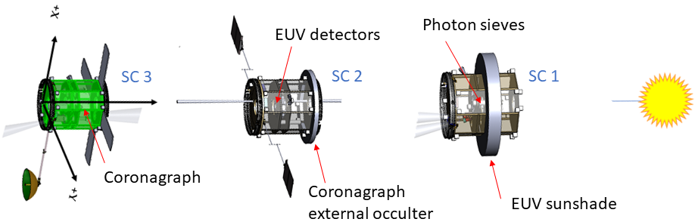

Figure 4.1 Schematic illustration of the Coronal Microscale Observatory.

Figure 4.1 illustrates the spacecraft configuration. The three craft maintain a precise formation to keep the EUV field of view stable and the coronagraph external occulter centered on the Sun. The challenging but attainable requirements on knowledge of inter-spacecraft separation (±15 mm) and transverse alignment ((±0.5 mm) are met with a precision 3D laser ranger and astrometric alignment system; however, the requirements on attitude control of the individual spacecraft are not unusual ((±5 arcsec). Liquid ionic thrusters provide fine control of the formation.

CMO will be located in a large-amplitude quasi-halo orbit around the Sun-Earth L1 point. The L1 location provides an uninterrupted view of the Sun and a low gravity-gradient environment that enables CMO to maintain formation for at least 5 years. CMO can be launched by several existing vehicles (including Falcon 9) and is compatible with the ESPA ring payload adapter.

The EUV microscope suite (Table 4.1) meets the following requirements:

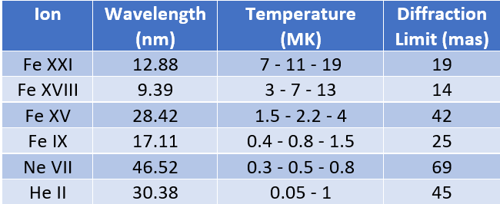

Table 4.1 CMO carries 6 EUV microscopes with broad temperature coverage. Temperatures are given at the peak of the contribution function and at 10% of peak on either side. Only a crude range is given for He II 30.4 nm because the line formation is complex. 1 mas = 0.001 arcsec.

* Spatial (two-pixel) resolution ≤ 15 km (0.02 arcsec)
* Temperature coverage 0.2 –10 MK
* Typical cadence 10 s, highest cadence ≤ 0.2 s
* Uninterrupted cadence for ≥ 1 hr
* Common field of view (FOV) ≥ 20,000 km (30 arcsec) across
* Ability to center the FOV anywhere on the EUV Sun (to 1.2 Rs)

The coronagraph meets the following requirements:

* Measure electron density, temperature, and radial flow speed

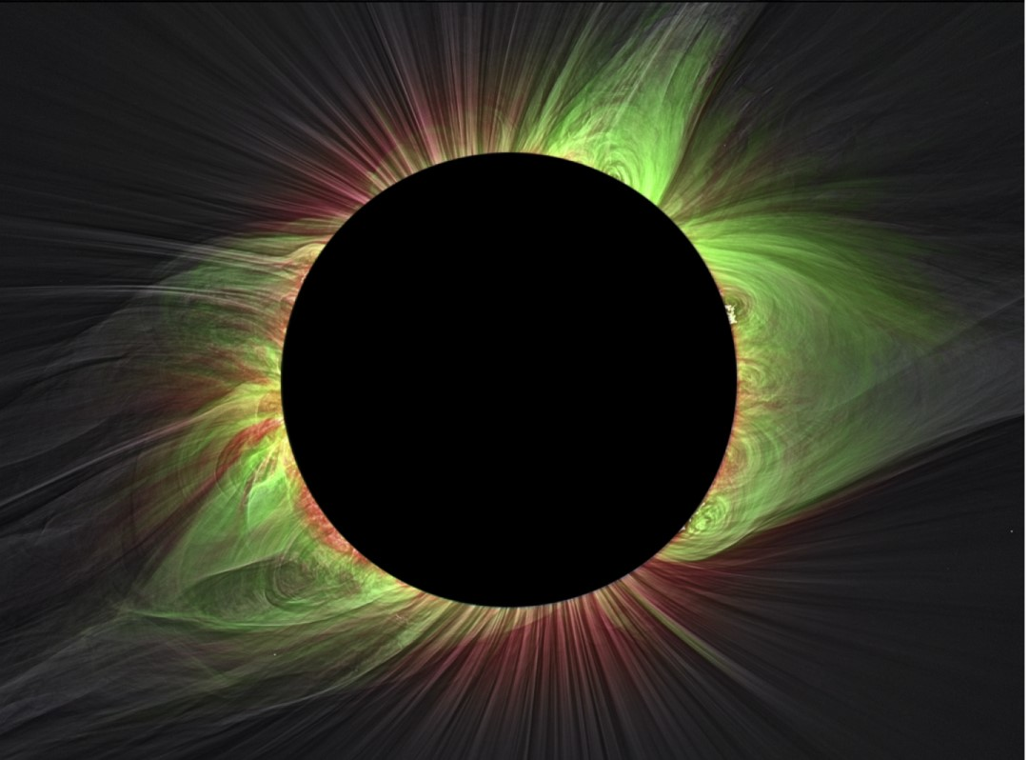

Figure 4.2 Composite image from the total solar eclipse of 2017. Narrowband images in Fe XI 789 nm (red) and Fe XIV 530 nm (green) are overlaid on a white light image [29].

* Full disk FOV, 1.03–3 Rs
* Typical cadence 60 s, highest cadence ≤ 10 s
* Uninterrupted cadence for ≥ 16 hr
* Pixel size < 3 arcsec

The coronagraph will measure electron temperature and radial flow speed in the K-corona using the filter-ratio method explicated by Cram [25] and Reginald and Davila [26] and demonstrated by ground-based and balloon-borne instruments [27] [28]. The coronagraph will also obtain narrowband images of the emission-line corona, including at least Fe XI 789.2 nm and Fe XIV 530.3 nm (Figure 4.2), following the diagnostic rationale presented by Habbal et al. [29].

Subsequent to the MDL study, the CMO science team judged that a third instrument, an EUV finescale imager, similar in performance to Hi-C [4] [30], is essential for bridging the resolution and FOV gaps between the EUV microscopes and full-disk EUV imagers (similar to the GOES Solar Ultraviolet Imager) expected to be available as supporting infrastructure. Observing near the limb, the finescale imager will also connect the EUV microscopes to the coronagraph. The finescale imager meets the following requirements:

* Two narrow bands (T~1 MK, T~3 MK)
* Spatial (two-pixel) resolution 0.2 arcsec (150 km)
* FOV 7x7 arcmin2
* Highest cadence < 10 s

The CMO engineering study was limited to already-defined instruments because of scheduling constraints and therefore omitted spectrographic instruments despite ample scientific motivation. The baseline CMO spacecraft buses could accommodate at least one other major instrument e.g., an EUV imaging spectrograph similar to EUVST [31] or a soft x-ray imaging spectrograph (see [32]). Such instruments might instead fly on other missions and be available to CMO as part of the Heliophysics System Observatory.

A preliminary cost analysis was carried out by the GSFC Cost Estimation, Modeling and Analysis (CEMA) Office and the MDL team. The inputs to the estimate included instrument space, weight, and power requirements, a master equipment list developed during the MDL study, and mission operation requirements. Additional costs were estimated for field programmable gate array development, flight software and software test bed, flight spares and engineering test units, ground support equipment, and environmental testing. CEMA estimated the total NASA Phase A-E cost, including 30% reserves but excluding launch services, at $1.3B (70% confidence level) in $FY27. As mentioned above, the finescale EUV imager is not included in this estimate. The CEMA estimate is highly preliminary, but clearly CMO is categorized as a large-scale mission.

The baseline CMO communications design employs direct-to-Earth Ka-band data transmission, which limits the EUV telescope cluster to about 10% duty cycle. Although this meets the minimum requirements of the CMO Science Traceability Matrix, direct-to-Earth optical communications could, according to a study by the GSFC Optical Communications Team, at least double the baseline downlink rate without increasing power consumption. The white paper by Shelton et al. discusses the potential of optical communications to increase science return from a range of next-generation Heliophysics missions [33].

Although the MDL study concluded that CMO is technically feasible and does not rely on breakthrough technology, the CMO HMCS includes a maturation plan for technologies rated at TRL 5 or lower. Such development costs are not included in the CEMA cost estimate.

The two most critical enabling technologies for CMO should be demonstrated in the near future by missions that will also obtain science-quality data. As mentioned above, PROBA-3, slated to launch in 2023, will, if successful, demonstrate an externally occulted coronagraph enabled by precision formation flying (PFF). The NSF-sponsored VISORS (Virtual Super-resolution Optics with Reconfigurable Swarms) mission, scheduled to launch in 2024, comprises two PFF 6U CubeSats in low-Earth orbit carrying a photon sieve EUV imager [34].

## Ground-based Imaging

The 4-m Daniel K. Inouye Solar Telescope (DKIST) is an all-reflecting, unobstructed coronagraphic telescope equipped with high-order adaptive optics [35]. The DKIST wavefront correction system is nominally designed to view the solar photosphere, a bright extended source [36]. The corona is too faint to be a source for this normal mode of operation, but the AO system can lock onto a bright off-limb point source. Unfortunately, only one bright star (Regulus) shines through the middle corona (at 2 Rs, once a year). If an artificial star could be positioned at will in the low to middle corona, DKIST could obtain high-resolution (0.05 arcsec or 40 km) images in white light or, potentially, coronal emission lines.

ORCAS (Orbiting Configurable Artificial Star) is a smallsat mission concept to provide a bright (1st visual magnitude) artificial star at nearly any point in the sky, thus enabling nearly diffraction-limited imaging at visible wavelengths from the ground [37] [38]. A derived mission concept, ORCAS-Helio (Orbiting Artificial Star for High-Resolution Coronal Imaging from the Ground) has been developed to realize the potential of ORCAS for solar physics. In August 2022, DKIST obtained first light on Sirius with the AO system in the loop. It is planned to observe the Sun-Regulus conjunction in 2023.

An ORCAS-like system in orbit during the CMO mission would provide the exciting opportunity to compare visible-light and EUV observations of coronal plasma with the same ultrahigh resolution.

# References

|  |  |
| --- | --- |
| [1] | E. N. Parker, "Topological dissipation and the small-scale fields in turbulent gases," *Astrophysical Journal,* pp. 499-510. doi:10.1086/151512, 1972. |
| [2] | E. N. Parker, Cosmical magnetic fields: their origin and activity, Clarendon Press, Oxford, 1979. |
| [3] | D. Pontin and G. Hornig, "The Parker problem: existence of smooth force-free fields and coronal heating," *Living Reviews in Solar Physics,* vol. 17, no. 5. doi:10.1007/s41116-020-00026-5, 2020. |
| [4] | J. Cirtain, L. Golub, A. Winebarger, B. de Pontieu, K. Kobayashi, R. Moore, R. Walsh, K. Korreck, M. Weber, P. McCauley, A. Title, S. Kuzin and C. DeForest, "Energy release in the solar corona from spatially resolved magnetic braids," *Nature,* vol. 493, no. 7433, pp. 501-503. doi:10.1038/nature11772, 2013. |
| [5] | L. Golub, J. Bookbinder, E. DeLuca and J. Karpen, "The reconnection and microscale (RAM) probe," *Proc. SPIE,* vol. 5901, p. 590113. doi:10.1117/12.614397, 2005. |
| [6] | L. Golub, J. Bookbinder, E. DeLuca, S. Christe, J. Cirtain, K. Kobayashi and C. Korendyke, *RAM: The Reconnection and Microscale MIssion,* White paper for 2013 Decadal Survey of Solar and Space Physics, 2012. |
| [7] | S. Cranmer, S. Gibson and P. Riley, "Origins of the ambient solar wind: implications for space weather," *Space Science Reviews,* vol. 212, no. 3-4, pp. 1345-1384. doi:10.1007/s11214-017-0416-y, 2017. |
| [8] | N. Viall, I. De Moortel, C. Downs, J. Klimchuk, S. Parenti and F. Reale, "The heating of the solar corona," in *Solar Physics and Solar Wind*, A. Vourlidas and N. Raouafi, Eds., Wiley, 2021, pp. 35-82. doi:10.1002/9781119815600.ch2. |
| [9] | J. Klimchuk, *private communication,* 2021. |
| [10] | J. Klimchuk, "Key aspects of coronal heating," *Philosophical Transactions of the Royal Society A,* vol. 373, no. 2042, pp. 20140256-20140256. doi:10.1098/rsta.2014.0256, 2015. |
| [11] | A. Malanushenko, M. Cheung, C. DeForest, J. Klimchuk and M. Rempel, "The coronal veil," *Astrophysical Journal,* vol. 927, no. 1. doi:10.3847/1538-4357/ac3df9, 2022. |
| [12] | P. Antolin, I. De Moortel, T. Van Doorsselaere and T. Yokoyama, "Observational signatures of transverse magnetohydrodynamic waves and associated dynamic instabilities in coronal flux tubes," *Astrophysical Journal,* vol. 836, no. 2. doi:10.3847/1538-4357/aa5eb2, 2017. |
| [13] | J. Klimchuk, "Heating of the magnetically closed corona and physical models of solar and stellar spectral irradiances," White paper for 2024 Decadal Survey of Solar and Space Physics, 2022. |
| [14] | N. Viall and J. Borovsky, "Nine outstanding questions of solar wind physics," *Journal of Geophysical Research Space Physics,* vol. 125, no. 7. doi:10.1029/2018JA026005, 2020. |
| [15] | N. Sheeley and others, "Measurements of flow speeds in the corona between 2 and 30 Rs," *Astrophysical Journal,* vol. 484, no. 1, pp. 472-478. doi:10.1086/304338, 1997. |
| [16] | R. Scott, S. Bradshaw and M. Linton, "The dynamic evolution of solar wind streams following interchange reconnection," *Astrophysical Journal,* vol. 933, no. 1. doi:10.3847/1538-4357/ac7144, 2022. |
| [17] | A. Higginson and B. Lynch, "Structured slow solar wind variability: streamer-blob flux ropes and torsional Alfvén waves," *Astrophysical Journal,* vol. 859, no. 1. doi:10.3847/1538-4357/aabc08., 2018. |
| [18] | N. Viall, J. Borovsky, L. Kepko, A. Higginson, A. Vourlidas, S. Di Matteo, E. Mason, S. Wallace, N. Alzate and D. Seaton, "Outstanding questions in solar wind physics," White paper 4066 for Heliophysics 2050, 2021. |
| [19] | D. Seaton, M. West, D. Wexler, C. Gilly, J. Kooi, E. Mason, J. Mason, L. Rachmeler, L. Chitta, Y. Rivera, J. Rayond, K. Reeves, L. Golub, S. Van Kooten, A. Vourlidas, A. Kobelski, C. Downs, A. Caspi, K. Nykyri, C. DeForest, B. Chen, N. Viall, S. Savage, N. Raouafi, G. Del Zanna, Y.-K. Ko, V. Andretta, S. Giordano, L. Harra and S. Gibson, "A strategy to close key questions about the middle solar corona during this decade," White paper for 2024 Decadal Survey of Solar and Space Physics, 2022. |
| [20] | A. Vourlidas, A. Caspi, Y.-K. Ko, M. Laming, J. Mason, M. Miralles, N.-E. Raouafi, J. Raymond, D. Seaton, L. Strachan, N. Viall, J. Vievering and M. West, "The critical coronal transition region: a physics-framed strategy to uncover the genesis of the solar wind and solar eruptions," White paper for 2024 Decadal Survey in Solar and Space Physics, 2022. |
| [21] | L. Kepko, S. Merkin, N. Viall, A. Vourlidas and S. McIntosh, "Mesoscale dynamics - the key to unlocking the universal physics of multiscale feedback," White paper for 2024 Decadal Survey of Solar and Space Physics, 2022. |
| [22] | L. Kepko, V. Angelopoulous and D. Baker, "On the need for ISTONext and an embedded international geospace systems program IGSP," White paper for 2024 Decadal Survey of Solar and Space Physics, 2022. |
| [23] | L. Kipp, M. Skibowski, R. Johnson, R. Berndt, R. Adelung, S. Harm and R. Seeman, "Sharper images by focusing soft X-rays with photon sieves," *Nature,* vol. 414, pp. 184-188. doi:0.1038/35102526, 2001. |
| [24] | E. Renotte and others, "Design status of ASPIICS, an externally occulted coronagraph for PROBA-3," *Proc. SPIE,* vol. 9604. doi:10.1117/12.2186962, 2015. |
| [25] | L. Cram, "Determination of the temperature of the solar corona from the spectrum of the electron-scattering continuum," *Solar Physics,* vol. 48, no. 1, pp. 3-19. doi:10.1007/BF00153327, 1976. |
| [26] | N. Reginald and J. Davila, "MACS for global measurement of the solar wind velocity and the thermal electron temperature during the total solar eclipse on 11 August 1999," *Solar Physics,* vol. 195, no. 1, pp. 111-122. doi:10.1023/A:1005251808764, 2000. |
| [27] | N. Gopalswamy, J. Newmark, S. Yashiro, P. Mäkelä, N. Reginald, N. Thakur, Q. Gong, Y.-H. Kim, K.-S. Cho, S.-H. Choi, J.-H. Baek, S.-C. Bong, H.-S. Yang, J.-Y. Park, J.-H. Kim, Y.-D. Park, J.-O. Lee, R.-S. Kim and E.-K. Lim, "The balloon-borne investigation of temperature and speed of electrons in the corona (BITSE): mission description and preliminary results," *Solar Physics,* vol. 296, no. 1. doi:10.1007/s11207-020-01751-8, 2021. |
| [28] | N. Reginald, J. Davila, O. C. St. Cyr and D. Rabin, "Electron temperature maps of the low solar corona: ISCORE results from the total solar eclipse of 1 August 2008 in China," *Journal of Geophysical Research: Space Physics,* vol. 122, no. 6, pp. 5856-5869. doi:10.1002/2017JA024014, 2017. |
| [29] | S. Habbal, M. Druckmüller, N. Alzate, A. Ding, J. Johnson, P. Starha, J. Hoderova, B. Boe, S. Constantinou and M. Arndt, "Identifying the coronal source regions of solar wind streams from total solar eclipse observations and in situ measurements extending over a solar cycle," *Astrophysical Journal Letters,* vol. 911, pp. L4. doi:10.3847/2041-8213/abe775, 2021. |
| [30] | K. Kobayashi, J. Cirtain, A. Winebarger, K. Korreck and L. Golub, "The high-resolution coronal imager (Hi-C)," *Solar Physics,* vol. 289, no. 11, pp. 4393-4412. doi:10.1007/s11207-014-0544-4, 2014. |
| [31] | T. Shimizu and others, "The Solar-C (EUVST) mission: the latest status," *Proc. SPIE,* vol. 11444, p. 114440N. doi:10.1117/12.2560887, 2020. |
| [32] | A. Caspi, A. Shih, H. Warren, A. Winebarger, M. Cheung, C. DeForest, S. Gburek, J. Klimchuk, M. Kowalinsky, G. Laurent, J. Mason, T. Mrozek, S. Palo, M. Schattenburg, R. Schwartz, D. Seaton, M. Steslicki, J. Sylwester and T. Woods, "Understanding heating of the solar corona through soft-x-ray spectroscopy," White paper 4128 for Heliophysics 2050, 2020. |
| [33] | M. Shelton, H. Li, D. Motto, E. Summerlin, D. Rabin, R. Rogalin, A. Douglas, S. Lichten, A. Caspi and B. Mathason, "Infrastructure strategy to enable optical communications for next-generation heliophysics missions," White paper for 2024 Decadal Survey of Solar and Space Physics, 2022. |
| [34] | [Online]. Available: https://ssdl.gatech.edu/research/projects/visors-virtual-super-resolution-optics-using-reconfigurable-swarms. |
| [35] | T. Rimmele and others, "The Daniel K. Inouye Solar Telescope - Observatory Overview," *Solar Physics,* vol. 295, no. 12. doi:10.1007/s11207-020-01736-7, 2020. |
| [36] | K. Richards, T. Rimmele, S. Hegwer, R. Upton, F. Woeger, J. Marino, S. Gregory and B. Goodrich, "The adaptive optics and wavefront correction systems for the Advanced Technology Solar Telescope," *Proc. SPIE,* vol. 7736, p. id. 773608. doi:10.1117/12.857515, 2010. |
| [37] | E. Peretz, K. McCormick, E. Moehring, C. Hamilton, J. Mather, K. Hall, D. Hyland, A. Freeman, T. Russin, J. Nash, D. Robie, R. Laron, P. Wizinowich, R. Slonaker, M. Christina and I. Barton, "Orbiting configurable artificial star multi-wavelength laser payload," *Proc. SPIE,* vol. 11820, p. id. 118200F. doi:10.1117/12.2594805, 2021. |
| [38] | E. Peretz, C. Hamilton, J. Mather, L. Pabarcius, K. Hall, A. Michaels, R. Pritchett, W. Yu, P. Wizinowich and E. Golliher, "ORCAS - Orbiting Configurable Artificial Star Mission Architecture," *Proc. SPIE,* vol. 11819. id. 1181905. doi:10.1117/12.2594789, 2021. |