Supplementary Material

Tables
Table S1. The viewshed coefficient (VC) models representing viewshed extent. Viewsheds were measured from eye-heights 0.25-50 m in the forest and 0.25-10 m in the other ecosystems. The viewsheds from the highest eye-heights were removed from all models due to lack of variation. P-values are listed on the right of each estimate (95% confidence).
 | Forest | p-value | Shrub-steppe | p-value | Prairie | p-value | Desert | p-value
Intercept | 497.5 | <0.0001 | 521.9 | <0.0001 | 560.4 | <0.0001 | 548.0 | <0.0001
0.75 m | -94.6 | <0.0001 | 584.3 | <0.0001 | 573.3 | <0.0001 | 519.7 | <0.0001
1.5 m | -49.7 | 0.0168 | 738.2 | <0.0001 | 668.4 | <0.0001 | 616.0 | <0.0001
5.0 m | 77.0 | 0.0002 | 931.4 | <0.0001 | 895.6 | <0.0001 | 836.4 | <0.0001
10.0 m | 167.9 | <0.0001 | - | - | - | - | - | -
15.0 m | 289.8 | <0.0001 | - | - | - | - | - | -
20.0 m | 402.7 | <0.0001 | - | - | - | - | - | -
25.0 m | 466.1 | <0.0001 | - | - | - | - | - | -
roughness | -0.1 | 0.9762 | 0.0 | 0.9996 | 7.2 | 0.6472 | 50.6 | 0.0466
Table S2. The coefficient of variation models representing viewshed variability. Viewsheds were measured from eye-heights 0.25-50 m in the forest and 0.25-10 m in the other ecosystems. The viewsheds from the highest eye-heights were removed from all models due to lack of variation. P-values are listed on the right of each estimate (95% confidence).
 | Forest | p-value | Shrub-steppe | p-value | Prairie | p-value | Desert | p-value
Intercept | -1.860 | <0.0001 | -3.229 | <0.0001 | -1.972 | 0.0506 | -2.812 | 0.0077
0.75 m | 0.431 | 0.0027 | -3.767 | <0.0001 | -1.991 | 0.0471 | -2.985 | 0.0047
1.5 m | 0.419 | 0.0036 | -4.251 | <0.0001 | -2.257 | 0.0249 | -3.313 | 0.0018
5.0 m | 0.356 | 0.0132 | -5.482 | <0.0001 | -3.286 | 0.0013 | -4.792 | <0.0001
10.0 m | 0.094 | 0.5130 | - | - | - | - | - | -
15.0 m | -0.352 | 0.0142 | - | - | - | - | - | -
20.0 m | -0.860 | <0.0001 | - | - | - | - | - | -
25.0 m | -1.968 | <0.0001 | - | - | - | - | - | -
roughness | 0.001 | 0.9415 | 0.684 | 0.0176 | -0.588 | 0.2626 | 0.196 | 0.7594

Table S3. Difference in viewshed coefficient estimates (ΔVC) in the forest across eye-heights, 95% confidence intervals and their associated p-values. Where ΔVC is positive, the eye-height listed first has a larger average VC. Where ΔVC is negative, the eye-height listed second has a larger average VC.
Eye-Heights | ΔVC | LCL | UCL | p-value
0.25-0.75 | 94.6 | 53.9 | 135.3 | <0.0001
0.25-1.5 | 49.7 | 9.0 | 90.3 | 0.0168
0.25-5 | -77.0 | -117.7 | -36.3 | 0.0002
0.25-10 | -167.9 | -208.6 | -127.2 | <0.0001
0.25-15 | -289.8 | -330.5 | -249.2 | <0.0001
0.25-20 | -402.7 | -443.4 | -362.0 | <0.0001
0.25-25 | -466.1 | -506.8 | -425.5 | <0.0001
0.75-1.5 | -45.0 | -4.3 | -2.2 | 0.0304
0.75-5 | -171.6 | -212.3 | -130.9 | <0.0001
0.75-10 | -262.5 | -221.8 | -12.7 | <0.0001
0.75-15 | -384.4 | -425.1 | -343.8 | <0.0001
0.75-20 | -497.3 | -538.0 | -456.6 | <0.0001
0.75-25 | -560.7 | -601.4 | -520.1 | <0.0001
1.5-5 | -126.6 | -167.3 | -86.0 | <0.0001
1.5-10 | -217.6 | -258.3 | -176.9 | <0.0001
1.5-15 | -393.5 | -380.2 | -298.8 | <0.0001
1.5-20 | -452.3 | -493.0 | -411.6 | <0.0001
1.5-25 | -515.8 | -556.5 | -475.1 | <0.0001
5-10 | -90.9 | -131.6 | -50.3 | <0.0001
5-15 | -212.9 | -253.5 | -172.2 | <0.0001
5-20 | -325.7 | -366.4 | -285.0 | <0.0001
5-25 | -389.2 | -429.8 | -348.5 | <0.0001
10-15 | -121.9 | -162.6 | -81.3 | <0.0001
10-20 | -234.8 | -275.5 | -194.1 | <0.0001
10-25 | -298.2 | -338.9 | -257.5 | <0.0001
15-20 | -112.8 | -153.5 | -72.2 | <0.0001
15-25 | -176.3 | -217.0 | -135.6 | <0.0001
20-25 | -63.5 | 104.2 | -22.8 | 0.0022

Table S4. Differences in viewshed coefficient estimates (ΔVC) in the low structure-ecosystems across eye-heights with 95% confidence intervals and their associated p-values. Where ΔVC is positive, the eye-height listed first has a larger average VC. Where ΔVC is negative, the eye-height listed second has a larger average VC.
Ecosystem | Eye-Height | ΔVC | LCL | UCL | p-value
Shrub-Steppe | 0.25-0.75 | -62.5 | -97.3 | -27.7 | 0.0004
 | 0.25-1.5 | -216.3 | -251.1 | -181.6 | <0.0001
 | 0.25-5 | -409.6 | -444.4 | -374.8 | <0.0001
 | 0.75-1.5 | -153.9 | -172.5 | -135.2 | <0.0001
 | 0.75-5 | -347.1 | -365.8 | -328.4 | <0.0001
 | 1.5-5 | -193.2 | -211.9 | -174.6 | <0.0001
Prairie | 0.25-0.75 | -12.9 | -30.9 | 5.0 | 0.1587
 | 0.25-1.5 | -108.0 | -125.9 | -90.0 | <0.0001
 | 0.25-5 | -335.2 | -353.2 | -317.3 | <0.0001
 | 0.75-1.5 | -95.1 | -97.4 | -92.8 | <0.0001
 | 0.75-5 | -322.3 | -324.6 | -320.0 | <0.0001
 | 1.5-5 | -227.2 | -229.5 | -224.9 | <0.0001
Desert | 0.25-0.75 | 28.3 | 9.6 | 47.2 | 0.0031
 | 0.25-1.5 | -68.0 | -86.8 | -49.2 | <0.0001
 | 0.25-5 | -288.3 | -307.1 | -269.5 | <0.0001
 | 0.75-1.5 | -96.4 | -102.3 | -90.4 | <0.0001
 | 0.75-5 | -316.7 | -322.6 | -310.7 | <0.0001
 | 1.5-5 | -220.3 | -226.2 | -214.4 | <0.0001

Table S5. Difference in coefficient of variation estimates (Δ Coeff. Var.) in the forest across eye-heights, 95% confidence intervals and their associated p-values. Where Δ Coeff. Var. is positive, the eye-height listed first has a larger average coefficient of variation. Where Δ Coeff. Var. is negative, the eye-height listed second has a larger average coefficient of variation.
Eye-Heights | ΔV Coeff. Var. | LCL | UCL | p-value
0.25-0.75 | -0.4306 | -0.7121 | -0.1491 | 0.0027
0.25-1.5 | -0.4187 | -0.7002 | -0.1372 | 0.0036
0.25-5 | -0.3561 | -0.6376 | -0.0746 | 0.0132
0.25-10 | -0.0940 | -0.3755 | 0.1875 | 0.5130
0.25-15 | 0.3522 | 0.0707 | 0.6337 | 0.0142
0.25-20 | 0.8583 | 0.5702 | 1.1465 | <0.0001
0.25-25 | 1.9663 | 1.6761 | 2.2564 | <0.0001
0.75-1.5 | 0.0119 | -0.2696 | 0.2934 | 0.9338
0.75-5 | 0.0745 | -0.2070 | 0.3560 | 0.6039
0.75-10 | 0.3366 | 0.0551 | 0.6181 | 0.0191
0.75-15 | 0.7828 | 0.5013 | 1.0643 | <0.0001
0.75-20 | 1.2889 | 1.0008 | 1.5771 | <0.0001
0.75-25 | 2.3969 | 2.1067 | 2.6870 | <0.0001
1.5-5 | 0.0626 | -0.2189 | 0.3441 | 0.6630
1.5-10 | 0.3247 | 0.432 | 0.6062 | 0.0238
1.5-15 | 0.7708 | 0.4894 | 1.0523 | <0.0001
1.5-20 | 1.2770 | 0.9889 | 1.5652 | <0.0001
1.5-25 | 2.3849 | 2.0948 | 2.6751 | <0.0001
5-10 | 0.2621 | -0.0194 | 1.825 | 0.0680
5-15 | 0.7083 | 0.4268 | 0.9898 | <0.0001
5-20 | 1.2144 | 0.9263 | 1.5026 | <0.0001
5-25 | 2.3224 | 2.0322 | 2.6125 | <0.0001
10-15 | 0.4461 | 0.1646 | 0.7276 | 0.0019
10-20 | 0.9523 | 0.6642 | 1.2404 | <0.0001
10-25 | 2.0602 | 1.7700 | 2.3504 | <0.0001
15-20 | 0.5062 | 0.2180 | 0.7943 | 0.0006
15-25 | 1.6141 | 1.3239 | 1.9043 | <0.0001
20-25 | 1.1079 | 0.8128 | 1.4031 | <0.0001

Table S6. Differences in viewshed coefficient estimates (Δ Coeff. Var.) in the low structure-ecosystems across eye-heights with 95% confidence intervals and their associated p-values. The eye-height listed first has a larger average coefficient of variation.
Ecosystem | Eye-Height | Δ Coeff. Var. | LCL | UCL | p-value
Shrub-Steppe | 0.25-0.75 | 0.5375 | 0.2544 | 0.8207 | 0.0002
 | 0.25-1.5 | 1.0218 | 0.7386 | 1.3049 | <0.0001
 | 0.25-5 | 2.2527 | 1.9696 | 2.5359 | <0.0001
 | 0.75-1.5 | 0.4843 | 0.1363 | 0.8322 | 0.0064
 | 0.75-5 | 1.7152 | 1.367 | 2.0632 | <0.0001
 | 1.5-5 | 1.2309 | 0.8830 | 1.5789 | <0.0001
Prairie | 0.25-0.75 | 0.0193 | -0.2109 | 0.2495 | 0.8695
 | 0.25-1.5 | 0.285 | 0.0550 | 0.5153 | 0.0152
 | 0.25-5 | 1.3141 | 1.0839 | 1.5442 | <0.0001
 | 0.75-1.5 | 0.2659 | 0.1730 | 0.3587 | <0.0001
 | 0.75-5 | 1.2948 | 1.2019 | 1.3876 | <0.0001
 | 1.5-5 | 1.0289 | 0.9360 | 1.1218 | <0.0001
Desert | 0.25-0.75 | 0.1733 | -0.0625 | 0.4091 | 0.1498
 | 0.25-1.5 | 0.5012 | 0.2654 | 0.7371 | <0.0001
 | 0.25-5 | 1.9797 | 1.7438 | 2.2155 | <0.0001
 | 0.75-1.5 | 0.3280 | 0.1546 | 0.5013 | 0.0002
 | 0.75-5 | 1.8064 | 1.6330 | 1.9798 | <0.0001
 | 1.5-5 | 1.4784 | 1.3050 | 1.6518 | <0.0001

Supplementary Figures
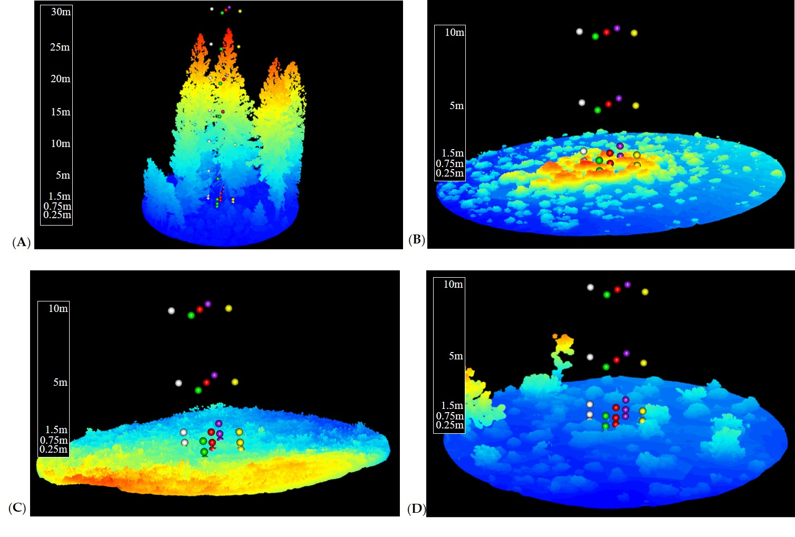
Figure 1. One complete 12-m radius lidar point cloud from each ecosystem: (A) forest; (B) shrub-steppe; (C) prairie; and (D) desert. The colors of the point clouds indicate the relative elevation of points within that cloud from low (dark blue) to high (red). Topography was not removed. The colored spheres represent the positions of the X,Y,Z vantage points from which viewsheds were calculated, with each color representing a single X,Y location across multiple eye-heights (i.e., Z) ranging from 0.25m to 30m (elevation displayed in scales).
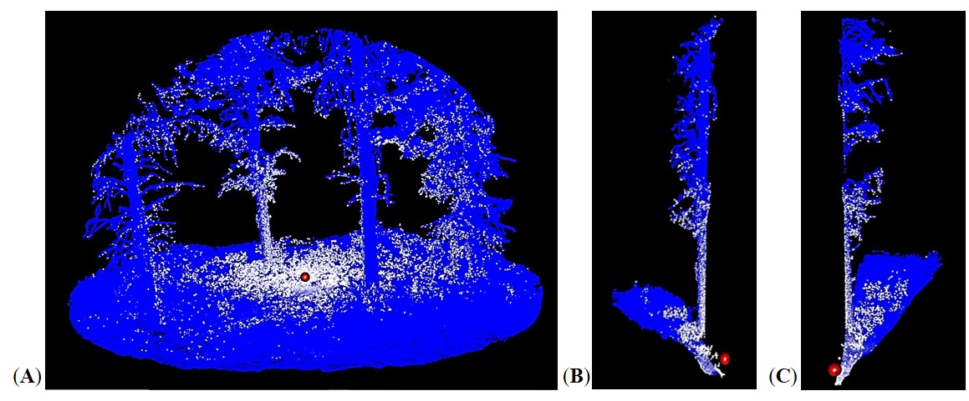
Figure 2. To determine variability within the viewsheds, whole point clouds were segmented in the azimuth into 20 segments of 18° each. The blue and white points are lidar data points; white points are obstructing individual sightlines. The viewshed coefficients (VC) of these individual segments were calculated and used to determine a coefficient of variation for the viewshed. This was repeated for all vantage points. (A) A full viewshed measured in a forest point cloud. (B) and (C) are adjacent viewshed segments from the same forest point cloud.

