Front Matter

Title
- The dynamic atmospheric and aeolian environment of Jezero crater, Mars.
- The dynamic environment of Jezero crater, Mars.

Authors
Claire E. Newman^{1,*}, Ricardo Hueso²†, Mark T. Lemmon³†, Asier Munguira²‡, Álvaro Vicente-Retortillo⁴‡, Víctor Apestigue⁵§, Germán Martínez Martínez⁶§, Daniel Toledo Carrasco⁵§, Rob Sullivan⁷, Ken Herkenhoff⁸, Manuel de la Torre Juarez⁹, Mark I. Richardson¹, Alex Stott¹⁰, Naomi Murdoch¹⁰, Agustín Sanchez-Lavega², Mike Wolff³, Ignacio Arruego Rodriguez⁵, Eduardo Sebastián⁴, Sara Navarro⁴, Javier Gómez-Elvira^{4,5}, Leslie Tamppari⁹, Daniel Viúdez-Moreiras⁴, Ari-Matti Hari¹¹, Maria Genzer¹¹, Maria Hieta¹¹, Ralph D. Lorenz¹², Pan Conrad¹³, Felipe Gómez Gómez⁴, Tim McConnochie^{14,15}, David Mimoun¹⁰, Christian Tate⁷, Tanguy Bertrand¹⁶, Jim Bell¹⁷, Justin Maki⁹, Jose Antonio Rodriguez Manfredi⁴, Roger Wiens¹⁸, Baptiste Chide¹⁹, Sylvestre Maurice¹⁹, Maria-Paz Zorzano⁴, Luis Mora⁴, Mariah Baker²⁰, Don Banfield⁷, Jorge Pla-Garcia^{4,15}, Olivier Beyssac²¹, Adrian Brown²², Ben Clark¹⁵, Alain Lepinette⁴, Franck Montmessin²³, Erik Fischer²⁴, Priyaben Patel²⁵, Teresa del Río-Gaztelurrutia², Thierry Fouchet¹⁶, Raymond Francis⁹, Scott Guzewich²⁶, and the Mars 2020 Atmospheric Science Working Group.

Affiliations
†,‡,§ These authors contributed equally to this work.
Affiliations:
¹Aeolis Research; Chandler, AZ, USA.
²Universidad del País Vasco UPV/EHU; Bilbao, Spain.
³Space Science Institute; College Station, TX, USA.
⁴Centro de Astrobiologia, INTA; Madrid, Spain.
⁵INTA; Madrid, Spain.
⁶Lunar and Planetary Institute; Houston, TX, USA.
⁷Cornell University; Ithaca, NY, USA.
⁸USGS Astrogeology Team; Flagstaff, AZ, USA.
⁹Jet Propulsion Laboratory - California Institute of Technology; Pasadena, CA, USA.
¹⁰ISAE-SUPAERO, Université de Toulouse; Toulouse, France.
¹¹Finnish Meteorological Institute; Helsinki, Finland.
¹²Johns Hopkins Applied Physics Lab; Laurel, MD, USA.
¹³Carnegie Institution for Science; DC, USA.
¹⁴University of Maryland; College Park, MD, USA.
¹⁵Space Science Institute; Boulder, CO, USA.
¹⁶LESIA, Observatoire de Paris; Meudon, France.
¹⁷Arizona State University; Tempe, AZ, USA.
¹⁸Los Alamos National Laboratory; NM, USA.
¹⁹IRAP-CNRS; Toulouse, France.
²⁰Smithsonian National Air and Space Museum; DC, USA.
²¹IMPMC, CNRS-Sorbonne Université; Paris, France.
²²Plancius Research, Severna Park; MD, USA.
²³LATMOS; Paris, France.
²⁴University of Michigan; Ann Arbor, MI, USA.
²⁵UCL; London, UK.
²⁶Goddard Space Flight Center; Greenbelt, MD, USA.

*Corresponding author. Email: claire@aeolisresearch.com

Abstract
Despite the importance of sand and dust to Mars geomorphology, weather, and exploration, the processes that move sand and that raise dust to maintain Mars’s ubiquitous dust haze have not been well quantified in situ, with missions lacking either the necessary sensors and/or a sufficiently active aeolian environment. Perseverance rover’s novel environmental sensors and Jezero crater’s dusty environment remedy this. In Perseverance’s first 216 sols, four convective vortices raised dust locally, while on average four passed the rover daily, over 25% of which were significantly dusty (‘dust devils’). More rarely, dust lifting by non-vortex wind gusts was produced by daytime convection cells advected over the crater by strong upslope winds, which also control aeolian surface features. One such event covered ten times more area than the largest dust devil, suggesting dust devils and wind gusts could raise equal dust.
Teaser
Perseverance sees huge aeolian activity due to strong daytime convection and slope flows driving dust devils and wind gusts.

MAIN TEXT

Introduction
Aeolian processes - the motion of surface sand and the lofting and redistribution of surface dust - are the primary causes of change to the Martian surface and atmosphere in the modern era (1,2). Large dust storms drastically alter atmospheric temperatures, densities, and circulation, presenting hazards to robotic and human missions, but atmospheric dust is also present year-round, impeding visibility and solar power (3,4). The mechanisms by which sand is moved and dust is lifted on Mars are not well quantified, however. This contributes to many outstanding questions, from what triggers the onset of global dust storms, which occur roughly three times per Mars decade, to what dust lifting processes are responsible for maintaining the background dust haze. Early studies, including analysis of Viking lander data, suggested that surface wind stresses on Mars might only rarely exceed the calculated threshold for moving sand-sized particles ($≳$40µm diameter) and would be even less likely to exceed the higher thresholds needed to raise smaller, more cohesive dust particles (5). However, this was inconsistent with observations of frequent dust storms and surface albedo changes attributed to widespread dust rearrangement (6,2). In the past decade, observations of active dunes from orbit and sand motion at the surface have also confirmed that saltation of sand particles occurs more widely over the Martian surface than suggested by earlier estimates (7,8).
A possible explanation is that Mars sand motion can be initiated by relatively shortlived strong wind gusts, which trigger significant saltation downstream (9), and recent wind tunnel measurements support a lower saltation threshold than used previously (10). Once saltation first occurs, it can also continue more easily, due to the sand saltating back to the surface and increasing the total stress, with this effect being far larger than on Earth (11). The same effect may also explain how dust is lifted despite the larger threshold stresses needed. However, in situ observations of dust lifting without apparent sand motion (12) suggest that the presence of dust aggregates - larger clumps of dust particles with lower cohesion than individual grains - may be crucial, or that Mars’s reduced gravity may modify the soil cohesion, making dust lifting easier (13). Finally, convective vortices - termed ‘dust devils’ when made visible by their dust content - may raise dust via a ‘suction effect’ associated with their low-pressure core, in addition to via the strong winds around it (14). Testing such ideas demands simultaneous measurements of aeolian activity and environmental variables, yet these are rare for Mars. Previous missions have generally either carried the necessary sensors or landed in an environment with significant local sand motion and dust lifting, but not both (12,15,16). Most recently, the Curiosity rover observes signficant sand motion and many vortices and dust devils but cannot measure winds correctly (8,17), while the InSight lander has detected vortices but has imaged only minor surface changes and no dust devils (18,19).
By contrast, the Perseverance rover carries the most sophisticated atmospheric and dust sensors yet flown to Mars. The Mars Environmental Dynamics Analyzer (MEDA; 20) includes novel Radiation and Dust Sensors (RDS), which detect dust clouds and dust devils via changes to direct and scattered sunlight at 1 Hz frequency, simultaneous with MEDA measurements of pressure, temperature, wind, relative humidity, and also radiative fluxes from MEDA’s Thermal InfraRed Sensor (TIRS). In combination, RDS and TIRS measurements of downward and upward shortwave radiation, respectively, provide information on albedo and also on albedo changes related to surface dust removal or deposition. Adding RDS and TIRS thus enables MEDA to track the passage of dusty phenomena around, past, and over the rover as a function of time over a large fraction of each sol, and to relate this both to meteorological timeseries and surface changes, which would be impossible with imaging due to the huge amount of resources that would be required. Perseverance also carries the first microphones to operate on Mars, which provide information on turbulence, vortices, and wind activity (21), and high-resolution cameras including the Navcams and Mastcam-Z, which may be used to image aeolian activity and features, such as dust devils and surface wind streaks (22,23). Most crucially, Jezero crater contains numerous aeolian surface features, imaged both from orbit (24,25) and since landing (see below), and dozens of examples of aeolian activity have been observed over the first 216 sols of the mission, covering early spring through early summer (areocentric solar longitude, L_{s}, ~13-105°), as described in detail below. The Mars 2020 mission is thus a perfect combination of instrumentation and environment for studying atmospheric and aeolian connections.

Results

Wind patterns and aeolian surface features are controlled by regional and local slopes
Aeolian processes are by definition driven by winds, thus understanding the circulation at the landing site is vital. Perseverance landed at longitude 77.45°E, latitude 18.44°N, close to the interior western rim of ~45 km-wide Jezero crater, which itself sits on the interior NW slopes of the ~1,350 km-wide Isidis basin (Fig. 1C,D). In situ wind data confirm atmospheric model predictions (26,27) that Jezero crater wind directions are driven primarily by regional (Isidis basin) and local (crater rim) slope flows, resulting in a reversal of wind direction twice per Mars day (sol). Daytime wind speeds vary hugely on sub-hourly timescales due to convective activity but both hourly mean and maximum wind speeds are generally much stronger than those at night (Fig. 1A). Winds blow on average from the ESE from mid-morning through sunset (Fig. 1B), and are more southerly earlier and more easterly later in the day. As shown in Fig. 6 of (26), aside from a slight mid-afternoon decrease in wind speed and greater wind direction variability, which is seen in the data but only found in higher-resolution simulations, the pattern of daytime winds is very similar to that predicted by both models that resolve the crater slopes and those that do not. This suggests that daytime winds are driven primarily by deep, strong, regional-scale Isidis basin upslope flows, with limited impact of the crater slope during the daytime period with its thick planetary boundary layer thus flows that are not confined close to the surface. However, inspection of the horizontal variation of daytime winds in a MarsWRF mesoscale model simulation (movie S1) suggests that the regional flows are slightly deflected around the western crater rim, and partially blocked from entering Jezero - especially after 14:00 - by opposing slope flows inside the crater on the south-east rim. Hence, although regional-scale slope flows appear to dominate during the daytime, local crater slopes likely explain the greater directional variability and mid-afternoon wind speed dip seen in the data.
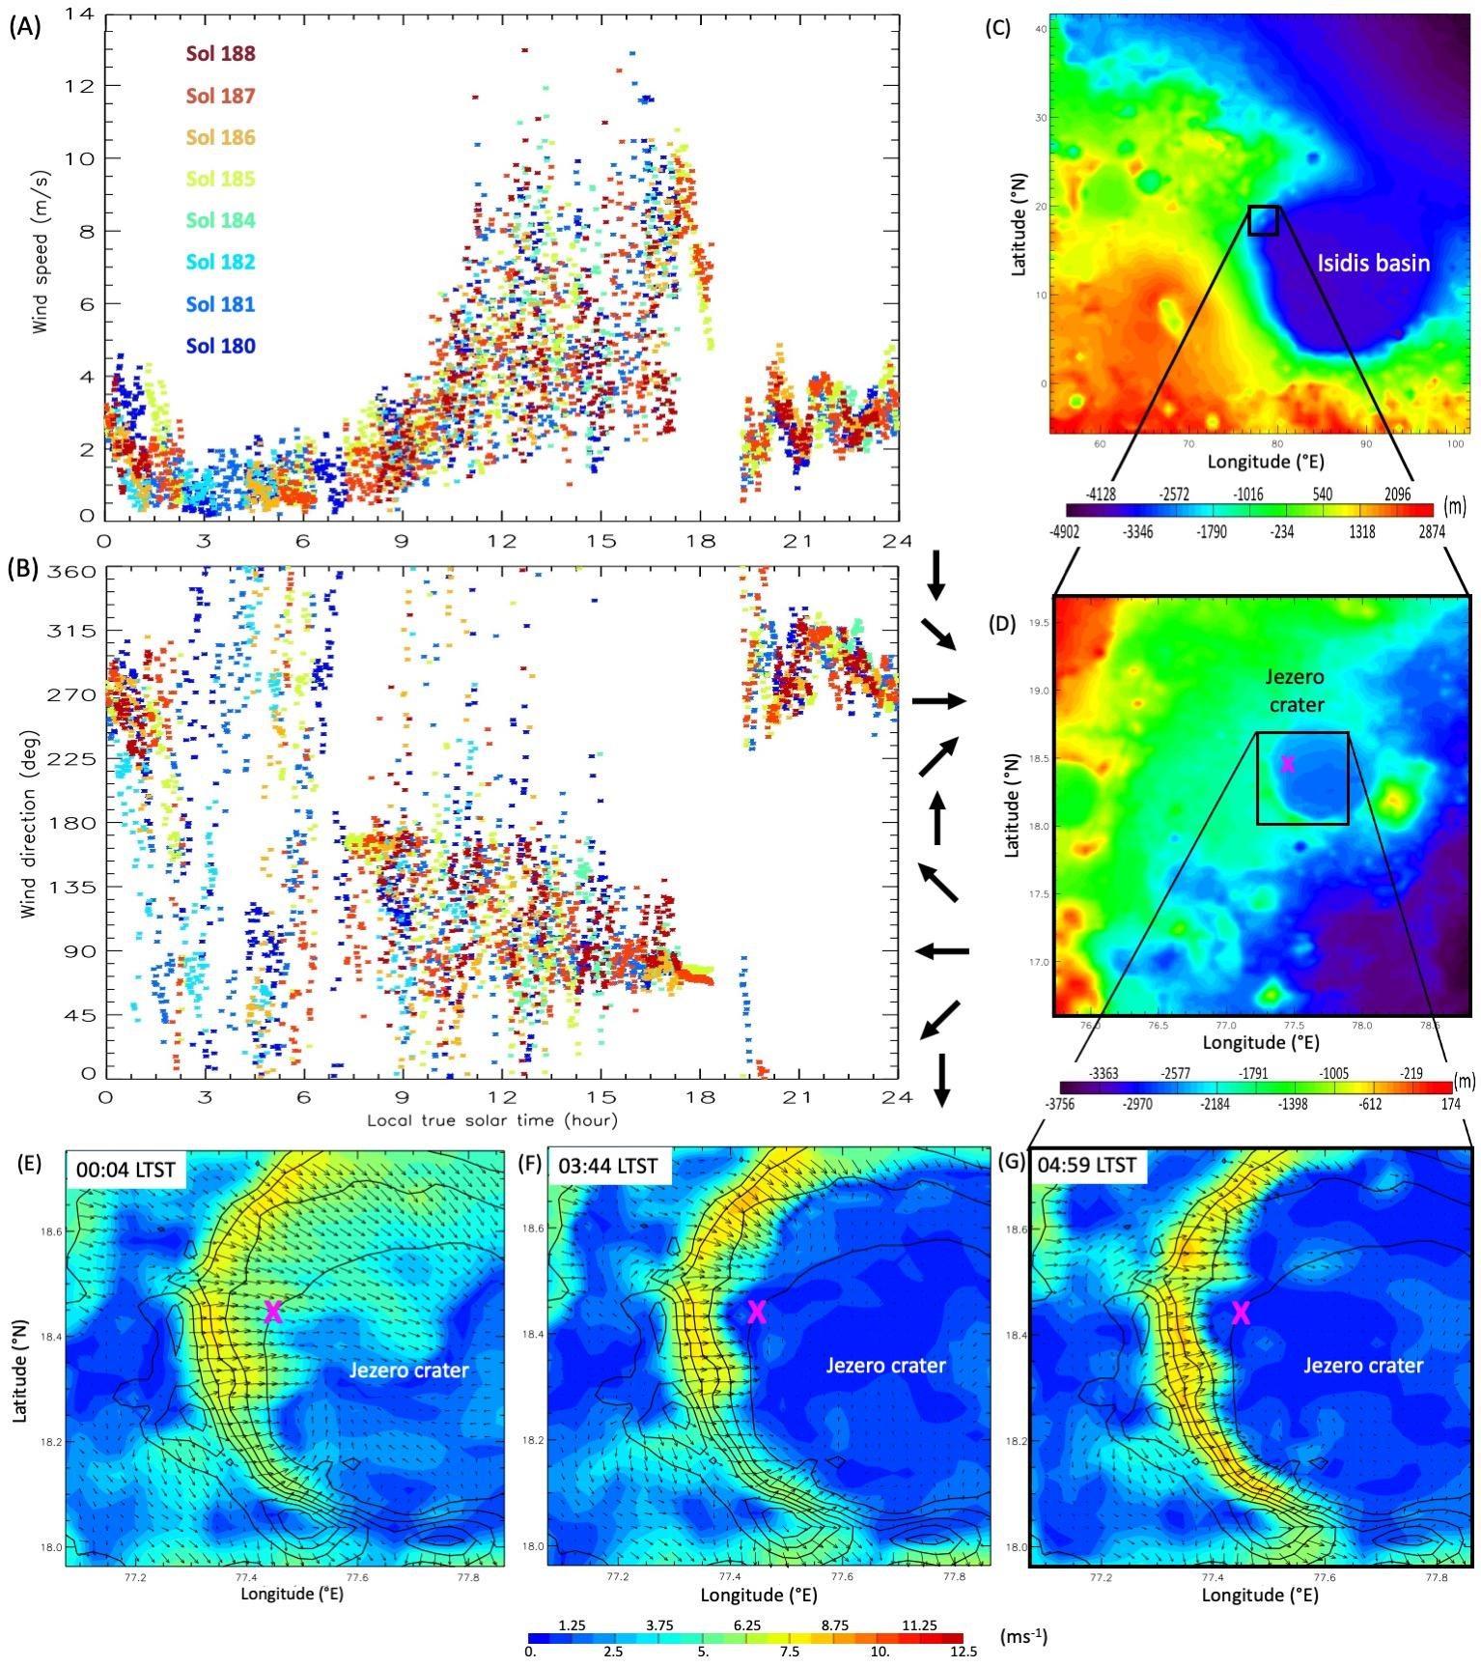
Fig. 1. Observed winds, regional and local topography, and modeled local slope control at night. Minute-averaged horizontal (A) wind speed and (B) direction the wind blows from at 1.45m, observed by MEDA over 8 sols at L_{s}~90°. (C,D) Location of landing site relative to Jezero crater and Isidis basin, showing regional (C) and local scale (D) topography. (E-G) Intensification and concentration of crater rim downslope flows from midnight to 5am LTST, shown as wind speed (shading) and vectors (arrows), simulated by the MarsWRF atmospheric model. Topography is shown as black contours and landing site is marked with a pink X.
The global-scale Hadley circulation and large-scale planetary waves (e.g., thermal tides) must certainly impact winds also, but their influence is less obvious. Modeling (26,27) predicted that as Mars approached (Ls=90°), daytime winds would become more southerly than at the start of the mission (Ls~5°). This is due to upwelling (downwelling) at low (mid-) latitudes around equinox producing a near-surface return flow from north to south at Jezero’s 18°N location, whereas at northern summer solstice there is upwelling at northern mid-latitudes and a near-surface return flow from south to north. However, more work is needed to clearly identify such a shift in observed wind directions up to sol 216 (Ls~105°), in part because routine winds measurement did not begin until Ls~20°. Similarly, the influence of thermal tides is difficult to disentangle from other factors, but is expected to amplify during periods of high dust opacity, as observed by previous surface missions (28-30).
Although wind stress (hence sand transport) increases with atmospheric density, which is greater at night, the dominance of daytime wind speeds over those at night translates to net sand transport towards 276° - i.e., from slightly south of east - over the first 216 sols of the mission; see Materials and Methods for a description of how wind stresses and sand fluxes are estimated from MEDA wind, pressure, and temperature data. This sand transport direction is consistent with orbital observations of active sand transport from the ~ESE in and around Jezero crater (26,27) and with Perseverance observations of wind tails in Navcam and Mastcam-Z images (Fig. 2A,B).
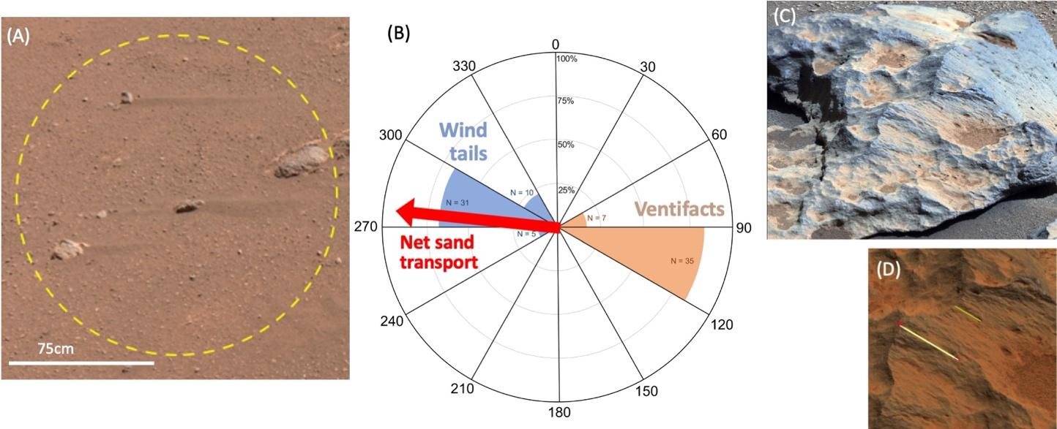
Fig. 2. Aeolian features and net sand transport direction over the first 216 sols. (A) “Wind tails” of sandy regolith extending from small rocks indicate wind-driven sand transport directions. Portion of a Navcam image taken on sol 32. (B) Rose diagram showing the orientation of wind tails (blue) and ventifacts (orange) observed along the rover traverse, plus net sand transport estimated from MEDA winds and air densities (red arrow), over the first 216 sols. (C) A ventifacted rock imaged by Navcam. (D) An example of azimuth measurements of flutes, from which the transport direction of abrading grains is inferred.
At night, winds since landing blow on average from the WNW, similar to the expected directions of nighttime downslope flows due to both the Isidis basin and Jezero crater slopes. While Isidis basin slope flows are predicted to increase in strength until sunrise, however, the observed wind minimum around 03:00 LTST is only found in atmospheric models that resolve Jezero crater’s rim (26,27; fig. S2). As shown in Fig. 1(E-G) and movie S1, in such models the rim blocks the relatively shallow regional downslope flows but develops its own strong downslope winds; these flows extend to the rover’s current location earlier in the night then but intensify and concentrate on the rim after ~01:30, causing wind speeds to decrease at the rover’s location, consistent with observations. As Perseverance drives toward the crater rim, we expect nighttime wind speeds to increase significantly. This could potentially result in nighttime aeolian activity dominating, resulting in net sand transport from the WNW.
Fluting in ventifacts observed by Perseverance along its traverse (Fig. 1 E,F) already indicates dominant transport from the WNW (Fig. 1D), which is consistent with nighttime wind directions but inconsistent with wind speeds being much larger during the daytime at all locations to date. While it is possible that the circulation will differ in seasons we have yet to observe, modeled winds appear to agree well with the seasons observed to date (fig. S1) and do not predict a seasonal shift in wind patterns (or net sand transport direction) large enough to explain the observed ventifact orientations. This suggests the ventifacts formed either during anomalous weather conditions that modify the circulation pattern (a likely example would be regional or global dust storms, the impact of which on Jezero crater winds has not yet been explored in models) or during a past climate epoch. In the latter case, a strengthening of the northern winter Hadley circulation at higher obliquities, and of its associated north-to-south surface return flow, could potentially weaken daytime winds from the ~SE and enhance nighttime winds from the ~NW (perhaps enabling regional winds to penetrate into Jezero at night), shifting the dominant sand transport direction.
Rare ‘gust lifting’ events are linked to the passage of convection cells
In Perseverance’s first 216 sols, Navcam took 30 time-lapse movies and 49 surveys (five image triplets taken in five directions clockwise around the rover, evenly spaced from N) designed to search for dust devils and dust lifting. Of these observations, three surveys show dust lifting by non-vortex wind gusts: on sols 117, 121, and 159 (Ls~60, 62, and 79°) at 12:46, 11:56, and 15:32 LTST, respectively. Such ‘gust lifting’ events were likely present in both Gusev and Gale crater and imaged by Spirit and Curiosity cameras, respectively, but were not reported due to a lack of certainty over their origin. For example, in Gale crater most candidates could also have been caused by a fading dust devil, or by a dust devil partly hidden by topography. By contrast, the scale of the events seen in Jezero crater makes it clear that they are driven by wind gusts and are not dust devil-related. Observations of the sol 117 gust lifting event, by far the largest of the three, are shown in Figs. 3 and 4. Based on the relationship of dust clouds to surface features seen from orbit (Fig. 3A), the first, north-centered triplet of images (Fig. 3B-D) shows dust being lifted, in a line running approximately north to south, over about half a minute. Regions of active dust lifting cannot be clearly differentiated from those with dust blowing over them, but we estimate a lifting area of at least 4km². The fifth image triplet, five minutes later and centered just north of west, shows a dust cloud moving away over the delta to the NW of the rover (fig. S2C). This is consistent with dust raised in the first image (Fig. 3B) being blown towards the WNW by the observed wind direction at this time (from the ESE, as shown in Fig. 4A).
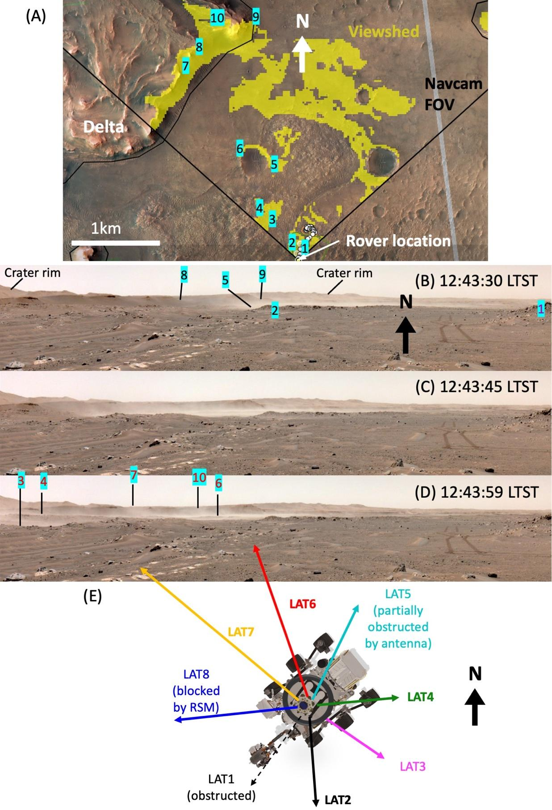
Fig. 3: The sol 117 ‘gust lifting’ event in imaging. (A) Features used to track the path of dust lifting / transport; yellow shading shows the ‘viewshed’ (the surface line-of-sight visible) from the rover’s position. (B-D) The first, north-centered triplet of Navcam images, spaced 14 seconds apart. Note that the right side of each image has been trimmed. (E) Azimuthal pointing of MEDA’s RDS sensors on this sol.
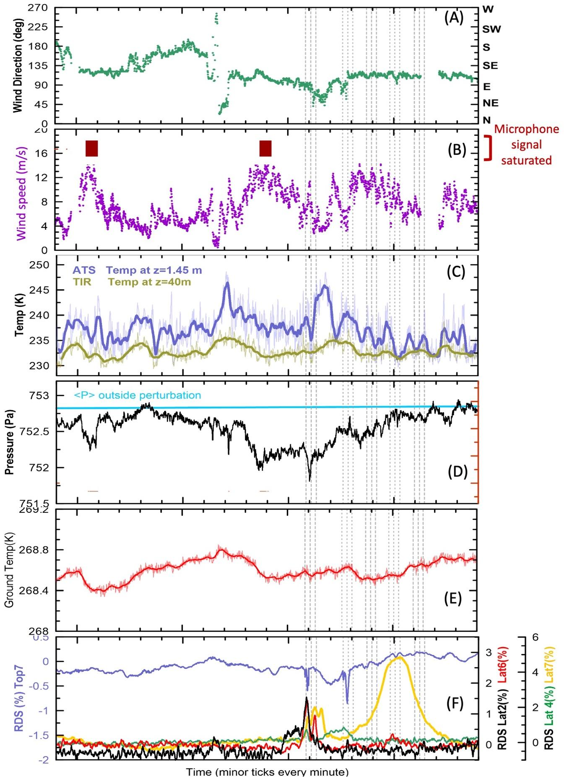
Fig. 4: The sol 117 ‘gust lifting’ event in meteorological timeseries. (A-E) Timeseries of meteorological data over 20 minutes surrounding the sol 117 Navcam survey, with timing of the five image triplets shown by vertical dotted lines. (A) MEDA direction that wind blows from, (B) MEDA wind speeds (purple) and periods with saturated SuperCam microphone signals (red boxes); (C) MEDA air temperature at 1.45m (blue) and ~40m (chartreuse); (D) MEDA surface pressure; (E) MEDA surface temperature, and (F) percentage change in SW radiation measured by MEDA’s RDS top7 (blue), lat2 (black), lat4 (green), lat6 (red), and lat7 (yellow) photodiodes.
Data from MEDA’s RDS photodiodes (Fig. 4F) provide a more complete picture of dust activity during this event. The vertical field of view (FOV) of the RDS lateral sensors is ~20-30° above the horizontal, with azimuthal pointing as shown in Fig. 3E, hence their signals can be interpreted as follows: Dust is raised and forms low dust clouds, producing the small lat6 and larger lat7 initial peaks; as lifting ceases, the dust is blown away at low altitudes to the WNW, moving sideways out of the lat6 FOV and below the lat7 FOV; as the dust cloud reaches the delta front, it rises and moves fully into the lat7 FOV, then moves below it again as it continues traveling away from the rover, producing the large, long, and smooth second lat7 peak. Peaks in the ~south-pointing lat2 and upward-pointing top7 sensors, coinciding with the first image triplet, seem unlikely to have been produced by the dust imaged in Fig. 3B-D but could be due to dust raised by a previous gust front, passing close by the rover to the S/SW. The lat4 signal coincides with diffuse dust activity to the east in the second image triplet (fig. S2).
It is difficult to determine exact dust lifting locations or cloud heights from the images, but if we assume that dust in Fig. 3B was lifted no closer to the rover than point 5 on Fig. 3A and interpret the later increase in the RDS lat7 signal (Fig. 4F), ~2.25 minutes after the first image, as resulting from the dust cloud lifting up over the 65-m-high delta~1.3 km away to the WNW, we obtain a speed of 9.6 ms⁻¹. This is larger than the average observed near-surface wind speed at the rover over this period, which is ~7 ms⁻¹ over the entire hour shown in Fig. 4B or ~6 ms⁻¹ over the second half of it. However, the dust cloud must have achieved a height of at least 65m to pass over the delta and wind speeds are expected to increase with height at this time of sol; for example, MarsWRF modeling indicates they are typically ~50% stronger at 100m than at 1.5m (fig. S3). Therefore the estimated speed at which the cloud has traveled is consistent with the observed near-surface wind speeds at the rover.
All imaged gust lifting events to date occurred during the period of strong convective activity from ~10:30-16:00 LTST, which manifests as large temporal variability in wind speed (Fig. 1A; 4B; 5A), temperature (Fig. 4C,E), and other meteorological timeseries. On sol 117 this included a sequence of 24 SuperCam microphone recordings (fig. S4). The microphone signal is sensitive to the product of wind speed and its standard deviation (31) and two recordings made during the largest peaks in the MEDA wind data were strongly saturated (Fig. 4B; fig. S4), corroborating them as particularly intense and variable winds. The timescale of the variations (shown for winds in Fig. 5A) is consistent with the walls of convection cells passing overhead ~6-8 times per hour (periods of 7.5 to 10 minutes), advected by the large-scale daytime upslope winds. Similar activity was previously reported for the InSight landing site in Elysium Planitia (32,33), albeit with fewer peaks per hour (periods of 25 to 33 minutes), and has long been predicted for Mars by analogy with observations of meteorological timeseries in Earth’s deserts (34) and in Large Eddy Simulations (LES) of the daytime convective martian atmosphere (35-37). These cells consist of strong, warm updrafts concentrated in narrow cell walls and weaker, cooler downdrafts in cell centers, with surface winds blowing toward the walls to conserve mass. As convection cells are advected over the region, the background and cellular near-surface winds have the same direction behind the leading cell wall and combine constructively to produce peak wind speeds there.
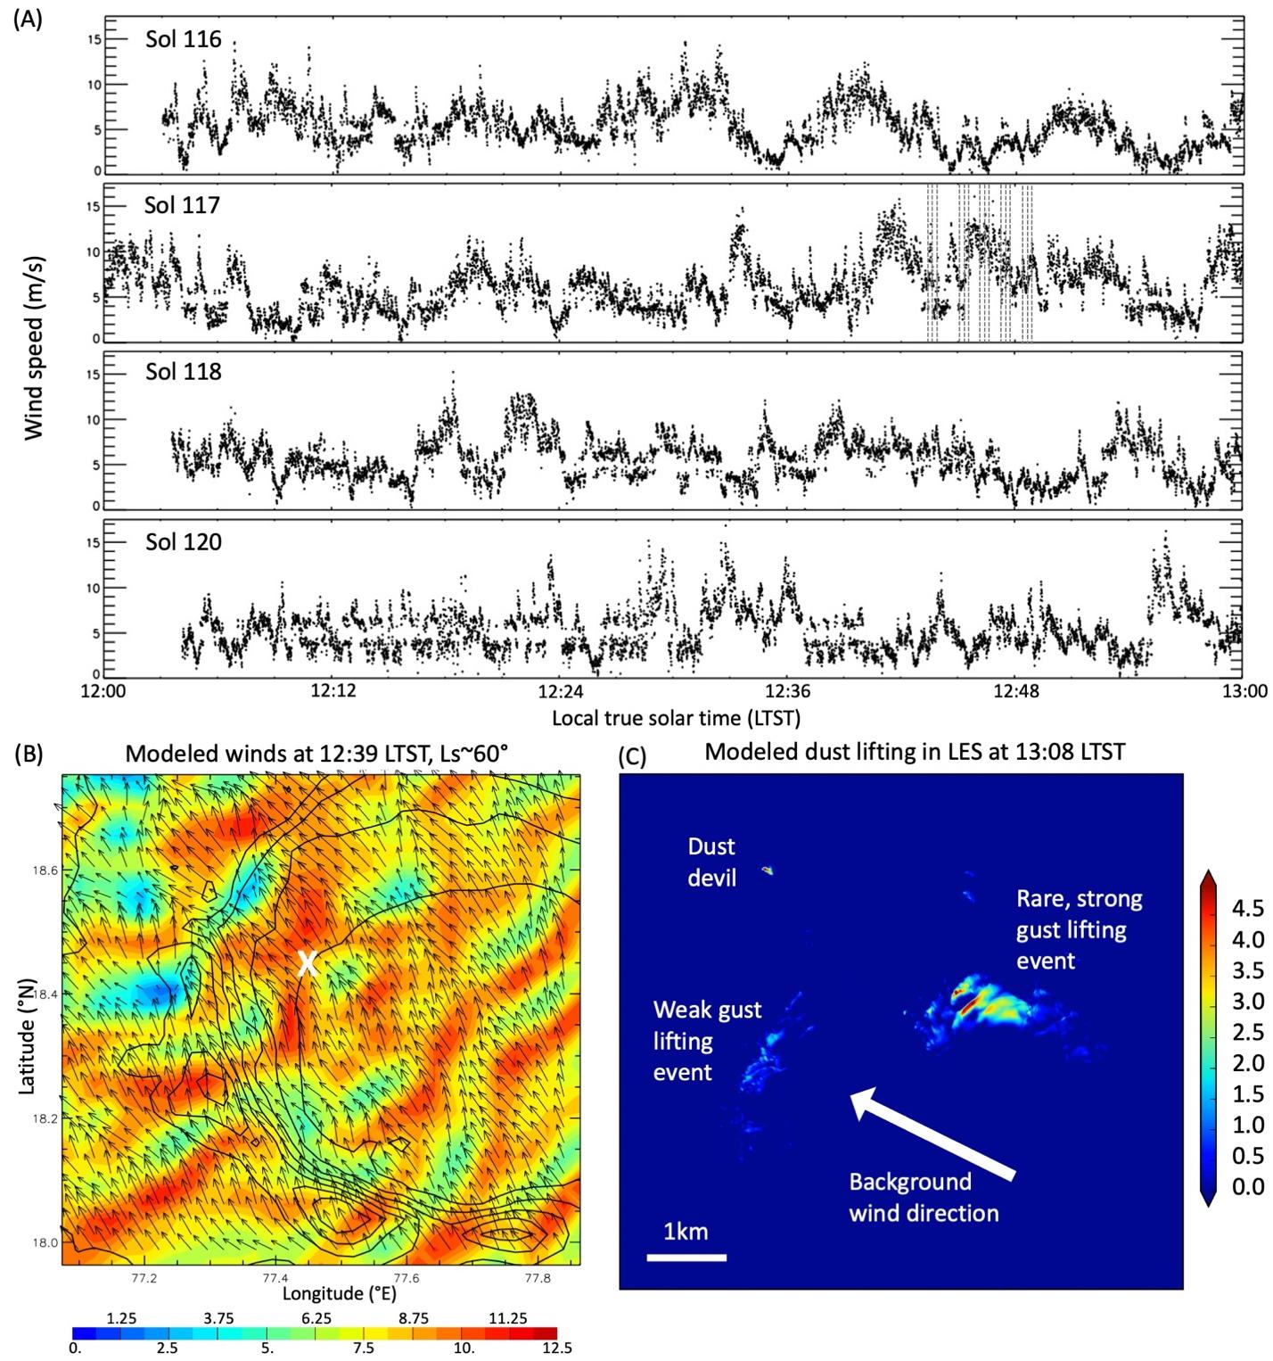
Fig. 5. Daytime winds and simulated gust lifting in Jezero crater around sol 117. (A) MEDA 12:00-13:00 instantaneous 2Hz wind speeds for sols 116-118 and 120. (B) As in Fig. 1D but now showing daytime convection cells being advected over Jezero crater at 12:39 LTST at Ls~60°. (C) Snapshot of lifted dust flux (in arbitrary units) at 13:08 LTST in an LES of Jezero crater.
This can be seen in the wind field of a 1.4km-resolution MarsWRF mesoscale simulation, as shown in Fig. 5B and movie S1. While that simulation is marginal in terms of resolution for the scale of these cells (which have widths of ~6-7km), the structure and sizing of the cells by this time of sol is confirmed by results from a 10m-resolution MarsWRF Large Eddy Simulation (LES) run with imposed background winds based on the mesoscale model output, as shown in fig. S5. Based on the observed timescales of variations and the mean wind speeds over the same periods (Fig. 5A), typical cell widths in the direction of motion are estimated to be ~2.8-5 km. This is lower than the ~6-7 km cell widths found in the mesoscale and LES atmospheric simulations (Fig. 5B; fig. S5; movie S1). Further, PBL depth is expected to scale with cell width (38) - and does so very closely in the mesoscale and LES models - so this could be interpreted as suggesting lower PBL depths than predicted. However, it should be noted that there are multiple scales of convection cells and structures in the convective boundary layer, and while the PBL depth will scale with the largest of them, the mixture may result in multiple or fragmented gust fronts (as shown in e.g. fig. S5, middle row).
As expected if they follow passage of the cell wall, the peaks in wind speed occur 1-2 minutes after a warming in surface temperature (Fig. 4E) and air temperature (Fig. 4C). The second large wind peak, two minutes before the first Navcam image, also coincides with a shallow, long-duration pressure drop (Fig. 4D). While cell walls are associated with updrafts, hence pressure drops might be expected to precede peak surface winds, the pressure signal is vertically-integrated (i.e., depends on the cell’s vertical tilt) and may not coincide with other surface signals (fig. S4; 39). We therefore hypothesize that gust lifting events are triggered by strong winds aligned in gust fronts behind the leading wall of strong convection cells, with these fronts (on average) perpendicular to the background wind direction. This hypothesis is consistent with the pattern of dust lifting and transport observed on sol 117 (Fig. 3). Over the period shown in Fig. 4, the mean wind direction was toward the WNW at a mean speed of ~7.4 m/s, while the dust lifting was consistent with strong winds along a gust front oriented roughly perpendicular to this wind direction.
Output from the high-resolution MarsWRF LES simulation is used to calculate dust lifting for a threshold wind stress of 0.008 Pa, and shows similar gust lifting events occurring along gust fronts (Fig. 5C; fig. S4). This threshold value corresponds to instantaneous wind speeds of between ~7 and 12 ms⁻¹ at 1.5m height in the LES, at the time of day shown in Fig. 5C. This is significantly lower than the peak wind speeds measured by MEDA, but peak wind speeds in the LES are typically lower, very rarely exceeding 12 ms⁻¹ (although a peak of 22 ms⁻¹ is produced at the peak of the gust lifting event). Thus, the threshold of 0.008 Pa was chosen to reproduce roughly the observed balance in occurrence between dust lifting by vortex winds and by wind gusts associated with fronts, with over 25 large dust devils but only one large gust lifting event in this sol over the entire 10 km² LES domain. The range in wind speeds corresponding to this threshold value is because the conversion between u* (hence wind stress) and wind speed at a given height depends on the atmospheric stability. This also highlights the importance of considering wind stress rather than wind speed if possible, although to date direct measurements of u* have never been made on Mars and only one attempt has been made to measure u* indirectly (40).
We speculate that a gust front responsible for the second large wind gust shown in Fig. 4B intensified shortly after it passed the rover, exceeding the threshold wind and producing the observed dust lifting event. These results suggest that gust lifting in Jezero crater is produced by gust fronts with wind speeds exceeding a threshold value that is greater than 15 ms⁻¹ by some unknown amount. We comment on the significance of this value, and other estimations of threshold limits, in the Discussion section below. Recent modeling of turbulent dust lifting in terrestrial deserts involves the use of LES to parameterize dust injection schemes in global and mesoscale models, and these LES - with dust lifting by wind stress enabled at turbulent scales - produce very similar results to those produced here for Mars (41,42). This demonstrates the many analogies between dust lifting processes on Earth and Mars that may be explored by comparing field data and LES modeling from both planets.
Daytime convective vortices and dust devils are common in Jezero crater
While dust lifting by wind gusts appears relatively rare inside Jezero crater, dust lifting by convective vortices is very common, with dust devils appearing in 30% of movies and surveys designed to look for them, as well as frequently appearing in other images (fig. S6). Fig. 6 shows a swarm of dust devils dancing across the crater floor in a Navcam movie, with intriguing dynamics as the two largest ones move toward and pass each other before fading. Convective vortices and thus dust devils typically form at the corners and edges of convection cells, where strong, warm updrafts exist. These areas of convection cells are thus associated with the strongest upwelling and the strongest horizontal gradients of temperature. The latter leads to baroclinic generation of horizontal vorticity, with some of these horizonal vortex tubes becoming buckled into the vertical (43). This is driven by rising air in the updrafts and general turbulent motions, both of which may be especially strong at vertices where cells intersect. Unlike Earth, on Mars the production of vorticity is primarily driven by horizontal buoyancy variations rather than wind shear (44). The now-vertical vortices can then intensity by direct heating at the base or via merger with other vortices. As the pressure drop deepens, a spiral inflow of warm air strengthens single-celled vortices; a vortex may then further intensify to become two-celled, with an even deeper pressure drop surrounding a narrow downdraft at its inner, calm core (45).
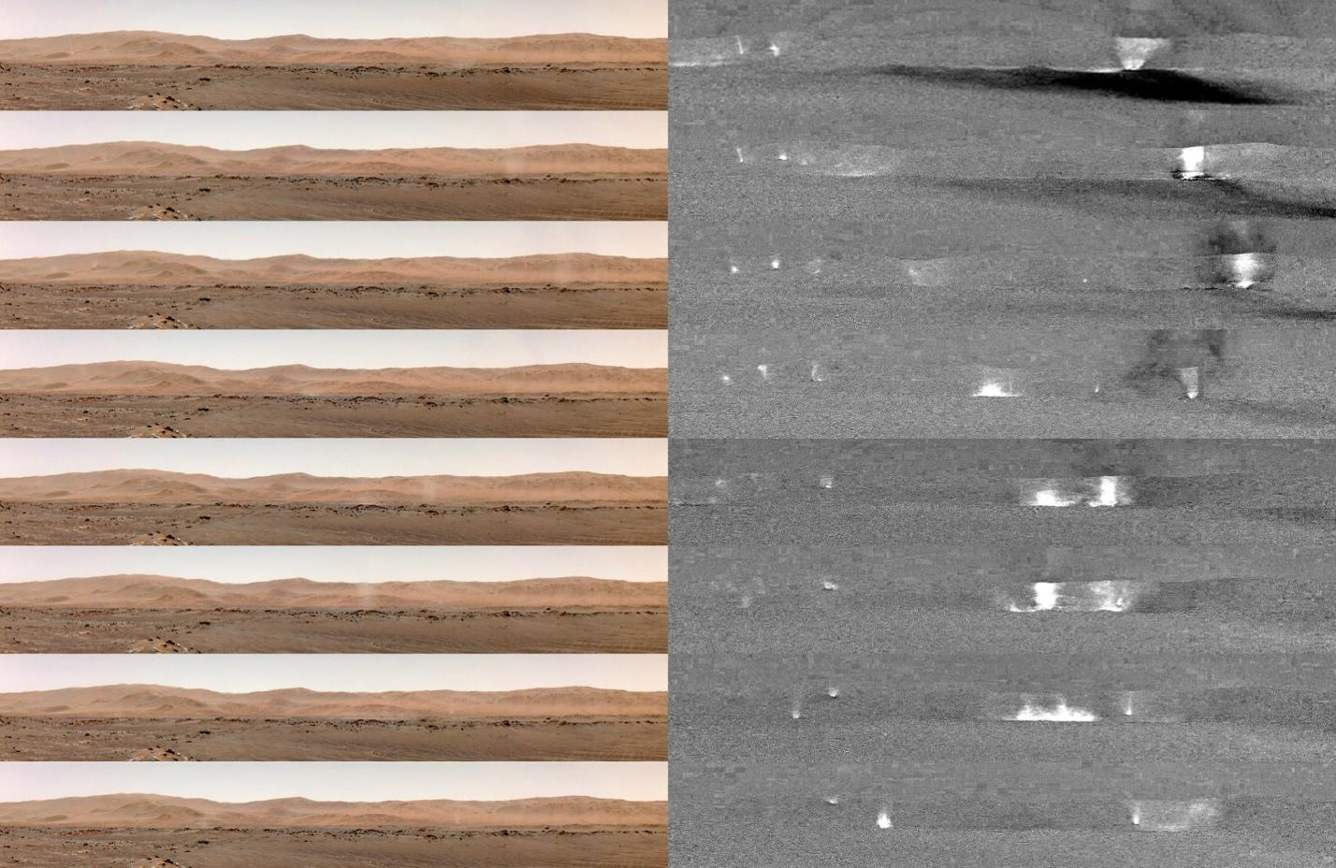
Fig. 6. Dancing dust devils on sol 148. (left) Portion of Navcam dust devil movie (see movie S2) zooming in on vortices in the scene with images every ~28s (every other frame) from 12:10:42 to 12:14:01 LTST. (right) Difference between each image and the average, enhancing changes in the scene, which include dust devils, their shadows, and surface dust changes.
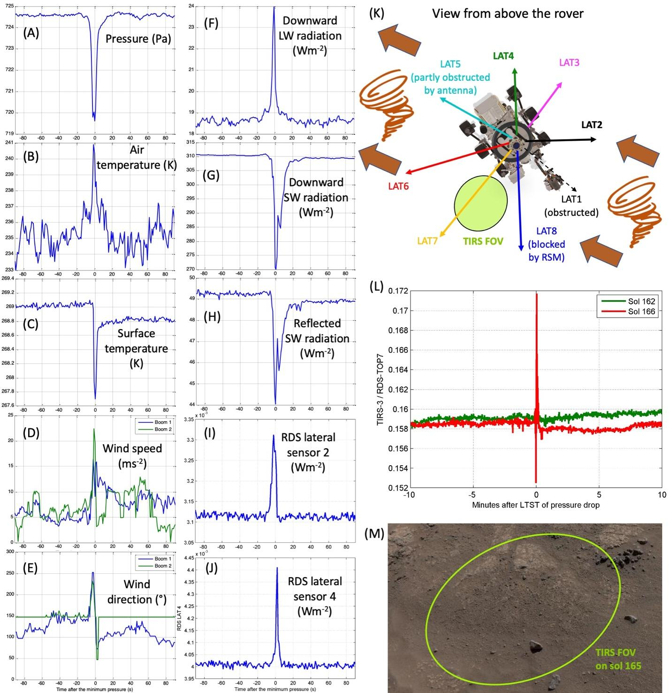
Fig. 7. The sol 166 vortex passage and dust lifting event. (A-J) MEDA data showing signature of a warm, single-celled, dusty convective vortex passing over the rover (see text). (K) Cartoon of inferred dust devil path. (L) Sudden, persistent change in surface reflectance following vortex passage indicates dust lifting within the TIRS FOV (see text). (M) Navcam image of the TIRS FOV on sol 165 at the same location as during the vortex passage.
The signature of all passing convective vortices is highly distinctive in MEDA wind and pressure and is also distinguished in many events in temperature and longwave flux. Further, MEDA’s RDS photodiodes allow us to identify those vortices with significant dust content. Fig. 7 shows the signature of a warm, dusty convective vortex passing the rover on sol 166. The large, short-duration pressure drop (A) and temperature changes (B,C), closely-spaced double-peak in wind speed (D), rapid change in wind direction (E), and increase in downward longwave radiation indicate a small, single-celled, but intense vortex (estimated to be ~20-30m diameter based on ambient wind speed) passing directly overhead. Further, the decrease in downward (G) and reflected (H) shortwave radiation as the vortex blocks sunlight indicates that this vortex contains significant dust, while the order of the RDS lat2 (I) and lat4 (J) response is consistent with scattered light from a dusty vortex advected over the rover in ambient winds from the SE or ESE, as shown by the cartoon in (K). Fig. S7 shows the signature of a much larger (~600m diameter) vortex passing over the rover in sol 184, which includes a double pressure drop but is less dusty.
Analysis of MEDA pressure timeseries from the first 216 sols was performed using sliding windows of continuous pressure data over a given period. We detrended data from linear variations fitting the first 15% and last 15% of the data (46). Pressure drops in the center of the period above a threshold (here 0.5 Pa) were identified and fit with a Gaussian giving a quantitative description of the intensity and duration of the events. We used six different time windows from 60 to 900 s and looked at plots of all individual events to ensure we did not miss vortices and did not add erroneous detections or incorrect durations. Correcting for gaps in coverage, results show >4 daytime vortex pressure drops exceeding 0.5 Pa detected on average per sol, with more than 1.15 vortices per hour detected on average at the peak time of day, 12:00-13:00 LTST (Fig. 8A). Of these vortices, about 25% produced a decrease in the RDS top7 signal of >0.5%, indicating sufficient dust content to significantly block incoming sunlight (Fig. 8B). Note that this includes some dust devils passing on the opposite side of the rover to the sun, which are close and/or large enough to block significant scattered sunlight. However, some dust devils detected by the pressure sensor will have passed on that side of the rover at a large enough distance to not block either the direct or scattered sunlight received by the sensor’s wide FOV. Hence, 25% is a lower bound on the percentage of dusty vortices, with the true value being between 25 and 50%, although a full geometrical analysis involving all top and lat sensors is needed to determine it. However, even 25% would make Jezero’s vortices far dustier than observed by other missions, as described in the section comparing landing sites below.
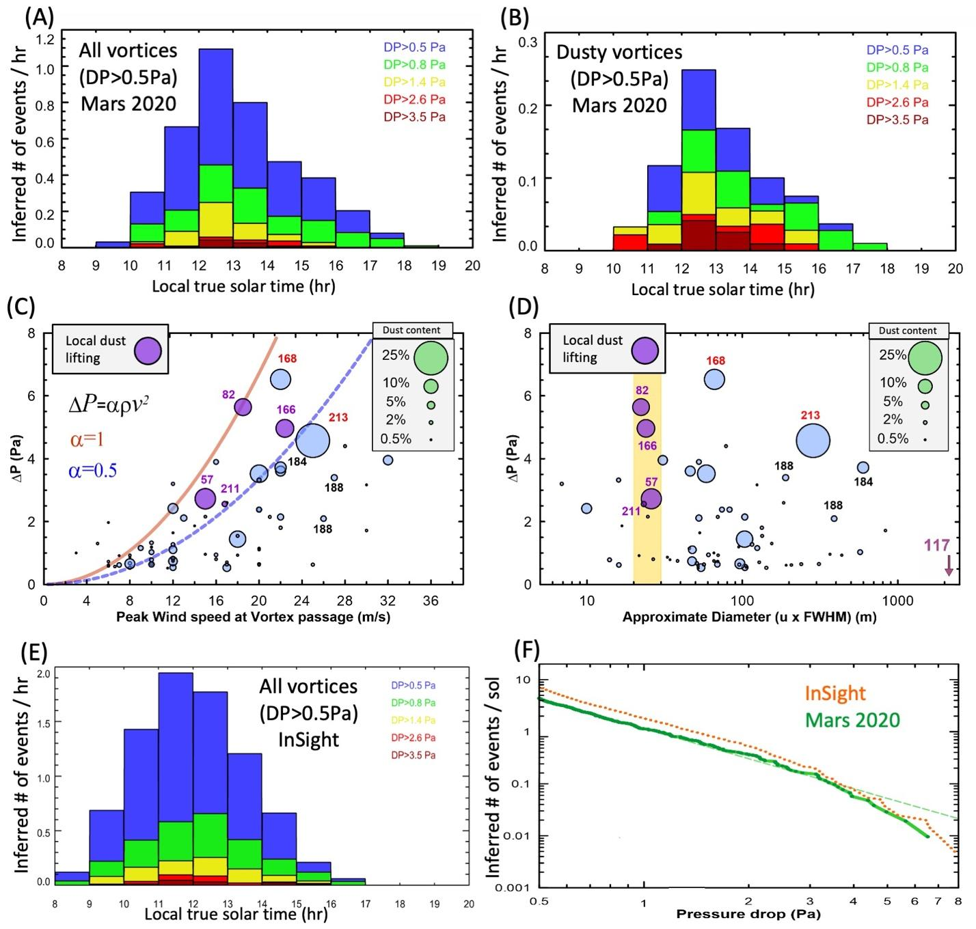
Fig. 8: Vortex and dust devil statistics in Jezero crater and comparison with same season at InSight. (A) Number and size distribution of vortex pressure drops >0.5 Pa as function of LTST, detected by Perseverance for L_{s}~13-105°, corrected for gaps in data. (B) As in (A) but for dusty vortices, defined as a decrease of >0.5% in the RDS top7 signal. (C) Scatter plot showing peak wind speed vs. largest pressure drop for all vortex events, with bubble size indicating dust content as % decrease in RDS top7. Curved lines show the relationship between maximum wind and central pressure drop in a vortex assuming cyclostrophic balance (see text). Purple bubbles indicate the four events with local dust lifting detected (see text). (D) As in (C) but replacing maximum wind speed with approximate vortex diameter inferred from ambient wind speed and encounter duration. The spatial scale of the sol 117 gust lifting event is shown for comparison. (E) As in (A) but for same seasonal period at InSight. (F) Intensity distribution of pressure drops per sol detected by InSight and Perseverance, corrected for gaps in data.
What controls vortex dust lifting on Mars?
The large number of dusty vortices, combined with Perseverance’s sensors, provides a valuable opportunity to study the cause of dust lifting by vortices on Mars.
Correlations between vortex characteristics and dust content
Dustier vortices typically have larger pressure drops (Fig. 8C; also compare Fig. 8A,B) and maximum wind speeds (Fig. 8C), which are expected to be correlated (e.g., 47,48). This is consistent with stronger tangential winds - perhaps combined with a pressure drop ‘suction’ effect - producing greater dust lifting. Exceptions, such as the two intense vortices on sol 188 (Fig. 8C), may have passed on the side of the rover opposite the sun and thus only appear less dusty. Interestingly, there is little correlation between the approximate vortex diameter (inferred from the mean wind speed and pressure drop duration; see fig. S7) and the pressure drop or dust content of the vortex (Fig. 8D). While the dustiest vortex observed to date (on sol 213) had an inferred diameter of nearly 300m, the second dustiest (on sol 57) was less than 30m across. In summary, the vortices lifting the most dust are often intense in terms of winds and pressure drops (for example, all dust devils causing more than a 15% drop in the RDS top7 signal have a delta P > 2.5 Pa and/or a wind speed > 18 ms⁻¹) but are not necessarily large in diameter.
Conditions required for local dust lifting by vortices
Unlike the gust lifting events, local dust lifting was detected in association with vortex passage on four occasions over the first 216 sols, providing direct information on the conditions needed to raise dust. On sols 57, 82, 166, and 211, MEDA’s TIRS and RDS sensors measured a sudden, significant, and persistent change in the ratio of the reflected and downward SW radiation immediately following passage of a vortex, indicating a change in surface albedo (Fig. 7L). Such a change can only be due to the removal of dust from the surface inside the FOV of the TIRS sensor (Fig. 7M). As shown by the purple bubbles in Fig. 8C, we find no local dust lifting by vortices for tangential wind speeds below 15 ms⁻¹ (sol 57) or for central pressure drops below 2.6 Pa (sol 211). This minimum wind speed for dust lifting is comparable to that measured regularly in association with passing convection cells (e.g., Fig. 5A), yet such wind speeds alone have not been observed to raise dust locally, suggesting that the vortical nature of the encounter - such as the pressure drop effect - may be important. We explore the significance of these results for understanding dust lifting thresholds in the Discussion section below.
Many vortices with much larger winds and/or pressure drops do not appear to raise dust locally, although again observational effects may have an impact. For example, the very dusty and intense sol 168 vortex occurred as the rover was moving, thus preventing the observation of any albedo change, while the dusty, intense sol 213 vortex occurred when a light-colored rock filled the TIRS FOV.
Comparison with other landing sites
Independent vortex and dust devil detections are available for this seasonal period at only two other places on Mars: Gale crater at ~4.5°S, location of the Curiosity rover, and Elysium Planitia at ~4.5°N, location of the InSight lander. For Curiosity, the peak number of vortex pressure drops >0.5 Pa detected from early local spring through early local summer (L_{s}~193-285° for this southern hemisphere site), using the same technique applied here, never exceeded 0.6 per hour in the first three Mars years, while the number of vortices identified as being dusty (based on a decrease in solar radiation received by the rover’s UV sensors) never exceeded 4% (49). This is consistent with the relatively low rate of dust devils imaged in Gale crater, although after nearly 5 Mars years on the surface the number now exceeds several hundred. Much stronger dust devil activity was predicted in Jezero than in Gale crater in local summer by (26), based on the thermodynamical theory of (47), and is due mostly to the thinner boundary layer depth in Gale crater, although differences in sensible heat flux are also involved. Comparisons with such model predictions will be explored further in a subsequent paper.
By contrast, applying the same technique to the InSight pressure timeseries, we find the peak number of vortex pressure drops >0.5 Pa detected from Ls~13-105° is nearly 2 per hour (Fig. 8E). If we compensate for the ‘observer effect’ noted by (50) - i.e., that given an identical rate of vortex production per unit area, stronger winds will advect more vortices over a stationary sensor in a set time - and correct for the mean daytime wind speed being roughly double at InSight in this season compared to Perseverance (~8 vs. ~4m/s), we find that nearly as many vortices are produced at InSight as in Jezero crater. The distribution of pressure drop durations also yields a similar distribution of vortex diameters at both sites (fig. S8), where the diameter is approximated by the background wind speed x duration (as defined in fig. S7), after we again account for the wind speed differences at the two sites. More importantly, the intensity of vortices at InSight and Perseverance is very similar, as shown by comparing the distribution of pressure drops up to 3.5 Pa in Fig. 8A and E. Peak pressure drops >8Pa were observed during this period at InSight (50), compared to a peak of ~6.5Pa at Perseverance (on sol 168), while peak wind speeds up to 31m/s were observed at InSight in association with the convective vortices (19), similar to the 32m/s peak wind speed associated with vortices at Perseverance (Fig. 8C). At both sites, such vortices were inferred to cause surface changes seen in imaging, such as the motion of surface grains and appearance of nearby dust devil tracks at InSight (18,19), or the appearance of surface grains on the rover deck and motion of surface drill tailings at Perseverance (fig. S9).
Yet, despite these strong similarities in vortex number and characteristics between the two sites, and contrary to the strong dust devil activity reported here by Perseverance, InSight has never imaged a dust devil in its more than 1.5 Mars years on the surface (as of early 2022), with cameras plus solar array data showing that only 0.08-2% of vortices by area have significant optical contrasts with the background atmosphere (51). A possible explanation might involve greater surface dust abundance and/or mobility at Perseverance than at InSight. Orbital and in situ data suggest that both InSight and Curiosity operate in regions of overall higher albedo and surface dust abundances than Perseverance (52-54), however. Further, InSight has observed significant net dust accumulation on its deck and solar panels since landing (55). This suggests that surface dust may be less abundant but more mobile - i.e., easier to raise - in Jezero crater, but a detailed hypothesis remains elusive.
Finally, we note that the number of vortex pressure drops exceeding 0.5 Pa appears to peak earlier at InSight than at Perseverance, between 11am and noon vs. noon and 1pm (compare Fig. 8A and E). A similar behavior was noted in the thermodynamically-based, pre-landing predictions of “dust devil activity” of (26). By examining the contributions to dust devil activity, we find that this occurs due to a later peak in predicted values of sensible heat flux, which in turn results from a later peak in predicted wind speeds and hence drag velocity, u*, at Perseverance than at InSight. This is consistent with the observed diurnal variation of wind speed at both sites, with InSight having strong winds from mid-morning (56), whereas Perseverance wind speeds increase rather rapidly shortly before noon (Fig. 1A). However, this same wind speed variation will also impact vortex detection rates via the observer effect noted above: i.e., more vortices will be advected past the pressure sensor per hour from about noon at Perseverance. Hence, this may explain the earlier peak in detections at InSight. More investigation of all landed datasets is needed to untangle the different potential impacts of wind speed on vortex occurrence, including the possibility that winds above some threshold suppress the conversion of horizontal to vertical vorticity and thus decrease the number of vortices produced (44,57).
Discussion
Dust devils and wind gusts could contribute equally to background dust lifting
An outstanding question for Mars is what maintains the background dust haze: dust devils or lifting by non-vortical wind stress. In total, more than 30% of dust devil surveys or movies clearly contain dust devils, while a further 5% contain events whose origin is unclear. By comparison, only three gust lifting events were imaged by Navcam (found in <4% of surveys or movies) over the same period. However, the huge sol 117 gust lifting event may have raised dust over an area >4km². By contrast, assuming a background wind of 4m/s and lifetime of 6 minutes, the largest dust devil imaged (270m diameter) would have swept out an area one tenth as large. While the other two gust lifting events were far smaller, and while larger dust devils were inferred from MEDA data (Fig. 8D), it is feasible that dust lifted by gust fronts might have equaled that lifted by vortices over this period, unless events such as that on sol 117 are exceedingly rare. More sols of data, and more information on event size and duration - perhaps involving longer imaging sequences - are needed to assess whether dust devil or gust lifting dominates and examine seasonal changes. This strongly motivates us to continue our search for both types of dust lifting events throughout the Mars 2020 mission.
Significance for understanding threshold conditions for dust lifting
A related outstanding question is what threshold conditions must be exceeded for sand motion or dust lifting to occur on Mars. We find that local dust lifting by vortices occurs only for tangential wind speeds above ~15 ms⁻¹, which was also the minimum wind speed reported by (19) at which surface darkening (inferred to be dust lifting by a passing vortex) was observed at InSight. However, the wind stress experienced by surface particles is the physically-relevant threshold for dust lifting, and its value for a given wind speed at some height also depends on atmospheric stability (hence the vertical wind profile), surface roughness, and atmospheric density, all of which differ between Jezero crater and InSight’s landing site. The ability to measure u* and hence wind stress directly, via eddy correlation measurements enabled by high-frequency, high-precision 3D wind sensors, would be a huge boon for future missions. Further, it should be clear that winds exceeding 15 ms⁻¹ have been observed at some point by most surface missions to carry wind sensors (18,19,58,59) but have not been observed to raise dust outside of vortex encounters, or to move sand. As clarified above, while Perseverance measured wind speeds of 15ms⁻¹ shortly before imaging huge gust lifting activity, no dust was raised locally. Combined with a lack of similar events either imaged or detected by MEDA RDS in most periods with similarly strong wind speeds, we assume that the gust front strengthened after passing over the rover, hence the winds associated with dust lifting are unknown. Thus, the idea of a possible 15 ms⁻¹ threshold appears limited to dust lifting by a vortex, in which case other factors are at work, including a ‘pressure drop’ effect. Further analysis of vortex encounters and their associated wind speeds, pressure drops, and other characteristics will improve our statistics on the conditions needed for local dust lifting to occur. In addition, although these have been rare to date, we hope to experience a gust lifting event at the rover’s exact location in the future, enabling us to measure wind conditions associated with local dust removal, and thus provide important information on thresholds for non-vortex dust lifting.
Why is Jezero crater so active compared to most other landing sites?
Winds patterns in Jezero crater are generally consistent with pre-landing predictions, with daytime winds largely controlled by convection cells superimposed on regional, Isidis basin-scale slope winds, and nighttime winds showing the clear influence of local crater slopes. However, the ability of gust fronts associated with convection cells to - albeit rarely - raise large amounts of dust was not predicted, and differs from observations at all prior landing sites. Further, while significant vortex activity was expected based on thermodynamical constraints, the fraction of vortices that are dusty is far higher than at all previous sites for which the detection of dusty vs. dust-free vortices was possible (Gusev crater had a large occurrence rate of dust devils, but Spirit carried no pressure sensor). The contrast with InSight is particularly striking, as a site which has equivalent size, number, and intensity (in terms of winds and pressure drops) of vortices to Jezero, but has yet to definitively detect any dust devils. Identifying the cause of this difference will have major implications for understanding dust lifting across Mars. One remaining factor that may be responsible could be a difference in surface properties such as roughness, cohesion, and particle size distribution, including the clumping of dust particles. More detailed investigations of the regolith are needed to investigate this further.
Materials and Methods

Mars Environmental Dynamics Analyzer (MEDA) overview
The Mars Environmental Dynamics Analyzer (MEDA) consists of a set of meteorological sensors that measure wind speed and direction, pressure, relative humidity, and atmospheric temperature at ~1.45 m above the surface, and atmosperic temperature at ~0.85 m above the surface. Further, MEDA’s Radiation and Dust Sensor (RDS) measures the direct and diffuse downward shortwave flux using 15 photodiodes, while MEDA’s Thermal and InfraRed Sensor (TIRS) measures the reflected broadband shortwave flux; TIRS also measures the upward and downward broadband longwave flux, as well as measuring the upward and downward longwave flux in two narrower bands to give the infrared brightness temperature of the surface and of the atmosphere at ~40m, respectively. Finally, MEDA also includes the Skycam camera, which measures the column dust opacity twice per sol as well as taking images of clouds and dust. Skycam images are typically taken 3 (and up to 7) times per sol, while all other MEDA data are taken once or twice per second over about 13 hours in most sols. Complete details are provided in (20) and are summarized below for the sensors used in this work.
Air temperature from MEDA
The MEDA air temperature sensor (ATS) consists of three thermocouple sensors located at 1.45m above the surface on the rover’s remote sensing mast (RSM) spaced in azimuth by 120°, plus two more thermocouple sensors located on either side of the rover front at 84cm above the surface. At either height, the minimum of all / both sensors is typically used as the best estimate of the actual temperature at that height, which assumes that the rover’s influence will generally warm the sensors above the temperature of the ambient air. However, more detailed analysis that combines the ATS and wind sensor (WS) is also possible, for example to determine when a sensor is heated by air coming from the radioisotope thermoelectric generator (RTG). The ATS uses the same thermocouple wires as flown on the Phoenix lander, which were shown to have a temporal response of better than 0.8 s for all Mars conditions (59). The accuracy of the ATS is better than 0.9 K at the coldest temperatures expected and better than 0.65 K for temperatures above freezing (20).
Pressure from MEDA
The MEDA pressure sensor (PS) uses the same Vaisala, Inc. Barocap® technology flown on MSL (60). Pressure moves the capacitor plates in a micro-machined sensor head, changing its capacitance in a way that is only sensitive to pressure and temperature, which is also measured by Thermocap sensor heads. The PS consists of two pressure transducers (oscillators), P1 and P2, each with its own controlling electronics. Both P1 and P2 have two Thermocap sensor heads; P1 then has three Barocap® sensor heads, two with very good stability and resolution and the third with a very short warm-up time (under 2 s), while P2 has two of the latter type of Barocap® sensor heads. The primary science Barocap® is one of high stability sensors in P1, and has a resolution of better than 0.13 Pa, with a response time of better than 1 s.
Wind speed and direction from MEDA
The MEDA WS is based on hot film anemometry and evolved from those flown on MSL-REMS and InSight-TWINS. The WS consists of two short, horizontal booms mounted 120° of azimuth apart on the RSM at about 1.5m above the surface. WS1 points 6° to right of the front of the rover, with WS2 rotated 120° clockwise from this. Due to interference of flows as they pass around the RSM, each boom is unable to provide accurate measurements from certain directions, thus both are required to provide complete winds retrievals. Each WS boom carries six transducer boards, which are located around the boom. This improves redundancy in case of damage and also provides more non-horizontal boards, which may be used to retrieve vertical winds. WS2 is also longer than on REMS, to extend the sensing elements further from the rover’s interference. Each wind sensor board consists of four hot dice (in a two-by-two grid) and a cold (unheated) die. The latter measures the ambient temperature, while the hot dice are each maintained at a constant temperature difference to the ambient value, with the power needed to maintain this difference being measured. This is used to calculate the local gas thermal conductance at each hot die (61). When properly combined to cancel out radiation and other effects, these values provide the conductance in two orthogonal directions (longitudinal and transverse) for each board. These conductances from all six boards are then combined with wind tunnel calibration data to obtain the local wind speed and direction at each boom. The WS provides a a resolution below 223 K of at least 0.5 ms⁻¹ in speed in the 0-10 ms⁻¹ range, and of 1 ms⁻¹ for wind speeds above 10 ms⁻¹ up to 40 ms⁻¹; above 223 K, the resolution is better than 1.25 ms⁻¹. Wind data were taken at 2 Hz until sol 151 when the measurement frequency was reduced to 1 Hz, as for all other MEDA sensors.
For the results shown in this work, ambient wind speed and direction at any given moment is obtained by inferring which of the two WS booms was least affected by rover interference at that point. A boom selection algorithm is utilized, in which the wind data are taken from the boom that most closely points into the incoming wind. Spurious data are also identified by removing measurements following an increase in wind speed of more than 5 ms⁻¹ compared to the immediately preceding measurement during a period of continuous measurement (i.e., within 1 second), with measurements used again after the wind speed drops by more than 5 ms⁻¹. Note that this does not exclude sudden increases in wind speed related to vortices passing the rover, which display a very rapid but not instantaneous increase in wind speed. We estimate the uncertainties in wind speed and direction in the results shown here to be less than 1.5 ms⁻¹ and 20°, respectively.
Radiative fluxes and surface and ~40 m air temperatures from MEDA
Located on the RSM at 1.5 m above the surface, TIRS is angled towards the surface by 15° from the vertical. The FOV of the downward-looking channels covers an ellipse of about 3 m² in area (large enough for good SNR, small enough to measure specific surface types in areas of variability) to the front side of the rover, which puts it ∼3.75 m away from the RTG (to mitigate thermal contamination). TIRS uses five TS-100 thermopiles, which were also used on MSL-REMS (Sebastián et al. 2010) and on the Rosetta lander Philae (Spohn et al. 2007), and which measure the radiative heat exchange between the observed targets and the transducer’s sensing elements for temperatures from 138 to 313 K (Graf et al. 2007). The pointings, bandwidths, and performance of each sensor is given in Table 10 of (20). All have a FOV of ±20° and ±10° in the horizontal and vertical, respectively, and the upward/downward sensors are pointed at +/- 35°. Band IR1 measures the broadband downward longwave from 6.5-30 $μm$ with an accuracy of ±1.2-6.9Wm⁻² and a resolution of ±0.18 Wm⁻². Band IR2 measures the air temperature at ~40 m (downward longwave from 14.5-15.5 $μm$) with an accuracy of ±2.83Wm⁻² and a resolution of ±0.45 Wm⁻². Band IR3 measures the broadband upward shortwave from 0.3-3 $μm$ with an accuracy of ±3.7-9.6 Wm⁻² and a resolution of ±0.1 Wm⁻². Band IR4 measures the broadband upward longwave from 6.5-30 $μm$ with an accuracy of ±0.9-3.3Wm⁻² and a resolution of ±0.13 Wm⁻². Finally, Band IR5 measures the flux used to find ground temperature (upward longwave from 8-14 $μm$) with an accuracy of ±0.75 Wm⁻² and a resolution of ±0.08 Wm⁻². Uncertainties in temperatures measured by TIRS are 0.5 K (at the surface) and 1.2 K (at ~40 m).
The RDS-Discrete Photodetectors (RDS-DP) radiometer consists of two sets of 8 photodiodes that measure sky brightness as a function of wavelength and azimuth. The first set (8 ‘top’ channels) look directly upward and cover a range of UV, visible and near infrared wavelengths, which were chosen to study aerosol particle size, to discriminate dust from water ice, and to estimate ozone column abundance, as shown in Table 22 of (20). Most have a FOV of ±5° and cover a somewhat narrow wavelength band. The exception is the top7 sensor, which has a hemispheric (±90°) FOV and covers solar wavelengths from the UV to near-IR (190-1100nm), making it sensitive to any changes in clouds or dust. The second set (8 ‘lat’ channels) The lateral sensors measure light at 750±10 nm and point around the rover every 45° in azimuth, as shown in Fig. (3K,6K) and Table 23 of (20), and at 20° above the horizontal (with the exception of lat8, which points at 35°), with a narrow FOV of ±5°. Note that the lat1 sensor is a calibration sensor and is permanently blocked by rover hardware. The accuracy of the RDS top 7 channel is 5.6%, while the accuracy of each RDS lat channel is 6.7%.
Extracting ‘albedo’ from MEDA TIRS and RDS data
The ratio between the upwelling and downwelling solar radiation, measured respectively by TIRS Band IR3 and by RDS top channel 7, is calculated as a proxy of the surface albedo. We note that the value might not reflect the actual surface albedo with high accuracy because further corrections based on the spectral responses of the sensors have not been performed at the time of writing. However, this ratio is adequate to detect rapid variations in surface reflectance due to changes in dust cover.
Navcam dust surveys and movies
Navcam dust devil surveys are imaging sequences designed to characterize the times and places of dust devil activity, as well as gather information on their properties (such as size and advection speed) in some circumstances. Surveys comprise 15 images, taken in 5 sets of 3. Each triplet has a common aim with no Remote Sensing Mast (RSM) motion, and the images are used to filter for motion and determine location and direction of any dust feature. The 5 different aims are offset by 72° (starting North and going through East and South to West-Northwest) to allow characterization of all visible landscape. The images are subframed and binned to keep the full 96° field-of-view of the camera (20), preserve the horizon, but avoid the area <20 m from the rover and minimize downlink bandwidth.
Navcam dust devil ‘movies’ are imaging sequences design to characterize the motion and dust load of dust devils through repeat, time-lapse imaging of the same place. The movies discussed in this work are typically 5-7 minutes in duration and involve 21 frames. They also have 96x18 degree subframes.
Survey and movie processing involved determination of a mean frame after some type of bright and dark exclusion for each pixel--the method depended on the number of co-pointed frames. Each individual frame was then ratioed with the mean frame to observe motion. The sol 148 movie (Fig. 4) shows -6% to +6% brightness compared to the mean.
SuperCam microphone
The SuperCam microphone is located on the mast of the rover, close to the SuperCam laser head (40). Its main task is to listen to SuperCam Laser Induced Breakdown Spectroscopy (LIBS) activities and use sound to help determine, for example, the hardness of rocks. It is also used to listen to other rover activities, such as the pump of the Mars Oxygen ISRU Experiment (MOXIE), and to helicopter flights. Further, it is used for atmospheric science by providing high-frequency information on the turbulent atmosphere, including wind statistics and the potential detection of convective vortices and dust devils (19,40).
The microphone signal is sensitive to the product of wind speed and its standard deviation and so will highlight/emphasise variable wind gusts. Fig. S10 shows scatter plots of the root mean square (RMS) of the SuperCam microphone signal in the 10-50Hz bandwidth and the wind speed, wind standard deviation and product of the wind speed and standard deviation (left to right). The wind speed data are from MEDA boom 1. The lower spread in the data for the product of wind speed and standard deviation shows that both factors are important in producing signal power in the microphone data, as demonstrated in (26).
Net sand transport estimated from MEDA data
The direction of net sand transport shown by a red arrow in Fig. 1D is estimated using MEDA data up to sol 216 of the mission, covering Ls~13°-105°. We use MEDA winds at 1.45m above the surface to estimate the friction velocity, u*, from the law of the wall for neutral conditions: u(z) = u* ln(z/z₀)/k, where Von Kármán’s constant, k=0.4, z=1.45m. We initially assume a roughness height, z₀=0.01m. We then assume that flux is proportional to D x u*² (u* – u_{*t}), after (39), to calculate the sand transport direction for each valid MEDA measurement, where D is atmospheric density, given by D=p/(R'T) where p is pressure measured by MEDA, R' is the gas constant for Mars = 190 J/kg/K, and T is atmospheric temperature measured by MEDA at 1.45m. To avoid reliance on a specific threshold for motion, we initially use a threshold friction velocity, u_{*t}=0. We next sum the sand transport vectors over 1-hr bins and find the average in each 1-hr bin for every sol. We finally combine these vectors, correcting for data gaps (i.e., missing 1-hr bins), to find the net sand transport direction over the complete period.
A more sophisticated analysis in future should: use a full year’s worth of data; correct for seasonal as well as time-of-sol biases in number of measurements; use a better estimation of roughness height in Jezero crater; find u* by also considering the stability of the near-surface atmosphere at each time; and explore the impact on the net sand transport direction of assuming different threshold wind stresses, S_{t}, for motion, where u_{*t}=sqrt(S_{t}/D).
The MarsWRF multi-scale model
The Mars Weather Research and Forecasting (MarsWRF) model (24,41-44) may be used to (i) simulate only the global circulation, (ii) simulated nested higher-resolution domains within a global context (acting as a two-way nested mesoscale model), (iii) simulate microscale turbulent motions (in LES mode). The model includes the treatment of radiative transfer in the Martian atmosphere, including the effects of carbon dioxide gas and ices, aerosol dust, and water vapor and water ice (45,46). The model also includes fully interactive cycles of carbon dioxide, dust, and water; however, the simulations used here do not include the effects of water vapor or ice, and the time-evolving, 3-D atmospheric dust distribution is prescribed using 3D evolving measurements of dust abundance retrieved from Mars Global Surveyor (MGS) Thermal Emission Spectrometer (TES) data, as described in (24). The model uses the Mediurm-Range Weather Prediction (MRF) Planetary Boundary Layer (PBL) scheme (47) to perform vertical mixing of heat and momentum, and a prognostic surface/sub-surface scheme treats the surface-atmosphere exchange of momentum and heat and the diffusion of heat within a multi-layer subsurface model (41). Surface property maps (albedo, thermal inertia, surface roughness) are based on MGS datasets, as described in (41,42).
MarsWRF run in nested mesoscale mode for the Jezero crater region
In nested mesoscale mode, MarsWRF is run as a global model (domain 1) with four embedded ‘nests’ (domains 2-5) centered on the Jezero crater region, each of which sits within its parent domain and covers a smaller area at three times the horizontal resolution (see Fig. 1 of 24). The horizontal grid spacing in domain 1 is 2°, giving a horizontal grid spacing of ∼1.4 km in domain 5 covering the region around Jezero crater. Fig. 1C in the main text of this paper shows MarsWRF domains 2 and 5. Vertical grid A, as shown in Table 2 of (43), is used and consists of 43 layers from the surface to ∼ 80 km, with greater vertical resolution in the lowest ∼ 12 km of the atmosphere. This grid has three layers with their midpoint below 105 m and the lowest layer midpoint at ∼ 10 m above the surface. These nested simulations are run for 8 sols every 30° of Ls over a full Mars year, with the first sol of each simulation discarded as spin-up.
MarsWRF run in Large Eddy Simulation (LES) mode for Jezero crater conditions
In LES mode, MarsWRF is run at much higher spatial resolution, such that many small-scale eddies and their impact on circulation and transport are resolved (27,41). Thus while same radiative transfer and surface/subsurface schemes are used as in the nested mesoscale simulation, a PBL scheme is not needed. The LES does not resolve all motions down to the scales of dissipation (<< 1m), however, so a Sub-Grid Scale (SGS) mixing parameterization is added, in which diffusivity and viscosity are based on the turbulent kinetic energy (TKE). The LES grid is treated as an idealized domain with doubly periodic boundary conditions. This can be thought of as creating an effectively infinite plane, although motions on scales larger than half the mesh extent are suppressed by the periodicity. The simulation shown here uses a 10m grid spacing over a region covering 10 x 10 km and imposes constant values of topography, surface albedo, thermal emissivity, and subsurface thermal diffusivity across the entire domain, although these may be prescribed to vary based on observations. The simulation is located at the landing site coordinates and is initialized with background westerly winds, blowing to the east at a speed of 4 ms⁻¹, which persists as the averaged wind speed and direction over the entire simulation. Note that the orientation of the LES domain has no impact on the simulated dynamics, thus to compare with observations one can simply rotate the domain such that the imposed wind direction matches the average wind direction observed at that time of day (i.e., from ~WNW at night and from ~ESE during the day).
The calculation of dust lifting in the LES simulation is performed using the sand transport formula of (39 - also described above - but with a threshold wind stress of 0.008 Pa, which is converted to a threshold friction velocity using the modeled atmospheric density.
Measuring orientations of surface aeolian features
Wind tails of sandy regolith extending from small rocks indicate wind-driven sand transport directions. Features such as these on flat ground away from large nearby obstacles (that could shield some wind azimuths) were measured during the first 200 sols of the mission to determine recent wind directions affecting loose surface materials.
Flutes and other features of ventifacts typically occur on the upwind side of rocks, so that they slope upward downwind (e.g., Laity and Bridges, 2008). Some rocks that stand well above the surrounding surface also show radiating patterns away from the upwind directions.
Detecting vortex signatures in pressure data
Methodology
Vortex detections in pressure data vary hugely depending on both the minimum size of pressure drop chosen and the exact method used to detect this. It is therefore very important to use the same threshold and vortex detection method when comparing results at different locations, which is why we perform an analysis of the InSight pressure dataset despite this having already been investigated in previous work. If one surface mission carries a much more sensitive or high-frequency pressure sensor than another, the threshold should be chosen such that events can be clearly differentiated from background pressure fluctuations in the less sensitive or lower frequency case. It is also very important to use a range of time windows to account for differences in the duration of vortex detections at different locations and to catch all vortices (exceeding the threshold pressure drop) passing the rover regardless of the geometry of their passage. For example, two identical vortices passing with the same geometry will produce signals of very different durations if the background wind advecting them past the pressure sensor is very different.
We used a detection algorithm modified from (29). The algorithm reads the data using a moving window of a fixed time duration, and calculates a linear fit to the first and last 15% of the pressure signal disregarding the central 70% of the signal. The pressure signal, minus the linear fit, form a detrended signal from the daily and seasonal variations of pressure. Whenever the central point of the detrended signal is at least -0.5 Pa (our detection threshold) we plot the pressure signal of the moving window and fit a Gaussian and a Lorenzian to the detrended signal to quantify the duration and intensity of the event. These fits do not need to be centered on the central point. The moving window advances by 1 second on each evaluation. Because the results depend on the time duration of the moving window, we perform several searches of the data with time windows of 60, 120, 180, 300, 600 and 900 seconds. Each evaluation of the algorithm generates a catalog of events and a series of plots that are visually examined to remove spurious detections and select the time window that results in a better fit to each event. The basis of the catalog for Mars 2020 is the 300 s time window, and the other evaluations of the algorithm contribute only with a small percentage of the events, or with slightly better fits to events identified using the different time windows. For InSight, the 120 s time window provides more detections, but time windows from 30 to 600 s were also examined. In both cases errors in the properties of the vortices were estimated from comparing fits to individual events using different time windows. For intense events with pressure drops larger than 2.0 Pa, the magnitude of the pressure drop is precise to within 3%. The FWHM of these intense events is precise to within 5% for events shorter than 20 s, but the error can grow to 20% for events that are weak or long or noisy. For Mars 2020 data, the final consolidated results are used to generate plots of 15 minutes (or shorter if the event is close to the start or the end of an acquisition session) of all MEDA sensors. These are examined to quantify the properties of each event, such as the simultaneous detection of a change in airborne dust abundance, or fluctuations in wind speed and direction.
Our MEDA results are shown in Data S1 and InSight results in Data S2.
Choice of 0.3 Pa detection threshold
The detection threshold depends on the noise level of the detector and the amount of turbulence in the environment producing frequent pressure variations. For small intensity pressure drops their identification as vortices can be problematic. Ellehof et al. (2010) used a 0.3 Pa detection threshold for Phoenix data. Spiga et al. (2020) use a threshold of 0.3 Pa for Insight data (although the first analysis of Insight data by Banfield et al. considered a more conservative threshold of 0.5 Pa). Both Insight and Phoenix used sensors with lower error noise than those on REMS or MEDA. A detection threshold of 0.5 Pa is typical in most analysis of REMS data: Kahanpaa et al. (2016), Ordonez-Etxeberria et al. (2018, 2020); Newman et al. (2019). In particular Kahanpaa et al. (2016) discuss on the merits and difficulties of both thresholds. Banfield et al. (2020) also use a threshold of 0.5 Pa for vortices at Insight location on Elysium Planitia.
Our analysis of the pressure data made us to conclude that the level of noise in the sensor and the typical variability at our location does not allow to detect “all” vortices with a threshold of 0.3 Pa. There are many of these low intensity events and many are very clear. Their analysis result in a similar daily distribution of activity with an increased number of events that scales up to at least 8 events detected per sol but we feel the MEDA data might be loosing many small events due to the combination of noise and environment turbulence.
An extended survey of pressure drops down to a 0.3 Pa threshold, where noise, turbulence and vortices become indistinguishable, allow us to estimate that we have detected all the vortices in the pressure data with pressure drops of 0.5 Pa or larger and duration larger than 5 s. Errors in the statistics of the inferred number of vortices per hour in Fig. 8 can be estimated using a Monte Carlo analysis considering our inferred number of detections and sampling. We compare the number of detections with the number of hours observed at each of the 24 hours in a sol to compute an observed event rate. Then we simulate how random events with a uniform distribution, and produced with the inferred event rate, would be detected in accumulated observations equal to the same number of hours. The statistics of over 500 hundred simulations indicates the errors in events rate in Fig. 8 shown only for the events with a pressure drop threshold of 0.5 Pa or larger. A Monte Carlo analysis of our detections and sampling indicates that statistics in detection of these events are correct to within a relative value of 5% of the detection rate at noon (1.13 ±0.06 events per hour for DP>0.5 Pa), and increase smoothly to 35% or more in the early morning and afternoon.
Detecting dust devil signatures in RDS data
Reductions in downward shortwave radiation measured by the full-sky FoV RDS top7 sensor are the best indicator of passage of a dust devil or dust cloud that blocks some sunlight from reaching the rover. The lat sensors are also very useful for determining the location or path of a dust devil or cloud around the rover; however, their much narrower FoVs makes such detections and their interpretation more complex and dependent on the rover-sun-dust devil/cloud geometry. While lat detections will be explored in future work, for this paper we focused on detections by only the top7 sensor, but acknowledge that dust devils passing on the opposite side of the rover to the sun may have been missed, and thus the fraction of vortices identified as containing significant dust may be underestimated by a factor of two.
Detections of drops in the RDS top7 sensor signal associated with simultaneous pressure drops were quantified by making linear fits to the RDS top7 sensor data over a 15 minute window. These fits were used to detrend the linear variation in top7 values from varying illumination conditions as the position of the sun changed over the period. Errors in the quantification of the downward shortwave reduction depend on the characteristic of individual events, and are around 0.2% for weak events and 1% for the strongest. Fig. 8 and Data S1 includes only events with a top7 signal decrease of at least 0.5%.
We compared detections associated with pressure signatures, as described above and shown in Data S1, and an independent analysis of the RDS top7 signals using a threshold of 0.4%, shown in Data S3. The two datasets are largely consistent, despite the difference in threshold, with the RDS-only dataset showing additional events that may be associated with either non-vortical dust clouds or with distant dust devils that are tall enough to impact top7 but too distant to have a strong signal in pressure data. Further analysis of these events, as well as all dust events detected in the lat sensors only, will form a future paper.

References and Notes
- S. Diniega et al., Modern Mars’ geomorphological activity, driven by wind, frost, and gravity. Geomorphology 107627 (2021). doi:10.1016/j.geomorph.2021.107627
- M.A. Szwast, M.I. Richardson, A.R. Vasavada, Surface dust redistribution on Mars as observed by the Mars Global Surveyor and Viking orbiters. J. Geophys. Res. 111, E11008 (2006). doi:10.1029/2005JE002485
- D. Viúdez‐Moreiras et al., Effects of the MY34/2018 global dust storm as measured by MSL REMS in Gale crater. J. Geophy. Res. 124, 1899-1912 (2019). doi: 10.1029/2019JE005985
- M.A. Kahre et al., “The Mars Dust Cycle” in The Atmosphere and Climate of Mars, R. Haberle et al., Eds. (CUP, 2017), 295-337, doi: 10.1017/9781139060172.010
- R. Greeley, N.T. Bridges, R.O., Kuzmin, J.E. Laity, Terrestrial analogs to wind-related features at the Viking and Pathfinder landing sites on Mars. J. Geophys. Res. 107, E1 (2002). doi: 10.1029/2000JE001481
- L.J. Martin, R.W. Zurek, An analysis of the history of dust activity on Mars, J. Geophys. Res., 98, E2, 3221–3246 (1993). doi:10.1029/92JE02937
- Bridges, N.T., F. Ayoub, J.-P. Avouac, S. Leprince, A. Lucas and S. Mattson, Earth-like sand fluxes on Mars, Nature, 485 (7398), 339-342, 2012.
- M.M. Baker et al., The Bagnold Dunes in southern summer: Active sediment transport on Mars observed by the Curiosity rover. Geophys. Res. Lett. 45, 8853-8863 (2018). doi:10.1029/2018GL079040
- R. Sullivan, J.F. Kok, Aeolian saltation on Mars at low wind speeds. J. Geophys. Res. 122, 2111-2143 (2017). doi:10.1002/2017JE005275
- C. Swann, D.J. Sherman, R.C. Ewing, Experimentally derived thresholds for windblown sand on Mars. Geophys. Res. Lett. 47, e2019GL084484 (2020). doi: 10.1029/2019GL084484
- J.F. Kok, Difference in the wind speeds required for initiation versus continuation of sand transport on Mars: Implications for dunes and dust storms. Phys. Rev. Lett. 104, 074502 (2010). doi: 10.1103/PhysRevLett.104.074502
- R. Sullivan et al., Wind-driven particle mobility on Mars: Insights from Mars Exploration Rover observations at “El Dorado” and surroundings at Gusev Crater. J. Geophys. Res. 113, E06S07 (2008). doi:10.1029/2008JE003101
- G. Musiolik et al., Saltation under Martian gravity and its influence on the global dust distribution. Icarus 306, 25-31 (2018). doi: 10.1016/j.icarus.2018.01.007
- L.D.V. Neakrase et al., Particle Lifting Processes in Dust Devils. Space Sci. Rev. 203, 347 (2016). doi:10.1007/s11214-016-0296-6
- H.J. Moore, R.E. Hutton, G.D. Clow, C.R. Spitzer, Physical properties of the surface materials at the Viking landing sites on Mars. USGS Professional Paper 1389 (1987). doi: 10.3133/pp1389
- R. Greeley, D.A. Waller, N.A. Cabrol, G.A. Landis, M.T. Lemmon, L.D.V. Neakrase, M. Pendleton Hoffer, S.D. Thompson, P.L. Whelley, Gusev Crater, Mars: Observations of three dust devil seasons. J. Geophys. Res. 115, E00F02 (2010). doi: 10.1029/2010JE003608
- H. Kahanpää et al., Convective vortices and dust devils at the MSL landing site: Annual variability. J. Geophys. Res. 121, 1514-1549 (2016). doi:10.1002/2016JE005027
- C. Charalambous et al., Vortex-dominated aeolian activity at InSight's landing site, Part 1: Multi-instrument observations, analysis and implications. J. Geophys. Res. 126, e2020JE006757 (2021). doi: 10.1029/2020JE006757
- M.M. Baker et al., Vortex‐dominated aeolian activity at InSight's landing site, Part 2: local meteorology, transport dynamics, and model analysis. J. Geophys. Res. 121, e2020JE006514 (2020). doi: 10.1029/2020JE006514
- J.A. Rodriguez-Manfredi et al., The Mars Environmental Dynamics Analyzer, MEDA. A Suite of Environmental Sensors for the Mars 2020 Mission. Space Sci. Rev. 217, 48 (2021). doi: 10.1007/s11214-021-00816-9
- B. Chide et al., Experimental Wind Characterization with the SuperCam Microphone under a Simulated Martian Atmosphere. Icarus 354, 114060 (2021). doi: 10.1016/j.icarus.2020.114060
- J.N. Maki et al., The Mars 2020 Engineering Cameras and Microphone on the Perseverance Rover: A Next-Generation Imaging System for Mars Exploration. Space Sci Rev 216, 137 (2020). doi: 10.1007/s11214-020-00765-9
- J.F. Bell et al., The Mars 2020 Perseverance Rover Mast Camera Zoom (Mastcam-Z) Multispectral, Stereoscopic Imaging Investigation. Space Sci Rev 217, 24 (2021). doi: 10.1007/s11214-020-00755-x
- M. Chojnacki, M. Banks, A. Urso, Wind-driven erosion and exposure potential at Mars 2020 Rover candidate-landing sites. J. Geophys. Res. 123, 468-488 (2018). doi: 10.1002/2017JE005460
- M. Day, T. Dorn, Wind in Jezero crater, Mars. Geophys. Res. Lett. 46, 3099-3107 (2019). doi: 10.1029/2019GL082218
- C.E. Newman et al., Multi-model Meteorological and Aeolian Predictions for Mars 2020 and the Jezero Crater Region. Space Sci. Rev. 217, 20 (2021). doi: 10.1007/s11214-020-00788-2
- J. Pla-García et al., Meteorological Predictions for Mars 2020 Perseverance Rover Landing Site at Jezero Crater. Space Sci Rev. 216, 148 (2020). doi: 10.1007/s11214-020-00763-x
- R.W. Zurek, C.B. Leovy, Thermal tides in the dusty martian atmosphere: a verification of theory. Science, 213, 4506, 437-9 (1981). doi: 10.1126/science.213.4506.437
- R.J. Wilson, K.P. Hamilton, Comprehensive model simulation of thermal tides in the martian atmosphere. J. Atmos. Sci., 53, 1290-1326 (1996). doi: 10.1175/1520-0469(1996)053<1290:CMSOTT>2.0.CO;2
- D. Viúdez-Moreiras et al., Effects of a large dust storm in the near-surface atmosphere as measured by InSight in Elysium Planitia, Mars. Comparison with contemporaneous measurements by Mars Science Laboratory. J. Geophys. Res. (Plan.), 125, e2020JE006493 (2020). doi:10.1029/2020JE006493
- S. Morgan, R. Raspet, Investigation of the mechanisms of low‐frequency wind noise generation outdoors, J. Acoust. Soc. Am. 92, 1180-1183 (1992). doi: 10.1121/1.404049
- A. Spiga et al., A study of daytime convective vortices and turbulence in the Martian planetary boundary layer based on half-a-year of InSight atmospheric measurements and large-eddy simulations. J. Geophys. Res. (Plan.), 126, e2020JE006511 (2021). doi: 10.1029/2020JE006511
- R.D. Lorenz, M.T. Lemmon, J. Maki, First Mars year of observations with the InSight solar arrays: Winds, dust devil shadows, and dust accumulation, Icarus, 364, 114468 (2021). doi: 10.1016/j.icarus.2021.114468, 2021
- A. Spiga, Comment on “Observing desert dust devils with a pressure logger” by Lorenz (2012) - insights on measured pressure fluctuations from large-eddy simulations, Geosci. Instrum. Method. Data Syst., 1, 151-154 (2012). doi: 10.5194/gi-1-151-2012
- T.I. Michaels, S.C.R. Rafkin, Large-eddy simulation of atmospheric convection on Mars. Q. J. R. Meteorol. Soc., 130, 1251-1274 (2004). doi: 10.1256/qj.02.169
- T.I. Michaels, S.C.R. Rafkin, Meteorological predictions for candidate 2007 Phoenix Mars Lander sites using the Mars Regional Atmospheric Modeling System (MRAMS). J. Geophys. Res. (Plan.), 113, E12 (2008). doi: 10.1029/2007JE003013
- M.I. Richardson, A.D. Toigo, C.E. Newman, PlanetWRF: A general purpose, local to global numerical model for planetary atmospheric and climate dynamics. J. Geophys. Res. 112, E09001 (2007). doi: 10.1029/2006JE002825
- G. Willis and J. Deardorff, Laboratory observations of turbulent penetrative–convection planforms. J. Geophys. Res., 84, 295-302 (1979). doi: 10.1029/JC084iC01p00295
- Z. Wu et al., Large Eddy Simulations of the dusty Martian convective boundary layer with MarsWRF. J. Geophys. Res. 126, e2020JE006752 (2021). doi: 10.1029/2020JE006752
- Sullivan, R., R. Greeley, M. Kraft, G. Wilson, M. Golombek, K. Herkenhoff, J. Murphy, P. Smith, Results of the Imager for Mars Pathfinder windsock experiment. J. Geophys. Res., 105 ( E10), 24547-24562, doi:10.1029/1999JE001234, 2000.
- M. Klose, Y. Shao, Large-eddy simulation of turbulent dust emission, Aeolian Res., 8, 49-58 (2013). doi: 10.1016/j.aeolia.2012.10.010
- Y. Shao et al., A tribute to Michael R. Raupach for contributions to aeolian fluid dynamics, Aeolian Res., 19, A, 37-54 (2015). doi: 10.1016/j.aeolia.2015.09.004
- N.O. Renno et al., MATADOR 2002: A pilot field experiment on convective plumes and dust devils. J. Geophys. Res., 109, E07001 (2004). doi:10.1029/2003JE002219
- S.C.R. Rafkin et al., Dust Devil Formation. Space Sci. Rev., 203, 183-207 (2016). doi: 10.1007/s11214-016-0307-7
- Y.Z. Zhao et al., Mechanism and large eddy simulation of dust devils. Atmosphere-Ocean, 42, 1, 61-84, (2004). doi: 10.3137/ao.420105
- I. Ordóñez-Exteberria, R. Hueso, A. Sánchez-Lavega, A systematic search of sudden pressure drops on Gale crater during during two Martian years derived from MSL/REMS data. Icarus 299, 309-330 (2018). doi: 10.1016/j.icarus.2017.07.032 0019-1035
- N.O. Renno, M.L. Burkett, M.P. Larkin, A simple thermodynamical theory for dust devils. J. Atmos. Sci. 55, 3244-3252 (1998). doi: 10.1175/1520-0469(1998)055<3244:ASTTFD>2.0.CO;2
- M.V. Kurgansky et al., Dust Devil Steady-State Structure from a Fluid Dynamics Perspective. Space Sci Rev 203, 209-244 (2016). doi: 10.1007/s11214-016-0281-0
- I. Ordóñez-Etxeberria, R. Hueso, A. Sánchez-Lavega, Strong increase in dust devil activity at Gale crater on the third year of the MSL mission and suppression during the 2018 Global Dust Storm. Icarus 347, 113814 (2020). doi: 10.1016/j.icarus.2020.113814
- A. Spiga et al., A study of daytime convective vortices and turbulence in the Martian planetary boundary layer based on half‐a‐year of InSight atmospheric measurements and large‐eddy simulations. J. Geophys. Res. 126, e2020JE006511 (2021). doi: 10.1029/2020JE006511
- R.D. Lorenz, M.T. Lemmon, J. Maki, First Mars year of observations with the InSight solar arrays: Winds, dust devil shadows, and dust accumulation. Icarus 364, 114468 (2021). doi: 10.1016/j.icarus.2021.114468
- M. Golombek et al., Assessment of InSight landing site predictions. J. Geophys. Res. 125, 8, e2020JE006502 (2020). doi: 10.1029/2020JE006502
- G.M. Martínez et al., The surface energy budget at Gale crater during the first 2500 sols of the Mars Science Laboratory mission. J. Geophys. Res. 126, e2020JE006804 (2021).
- R.L. Fergason, P.R. Christensen, M.P. Golombek, T.J. Parker, Surface properties of the Mars science laboratory candidate landing sites: characterization from orbit and predictions. Space Sci. Rev. 170 (2012). doi: 10.1007/s11214-012-9891-3
- R.D. Lorenz et al., Lander and rover histories of dust accumulation on and removal from solar arrays on Mars. Plan. Space Sci. 207, 105337 (2021). doi: 10.1016/j.pss.2021.105337
- D. Banfield, A. Spiga et al., The atmosphere of Mars as observed by InSight. Nat. Geo., 13, 190-198 (2020). doi: 10.1038/s41561-020-0534-0
- A. Spiga et al., Large-Eddy Simulations of Dust Devils and Convective Vortices. Space Sci. Rev., 203, 245 (2016). doi:10.1007/s11214-016-0284-x
- G.M. Martínez et al., The Modern Near-Surface Martian Climate: A Review of In-situ Meteorological Data from Viking to Curiosity. Space Sci. Rev., 212, 295-338 (2017). doi: 10.1007/s11214-017-0360-x
- N.T. Bridges et al., Martian aeolian activity at the Bagnold Dunes, Gale Crater: The view from the surface and orbit. J. Geophys. Res. Plan., 122, 2077-2110 (2017). doi:10.1002/2017JE005263
- P.A. Taylor et al., Temperature, pressure and wind instrumentation on the Phoenix meteorological package. J. Geophys. Res. 113, EA0A10 (2008). doi: 10.1029/2007JE003015
- A.-M. Harri et al., Pressure observations by the Curiosity rover: initial results. J. Geophys. Res., Planets 119, 9, 2132-2147 (2014). doi: 10.1002/ 2013JE004514
- M. Dominguez et al., A hot film anemometer for the Martian atmosphere. Planet. Space Sci. 56, 8, 1169-1179 (2008). doi: 10.1016/j.pss.2008.02.013
- K. Lettau, H.H. Lettau, “Experimental and micro-meteorological field studies of dune migration” in Exploring the world’s driest climate, H.H. Lettau, K. Lettau, Eds. (Univ. of Wisconsin-Madison, IES report), 101, 110-147, 1978.
- S. Maurice et al., The SuperCam Instrument Suite on the Mars 2020 Rover: Science Objectives and Mast-Unit Description. Space Sci Rev 217, 47 (2021). doi: 10.1007/s11214-021-00807-w
- A.D. Toigo, C. Lee, C.E. Newman, M.I. Richardson, The impact of resolution on the dynamics of the martian global atmosphere: Varying resolution studies with the MarsWRF GCM. Icarus 221, 1, 276-288 (2012). doi: 10.1016/j.icarus.2012.07.020
- C.E. Newman et al., Winds measured by the Rover Environmental Monitoring Station (REMS) during the Mars Science Laboratory (MSL) rover’s Bagnold Dunes Campaign and comparison with numerical modeling using MarsWRF. Icarus 291, 203-231 (2017). doi: 10.1016/j.icarus.2016.12.016
- C.E. Newman et al., Convective vortex and dust devil predictions for Gale crater over 3 mars years and comparison with MSL‐REMS observations. J. Geophys. Res., 124, 3442-3468 (2019). doi: 10.1029/2019JE006082
- M.A. Mischna, C. Lee, M.I. Richardson, Development of a fast, accurate radiative transfer model for the Martian atmosphere, past and present. J. Geophys. Res. 117, E10009 (2012). doi:10.1029/2012JE004110
- C. Lee, M.I. Richardson, C.E. Newman, M.A. Mischna, The sensitivity of solsticial pauses to atmospheric ice and dust in the MarsWRF General Circulation Model. Icarus 311, 23-34 (2018). doi:10.1016/j.icarus.2018.03.019
- S.-Y. Hong, H.-L. Pan, Nonlocal boundary layer vertical diffusion in a medium-range forecast model. Mon. Wea. Rev. 124, 2322-2339, 1996. doi: 10.1175/1520-0493(1996)124<2322:NBLVDI>2.0.CO;2
Acknowledgments: The authors gratefully acknowledge the huge effort by the entire Mars 2020 team to meet our launch date despite the COVID-19 pandemic, land and deploy instruments successfully in Jezero crater, and conduct operations on the surface of Mars since February 2021. This paper would not be possible without the tremendous contributions of so many working in Mars 2020 operations, and we especially thank the many team members based in Europe who regularly work throughout the night as instrument Payload Upload and Download Leads.
Funding:
RH, ASL, AM, TdR are supported by the Spanish Ministry of Science and Innovation project PID2019-109467GB-I00 funded by MCIN/AEI/10.13039/501100011033/ and Grupos Gobierno Vasco IT1366-19.
IA, DT and VA are supported by the Spanish National Research, Development, and Innovation Program through the grants RTI2018-099825-B-C31, ESP2016-80320-C2-1-R, and ESP2014-54256-C4-3-R.
AVR and MPZ are supported by the Spanish State Research Agency (AEI) Project No. MDM-2017-0737 Unidad de Excelencia “María de Maeztu” - Centro de Astrobiología (INTA-CSIC).
MPZ is supported by the Spanish Ministry of Science and Innovation, PID2019-104205GB-C21.
MMB and MPZ are supported by NASA’s Mars 2020 Participating Scientist Program.
All other authors were supported by funding from the Mars 2020 mission, part of the NASA Mars Exploration Program.
Author contributions:
Conceptualization: All authors.
Data curation: SN, JGE, ES, LM, AL
Formal analysis: RH, MTL, CEN, AM, AVR, VA, GM, DT, RS, KH, MdlTJ, DVM
Investigation: MW, MTL, MdlTJ, CEN, RH, JARM, LT, TM, CT, GM, DT, EF, RS, DM, AS, NM, FG, PP, TdRG, DVM, PC, SN, JB, JM, RW, BC, MPZ, LM, MB, DB, JPG, AL, RF
Methodology: MTL, RH, CEN, MIR, AM, AVR, VA, GM, DT, RS, KH, MdlTJ, AS, NM, IA, SM, JGE, DM
Project administration/Supervision: CEN, MW, MTL, MdlTJ, JARM, JB, JM, RW, IA
Resources: MdlT, JB, JM, JARM, RW, SM
Visualization: RH, MTL, CEN, AVR, MIR, AS, NM
Writing – original draft: CEN, RH, MTL
Writing – review & editing: CEN, RH, MTL, AM, AS, RS, GM, KH, ASL, MdlTJ, NM, LT, DVM, DT, VA, TB, AB, BClark, OB, RDL, PC, FG
Competing interests: Authors declare that they have no competing interests.
Data and materials availability: All Mars 2020 MEDA data used in this paper are available via the Planetary Data System (PDS) Atmospheres node here: https://pds-atmospheres.nmsu.edu/data_and_services/atmospheres_data/PERSEVERANCE/meda.html. All InSight APSS data used are already available in the PDS here: https://pds-atmospheres.nmsu.edu/data_and_services/atmospheres_data/INSIGHT/insight_04032019. Selected microphone recordings are available here: https://mars.nasa.gov/mars2020/multimedia/audio/ and the remainder will be archived before this paper is published. Raw images from Mastcam-Z and Navcam are available here: https://mars.nasa.gov/mars2020/multimedia/raw-images/. A list of vortex pressure drops detected in Mars 2020 MEDA and InSight APSS data, a list of RDS dust event detections, and the measurements of wind tails and ventifacts orientations shown in Fig. 2B, are provided in the supplementary materials of this paper. Output from the MarsWRF mesoscale and LES simulations shown in this paper will soon be available via NASA’s Advanced Supercomputing (NAS) data portal: https://data.nas.nasa.gov/

