Grand Valley Ecological Forecasting II
Forecasting Trends in Pinyon-Juniper and Sagebrush Habitat Relative to Wildfire, Drought, Beetle Disturbance, and Treatment Impact for Management Planning


Technical Report
Final – August 11th, 2022

William Curtiss (Project Lead)
Sambadi Majumder
Rhea Martinez
Aliza White

Advisors:
Keith Weber, Idaho State University, GIS Training and Research Center (Science Advisor)
Joseph Spruce, SSAI (Science Systems and Applications, Inc.) Diamondhead, MS (Science Advisor)

Previous Contributors:
Garrett Powers
Kolawole Arowoogun
Elizabeth Stone
Mitchell Tree

Fellow:
Brandy Nisbet-Wilcox (Idaho Fellow)

1. Abstract
Disturbances and landcover change in pinyon-juniper and sagebrush ecosystems are exacerbated by environmental conditions such as variability in climate characteristics. Our DEVELOP team partnered with the National Park Service (NPS) in Colorado National Monument and the Bureau of Land Management (BLM) in McInnis Canyons and Dominguez-Escalante National Conservation Areas to investigate disturbances to land cover. NPS partners were interested in identifying areas at risk of pinyon-juniper die-off or encroachment by invasive species. The BLM partners prioritized identifying areas suitable for fire reduction/prevention treatment. To address these concerns, we forecasted landcover change in the Grand Valley region of Colorado using NASA Earth observation data from Landsat 5 Thematic Mapper (TM), Landsat 7 Enhanced Thematic Mapper (ETM+), Landsat 8 Operational Land Imager (OLI), and Moderate Resolution Imaging Spectroradiometer (MODIS) aboard Terra and Aqua. We collected and analyzed these data in conjunction with Term I of this project. We found that the primary drivers of forecasted landcover change in the study area were aspect and elevation. Our forecasted landcover change maps, created using the Idrisi TerrSet Land Change Modeler, addressed the needs of our partners by showing potential habitat suitability trends, which will inform management planning. Forecasted land cover maps indicated that by 2040, ecosystems within partner management areas will likely see tree encroachment on shrublands.
Key Terms
ecology, land cover change, remote sensing, TerrSet LCM, Ips beetle, MODIS, Landsat, pinyon-juniper woodlands

2. Introduction
2.1 Background Information
Pinyon-juniper woodlands (PJW) are the most prevalent forest type in the American Southwest (Shaw et al., 2005). PJW provide several ecosystem services including wildlife habitat and watershed protection. Climate is an important driver of both the expansion and decline of PJW communities (Nielson, 2009). While decline of PJW is an issue due to the loss of ecosystem services and habitat, expansion of PJW is also of concern due to the negative effects of encroachment into other plant communities (Miller et al., 2019). More frequent fires in higher-density stands leave PJW and sagebrush habitats more susceptible to invasion by non-native species, which also leads to loss of ecosystem services and habitat (Grant-Hoffman & Plank, 2021). An increase in PJW mortality in recent years has been attributed to several disturbances — frequent stand-replacing fires, infestation by insects such as the Pinyon ips bark beetle (Ips confusus), and disease — which have been intensified due to stress from severe droughts (Nielson, 2009; Shaw et al., 2005). Climate variations will undoubtedly continue to affect PJW and sagebrush habitats; therefore, understanding climatic effects is critical for the preservation of these ecosystems.

Several studies have used satellite data to create forecasted land cover maps, and these studies highlight the critical role ecological forecast maps can play in management decisions, especially in areas experiencing more severe impacts of climate change. For instance, the predictive maps created in Hasan et al. (2020), examining climate-forced land cover change in Bangladesh, revealed that dense forests would continue to degrade out to 2029, and likely beyond, if effective management interventions were not carried out. The ability to accurately forecast ecological change is critical for informing environmental managers of threats to better preserve ecosystems, especially in an era of rapidly changing climate (Tulloch et al., 2020).

The Grand Valley region was our area of interest, which is partially situated in Mesa County in western Colorado and partially in Grand County, Utah. We focused on the geography and the ecosystem of Colorado National Monument (CNM), McInnis Canyons National Conservation Area (MCNCA), and Dominguez-Escalante National Conservation Area (DENCA; Figure 1). The historical component of our study explored data from 1985–2021. Meanwhile, forecasting of land surface cover change extended from the current time frame into the future up to 2040.
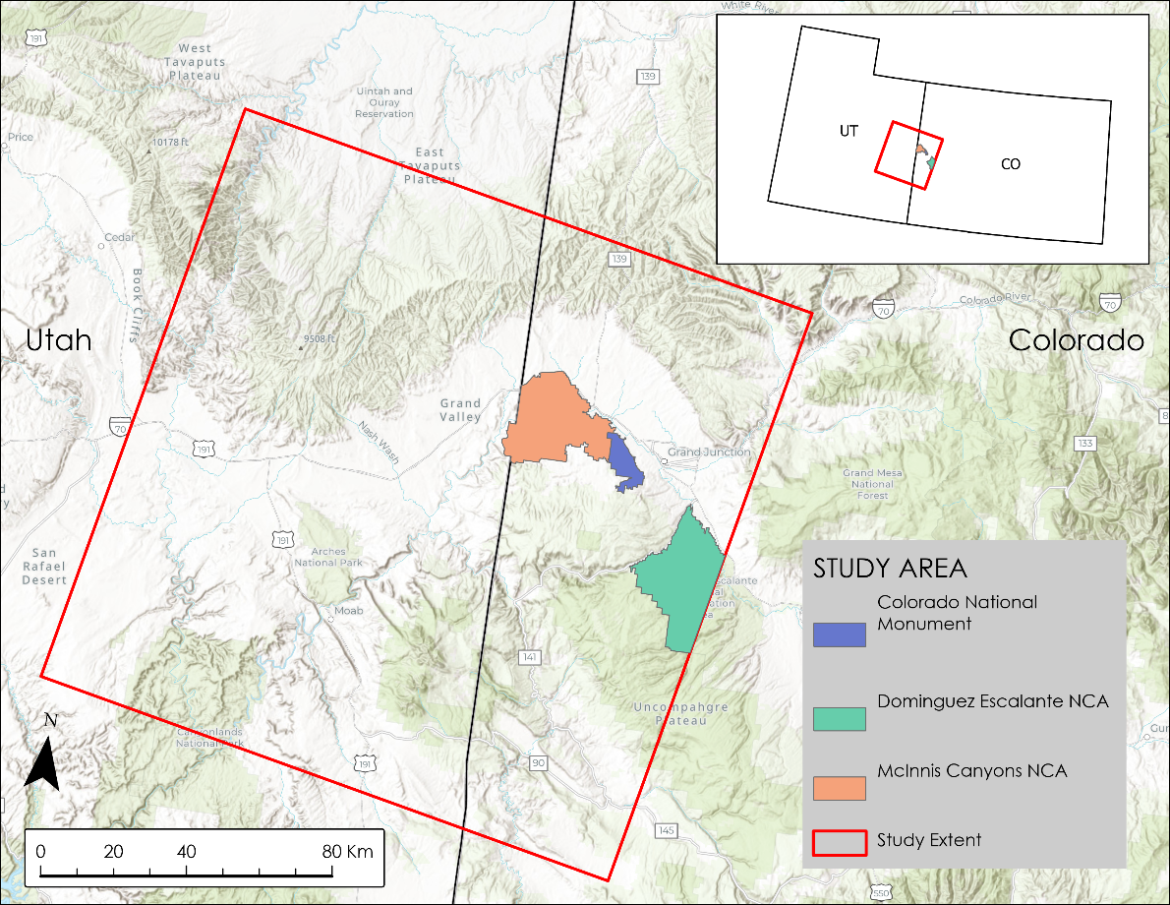
Figure 1: The extent of our study area, including Colorado National Monument, McInnis Canyons National Conservation Area, and Dominguez-Escalante National Monuments
The previous term of this project used NASA Earth observations to monitor and assess change in the extent of PJW and sagebrush habitat from 1985–2021. They measured the impacts of wildfire and beetle infestation on vegetation health and composition and assessed the effects of various vegetation treatments on the landscape. The team found that PJW expanded more than other types of land cover over the time period. They also concluded that higher severity fires on average had greater impacts on vegetation conditions than other areas without such disturbance, which could be useful for partners to prioritize these sites for post-fire rehabilitation. Finally, they found that pre-fire treatments were effective in slowing or stopping fires and aided in faster vegetation recovery post-fire (Powers et al., 2022).
2.2 Project Partners & Objectives
Our partners for this project were the National Park Service (NPS), Colorado National Monument (CNM), and the Bureau of Land Management, McInnis Canyons National Conservation Area (MCNCA), and Dominguez-Escalante National Conservation Area (DENCA). Both partners were interested in this project because of its potential to aid in management decisions and assess the effectiveness of treatments to mitigate increasingly frequent disturbances. NPS staff at CNM are interested in knowing what changes they can expect over time and not necessarily what action they can take to prevent it, whereas staff at the BLM are interested in taking action based on what they can expect. However, staff at CNM may consider monitoring and treating disturbances such as invasive plants to mitigate fire risk. Both partners frequently employ GIS and are seeking to incorporate GIS layers that include NASA satellite data alongside other datasets already in use to update their wildland resource and fire management practices.

To support the management needs of our partners and preserve the PJW and their ecosystem services, this project addressed several objectives. The first was to forecast landcover changes in PJW and sagebrush habitat in relation to historical fires, fuels treatments, and potential beetle kill effects. Through forecasting we aimed to identify areas at high-risk of PJW tree mortality, areas that might recover well from vegetation management treatments, or what PJW encroachment into shrublands might look like. Our second objective was to evaluate the threat of land cover change (e.g., from bark beetle infestation and wildfire) based on environmental variables such as temperature, precipitation, and solar radiation. Finally, we verified possible beetle infestation locations identified in the previous term through field surveys by partner organizations in conjunction with high spatial resolution aerial and satellite imagery.

3. Methodology
3.1 Data Acquisition
Our data included Earth observations (EO; Table 1), raw and processed GIS products from the Spring 2022 term (Term I), partner-provided GIS layers, and publicly available ancillary datasets from various United States government agencies. Earth observation data sources included Landsat 5 Thematic Mapper (TM), Landsat 7 Enhanced Thematic Mapper Plus (ETM+), Landsat 8 Operational Land Imager (OLI), and Terra and Aqua Moderate Resolution Imaging Spectroradiometer (MODIS). The spatial extent of our study area included path 36, row 33 of the Worldwide Reference System-2 (Figure 1). This scene is approximately 180km by 185km and the temporal range of our study spanned the years 1985 to 2021, with forecasts to 2040. Our partners at the Bureau of Land Management provided us with the Geodatabase of National Conservation Area Boundaries.

Table 1
NASA Earth observations data, parameters, and temporal coverage
Platform & Sensor | Parameters | Temporal Coverage | Data Source
Landsat 5 TM | Normalized Difference Vegetation Index (NDVI) products | June – September 1987–2012 | Raster datasets containing max value composite NDVI values created by the Term I team.
Landsat 7 ETM+ | NDVI products | June – September 1999–2020 | Raster datasets containing max value composite NDVI values created by the Term I team.
Landsat 8 OLI | NDVI products | June – September 2013–2020 | Raster datasets containing max value composite NDVI values created by the Term I team.
Terra MODIS | NDVI products | 2000–2020 | MODIS vegetation index products
Aqua MODIS | NDVI products | 2002–2020 | MODIS vegetation index products

We included climate variables such as minimum and maximum monthly temperature as well as monthly cumulative precipitation in our analysis. These data came from the NOAA National Centers for Environmental Information in the form of multidimensional NetCDF files at a 5km resolution. Furthermore, average monthly horizontal solar irradiance data at a 4km resolution were downloaded from the National Solar Radiation Database as TIFF files. Land cover type and a summary of land cover change were also added to our analysis through the procurement of yearly tiff raster datasets from the Landscape Change Monitoring System (LCMS) database.

3.1.1 Field Survey of Pinyon Pine Bark Beetle Mortality
Term I of the Grand Valley Ecological Forecasting project created a dataset called Consecutive Vegetation Productivity Decline (CVPD; Figure A1). To generate this dataset, they used maximum NDVI. Intra-annual composite imagery was extracted for the study area during the growing season. They then performed an image difference for all images using a 1-year time step and estimated a threshold value for probable vegetation decline for each image using a moving average of the 5 years prior to a given “target” year. Pixel values in the annual NDVI composite having 1.96 standard deviations or more below the established five-year mean threshold were considered probable true declines (outliers) and the resulting CVPD layer was reclassified accordingly in ArcGIS Pro. Term I aggregated annual data to arrive at a count for consecutive years of decline. They masked non-forest areas and known disturbances to produce a vegetation greenness decline persistence map that showed where a decline in NDVI persisted for 1–5 consecutive years (5 being the maximum encountered in this study). The probable outlier layer of the target year was subtracted from the baseline year to generate a vegetation disturbance map. Because tree mortality associated with bark beetle infestation results in loss of vegetation cover and loss of biomass production and because known disturbances (e.g., wildfire) were masked out, the assumption was made that areas with consecutive vegetation productivity decline could be attributed to Ips beetle infestation in the pinyon-juniper woodlands. To validate this assumption, our team (Term II) acquired ground verification data collected by our partners. We guided our partners in the collection process by providing them with shapefiles of georeferenced ground validation points that corresponded to the coordinates of locations showing at least two years of consecutive vegetation productivity decline as predicted by CVPD maps (Figure 2). Also included was a diagnostic survey utilizing Esri’s Survey123, in which we asked questions about the primary causes of disturbance and general ecosystem health. Teams of employees and citizen science volunteers went out into the field to assist in the collection and completion of the point surveys. The National Park Service biologists also selected and georeferenced 20 additional points representing healthy, undisturbed pinyon-juniper woodlands. These points would be used as control points to juxtapose the areas of modeled decline.

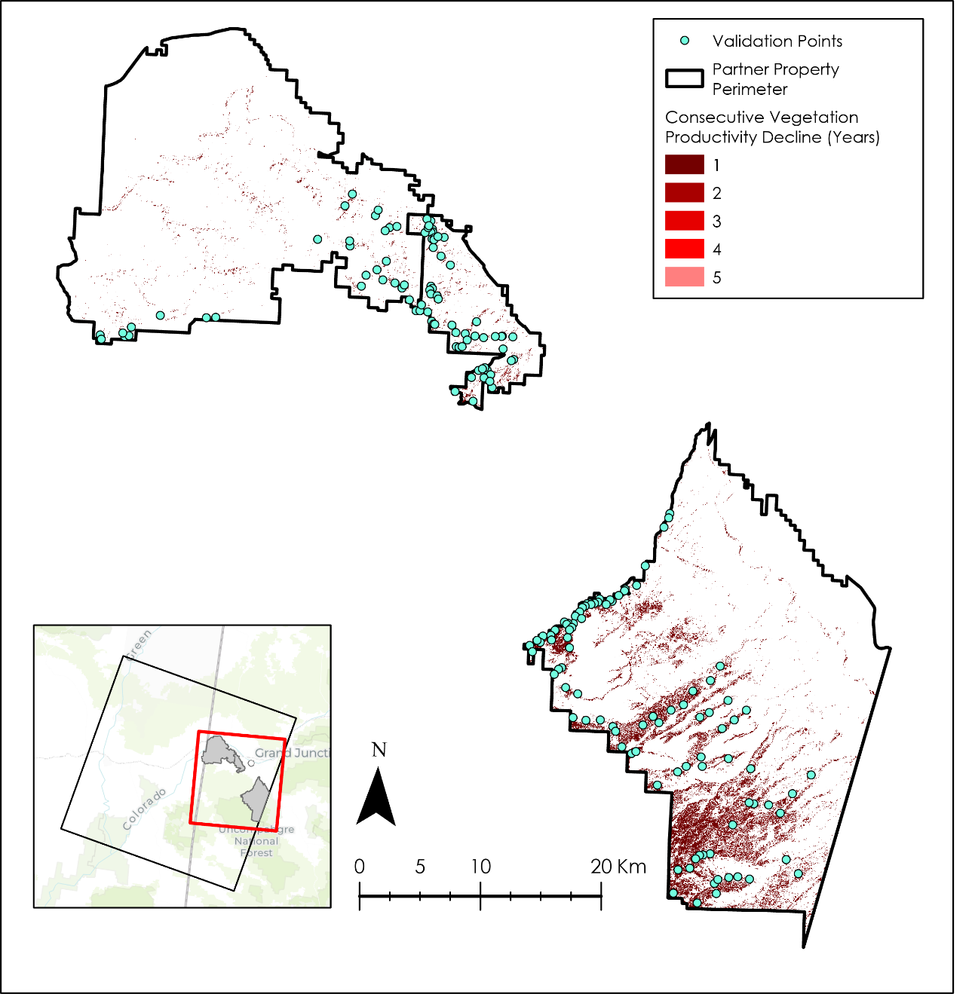
Figure 2: Points selected to send to partners for field validation in locations showing at least two years of consecutive vegetation productivity decline (CVPD)

3.2 Data Processing
3.2.1 File Preparation in ArcGIS and R
We used a combination of geoprocessing tools within ArcGIS Pro software and R scripting for data preprocessing and data cleaning prior to analysis. We set the coordinate system for each raster dataset to USA Contiguous Albers Equal Area Conic map projection (WKID: 102039). Any raster dataset that did not initially have this spatial reference system was reprojected to have this system before any subsequent data extraction or analysis.
The temporal range of the temperature and precipitation data spanned from 1985 to 2020. To subset these data in accordance with the temporal range of our analysis (1985–2020), we applied the Subset Multidimensional Raster tool in ArcGIS Pro. We then reprojected each raster layer and clipped it to the study area by using the Export Raster tool. The exported raster was a multidimensional NetCDF file which was then imported into the R Studio IDE for further preprocessing. The R package ncdf4, raster and tidyverse were used to extract and reshape the data in the form of a structured data frame.
The datasets outlined in Table 2 are not multidimensional raster files, but rather single raster images. The average monthly Solar Horizontal Irradiance data was downloaded as twelve separate raster images, one for each month of the year. Similarly, thirty-four separate NDVI raster images were acquired from the data archive compiled by the Term-I. Each NDVI tiff raster corresponded to a specific year and contained the composite NDVI data from June to September for that year. We used the NDVI raster data that corresponded to the years of our study (1985–2020). Datasets in Table 2 were first reprojected using the Project Raster tool and clipped to the study area using the Extract by Mask tool. The data for each point within the study area were then acquired using the Extract Raster Values to Point tool. This resulted in a point layer and a corresponding attribute table which we then exported as a comma-separated values (csv) file using the Export Table tool. The csv files were then imported into R Studio and added to the data frame containing temperature and precipitation data.
Table 2
Yearly and monthly non-multidimensional raster datasets
Dataset | Parameters | Temporal Coverage | Data Source | Earth Observation Sources
NDVI max value composites computed from Landsat 5 TM, Landsat 7 ETM+ and Landsat 8 OLI | Spectral vegetation indices in the form of Normalized Difference Vegetation Index (NDVI) during June to September | 1986–2020 | Raster datasets containing max value composite NDVI values created by the Term-I team. | Landsat 5 TM, Landsat 7 ETM+ and Landsat 8 OLI
National Elevation Dataset | Elevation in meters | Elevation is assumed to be constant from 1985–2020 | GIS Training and Research Center at Idaho State University and USGS | Light Detection and Ranging (LiDAR)
Shuttle Radar Topography Mission (SRTM) | Aspect measured in positive integer degrees from 0 to 360 degrees | Aspect is assumed to be constant from 1985–2020 | GIS Training and Research Center at Idaho State University and USGS | SRTM
Solar Horizontal Irradiance | Average direct normal solar irradiance | 1987–2020 | National Solar Radiation Database | TERRA MODIS and AQUA MODIS

The values extracted from each raster dataset were combined into a single data frame. Each column of this data frame represented data recorded for a specific month and the rows represented specific coordinates within the study area and the year when the data was collected at that point and the yearly composite NDVI specific to that point. Data collected spatially across all the coordinates within the study area, between 1987 and 2020, resulted in a total of 49,368 spatially distinct observations.

3.2.2 File Preparation in Idrisi TerrSet
To prepare files for analysis in Idrisi TerrSet Land Change Modeler (LCM), we first had to ensure that all parameters were identical. Into TerrSet we imported raster files from the USDA Forest Service Landscape Change Monitoring System (LCMS) at five-year increments for the years of 1985–2020 and for the most important driver variables identified by mean decrease of root mean square error. Variables included: elevation, aspect, annual precipitation, maximum temperature (Tmax), and minimum temperature (Tmin). The images and raster datasets were co-registered for window size and spatial resolution. We used a simplified classification of the LCMS rasters of land cover types (Figure A2). This simplified classification condensed the specific classes into broader classes of either “Tree”, “Shrub”, “Grass&Forb”, or “Other” which enabled us to generalize the land cover changes sub-modeled within the LCM program (Figure 3).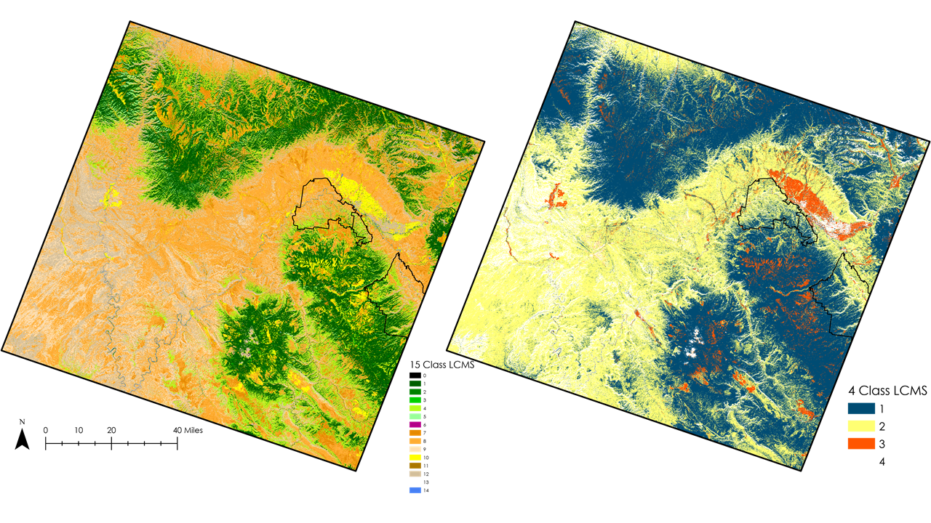
Figure 3: Reclassified LCMS image from 2021. The original 15 classes were simplified to 4 broader land cover classes (See Figure A2 for class descriptions).

3.2.3 Survey Results Processing
The ground validation survey results automatically uploaded onto a Survey123 database, which was then exported as a shapefile with a descriptive attribute table. From this attribute table we derived whether or not there was bark beetle related disturbance and tree mortality at each of the locations. This information was distributed into a binary “beetle” or “no beetle” category and classified as “1” and “-1” respectively. Those values were then compared to the calculated pixel values of one or more years of consecutive vegetation productivity decline (CVPD) versus zero years (no decline). Survey results and descriptions that we used to classify a site as “beetle” included: active pinyon Ips beetle infestation, old beetle infestation, beetle killed trees, Ips killed pines. We then exported the tables into MS Excel for analysis.

3.3 Data Analysis
3.3.1 Identifying Important Driver Variables
We used a machine learning approach to model NDVI variation within our study area in relation to the predictor variables. This approach enabled us to account for the non-linearity and the multidimensional nature of the data to derive reliable insights in relation to patterns influencing NDVI. Specifically, this approach allowed us to compute the importance of each predictor and rank them in order of their importance. The metric used for calculating variable importance was mean decrease of root mean square error. The general workflow involved dividing the dataset into training and test data (Figure 4). The training data contained data from 1987 up until 2013, whereas the test data contained data from 2014 to 2020. The R package CAST was used to train a Random Forest regressor on the training dataset. To preserve the spatio-temporal structure of the data as well as to combat overfitting, target oriented cross-validation (TO-CV) was used instead of k-fold cross validation. TO-CV leaves out data points from certain coordinates across certain timesteps during the training process. The data left out were then used for model validation. The importance of each variable was computed on the training dataset and the model was validated using the test dataset. Model evaluation was a crucial step to check for overfitting and evaluate whether the variable importance measures computed for each predictor on the training dataset was reliable or not.

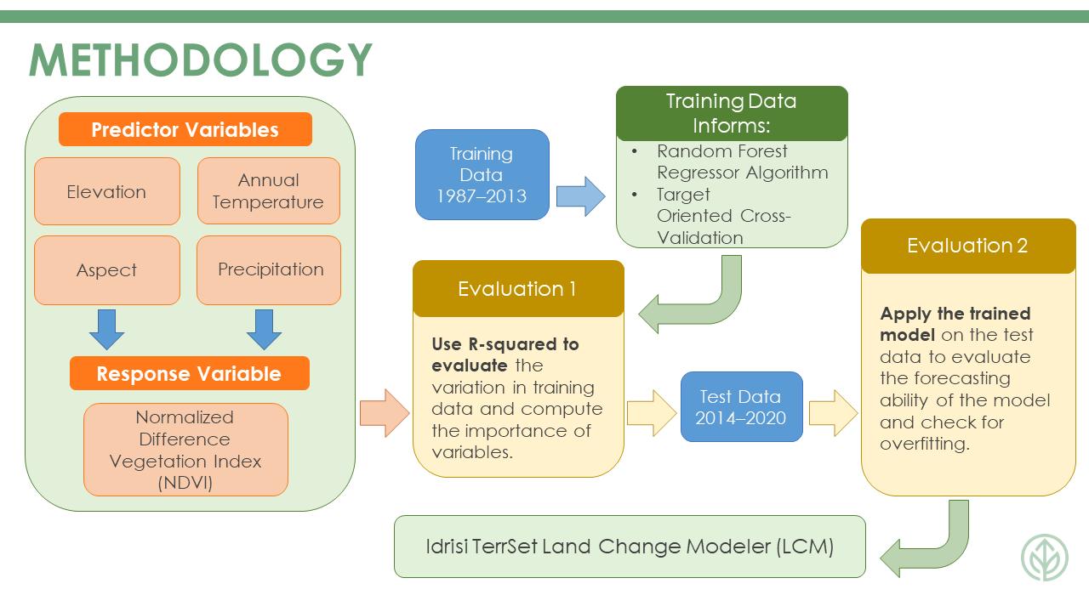
Figure 4: The complete workflow outlining the method used for identifying the most important drivers of NDVI variation within the study area. The metric used for computing the importance of each variable was mean decrease of root mean square error.

3.3.2 Idrisi TerrSet Land Change Modeler Analysis
The variables with the highest importance were then used to create forecasted land cover maps analyzed using LCM. In LCM, we performed three change analyses to assess how different timespans of training data affect forecasted change. We used the following years of LCMS images for training: 1985, 2010, 2015, and 2020. LCM uses an earlier image and contrasts it to a later image to assess change. We used 1985 as our earlier image for the three experiments and 2010, 2015, and 2020 as the latter in each successive iteration. Our reprojected and windowed elevation file was input as the elevation model file for the change analysis. The program then used the earlier image and later image in conjunction with the driver variables, elevation and aspect, to create the following transitions: Tree to Shrub, Tree to Grass&Forb, Shrub to Tree, Shrub to Grass&Forb, Grass&Forb to Tree, and Grass&Forb to Shrub. We then grouped all transitions into a single sub model to create transition potentials using a Multi-Layer Perceptron (MLP) neural network. Initial attempts using all five driver variables (elevation, aspect, Tmin, Tmax, and precipitation) caused the model to fail, possibly due to the background null values of the temperature and precipitation files or their multi-layered characteristics. Because of this, we decided to run the model using only the elevation and aspect driver variables.

For the 1985–2010 experiment, we created a change prediction for 2015 and 2020. The resulting forecasted land cover maps were then validated in TerrSet against the actual LCMS map for 2015 and 2020 using the Error Matrix tool. The Kappa value for our 2015 forecast was 0.81 and the value for the 2020 forecast was 0.68, indicating that the model was accurately predicting actual land cover changes. We then ran a second validation test using the 1985–2015 imagery. When those training dates were used to forecast 2020, our Kappa value was 0.73. The 1985–2020 experiment was used for creating forecast maps, but we were unable to run a validation due to the lack of a post-2020 co-registered LCMS image. Forecasted land cover maps were then created for 2025, 2030 and 2040 for each of the experimental training timeframes (1985–2010, 1985–2015, 1985–2020). All parameters for these models were kept the same as our validated forecasted land cover maps.

3.3.3 Field Validation Results Analysis
The data points obtained from the survey included 53 of 160 prescribed ground validation points and 20 partner-selected healthy vegetation control points. The 107 prescribed ground validation points that were not surveyed were due to accessibility restrictions and were discarded from further processing. Only 2 of the 20 partner selected control points were utilized in our final accuracy assessment as 18 of the points were located in a Null value location of the CVPD dataset. This gave us a total of 55 ground validation points distributed across the study area, with the majority of ground validation being conducted within Colorado National Monument. The accuracy of the consecutive vegetation productivity decline was calculated by dividing the pixels that showed 1 to 5 years of decline and ground validated beetle disturbance by the total number of validation points (see Equation 1).

$\frac{Total Validated Decline Pixels}{Total Validation Pixels}⋅100= \% Agreement$ (1)

4. Results & Discussion
4.1 Analysis of Results
4.1.1 Important Drivers of Yearly NDVI Variation
Elevation (approximate relative importance: 100) and aspect (approximate relative importance: 72) were identified to be the most important variables in relation to NDVI variation (Figure 5). This indicates that these are the most influential factors driving vegetation productivity in the study area. The type and amount of vegetation is highly variable across elevation and this result captured that pattern of variability. The influence of annual average Tmin (approximate relative importance: 32) and Tmax (approximate relative importance: 17) alongside annual average cumulative precipitation (approximate relative importance: 3) is relatively low in comparison while annual solar irradiance (approximate relative importance: 0) shows negligible importance compared to other variables (Figure 5). This could be a very coarse representation of the evolutionary history of the plants in the area, specifically from the context of environmental cues. The climate of the study area is mostly semi-arid and plants that have evolved to grow in dry conditions have an efficient water management strategy, which might explain why we did not see a high impact of precipitation on vegetation productivity. Similarly, the plants might rely on the minimum range of temperature more than the maximum range for plant productivity and growth. The results could also be due to the relatively coarse spatial representation of the weather data.
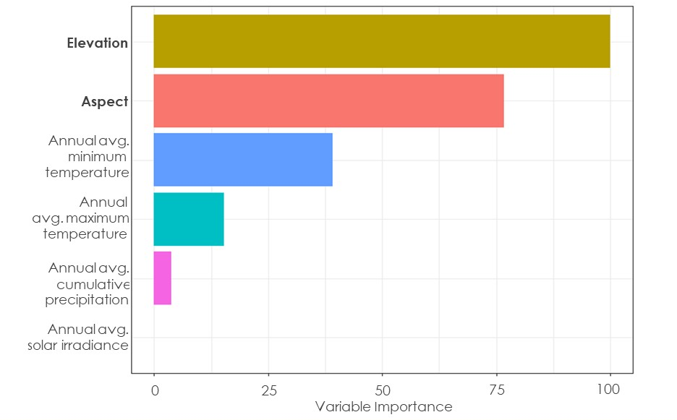

Figure 5: The relative importance of each driver variable in the dataset in relation to the variation of yearly NDVI. Mean decrease of root mean square error was used to compute the importance of each variable. Elevation and Aspect are the most important driver variables i.e., having the most influence in relation to the variation to yearly NDVI whereas annual average solar irradiance has a negligible influence.

4.1.2 Idrisi TerrSet LCM Analysis
The forecasted land cover maps (Appendix C) created for the 1985–2010 experiment projected an increase in trees and a decrease in shrubs and grasses. For the 1985–2015 experiment, the trend was similar in both direction of conversion and scale, with the notable deviation that the land cover type “Grass & Forbs” showed a relatively large increase. The 1985–2020 experiment showed a steady decrease in trees conducive with the observed trends from 1990–2020. The consensus result across all three experiments was that the change of LCMS images between 2015–2020 caused an exaggerated shift in the forecasted land cover changes within the CNM, MCNCA and DENCA perimeters (Figures 6–8). This suggests a different pattern of land cover change in the last 5 years than that of the previous 30. These results also demonstrate the importance of the inclusion of the most current data due to the dramatic shifts that have been occurring in recent years. Without the inclusion of 2020 as a training year, we found that partners could expect to see an increase in trees and a decrease in shrublands. With the inclusion of 2020 as a training year for the forecast model, partners could expect to see a conversion of trees to shrublands within their perimeters. Based on these results, the model that included 2020 data appeared to provide a more realistic forecast because it accounts for the most recent changes in land cover within the study area.
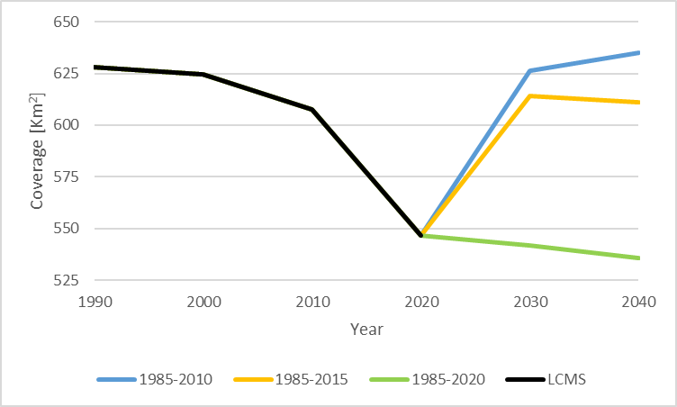
Figure 6: Variation in land cover attributed to “TREE” land cover type within partner perimeters between 1990 and 2040 for all three forecasting experiments

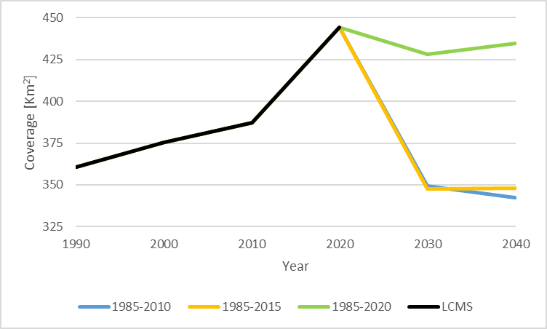
Figure 7: Variation in land cover attributed to “SHRUB” land cover type within partner perimeters between 1990 and 2040 for all three forecasting experiments
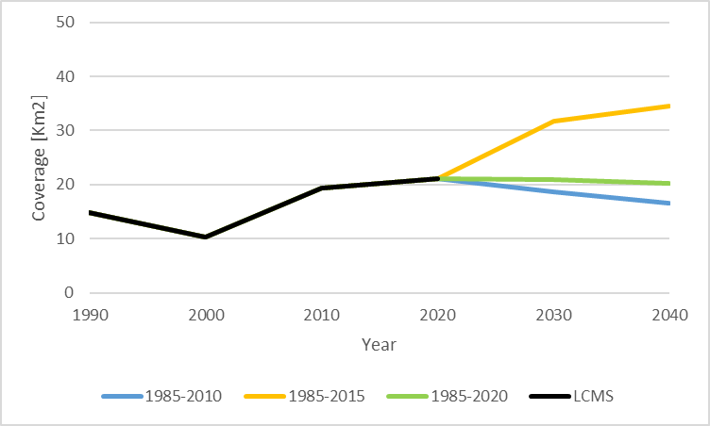
Figure 8: Variation in land cover attributed to “GRASS & FORBS” land cover type within partner perimeters between 1990 and 2040 for all three forecasting experiments

4.1.3 Field Validation Results Analysis
Results from our partner conducted survey indicated that 38 of the 55 acceptable ground validation points were positively attributed to beetle kill (Figure 9). This translates to a 69% level of agreement between the ground and test data when inferring that consecutive vegetation productivity decline is associated with bark beetle infestation. It is important to note that points where partners indicated signs of a beetle infestation do not necessarily mean that the whole ecosystem at those selected points was unhealthy. However, more often than not consecutive vegetation productivity decline suggests tree mortality was associated with active or past beetle infestation.
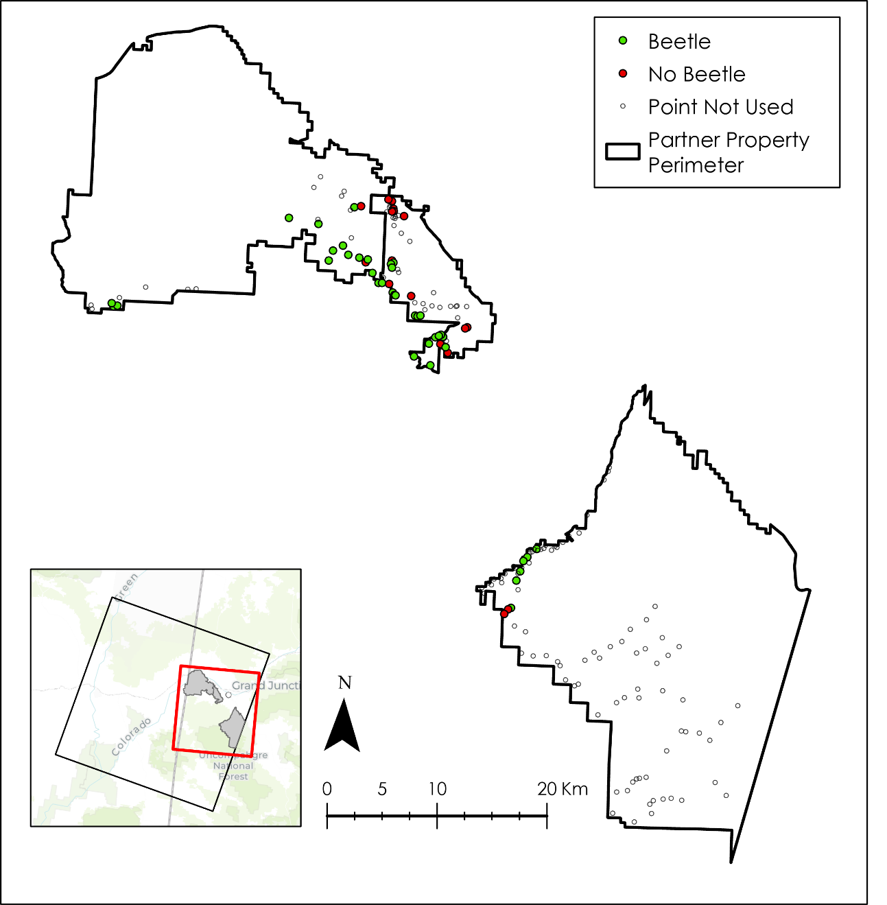
Figure 9: Ground observations of points that were incorporated in the validation. Green points are locations that remote sensing accurately modeled decline. Red points are locations that remote sensing modeled decline, but had no signs of vegetation productivity decline or beetle infestation and had good overall forest ecosystem health.

4.2 Limitations and Errors
While driver variable analysis was able to account for the non-linearity, spatial and temporal autocorrelation in the data, it was conducted at a relatively coarse spatial resolution of about 4600 meters. Although resampling algorithms can be used to down sample the predictions to finer resolutions, they can lead to increased uncertainty in predicted landcover (Pontius Jr. et al., 2008). Although our model was adept at classifying areas of shrubs, trees, and barren land, it failed to predict the landcover type and change in certain areas, such as grasses and forbs, due to a lack of data in the predictor variables in those specific locations.

Additionally, satellite imagery classified according to land cover type also contains errors, and thus our LCMS maps may have had inaccuracies that contributed to the overall uncertainty of our forecast models (overall accuracy = 82.5%; Stehman et al., 2021). While LCMS maps are sufficiently accurate, they are not perfect predictors of land cover; when evaluating points at the scale of single pixels as we did in this study, any error needs to be considered. We were also unable to incorporate temperature and precipitation as driver variables in our analysis due to complications within LCM, which may have also affected the accuracy of our forecasted land cover maps. Further, because our forecast maps only accounted for static variables, results need to be interpreted with caution as a disturbance, such as a wildfire, could change the distribution of land cover types in our forecast maps.

Our ground validation survey could have been more statistically rigorous if we had had more observations of PJW that showed no decline on the consecutive vegetation productivity decline raster. However, time did not allow for the surveys to be expanded beyond what was accomplished. As is, our survey was focused on point locations with at least two years of predicted productivity decline. Our validation did not sufficiently sample non-decline PJW areas. A larger sample size that included both multi-year consecutive decline and non-decline PJW areas would have enabled a more comprehensive assessment. Also, a separate validation of the masking that took place, specifically the classification of pinyon-juniper woodlands versus other specific types of land cover types, would allow for a better analysis of the null raster values, within the study area. In addition, stratified random sampling of declining versus non-declining PJW would add statistical rigor that was not possible given the limited duration of this project.

4.3 Future Work
Although there is not currently a third term planned for this project, there are several additional analyses that could be investigated further to add to the informative capability of this project in the future. For example, future research could include the effect of insect and disease outbreaks on pinyon-juniper and sagebrush habitats in addition to the climate variables investigated in this study, as climate change can increase the occurrence of fatal diseases that can cause large-scale PJW die-off (Shaw et al., 2005). Additionally, future research could focus explicitly on forecasting what expected invasion of non-native species would look like if trends in land cover change continue as forecasted. Further, the forecasting methods utilized in this project could also be used to investigate the effects of wildlife grazing on pinyon-juniper and sagebrush habitats as well as map changes in wildlife distribution based on forecasted land cover change. We were also unable to include dynamic driver variables such as temperature and precipitation in our forecasting model, so future analyses would benefit from the addition of these variables as drivers of change to forecast landcover change. Based on the results of our field validation, sites that were identified as potential beetle kill sites but were not accurate could be reevaluated to determine the actual cause of disturbance and sites that volunteers were not able to access could also be sampled to further improve our validation results. Further, future work could assess the impacts of wildland fires and vegetation treatments to forecast vegetation recovery in order to make targeted treatment decisions. Another avenue for future research that would enhance the findings in our study would be the use of CNM as a control area without fires to compare to the BLM lands that have burned in order to assess potential land cover changes after fires.

5. Conclusions
We developed several maps to identify forecasted land cover change in PJW and sagebrush habitats that factored in historical climate variability and land cover change. In this process, we identified the most important drivers of change in land cover to be elevation, aspect, temperature, and precipitation. Forecasted land cover change maps were created using the two most important variables (elevation and aspect) to train the model. Forecasted land cover maps excluding 2020 data suggest that both CNM and MCNCA could expect a transition to some extent from shrubs to trees by the year 2040 if conditions persist. However, forecasted land cover maps that include 2020 suggest that some areas that were previously trees will transition to shrublands within partner perimeters. Additionally, our ground truthing of suspected beetle infestation areas provided evidence that Landsat NDVI data were more accurate than not at identifying areas of vegetation decline indicative of tree mortality from bark beetle outbreaks.

The potential transition of shrubs to trees throughout the partners’ perimeters will likely have consequences that reverberate throughout the ecosystem of the Grand Valley region. For example, native flora and fauna that rely on shrublands for survival could lose critical habitat due to PJW encroachment or be replaced by invasives. Another concern that arises with the encroachment of PJW into shrublands is the increase in the severity of wildfires with the increase in density of PJW stands (Miller et al., 2019). This increased severity of wildfires threatens the survival of native species and the infrastructure of rural communities. However, our forecast maps (see Figure C1) that include 2020 as a training year suggest a shift in land cover trends over the last five years towards a greater transition from trees to shrubs. McInnis Canyons NCA had multiple wildland fires between 1998 and 2020, and it’s possible that these large disturbances in the short term (less than 20 years) could influence the future land cover changes.

Our results will assist the NPS and BLM in managing their respective parcels within Grand Valley, CO. The forecasted land cover change maps generated will benefit both CNM and MCNCA/DENCA by allowing them to visualize changes in the extent of pinyon-juniper woodlands and sagebrush stands as well as general landcover changes. Specifically, our projections of areas vulnerable to extensive change from trees to shrubs could be used by the BLM to make decisions on prevention or encouragement. The NPS, in line with their more hands-off strategy, can utilize the geodatabase provided and interact with or update the GIS layers in combination with their own Earth observation data and field surveys to inform management.

This project is an example of what an effective collaboration between partner organizations and DEVELOP teams can look like. We were able to utilize satellite data and areas of consecutive vegetation productivity decline identified by the previous term to select points of interest which citizen science volunteers and staff at Colorado National Monument, as well as the staff at the Grand Valley BLM office, were then able to validate on the ground. This collaboration should benefit partners because the results of the validation suggest that satellite imagery can be used to effectively identify locations of disturbances in the Grand Valley region, such as beetle infestations of PJW, possibly before they are detected on the ground. Being able to accurately detect, assess, and monitor PJW disturbances with the use of satellites and remote sensing technology could help to better inform management decisions by the partners in the future.

6. Acknowledgments
We would like to acknowledge and thank the NASA DEVELOP Program for giving us the opportunity to work on this project. We also thank our fellow Brandy Nisbet-Wilcox and our science advisors Keith Weber and Joseph Spruce for their valued insights and thoughtful advice. Another big thank you to our partners at the National Park Service: Molly Murphy, Arlene Jackson, Jessica Resnik, and Eric Shaver and at the Bureau of Land Management: Nikki Grant-Hoffman, Marlin Deras, and Emily Latta for the opportunity to collaborate on this project and for their insights. We also acknowledge and thank the volunteers at the National Park Service and the Bureau of Land Management for their contribution to our field validation. Finally, we thank DEVELOP’s Project Coordination Fellows Tamara Barbakova and Robert Cecil Byles for their guidance and editing.

Any opinions, findings, and conclusions or recommendations expressed in this material are those of the author(s) and do not necessarily reflect the views of the National Aeronautics and Space Administration.

This material is based upon work supported by NASA through contract NNL16AA05C.

7. Glossary
ArcGIS Pro – Geographic Information Systems (GIS) software used to store, view, and analyze geographic data
BLM – Bureau of Land Management
CAST – 'caret' Applications for Spatial-Temporal Models, R package
CNM – Colorado National Monument
DENCA – Dominguez-Escalante National Conservation Area
Earth observations – Satellites and sensors that collect information about the Earth’s physical, chemical, and biological systems over space and time
GIS – Geographic Information Systems, computer applications used to store, view, and analyze geographic information
Idrisi TerrSet LCM – Idrisi TerrSet Land Change Modeler
LCMS – Landscape Change Monitoring System
LiDAR – Light Detection and Ranging, remote sensing method
MCNCA – McInnis Canyons National Conservation Area
MODIS – Moderate Resolution Imaging Spectroradiometer
NDVI – Normalized Difference Vegetation Index
NetCDF – Multidimensional raster datasets
NPS – National Park Service
PJW – Pinyon-juniper woodlands
R – Scripting language
Random Forest – Machine Learning algorithm for classification and regression

Remote Sensing – Obtaining information about an object or area from a distant sensor, such as on a drone, aircraft, or satellite

Shapefile – Data format for Geographic Information Systems (GIS) software, data is in the format of points, lines, and/or polygons

Tidyverse – R package for data wrangling

Tmax – Maximum temperature

Tmin – Minimum temperature

TO-CV – Target Oriented Cross-Validation

8. References

Gesch, D. B., Evans, G. A., Oimoen, M. J., & Arundel, S. (2018). The National Elevation Dataset. [Data set] In, Digital Elevation Model Technologies and Applications: The DEM Users Manual 3rd Edition (pp. 83-110) American Society for Photogrammetry and Remote Sensing, USGS Publications Warehouse. http://pubs.er.usgs.gov/publication/70201572

Grant-Hoffman, M. N., Plank, H. L. (2021). Practical postfire sagebrush shrub restoration techniques. Rangeland Ecology & Management, 74, 1-8. https://doi.org/10.1016/j.rama.2020.10.007

Hasan, M. E., Nath, B., Sarker, A. H. M. R., Wang, Z., Zhang, L., Yang, X., Nobi, M.N., Røskaft, E., Chivers, D.J., & Suza, M. (2020). Applying multi-temporal Landsat satellite data and markov-cellular automata to predict forest cover change and forest degradation of Sundarban reserve forest, Bangladesh. Forests, 11(9), 1016. https://doi.org/10.3390/f11091016

K. Didan. 2015. MOD13Q1 MODIS/Terra Vegetation Indices 16-Day L3 Global 250m SIN Grid V006. [Data set] NASA EOSDIS Land Processes DAAC. https://doi.org/10.5067/MODIS/MOD13Q1.006

Miller, R. F., Chambers, J. C., Evers, L., Williams, C. J., Snyder, K. A., Roundy, B. A., & Pierson, F. B. (2019). The ecology, history, ecohydrology, and management of pinyon and juniper woodlands in the Great Basin and Northern Colorado Plateau of the western United States. Gen. Tech. Rep. RMRS-GTR-403. Fort Collins, CO: U.S. Department of Agriculture, Forest Service, Rocky Mountain Research Station. 284 p., 403. https://doi.org/10.2737/RMRS-GTR-403

NASA Shuttle Radar Topography Mission (SRTM). (2013). Shuttle Radar Topography Mission (SRTM) Global. Distributed by OpenTopography. https://doi.org/10.5069/G9445JDF. Accessed: 2022-08-04

Nielson, J. (2009). Series: Pinyon-Juniper Woodlands. National Park Service. https://www.nps.gov/articles/series.htm?id=0216D798-933C-2108-EB4384D97499E89A

Pontius Jr., R. G., Boersma, W., Castella, J. C., Clarke, K., de Nijs, T., Dietzel, C., Duan, Z., Fotsing, E., Goldstein, N., Kok, K., Koomen, E., Lippitt, C. D., McConnell, W., Sood, A. M., Pijanowski, B., Pithadia, S., Sweeney, S., Trung, T. N., Veldkamp, A. T., & Verburg. P. H. Comparing the input, output, and validation maps for several models of land change. The Annals of Regional Science 42,11–37 (2008). https://doi.org/10.1007/s00168-007-0138-2

Powers, G., Arowoogun, K., Stone, E., & Tree, M. (2022, March). Grand Valley Ecological Forecasting: Assessing Trends in Pinyon-Juniper Habitat Relative to Drought, Beetle Infestation, Wildland Fires, And Treatment to Plan Future Management Strategies [Unpublished manuscript]. NASA DEVELOP National Program, Idaho – Pocatello

Shaw, J. D., Steed, B. E., & DeBlander, L. T. (2005). Forest inventory and analysis (FIA) annual inventory answers the question: what is happening to pinyon-juniper woodlands?. Journal of Forestry, 103(6), 280-285. https://doi.org/10.1093/jof/103.6.280

Stehman, S. V., Pengra, B. W., Horton, J. A., & Wellington, D. F. (2021). Validation of the US Geological Survey's Land Change Monitoring, Assessment and Projection (LCMAP) Collection 1.0 annual land cover products 1985–2017. Remote Sensing of Environment, 265, 112646. https://doi.org/10.1016/j.rse.2021.112646

Tulloch, A. I., Hagger, V., & Greenville, A. C. (2020). Ecological forecasts to inform near-term management of threats to biodiversity. Global Change Biology, 26(10), 5816-5828. https://doi.org/10.1111/gcb.15272

United States Department of Agriculture Forest Service (2021). USFS Landscape Change Monitoring System Conterminous United States (2020-5). [Data set] Salt Lake City, Utah. https://apps.fs.usda.gov/lcms-viewer/

United States Geological Survey, Earth Resources Observation and Science Center. (2021). Landsat 4-5 TM Collection 2 Level-2 Science Products. [Data set] U.S. Department of the Interior.
https://doi.org/10.5066/p9iaxovv

United States Geological Survey, Earth Resources Observation and Science Center. (2021). Landsat 7 ETM Plus Collection 2 Level-2 Science Products [Data set] U.S. Department of the Interior. https://doi.org/10.5066/p9c7i13b
United States Geological Survey, Earth Resources Observation and Science Center. (2021). Landsat 8 OLI/TIRS Level-2 Data Products - Surface Reflectance [Data set] U.S. Department of the Interior. https://doi.org/10.5066/f78s4mzj

9. Appendices

Appendix A

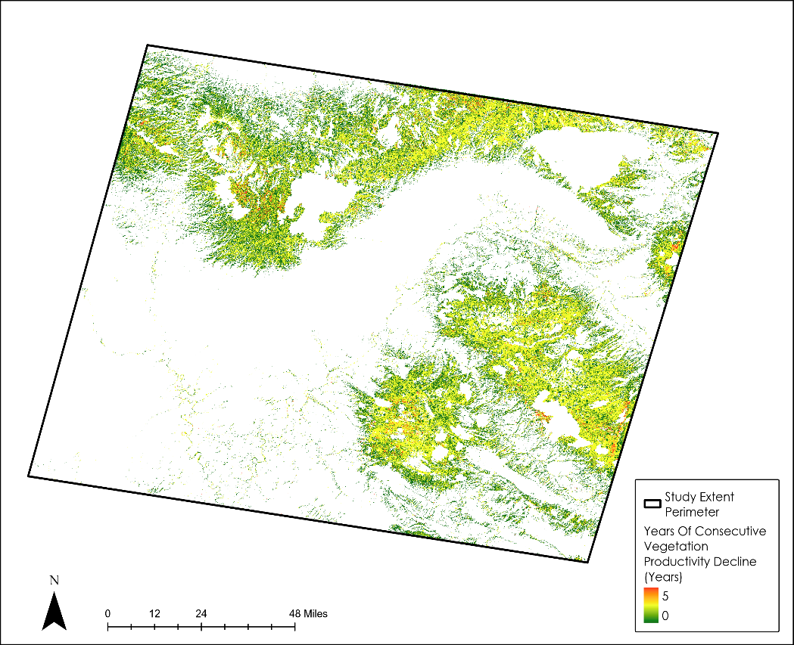
Figure A1: Map of Consecutive Vegetation Decline created by the Term-1 Team that was used for selection of validation points

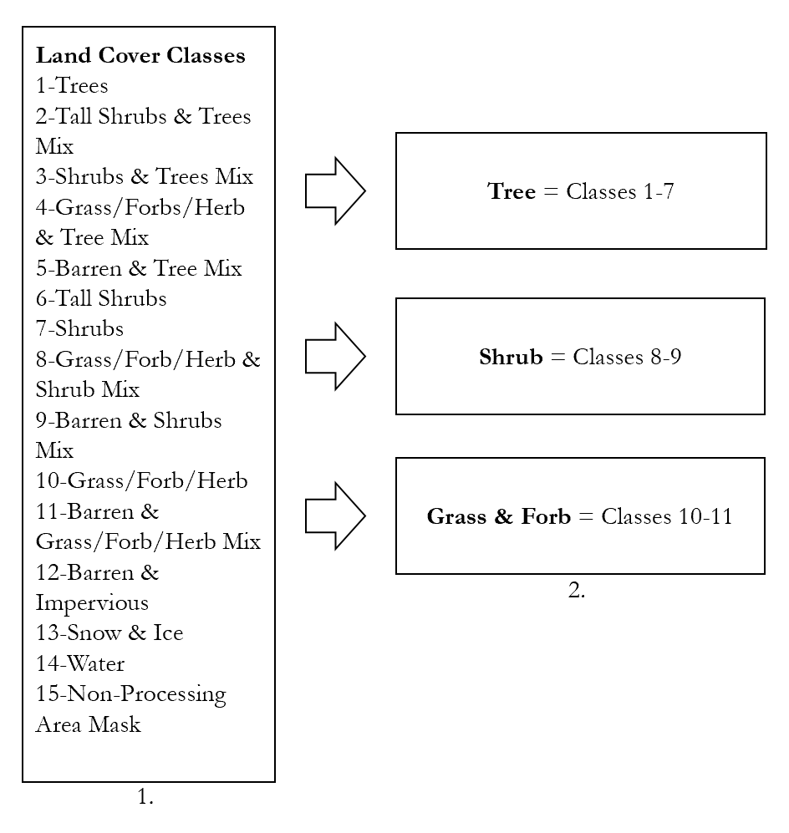
Figure A2: Reclassification of land cover classes in LCMS images

Appendix B

Confusion Matrix |  | Ground Observations
 |  | No Beetle Kill | Beetle Kill
Predicted by Consecutive Vegetation Productivity Decline | No Beetle Kill | 0 | 0
Predicted by Consecutive Vegetation Productivity Decline | Beetle Kill | 17 | 38 | 55
 |  | False Positives: 17 (31%) | True Positives:  38 (69%) | 55
Figure B1: Confusion Matrix of field validation survey points.

Appendix C

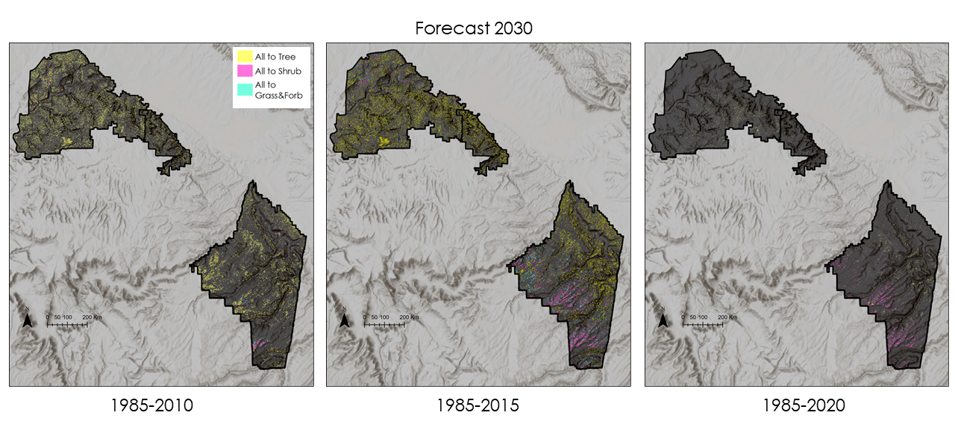
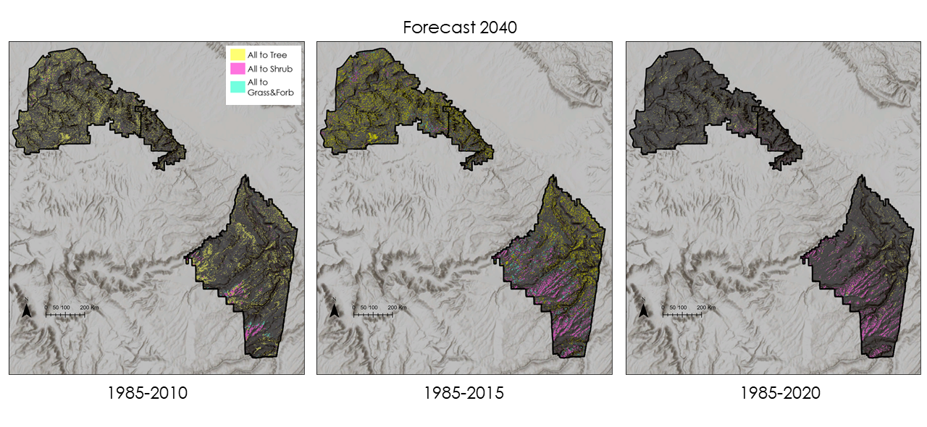Figure C1: Forecasted conversions of Tree, Shrub, and Grass & Forb landcover types within the boundaries of Colorado National Monument, Dominguez-Escalante and McInnis Canyons National Conservation Areas. The dates below each map indicate the temporal range of the training data. The 1985–2010 model favors tree expansion, while the 1985–2015 model shows a balance between conversion to trees and shrubs. 1985–2015 also shows more transition in McInnis Canyons National Monument than in Dominguez-Escalante, and favors tree expansion in MCNCA. The 1985–2020 model shows the least replacement overall, but favors transition to shrubland, especially in Dominquez Escalante.

