Albuquerque Urban Development
Enhancing Urban Cooling Interventions by Modeling Urban Forestry through NASA Earth Observations in Albuquerque, New Mexico

Technical Report
Max Stewart (Project Lead)
Christina Dennis
Ritisha Ghosh
Richard Kirschner
Steven Nystrom

Advisors:
Dr. David Hondula, Arizona State University (Science Advisor)
Dr. Kenton Ross, NASA Langley Research Center (Science Advisor)

1. Abstract
The City of Albuquerque, New Mexico is experiencing increasing urban heat island (UHI) effects, which impact the health, safety, and comfort of the community. In partnership with the City of Albuquerque Department of Environmental Health, Department of Parks and Recreation, and Let’s Plant Albuquerque!, this project used satellite Earth observations from April 2016–August 2022 to model increases in tree canopy within the City of Albuquerque to help combat the urban heat island in the city’s warmer areas over the next decade. Using Landsat 8’s Thermal Infrared Sensor (TIRS) and the Ecosystem Spaceborne Thermal Radiometer Experiment on the International Space Station (ECOSTRESS), along with the Integrated Valuation of Ecosystem Services and Tradeoffs (InVEST) Urban Cooling and ENVI-Met models, the team modeled tree cover interventions and created land surface temperature maps. These outputs will help the city make data-driven decisions for their tree planting goal in a targeted approach.

Key Terms
remote sensing, urban heat island, urban development, tree canopy, land surface temperature, ECOSTRESS, InVEST, ENVI- met

2. Introduction
2.1 Background Information
A 2015 report on Climate Futures Analysis for Central New Mexico projected that Albuquerque, New Mexico will see four times more days each year over 100°F by 2040 compared to baseline studies from 1950–1999 (John A Volope National Transportation Systems Center, 2015). Anthropogenic emissions of greenhouse gases are changing the climate system, leading to more extreme temperatures and heat-related disasters, potentially pushing communities and ecosystems beyond their coping capabilities (Tong et al., 2021). Urban areas are commonly warmer than adjacent suburban or rural areas due to higher amounts of artificial materials like metal, concrete, and brick that absorb and store solar energy. This, in combination with a lack of vegetation to cool the surrounding environment, creates what is known as the urban heat island (UHI) effect (Tong et al., 2021). UHIs can directly increase heat-related illness and mortality, reduce labor productivity, and overwhelm healthcare systems (Tong et al., 2021).

Urban greening through dense tree planting has received much attention as a heat mitigation strategy, with the ability to achieve localized cooling as much as 2.7°F within 2–3 meters from the surface through shading and evapotranspiration (Tong et al., 2021; Pataki et al., 2021). The capacity of urban trees to reduce land surface temperatures is dependent on the level of development and requires highly targeted design interventions to be most effective in improving human thermal comfort (Pataki et al., 2021).
Situated at the end of the Rocky Mountains, Albuquerque is a high desert city with a population of approximately 560,000 (U.S. Census Bureau, 2021). The climate is arid, and the summer season is characterized by dry heat with temperatures consistently around 90°F. State incentives for industrial migration have contributed to urban sprawl and an increase in impervious surfaces over time.

Through literature review, the team identified green infrastructure (GI), specifically increasing the urban canopy, as an effective and cost-efficient method for combating UHIs. This is a common heat mitigation strategy that utilizes both shading and evapotranspiration. Although other tactics, such as altering the albedo impervious surfaces, help attenuate urban environmental problems, installing GI can provide additional benefits by increasing ecosystem services. Through shading, urban trees lessen the net energy absorption of impervious surfaces, effectively altering the urban energy balance (Roy et al., 2012). This results in decreased temperatures at the canopy and boundary layers (Upreti et al., 2017). Further, the urban canopy increases human thermal comfort through the mitigation of direct and diffusive shortwave solar radiation (De Abreu-Harbich et al., 2015). In an arid desert landscape like Albuquerque, the cooling effect of urban trees is predominated by shading rather than evapotranspiration (Wang et al., 2016). Previous studies have investigated the relationship between UHIs and GI with findings stating that an increase in urban canopy yields lower surface temperatures and higher levels of human thermal comfort (Zhao et al., 2018).

Modeling can be utilized to establish economic metrics stemming from an increased urban tree canopy. The Integrated Valuation of Ecosystem Services and Tradeoffs (InVEST) Urban Cooling Model applies biophysical metrics to establish cooling capacity (Bosch et al., 2020). Through a suite of spatial models, InVEST presents a valuation of ecosystem services and the effects of impervious materials and canopy cover on UHIs. The application of this software allows end-users and affected parties to quantify benefits stemming from the “Let’s Plant ABQ” initiative and creates incentives for increasing the urban canopy.

2.2 Project Partners & Objectives
Let’s Plant Albuquerque (ABQ) is a community alliance composed of a broad network of civic, government, and community organizations, collectively dedicated to planting 100,000 trees in Albuquerque by 2030. Let’s Plant ABQ strives to build up the city’s urban canopy to reap its social, economic, and health benefits to create a cooler community. The summer 2022 NASA DEVELOP Albuquerque Urban Development team partnered with the City of Albuquerque Department of Environmental Health and Department of Parks and Recreation, as well as Let’s Plant ABQ, to use remote sensing techniques to inform urban forestry planning decisions. The team utilized NASA Earth observations from Landsat 8 Thermal Infrared Spectrometer (TIRS), the International Space Station (ISS) Ecosystem Spaceborne Thermal Radiometer Experiment on Space Station (ECOSTRESS), as well as several models (Urban Heat Exposure Assessment [UHEAT] 2.0, InVEST Urban Cooling, and ENVI-Met) to address tree cover interventions and produce land surface temperature (LST) maps. By integrating Earth observations and models like InVEST and ENVI-Met to calculate economic and social benefits, feasibility maps, a brochure deliverable, and a standard operating procedure can be created to bolster tree canopy initiatives, understand heat risk, and prioritize urban cooling in Albuquerque.

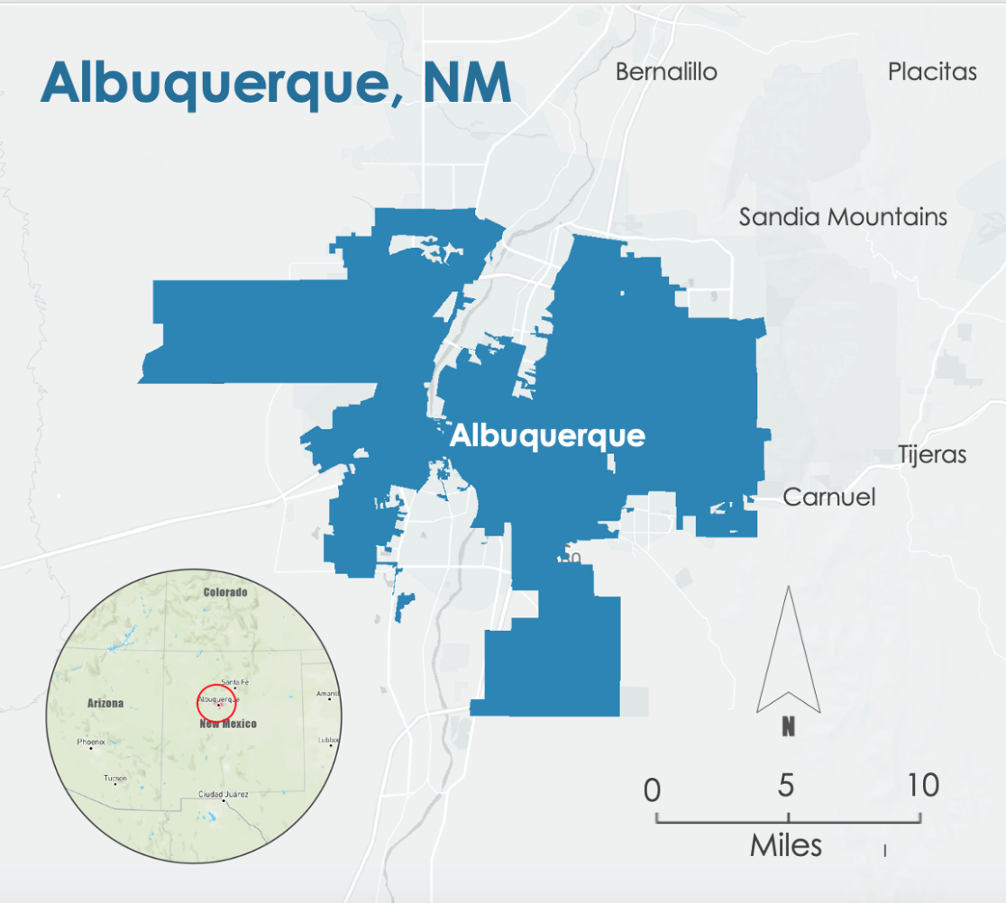
Figure 1. Study Area of Albuquerque, New Mexico
(Municipal Boundary Source: https://www.cabq.gov/gis/geographic-information-systems-data,
Mapbox basemap)

3. Methodology
3.1 Data Acquisition
The data collected for the analyses within this project are listed in Table A1 and A2. Table A1 labels the NASA Earth observations and datasets used, and Table A2 lists the ancillary datasets.

The Albuquerque Urban Development team obtained Landsat 8 Thermal Infrared Sensor (TIRS) Level 2, Collection 2, Tier 2 data from the Google Earth Engine Catalog. The data have a spatial resolution of 100m with the LST product gridded at 30m. Images with less than 20% cloud cover were selected. The surface temperature from band 10 was re-scaled before being averaged over the study period in ArcGIS Pro. Once averaged, these data were input into the InVEST model. To make evapotranspiration maps, the team obtained data from the International Space Station ECOsystem Spaceborne Thermal Radiometer Experiment on Space Station (ISS ECOSTRESS) for the study period of 2016–2022. We obtained the ECO3ETPTJPL Version 1 instantaneous ET layer from the Application for Extracting and Exploring Analysis Ready Samples (AppEEARS) through the Land Processes Distributed Active Archive Center (LPDAAC) as GeoTiff files clipped to our study area.

In addition to remotely sensed satellite data, we used various ancillary datasets to help analyze the urban heat island’s effect in Albuquerque. We obtained in situ air temperature data from the Climate Adaptation Planning and Analytics (CAPA) Urban Heat Island Map provided by the National Integrated Heat Health Information System (NIHHIS). The team also utilized data that provided inputs for the ENVI-Met and InVEST models. Building footprint data provided by the City of Albuquerque served as the input for building intensity for InVEST. ENVI-Met input data were obtained from the Real-Time Mesoscale Analysis (RTMA) produced by the National Oceanic and Atmospheric Administration (NOAA) and the National Weather Service (NWS), which provided inputs for air temperature, wind speed, and wind direction. Land cover data inputs including impervious surfaces were obtained from the USGS National Land Cover Database (NLCD) and the Multiresolution Land Characteristics Consortium (MRLC) for both ENVI-Met and InVEST. We used The Nature Conservancy of New Mexico’s 2020 tree canopy raster as input for InVEST.

Table A1
Platform/ Program | Sensor | Product ID | Purpose | Dates Used | Acquisition Method | Spatial Resolution
Landsat 8 | TIRS | LANDSAT/TIRS/L T08/C02/Level-2 | Calculate daytime LST for input into calculating a heat vulnerability score. Calculate albedo from surface reflectance bands. | June 1st – August 31st of 2019–2021 | Google Earth Engine (GEE) Catalog | 30-meter
ISS | ECOSTRESS | ECO2LSTE.001 | Calculate nighttime LST for input into calculating a heat vulnerability score, create evapotranspiration map as an input for InVEST | June 1st – August 31st of 2019–2021 | AppEEARS | 70-meter

Table A2
Parameter | Provider | Purpose | Dates Used | Source & Product ID | Resolution
CAPA Urban Heat Island Map | NOAA NIHHIS | Validated and provided in situ air temperature | 2018 | NOAA Climate Program Office - NIHHIS | Census tract
Tree canopy | The Nature Conservancy- derived from National Agriculture Imagery Program | Used as tree canopy input in InVEST model | June – August 2020 | The Nature Conservancy  Albuquerque Metro Canopy Cover 2020 | 30-meter
Building footprint | City of Albuquerque | Used as input for building intensity in InVEST model | 2016 | City of Albuquerque GIS data | Individual building structure
Temperature | NOAA & NWS RTMA | Used as meteorological input for ENVI-Met model | June 14th 2021 | GEE  Real-Time Mesoscale Analysis | 2,500-meter
Wind speed
Wind direction
Temperature | NOAA & NCEI | Used as meteorological input for ENVI-Met model | June 14th 2021 | National Centers for Environmental Information  Integrated Surface Dataset (Global) | N/A
Wind speed
Wind direction
Cloud cover
Cloud altitude
Land cover | USGS | Used as input for InVEST | 2018 – 2019 | USGS NLCD | 30-meter

3.2 Data Processing
3.2.1 UHEAT 2.0
The Urban Heat Exposure Assessment Tool (UHEAT 2.0) was developed by a Spring 2022 DEVELOP team and was utilized in this project. The tool incorporates US census tract American Community Survey estimates, Earth observations, and other freely available data to generate output maps that hierarchically define areas of interest within a study area. UHEAT 2.0 uses a Principal Component Analysis (PCA) to identify correlation patterns using three sets of criteria: Kaiser Criterion (providing a list of eigenvalues), Explained Variance (providing the ratio of variance within the components), and Parallel Analysis (a comparison of a random simulative data set to an actual data set to produce eigenvalues). These criteria allow for the optimal selection of components, resulting in three map products. The first map the tool produces visualizes the heat vulnerability score by census tract, calculating outputs from socioeconomic variables, which include total population, median income, percent minority population, percent below the poverty line, percent population over the age of sixty-five, percent population over the age of sixty-five who live alone, and percent population who live alone. All of these socioeconomic factors contribute to a greater risk of complications due to extreme heat events. The second map visualizes the heat exposure score by calculating outputs from biophysical variables. These variables include daytime LST, nighttime LST, normalized difference vegetation index (NDVI), normalized difference built-up index (NDBI), normalized difference water index (NDWI), and albedo. The final map visualizes the Heat Priority Score in a map that aggregates the two sets of variables to identify census tracts that present the highest risk to human health. Heat priority maps were generated for Julian days 180–200 from 2016 to 2020 which are typically from the last days of June through mid-July.

3.2.2 InVEST Urban Cooling Model
The team used Stanford University’s Natural Capital Project InVEST 3.11 Urban Cooling model to create a heat mitigation index of the City of Albuquerque’s current tree canopy, and of a hypothetical increased tree canopy. The model uses evapotranspiration, land cover, shade, albedo, and distance from cooling islands (like parks) to create the index that estimates how vegetation reduces temperature. To run the model, we needed raster files of land cover and evapotranspiration, and a biophysical table describing attributes of the land cover, an area of interest, and meteorological values.

3.2.2.1 Landcover
Landcover is the crucial element of the InVEST model. It uses the landcover raster to determine the spatial resolution of its output files, ours being 30m. We used GEE to clip the NLCD 2019 layer to the study area and exported that image to Google Drive to download as an input for InVEST. The most recent data are from 2018–2019. In ArcGIS Pro v3.0.0, we projected the layer to EPSG 2826 (NAD 1983 HARN State Plane New Mexico Central FIPS 3002), the desired projection from our project partner. InVEST requires each raster to be in meters, so we had to choose the version of the projection that displays the raster in meters. Normally, InVEST analyzes biophysical values of a land cover type over the whole study area, but the partners were interested not only in a city-wide scale, but also in a census block group scale. Breaking the land cover up by census block groups allowed us to find the biophysical values for more specific geographies, which created more nuanced outputs. In ArcGIS Pro, we started by rasterizing the census block group vectors. We then multiplied the land cover raster by 100,000, to give us space to add the field ID of each census block group to the land cover ID (the field ID of these census block groups ranged from 1 to 1000). That calculation gave us a new value like 210108, where 21 is the land cover code for developed, open space land, and 0108 is the census block group with a field ID of 108. Doing this provided us with approximately 3,000 unique combinations of land cover and census block groups, with most census block groups containing multiple types of land cover. Once we created these geographies, we could easily run specific scenarios depending on the partner’s needs.

3.2.2.2 Evapotranspiration
We used ECOSTRESS’s instantaneous evapotranspiration data to create a composite image of evapotranspiration during the daytime from June 2019. This was accomplished by importing the evapotranspiration GeoTiff files from AppEEARS into ArcGIS Pro and using the composite bands tool to combine the images into a composite raster that was then exported to the InVEST model. The model resamples all input rasters to match the resolution of the land cover raster, and since we used a 30m resolution NLCD land cover file, the model resampled the 70m resolution ECOSTRESS file to 30m. Before running it through the model, we converted the units from W/m² to mm/day, since the AppEEARS application outputs evapotranspiration in latent heat flux units.

3.2.2.3 Building Footprints
We used building footprint and land use shapefiles provided by the City of Albuquerque to create a map of built infrastructure footprints. These shapefiles were spatially joined together in ArcGIS Pro in order for each building to have an associated type based on its intersecting land use category. We then added a “type” integer field to the resulting vector layer to specify the associated type for each building.

3.2.2.4 Shade
For shade, we used The Nature Conservancy in New Mexico’s Albuquerque 30m canopy data, which they created from 2020 National Agriculture Imagery Program (NAIP) imagery. Since this resolution matched the landcover imagery resolution, we only had to snap the NAIP file to match the landcover grid. We then used the Zonal Statistics tool in ArcGIS Pro to find the mean shade value for each land cover/census block group type and joined those values to our biophysical table.

3.2.2.5 Albedo
The team used the Spring 2020 DEVELOP Philadelphia Health & Air Quality team’s Google Earth Engine code to create an albedo raster as an input for InVEST. The script weighs the bands SR_B2, SR_B3, SR_B4, SR_B5, SR_B6 which are Blue, Green, Red, NIR, SWIR1 and SWIR2 respectively (Olmedo, Ortega-Farías, de la Fuente-Sáiz, Fonseca- Luego, & Fuentes-Peñailillo, 2016). We modified the code to retrieve albedo from Landsat 8 surface reflectance Tier 2 data from 2018 to 2022 in the summer months from June to August (Equation 1).

$\text{albedo} \text{=} \left(\text{Blue} \text{⋅}\text{0.246+Green}\text{⋅}\text{0.146+Red}\text{⋅}\text{0.191+NIR}\text{⋅}\text{0.105+SWIR1}\text{⋅}\text{0.008+SWIR2}\text{⋅}\text{0.008}\right)$ (1)

We then used Zonal Statistics as Table tool in ArcGIS Pro to find mean albedo for each land cover/census block group type and joined those values to our biophysical table.

3.2.2.6 Crop Evapotranspiration (kc)
InVEST uses crop evapotranspiration to predict the real evapotranspiration of each cell because the model assumes you are using a potential evapotranspiration raster. We had actual evapotranspiration from ECOSTRESS, so to force the model to use those values, we set each kc value in the biophysical table to 1.

3.2.2.7 Green Space
We communicated with our science advisors to decide if each land cover type should be considered a green space (0 or 1 in the biophysical table). They advised us that to be considered a green space, the land cover had to provide shade to humans. We, therefore, gave a value of 1 only to forests and woodlands, and land cover type 21 (developed, open space) because that includes many parks and golf courses. Partners can tweak this depending on the geography. At first, we labeled open water as a green space, but we found that the only open water in our study area is the Rio Grande, which is shallow through Albuquerque, making it unlikely to have any significant cooling effect. Also, during the time of our project, the Rio Grande ran dry. We, therefore, decided open water wouldn’t have a cooling effect and gave it a value of 0.

3.2.2.7 Envi-Met Processing
To understand thermal comfort in Albuquerque neighborhoods and to simulate how additional tree cover would benefit residents from extreme heat conditions, the ENVI-Met climate model was used. ENVI-Met creates a three-dimensional microclimate simulation that can be used to investigate the thermal environment, including urban heat islands, using computational fluid dynamics to assess meteorological variables around different forms of architecture (Cortes et al., 2002). The ENVI-Met simulation performed for this example is located in the South Broadway neighborhood in Albuquerque, around Eugene Field Elementary School. The area selected a portion of South Broadway, an area of high heat vulnerability, shown through the UHEAT 2.0 model, and an area of interest to our community partners. This area of focus around a school and its nearby residential neighborhood aligns with their goal of having one tree planted for every child in Albuquerque, and emphasizes access to safe, outdoor spaces for play and learning.

The modeled intervention is located in the Eugene Field Elementary School neighborhood of South Broadway. It is bordered to the east by Walter Street, Arno Street to the west, with Santa Fe Avenue bordering the south, Hazeldine Avenue to the north, and Edith Boulevard through the middle. Google Street View was utilized to roughly predict building material, surface material, and tree types. The area is characterized by extensive parking lots around the school and nearby church, and a dense residential area separated by concrete driveways. Houses and buildings are separated from roadways by road verges, which provide infrastructure to plant additional street trees. However, the high impervious surface area in this urban environment prevents large-scale planting. Therefore, if sufficient investment is made to clear surfaces for tree planting, an ample cooling benefit may be experienced for residents, students, and pedestrians.

To run the ENVI-Met simulation, different meteorological data parameters were used, including wind speed, wind direction, temperature range, humidity range, cloud cover, and microscale roughness length of the surface. Temperature and humidity ranges, as well as a wind speed of 8.5 m/s were acquired from the Automated Surface Weather Observing System’s (ASOS/AWOS) public meteorological dataset for the hottest day in Albuquerque in 2021, June 14th. Cloud cover was approximated from ASOS/AWOS as well, and the remaining inputs were set as default values through ENVI Guide’s beginner level.

3.3 Data Analysis
3.3.1 InVEST Urban Cooling Model
The team started by running the InVEST Urban Cooling Model for current tree canopy conditions, meaning we kept the mean shade values from the original canopy cover raster. The City of Albuquerque ideally would like to increase the urban canopy to 30%, but our partners informed us that that may be an unrealistic goal for the city’s ecosystem and that 10% is likely more feasible. Therefore, after running the current conditions, we ran scenarios of 10%, 20%, and 30% canopy increases. We only increased the shade (tree canopy) to developed areas (land cover codes 21, 22, 23, and 24), because the city is focusing on areas where people could pledge to plant more trees.

The model creates a heat mitigation index by combining a cooling capacity index with the distance from large green spaces (<2 hectares). The cooling capacity index is based on local shade, evapotranspiration and albedo as shown in the equation below where ETI is the evapotranspiration index of the cell calculated by multiplying the reference evapotranspiration (or in our case the actual) by the crop coefficient, which in our case is always 1 (Equation 2).

$\text{CC-day=}\left(\text{0.6*shade}\right)\text{+}\left(\text{0.2*albedo}\right)\text{+(0.2*ETI)}$ (2)

Then, if the cell is close enough to a large green space, the model adds that effect to the cooling capacity of the cell to create the heat mitigation index. If an area is not near enough, the heat mitigation is equal to the cell’s cooling capacity. The model creates various outputs, but we used the heat mitigation index, cooling capacity index, and estimated air temperature outputs to analyze and compare.

3.3.2 ENVI-Met – BIO-Met
The simulation output data were used for BIO-Met, a post-processing tool that calculates human thermal comfort indices by directly interacting with the ENVI-Met output for both current conditions and an increased tree canopy intervention, and summarizing the impact of air temperature, radiative temperature, wind speed, and humidity. Thermal comfort was calculated as a Predicted Mean Value (PMV) for a standard female, 30 years of age, 1.6 meters in height, and 60 kilograms in weight, calculated without restriction on vertical range. The interventions (Figure 2) were set on the modeled characteristics of middle-aged Oak trees (Quercus fusiformis) and Elm trees (Accolade and Frontier), both of which are labeled as top climate-ready trees for Albuquerque through Albuquerque Bernalillo County Water Authority recommendations. Trees were placed towards the south side of the neighborhood alongside Santa Fe Avenue, which has concentrated pavement and many open spaces, as well as areas for planting around the school and nearby church. The placement was more roughly staggered in south-side residential backyards based on existing vegetation and to mimic personal planting choice.
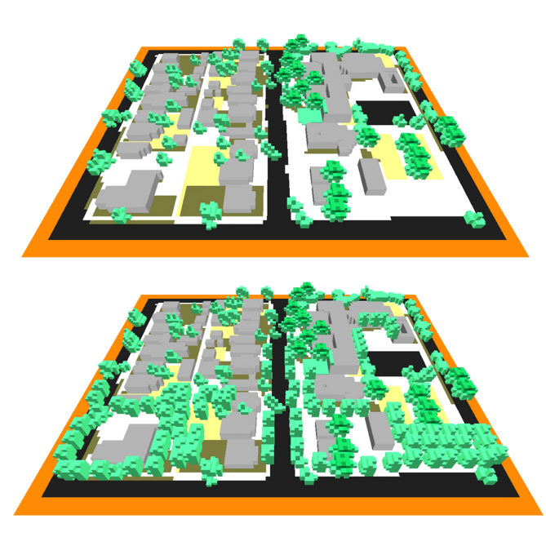
Figure 2: 3-D model of the simulated current South Broadway neighborhood conditions around Eugene Field Elementary School (top), and 3-D model of the same neighborhood with additional planted trees towards the south

4. Results & Discussion
4.1 Analysis of Results
4.1.1 InVEST Results
The physical geography of Albuquerque varies drastically from west to east. Within city limits to the west and south, is the semi-arid Albuquerque Basin, cut through by the Rio Grande River, and bounded to the east by the Sandia Mountains. These distinct geographies make the urban heat island of Albuquerque unique. Urban heat islands normally imply that the urban landscape is warmer than the surrounding rural/suburban landscape because of increased development and impervious surfaces. But, because Albuquerque is partly surrounded by a desert, while it’s still hot in the city, it’s also hot in the surrounding desert areas, specifically the desert shrubland nearer the Albuquerque Basin. These south and western portions have low index scores, not only because of urban infrastructure but also from proximity to the Albuquerque Basin. Areas closer to the Sandia Mountains and right along the Rio Grande have higher index scores. The Rio Grande is shallow and even ran dry during the time of this project, but the groundwater it creates fuels the riparian vegetation and parks along its banks, which cools down the urban environment. Within the city limits, the mean heat mitigation index value is .14 out of 1 (scores closer to zero indicate that area is doing a worse job at mitigating heat, and scores closer to 1 mean that area is doing a better job of mitigating heat) and the mean value of census block groups is .42. The highest value within the city is along the river, but is still only .67 out of 1. Right outside of the city limits in the Sandias, the values are as high as .99.
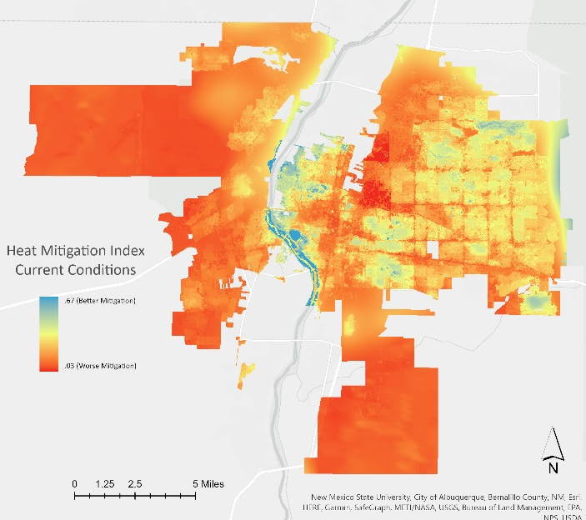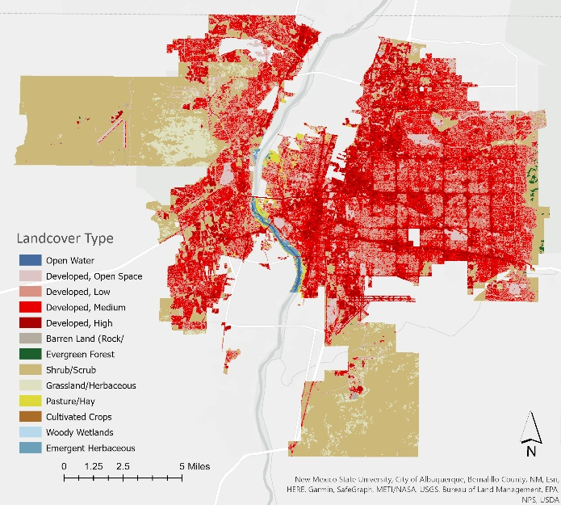
Figure 3. InVEST heat mitigation index and NLCD 2019 land cover

The InVEST model weighs physical attributes, not social attributes, so it’s important to look at its outputs alongside social data. At first glance, census block groups west and south of the city look like they need the most mitigation, but those areas are both within the Albuquerque Basin, which are not areas where the city is likely to focus tree-planting efforts. Industrial areas and large shopping centers with parking lots also stand out, which will be more important for urban forestry planning. Comparing the results to social vulnerability maps like the UHEAT 2.0 output can provide another useful frame of reference. Using land cover type and social vulnerability data makes the InVEST outputs more meaningful. One key factor that goes into UHEAT scoring that doesn’t go into InVEST indices is population. You can see in Figure 4 that the two large census tracts in the west and south have low heat mitigation scores, but they are a lower priority on the UHEAT map, since those are less populated areas. The two scores line up well in the north and southwestern parts of the city. Both maps show that some areas closer to the mountains and along the Rio Grande are of lower priority.

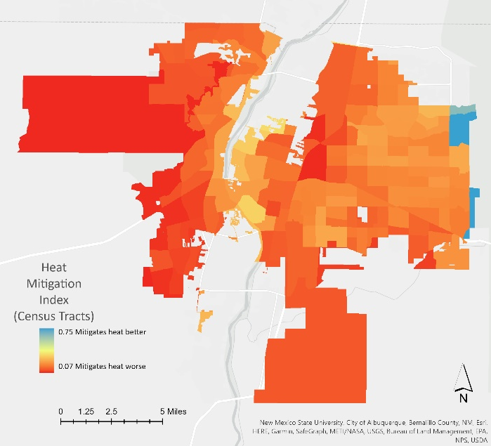 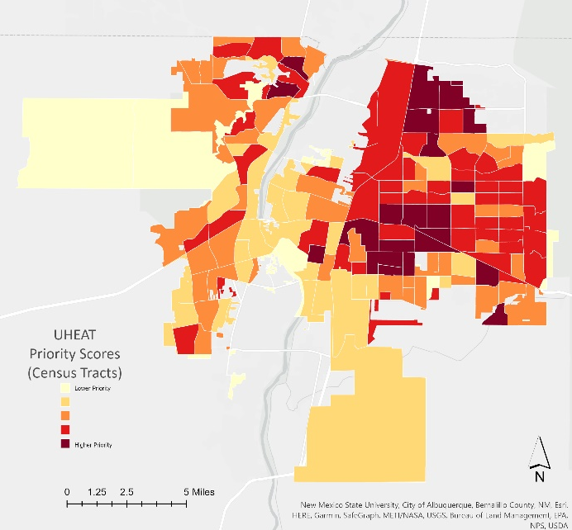 Figure 4. InVEST heat mitigation index average by census tracts vs UHEAT priority scores by census tracts

4.1.2 ENVI-Met Results – South Broadway
The results of the South Broadway thermal comfort analysis (Figure 5) visualize the thermal comfort experienced in current conditions versus a modeled intervention with increased tree canopy coverage and show that a cooling effect is created. Improvement is mostly seen in the exact location of the planted trees, which are alongside major roads, in private backyards, and bare spaces. Results are shown with the PMV model, which is a widely used and standard model for thermal comfort that depends on six factors: metabolic rate, clothing insulation, air temperature, relative humidity, air velocity and mean radiant temperature (Dyvia et al., 2021, Gilani et al., 2015). A PMV closer to 0 is considered the highest satisfaction of the environment, and index values range from -3 to +3, describing a feeling from cold to hot (Dyvia et al., 2021, Gilani et al., 2015). Area 1 of Figure 5 shows a decrease in PMV value from 2.63-2.76 down to 2.33-2.44 – a thermal comfort increase of 11.5%. Areas 2 and 3 also experienced a similar decrease in PMV value, revealing a higher level of comfort experienced by an average human with an increase in climate-ready tree planting. A high level of thermal comfort can improve morale, ability, and productivity, as well as improve the health and safety of those living and working in Albuquerque (HSE Thermal Comfort: Homepage).

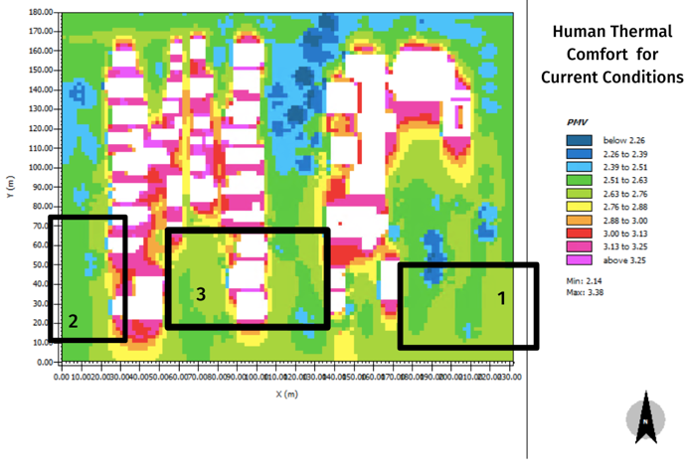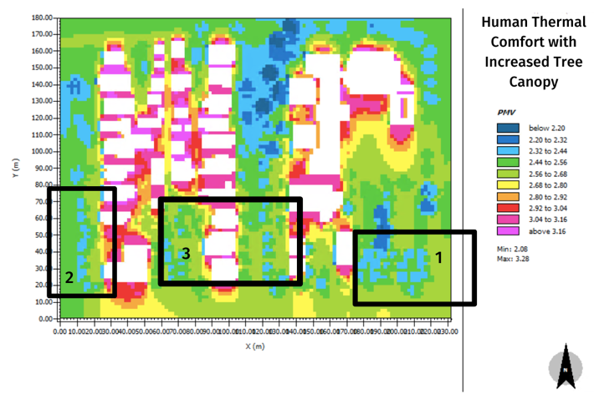
Figure 5. Thermal comfort analysis from ENVI-Met model outputs in the South Broadway neighborhood in PMV, showing conditions from June 14th, 2021 at hour 3 out of a 24-hour simulation (left), and the same area with a simulated increase in tree canopy coverage towards the south (right). The buildings are in white.

4.2 Limitations and Uncertainties
These results were limited by the quality and availability of data and the data analysis was limited by the length of the 10-week project term. For all data analysis, the spatial resolution of available data was limited, particularly the RTMA data used as an input for the ENVI-Met thermal comfort modeling. These data have a spatial resolution of 2,500 meters, making it difficult for the meteorological data to represent the fine scale of our study area. Further, ENVI-Met requires inputs of building materials, vegetation species, and surface types to accurately model fluid dynamic interactions. Because of data availability, we relied on Google Maps imagery to estimate these parameters. This limits the validity of our results as the model was created off estimates rather than in situ data. In addition, the ENVI-Met simulated increased tree canopy model has trees planted without uprooting all existing pavement. If pavement can be replaced with soil before an intervention to plant trees and then this change is mirrored in the simulation model, the thermal comfort index will most likely change. With extended time, these models can be refined further.

The LST input data used for both the InVEST and ENVI-Met models is also restrictive as it doesn’t account for human thermal comfort. Although LST can be combined with meteorological values and radiation fluxes to yield potential thermal comfort, these data don’t account for the human experience which includes personal, physical, and behavioral characteristics. The BIO-met application housed within ENVI-Met does provide personal human parameters for thermal comfort analysis including age, gender, weight, height, surface area, clothing parameters, and metabolic rate. However, parameters such as fitness level, previous exposure, adaptive capacity, and other factors are omitted. Even with a comprehensive index, it is difficult to quantify thermal comfort for diverse populations.

An additional limitation to consider concerns the definition of vulnerability. We relied on the parameters of vulnerability utilized in the UHEAT model which include total population, median income, % minority, % in poverty, % >65, % >65 and living alone, and % living alone. While these socioeconomic factors act as a baseline for vulnerability, additional metrics would provide a more nuanced definition of vulnerability that highlights the intersectionality of what makes populations vulnerable. Further, the ACS data utilized in the UHEAT vulnerability index calculations are based on 5-year estimates and is accompanied by its own limitations. In some instances, the margin of error reported in the ACS estimates accounts for >25% of the population in our modeled area, limiting the certainty of our neighborhoods selected for priority planting opportunities.

4.3 Future Work
Some possibilities for future work include collaboration with local environmental justice groups to create a nuanced definition of vulnerability for the city of Albuquerque to work with. Through engaging the local community, the project would benefit from affected party inputs regarding what metrics of vulnerability are most important to those impacted by UHIs. Further, collaborating with environmental justice groups has the potential to benefit future modeling efforts through citizen science. By asking community members to participate in the collection of data for inputs into modeling, specifically utilizing smartphone-based technology to determine vegetation species in the model area, the community gains ownership of the findings through active collaboration. Future projects would also benefit from multi-term timelines to build relationships with organizations and affected communities.

The InVEST model output’s heat mitigation index clearly defines the Rio Grande and Bosque as yielding high cooling capacity. However, as the Rio Grande has recently run dry through Albuquerque, future work can be done to model cooling capacity without the presence of the river. As the state of New Mexico continues to face drought and widespread fires, the cooling capacity of the Bosque and Rio Grande may be limited or disappear entirely. Because of this, more work can be done to model potential futures without an abundant river and forest splitting the city in two. Additionally, future work can be done regarding the economic valuation of shade. The partners have expressed a keen interest in the valuation of a square foot of shade and how it relates to diminished spending on heat-related healthcare costs. Further, the InVEST model has the potential to quantify the economic benefits of shade as it relates to energy costs which can be modeled.

5. Conclusions
Based on the analyses, we were able to identify and visualize areas that could be prioritized for tree planting initiatives by the City of Albuquerque. As evidenced by our ENVI-Met simulations, increased location-specific interventions are likely to increase microclimate thermal comfort. Additionally, the InVEST model output shows increased cooling capacity across the city as a result of such interventions. The Heat Vulnerability indices provided a more nuanced visualization of social and biophysical variables' effect on vulnerability within the city. While looking at LST or thermal comfort alone might yield the hottest areas within Albuquerque to plant, the addition of socioeconomic variables allows our team to identify which areas would benefit the most from tree-planting efforts. By comparing heat vulnerability, tree-canopy cover, and heat mitigation and cooling capacity across the city, the City of Albuquerque will be able to prioritize specific areas for tree-planting that will yield the highest impact. Several neighborhoods would be ideal for prioritization. These include neighborhoods like Nob Hill, the International District, sections of South Broadway, as well as residential neighborhoods on the west side of the Rio Grande, south of the old Route 66. Not only will these results help inform our partners with the City of Albuquerque with regard to planned tree-planting interventions, they will also aid in efforts by the city to inform stakeholders of potential urban cooling strategies and cooling benefits. The City of Albuquerque will be able to distribute both a leaflet and a tri-fold brochure produced for the aid of information dissemination regarding our findings as well as the overall benefits of heat mitigation. All of these efforts will help aid the City of Albuquerque in improving their overall standard of living, help address community health and safety concerns, improve heat resiliency, and meet the goals of the Let’s Plant Albuquerque! initiative.

6. Acknowledgments
- Sean O’Neill, City of Albuquerque (Collaborator & End User)
- Michelle Gricius, City of Albuquerque (End User)
- Denise Castillo, City of Albuquerque (End User)
- Dr. David Hondula, Arizona State University (Science Advisor)
- Dr. Kenton Ross, NASA Langley Research Center (Science Advisor)
- Ryan Hammock, NASA DEVELOP Arizona (Fellow)

The DEVELOP team would like to acknowledge that our study area and the City of Albuquerque are located on the traditional, unceded territory of the Tiwa People.

Any opinions, findings, and conclusions or recommendations expressed in this material are those of the author(s) and do not necessarily reflect the views of the National Aeronautics and Space Administration.

This material is based upon work supported by NASA through contract NNL16AA05C.

7. Glossary
ACS – American Community Survey; conducted annually to provide frequent estimates regarding the socioeconomic characteristics of communities
Albedo – The fraction of light that is reflected by a surface
Cooling Capacity – A measure of a system’s ability to remove heat
Earth Observations – Satellites and sensors that collect information about the Earth’s physical, chemical, and biological systems over space and time
ECOSystem Spaceborne Thermal Radiometer Experiment on Space Station (ECOSTRESS) – Satellite mission located on the International Space Station that measures the temperature of plants to understand how much water they need and their response to stress.
ENVI-Met – Software that simulates the microclimate of urban areas at fine scales and provides multiple tools to analyze dynamic facets of the microclimate complex
Evapotranspiration – The sum of evaporation of water from land and other surfaces and through transpiration by plants
Heat Mitigation Index – An output index from InVEST model that accounts for the cooling effect of green spaces (greater than2 hectares) on surrounding areas
Integrated Valuation of Ecosystem Services and Tradeoffs (InVEST) – A suite of models used to map and value the goods and services from nature that benefit human life
Landsat 8 – An Earth-imaging satellite from NASA, launched in 2013
Land Surface Temperature (LST) – The temperature of the surface of the Earth
National Land Cover Database (NLCD) – Data released by the U.S. Geological Survey that contains land cover data of the entire continental United States at a 30-meter spatial resolution, and provides data on percent developed imperviousness and percent tree canopy cover per pixel
Real-Time Mesoscale Analysis (RTMA) – High spatial and temporal resolution dataset that records hourly near-surface weather conditions.
Thermal Comfort – Satisfaction with the surrounding thermal environment that is subjective between individuals
Thermal Infrared Sensor (TIRS) – Sensor aboard the Landsat 8 and 9 satellites that measures both Earth’s surface temperature and atmosphere temperature
Urban Heat Island – An urban or metropolitan area that is significantly warmer than its surrounding rural areas due to how well the surfaces in each environment absorb and retain heat

8. References

Bosch, M., Locatelli, M., Hamel, P., Remme, R. P., Chenal, J., & Joost, S. (2020, July 13). A spatially explicit

approach to simulate urban heat mitigation with InVEST (v3.8.0) Geoscientific Model Development, 14,

3521–3537. https://doi.org/10.5194/gmd-2020-174

Cortes, A., Rejuso, A. J., Santos, J. A., & Blanco, A. (2022). Evaluating mitigation strategies for urban heat island in Mandaue City using ENVI-met. Journal of Urban Management, 11(1), 97–106. https://doi.org/10.1016/J.JUM.2022.01.002

De Abreu-Harbich, L. V., Labaki, L. C., & Matzarakis, A. (2015). Effect of tree planting design and tree
species on human thermal comfort in the tropics. Landscape and Urban Planning, 138, 99-109.
https://doi.org/10.1016/j.landurbplan.2015.02.008.

Dyvia H A, & Arif C. (2021). IOP Conference Series: Earth and Environmental Science Analysis of thermal comfort with predicted mean vote (PMV) index using artificial neural network. IOP Conf. Series: Earth and Environmental Science, 622, 012019. https://doi.org/10.1088/1755-1315/622/1/012019

HSE - Thermal Comfort: Homepage. (n.d.). Retrieved August 9, 2022, from https://www.hse.gov.uk/temperature/thermal/

Gilani, S.I., Khan, M. H., & Pao, W. (2015). Thermal comfort analysis of PMV model prediction in air conditioned and naturally ventilated buildings. Energy Procedia, 75, 1373-1379. https://doi.org/10.1016/j.egypro.2015.07.218

InVEST | Natural Capital Project. (n.d.). https://naturalcapitalproject.stanford.edu/software/invest

John A Volope National Transportation Systems Center. (2015). Integrating climate change in transportation and land use scenario planning: an inland example. https://www.mrcog-nm.gov/DocumentCenter/View/2221/Climate-Futures-Report-PDF?bidId=
National Oceanic and Atmospheric Administration, National Centers for Environmental Information (NCEI). (2021). Integrated Surface Dataset (Global). Retrieved August 9, 2022, from https://www.ncei.noaa.gov/access/search/data-search/global-hourly?dataTypes=AU1&bbox=35.254%2C-106.819%2C34.914%2C-106.479&startDate=2021-06-14T00%3A00%3A00&endDate=2021-06-14T23%3A59%3A59
Pataki, D. E., Alberti, M., Cadenasso, M. L., Felson, A. J., McDonnell, M. J., Pincetl, S., Pouyat, R. V., Setälä, H., & Whitlow, T. H. (2021). The benefits and limits of urban tree planting for environmental and human health. Frontiers in Ecology and Evolution, 9, 603757. https://doi.org/10.3389/fevo.2021.603757

Roy, S., Byrne, J., & Pickering, C. (2012). A systematic quantitative review of urban tree benefits, costs, and assessment methods across cities in different climatic zones. Urban Forestry & Urban Greening, 11(4), 351-363. https://doi.org/10.1016/j.ufug.2012.06.006.

Tong, S., Prior, J., McGregor, G., Shi, X., & Kinney, P. (2021). Urban heat: An increasing threat to global health. The BMJ, 375, n2467. https://doi.org/10.1136/bmj.n2467

Upreti, R., Wang, Z.-H., & Yang, J. (2017). Radiative shading effect of urban trees on cooling the regional built environment. Urban Forestry & Urban Greening, 26, 18–24. https://doi.org/10.1016/j.ufug.2017.05.008

U.S. Census Bureau (2021). Quick Facts Albuquerque City, New Mexico. Retrieved from h ttps://www.census.gov/quickfacts/albuquerquecitynewmexico

Wang, Y., & Akbari, H. (2016). The effects of street tree planting on Urban Heat Island mitigation in Montreal. Sustainable Cities and Society, 27, 122–128. https://doi.org/10.1016/j.scs.2016.04.013

Zhao, L., Oppenheimer, M., Zhu, Q., Baldwin, J. W., Ebi, K. L., Bou-Zeid, E., ... & Liu, X. (2018). Interactions between urban heat islands and heat waves. Environmental Research Letters, 13(3), 034003. https://doi.org/10.1088/1748-9326/aa9f73

