The Big Plunge at Venus: The DAVINCI Descent Phase
Matthew Garrison, Dr. Giada Arney, Arlin Bartels, Vince Elliott, Dr. Jim Garvin, Dr. Stephanie Getty, Colby Goodloe, Chetan Sayal, Richard Saylor, Ken Schwer, Michael Sekerak
NASA Goddard Space Flight Center
8800 Greenbelt Rd.
Greenbelt, MD 20771
Matthew.B.Garrison@nasa.gov

Soumyo Dutta
NASA Langley Research Center
1 Nasa Dr.
Hampton, VA 23666

Abstract—DAVINCI (Deep Atmosphere Venus Investigation of Noble gases, Chemistry, and Imaging) was selected as one of two new Discovery missions in summer of 2021 with the primary goals to study how the Venus atmosphere formed and changed over time. DAVINCI does this by making in situ measurements of the atmosphere, taking images below the cloud layer during the descent phase, and imaging the surface and clouds during two flyby science opportunities. The Descent Sphere is neither designed nor required to land on the surface so all critical science data must be taken and transmitted to a relay spacecraft prior to impact. This architecture drives the mission to a carefully-crafted concept of operations; deployments, instrument operations, and communications are choreographed to ensure the right data is gathered at the right altitude given the uncertainties in the trajectory and timeline. A complex flow of analyses and tests throughout development will validate the system’s ability to execute the mission goals. In the end DAVINCI will be ready for its one hour of descent time to meet its driving science goals.

Table of Contents
1. Introduction 1
2. Descent Science Goals 1
3. DAVINCI Flight System 2
4. Descent Phase Concept of Operations 3
5. Descent Phase Challenges 4
6. Descent Phase Validation 5
7. Entry and Descent Analysis 5
8. Summary 6
Acknowledgements 6
References 6
Biography 6

1. Introduction
Venus is an intriguing science target because of its many similarities to and significant differences from Earth. However the thick acidic cloud layer makes it challenging to study the surface and sub-cloud atmosphere from orbit, and the high atmospheric temperatures and pressures pose a challenge for in situ measurements. The only missions to study Venus from within the atmosphere are the Venera landers and Vega balloons sent by the former Soviet Union (1967-1985) and NASA’s Pioneer Venus Large Probe (PVLP) in 1978.
DAVINCI was selected in 2021 as one of a pair of new NASA Discovery missions to study Venus [1]. Where the VERITAS mission will provide global coverage from orbit, DAVINCI descent phase will study Venus from within the atmosphere. DAVINCI is planned to launch in June 2029, will conduct two Venus Gravity Assists (VGAs) with remote sensing opportunities, then conduct a probe mission over the Alpha Regio tessera in 2031.
The DAVINCI project is led by Principal Investigator (PI) Dr. Jim Garvin and deputy PIs Dr. Stephanie Getty and Dr. Giada Arney, all from NASA Goddard Space Flight Center (GSFC). The mission is managed out of GSFC with major elements contributed by GSFC, Lockheed Missiles and Space Company (LMSC), the Jet Propulsion Lab (JPL), Malin Space Science Systems (MSSS), Johns Hopkins University (JHU) and the JHU Applied Physics Lab (APL). DAVINCI is a class C mission.
2. Descent Science Goals
DAVINCI aims to answer multiple science questions about the history and evolution of Venus [2]. The mission will:
- Investigate the Origins and Evolution of the Venus Atmosphere by directly measuring abundances and isotope ratios of inert (i.e. noble) gases. Inert gases should be well-mixed below the homopause so a single measurement is representative of the atmosphere as a whole. These gases are informative of past planetary processes such as formation, atmospheric loss, and volcanic outgassing.
- Investigate the History of Water on Venus by directly measuring D/H and oxygen isotope ratios in water. Vertical gradients of these ratios will provide insight into chemical activity within the atmosphere and help differentiate between multiple theories of Venus water history. Multiple measurements are needed at various altitudes.
- Investigate the Chemical Processes at Work in the Venus Atmosphere by directly measuring trace gas abundances and trace gas isotope ratios. Similar to the investigation into the history of water, vertical gradients of these trace gases will provide information on chemical activity within the atmosphere and at the atmosphere-surface boundary. Multiple measurements are needed at various altitudes.
- Investigate Origins and History of the Tesserae by generating Digital Elevation Models (DEMs) at multiple scales, measuring the particle size distribution of the surface, and creating local and regional composition maps. DEMs require sets of overlapping broadband images with horizontal offsets. Particle size distribution measurements require broadband images with a limited field of view (FOV) at the lowest altitudes possible. Local composition maps are derived from closely-timed pairs of broadband and narrow band images.
The first three goals can only be met by directly sampling the Venus atmosphere at various depths. The fourth goal requires imaging below the cloud layer, especially in the lowest few kilometers of elevation in order to reduce the impact of haze-induced scattering. The investigation into chemical processes and the tesserae are supported by images taken during VGAs but still require instrumentation to enter Venus. None of these science goals require data collection on the Venus surface.

3. DAVINCI Flight System [3]
Architecture Overview
The Flight System (FS) in Figure 1 consists of the Carrier Relay and Imaging Spacecraft (CRIS) and Probe Flight System (PFS). The PFS consists of the Entry System (ES) and the Descent Sphere (DS). The science instruments are located within the DS and CRIS, as shown in Table 1. Further details on the payload may be found in [2].
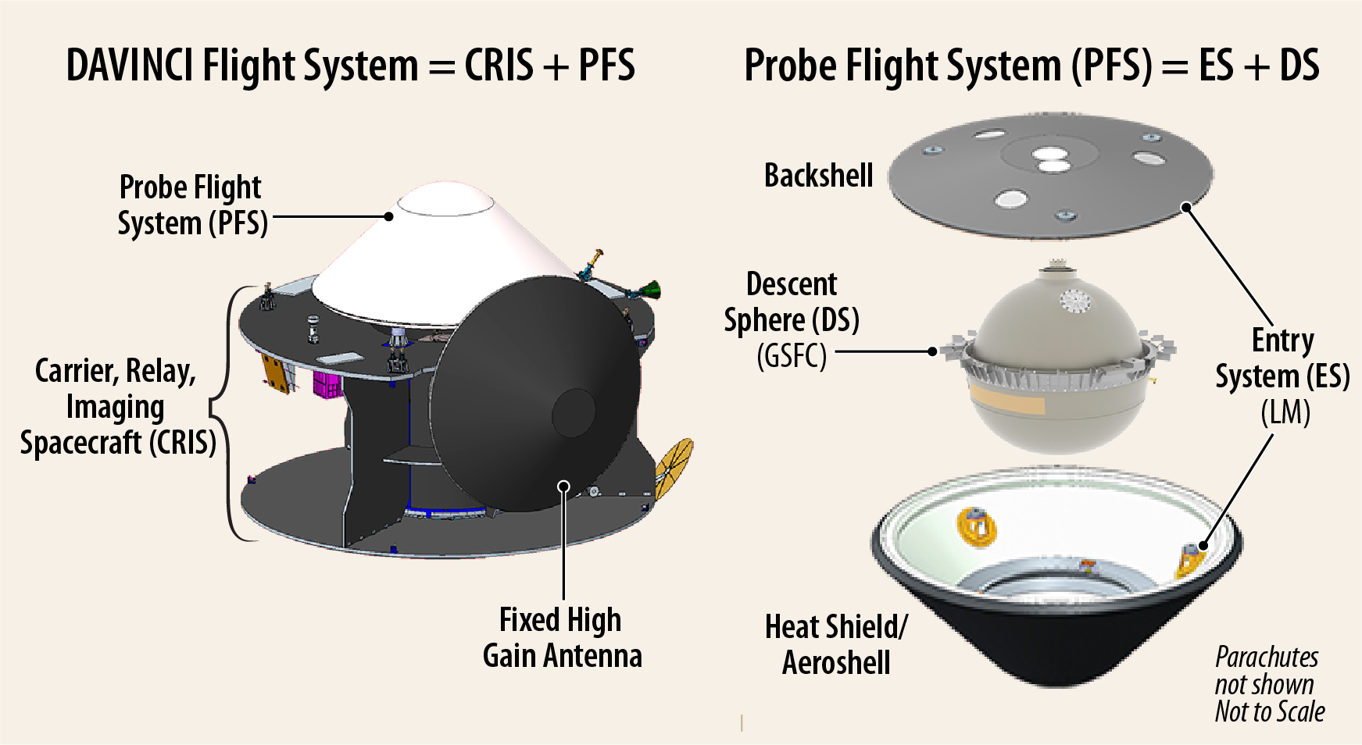
Figure 1. DAVINCI Flight System and major elements.
Table 1. Summary of DAVINCI Payloads.
Instrument | Loca-tion | Technical Approach | Prov-ider
Venus Mass Spectrometer (VMS) | DS | Quadrupole Mass Spectrometer, space-qualified turbomolecular pump, and Gas Processing System | GSFC
Venus Tunable Laser Spectrometer (VTLS) | DS | Three channel laser spectrometer with multi-pass Herriott sample cell | JPL
Venus Atmospheric Structure Investigation (VASI) | DS | Suite of commercial off-the-shelf (COTS) sensors for atmospheric pressure, temperature, and DS dynamics including three-axis accelerations and roll rates | GSFC
Venus Descent Imager (VenDI) | DS | Full-frame Charge-Coupled Device (CCD) detector with 7 element refractive system and two-position filter wheel: broadband and ~1-μm narrow-band | MSSS
Venus Oxygen Fugacity (VfOx) | DS | Solid-state ceramic oxygen sensor to measure oxygen partial pressure.  Student experiment. | JHU
Venus Imaging System for Observational Reconnaissance (VISOR) | CRIS | Integrated system of four cameras with 5 megapixel Complementary Metal Oxide Semiconductor (CMOS) detectors: one UV and three NIR | MSSS
Compact Ultraviolet to Visible Imaging Spectrometer (CUVIS) | CRIS | UV to visible, dual-band dispersion and imaging spectrometer with freeform optics and advanced onboard data processing.  Technology demonstration. | GSFC

Descent Sphere
The DS in Figure 2 supports the instrument payloads, avionics, battery, and Radio Frequency (RF) communications system by protecting them from the Venus environment. The DS provides access to the environment by way of inlet ports visible in Figure 2 for sampling the Venus atmosphere and a nadir window for descent imaging. The DS inherits PVLP flight-proven design features and materials where possible with state-of-the-art upgrades to the shells’ titanium alloy, sealing technology, RF antenna, and thermal blanketing. The DS structures are designed to withstand all driving requirements for pressure differentials, deceleration loads, and anticorrosive qualities. Stability and attitude during terminal descent are passively controlled by placement of the Center of Gravity (CG) below the center of pressure and with angled spin vanes and drag plates around the perimeter. The thermal design utilizes passive methods to increase thermal capacitance and maximize the thermal time constant during the descent into the extreme heat of the Venus atmosphere.
The energy source for the DS during Coast and Entry, Descent phases is a primary battery. The avionics and flight software are high heritage from other GSFC flight missions, respectively implementing the Modular Unified Space Technology Avionics for Next Generation (MUSTANG) and Core Flight System software architectures. These components continuously gather status and health data from the system and science data from the instrument payloads. Additionally, the data prioritization and retransmission algorithms provide the highest probability to return the critical event and science data during the descent. The DS adapts GSFC’s proven fault management design, adding fail operational and graceful degradation logic for the critical DS operations.
During the Entry, Descent phase, and Coast comm checkouts, DAVINCI’s S-band relay approach maximizes in situ science data return by utilizing a two-way coherent S-band Adjustable Data Rate (ADR) relay system. The ADR algorithm uses real-time link performance and measured receive signal strength to adjust the forward and return data rates ensuring reliable link performance and transmission capacity.
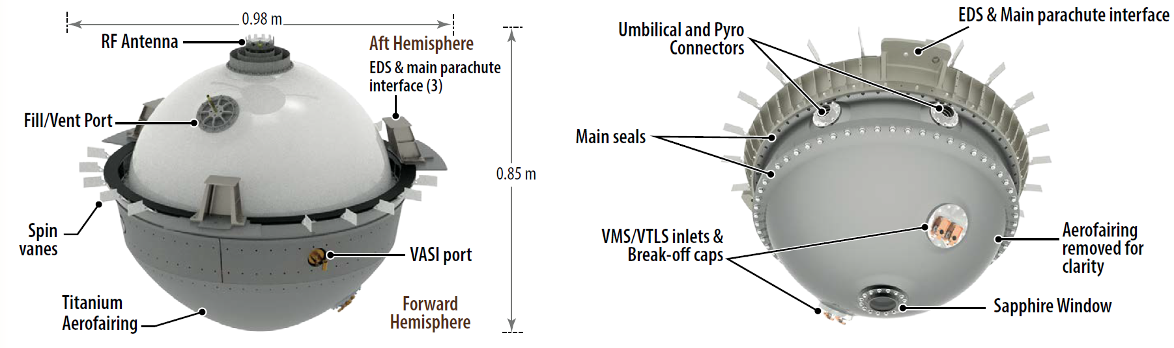
Figure 2. Descent Sphere external features.
Entry System
The ES protects the DS through peak atmospheric heating and deceleration, then deploys parachutes and extracts the DS, delivering it to descend through the Venus atmosphere. The ES is provided by LMSC and consists of the Thermal Protection System (TPS), backshell, avionics, separation mechanisms, subsonic pilot and main parachute. Similar to the PVLP, the PFS flies ballistically, without need of attitude control or propulsion, due to the inherent aerodynamic stability of its 45° forebody cone and CG location.
Spacecraft [2]
The LMSC spacecraft is based on proven designs and established hardware, software, and processes from many deep space missions including most recently InSight, OSIRIS-REx, and Lucy. The telecommunications system consists of two independent communication subsystems: a Direct-to-Earth (DTE) X-band subsystem and a S-Band relay system. The science data relay S-band subsystem is operated independently of the X-band subsystem and during the PFS release, entry, and descent sequence, establishes a two-way S-band data link with the probe flight system to receive science data. The spacecraft carries a 2.0 m S-band transmit and receive HGA and a S-band Frontier Lite transceiver also supplied by APL. Electrical power generation is provided by two body-mounted solar panels on the aft deck. Energy storage is provided by a single rechargeable Li-ion battery.

4. Descent Phase Concept of Operations
DAVINCI will launch in 2029, then will perform two VGAs over the next two years to achieve the right approach trajectory. During those VGAs VISOR will use UV imaging to study cloud motion and NIR imaging to make regional-scale composition maps of the Venus surface. This will also allow opportunities for the CUVIS technology demonstration to measure spectra of the Venus atmosphere aimed at understanding the nature of the “unknown ultraviolet absorber” responsible for absorbing 50% of incident sunlight on Venus, yet whose identity has eluded scientists for decades.
The descent phase begins on DAVINCI’s third approach to Venus on a predetermined trajectory. The FS will configure the DS for separation, which includes preheating the interior and configuring the DS avionics, then it will spin up to 5 +/-1 revolutions per minute. The PFS is then separated from CRIS and begins a 2-day coast to Venus.
After PFS separation, CRIS will spend 15 minutes in the same attitude and spin rate while imaging the PFS using the VISOR-UV camera. After 15 minutes the PFS is far enough away to avoid thruster plume impingements; at that point CRIS will de-spin and perform a divert maneuver. This maneuver will set up a CRIS trajectory that optimizes the data rates to the DS during descent and prevents the CRIS from following the PFS into Venus. Finally, the CRIS will begin tracking the estimated DS position using its HGA. It will remain in this configuration until the end of the descent phase.
PFS separation will also start execution of a coast and entry Sequence on the DS avionics. This sequence will control PFS operations for the two-day coast, including three communication checks with the CRIS to demonstrate functionality of both systems and their relay link. As the PFS approaches the estimated time of Venus Atmosphere Entry Interface (AEI) it will begin to configure the system for entry. The DS and ES systems are pre-heated and powered on, and the VASI instrument is put in a high-rate mode to capture the dynamics of entry. The VenDI camera remains off at this time.
The PFS senses entry using an accelerometer g-trigger that detects the deceleration caused by the Venus atmosphere, as shown in Figure 3. An accelerometer makes two measurements on entry: one when accelerations reach >5g and another 12 seconds later. The difference between those measurements is used to calculate when the Mach number will be <0.8 to guarantee a safe PFS deployment. This approach was used successfully on Mars Pathfinder. The g-trigger is the only piece of feedback that affects the descent phase timing; all other steps are scripted with times relative to this trigger before the start of descent phase. The timing of this g-trigger will begin execution of the Probe Deployment Sequence on the ES, the VMS/VTLS Sequence on the VMS electronics, and the Descent and VenDI Sequences on the DS avionics. That network of sequences is shown in Figure 4.
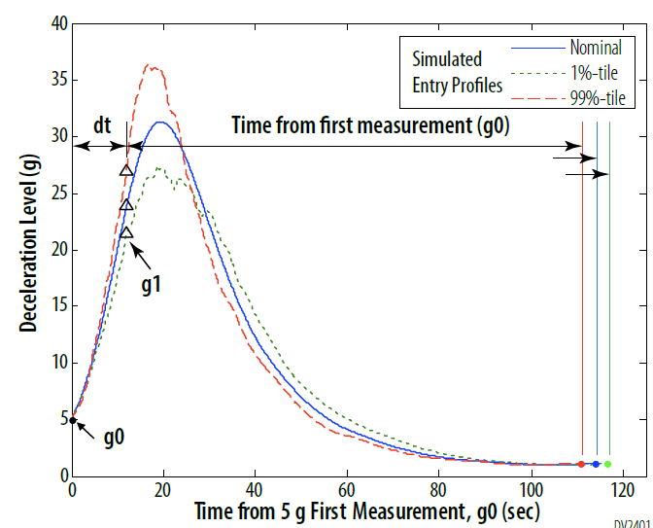
Figure 3. Example of g-trigger operation calculated in DAVINCI Phase A.
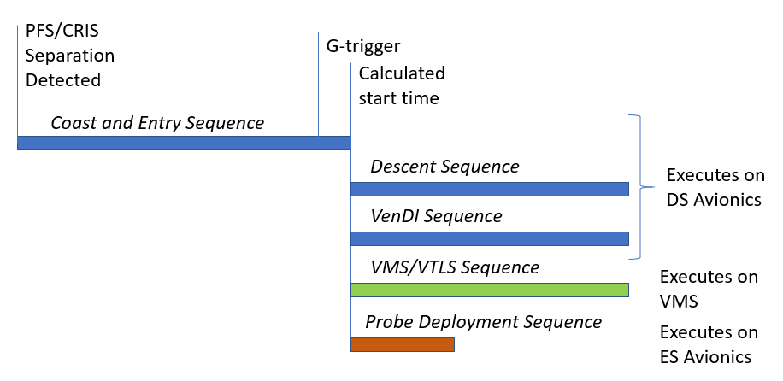
Figure 4. Relationship between the various sequences that govern the Descent Phase. The time is not to scale.

The Probe Deployment Sequence will quickly extract the DS from the ES. A mortar will deploy a pilot chute which will in turn separate the backshell and withdraw the main chute. Finally, the heat shield will separate leaving the DS descending under the main chute.
At this point the DS uses the descent, VMS/VTLS, and VenDI sequences to execute the descent phase science investigations starting above the clouds. The relay to CRIS is configured for ADR operations, allowing the DS to realize the maximum available data rates at any time. VASI is taken out of its high-rate mode to a nominal mode in order to characterize temperature, pressure, and DS motions throughout the entire descent. A pair of inlets are opened up to allow VMS and VTLS to begin sampling the atmosphere. VMS will continuously sip and sample the atmosphere, but VTLS operates by taking in a large ingest, measuring it in the instrument, then venting it to a pump-out volume in preparation for the next ingest.
VMS and VTLS will stop taking in new samples as the DS approaches the cloud tops to reduce the chance of ingesting droplets that could clog the instruments. VTLS will take an ingest before entering the clouds and integrate on it for the duration it takes to pass through the expected cloud layer. VMS will use this time to enrich and measure the noble gas makeup of the Venus atmosphere.
As the DS nears the bottom of the cloud layer it will cut the main chute and begin free-fall, reducing the amount of time to reach the surface. A longer descent time would result in thermal and power issues for the DS, and would mean the CRIS relay would have fallen below the horizon before the DS approaches the surface.
Once the DS drops below the cloud deck it opens a second set of inlets to resume VMS and VTLS samples. VenDI is powered on and begins taking a sequence of pictures. It begins by taking alternated broadband and narrow band images, then at lower altitudes switches to broadband images only. Venus has noticeable atmospheric haze and Rayleigh scattering so image resolution will increase significantly as the DS descends closer to the surface. These images are taken faster than they can be transmitted up the relay link; they are compressed and stored locally on VenDI. The DS will then request playbacks from VenDI when scripted in the VenDI sequence with the opportunity for additional playbacks if the relay link bit rate allows.
Throughout the descent the DS avionics is receiving all housekeeping and science data, sorting it into pre-determined priority tiers, then feeding that data to the relay link system. The system is designed so that all required science data can make it up the relay link assuming a conservative worst-case bit rate profile, but allows for extra science data and retransmissions in the event of a higher-performing link.
The descent phase ends when the DS contacts the Venus surface. There is no requirement to survive landing which implies a requirement to uplink all necessary science data prior to that time. The DS sequences will allow further operation in case it survives landing and maintains a link to CRIS.
A summary of the descent phase can be seen in Figure 5.
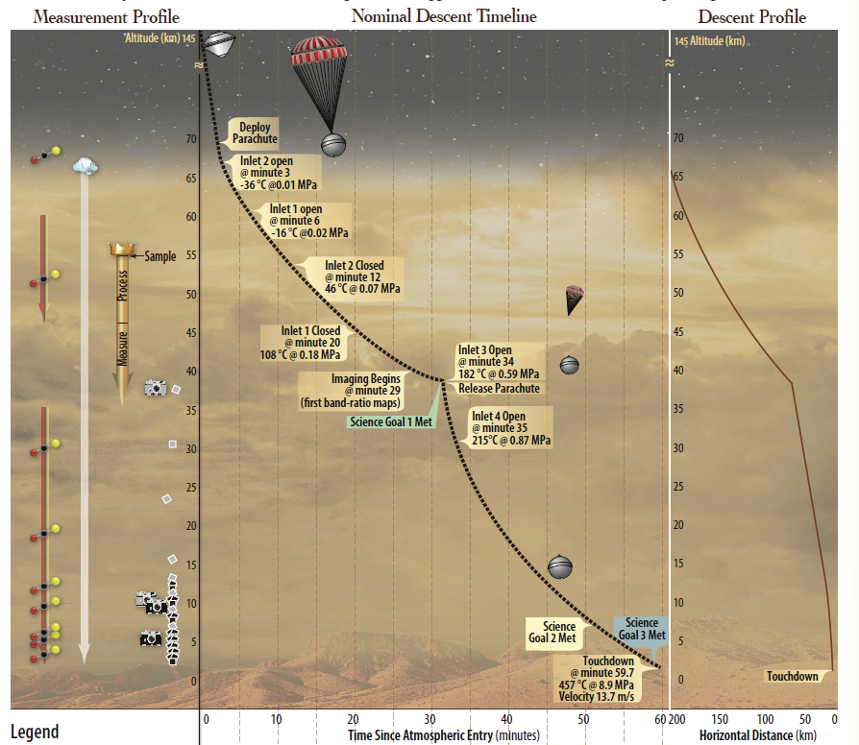
Figure 5. Descent phase trajectory and measurements

5. Descent Phase Challenges
The descent phase concept of operations presents a few engineering challenges that have to be overcome.
First and foremost, this is a single-shot operation that provides the primary science return for the DAVINCI mission. The DS has tight resource constraints that prevent widespread redundancy so instead the focus is on functional redundancy and resiliency. Every required science observation has at least one backup captured in the sequences. The only exception is the VMS noble gas measurement; it takes too much time and power to make this measurement. Instead that measurement gets a required retransmission to reduce the risk of a link error impacting that data.
There are also complications imposed by using time-determined operations given the uncertainty in the descent rates and local terrain elevation. Most of the science requirements call for measurements in given altitude bands. The sequences are designed to meet those requirements in the bounding fastest and slowest descent cases described in the next section. The only measurement available during descent to help reduce this uncertainty is the timing of the g-trigger; any timing uncertainty after that must be accounted for in sequences. An example of this timing uncertainty is shown in Figure 6.
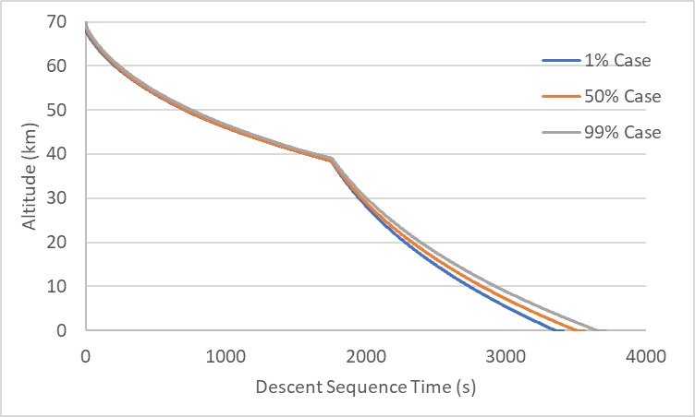
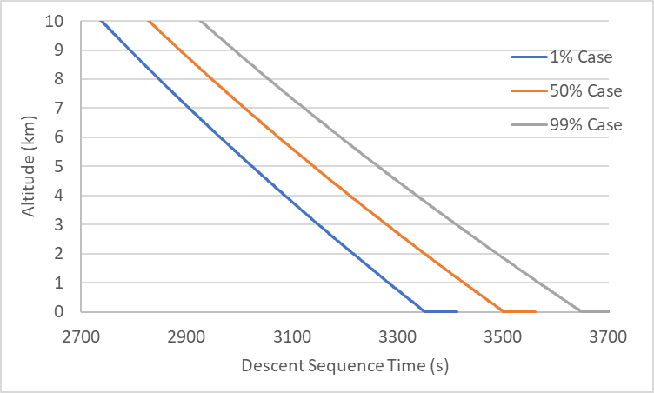
Figure 6. Estimated uncertainty of altitude above ground level during descent, including details below 10km.
Finally, there is an indetermined profile of link data rates throughout descent. The mission design must guarantee that all required science data can be transmitted in a conservative worst case, but also take advantage of every transmitted bit on a “good day.” This leads to an architecture where the DS creates more science data than is needed, then uses the priority tier system described in the previous section to feed any extra data to the relay link when available. The performance of this approach is assessed using the Monte Carlo analysis described in a following section.
6. Descent Phase Validation
It is impossible to run a flight-like test that represents the DAVINCI descent phase which increases the importance of a good validation plan. This effort is split into two pieces: validation of the requirements and validation of the system and concept of operations.
Requirements are primarily validated through a descent phase success tree using tools and processes from Model Based Systems Engineering (MBSE). Descent phase success is decomposed into goals such as “safely reach the Venus surface” and “uplink all required science data.” These goals are further decomposed into sub-goals. This process continues until a level where success is made up of a single function executed by a single element (DS, ES, CRIS, instruments, etc.). A portion of this tree is shown in Figure 7. Each node on this tree is then mapped to the hardware assembly that executes it and the requirements that describe success of that node. This allows the engineering team to audit the requirement set for completeness and correctness in the descent phase. This process is still in the works but will be completed for the system requirements reviews in 2023.
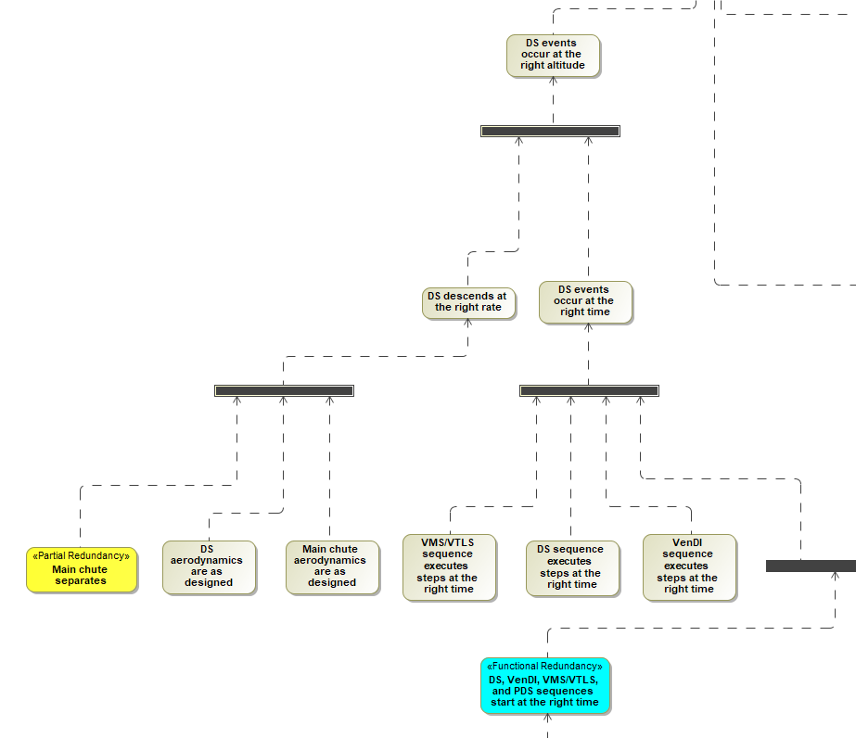Figure 7. Portion of the descent phase success tree.
The system and concept of operations are primarily validated using a set of interrelated models described in the next section. This model takes into account uncertainty on the various inputs and boundary conditions to predict the range of possible behaviors during descent. In addition to validating the system, this model is used to verify some mission requirements that can’t otherwise be tested on the ground. So much relies on this model that the project has outlined a campaign of tests and parallel analyses to make sure the model and all inputs are correct. These include wind tunnel tests to measure aerodynamic properties, descent simulation tests to measure timing of activities, and relay link tests to measure expected bit rate performance. All of this feeds a philosophy of “Validate the model to validate the mission.”
7. Entry and Descent Analysis
The DAVINCI project uses a suite of interrelated models to answer the questions:
- Can DAVINCI take all the required science measurements during descent?
- Can all the required science measurements be uplinked to the CRIS?
- Will all environments be within requirements through touchdown?
A flow of the descent phase modeling is shown in Figure 8. A flight dynamics model provides the incoming FS trajectory at the start of the decent phase. An Automated Dynamic Analysis of Mechanical Systems (ADAMS) model calculates the forces and torques at PFS separation, at which point the flight dynamics models propagate the PFS trajectory to AEI and the CRIS trajectory throughout the entire phase. At AEI a Program to Optimize Simulated Trajectories II (POST2) model [4] begins calculating the PFS entry trajectory, then continues with the DS trajectory under the parachute and finally the DS in freefall. These POST2 models are informed by aerodynamics databases calculated from a collection of aerodynamic models [5]. In parallel, a relay link model is calculating the expected bit rate based on the relative position and attitude of the CRIS and DS plus the impact of atmospheric attenuation. Finally, a data model tracks the generation, prioritization, and transmission of science data given the simulation timing and expected relay link rate. The relay link and data models are coded into POST2 and run alongside the trajectory calculations.
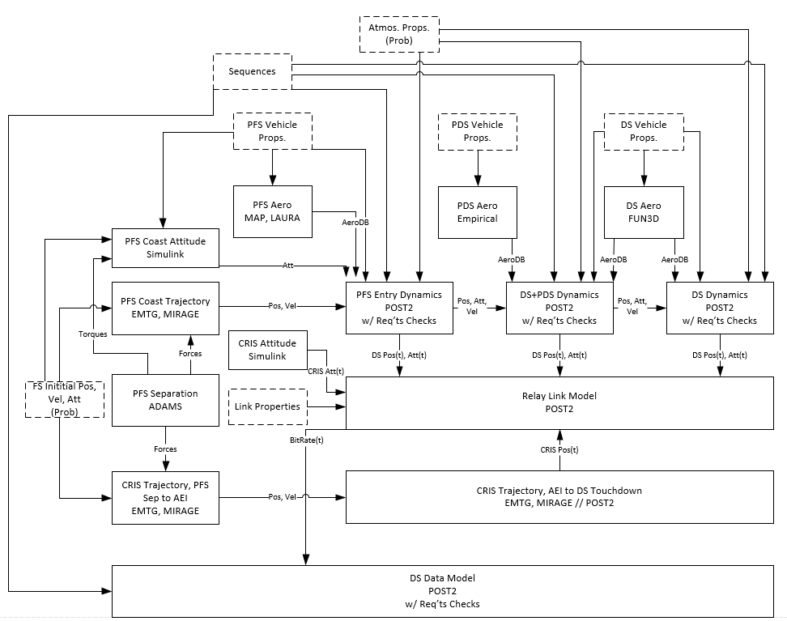Figure 8. Descent model flow.
The flight dynamics, ADAMS, and aerodynamics models all provide results including error bards. These uncertainties are sampled by the POST2 models which are run as a Monte Carlo analysis to provide estimates of uncertainty throughout the entire descent phase. All results from the analysis are reported out for the 1% and 99% bounding Monte Carlo results; cases outside of those bounds are not considered when determining requirement verification or mission success.
This model is used to automatically check compliance to DAVINCI requirements. These range from environmental requirements such as the maximum expected dynamic pressure at heat shield separation to science measurement requirements such as whether the DS can take and uplink enough VenDI images near the surface. The model creates a scorecard that shows performance against each identified requirement by showing the worst case 1% or 99% results, and what percentage of cases met the requirement. This can be used as a quick-look assessment about whether the expected descent will be successful or if it needs changes to the system or timing.
8. Summary
DAVINCI is an exciting mission that promises to greatly expand our understanding of Venus. The descent to the planet’s surface is the most scientifically-rich phase but also presents a number of exciting engineering challenges. The system design and concept of operations accommodate a range of uncertainties in timing, altitude, and available link data rates. The DAVINCI project is using a combination of MBSE and interrelated models to validate the system and concept of operations, then using a set of independent analyses and tests to validate those models. All of this will help prepare DAVINCI for its hour-long trip to Alpha Regio.
Acknowledgements
DAVINCI development support since 2011 has been provided by GSFC and LM leadership. Special thanks to the GSFC center leadership for the many IRADs that contributed to the technical development and the teams who worked those IRADs which were critical to the design maturation and success of DAVINCI.

References
[1] “NASA Selects 2 Missions to Study ‘Lost Habitable’ World of Venus,” NASA Press Release 21-073, June 2, 2021. https://www.nasa.gov/press-release/nasa-selects-2-missions-to-study-lost-habitable-world-of-venus
[2] Garvin, J., et al, “Revealing the Mysteries of Venus: The DAVINCI Mission,” 2022 Planetary Science Journal, Volume 3 117. https://iopscience.iop.org/article/10.3847/PSJ/ac63c2
[3] Sekerak, M., et al, “The Deep Atmosphere Venus Investigation of Noble gases, Chemistry and Imaging (DAVINCI) Mission: Flight System Design Technical Overview,” 2021 IEEE Aerospace Conference, 2021.
[4] Dutta, S., et al, “Modeling and Simulation for DAVINCI Entry, Descent, and Landing,” International Planetary Probe Workshop, August 2022.
[5] Guecha-Ahumada, N., et al, “Aerodynamic Testing of the Venus Descent Sphere,” International Planetary Probe Workshop, August 2022.

Biography
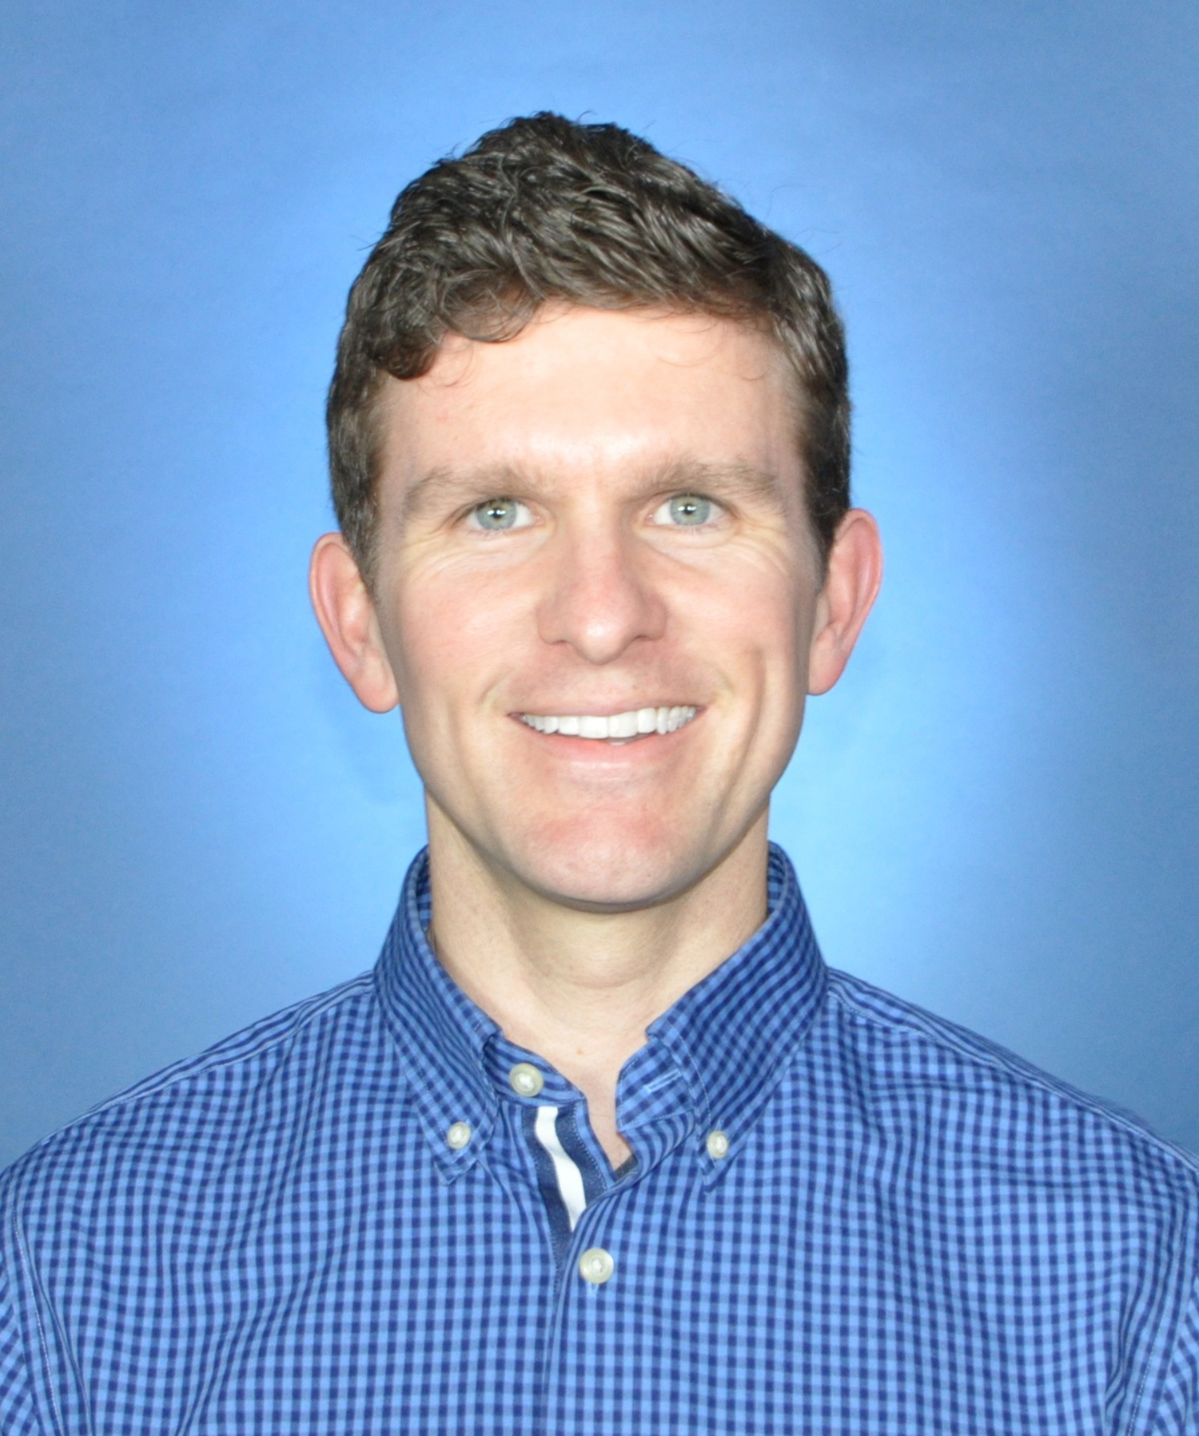
Matthew Garrison was the L’Ralph Instrument Systems Engineer. He has worked at the NASA GSFC since 2005, first as a thermal engineer and then as a systems engineer. He has supported in-house flight hardware for Earth science, planetary science, and astrophysics missions. He is currently supporting the DAVINCI mission and serving as chief engineer of the Planetary Science Projects Division.
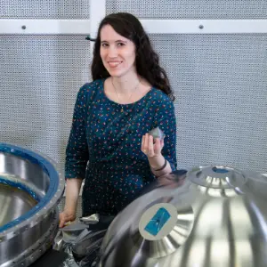Dr. Giada Arney is a Research Space Scientist in the Planetary Systems Laboratory at NASA Goddard Space Flight Center, with interests in planetary atmospheres, astrobiology, photochemistry, and exoplanets. She is a Deputy PI of the DAVINCI mission to Venus.
Arlin Bartels received a B.S. in Engineering Physics from the University of Colorado-Boulder. He has more than thirty years of systems engineering, integration and test, and management experience on flight project development and operations across NASA, DOD and commercial projects, specializing in planetary missions such as MESSENGER, LRO, MAVEN, OSIRIS-REx and Lucy. He currently serves as the Lucy/DAVINCI Deputy Project Manager.
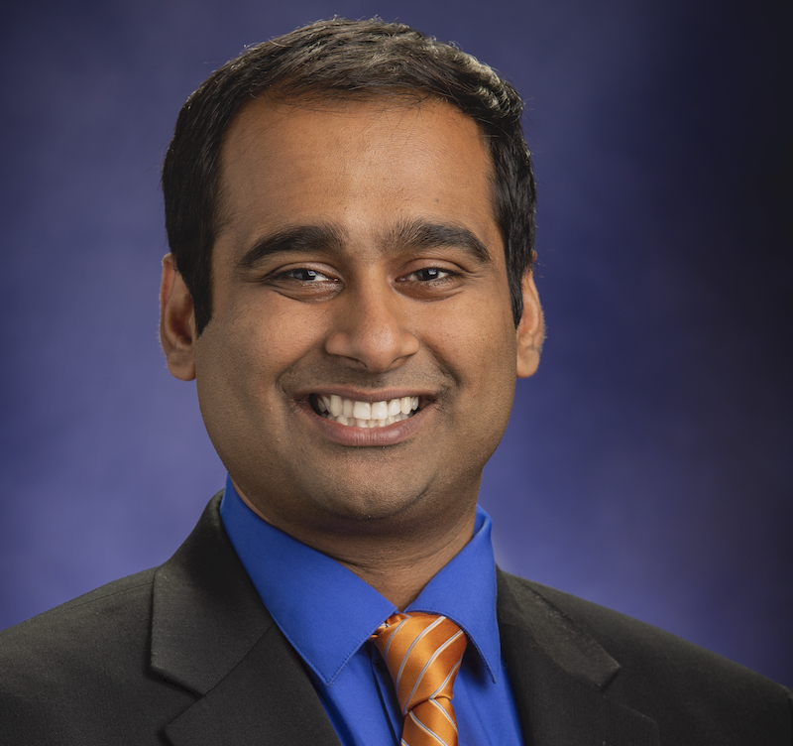 Dr. Suomyo Dutta is an Aerospace Engineer in the Atmospheric Flight and Entry Systems Branch at NASA Langley Research Center. His current research focus is flight mechanics simulation and modeling of planetary entry systems. Soumyo has working on Earth technology demonstrations, such as LDSD, ASPIRE, ADEPT SR-1, and LOFTID, has contributed to Mars landers such as Phoenix and Mars Science Laboratory, was part of the operational team for the 2021 Mars 2020/Perseverance EDL Team. Soumyo has a Ph.D. and M.S. in Aerospace Engineering from the Georgia Institute of Technology and a B.S. in Mechanical Engineering from the University of Tennessee, Knoxville.
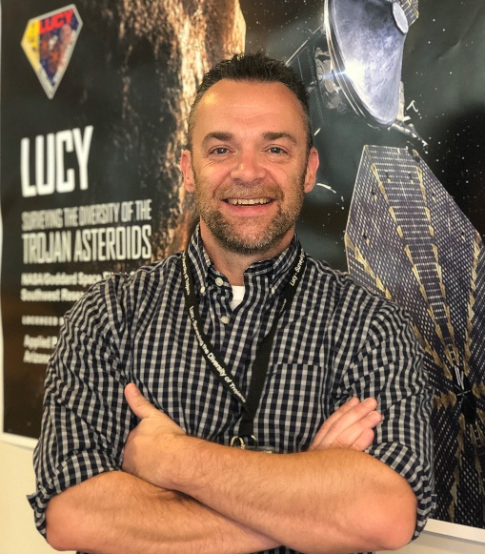Vincent Elliott is the DAVINCI DPM-R, serving as the Deputy Project Manager over all resources. He leads the day-to-day resources management of the Project and is responsible and accountable for the overall project business management to include financial and schedule performance, procurement acquisition, Earned Value Management (EVM), workforce planning and execution, and space and property administration. He is further accountable for the strategy, forecasting, and planning activities over the mission lifecycle.
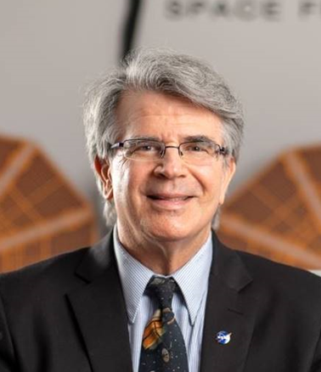Dr. James Garvin is the Chief Scientist at the National Aeronautics and Space Administration (NASA) Goddard Space Flight Center (GSFC) and Principal Investigator of the DAVINCI mission to Venus. As Goddard Chief Scientist, Garvin works with Center leaders and a large cadre of scientists to advance understanding of the Earth and its life-sustaining environment; investigates planets and moons in the solar system; and observes the wider universe beyond. GSFC is NASA’s premier science Center with over 500 civil servants and 2,000 supporting scientific staff. Dr. Garvin has an impact on the success of each science program at GSFC including his leadership of the newly selected DAVINCI mission to Venus. Dr. Garvin was appointed a Senior Technical (ST) scientist for NASA in 2001. For over 37 years, he excelled in positions of scientific leadership including: GSFC Chief Scientist, Co-Investigator on Mars InSight Lander and Mars Curiosity Rover missions, lead scientist for NASA Headquarters Mars Program Planning Group that selected the Mars 2020 rover mission, science investigator on Canadian Space Agency’s Radarsat series of missions in Earth sciences for 25 years, Lunar Reconnaissance Orbiter mission Associate Project Scientist, OSIRIS-REx New Frontiers mission to asteroid Bennu supporting scientist, and Chairman of the Administrator’s Decadal Planning Team, as well as NASA’s first chief scientist for Mars Exploration. Dr. Garvin holds a bachelor’s degree in applied mathematics/computer science from Brown University (Magna Cum Laude; elected to Phi Beta Kappa: 1978), a master’s degree in computer science from Stanford University (1979), and a Doctorate in Philosophy (Ph.D.) in Geological Sciences from Brown University (1984). He has published over 120 peer reviewed scientific papers and appeared as a Guest on Late Night with David Letterman (CBS TV) in 2004. Garvin received several prestigious awards, including: two NASA Outstanding Leadership Awards (2002, 2004); three Presidential Rank Awards (2005, 2014, and 2019); over 14 NASA Honor Awards, multiple Group Achievement awards, special recognition by the Administrator for work with NASA’s Mars Exploration Program and Lunar Reconnaissance Orbiter mission definition (2015); and the William Rogers Award, Brown University’s highest award for achievement in raising social consciousness (2004). As Principal Investigator of the DAVINCI mission to Venus, he leads a team of women and men across the USA, with over 500 colleagues supporting the June 2029 launch of the mission, which is the first by NASA to Venus’ atmosphere since 1978. In addition, he is promoting new studies of the impact cratering record on Earth, investigating recent ocean island volcanic eruptions, and developing concepts for next-generation radar remote sensing of the Moon and Mars.
Dr. Stephanie Getty is a planetary research scientist and the Director of the Solar System Exploration Division at NASA Goddard Space Flight Center. Her research interests are in the area of science instrument development for in situ planetary missions, particularly in the pursuit of understanding the origin, evolution, and processing of planetary environments in our Solar System. She is currently serving as Deputy Principal Investigator of the DAVINCI mission to Venus. She is also a member of the ExoMars Rover Mars Organic Molecule Analyzer science team. Dr. Getty is a current member of the American Chemical Society, AAS Division of Planetary Science, and the American Society for Mass Spectrometry. She is also a member of the session organizing committee of the IEEE Aerospace Conference.
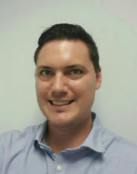Colby Goodloe received a B.S. and M.S. in Electrical Engineering from University of Maryland in 2005 and 2008, respectively. He has worked for NASA Goddard Space Flight Center since 2002 and is the Descent Sphere Lead Engineer. Previously he was the Lead Spacecraft Engineer for Lucy and Project V&V engineer for OSIRIS-REx. He also worked on electronics for GNC components and instruments for several successful missions including SDO, GPM, FASTSAT, MMS, and 7-SEAS BASELInE and others still in development including ICESAT-2 and LCRD.
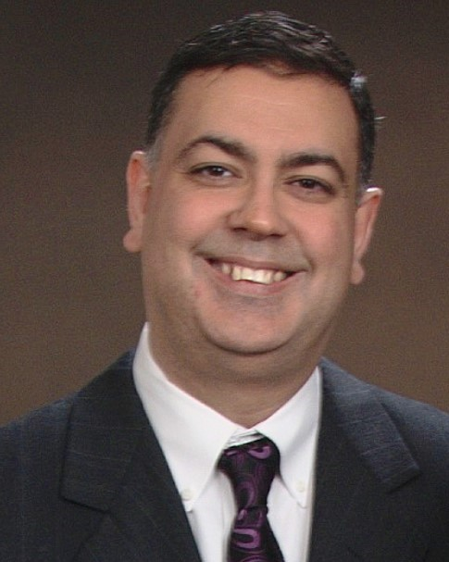Chetan Sayal received a B.S in Mechanical Engineering from the University of Maryland and a M.S. in Technical Management from the Johns Hopkins University. He is the Payload Manager for DAVINCI and the Project Manager for the Integrated LCRD LEO User Modem and Amplifier Terminal (ILLUMA-T) at Goddard Space Flight Center. Previously, he was the Mission Systems Engineer for the Space Weather Follow-On (SWFO) Ground Project and the Flight Readiness Manager for the Joint Polar Satellite System-2 (JPSS-2). He has also worked on JPSS-1 and Geostationary Operational Environmental Satellite (GOES) series of satellites.
Richard Saylor received his B.S. in Aerospace Engineering from Pennsylvania State University. He is a Mission Systems Engineer at NASA Goddard Spaceflight Center and is the Deputy Project Systems Engineer for the DAVINCI mission. He has worked a number of missions performing systems engineering roles including Mars Icemapper Mission (MIM), Lunar Reconnaissance Orbiter (LRO), Ice Cloud and land Elevation Satellite (ICESat), and NPOESS Preparatory Project (NPP). In addition, he worked 10 years on the Space Network Ground System Sustainment (SGSS) project serving as the Ground Segment Development Manager. Prior to joining NASA in 2009, he worked at Honeywell Technical Services and Allied Signal Technical Services. He served 8 years in the U.S. Army Reserves as an Army Ordnance Officer.
Kenneth Schwer

Dr. Michael Sekerak is the Project Systems Engineer for DAVINCI at NASA GSFC. He was the Deputy Project Systems Engineer for Lucy from 2017 through launch in 2021. He has worked at the NASA Jet Propulsion Laboratory, Sandia National Laboratories, Air Force Research Laboratory, and the National Security Space Institute. He is a former Armored Cavalry officer in the Army completing a combat tour in Iraq and is currently an Officer in the Air Force Reserves. He holds a B.S. in Mechanical Engineering from Illinois Institute of Technology, M.S. in Aeronautics from California Institute of Technology, and Ph.D. in Aerospace Engineering from University of Michigan researching Hall Effect Thrusters.

