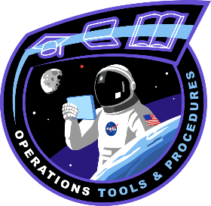

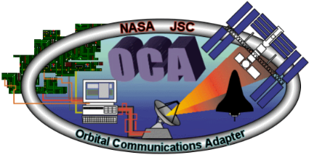
OCA
Orbital Communications Adaptor

What is OCA?
The OCA system provides the capability to transfer data (documents, imagery, video, data) between a ground PC network in MCC-H and the onboard SSC and JSL systems via Ku band.
Who is OCA?
The OCA function is part of the Operations Planner (OPS PLAN) Flight Controller position in MCC-H. An OCA Operator is on console whenever the OPS PLAN team is on console (all shifts M-F and 1 shift daily on weekends).
An OCA Specialist is typically on console 10:00-13:00 central time M-F.
OCA Capabilities:
We are the primary interface for the exchange of data and imagery between ground and the ISS JSL. To do this we use software applications called SWRDFSH and the OCA Management System (OCAMS). OCAMS allows the automation of many routine operations, including downlink and ground distribution tasks.
How we can help you:
Should your payload be assigned to the SSC System, please contact the OCA leads (see sidebar) to determine how to best design your software and process for use with our tools.

How you can help us:
Be prepared to answer questions about your data flow plan as you progress through the PIA process, such as the following:
1) How often does data need to be downlinked/uplinked?
2) What is your ground source/delivery location?
3) Estimate your file sizes and file quantity per session/day, etc.

Q: How do I contact OCA?
A: Email the OCA console leads at jsc-dl-fod-oca-leads@mail.nasa.gov

Q: What is your nominal downlink rate?
A: Approx. 70 Mbps, based on available Ku bandwidth.

Q: What is your uplink rate?
A: Approx. 6 Mbps

Q: What file sizes are you able to transfer?
A: OCA prefers file sizes of 1 GB or smaller so that our systems can efficiently downlink and distribute files. Please coordinate with the OCA leads if larger files are expected.

References:
- Generic OIP 8.2.15.1 OCA Process for Uplink and Downlink
- Generic OIP 8.2.15.3 OCAMS Customer Request Editor
Fun Fact:
Since April 2001 OCA has uplinked over 2 million files and downlinked over 18 million files. That’s over 7 TB of data uplinked and 270 TB downlinked!
FAQs:

