**Yellowstone Ecological Forecasting**

Assessing Change in Aspen Extent in Northern Yellowstone National Park

 **Technical Report**

**Final** – August 11th, 2022

Kyle Steen (Project Lead)

Vanessa Bailey

Gabriella Boodhoo

Barry McLaughlin

***Advisors:***

Dr. Marguerite Madden, University of Georgia, Center for Geospatial Research (Science Advisor)

Dr. Kunwar Singh, William & Mary, AidData, Global Research Institute (Science Advisor)

# 1. Abstract

The removal and reintroduction of the gray wolf (*Canis lupus*) in Yellowstone National Park have shaped the ecological composition of this distinct landscape, representing a textbook example of trophic dynamics. With particular importance to conservation science, researchers have studied the trophic cascades between wolves and species such as elk (*Cervus canadensis*) and quaking aspen (*Populus tremuloides*). In conjunction with the National Park Service, Yellowstone National Park, Utah State University, and the University of Wisconsin–Stevens Point, this project utilized satellite remote sensing to investigate the long-term trends in aspen extent. Through random forest modeling and phenological approaches, Landsat 5 Thematic Mapper (TM; years 1986–2011) and Sentinel-2 Multispectral Instrument (MSI; years 2017–2019) datasets were used to derive color composites, Normalized Difference Vegetation Index (NDVI), Enhanced Vegetation Index (EVI), and Tasseled Cap Indices (Brightness, Greenness, Wetness). The International Space System (ISS) Global Ecosystem Dynamics Investigation (GEDI) provided canopy height data. The team consolidated results into maps and time-series which provide an in-depth depiction of aspen stand extent. The National Park Service will use these end products to assist in its management practices and inform wildlife restoration decisions within and beyond Yellowstone National Park.

**Key Terms**

*Populus tremuloides*, trophic cascade, NDVI, EVI, random forest, phenology, ISS GEDI

# 2. Introduction

***2.1 Background Information***

A textbook example of trophic dynamics is the removal and subsequent reintroduction of gray wolves (*Canis lupus)* in Yellowstone National Park. The full extent of these changes on aspen have yet to be fully examined (Ripple & Beschta, 2012; Ripple & Larsen, 2000). Despite occupying around 1% of the lands in Yellowstone National Park, aspen supports valuable habitat, food supply, nutrient cycling, and high ecological value, thus, its decline has negative impacts for biodiversity (Brown et al., 2006). Several decades of wolf absence allowed the Rocky Mountain elk (*Cervus canadensis*) population to grow. As a result, elk browsing of quaking aspen (*Populus tremuloides*) increased, leading to mature aspen stands with no new shoots (Beschta & Ripple, 2016). Aspen stands that lack heterogeneity in age are more vulnerable to die-off and encroachment by competing vegetation (Romme et al., 2005). It is estimated that over 95% of the aspen overstory in Yellowstone National Park consist of trees over the age of 80 years (Larsen & Ripple, 2005), and the decline in young aspen biomass is widely considered to be ecologically significant due to its negative effects on biodiversity. As a species, aspen is suffering from Sudden Aspen Decline (SAD), which is described as the rapid death (typically over 1-2 years) of mature aspen clones and limited or no surviving offshoots (Hamilton et al., 2009). SAD is largely the result of drought events, but other contributing factors to aspen vulnerability include unfavorable climate conditions, fire suppression, pests, and pathogens (Worrall et al., 2013). Aspen in Yellowstone may be uniquely affected by these wolf and elk dynamics that are not present elsewhere. Since the reintroduction of the gray wolf in 1995, researchers theorized that the combination of predation and change in elk browsing behavior have supported the regeneration of aspen in Yellowstone.

***2.2 Scientific Basis***

The National Park Service holds significant interest in the preservation of biodiversity and the ecological benefits associated with the presence of aspen in Yellowstone National Park. Currently, researchers monitor *in situ* 113 (20m by 1m) transects with varying aspen presence. While the sample plots provide information on vegetative cover and aspen presence, they do not have sufficient detail across the whole northern Yellowstone region due to the limited span of the transects (Fleming, 2019; Hamilton et al., 2009).

Developments in the quantitative understanding of aspen and the restoration of the species in Yellowstone National Park could be achieved through advancing the application of remote-sensing technology for ecological forecasting. In a previous study by Hamilton et al. (2009), a regression tree classifier was used successfully to identify percentage of aspen extent in a similar landscape. Other studies used both supervised and unsupervised classification methods for landcover mapping (Lachowski et al., 1996; Wirth et al., 1996) and noted that willow and aspen have very similar spectral signatures (Hayes et al., 2014). These previous studies showed initial success using remote sensing techniques for aspen classification.

***2.3. Study Area***

The study area is the ~1530 km2 extent of the northern Yellowstone elk wintering range (Figure 1). The landcover in the area includes shrublands, grasslands, and deciduous and coniferous forests. The study area is within Montana and Wyoming. Policy for the National Park Service encourages natural regulation of populations within park boundaries including Yellowstone. Some land in the north of the study area is privately owned and subject to external factors such as hunting. The study period (1986-2019) encompasses the periods before, during, and after wolf reintroduction, which allows for understanding the top-down effects of this trophic cascade on aspen.

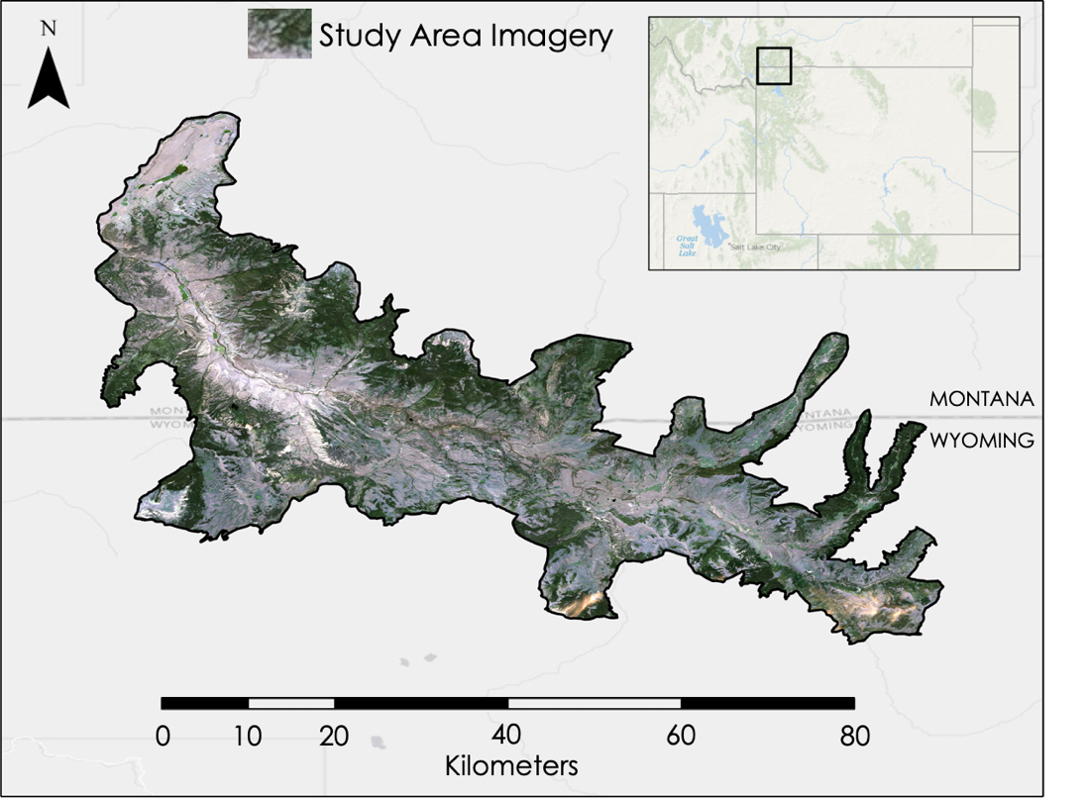

*Figure 1.* Map of Study Area, Wintering Extent of Elk in Yellowstone.

***2.4 Project Partners & Objectives***

The end user was the National Park Service in Yellowstone National Park and the collaborators included Utah State University and the University of Wisconsin – Stevens Point. Yellowstone National Park lacked sufficient data across the northern Yellowstone range to inform decision-making on aspen restoration. Therefore, the team utilized spatial analysis techniques to understand trends in aspen extent. With findings consolidated into maps and time-series, the partners gained insight into the regeneration of aspen following wolf reintroduction, which may inform future land management and decision-making.

This project had four main objectives. First, the team assessed aspen extent by performing landcover classification through a random forest model. Second, the team identified aspen extent by contrasting peak and late senescence Normalized Difference Vegetation Index (NDVI) using a phenological approach. Third, the team uncovered long-term trends in aspen stand regeneration through the creation of maps and time-series. Finally, the team investigated the feasibility of using canopy height data from the International Space Station’s (ISS) Global Ecosystem Dynamics Investigation (GEDI) to characterize aspen health.

# 3. Methodology

***3.1 Data Acquisition***

The team utilized various Earth observations including NASA and ESA satellite data from 1986–2019 in (GEE) Google Earth Engine (Table 1). The data collection focused on peak summer and senescence (change in leaf color) periods from Landsat 5 Thematic Mapper (TM) surface reflectance imagery (USGS, 2020) and Sentinel-2A Multispectral Imagery (MSI) (Copernicus, 2019). The team utilized the NASA Earthdata Search engine to find tree-canopy height data from ISS GEDI. Level 2 GEDI data are constrained to the locations of 25m footprints, every 60m, in beam paths 600m apart. Level 2 GEDI data includes tree canopy cover and profile metrics. While there are several tracks that have passed over the study area, for this preliminary exploration, the team used data collected on August 25th, 2021 to include deciduous leaf area measurements that would be lost in winter.

The team acquired Digital Elevation Model (DEM) data from the U.S. Geological Survey (USGS) 3DEP LidarExplorer with a 1/3 arc-second (~10m) resolution (U.S. Geological Survey, 2020). The team obtained training points of multiple landcover classes within the elk wintering range from the partners who have extensive knowledge of the environment. Landcover points were verified and removed or repositioned if unsuitable. They used Google Earth imagery from 2013 and 2015 to mark bare ground, water, aspen, conifer, grasslands, shrublands, and other deciduous vegetation (cottonwood and willow).

Table 1

*Satellites* *used to create aspen extent maps and vegetation profiles*.

|  |  |  |  |  |
| --- | --- | --- | --- | --- |
| **Platform & Sensor** | **Year** | **Parameters** | **Resolution** | **Description** |
| **Landsat 5 TM** | 1986, 1992, 1995, 1997, 2002, 2006, 2007, 2008, 2011 | Color composites, NDVI, EVI, Tasseled Cap Indices | 30 m | Landsat 5 TM spectral indices were used to classify aspen stand extent through random forest modeling and phenological approaches. |
| **Sentinel-2 MSI** | 2019 | Color composites, NDVI, EVI, Tasseled Cap Indices | 10 m | Sentinel-2 MSI spectral indices were used to classify aspen stand extent through random forest modeling and phenological approaches. |
| **ISS GEDI** | 2021 | LiDAR | 25 m footprints | ISS GEDI geolocated waveforms (Level 1) and canopy height and profile metrics (Level 2) were used to produce canopy height and vegetation density graphs. |

***3.2 Data Processing***

*3.2.1 Elevation, Slope & Aspect*

The team processed DEM scenes acquired from USGS 3DEP LidarExplorer into one raster image using ArcGIS Pro 2.9.0. The mosaiced raster dataset was then clipped to the extent of the study area. Slope was calculated from the clipped DEM raster, and the Aspect function was utilized to create an aspect dataset of the study area.

*3.2.2 Google Earth Engine*

The team utilized GEE to process Landsat 5 TM and Sentinel-2 MSI imagery. Potential images were filtered using the necessary dates and clipped to the study area. For the random forest approach, the team visually inspected and selected Landsat 5 images during peak summer for the years of interest. The team performed a median of images to get a composite image that fully covered the extent of the study area for 2019’s Sentinel-2. For the phenological approach, the team filtered out images with high cloud cover and took the median of suitable imagery to get data for the entire study area at the desired time periods. After gathering the images, the team viewed the raw imagery to assess usability and imported partner-provided landcover data points. The team then calculated the indices in GEE.

*3.2.3 Normalized Difference Vegetation Index*

Normalized Difference Vegetation Index (NDVI) represents the density of greenness over land, which is used as an indicator of vegetative health. The team calculated NDVI by taking the difference of near infrared light (*NIR*) and visible red light (*Red*) over their sum (Equation 1; Rouse et al., 1974). For the random forest modeling, we used peak summer imagery and calculated NDVI. For the phenological approach, we used peak summer (July) and senescence (October) periods.

$$\text{NDVI=}\frac{\left(\text{NIR-Red}\right)}{\left(\text{NIR+Red}\right)}$$

( 1 )

*3.2.4 Enhanced Vegetation Index*

The team calculated Enhanced Vegetation Index (EVI) to visualize vegetation health as well. EVI is an optimized vegetation index that differentiates variations in plant canopies. While NDVI and EVI are similar, EVI has greater sensitivity in dense vegetation areas. EVI uses near-infrared, red, and blue bands along with several coefficients. *G* is a gain factor, *C1* and *C2* are coefficients for atmospheric resistance, and *L* is a value for canopy background adjustments (Equation 2; Huete et al., 1994). For Landsat 5 TM and Sentinel-2 MSI satellite imagery, the constants and coefficients remained unchanged. They both use the same values: L=1, C1=6, C2=7.5, and G =2.5 (Huete et al., 1994). These values were taken from the Moderate Resolution Imaging Spectroradiometer (MODIS) EVI algorithm and adopted for use in Landsat 5 TM and Sentinel-2 MSI calculations.

$$\text{EVI} \text{=} \text{G}\text{⋅}\left(\frac{\left(\text{NIR} \text{-} \text{Red}\right)}{\left(\text{NIR+C1}\text{⋅}\text{Red-C2}\text{⋅}\text{Blue+1}\right)}\right)$$

( 2 )

*3.2.5 Tasseled Cap Transformation*

The team calculated Tasseled Cap Transformations (TCT; Equations 3-5; Kauth & Thomas, 1976). TCTs provides a wealth of information. The team chose to use the first three band components (brightness, greenness, and wetness) because these transformations were the most relevant for this study. Brightness is a measurement for bare ground, greenness measures green vegetation, and wetness is associated with moisture and water. The coefficients for TCT (Appendix A) are specific to each satellite sensor and result in weighted sums of the satellite bands. The bands used remained unchanged; these include the 3 true color bands (RGB), near infrared band (NIR), and shortwave infrared bands (SWIR1 and SWIR2).

$$\text{Brightness} \left(\text{b}\right)\text{=} {\text{C}}_{\text{b}}\text{1}\left(\text{B}\right) \text{+} {\text{C}}_{\text{b}}\text{2}\left(\text{G}\right) \text{+} {\text{C}}_{\text{b}}\text{3}\left(\text{R}\right) \text{+} {\text{C}}_{\text{b}}\text{4}\left(\text{NIR}\right) \text{+} {\text{C}}_{\text{b}}\text{5}\left(\text{SWIR1}\right) \text{+} {\text{C}}_{\text{b}}\text{6}\left(\text{SWIR2}\right)$$

( 3 )

$$\text{Greenness} \left(\text{g}\right) \text{=} {\text{C}}_{\text{g}}\text{1}\left(\text{B}\right) \text{+} {\text{C}}_{\text{g}}\text{2}\left(\text{G}\right) \text{+} {\text{C}}_{\text{g}}\text{3}\left(\text{R}\right) \text{+} {\text{C}}_{\text{g}}\text{4}\left(\text{NIR}\right) \text{+} {\text{C}}_{\text{g}}\text{5}\left(\text{SWIR1}\right) \text{+} {\text{C}}_{\text{g}}\text{6}\left(\text{SWIR2}\right)$$

( 4 )

$\text{Wetness} \left(\text{w}\right) \text{=} {\text{C}}_{\text{w}}\text{1}\left(\text{B}\right) \text{+} {\text{C}}_{\text{w}}\text{2}\left(\text{G}\right) \text{+} {\text{C}}_{\text{w}}\text{3}\left(\text{R}\right) \text{+} {\text{C}}_{\text{w}}\text{4}\left(\text{NIR}\right) \text{+} {\text{C}}_{\text{w}}\text{5}\left(\text{SWIR1}\right) \text{+} {\text{C}}_{\text{w}}\text{6}\left(\text{SWIR2}\right)$

( 5 )

*3.2.6 Tree Canopy Profile*

The team used the rGEDI (Silva et al., 2020) package to process the GEDI data in RStudio. The team used functions (primarily readLevel and getLevel) within rGEDI to access plant metrics from the Hierarchal Data Format (HDF) 5 file types GEDI data are available in. Following conversions to spatial points data frames, the team exported those point data to shapefiles using the raster package. The shapefiles show the shot locations within the beam paths and include attributes like ground elevation, relative canopy height, and plant area index (PAI, a ratio of leaf and woody area to ground area).

***3.3 Data Analysis***

*3.3.1 Random Forest Model*

A random forest model is a commonly used supervised machine-learning algorithm that builds decision trees to classify data into groups suggested by most trees (Hayes et al., 2014). The team used several predictor variables and partner-provided data points to run the model focusing on summer imagery. The color bands (RGB), near infrared, shortwave infrared, elevation, slope, aspect, NDVI, EVI, and TCTs were used as predictor variables. The partners provided point locations for various landcover classes (water, bare ground, aspen, conifers, grass, shrubs, and other deciduous). Following outputs that misidentified and overestimated aspen, the team decided to combine grasslands, shrublands, cottonwood, and willow into one aggregate class. The team used 80% of the partner-provided points to train the model with the other 20% used for validation. The team analyzed the role of different predictors through variable of importance graphs and assessed model accuracy with Cohen’s kappa statistic and confusion matrices for different years.

*3.3.2 Phenological Approach*

The team used partner-provided data points for both aspen and conifer to calculate NDVI for each vegetation type and study year. Aspen and conifers are distinguishable because aspen shows a change in NDVI between summer and fall while conifers are evergreen and have a relatively stable NDVI (Appendix B). Change in NDVI for the study area was calculated by subtracting fall from summer values. The team produced a histogram of NDVI difference values. After visualizing the change in NDVI and the chart of NDVI over time for each vegetation type, a threshold of 0.2 NDVI difference between summer to fall months was set with any location falling above a certain value assumed to be deciduous and the rest, non-deciduous. For 2019, a threshold of 0.5 was used to compensate for high amounts of NDVI change.

*3.3.3 GIS Analysis*

The team imported the classified aspen (random forest model) and deciduous (phenological approach) areas from GEE into ArcGIS Pro 2.9.0. Utilizing the INT (Integer) function, the team produced new layers with an integer data type value. The team created attribute tables for the INT output layers, and they were converted into identical shapefiles using the Raster to Polygon function. The team did not simplify polygons to ensure the vector outputs were identical to the input raster layers, and the team deleted the no data values. The Pairwise Intersect function was performed to identify the overlap of the two methods during each study year and to show places of consistency from different years for each method. The intersect layers were exported from ArcGIS Pro and input into GEE to calculate the area of the aspen locations.

*3.3.4 Tree Canopy Profile*

The team conducted a preliminary analysis of tree canopy height and PAI in both QGIS and R. The team displayed shapefiles of the shot locations after adjusting symbology in QGIS. The team used R to create line plots of canopy profile transects and raster images of other plant metrics (e.g., relative height and PAI). The data were included in the downloaded products and called upon with no need for manipulation.

# 4. Results & Discussion

***4.1 Analysis of Results***

*4.1.1 Random Forest Modeling*

The random forest results indicated a change from 198.98 km2 in 1986 to 67.78 km2 in 2019, a reduction of 131.20 km2 (Figure 2); only 18.69 km2 remained constant over the study period. The team calculated multiple accuracy statistics. Validation kappa statistics over the years ranged from 0.631 to 0.809 (Appendix C). Confusion matrices differed across the years, but the overall validation accuracy for all classes in the random forest model was always above 75%, ranging between 76.8% to 87.9%. Variables of importance differed over the years as well, with NDVI and NIR often being important and aspect often being of little importance. Some years did show relatively low consumer’s and producer’s accuracies for the specific aspen class, but this could be attributed to the training points being inaccurate as the imagery used was not from the same time as those used for aspen location marking.

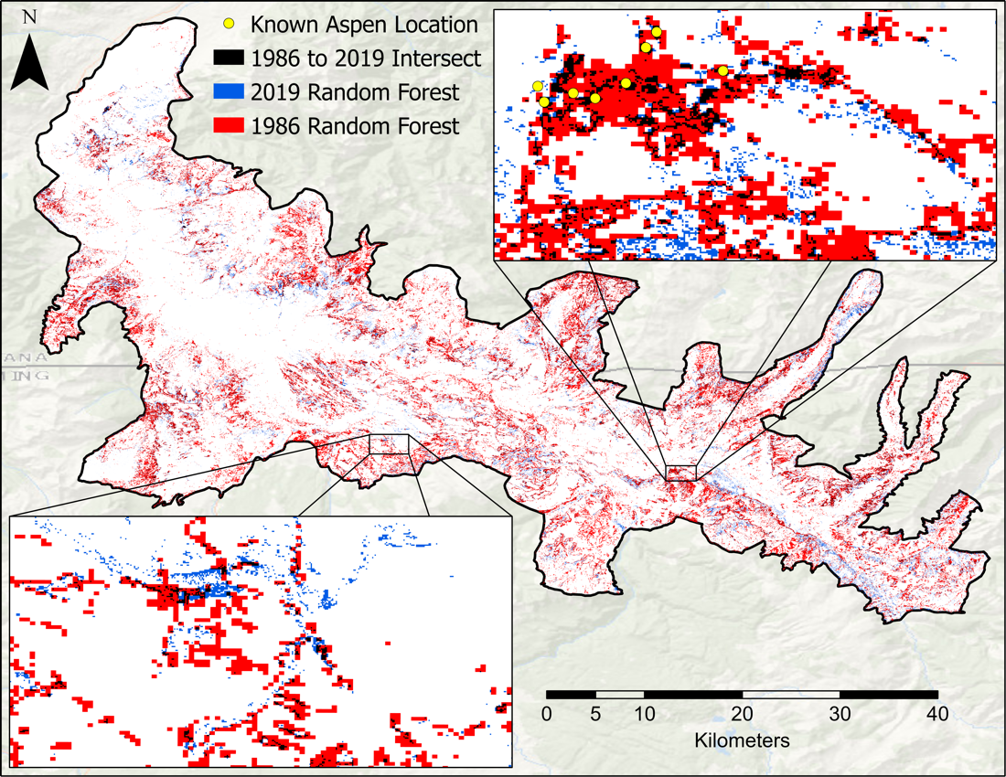

*Figure 2.* Aspen extent in 1986 and 2019 from the random forest approach.

*4.1.2 Phenological Approach*

The phenological approach differed from the random forest results. Instead, a change in deciduous area from 212.77 km2 in 1986 to 250.87 km2 in 2019, an increase of 38.10 km2, was estimated for phenology (Figure 3). 107.92 km2 remained constant.

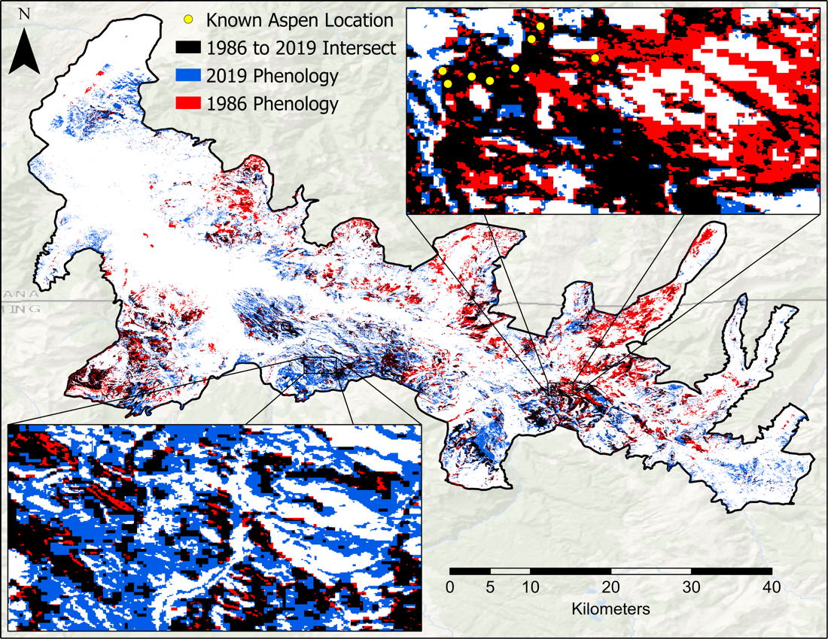

*Figure 3.* Deciduous extent in 1986 and 2019 from the phenological approach.

*4.1.3 Combined Approach*

To reduce overestimations in aspen extent and build confidence in identified locations, the team decided to combine outputs of both methods. The aspen extent differed significantly from those calculated from each individual approach. With this approach, the aspen area changed from 62.62 km2 in 1986 to 21.12 km2 in 2019. For 2019 specifically, as stated above, the random forest approach identified 67.78 km2 as aspen and the phenology identified 250.87 km2 as deciduous (Figure 4). Over the years, there were sometimes when areas identified were similar and others when the results differed considerably (Figure 5). From 1986 to 2019, the random forest method generally shows a decline in aspen extent, though this could be attributed to finer resolution in 2019. The combined approach (intersect) shows a more muted trend, that is likely overestimated with singular approaches.

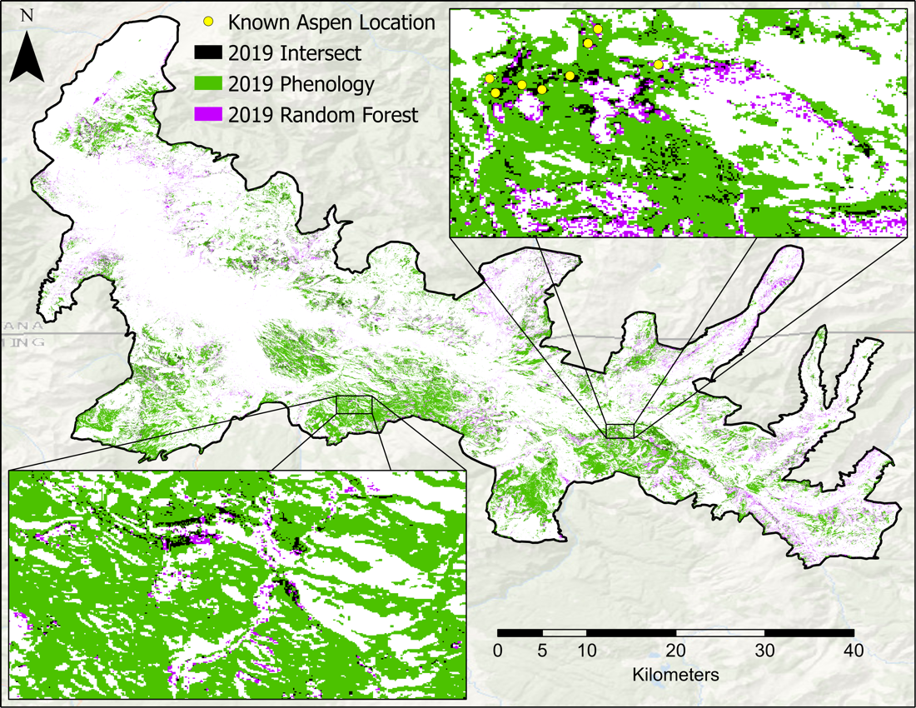

*Figure 4.* Aspen and deciduous extent for 2019 for the random forest and phenological approaches.

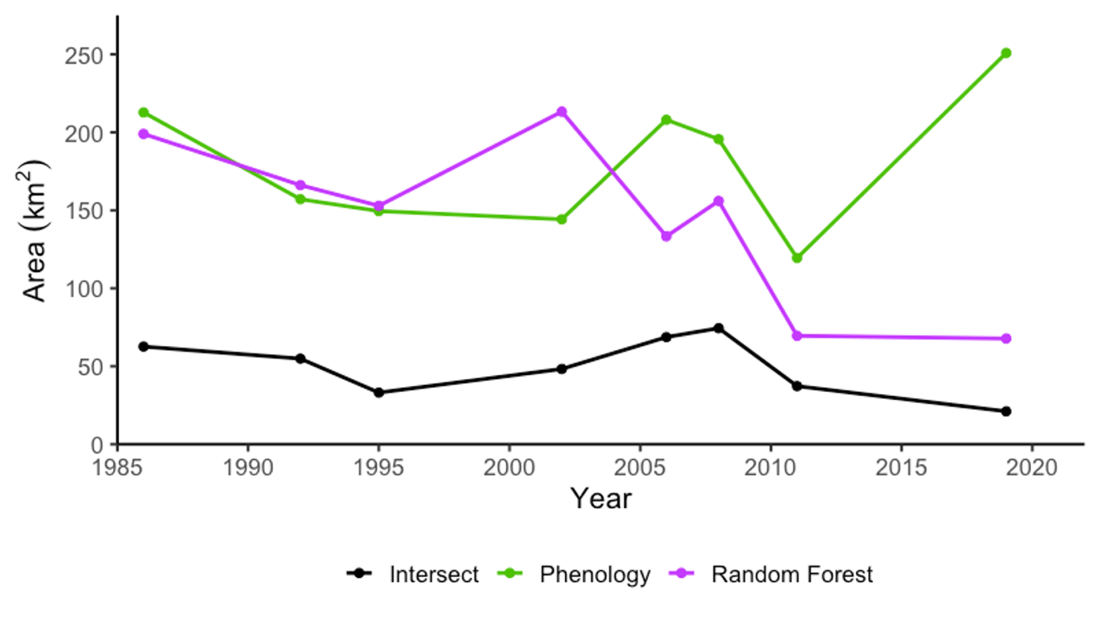

*Figure 5.* Area changes in extent for random forest, phenology, and combined (intersect) approaches.

*4.1.4 Tree Canopy Height*

The team conducted a brief analysis of profile metrics for the study area. GEDI is a useful data product for observing canopy height and PAI to depict forest health. The team plotted a transect of profile metrics to get a better understanding of forest structure (Figure 6).

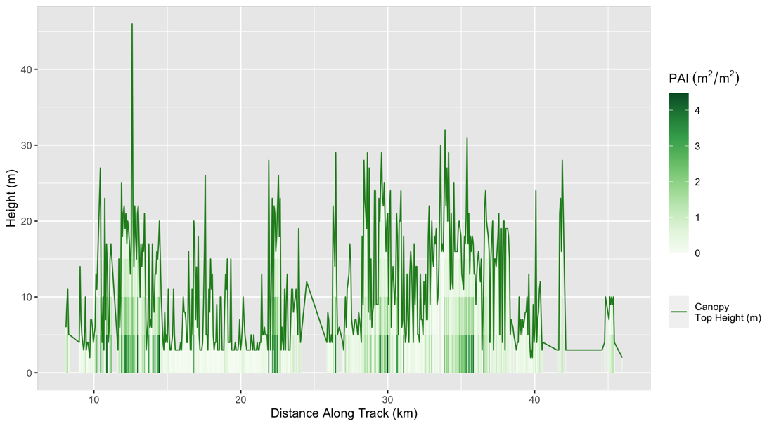

*Figure 6.* Canopy height and PAI for one transect within the study area.

***4.2 Random Forest & Phenological Comparison***

For the random forest approach, the multiple accuracy statistics (kappa statistic, consumer’s and producer’s accuracy) calculated for the model showed high promise. This approach relied on the collection of accurate training points for the desired classes. The partners provided point locations from 2013 to 2015, the default satellite imagery in Google Earth for point data designation. Using these training points for years farther back in time when they were potentially not the same landcover type could be complicating those results. On the other hand, the phenological approach is not reliant on training data. Since aspen is deciduous, there is a noticeable change in NDVI that can be used to identify deciduous vegetation. However, all deciduous vegetation, not just aspen, are included in these outputs. The increase in area in 2019 is likely attributed to the NDVI difference threshold not set high enough for that year. The change in resolution from Landsat to Sentinel likely produces the decrease in the random forest method (i.e., coarser resolution overestimated aspen area in the early study years) and the increase in the phenological approach (i.e., better detection in NDVI difference). Both approaches have benefits and limitations that are useful in identifying aspen and deciduous extent. Combining the two approaches seems to eliminate the overestimation and variability of each approach alone and builds confidence in the likelihood of aspen presence but inherently faces the limitations of both.

***4.3 Limitations***

*4.3.1 Spatial Limitations*

The primary limitation of this project was spatial resolution, especially prior to 2012. Given higher resolution satellite imagery, the random forest model and training sets would be better equipped to identify aspen extent. Coarser spatial resolution complicates aspen spectral signatures since other landcover may be included. Finer spatial resolution was only available for more recent years. GEDI footprints miss much of the study region as they are only snapshots within a greater path. The paths across the study region vary in timing and area they cover thus lacking consistency. For these reasons, this data level is missing much of the area of interest.

*4.3.2 Temporal Limitations*

Random forest uses training data points for 2015 which were provided by the partners, so the model should be more accurate in the years closest to 2015. Some of these training points may not have aspen before or after 2015, so the model may have been trained with areas of non-aspen being classified as aspen. To compensate for this limitation, the phenological approach is useful since it does not rely on training points, but a threshold of NDVI difference. The phenological approach is also limited by necessary suitable imagery twice during the year. Finding usable fall imagery often proved difficult. GEDI data also had temporal limitations; as it has only been in operation since late 2018. Information on canopy height prior to the GEDI data collection start date is unavailable. GEDI inconsistently passed over the study area throughout its mission with several measurement recordings in late fall and winter, reducing the ability to identify aspen leaf area in profile metrics.

*4.3.3 Data Quality & Aspen Site Variability*

The accuracy of the team’s results relies on the data quality. Clouds limit the usability of imagery. The team made considerable efforts to select imagery that would not be complicated by clouds, especially for the random forest approach where one image was used. There are limitations on the quality of GEDI data as well with many flagged as degraded in the metadata. Other nuances also make generating and interpreting results challenging. Aspens in the study area are found at different elevations with varying microclimates. Therefore, their response to abiotic conditions will differ. Static imagery and NDVI values may not be representative of this aspen variability. Leaves and snow may fall at slightly different times across the area, which could also complicate NDVI change each year in the phenological approach.

***4.4 Future Work***

This project will continue in the Fall 2022 DEVELOP term. The team will focus the spatial extent on specific areas of interest within the elk wintering range. Spatial resolution will be improved using PlanetScope imagery for recent years. The team will improve the temporal resolution of aspen extent maps by increasing analysis to yearly increments and explore historical aerial imagery dating back to 1985 to provide more context to aspen change. The team will perform further comparative analysis of the random forest and phenological methods and decide on which method(s) is most suitable. Once aspen extent is established, the team will analyze aspen health through NDVI and EVI time-series. Finally, the team will compare remotely sensed aspen extent and plot level data with ISS GEDI canopy height data that corresponds with the aspen stands identified in the summer team’s maps to assess stand health. The Global Land Analysis and Discovery group created the Global Forest Canopy Height dataset (Potapov et al., 2021) from GEDI and Landsat Analysis Ready Data (ARD). These data have a 30m resolution, are another option for canopy height analysis, and could be compared with established belt transects in the field.

# 5. Conclusions

Applications of satellite remote-sensing technologies can be used to advance both understanding of aspen extent and the restoration of aspens in Yellowstone National Park. The random forest modeling and phenological approaches helped the team analyze how aspen and deciduous extent have changed over time. The random forest model is useful for classifying aspen and only relies on one suitable image while the phenological approach may be more useful further back in time when identified aspen locations are not available to perform a classification. The techniques that the team deployed for this project serve as a framework for the utilization of remote sensing for aspen and deciduous presence. The end products of maps and time-series help visualize aspen presence, growth, and decline, providing insights on the impact of rewilding decisions. The partners will use these end products to both explore the effects of trophic cascades and inform decision-making on conservation efforts within the study area.

# 6. Acknowledgments

The Yellowstone Ecological Forecasting Team acknowledges the work and support of the project partners from the National Park Service at Yellowstone National Park, Utah State University, and the University of Wisconsin – Stevens Point. The team is thankful for the resources provided at the NASA DEVELOP GA node at the University of Georgia’s Center for Geospatial Research (CGR), including the DEVELOP Node Fellow, Sarah Payne; the science advisors, Dr. Marguerite Madden and Dr. Kunwar Singh; and NASA DEVELOP personnel.

This material contains modified Copernicus Sentinel data (2015-2019), processed by ESA.

Maps throughout this work were created using ArcGIS® software by Esri. ArcGIS® and ArcMap™ are the intellectual property of Esri and are used herein under license. All rights reserved.

Any opinions, findings, and conclusions or recommendations expressed in this material are those of the author(s) and do not necessarily reflect the views of the National Aeronautics and Space Administration.

This material is based upon work supported by NASA through contract NNL16AA05C.

# 7. Glossary

**ESA** – European Space Agency

**EVI** – Enhanced Vegetation Index

**Earth Observations** – Satellites and sensors that collect information about the Earth’s physical, chemical, and biological systems over space and time

**GEDI –** Global Ecosystem Dynamics Investigation

**GEE** – Google Earth Engine

**GIS** – Geographic Information Systems

**ISS** – International Space Station

**Landsat** – Joint NASA and USGS mission to provide satellite images of Earth since 1972

**LiDAR** – Light Detection and Ranging

**PAI** – Plant Area Index

**Phenology** – the study of seasonal plant and animal life

**MODIS** – Moderate Resolution Imaging Spectroradiometer

**NASA** – National Aeronautics and Space Administration

**NDVI** – Normalized Difference Vegetation Index

**NPS** – National Park Service

**Random Forest** – a classification method using decision trees to form groups from predictor variables and training data

**RBG** – True Color Composite

**Senescence** – the stage of plant deterioration over time, often seen in change of leaf color

**TCT** – Tasseled Cap Transformation (Brightness, Greenness, and Wetness)

**Trophic Cascade** – top-down effects driving change in lower levels from predators in an ecosystem

**USGS** – United States Geological Survey

# 8. References

Beschta, R. L., & Ripple, W. J. (2016). Riparian vegetation recovery in Yellowstone: the first two decades after wolf reintroduction. *Biological Conservation*, *198*, 93-103. <http://dx.doi.org/10.1016/j.biocon.2016.03.031>

Brown, K., Hansen, A. J., Keane, R. E., & Graumlich, L. J. (2006). Complex interactions shaping aspen dynamics in the Greater Yellowstone Ecosystem. *Landscape Ecology*, *21*(6), 933-951. [https://doi.org/](https://doi.org/10.1016/0034-4257(94)90018-3)10.1007/s10980-005-6190-3

Copernicus Sentinel-2 (processed by ESA), 2021, *MSI Level-2A BOA Reflectance Product*. Collection 1. European Space Agency. <https://doi.org/10.5270/S2_-znk9xsj>

Crist, E.P. (1985). A TM Tasseled Cap is equivalent to transformation for reflectance factor data. *Remote*  *Sensing of Environment*, 17, 301-306. <https://doi.org/10.1371/journal.pone.0147121>

DeVries, B., Pratihast, A. K., Verbesselt, J., Kooistra, L., & Herold, M. (2016). Characterizing forest change using community-based monitoring data and Landsat time series. *PLoS ONE, 11*(3),e0147121. <https://doi.org/10.1371/journal.pone.0147121>

Dubayah, R., Blair, J. B., Goetz, S., Fatoyinbo, L., Hansen, M., Healey, S., Hofton, M., Hurtt, G., Kellner, J., Luthcke, S., Armston, J., Tang, H., Duncanson, L., Hancock, S., Jantz, P., Marselis, S., Patterson, P. L., Qi, W., & Silva, C. (2020). The Global Ecosystem Dynamics Investigation: High-resolution laser ranging of the Earth’s forests and topography. *Science of Remote Sensing*, *1,* 1-14. <https://doi.org/10.1016/j.srs.2020.100002>

Fleming, P. J. S. (2019). They might be right, but Beschta et al. (2018) give no strong evidence that “trophic cascades shape recovery of young aspen in Yellowstone National Park”: A fundamental critique of methods. *Forest Ecology and Management*, *454*, 117283. <https://doi.org/10.1016/j.foreco.2019.04.011>

Hamilton, R., Megown, K., DiBenedetto, J., Bartos, D., & Mileck, A. (2009). Assessing aspen using remote sensing. RSAC-0110-RPT2. Salt Lake City, UT: US Department of Agriculture, Forest Service, Remote Sensing Applications Center. 14 p. <https://www.fs.usda.gov/treesearch/pubs/34237>

Hayes, M., Miller, S., & Murphy, M. (2014). High-resolution landcover classification using Random Forest. *Remote Sensing Letters*, 5. <https://doi.org/10.1080/2150704X.2014.882526>

Huete, A., Justice, C., & Liu, H. (1994). Development of vegetation and soil indices for MODIS-EOS. *Remote*  *Sensing of Environment*, *29*, 224–234. <https://doi.org/10.1016/0034-4257(94)90018-3>

Kauth, R. J. & Thomas, G. S. (1976). "The Tasselled Cap -- A Graphic Description of the Spectral-Temporal Development of Agricultural Crops as Seen by LANDSAT" (1976). *LARS Symposia*. Paper 159. <https://docs.lib.purdue.edu/cgi/viewcontent.cgi?article=1160&context=lars_symp>

Lachowski, H., Powell, J., Wirth, T. Maus, P., Suzuki, K., McNamara, J., Riordan, P., & Brohman, R. (1996). Monitoring aspen decline using remote sensing and GIS—Gravelly Mountain Landscape, southwestern Montana. Report prepared for Remote Sensing Steering Committee, USDA Forest Service. 15 p. <https://digitalcommons.usu.edu/aspen_bib/6931/>

Lamqadem A.A, Saber H, & Pradhan B. (2018). Quantitative Assessment of Desertification in an Arid Oasis Using Remote Sensing Data and Spectral Index Techniques. *Remote Sensing,* 10(12):1862. <https://doi.org/10.3390/rs10121862>

Larsen, E. J., & Ripple, W. J. (2005). Aspen stand conditions on elk winter ranges in northern Yellowstone, USA. *Natural Areas Journal*, *25*(4), 326. <https://digitalcommons.usu.edu/aspen_bib/55>

Potapov, P., Li, X., Hernandez-Serna, A., Tyukavina, A., Hansen, M. C., Kommareddy, A., Pickens, A., Turubanova, S., Tang, H., Silva, C. E., Armston, R., Dubayah, R., Blair, J. B., & Hofton, M. (2021). Mapping and monitoring global forest canopy height through integration of GEDI and Landsat data. *Remote Sensing of Environment*, 112165. <https://doi.org/10.1016/j.rse.2020.112165>

Ripple, W. J., & Beschta, R. L. (2012). Trophic cascades in Yellowstone: The first 15 years after wolf reintroduction. *Biological Conservation*, *145*(1), 205-213. <https://doi.org/10.1016/j.biocon.2011.11.005>

Ripple, W. J., & Larsen, E. J. (2000). Historic aspen recruitment, elk, and wolves in northern Yellowstone National Park, USA. *Biological Conservation*, *95*(3), 361-370. <https://doi.org/10.1016/S0006-3207(00)00014-8>

Romme, W. H., Turner, M. G., Tuskan, G. A., & Reed, R. A. (2005). Establishment, persistence, and growth of aspen (Populus tremuloides) seedlings in Yellowstone National Park. *Ecology*, *86*(2), 404-418. <https://doi.org/10.1890/03-4093>

Rouse, J. W., Haas, R. H., Schell, J. A., & Deering, D. W. (1974). Monitoring vegetation systems in the Great Plains with ERTS. *NASA,* 1(A). <https://ntrs.nasa.gov/citations/19740022614>

Silva, C. A., Hamamura, C., Valbuena, R., Hancock, S., Cardil, A., Broadbent, E. N., Almeida, D. R. A., Silva Junior, C. H. L, & Klauberg, C. (2020). rGEDI: NASA’s Global Ecosystem Dynamics Investigation (GEDI) Data Visualization and Processing. R package version 0.1.9. [https://CRAN.R-project.org/package=rGEDI](https://cran.r-project.org/package=rGEDI)

U.S. Geological Survey. (2020). 1/3rd arc-second Digital Elevation Models (DEMs). [Data set]. U.S. Geological Survey. <https://data.usgs.gov/datacatalog/data/USGS:3a81321b-c153-416f-98b7-cc8e5f0e17c3>

USGS. (2020). Landsat 4-5 TM Collection 2 Level-2 Science Products.[Data set]. USGS EROS Archive. <https://doi.org/10.5066/P9IAXOVV>

Worrall, J. J., Rehfeldt, G. E., Hamann, A., Hogg, E. H., Marchetti, S. B., Michaelian, M., & Gray, L. K. (2013). Recent declines of *Populus tremuloides* in North America linked to climate. *Forest Ecology and Management,* *299*, 35-51. <http://dx.doi.org/10.1016/j.foreco.2012.12.033>

# 9. Appendices

# Appendix A

Table A1

*TCT coefficient values for Landsat 5 bands (DeVries et al., 2016).*

|  |  |  |  |  |  |  |
| --- | --- | --- | --- | --- | --- | --- |
|  | C1 (Blue) | C2 (Green) | C3 (Red) | C4 (NIR) | C5 (SWIR1) | C6 (SWIR2) |
| Brightness | 0.2043 | 0.4158 | 0.5524 | 0.5741 | 0.3124 | 0.2023 |
| Greenness | -0.1603 | -0.2819 | -0.4934 | 0.7940 | -0.0002 | -0.1446 |
| Wetness | 0.0315 | 0.2021 | 0.3102 | 0.1594 | -0.6806 | -0.6109 |

Table A2

*TCT coefficient values for Sentinel-2 MSI bands (Lamqadem, Saber, & Pradhan, 2018).*

|  |  |  |  |  |  |  |
| --- | --- | --- | --- | --- | --- | --- |
|  | C1 (Blue) | C2 (Green) | C3 (Red) | C4 (NIR) | C5 (SWIR1) | C6 (SWIR2) |
| Brightness | 0.0822 | 0.1360 | 0.2611 | 0.3895 | 0.3882 | 0.1366 |
| Greenness | -0.1128 | -0.1680 | -0.3480 | 0.3165 | -0.4578 | -0.4064 |
| Wetness | 0.1363 | 0.2802 | 0.3072 | -0.0807 | -0.4064 | -0.5602 |

# Appendix B

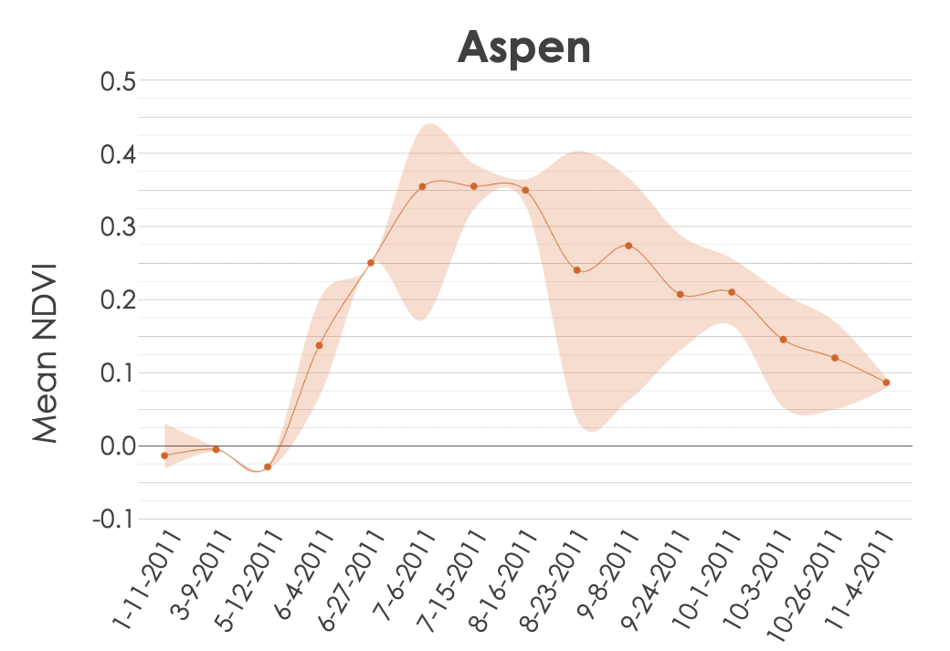

*Figure B1*. NDVI for partner-provided aspen points for the year 2011.

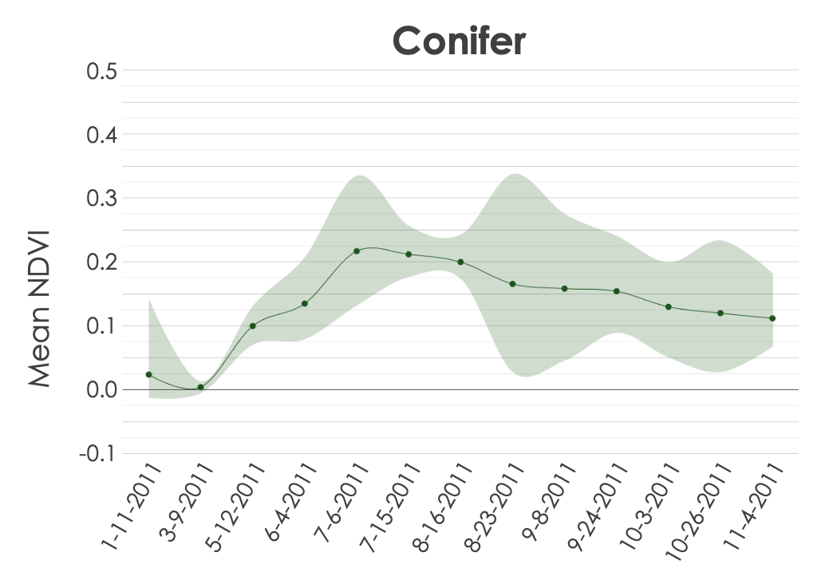

*Figure B2*. NDVI for partner-provided conifer points for the year 2011.

# Appendix C

Table C1

*Summary statistics for the random forest approach across all study years.*

|  |  |  |  |  |  |  |
| --- | --- | --- | --- | --- | --- | --- |
| Year | Training Accuracy | Validation Accuracy | Training Kappa Statistic | Validation Kappa Statistic | Aspen Consumer’s Accuracy | Aspen Producer’s Accuracy |
| 1986 | 0.978 | 0.850 | 0.966 | 0.760 | 0.600 | 0.750 |
| 1992 | 0.978 | 0.807 | 0.967 | 0.631 | 0.286 | 0.400 |
| 1995 | 0.966 | 0.842 | 0.945 | 0.724 | 0.700 | 0.636 |
| 2002 | 0.966 | 0.879 | 0.945 | 0.809 | 0.667 | 0.667 |
| 2006 | 0.975 | 0.768 | 0.958 | 0.653 | 0.500 | 0.333 |
| 2008 | 0.961 | 0.839 | 0.935 | 0.755 | 0.875 | 0.636 |
| 2011 | 0.939 | 0.859 | 0.905 | 0.766 | 0.636 | 0.700 |
| 2019 | 0.965 | 0.868 | 0.943 | 0.788 | 1.000 | 0.875 |