Lower Illinois River Valley Ecological Forecasting

Inundation Mapping of the Lower Illinois River Valley Using Synthetic Aperture Radar and Optical Satellite Imagery for Wetland Conservation and Restoration Prioritization Efforts

 **Technical Report**

Final Draft – August 11th, 2022

Vanessa Machuca (Project Lead)

Dana Myers

Hannah Rigdon

Christiana Saldana

***Advisors:***

Bruce Chapman, NASA Jet Propulsion Laboratory, California Institute of Technology (Science Advisor)

Benjamin Holt, NASA Jet Propulsion Laboratory, California Institute of Technology (Science Advisor)

# 1. Abstract

The Lower Illinois River Valley (LIRV) is home to some of the richest agricultural lands in the United States and its wetlands provide key ecosystem services like clean water and flood reduction. It has also experienced extensive degradation due to development and urban pollution. The Great Rivers Land Trust (GRLT), the National Great Rivers Research & Education Center, Principia College, and the American Geophysical Union’s (AGU) Thriving Earth Exchange sought to incorporate inundation and surface water extent layers into their geodatabases to more accurately identify priority areas for wetland restoration. This project aimed to determine the feasibility of detecting inundation extent and duration along the valley using remotely sensed data. We used Sentinel-1 C-band Synthetic Aperture Radar (SAR) data to classify open water and inundated vegetation within the study site. The open water classification was compared to Dynamic Surface Water Extent (DSWE) derived from Landsat 8 Operational Land Imager. We successfully created layers of inundation minimum and maximum extent, as well as inundation duration across the study area for 2019 and 2020. The open water classification resulted in an overall accuracy of 86% when validated against DSWE classifications. These analyses will help end users to identify high priority areas along the LIRV best suited for land conversion projects in the future.

**Key Terms**

Landsat 8 OLI, Sentinel-1 C-SAR, inundation detection, DSWE, mixed wetland, restoration

# 2. Introduction

***2.1 Background Information***

Urbanization and intensive agriculture have caused extensive wetland reduction and degradation in the United States. Wetlands provide habitat for fish and wildlife, as well as vital ecosystem services like sediment abatement, carbon sequestration, water filtration, stormwater control, and protection of sensitive species. In the Upper Mississippi River System, wetlands are characterized as “floodplain forests” and serve as drivers of the terrestrial water cycle (Guyon *et al.*, 2016). While invasive grass species and agricultural land allow for significant run-off, floodplains forests better recharge precipitation because they maintain evapotranspiration rates (Guyon *et al.*, 2016). These areas also provide open space conducive to improving quality of life and providing additional opportunities for popular recreational activities, such as hunting and fishing.

According to the Natural Resources Conservation Service (NRCS), wetlands have predominantly hydric soils, are often inundated or saturated by groundwater or surface water, and support hydrophytic vegetation (NRCS, 2011). The U.S. Fish and Wildlife Service (USFWS) uses these characteristics to classify and digitally map wetlands from high-resolution optical imagery and *in situ* measurements (Higgins *et al*., 2019). The limited spatial resolution of *in situ* data and the inability of passive optical imagery to penetrate cloud and vegetation cover severely limit these wetland classification methods.

Synthetic Aperture Radar (SAR) data help address the limitations of optical imagery by using active data collection (in which the sensor transmits energy and records what is returned, or backscattered). To be able to detect various objects, SAR uses different polarization schemes, which refers to the direction in which radio waves are being received. SAR data from the Sentinel-1 satellite uses the C-band (C-SAR), which operates at a relatively short wavelength (~5.55 cm), so it can penetrate through cloud cover and sparse vegetation (but not dense forest canopy). This penetration capacity allows C-SAR to improve and help validate water inundation metrics thus making it useful for detecting inundated vegetation (Lang & Kasischke, 2008). These characteristics make Sentinel-1’s C-SAR the preferred sensor for inundation detection.

This study focused on the Lower Illinois River Valley (LIRV) in the years 2019 and 2020. The LIRV is home to some of the richest agricultural lands in the US. The banks of the Illinois River have been extensively leveed to protect these agricultural fields from flooding. The LIRV’s wetlands provide key ecosystem services, like clean water and flood reduction (Thriving Earth Exchange, 2022). Due to development and urban pollution, the LIRV has experienced extensive wetland degradation and floodplain reduction. For the purpose of presenting our analyses, we showcased our results for a small focus area in the southern portion of our study area (*Figure 1*). We chose 2019 and 2020 as our study period as, compared to the 100-year flood line, 2019 was considered a peak flood year while 2020 descended into drought conditions.

The project study area, the Lower Illinois River Valley, zoomed into to its southern portion in true color imagery.


Figure 1. The project study area, the Lower Illinois River Valley, is shaded in orange, while the focus area is bounded in the black box in the southern portion of the valley.

***2.2 Project Partners & Objectives***

We worked with the Great Rivers Land Trust (GRLT), National Great Rivers Research & Education Center, American Geophysical Union’s Thriving Earth Exchange, and Principia College to create water inundation layers for the LIRV. Our partners and their collaborators are developing a geographic information systems (GIS) tool to assist in identifying potential sites for wetland conservation and restoration (Holman, 2015). This tool currently relies on *in situ* data, including parameters like soil type, land type, and vegetation type. This project provided layers derived from remotely sensed C-SAR data that focus on inundation extent and duration that had not previously been utilized in their tool.

The purpose of this project was to demonstrate the feasibility of utilizing C-SAR data to accurately classify inundation in a mixed land type area during flood and drought years. The objectives were to: generate water inundation extent and duration layers of the LIRV over 2019 and 2020, compare this to other metrics (e.g., Dynamic Surface Water Extent [DSWE]) for detecting inundation, and determine feasibility for further incorporation of remotely sensed products into the GRLT land acquisition decision-making practices beyond the current study period. We created valuable resources that will assist in identifying wetlands of high conservation value and potential restoration sites.

# 3. Methodology

***3.1 Data Acquisition***

We accessed Sentinel-1 C-SAR imagery through Google Earth Engine (GEE) and filtered the collection for our study area location during the study period of 2019 through 2020 (*Table 1).* Our partners identified April through October as the snow-free period in our study area, so we further refined our data acquisition to images from this month range in both years. C-SAR data were filtered for the ascending, interferometric wide swath (as it was appropriate for the area coverage).

We used the Landsat-8 DSWE product as a validation metric for our classification, acquired from the United States Geological Survey (USGS) Earth-Explorer data download tool. We then used the Interpreted Layer with All Masks applied (INWAM) DSWE images that were already calibrated and radiometrically and atmospherically corrected, so no additional processing steps were necessary. Additionally, we used landcover data from the USGS National Land Cover Database (NLCD) to mask out urban land cover types with similar backscatter signatures to inundated vegetation, as well as river gauge data from the USGS National Water Information System to identify periods of peak flooding (Dewitz & USGS, 2021; USGS, 2022). We overlaid our results with data from the United States Army Corps of Engineers’ National Levee Database (USACE, 2022).

Table 1

*Earth observation data acquired for this project.*

|  |  |  |  |  |
| --- | --- | --- | --- | --- |
| **Platform, Sensor & Product** | **Processing Level** | **Resolution** | **Date Range of Accessed Data** | **Data Provider** |
| **Sentinel-1 C-band Synthetic Aperture Radar (C-SAR)** | **Level 1 Ground Range Detected, log scaling** | 10-meter, 12-day revisit | January 2019–December 2020 | European Space Agency (ESA) |
| **Landsat-8 Dynamic Surface Water Extent (DSWE)** | **Level 3, Collection 2, Interpreted Layer with All Masks applied (INWAM)** | 30-meter, 16-day revisit | January 2019–December 2020 | United States Geological Survey (USGS) |

***3.2 Data Processing***

*3.2.1 Sentinel-1 C-SAR Processing*

Sentinel-1 C-SAR imagery was processed in the GEE JavaScript API. We created numerous functions to apply across images in the study area, including unit conversions, pixel size resampling, new band creation, speckle reduction, and an urban area mask (*Figure 2*). First, the data units were converted from decibels (dB) to natural values (*Equation 1*). Next, we resampled the pixel size of the imagery from 10 meters (m) to 30 m for comparison with the DSWE and NLCD products that both have a spatial resolution of 30 m. We created a band for the ratio between the sensor’s Vertically Transmitted-Vertically Received Polarization (VV) band and the Vertically Transmitted-Horizontally Received Polarization (VH) band to better visualize inundated vegetation. SAR data has a known pitfall where image interpretation is misled by interference from imaging mechanisms; therefore, we ran the Refined Lee Filter refinement technique to reduce this speckle and smooth the imagery (Yommy *et al.*, 2015). The urban mask was created using the NLCD to identify urban areas within the study area and ensure the pixels are classified as land in our analysis. This step was necessary due to the similarities between backscatter values of urban areas and the double-bounce phenomenon of inundated vegetation as detected by SAR (Franceschetti *et al.*, 2002). After the completion of these processing steps, we began analysis on 51 images and 44 images from 2019 and 2020, respectively.

**Natural values= ${\text{ 10}}^{\frac{\text{dB}}{\text{10}}}$** (*Equation 1*)

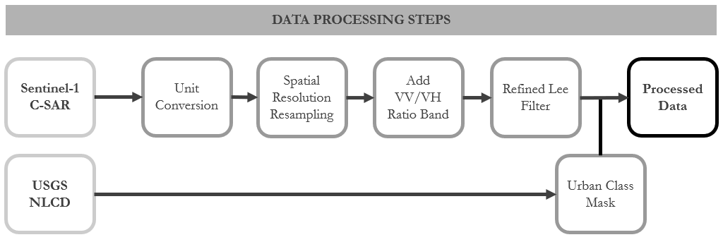

Figure 2. The data processing methodology steps performed on Sentinel-1 C-SAR imagery before analysis.

***3.3 Data Analysis***

*3.3.1 C-SAR Classification*

Due to the limited processing capacity of GEE, we ran the first round of data analysis on six, 1 km2 test sites within our study area, during the crest of the flood season in June 2019. These sites were chosen because they are regularly inundated and contain permanent standing water. We aimed to create three classes for our classification: open water, inundated vegetation, and not inundated vegetation or open water. To assign pixels to a class, we applied a thresholding methodology by identifying pixel value ranges for each category and classifying each pixel accordingly. To determine our thresholds, we mapped histograms of the pixel value within our test sites to pick out three distinct pixel groups that correlated with our landcover classes. After solidifying our methodology and determining classification thresholds over these sites and days, we expanded our analysis to the entire study area and study period.

*3.3.2 Water Extent Calculations*

Having classified each image individually, we then sought to create layers that mapped the minimum and maximum inundation extents in both 2019 and 2020. The category ‘surface water’ combined the open water class and inundated vegetation class created in the C-SAR classification. We defined minimum extent as the pixels that were identified as surface water pixels a majority of the time and maximum extent as the pixels that were identified as surface water at any point in time during 2019 and 2020, respectively. We then compared the difference in extent between the two study years to better understand the changes in inundation across flood and drought years.

*3.3.3 Inundation Duration Classification*

We defined inundation duration as the number of days in which a pixel is classified as surface water across a time frame. To accurately calculate this index, we first accounted for the difference in the number of images that contain a certain pixel, and the overlap in image frames covering our study site. For example, in a given year, pixel A may occur in 21 images, while pixel B occurs in 18 images due to the swath coverage of Sentinel-1 on different days. Thus, we would need to divide the number of times that pixel A is classified as surface water by 21, and pixel B by 18. This gives the fraction of the images that the pixel is classified as surface water, which can then be multiplied by the number of days in the time frame.

To account for these image number discrepancies, we first determined that there were three distinct image frame geometries covering our study site and selected a point in each frame that was not present in the other two frames (*Figure 3*). We then filtered the classified images for 2019 and 2020 using these points, thus creating three sub-collections for each year. Next, we ran our surface water classifier for each sub-collection in each year, assigning a value of “1” to pixels classified as surface water, and “0” to all others. Then we summed all images and divided the resultant values by the total number of images, culminating in a single inundation duration image for each sub-collection. Finally, we generated a mean composite of the three images, resulting in a single inundation duration image for each month and year, for 2019 and 2020.

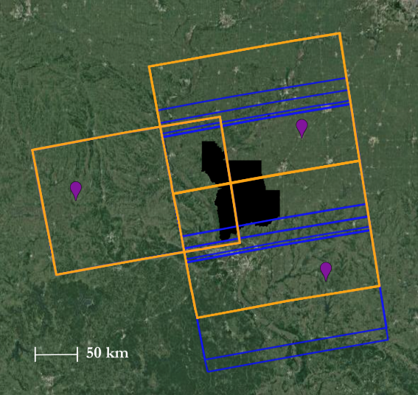

*Figure 3.* The standard Sentinel-1 C-SAR footprint frames in orange, shifted frames in blue, the point locations used to identify each frame in purple, and the study area filled in black.

# 4. Results & Discussion

***4.1 Analysis of Results***

For this section, we present results in the focus area subset of the study area measuring 6,614.85 km2 (*Figure 1*). We selected this location because it encompasses leveed land neighboring the Lower Illinois River that breached during the 2019 flood season. For this reason, we are able to highlight the effectiveness of our classifications based on known flooding instances.

***4.2 Classification Creation***

*4.2.1 Initial Classification*

The results of the initial classification showed that our methodology was successful at identifying inundated vegetation and open water from the C-SAR images. For classification of open water pixels, we drew from pixel values in the C-SAR VH polarization. We found that a VH pixel value of less than –21 corresponded with areas of open water within the imagery and isolated those pixels for the creation of our open water class. We classified our inundated vegetation class by isolating VV/VH ratio pixel values that were not already categorized as open water and had a pixel value greater than 12.5. The final class, not inundated vegetation or open water, encompassed the remaining pixels.

In *Figure 4* below, it is evident that our classification is accurately mapping the 2019 spring inundation that is clearly visible in the C-SAR images. We can see that in the early spring months, the only water visible is that of standing water bodies like the Illinois River and other small pockets of open water. As water levels start to rise (particularly after significant flood events in June), our classification accurately picks out the inundated agricultural lands in the failed levee district. It is also clear from these images that our inundated vegetation class is relatively small. It is possible that our open water class is too inclusive and inundated vegetation is getting grouped in with open water. Due to the marginal differences between open water and inundated vegetation, we grouped the two classes together to create one class representing all surface water for the extent and duration analyses.

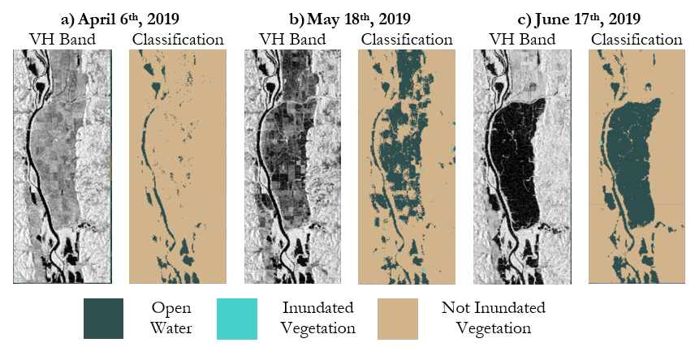

*Figure 4.* C-SAR VH polarization band imagery of the focus area extent on the left and C-SAR generated classifications on the right for a) April 6th, 2019, b) May 18th, 2019, and c) June 17th, 2019.

*4.2.2 Accuracy Assessment*

We validated our open water classification results against the Landsat-8 DSWE product (*Figure 5*). Within the DSWE classification, we considered 3 classes of pixels to be equivalent to our open water class: Water- High Confidence, Water- Low Confidence, and Partial Surface Water- High Confidence. To assess our open water classification accuracy, we generated a confusion matrix (*Table 2*). The producer’s accuracy of open water agreement indicates that there is room for improvement in our generated classification and it could benefit from further refinement. The producer’s accuracy of not open water agreement is likely due to sample size as the study area is mostly dry land. We had a reported overall accuracy of 86% for our classification. Given that inundation detection through radar remote sensing is a relatively new science, there does not exist an equivalent product against which we could validate our inundated vegetation class. Overall, our classification seemed to identify more open water than the DSWE product, which could be attributed to either the over-inclusiveness of our open water classification or the higher sensitivity C-SAR has towards open water.

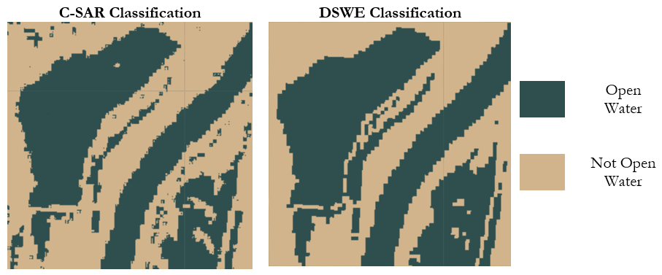

*Figure 5.* Comparison of DSWE and C-SAR classifications of a test site along the Lower Illinois River for October 2019.

Table 2

*Confusion matrix comparing DSWE Classification and Sentinel-1 C-SAR Classification. Values reflect number of pixels.*

|  |  |  |  |  |
| --- | --- | --- | --- | --- |
| Overall Accuracy: 86% | | Reference: DSWE Classification | | |
| **Open Water** | **Not Open Water** | **Producer’s Accuracy (%)** |
| Predicted: C-SAR Classification | **Open Water** | 4,421 | 2,182 | 67 |
| **Not Open Water** | 1,607 | 18,336 | 92 |
| **User’s Accuracy (%)** | 73 | 90 |  |

***4.3 Maximum and Minimum Inundation Extent***

Within the focus area, the minimum extent of surface water in 2019 and 2020 measured 7.84 km2 and 6.61 km2, respectively. We did not expect to see much of a difference between the minimum extent of surface water between 2019 and 2020 since the river typically stays within its banks. Some smaller bodies of water appear beside the river in 2019 that were not present in 2020, indicating that there was more flooding during this time. In contrast, we saw a bigger difference between the maximum extent of surface water between 2019 and 2020 at 79.63 km2 and 72.76 km2, respectively (*Figure 6*). This is likely due to the fact that the levee did not breach in 2020 and, therefore, less water was retained in the leveed land.

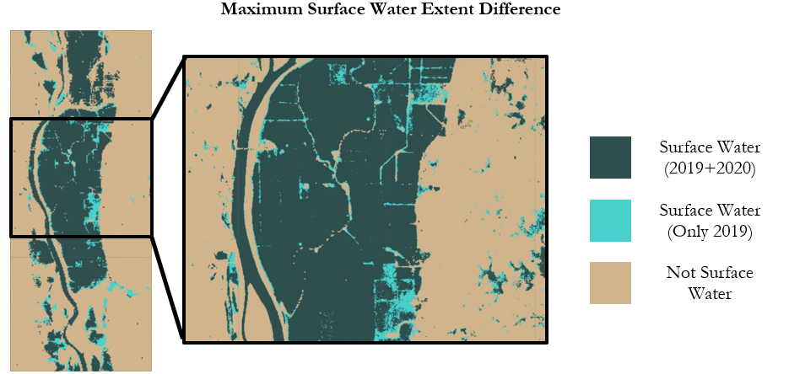

*Figure 6.*The difference in minimum and maximum inundation extent for the 2019 flood year— light blue indicates surface water was present in 2019 but not in 2020, dark blue indicates surface water was present in both 2019 and 2020, and tan indicates there was not surface water in either 2019 or 2020.

***4.4 Inundation Duration***

We created a composite of yearly water inundation duration across the focus area and noticed 2019 had elevated duration compared to 2020 (*Figure 7*). Levees, indicated by the red lines, are earthen walls used to keep flooding from reaching agricultural fields, but they don’t always succeed. The dark patch spanning the middle of the focus area corresponds to a levee that was breached during the severe flooding of 2019, resulting in an accumulation of water in the agricultural land it was meant to protect. These lands can remain flooded for months before they are eventually pumped, according to our partners.

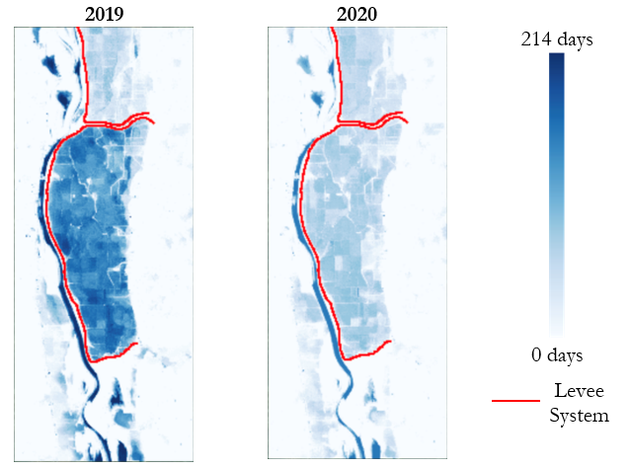

*Figure 7.* The inundation duration for 2019 and 2020 overlaid with the levee system present in the focus area

Monthly inundation duration gives us a sense of the progression of inundation across 2019 and 2020 (*Figure 8*)*.* We can see that the leaked levee noticeable in the 2019 inundation duration image starts to experience inundation around June 2019 and then this accumulated water was presumably pumped out in August. The land below this levee district is un-leveed and reserved for recreation, so presumably it undergoes natural cycles of inundation each year. That said, we only see inundation in certain patches in this area. In comparing the inundation duration images to the satellite image of our focus area (*Figure 1*), we see that much of this area is covered in forest. While C-SAR can detect inundation beneath sparse vegetation, it cannot penetrate through dense canopy cover. This may indicate, then, that C-SAR was not able to detect inundation beneath the dense canopy in this area. Another possible explanation is that this un-leveed land experiences better drainage than the leveed land. Thus, any inundation quickly recedes back to the Illinois River, rather than accumulating and remaining for months, as happened in the failed levee district to the north.

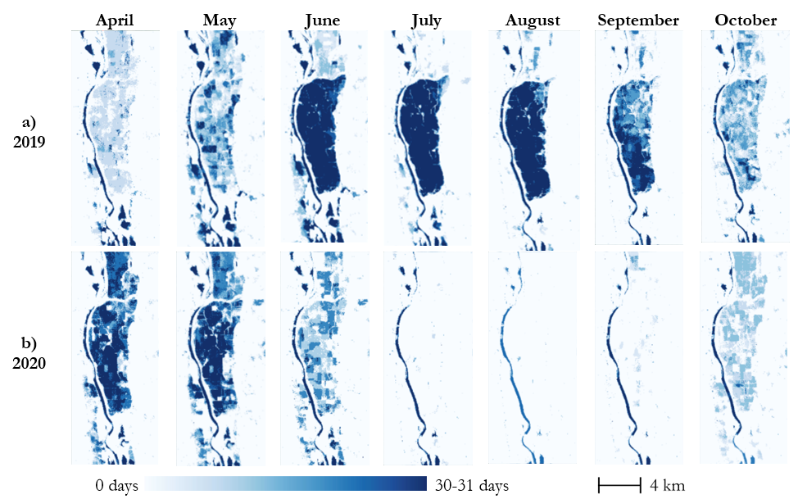

*Figure 8.* Monthly inundation duration for (a) 2019 and (b) 2020 across April-October.

***4.5 Future Work***

While this project was successful in attaining its goals, there is more that could be done to reinforce the findings of this project. First, L-Band and C-Band from the upcoming NASA-Indian Space Research Organization SAR (NISAR) mission could be incorporated to gain better imaging beneath dense tree canopy. Due to the vegetation mixture in the wetlands along the Illinois River, radar capable of sensing across all vegetation types would prove quite informative. Furthermore, establishing a validation metric for inundated vegetation could also be a focus**,** as we were only able to validate open water classifications using DSWE. There is currently no robust way for inundated vegetation classifications using SAR data to be validated. An additional analysis to consider would involve incorporating water level data and integrating parameters for variation between how water recedes from floodplain forests versus leveed agricultural lands. Finally, our partners indicated that this application could be useful to other land trusts, as inundation extent is a valuable metric not confined to the parameters of any specific riparian area. Therefore, future work could build toward standardizing these methods for use by other organizations.

# 5. Conclusions

We generated inundation extent and duration maps using Sentinel-1 C-SAR imagery across 2019 flood and 2020 drought conditions. These maps provided valuable insight on inundation patterns, including in the swaths of leveed land within the LIRV. They also showcased the feasibility of using C-SAR to detect inundated vegetation, which optical sensors are largely unable to do. We confirmed, in conversation with our partners, that the phenomena apparent in our duration and extent maps reflected what actually occurred in the study area and time period. Our partners can use these maps to better identify wetlands in the LIRV and inform purchasing practices in the foreseeable future. These maps could also be useful for other projects our partners choose to pursue, including providing justification for grant requests to various governmental agencies. In regard to community concerns, restoration of wetlands could provide increased access to natural lands and recreational activities.

The end products have the potential to expand the utility of remote sensing in wetland identification and monitoring. To date, there has been limited fine spatial scale mapping of inundation along the LIRV. Our end users will be able to interpret the inundation extent and duration layers generated to identify wetlands of high conservation value and potential restoration sites. End users can combine these layers with additional classifiers to identify land type based on their working definition of a wetland.

# 6. Acknowledgments

The Lower Illinois Ecological Forecasting team would like to thank the mentors and partners who provided their support and time to make this project possible. Specifically, thank you to our Lead Science Advisor Benjamin Holt and Science Advisor Dr. Bruce Chapman at JPL for their wisdom and guidance, DEVELOP Fellow Erica Carcelén for her GEE expertise, and project partners Alley Ringhausen at GRLT, David Holman at GRLT, Dr. Lyle Guyon at National Great Rivers Research & Education Center, Zavia Jenkins at the American Geophysical Union’s Thriving Earth Exchange, and Dr. Marie Farson at Principia College for their assistance throughout the project.

The Lower Illinois Ecological Forecasting team would like to remind ourselves and our audience that the lands we now call the state of Illinois are the ancestral homelands of many Tribal Nations including: the people of the Council of the Three Fires: the Ojibwe, Potawatomi, and Odawa, the Peoria, Kaskaskia, Piankashaw, Wea, Miami, Mascoutin, Sauk and Fox, Mesquaki, Kickapoo, Ho-Chunk, Menominee, and Chickasaw Nations. Today Native peoples from over 100 Tribal Nations continue to call these lands home. It is necessary for us to acknowledge these Tribal Nations and for us to work with them as we move forward in land conservation actions.

This material contains modified Copernicus Sentinel data (2019–2020), processed by ESA. Any opinions, findings, and conclusions or recommendations expressed in this material are those of the author(s) and do not necessarily reflect the views of the National Aeronautics and Space Administration.

This material is based upon work supported by NASA through contract NNL16AA05C.

# 7. Glossary

**Backscatter** – redirection of radar signal back toward the radar antenna after the signal has interacted with the Earth’s surface

**C-SAR** – a synthetic aperture radar instrument operating at 5.405GHz

**DSWE** – Dynamic Surface Water Extent

**Earth Explorer** – USGS satellite, aerial imagery, and remote sensing data catalog

**Earth observations** – Satellites and sensors that collect information about the Earth’s physical, chemical, and biological systems over space and time

**GEE** – Google Earth Engine

**GeoTIFF** – File format that integrates georeferenced geographical data with TIFF imagery

**Levee** – an embankment built to prevent overflow of a river

**LIRV** – Lower Illinois River Valley

**NISAR** – NASA-ISRO SAR Mission; an upcoming SAR mission jointly planned by NASA and the Indian

Space Research Organization (ISRO) that will provide L-Band and S-Band SAR measurements

**NLCD** – National Land Cover database

**NRCS** – Natural Resources Conservation Service

**SAR** – Synthetic Aperture Radar

**Speckle** – grainy salt-and-pepper pattern present in SAR imagery caused by the interaction of out-of-phase waves with a target

**USFWS** – United States Fish and Wildlife Service

**USGS** – United States Geological Survey

**VV** – Vertically transmitted, vertically received; radar system wave polarization consisting of vertical linear transmission and vertical linear reception.

**VH** – Vertically transmitted, horizontally received; radar system wave polarization consisting of vertical linear transmission and horizontal linear reception.

# 8. References

Dewitz, J., and U.S. Geological Survey (USGS). (2021). National Land Cover Database (NLCD) 2019

Products (ver. 2.0, June 2021). *U.S. Geological Survey data release.*

<https://doi.org/10.5066/P9KZCM54>.

Earth Resources Observation and Science (EROS) Center. (2022). USGS EROS Archive - Landsat Collection 2 Level-3 Dynamic Surface Water Extent (DSWE) Science Product. *United States Geological*

*Survey/EROS/Operational Land Imager.* Retrieved June 30, 2022. <https://doi.org/10.5066/P9DPWBUS>

European Space Agency (ESA) Copernicus Open Access Hub. (2014-2022). Sentinel-1 SAR GRD: C-band Synthetic Aperture Radar Ground Range Detected, log scaling (Version No.) [Level 1 Ground Range Detected]. *E*[*uropean Union/ESA/Copernicus*](https://sentinel.esa.int/web/sentinel/user-guides/sentinel-1-sar/). Retrieved June 16, 2022.

Franceschetti, G. Iodice, A. & Riccio, D. (2002). A canonical problem in electromagnetic backscattering

from buildings. *IEEE Transactions on Geoscience and Remote Sensing*, 40(8), 1787-1801. <https://doi.org/10.1109/TGRS.2002.802459>.

Guyon, L., Sloan, J., Van Essen, R., & Corcoran, M. (2016). Floodplain Forests and Water Quality in the

Upper Mississippi River System. *Report to the National Audubon Society.*

<http://www.ngrrec.org/uploadedFiles/Pages/Research_Program/Floodplain_Forests_and_Water_Quallity.pdf>

Higgins, A., Ly, R., Peacock, A., & Vaccaro, A. (2019). Semi-Automated Mapping of Alaskan Wetland Inundation by Integrating Synthetic Aperture Radar and Optical Satellite Imagery. *NASA DEVELOP National Program, Virginia – Langley* [Unpublished manuscript]. <https://www.devpedia.developexchange.com/dp/index.php?title=Alaska_Ecological_Forecasting_II_JPL_Spring_2019#Final_Deliverables>

Holman, D. (2015). 2015 Year in Review. *Prairie State Conservation Coalition*.

<https://www.prairiestateconservation.org/pscc/wp-content/uploads/2020/12/2015-IL-Review-Update.pdf>

Lang, M. W. & Kasischke, E. S. (2008). Using C-band synthetic aperture radar data to monitor forested wetland hydrology in Maryland's coastal plainUSA. *IEEE Transactions on Geoscience and Remote Sensing.* 46(2), 535-546. <https://doi.org/10.1109/TGRS.2007.909950>.

National Resources Conservation Service (NRCS). (2011). Wetlands and Conservation Compliance. *United*

*States Department of Agriculture*.

<https://www.nrcs.usda.gov/Internet/FSE_DOCUMENTS/stelprdb1117073.pdf>

Thriving Earth Exchange. (2022). Identifying and prioritizing wetland restoration sites in the Lower Illinois

River Valley. *AGU Thriving Earth Exchange*.

<https://thrivingearthexchange.org/project/lower_illinois_river_valley-il/>

United States Army Corps of Engineers (USACE). (2022). Levees of the Nation [States and Counties:

Illinois]. *National Levee Database*. <https://levees.sec.usace.army.mil/#/>

United States Geological Survey (USGS). (2022). Surface Water Daily-Data for the Nation*.*

*National Water Information System*. <https://waterdata.usgs.gov/nwis>

Yommy, A. S., Liu, R., & Wu, S. (2015). SAR image despeckling using refined Lee filter. *International Conference*  *on Intelligent Human-Machine Systems and Cybernetics.* (2), 260-265.

https://doi.org/10.1109/IHMSC.2015.236