Lake Champlain Water Resources
Using Earth Observations to Identify Spatial and Seasonal Trends of Harmful Algal Events in Lake Champlain

Technical Report
Final – August 11th, 2022

Brianne Kendall (Project Lead)
Laramie Plott
Ian Turner
Aaron Carr

Advisors:
Dr. Robert Griffin, The University of Alabama Huntsville (Science Advisor)
Dr. Jeffrey Luvall, NASA Marshall Space Flight Center (Science Advisor)

1. Abstract
Lake Champlain provides clean drinking water for 35% of the surrounding watershed and offers recreational opportunities to millions of tourists. However, current levels of cyanobacteria and phosphorus created breeding grounds for harmful algal blooms (HABs). The excess of phosphorus runoff into Lake Champlain over the past decade encouraged toxic cyanobacterial formations, thereby increasing the severity of HABs towards local economy and ecology. In partnership with the Natural Resources Conservation Service (NRCS) Northeast Region, this project utilized Earth observations to identify risk factors associated with toxic algal blooms. The team detected historic algal bloom trends with Sentinel-2 Multispectral Instrument (MSI), Sentinel-3 Ocean and Land Color Instrument (OLCI), Landsat 8 Operational Land Imager (OLI) and Landsat 9 OLI-2. The team also used Sentinel-3 OLCI and the German Aerospace Center’s Earth Sensing Imagery Spectrometer (DESIS) to visualize algal bloom patterns and Landsat 8 OLI, Landsat 9 OLI-2, and Shuttle Radar Topography Mission (SRTM) to identify phosphorus sources within the watershed. The team’s analyses indicated an increase in cyanobacteria blooms during summer months from 2016-2022, with Missisquoi and St. Albans Bay exhibiting the greatest concentrations of toxic events. Furthermore, 16% of the watershed was identified as posing an immediate threat to the lake’s hydrology. The area of greatest concern was the Missisquoi Bay sub-watershed, with 229,044 acres of land prone to excessive phosphorus runoff. Providing this information to the NRCS Northeast Region enabled the organization to quantify risk factors associated with algal blooms and modify mitigation efforts to better target future bloom events.

Key Terms
cyanobacteria, chlorophyll-a, phosphorus, algal blooms, runoff, Sentinel-3, DESIS

2. Introduction
2.1 Background Information
Harmful algal blooms (HABs) are a global phenomenon in which algae proliferates into massive algal blooms and damage the surrounding ecosystem through the release of bacterial toxins. HABs occur when suspended phytoplankton receive excessive nutrients that accelerate photosynthetic processes. Algae growth proliferates, and when the massive plumes die and decompose, oxygen content in the water decreases and dead zones form where aquatic life can no longer survive (Environmental Protection Agency, 2022). Any algae can proliferate into HABs, but cyanobacteria are the most notorious agents. These toxic bacteria thrive in polluted waters, withstand environmental extremes, and compromise the integrity of water used for recreational and drinking purposes (Paerl et al., 2001). Analyses show that cities across the United States have spent at least $1 billion on managing HAB outbreaks since 2010, and some have even been forced to temporarily shut off access to all drinking water until the bloom has passed (Environmental Working Group, 2020). Harmful algal blooms pose a threat to human safety, aquatic integrity, and economic survival.

This project identified HAB trends in Lake Champlain, which is a 435 square mile lake that extends across New York, Vermont, and Quebec, Canada, and nearly the entire watershed, which encompasses over 5 million acres (Figure 1; Stager & Thill, 2010). Over half a million people visit Lake Champlain every year for its unique boating and fishing industry, and nearly 200,000 residents rely on the lake for clean drinking water year-round. The water quality of the lake drives the local economy, but the commercial and ecological integrity of Lake Champlain is compromised by increasingly severe algal bloom events. A study from the Lake Champlain Basin Program estimated a $16.8 million loss in local revenue for every one-meter decrease in water clarity over the summer season as well as a 37% depreciation in the value of lakeside homes (Waugh, 2016). Recent cyanobacteria proliferations also negatively impacted the health of people and animals who ingest toxic water (Lake Champlain Basin Atlas, 2022).

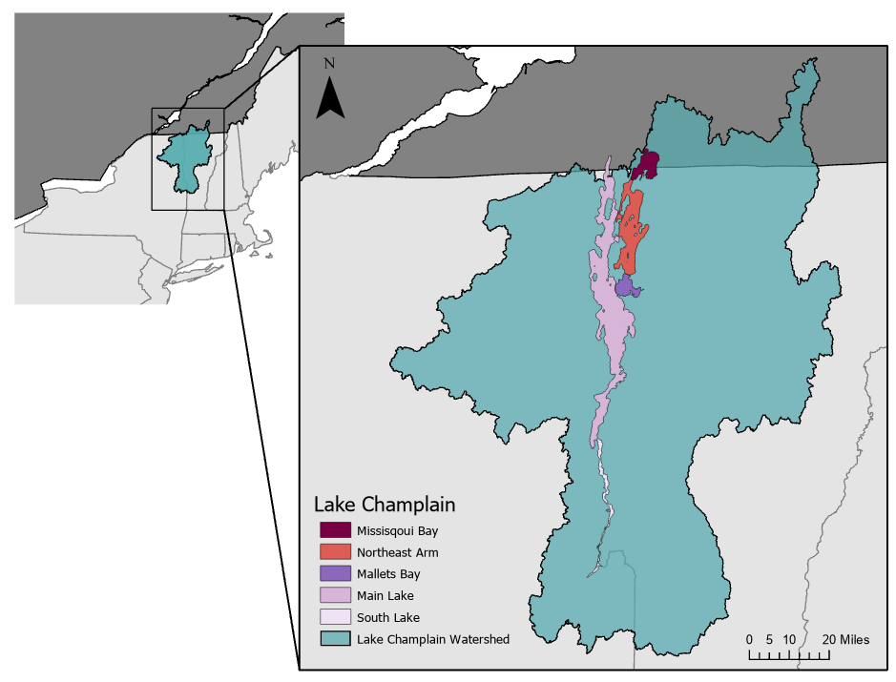
Figure 1. Highlighted regions of Lake Champlain surrounded by the watershed basin.

While there are many factors that contribute to the proliferation of cyanobacteria, the main concern for this project was the identification of phosphorous sources within the watershed and phycocyanin presence in the lake. The presence of phosphorus, a key ingredient in the formation of HABs, increases the severity and frequency of toxic cyanobacteria blooms, especially in regions with calm, shallow water (Eilola et al., 2009). With 587 miles of shallow shorelines, phosphorus runoff from nonpoint sources, like agriculture and developed lands, creates a breeding ground for harmful algal blooms (Lake Champlain
Basin Program, 2022). Stakeholders currently use field work methods to track phosphorous and cyanobacteria blooms, but these methods are costly and time consuming. Detecting phycocyanin, a pigment found in cyanobacteria, with the Oa07 band of the Sentinel-3 Ocean and Land Color Instrument (OLCI) and assessing phosphorus risk using meteorological and geophysical data helped end users analyze historic trends, identify areas at greatest risk, and predict future cyanobacteria events (Ghebremichael et al., 2010; Ogasawara, 2019;). This project utilized remote sensing opportunities to identify risk factors associated with toxic algal blooms in Lake Champlain from May through November of 2016–2022.

2.2 Project Partners & Objectives
In partnership with the NRCS Northeast Region, this project aimed to identify sources of sediment runoff associated with resulting algal blooms and focus mitigation efforts around areas of Lake Champlain at greatest risk of future algal bloom events. The NRCS Northeast Region currently uses Geographic Information Systems (GIS) to generate dynamic soil and land use maps as well as ortho imagery and LiDAR Digital Elevation Models (DEM). This project expanded their ability to utilize remote sensing by introducing Sentinel-3 OLCI and German Aerospace Center Earth Sensing Imagery Spectrometer (DESIS) instruments. The team first generated a time series analysis of cyanobacteria, turbidity, and temperature to identify historic runoff trends in the watershed. The team compared those trends to cyanobacteria concentration maps that observed bloom activity across Lake Champlain. Lastly, the team produced a phosphorus runoff potential map to identify risk factors within areas contributing to watershed contamination and highlight areas of greatest concern for phosphorus buildup. Combined, these objectives created an array of resources for the partners to better plan mitigation efforts for future toxic algal blooms.

3. Methodology

3.1 Data Acquisition
The team acquired most Earth observation data through the Google Earth Engine (GEE) data catalog and ancillary datasets through their respective online portals. Historic algal events timeseries analyses were conducted using Sentinel-3 OLCI Earth observation Full Resolution (EFR), Sentinel-2 Multispectral Instrument (MSI), Landsat 8 Operational Land Imager (OLI) and Landsat 9 Operational Land Imager 2 (OLI-2) Top of Atmosphere (TOA) reflectance data, and cloud cover data from the Visual Crossing Weather Query Builder. Next, cyanobacteria concentrations were sourced from Cyanobacteria Assessment Network (CyAN) products created with OLCI imagery. DESIS imagery was gathered for cyanobacteria monitoring as well. The team also collected in-situ bloom reports from the Vermont Departments of Health, Environmental Conservation, and Lake Champlain Committee Cyanobacteria (Blue-Green Algae) Tracker. Lastly, the team gathered data from the Shuttle Radar Topography Mission (SRTM), United States Geologic Survey (USGS) National Land Cover Database (NLDC), United State Department of Agriculture (USDA) Soil Survey Geographic (SSURGO) Database, USDA Distribution of Phosphorus in Soils data, USDA Cropland Data Layer, and Canadian Annual Crop Inventory to indicate areas within the watershed contributing to phosphorus runoff in Lake Champlain and highlight areas of greatest concern for water quality contamination. See Table 1 for further detail on these products.

Table 1
Earth observations and datasets used to complete project objectives.
Sensor/Dataset | Processing Level | Dates | Acquisition Method | Product ID
Sentinel-3 OLCI | Level 1 EFR | 2016-2022 | European Space Agency | COPERNICUS/S3/OLCI
Sentinel-2 MSI | Level 2A | 2017-2022 | European Space Agency | COPERNICUS/S2
Landsat 8 OLI | Tier 1 TOA | 2013-2022 | Google Earth Engine | LANDSAT/LC08/C02/T1_TOA
Landsat 9 OLI-2 | Tier 1 TOA | 2021-2022 | Google Earth Engine | LANDSAT/LC09/C02/T1_TOA
Cyanobacteria Weekly Composites | Level III | 2016-2022 | Cyanobacteria Assessment Network (CyAN) | N/A
DESIS | Level 1C | 2018-2022 | Teledyne Brown Catalog | N/A
SRTM Digital Elevation Data V.4 | Version 4 | N/A | Google Earth Engine | N/A
USGS NLCD 2019 CONUS Land Cover | Level I & II | 2019 | Multi-Resolution Land Characteristics Consortium | N/A
USDA SSURGO | N/A | N/A | Vermont Open Geodata Portal | N/A
USDA Distribution of Phosphorus in Soils | N/A | 2007-2013 | USGS Science Data Catalog | N/A
USDA Cropland Data Layer | N/A | 2021 | USDA CropScape | N/A
Canadian Annual Crop Inventory | Level III | 2021 | Agriculture and Agri-Food Canada | N/A

3.2 Data Processing

3.2.1 Algal Bloom Trends
The team’s first goal was to identify historic trends in algal bloom events. The three variables considered in the time series analysis were turbidity, water surface temperature, and 620-nanometer radiance. Areas of high turbidity can be used to indicate algal bloom presence (Apted et al., 2004). Algae also tends to grow best at temperatures of around 25 degrees Celsius (Paerl, 2014). Cyanobacteria has a unique absorption peak lying around 620-nanometers. Normally, algae reflect the 620-nanometer wavelength well, however, cyanobacteria do not. This means that in order to specifically identify cyanobacteria, one must use more specific techniques using other bands. However, for this product, the team simply used Sentinel-3 OLCI’s 620-nanometer band as a very basic proxy for cyanobacteria concentration, since the index is a way to indicate potential areas of concern.

First, the team calculated the median Normalized Difference Turbidity Index (NDTI) value for May to November 2017-2021. This translated the level of turbidity into an index of –1 to 1. The adjusted NDTI equation in Table 2 adjusted the index to a 0-1,000 scale to better compare it with the other indices. The team also created a temperature index using the thermal infrared band on Landsat 8 OLI and Landsat 9 OLI-2 using 1 image for May through August, and another image for September through November. The temperature index equation in Table 2 assigned temperature at or above 25 degrees Celsius to 1,000, and anything at or below 10 degrees Celsius, to 0. Finally, the team created a 620nm index for a basic cyanobacteria concentration map using Sentinel-3 OLCI, where a radiance value of 100 is assigned a 1,000, and both 0 and 200 are assigned a 0 (Table 2). The mean index value for each pixel over time to visualize the areas of the lake that have the greatest condition for potential HABs to form. These results were then compared to cyanobacteria concentration maps that visualized the distribution of observed blooms in Lake Champlain.

The team researched historic data on real bloom observations to create cyanobacteria concentration visuals and determine the validity of the index. The Cyanobacteria Tracker is a database of in-situ cyanobacteria bloom reports along Vermont lakes. A limited number of reports provided both water temperature and cyanobacteria concentration. The summaries were aggregated in RStudio, then imported into ArcGIS Pro to extract reports within Lake Champlain with the ‘Select by Location’ tool. The resulting data were re-imported to RStudio and filtered by status such that 1,048 reports of ‘Low’ (beginning of potential bloom formation) or ‘High’ (blooms extending 10-15 feet offshore) alert designation remained.

The CyAN project automatically produces daily rasters of cyanobacteria density derived from Sentinel-3 OLCI using the Cyanobacteria Index and a conditional requirement, CIcyano, to derive bloom biomass (Table 2). Data access instructions are included in the team’s CyAN Tutorial, and image processing techniques are detailed in the Harmful Algal Bloom-Forecasting Branch's Ocean Color Satellite Imagery Processing Guidelines (Briggs et al., 2020). The team attempted to replicate CyAN-quality products using DESIS, but there was not enough time in the term or available imagery to adapt the necessary processing steps. Instead, the team visualized reflectance of band 86 (619.30 nm) as a proxy for cyanobacteria abundance in order to explore DESIS’ resolution advantages.

Table 2
Equations for deriving indices related to harmful algal bloom trends.
Index | Equation
Adjusted Normalized Difference Turbidity Index  (Lacaux et al., 2007) | $$1000⋅\frac{\left(\frac{\left(Red Band - Green Band\right)}{\left(Red Band + Green Band\right)}+ 1\right)}{\begin{aligned}2 \\ \end{aligned}}$$
Temperature Index (Paerl, 2014) | $$5000 ⋅ \left(\frac{{\left(Celsius - 25\right)}^{3}}{15625}+1\right)$$
620nm Index (Serrano, 1988) | $$\left({\left(620nm Radiance - 100\right)}^{2} + 1\right) ⋅ 1000$$
Cyanobacteria Index  (Wynne et al., 2008) | $$-\left[R\left(681\right) - R\left(665\right) + \left[R\left(709\right) - R\left(665\right)\right] ⋅ \frac{\left(681-665\right)}{\left(709 - 665\right)}\right]$$
CIcyano (Lunetta et al., 2015) | $$R\left(665\right) - R\left(620\right) + \left[R\left(681\right) - R\left(620\right)\right] ⋅ \frac{\left(665-620\right)}{\left(681-620\right)}$$
CIcyano Product DN-descaling  (Briggs et al., 2020) | $${10}^{\left(\left(\frac{3}{250}\right)⋅DN\right) - 4.2}$$

3.2.2 Phosphorus Runoff
The final goal of this project was to identify phosphorus runoff within the watershed and map potential phosphorus runoff to highlight areas of greatest concern. First, the team created a geodatabase with layers that accounted for 5 key factors in phosphorus runoff: topographical slope, distance to water, existing phosphorus in the top layer of soil, landcover, and crop type. For topographical slope, the team utilized SRTM data which calculated slope by comparing adjacent pixels in GEE and interpolating the difference. Once the SRTM data were converted, the team imported the data into ArcGIS Pro. Next, the slope layers were reclassified into the following classifications based on a sedimentary runoff index and then assigned risk values (Table 3). Sedimentary runoff hits its peak at the critical value of a 25% slope. Thus the 20 - 30% slope range was given the highest risk value (Jourgholami et al., 2021).

Table 3
Slope Risk Indices
Original Unit Range | Risk Index
0 - 10 % | 2
10 - 20 % | 6
20 - 30 % | 10
30 - 40 % | 8
> 40 % | 4

For the distance to water factor, the team pulled SSURGO data from every county within the Lake Champlain watershed into ArcGIS Pro and merged them into one large dataset. From this dataset, the team selected all shapefiles labeled as ‘water’ and generated one ‘water’ shapefile. The team then created a layer that showed the distance to water in raster form. This new raster layer was then reclassified based on corresponding risk values from the Vermont P-Index (Faulkner, 2021; Table 4). For this, the team chose the Non-Vegetated Buffer Distance parameter from the Vermont P-Index to showcase a simple distance-to-water risk factor.

Table 4
Distance to Water Risk Indices
Original Unit Range | Risk Index
0 - 20 ft | 10
20 - 50 ft | 9
50 - 200 ft | 8
>200 ft | 7

Next, the team used USDA’s phosphorus data set to calculate existing phosphorus in the ground; however, these data did not extend into the northernmost point of Lake Champlain in Quebec, Canada. The team performed a fishnet analysis in ArcGIS Pro to rectify this issue. The fishnet analysis generated rectangles ~309 x 550 m all over the watershed and placed a data point in the middle of each rectangle. The team assigned the points to their corresponding phosphorus value from the existing USDA layer and then stretched the layer into Canada using the ‘Kriging’ tool in ArcGIS Pro. The team converted all of the data into the following visual classifications based on natural breaks. The associated risk factor came from assuming a linear increase of natural soil phosphorus leads to a higher risk of phosphorus runoff (Table 5).

Table 5
Phosphorus in Top Layer of Soil Risk Indices
Original Unit Range | Risk Index
>1023 mg/kg | 10
882 - 1023 mg/kg | 9
818 - 882 mg/kg | 8
789 - 818 mg/kg | 7
775 - 789 mg/kg | 6
746 - 775 mg/kg | 5
682 – 746 mg/kg | 4
541 – 682 mg/kg | 3
232 – 541 mg/kg | 2

The team utilized the 2019 NLCD, the Canadian Crop Inventory, and the USDA Cropland Data Layer to create a landcover map of the Lake Champlain watershed. The team merged the 2019 NLCD and USDA Cropland Layer into one United States raster and then re-classified the new image to match the Canadian Crop Inventory. These classifications were assigned the following risk indices (Table 6). The risk indices came from properties of these classifications that make phosphorus runoff unique relative to other landcover classifications and the amount of phosphorus in Lake Champlain that came from the different landcover classification types (Environmental Protection Agency, 2016).

Table 6
Landcover Risk Indices
Classification | Risk Index
Agricultural | 10
Urban | 5
Forested | 3
Water/Wetlands/Other | 1

Lastly, agriculture was the landcover classification of greatest concern as phosphorus is directly applied to these lands, so the team included various crop types as the final risk factor. The USDA Cropland and Canadian Crop Inventory were reclassified so that each individual crop was sorted into these classifications (Table 7): annual crops (crops harvested each year), perennial crops (crops harvested every other year), hay/pastureland, and fallow fields/other. The risk indices were based on relationships between the categories. For instance, annual crops require more fertilizer (twice as much typically) and more tilling and harvesting than perennial crops and therefore pose a greater threat to phosphorus runoff. This same relationship is seen in between perennials and hay. Fallow fields and non-agricultural land pose minimal risk as there is typically no phosphorus being added to it. This information was gathered from Dr. Joshua Faulkner, a Vermont phosphorus specialist.

Table 7
Crop Type Risk Indices
Classification | Risk Index
Annual Crops | 10
Perennial Crops | 5
Pastureland/Hay | 3
Fallow/Other | 1

3.3 Data Analysis

3.3.1 Algal Bloom Trends
The team conducted a weighted overlay analysis over the lake using the three resulting rasters from the time series analysis. Each index is on a scale of 0 to 1,000, with lower values being assigned to conditions where algal blooms were unlikely to form and higher values being assigned to more ideal conditions for algae proliferation. The team created an original equation by averaging the index value for each HAB factor over the study period (Equation 1). The index resulted in a map of areas with the most optimal conditions for an algal bloom. (Figure B1). The team also created basic maps comparing the index values for each average year (Figure B2). Next, the team ran an optimized hot spot analysis on the resulting data, which allowed the team to visualize where there was a statistically significant area of interest. Then, the team created charts (Figures B3-B6) comparing the temperature, turbidity, and reflectance of Sentinel-3 OLCI’s 620-nanometer band over time. The index was then compared to real bloom observations from the CyAN data. The team ran the ‘Optimized Hotspot Analysis’ tool in ArcGIS Pro on the overall and month datasets. Additionally, charts of yearly trends in cyanobacteria density by lake segment were created. Lastly, cyanobacteria density was compared to the in-situ standardized report frequencies.

$Total Index = \frac{\left(Adjusted NDTI+Temperature Index+Cyanobacteria Index\right)}{3}$ (1)

3.3.2 Phosphorus Runoff
Once all phosphorus runoff factors were properly classified and given appropriate risk weights, the team performed a weighted overlay analysis with all factors weighed equally (for simplicity's sake as there was no prevailing research on how to weigh these factors). Then, the team split the results of the weighted overlay by sub-watersheds to analyze which sub watersheds posed the greatest risk to Lake Champlain.

4. Results & Discussion

4.1 Analysis of Results

4.1.1 Algal Bloom Trends
Overall, the time series analysis showed a general increase in the created index value and each of the individual factors since 2017. The index identified Missisquoi Bay as the area of greatest concern, with generally high values in each index factor. St. Albans and Mallett’s Bay also contained the right conditions for algal blooms. Surface water temperature remained fairly consistent across years. Spatially, there was a variation of about 20 degrees Celsius between the maximum and minimum temperatures in the lake during the study period. In general, the shallower areas of the lake, such as bays and inlets, were warmer than the deeper section of the main lake. Lake Champlain is not a very turbid lake, with just a few pockets of high turbidity. The South Lake and Missisquoi Bay were both more turbid than average, but the lake as a whole was consistently not very turbid across space and time. Reflectance in the 620-nanometer band was also fairly consistent across time and space, and again, Missisquoi Bay and South Lake generally had higher index values than the other regions. After combining the indices, the areas that showed the best conditions for algal blooms are Missisquoi Bay and South Lake, as expected from the above results. The months of July and August typically showed the highest values in the total index. September, October, and November showed much lower values than the summer months, due to the methodology of grouping these months’ temperature images together.

The index generally aligned with the bloom observations in the CyAN data, however, the index, seemingly incorrectly, identified the South Lake as an area of concern, which did not match the overall CyAN hotspot analysis. This pointed out several limitations of using this index as an indicator of actual algal bloom events. First, due to Sentinel-3's cloud filtering limitations, the team was left with using just one image of the lake per month for the 620-nanometer band. Sentinel-3 also has very large pixels at 300 square meters. This poor resolution made it quite difficult to pick up the very narrow regions of Lake Champlain, especially in the southern portion. Due to this issue, the satellite could have picked up portions of forested land, which would likely show 620-nanometer reflectance at a level similar to algae. This issue also meant that some parts of the lake could have been masked out of the final analysis due to shapefile masking problems. Additionally, because the 620-nanometer wavelength is an absorption peak, rather than a reflectance peak, for cyanobacteria, this index did not specifically discriminate between cyanobacteria and other forms of non-toxic algal blooms. Next, there was the lack of in-situ data for verification of this index. Without training data available to classify the lake, it would be difficult to use this index as a decision-making tool. Finally, the team could only study the index from 2017 onwards, since Sentinel-3 was launched in late 2016. The cyanobacteria concentration maps created from real observances showed a more precise, in-depth picture than the created index, but still showed similar results to the time series analysis.
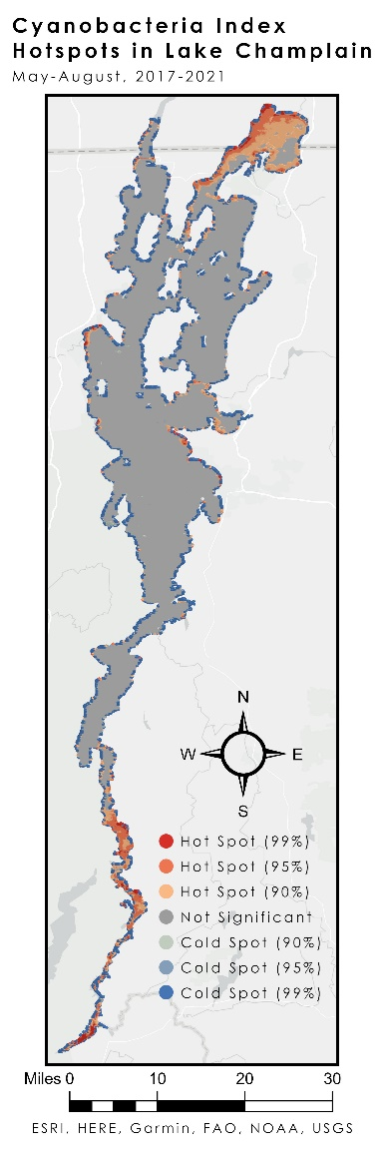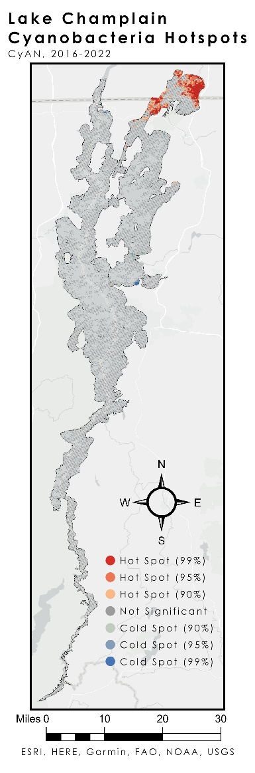
Figures 2 & 3. Index (left) and CyAN (right) Optimized Hotspot Analysis results.

The team’s hot spot analyses of the CyAN data defined overall and monthly cyanobacteria hotspots (clustered high concentration blooms) and coldspots (clustered low concentration blooms) (Figure 3 & Appendix C3). These areas are often unique to the time of year—for example, the South Lake was pocketed with hotspots only in November and the Main Lake was nearly absent of cyanobacteria from May-August. However, blooms appeared in much of the Main Lake from September through November. 43% of the Missisquoi Bay lake segment was classified as an overall hotspot. Overall hotspots and coldspots are described in further
detail in table 8.

Table 8
CyAN Optimized Hotspot Analysis results.
Characteristic | Segment/Region | Months
Overall Hotspot | Missisquoi Bay | May-October
Overall Hotspot | Northern Northeast Arm | September-October
Overall Hotspot | St. Albans Bay | November
Overall Coldspot | Northern Main Lake | July-September
Overall Coldspot | Northern Northeast Arm | May and August-September
Overall Coldspot | Southern Northeast Arm | August-October
Overall Coldspot | Mallets Bay | July-October
Overall Coldspot | St. Albans Bay | July-September

The highest concentration blooms occurred in August or September and 2016 and 2021 exhibited the highest concentration blooms (Appendix C1). However, lake-wide cyanobacteria density was on a decreasing trend over 2016-2021. The standardized count of in-situ reports of cyanobacteria blooms increased during the same time period, so blooms became less severe but occurred more frequently (Appendix C5). The median concentration of cyanobacteria blooms in Lake Champlain typically reduced by approximately one-half from May to June, then accelerated into July, reached a peak around September, and quickly fell off by November (Appendix C2). There were also unique trends in cyanobacteria concentration by lake segment and year (Appendix C4). Missisquoi Bay experienced the highest median concentration blooms over any other segment, though it shared a decreasing trend in cyanobacteria density with the Northeast Arm. The South Lake exhibited a unique peak in 2019, while the Main Lake and Mallets Bay were relatively static during the study period.

The primary concern of the use of CyAN weekly composites is that they only keep the highest concentration bloom per pixel, so lower values that occur in the same spot in a single week are disregarded. The team’s analysis of DESIS’ feasibility for cyanobacteria monitoring was limited by the lack of in-situ concentration data, limited imagery, and the requirement of image processing (Appendix C6). The Cyanobacteria Tracker contained concentration measurements taken too close to the shore to be used for satellite validation, and the team was unable to source applicable in-situ data. Additionally, DESIS had only taken two clear images of Lake Champlain at the time of access. Lastly, CyAN’s image processing techniques applied to OLCI imagery would need to be reworked in order to apply to DESIS. However, the higher spatial resolution of DESIS (30 meters) can see portions of the lake that were too thin to see with OLCI (300 meters).

4.1.2 Phosphorus Runoff
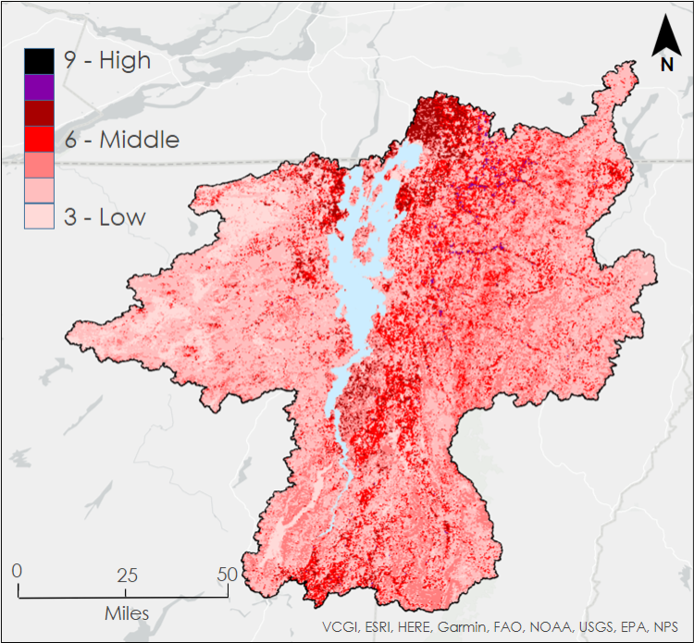
Figure 4. Lake Champlain Watershed Runoff Potential Map

The final phosphorus runoff potential map highlighted areas of greatest concern for phosphorus runoff on a scale of 3-9, with 3 being the lowest risk and 9 being the highest risk of runoff (Figure 4). Visually, the clusters of higher risk were concentrated at the Northern and Southeastern shores of the lake, in the southern tip of the watershed, and along the Missisquoi and Lamoille Rivers in Vermont. Table 9 compares the percentage of land at an elevated risk for phosphorus runoff between the entire Lake Champlain basin and the three sub-watersheds of greatest concern. Of these the Missisquoi sub-watershed has the greatest area of concern, with 229,044 acres of land at elevated risk. A visual representation of these sub watersheds can be found in Appendix A.

Table 9
Watersheds at Above Average Elevated Runoff Risk
Watershed | Percent of Land at Elevated Risk
Total Lake Champlain Basin | 16.26 %
Missisquoi | 29.71 %
Lake Direct | 27.05 %
Poultney - Mettawee | 22.00 %

This map (Figure 4) does have two primary limitations. First, the data layer of major water sources did not include streams and rivers on the Canadian Side of the of the border. As such, risk on the Canadian side of the Missisquoi Sub-Watershed is underrepresented. Second, this map is an indicator of regions that may be more at risk based on common phosphorus runoff risk factors, but it is not a field-tested indicator of where phosphorus is coming from. It is rather an indicator of where phosphorus is likely to come from.

4.2 Future Work
Future analyses would assist in developing mitigation strategies to lessen the impact of phosphorus runoff and harmful algal blooms in the Lake Champlain community. There are more than 300,000 acres of wetlands within the Lake Champlain basin ranging in diversity from open marshes to dense forested swamps. Wetlands offer a host of environmental functions from habitat nourishment to erosion prevention, but they also serve as Lake Champlain’s largest phosphorus filtration system. There are ongoing efforts to restore and acquire more wetland acreage (Lake Champlain Basin Program, 2022). Future projects could research the feasibility of these wetlands as permanent phosphorus sinks for Lake Champlain. Projects should also replicate the cyanobacteria concentration maps using future Sentinel-3 products that have cloud masking capabilities. Using cyanobacteria-specific algorithms to classify areas of the lake into portions containing algae or not could also be used as training data to create a tool to better identify and predict harmful algal blooms. It would also be beneficial to adapt this project to use DESIS. DESIS may be able to help future projects identify the causes of cyanobacteria concentration trends unique to specific portions of the lake but needs a tracking plan to collect sufficient imagery. Lastly, future work could focus phosphorus identification efforts on the drainage basin, mainly the streams and tributaries that feed into Lake Champlain. Nearly 90% of the water that enters Lake Champlain is sourced from the drainage basin (Lake Champlain Basin Program, 2022). Understanding nutrient loading trends in these tributaries could help management groups center their mitigation efforts on water bodies of greatest concern.

5. Conclusions
This project identified six Earth observations that can be used to identify HAB and phosphorus trends. Of these, DESIS can help future projects image smaller blooms due to its higher spectral resolution. The team can also conclude that while the combined index is not a replacement for more precise cyanobacteria identification, it does identify potential areas in Lake Champlain that can then be investigated with more precision. This method could be useful if applied to other, similar lakes, with only minor tweaks to the formulae based on environmental factors. Providing this information to the partners at the NRCS Northeast Region will hopefully benefit them in two different ways. First, the partners will have a new methodology to observe, track, and analyze algal activity in the lake. Second, the partners can use the end products to identify individual areas of greatest concern of phosphorus runoff. These findings allow the partners to specifically tailor mitigation strategies to those local areas to not only pinpoint phosphorus runoff sources in the watershed but also manage the harmful algal blooms that threaten the lake’s hydrology.

The team made some unique conclusions concerning algal activity and phosphorus runoff in Lake Champlain. There are month and segment-specific hotspots and cold spots that can help the NRCS Northeast Region identify sources of phosphorous input. In terms of frequency, HABs occurred most frequently in Missisquoi Bay and St. Albans Bay. Of all locations, Missisquoi Bay was pegged as an area of greatest concern for HAB events, while South Lake showed up as inconclusive and in need of further review. In terms of phosphorus, the phosphorus risk runoff map showed the Missisquoi, Lake Direct, and Poultney-Mettawee sub-watersheds as areas of greatest concern. The common denominator among all three of these areas of concern is high concentrations of annual crop agricultural activity near major water sources like streams and tributaries. A quarter of a million residents rely on Lake Champlain for drinking water, and it is vital that the NRCS Northeast Region can identify HAB trends and implement strategies to lessen the impact of toxic cyanobacteria blooms in the local communities.

6. Acknowledgments
The Lake Champlain water resource team would like to extend a special thanks to the team’s partners from the Natural Resources Conservation Service, their science advisors Dr. Robert Griffin and Dr. Jeffrey Luvall, and their Fellow Paxton LaJoie for their collaboration and guidance during this project. The team would also like to thank Dr. Kenton Ross for his technical support, Dr. Joshua Faulkner from the University of Vermont for his insight into phosphorus runoff, and the greater DEVELOP network for their continued support throughout this project.

This material contains modified Copernicus Sentinel data (2016–2022), processed by ESA.
Any opinions, findings, and conclusions or recommendations expressed in this material are those of the author(s) and do not necessarily reflect the views of the National Aeronautics and Space Administration.

This material is based upon work supported by NASA through contract NNL16AA05C.

7. Glossary
ArcGIS Pro – Geographic Information Systems software used to generate and analyze maps

Cyanobacteria – Blue-green algae bacteria that can photosynthesize and proliferate into toxic algal blooms

DESIS – DLR Earth Sensing Imaging Spectrometer| Hyperspectral satellite operated by NASA since 2018

Earth observations (EO) – Satellites and sensors that collect information about the Earth’s physical, chemical, and biological systems over space and time

European Space Agency (ESA) – Intergovernmental organization committed to furthering European-led space exploration and expanding science communication with European citizens

Google Earth Engine (GEE) – Cloud-based catalog and API used to acquire and process geospatial data

Harmful Algal Bloom (HAB) – Out of control algae growth that produces bacterial toxins

Phosphorus – Chemical element found in soils and fertilizers that is known to proliferate algal blooms when combined with warm, calm water

Phycocyanin – Photosynthesizing pigment protein found in cyanobacteria species

Sentinel-3 OLCI EFR – Ocean and Land Color Imager|Earth Observation Full Resolution|Satellite operated by the ESA since 2016

8. References
Alliance for the Great Lakes. (2019, August 1). Five Yars Later: Lessons Learned from the Toledo Crisis. https://greatlakes.org/2019/08/five-years-later-lessons-from-the-toledo-water-crisis/#:~:text=On%20August%202nd%2C%202014%2C%20residents,bloom%20growing%20in%20Lake%20Erie)

Apted, M., Berryman, K., Chapman, N., Cloos, M., Connor, C., Kitayama, K., Sparks, S., & Tsuchi, H. (2004). MODIS detects a devastating algal bloom in Paracas Bay, Peru. AGU Publications, 85(45), 465–472. https://doi.org/10.1029/2004EO450002

Briggs, T., Litaker, W., Meredith, A., Stumpf, R., Wynne, T. (2020). Harmful Algal Bloom Forecasting Branch Ocean Color Satellite Imagery Processing Guidelines, 2020. https://doi.org/10.25923/606t-m243

Dyble, T. J., Fahnenstiel, G.L., Stumpf, R. P., Tester, P.A.., Tomlinson, M. C., Warner, R.A., Wynne, T. T.(2008). Relating spectral shape to cyanobacterial blooms in the Laurentian Great Lakes. International Journal of Remote Sensing, 29(12), 3665–3672. https://doi.org/10.1080/01431160802007640

Eilola, K., Meier, H. E. M, & Almroth, E. (2009). On the dynamics of oxygen, phosphorus and cyanobacteria in the Baltic Sea; A model study. Journal of Marine Systems, 75(1-2), 163–184. https://doi.org/10.1016/j.jmarsys.2008.08.009

Environmental Protection Agency. (2016, June 17). Phosphorus TMDLs for Vermont Segments of Lake Champlain. https://www.epa.gov/sites/default/files/2016-06/documents/phosphorus-tmdls-vermont-segments-lake-champlain-jun-17-2016.pdf

Environmental Working Group (EWG). (2020, August 26). The High Cost of Algal Blooms in U.S. Waters: More than $! Billion in 10 Years. https://www.ewg.org/research/high-cost-of-algae-blooms/

Faulkner, Joshua. (2021, November). Vermont P-Index V.6.3. https://www.uvm.edu/extension/agriculture/vermont-phosphorus-index

German Aerospace Center (DLR). (2019). DLR Earth Sensing Imaging Spectrometer [Dataset]. Teledyne Brown Engineering. Retrieved June 2022 from https://doi.org/10.15489/hxom21uqeo90

Ghebremichael, L. T., Veith, T. L., & Watzin, M. C. (2010). Determination of critical source areas for phosphorus loss: Lake Champlain basin, Vermont. Transactions of the American Society of Agricultural and Biological Engineers, 53(5), 1595–1604. https://doi.org/10.13031/2013.34898

Jarvis A., H.I. Reuter, A. Nelson, E. Guevara (2008). Hole-filled seamless SRTM data V4. International Centre for Tropical Agriculture (CIAT). Available from https://srtm.csi.cgiar.org.

Jourgholami, M., Karami, S., Tavankar, F., Lo Monaco, A., & Picchio, R. (2021). Effects of slope gradient on runoff and sediment yield on machine-induced compacted soil in temperate forests. Forests, 12(1), Article 49. https://doi.org/10.3390/f12010049

Lacaux, J. P., Tourre, Y. M., Vignolles, C., Ndione, J. A., & Lafaye, M. (2007). Classification of ponds from high-spatial resolution remote sensing: Application to Rift Valley Fever epidemics in Sengal. Remote Sensing of Environment, 106(1), 66–74 https://doi.org/10.1016/j.rse.2006.07.012

Lake Champlain Basin Atlas (2022). Lake Champlain. https://atlas.lcbp.org/nature-environment/lake-champlain/

Lake Champlain Basin Program (LCBP). (2022). Fish and Wildlife. https://www.lcbp.org/our-goals/healthy-ecosystems/biodiversity/fish-and-wildlife/

Lunetta, R., Schaeffer, B., Stumpf, R., Keith, D., Jacobs, S., & Murphy, M. Evaluation of cyanobacteria cell count detection derived from MERIS imagery across the eastern USA. Remote Sensing of Environment, 157(0034-4257), 24–34. https://doi.org/10.1016/j.rse.2014.06.008

Natural Resources Defense Council (NRDC). (2019, August 28). Freshwater Harmful Algal Blooms 101. https://www.nrdc.org/stories/freshwater-harmful-algal-blooms-101

Ogasawara, I. (2019). The use of Sentinel-3 Imagery to monitor cyanobacterial blooms. Environments, 6(6), Article 60 https://doi.org/10.3390/environments6060060
Paerl H. W. (2014). Mitigating harmful cyanobacterial blooms in a human- and climatically-impacted world. Life (Basel, Switzerland), 4(4), 988–1012. https://doi.org/10.3390/life4040988

Paerl, H. W., Fulton, R. S., Moisander, P. H., & Dyble, J. (2001). Harmful freshwater algal blooms, with an emphasis on cyanobacteria. The Scientific World Journal, 1, Article 139109, 76–113, https://doi.org/10.1100/tsw.2001.16

Serrano, A., & Losada, M. (1988). Action Spectra for Nitrate and Nitrite Assimilation in Blue-Green Algae, Plant Physiology. 86(4). 1116-1119. https://doi.org/10.1104/pp.86.4.1116

Stager, J. C., & Thill, M. (2010). Climate Change in the Champlain Basin: What Natural Resource Managers Can Expect and Do. The Nature Conservancy. 1–44, https://www.researchgate.net/publication/280204504_Climate_Change_in_the_Champlain_Basin_What_natural_resource_managers_can_expect_and_do

United States Environmental Protection Agency (EPA). (2022, January 21). The Effects: Dead Zones and Harmful Algal Blooms. https://www.epa.gov/nutrientpollution/effects-dead-zones-and-harmful-algal-blooms#:~:text=Excess%20nitrogen%20and%20phosphorus%20cause,in%20the%20water%20is%20consumed

US Geological Survey (USGS). (2013). Landsat 8 Operational Land Imager (OLI) Level 2, Collection 2, Tier 1 Top of Atmosphere Reflectance [Dataset]. Earth Engine Data Catalog/USGS. Retrieved June 2022, from doi.org/10.5066/P9OGBGM6

US Geological Survey (USGS). (2021). Landsat 9 Operational Land Imager (OLI) 2 Collection 2, Tier 1 Top-of-Atmosphere Reflectance [Dataset]. Earth Engine Data Catalog/USGS. Retrieved June 2022, from doi.org/10.5066/P9OGBGM6

European Space Agency (ESA). (2015). Sentinel-2 MSI: Multispectral Instrument [Dataset]. Earth Engine Data Catalog/USGS. Retrieved June 2022, from https://doi.org/10.5270/S2_-6eb6imz

European Space Agency (ESA). (2021). Sentinel-3 OLCI EFR: Ocean and Land Color Instrument Earth Observation Full Resolution [Dataset]. Earth Engine Data Catalog/USGS. Retrieved June 2022, from 10.5607/S3A/OLCI/L2/EFR/IOP/2022

Vermont Department of Health (VT DOH). (2022). Tracking Cyanobacteria (Blue-Green Algae) in Vermont. Retrieved June 27, 2022 from https://www.healthvermont.gov/tracking/cyanobacteria-tracker

Visual Crossing. (n.d.). Weather Query Builder. Retrieved June 16, 2022 from https://www.visualcrossing.com

Waugh, B. D. N. (2016, July 20). Price of Beauty? For Lake Champlain, it’s $17 Million Per Meter: Algae Blooms, Cloudy Water Can Hurt Tourism, Home Prices, and Jobs. https://www.uvm.edu/news/gund/price-beauty-lake-champlain-its-17-million-meter

9. Appendices

Appendix A – Sub-Watersheds of Greatest Concern
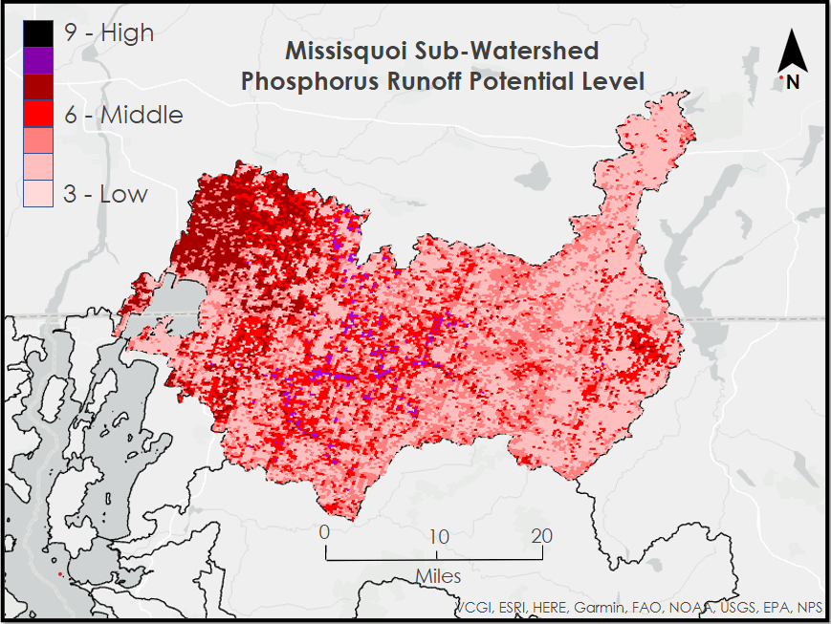
Figure A1 - Missisquoi Sub-Watershed Phosphorus Runoff Potential Level
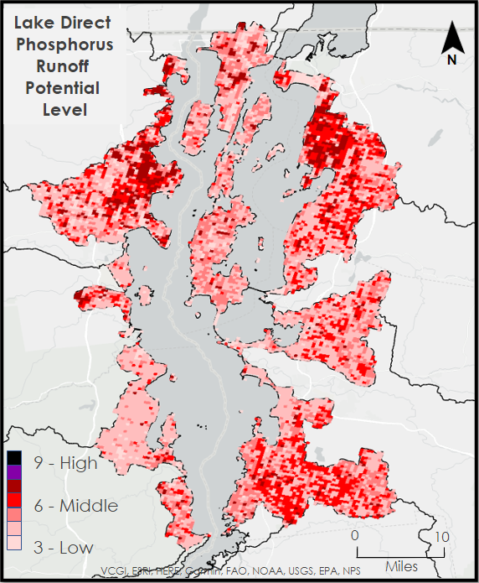
Figure A2 - Lake Direct Sub-Watershed Phosphorus Runoff Potential Level

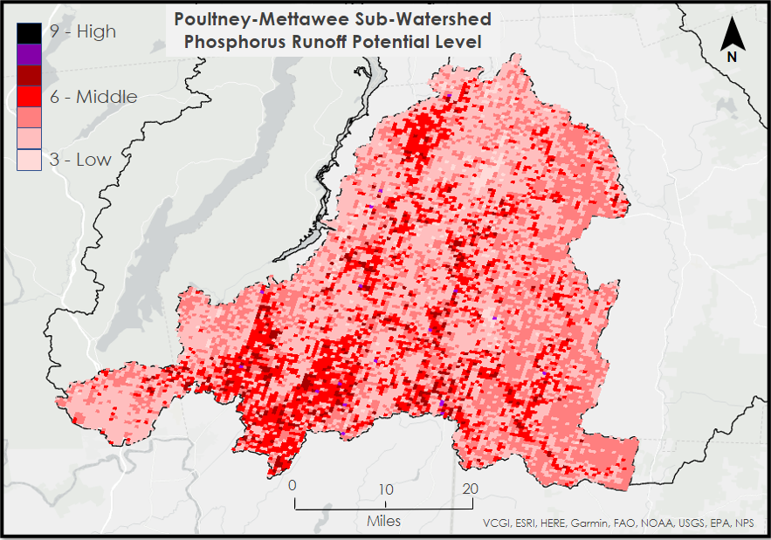
Figure A3 - Poultney-Mettawee Sub-Watershed Phosphorus Runoff Potential Level
Appendix B – Time Series Analysis
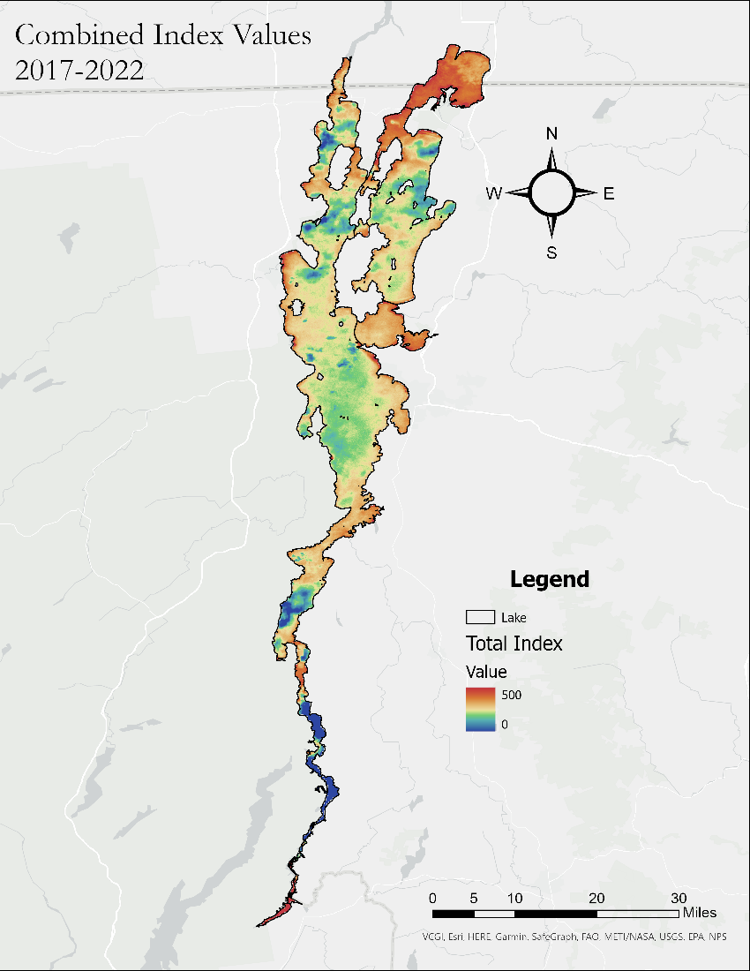
Figure B1. Lake Champlain total index values averaged over the entire study period.

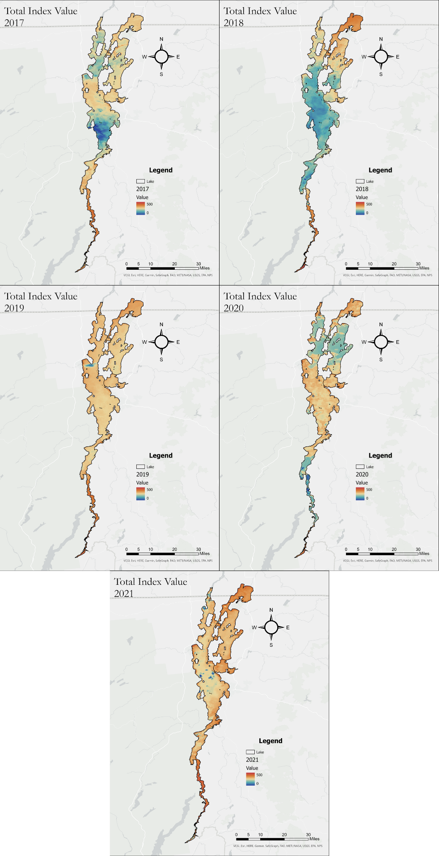
Figure B2. Total index for each individual year.
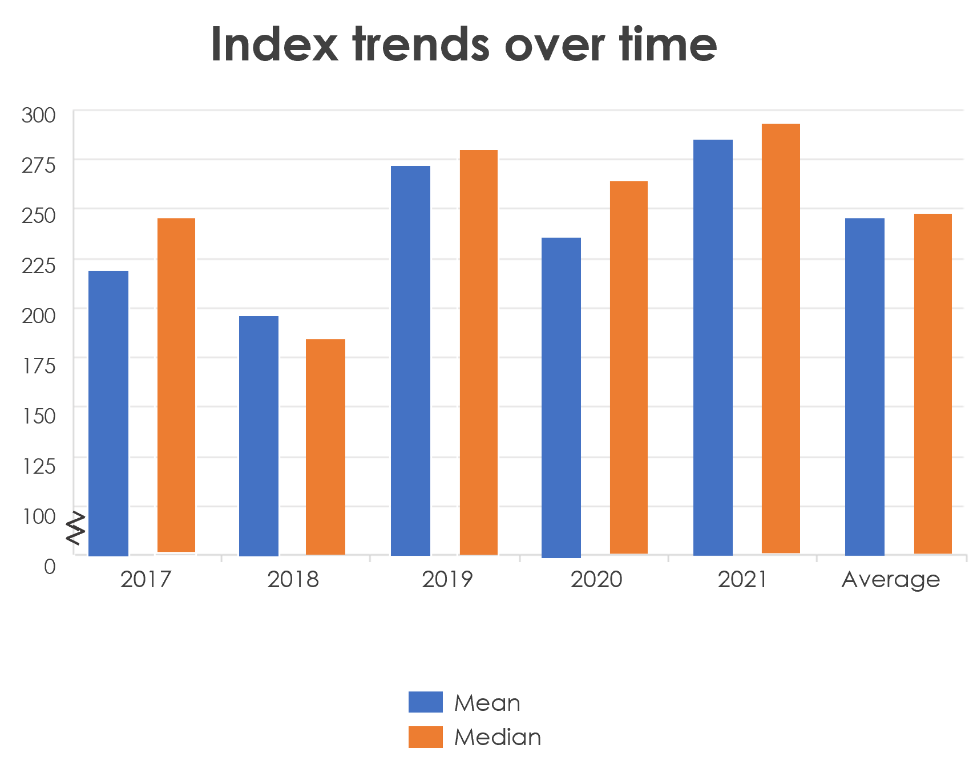
Figure B3. Mean and median index trends per year.

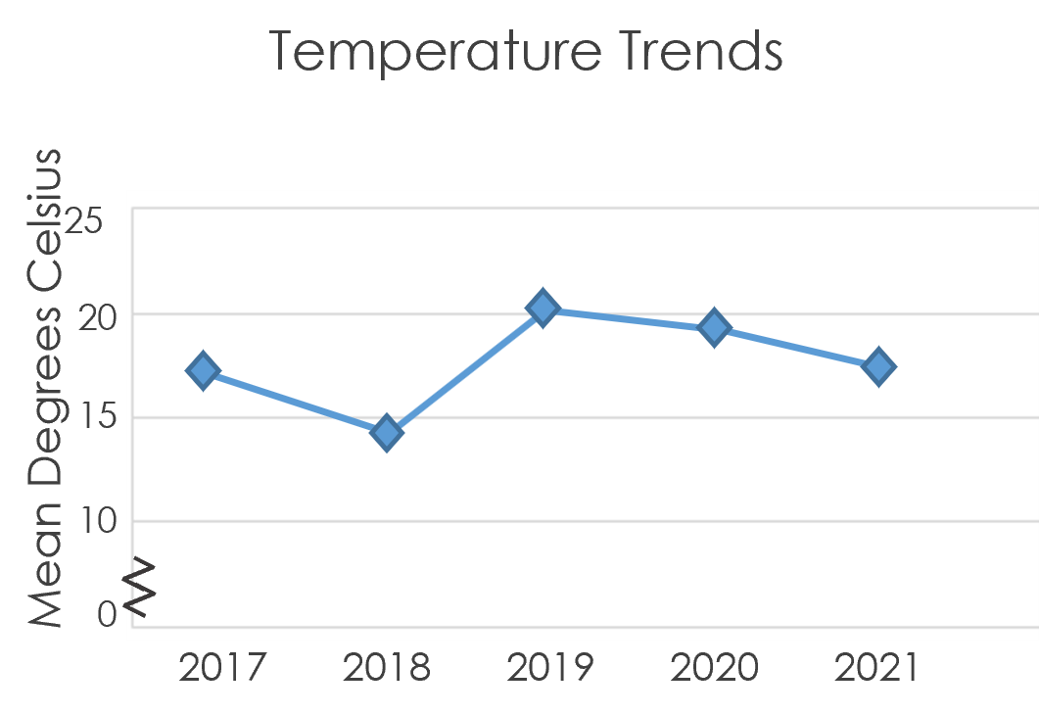
Figure B4. Mean surface water temperature on Lake Champlain.

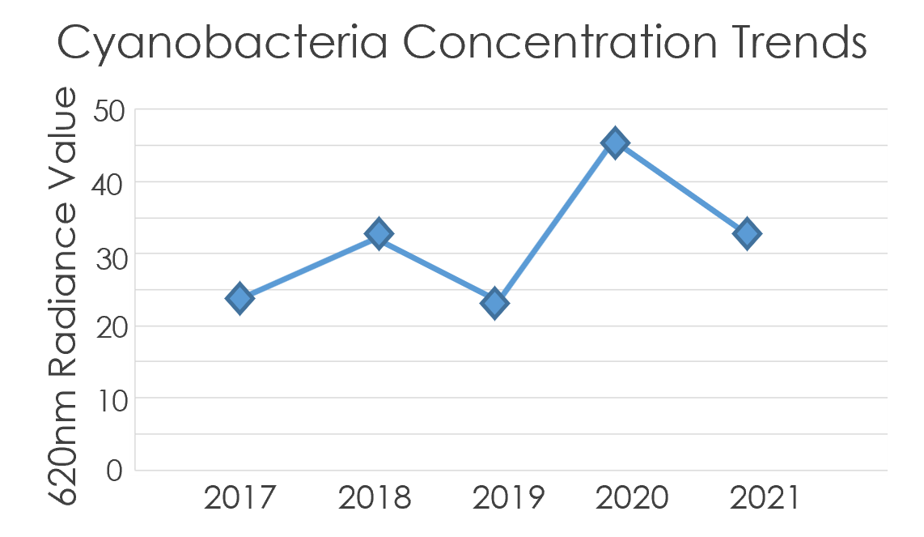
Figure B5. Mean 620nm radiance value.

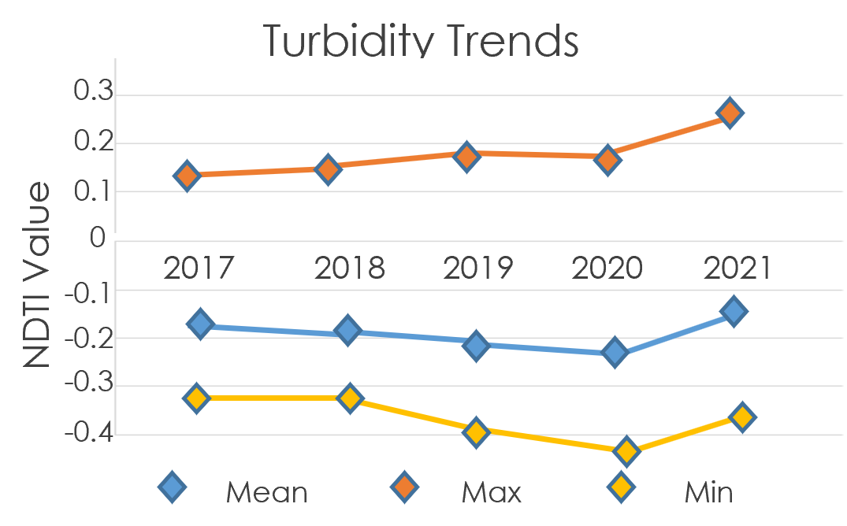
Figure B6. Mean, maximum, and minimum NDTI value.

Appendix C – Cyanobacteria Observations
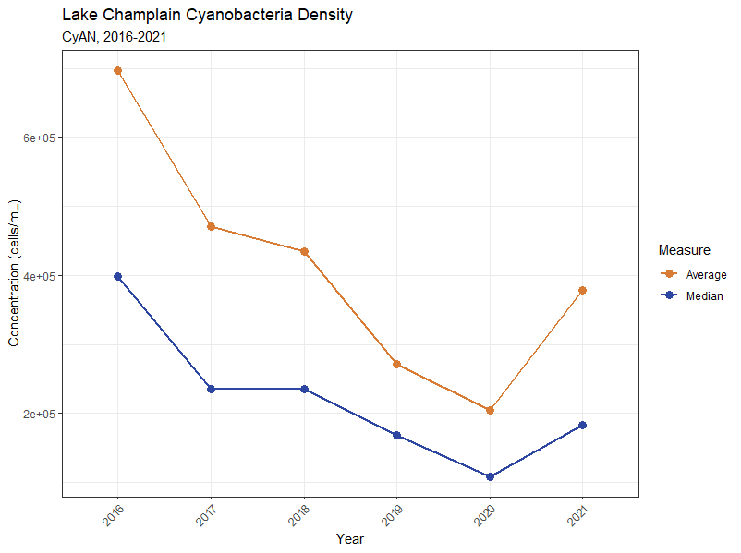
Figure C1. CyAN (Sentinel-3 OLCI) yearly cyanobacteria concentration time series.

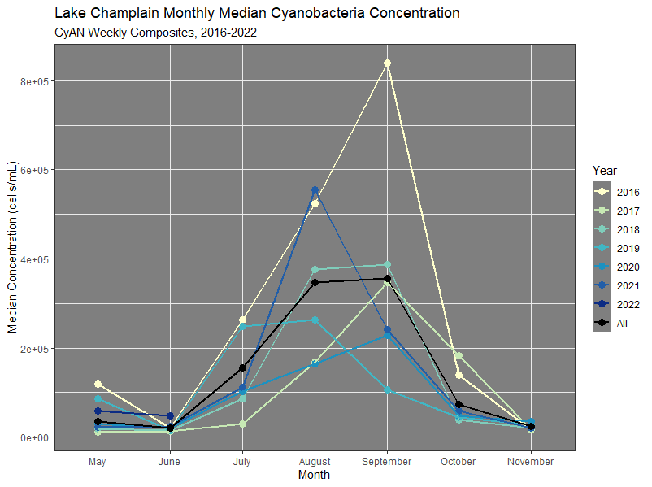
Figure C2. CyAN monthly cyanobacteria concentration time series.
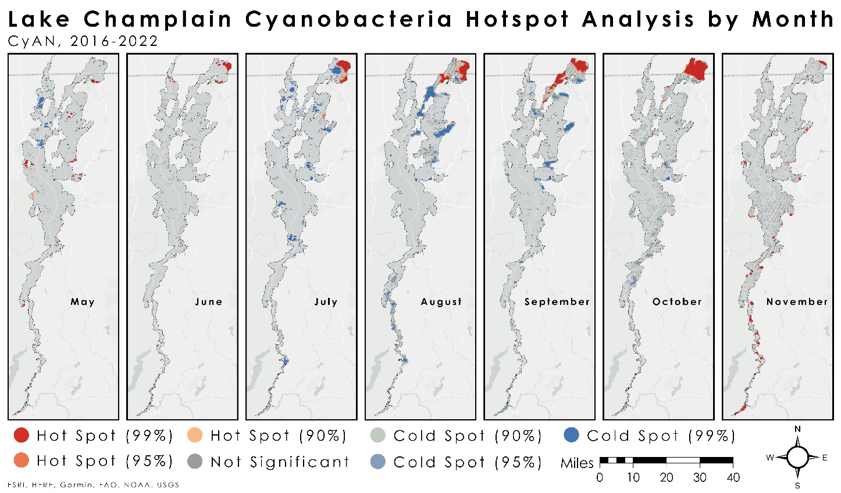Figure C3. Lake Champlain monthly hotspot analysis.
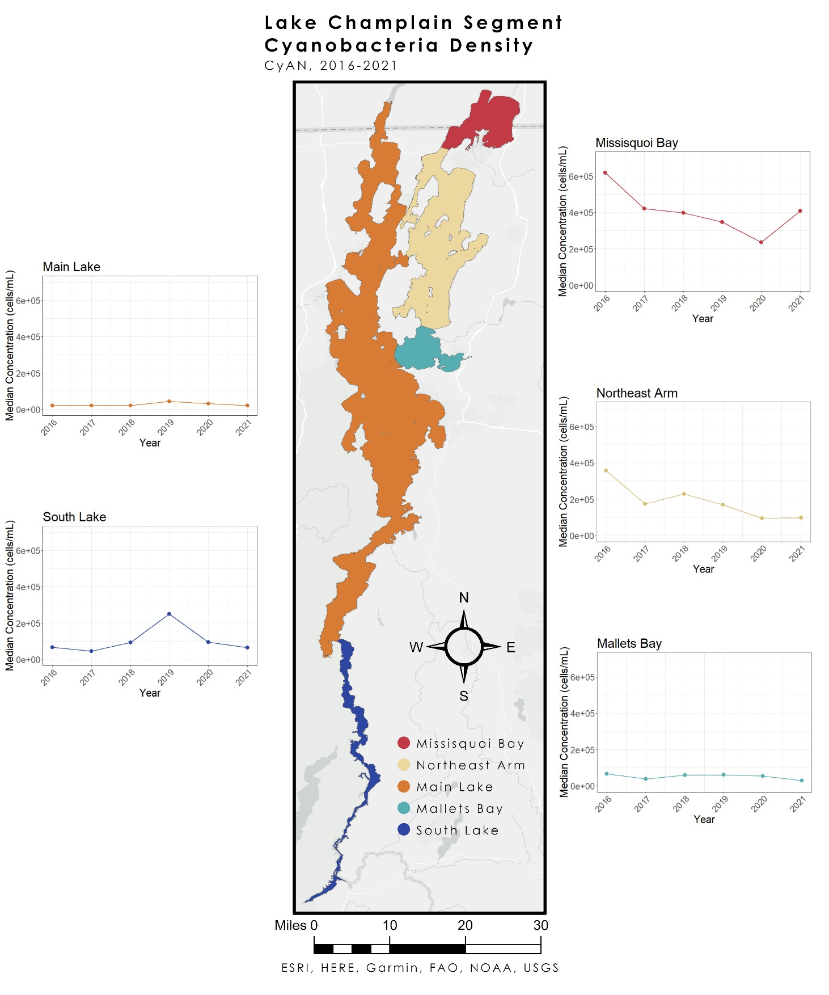
Figure C4. Yearly cyanobacteria density trends by lake segment.

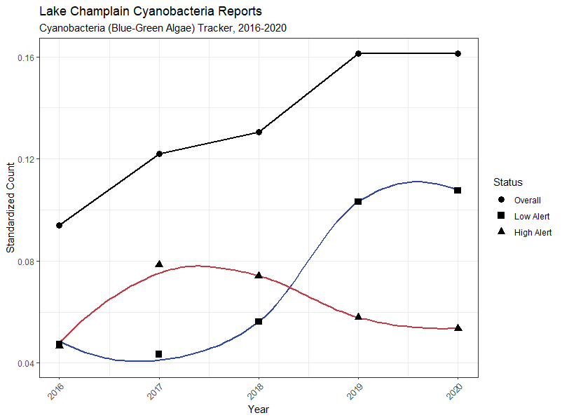
Figure C5. In-situ reports of cyanobacteria submitted to the Cyanobacteria (Blue-Green Algae) Tracker.

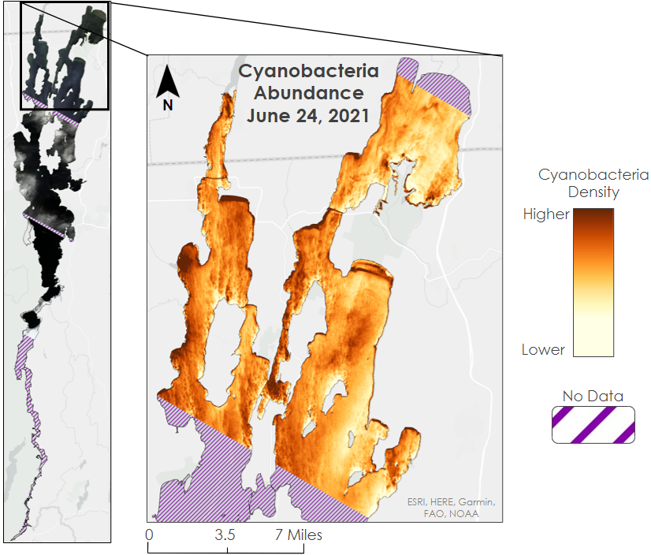
Figure C6. DESIS imagery of Lake Champlain is limited, but able to sense cyanobacteria.

