Chesapeake Bay Water Resources
Characterization of Sediment Dynamics for Enhanced Water Quality Monitoring in the Chesapeake Bay

Technical Report
Final Draft – August 11th, 2022

Katherine Hahn (Project Lead)
Abigail Sgan
Julia Atayi
Julia Portmann

Advisors:
Dr. Venkataraman Lakshmi, University of Virginia (Science Advisor)
Dr. Kent Ross, NASA Langley Research Center (Science Advisor)

1. Abstract
An increase in total suspended sediment (TSS) concentrations and turbidity have contributed to poor water quality in the Chesapeake Bay since the 1970s. Although turbidity and TSS have been moderately improving over the past few decades, poor water quality is detrimental to the Chesapeake Bay’s ecosystems and the surrounding watersheds. The Summer 2022 Chesapeake Bay Water Resources project observed sediment dynamics and turbidity in the York River watershed using remote sensing tools, models, and Earth observations including NASA and United States Geological Survey’s (USGS) Landsat satellite series, NASA DEVELOP’s Optical Reef Coastal Area Assessment Tool 2.0 (ORCAA), and Soil and Water Assessment Tool (SWAT). The collaborators on this project were the Chesapeake Bay National Estuarine Research Reserve (CBNERR), Group on Earth Observations (GEO) AquaWatch, the Committee on Earth Observation Satellites Coastal Observations, Applications, Services and Tools (CEOS COAST), and the Virginia Department of Environmental Quality (VA DEQ). The team concluded that the upstream sections of the York River watershed increased in TSS from 2009–2019. However, the seasonal TSS patterns often correlated with higher precipitation levels, although not necessarily major storm events. This may be due to factors like wind and waves contributing to the sedimentation trends observed. Although projects have been conducted to improve water quality, additional efforts like planting riparian buffers along areas with high TSS are needed to reduce the intensity of runoff. The team’s results will allow the end user, the VA DEQ, to inform their policymaking regarding future Bay conservation efforts.
Key Terms
Chesapeake Bay, erosion, remote sensing, suspended sediment, SWAT, turbidity, water quality

2. Introduction
2.1 Background Information
The Chesapeake Bay faces numerous issues such as poor water quality and invasive species, as well as sea level rise and increasing temperatures resulting from climate change. The Bay is the largest estuary in the United States, the third largest in the world, and one of the most vulnerable regions in the nation experiencing environmental shifts from warming temperatures to rising sea levels (Chesapeake Bay Program, 2022). The surrounding watershed supports 18 million people and 3,600 plant and animal species, several of which are threatened or endangered (Morimoto et al., 2003; Phillips & McGee, 2016; US Fish and Wildlife Service, 2022). Primarily due to fishing and recreation industries, along with the ecosystem services it provides, the Bay has been valued at approximately $100 billion annually (Phillips & McGee, 2016). Despite its immense ecological and economic value, the Chesapeake Bay is impaired based on indicators of increased pollution, decreased fisheries health, and diminished aquatic habitat (Chesapeake Bay Foundation, 2020).

Although the Chesapeake Bay faces several different stressors (e.g., excess nutrients), water clarity is a major issue (Clune et al., 2021). Water clarity can be quantified in multiple ways, two of which are sediment concentrations and turbidity. Sediments are deposited into waterways from agricultural non-point source pollution (e.g., runoff), as well as tidal and nearshore erosion (Reay, 2009). Higher turbidity levels affect the health of underwater vegetation, particularly aquatic grasses (Heck & Orth, 1980; Moore et al., 1996; Orth & Heck, 1980). These grasses support the health of the Bay by producing oxygen, filtering sediment, and providing habitat for native species. However, as turbidity decreases the amount of light available for photosynthesis, aquatic grasses are weakened and the benefits they provide to the health of the Bay are diminished. The York River watershed, a major sub-watershed of the Chesapeake Bay, spans 6,992 square kilometers and was recently declared a Habitat Focus Area by the National Oceanic and Atmospheric Administration (NOAA) to improve habitat conservation through efforts with local communities and partners (NOAA CBO, 2022). The York River also serves as a critical habitat area for Atlantic sturgeon, a historically important, but now endangered, fisheries species which is threatened by high turbidity levels (Johnson, 2018). Although in situ water quality monitoring is an effective and accurate method, turbidity can also be assessed remotely. Using various satellite imagery sources and modelling techniques in conjunction with one another allows for a more accurate assessment (Elhag et al., 2016).

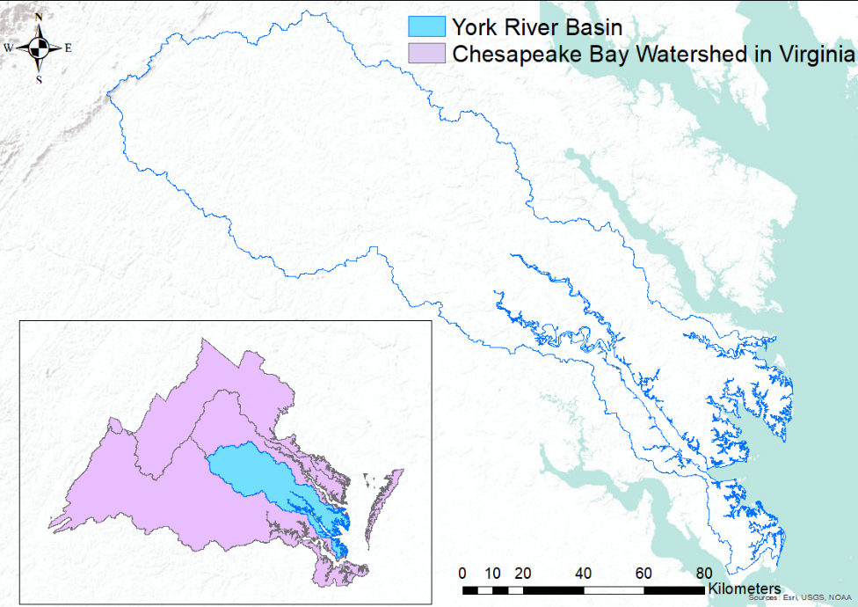
Figure 1. The study area outlined in blue (York River basin) and the section of the Chesapeake Bay watershed in Virginia outlined in purple.
The two models used in this research are Texas A&M University’s Soil and Water Assessment Tool (SWAT) and NASA DEVELOP's Optical Reef and Coastal Area Assessment (ORCAA) Tool. The SWAT is a semi-distributed hydrological watershed model that has been used worldwide for simulating the impact of land use change on streamflow, sediment and nutrient transport (Johnson et al., 2015; Pohlert et al., 2005; Storm et al., 2003; Yevenes & Mannaerts, 2011). The ORCAA tool was originally developed in 2019 for the NASA DEVELOP Belize and Honduras Water Resources projects to map water quality changes in coastal regions (Lin et al., 2019; Pippin et al., 2019). The ORCAA tool was adapted in this study to model turbidity in the York River Basin. Landsat 5 Thematic Mapper (TM), Landsat 7 Enhanced Thematic Mapper Plus (ETM+), and Landsat 8 Operational Land Imager (OLI) satellites were used to collect turbidity imagery because they provided the satellite images for our study time frame in the ORCAA tool. The team also used GPM IMERG data, or precipitation data processed by the IMERG (Integrated Multi-Satellite Retrievals) algorithm for the Global Mean Precipitation (GPM) Core satellite, which collects worldwide mean precipitation data, to create monthly precipitation models. Although recent reports show a trend of slightly improving water quality in the Chesapeake Bay, turbidity and decreased light availability remain major issues (Chesapeake Bay Foundation, 2020). This study also used Earth observation (EO) datasets from NASA, the European Space Agency (ESA), and was supplemented with in situ data from the United States Geological Survey (USGS) and Power Data Access.

2.2 Project Partners & Objectives
This study examined sediment dynamics in the York River Basin from 2009 to 2019 to enhance water quality monitoring of the Chesapeake Bay (Figure 1). The Virginia Department of Environmental Quality (VA DEQ), a state governmental organization, is the end user for the project. One goal of the VA DEQ is to monitor water quality throughout the state, particularly in the Chesapeake Bay region as part of the Virginia Water Quality Monitoring, Information and Restoration Act. The EO analyses produced in this study will supplement the VA DEQ’s in situ data collection and inform management plans for improving water quality in the Chesapeake Bay. The end user may also use the methodologies produced from this study to incorporate modeling using SWAT and ORCAA into their water quality management strategies.

The collaborators on this project were as follows: the Chesapeake Bay National Estuarine Research Reserve (CBNERR), which has collected water quality data including turbidity in the study area since ~2005; Group on Earth Observations (GEO) AquaWatch, an initiative that uses Earth observations to collect water quality data and support aquatic management decisions; and the Committee on Earth Observation Satellites Coastal Observations, Applications, Services and Tools (CEOS COAST), a group that uses satellite observations to assess coastal regions, engage partners, and inform coastal management. This project aims to analyze suspended sediment concentrations in the Chesapeake Bay, assess turbidity using the ORCAA tool, and identify changes in water quality from 2009 to 2019.

3. Methodology
3.1 Data Acquisition
The Google Earth Engine (GEE) JavaScript API was used to utilize NASA’s Optical Reef and Coastal Area Assessment (ORCAA) tool. The ORCAA tool was developed by the Belize and Honduras Water Resources NASA DEVELOP team in 2019 and updated to version 2.0 in spring 2022 (Lin et al., 2019; Pippin et al., 2019; Tentoglou et al., 2022). The ORCAA code utilized Sentinel-2 MSI Level 1-C and Landsat 8 OLI Surface Reflectance Collection 1 Tier 2 imagery which were used to calculate the Normalized Difference Turbidity Index (NDTI).

For the SWAT model, both spatial and temporal datasets were used. The land cover, soil, digital elevation model (DEM), streamflow (discharge), water quality parameters, and climatic variables described in Table 1. The Hydrological Response Units (HRUs) are the fundamental computational units of the SWAT model which are not georeferenced and were created by setting the land use area, slope class and soil area at 10% threshold respectively (Meng et al., 2010). Table 2 shows the various land cover classes identified within the study area. The subbasins were further divided into the HRUs based on similar landcover, slope, and soil properties. In all, 15 subbasins (Figure 2) and 239 HRUs were generated by the model. Daily discharge data were obtained from the downstream portion of the York River watershed at the Pamunkey gauge station (Table 1). These data were used to calibrate and validate the discharge of the SWAT model. These datasets were obtained from USGS National Water Information System.

The sediment yield generated by the model was calibrated and validated using the observed total suspended sediment (TSS) in absence of the observed sediment yield. This was used based on studies by Galloway et al., (2005) which stated that TSS is directly proportional to suspended sediment concentration. The TSS dataset from 2009 to 2019 of the Pamunkey gauge station was obtained from the USGS database. Mean monthly precipitation data from January 2009 to December 2019 were collected from Google Earth Engine using the GPM IMERG dataset (Huffman et al., 2019).

Table 1.
Data types utilized in the study, their purpose, resolution, time frame, and source.
Data Type | Purpose | Resolution/Time Frame | Data Source
Surface reflectance | ORCAA input | 30 m / 2009–2019 | Sentinel-2 MSI, Landsat 5 TM, Landsat 7 ETM+, Landsat 8 OLI
Digital elevation model | SWAT input | 90 m / 2009–2019 | Shuttle Radar Topography Mission (SRTM)
Land cover | SWAT input | 30 m / 2019 | National Land Cover Database Multi-Resolution Land Characteristics
Soil type | SWAT input | 1:5,000,000 scale / NA | FAO Digital Soil Map of the World (DSMW) (FAO, 2007)
Daily precipitation and temperature | SWAT input | 2 m / 2009–2019 | NASA POWER
Daily discharge | SWAT calibration/validation? | N/A / 2009–2020 | USGS National Water Information System
Mean monthly precipitation | Correlate with turbidity/TSS | 900 m / 2009–2019 | GPM IMERG

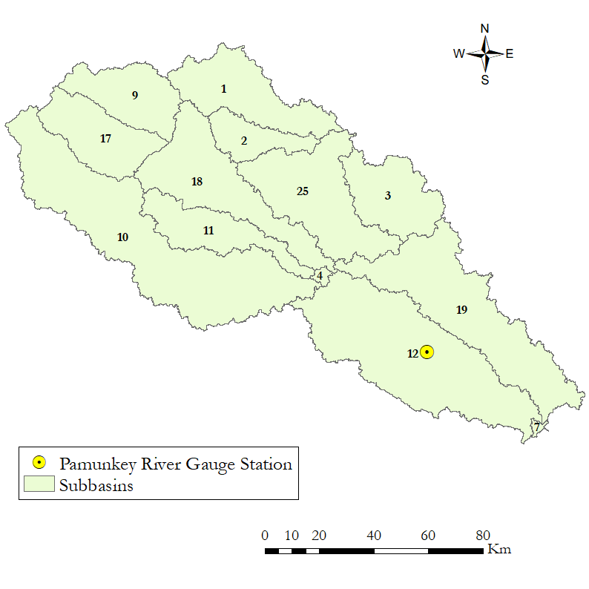
Figure 2. Subbasins generated from the SWAT Model and the gauge station, which was located near the outlet of the Pamunkey River.
Table 2.
Land cover types in the York River watershed.
Value | Land Cover Type | Description
11 | Open Water | Open water, usually <25% cover by vegetation or soil
21 | Developed, Open Space | Often single-family residential areas with lawns, or parks and golf courses. <20% impervious surface cover.
22 | Developed, Low Intensity | Mixed buildings and vegetation, 20-49% impervious surface cover.
23 | Developed, Medium Intensity | Mixed buildings and vegetation, 50-79% impervious surface cover.
24 | Developed, High Intensity | Primarily buildings such as apartments or commercial buildings, 80-100% impervious surface cover.
31 | Barren Land (Rock/Sand/Clay) | Usually less than 15% vegetation cover, open areas of earthen material (e.g., gravel pits, strip mines)
41 | Deciduous Forest | Greater than 20% vegetation cover, trees are at least 5 m tall, majority (>75%) lose leaves seasonally
42 | Evergreen Forest | Greater than 20% vegetation cover, trees are at least 5 m tall, majority (>75%) have leaves year-round.
43 | Mixed Forest | Greater than 20% vegetation cover, trees are at least 5 m tall, mixture of deciduous and evergreen species (neither >75%).
52 | Shrub/Scrub | Vegetation less than 5 m tall, greater than 20% vegetation cover, includes shrubs, young and stunted trees.
71 | Grassland/Herbaceous | Greater than 80% of vegetation cover is grasses or herbaceous species, not tilled, but can be used for grazing.
81 | Pasture/Hay | Mixture of grasses and/or legumes accounting for at least 20% of vegetation cover, used for livestock grazing or producing perennial seed/hay crops.
82 | Cultivated Crops | Annual crops including corn, soybeans, vegetables, perennial woody crops including orchards and vineyards, all actively tilled land, at least 20% of total vegetation.
90 | Woody Wetlands | Soil is regularly saturated with water, trees/shrubs account for at least 20% of vegetation cover.
95 | Emergent Herbaceous Wetlands | Soil is regularly saturated with water, greater than 80% of vegetation cover is comprised of perennial herbaceous vegetation.

3.2 Data Processing
The datasets obtained were clipped to the York River watershed for further analysis in the SWAT model. The spatial datasets included in the SWAT model include slope, soil type, and land cover (Figure 3). Calibration and validation data were downloaded and subset to only stations within the watershed.

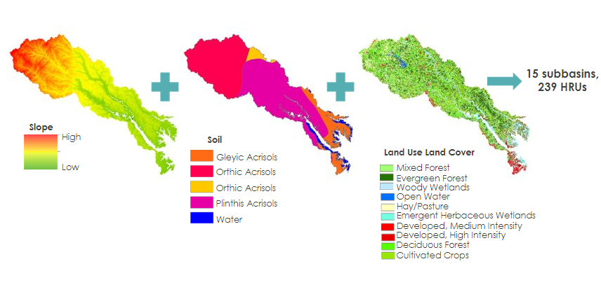
Figure 3. Spatial datasets used in SWAT model setup

We also analyzed turbidity levels in the York River using the ORCAA tool. To do this, we uploaded our study area parameters to the ORCAA tool in GEE. We then applied Landsat 5 TM, Landsat 7 ETM+, and Landsat 8 OLI imagery to the map. These were clipped to the study area and images were mosaicked together. NDTI was calculated using a ratio of the red and green bands and the layer was added onto the satellite imagery (Equation 1).

$NDTI = \frac{Red - Green}{Red + Green}$ (1)

3.3 Data Analysis
For the SWAT model, we took into consideration the type of land use and how it affects sediment flows. For example, we considered how areas of primarily agricultural land use deposited a significant amount of sediment compared to areas of urban land use (citation). Assessing NLCD data first was important to our further data analysis in that it allowed us to better analyze our SWAT projections upon inputting the data into SWAT.

3.3.1 SWAT Model Calibration and Validation
In this study, the calibration and validation of the SWAT model were carried out by comparing the output of the SWAT model with the observed data at the same conditions using SWAT-Calibration and Uncertainty Program (CUP) version 5.2.1.1. SWAT-CUP is a stand-alone calibration program developed by Abbaspour et al. (2007). The Sequential Uncertainty Fitting version 2 (SUFI-2) calibration algorithm embedded in SWAT-CUP was used in this analysis for calibrating the daily streamflow and TSS datasets. The SUFI-2 archives and optimizes model results with 95% uncertainty range which accounts for uncertainty as well as the sensitivity of model parameters (HAWQS, 2020). Sensitivity analysis and calibration of the model were carried out by running the SWAT-CUP model 50 times to achieve the final outputs, due to processing constraints. Observed data from the Pamunkey gauge station were used in calibrating the SWAT model as this was the closest gauge to the outlet of the York River watershed.

For discharge, calibration and validation of the model were performed using an 11-year period of observed data obtained from the Pamunkey gauge station (Figure B1). Two years of data (January 01, 2009 to December 31, 2010) were used as the warm-up period for the model, while January 1, 2011 to December 31, 2014, and January 1, 2015 to December 31, 2019 were used for calibration and validation, respectively. For TSS calibration, the USGS discharge data were used from January 2011–December 2014 while data were used from January 2015–September 2018 in validation.

Selection of the most important SWAT-CUP parameter is required to enhance the efficiency of the calibration. In this study, thirteen parameters were selected for discharge calibration and seven for sediment calibration. These parameters were selected based on the relative significance of each parameter and their sensitivity to the model. The significance of the parameters was measured based on two indicators, the t-stat and the p-value, during the sensitivity analysis process as recommended by Abbaspour et al., 2015. The parameters used for the discharge are: base flow alpha factor (ALPHA_BF), Soil Conservation Service-Curve Number (SCS-CN2), groundwater delay (days) (GW_DELAY), surface runoff lag time (SURLAG), threshold depth of water (GWQMN), Manning’s ‘n’ value for main channel (CH_N2), available water capacity of the soil (SOL_AWC), surface runoff lag time (SURLAG), effective hydraulic conductivity in the main channel alluvium (CH_K2), soil evaporation compensation factor (ESCO), groundwater coefficient to occur (mm) (GW_REVAP), maximum canopy storage (CANMX), and plant uptake compensation factor (EPCO). The parameters used for the sediment calibration are: channel erodibility factor (CH_COV1), channel cover factor (CH_COV2), sediment concentration in runoff (SED_CON), Universal Soil Loss Equation soil erodibility factor (USLE_K), sediment concentration in lateral flow and groundwater flow (LAT_SED), linear re-entrainment parameter for channel sediment routing (SPCON), and exponential re-entrainment parameter (SPEXP).

Moreover, uncertainties of the parameters associated with the model were evaluated using P-factor and R-factor. The P-factor is the degree to which all uncertainties accounted for in the model are quantified. This represents the percentage of measured data bracketed by 95% prediction uncertainty (95PPU) in Meng et al., 2010. The P-factor varies from 0.0 to 1.0; a value closer to 1.0 indicates very high performance and efficiency of the model. The R-factor on other hand is the ratio of the average width of the 95PPU which varies from 0 to infinity. Studies show that values approaching zero represent a smaller 95PPU band thickness and it indicates the better performance of the model (Abbaspour et al., 2007; Yang et al., 2008). Furthermore, performance of the model and the observed values were evaluated using statistical indices embedded in SWAT-CUP (Ndulue et al., 2015). These indices include the coefficient of determination (R²), percentage bias (PBIAS), and Nash-Sutcliffe Efficiency (NSE; Costa et al., 2015; Ghoraba, 2015).

3.3.2 ORCAA Tool Data Analysis
NASA DEVELOP’s ORCAA 2.0 tool was used in this study to remotely view turbidity levels in the York River from 2009 to 2019 using imagery from NASA and USGS’s Landsat satellite series (Landsat 5 TM, Landsat 7 ETM+, and Landsat 8 OLI). The turbidity data were calculated through GEE, using data from its archives. When the tool was run via the user interface, median monthly imagery for the chosen month (e.g., July 2019) was applied to the chosen study area (Figure 4). Turbidity levels were then analyzed using NDTI. The team created models using precipitation data collected by NASA’s GPM IMERG satellite (Figure 4). These models presented monthly mean precipitation levels for the York River watershed, thus allowing a connection between precipitation and turbidity levels calculated through ORCAA to be observed.
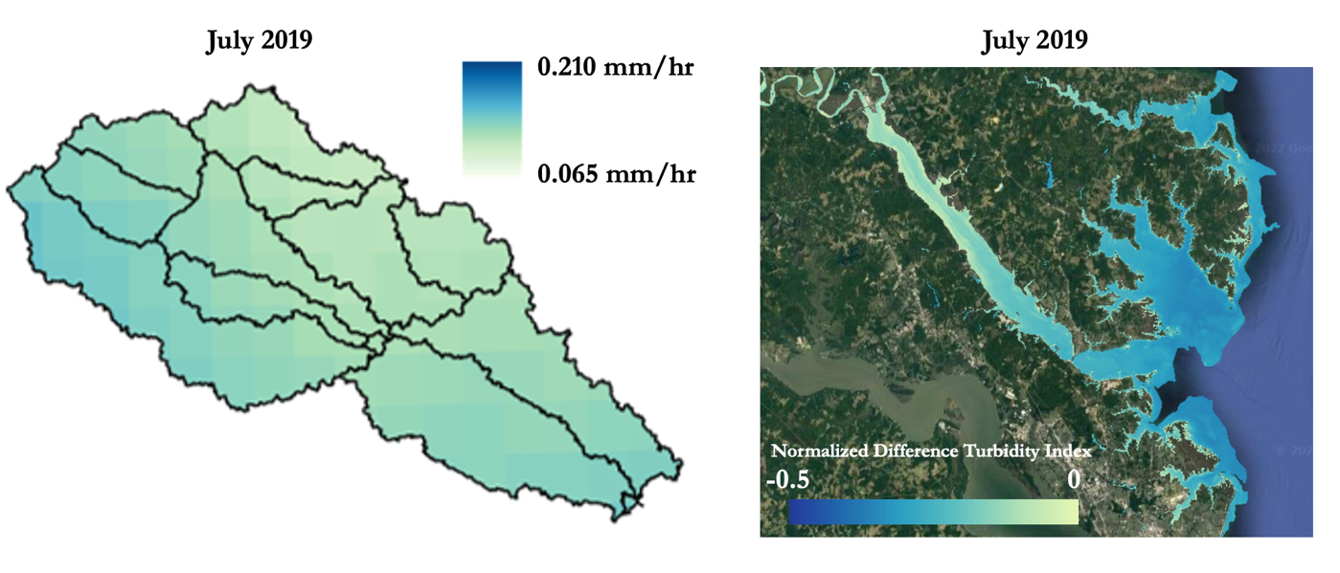

Figure 4. July 2019 median NDTI turbidity levels and July 2019 mean precipitation levels. ORCAA imagery was derived from Landsat 8 OLI. Precipitation data were derived from GPM IMERG.

4. Results & Discussion
4.1 Analysis of Results
4.1.1 Calibration and Validation of Discharge and Total Suspended Sediments
Appendix A shows the graphical representation of the observed and simulated discharge used in the calibration and validation periods. From the summary statistics obtained from SUFI-2 in Table 3, the R² recorded for both the calibrated and validated discharge and TSS were more than 0.80. The observed and simulated discharge showed good correlation (Figure A1). The PBIAS were within the range of ±10% whereas NSE values were more than 0.75. This shows that the performance of the SWAT model was good as stated by Moriasi et al. (2007). However, the negative values of PBIAS show overestimation of the model.

Table 3. Summary statistics of the calibration and validation performance of the SWAT model.
Statistical Indices
Flow Discharge
Method | R² | PBIAS | NSE | P-factor | R-factor
Calibration | 0.885 | -0.251 | 0.803 | 0.640 | 0.763
Validation | 0.911 | -0.190 | 0.854 | 0.590 | 0.742
Total Suspended Sediments
Calibration | 0.856 | -0.320 | 0.763 | 0.660 | 0.682
Validation | 0.928 | -0.401 | 0.715 | 0.620 | 0.630

Appendix C shows a clear consistency between the observed and simulated TSS values (Figure C1). Table 3 as shown above indicates the statistical indices between the observed and simulated TSS. Though the monthly simulated and observed TSS were similar, from the graph it shows that the observed TSS was overestimated (Figure D1). This difference may be due to few observed suspended sediments data having the same values recorded.

4.1.2 Characterizing TSS
The TSS were grouped and classified based on each subbasin of the York River watershed. The upstream subbasins of the watershed recorded high TSS yields from 2009–2019. These are attributed to several factors such as the steeper slope and the agricultural land cover in the area. As vegetation covers are displaced for other land use, the soil gets compacted resulting in an increase runoff instead of infiltration which leads to sediments and other nutrients being carried into nearby rivers bodies (Van Oost et al., 2000). Other studies also predict an increase in sediment loads based on intensification of soil erosion as a result of an upward trend of average precipitation (Barrera Crespo et al., 2019; Darby et al., 2015; Giardino et al., 2018). This may however vary from catchments depending on the type of vegetation cover found there.

Across the time period, TSS yields were highest in spring months (March through May), and lower in fall and winter (Figure 6). Across the study period, spikes in TSS yields occurred more frequently in the later years of the model (Figure 7). Some of these spikes correlated with high precipitation caused by hurricanes and tropical storms, but not all (Figure 7).
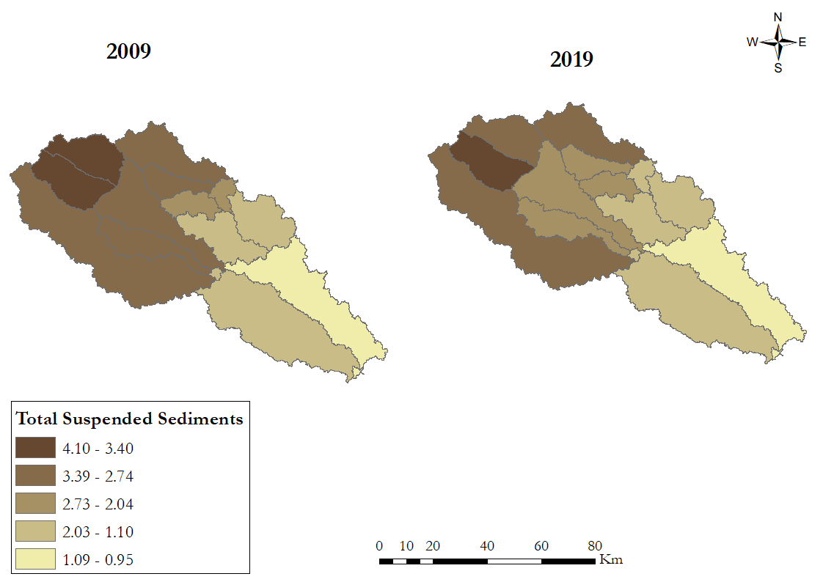
Figure 5. Characterized TSS of the York River
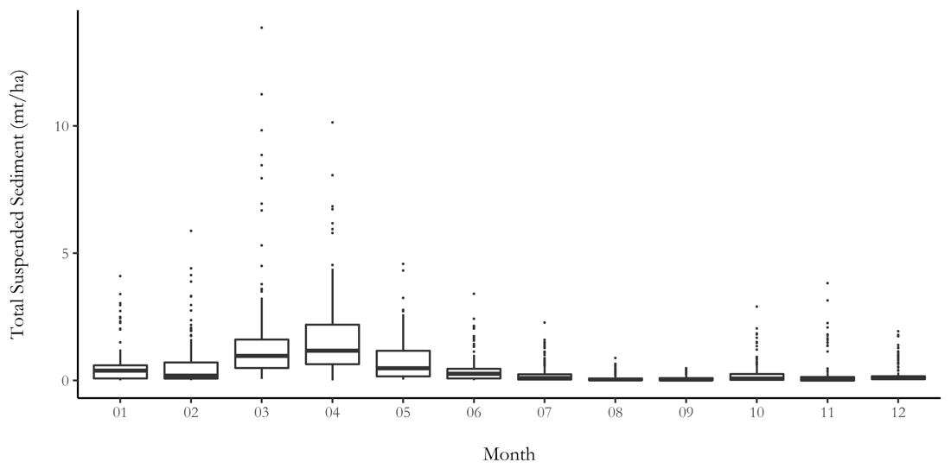
Figure 6. Distribution of TSS yields across the 2009 to 2019 study period, separated by month.

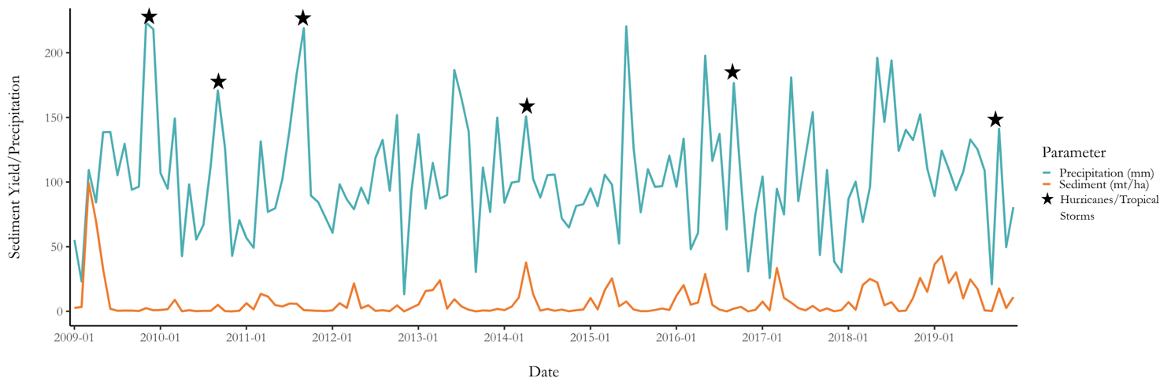Figure 7. Monthly TSS and precipitation values from 2009 to 2019. Stars represent hurricanes and tropical storms during the study period.
4.1.3 ORCAA Analysis
The ORCAA imagery collected for this analysis represents median monthly imagery from selected months in 2009 and 2019 (Figure 8) while GPM IMERG precipitation models show monthly mean precipitation levels (Figure E1). From the collected ORCAA imagery, the team concluded that turbidity did not necessarily worsen solely based on the passage of time from 2009 to 2019. Seasonal turbidity changes often resulted from differing precipitation, wind, and wave conditions. Solely based on the imagery collected, there was a correlation between precipitation and turbidity in which higher precipitation levels corresponded with increased turbidity levels. The notable exception occurred during October 2019, which had very high precipitation levels, due to multiple heavy precipitation events occurring in the area during that time (Figure E1). Hurricane Dorian made landfall on the East coast in September 2019, contributing to this heavier precipitation and possibly leading to the decrease in turbidity shown through ORCAA as compared to October 2009 (NOAA, 2019; Figure 8). Some literature suggests, however, that major storm and precipitation events can resuspend sediments and increase turbidity levels in tidal areas (Walker, 2001). Although wind and waves were not analyzed through the ORCAA tool in this study, these factors are major causes of sediment resuspension and can have a profound impact on turbidity levels in addition to precipitation (Carlin et al., 2016).

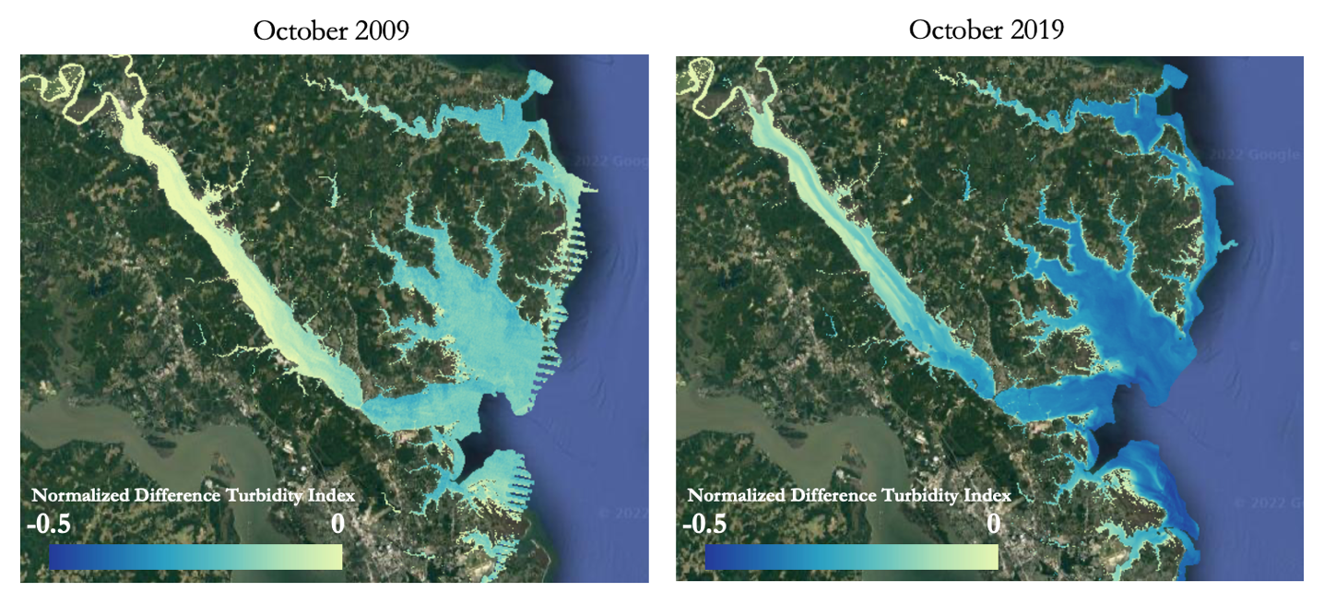Figure 8. York River NDTI turbidity levels for October 2009 and October 2019. Images derived from Landsat 5 TM, Landsat 7 ETM+, and Landsat 8 OLI.

4.2 Future Work
Future work on the project would include analyzing other aspects of water quality data such as chlorophyll-a and colored dissolved organic matter (CDOM) through a longer study period. This would aid our partners as they can utilize their in situ data alongside the new data and pinpoint the major contributing factors of poor water quality in the Chesapeake Bay. Examining the major causes of water quality decrease over decades of historical data could allow for a projection of water quality trends for the next 10 to 20 years. The time period could also be narrowed, to examine specific sediment trends around major storm events. Broadly, partners in the Chesapeake Bay watershed should continue to implement restoration practices such as planting riparian buffers around streams that have high sediment yields.

5. Conclusions
Overall, sediment levels in the York River watershed were found to generally increase during the study period. Within the watershed, the TSS yields were typically higher in the headwaters, where the slopes were steeper and forest cover was lower. There did not appear to be a strong correlation between precipitation and TSS across the study period, including following major tropical storms and hurricanes. Turbidity was highly variable between 2009 and 2019. Some seasons showed an increase in turbidity, while others showed a decrease. Generally, there was a correlation between precipitation and turbidity; months of greater mean precipitation usually also had greater turbidity, with only a few exceptions. These exceptions may have been driven by other factors that influence turbidity such as wind and waves.

The Virginia Department of Environmental Quality will benefit from the provided analyses through understanding the land use dynamics in the Chesapeake Bay watershed and how it impacts the local ecosystem health. The results that were produced highlight areas within the York River watershed that are susceptible to sediment runoff and turbidity, which will help focus management efforts by collaborators. Future restoration or rehabilitation efforts could be implemented using all end products and data provided, such as planting riparian buffer zones around sections of the stream with increased runoff. The project partners and collaborators will also have a better understanding of the capacities of Earth observations and the effectiveness of using in situ data in tandem with satellite data. Reducing the TSS and turbidity of the York River, and in turn, the Chesapeake Bay, will contribute to pollution reduction goals and increased value.

6. Acknowledgments
We would like to thank Caroline Williams, the NASA DEVELOP Pop-Up Projects Fellow, Dr. Venkataraman Lakshmi of the University of Virginia, and Dr. Kenton Ross of NASA Langley Research Center, the science advisors for this project, for their guidance. We also acknowledge our partners Amanda Shaver of VA DEQ, Carl Friedrichs of CBNERR, Steve Greb of GEO AquaWatch, and Merrie Beth Neely of CEOS COAST. We sincerely thank Prakrut Kansara and Duc Tran of the University of Virginia for their knowledge and assistance with the SWAT model.

This material contains modified Copernicus Sentinel data (2009 to 2019), processed by ESA.

Any opinions, findings, and conclusions or recommendations expressed in this material are those of the authors and do not necessarily reflect the views of the National Aeronautics and Space Administration.

This material is based upon work supported by NASA through contract NNL16AA05C.

7. Glossary
EO – Earth Observations. Satellites and sensors that collect information about the Earth’s physical, chemical, and biological systems over space and time.
GEE – Google Earth Engine. A global geospatial code-editing platform that allows users to access Earth observation technology and view satellite images of the Earth.
GPM IMERG – Global Precipitation Measurement Integrated Multi-Satellite Retrievals. Global precipitation data processed by the IMERG algorithm, which analyzes information from NASA’s Global Precipitation Measurement Core (GPM Core) satellite to provide estimations of precipitation levels across the surface of the Earth.
Landsat 7 ETM+ – Landsat 7 Enhanced Thematic Mapper Plus. Satellite that collects Earth observation imagery with 8 spectral bands.
Landsat 8 OLI – Landsat 8 Operational Land Imager. Satellite that collects Earth observation imagery with 9 spectral bands.
Landsat 5 TM – Landsat 5 Thematic Mapper. Satellite that collects Earth observation imagery with 7 spectral bands
MODIS – Moderate Resolution Imaging Spectroradiometer. A satellite instrument attached to NASA’s. Terra and Aqua satellites that uses 36 spectral bands to collect Earth observation images.
MRLC – Multi-Resolution Land Characteristics Consortium. The source for downloading land cover data.
NASS – U.S. Department of Agriculture National Agriculture Statistics Service.
NDTI – Normalized Difference Turbidity Index. Index used as a proxy for turbidity in the water.
NLCD LCD – National Land Cover Database Land Cover Data. Land cover database at 30 m resolution.
ORCAA - Optical Reef Coastal Area Assessment Tool. Provides visual imagery of various water qualities including turbidity, chlorophyll-a levels, and water surface temperatures.
SWAT – Soil and Water Assessment Tool. A mapping tool used to model various hydrological variables such as watershed surface water dynamics, soil erosion, and land use.
TSS – Total Suspended Sediment. The total concentration of suspended sediments in water.
Turbidity – A measure of the clarity of water in terms of suspended sediment concentrations.
VIMS – Virginia Institute of Marine Science. A source that provided in situ turbidity data for this project.

8. References
Abbaspour, K. C., Yang, J., Maximov, I., Siber, R., Bogner, K., Mieleitner, J., & Srinivasan, R. (2007). Modelling hydrology and water quality in the pre-alpine/alpine Thur watershed using SWAT. Journal of Hydrology, 333(2–4), 413–430. https://doi.org/10.1016/j.jhydrol.2006.09.014.
Abbaspour, K. C., Rouholahnejad, E., Vaghefi, S., Srinivasan, R., Yang, H., & Kløve, B. (2015). A continental-scale hydrology and water quality model for Europe: Calibration and uncertainty of a high-resolution large-scale SWAT model. Journal of Hydrology, 524, 733–752. https://doi.org/10.1016/j.jhydrol.2015.03.027.
Barrera Crespo, P. D., Mosselman, E., Giardino, A., Becker, A., Ottevanger, W., Nabi, M., & Arias-Hidalgo, M. (2019). Sediment budget analysis of the Guayas River using a process-based model. Hydrology and Earth System Sciences, 23(6), 2763–2778. https://doi.org/10.5194/hess-23-2763-2019.
Carlin, J. A., Lee, G., Dellapenna, T. M., & Laverty, P. (2016). Sediment resuspension by wind, waves, and currents during meteorological frontal passages in a micro-tidal lagoon. Estuarine, Coastal and Shelf Science, 172, 24-33. https://doi.org/10.1016/j.ecss.2016.01.029.
Chesapeake Bay Program (CBP). (2022). Chesapeake Bay Program; Science. Restoration. Partnership. https://www.chesapeakebay.net/issues/climate_change#:~:text=The%20Chesapeake%20Bay%20is%20one,further%20shifts%20in%20environmental %20conditions.
Chesapeake Bay Foundation. (2020). State of the Bay. https://www.cbf.org/document-library/cbf-reports/2020-state-of-the-bay-report.pdf.
Clune, J. W. & Capel, P. D., eds. (2021). Nitrogen in the Chesapeake Bay watershed—A century of change, 1950–2050 (ver. 1.1, December 2021): U.S. Geological Survey Circular 1486, 168 p., https://doi.org/10.3133/cir1486.
Costa, D., Avelino, R., Sára, S., Thomazini, L., Aurélio, M., & Caiado, C. (2015). Application of the SWAT Hydrologic Model to a Tropical Watershed at Brazil. Catena, 125, 206–213. https://doi.org/10.1016/j.catena.2014.10.032.
Darby, S., Dunn, F., Nicholls, R., Rahman, M., & Riddy, L. (2015). A first look at the influence of anthropogenic climate change on the future delivery of fluvial sediment to the Ganges–Brahmaputra–Meghna delta. Environmental Science: Processes & Impacts, 17(9), 1587–1600. https://doi.org/10.1039/C5EM00252D.
Elhag, M., Gitas, I., Othman, A., Bahrawi, J., & Gikas, P. (2019). Assessment of water quality parameters using temporal remote sensing spectral reflectance in arid environments, Saudi Arabia. Water, 11(56). https://doi.org/10.3390/w11030556.
Food and Agriculture Organization of the United Nations (FAO). (2007). Digital Soil Map of the World (3.6) [Digital map]. FAO Map Catalog. https://data.apps.fao.org/map/catalog/srv/eng/catalog.search?id=14116#/metadata/446ed430-8383-11db-b9b2-000d939bc5d8.
Galloway, J. M., Evans, D. A., & Green, W. R. (2005). Comparability of suspended-sediment concentration and total suspended-solids data for two sites on the L’Anguille River, Arkansas, 2001 to 2003. U.S. Geological Survey Scientific Investigations Report 2005-5193.
Ghoraba, S. M. (2015). Hydrological Modeling of the Simly Dam Watershed (Pakistan) Using GIS and SWAT Model. Alexandria Engineering Journal, 54, 583–594. https://doi.org/10.1016/j.aej.2015.05.018.
Giardino, A., Schrijvershof, R., Nederhoff, C., De Vroeg, H., Brière, C., Tonnon, P., Caires, S., Walstra, D., Sosa, J., Van Verseveld, W., & Schellekens, J. (2018). A quantitative assessment of human interventions and climate change on the West African sediment budget. Ocean & Coastal Management, 156, 249–265. https://doi.org/10.1016/j.ocecoaman.2017.11.008
HAWQS. (2020). HAWQS System and Data to model the lower 48 conterminous U.S using the SWAT model, Texas Data Repository Dataverse, V1. https://doi.org/10.18738/T8/XN3TE0.
Heck, K. L., & Orth, R. J. (1980). Structural components of eelgrass (Zostera marina) meadows in the lower Chesapeake Bay—Decapod Crustacea. Estuaries, 3(4), 289–295. https://doi.org/10.2307/1352084.
Huffman, G. J., Stocker, E. F., Bolvin, D. T., Nelkin, E. J., & Tan, J. (2019). GPM IMERG Final Precipitation L3 1 month 0.1 degree x 0.1 degree V06, Greenbelt, MD, Goddard Earth Sciences Data and Information Services Center (GES DISC). Accessed: [20 July, 2022]. https://doi.org/10.5067/GPM/IMERG/3B-MONTH/06.
Johnson, T., Butcher, J., Deb, D., Faizullabhoy, M., Hummel, P., Kittle, J., McGinnis, S., Mearns, L. O., Nover, D., Parker, A., Sarkar, S., Srinivasan, R., Tuppad, P., Warren, M., Weaver, C., & Witt, J. (2015). Modeling streamflow and water quality sensitivity to climate change and urban development in 20 U.S. watersheds. Journal of the American Water Resources Association, 51(5), 1321–1341. https://doi.org/10.1111/1752-1688.12308.
Johnson, A. (2018). The effects of turbidity and suspended sediments on ESA-listed species from projects occurring in the greater Atlantic Region. Greater Atlantic Region Policy Series 18(2). NOAA Fisheries Greater Atlantic Regional Fisheries Office. www.greateratlantic.fisheries.noaa.gov/policyseries/. 106p.
Lin, A., Devine, C., Skoglund, S., & Higgins, A. (2019). A Google Earth Engine Dashboard for Assessing Coastal Water Quality in Belize's Coral Reefs to Identify Sustainable Development Goals for Achieving Sustainable Use of Natural Resources [Unpublished Manuscript]. NASA DEVELOP National Program.
Meng, H., Sexton, A. M., Maddox, M. C., Sood, A., Brown, C. W., Ferraro, R. R., & Murtugudde, R. (2010). Modeling Rappahannock River basin using SWAT-pilot for Chesapeake Bay watershed. Applied Engineering in Agriculture, 26(5), 795-805. http://dx.doi.org/10.13031/2013.34948
Moore, K., Neckles, H., & Orth, R. (1996). Zostera marina (eelgrass) growth and survival along a gradient of nutrients and turbidity in the lower Chesapeake Bay. Marine Ecology Progress Series, 142, 247–259. https://doi.org/10.3354/meps142247
Moriasi, D. N., Arnold, J. G., Van Liew, M. W., Bingner, R. L., Harmel, R. D., & Veith, T. L. (2007). Model evaluation guidelines for systematic quantification of accuracy in watershed simulations. Transactions of the ASABE, 50(3), 885–900. https://doi.org/10.13031/2013.23153
Morimoto J., Voinov, H., Wilson, M. A., & Costanza, R. (2003). Estimating watershed biodiversity: An empirical study of the Chesapeake Bay in Maryland, USA. Journal of Geographic Information and Decision Analysis, 7(2), 150–162.
National Oceanic and Atmospheric Administration Chesapeake Bay Office (NOAA CBO). (2022, May 03). Virginia’s Middle Peninsula Is the Newest NOAA Habitat Focus Area. NOAA Fisheries. https://www.fisheries.noaa.gov/feature-story/virginias-middle-peninsula-newest-noaa-habitat-focus-area
National Weather Service (NWS). (2019, September 6). Hurricane Dorian – September 6, 2019. https://www.weather.gov/mhx/Dorian2019
Ndulue, E. L., Mbajiorgu, C. C., Ugwu, S. N., Ogwo, V., & Ogbu, K. N. (2015). Assessment of Land Use/Cover Impacts on Runoff and Sediment Yield Using Hydrologic Models: A Review. Journal of Ecology and the Natural Environment, 7, 46–55. https://doi.org/10.5897/JENE2014.0482
Orth, R. J. & Heck, K. L. (1980). Structural components of eelgrass (Zostera marina) meadows in the lower Chesapeake Bay—Fishes. Estuaries, 3(4), 278–288. https://doi.org/10.2307/1352083
Phillips, S. & McGee, B. (2016). Ecosystem service benefits of a cleaner Chesapeake Bay. Coastal Management, 44:241–258. http://dx.doi.org/10.1080/08920753.2016.1160205
Pippin, H., Valenti, V., Olarte, A., & Pilot, R. (2019). Developing a Google Earth Engine dashboard for assessing coastal water quality in the Belize and Honduras barrier reefs to identify adequate waste control and inform coastal resource monitoring and management [Unpublished Manuscript]. NASA DEVELOP National Program.
Pohlert, T., Huisman, J. A., Breuer, L., & Frede, H. G. (2005). Modeling of river Dill, Germany. Advances in Geosciences, 5, 7–12. https://doi.org/10.5194/adgeo-5-7-2005
Reay, W. G. (2009). Water quality within the York River Estuary. Journal of Coastal Research. Article 10057, 23–39. https://doi.org/10.2112/1551-5036-57.sp1.23
Storm, D. E., White, M. J., & Stoodley, S. (2003). Modeling non-point source component for the Fort Cobb TMDL. Oklahoma Department of Environmental Quality. https://digitalprairie.ok.gov/digital/collection/stgovpub/id/133/
Tentoglou, T., Carrasco, D., Fernald, E., & Weingram, A. (2022). Updating and expanding the Optical Reef and Coastal Area Assessment (ORCAA) tool [Unpublished Manuscript]. NASA DEVELOP National Program.
United States Geological Survey (USGS). Landsat 5. https://www.usgs.gov/landsat-missions/landsat-5
United States Geological Survey (USGS). (2018, July 18). USGS EROS Archive – Landsat Archives- Landsat 7 Enhanced Thematic Mapper Plus (ETM+) Level-1 Data Products. https://www.usgs.gov/centers/eros/science/usgs-eros-archive-landsat-archives-landsat-7-enhanced-thematic-mapper-plus-etm
U.S. Fish and Wildlife Service (2022). Featured species. Chesapeake Bay Field Office. https://www.fws.gov/office/chesapeake-bay-ecological-services/species
Van Oost, K. Govers, G. & Desmet, P. (2000). Evaluating the Effects of Changes in Landscape Structure on Soil Erosion by Water and Tillage. Landscape Ecology, 15(6), 577–589. https://doi.org/10.1023/A:1008198215674
Walker, N. D. (2001). Tropical Storm and Hurricane Wind Effects on Water Level, Salinity, and Sediment Transport in the River-Influenced Atchafalaya-Vermillion Bay System, Louisiana, USA. Estuaries, 24(4), 498-508. https://doi.org/10.2307/1353252
Yang, J., Reichert, P., Abbaspour, K. C., Xia, J., Yang, H. (2008). Comparing uncertainty analysis techniques for a SWAT application to the Chaohe Basin in China. Journal of Hydrology, 358, 1–23. https://doi.org/10.1016/j.jhydrol.2008.05.012
Yevenes, M. A. & Mannaerts, C. M. (2011). Seasonal and land use impacts on the nitrate budget and export of a mesoscale catchment in Southern Portugal. Agricultural Water Management, 102, 54–65. https://doi.org/10.1016/j.agwat.2011.10.006

9. Appendices
Appendix A. Discharge Calibration and Validation
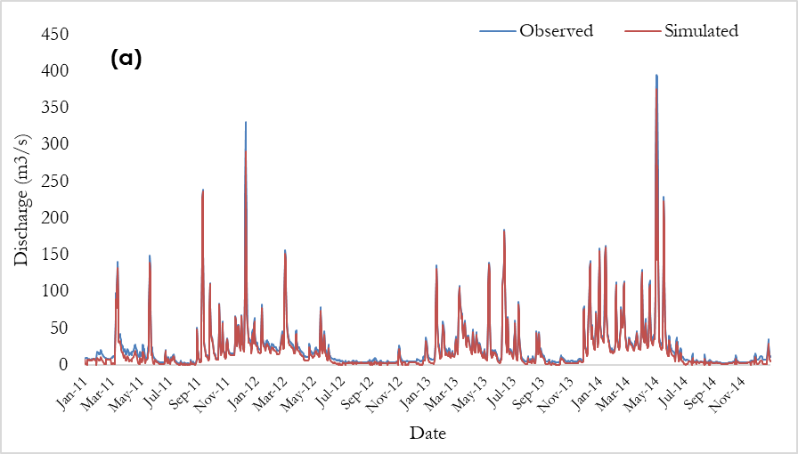
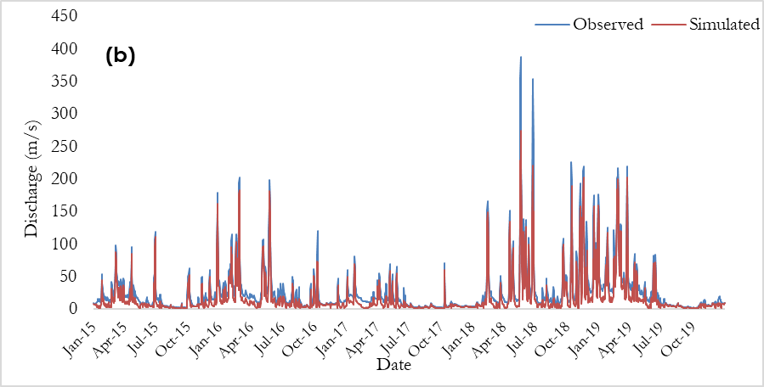
Figure A1. Time series plots of observed and simulated daily discharge during calibration (a) and validation (b).

Appendix B. Scatter Plots of Simulated and Observed Discharge
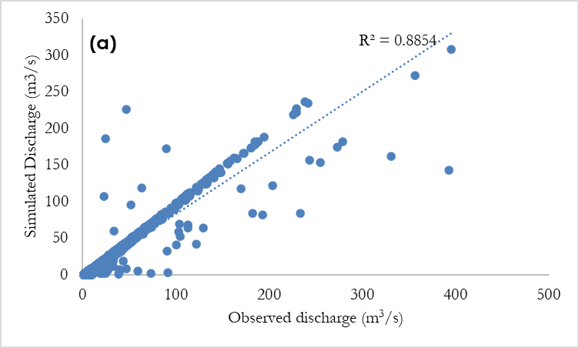
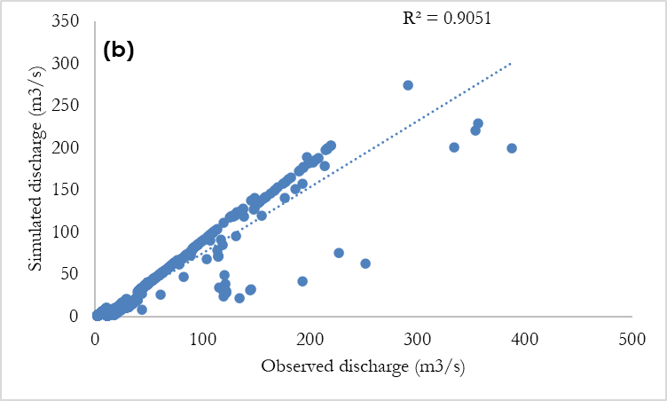
Figure B1. Scatter plots of simulated and observed discharge for calibrated (a), and validated (b)

Appendix C. Total Suspended Sediment Calibration and Validation
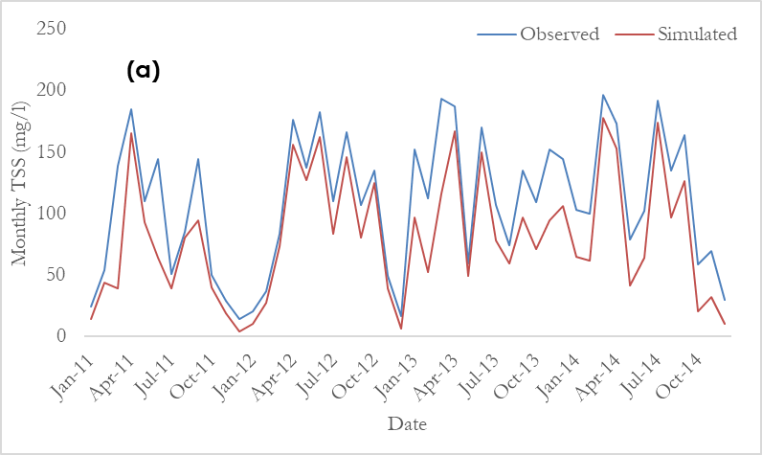
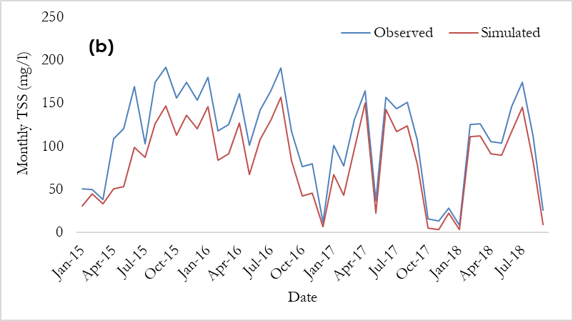
Figure C1. Time series plots of observed and simulated Total Suspended Sediments during calibration (a) and validation (b).

Appendix D. Scatter Plots of Simulated and Observed Total Suspended Sediments
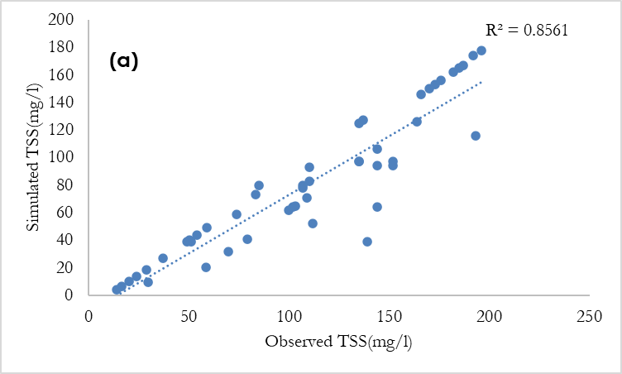
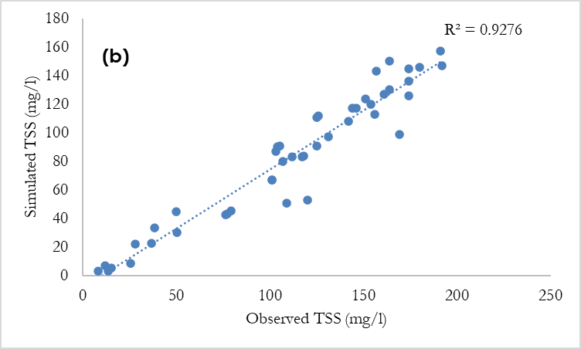
Figure D1. Scatter plots of simulated and observed TSS for calibrated (a), and validated (b)

Appendix E. GPM IMERG York River Watershed Monthly Mean Precipitation Levels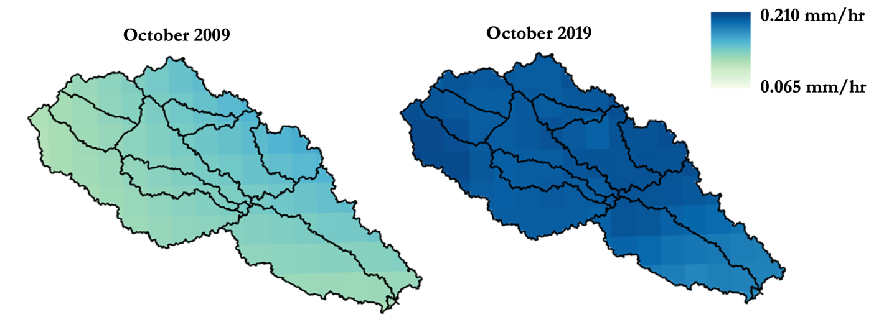Figure E1. October 2009 and 2019 precipitation maps in the York River watershed, using GPM IMERG data.

