Design optimization of energized composite using simulation and experimental methods

Deepak Pandey^{1,2}, Rajkumar Gurjar^{1,2}, Kowsik Sambath Kumar^{1,2}, Leaford Nathan Henderson^{1,2}, Maydenee Maydur Tresa^{1,2}, Luke Roberson³, Mohammed Hussain Abdul Jabbar⁴ and Jayan Thomas*^{1,2,5}

¹Department of Materials Science and Engineering, University of Central Florida, Orlando, Florida 32816, United States
²NanoScience Technology Center, University of Central Florida, Orlando, Florida 32826, United States
³NASA Kennedy Space Center, FL, 32899, USA
⁴Nissan Technical Center, North America, 39001 Sunrise Drive, Farmington Hills, MI
⁵CREOL, College of Optics and Photonics, University of Central Florida, Orlando, Florida 32816, United States.

*E-mail: Jayan.Thomas@ucf.edu

Abstract
As the electric vehicles (EVs) around the world, still suffer with limited miles per charge, the technology of “Energized Composite” (by storing energy in the body of EVs) could help extend its range. The composite’s unique ability to function as both structural body panel and storing charge for the motors, stems from its alternate patterned design between “Electrochemical Areas (EcA)” and “Epoxy Area (EpA)”. Here we present a design optimization study to obtain a balanced ratio between EcA vs EpA to maximize the charge storage ability of the composite while maintaining a decent tensile and bending strength. Simulation methods using ANSYS and experimental confirmation using universal testing machines and electrochemical analyzers are used to study the effect of EcA vs EpA. Uniaxial tension test and 3-point bend test have been performed to optimize the tensile and bend strengths, whereas cyclic voltammetry, galvanic charge-discharge and electrode impedance spectroscopy have been used to determine the electrochemical performance of various design configurations by modulating the ratios of EcA vs EpA. Overall, highest achieved energy storage per lamina is 2531 mWh/m² for a maximum of 81.6% EcA, with a tensile strength of 417.73 MPa and a bending strength of 263.13 MPa.

1. Introduction
With the rising concerns over global warming, there is a serious effort to utilize renewable energy sources and store the energy harvested in highly efficient energy storage systems.^{[1]} Globally, there are many initiatives to reduce carbon emissions through various means; one of them is the mass adoption of electric vehicles (EVs). Though EVs are becoming more and more popular, the majority of the general population still expresses range anxiety as one of the major reasons for its mass adoption.^{[2]} A well-known technological knowhow is “lighter the EV, farther it can go in a single charge.” As the automobile manufacturers try to increase the range of their new EV models by adding more batteries to the existing pack, the overall weight of the vehicle increases, which mitigates the increase in range to a certain extend. Thus, it becomes a looping challenge. Moreover, the limited charge storage capacity of EV batteries is another burning issue that nearly all automotive OEMs are trying to resolve.
To address these multiple engineering challenges in extending the range of EVs, we recently developed a dual-function carbon fiber-based composite. These composites are not only lightweight and super strong but can store electrical charge (to supplement the existing EV battery pack) and be molded to any shape.^{[3]} We have termed this composite as “Energized composite” or e-CFRP (energized – carbon fiber reinforced polymer) composite. We have proposed its application in the form of body shell (body panels) of future EVs.^{[3]} Energized composites are made from carbon fiber electrodes, where graphene sheets are vertically attached to carbon fibers to enhance the surface area.^{[4]} Then metal oxides like Mn₃O₄ and MoO₂ are used as cathode and anode coating on graphene to provide high work function difference, which helps in increasing the voltage.^{[5]} Further, these anodes and cathodes are assembled using a patterned approach between electrolyte and epoxy and are cured at a certain temperature and pressure to develop a high-strength, energy-storing carbon fiber composite.^{[3, 6]} The energy stored in the body shell supplements the existing battery energy storage. When it comes to the safety concerns regarding storing energy in the body shell of the EVs, the energized composite is non-flammable since it uses aqueous (water-based) electrolytes instead of the conventional flammable organic electrolytes.^{[7]} Moreover, it possesses high cycle life of almost 8500 charge discharge cycles with more than 90% retention compared to the conventional Li-ion batteries (LIBs) which only show ~ 2000 cycles.^{[8]} This is very important considering the fact that the body shell is supposed to last the vehicle’s life time.
Though the electrochemical storage area of energized composite exhibited a high areal energy density of 0.31 mWh cm⁻² at a bend strength of 477 MPa and tensile strength of 518 MPa due to its unique patterned electrode disposition, a design optimization study is missing. Such a study enables to achieving maximum possible energy storage while retaining the minimum required tensile and bend strength.^{[3]} Our previous study used 20 mm × 20 mm square patch deposition pattern for electrodes (and electrolyte) and epoxy was applied in the remaining area. However, there can be many configurations by varying these pattern sizes. This will change the ratio of the electrochemical area (EcA) vs. epoxy area (EpA). Such a variation in EcA vs. EpA will lead to different tensile and bend strengths for the energized composite at different energy storage capabilities.
In energized composites, both tensile strength and bend strength are linked to the ratio and distribution of EcA vs. EpA. This study modulates the electrode area as shown in Scheme 1 and Figure S2. In order to choose an appropriate dimension for design optimization studies, a 160 mm × 160 mm × 2.3 mm volume (based on 7 layers thickness) was initially chosen. However, since such a size is difficult to test experimentally on a UTM, a representative volume element (RVE) of 160 mm × 30 mm × 2.3 mm was used (for both simulation and experimental) instead, which is given in Figure S1. This is clearly the smallest volume over which measurements can be made to yield a value representative of the whole composite. Since the required sample is in the shape of a bar, this could be easily fabricated and experimentally tested on a UTM for tensile and bend tests based on ASTM standards. Thus, in this work, seven configurations with varying patch sizes: 28×28, 24×24, 20×20, 16×16, 12×12, 8×8, and 4×4 mm² were chosen for design optimization (Figure S2). Each of these composites has been simulated with four carbon fiber laminates (2 anodes and 2 cathodes) and 3 glass fiber laminates (2 separators and 1 insulator) layers such that the total thickness is ~ 2.3 mm.
To understand the effect of the EcA vs EpA, these 7 configurational energized composites have also been fabricated and tested on a UTM to confirm the simulation results. The electrochemical performances of various electrode sizes have also been measured using cyclic voltammetry, galvanic charge-discharge and electrode impedance spectroscopy. This has helped to understand the energy storage capacity vs. the overall mechanical strengths of these energized composites.
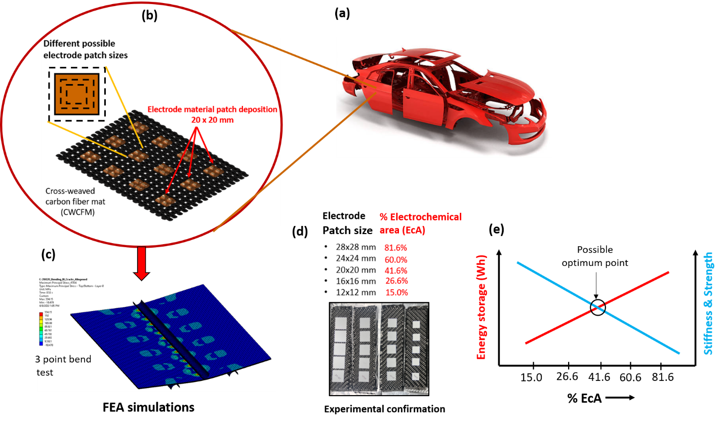
Scheme 1. (a) Different body panels that could be replaced with energized composite parts. (b) Various square patched electrodes with different EcA vs. EpA ratios. EpA is given in black and EcA in brown (square area). (c) Representative FEA simulation using ANSYS 2022 R1 for optimizing the stiffness via 3point bend test. (d) Experimental samples for bend and tensile tests with varying EcA vs. EpA using representational white patches. (e) Energy storage vs. % EcA vs. stiffness and strength behavior optimization based on specific requirements.
2. Numerical simulations
2.1. Finite element model for the energized laminates
Finite element analysis is applied to understand the mechanical behavior of the woven laminates. In this part, seven 3D finite element models with different EcA areas (160 × 30 × 2.3 mm geometry) are built using ANSYS space claim (ver. 2021 R2 student) on a Windows 10 pro interface. The material properties for carbon fiber/epoxy and glass fiber/epoxy lamina are defined in ANSYS engineering data interface, as given in Table 1. The mechanical strength of electrolytes is considered negligible, as also mentioned in our previous study.^{[3]} The epoxy volume percentage decreases as the electrolyte area increases. Hence, continuous degradation of mechanical properties is observed. The elastic modulus of laminas decreases progressively by 1.5% as the patch sizes increase based on the following equation:^{[3, 6, 9]}
$E_{e-CFRP}=E_{m}\left(1-{(V}_{f}+V_{s})\right)+E_{f}V_{f}$ …(1)
where $V_{f}+V_{m}+V_{s}=1$;
${ V}_{f}, V_{m}, V_{s}$ are the volume fractions of fiber, epoxy matrix and gel electrolyte (supercapacitors), respectively;
$E_{f}$ and $E_{m}$ are the elastic modulus of fiber and matrix, respectively.
The tensile strength of fibers is also progressively reduced with the same fraction as it is directly correlated to the Young’s Modulus.^{[9-10]} The meshing is performed with ANSYS-workbench mechanical. Node to node connectivity is provided to the EcA and EpA elements. Fibers in all layers are assigned the same orientations with the ANSYS ACP-Pre-tool. Laminate damage can be segregated in three ways, fiber damage, matrix damage, and interlaminar delamination.^{[11]} Damage in laminates can be modeled with Hashin’s strength criteria, Tsai-Hill, Tsai-Wu, maximum stress, maximum strain, and puck criteria in Ansys.^{[12]} However, the Ansys guide recommends maximum stress, maximum strain, Tsai-Wu, Tsai-Hill criteria for woven plies.^{[13]} We have used maximum stress criteria to initiate damage in all the laminates owing to their simplicity (supporting information section 1.2). The damage evolution is characterized by material property degradation ^{[14]} and the damage properties are integrated into the laminas material properties in the engineering data. Cohesive zone modeling (CZM) is applied to simulate the effect of electrolyte area in interlaminar layers of the composite (theory discussed in supporting information (SI) section 1.3).^{[15]} Further in this study, glass fiber reinforced polymer is abbreviated as GFRP.
Table 1: Material properties of CFRP and GFRP for single-ply^{[16]}
Material Property | Carbon fiber/Epoxy composite | Glass fiber/Epoxy composite^{[16a]}
Longitudinal and transverse Elastic Modulus (E₁₁ = E₂₂) | 36.1 GPa | 23.4 GPa
Poisson’s ratio (in plane) (ν₁₂) | 0.04 | 0.153
Poisson’s ratio (out of plane) (ν₁₃ = ν₂₃) | 0.30 | 0.25
In-Plane shear modulus (G₁₂) | 3.30 GPa | 3.52 GPa
Out-of- plane shear modulus (G₁₃ = G₂₃) | 2.70 GPa | 1.36 GPa
Longitudinal and Transverse tensile strength (X_{t} = Y_{t}) | 513 MPa | 449 MPa
Longitudinal and Transverse compressive strength (X_{c} = Y_{c}) | 437 MPa | 336 MPa
In plane Shear strength (S₁₂) | 120 MPa | 45.2 MPa
Out of plane Shear strengths (S₁₃ = S₂₃) | 55 MPa | 37.6 MPa

Tensile test model: Tensile and 3-point bending tests are performed for all the above-mentioned configurations (figure S2 in SI) with Ansys mechanical, as shown in Figure 1. Figure 1(a) shows the schematic of the tensile FE model for a 20X20 EcA patch laminate. Fixed support is applied to one end of the FE model in the tensile test, as shown in Figure 1(a). Additionally, the displacement is applied at the opposite end of the FE model. The FE model for the tensile test has 16,488 nodes and 8,939 elements. “Static Structural” method is applied with sufficient refined mesh (2 mm).
Flexural test model: FE model for the three-point bend test is developed similar to the 3-point bend test FEM model of Bouligand CFRP samples developed by Mencattelli et al.^{[17]} The modeling of composite is kept the same as the tensile test. However, additional bending fixtures (10 mm diameter) with structural steel properties are incorporated as SHELL 181 elements. Frictionless surface to surface contact is maintained between bending fixtures and the laminate. Fixed support boundary conditions are applied to the bending fixtures in parallel to the z-direction displacement boundary condition to the top pin of the laminate, as shown in Figure 1(b). The 3-point bend test FE model has total 18,022 nodes and 10,334 elements. Figure 1(c) illustrates the various element types corresponding to the different geometries involved in FE model. The laminate is modeled with SOLID 185 elements; however, SHELL 181 elements are used to model bend fixtures. The epoxy region of interlaminar layers is modeled with INTER205 interface elements, as shown in Figure 1(d). The electrolyte zones are modeled as open cracks in laminates, as seen in Figure 1 (e).^{[18]} These open cracks function as stress singularities regions in the laminates due to the negligible mechanical strength of the gel electrolyte. Figure 1(f) represents the stacking sequence of plies for all laminates. All laminates follow the same stacking sequence of CFRP and GFRP alternate layers.
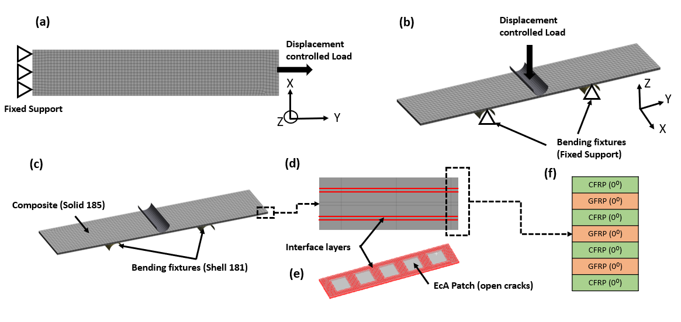
Figure 1: Finite Element Model (FEM) of energized composite. (a) Schematic of the 3 PB test. (b) Schematic of the 3 PB test (c) Mesh description (d & e) Schematic showing interface layers and open cracks in 20×20 EcA laminate (f) Stacking sequence

2.2 Finite element analysis-Results and discussion.
Tensile tests: The load-displacement curves with a maximum displacement of 8mm are shown in Fig. 3(a) for the tensile FE model. The progressive reduction in the stiffness with the increased EcA area is mainly due to the continuous reduction in the elastic modulus of composite, as explained earlier.^{[3]}
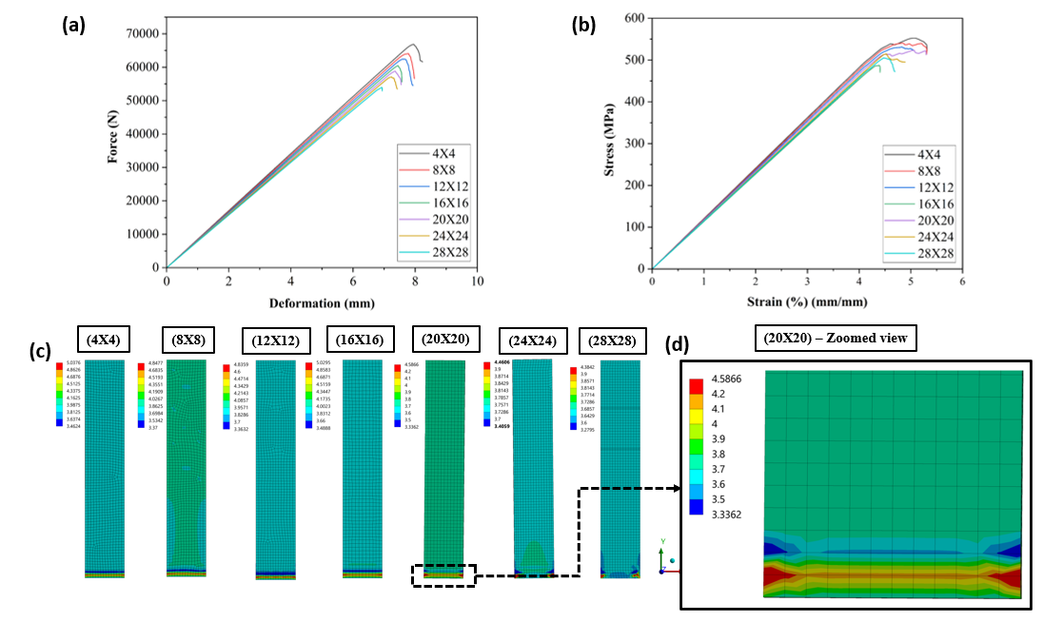
Figure 2: Tensile test FEA results for energized composites with different patch areas (a) Force vs. deformation plot (b) Average stress vs. average strain curve (c) % normal strain (y-direction) for energized composite laminates to their corresponding maximum stress values (d) zoomed-in view of % strain illustrating the behavior of failure in laminates.

The simulation is stopped at the first significant reduction in load values indicating the initiation of damage in the composite material. Jarrah et al.^{[19]} observed similar behavior of load-displacement curve in the tensile test of composite laminates of CFRP and GRFP. Riccio et al. demonstrated that load-displacement is less sensitive to the mesh size.^{[20]} Therefore, a mesh of 2 mm is considered sufficient for the analysis. The maximum possible load (Force in N) values of different configurational designs before damage initiation are shown in Table 2 (along with their respective %EcA). Figure 2(a) shows the load-displacement curves for various configurations. It is clear from the obtained results that there is a minor variation between various configurations for maximum load-bearing ability in the tensile test. The reason is further explained after experimental studies in section 3.2. The simulation results given in Table 2 also show the longitudinal stiffness (from the slope of the load displacement curves) obtained for each of these configurations. Further, the tensile strength has been estimated from the average normal stresses in laminates, which can be seen reducing very mildly for different configurations, as shown in Figure 2(b). It has values: 552, 540, 531, 523, 515, 505 and 487 MPa corresponding to 4×4, 8×8, 12×12, 16×16, 20×20, 24×24 and 28×28 patch size laminates, respectively. These values have also been tabulated in the last column of Table 2. The progressive reduction in the tensile strength is mainly attributed to the reduction in the volume fraction of the matrix and ultimately, elastic modulus.^{[3]} The percentage normal strain plots corresponding to respective maximum stress values, as seen in Figure 2(c), shows that the deformation behavior is similar in all the composites, which illustrates that the effect of EcA is less significant on the tensile failure behavior of composites. Figure 2(d) shows the zoomed-in view of the % normal strain (y-direction) for a 20×20 EcA composite.

Table 2: Maximum sustained force, stiffness and ultimate strength for simulated tension test of energized composite samples for different configurations.
Electrolyte Patch size (mmXmm) | Tensile Test
Electrolyte Patch size (mmXmm) | % EcA | Force, N (F_{max}) | Longitudinal Stiffness (N/mm) | Tensile Strength (MPa)
4×4 | 1.67 | 66,844 | 8534 | 552.42
8×8 | 6.67 | 64,040 | 8420 | 540.46
12×12 | 15.00 | 62,392 | 8306 | 531.52
16×16 | 26.67 | 60,459 | 8198 | 523.51
20×20 | 41.67 | 58,273 | 8074 | 515.1
24×24 | 60.00 | 57,074 | 7977 | 505.3
28×28 | 81.60 | 53,946 | 7870 | 487.35

Flexural tests (3 point -bend tests): Similarly, load-displacement curves obtained for 3-point bend tests of different configurations are shown in Figure 3(a). However, as can be observed in load-displacement curves (Fig. 3a), laminates' stiffness (slope) decreases sharply after deformation reaches a specific value. This is mainly attributed to the first ply failure of composite, also called as “knee effect.”^{[21]} The maximum load values at the first failure are shown in Table 3 for various configurations. Unlike the results of the tensile tests, the bending stiffness, calculated from the slope of the load-displacement curve, reduces significantly as the amount of electrolyte (EcA) is increased. The bending stiffness, as presented in Table 3, reduces from 656.18 N/mm to 160.29 N/mm as the area of electrolyte is increased from 1.67 % (4×4 configuration) to 81.60 % (28×28 configuration). The Force-displacement curves of various laminates clearly follow a particular trend; as EcA increases, the F_{max} value decreases. These results are further discussed in section 3.2. As an example, normal stress (in Z axis – out of the plane) results are shown for 20×20 EcA composite in Figure 3(b) with a contour plot showing peak value in red, corresponding to the maximum load. This peak value is observed at the bottom layer of the composite, as shown in the zoomed-in plot of figure 3(c). These peak stresses are due to interlaminar shearing owing to the modeled EcA as open cracks in the FE model. As a result, the mechanical strength of energized composite reduces as the electrolyte area increases.
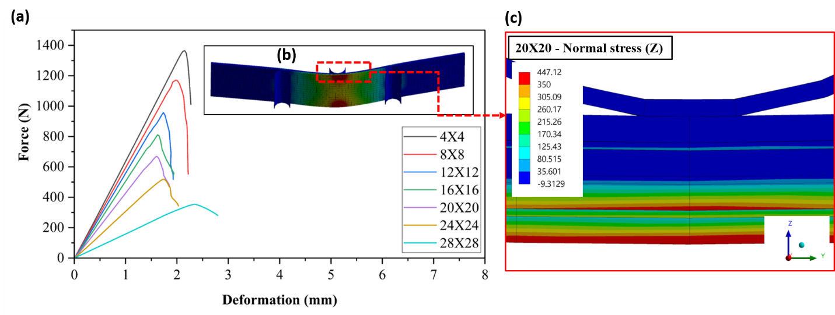
Figure 3: (a) 3-point bend test load-displacement curves from FEA for energized composites with different patch areas; inset image (b) shows a full and zoomed plot for normal stress for 20×20 EcA composite at maximum force (c) Zoomed in view illustrating the higher stresses in the inner layers as a result of incorporating electrolytes in composites.

Table 3: Maximum sustained force, bending stiffness and strength for simulated 3-point bend test of energized composite samples for different configurations.
Electrolyte Patch size (mm×mm) | Flexural Test
Electrolyte Patch size (mm×mm) | % EcA | Force, N (F_{max}) | Bending Stiffness (N/mm) | Bend Strength (MPa)
4×4 | 1.67 | 1365.4 | 656.18 | 903.10
8×8 | 6.67 | 1172.7 | 606.30 | 775.80
12×12 | 15.00 | 957.8 | 569.48 | 633.70
16×16 | 26.67 | 811.15 | 517.91 | 536.78
20×20 | 41.67 | 667.64 | 436.20 | 447.20
24×24 | 60.00 | 519.13 | 313.70 | 343.46
28×28 | 81.60 | 353.87 | 160.29 | 234.13

3. Experimental studies – Results and Discussion
To confirm the simulation results, both bending and tensile experiment tests were performed. Samples of the energized composite were made and tested for their mechanical strengths on a universal testing machine (UTM) in accordance with the relevant industry standards. The flexural test, also known as 3-point bend test, was performed to determine the bending stiffness and strength based on the recommendations of ASTM D790.^{[22]} A tension test was performed to determine the tensile stiffness and strength of the samples following the guidelines given as per ASTM D3039.^{[23]}
3.1 Mechanical Characterizations
3.1.1 Flexural test: All 7 configurations of energized composite with varying EcA vs. EpA ratios were fabricated and tested for their bending stiffness and strength in accordance with the recommendations of ASTM D790.^{[22]} Further details of sample preparation are given in section 2.1 of SI.
The 3-point bend test was performed to determine flexural (bending) strength and stiffness. Figure S4 (a), in the supporting information, shows the experimental setup for the 3 point bend test. The test was performed on an Instron 3369 UTM, in accordance with the recommendations of ASTM D790.^{[22]} Each sample was tested under a load cell of 50 kN, with a minimum span length (l) of 70 mm. This satisfies the necessary condition of D790; the span to thickness (L:H) ratio of the samples should be greater than 16:1. The test was performed under a displacement-controlled condition where crosshead speed was set to 3 mm/min.
After completing 3-point bend tests of these seven composites on the UTM, their load (N) vs. deflection (mm) curves are plotted as shown in Figure 4(b). For comparison purposes, the load vs. deflection curves from simulation studies have been shown in Figure 4(a). Several of these curves clearly exhibit all three characteristics: elastic region, elastic-plastic elongation and plastic deformation followed by breaking. All of these curves start with linear elastic behavior where Force is proportional to the deflection (mm). After reaching a certain deflection value, the proportionality relation no longer exists and the curves tend to bend more towards x-axis but still keep going up. This is where they show elastic-plastic behavior. After reaching a maximum value of force (F_{max}), these curves take a dip and this is where they enter a total plastic deformation zone where the curve starts to come down and continues with increasing deflection till it ends (where sample breaks).
In composites (Figure 4(b)), for all purposes of technical and scientific relevance, only the section of the curves where F_{max} is achieved is considered to be of significance, beyond which the sample is assumed to be fractured.^{[24]} After this fracture point, the behavior of the curve is totally random since the breaking starts via internal crack propagation in multiple directions. Based on the data obtained from testing different samples (figure 4(b)), the 4×4 mm² configuration exhibited F_{max} of about 1342 N (highest among all configurations) at a deflection (δ) of 2.96 mm. The reason for it showing the highest F_{max} is its lowest EcA of just 1.96 %. While on the other hand, 28 × 28 mm² configurations with the highest EcA of 81.6% exhibited the lowest F_{max} of just 397.71 N at a deflection of 4.78 mm. All other configurations exhibited their F_{max} between these two extremes: 8×8 mm²: F_{max} = 1144 N, 12 ×12 mm²: F_{max} = 943 N, 16 ×16 mm²: F_{max} = 810 N, 20 × 20 mm²: F_{max} = 725 N, and 24×24 mm²: F_{max} = 490 N. The bending strength (MPa) and bending stiffness (Nmm⁻¹) are both determined within the region up to F_{max}. Following bending equations have been used to determine bending strength and stiffness:^{[25]}
Bending stiffness $\left(S\right)=\frac{F}{δ}$ …(1)
Bending equation: $\frac{M}{I}=\frac{E_{Comp.}}{R}=\frac{σ}{Y}$ …(2)
Flexural (Bending) strength $(σ_{fs})=\frac{3F_{max}l}{2bh^{2}}$ …(3)

where F is the obtained reaction force (in N), δ is the deflection (in mm) of the center point of the composite (obtained from the crosshead movement in UTM), M is the bending moment, I is the moment of inertia of the cross-section, E_{comp} is effective young’s modulus of composite, R is the radius of curvature, l is the span length in the bend test, b is the width of the composite and h is the thickness of the composite.
First, the bending stiffness (S_{b}) was determined from the slope (using eq. 1) of the linear elastic region of these curves, where proportionality between F and δ was maintained (figure 4(b)). This was clearly visible in the deflection (δ) range of 0 – 2 mm, for all of the configurations. The 4×4 mm² configuration exhibited S_{b} of about 659.29 Nmm⁻¹ (highest among all configurations), while the 28 × 28 mm² showed S_{b} value reaching only 137.06 Nmm⁻¹ as given in figure 4(c). All other configurations have their stiffness values between these two extremes: 8×8 mm²: S_{b} = 564.02 Nmm⁻¹, 12 ×12 mm²: S_{b} = 524.82 Nmm⁻¹, 16 ×16 mm²: S_{b} = 483.41 Nmm⁻¹, 20 × 20 mm²: S_{b} = 375.05 Nmm⁻¹, and 24×24 mm²: S_{b} = 265.66 Nmm⁻¹. Stiffness results from all of these 7 configuration composites are plotted against their respective % EcA in Figure 4(c) to understand how the ratio of electrochemical area vs. epoxy area governs the overall stiffness of the energized composite. The results of simulation studies have also been plotted in the same perspective in Figure 4(c). It can be seen that experimental stiffness results are in tandem with the simulation studies. Experimental stiffness is slightly lower in most cases than the simulation stiffness. The reason could be attributed to the manual hand layup process in the fabrication of these composites, where it is difficult to control the correct ratio of EcA vs. EpA while fabricating.
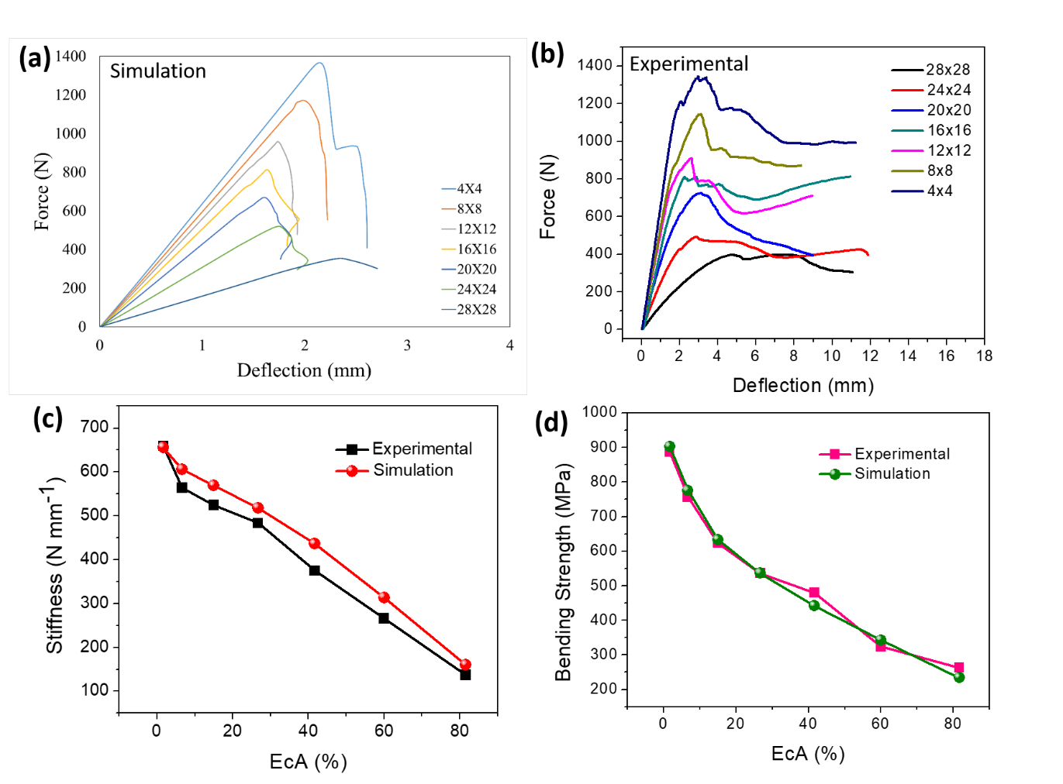
Figure 4: (a) Force vs. displacement curves of various configurations of the energized composite obtained through simulation studies on 3-point bend tests. (b) Force vs. displacement curves of various configurations of the energized composite obtained through experimental studies (3-point bend tests). (c) Bending stiffness vs. Electrochemical area (%) curve from simulation and experimental studies. (d) Bending strength vs. Electrochemical area (%) curves obtained for simulation and experimental studies.

Using F_{max} value for each of the configurational composite and their respective dimensions (b, h), the ultimate value of the flexural strength (σ_{fs}), also known as bending strength, was calculated with the help of eq. 3. Just like stiffness behavior vs. EcA %, the 4×4 mm² configurational composite exhibited the highest bending strength of 887.9 MPa. On the other hand, the 28 × 28 mm² configurational composite fractured with a bending strength of only 263.13 MPa. Bending strength for all of the other configurational composites was also calculated and plotted against their respective EcA %, as shown in Figure 4(d). For all of the other configurations, the bending strength ranged between these two extremes and showed an exponential drop as the EcA % was increased. The values were as follows: 8×8 mm²: σ_{fs} = 756.8 MPa, 12 ×12 mm²: σ_{fs} = 623.9 MPa, 16 ×16 mm²: σ_{fs} = 535.9 MPa, 20 × 20 mm²: σ_{fs} = 479.6 MPa, and 24 ×24 mm²: σ_{fs} = 324.19 MPa. The bending strength for the composites was also calculated from F_{max} values obtained for various configurations in the simulation studies. They are given in Table 1 and also plotted against the experimentally obtained values in Figure 4(d). The experimental bend strengths for composites are in close proximity to the simulated bend strength with a few minor deviations owing to the manual layup fabrication method of the composites.

3.1.2 Tension test: All 7 configurations of energized composite with varying EcA vs. EpA ratios were experimentally fabricated and tested for their tensile strength in accordance with the recommendations of ASTM D3039. ^{[23]} Further details of sample preparations are given in section 2.2 of SI.
All the 7 configurational composite samples were subjected to a uniaxial tension test on an Instron 3380 UTM, having a rated capacity of 100 kN. Figure S4 (b), in the supporting information shows the experimental setup for the uniaxial tension test on the energized composite samples. The test was performed under a displacement-controlled environment where the crosshead speed was kept constant at 2 mm/min based on the recommendations of ASTM D3039. ^{[23]}
Load (N) vs. displacement (mm) data was generated under the displacement-controlled conditions for all 7 configurational composites. Engineering stress vs. strain data was obtained by using load vs. displacement data through dimensional calculations of the samples. Results for these are plotted in Figures 5(a) and (b). Interestingly, unlike the results in the bending tests, uniaxial tension tests tend to generate stress vs. strain curves (and load-displacement curves) for all configurations of nearly similar slopes. The slope of the stress vs. strain curves of these composites gives the Young’s modulus for each of them. The relation of this modulus to the volume fractions of fiber and epoxy can very well explain this result of nearly similar slopes for tension tests of these different configurations. This can also be well explained by how the Young’s modulus, which is nothing but the slope of stress vs. strain curves of composites, is given.^{[25c]} If the volume fraction of the fibers in the composite is given by V_{f} , and the volume fraction of the epoxy (or matrix) is given by V_{m}, then the Young’s modulus for any regular fiber-epoxy composite can be given by the relation:^{[26]}
E_{CFRP} = E_{m}(1-V_{f}) + E_{f}V_{f} …(4)
and V_{f} + V_{m} = 1 …(5)
where, E_{m} is Young’s modulus of the epoxy (matrix) and E_{f} is Young’s modulus of the fibers. However, in the case of energized composite (e-CFRP), there is a separate volume occupied by the electrode materials and electrolyte (supercapacitor patche areas) where the Young’s modulus is negligible compared to epoxy and the fibers. If the volume fraction of supercapacitors is given by V_{S} then Young’s modulus for energized composite is given by^{[3, 26]}
E_{e-CFRP} = E_{m}(1-(V_{f} + V_{S})) + E_{f}V_{f} … (6)
However, in the case of carbon fiber-based composites, the value of E_{f} >> E_{m}. ^{[27]} Thus even in the case of different configurations of energized composite (each configuration will have a different V_{S}), since overall Young’s modulus largely depends only on E_{f}, we do not observe any significant changes in the slope of these curves.
Figure 5(c) shows the longitudinal stiffness vs. EcA% of different configurational composites as obtained from the slope of their respective load vs. displacement curves. For comparison purposes, longitudinal stiffness (S_{l}) values from the simulation study have also been plotted in the same figure and experimental values closely follow the simulation values. For 4×4 mm² composite, the obtained stiffness value is around 8493 Nmm^{-1,} whereas the 28×28 mm² composite exhibited stiffness of 8525 Nmm⁻¹. For all other configurations the stiffness values ranged as follows: 8×8 mm²: S_{l} = 8380 Nmm⁻¹, 12 ×12 mm²: S_{l} = 8160 Nmm⁻¹, 16 ×16 mm²: S_{l} = 7897 Nmm⁻¹, 20 × 20 mm²: S_{l} = 7972 Nmm⁻¹, and 24 ×24 mm²: S_{l} = 8478 Nmm⁻¹. Hence there is a minor change in the longitudinal stiffness value for all the configurations and the overall value hovers around 8000 Nmm⁻¹.
Figure 5(d) shows the ultimate tensile strength of energized composite plotted against its respective %EcA. This is obtained from the ultimate stress values of stress vs. strain curves (from figure 5(b)) of various configurational composites tested. The majority of configurations showed almost similar tensile strength except for a few outliers like 28×28. The 4×4 mm² composite showed the highest tensile strength of 563 MPa, while 28×28 mm² composite showed a still good tensile strength of 417.73 MPa. For all other configurations ultimate strength values were as follows:- 8×8 mm²: σ_{t} = 547.56 MPa, 12 ×12 mm²: σ_{t} = 531.15 MPa, 16 ×16 mm²: σ_{t} = 525.8 MPa, 20 × 20 mm²: σ_{t} = 516.23 MPa, and 24 ×24 mm²: σ_{t} = 465.49 MPa. For comparison purposes, the ultimate strength values from the simulation study have also been plotted in the same Figure 5(d). It can be observed that the results of the experimental study are in close proximity to simulation studies. However, as the percentage EcA goes beyond 60% (for configurations like 24 ×24 and 28 ×28 mm²), since there is less area available for epoxy application, it becomes difficult to control the area in which epoxy spreads, especially if this is done using manual layup method. Thus, it can cause minor deviation from the expected results in stiffness and strength while testing the composites. This is shown by the outlier values in Figures 5 (c) and (d).

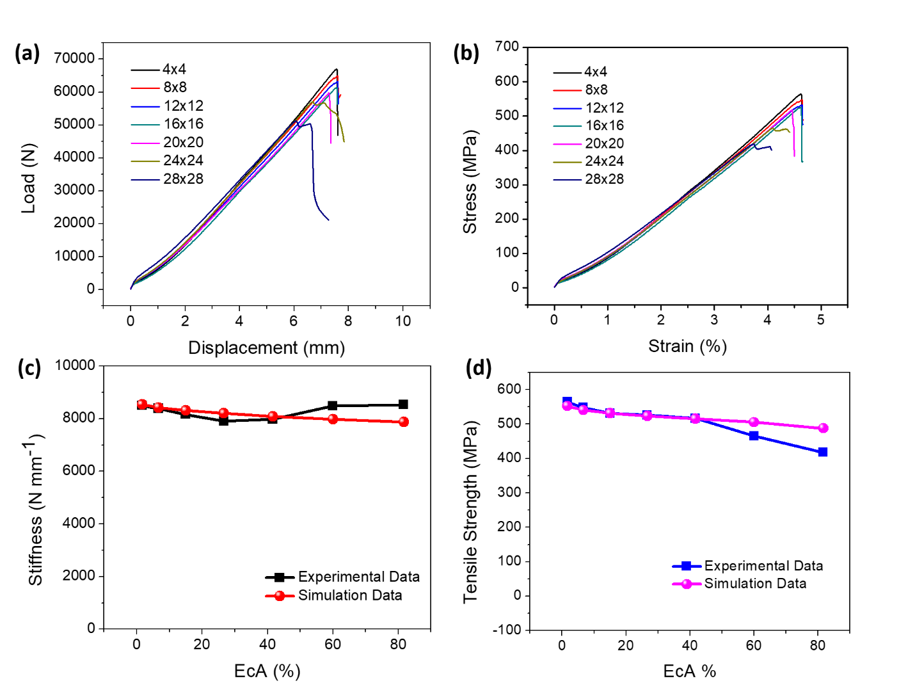
Figure 5: (a) Force vs. displacement curves of various configurations of the energized composite obtained through experimental studies of tension test. (b) Tensile Stress vs. Strain curves of various configurations of the energized composite obtained through experimental studies of tension tests. (c) Longitudinal stiffness vs. Electrochemical area (%) curve obtained for both simulation and experimental studies. (d) Tensile strength vs. Electrochemical area (%) curve obtained for both simulation and experimental studies

3.2 Electrochemical characterizations
To determine the effect of EcA vs. EpA ratio on the energy storage ability of energized composite, different patch sizes were assembled in the form of the asymmetric solid-state devices with PAM/Na₂SO₄ gel electrolyte, as discussed in our previous study.^{[3]} The cathode is made up of VGCF/Mn₃O₄ electrodes on a carbon fiber mat (as a current collector). In contrast, the anode is made up of VGCF/MoO₃ electrode material on a carbon fiber mat (as a current collector). These devices (4×4, 8×8, 12×12, 16×16, 20×20, 24×24, and 28×28 mm²) were assembled using a similar approach as that of energized composite. After curing, the samples were tested on a CHI Impedance analyzer for their electrochemical characteristics.
First, cyclic voltammetry (CV) study was performed on these devices with varying patch areas at a scan rate of 5 mVs⁻¹. Figure 6(a) shows the various cyclic voltammograms obtained for different patch sizes. The area enclosed by a cyclic voltammogram determines its capacitance, i.e., charge storage ability.^{[28]} The larger the area, the higher the charge storage ability. This is also evident from Figure 6(a). A patch area of 4x4 mm² (black) exhibited the smallest area enclosed in a CV curve, while the patch area of 28x28 mm² (navy blue) showed the highest area loop enclosed. Based on the area enclosed by these cyclic voltammograms, the capacitance for each of these patch sizes was also determined: 4x4 mm²: 88mF, 8x8 mm²: 352 mF, 12 x12 mm²: 792 mF, 16 x16 mm²: 1408 mF, 20 x 20 mm²: 2200 mF, 24 x24 mm²: 3168 mF and 28x28 mm²: 4312 mF. Based on this data, it is evident that the largest area devices have the highest charge storage ability.
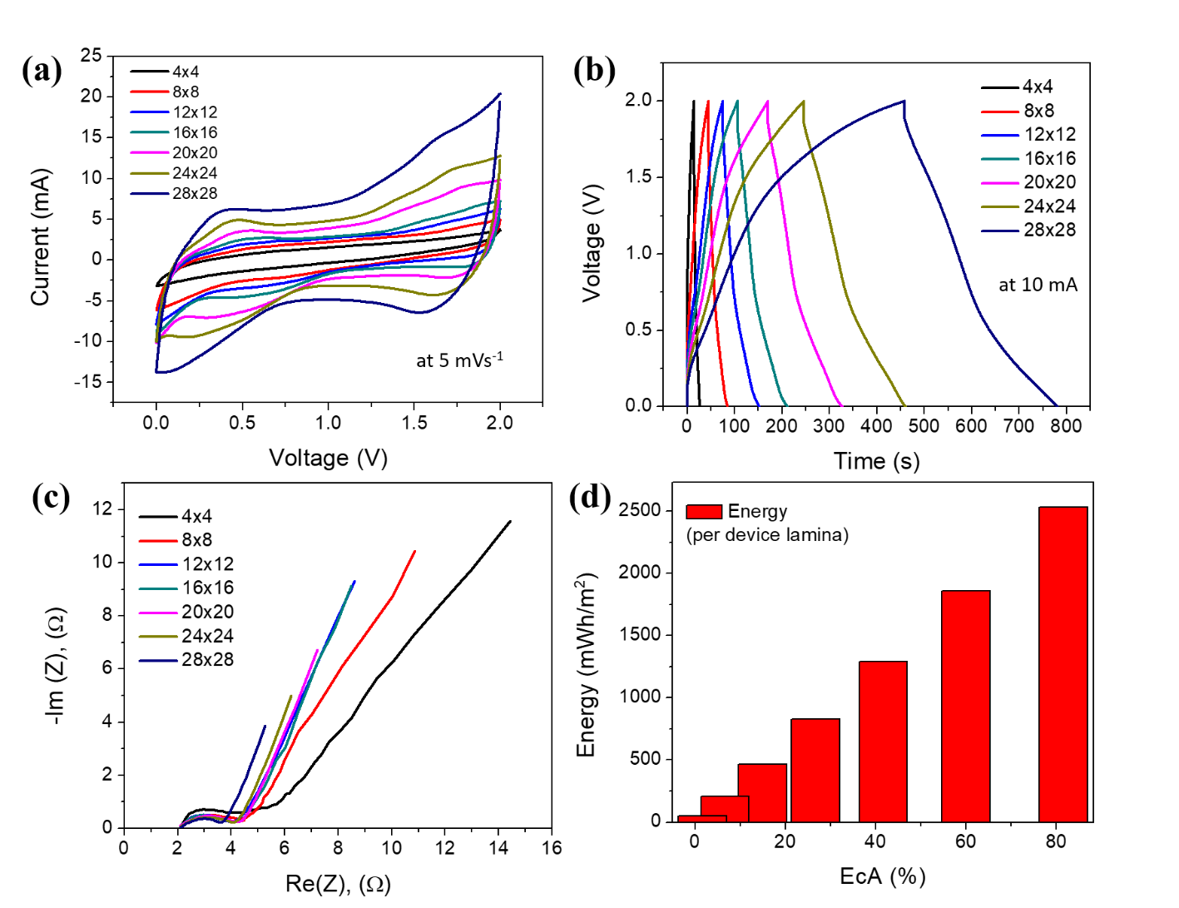

Figure 6. (a) Cyclic voltammograms of various patch sizes of the fabricated energized composite obtained at a scan rate of 5 mVs⁻¹. (b) Galvanic charge-discharge plots of various patch sizes obtained at a charge-discharge current of 10 mA. (c) Electrode impedance spectra of various patch sizes. (d) Energy storage ability per device lamina of various configurations of energized composite based on their % EcA.

Next, these devices were subjected to a galvanic charge-discharge test at a current of 10 mA. GCD plots for these different patch sizes are shown in Figure 6(b). Again, a similar pattern was obtained where the highest area electrode 28 x28 mm² delivered the highest discharge time of 323 s, whereas the lowest area electrode, 4x4 mm² delivered a discharge time of just 12s at 10 mA charge-discharge current. The other patch area electrode had their discharge time between these two extremes: 8x8 mm²: 41 s, 12x12 mm²: 75 s, 16 x16 mm²: 104 s, 20 x 20 mm²: 155 s, and 24 x24 mm²: 216 s.
Further, to determine the impedance of these patch sizes, the fabricated devices were subjected to electrode impedance spectroscopy (EIS). The obtained EIS spectra for these patch sizes are plotted in Figure 6(c) in the form of a Nyquist plot. Equivalent series resistance (ESR) for various patch sizes was obtained from the abscissa of the curves in the initial high-frequency region.^{[29]} Almost all of these curves intersect the real axis of the spectra at a value of ~ 2.08 Ω. This can be explained since the electrode material and the electrolyte are exactly the same in all of the patches; hence, the ESR value should be the same for all devices.^{[30]} Next, the charge transfer resistance (R_{ct}), also known as faradaic resistance, is obtained from the cut (chord) on the real axis by the imaginary semicircle arc made by these plots in the high-frequency region.^{[30]} Unlike the constant ESR, the charge transfer resistance is inversely dependent on the patch area of the electrodes. The smallest 4x4 mm² patch exhibited the highest R_{ct} of ~ 3Ω, while the largest 28x28 mm² patch size showed the least R_{ct} of ~1.5 Ω. This can be explained by the fact that a larger patch size means a larger area of the current collector (carbon fabric) that can better facilitate charge transfer hence showing a lower resistance. A similar trend was shown in the low-frequency regions of Nyquist plots, where the slope of the plots determines the leakage resistance (R_{L}). Clearly, the 4x4 patch size (smallest area) had the smallest slope showing high leakage resistance, while 28x28 patch size (largest area) had a higher slope signifying low leakage resistance. All other patch area devices offered leakage resistance in between these two extremes.
Based on the charge storage value and EcA vs. EpA ratio, various configurations of the energized composites are categorized based on their energy storage ability (per device laminate). A bar chart shows this in Figure 6(d). The 4x4 patch size configuration has the lowest EcA vs. EpA ratio (i.e., lowest EcA %). However, it exhibits the highest tensile and bend strength (as discussed previously), but offers the energy storage ability of 51.67 mWh/m² only. On the other hand, the highest patch size device of 28x28 offered a high energy storage value of 2531 mWh/m². All other configurations showed energy storage ability directly proportional to their patch sizes (i.e. EcA %): 8x8 mm²: 206.66 mWh/m², 12x12 mm²: 464.99 mWh/m², 16 x16 mm²: 827.96 mWh/m², 20 x 20 mm²: 1291 mWh/m², and 24 x24 mm²: 1859 mWh/m².

4. Conclusion
In this work, we have performed a design optimization study on the tensile strength, bending strength and electrochemical energy storage ability of our multifunctional energized composite. We have designed different configurations of energized composites by modulating the ratios of EcA vs. EpA. Further, these configurations have been simulated using ANSYS software to check their tensile strength and bend strength by uniaxial tension test and a 3-point bend test. To confirm the results of simulation studies, the exact replica of these composites has been fabricated in the lab and were also tested on an Instron UTM machine, based on the relevant ASTM standards for tensile and bend test. Further, to assess the energy storage ability of the configuration based on their patch size, electrochemical characterizations like cyclic voltammetry, galvanic charge discharge tests, and electrode impedance spectroscopy have been performed. It can be concluded from the results that as the electrochemical area on the laminates of energized composite is increased (i.e., epoxy area is reduced), there is an exponential drop in the bending strength of the composite, while the tensile strength almost remains constant. An increase in the electrochemical area also correlates to the higher energy storage ability in energized composites. By analyzing the bending, tensile and electrochemical test results for various design configurations of energized composite, a specific configuration for each body panel in the EV can be chosen for desired maximum charge storage while at the same time maintaining minimum tensile and bending strengths. Results from this study could help in faster adoption of the energized composite technology in the EV industry, which will also help to extend the range of EVs making them more popular among the customers

Conflicts of interest
There are no conflicts to declare.

Acknowledgments
JT acknowledges National Science Foundation (IIP-2122779) for the financial support. Raman spectrum was taken using an instrument supported by NSF MRI Grant No. 1920050.

References

[1] S. Potrč, L. Čuček, M. Martin, Z. Kravanja, Renewable and Sustainable Energy Reviews 2021, 146, 111186.
[2] J. A. Sanguesa, V. Torres-Sanz, P. Garrido, F. J. Martinez, J. M. Marquez-Barja, Smart Cities 2021, 4, 372.
[3] D. Pandey, K. Sambath Kumar, L. N. Henderson, G. Suarez, P. Vega, H. R. Salvador, L. Roberson, J. Thomas, Small 2022, 2107053.
[4] J. Cherusseri, K. Sambath Kumar, D. Pandey, E. Barrios, J. Thomas, Small 2019, 15, 1902606.
[5] J. Chang, M. Jin, F. Yao, T. H. Kim, V. T. Le, H. Yue, F. Gunes, B. Li, A. Ghosh, S. Xie, Advanced Functional Materials 2013, 23, 5074.
[6] J. Cherusseri, S. Pramanik, L. Sowntharya, D. Pandey, K. K. Kar, S. Sharma, in Composite Materials, Springer, 2017.
[7] M. Sajjad, M. I. Khan, F. Cheng, W. Lu, Journal of Energy Storage 2021, 40, 102729.
[8] X. Han, L. Lu, Y. Zheng, X. Feng, Z. Li, J. Li, M. Ouyang, ETransportation 2019, 1, 100005.
[9] W. D. Callister, D. G. Rethwisch, Materials science and engineering: an introduction, Vol. 9, Wiley New York, 2018.
[10] T. Tagawa, T. Miyata, Materials Science and Engineering: A 1997, 238, 336.
[11] J.-F. Chen, E. V. Morozov, K. Shankar, Composites Part A: Applied Science and Manufacturing 2014, 61, 185.
[12] a)R. Hill, Press, London 1950; b)S. W. Tsai, Fundamental aspects of fiber reinforced plastic composites 1968; c)C. Sun, Kelly, A. et al 2000.
[13] I. ANSYS, ed, 2013.
[14] S. Lurie, M. Minhat, in Structural Integrity and Durability of Advanced Composites, Elsevier, 2015.
[15] G. Alfano, M. Crisfield, International journal for numerical methods in engineering 2001, 50, 1701.
[16] a)T. Wiczenbach, T. Ferenc, Archives of Civil Engineering 2021, 67; b)A. Inc., ANSYS, ANSYS 2021; c)B. Yang, Y. Chen, J. Lee, K. Fu, Y. Li, Thin-Walled Structures 2021, 158, 107186.
[17] L. Mencattelli, S. T. Pinho, Composites Part A: Applied Science and Manufacturing 2020, 129, 105655.
[18] a)M. K. Thompson, J. M. Thompson, ANSYS mechanical APDL for finite element analysis, Butterworth-Heinemann, 2017; b)E. Lindgaard, B. Bak, J. Glud, J. Sjølund, E. Christensen, Engineering Fracture Mechanics 2017, 180, 229.
[19] M. Jarrah, E. P. Najafabadi, M. H. Khaneghahi, A. V. Oskouei, Construction and Building Materials 2018, 190, 38.
[20] A. Riccio, C. Palumbo, V. Acanfora, A. Sellitto, A. Russo, Journal of Composites Science 2021, 5, 310.
[21] C. Wen, S. Yazdani, Composite structures 2008, 82, 127.
[22] a)F. Rezaei, R. Yunus, N. Ibrahim, E. d. o. s.-c.-f.-r. p. c. f. c. b. Mahdi, Polymer-Plastics Technology and Engineering 2008, 47, 351; b)I. ASTM, ASTM D790-07 2007.
[23] a)J. M. F. d. Paiva, S. Mayer, M. C. Rezende, Materials Research 2006, 9, 83; b)A. ASTM_International, ASTM International, West Conshohocken (PA) 2000.
[24] a)D. D. Chung, D. Chung, Carbon fiber composites, Elsevier, 2012; b)E. Botelho, M. Rezende, B. Lauke, Composites Science and Technology 2003, 63, 1843.
[25] a)M. R. Abusrea, S.-W. Han, K. Arakawa, N.-S. Choi, Composites Part B: Engineering 2019, 156, 8; b)W. D. Callister Jr, D. G. Rethwisch, Fundamentals of materials science and engineering: an integrated approach, John Wiley & Sons, 2020; c)W. D. Callister Jr, D. G. Rethwisch, Callister's materials science and engineering, John Wiley & Sons, 2020.
[26] H. Zhu, T. Fan, D. Zhang, Scientific reports 2015, 5, 1.
[27] a)H. Rahmani, S. H. M. Najaf, A. Ashori, M. Golriz, Polymers and Polymer Composites 2015, 23, 475; b)K. Yang, Y. Yue, W. Zhao, Y. Liang, L. Mei, J. Xue, presented at IOP Conference Series: Materials Science and Engineering, 2020.
[28] Y. Shao, M. F. El-Kady, J. Sun, Y. Li, Q. Zhang, M. Zhu, H. Wang, B. Dunn, R. B. Kaner, Chemical reviews 2018, 118, 9233.
[29] a)G. G. G. Costa, R. C. Pietronero, T. Catunda, Physics Education 2012, 47, 439; b)V. Khomenko, E. Raymundo-Pinero, E. Frackowiak, F. Beguin, Applied Physics A 2006, 82, 567.
[30] A. Noori, M. F. El-Kady, M. S. Rahmanifar, R. B. Kaner, M. F. Mousavi, Chemical Society Reviews 2019, 48, 1272.

