To the Moon! Space Launch System Modal Testing with Video and Motion Magnification
Justin G. Chen¹, Raul Rios¹, Kevin E. Franks², and Eric C. Stewart²
¹ MIT Lincoln Laboratory, Lexington, MA 02421
² NASA Marshall Space Flight Center, Huntsville, AL 35808

ABSTRACT
MIT Lincoln Laboratory and NASA Marshall Space Flight Center have been collaborating on using video camera measurements and motion magnification for modal testing of large aerospace components for several years. This presentation will discuss results from the Space Launch System Integrated Modal Test (IMT) and Dynamic Rollout/Rollback Test (DRRT) in support of the Artemis I mission.
During the IMT, the data collection focused on operational mode shapes. In addition, the cameras were repositioned mid-test to better understand the physics of a low-frequency torsion mode. The non-contact nature of video data capture allowed for the quick redeployment of the cameras while not causing any delay in test schedule, whereas traditional instrumentation would have required a pause in testing to attach the sensors to the test article. The motion magnification analysis was able to find the low-frequency operational mode shapes and help the test team better understand the physics of the torsion mode.
Building upon the success of the IMT motion magnification work, a camera system was used during the DRRT to find operational mode shapes, if the physics of the low-frequency torsion mode remained with different boundary conditions, and relative deflection of the vehicle and ML tower during the roll. In this paper we will present operational mode shape results, discuss the physics of the torsion mode, and review experimental setup idiosyncrasies to help the community in designing video camera measurement systems.
Keywords: Optical, Motion magnification, Video, Aerospace, Artemis

Introduction
The Artemis program is the NASA effort to land the first woman and next man on the moon. As part of that program, the Artemis I flight vehicle consists of the Space Launch System (SLS) and Orion Multi-Purpose Crew Vehicle (MPCV), and that system is launched from the mobile launcher (ML). To understand the dynamics of the flight system and the integrated ground configuration, a “building block” approach to modal testing was used [1]. In this building block approach, modal tests were performed on the major substructures of the system [2,3], and the IMT [4] was performed on the ground configuration to validate the system-level response.
The purpose of the modal testing is to validate the finite element models (FEMs) that are used to determine the vehicle loads and control stability of the vehicle. While the substructure modal tests validate the FEMs for those components, the interface stiffnesses between the substructures have high uncertainties [5] until the integrated structure is tested. Flight model uncertainties, including the interfaces, are critical to understand due to the tight uncertainty tolerances that are required by the loads and control stability analysis. While the flight model uncertainties are tight, the ground model uncertainties are even more restricted due to the relationship between the flight modes and the ground modes [6]. With these tight uncertainties, it is critical to understand and characterize the fundamental bending and torsion modes in the ground configuration.
This modal testing of the ground configuration was undertaken in a set of tests with a full complement of wired accelerometers all around the vehicle to measure the vibration response to a set of shakers located all around the vehicle during the IMT and as a “test of opportunity” during DRRT to and from the launch pad. Since the testing occurs directly on the flight hardware that will be going to the moon, a lot of careful labor is necessary for placing or removing these sensors; this corresponds to a lot of time and labor. This is a common difficulty with wired instrumentation for testing, and thus more researchers are turning to video cameras to provide quickly reconfigurable “virtual” sensor placements and more general situational awareness instead of point measurements [7].
Computer vision algorithms are used to extract useful information (e.g. displacements) from video cameras and recorded video; optical flow is typically used [8] as well as a related class of algorithms termed “motion magnification” [9, 10]. The key ability that motion magnification has is, not only to measure small sub or single pixel displacements from video, but also visualize and amplify small motions in specific frequency bands, typically corresponding to operational modes of a structure. These techniques have been used for a variety of applications [11, 12, 13].
This extended abstract will describe motion magnification assisted analysis of video collected during the SLS IMT and DRRT in support of the Artemis I mission. We will discuss background of the tests, methods involved in the instrumentation, and give a brief preview of the results. We also hope to describe specific experimental considerations for participating in large-scale modal and vibration tests with video cameras for the purpose of motion magnification.

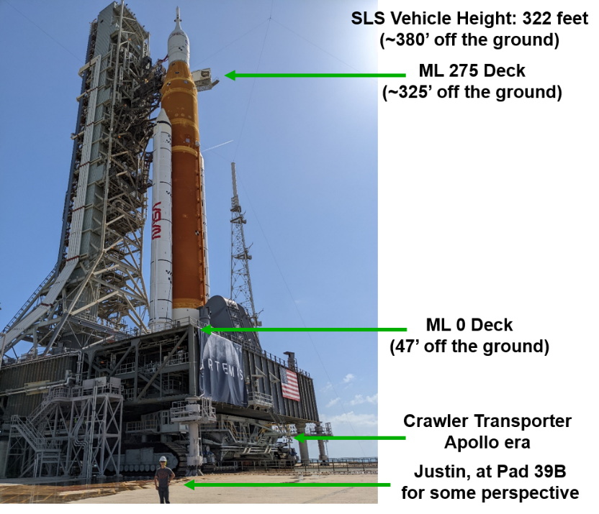
Figure 1: Space Launch System at Pad 39B atop the mobile launcher (ML)

Background
The IMT and DRRT provided opportunities to collect video to demonstrate and validate motion magnification alongside traditional instrumentation methods, refine the experimental methodology by participating in a real large-scale test, and potentially provide some benefit to the SLS engineering team. We briefly describe the tests themselves and the video camera experimental setup we used during the test campaign.
IMT – Integrated Modal Test
The IMT is the modal test that measures the dynamic response of the Artemis I vehicle in the ground configuration. It consists of the ML, SLS vehicle – consisting of the core, boosters, Launch Vehicle Stage Adapter (LVSA), Interim Cryogenic Propulsion Stage (ICPS), Orion Stage Adapter (OSA) – and the Mass Simulator of Orion (MSO). The SLS subsystem components are all flight hardware, whereas the MSO is a metallic cylinder that closely represents the total mass and center of gravity (CG) of the Orion spacecraft. The MSO is designed to be nearly rigid with respect to the frequency range of interest in the IMT. However, the Orion spacecraft is used during the DRRT since it is critical hardware for the Wet Dress Rehearsal (WDR) test.
There are two test configurations during the IMT. The 6-point modal test configuration is when the ML-SLS-MSO integrated stack is configured to sit atop six mount mechanisms that are positioned in six locations along the bottom of the ML. The other test configuration is the 10-point modal test, where the crawler-transporter (CT) is used to pick up the integrated stack to the point that only half of the test weight was resting on the mount mechanisms and the other half was on the CT. Two test configurations were used in an attempt to isolate and understand the dynamics of the Artemis I vehicle from the dynamics of the ML. The 10-point configuration, with the CT used to prop up the vehicle, is shown in Figure 2a, and the 6-point configuration is shown in Figure 2b. Figure 2c shows a picture of the ML-SLS-MSO integrated stack inside the Vehicle Assembly Building (VAB).
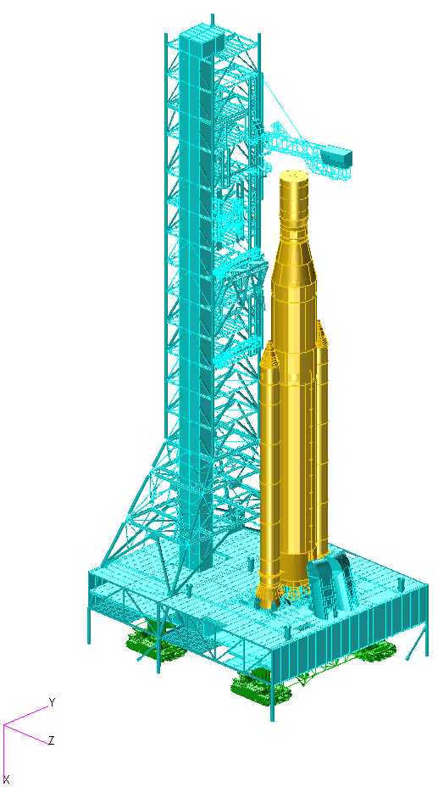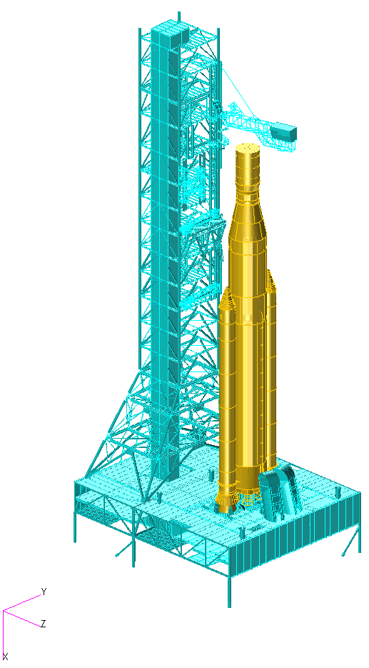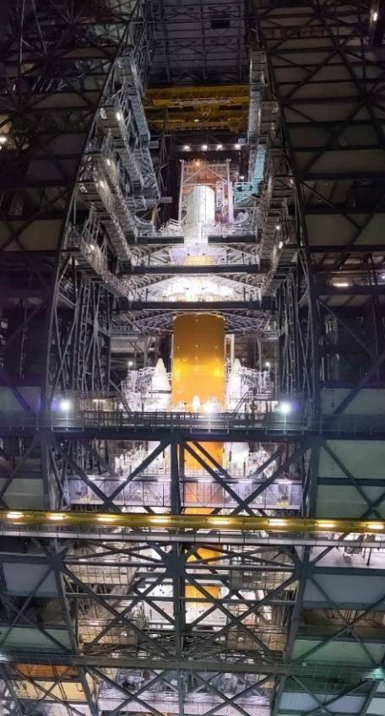Figure 2: (a) IMT 10-point configuration, (b) IMT 6-point configuration, and (c) picture of the Artemis I IMT in the Vehicle Assembly Building
(a)
(b)
(c)
The purpose of the IMT was to capture and understand the low-frequency dynamics of the vehicle that govern the flight control stability and loads analyses. In each configuration, five primary shakers were used to excite the vehicle and nearly 300 accelerometer locations were used to measure the dynamic response. Additional accelerometers were used on the CT to measure its motion during the 10-point modal test. There were 16 target modes in the 10-point configuration and 31 target modes in the 6-point configuration that were adequately captured by the wired test instrumentation.
While all target modes were adequately captured during the IMT, the first low-frequency torsion mode was a drastically lower frequency than predicted in the pre-test analysis. During testing, examination of the load cells in the booster-core aft struts, seen in Figure 3c, showed that they were not actively engaging at all levels of excitation. This aft strut free play decreased the torsional stiffness of the vehicle, which led to the low torsion frequency. While there were load cells in the aft struts, there were not accelerometers present on both sides of the aft struts to measure relative motion on either side of each strut. It was logistically infeasible to add accelerometers to the region of interest mid-test, so the cameras being used for motion magnification analysis of the integrated stack as in Figure 3a and 3b were redeployed to focus on the local motion of the aft struts as in Figure 3c.

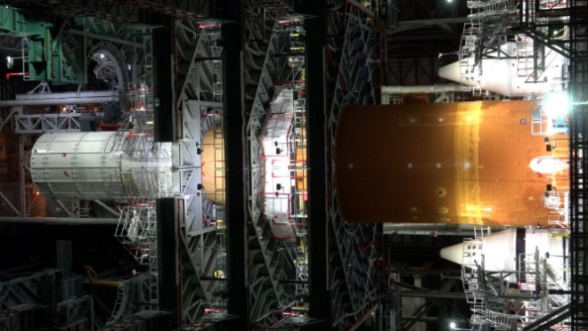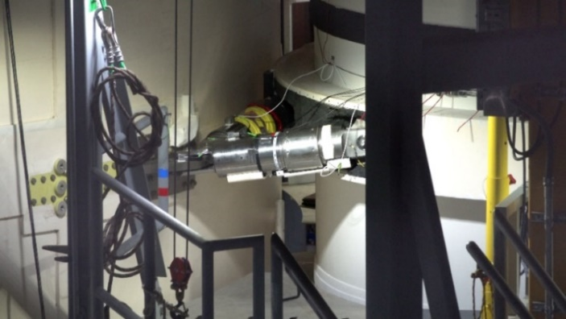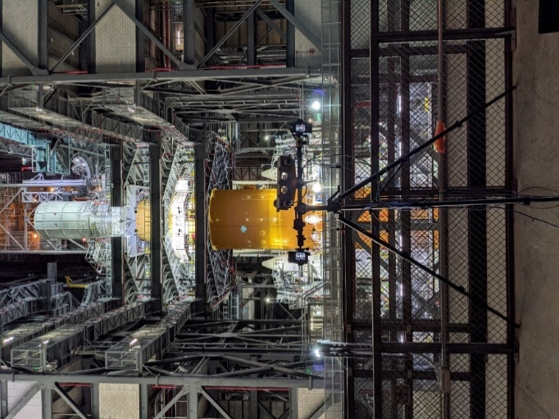
(a)
(b)
(c)
Figure 3: (a) Picture of the camera setup atop a tripod, (b) camera view of the SLS with MSO at the top of the stack, (c) camera view of aft struts connecting the booster to the core stage
DRRT - Dynamic Rollout/Rollback Test
The goal of the DRRT is to provide substantiating dynamic test data of the flight vehicle when it has different boundary conditions and excitation inputs from the IMT. The DRRT configuration consists of the ML sitting on top of the CT, the Artemis I flight vehicle sitting on the ML, and the umbilicals connecting the ML tower with the flight vehicle. The excitation of the system comes from the operation and rolling of the CT.
The excitation levels of the DRRT were expected to be larger than the excitation experienced during the IMT. So, one focus of the DRRT is to determine if the first torsion mode has a much lower frequency than predicted in the pre-test analysis. Similar to the IMT, no accelerometers were placed at the ends of the aft struts to determine the relative motion of the booster and core during the torsion mode. Cameras were placed on the ML deck to measure the low-frequency bending modes during roll as seen in Figure 4a and 4c.
Another focus of the DRRT is the relative deflection of the flight vehicle with the ML tower during the roll. This is an important measurement, because the vehicle stabilization system (VSS) induces loads on the SLS based on how the vehicle and tower deflect during DRRT and stay at the launch pad. This relative deflection is difficult to measure accurately during the roll, so cameras were set up to use Motion Magnification, as seen in Figure 4b and 4d.

ANALYSIS
There are potentially many difficulties when running a video camera as secondary and non-essential instrumentation to the main wired system in a modal test as well as a new set of challenges with large-scale structural testing (vs. laboratory testing). We outline some experimental guidelines, some which may be obvious, but others that are hopefully useful, for a successful experimental campaign. We also provide a preview of some of the results determined from the analyzed video collected during testing. The presentation at IMAC will go into more detail regarding the findings and show some motion magnified videos.
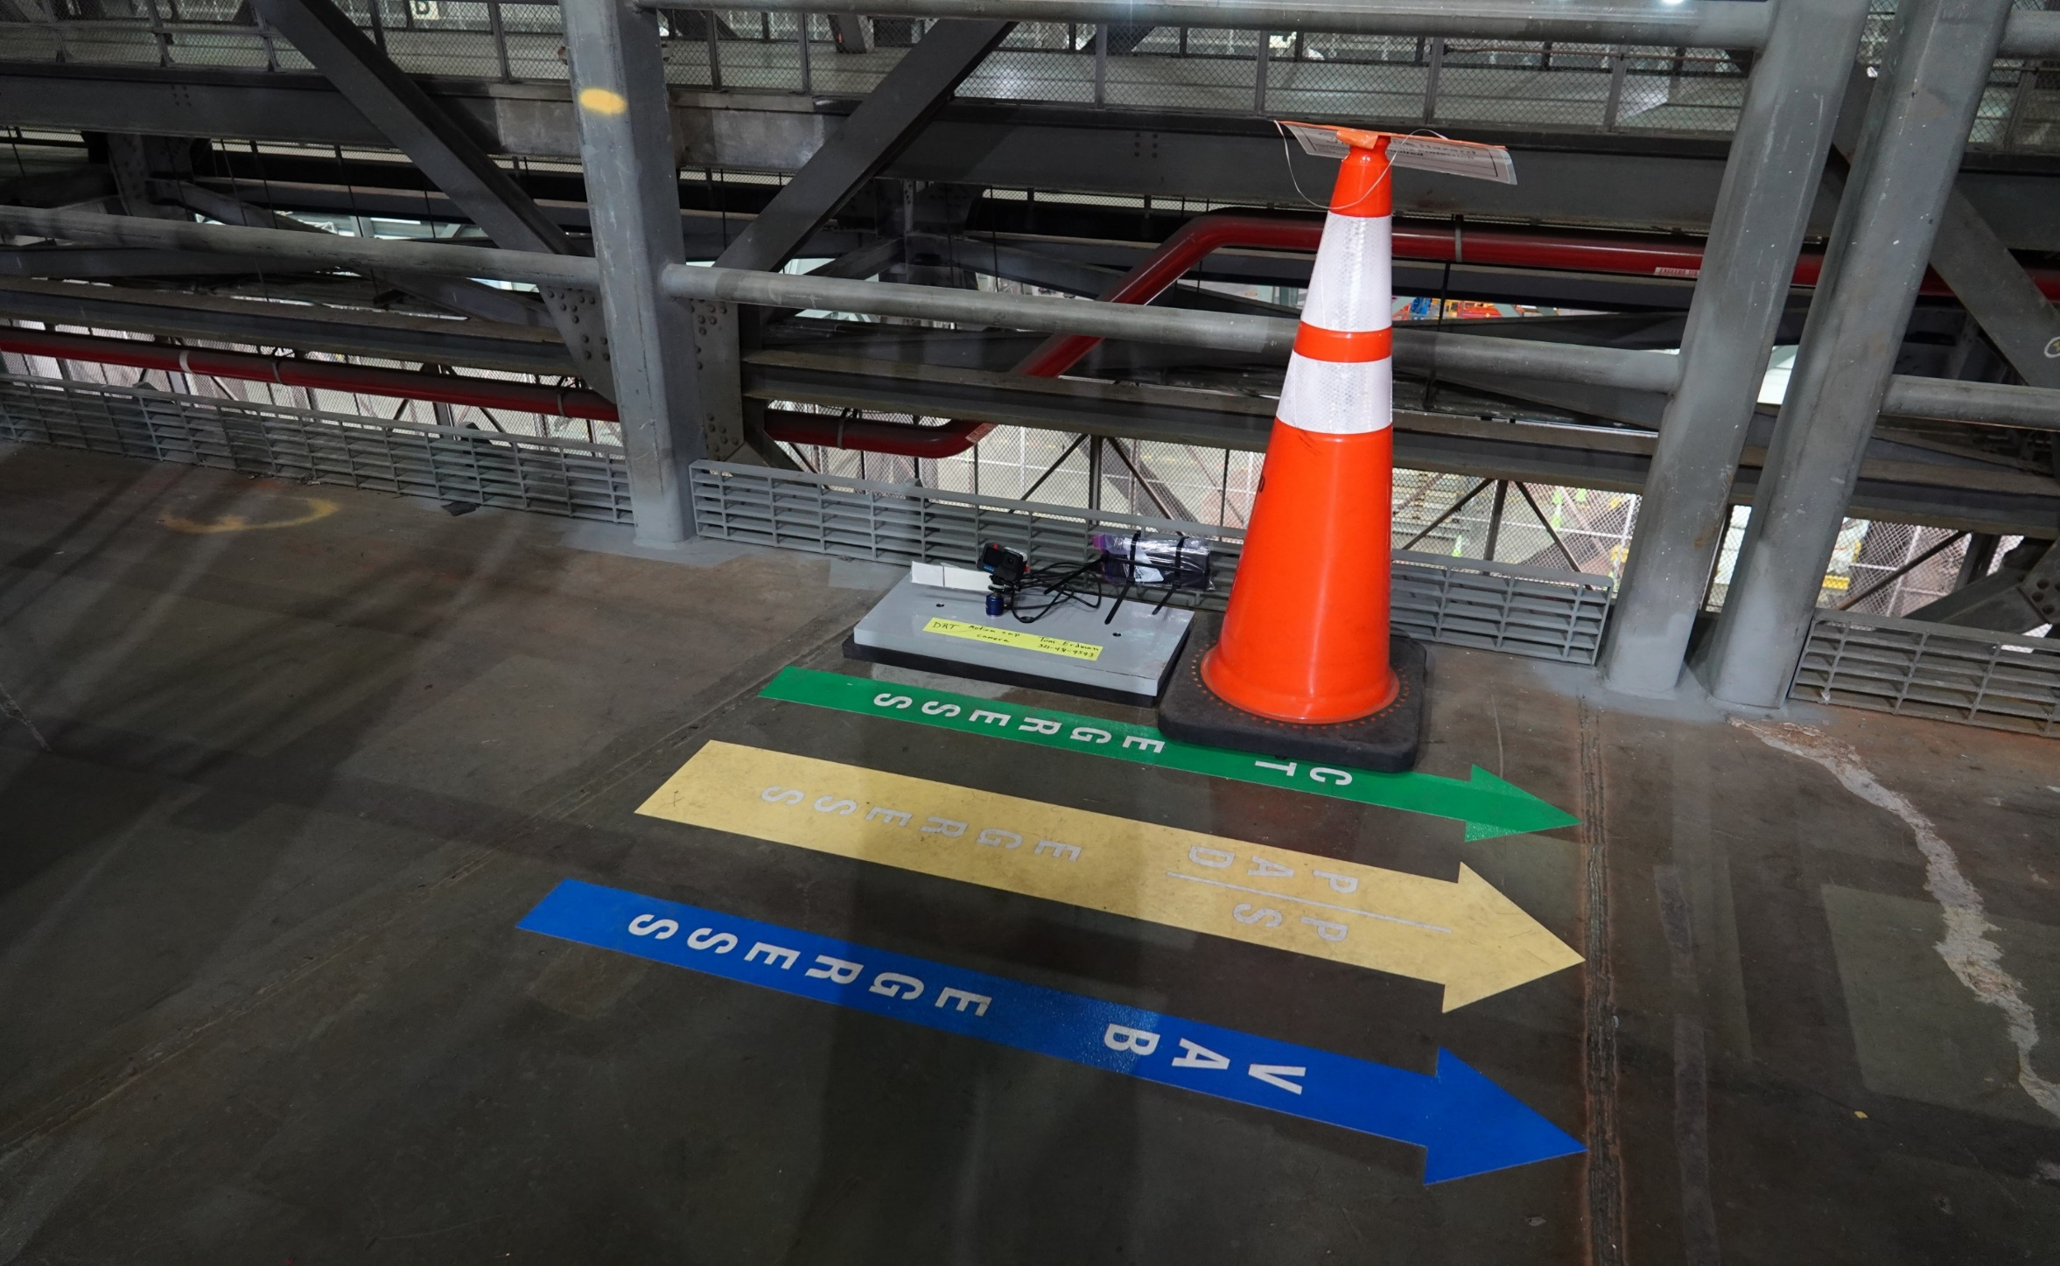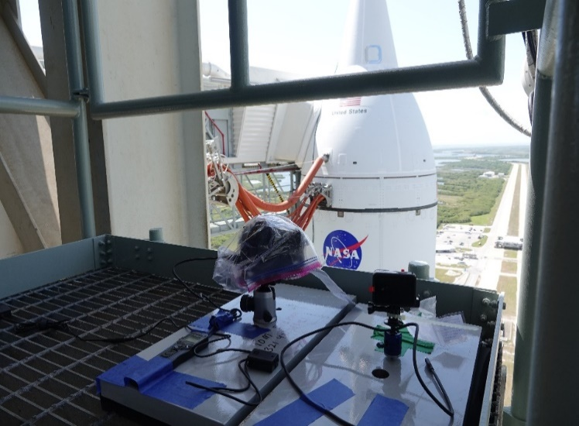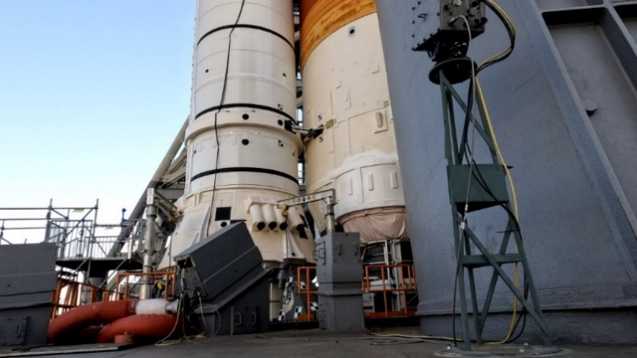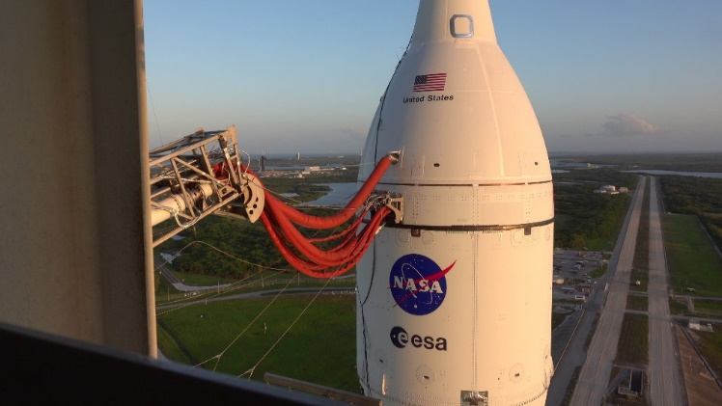Figure 4: (a) DRRT ML 0-deck camera to record the Aft SRB struts and generate vehicle motion, (b) DRRT ML tower cameras to record relative motion between the ML tower and vehicle, (c) field of view of the ML 0-deck camera, and (d) field of view of the ML tower camera.
(a)
(b)
(c)
(d)
We will briefly discuss a standard list of issues and differences from laboratory testing that one might encounter during real-world testing including: power for instrumentation, lighting in outdoor or uncontrollable conditions, and triggering of cameras.
Power is often a challenge during outdoor or large-scale tests as outlets may be scarce or far from the location that you want your cameras. Bringing a long extension cord or your own batteries is advised. We have found that GoPros are prone to overheat when being used with external battery packs or plugged in to wall power, so it is recommended to remove the internal battery while running with external power.
Lighting can be a potential source of interference either due to strobing or AC driven lighting, or it can be slowly changing over the time period of the collect (e.g. sunset); in either case it may present issues. Dealing with changing lighting has always been a challenge for motion magnification, however a new paper may offer a potential solution [14]. In drastically changing lighting conditions, such as at dusk, cameras should be set to a manual or fixed focus such that the autofocus system does not end up focusing on something erroneous due to the change in lighting. The best situation would be to bring your own lighting to ensure consistency, but this is often not possible.
Camera triggering can be a complicated task, especially when combined with limited runtime limitations due to power or storage capacity, if it is not possible for an experimenter to simply hit the “record” button at test time. Consumer cameras or DSLRs photography cameras with video capabilities often have a 30 minute video length restriction due to European tax laws, so take care if you are using one or planning on purchasing a new video camera for especially long tests; consider a dedicated camcorder/video camera instead. Pay extra attention when using any delayed triggering/record functionality provided by an external timed remote shutter with any power saving or sleep features of your camera.
A final recommendation is to fully test the exact experimental configuration you plan on using regarding power or triggering, in the exact way you are going to use it (e.g. delayed triggering, runtime) to make sure everything works as intended before the big day. If the test collection is a one-shot deal, and it is vital to get video, multiple backup systems are ideal.
Results Preview
Here is a quick preview and example of some of the operational frequencies measured during the IMT and DRRT. Figure 5 shows spectrograms representative of the bulk operational modes of the vehicle due to sine sweep excitation from the shakers. Figure 6 shows spectrograms that are mostly representative of the excitation from the CT during Rollout as well as some operational modes of the vehicle.
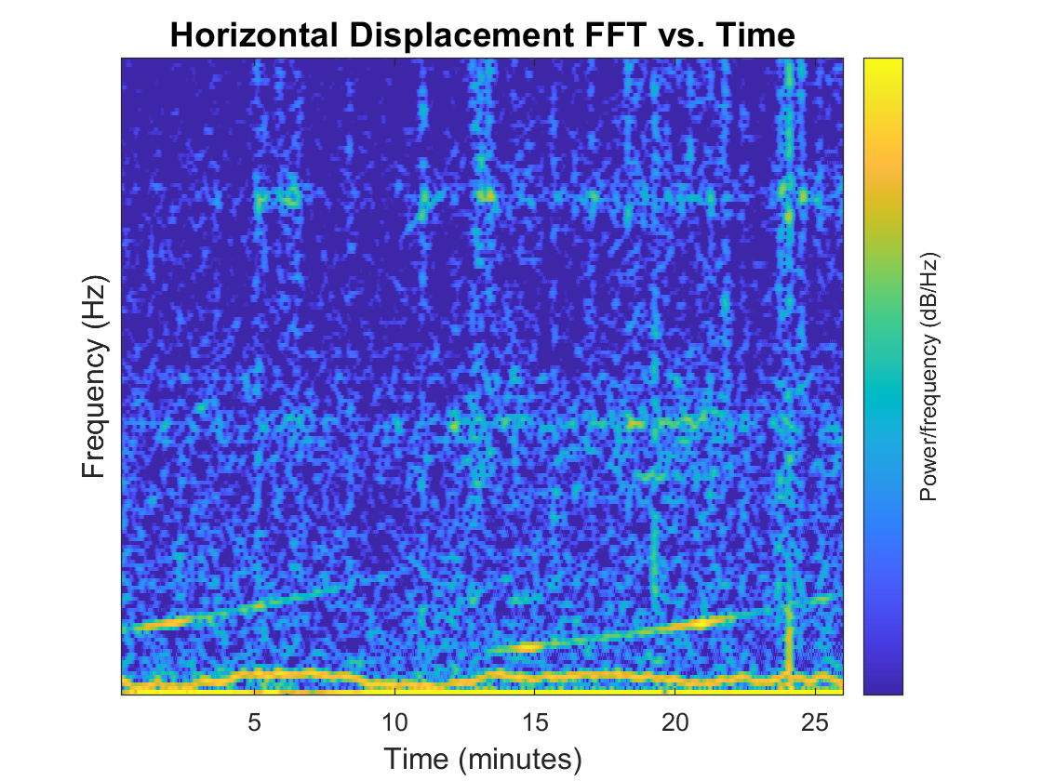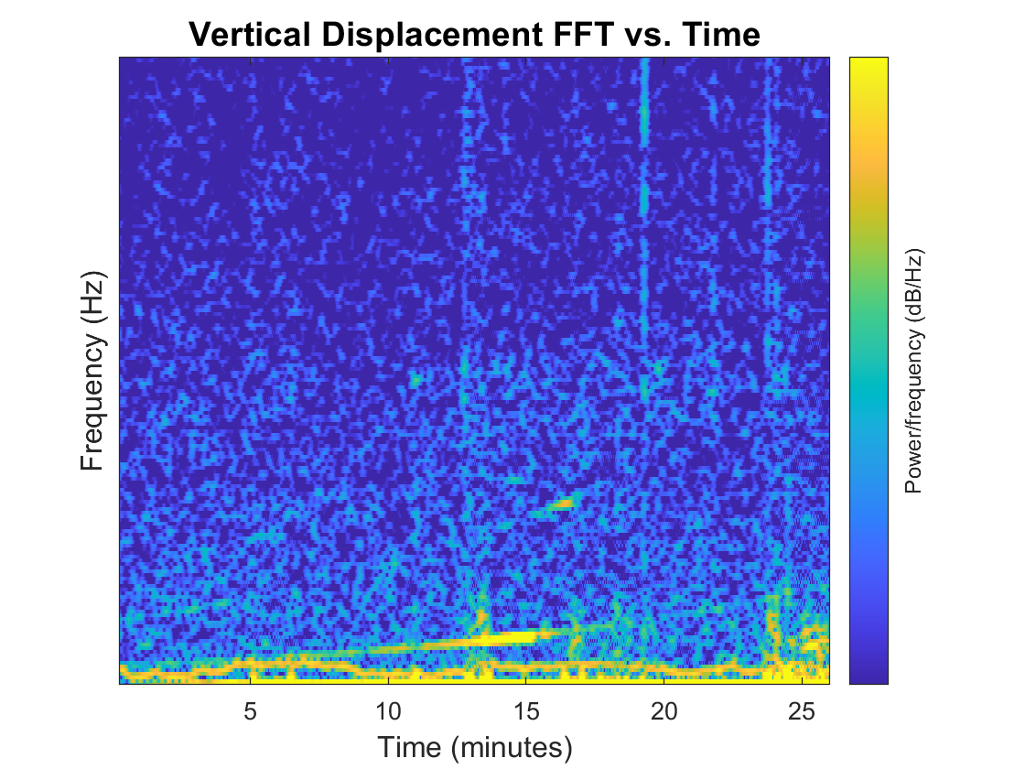
Figure 5: Spectrograms showing response of the vehicle due to sine sweep excitation from the IMT 10-point testing.
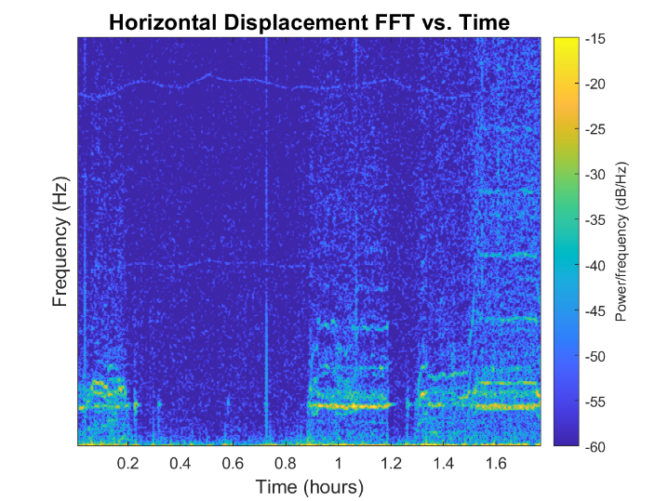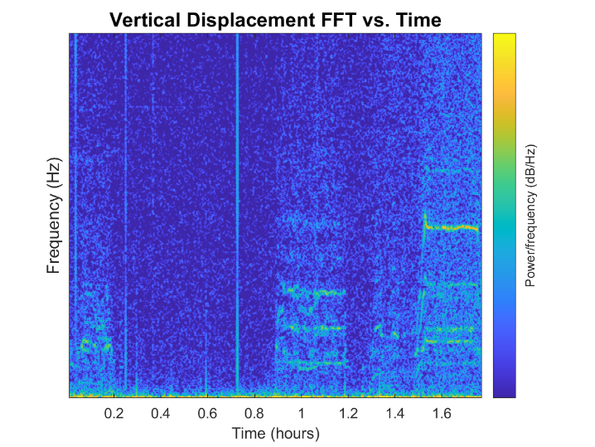
Figure 6: Spectrograms showing excitation and vehicle response from DRRT (Rollout) from the ML 0-deck camera.

CONCLUSION
We discussed an instrumentation and test campaign to collect video and use motion magnification analysis alongside a traditional accelerometer system during the IMT and DRRT in support of the Artemis I program. The cameras were able to accurately measure the operational mode frequencies of the vehicle in both tests, and motion magnification was able to pull out visualizations of operational mode shapes. We also provided recommendations for participating in large-scale real-world tests.

ACKNOWLEDGEMENTS
The authors would like to thank Dan Lazor and Tom Erdman for their invaluable assistance before and during the IMT and DRRT tests. The authors would also like to thank Katrina Magno for her contribution to the development of the camera system.
DISTRIBUTION STATEMENT A. Approved for public release. Distribution is unlimited.
This material is based upon work supported by the Natl Aeronautics & Space Admin under Air Force Contract No. FA8702-15-D-0001. Any opinions, findings, conclusions or recommendations expressed in this material are those of the author(s) and do not necessarily reflect the views of the Natl Aeronautics & Space Admin.

REFERENCES
- M. S. Allen and J. W. Sills, 2019, Historical Review of ‘Building Block Approach’ in Validation for Human Space Flight, In IMAC XXXVI, Orlando, FL
- Stasiunas, E.C., Parks, R.A., Sontag, B.D. and Chandler, D.E., 2021. Modal test of the NASA mobile launcher at Kennedy Space Center. In Sensors and Instrumentation, Aircraft/Aerospace, Energy Harvesting & Dynamic Environments Testing, Volume 7 (pp. 213-228). Springer, Cham.
- Stasiunas, E.C., Parks, R.A., Sontag, B.D. and Chandler, D.E., Green Run Modal Test of the NASA Space Launch System Core Stage. In IMAC XXXIX.
- McMahan, T, Aug 19, 2021. “Vibration Tests for Moon Rocket Help Ensure Safe Travels on Road to Space.” https://www.nasa.gov/exploration/systems/sls/vibration-tests-for-moon-rocket-help-ensure-safe-travels-on-road-to-space.html
- Alley, V. L., Leadbetter, S. A., 1963. Prediction and Measurement of Natural Vibrations of Multistage Launch Vehicles. AIAA Journal, 1(2), p.374-379.
- Stewart, E. C., Bertaska, I. R., Zuo, Q. H., Swatzel, S., Hahn, S. R., Howsman, T. G., 2022. The Flight Dynamics Risk Assessment of Artemis I, Proceedings of the 2022 AIAA SciTech Forum and Exposition, San Diego, CA.
- Schumacher, T. and Shariati, A., 2013. Monitoring of structures and mechanical systems using virtual visual sensors for video analysis: Fundamental concept and proof of feasibility. Sensors, 13(12), pp.16551-16564.
- Horn, B.K. and Schunck, B.G., 1981. Determining optical flow. Artificial intelligence, 17(1-3), pp.185-203.
- Wadhwa, N., Rubinstein, M., Durand, F. and Freeman, W.T., 2013. Phase-based video motion processing. ACM Transactions on Graphics (TOG), 32(4), pp.1-10.
- Wadhwa, N., Chen, J.G., Sellon, J.B., Wei, D., Rubinstein, M., Ghaffari, R., Freeman, D.M., Büyüköztürk, O., Wang, P., Sun, S. and Kang, S.H., 2017. Motion microscopy for visualizing and quantifying small motions. Proceedings of the National Academy of Sciences, 114(44), pp.11639-11644.
- Chen, J.G., Adams, T.M., Sun, H., Bell, E.S. and Büyüköztürk, O., 2018. Camera-based vibration measurement of the world war I memorial bridge in Portsmouth, New Hampshire. Journal of Structural Engineering, 144(11), p.04018207.
- Yang, Y., Dorn, C., Mancini, T., Talken, Z., Kenyon, G., Farrar, C. and Mascareñas, D., 2017. Blind identification of full-field vibration modes from video measurements with phase-based video motion magnification. Mechanical Systems and Signal Processing, 85, pp.567-590.
- Sarrafi, A., Mao, Z., Niezrecki, C. and Poozesh, P., 2018. Vibration-based damage detection in wind turbine blades using Phase-based Motion Estimation and motion magnification. Journal of Sound and vibration, 421, pp.300-318.
- Wang, Y., Hu, W., Teng, J. and Xia, Y., 2023. Phase-based motion estimation in complex environments using the illumination-invariant log-Gabor filter. Mechanical Systems and Signal Processing, 186, p.109847.

