Kansas City Disasters
Assessing Environmental and Socioeconomic Factors of Urban Flood Vulnerability in Kansas City, Kansas


Technical Report
Final Draft – August 11th, 2022

M. René Castillo (Project Lead)
Hadwynne Gross
Eric Sjöstedt
Raychell Velez

Advisor:
Dr. Kenton Ross, NASA Langley Research Center (Science Advisor)

1. Abstract
Pluvial flooding, over-saturated ground, and poor drainage systems disproportionately impact historically disinvested neighborhoods during extreme rainfall events independently of overflowing water bodies. These communities are impacted by physical and socioeconomic factors that make them vulnerable to flooding events, such as high concentration of impervious land cover, high precipitation rates, and a combined sewer system framework. Despite known vulnerability to environmental hazards, there is a lack of data supporting the potential pluvial street-level flooding events. The DEVELOP team investigated flooding events from June 2010 through June 2021 in Google Earth Engine (GEE) using NASA Earth observation products from the Global Precipitation Measure. Alongside the satellite imagery and ancillary datasets, the Natural Capital Project’s Integrated Valuation of Ecosystem Services and Tradeoffs (InVEST) Urban Flood Risk Mitigation model was utilized to generate outputs of runoff retention and potential economic damage for risk mapping of Kansas City, Kansas to aid in identifying areas where future intervention is necessary. Then a cloudburst blue spot model produced spatially-explicit outputs of how pluvial flooding would accumulate across the surface elevation gradients. These resulting maps identify the most vulnerable neighborhoods throughout Kansas City, alongside potential economic damage from flooding. The resulting methodology and end products provide partners from Groundwork USA and Groundwork Northeast Revitalization Group (Groundwork NRG) with a detailed analysis of urban flood risk throughout Wyandotte County, Kansas, and streamline the provision of neighborhood-scale vulnerability analysis to Groundwork USA’s Climate Safe Neighborhoods project.

Key Terms
InVEST Urban Flood Risk Mitigation model, Arc-Malstrøm model, urban flooding, socioeconomic vulnerability, GPM IMERG

2. Introduction
2.1 Background Information
Cities face increasing vulnerability to natural disasters due to climate change. Warming temperatures can induce frequent short-duration, high-intensity rainfall events that cause excessive flooding (Quagliolo et al., 2021). Pluvial flooding, commonly referred to as “urban flooding,” is characterized by high runoff volumes over an abundance of impervious land cover and is known to overwhelm sewage systems (Kilsdonc et al., 2022). When the surface runoff exceeds infiltration rates and drainage capacity, flooding events become disasters and damage can become costly to individuals, businesses, and infrastructure (Houston et al., 2011). As such, understanding environmental and socioeconomic vulnerability to flooding can help to inform future mitigation efforts.

Kansas City, Kansas, in Wyandotte County, is home to roughly 156,600 residents (Figure 1). It is a booming urban center built on a floodplain, with a combined sewer system and an abundance of impervious land cover. 19.2 % of the population lives below the poverty line (U.S. Census Bureau, 2020). The city faces legacies of redlining and disinvestment of minority communities. In the 1930s, the government systematically blocked investment in East side neighborhoods in Kansas City with high minority populations. Redlining continues to exacerbate neighborhood inequality, creating environmental justice concerns (Hopkins, 2022). Without suitable mitigation, climate change will continue to increase flood risk and associated damages for vulnerable populations (Miller & Hutchins, 2017).

This project focused on flooding between June 2010 and June 2021, highlighting the flood events of August 21st to August 24th, 2017, and May 25th to June 6th, 2019. However, Kansas City has experienced catastrophic flooding throughout the last few decades. Known as the Great Flood of 1993, above-normal rainfall and snow depth during the fall of 1992 resulted in higher soil moisture and a wet spring (Corrigan, 2022). By June 1993, a significant part of the Missouri River basin was flooded, with over $15 billion in damage (Combs & Perry, 2003). More recently, Kansas City and surrounding areas have seen above-normal precipitation during the spring and summer months. In 2017, there was heavy rainfall with totals of 4 to 6 inches throughout the Kansas City metropolitan area between August 21st and 22nd (National Weather Service, 2017). During mid-March of 2019, a bomb cyclone resulting in heavy rainfall of 1 to 3 inches collecting in the Missouri River basin left a historic river crest of 35 feet by March 23rd (Morgan, 2019).
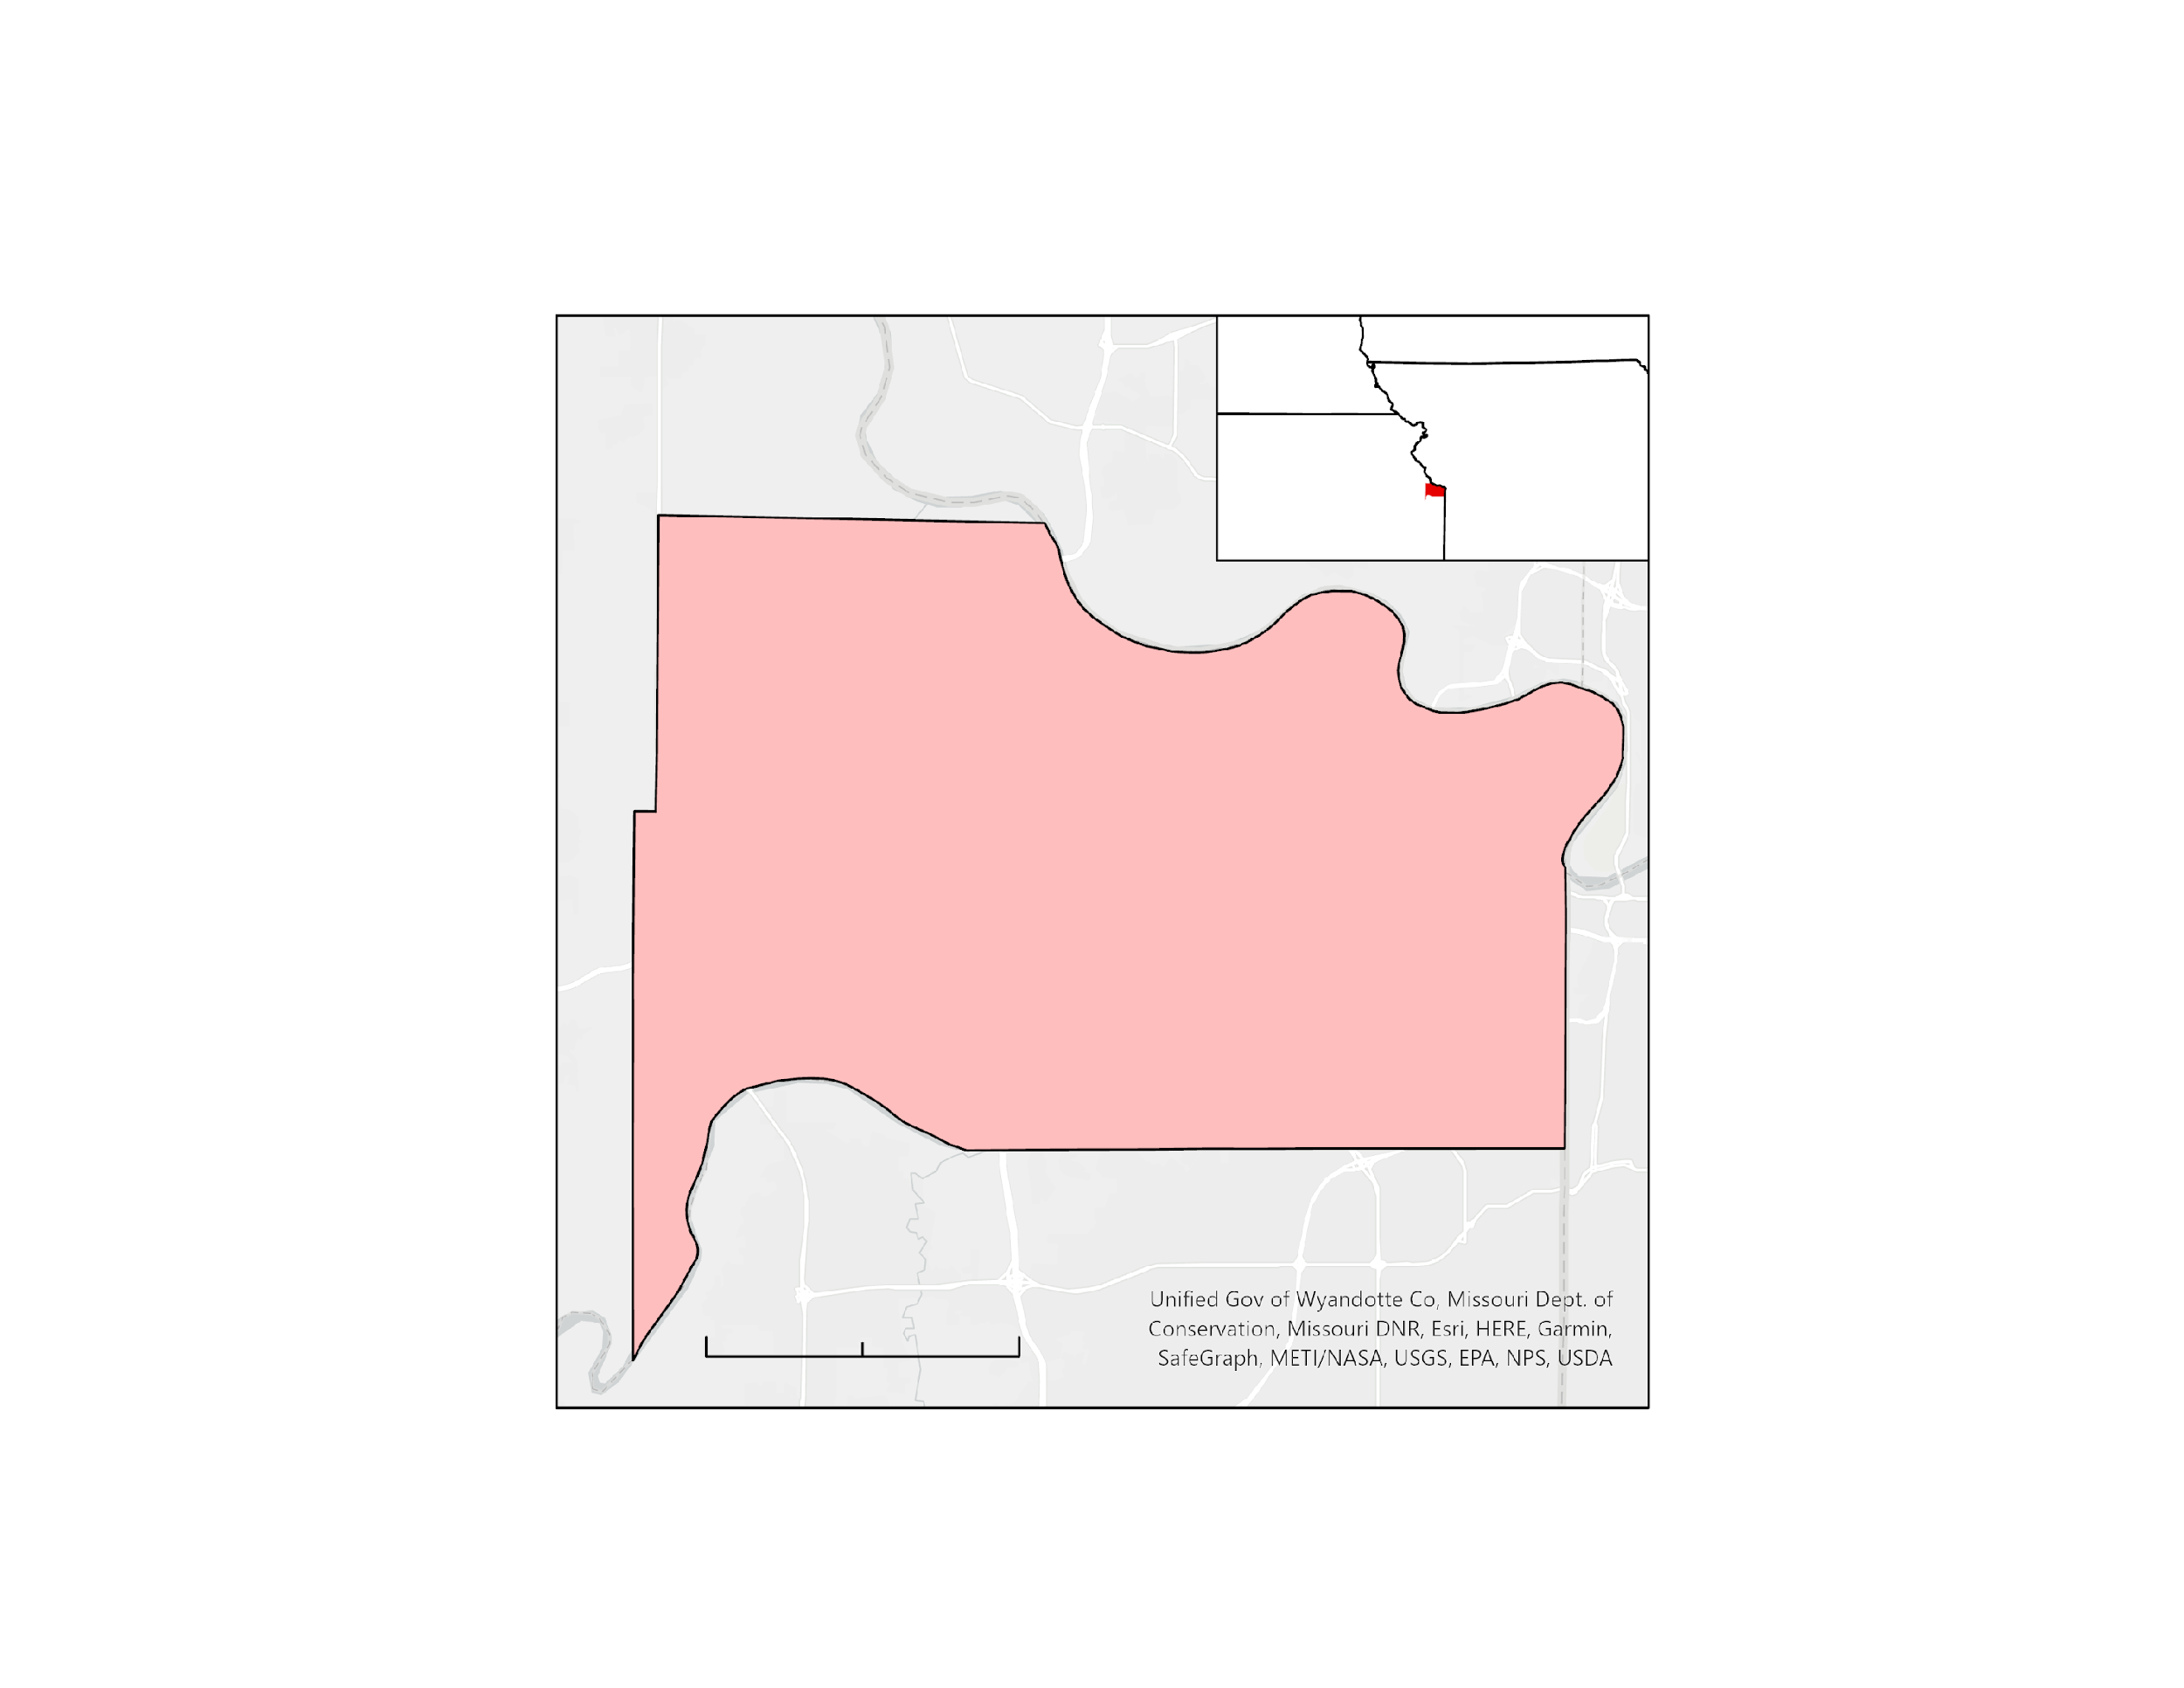

Figure 1. The Wyandotte County study area is highlighted in pink. The inset map highlights the county alongside the border between Kansas and Missouri.

Kansas
Missouri
N
0
3
6
Miles

The mismanagement of extreme flooding events by the Unified Government of Wyandotte County and Kansas City led to violations of the United States Environmental Protection Agency’s Clean Water Act. In 2013, the Unified Government was charged with unauthorized discharge of sewage from sanitary system, dry weather overflows, failure to maintain and operate the sewer system in accordance with the National Pollutant Discharge Elimination System (NPDES) permit, and violation of the Municipal Separate Storm Sewer System (MS4) NPDES permit (United States Environmental Protection Agency, 2020). Because the Unified Government serves low-income and minority communities, the Unified Government’s relief plan has environmental justice concerns at the forefront, specifically allocating wastewater control projects in the Eastern areas where vulnerable communities reside.

Earth observations are used to assess and model flooding in a timely and cost-effective way. The surface complexity of urban environments makes it challenging to map floods using spectral data (Zhang et al., 2021). Urban flood modeling efforts can be divided into qualitative and quantitative categories. Qualitative urban flood models depend on expert knowledge and experience channeled into a multi-criteria assessment. Quantitative urban flood models are based on measurable data and are widely adopted in flood mechanism simulations (Qi et al., 2021). While urban flood models have improved and datasets are more spatially detailed, creating precise urban flood models is beyond typical municipal Geographic Information Systems (GIS) offices’ capabilities. The Natural Capital Project’s Integrated Valuation of Ecosystem Services and Tradeoffs (InVEST) Urban Flood Risk Mitigation model is a software package that utilizes readily available datasets and is user-friendly to run. It provides clear outputs highlighting natural infrastructure capability to reduce surface runoff production and determine where flood mitigation efforts should be allocated (Hamel et al., 2021). The Arc-Malstrøm model is another urban flood methodology that provides insight into pooling of flood water following a cloudburst event, which is a short period of extreme precipitation that produces flood conditions. The model utilizes surface landscape elevation depressions to produce spatially-explicit outputs that are suitable for neighborhood-scale flood vulnerability (Balstrøm & Crawford, 2018).

2.2 Project Partners & Objectives
In partnership with Groundwork USA and Groundwork Northeast Revitalization Group (Groundwork NRG), the project identified Kansas City, Kansas neighborhoods most vulnerable to urban floods, highlighting the socioeconomic factors amplifying flood vulnerability. Groundwork USA is a network of local organizations working to promote health, equity, and resilience in low-resource communities. The team created pluvial flood maps of Wyandotte County and outreach materials. For their Climate Safe Neighborhoods initiative, Groundwork USA and Groundwork NRG can utilize remote sensing to analyze the environmental hazards and health risks of urban flooding and raw sewage exposure. These analyses provide our partners with spatial insight into urban flood vulnerability and potential economic damages to better inform community-based efforts for environmental justice.

3. Methodology
3.1 Data Acquisition
Using Google Earth Engine (GEE), the team extracted Earth observation imagery for the study period between June 2010 and June 2021. Integrated Multi-satellitE Retrievals for Global Precipitation Measurement (GPM IMERG) datasets were retrieved to provide precipitation data for the InVEST Urban Flood Risk Mitigation model (Table 1). The InVEST model’s input parameters required multiple ancillary datasets (Appendix 1).

Table 1
Description of Earth observations used in data processing
Platform | GEE Product ID | Dates | Purpose | Source
GPM IMERG | NASA/GPM_L3/IMERG_V06 | June 2011 – June 2021 | precipitation reference data for the InVEST input | NASA GES DISC at NASA Goddard Space Flight Center

The runoff production and runoff attenuation outputs required inputs of a watershed vector, a mean depth value of precipitation in millimeters, a soil hydrological group classification raster, a land cover raster, and a biophysical table that represented the curve value of the soil types’ relationship to land cover classes. The model also produces an optional output of potential service, providing values of flood volume, potential damage to built infrastructure, and runoff retention service for the watershed (Lajoy et al., 2021). The team focused exclusively on the potential damage to built infrastructure optional output. The optional outputs required a built infrastructure vector alongside a damage loss table that categorizes infrastructure and its economic value. The soil hydrological group classification raster was produced using the United States Department of Agriculture (USDA) Gridded Soil Survey Geographic (gSSURGO) soil type and drainage class dataset. The land use land cover (LULC) raster and associated biophysical table were produced using the United States Geological Survey (USGS) 2019 USA National Land Cover Dataset (NLCD) (Appendix 2). The Unified Government of Wyandotte County Geoportal provided building footprint shapefiles used to calculate the infrastructure presence. A mean precipitation value was collected from the GPM IMERG satellite dataset to prescribe the precipitation depth value for the InVEST model. Additionally, the watershed vector was produced from delineating the USGS National Elevation Dataset 3D Elevation Program’s 1/3rd arc-second digital elevation model (DEM). The environmental justice analysis required race, age, income, and educational attainment data. The team retrieved a census block group polygon shapefile and 2020 American Community Survey data from the Integrated Public Use Microdata Series National Historical Geographic Information System (Manson et. al, 2021).

3.2 Data Processing
3.2.1 Precipitation Values
Utilizing GEE, GPM IMERG data were averaged to generate a chart of mean precipitation of cloudburst events for Wyandotte County, Kansas during June 2011 – June 2021. The team identified two cloudburst events: August 21st to 24th, 2017, and May 30th to June 6th, 2019. These cloudburst events yielded mean precipitation values of 117 mm and 40 mm (precipitation averaged across the temporal duration of cloudburst event), respectively, used as precipitation depth input values for the InVEST model.

3.2.2 Runoff and Runoff Retention
For the runoff and runoff retention outputs of the InVEST model standard outputs, the team processed ancillary datasets for Wyandotte County, Kansas. A raster map of soil hydrologic groups was reclassified into A, B, C, and D categories (Appendix 3), representing different sediment infiltration speeds in accordance with the USDA National Engineering Handbook Chapter 7 (United States Department of Agriculture, 2009). Areas of unclassified soil types were prescribed a soil hydrologic group by referencing the parent USDA Natural Resources Conservation Service (NRCS) Soil Survey Geographic (SSURGO) Database (United States Department of Agriculture, 2022). The classified hydrologic groups have an associated runoff curve number from the NRCS used to predict the soil infiltration capacity and runoff potential for each LULC type (United States Department of Agriculture, 2009). The team extracted the LULC dataset to the study area extent and used the LULC classes distribution to validate the runoff and runoff retention outputs of the InVEST model (Figures 2 & 3).

The team utilized the National Hydrography Dataset Plus (NHD Plus), a USGS dataset consisting of hydrological rasters and polygons across streams and catchment areas, to create a sub-watershed to accurately represent hydrologic properties of Wyandotte County, Kansas. The process of creating this delineated watershed layer is outlined in the project methodology guide.

3.2.3 Potential Economic Damage
The team aggregated the building types of the building footprint layer into five categories: residential, commerce, industry, infrastructure, and agriculture (Appendix 5). The building footprint vector was converted from feet to meters to match the metric used by the damage loss table (dollars per square meter). The team produced a damage loss table utilizing the European Union Global Flood Depth-Damage Function technical report (Huizinga et al., 2017). The team then adjusted the damage costs presented in the 2010 Euro for the inflation increase of 26.93% to the 2020 Euro before converting to the 2020 Dollar value at the highest exchange rate of 0.9383 Dollars per Euro for that year.

3.2.4 Pluvial Flood Pooling
With the Arc-Malstrøm model, a 10-meter resolution USGS DEM was extracted to the extent of Wyandotte County, Kansas, and inset streamlines and building footprints onto the DEM (Balstrøm & Crawford, 2018). These additions allowed the model to better represent the surface flow of water across urban landscapes with buildings and elevation gradients. The model generated blue spot vectors that showed the local depth difference between a standard DEM and a filled DEM, highlighting local surface elevation depressions where water would accumulate. The method for this process is outlined in the project methodology guide.

3.2.5 Socioeconomic Vulnerability and Environmental Justice
The team selected four socioeconomic variables according to Table 8.1 in “Climate Change and Social Vulnerability in the United States: A Focus on Six Impacts,” a report published by the Environmental Protection Agency (EPA). Using 2020 American Community Survey data, the team found the low-income population by calculating the number of households with income below $50,000. The minority population was found by calculating the non-white population. The population without a high school diploma was calculated by the population over the age of 25 without a high school diploma. Lastly, the team found the elderly population by calculating the population over the age of 65. We used the merge tool to join the population data to the census block group polygon layer for the environmental justice analysis.

3.3 Data Analysis
3.3.1 Runoff and Runoff Retention
To validate and further analyze the InVEST model outputs of runoff and runoff retention, the team created line graphs of % total runoff and runoff retention per LULC class for both cloudburst events of 2017 and 2019 (Appendices 6 & 7). This allowed for the identification of a high concentration of impervious land cover in urbanized areas of Kansas City, Kansas, corresponding with high runoff values with near-zero runoff retention capability. This inability to allow water to percolate through the soil in urban environments increases the probability of the surface runoff becoming pluvial flooding hazards. In comparison, the highly forested landcover in western Wyandotte County, Kansas, indicated low levels of runoff alongside high levels of runoff retention, inferring that the interception capabilities of vegetation and the permeability of landcover all but removed the potential for flooding hazards. These two landcover types present the highest contrast in runoff and runoff retention values, highlighting the importance of land cover characteristics to urban flood vulnerability and mitigation.

3.3.2 Potential Economic Damage
The optional potential damage output of the InVEST Urban Flood Risk Mitigation model considered a damage cost function of a dollar per square meter that was used in conjunction with the categorized building footprint of Wyandotte County, Kansas, to highlight the spatial distribution of the cost of flood damage on present built infrastructure. The damage cost function of flooding for the 2017 cloudburst event calculated damage using the 2.5 meter or 8.2 feet flood crest height recorded at the Missouri River USGS gauge station 06893000 in Kansas City, Missouri (United States Geological Survey, 2022).

3.3.3 Pluvial Flood Pooling
The team also addressed the spatial limitations present with the InVEST model outputs by utilizing the Arc-Malstrøm model to produce a spatially explicit blue spot output that highlights where pluvial flooding would accumulate in surface elevation depressions. The team then used the blue spot depth output produced by the model to calculate an average depth value for all blue spots across Wyandotte County, Kansas. The high-resolution of a cell-by-cell representation of pluvial flooding provides insight into neighborhood-scale flood risk mitigation understanding.

3.3.4 Adjusted Potential Economic Damage
Using 2020 American Community Survey data, the team calculated median household income for each census block group. The team then added the potential economic damage cost values to the census block group shapefile to examine the relationship between income and damage costs at the census block group level. The adjusted potential economic damage output was produced using the blue spot polygons and the average blue spot depth as input to the InVEST Urban Flood Risk Mitigation model. The method to produce this is shown in the project user guide. To examine the relationship between income and damage costs at the census block group level, the team mapped both variables using bivariate visualization.

3.3.5 Socioeconomic Vulnerability and Environmental Justice
To look at the intersections between environmental and socioeconomic vulnerability, the team generated bivariate maps comparing runoff with each of the four socioeconomic vulnerability variables. This was accomplished using the Zonal Statistics tool in ArcGIS Pro to find the mean runoff value within each census block group polygon. This mean value was then added to the census block groups’ attribute tables, from which the four socioeconomic variables and runoff values were compared. The team depicted overall vulnerability with bivariate legends, identifying overlap between environmental and socioeconomic vulnerabilities.

4. Results & Discussion
4.1 InVEST Urban Flood Risk Mitigation Results
4.1.1 Runoff and Runoff Retention
To understand which neighborhoods are most susceptible to flooding, the team examined two historic flood events from 2017 and 2019. Using the 2017 storm precipitation data, the InVEST model produced the outputs seen in Figure 2. The eastern regions of Kansas City saw the highest levels of surface runoff, visualized in dark blue and reaching upwards of 117 millimeters (Figure 2a). Figure 2b represents the runoff retention with higher levels symbolized in dark red and orange. The western areas of Kansas City saw higher levels of runoff retention, up to 105 m³, during the storm event. This high level of runoff retention may be due to the lack of urban development within the area.

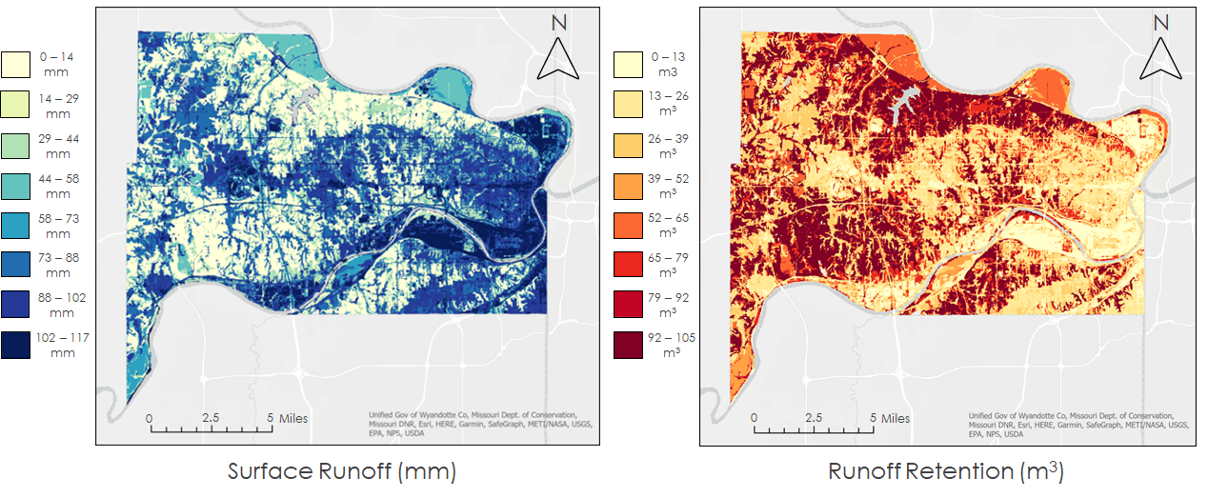

Figure 2. Modeled (a) surface runoff and (b) runoff retention during the 2017 storm event.

Though the 2017 storm saw greater precipitation, the 2019 storm event produced similar spatial patterns of runoff and retention. These similarities are due to the InVEST model’s inputs of impervious landcover and soil hydrologic groups remaining constant for both storm events. During the 2019 event, eastern Wyandotte County experienced high levels of surface runoff in the range of 35 to 40 millimeters (Figure 3a). The county also saw high levels of runoff retention in the western region with values up to 36 m³ (Figure 3b).

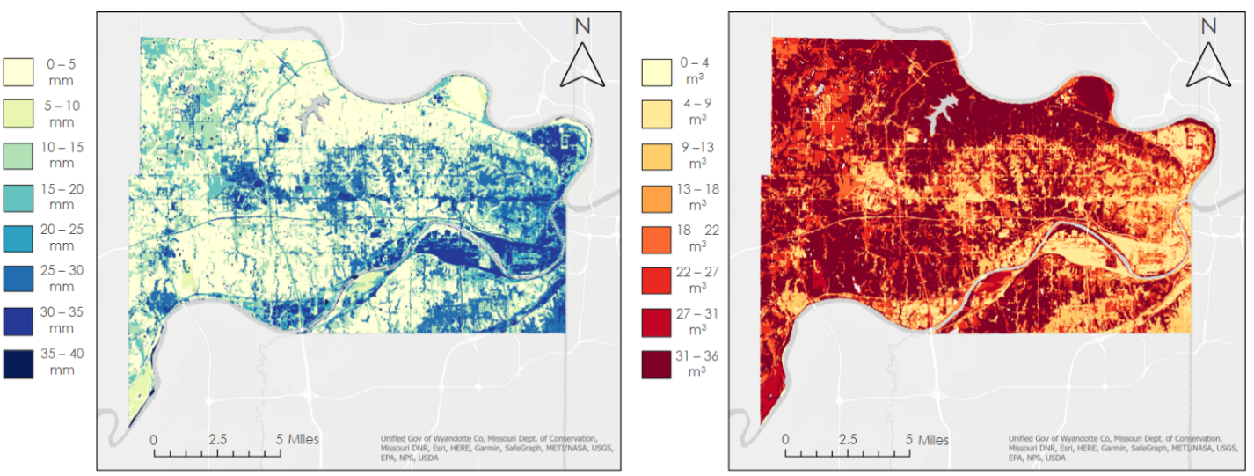

Figure 3. Modeled (a) surface runoff and (b) runoff retention during the 2019 storm event.

Overall, the InVEST Urban Flood Risk Mitigation model provided a clear understanding of the areas within Wyandotte County that need the most intervention. The team was able to identify land cover types within the county that contribute to pluvial flooding, allowing for the partners to distinguish land cover where flood risk mitigation is most needed.

4.1.2 Potential Economic Damage
In addition to the runoff and runoff retention outputs, the InVEST Urban Flood Risk Mitigation model provides the optional output of the potential economic damage. This output examined the cost of pluvial flood damage for Wyandotte County using building footprints and building type classification. Using the USGS stream gauge stations located around Kansas City, Kansas during the 2017 storm, the team found that flooding crested at 8.2 feet, or 2.5 meters. Once the crest value was included into the model, the output estimated economic damage values much higher than what would occur in a real-time pluvial flood event. As seen in Figure 4, the region that experienced the highest economic damage was within the western region of Wyandotte County. This result is due to the affluent western region possessing larger building footprints than the building in the eastern region of Wyandotte County. This methodology is dependent on building footprint to measure potential economic damage, resulting in a lack of representation of the more socioeconomically vulnerable communities.

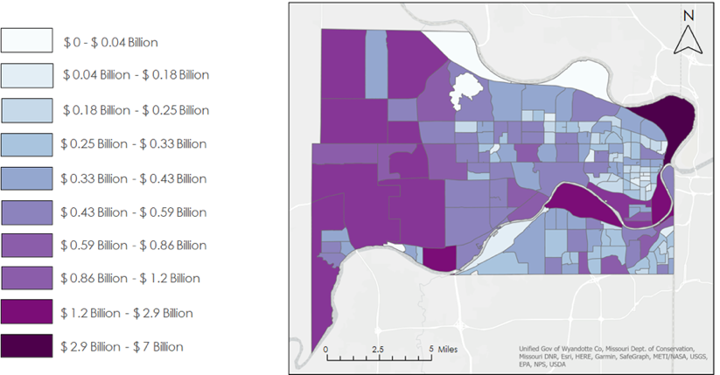

Figure 4. The potential economic damage, in dollars, for the 2017 storm event.

4.2 Arc-Malstrøm Results
4.2.1 Blue Spots
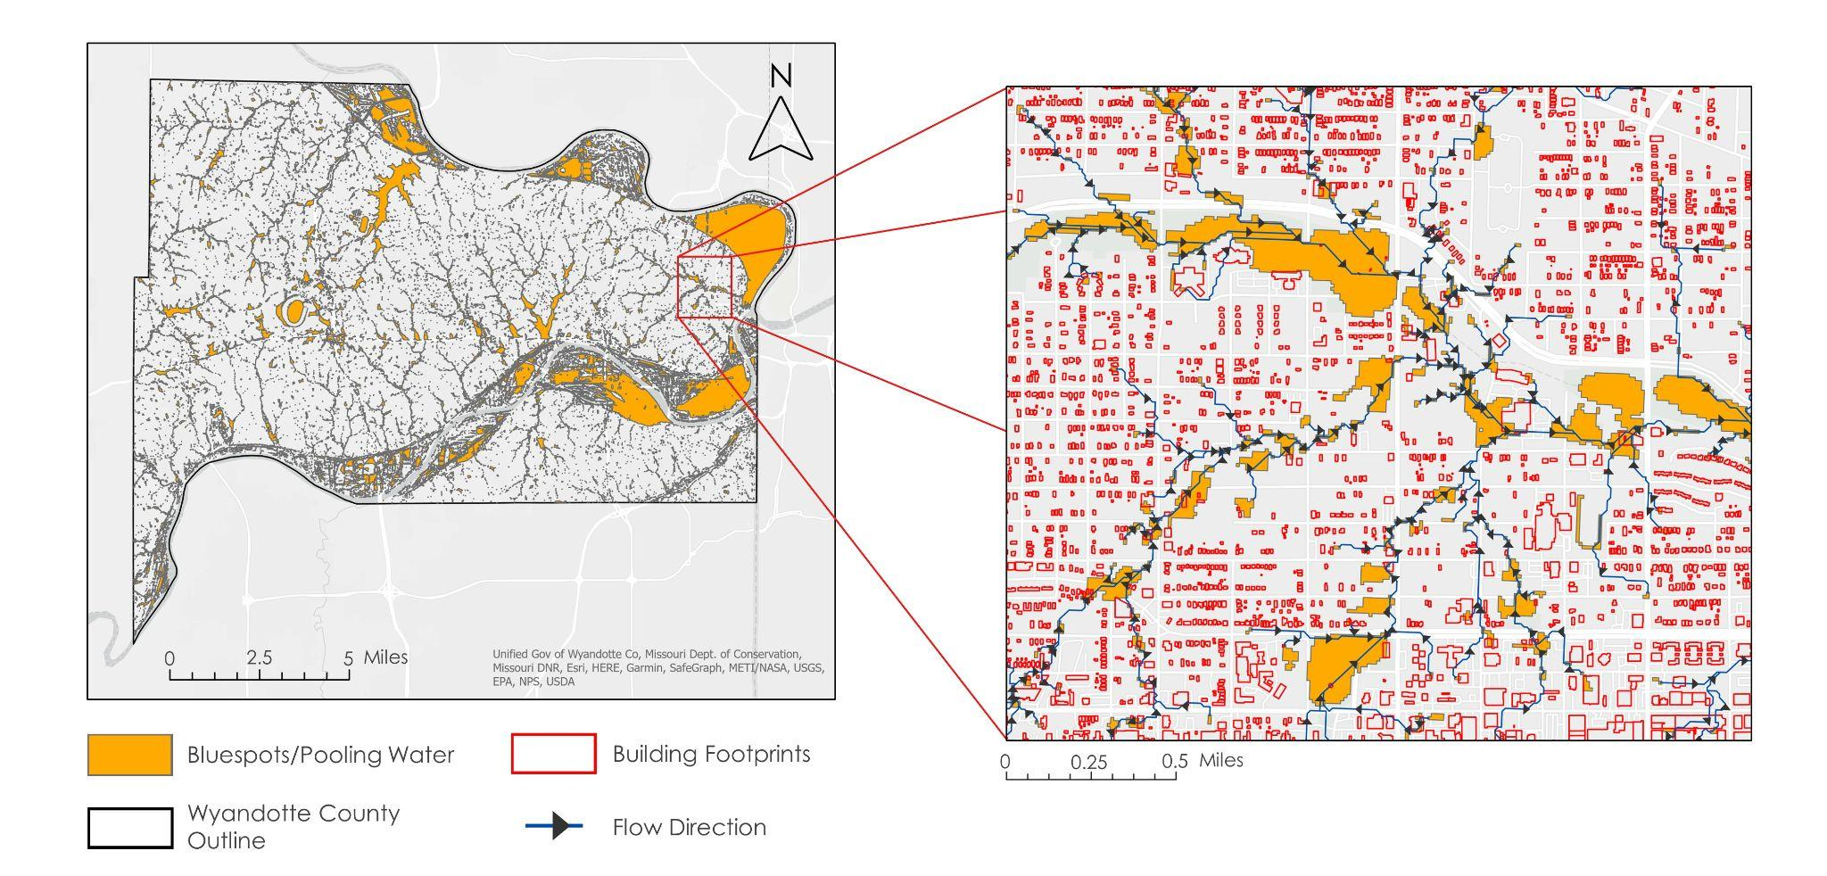
Figure 5. The Blue Spot model (left) overlapped with building footprints and flow direction (right).

To appropriately and effectively identify socially vulnerable communities and their infrastructure damages, the team utilized the Arc-Malstrøm model. This model was able to identify the areas where precipitation would pool in the case of a storm event (i.e., blue spots) according to surface elevation depressions throughout the county. The map on the left of Figure 5 indicates the pooling and flows of pluvial flooding across the surface elevation depressions within the county. The inset map in Figure 5 shows the northeast region of Kansas City, Kansas with detailed pluvial flood accumulation, the respective flow direction across the surface, and building footprints. This modeling allows for spatially explicit insight into neighborhood pluvial flooding and the potential damages many communities face after a flood event.

4.2.2 Blue Spots Potential Economic Damage
To refine the original map of potential economic damage (Figure 4), the team adapted and redeployed the InVEST Urban Flood Risk Mitigation model. However, this time the team utilized the Arc-Malstrøm model outputs of blue spots as the study area input, and the average blue spot depth of 1.6 feet, or 0.5 meters, was used to adjust the damage cost table input. This produced a spatially-explicit potential damage cost output highlighting neighborhood-scale damage. In contrast to the original potential damage map, this output presents more realistic in representing the costs of pluvial flooding from the 2017 cloudburst event (Figure 6). Individual buildings within neighborhoods can be identified as vulnerable to pluvial flooding when looking at building footprints in relation to the blue spot locations (Appendix 8).

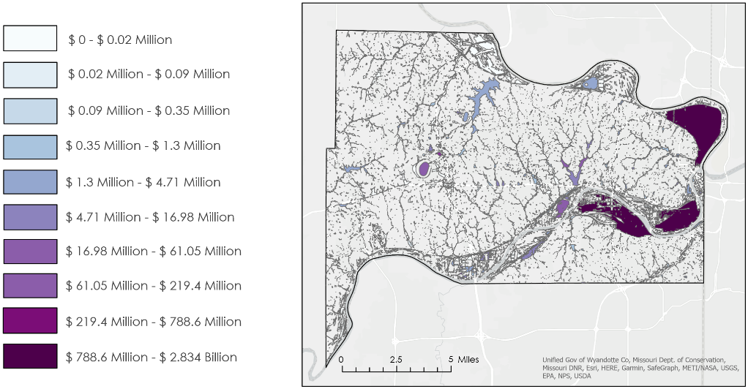

Figure 6. The Blue Spot Adjusted Potential Damage Cost model

4.3 Environmental Justice Results
4.3.1 Social Vulnerability Bivariate Maps
To understand the concerns of the community, the team examined both social factors and environmental justice concerns. Analysis revealed high environmental and socioeconomic vulnerability in the northeastern region for three out of four variables.
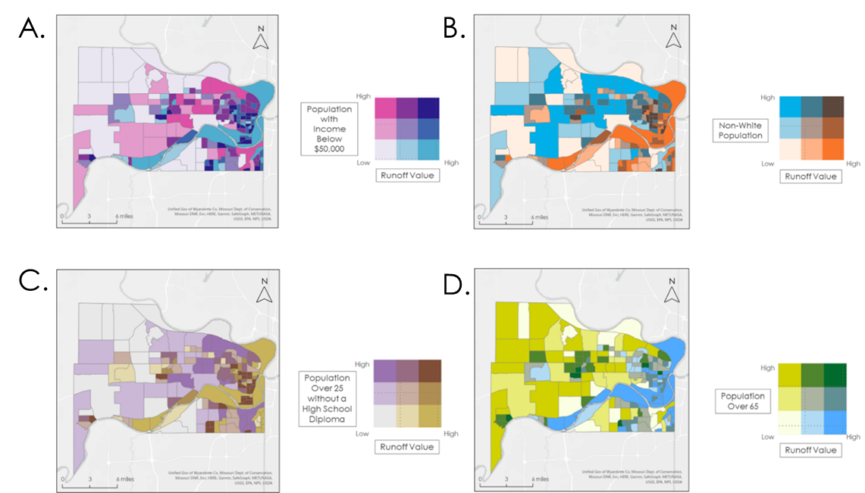

Figure 7. Bivariate maps of the spatial distribution of runoff and the (a) low-income population, (b) non-white population, (c) population over 25 without a high school diploma, and (d) population over 65 years of age across census blocks of Kansas City. Darker shades represent higher values of runoff and of each socioeconomic variable.

The state of Kansas considers households to be low-income if their annual income is below $50,000 (National Low Income Housing Coalition, 2021). A bivariate map allowed the team to identify the northeastern region of Wyandotte County to have the highest values of both runoff and low-income populations (Figure 7a). This region also exhibits a high concentration of both runoff and the non-white population (Figure 7b). The non-white population has limited access to resources designed to prevent or mitigate flood risk. Overlaps between low income and minority status are also present due to legacies of redlining and historical disinvestment in minority communities (Hopkins, 2022).

Individuals over the age of 25 without a high school diploma are more likely to receive lower hourly wages, making it difficult to leave flood susceptible areas. In Figure 7c, the northeastern region of the county continued to hold higher values of both runoff and the socioeconomic factor at play, populations without high school diplomas. Lastly, the team examined the comparison between runoff and the population 65 years and over (Figure 7d). This population is highly important to this county due to their ties to the community and homes. The elderly population is more spread-out and therefore not as explicitly vulnerable in the northeastern region.

4.3.2 Median Household Income and Potential Economic Damage Bivariate Map
As the human impacts of flooding are often disproportionately concentrated in low-income households, vulnerability to pluvial flooding is inherently linked to poverty (Intergovernmental Panel on Climate Change, 2022; McDermott, 2022). Households in Kansas City, Kansas with income below $50,000 annually lack access to financial security mechanisms such as insurance, healthcare, and damage repair fees. To highlight this presence of financial insecurity, the team produced a bivariate map that compared the adjusted potential damage cost to the median household income of Kansas City, Kansas census block groups (Figure 8). This output revealed that the eastern portion of Wyandotte County, Kansas faced high potential damage costs from pluvial flooding, with low median household income. On the other hand, the western portion of Wyandotte County, Kansas also encountered high potential damage cost, but the high median household income suggests the ability to afford the insurance, preventative measures, and repairs to their property and assets.
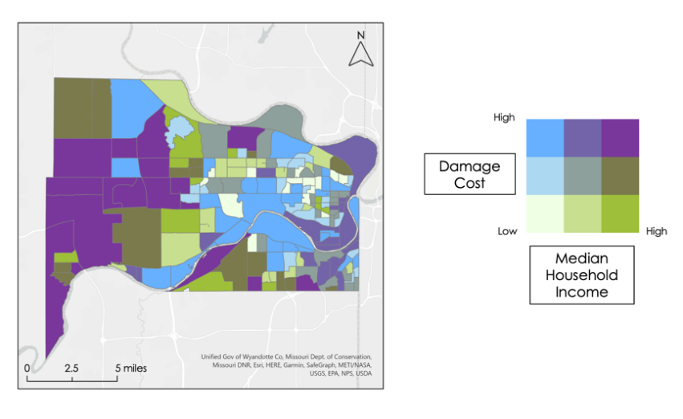
Figure 8. High damage cost compared to the median household income within Wyandotte County.

4.4 Uncertainties and Limitations
While our team was successful in producing a spatially-explicit output that provided neighborhood scale insight for both pluvial flooding and social vulnerability, it was not without encountering limitations and uncertainties. The InVEST Urban Flood Risk Mitigation model was successful in producing outputs of runoff, runoff retention, and potential economic damage. However, the team found that the InVEST model does not consider the flow of water across an elevation gradient; it only considers the flow of water across the surface based on its status as impervious or pervious using the assigned NRCS curve. In coupling this distribution of flow with precipitation as a single uniform value across the study area instead of a raster, the model does not represent spatial distribution of pluvial flood from a cloudburst, but rather only by the land cover. Additionally, the standard potential economic cost output from the InVEST model applies a uniform flood height across the entire study area, meaning that it is not representative of locations where pluvial flooding would realistically accumulate. The damage cost table that determines the dollar per square meter of flood damage is based on a detailed continental study; these assigned dollar values for infrastructure damage do not reflect the varying economic value of the differing building types in Wyandotte County, Kansas (Huizinga et al., 2017). It was never the intent for the InVEST toolset to be as adaptable as other detailed urban planning tools, however, it can be used to complement other tools and models (Hamel et al., 2021).

The Arc-Malstrøm model produced a cloudburst blue spot output, highlighting the surface elevations depressions where pluvial flooding would accumulate. The team found that this model’s output spatial accuracy is limited by the resolution of the input DEM, and the model only considered pluvial flooding from precipitation and surface runoff. The model is currently unable to account for sewer systems or other water infrastructure overflowing its capacity and creating differing blue spots not produced solely by surface runoff flows (Balstrøm & Crawford, 2018).

In the team’s environmental justice analysis, data concerning the four socioeconomic factors were only available at the census block group level. This prevented a true neighborhood-scale analysis. With more comprehensive spatial data, and the analysis of more social factors such as historically important sites, grocery stores, museums, and culture, the environmental justice analysis could be further examined in future projects.

4.5 Future Work
The team’s findings provide a strong foundation for future research in Kansas City, Kansas in collaboration with Groundwork USA and Groundwork NRG. One future research application can be combining this research with analysis of water quality, allowing for a holistic study of water security in Kansas City, Kansas. This future work could take the form of utilizing the InVEST Urban Stormwater Retention model, which calculates annual stormwater retention volume and its associated water quality benefits to model the EPA-violating levels of sewage and industrial pollution present in the local water systems.

Another pathway for future research can be the development of citizen science with pluvial flood modeling. In collaboration with Groundwork USA and Groundwork NRG, a future team could develop a community-based reporting system for collecting local data on factors such as flooding, damage, odors, or environmental quality. This would allow for the collection of a fine scale dataset to be used to refine the pluvial flooding models. This can also be used by the community to advocate for acceleration of the 25-year plan to split the stormwater and sewage pipes and relocate to more suitable sites.

Additionally, future research could dive into the health disparities and related impacts from poor air quality in Kansas City, Kansas. Similarly to how this study explored the relationship between environmental and social vulnerabilities, an analysis on environmental and health vulnerability could be done. This can further highlight the vulnerabilities of the historically disenfranchised and redlined communities in Kansas City, Kansas.

5. Conclusions
This study examined the environmental and socioeconomic factors of flood events throughout Kansas City, Kansas from June 2010 to June 2021. This was accomplished by using the InVEST Flood Risk Mitigation model outputs of runoff, runoff retention, and potential economic costs. Through a combination of soil, infrastructure, and precipitation data, the team was able to run the model and identify areas of pluvial flooding in Kansas City, Kansas. The team observed that these methods captured pluvial flooding in conjunction with the Arc-Malstrøm model, which assessed neighborhood-scale flood pooling and economic damage. With the limitations of the InVEST model, the Arc-Malstrøm model supplemented modeling and vulnerability assessments and can be further refined to include environmental and socioeconomic data. Through our environmental justice analysis, we identified regions, specifically areas in the northeast region of the study area, as being particularly vulnerable to pluvial flooding, both environmentally and socioeconomically. These results support Groundwork NRG’s work within areas of Kansas City, Kansas where data were limited. The team also secured the confidence in the available input data by developing a HUC 12 sub-watershed layer and methodology to provide neighborhood-scale pluvial flooding and social vulnerability analysis to the Groundwork USA’s Climate Safe Neighborhoods project.

6. Acknowledgments
The Kansas City Disasters team thanks our project partners at Groundwork USA and Groundwork NRG for their support and collaboration: Reverend Adrianne Showalter-Matlock, Ben Carpenter, Lawrence Hoffman, and Jalisa Gilmore. Additionally, the team thanks Dr. Kenton Ross for his technical guidance and feedback throughout this term. The team is grateful to our NASA DEVELOP Fellow Tyler Pantle for his mentorship and support throughout this term.

Maps throughout this work were created using ArcGIS® software by Esri. ArcGIS® and ArcMap™ are the intellectual property of Esri and are used herein under license. All rights reserved.

Any opinions, findings, and conclusions or recommendations expressed in this material are those of the author(s) and do not necessarily reflect the views of the National Aeronautics and Space Administration.

This material is based upon work supported by NASA through contract NNL16AA05C.

7. Glossary
Blue Spot - Surface land area where the likelihood of pluvial flooding is relatively high with affiliated consequences.

Earth observations – Satellites and sensors that collect information about the Earth’s physical, chemical, and biological systems over space and time.

GEE – Google Earth Engine: a cloud-based geospatial analysis platform that allows users to visualize and analyze satellite imagery.

GPM – Global Precipitation Measurement: an international satellite mission that measures both active precipitation and atmospheric conditions.

HUC – Hydrologic Unit Code: a unique code used to identify watersheds based on the USGS’s four-level classification system and typically consisting of two to eight digits.

IMERG – Integrated Multi-satellitE Retrievals for GPM: an algorithm that uses GPM imagery to calculate precipitation amounts over the Earth’s surface.

InVEST – Integrated Valuation of Ecosystem Services and Tradeoffs: a suite of models used to map and evaluate the changes in ecosystems influencing natural goods and services that sustain human life.

LiDAR – Light Detection and Ranging: a remote sensing method that uses light in the form of a pulsed laser to measure variable distances to the Earth.

LULC – Land Use Land Cover: the classification of human-related activities and land elements on the Earth’s surface.

8. References
Balstrøm, T., & Crawford, D. (2018). Arc-Malstrøm: A 1D hydrologic screening method for stormwater assessments based on geometric networks. Computers & Geosciences, 116, 64–73. https://doi.org/10.1016/j.cageo.2018.04.010
Climate Change 2022 Impacts, Adaptation and Vulnerability: Working Group II contribution to the Sixth Assessment Report of the Intergovernmental Panel on Climate Change (IPCC). (2022). https://www.ipcc.ch/report/ar6/wg2/
Combs, L. J., & Perry, C. A. (2003). The 1903 and 1993 Floods in Kansas – The Effects of Changing Times and Technology. United States Geological Survey. https://pubs.usgs.gov/fs/2003/0019/report.pdf
Corrigan, P. (2022). Great Flood of 1993. National Weather Service. https://www.weather.gov/arx/flood_1993
EPA. (2021). Climate Change and Social Vulnerability in the United States: A Focus on Six Impacts. U.S. Environmental Protection Agency, EPA 430-R-21-003. www.epa.gov/cira/social-vulnerability-report
Hamel, P., Guerry, A. D., Polasky, S., Han, B., Douglass, J. A., Hamann, M., Janke, B., Kuiper, J. J., Levrel, H., Liu, H., Lonsdorf, E., McDonald, R. I., Nootenboom, C., Ouyang, Z., Remme, R. P., Sharp, R. P., Tardieu, L., Viguié, V., Xu, D., … Daily, G. C. (2021). Mapping the benefits of nature in cities with the InVEST software. npj Urban Sustainability, 1, Article 25. https://doi.org/10.1038/s42949-021-00027-9
Hopkins, J. S. “Kansas City Businesses Haunted by Redlining Legacy amid the Pandemic.” Center for Public Integrity, 28 Jan. 2022, https://publicintegrity.org/health/coronavirus-and-inequality/kansas-city-redlining-businesses-pandemic-ppp/
Houston, D., et al. (2011 November 9). Pluvial (rain-related) flooding in urban areas: the invisible hazard. Joseph Rowntree Foundation. https://www.jrf.org.uk/report/pluvial-rain-related-flooding-urban-areas-invisible-hazard
Huizinga, J., De Moel, H., & Szewczyk, W. (2017). Global flood depth-damage functions: Methodology and the database with guidelines. EUR 28552 EN, Publications Office of the European Union, Luxembourg, https://doi.org/10.2760/16510
LaJoie, P., Cronin, E., Perrotti, J., Shives, E., & Webster, S. (2021). Cincinnati and Covington Urban Development II: Assessing flooding and landslide susceptibility along the Ohio-Kentucky border. NASA DEVELOP National Program, Massachusetts – Boston. https://ntrs.nasa.gov/citations/20210021222
Manson, S., Schroeder, J., Van Riper, D., Kugler, T., & Ruggles, S. IPUMS National Historical Geographic Information System (Version 16.0) [Data set]. Minneapolis, MN: IPUMS. 2021. http://doi.org/10.18128/D050.V16.0
McDermott, T. K. J. (2022). Global exposure to flood risk and poverty. Nature Communications, 13, Article 3529. https://doi.org/10.1038/s41467-022-30725-6
Miller, J. D., & Hutchins, M. (2017). The impacts of urbanisation and climate change on urban flooding and urban water quality: A review of the evidence concerning the United Kingdom. Journal of Hydrology: Regional Studies, 12, 345–362. https://doi.org/10.1016/j.ejrh.2017.06.006
Morgan, A. (2019). Kansas Flooding 2019. Kansas Division of Emergency Management. https://kansastag.gov/AdvHTML_doc_upload/kda%20presentation%20updated.pdf
National Low Income Housing Coalition. (2021.) Out of Reach: Kansas. https://reports.nlihc.org/oor/kansas#:~:text=$1,369,Kansas
National Weather Service. (2017). Significant Flooding Event of August 21st-22nd, 2017. National Weather Service. https://www.weather.gov/eax/SignificantFloodingEventofAugust21st-22nd2017
Qi, H., Ma, C., Xu, H., Chen, Z., Zhao, K., & Han, H. (2021). A review on applications of urban flood models in flood mitigation strategies. Natural Hazards, 108(1), 31–62. https://doi.org/10.1007/s11069-021-04715-8
Quagliolo, C., Comino, E., & Pezzoli, A. (2021). Experimental flash floods assessment through Urban Flood Risk Mitigation (UFRM) model: The case study of Ligurian coastal cities. Frontiers in Water, 3, Article 663378. https://doi.org/10.3389/frwa.2021.663378
Stanford Natural Capital Project. (2022). InVEST. Natural Capital Project. https://naturalcapitalproject.stanford.edu/software/invest
Stanford Natural Capital Project. (2022). InVEST Documentation: Urban Flood Risk Mitigation model. Natural Capital Project. https://invest-userguide.readthedocs.io/en/latest/urban_flood_mitigation.html
United States Department of Agriculture. “Part 630 Hydrology, National Engineering Handbook Chapter 7 Hydrologic Soil Groups.” Natural Resource Conservation Service, USDA, United States Department of Agriculture, Jan. 2009, https://www.nrcs.usda.gov/wps/portal/nrcs/detailfull/national/water/manage/hydrology/?cid=stelprdb1043063
United States Department of Agriculture Soil Survey Staff. (2022). Gridded Soil Survey Geographic (gSSURGO) database for the Conterminous United States [Data set]. https://catalog.data.gov/dataset/gridded-soil-survey-geographic-gssurgo-30-database-for-the-conterminous-united-states-30-m
United States Environmental Protection Agency. “Unified Government of Wyandotte County and Kansas City, Kansas.” EPA, United States Environmental Protection Agency, 20 Mar. 2020, https://www.epa.gov/enforcement/unified-government-wyandotte-county-and-kansas-city-kansas#over.
United States Geological Survey. (2022). Missouri River at Kansas City, Missouri, Gauge Station 06893000 [Data set]. https://waterdata.usgs.gov/nwis/uv?site_no=06893000
Zhang, H., Qi, Z., Li, X., Chen, Y., Wang, X., & He, Y. (2021). An urban flooding index for unsupervised inundated urban area detection using Sentinel-1 polarimetric SAR images. Remote Sensing, 13(22), Article 4511. https://doi.org/10.3390/rs13224511

9. Appendices

Appendix 1. A table of ancillary datasets used in this project.

Dataset Name | Date | Description
U.S. Census Bureau Block Group Shapefile | 2020 | Polygon layer of U.S. Census Block Groups for Wyandotte County, Kansas used for environmental justice analysis and InVEST model inputs
American Community Survey Socioeconomic Data | 2020 | Demographic and socioeconomic data at the U.S. Census Block Group level used for environmental justice analysis
USGS NHDPlus (National Hydrography Dataset Plus) High Resolution (HR) | 2018 | Regional watershed boundary dataset containing HUC 8 and 12 watersheds for creating a delineated watershed polygon
United States Department of Agriculture (USDA) Gridded Soil Survey Geographic (gSSURGO) Database, 2019 | 2019 | Soil hydrologic group classification for the InVEST Urban Flood Risk Mitigation model
United States Geological Survey (USGS) National Land Cover Database (NLCD) | 2019 | Land cover and land use data for input into the InVEST Urban Flood Risk Mitigation model
United States Geological Survey (USGS) 3-DEM 10-meter (1/3 arc-second) | 2020 | Digital elevation model for input to watershed delineation and Arc-Malstrøm model
Wyandotte County Unified Government Streams Layer | 2014 | Stream location data for input into the Arc-Malstrøm model
Wyandotte County Unified Government County Limits | 1988 | County shapefile data for input into the InVEST Urban Flood Risk Mitigation model
Wyandotte County Unified Government Building Footprints | 2011 | Local building footprint data for input into the InVEST Urban Flood Risk Mitigation model and the Arc-Malstrøm model

Appendix 2. A raster output of land use and land cover of Wyandotte County, Kansas

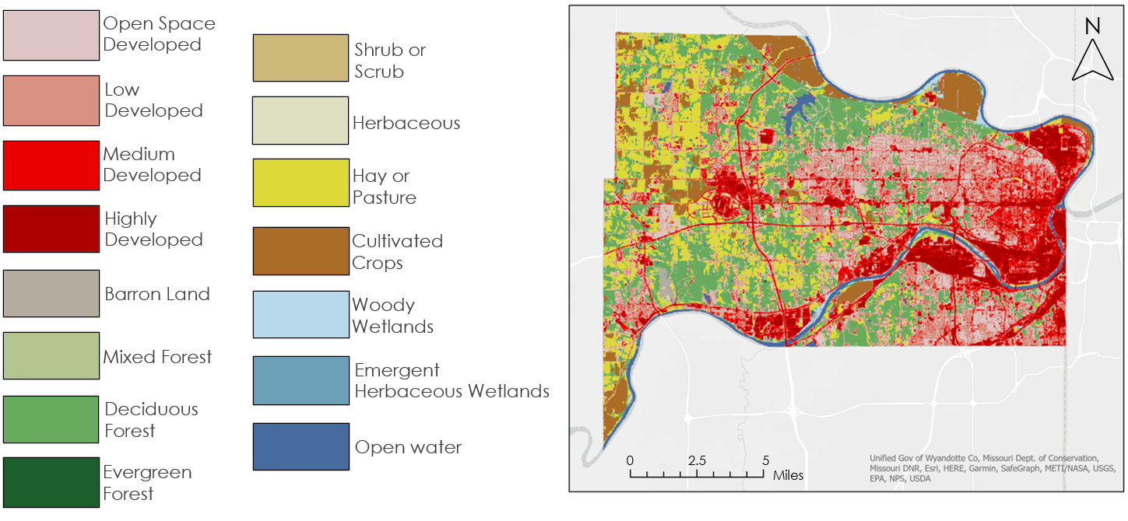

Appendix 3. A polygon output of the soil hydrologic groups of Wyandotte County, Kansas

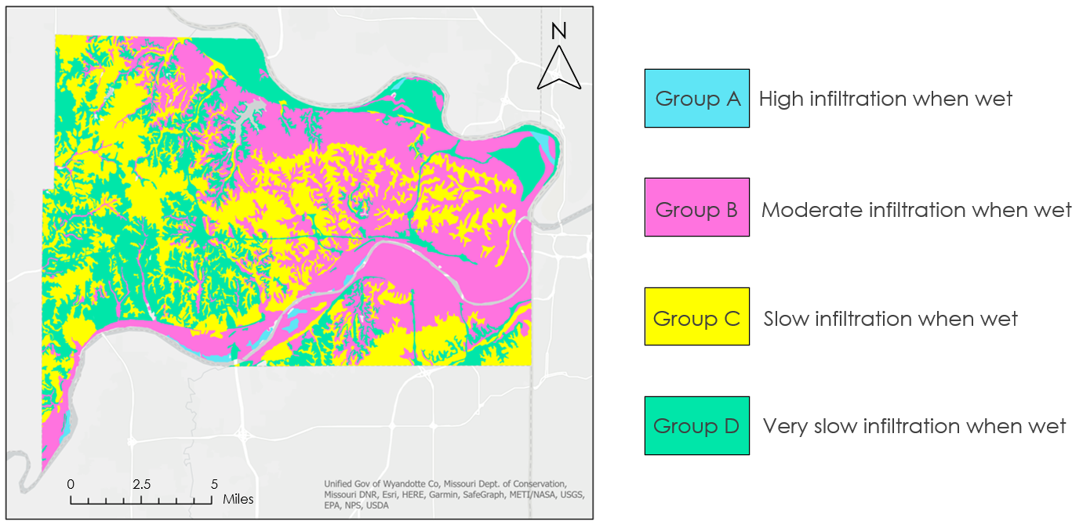

Appendix 4. A table of National Resource Conservation Service (NRCS) curve numbers for producing the biophysical table

LULC Code | Description | CN_A | CN_B | CN_C | CN_D
11 | open water | 100 | 100 | 100 | 100
21 | developed, open space | 49 | 69 | 79 | 84
22 | developed, low intensity | 77 | 86 | 91 | 94
23 | developed, medium intensity | 89 | 92 | 94 | 95
24 | developed, high intensity | 98 | 98 | 98 | 98
31 | barren land (rock/sand/clay) | 77 | 86 | 91 | 94
41 | deciduous forest | 32 | 48 | 57 | 63
42 | evergreen forest | 39 | 58 | 73 | 80
43 | mixed forest | 46 | 60 | 68 | 74
52 | shrub/scrub | 49 | 68 | 79 | 84
71 | grassland/herbaceous | 64 | 71 | 81 | 89
81 | pasture/hay | 49 | 69 | 79 | 84
82 | cultivated crops | 71 | 80 | 87 | 90
90 | woody wetlands | 88 | 89 | 90 | 91
95 | emergent herbaceous wetlands | 89 | 90 | 91 | 92

Appendix 5. A table of the Wyandotte County, Kansas building type conversion

Wyandotte County Building Types | Building type Conversion | New Building Type
Agriculture, Food, Livestock | 5 | Agriculture
Banking & Finance | 2 | Commerce
Building General | 1 | Residential
Commercial and Retail | 2 | Commerce
Education | 4 | Infrastructure
Emergency response | 4 | Infrastructure
Energy | 4 | Infrastructure
Government and military | 4 | Infrastructure
Health and medical | 4 | Infrastructure
Industry | 3 | Industry
Information & communication | 4 | Infrastructure
Mail and shipping | 2 | Commerce
public attractions and landmarks | 2 | Commerce
Transportation | 4 | Infrastructure
Transportation Facilities | 4 | Infrastructure
Water Supply | 4 | Infrastructure

Appendix 6. A line graphs of percent total runoff for each LULC class

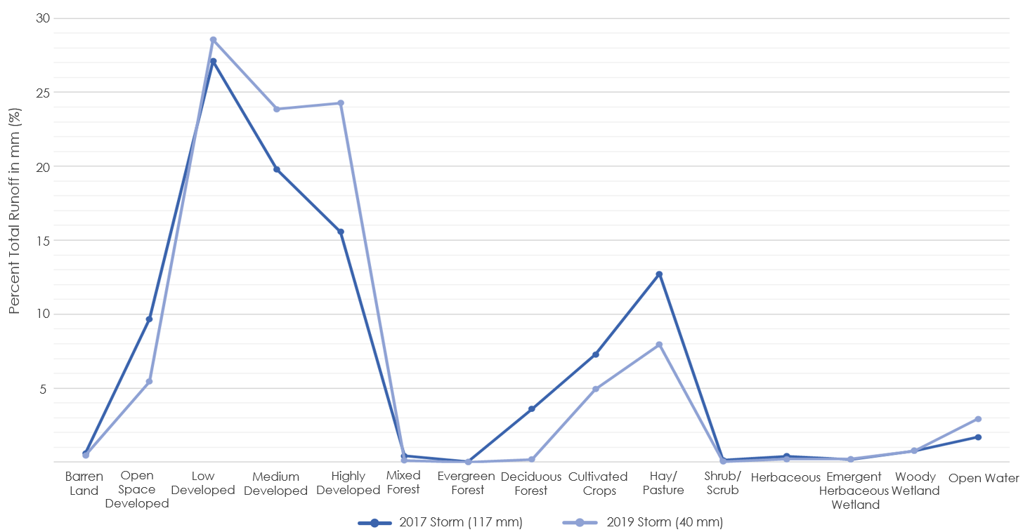

Appendix 7. A line graphs of percent total runoff retention for each LULC class

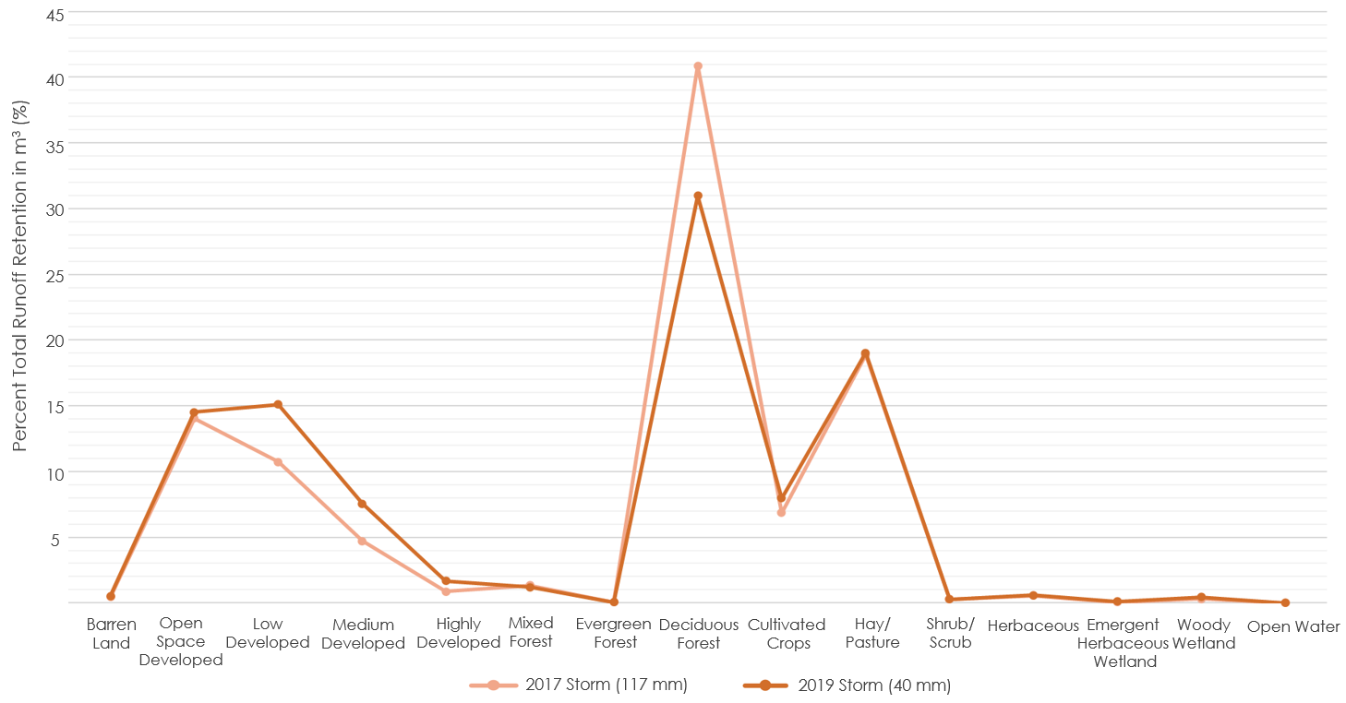

Appendix 8. A raster output of the Arc-Malstrøm blue spot adjusted potential economic damage in Wyandotte County, Kansas with an inset map of northeastern Kansas City, Kansas. The blue and purple sections within the left figure indicate the adjusted potential cost damage with blue representing low ($0 to $0.02 million) and dark purple representing high ($$788.6 to $2.834 million).

