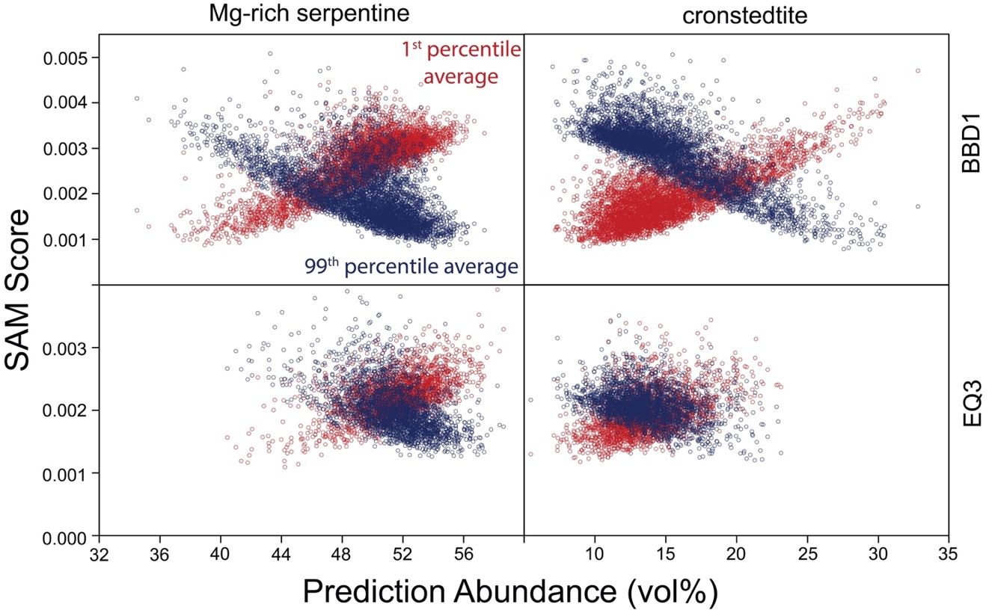

Figure S1. SAM scores of the BBD1 (top) and EQ3 (bottom) datasets compared to the 1st (red) and 99th (blue) percentile averages versus the PLS prediction abundances for Mg-rich serpentine (left) and cronstedtite (right). Each individual OTES spectrum is represented by a single data point. SAM scores indicate degree of spectral match of each OTES observation to the 1st and 99th percentile averages, where low scores are best matches.

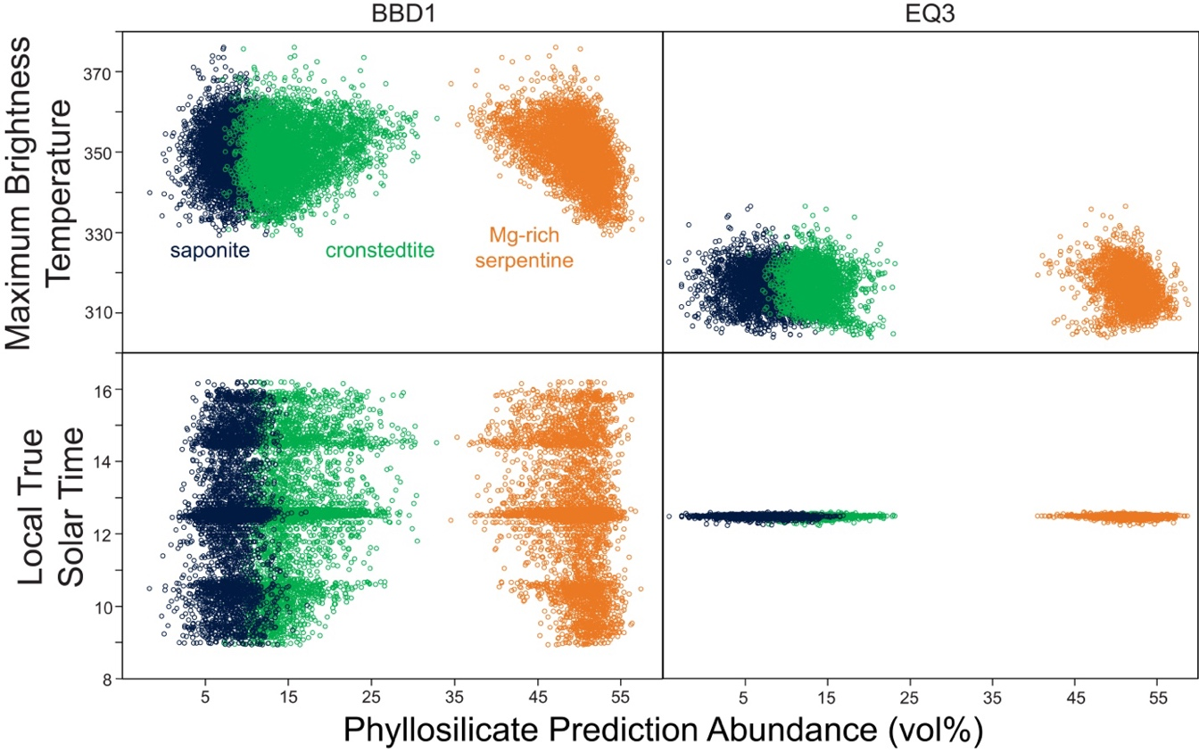
Figure S2. MBT and LTST of the BBD1 (left) and EQ3 (right) OTES datasets versus Mg-rich serpentine, cronstedtite, and saponite PLS prediction abundances.

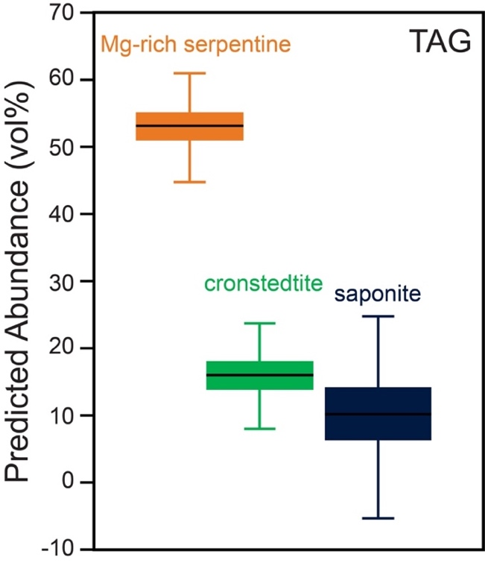
Figure S3. Box-and-whisker plot of Mg-rich serpentine, cronstedtite, and saponite PLS prediction abundances for the TAG dataset. Black lines represent median values, boxes indicate first and third quartile, and whiskers denote data range. Outliers (1.5 times the interquartile range larger than the third quartile or 1.5 times the interquartile range smaller than the first quartile) are omitted.

